Light-Driven Enzyme Catalysis: Ultrafast Mechanisms and Biochemical Implications
YongLe He†, Marco Barone†, Stephen R. Meech‡, Andras Lukacs§ and Peter J. Tonge† *

†Center for Advanced Study of Drug Action and Department of Chemistry, Stony Brook University, Stony Brook, New York 11794, United States.
§Department of Biophysics, Medical School, University of Pecs, Szigeti str. 12, 7624 Pecs, Hungary.
‡School of Chemistry, University of East Anglia, Norwich, NR4 7TJ, U.K.

*Correspondence: peter.tonge@stonybrook.edu

Keywords: enzyme mechanism, light-activation, photoactivation, flavin, signal transduction, photolyase, photoreceptors

ABSTRACT
Light-activated enzymes are an important class of biocatalysts in which light energy is directly converted into biochemical activity. In most cases the light absorbing group is the isoalloxazine ring of an embedded flavin cofactor and in general two types of mechanism are in operation depending on whether the excited chromophore directly participates in catalysis or where photoexcitation triggers conformational changes that modulate the activity of a downstream output partner. This review will summarize studies on DNA photolyase, fatty acid photodecarboxylase (FAP), and the monooxygenase PqsL, where flavin radicals generated by excitation are directly used in the reactions catalyzed by these enzymes, and the blue light using FAD (BLUF) and light oxygen voltage (LOV) domain photoreceptors where flavin excitation drives ultrafast structural changes that ultimately result in enzyme activation. Recent advances in methods such as time-resolved spectroscopy and structural imaging have enabled unprecedented insight into the ultrafast dynamics that underly the mechanism of light-activated enzymes and here we highlight how understanding ultrafast protein dynamics not only provides valuable insights into natural phototransduction processes but also opens new avenues for enzyme engineering and consequent applications in fields such as optogenetics.

INTRODUCTION
Ultrafast protein dynamics play a fundamental role in the functionality of light-activated enzymes, facilitating rapid and precise response to photon absorption.¹ These enzymes contain an embedded chromophore and undergo intricate conformational changes upon illumination, triggering cascades of molecular events that culminate in catalytic activation or signal transduction.^{2,3} Understanding the ultrafast dynamics that underlie formation of the activated state provides crucial insights into the fundamental mechanisms governing enzyme function and light-driven biological processes. Advanced techniques including time-resolved spectroscopy and femtosecond serial crystallography have been applied to elucidate the ultrafast molecular events that control the coupling between light absorption and catalysis in photoactivated enzymes,^{1,4,5} which have also been used as model systems to understand how light-triggered ultrafast conformational changes control catalytic reactions in the cell. This review focuses on the ultrafast protein dynamics and activation mechanisms of blue light-activated enzymes that utilize an embedded flavin chromophore to absorb light. We do not include light activated enzymes that do not use a flavin such as phytochrome-activated di-guanylyl cyclase (PadC)⁶ or light-dependent protochlorophyllide reductases.⁷

FLAVIN COFACTORS IN ENZYMES
Flavin cofactors are derived from riboflavin (vitamin B2) and encompass a family of redox-active molecules known for their distinctive chemical properties and biological roles.⁸ Flavin cofactors, including flavin mononucleotide (FMN) and flavin adenine dinucleotide (FAD), exist in several oxidation states, each exhibiting unique reactivity and spectral characteristics,⁹ and serve as redox carriers, mediating electron transfer reactions, and as functional groups for nucleophilic catalysis and substrate activation (Figure 1).¹⁰
Figure 1: Structures and oxidation states of the flavin chromophore

Light-activated flavin enzymes represent a diverse group of proteins that utilize FAD or FMN as cofactors to initiate photochemical reactions in response to light stimulation. These enzymes play crucial roles in various biological processes, including photoreception, DNA repair, and metabolic regulation.¹¹ Major classes of light-activated flavin enzymes include DNA photolyase, fatty acid photodecarboxylase (FAP), flavoprotein monooxygenase, and the Blue-Light Utilizing FAD (BLUF) and Light Oxygen Voltage (LOV) sensing domain photoreceptors. DNA photolyase repairs UV-induced DNA damage including cyclobutane pyrimidine dimers (CPDs) and 6-4 photoproducts (6-4PPs) following visible light excitation of a noncovalently bound FAD cofactor.¹² In addition, to their role in DNA repair, photolyases are also the evolutionary ancestors of cryptochromes (CRYs) which represent another important class of light-activated flavoproteins, with multiple crucial biological roles in plants and in animals.^{13,14} FAP is an enzyme that utilizes blue light to decarboxylate fatty acids, leading to the production of hydrocarbons. The mechanism involves light-induced activation of the enzyme-bound FAD cofactor to initiate fatty acid decarboxylation.¹⁵ PqsL is a monooxygenase from Pseudomonas aeruginosa that catalyzes the hydroxylation of aromatic amines during the biosynthesis of 2-alkyl-4-hydroxyquinoline N-oxides (AQNO).¹⁶ LOV or BLUF light-sensing protein domains contain a flavin chromophore (either FMN or FAD) that triggers light-induced conformational changes in the protein matrix, resulting in downstream signaling events. BLUF and LOV domain photoreceptors are found in various organisms and regulate diverse cellular processes, including phototropism, circadian rhythms, and stress responses.^{17,18} The central function of the light-activated flavin enzyme is the ability to transduce photon energy into structural rearrangements that propagate through the protein scaffold, ultimately modulating the enzymatic activity or signaling output molecular events occur from ultrafast sub-ps timescale to biologically relevant sub-ms timescale.¹⁹

Ultrafast spectroscopic techniques, such as time-resolved and femtosecond laser spectroscopy, have emerged as powerful tools for probing the dynamics of light-activated enzymes with unprecedented temporal resolution. These techniques allow the capture of transient structural intermediates and elucidate the sequence of events following photon absorption, shedding light on the molecular choreography underlying enzyme activation and signal transduction pathways.^{1, 4} In this context, we will provide an overview of the current knowledge regarding ultrafast protein dynamics in light-activated enzymes. We will explore critical examples from the literature, highlighting the structural and functional implications of ultrafast conformational changes in these three classes of enzymes. Additionally, through interdisciplinary approaches combining structural biology, spectroscopy, and computational modeling, we can have a deeper insight into the fundamental principles of biological regulation by light.

Photolyase: A light-activated DNA repair enzyme
UV radiation from sunlight can induce the formation of covalent bonds between adjacent pyrimidine bases in DNA, leading to cyclobutane pyrimidine dimers (CPDs) and pyrimidine-pyrimidone 6-4 photoproducts (6-4PPs) which distort the DNA helix and interfere with DNA replication and transcription, potentially leading to mutations and cellular damage.²⁰ Several systems exist to repair DNA damage including DNA photolyases which are found in plants, fungi, birds, fish, marsupials and some bacteria.^{12,21,22} DNA photolyases are members of the photolyase/cryptochrome superfamily which use FAD as the principal light absorbing cofactor and utilize a mechanism known as photoreactivation to repair UV-induced DNA damage.^{23,24} Several classes of DNA photolyases have been identified including Class I, II and III CPD photolyases, single-strand specific DNA photolyases, and (6-4) photolyases.²⁵ Below we summarize aspects of the mechanism of CPD and (6-4) photolyases with particular emphasis on insight gained from ultrafast spectroscopy.

DNA repair by CPD photolyases is initiated by excitation of the reduced anionic state of FAD (FADH⁻). However, the FAD cofactor normally exists as the inactive semireduced radical state FADH•, which must first be converted to FADH⁻ through a process known as photoactivation. This is achieved by electron transfer from a nearby Trp residue (W382 in E. coli photolyase) to the excited state of FADH• (FADH•*) which is formed by irradiation of FADH•. W382 is part of a Trp triad (W359 and W306 in E. coli photolyase) that transfers electrons from an exogenous reductant to the FADH•*. Electron transfer through the Trp triad has been studied by ultrafast spectroscopy including polarized femtosecond transient absorption spectroscopy,^{26,27} leading to a detailed understanding of electron hopping through the Trp ‘wire’ (Figure 2).
Figure 2: Electron hopping through the Trp triad in DNA photolyase. The electron transfer chain in E. coli DNA photolyase. W382 serves as the primary donor to reduce the flavin and the resulting positive charge is stabilized on W306 within 30 ps which then deprotonates in 200 ns. The figure was adapted from Lukacs et al.²⁷ and was made with pymol,²⁸ from 1DNP.pdb.²⁹ In addition to the Trp triad, the antenna chromophore 5,10-methenyltetrahydrofolate (MTHF) is also shown.

More recently, femtosecond X-ray crystallography has been used to analyze the structural changes accompanying electron transfer through the Trp chain in the Drosophila melanogaster (6-4) photolyase.³⁰ In D. melanogaster photolyase, where the Trp chain consists of 4 Trp residues, the photoexcited cofactor extracts an electron from the proximal Trp residue within just 1 ps, starting the tunneling along the Trp chain, which ultimately results in the formation of a long-range radical pair between FAD^{●-} and the terminal Trp radical. Specific structural dynamics include the Asp397–Arg368 salt bridge which responds within 400 fs to photoreduction of FAD, N403, and reorganization of a water network around the FAD which collectively stabilize the charge on FAD^{●-}. The terminal Trp (W381) responds within 20 ps with further dynamics observed for residues around W381 extending to 100 μs, indicating rapid charge transfer followed by structural changes which stabilize the W381 radical. These events are summarized in Figure 3.

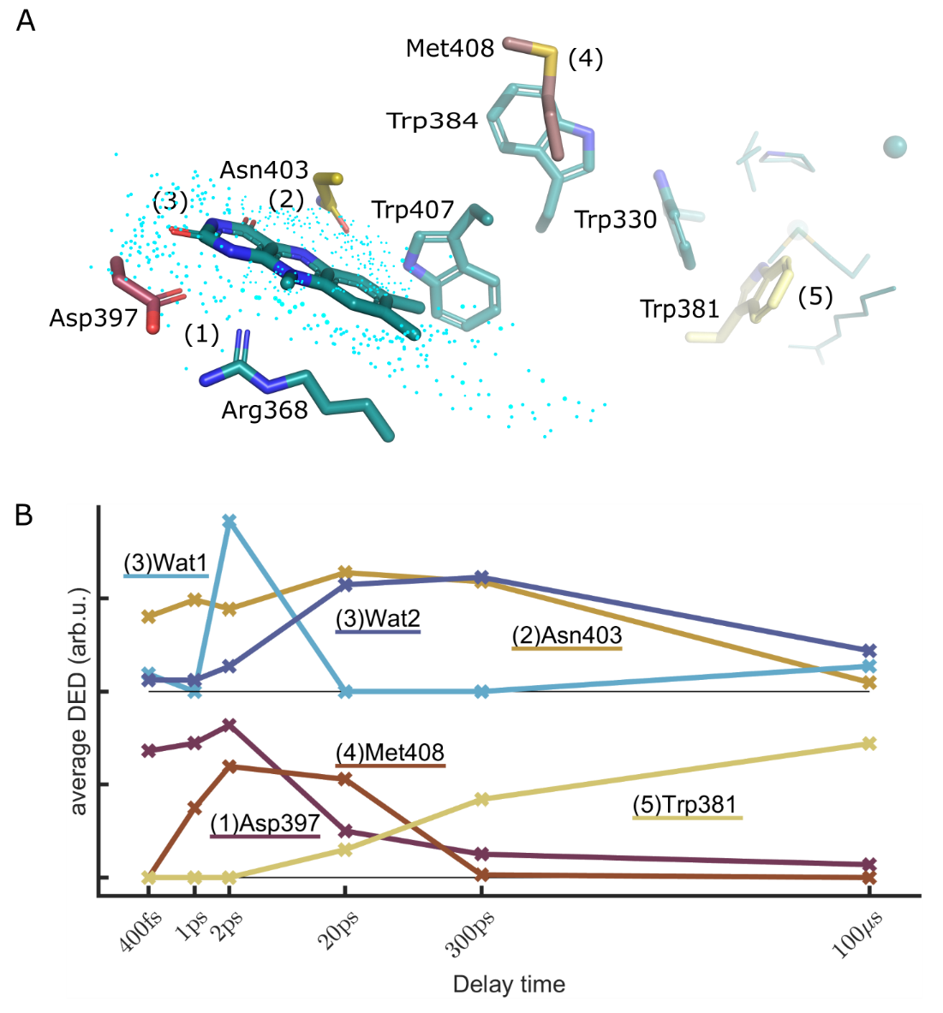
Figure 3: Photochemical events upon reduction of FAD• in D. melanogaster (6-4) photolyase.
(A) Key residues and processes. (1) FAD is reduced and Asp397 and Arg368 respond immediately. (2) Asn403 reacts similarly fast and undergoes a slow phase of response up to 20 ps. (3) A delayed (from 1 ps) and complex motion of water molecules is completed at 20 ps. (4) Met408 undergoes a photoreaction from 1 ps to 20 ps. (5) Trp381 is oxidized at 300 ps, with structural changes evolving around it up to 100 μs. (B) The kinetics of the observed difference electron density (DED) at key positions are shown. For water features the electron density is averaged over positive DED >2σ and for the amino acids over negative DED <2σ (side chains only). The radius of integration was 2.5 Å. Wat1 corresponds to feature V and Wat2 to feature VI in Figure 3 of Cellini et al.³⁰ The kinetics for water and Asn403 are vertically offset. The figure was taken from Cellini et al.³⁰

Following formation of FADH⁻, DNA repair is initiated by excitation of FADH⁻ either by direct light absorption or by energy transfer from a light-harvesting antenna chromophore such as 5,10-methenyltetrahydrofolate (MTHF) or 8-hydroxy-7,8-didemethyl-5-deazariboflavin. The antenna chromophore increases the efficiency of catalysis as it has an ~5-fold higher extinction coefficient than the reduced flavin. Following excitation of the antenna, energy is then transferred to the flavin via the classical Förster-type energy transfer mechanism (FRET).^{31,32} Using femtosecond fluorescence spectroscopy the fluorescence lifetime of MTHF* in E. coli DNA photolyase was 2.6 ns in the absence of the flavin but was heavily quenched when the reduced flavin was present with a lifetime of 170 ps. Thus, the efficiency of energy transfer between MTHF* and the reduced flavin was shown to be ~ 94% ³³

Once formed, FADH–* transfers an electron to the adenine of the FAD cofactor: for the functionally active FADH–* redox state this occurs in 2 ns, followed by ultrafast charge recombination in 25 ps leading to electron tunneling to the substrate in 250 ps.^{24,34} Thus the unique bent conformation of the FAD cofactor is thought to perform a central role in catalysis in which the adenine mediates electron transfer to the substrate.

The reaction catalyzed by the CPD photolyase from Methanosarcina maze (mmCPD) has been studied in detail using time-resolved serial femtosecond crystallography.³⁵ Structural analysis of the reduced form of mmCPD in complex with a cis-syn thymine dimer was performed from 3 ps to 30 ns following a 1.1-ps pulse of 396 nm light. This revealed several key features of the reaction coordinate including the observation that the isoalloxazine ring of the cofactor undergoes “butterfly bending” upon excitation resulting in a rearrangement of a hydrogen bond network around the isoalloxazine and adenine rings upon formation of FAD^{-*} (within 3 ps) (Figure 4). The change in the water network that interacts with the adenine supports a direct role for the adenine in the electron transfer reaction. Subsequently, between 300 ps to 3 ns, the reaction proceeds through the stepwise cleave of the two carbon-carbon bonds in the thymine dimer via an intermediate in which the C5–C5′ bond is broken, conclusively arguing against a mechanism that involves concerted cleavage of both bonds. During this process, the isoalloxazine ring flattens, assuming a geometry consistent with the FAD● product state. This is followed by product dissociation in 10-100 μs (Figure 4).
Figure 4: The CPD photolyase reaction mechanism revealed by time-resolved femtosecond crystallography. Structural data of the CPD photolyase from Methanosarcina maze (mmCPD) in complex with a synthetic thymine dimer.³⁵ (A) and (B) Excitation of FAD⁻ results in formation of the FAD^{-*} excited state in 3 ps in which the isoalloxazine ring undergoes “butterfly bending” which results in a rearrangement of a hydrogen bond network around the ring that includes amino acid residues and ordered water molecules. This is followed by relaxation of the isoalloxazine ring into the geometry of the FAD● semiquinone product within 3 ns. (C) The reaction mechanism showing the cofactor redox states, bind cleavage and product release. The figure was made from Figures 1C, 2A and 2B in Christou et al.³⁵

Light-induced fatty acid decarboxylation
Fatty acid photodecarboxylase (FAP) is an intriguing enzyme that catalyzes the light-driven decarboxylation of fatty acids into hydrocarbons and CO₂, and consequently has important applications in biofuel production.¹⁵ FAP was initially identified in microalgae and is a member of the glucose-methanol-choline (GMC) oxidoreductase family.³⁶ The X-ray structure of the enzyme from Chlorella variabilis in complex with palmitate shows that the carboxyl group of the substrate is located close to the isoalloxazine ring of FAD. The reaction was initially characterized using time-resolved fluorescence and absorption spectroscopy resulting in a model in which the excitation of the oxidized FAD results in an excited state (FAD*) that forms FAD^{•−} in ~300 ps due to electron transfer from the substrate, leading to decarboxylation and formation of an alkyl radical.³⁶ Electron transfer from FAD^{•−} to the alkyl radical was then proposed to result in an alkyl anion in ~100 ns that caused a red shift in the FAD spectrum followed regeneration of the resting state of the enzyme in ~4 ms. Subsequently, time-resolved spectroscopy at cryogenic temperatures provided direct evidence for a red-shifted flavin intermediate that was proposed to involve a charge transfer species between the thiolate of C432 and the FAD C4a position.³⁷

Subsequent serial femtosecond crystallography combined with 100-fs-resolution pump-probe spectroscopy, absorption and Raman microspectrophotometry, FTIR spectroscopy and MD simulations, have provided additional insight in the mechanism of photodecarboxylation.³⁸ Highlights of these studies include the observation that CO₂ is initially formed with a time constant of ~270 ps i.e. concomitant with electron transfer from substrate to FAD*, and that subsequently dissociation of CO₂ and/or formation of HCO₃⁻ occurs in 100 ns and is accompanied by generation of the oxidized FAD with a red-shifted spectrum. A structure of the product complex is shown in Figure 5 and includes electron density assigned to HCO₃⁻, while a proposed photocycle is shown in Figure 6. While a more recent analysis using time-resolved fluorescence and transient absorption proposed that decarboxylation occurs on the ns time-scale,³⁹ further quantum chemical calculations support a mechanism that involves decarboxylation on the ps time-scale without accumulation of RCOO•.⁴⁰
Figure 5. X-ray structure of the FAP product complex. Data were obtained from crystals at 150 K and pH 8.5 and show positive electron density from the polder omit map contoured at 3.5 rmsd. close to C432 that is assigned to bicarbonate (HCO₃⁻). Also shown are the alkyl product (Alk), CO₂ and the isoalloxazine ring which adopts a bent conformation. The figure was made using pymol,²⁸ and is adapted from Figure 4D in Sorigué et al.³⁸

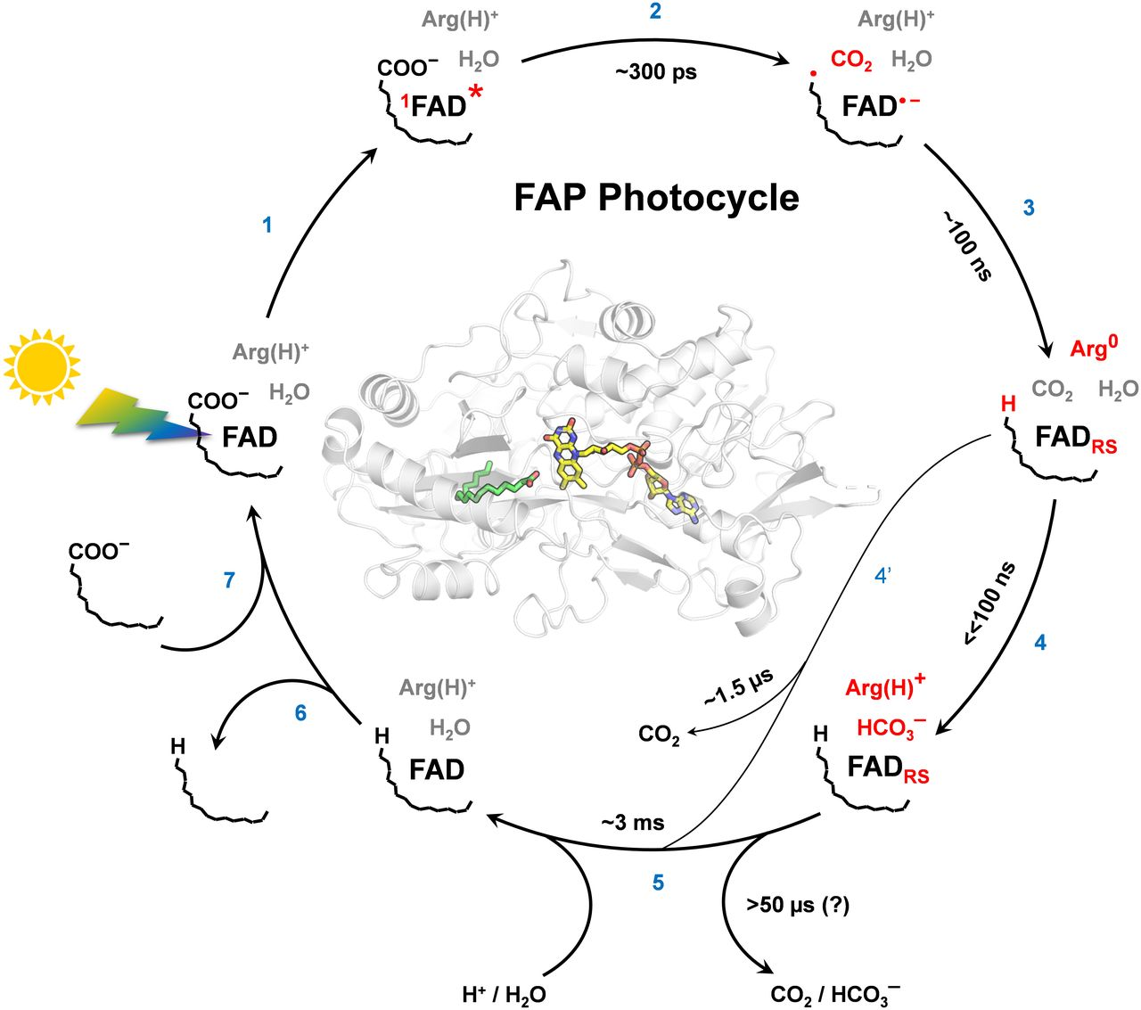
Figure 6. Proposed photocycle for the C. variabilis FAP.
Photoexcitation of FAD to FAD* (1) is followed by electron transfer from the RCOO⁻ to generate FAD^{•-} in ~300 ps which is accompanied by decarboxylation without accumulation of RCOO• (2). This is followed by electron transfer from FAD^{•-} (presumably to the alkyl radical) in ~100 ns resulting in oxidized FAD with a red-shifted spectrum (FAD_{RS}) which involves proton transfer from an Arg to the alkyl product (3). Concomitantly, most CO₂ (~75%) is transformed (4) to bicarbonate and FAD_{RS} disappears in ~3 ms (5) with a H/D KIE > 3, indicating coupling to PT. Upon alkane release (6), new substrate binds (7). About 25% of the formed CO₂ is not transformed to bicarbonate, likely because it migrates away from the active site within 100 ns, leaving the protein in ~1.5 μs (4′). In this minor fraction, arginine (R451) should reprotonate at latest in the ~3 ms step (5). Changes after individual steps are marked in red; time constants are for RT. This figure and legend were taken from Figure 8 in Sorigué et al.³⁸

The flavoprotein PqsL from Pseudomonas aeruginosa
PqsL is a light activated flavoprotein monooxygenase (FPMO) from Pseudomonas aeruginosa where it is involved in the biosynthesis of antibacterial alkyl hydroxyquinoline N-oxides (AQNOs).¹⁶ PqsL is a member of the UbiH family and is structurally homologous to group A FPMOs such as p-hydroxybenzoate-3-monooxygenase that have a GSH reductase fold and a nucleotide-binding Rossman fold. PqsL hydroxylates aromatic amines such as 2-aminobenzoylacetate leading to the formation of the respective hydroxyamine. For the reaction to proceed, the bound FAD must be in the fully reduced state which is generated by photoreduction with NAD(P)H. Structural studies support a flavin ‘OUT’ conformation for the isoalloxazine ring,⁴¹ by analogy to the IN and OUT positions of the ring observed in p-hydroxybenzoate hydroxylase (PHBH),⁴². Detailed analysis of the reaction mechanism supports a model for the formation of fully reduced FAD via a two-step mechanism through a single-electron transfer and subsequent semiquinone intermediate (Figure 6). Upon blue-light excitation of the flavin, single electron transfer leads to a transient radical couple between NADH● and FAD^{●-}. Rapid protonation prevents accumulation of FAD^{●-} and formation of the fully reduced flavin, FADH₂, is proposed to occur by the subsequent disproportionation of two neutral flavin semiquinone species.⁴¹

Figure 6. PqsL reaction and proposed mechanism of photoexcitation.
(A) PqsL catalyzes the hydroxylation of aromatic amines such as the conversion of 2-aminobenzoylacetate (2-ABA) to 2-hydroxylaminobenzoylacetate (2-HABA). (B) Proposed mechanism for the photoactivation of FAD to FADH₂ via the disproportionation of two neutral flavin semiquinone species.⁴¹

Flavin-dependent ene-reductases
Flavin-dependent ene-reductases (EREDs) are versatile biocatalysts, capable of catalyzing stereoselective reactions through hydride transfer or radical mechanisms. Recent studies have expanded their scope by leveraging flavin activation via light excitation.⁴³ One important application is the photoredox-mediated reduction of aromatic ketones that proceeds via ketyl radical formation. In this process, the flavin acts as a hydrogen donor, and supported by ruthenium-based photocatalysts, opens new avenues for non-natural biocatalytic reactions. Mechanistic studies suggest that substrate binding within the enzyme active site lowers the reduction potential, facilitating single electron reduction.⁴⁴ For instance, the direct radiation-activation of flavin hydroquinone (FMNhq) in its excited state can lead to the formation of radical intermediates with less reactive substrates, such as α, β-unsaturated amides. This strategy broadens the range of compatible substrates, enhancing catalytic versatility.⁴⁴
One interesting example is the use of flavin-dependent ene-reductases from Gluconobacter oxydans (GlueER) to perform cyclization reactions on α-chloroamides. Engineered forms of this enzyme enable improved control of byproducts leading to higher yields and better enantioselectivity.⁴⁵ These photo-enzymes can perform new reactions such as the light-triggered radical cyclization of α-haloamides to oxindoles by 12-oxophytodienoate reductase (OPR1) (Figure 7).⁴⁶

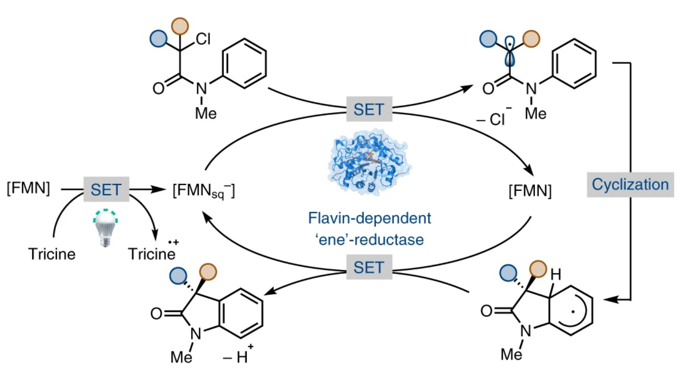
Figure 7. Enzymatic photoreduction of FMN to FMNsq⁻ (FMN^{•-}). FMN bound to 12-oxophytodienoate reductase (OPR1) is reduced by photoinduced electron transfer to generate FMNsq⁻. Subsequently, FMNsq⁻ generates an α-acyl radical which stereoselectively cyclizes to form the oxindole product. SET, single electron transfer. The figure was taken from Black et al.⁴⁶

Light-activated enzymes that generate a second messenger
Light-activated enzymes that produce second messengers represent a groundbreaking strategy for dissecting and manipulating cellular signaling networks with unparalleled precision.⁴⁷ The unique properties of the light-sensing chromophores allow the modulation of the activity of critical enzymes involved in second messenger synthesis upon light stimulation.¹⁷ This revolutionary approach enables the interrogation of signaling dynamics with high temporal resolution and offers insights into the spatial organization of signaling events within living cells. Light-activated enzymes that produce signaling molecules include the photoactivated adenylate cyclases (PACs), that generate cyclic-AMP (cAMP) from ATP, and photoactivated diguanylate cyclases that synthesize cyclic-di-GMP (c-di-GMP) from two molecules of GTP. Both cAMP and c-di-GMP are important second messengers in cellular signaling pathways, regulating various physiological processes, including gene expression, metabolism, and ion channel activity.^{48,49} For instance, the increase in cAMP levels resulting from light activation triggers downstream signaling cascades involving cAMP-dependent protein kinases (PKAs) and other effector proteins,⁵⁰ while c-di-GMP is a key regulator of biofilm formation and virulence in bacteria.⁵¹ Finally, PACs are of particular interest in neuroscience and optogenetics as the signaling pathways modulate cellular responses to light stimulation, such as changes in neuronal excitability, synaptic transmission, and gene transcription.^{52,53}

BLUF and LOV domain photoreceptors
Blue-light using FAD (BLUF) and Light Oxygen Voltage (LOV) domain photoreceptors are widely distributed in bacteria and unicellular eukaryotes,⁵⁴ whilst LOV domains are also found in higher organisms such as plants and fungi.⁵⁴⁻⁵⁷ Light activated signaling occurs either through non-covalent or covalent interaction with downstream output partners and regulates a variety of biological processes including phototropism, circadian rhythms and gene transcription. Due to their modular structure, the light-absorbing BLUF and LOV domains have been also been used to create novel optogenetic tools.^{17,58-63} However, in order to optimize factors such as the dynamic range, quantum yield, lifetime of the photoactivated state and the rates of photoactivation and dark state recovery, a detailed understanding is needed of the photoactivation mechanism, and specifically how ultrafast structural changes on the sub-ps time scale induced by light absorption, lead to macromolecular reorganization and photoreceptor activation on the ms-s time scale. Light-activated enzymes in which the catalytically functional domain is fused to a BLUF or LOV domain are excellent model systems for probing the signal transduction pathway that leads to photoactivation. Enzymes regulated by a BLUF domain include the PACs OaPAC,⁶⁴ bPAC from Beggiatoa,⁵² PACα and PACβ from Euglena gracilis,⁵³ TpPAC from Turneriella parva,⁶⁵ LiPaC from Leptonema illini,⁶⁶ nPAC from Naegleria gruberi,⁶⁷ as well as the phosphodiesterase BlrP1,⁶⁸ while those based on a LOV domain include the phototropin serine/threonine kinase,^{55,69,70} of which the isolated AsLOV2 domain is the most heavily studied, the diguanylate cyclase LadC, and the senor histidine kinase LOVK,⁷¹ and mPAC from Microcoleus chthonoplastes.⁷² Below we summarize efforts to determine the mechanism of OaPAC, AsLOV2 and LadC.

The BLUF photoreceptor OaPAC
OaPAC is a PAC from the photosynthetic cyanobacterium Oscillatoria acuminata. The enzyme is a 366-residue homodimer with an N-terminal BLUF domain and a C-terminal class III adenylate cyclase (AC) domain. The two monomers interact in a head-to-head configuration in which the BLUF and AC domains are connected by a coiled coil. Structural studies indicate that the isoalloxazine ring is surrounded by a hydrogen bonding network that includes Y6, Q48 and N30 that are strictly conserved in all BLUF photoreceptors (Figure 8).^{54,64} Light absorption results in a 10 nm red shift in the flavin absorbance at 450 nm which is due to a rearrangement of the hydrogen bonding network around the isoalloxazine ring and formation of a second hydrogen bond to the flavin C4=O.^{73,74} Several models have been proposed for the ultrafast perturbation of the conserved hydrogen bond network in BLUF photoreceptors including rotation and/or keto-enol tautomerism of the conserved Gln.⁷⁵⁻⁷⁸ The prevailing mechanism based on detailed spectroscopic studies including femtosecond stimulated Raman spectroscopy (FSRS) and quantum mechanical/molecular mechanical (QM/MM) molecular dynamics simulations on the related BLUF domain Slr1694/PixD involves rotation and tautomerization of the Gln sidechain so that the enol OH forms a hydrogen bond with the C4=O.^{79,80} This model is supported by serial femtosecond crystallography (SFX) and cryo-trapping studies of OaPAC where a rotation of the Q48 side-chain was observed upon photoactivation (Figure 8).⁸¹

Figure 8: The OaPAC dimer and flavin binding pocket. A) The OaPAC dimer (PDB: 8QFE). FAD (yellow) and ATP (purple) are shown as spheres in the BLUF and AC domains, respectively. Residues substituted with unnatural amino acids include Y6, W90, F103, Y125 and F180. B) Dark state of OaPAC with Q48 in the keto tautomer and W90 in the ‘OUT’ conformation. The Q48 NH₂ is shown hydrogen bonded to the flavin N5 but not the C4=O. C) Light state of OaPAC with Q48 rotated and in the enol tautomer, and with W90 adopting the ‘IN’ conformation. The Q48 enol OH is hydrogen bonded to the flavin C4=O and accepts a hydrogen bond from the W90 indole NH.^{79,80} The movement of W90 is based on the structures of OaPAC determined by serial femtosecond crystallography and cryotrapping (PDB: 8QFE and 8GFG).⁸¹ D) W90 and F103 were replaced with AzPhe. These residues interact across the dimer interface at the tip of the central helix. E) F180 was replaced by AzPhe. F) Y125 was replaced by fluoro-Tyr analogs. Figures A), D), E) and F) were made using pymol,²⁸and taken/adapted from Jewlikar et al.⁸²

Photoexcitation results in a ~100-fold increase in the synthesis of cAMP from ATP, indicating that adenylate cyclase activity is efficiently suppressed in the dark state.⁸³ Initial X-ray structural studies of dark and light-adapted OaPAC revealed that the protein does not undergo large scale changes in structure upon photoactivation,^{64,84} suggesting that the AC domain must undergo more subtle structural changes to generate the catalytically active state. In addition, based on structural studies using SFX, Chretien et al proposed that W90 rotates from an ‘OUT’ conformation in the dark state to an ‘IN’ conformation in the light state which is accompanied by movement of M92 out of the pocket (Figure 8).⁸¹ This results in the formation of an additional hydrogen bond between Q48 and the indole NH of W90. The movement of W90 alters the position of β-sheet 5 which adopts a new conformation, and causes a restructuring of the loop between β-sheets 4 and 5. Since β-sheet 5 is connected via a loop to α-helix 3 which links the BLUF and AC domains, the light-induced Trp/Met switching is assumed to play a direct role in signal transduction. This proposed movement of W90 in OaPAC is consistent with observations on the related BLF protein AppA where we used FRET, nanosecond fluorescence anisotropy decay, picosecond fluorescence lifetime measurements and transient IR spectroscopy to show that the analogous Trp (W104) moves from an OUT to an IN conformation during photoactivation.⁸⁵

The OaPAC photoactivation mechanism has also been probed using ultrafast time-resolved infrared spectroscopy (TRIR), time-resolved multiple probe spectroscopy (TRMPS) and transient absorption (TA) spectroscopy coupled with unnatural amino acid mutagenesis. In some BLUF proteins, including OaPAC and Slr1694/PixD, photoexcitation leads to the transient formation of flavin radicals by proton coupled electron transfer (PCET) from the conserved tyrosine (Y6 in OaPAC) to the isoalloxazine ring.⁸⁶ In OaPAC we investigated the role of Y6 by replacing this residue with fluoro-Tyr analogs that have altered pKa values and reduction potentials.⁸³ TRIR spectra of wild-type OaPAC and variants substituted at position Y6 with 3-fluoroTyr (3-FY6), 2,3-difluoroTyr (2,3-F₂Y6), 3,5-difluoroTyr (3,5-F₂Y6), and 2,3,5-trifluoroTyr (2,3,5-F₃Y6) are shown in Figure 9.

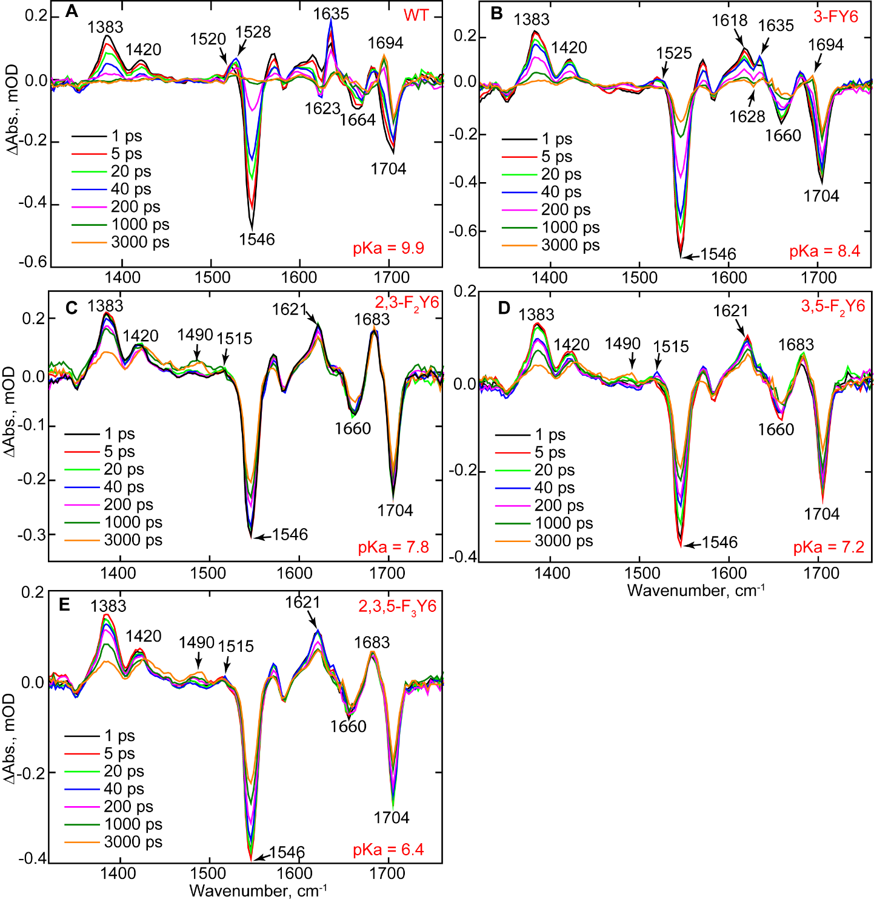
Figure 9. TRIR of wild-type OaPAC and the n-FY6 OaPAC variants. Spectra recorded at 1, 5, 20, 40, 200, 1000, and 3000 ps are shown in the figure. (A) Wild-type (WT), (B) 3-FY6, (C) 2,3-F₂Y6, (D) 3,5-F₂Y6, and (E) 2,3,5-F₃Y6. The figure was taken from Tolentino et al.⁸³

Analysis of the TRIR spectra of wild-type OaPAC reveals bands assigned to FAD^{•-} and FADH• which evolve with the same rate constant, indicating a concerted PCET process. In addition, as the pKa of the fluoroTyr analogs become more acidic, formation of FADH• is prevented and the photocycle stops at FAD^{•-} in 2,3-F₂Y6, 3,5-F₂Y6 and 2,3,5-F₃Y6 OaPAC: a transient is observed at 1515 cm⁻¹ assigned to FAD^{•-,} however no transients are observed at 1528 cm⁻¹ for FADH● or at 1694 cm⁻¹ for the light state. The inability to protonate FAD^{•-} can be directly linked to photoactivation since enzyme activity is abolished in the most acidic 3,5-F₂Y6 and 2,3,5-F₃Y6 variants (pKa 7.2 and 6.4, respectively) where the phenol hydroxyl is likely deprotonated. Thus, proton transfer plays an essential role in initiating the structural reorganization of the AC domain that results in enzyme activity.⁸³

Fluoro-Tyr substitution has also been used to analyze the importance of an intersubunit hydrogen bond between Y125 and N256 (Figure 8). Y125 is fully conserved in all PACs and is present at the interface between the α3 helix and AC domain. The Y125F mutant renders both OaPAC, and the related photoreceptor bPAC, catalytically inactive,^{64,87} Whereas the light-induced red shift in the FAD spectrum was preserved in all OaPAC variants in which Y125 was replaced with fluoro-Tyr analogs, only 3F-Y125 OaPAC retained light-activated AC activity. In contrast, the3,5-F₂Y125 and 2,3,5-F₃Y125 photoreceptors were inactive suggesting that Y125 has to be protonated to effectively participate in signal transduction from the BLUF to the AC domains.⁸²

The structural dynamics that accompany photoactivation have been explored using the IR reporter azido-Phe (AzPhe). AzPhe has previously been used to analyze the dynamics associated with the conserved Trp in the BLUF proteins AppA and PixD.⁸⁸ Recently this approach was extended to OaPAC, and AzPhe was incorporated into three positions replacing W90, F103 and F180 (Figure 7). F180 is close to the ATP binding pocket and the F180AzPhe mutant was catalytically inactive. F103 and W90 interact across the dimer interface in the OaPAC dark state. Both F103AzPhe and W90AzPhe had wild-type light-induced catalytic activity, however only W90AzPhe showed a major perturbation in the azido stretching vibration upon photoactivation. Subsequently, TRIR was used time-resolve the structural dynamics of W90AzPhe (Figure 10).
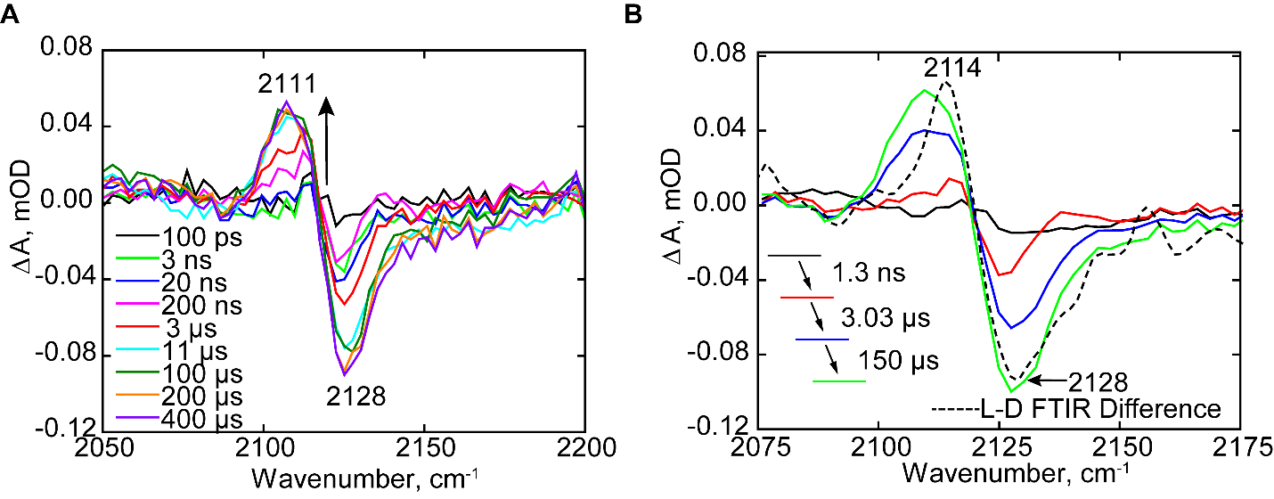
Figure 10: TRMPS spectra of the W90AzPhe OaPAC dark state. A) Time resolved IR difference response of the azido mode following ultrafast excitation of isoalloxazine cofactor in OaPAC at the W90 position. B) EADS of W90AzPhe obtained from globally fitting the time-resolved data in A to a sequential first order kinetics model with an initial state (black) two intermediate states (red, blue) which form on a ns-μs timescale, and subsequently relaxes to a final state (green). The final state is compared with the FTIR difference spectra (black dash line). All analyses used the Glotaran software package. The figure was taken from Jewlikar et al.⁸²

The temporal evolution of the AzPhe at W90 position shows a negative bleach at 2128 cm⁻¹ within ~ 1 ns and deepens on the μs timescale as a transient at 2111 cm⁻¹ evolves (Figure 10). Global analysis resulted in evolution-associated difference spectra (EADS) described by three-time constants of 1.3 ns, 3.03 μs, and 150 μs and a fourth that was kept constant. In contrast to the TRIR of W104AzPhe AppA_{BLUF} and W91AzPhe PixD,⁸⁸ no evolution of the W90AzPhe OaPAC azido vibration is detected on the ps timescale. The instantaneous response of the W104AzPhe in AppA and W91AzPhe in PixD was taken as evidence for communication of the AzPhe with the hydrogen bond network surrounding the flavin, i.e. a Trp_{in} conformation, and the absence of an instantaneous perturbation in the spectrum of W90AzPhe is thus consistent with a Trp_{out} conformation in OaPAC.⁸²

The LOV photoreceptor LadC
LadC is a light activated diguanylate cyclase (DGC) in which a LOV domain is coupled to a GGDEF effector domain.⁸⁹ The LOV domain, which is a Per-ARNT-Sim (PAS) protein superfamily member, contains a noncovalently bound FMN that is surrounded by a hydrogen bonding network resembling that found in BLUF proteins (Figure 11).^{55,70,90-92} Photoactivation results in the formation of an FMN triplet state that subsequently reacts with a conserved Cys to generate a covalent adduct with the C4(a) FMN carbon. This results in a bleach of the 450 nm flavin absorption and appearance of a new band at 390 nm.
Figure 11: Structure of MsLadC. A) The flavin binding pocket in the dark state. During photoactivation C53 forms an adduct with the flavin C4a. B) X-ray structure of dark MsLadC dimer (8c05.pdb). The BLUF and DGC domains are cyan and grey, and the linker is brown. FAD is yellow and pyrophosphate/Mg²⁺ is colored by atom. C) The structure predicted by AlphaFold which is thought to be the light activated state.

Vide et al identified LadC photoreceptors with either short (21 residue) or long (35 residue) linkers between the LOV and DGC domains. Intriguingly, LadCs with short linkers exhibited a 15-fold increase in diguanylate cyclase activity upon activation, whereas the dynamic range for those with longer linkers was >10,000-fold. LOV domains are typically flanked by two helices that are involved in signal transduction, the N-terminal A’α helix and the C-terminal Jα-helix. The structure of LadC from Methylotenera sp. (MsLadC), which has a 35-residue linker, was determined in the dark state (Figure 11). The protein is a homodimer with a characteristic LOV-dimer interdomain interface involving the core β-sheet and A’α helices. The Jα-helix often serves as the linker to the effector domain and commonly forms a coiled-coil structure. However, in dark MsLadC the GGDEF domain is folded back onto the LOV domain inhibiting enzyme activity. The conformational dynamics of MsLadC was analyzed using a combination of size-exclusion chromatography, small-angle x-ray scattering (SAXS), and hydrogen-deuterium exchange coupled to mass spectrometry (HDX-MS) which supported a major change in structure of the protein upon light activation. In contrast, analogous experiments on LadC from Aquella Oligotrophica (AoLadC), which has a short linker, were consistent with similar conformations of this protein in both dark and light states. Based on these data it was proposed that MsLadC undergoes a large-scale conformational change upon photoactivation and adopts the expected elongated coiled-coil structure which was modeled using AlphaFold (Figure 11).⁸⁹

AsLOV2, an isolated LOV domain
Phototropins are plant photoreceptors that contain two LOV domains fused to a serine-threonine kinase.^{55,93} The isolated LOV2 domain from Avena sativa (AsLOV2) has been heavily studied and has been utilized as the light absorbing domain in a variety of optogenetic constructs. AsLOV2 is connected to the kinase domain via the C-terminal Jα-helix, which undergoes structural changes upon light activation leading to dimerization. The allosteric pathways leading to Jα-helix unfolding have been visualized using a combination of TRIR, NMR spectroscopy, MD simulations and in-cell optogenetics which demonstrate the importance of Q513 in the signal transduction pathway and indicate that helix unfolding is complete in ~ 7 μs Figure 12.⁹⁴
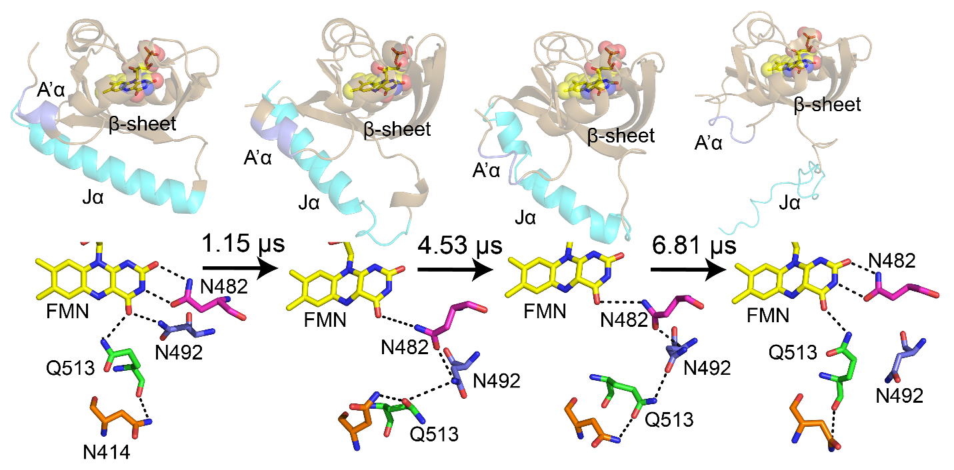
Figure 12: MD simulations of Jα-helix unfolding: The evolution in secondary structure and hydrogen bonding interactions between the flavin and N482, N492, Q513, and N414 for post-adduct formation simulation times of 0 (dark state AsLOV2, 2V1A), 1.15 μs, 4.53 μs, and 6.81 μs (light state, MD). The figure was taken from Iuliano et al.⁹⁴

The light-induced structural changes in AsLOV2 have also been probed by time-resolved X-ray liquidography (time-resolved X-ray solution scattering, TRXL) which capture the protein structural dynamics directly in solution.⁹⁵ TRXL data collected from 5.62 μs to 100-316 ms combined with MD simulations confirmed that the A’α and Jα helices unfold on the microsecond time scale, and that the protein then dimerizes within milliseconds. Experiments with different protein constructs resulted in the conclusion that the dimerization interface involves interaction between the β-scaffolds which is stabilized by local electrostatic interactions. The time-resolved data were then used to propose a kinetic model for photoactivation (Figure 13).

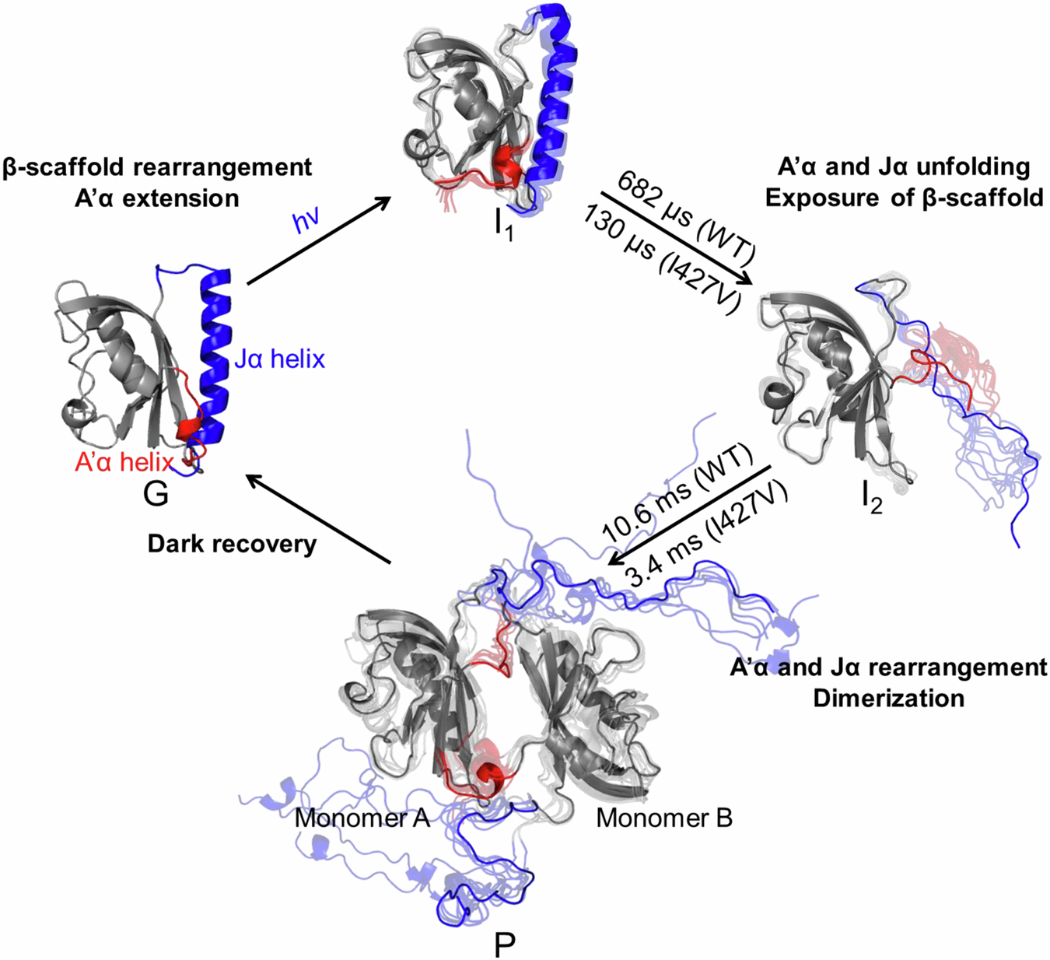
Figure 13: Structural dynamics of the AsLOV2 photocycle revealed by TRXL. The photocycle of AsLOV2 includes the G state, three intermediates (I1, I2, and P), and related time constants (WT: 682 μs and 10.6ms, and I427V: 130 μs and 3.4ms), as determined from the kinetic analysis of the scattering data. The optimal structures (I1 and I2) indicate that the structural changes within the A’α and Jα helices allow the exposure of the β-scaffold to the external environment. Subsequently, AsLOV2 undergoes dimerization (P), utilizing the dimeric interface formed between their β-scaffolds. The figure was reproduced from Kim et al.⁹⁵

CONCLUSION
Photoreceptors convert the energy in a photon of light into biological function. To do so they must couple the ultrafast structural changes resulting from the initial photoexcitation into conformational changes that ultimately result in activation of the downstream output partner. Light-activated enzymes, in which the light-absorbing and catalytic domains are part of the same protein, present an unparalleled opportunity to visualize the entire photoactivation pathway and correlate specific structural changes with enzyme activity. This possibility is now being realized with the availability of advanced analytical methods that span multiple time scales enabling the structural dynamics to be resolved in both time and space. In the present review we focus on a subset of systems in which a flavin is the light absorbing chromophore and which demonstrate the detailed structural and mechanistic information that can be extracted using techniques such as ultrafast infrared spectroscopy, transient absorption spectroscopy, serial femtosecond crystallography, time-resolved X-ray solution scattering combined with methods such as unnatural amino acid mutagenesis and molecular dynamics simulations. These approaches shed light on the intricate interplay between protein dynamics and function, deepening our understanding of enzymatic mechanisms and paving the way for designing novel light-driven biocatalysts with applications in the field of optogenetics.

AUTHOR INFORMATION
Corresponding Author
Peter J. Tonge - Department of Chemistry, Stony Brook University, Stony Brook, New York 11794, United States. https://orcid.org/0000-0003-1606-3471
Phone: (631) 632-7907. Email: peter.tonge@stonybrook.edu

Authors
YongLe He - Department of Chemistry, Stony Brook University, Stony Brook, New York 11794, United States. Email: yongle.he@stonybrook.edu
Marco Barone - Department of Chemistry, Stony Brook University, Stony Brook, New York 11794, United States. https://orcid.org/0000-0001-7184-2940 Email: marco.barone@stonybrook.edu
Stephen Meech - School of Chemistry, University of East Anglia, Norwich, NR4 7TJ, U.K; Email: s.meech@uea.ac.uk
Andras Lukacs – Department of Biophysics, Medical School, University of Pecs, Szigeti str. 12, 7624 Pecs, Hungary; Email: andras.lukacs@aok.pte.hu

ACKNOWLEDGMENTS
This work was supported by grants to P.J.T from the National Institutes of Health (GM149297) and the National Science Foundation (MCB-1817837). and to S.R.M. from the EPSRC (EP/N033647/1). A.L. acknowledges funding from the Hungarian National Research and Innovation Office (K-137557) and was supported by PTE ÁOK-KA-2021. Y.H. was supported by a National Institutes of Health Chemistry-Biology Interface Training Grant (T32GM092714).

ABBREVIATIONS

REFERENCES
(1) Poddar, H.; Heyes, D. J.; Schiro, G.; Weik, M.; Leys, D.; Scrutton, N. S. A guide to time-resolved structural analysis of light-activated proteins FEBS J, 2022, 289, 576-595. DOI: 10.1111/febs.15880
(2) Montgomery, B. L. Sensing the light: photoreceptive systems and signal transduction in cyanobacteria Mol Microbiol, 2007, 64, 16-27. DOI: 10.1111/j.1365-2958.2007.05622.x
(3) Fujisawa, T.; Masuda, S. Light-induced chromophore and protein responses and mechanical signal transduction of BLUF proteins Biophys Rev, 2018, 10, 327-337. DOI: 10.1007/s12551-017-0355-6
(4) Greetham, G. M.; Burgos, P.; Cao, Q.; Clark, I. P.; Codd, P. S.; Farrow, R. C.; George, M. W.; Kogimtzis, M.; Matousek, P.; Parker, A. W.; Pollard, M. R.; Robinson, D. A.; Xin, Z. J.; Towrie, M. ULTRA: A Unique Instrument for Time-Resolved Spectroscopy Appl Spectrosc, 2010, 64, 1311-1319. DOI: 10.1366/000370210793561673
(5) Hardman, S. J. O.; Iorgu, A. I.; Heyes, D. J.; Scrutton, N. S.; Sazanovich, I. V.; Hay, S. Ultrafast Vibrational Energy Transfer between Protein and Cofactor in a Flavoenzyme J Phys Chem B, 2020, 124, 5163-5168. DOI: 10.1021/acs.jpcb.0c04929
(6) Gourinchas. Long-range allosteric signaling in red light–regulateddiguanylyl cyclases Sci Adv, 2017, 3, e1602498. DOI: 10.1126/sciadv.16024
(7) Gabruk, M.; Mysliwa-Kurdziel, B. Light-Dependent Protochlorophyllide Oxidoreductase: Phylogeny, Regulation, and Catalytic Properties Biochemistry, 2015, 54, 5255-5262. DOI: 10.1021/acs.biochem.5b00704
(8) Pimviriyakul, P.; Chaiyen, P. Overview of flavin-dependent enzymes Enzymes, 2020, 47, 1-36. DOI: 10.1016/bs.enz.2020.06.006
(9) Kabir, M. P.; Orozco-Gonzalez, Y.; Gozem, S. Electronic spectra of flavin in different redox and protonation states: a computational perspective on the effect of the electrostatic environment Phys Chem Chem Phys, 2019, 21, 16526-16537. DOI: 10.1039/c9cp02230a
(10) Mansoorabadi, S. O.; Thibodeaux, C. J.; Liu, H. W. The diverse roles of flavin coenzymes--nature's most versatile thespians J Org Chem, 2007, 72, 6329-6342. DOI: 10.1021/jo0703092
(11) Losi, A. Flavin-based Blue-Light photosensors: a photobiophysics update Photochem Photobiol, 2007, 83, 1283-1300. DOI: 10.1111/j.1751-1097.2007.00196.x
(12) Sancar, A. Structure and Function of DNA Photolyase and Cryptochrome Blue-LightPhotoreceptors Chem Rev, 2003. DOI:
(13) Mei, Q.; Dvornyk, V. Evolutionary History of the Photolyase/Cryptochrome Superfamily in Eukaryotes PLoS One, 2015, 10, e0135940. DOI: 10.1371/journal.pone.0135940
(14) Chaves, I.; Pokorny, R.; Byrdin, M.; Hoang, N.; Ritz, T.; Brettel, K.; Essen, L. O.; van der Horst, G. T.; Batschauer, A.; Ahmad, M. The cryptochromes: blue light photoreceptors in plants and animals Annu Rev Plant Biol, 2011, 62, 335-364. DOI: 10.1146/annurev-arplant-042110-103759
(15) Hedison, T. M.; Heyes, D. J.; Scrutton, N. S. Making molecules with photodecarboxylases: A great start or a false dawn? Current Research in Chemical Biology, 2022, 2, 2666-2469. DOI: 10.1016/j.crchbi.2021.100017
(16) Drees, S. L.; Ernst, S.; Belviso, B. D.; Jagmann, N.; Hennecke, U.; Fetzner, S. PqsL uses reduced flavin to produce 2-hydroxylaminobenzoylacetate, a preferred PqsBC substrate in alkyl quinolone biosynthesis in Pseudomonas aeruginosa J Biol Chem, 2018, 293, 9345-9357. DOI: 10.1074/jbc.RA117.000789
(17) Losi, A.; Gardner, K. H.; Moglich, A. Blue-Light Receptors for Optogenetics Chem Rev, 2018, 118, 10659-10709. DOI: 10.1021/acs.chemrev.8b00163
(18) Lukacs, A.; Tonge, P. J.; Meech, S. R. Photophysics of the Blue Light Using Flavin Domain Acc Chem Res, 2022, 55, 402-414. DOI: 10.1021/acs.accounts.1c00659
(19) Agarwal, P. K. Enzymes: An integrated view of structure, dynamics and function Microb Cell Fact, 2006, 5, 2. DOI: 10.1186/1475-2859-5-2
(20) Mielko, Z.; Zhang, Y.; Sahay, H.; Liu, Y.; Schaich, M. A.; Schnable, B.; Morrison, A. M.; Burdinski, D.; Adar, S.; Pufall, M.; Van Houten, B.; Gordan, R.; Afek, A. UV irradiation remodels the specificity landscape of transcription factors Proc Natl Acad Sci U S A, 2023, 120, e2217422120. DOI: 10.1073/pnas.2217422120
(21) Li, Y. F.; Kim, S. T.; Sancar, A. Evidence for lack of DNA photoreactivating enzyme in humans Proc Natl Acad Sci U S A, 1993, 90, 4389-4393. DOI: 10.1073/pnas.90.10.4389
(22) Menck, C. F. Shining a light on photolyases Nat Genet, 2002, 32, 338-339. DOI: 10.1038/ng1102-338
(23) Ramirez-Gamboa, D.; Diaz-Zamorano, A. L.; Melendez-Sanchez, E. R.; Reyes-Pardo, H.; Villasenor-Zepeda, K. R.; Lopez-Arellanes, M. E.; Sosa-Hernandez, J. E.; Coronado-Apodaca, K. G.; Gamez-Mendez, A.; Afewerki, S.; Iqbal, H. M. N.; Parra-Saldivar, R.; Martinez-Ruiz, M. Photolyase Production and Current Applications: A Review Molecules, 2022, 27. DOI: 10.3390/molecules27185998
(24) Zhang, M.; Wang, L.; Zhong, D. Photolyase: Dynamics and Mechanisms of Repair of Sun-Induced DNA Damage Photochem Photobiol, 2017, 93, 78-92. DOI: 10.1111/php.12695
(25) Kavakli, I. H.; Ozturk, N.; Gul, S. DNA repair by photolyases Adv Protein Chem Struct Biol, 2019, 115, 1-19. DOI: 10.1016/bs.apcsb.2018.10.003
(26) Aubert, C.; Vos, M. H.; Mathis, P.; Eker, A. P.; Brettel, K. Intraprotein radical transfer during photoactivation of DNA photolyase Nature, 2000, 405, 586-590. DOI: 10.1038/35014644
(27) Lukacs, A.; Eker, A. P.; Byrdin, M.; Brettel, K.; Vos, M. H. Electron hopping through the 15 A triple tryptophan molecular wire in DNA photolyase occurs within 30 ps J Am Chem Soc, 2008, 130, 14394-14395. DOI: 10.1021/ja805261m
(28) PyMOL. The PyMOL Molecular Graphics System, Version 2.5 Schrödinger, LLC, 2015. DOI:
(29) Park, H. W.; Kim, S. T.; Sancar, A.; Deisenhofer, J. Crystal structure of DNA photolyase from Escherichia coli Science, 1995, 268, 1866-1872. DOI: 10.1126/science.7604260
(30) Cellini, A.; Shankar, M. K.; Nimmrich, A.; Hunt, L. A.; Monrroy, L.; Mutisya, J.; Furrer, A.; Beale, E. V.; Carrillo, M.; Malla, T. N.; Maj, P.; Vrhovac, L.; Dworkowski, F.; Cirelli, C.; Johnson, P. J. M.; Ozerov, D.; Stojkovic, E. A.; Hammarstrom, L.; Bacellar, C.; Standfuss, J.; Maj, M.; Schmidt, M.; Weinert, T.; Ihalainen, J. A.; Wahlgren, W. Y.; Westenhoff, S. Directed ultrafast conformational changes accompany electron transfer in a photolyase as resolved by serial crystallography Nat Chem, 2024, 16, 624-632. DOI: 10.1038/s41557-023-01413-9
(31) Forster, T. Energiewanderung und Fluoreszenz Naturwissenschaften, 1946, 33, 166-175. DOI: 10.1007/BF00585226
(32) Lakowicz, J. R. Principles of Fluorescence Spectroscopy; 3 ed.; Springer, 2006. DOI: 10.1007/978-0-387-46312-4
(33) Tan, C.; Guo, L.; Ai, Y.; Li, J.; Wang, L.; Sancar, A.; Luo, Y.; Zhong, D. Direct determination of resonance energy transfer in photolyase: structural alignment for the functional state J Phys Chem A, 2014, 118, 10522-10530. DOI: 10.1021/jp504349b
(34) Zhang, M.; Wang, L.; Shu, S.; Sancar, A.; Zhong, D. Bifurcating electron-transfer pathways in DNA photolyases determine the repair quantum yield Science, 2016, 354, 209-213. DOI: 10.1126/science.aah6071
(35) Christou, N. E.; Apostolopoulou, V.; Melo, D. V. M.; Ruppert, M.; Fadini, A.; Henkel, A.; Sprenger, J.; Oberthuer, D.; Gunther, S.; Pateras, A.; Rahmani Mashhour, A.; Yefanov, O. M.; Galchenkova, M.; Reinke, P. Y. A.; Kremling, V.; Scheer, T. E. S.; Lange, E. R.; Middendorf, P.; Schubert, R.; De Zitter, E.; Lumbao-Conradson, K.; Herrmann, J.; Rahighi, S.; Kunavar, A.; Beale, E. V.; Beale, J. H.; Cirelli, C.; Johnson, P. J. M.; Dworkowski, F.; Ozerov, D.; Bertrand, Q.; Wranik, M.; Bacellar, C.; Bajt, S.; Wakatsuki, S.; Sellberg, J. A.; Huse, N.; Turk, D.; Chapman, H. N.; Lane, T. J. Time-resolved crystallography captures light-driven DNA repair Science, 2023, 382, 1015-1020. DOI: 10.1126/science.adj4270
(36) Sorigue, D.; Legeret, B.; Cuine, S.; Blangy, S.; Moulin, S.; Billon, E.; Richaud, P.; Brugiere, S.; Coute, Y.; Nurizzo, D.; Muller, P.; Brettel, K.; Pignol, D.; Arnoux, P.; Li-Beisson, Y.; Peltier, G.; Beisson, F. An algal photoenzyme converts fatty acids to hydrocarbons Science, 2017, 357, 903-907. DOI: 10.1126/science.aan6349
(37) Heyes, D. J.; Lakavath, B.; Hardman, S. J. O.; Sakuma, M.; Hedison, T. M.; Scrutton, N. S. Photochemical Mechanism of Light-Driven Fatty Acid Photodecarboxylase ACS Catal, 2020, 10, 6691-6696. DOI: 10.1021/acscatal.0c01684
(38) Sorigue, D.; Hadjidemetriou, K.; Blangy, S.; Gotthard, G.; Bonvalet, A.; Coquelle, N.; Samire, P.; Aleksandrov, A.; Antonucci, L.; Benachir, A.; Boutet, S.; Byrdin, M.; Cammarata, M.; Carbajo, S.; Cuine, S.; Doak, R. B.; Foucar, L.; Gorel, A.; Grunbein, M.; Hartmann, E.; Hienerwadel, R.; Hilpert, M.; Kloos, M.; Lane, T. J.; Legeret, B.; Legrand, P.; Li-Beisson, Y.; Moulin, S. L. Y.; Nurizzo, D.; Peltier, G.; Schiro, G.; Shoeman, R. L.; Sliwa, M.; Solinas, X.; Zhuang, B.; Barends, T. R. M.; Colletier, J. P.; Joffre, M.; Royant, A.; Berthomieu, C.; Weik, M.; Domratcheva, T.; Brettel, K.; Vos, M. H.; Schlichting, I.; Arnoux, P.; Muller, P.; Beisson, F. Mechanism and dynamics of fatty acid photodecarboxylase Science, 2021, 372. DOI: 10.1126/science.abd5687
(39) Wu, R.; Li, X.; Wang, L.; Zhong, D. Ultrafast Dynamics and Catalytic Mechanism of Fatty Acid Photodecarboxylase Angew Chem Int Ed Engl, 2022, 61, e202209180. DOI: 10.1002/anie.202209180
(40) Aleksandrov, A.; Bonvalet, A.; Muller, P.; Sorigue, D.; Beisson, F.; Antonucci, L.; Solinas, X.; Joffre, M.; Vos, M. H. Catalytic Mechanism of Fatty Acid Photodecarboxylase: On the Detection and Stability of the Initial Carbonyloxy Radical Intermediate Angew Chem Int Ed Engl, 2024, 63, e202401376. DOI: 10.1002/anie.202401376
(41) Ernst, S.; Rovida, S.; Mattevi, A.; Fetzner, S.; Drees, S. L. Photoinduced monooxygenation involving NAD(P)H-FAD sequential single-electron transfer Nat Commun, 2020, 11, 2600. DOI: 10.1038/s41467-020-16450-y
(42) Wang, J.; Ortiz-Maldonado, M.; Entsch, B.; Massey, V.; Ballou, D.; Gatti, D. L. Protein and ligand dynamics in 4-hydroxybenzoate hydroxylase Proc Natl Acad Sci U S A, 2002, 99, 608-613. DOI: 10.1073/pnas.022640199
(43) Fu, H.; Hyster, T. K. From Ground-State to Excited-State Activation Modes: Flavin-Dependent "Ene"-Reductases Catalyzed Non-natural Radical Reactions Acc Chem Res, 2024, 57, 1446-1457. DOI: 10.1021/acs.accounts.4c00129
(44) Sandoval, B. A.; Kurtoic, S. I.; Chung, M. M.; Biegasiewicz, K. F.; Hyster, T. K. Photoenzymatic Catalysis Enables Radical-Mediated Ketone Reduction in Ene-Reductases Angew Chem Int Ed Engl, 2019, 58, 8714-8718. DOI: 10.1002/anie.201902005
(45) Biegasiewicz, K. F.; Cooper, S. J.; Gao, X.; Oblinsky, D. G.; Kim, J. H.; Garfinkle, S. E.; Joyce, L. A.; Sandoval, B. A.; Scholes, G. D.; Hyster, T. K. Photoexcitation of flavoenzymes enables a stereoselective radical cyclization Science, 2019, 364, 1166-1169. DOI: 10.1126/science.aaw1143
(46) Black, M. J.; Biegasiewicz, K. F.; Meichan, A. J.; Oblinsky, D. G.; Kudisch, B.; Scholes, G. D.; Hyster, T. K. Asymmetric redox-neutral radical cyclization catalysed by flavin-dependent 'ene'-reductases Nat Chem, 2020, 12, 71-75. DOI: 10.1038/s41557-019-0370-2
(47) Naim, N.; Reece, J. M.; Zhang, X.; Altschuler, D. L. Dual Activation of cAMP Production Through Photostimulation or Chemical Stimulation Methods Mol Biol, 2020, 2173, 201-216. DOI: 10.1007/978-1-0716-0755-8_14
(48) Jenal, U.; Reinders, A.; Lori, C. Cyclic di-GMP: second messenger extraordinaire Nat Rev Microbiol, 2017, 15, 271-284. DOI: 10.1038/nrmicro.2016.190
(49) Popovych, N.; Tzeng, S. R.; Tonelli, M.; Ebright, R. H.; Kalodimos, C. G. Structural basis for cAMP-mediated allosteric control of the catabolite activator protein Proc Natl Acad Sci U S A, 2009, 106, 6927-6932. DOI: 10.1073/pnas.0900595106
(50) Yan, K.; Gao, L. N.; Cui, Y. L.; Zhang, Y.; Zhou, X. The cyclic AMP signaling pathway: Exploring targets for successful drug discovery Mol Med Rep, 2016, 13, 3715-3723. DOI: 10.3892/mmr.2016.5005
(51) Romling, U.; Galperin, M. Y.; Gomelsky, M. Cyclic di-GMP: the first 25 years of a universal bacterial second messenger Microbiol Mol Biol Rev, 2013, 77, 1-52. DOI: 10.1128/MMBR.00043-12
(52) Stierl, M.; Stumpf, P.; Udwari, D.; Gueta, R.; Hagedorn, R.; Losi, A.; Gartner, W.; Petereit, L.; Efetova, M.; Schwarzel, M.; Oertner, T. G.; Nagel, G.; Hegemann, P. Light modulation of cellular cAMP by a small bacterial photoactivated adenylyl cyclase, bPAC, of the soil bacterium Beggiatoa J Biol Chem, 2011, 286, 1181-1188. DOI: 10.1074/jbc.M110.185496
(53) Iseki, M.; Matsunaga, S.; Murakami, A.; Ohno, K.; Shiga, K.; Yoshida, K.; Sugai, M.; Takahashi, T.; Hori, T.; Watanabe, M. A blue-light-activated adenylyl cyclase mediates photoavoidance in Euglena gracilis Nature, 2002, 415, 1047-1051. DOI: 10.1038/4151047a
(54) Gomelsky, M.; Klug, G. BLUF: a novel FAD-binding domain involved in sensory transduction in microorganisms Trends Biochem Sci, 2002, 27, 497-500. DOI: 10.1016/S0968-0004(02)02181-3
(55) Briggs, W. R.; Christie, J. M.; Salomon, M. Phototropins: a new family of flavin-binding blue light receptors in plants Antioxid Redox Signal, 2001, 3, 775-788. DOI: 10.1089/15230860152664975
(56) Losi, A. The bacterial counterparts of plant phototropins Photochem Photobiol Sci, 2004, 3, 566-574. DOI: 10.1039/b400728j
(57) Conrad, K. S.; Manahan, C. C.; Crane, B. R. Photochemistry of flavoprotein light sensors Nat Chem Biol, 2014, 10, 801-809. DOI: 10.1038/nchembio.1633
(58) Deisseroth, K. Optogenetics Nat Methods, 2010, 8, 26-29. DOI: 10.1038/nmeth.f.324
(59) Moglich, A.; Moffat, K. Engineered photoreceptors as novel optogenetic tools Photochem Photobiol Sci, 2010, 9, 1286-1300. DOI: 10.1039/c0pp00167h
(60) Losi, A.; Gartner, W. The evolution of flavin-binding photoreceptors: an ancient chromophore serving trendy blue-light sensors Annu Rev Plant Biol, 2012, 63, 49-72. DOI: 10.1146/annurev-arplant-042811-105538
(61) Christie, J. M.; Gawthorne, J.; Young, G.; Fraser, N. J.; Roe, A. J. LOV to BLUF: flavoprotein contributions to the optogenetic toolkit Mol Plant, 2012, 5, 533-544. DOI: 10.1093/mp/sss020
(62) Shcherbakova, D. M.; Shemetov, A. A.; Kaberniuk, A. A.; Verkhusha, V. V. Natural photoreceptors as a source of fluorescent proteins, biosensors, and optogenetic tools Annu Rev Biochem, 2015, 84, 519-550. DOI: 10.1146/annurev-biochem-060614-034411
(63) Zhu, L.; McNamara, H. M.; Toettcher, J. E. Light-switchable transcription factors obtained by direct screening in mammalian cells Nat Commun, 2023, 14, 3185. DOI: 10.1038/s41467-023-38993-6
(64) Ohki, M.; Sugiyama, K.; Kawai, F.; Tanaka, H.; Nihei, Y.; Unzai, S.; Takebe, M.; Matsunaga, S.; Adachi, S.; Shibayama, N.; Zhou, Z.; Koyama, R.; Ikegaya, Y.; Takahashi, T.; Tame, J. R.; Iseki, M.; Park, S. Y. Structural insight into photoactivation of an adenylate cyclase from a photosynthetic cyanobacterium Proc Natl Acad Sci U S A, 2016, 113, 6659-6664. DOI: 10.1073/pnas.1517520113
(65) Penzkofer, A.; Tanwar, M.; Veetil, S. K.; Kateriya, S. Photo-dynamics of photoactivated adenylyl cyclase TpPAC from the spirochete bacterium Turneriella parva strain H(T) J Photochem Photobiol B, 2015, 153, 90-102. DOI: 10.1016/j.jphotobiol.2015.08.027
(66) Penzkofer, A.; Tanwar, M.; Veetil, S. K.; Kateriya, S. Photo-dynamics of photoactivated adenylyl cyclase LiPAC from the spirochete bacterium Leptonema illini strain 3055 Trends Appl Spec, 2014, 11, 39-62. DOI:
(67) Penzkofer, A.; Stierl, M.; Hegemann, P.; Kateriya, S. Photo-dynamics of the BLUF domain containing soluble adenylate cyclase (nPAC) from the amoeboflagellate Naegleria gruberi NEG-M strain Chem Phys, 2011, 387, 25-38. DOI: 10.1016/j.chemphys.2011.05.028
(68) Tyagi, A.; Penzkofer, A.; Griese, J.; Schlichting, I.; Kirienko, N. V.; Gomelsky, M. Photodynamics of blue-light-regulated phosphodiesterase BlrP1 protein from Klebsiella pneumoniae and its photoreceptor BLUF domain Chem Phys, 2008, 354, 130-141. DOI: 10.1016/j.chemphys.2008.10.003
(69) Christie, J. M.; Salomon, M.; Nozue, K.; Wada, M.; Briggs, W. R. LOV (light, oxygen, or voltage) domains of the blue-light photoreceptor phototropin (nph1): binding sites for the chromophore flavin mononucleotide Proc Natl Acad Sci U S A, 1999, 96, 8779-8783. DOI: 10.1073/pnas.96.15.8779
(70) Crosson, S.; Moffat, K. Structure of a flavin-binding plant photoreceptor domain: insights into light-mediated signal transduction Proc Natl Acad Sci U S A, 2001, 98, 2995-3000. DOI: 10.1073/pnas.051520298
(71) Purcell, E. B.; McDonald, C. A.; Palfey, B. A.; Crosson, S. An analysis of the solution structure and signaling mechanism of LovK, a sensor histidine kinase integrating light and redox signals Biochemistry, 2010, 49, 6761-6770. DOI: 10.1021/bi1006404
(72) Chen, Z. H.; Raffelberg, S.; Losi, A.; Schaap, P.; Gartner, W. A cyanobacterial light activated adenylyl cyclase partially restores development of a Dictyostelium discoideum, adenylyl cyclase a null mutant J Biotechnol, 2014, 191, 246-249. DOI: 10.1016/j.jbiotec.2014.08.008
(73) Masuda, S.; Hasegawa, K.; Ishii, A.; Ono, T. A. Light-induced structural changes in a putative blue-light receptor with a novel FAD binding fold sensor of blue-light using FAD (BLUF); Slr1694 of synechocystis sp. PCC6803 Biochemistry, 2004, 43, 5304-5313. DOI: 10.1021/bi049836v
(74) Unno, M.; Masuda, S.; Ono, T. A.; Yamauchi, S. Orientation of a key glutamine residue in the BLUF domain from AppA revealed by mutagenesis, spectroscopy, and quantum chemical calculations J Am Chem Soc, 2006, 128, 5638-5639. DOI: 10.1021/ja060633z
(75) Stelling, A. L.; Ronayne, K. L.; Nappa, J.; Tonge, P. J.; Meech, S. R. Ultrafast structural dynamics in BLUF domains: transient infrared spectroscopy of AppA and its mutants J Am Chem Soc, 2007, 129, 15556-15564. DOI: 10.1021/ja074074n
(76) Udvarhelyi, A.; Domratcheva, T. Photoreaction in BLUF Receptors: Proton-coupled Electron Transfer in the Flavin-Gln-Tyr System Photochem Photobiol, 2011, 87, 554-563. DOI: 10.1111/j.1751-1097.2010.00884.x
(77) Domratcheva, T.; Hartmann, E.; Schlichting, I.; Kottke, T. Evidence for Tautomerisation of Glutamine in BLUF Blue Light Receptors by Vibrational Spectroscopy and Computational Chemistry Sci Rep, 2016, 6, 22669. DOI: 10.1038/srep22669
(78) Iwata, T.; Nagai, T.; Ito, S.; Osoegawa, S.; Iseki, M.; Watanabe, M.; Unno, M.; Kitagawa, S.; Kandori, H. Hydrogen Bonding Environments in the Photocycle Process around the Flavin Chromophore of the AppA-BLUF domain J Am Chem Soc, 2018, 140, 11982-11991. DOI: 10.1021/jacs.8b05123
(79) Goings, J. J.; Li, P.; Zhu, Q.; Hammes-Schiffer, S. Formation of an unusual glutamine tautomer in a blue light using flavin photocycle characterizes the light-adapted state Proc Natl Acad Sci U S A, 2020, 117, 26626-26632. DOI: 10.1073/pnas.2016719117
(80) Hontani, Y.; Mehlhorn, J.; Domratcheva, T.; Beck, S.; Kloz, M.; Hegemann, P.; Mathes, T.; Kennis, J. T. M. Spectroscopic and Computational Observation of Glutamine Tautomerization in the Blue Light Sensing Using Flavin Domain Photoreaction J Am Chem Soc, 2023, 145, 1040-1052. DOI: 10.1021/jacs.2c10621
(81) Chretien, A.; Nagel, M. F.; Botha, S.; de Wijn, R.; Brings, L.; Dorner, K.; Han, H.; Koliyadu, J. C. P.; Letrun, R.; Round, A.; Sato, T.; Schmidt, C.; Secareanu, R. C.; von Stetten, D.; Vakili, M.; Wrona, A.; Bean, R.; Mancuso, A.; Schulz, J.; Pearson, A. R.; Kottke, T.; Lorenzen, K.; Schubert, R. Light-induced Trp(in)/Met(out) Switching During BLUF Domain Activation in ATP-bound Photoactivatable Adenylate Cyclase OaPAC J Mol Biol, 2024, 436, 168439. DOI: 10.1016/j.jmb.2024.168439
(82) Jewlikar, S. S.; Collado, J. T.; Ali, M. I.; Sabbah, A.; He, Y.; Iuliano, J. N.; Hall, C. R.; Adamczyk, K.; Greetham, G. M.; Lukacs, A.; Meech, S. R.; Tonge, P. J. Probing the signal transduction mechanism of the light-activated adenylate cyclase OaPAC using unnatural amino acid mutagenesis ACS Chem Biol, 2025, accepted. DOI:
(83) Tolentino Collado, J.; Iuliano, J. N.; Pirisi, K.; Jewlikar, S.; Adamczyk, K.; Greetham, G. M.; Towrie, M.; Tame, J. R. H.; Meech, S. R.; Tonge, P. J.; Lukacs, A. Unraveling the Photoactivation Mechanism of a Light-Activated Adenylyl Cyclase Using Ultrafast Spectroscopy Coupled with Unnatural Amino Acid Mutagenesis ACS Chem Biol, 2022, 17, 2643-2654. DOI: 10.1021/acschembio.2c00575
(84) Ohki, M.; Sato-Tomita, A.; Matsunaga, S.; Iseki, M.; Tame, J. R. H.; Shibayama, N.; Park, S. Y. Molecular mechanism of photoactivation of a light-regulated adenylate cyclase Proc Natl Acad Sci U S A, 2017, 114, 8562-8567. DOI: 10.1073/pnas.1704391114
(85) Karadi, K.; Kapetanaki, S. M.; Raics, K.; Pecsi, I.; Kapronczai, R.; Fekete, Z.; Iuliano, J. N.; Tolentino Collado, J.; Gil, A. A.; Orban, J.; Nyitrai, M.; Greetham, G. M.; Vos, M. H.; Tonge, P. J.; Meech, S. R.; Lukacs, A. Functional dynamics of a single tryptophan residue in a BLUF protein revealed by fluorescence spectroscopy Sci Rep, 2020, 10, 2061. DOI: 10.1038/s41598-020-59073-5
(86) He, Y.; Gil, A. A.; Laptenok, S. P.; Fatima, A.; Collado, J. T.; Iuliano, J. N.; Woroniecka, H. A.; Brust, R.; Sabbah, A.; Towrie, M.; Greetham, G. M.; Sazanovich, I. V.; French, J. B.; Lukacs, A.; Meech, S. R.; Tonge, P. J. Enhancing Proton-Coupled Electron Transfer in Blue Light Using FAD Photoreceptor AppA(BLUF) J Am Chem Soc, 2025, 147, 39-44. DOI: 10.1021/jacs.4c11817
(87) Lindner, R.; Hartmann, E.; Tarnawski, M.; Winkler, A.; Frey, D.; Reinstein, J.; Meinhart, A.; Schlichting, I. Photoactivation Mechanism of a Bacterial Light-Regulated Adenylyl Cyclase J Mol Biol, 2017, 429, 1336-1351. DOI: 10.1016/j.jmb.2017.03.020
(88) Hall, C. R.; Tolentino Collado, J.; Iuliano, J. N.; Gil, A. A.; Adamczyk, K.; Lukacs, A.; Greetham, G. M.; Sazanovich, I.; Tonge, P. J.; Meech, S. R. Site-Specific Protein Dynamics Probed by Ultrafast Infrared Spectroscopy of a Noncanonical Amino Acid J Phys Chem B, 2019, 123, 9592-9597. DOI: 10.1021/acs.jpcb.9b09425
(89) Vide, U.; Kasapovic, D.; Fuchs, M.; Heimbock, M. P.; Totaro, M. G.; Zenzmaier, E.; Winkler, A. Illuminating the inner workings of a natural protein switch: Blue-light sensing in LOV-activated diguanylate cyclases Sci Adv, 2023, 9, eadh4721. DOI: 10.1126/sciadv.adh4721
(90) Nash, A. I.; Ko, W. H.; Harper, S. M.; Gardner, K. H. A conserved glutamine plays a central role in LOV domain signal transmission and its duration Biochemistry, 2008, 47, 13842-13849. DOI: 10.1021/bi801430e
(91) Nozaki, D.; Iwata, T.; Ishikawa, T.; Todo, T.; Tokutomi, S.; Kandori, H. Role of Gln1029 in the photoactivation processes of the LOV2 domain in adiantum phytochrome3 Biochemistry, 2004, 43, 8373-8379. DOI: 10.1021/bi0494727
(92) Harper, S. M.; Neil, L. C.; Gardner, K. H. Structural basis of a phototropin light switch Science, 2003, 301, 1541-1544. DOI: 10.1126/science.1086810
(93) Christie, J. M. Phototropin Blue-Light Receptors Ann Rev Plant Biol, 2007, 58, 21-45. DOI: 10.1146/annurev.arplant.58.032806.103951
(94) Iuliano, J. N.; Collado, J. T.; Gil, A. A.; Ravindran, P. T.; Lukacs, A.; Shin, S.; Woroniecka, H. A.; Adamczyk, K.; Aramini, J. M.; Edupuganti, U. R.; Hall, C. R.; Greetham, G. M.; Sazanovich, I. V.; Clark, I. P.; Daryaee, T.; Toettcher, J. E.; French, J. B.; Gardner, K. H.; Simmerling, C. L.; Meech, S. R.; Tonge, P. J. Unraveling the Mechanism of a LOV Domain Optogenetic Sensor: A Glutamine Lever Induces Unfolding of the Jalpha Helix ACS Chem Biol, 2020, 15, 2752-2765. DOI: 10.1021/acschembio.0c00543
(95) Kim, C.; Yun, S. R.; Lee, S. J.; Kim, S. O.; Lee, H.; Choi, J.; Kim, J. G.; Kim, T. W.; You, S.; Kosheleva, I.; Noh, T.; Baek, J.; Ihee, H. Structural dynamics of protein-protein association involved in the light-induced transition of Avena sativa LOV2 protein Nat Commun, 2024, 15, 6991. DOI: 10.1038/s41467-024-51461-z

