Abstract

Neurotypical variability in face recognition abilities is known to be driven by differences present across multiple elements of an extended processing pathway, i.e., from early visual perception through to later explicit retrieval and recall. Here across two experiments, we utilised breaking Continuous Flash Suppression paradigms to explore the earliest stage of face encoding: the lead up to conscious detection. We investigated whether faces selectively receive preferential access to awareness among participants with relatively stronger (cf. weaker) face recognition abilities at the categorical level (contrasting detection of faces with another object category) and higher levels of face processing (exploring differences associated with orientation and attractiveness). Both experiments identified selectively faster access to awareness for faces over a non-face object control (houses) in better face recognisers at both the group and individual level. Experiment two further clarified that these expertise-related effects are selective to upright (cf. inverted) faces, indicating that this link is unlikely to be solely driven by sensitivity to low level visual cues. We also observed expertise-related modulation of attractiveness effects on CFS breakthrough, consistent with the possibility that individuals with higher levels of face processing ability have accelerated early access to even this high-level stimulus dimension. Taken together these experiments provide new insight into very early face perception, and the extent to which expertise modulates this processing stage at both the group and individual level.

Highlights
- Face expertise associated with earlier selective breakthrough of faces (vs houses)
- Expert breakthrough effects stronger for upright compared to inverted faces
- Orientation selectivity indicates higher level attributes drive faster breakthrough
- Faster expertise breakthrough effects replicate in two independent samples

Introduction
Humans are an extraordinarily social species, with face perception providing critical information to guide successful social interactions (Frith & Frith, 2010; Herrmann et al., 2007). It is widely reported that even a brief glance at a face is sufficient to extract a wealth of socially relevant information, ranging from establishing familiarity and identifying a particular individual, through to evaluating more changeable characteristics, including emotional expression and focus of attention. From the very first hours of life: infants preferentially attend to more face like objects (Johnson et al., 1991). Moreover, specialised processing of faces, has been robustly identified across a range of face processing tasks from early in development (Hoehl & Peykarjou, 2012), throughout the lifespan and into old age (Hildebrandt et al., 2011).
Although humans are broadly considered to be face processing experts, a wide spectrum of abilities exists within the typical population (Wilmer, 2017). At one extreme, super-recognisers have been established as people for whom face identity is such a strength that even with the briefest introduction, a face is rarely forgotten (Russell, Duchaine & Nakayama, 2009). Developmental prosopagnosia sits at the opposite end of the ability spectrum, where individuals struggle to identify even close family and friends from their face (Duchaine & Nakayama, 2006). The vast majority of individuals sit within these bounds, with face expertise normally distributed in the typically developed adult population (Noyes et al., 2018).
The process of recognising a face has been the subject of extensive theoretical and empirical scrutiny. Initial stages include early processing of low-level sensory cues, detecting a face in the visual scene and encoding key visual features (e.g., eyes, mouth, face shape and jaw line) which are integrated to form a holistic representation of the face (Bruce & Young, 1986; Haxby & Gobbini, 2011). Later stages require the activation of stored representations that permit individualisation of face identity and other information routinely extracted from faces, e.g. emotion, age, gender, attractiveness. Extant findings suggest that variability in face recognition ability occurs across multiple stages of the face processing pathway, ranging from early visual perception through to later explicit identification stages (see Lander, Bruce & Bindemann, 2018).
At the level of early face encoding, individuals that perform particularly well on standardised tests of face identification have been shown to be more attuned to the critical visual information underlying face identification. For example, they are more responsive to horizontal visual cues (Little & Susilo, 2023), more likely to look at the eyes (Yüvrük, Tütüncü, & Amado, 2023) and make more use of critical eye information when identifying faces (Royer et al., 2018; Tardif et al., 2018). Emerging evidence also suggests that ability-linked differences exist in the early neural response to faces within the first few hundred milliseconds of encoding (Mares et al, 2023) alongside the more established differences in later processing components thought to index the process of linking a perceived face to a stored identity (Eimer, 2000).
The present study investigates how face expertise modulates the lead up to conscious detection and perception of faces. We target processing during this particularly early stage at the categorical level by contrasting detection of faces with another object category and higher levels of face processing by exploring differences associated with characteristics like orientation and attractiveness. To this end, we employ a methodological approach termed breaking Continuous Flash Suppression (b-CFS, Jiang, Costello, & He, 2007; Stein, Hebart, & Sterzer, 2011), which leverages a particularly powerful variant of binocular rivalry to establish the time taken for visual stimuli to breakthrough active visual suppression and drive behavioural outcomes (see Lin & He, 2008 for a detailed account). Briefly, b-CFS involves a dichoptic viewing experience where different visual stimuli are presented to each eye (e.g., using a mirror-stereoscope). One eye is exposed to a rapidly flashing CFS mask (high in angularity and contrast and presented at 10Hz), which temporarily renders a target image presented to the other eye, invisible. In b-CFS, the time it takes a participant to detect the initially suppressed target stimulus, constitutes an index of its access to conscious awareness (Stein, Reeder, & Peelen, 2016), with earlier breakthrough times interpreted as a marker of preferential object processing. Beyond the expected influence of low-level image properties (e.g. luminosity, size, contrast), higher level attributes such as stimulus familiarity, semantics and ecological relevance, are associated with differential rates of ‘breakthrough’ (Gayet, Van der Stigchel, & Paffen, 2014).
Human faces have already been extensively studied using this approach (see Axelrod, Bar, & Rees, 2015 for a review). Accelerated breakthrough time is reported consistently for faces compared with non-face stimuli of similar visual complexity (Jiang & He, 2006; Stein, Sterzer, & Peelen, 2012; Sterzer, Haynes, & Rees, 2008), as is a selective modulation of breakthrough times driven by higher level characteristics of those faces (e.g. familiarity, Gobbini et al., 2013; own-age and own-race, Stein, End, & Sterzer, 2014; gaze direction, Stein, Senju, Peelen, & Sterzer, 2011; emotion, Stein & Sterzer, 2012; Yang, Zald, & Blake, 2007; Yang & Yeh, 2018; and trait attributes, such as attractiveness, Hung, Nieh, & Hsieh, 2016; Nakamura & Kawabata, 2018, dominance and trustworthiness, Getov, Kanai, Bahrami, & Rees, 2015; Stein, Awad, Gayet, & Peelen, 2018).
There has also been one report of faster stimulus breakthrough times for faces and other visual objects as a function of perceptual processing ability. Stein and colleagues (2016) recruited a sample of car experts and found that b-CFS suppression times for car images correlated with perceptual processing ability for cars. Independently in the same sample, they also found that b-CFS suppression times for faces correlated with scores on a measure of face perception (single image matching task). This finding constitutes the first evidence that perceptual expertise may broadly modulate very early levels of visual processing to enhance the speed with which a visual stimulus breaks suppression and enters conscious awareness.
Here we go further, to establish the extent to which expertise is selectively associated with what may constitute one of the earliest indices of specialised face processing. We examine the link between breakthrough times and performance on a standardised face identity recognition task, which assesses participants’ face memory as well as perceptual discrimination abilities. We also assess whether associations with face expertise extend beyond a simple categorical breakthrough advantage (detecting faces compared to other visual objects) to the breakthrough advantages that have been observed in relation to other, higher order aspects of face processing (orientation and attractiveness). Breakthrough times are known to be faster for upright faces than for inverted faces (e.g., Stein et al., 2012), which is consistent with this canonical face orientation more effectively engaging specialised processing mechanisms (e.g., holistic coding) from the earliest stages of face detection. Further, breakthrough times are faster for attractive faces than unattractive faces (when presented upright only), suggesting that this high-level stimulus dimension is also processed from the outset of conscious awareness (Hung et al., 2016). Here, we hypothesise that if individuals with higher levels of recognition expertise have accelerated perceptual access to target stimuli, then the selectively increased breakthrough times for upright and attractive faces will be more pronounced for individuals with higher vs. lower levels of expertise.
In a first experiment, we directly test the association between early access to awareness for faces, and performance on the widely used Cambridge Face Memory Test (CFMT; Duchaine & Nakayama, 2006) where participants learn a set of novel identities and then recognise those individuals from newly built memory representations. To establish the face-selectivity of breakthrough effects in the b-CFS task, we also assess the speed of access to awareness for a non-face comparison category, houses (well matched with faces for perceptual complexity and global low-level visual properties, e.g., size, colour, contrast, and luminosity). We expect to replicate and extend previous reports of a faster breakthrough time for faces associated with perceptual face expertise (Stein et al, 2016).
In a second experiment we further target the extent to which expertise-linked differences in face breakthrough times reflect the operation of specialist, i.e., high-level face processing mechanisms. It is alternatively possible that any such effects reflect a simpler but nevertheless expertise-related difference in responses to particular local/low-level features (e.g. driven by local contrast in the eye region). We will assess the strength of associations observed with upright faces (which engage expert face coding mechanisms most effectively, see Peterson & Rhodes, 2003) and inverted faces. If individuals with higher levels of face processing ability are particularly good at detecting the low-level properties associated with face stimuli, then the strength of associations with face expertise should be similar for upright and inverted face stimuli. A high degree of orientation selectivity will implicate a role for more specialist, higher level face coding mechanisms.
Taken together these two experiments will provide new insights into the earliest processing of faces, their breakthrough into conscious awareness, and the extent to which expertise modulates this process at both the group and individual level. Of note, Experiment 2 not only expands the scope of the work by investigating the extent to which faster expertise related breakthrough of faces is driven by specialist, high-level processing mechanisms, it also provides a replication of the core findings from Experiment 1 with a new sample of individuals. Such replication is reassuring regarding the empirical robustness of findings (though see Cumming, 2008 and Piper et al, 2019) which can be particularly challenging to establish when investigating constructs close to the edge of conscious awareness (Moors et al., 2019; Stein et al., 2024).

Experiment 1. Categorical Breakthrough Advantage for Faces

Method
Participants

Fifty-eight adults, with normal or corrected to normal vision were recruited, based on sample sizes in previous research investigating individual differences in b-CFS effects (e.g., Stein et al., 2016). Participants were compensated for their time with either a small monetary reimbursement, equivalent to minimum wage, or undergraduate course credit. Five participants were excluded from the analysis: four due to computer failure, and one at the data-processing stage, when high average breakthrough times prompted concerns about task engagement (> 2 SD above the mean). The final mixed ethnicity sample comprised 53 participants, aged 18 to 40 years (M_{age} = 24.0, SD = 4.5), see Table 1 for details. This study (and Experiment 2) was approved by the ethical committee of the Department of Psychological Sciences, Birkbeck College, University of London (Reference 161709) and written informed consent was obtained from all participants.
For group-based analyses, participants were divided into two ‘face expertise groups’ based on their CFMT accuracy scores (percent correct), which ranged from 52.8% to 98.6% (see Table 1). In experiment one, a median (77.8) split separated the lower face ability group (N=22) from the higher face ability group (N = 26, differences in the CFMT scores: t(46) = -11.41, p < .001, d = -3.30, 95% CI [-4.18 to -2.42]). Five participants with the median score were excluded from group-based analysis, leaving a total sample of 48 participants for those analyses.

Table 1. Participants demographics
 |  | N | Age | CFMT
 |  | Total (M, F) | Mean Years (SD) | Mean % Correct (SD)
Experiment One | Low CFMT | 22 (9, 13) | 23.6 (4.4) | 68.1 (5.5)
 | High CFMT | 26 (7,19) | 24.1 (4.8) | 88.1 (6.5)
 | Combined | 53 (16, 37) | 24.0 (4.5) | 78.8 (11.1)
Experiment Two | Low CFMT | 21 (7, 14) | 24.4 (6.8) | 69.5 (8.7)
 | High CFMT | 21 (4, 17) | 25.2 (4.8) | 90.1 (5.8)
 | Combined | 46 (13, 33) | 24.7 (5.6) | 80.0 (12.2)

Apparatus and stimuli
Faces exhibiting neutral expressions, with direct gaze and no glasses or accessories were sourced from the Karolinska, Directed Emotion Faces set (Lundqvist, Flykt, & Öhman, 1998). In a pilot study, an independent sample of adult participants (N = 34; 22 female, 12 male) rated a randomly sampled set of 40 identities (half female, half male) for attractiveness, using a seven-point Likert-scale (1 = not at all attractive; 7 = very attractive). The five faces rated as most and least attractive for each sex were included in the CFS task (total = 20 identities). Ten front-view images of houses were used as control stimuli (see Eimer, 2000 for details and examples). Each image was masked with an oval (4.2° x 4.8°) to remove external cues, such as hair in the face stimuli. These images were presented in greyscale, with an upright orientation and were matched for global contrast and luminance using the MATLAB SHINE toolbox (Willenbockel et al., 2010). This resulted in three distinct target stimuli categories (attractive faces, unattractive faces, houses).
Individual target stimuli were inserted into videos (10 Hz), in each of which a single target stimulus was presented in one of four corner quadrants. To ensure target images were fully suppressed at the beginning of each trial, contrast (localised to the target stimulus only) began at 0% and increased linearly to 100% during the first second. Masking videos were also created to induce interocular suppression. These were 80 Mondrian-esque pattern images (consisting of 70 randomly coloured and sized, partially overlapping quadrilaterals) which were presented in ten second video sequences updated at ten frames a second (10 Hz; as in Tsuchiya & Koch, 2005) created using MATLAB, version 2016b. To ensure that suppression was eventually broken on each trial, the contrast of the Mondrian mask reduced linearly after the third second (from 100-0%), until it was invisible (as in Stein et al., 2012). To maximise binocular fusion, a black centred, red fixation point, and red framed, black, and white checkered borders were included in both the target and masking windows. See Figure 1 for a schematic representation of a trial sequence.
Observers viewed each window dichotically, through a custom-built mirror stereoscope, using a four-mirror system, each with approximately 45 degrees of inclination. Chin and head rests were used to stabilise participants’ heads, with a viewing distance of 60 cm from the screen. Experimental stimuli were presented on a 22-in LED monitor (1920 x 1080 pixels resolution, 60 Hz refresh rate) with a white background. E-Prime 2.0 software was used for stimulus presentation and response collection (Psychology Software Tools, Pittsburgh, PA).

Procedure
Prior to undertaking the b-CFS task, each participant’s eye dominance was tested using the Porta Sighting Test (see Wade, 1998). To ensure stable binocular fusion, the mirror stereoscope was calibrated, individually for each participant. Calibration was deemed satisfactory when participants verbally confirmed that they could perceive only one central fixation point with both eyes open and locate the entirety of the test stimuli when viewing with only individual eyes opened.
For the main b-CFS localisation task, each trial began with a fixation point lasting one second followed by a target video presented to the non-dominant eye and a masking video to the dominant eye to increase suppression (as in Gayet et al., 2014). Target stimuli were presented in a fully randomised order, once in each corner quadrant, for a total of 120 trials. Stimuli were presented until participant response, or a maximum of ten seconds. Participants indicated whether the target stimulus appeared on the left or right of the display with a keyboard press made as quickly and accurately as possible. A single break was coded into the experiment after 60 trials. In total, the task took approximately 20 minutes to complete.
Participants concluded the session by completing the Cambridge Face Memory Test (CFMT, Duchaine & Nakayama, 2006). During this well-established measure of face identity processing ability, participants must learn six novel identities and then identify them when their images are presented alongside 2 foils, in three recognition test stages of increasing difficulty (i.e. with changes in view point and with the addition of visual noise, see Duchaine & Nakayama, 2006 for more details). This task lasted approximately fifteen minutes.

Results
Statistical analysis was conducted in JASP (version 0.18.3). Participants were able to identify the left vs. right location of the b-CFS target images with high levels of accuracy (M = 95.0%, SD = .05, range: 80 - 100). Only trials with correct localisation responses were included in further analysis.
A face breakthrough advantage (FBA) metric was calculated to estimate the temporal advantage associated with face stimuli compared to house stimuli (a well-matched, non-face comparison category). This metric was calculated separately, for each participant, by subtracting the time taken for faces to break into awareness from the time taken for houses to break through. In a similar manner as used by Stein and Peelen (2021), Scores were normalised by dividing this difference by the average overall suppression time and multiplying by one hundred (see equation 1). For completeness original face and house breakthrough times are presented in supplementary table 1.
$$∆RTNormalised face breakthrough advantage=100 * \frac{RTHouse -RTFace}{RTOverall}$$
Positive face breakthrough advantage (FBA) scores indicate a faster breakthrough into awareness for faces compared to houses, whereas negative scores indicate faster breakthrough of houses compared to faces. Note that these scores were calculated independently for attractive and less attractive faces, resulting in two values per participant. For completeness, we can confirm that a significant face breakthrough advantage compared to houses was observed both for attractive and unattractive faces (attractive: t (47) = 9.77, p < .001, d = 1.41, 95% CI [1.01 to 1.81]; unattractive: t (47) = 9.22, p < .001, d = 1.41, 95% CI [0.94 to 1.72]) as seen with one-sample t-tests (contrasted with 0).
A mixed ANOVA investigated the effects of face stimulus category (more attractive, less attractive) and participant face expertise (higher ability, lower ability) on this targeted metric. Greenhouse-Geisser corrections were applied to the degrees of freedom where sphericity was violated and two-tailed significance tests are reported. There was a main effect of face expertise, (F(1, 46) = 5.96, p = .019, η²_{p} = .115). Higher ability participants showed a larger positive FBA than lower ability participants (see Table 2) indicating selectively faster breakthrough for faces (compared with houses) in experts. As expected, we also identified a larger FBA for more attractive faces compared with less attractive faces (F(1, 46) = 5.05, p = .029, η²_{p} = .099), however, this effect did not interact significantly with face ability F(1, 46) < .01, p = .983, η²_{p} < .001). See Figure 2, panel A for violin plots detailing the breakthrough advantage for faces (c.f. houses) for each level of face expertise and stimulus attractiveness.
The relationship between face expertise and face breakthrough advantage was further explored at the individual level using the full sample of participants (including those with the median score on the CFMT). A Pearson correlation confirmed a significant positive association between face recognition ability (CFMT accuracy) and FBA r(53) = .327, p = .017, 95% CI [.062 to .549], see Figure 2, panel B; see Supplementary Material 3 for the use of Linear Mixed Models (LMM) to further probe the continuous effect of CFMT on breakthrough times).

Experiment 1 Discussion
Experiment 1 examined the relationship between face expertise and selective early perceptual access to faces during a b-CFS localisation task. We evaluated a breakthrough advantage metric (FBA), to capture any selectively faster temporal breakthrough for faces when compared with a similarly complex, category of visual stimuli (houses). In line with predictions, a significant relationship was observed between face expertise, indexed by performance accuracy on an independent gold standard measure (CFMT) and the FBA. Strikingly this was observed at both the group and individual levels. Participants who performed better on the CFMT (indicating stronger perceptual discrimination and memory skills), demonstrated a more positive FBA, i.e., a relatively earlier breakthrough of faces into awareness (compared to houses) than those that performed more poorly on the CFMT. Additionally, attractive faces were found to elicit a greater FBA than less attractive faces, an effect that did not interact with CFMT ability.
It is important to consider these findings in light of the mechanisms thought to be driving general CFS image breakthrough. It is appealing to conclude from Experiment 1 that face expertise and faster perceptual access to faces are linked. We note, however, that despite equating the low-level visual properties of the face and house images used (global contrast, colour, luminosity, and image size), differences in local contrast and other low-level visual differences necessarily remain between these two categories of stimuli (e.g. local contrast in eye region, spatial frequency content). It is therefore possible that it is these properties, rather than the object categories themselves that somehow critically mediated the selective breakthrough effects observed for faces in higher face expertise participants (e.g. see Gayet, et al., 2014). Therefore, in a second experiment, conducted with an independent sample of participants, we set out to replicate and extend our findings by considering breakthrough times for upright faces in contrast to identical images presented in an inverted orientation. Here, given that upright and inverted face images contain identical pixels, any differences in breakthrough time as a function of stimulus orientation are taken to be a consequence of higher-level differences in the processing of upright faces (McKone, Kanwisher & Duchaine, 2007).

Experiment 2: Face orientation.

Method

Participants
The sample size was similar to that of Experiment 1. 50 new volunteers participated for a small monetary reimbursement equivalent to minimum wage or undergraduate course credit. Four participants were removed; two due to computer failure, and two at the data processing stage, when their average breakthrough times were identified as outliers that prompted concerns about task engagement (> 2 SD above the mean). Post exclusion, the final sample comprised 46 mixed ethnicity volunteers (33 female, 13 male) aged between 18 and 40 years (see Table 1). Once again, for some analyses, participants were split into two groups based on their CFMT accuracy (percent correct), ranging from 51.1% to 100% (Table 1). A median split separated the lower face ability group (N = 21) and the higher face ability group (N = 21, t(40) = -8.985, p < .001, d = -2.77; 95% CI [-3.62 to -1.91]). Four participants with the median accuracy (81.9%) were excluded, leaving a sample of 42 participants for these analyses.

Stimuli and Procedure
The stimuli and procedure were identical to those used in Experiment 1, but with the inclusion of an additional condition (orientation: upright and inverted), which doubled the trial count to 240 trials. Order of trials was randomised and participants completed four blocks of 60 trials with breaks between them. In total, this experiment lasted approximately 40 minutes.
Results
As in Experiment 1, mean localisation accuracy on the b-CFS task was high (M = 94%, SD = .08, range: 76-100) and only those trials with correct localisation responses were included in the analysis. We also took the same approach to calculating difference scores to estimate the magnitude of any face breakthrough advantage (FBA) relative to houses (see Supplementary Table 2 for the raw data). These scores were computed separately for upright and inverted faces - with upright and inverted house breakthrough times serving as the control conditions for each, respectively. As before, there was a significant face breakthrough advantage compared to houses for all face categories (t > 6.07, p < .001, d > 0.94; 95% CI [<0.57 to <1.30]) as seen with one-sample t-tests (contrasted with 0).
A mixed ANOVA investigated the effects of face image category (more attractive, less attractive), stimulus orientation (upright, inverted) and participant face expertise (lower ability, higher ability). See Table 2 for descriptive statistics split by ability, orientation and face attractiveness, and Figure 3A for violin plots of individual data per condition (Figure 3C additionally plots the FBA for the equivalent upright face conditions in Experiments 1 and 2 side by side). As expected we observed a main effect of orientation (F(1, 40) = 5.75, p = .021, η²_{p} = .126) with upright faces breaking into awareness faster than inverted faces. A main effect of face expertise confirmed a more positive FBA in the higher ability group than the lower ability group (F(1, 40) = 8.27, p = .007, η²_{p} = .171). Critically, this effect was modulated by image orientation (F(1, 40) = 4.85, p = .033, η²_{p} = .108), but there was no significant three-way interaction with attractiveness (F(1, 40) = .75, p = .785, η²_{p} = .002). Independent t-tests conducted to explore the face expertise by orientation interaction further (collapsing across attractiveness levels) indicated that an effect of face expertise ability (larger FBA for the higher face expertise group) was only present for upright faces (t(40) = -3.57, p < .001, d =-1.102; 95% CI [-1.75 to -0.45]) but not inverted (t(40) = -1.31, p = .198, d = -0.40; 95% CI [-1.01 to 0.21]).
At the individual level, as predicted and replicating Experiment 1, correlations confirm a significant, positive relationship between face expertise and FBA for upright face images (r(46) = .309, p = .037, 95% CI [.020, .550]), see Figure 3B. This correlation was not observed for inverted face images (r(46) = .205, p = .172, 95% CI [-.091, .468]).
There were also some notable effects associated with face image category (attractiveness). As in Experiment 1, the FBA was significantly larger and more positive for more attractive faces, than less attractive faces (F(1,40) = 22.4, p < .001, η²_{p} = .359). Face image category also interacted with orientation (F(1,40) = 4.82, p = .034, η²_{p} = .107). In contrast to the results of Experiment 1, here the effect of facial attractiveness on FBA did not reach significance in the upright condition (t(41) = 1.58, p = .122, d = .243; 95% CI [-0.07 to 0.55]), but did so in the inverted condition (t(41) = 5.52, p < .001, d = .851; 95% CI [0.49 to 1.20]). Moreover, in this experiment, face image category significantly interacted with face expertise (F(1, 40) = 6.45, p = .015, η²_{p} = .139), which reflected attractiveness-related modulation of breakthrough times for the higher ability group (t(20) = – 6.2, p < .001, d = 1.353; 95% CI [-1.94 to -0.75]) but not the lower (t(20) = -1.39, p = .179, d = -.304; 95% CI [-0.74 to 0.14]). We also noted relatively faster breakthrough in the higher ability group for both the more attractive faces (t(40) = -3.18, p = .003, d = - .982; 95% CI [-1.62 to -0.34]), and less attractive faces (t(40) = -2.04, p = .048, d = -.630 ; 95% CI [-1.25 to -0.01]). Though at the individual level we observed only marginal associations between face expertise and the FBA for more attractive (r(46) = .278, p = .062, 95% CI [-.014, .526]), and less attractive faces (r(46) = .281, p = .058, 95% CI [-.01, .528]; as before see Supplementary Material 4 for the use of LMM analysis to further probe the continuous effect of CFMT).

Discussion – Experiment Two
This second experiment set out to replicate the findings of Experiment 1 and establish whether the orientation selectivity of effects implicates the operation of specialist/high-level face processing mechanisms. Critically, we observed an equivalent and significant difference between levels of face expertise (as measured with the CFMT) on face breakthrough advantage across the two experiments. This association reflected a faster breakthrough into conscious awareness for faces (compared to houses) in higher ability participants at the group, and individual level. Experiment 2 further clarified that these expertise-related effects are selective to upright faces. No significant group difference in FBA was observed with inverted faces. Moreover, at the individual level we observed a significant association between face expertise and FBA for upright but not inverted face images. This selectivity suggests that the link between expertise and CFS breakthrough is unlikely to be solely driven by low level visual cues.
Interestingly, while in Experiment 1 we identified only a main effect of attractiveness, Experiment 2 qualifies this effect with an interaction with face expertise, and also separately with face orientation. Expertise-related modulation of attractiveness effects on CFS breakthrough are consistent with the possibility that individuals with higher levels of face processing ability have accelerated access to even this high-level stimulus dimension.

General Discussion
The present study investigated the possibility of expertise-related differences during one of the earliest stages of face processing: perceptual filtering during the lead up to conscious detection and perception of faces. Across two experiments, we investigated whether faces benefit from preferential access to awareness among those with higher levels of recognition ability. We used an established visual suppression paradigm (CFS) to manipulate the visibility of different types of stimuli for our participants, and then calculated the breakthrough rates for faces (attractive and less attractive) and comparison categories well matched with respect to low level properties (upright houses: Experiment 1 & 2; inverted faces and houses: Experiment 2). The results of our first experiment indicated that stimulus breakthrough times are selectively faster for faces among individuals classed as better face processors, at both the group and individual level. This effect was replicated in Experiment 2, with an independent sample of participants. There we further observed the orientation selectivity of the effect, indicating that better face processors may show a greater face breakthrough advantage for upright faces but not inverted faces. Please note, however, that this conclusion is tempered somewhat by the results of the additional LMM model (see supplementary materials) which provide partial support for this conclusion.
This work builds upon the results of a previous study that identified modulation of stimulus breakthrough times with perceptual processing ability, e.g., faster breakthrough times for cars and faces among individuals with higher levels of car expertise (Stein et al., 2016). Here we replicated this broad association and investigated selectivity of the expertise-related association with breakthrough times. That is, we provide the first evidence that participants’ expertise for faces, as measured with an independent task distinct from the experimental measure with respect to its processing requirements, is selectively associated with the breakthrough advantages observed for that particular stimulus category. The inclusion of inverted faces in particular, allows for the control of any more generic advantage in this aspect of early visual processing. If our experiments had indicated that individuals with higher face expertise showed similar breakthrough rates for faces and houses (in any orientation) that were faster than those with lower face ability, then a more general account would seem the most pragmatic. For example, people that tend to be good at perceptual discrimination and recognition of visual stimuli might also have a visual processing system that allows them to rapidly bring all of the stimuli they encounter into conscious awareness. Yet this is not what we observed.
It is important to note, that the present data does not make claims about the directionality of these effects i.e., strong face expertise might support early face access to awareness, and/or early face access to awareness might support strong face expertise.
When speculating about the factors driving the observed selective associations, one appealing factor to consider is social motivation. Particularly strong face processing abilities have been associated with social interest/motivation and the accumulation of social experience (associations confirmed with respect to the quality if not quantity of their connections, see Engfors et al., 2024). Highly socially motivated people might consciously perceive faces more rapidly because of their selectively higher ecological relevance to them, as previously reported for cars among car experts (Stein et al., 2016). In addition, strong face processing abilities might themselves facilitate selective differences in breakthrough times driven by particularly well-established or tuned face template/norm representation. This could confer a benefit when trying to visually resolve an image at the earliest stages of processing when the sensory signals remain somewhat ambiguous (see Stein et al., 2016). It is worth noting, however, that individual differences in face detection (as measured in more conventional tasks) are notably dissociated from other aspects of expertise, e.g., perception and memory (see Fysh, 2018; Robertson et al., 2017), suggesting that a different mechanism than simple attention capture is observed here.
In line with other findings (e.g., Hung, Nieh, & Hsieh, 2016; Nakamura & Kawabata, 2018) we also consistently observed that attractive faces broke through into awareness faster than less attractive faces. We also predicted that the impact of this stimulus dimension on early visual processing might be more pronounced for those with higher expertise who have accelerated access to the targets. Evidence in this regard was mixed. While in Experiment 1, there was no significant interaction between stimulus attractiveness and expertise, in Experiment 2, the higher ability group showed significantly faster breakthrough for more attractive faces (cf. less attractive), but the lower ability group did not. Further, in Experiment 2, at the individual level, we observed only marginal associations between face expertise and the breakthrough advantage for attractive and unattractive faces.
This inconsistency between the attractiveness-related results of Experiments 1 and 2 is challenging to explain. Given that the stimuli and procedure were broadly the same, the main difference to consider is the impact of the additional orientation condition. These appeared the most effortful trials for participants - to the extent that breakthrough times were consistently longer when faces and houses were presented inverted (cf. upright). It is possible that the relatively increased task difficulty, along with the doubled trial count, could have amplified the processing distinction between the attractive and unattractive stimuli for the higher ability participants.
We also did not expect the effect of attractiveness on the face breakthrough advantage to be greater when faces were inverted, compared to upright. Past research has identified faster detection of attractive (cf. lower attractive) faces when presented both upright and inverted (Nakamuru & Kawabata, 2018). We hypothesised that our face breakthrough advantage metric would reveal effects of facial attractiveness to be most salient when images are presented upright, given that human observers have most experience with the canonical orientation. Yet, these findings are consistent with previous research where face inversion has been shown to ‘boost’ attractiveness impressions, by reducing the apparent distinctiveness of less attractive faces (see Leder et al., 2017), which could lead to FBA effects associated with attractiveness to be similarly boosted. We speculate that this inversion-related attenuation of distinctiveness might further support processing when presented at the edge of conscious awareness, e.g., with the attractive inverted faces perhaps more average and closely resembling face norm/templates to aid their rapid categorisation (Langlois & Roggman, 1990). Further research is needed to disentangle the interaction of face attractiveness, expertise and orientation.
Critically, the earlier breakthrough of faces for face experts observed here interacted with stimulus orientation. That is, higher ability comparted to lower ability participants showed a greater face breakthrough advantage for upright, but not inverted stimuli. This result signals that the expertise-related differences in breakthrough time may not be simply a product of differences in the processing of low-level stimulus features. Rather they may signal the presence of high-level difference that exist in the earliest stages of face processing. This result aligns with other striking evidence from recent EEG studies which identified distinct profiles of the neuronal response to upright vs inverted face orientation associated with face expertise early in the processing time course (though later than we have probed here; Mares et al., 2023). Such work highlights the importance of considering all stages in the processing time course (even related to expectation prior to stimulus onset, see Mares et al., 2024), when working to understand the mechanisms driving the consequential individual differences in this domain.
One potential limitation of the current work was the size of our samples. While consistent with prior studies in this field, sensitivity analyses suggest that small effect sizes may not have been detectable. The replication of our primary findings across two independent experiments provides some reassurance regarding the robustness of the observed effects (though see Cumming, 2008 and Piper et al, 2019 on the value of such replications) but we note that future studies should employ larger sample sizes determined through a priori power calculations to further strengthen the reliability of reported findings.
To conclude, these experiments build on past research to critically establish the selectivity of expertise-related links with the earliest visual processing of faces. Across two studies we demonstrate robust links between standardised b-CFS metrics and participants’ performance on an independent test of face identity recognition: a complex task that taps real-world recognition abilities that recruit later stage processes (e.g., retrieval) as well as early ones (e.g., detection, encoding). Our findings cannot be explained with respect to differences in generic processing characteristics (i.e., they do not extend to the breakthrough times of other object categories) or accounted for with respect to group/individual differences in the processing of low-level stimulus features in our target faces (i.e., they are orientation-selective). Importantly, the critical findings relating expertise to earlier face breakthrough are replicated across two experiments and clear at both group and individual levels, providing robust evidence that upright faces break into awareness earlier for more expert face processors.
Acknowledgements
IM is supported by FCT – Fundação para a Ciência e Tecnologia, I.P., in the context of the project UID/04810/2020, DOI: 10.54499/UIDP/04810/2020

References
Bruce, V., & Young, A. (1986). Understanding face recognition. British Journal of Psychology, 77(3), 305–327. https://doi.org/10.1111/j.2044-8295.1986.tb02199.x
Duchaine, B., & Nakayama, K. (2006). The Cambridge Face Memory Test: Results for neurologically intact individuals and an investigation of its validity using inverted face stimuli and prosopagnosic participants. Neuropsychologia, 44(4), 576–585. https://doi.org/10.1016/j.neuropsychologia.2005.07.001
Eimer, M. (2000). Effects of face inversion on the structural encoding and recognition of faces - Evidence from event-related brain potentials. Cognitive Brain Research, 10(1–2), 145–158. https://doi.org/10.1016/S0926-6410(00)00038-0
Eimer, M. (2000). Event-related brain potentials distinguish processing stages involved in face perception and recognition. Clinical Neurophysiology, 111(4), 694-705. https://doi.org/10.1016/S1388-2457(99)00285-0
Engfors, L. M., Wilmer, J., Palermo, R., Gignac, G. E., Germine, L. T., & Jeffery, L. (2024). Face recognition's practical relevance: Social bonds, not social butterflies. Cognition, 250, 105816. https://doi.org/10.1016/j.cognition.2024.105816
Frith, C. D., & Frith, U. (2007). Social cognition in humans. Current Biology, 17(16), R724-R732. https://doi.org/10.1016/j.cub.2007.05.068
Fysh, M. C. (2018). Individual differences in the detection, matching and memory of faces. Cognitive Research: Principles and Implications, 3(1), 20. https://doi.org/10.1186/s41235-018-0111-x
Gayet, S., Van der Stigchel, S., & Paffen, C. L. E. (2014). Breaking continuous flash suppression: Competing for consciousness on the pre-semantic battlefield. Frontiers in Psychology, 5, 460. https://doi.org/10.3389/fpsyg.2014.00460
Gobbini, M. I., Gors, J. D., Halchenko, Y. O., Rogers, C., Guntupalli, J. S., Hughes, H., & Cipolli, C. (2013). Prioritized Detection of Personally Familiar Faces. PLOS ONE, 8(6), e66620. https://doi.org/10.1371/journal.pone.0066620
Getov, S., Kanai, R., Bahrami, B., & Rees, G. (2015). Human brain structure predicts individual differences in preconscious evaluation of facial dominance and trustworthiness. Social Cognitive and Affective Neuroscience, 10(5), 690-699. https://doi.org/10.1093/scan/nsu103
Haxby, J. V, Hoffman, E. A., & Gobbini, M. I. (2000). The distributed human neural system for face perception. Trends in Cognitive Sciences, 4(6), 223–233. https://doi.org/10.1016/s1364-6613(00)01482-0
Herrmann E, Call J, Hernàndez-Lloreda MV, Hare B, Tomasello M. (2007) Humans have evolved specialized skills of social cognition: the cultural intelligence hypothesis. Science. 7, 317(5843): 1360-6. https://doi.org/10.1126/science.1146282.
Hildebrandt A, Wilhelm O, Schmiedek F, Herzmann G, Sommer W. (2011). On the specificity of face cognition compared with general cognitive functioning across adult age. Psychological Aging. 26(3), 701-15. https://doi.org/10.1037/a0023056
Hoehl S, Peykarjou S. (2012) The early development of face processing--what makes faces special? Neuroscience Bull. 28(6), 765-88. https://doi.org/10.1007/s12264-012-1280-0
Hung, S. M., Nieh, C. H., & Hsieh, P. J. (2016). Unconscious processing of facial attractiveness: Invisible attractive faces orient visual attention. Scientific Reports, 6(1), 37117. https://doi.org/10.1038/srep37117
Jiang, Y., Costello, P., & He, S. (2007). Processing of Invisible Stimuli: Advantage of Upright Faces and Recognizable Words in Overcoming Interocular Suppression. Psychological Science, 18(4), 349–355. https://doi.org/10.1111/j.1467-9280.2007.01902.x
Jiang, Y., & He, S. (2006). Cortical responses to invisible faces: dissociating subsystems for facial-information processing. Current Biology, 16(20), 2023–2029. https://doi.org/10.1016/j.cub.2006.08.084
Johnson MH, Dziurawiec S, Ellis H, Morton J. (1991). Newborns' preferential tracking of face-like stimuli and its subsequent decline. Cognition. 40(1-2), 1-19. https://doi.org/10.1016/0010-0277(91)90045-6.
Lander, K., Bruce, V. & Bindemann, M. (2018). Use-inspired basic research on individual differences in face identification: implications for criminal investigation and security. Cognition Research: Principles and Implications, 3, 26. https://doi.org/10.1186/s41235-018-0115-6
Leder, H., Goller, J., Forster, M., Schlageter, L., & Paul, M. A. (2017). Face inversion increases attractiveness. Acta Psychologica, 178, 25-31. https://doi.org/10.1016/j.actpsy.2017.05.005
Little, Z., & Susilo, T. (2023). Preference for horizontal information in faces predicts typical variations in face recognition but is not impaired in developmental prosopagnosia. Psychonomic Bulletin & Review, 30(1), 261–268. https://doi.org/10.3758/s13423-022-02163-4
Langlois, J. H., & Roggman, L. A. (1990). Attractive faces are only average. Psychological Science, 1(2), 115–121. https://doi.org/10.1111/j.1467-9280.1990.tb00079.x
Lin, Z., & He, S. (2008). Seeing the invisible: The scope and limits of unconscious processing in binocular rivalry. Nature Proceedings. https://doi.org/10.1038/npre.2008.2246.1
Lundqvist, D., Flykt, A., & Öhman, A. (1998). Karolinska directed emotional faces [Database Record]. https://doi.org/10.1037/t27732-000
Mares, I., Ewing, L., Papasavva, M., Ducrocq, E., Smith, F. W., & Smith, M. L. (2023). Face recognition ability is manifest in early dynamic decoding of face-orientation selectivity—Evidence from multi-variate pattern analysis of the neural response. Cortex, 159, 299-312. https://doi.org/10.1016/j.cortex.2022.11.004
Mares, I., Smith, F. W., Goddard, E. J., Keighery, L., Pappasava, M., Ewing, L., & Smith, M. L. (2024). Effects of expectation on face perception and its association with expertise. Scientific Reports, 14(1), 9402. https://doi.org/10.1038/s41598-024-59284-0
McKone, E., Kanwisher, N., & Duchaine, B. C. (2007). Can generic expertise explain special processing for faces? Trends in Cognitive Sciences, 11(1), 8–15. https://doi.org/10.1016/j.tics.2006.11.002
Moors, P., Gayet, S., Hedger, N., Stein, T., Sterzer, P., van Ee, R., ... & Hesselmann, G. (2019). Three criteria for evaluating high-level processing in continuous flash suppression. Trends in Cognitive Sciences, 23(4), 267-269. https://doi.org/10.1016/j.tics.2019.01.008
Noyes, E., Hill, M.Q. & O’Toole, A.J. (2018) Face recognition ability does not predict person identification performance: using individual data in the interpretation of group results. Cognitive Research: Principles and Implications, 3, 23. https://doi.org/10.1186/s41235-018-0117-4
Nakamura, K., & Kawabata, H. (2018). Preferential access to awareness of attractive faces in a breaking continuous flash suppression paradigm. Consciousness and Cognition, 65, 71–82. https://doi.org/10.1016/j.concog.2018.07.010
Peterson, M. A., & Rhodes, G. (Eds.). (2003). Perception of faces, objects, and scenes: Analytic and holistic processes. Oxford University Press.
Robertson, D. J., Jenkins, R., & Burton, A. M. (2017). Face detection dissociates from face identification. Visual Cognition, 25, 740–748. https://doi.org/10.1080/13506285.2017.1327465.
Royer J, Blais C, Charbonneau I, Déry K, Tardif J, Duchaine B, Gosselin F, Fiset D. (2018) Greater reliance on the eye region predicts better face recognition ability. Cognition. 181, 12-20. https://doi.org/10.1016/j.cognition.2018.08.004.
Russell, R., Duchaine, B., & Nakayama, K. (2009). Super-recognizers: People with extraordinary face recognition ability. Psychonomic Bulletin & Review, 16(2), 252–257. https://doi.org/10.3758/PBR.16.2.252
Stein, T., End, A., & Sterzer, P. (2014). Own-race and own-age biases facilitate visual awareness of faces under interocular suppression. Frontiers in Human Neuroscience, 8, 582. https://doi.org/10.3389/fnhum.2014.00582
Stein, T., Hebart, M., & Sterzer, P. (2011). Breaking Continuous Flash Suppression: A New Measure of Unconscious Processing during Interocular Suppression? Frontiers in Human Neuroscience, 5, 167. https://www.frontiersin.org/article/10.3389/fnhum.2011.00167
Stein, T., & Peelen, M. V. (2021). Dissociating conscious and unconscious influences on visual detection effects. Nature Human Behaviour, 5(5), 612–624. https://doi.org/10.1038/s41562-020-01004-5
Stein, T., Sterzer, P., & Peelen, M. V. (2012). Privileged detection of conspecifics: Evidence from inversion effects during continuous flash suppression. Cognition, 125(1), 64-79. https://doi.org/10.1016/j.cognition.2012.06.005
Stein, T., & Sterzer, P. (2012). Not just another face in the crowd: detecting emotional schematic faces during continuous flash suppression. Emotion, 12(5), 988. https://doi.org/10.1037/a0026944
Stein, T., Awad, D., Gayet, S., & Peelen, M. V. (2018). Unconscious processing of facial dominance: The role of low-level factors in access to awareness. Journal of Experimental Psychology: General, 147(11), e1–e13. https://doi.org/10.1037/xge0000521
Stein, T., Reeder, R. R., & Peelen, M. V. (2016). Privileged access to awareness for faces and objects of expertise. Journal of Experimental Psychology: Human Perception and Performance. 42(6), 788–798. https://doi.org/10.1037/xhp0000188
Stein, T., Senju, A., Peelen, M. V., & Sterzer, P. (2011). Eye contact facilitates awareness of faces during interocular suppression. Cognition, 119(2), 307-311. https://doi.org/10.1016/j.cognition.2011.01.008
Stein, T., van Gaal, S., & Fahrenfort, J. J. (2024). How (not) to demonstrate unconscious priming: Overcoming issues with post-hoc data selection, low power, and frequentist statistics. Consciousness and Cognition, 119, 103669. https://doi.org/10.1016/j.concog.2024.103669
Sterzer, P., Haynes, J.-D., & Rees, G. (2008). Fine-scale activity patterns in high-level visual areas encode the category of invisible objects. Journal of Vision, 8(15), 10. https://doi.org/10.1167/8.15.10
Tardif, J., Morin Duchesne, X., Cohan, S., Royer, J., Blais, C., Fiset, D., Duchaine, B., & Gosselin, F. (2019). Use of Face Information Varies Systematically From Developmental Prosopagnosics to Super-Recognizers. Psychological Science, 30(2), 300-308. https://doi.org/10.1177/0956797618811338
Tsuchiya, N., & Koch, C. (2005). Continuous flash suppression reduces negative afterimages. Nature Neuroscience, 8(8), 1096–1101. https://doi.org/10.1038/nn1500
Wade, N. J. (1998). Early studies of eye dominances. Laterality: Asymmetries of Body, Brain and Cognition, 3(2), 97–108. https://doi.org/10.1080/713754296
Willenbockel, V., Sadr, J., Fiset, D., Horne, G. O., Gosselin, F., & Tanaka, J. W. (2010). Controlling low-level image properties: the SHINE toolbox. Behavior Research Methods, 42(3), 671–684. https://doi.org/10.3758/BRM.42.3.671
Wilmer, J. B. (2017). Individual Differences in Face Recognition: A Decade of Discovery. Current Directions in Psychological Science, 26(3), 225-230. https://doi.org/10.1177/0963721417710693
Yang, E., Zald, D. H., & Blake, R. (2007). Fearful expressions gain preferential access to awareness during continuous flash suppression. Emotion, 7(4), 882. https://doi.org/10.1037/1528-3542.7.4.882
Yang, Y. H., & Yeh, S. L. (2018). Can emotional content be extracted under interocular suppression?. Plos One, 13(11), e0206799. https://doi.org/10.1371/journal.pone.0206799
Yüvrük, E., Tütüncü, I.S. & Amado, S. (2024) How do face processing strategies and eye-movements contribute to individual differences in face recognition ability? Current Psychology, 43, 14136–14147. https://doi.org/10.1007/s12144-023-05433-z

Figures
1.
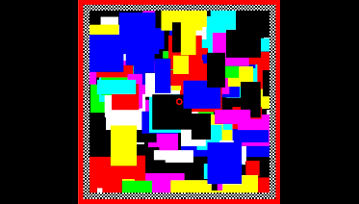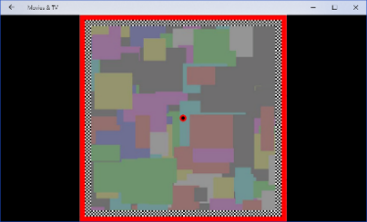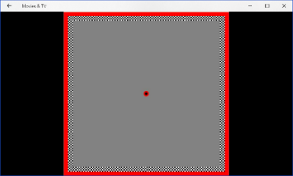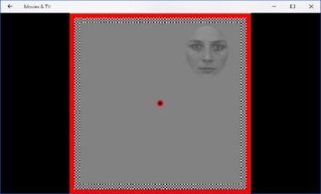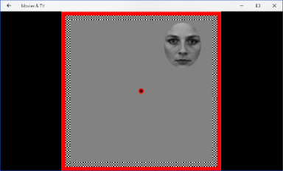
A)
B)
Time
(7-10 s)

Time
(1-3 s)

Time
(0.1-1 s)

Time
(1-10 s)

2.
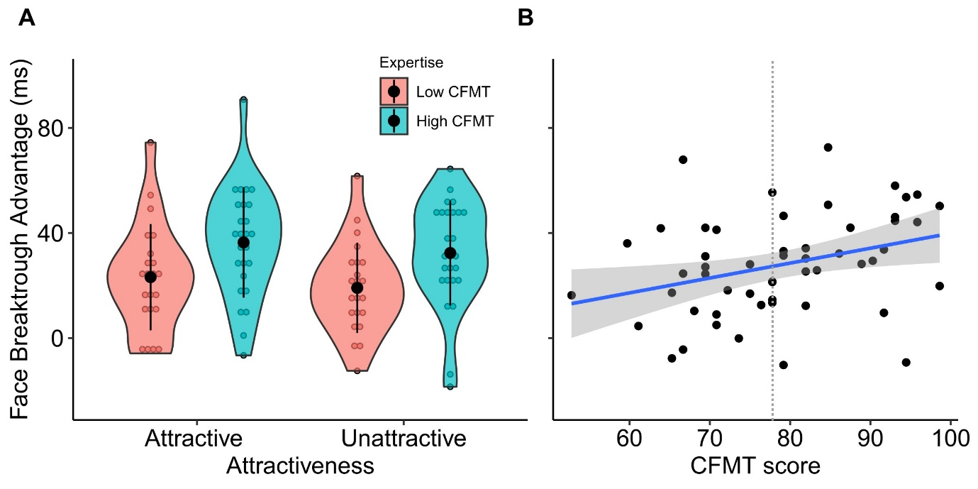

3.
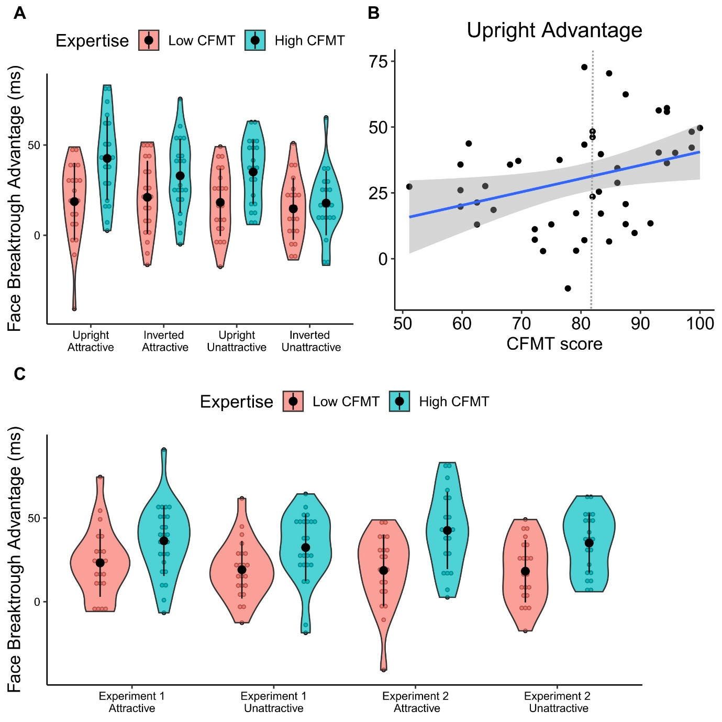

Figure captions
Figure 1. Schematic representation of a trial sequence; A. Mondrian pattern flashing at 10 Hz presented to dominant eye, with progressively decreasing contrast after the third second. B. Target stimuli displayed to non-dominant eye, with progressively increasing contrast between the first and third seconds.
Figure 2. Experiment 1. A. Violin plots showing individual breakthrough advantage times for faces (with respect to houses) for participants in the high (pink) and low (cyan) expertise groups, split for attractive and less attractive face images. Note that higher positive scores indicate a greater advantage for faces relative to houses while negative scores indicate faster breakthrough for houses than faces. Coloured circles indicate individual data points, central full black circles indicate the group mean and the extending bars indicate the standard error above and below the mean. The envelope of the violin represents the shape of the data distribution for each experimental condition of interest. B. Scatterplot showing the relationship between an individual’s score on the Cambridge Face Memory Test (CFMT) and their overall face breakthrough advantage time (collapsed across attractiveness). Blue line is the line of best fit, while the shaded envelope represents the confidence interval around the line. The dotted vertical line represents the median value.
Figure 3. Experiment 2. A. Violin plots showing individual breakthrough advantage times for faces (with respect to houses) for participants in the high (pink) and low (cyan) expertise groups, split for attractive and less attractive face images presented upright and inverted. B. Scatterplot showing the relationship between an individual’s score on the Cambridge Face Memory Test (CFMT) and their face breakthrough advantage time for upright faces (collapsed across attractiveness). Blue line is the line of best fit, while the shaded envelope represents the confidence interval around the line. C. Violin plots for upright face advantage times in Experiments 1 and 2 side by side for comparison. The dotted vertical line represents the median value.

Table 1
Experiment 1. Descriptive Statistics of face breakthrough advantage split by face ability group.
Face Breakthrough Advantage (ms)
M (SD)
Participant Face Expertise | N | More attractive | Less attractive
Lower ability | 22 | 23.18 (20.24) | 19.09 (17.19)
Higher ability | 26 | 36.39 (21.03) | 32.38 (20.02)

Table 2
Experiment 2. Descriptive Statistics of face breakthrough advantage split by face ability group.
Face Breakthrough Advantage (ms)
M
(SD)
 |  |  | Upright |  | Inverted
 | N |  | More attractive faces | Less attractive faces | More attractive faces | Less attractive faces
Lower ability | 21 |  | 18.67  (21.43) | 18.22  (18.66) | 21.06  (20.21) | 14.69  (17.16)
Higher ability | 21 |  | 42.58  (23.12) | 35.08  (17.92) | 32.97  (20.57) | 17.85  (17.88)

The significant association with face expertise was observed for more attractive faces, r(53) = .28, p = .04, 95% CI [.013 to .514], as well as less attractive faces, r(53) = .344, p = .012, 95% CI [.082 to .562].

