Novel metaphor processing in dyslexia: A visual world eye-tracking study

Abstract
Metaphor comprehension has been investigated in neurodevelopmental disorders, but studies devoted to adults with dyslexia are few and present inconsistent results. The present study sought to investigate how adults with dyslexia process novel metaphors. Individual differences in vocabulary, working memory, and Theory of Mind were also assessed. An online metaphor comprehension task based on the Visual World Paradigm was carried out with eye-tracking. Metaphors and corresponding literal sentences were aurally presented in isolation, and participants were asked to select a picture that best corresponded to the sentence they heard. Our results indicated that participants with dyslexia chose metaphor interpretations at a similar rate as did the control group. However, online processing data indicated generally slower response times, with a particular delay in processing metaphorical utterances. Eye movement analyses provided further insights into the underlying nature of the processing slowdowns, highlighting specific challenges encountered by individuals with dyslexia when interpreting figurative language.

Keywords: developmental dyslexia, Visual World Paradigm, eye-tracking, metaphor processing, individual differences

1. Introduction

Metaphors have been widely studied in different fields, and linguists, psychologists, and philosophers have advanced many alternative hypotheses on how people understand them (Bowdle and Gentner, 2005; Gentner and Clement, 1988; Glucksberg and Keysar, 1990; Lakoff and Johnson, 1980; Ortony, 1979). According to the view first outlined by Aristotle, and then developed in modern times by Black (1962), Gentner and Clement (1988), Tourangeau and Sternberg (1982, 1982), Trick and Katz (1986), understanding metaphor requires the identification and mapping of relevant analogies between a topic and a vehicle. Alternatively, the view proposed by Glucksberg and Keysar (1990) claimed that the process of understanding metaphors requires a class-inclusion assertion. This means that in a metaphor like personality is an iceberg, the typical properties of iceberg (e.g., “being only partially visible”) create a broader ad hoc category that can be attributed to personality. In this way, iceberg takes on a more abstract meaning compared to its more specific concrete meaning (e.g., “being hard, cold, and composed of ice”). However, despite decades of research, no agreement has been reached on whether metaphor comprehension relies on analogy, categorization, or a mix of both (Di Paola et al., 2020; Holyoak & Stamenković, 2018; Patterson, 2016) but it is clear that some characteristics of the metaphor may have an influence on the way in which we process them. Several studies identify different processes depending on the features of the metaphor itself (Dulcinati et al., 2014). For instance, metaphors can be placed on a continuum based on how frequently one has already encountered them in life. This scale ranges from novel metaphors, which have never been or rarely heard before, to conventional metaphors, which have been frequently encountered. Analogy processes seem to be mainly employed for novel metaphors, while categorization is applied to more conventional metaphors (Bowdle & Gentner, 2005). Moreover, a more sustained effort has been detected during the processing of novel metaphors, as they involve the formulation of new meanings instead of retrieving previously known metaphorical meanings from memory (Columbus et al., 2015). Several studies highlighted that novel figurative meanings undergo a more intensive computational comparison process (Goldstein et al., 2012; Lai & Curran, 2013; Mashal, 2013) that results in slower reading and reaction times compared to more conventional and familiar meanings (Blasko & Briihl, 1997; Blasko & Connine, 1993; Lai & Curran, 2013; Mashal & Faust, 2009).
These processes not only depend on features of the metaphor itself, but also to the individual differences required to process and understand metaphors (Stamenković et al., 2019). Figurative language comprehension is not a constant process between individuals. On one hand, a person should have sufficient prior knowledge and linguistic competence to understand a metaphor; Event Related Brain Potentials (ERPs) studies demonstrated that metaphor comprehension goes through an early phase of lexical effort, followed by inferential operations (Bambini et al., 2016; Weiland et al., 2014). To understand a metaphor, individuals are required to perceive similarities between two entities, which are typically regarded as distinct, often involving features that are not the most salient in either entity. Therefore, one must possess enough world knowledge and sufficiently broad semantic representations to grasp the intended comparison (Evans & Gamble, 1988). Kazmerski et al. (2003) reported that vocabulary skills predicted the quality of metaphor interpretation, and Chiappe & Chiappe (2007) identified a predictive relationship between vocabulary knowledge and the quality of metaphor production. In both studies, the authors also found that working memory had a role in metaphor comprehension. Mapping common features may depend on active manipulation of complex multi-component structures, and thus, place high load on executive control (Cho et al., 2007; Menashe et al., 2020; Waltz et al., 2000), that is, cognitive skills such as planning, working memory, and selective attention (Miyake et al., 2000). Previous research indicates that people with higher working memory or inhibition skills show quicker and better interpretation of metaphorical expressions (Blasko, 1999; Chiappe & Chiappe, 2007; Olkoniemi et al., 2016; Pierce et al., 2010). The role of executive control seems to be particularly relevant for novel metaphors. Mashal (2013) found that people with larger backwards digit spans had better recognition, comprehension, and recall of unfamiliar metaphors compared to unrelated word pairs. Columbus et al. (2015) recorded the eye movements of participants, while they were reading sentences, including metaphors or idioms (e.g., highly conventional figurative expressions). First, they confirmed that familiarity modulated reading times, with less familiar metaphors requiring more time. Interestingly, executive functions were correlated to metaphors but not to idioms. Moreover, high and low executive control readers differed in the time in which they used contextual clues to interpret a verb used metaphorically on the first pass: those with higher executive control made more immediate semantic integration, while those with lower executive control did later, showing a delayed meaning disambiguation.
Research conducted so far presents a heterogeneous picture, showing that metaphor comprehension differs depending on specific conditions, such as the type of metaphor and individual differences. Specifically, novel metaphors seem to require different processes compared to more familiar ones, tapping into executive control and vocabulary knowledge. This is particularly relevant when it comes to disorders that affect cognitive and linguistic functions, as in the case of dyslexia.

2. Metaphor Processing in Dyslexia

Dyslexia is a neurobiological learning difficulty, which affects the phonological component of language, resulting in a discrepancy between cognitive ability and reading. There are many theories that try to identify causes of developmental dyslexia. The historically dominant one is the phonological theory, which contends that reading problems are due to inadequate phonological skills (Vellutino et al., 2004). Other theories focus on auditory (Tallal et al., 1993), visual (Lovegrove et al., 1980), magnocellular (Stein, 2001), or sensory (Nicolson et al., 2001) deficits. More recently, approaches pointing to a cognitive disorder in the spatial focusing of attention (Facoetti et al., 2003) or in executive control, and particularly inhibition (Brosnan et al., 2002), have also been proposed without much general agreement.
Until relatively recently, dyslexia has been described as a specific deficit that results in difficulties with decoding and spelling words, but it is now clear that the majority of people who develop dyslexia have more global cognitive and linguistic issues (Compton, 2021). New theoretical models (Pennington et al., 2012; Perry et al., 2019) emphasize a multifactorial approach, arguing a primary involvement of phonological deficits, together with weaknesses in processing speed, language skills, and executive functions (Peterson & Pennington, 2015). Cognitive profiles frequently associated with dyslexia entail limitations in executive functioning (Baker & Ireland, 2007), such as attention (Lallier et al., 2009) and inhibition (Wang & Yang, 2015), working memory (Baddeley, 2010; Gathercole et al., 1992), processing speed, and skill automatization (Nicolson & Fawcett, 2008). These cognitive features may also be related to other more nuanced language impairments (Compton, 2021). Previous research indicates difficulties in processing syntactic and grammatical structures that are particularly expensive in terms of processing costs (Stella & Engelhardt, 2019; Vender, 2017) and with pragmatics (Cappelli et al., 2022; Griffiths, 2007).
Considering this multifaceted profile, it is evident that more research is needed to better understand the main causes and outcomes of dyslexia (Engelhardt, 2020), especially if we want to investigate the intersections between metaphor comprehension and developmental dyslexia, as is the main aim of this paper.

3. Previous Studies

There are few studies that address metaphor comprehension in people with dyslexia (see Table 1).

Table 1. Previous studies involving metaphor comprehension in developmental dyslexia.
Paper | Participants | Age | Lang. | Batteries | Metaphor task
Griffiths (2007) | 20 (20 TD) | 18-45 (range) | English | Right Hemisphere Language Battery RHLB (Bryan, 1995). | Metaphor picture test (picture selection); metaphor written test (multiple choice, aurally presented).
Kasirer & Mashal (2016) | 18 (19 TD)  17 (18 TD)  17 (17 TD) | 11.2 (mean)  14.29  22.82 | Hebrew | Multiple-choice questionnaire (Mashal & Kasirer, 2011); concept-creation task (Kasirer & Mashal, 2014). | Conventional and novel metaphor comprehension (multiple choice) and generation.
Cardillo et al. (2018) | 21 (21 TD) | 8-10 (range) | Italian | APL Medea battery (Lorusso, 2009). | Picture metaphors (picture selection); verbal metaphors (meaning explanation).
Cappelli et al. (2018) | 19 (19 TD) | 21 (mean) | Italian | APACS (Arcara & Bambini, 2016); BLED (Rinaldi et al., 2006). | Metaphor picture test (picture selection); metaphor written test (multiple choice); metaphors in short context (verbal explanation); multiple choice sentence matching task (figurative, literal and unrelated interpretation).
Cersosimo et al. (2024) | 26 (31 TD) | 24.5 (mean) | Italian | - | Semantic judgement task based on the Metaphor Interference Effect; aurally presented; high and low familiar metaphors from (Bambini et al., 2013)

Two studies (Cardillo et al., 2018; Lam et al., 2014) analyzed pragmatic abilities in children with dyslexia and showed that this group had reduced pragmatic competence. However, only Cardillo et al. (2018) had metaphor-related tasks. Difficulties were observed in recovering the meaning implicitly conveyed in texts and in understanding metaphors. They hypothesized that individuals with dyslexia present issues in (i) suppressing literal meaning and (ii) creating coherent semantic representations of the intended (metaphorical) meaning. In a pictorial task, for example, children with dyslexia showed more errors than the control group, choosing the alternatives that depicted just a partial interpretation. It is interesting to note that when reading and vocabulary skills were controlled for, only performance in the picture-metaphor test remained significant, comparing dyslexia and control groups. The authors concluded that some pragmatic difficulties may be directly related to the core areas of impairment in dyslexia, such as literacy. However, difficulties in processing and integrating visual information can also be a factor (Li et al., 2009).
Two other studies (Cappelli et al., 2018; Griffiths, 2007) extended the focus on pragmatic skills of adults with dyslexia. Both used the Right Hemisphere Language Battery (RHLB) (Bryan, 1995) and Cappelli et al. also used APACS (Arcara & Bambini, 2016), a standardized battery developed to assess pragmatic ability in Italian-speaking adults. Both tests showed impairments in pragmatic skills in the group with dyslexia, that had lower scores in metaphor comprehension tasks. Griffiths (2007) found metaphor tasks (RHLB 1 and 2) equally challenging for both groups. However, when tested with BLED (Rinaldi et al., 2006) – i.e., the Italian version of the RHLB – in Cappelli et al. (2018), people with dyslexia performed significantly worse than controls in the Picture Metaphor task, and a trend was also observed in the Written Metaphor task. The same study showed poor performance in the group with dyslexia on all subtests of APACS, including Figurative Language 1 and Figurative Language 2. Thus, the authors hypothesized that metaphor comprehension is a challenge for young adults with dyslexia, particularly when assessed through an explanation task that requires a verbalization of abstract meanings (Figurative Language 2), but also when assessed through a multiple-choice task (Figurative Language 1). These tasks were correlated with reading fluency and comprehension, vocabulary, and working memory.
Kasirer and Mashal (2017) conducted a longitudinal study focused on metaphor comprehension in dyslexia. Their work investigated the comprehension and generation of metaphors in three different age groups (children, adolescents, and adults). They also examined the contribution of executive functioning on metaphor processing. To assess metaphor comprehension, a questionnaire previously developed by Mashal and Kasirer (2011) was used. It contained ten conventional metaphors (e.g., a sharp tongue) and ten novel metaphors (e.g., a pure hand). Every metaphoric expression was followed by four alternatives: a correct metaphoric interpretation, a literal interpretation, an unrelated interpretation, and an option that stated “This expression in meaningless”. Participants were asked to choose only one of the four options. The task was presented in written form, but participants had the possibility of having the questionnaire read aloud to them. No adolescents, nor adults, in the group with dyslexia asked for this compensatory measure. Differences between groups were only found in children, who showed impairments only in conventional metaphor comprehension (with a medium-to-large effect size, η²= 0.29), but not in novel metaphor comprehension. In adults, effects of group and type of metaphor were not significant (i.e., η² < 0.04). The authors identified a couple of limitations with regard to presenting metaphors in a multiple-choice format, which may have benefited comprehension by providing participants with distinct and readily available interpretations.
Metaphor production was assessed through a concept-creation task developed by Kasirer and Mashal (2014). Participants were presented with ten concepts involving common emotions (e.g., feeling sad) and their task was to write down a new and original way to express the meaning. In this case, children and adolescents with dyslexia showed the same performance as controls. Interestingly, adults with dyslexia outperformed the control group (showing a small-to-medium effect size, η² = 0.17). The authors also analyzed, which skill best predicted the comprehension and generation of metaphors, through regression analyses. Significant positive relationships were found between verbal knowledge and mental flexibility and conventional metaphor comprehension, and between non-verbal tests and mental flexibility and novel metaphor generation. This link between metaphor processing and mental flexibility, which is considered a component of creativity (Brockett, 1985), is particularly relevant in the case of dyslexia, in which this kind of ability is generally enhanced (Cancer & Antonietti, 2020), at least in adults (Majeed et al., 2021).
The only study that provides online measures for metaphor processing in adults with dyslexia is one reported by Cersosimo et al. (2024). That research utilized a Metaphor Interference Effect (MIE) task to investigate potential difficulties in the initial phases of metaphor comprehension. Theoretical models of metaphor processing (see Glucksberg et al., 1982) propose that understanding metaphors involves multiple steps: retrieving relevant information for all words in a sentence, integrating this information to construct both literal and figurative interpretations, and ultimately, selecting the intended meaning by suppressing irrelevant alternatives. These phases predict the actual integration of the metaphorical meaning in a context. The findings did not indicate any delays or inefficiencies in these early stages of processing, regardless of whether the metaphors were highly familiar or less so. Therefore, the authors concluded that the previously identified difficulties are more likely to arise from the integration of metaphorical meaning in later stages (i.e., within context) rather than from early stages of processing.

4. Current Study

The current study investigated how people with dyslexia process novel metaphors. A battery of cognitive measures was administered to gain a thorough knowledge on the individual differences in the sample, and a metaphor comprehension task was presented to each participant in the study. Previous research was mainly conducted in the written modality, and none explored the online comprehension of novel metaphors. To address these shortcomings, eye tracking was used in the metaphor comprehension task, and any possible difficulty due to reading impairments was reduced by presenting metaphors in the auditory modality (i.e., distinct interpretations of the auditory sentence were represented visually, via different pictures). One main research question was addressed: are there differences in metaphor processing in adults with dyslexia compared to typically developing controls?
Literature on cognitive abilities involved in understanding metaphors allows us to predict a possible processing difficulty of people with dyslexia. As mentioned above, cognitive abilities correlated with novel metaphor comprehension are (i) executive functions, such as inhibition, and working memory, where higher abilities predict more accurate and faster metaphor processing (Pierce et al., 2010); (ii) vocabulary knowledge, which promotes better metaphoric interpretations (Kazmerski et al., 2003); (iii) mental flexibility, which was positively correlated to metaphor understanding (Kasirer & Mashal, 2014; Mashal & Kasirer, 2011); (iv) Theory of Mind (ToM) and pragmatic abilities (Bambini and Resta, 2012; Norbury, 2005). The role of ToM in metaphor comprehension is not universally agreed upon (Bosco et al., 2018; Gernsbacher & Pripas-Kapit, 2012). Some scholars propose that ToM skills are crucial, contending that grasping a metaphor necessitates understanding another person’s perspective on the world (Happé, 1993). In contrast, others argue that ToM alone is not sufficient for the comprehension of metaphorical language. Norbury (2005) emphasized that ToM skills might support metaphor understanding by contributing to a more robust contextual representation, but that semantic knowledge seems to play a more central role.
When it comes to dyslexia, previous research indicates that executive functions tend to be impaired, with poorer inhibitory control (Faccioli et al., 2008; Proulx and Elmasry, 2015), and lower working memory capacity (Cancer & Antonietti, 2018). Theory of Mind and pragmatic abilities also tend to be lower in this population (Cappelli et al., 2018; Egilsdóttir, 2015). Also, semantic processing of unexpected or novel idiomatic phrases seems problematic in adults with dyslexia (Egan et al., 2022).
By contrast, some difficulties may be mitigated by the fact that adults with dyslexia (at least university students) do not seem to be impaired in vocabulary knowledge (Cavalli et al., 2016; Rasamimanana et al., 2020). They also tend to show higher mental flexibility (e.g., creative skills) than typically-developing controls (Cancer & Antonietti, 2020; Majeed et al., 2021). To explore possible influences of individual differences on our results, we assessed each participant’s working memory, reading history, vocabulary knowledge, and Theory of Mind. We did not assess mental flexibility and creativity, whose tasks usually require multiple measurements (e.g., fluency, flexibility, elaboration, and originality) and there is ongoing debate on their reliability (see Plucker et al., 2020; Sternberg, 2020).

5. Methods

Participants

Seventy-nine participants took part in the study. The sample included 38 English native speakers with a diagnosis of dyslexia (DYS) and no associated comorbidities and 41 typically-developing (TD) English native speakers as control participants. Both groups were recruited from the University of East Anglia. After removing four individuals who showed anomalous reaction times (3 SDs from the mean; see the “Results” section) and one subject with dyslexia that had anomalous RAN scores (not in line with the condition), the final sample included 35 participants (6M, 30F, mean age = 21.4, SD = 4.56) in the DYS group and 39 participants (8M, 31F, mean age = 21.1, SD = 4.53) in the TD group. The two groups did not differ in age (t = -0.305, p = .761) or gender (χ²(1) = 0.157, p = 0.691).
Participants were compensated for their time either with participation credits or with £12. The study was approved by the School of Psychology Research Ethics Committee at the University of East Anglia (UK). Informed consent was obtained from all participants before carrying out the study and all were debriefed at the end of the study.

Individual differences assessment

All participants were tested individually before the eye-tracking task. The standardized procedures of administration for each test were followed as described in the test manuals; a description of the tests used is provided in the Supplementary Materials, Section A. Table 2 reports all the measures for each group and t-tests were used to identify between-group differences.

Table 2 - Means and standard deviations for individual differences measures.
 | TD (N=39) | DYS (N=35) | t-value | p-value | Cohen’s d
 | Mean (SD) | Mean (SD)
Dyslexia screening
RAN Letters (sec.) | 13.4 (2.80) | 18.6 (6.38) | -4.762 | < .001* | -1.09
RAN Digit (sec.) | 12.1 (2.86) | 16.6 (4.25) | -5.499 | < .001* | -1.26
ARHQ | 31.3 (8.71) | 54.6 (12.8) | -9.23 | < .001* | -2.15
Working Memory
Digit span forward | 10.5 (1.92) | 8.8 (1.64) | 4.1 | < .001* | 0.956
Digit span backward | 8.41 (1.92) | 7.77 (1.52) | 1.58 | 0.119 | 0.367
﻿Vocabulary
PPVT | 98.6 (9.46) | 96.3 (12.2) | 0.943 | 0.349 | 0.220
﻿Theory of Mind
﻿Faux Pas test | 28.8 (2.36) | 26.5 (3.74) | 3.2 | .002* | 0.746

Metaphor Comprehension Task

Our metaphor task was based on the Visual World Paradigm (Tanenhaus et al., 1995) and all stimuli were a combination of a visual array consisting of three pictures and an aurally presented sentence. Stimuli for this task were adapted from Pouscoulous and Tomasello (2020) and Di Paola et al. (2020). New novel metaphors were created to have more suitable stimuli for adult participants. Twenty pairs of novel metaphors and corresponding literal expressions in the form [The X with the Y], where (Y) was figurative in the metaphor condition, were constructed. Sentences were similar in length. Nouns used in the (X) and (Y) positions were frequent and concrete. To check for words concreteness and frequency, we used ratings from Brysbaert et al., (2014) and van Heuven et al. (2014). For each trial, a target picture and two control pictures were sourced: (1) the target picture showed the target object referred to either metaphorically or literally (e.g., a cup with handles for The cup with the ears/handles), (2) the irrelevant illustrated the metaphor target without the relevant property (e.g., a cup without handles), and (3) the distractor was a literal competitor, literally showing both target and vehicle (e.g., a cup and a boy pointing at his ears) (see Figure 1).

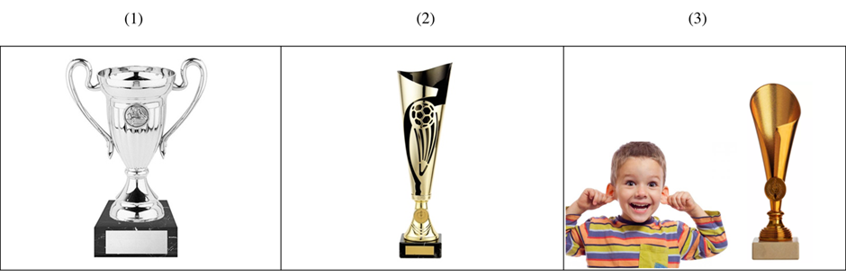

500ms | The | cup with the | ears | 2000 ms
Blank | Det1 | NP1+PP+Det2 | NP2 | Ending/Button Press

Figure 1. Example visual array ‘The cup with the ears’ and the literal item ‘The cup with the handles’: (1) target picture, (2) irrelevant, and (3) distractor. The bottom panel shows the key time points for dividing the sentence into critical time periods.

We defined five key time points for each trial (see Figure 1, bottom panel). Based on the key time points, we analysed three time windows. The first (Region 1) was from the onset of the picture to the onset of NP1. Recall that the pictures appeared on the screen and there was 500 ms of silence before the sentence began. The second time window (Region 2) was from the onset of NP1 to the mid-point of NP2. The mean time of this region of interest was approximately 900 ms. The final time window (Region 3) was from the mid-point of NP2 to when the participant made a button response. We started this time point at the mid-point of NP2 in order to allow some time for word recognition and eye movement planning to occur (i.e. this is the earliest point in time in which participants attention could be shifted to the target picture).
Metaphors were normed on a 7-points Likert scale for their familiarity, aptness, and conventionality following the same procedure, as in Dulcinati et al. (2014). Target pictures were normed for their suitability to the sentence (i.e., How suitable is this image to represent the sentence?). A total of 120 native English speakers recruited through Prolific (www.prolific.co), took part in the norming task and were paid for their time, with groups of 30 unique participants assigned to each survey (see Online Materials for norming data). Three sentences were considered as outliers and removed from the study. Two sentences showed high familiarity or conventionality ratings (between 4 and 7 points). One showed a low picture suitability (less than 3 points). All sentences were considered apt metaphors (i.e., are perceived as providing an accurate description of the topic). One sentence was taken as a practice item. A total of 16 sentences rated as apt novel metaphors were included in the study together with their 16 literal corresponding expressions and 32 fillers (half of the fillers were idioms, and half were literal controls in which the sentence referred to only one picture).

Online Materials

Materials and norming results are available on the Open Science Framework online data repository (https://osf.io/39bxk/).

Apparatus

Eye movements were recorded with an SR Research Ltd. EyeLink 1000 eye-tracker, which records the position of the reader’s eye every millisecond. Head movements were minimised with a chin rest. Eye movements were recorded from the right eye. Experiment Builder was used to program the experiment, and Data Viewer was used to extract the interest area reports for eye movements. The sentences were aurally presented through a speaker.

Design and Procedure

The task was designed after the Visual World Paradigm (Tanenhaus et al., 1995). The design was a 2 $×$ 2 (Sentence Type $×$ Group), in which sentence type (literal and metaphorical) was within subject. Participants completed two practice trials, 32 experimental trials, and 36 fillers. Trials were presented in a random order for each participant. Critical trials were rotated in a Latin Square design, and images were rotated across the three possible positions. Thus, there were six lists of stimuli.
Before the experiment, participants were provided with a set of instructions that detailed the experimental procedure. The researcher added further explanations, if required. Participants then sat at the eye tracker and responded to on-screen instructions using the keyboard. At the beginning of each trial, a message appeared asking the participant to press a button when they were ready to continue. After participants pressed the button, they were required to fixate a drift-correction dot, which appeared in the centre of the screen. The experimenter then initiated the trial. There were two practice trials. If the participant was ready and had no more questions, they proceeded to the critical trials. Participants heard the sentences, ﻿while simultaneously being presented with three pictures.
For each trial, the audio file started 500 ms after the pictures appeared. There was a 2000 ms time window following the sentence in which participants needed to make their choice about which picture they thought best fit the sentence. They were asked to press ‘1’ if they wanted to choose the left picture, ‘2’ for the centre picture, and ‘3’ for the picture on the right. The eye-tracking testing session for each participant lasted approximately 5 minutes. To avoid any bias, participants were not informed of the inclusion of figurative language among the sentences. During the debrief, the aim of the experiment was explained in detail.

6. Results
Outliers were defined by examining standardized scores and histogram plots. We used a threshold of 3 SDs from the mean. Two reaction time outliers were identified in the control group, and two from the dyslexia group. They were eliminated from all analyses. Results are presented in the following order: assessment of individual differences in cognitive abilities, comprehension accuracy, reaction time, summed dwell time, and divergence point analysis. Inferential analyses were conducted using R (R Core Team, 2012). The complete code and output are available at the Open Science Framework online data repository (https://osf.io/39bxk/).

Individual Differences in Cognitive Abilities

Groups were matched on age and gender but differed significantly on the three dyslexia screening measures (see Table 2). These findings show that our groups were well matched on key demographic variables and show the expected differences with respect to dyslexia (all screening effect sizes were large). With respect to cognitive abilities, our groups differed in forward digit span and ToM, but they did not differ in vocabulary and backwards digit span. For a description of the tests used for the assessment, see Supplementary Materials, Section B.

Comprehension Accuracy

For comprehension accuracy, we fitted a generalized linear mixed model with comprehension accuracy as the outcome variable (binomial), condition (metaphorical, literal) and group (DYS, TD) as fixed effects, and item and participant as random effects. Contrasts were set with metaphorical items and the control group as the baseline. Results showed a significant main effect of sentence type, in which the literal trials had higher comprehension than did the metaphorical trials (see Figure 2 and Table 3). The main effect of group and the interaction were not significant.

Table 3 - Estimates, standard errors, t-values of the linear mixed effects models.

Fixed Effect Estimate Std. Err. t–value Pr(> |t|)

Comprehension
Intercept 0.6783 0.3805 1.782 (z) 0.074*
Group -0.2954 0.4443 -0.665 (z) 0.506
Sentence 30.4270 13.0034 2.340 (z) 0.019*
Group: Sentence -4.8631 17.1950 -0.283 (z) 0.777

Reaction Time (all trials)
Intercept 2499.66 94.49 26.454 < 0.001*
Group 447.35 125.57 3.563 < 0.001*
Sentence -343.46 103.04 -3.333 < 0.001*
Group: Sentence -256.52 123.15 -2.083 < 0.037*

Reaction Time (all trials) – paired comparisons
TD:Metaphor DYS:Metaphor -447 126 -3.563 (z) 0.002*
TD:Literal DYS:Literal -191 100 -1.902 (z) 0.227
TD:Metaphor TD:Literal 343 103 3.333 (z) 0.004*
DYS:Metaphor DYS:Literal 600 132 4.550 (z) <.001*

Reaction Time (correct trials)
Intercept 2729.8 119.8 22.783 <.001*
Group 427.8 150.5 2.842 0.004*
Sentence -567.9 116.1 -4.890 <.001*
Group: Sentence -235.7 155.5 -1.515 0.129

Summed Dwell Time (correct trials)
Intercept 629.9302 30.0172 20.986 < 0.001*
Group 47.6510 38.3801 1.242 0.214
Sentence -52.8495 30.9133 -1.710 0.087*
Picture 0.9967 48.1707 0.021 0.983
Group: Sentence -42.7155 48.3739 -0.883 0.377
Group: Picture -81.1757 59.5289 -1.364 0.172
Sentence: Picture -135.5143 50.3454 -2.692 0.007*
Group: Sentence: Picture. 78.2925 73.4840 1.065 0.286

Summed Dwell Time (correct trials) – Sentence : Picture paired comparisons
Met. Target - Lit. Target 74.2 24.1 3.084 0.011*
Met.Target - Met.Distractor 39.6 46.3 0.855 0.828
Met. Target - Lit. Distractor 210.2 34.0 6.189 <.001*
Lit. Target - Met. Distractor -34.6 43.3 -0.800 0.854
Lit. Target - Lit. Distractor 136.0 29.9 4.543 <.001*
Met. Distr. - Lit. Distr. 170.6 31.4 5.440 <.001*

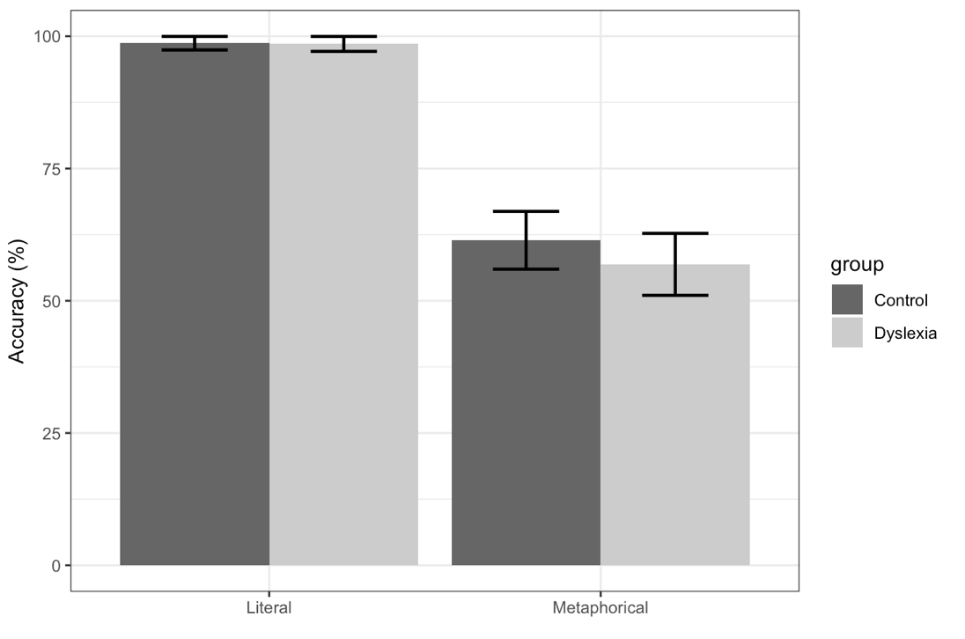
Figure 2. Means of comprehension accuracy. Error bars show the 95% confidence intervals.

Reaction Time

Reaction times were computed from the midpoint of NP2 (Region 3) to when participants made the button press to select a response (see Figure 1). Reaction times were checked for outliers below 80ms or over 8000ms, however all data fell within 80-8000ms, so the full data set was analysed. The distribution of the reaction time exhibited a positive skew, which necessitated adjustments in the modeling approach to ensure appropriate handling of the data distribution. We specified the models using an identity link function, which assumes a linear relationship between the predictors and the observed responses, and a Gamma distribution (Lo & Andrews, 2015), to accommodate the positively skewed nature of duration data.
This approach enabled us to fit a maximally specified model, with reaction time as the outcome variable. Fixed effects included sentence type (metaphorical, literal) and group (DYS, TD), while random effects accounted for variability across items and participants. To facilitate meaningful interpretation, contrasts were set with metaphorical items and the control group as the baseline.
Results for all trials showed significant main effects of sentence type, in which literal trials were processed more quickly, and group, where controls had shorter reaction times than did the participants with dyslexia (see Figure 3). The interaction was also significant (see Table 3). The emmeans package (Lenth, 2022) was used to break-down the significant interaction. Paired comparisons showed significant differences between literal and metaphorical items for both groups (see Table 3). The comparison of DYS vs. TD showed significant differences for metaphorical trials, but not for literal trials. Thus, the interaction was based primarily on the elevated reaction times for metaphorical trials in individuals with dyslexia.

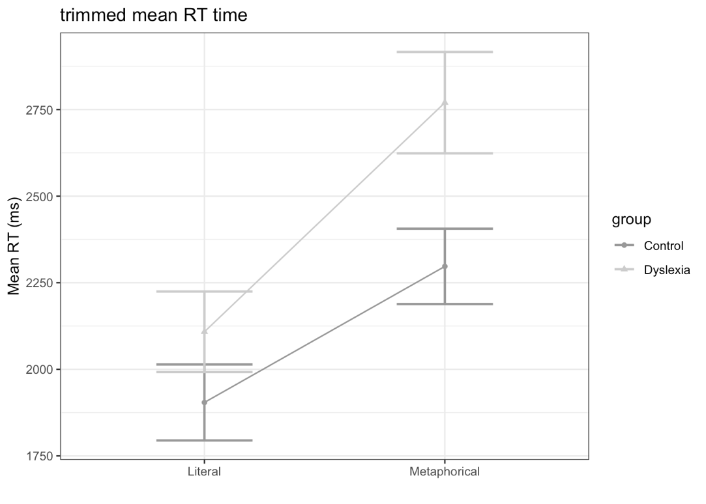
Figure 3. Means of reaction time for all trials. Error bars show the 95% confidence intervals.

Reaction times for correct trials confirmed significant main effects of sentence type and group, but no significant interaction between variables (see Figure 4 and Table 3). Metaphor trials had longer reaction times and participants with dyslexia were slower than controls.

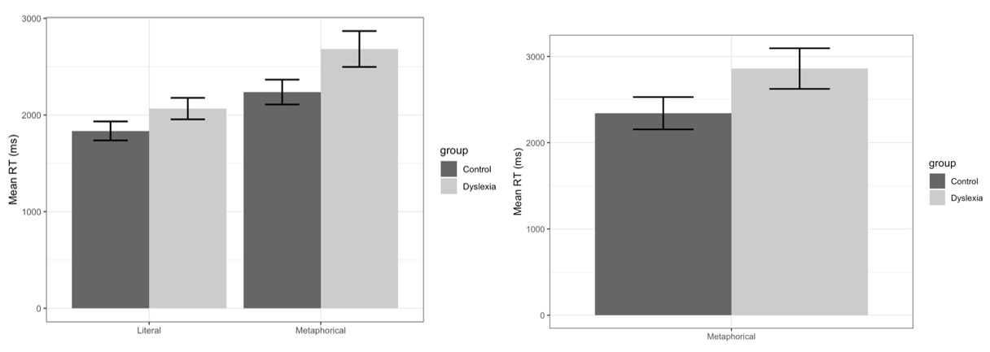
Figure 4. Means of reaction time for correct trials (left panel). Means of reaction time for metaphor incorrect trials (right panel). Error bars show 95% confidence intervals.

We also considered the reaction times for incorrect metaphor trials. The literal trials showed very few incorrect responses (<5%), and so, we did not analyze them. A t-test for metaphor incorrect trials revealed a significant difference between groups (t = -3.37, p < .001), in which the participants with dyslexia had longer reaction times (see Figure 4).

Eye Movements – Summed Dwell Time

Summed dwell time was calculated over the same time window as RTs, from the midpoint of NP2 (Region 3) to when participants selected a response. For eye movements, we fitted a model following the same procedure as before, but with dwell time (i.e., the summed fixation duration on each picture) as the outcome variable. Sentence type (metaphorical, literal), group (DYS, TD), and picture type (target, distractor) were the fixed effects, and item and participant as random effects. We did not include the irrelevant picture in these analyses, and only analysed eye movements for correct trials.
The models were run for each time window (the results for Regions 1 and 2 are presented in the Supplementary Materials, section C). For Region 3, dwell time was checked for outliers, and any value below 80ms or above 8000ms was removed (10.05% of the data). Region 3 showed a marginally significant main effect of group and a significant interaction between sentence type and picture type (see Figure 5 and Table 3). The dyslexics had longer dwell times, consistent with the reaction time analysis. The interaction between sentence and picture showed a larger difference in dwell time between the target and distractor for literal trials and similar dwell time on target and distractor for metaphorical trials (see Figure 5).

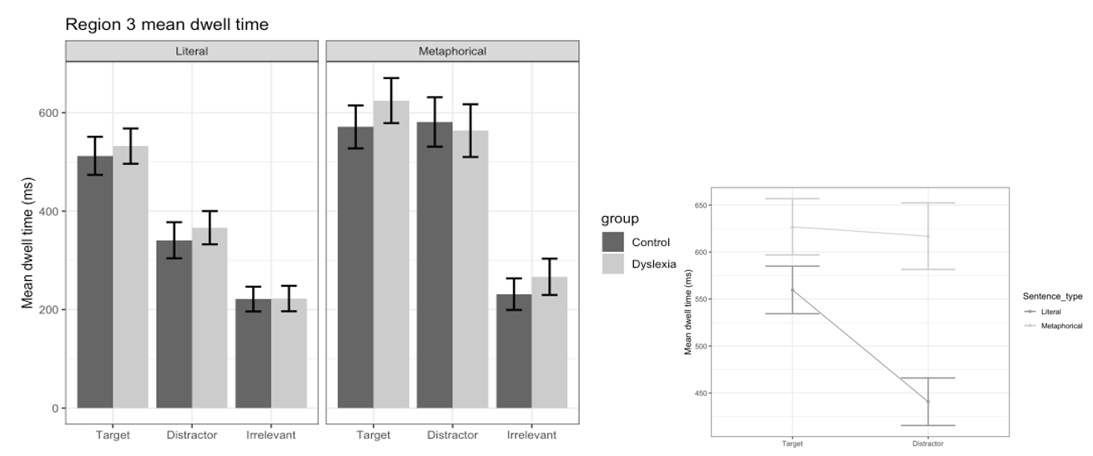
Figure 5. Means for dwell time in region 3 (left panel). Means for the significant interaction of sentence type and picture type (right panel). Error bars show the 95% confidence interval.

Eye Movements – Divergence Point Analysis

The time course of fixations on Region 3 was analyzed using Divergence Point Analysis (DPA; Stone et al., 2020), a non-parametric bootstrapping method that enables group comparisons through the estimation of confidence intervals (CIs). This method is particularly well-suited for analyzing time-course data, as it identifies the point at which fixation patterns between groups or conditions diverge. DPA employs a series of t-tests to compare fixations between the Target and Distractor pictures across consecutive 50 ms time bins, with divergence determined after at least four consecutive bins (200 ms) showing a difference between groups. By resampling the original dataset using bootstrapping, 2000 new datasets are generated, allowing for the estimation of a new divergence point for each iteration. The mean divergence point and its associated CI are then calculated. We first analyzed the time course of fixations for correct literal and metaphorical trials (Figure 6).

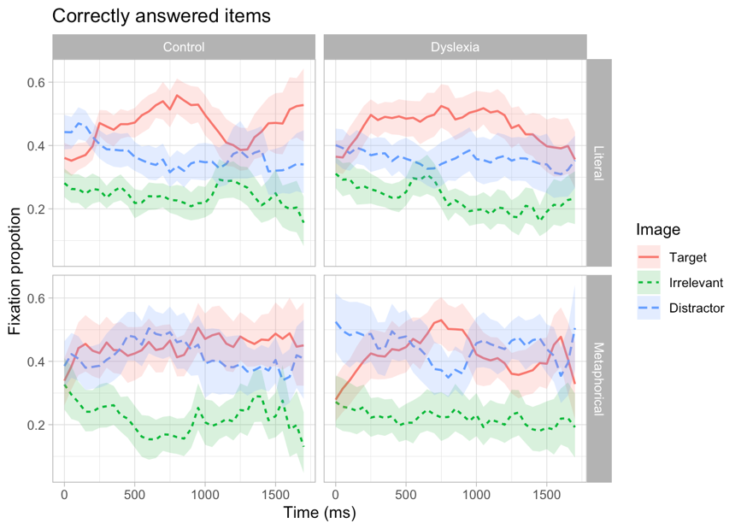
Figure 6. Time course analysis for correct trials (literal and metaphorical) between groups.

Results for literal trials revealed that for the control group, the divergence point (DP) was observed at 583 ms [CI: 500, 850]. For the dyslexia group, the DP occurred at 625 ms [CI: 300, 10507]. The estimated difference between the two groups was approximately 44 ms [CI: -400, 500]. Since the CI includes 0, no difference was detected between the groups (see Figure 7).

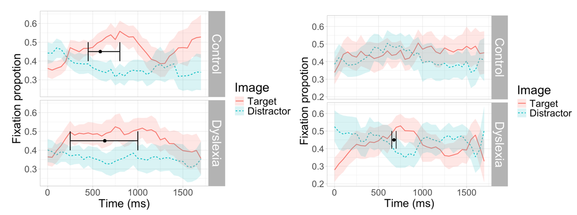
Figure 7. Left panel shows the divergence points for correct literal trials, and the right panel shows the divergence points for correct metaphorical trials.

Results for metaphorical trials (Figure 7) showed that in the control group, no DP was identified, suggesting no clear distinction between fixations on the Target and Distractor. In contrast, for the dyslexia group, a DP was detected at 675 ms [CI: 700, 750]. For incorrect trials (Figure 8), no divergence points were identified for either the control or dyslexia groups in the metaphorical condition (Figure 8).

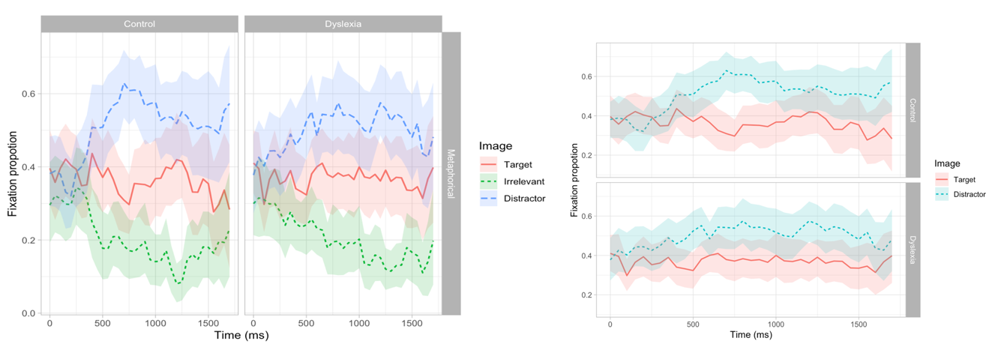
Figure 8. Time course analysis for incorrect trials (metaphorical) between groups (left panel). Divergence points analysis for metaphorical incorrect trials is shown in the right panel.

7. Discussion

The current study explored novel metaphor processing in adults with dyslexia. Prior literature is limited and is filled with conflicting findings (see Table 1), concerning whether individuals with dyslexia experience difficulties with metaphor comprehension. In this study, we examined both offline (comprehension) and online (reaction times and eye movements) processing measures with novel metaphors, using a version of the Visual World Paradigm. In order to mitigate the reading difficulties in individuals with dyslexia, we presented the metaphorical expressions auditorily. In addition, we also assessed several of the key individual differences measures that were identified in previous research as being related to metaphor comprehension (e.g. working memory, ToM, and verbal abilities). The results of this study showed that individuals with dyslexia chose the metaphorical meaning at a similar rate as did the control participants. With respect to online processing, we found that individuals with dyslexia were generally slower, and were specifically slower in comprehending metaphorical utterances. Moreover, the eye movement data allows us to draw further conclusions concerning the underlying nature of the processing difficulties (slowdowns) that individuals with dyslexia experience. In the remainder of the discussion, we first cover comprehension, followed by reaction times and eye movements, and lastly, we provide a few comments on the individual differences measures.
The “accuracy” rate in metaphorical trials was comparable between the two groups, indicating no difference in rate in which individuals with dyslexia chose the metaphorical meaning. Throughout this paper, we have referred to comprehension using the labels of “correct” and “incorrect”. This is a convenient simplification for metaphor trials. Ultimately, participants made a choice (or a decision) about which of the two available interpretations (based on the relevant visual contexts) they thought best corresponded to the (metaphorical) utterances. Literal utterances only have one relevant picture, and therefore, these trials do not involve any kind of choice (or decision) process, and these can be clearly described as “correct” and “incorrect”. Results showed no difference between groups and overall accuracy was > 95% correct for literal trials. For metaphor trials, participants were more likely to choose the metaphorical interpretation, with an approximate 60/40 split (metaphor/literal, respectively). This is similar to the rates reported in prior studies (Di Paola et al., 2020; Pouscoulous & Tomasello, 2020). What is important for the current study is that the response patterns were comparable between the two groups, which resulted in a non-significant main effect of group and no interaction between group and sentence type (literal/metaphorical).
In the next few paragraphs, we present an integrated discussion of reaction times and eye movements, and for the sake of simplicity, we first discuss the results from literal trials, then the “correct” metaphorical trials, and lastly, the “incorrect” metaphorical trials. For the literal trials, both the control and dyslexia group showed a divergence between the target and distractor picture, which occurred approximately 600 ms from the onset of NP2 (looks to the target were significantly greater than the distractor). The divergence point difference between groups was 45 ms, in which the divergence occurred numerically later in individuals with dyslexia. The analysis of reaction times, for literal trials, showed approximately a 200 ms difference between groups, which was not significant. To summarize, there is very little difference between groups in the processing of literal utterances. Attention to the relevant picture is slightly slower and the reaction time is slightly longer in participants with dyslexia (neither of which achieved statistical significance).
For metaphor trials, there was a significant reaction time difference between groups when all trials were analyzed, but when only correct trials were considered, the difference between the dyslexia and control group was smaller (i.e. there was a main effect of group but not a significant interaction). To further understand the disparity between these two analyses, we also examined the reaction times for metaphor (incorrect) trials. In these trials, participants selected the distractor image, which depicts the literal meaning of the sentence. The dyslexia group had significantly longer reaction times compared to controls. Moreover, controls showed more similar reaction times for correct and incorrect metaphor trials, whereas individuals with dyslexia showed a clear trend for longer reaction times in “incorrect” trials as compared to “correct” trials. This difference is the reason why the analysis of reaction times for all trials showed a significant interaction, whereas correct trials showed only a double main effect.
It is important to note that the reaction times of metaphor (incorrect) trials are longer than metaphor (correct) trials. We found this result very counterintuitive. We expected that literal interpretations of metaphorical utterances would pattern similarly to literal trials and they clearly did not. Specifically, the reaction times and eye movements should indicate that the metaphorical interpretation is not activated or computed in metaphor incorrect trials. We interpret this finding as showing that the metaphorical interpretation is likely activated on the vast majority of trials for both groups. A second possibility is that there might have been a bimodal distribution in reaction times for metaphor incorrect trials (Ferreira et al., 2002). One peak in the distribution, with shorter reaction times, would correspond to cases where the metaphorical interpretation is never activated, and a second peak in the distribution, with longer reaction times, where participants considered the metaphorical interpretation, and following a deliberation period, participants select the picture corresponding to the literal interpretation (sequentially equating to literal => metaphorical => literal). An examination of the reaction times for metaphor incorrect trials did not reveal a bimodal distribution.
Turning to the divergence point analysis for metaphorical trials, we observed only one divergence, and it was in the dyslexia group for correct trials. This divergence was short-lived and occurred approximately 700 ms post noun onset. The controls did not show a divergence for either metaphor correct or metaphor incorrect. Although there was a trend in metaphor incorrect trials (see Figure 5). In contrast, the dyslexia group did not show a (or trend of a) divergence for metaphor incorrect trials. We also reported the summed dwell times from the mid-point of the second noun to the button press. That analysis also did not show a preference for the target over the distractor in metaphor trials. To summarize, in metaphor trials, it is very evident that participants (in both groups) spend substantial time fixating both of the relevant pictures, and ultimately, one was not significantly preferred over the other. The only exception is the short-lived divergence shown by participants with dyslexia.
With these general patterns in mind, there are some trends in the data worth highlighting, and some conclusions that can be drawn from a discussion of divergence points, alongside the significant differences in reaction times. First, the controls showed competition between the two pictures in the first half of the analysis window (from 0 to 1000 ms), and then in second half of the window, the target fixation probability is numerically higher than the distractor (starting at approximately 1000 ms). Second, the dyslexia group shows higher probability of fixating the distractor in the early and later parts of the analysis window. The centre of the analysis window shows that one divergence where the target is looked at more than the distractor. Thus, very oddly, participants with dyslexia showed an earlier preference for the target picture compared to the controls, which intuition would lead one to think that those with dyslexia should then have shorter reaction times. Instead, they had longer reaction times.
Our interpretation of this counter intuitive divergence peak in target fixations in the eye movements of the dyslexia group is that, that is the point in which the metaphorical meaning either becomes activated or is mapped onto the available visual context (our behavioural data cannot tease apart these two explanations, see below for further discussion). There several aspects of the data, which support this interpretation. The probability of fixation on the target picture starts very low (less than .3) in the dyslexia group, which is followed by a substantial increase over the next 700 ms. This results in the significant peak (target > distractor) and significant divergence point. Following that peak, fixations to the target picture then decrease to the point in which the fixations to the distractor are numerically greater. In controls, looks to the target start out higher, suggesting that they were already restricting attention to the two relevant pictures during the second noun. They then showed competition between the two relevant pictures, and at approximately 1000 ms, the target trends higher compared to the distractor.
To summarize, the dyslexia group activate the metaphorical meaning (or map the metaphorical meaning to visual context) later than do the controls, they then tend to re-fixate the distractor picture before ultimately choosing the metaphorical interpretation by selecting the target picture. The late activation of the metaphorical meaning combined with the later preference of distractor image over target image, results in approximately 500 ms longer reaction times in individuals with dyslexia.
With these interpretations in mind, we now turn to different theoretical explanations. One possibility is the cognitive processes associated with the activation and inhibition of metaphorical and literal features. For approximately 400 ms after the offset of a novel metaphorical word, both relevant and irrelevant features remain active (Glucksberg et al., 1982; Rubio Fernández, 2007). Subsequently, only the relevant metaphorical properties persist, while irrelevant literal properties are suppressed (the timing of the divergence point in dyslexics, in the current study, is generally consistent with the Rubio-Fernandez (2007) activation time course findings). The activation and suppression processes, in this case, are assumed to rely on executive functioning (Mashal, 2013). Thus, one possible explanation is that individuals with dyslexia, who often exhibit less efficient executive functions, may manage the interplay between activation and suppression less effectively compared to controls (see also, Cersosimo et al., 2024). We think that this possibility is less likely given that we did not observe strong correlations with individual differences variables, although we did not assess inhibition in our test battery.
A second possible explanation involves a difficulty in processing and integrating visual information, while interpreting spoken language (Hokken et al., 2023). As noted in the review of previous studies, similar findings were reported in figurative language comprehension by Cardillo et al. (2018) and Griffiths (2007). In these studies, visual assessments revealed that participants with dyslexia underperformed compared to control groups. Future research will need to confirm or rule out this possibility by carefully evaluating the strengths and limitations of using the Visual World Paradigm in studies of dyslexia. While the paradigm avoids reading demands, it may introduce challenges related to visual-linguistic integrative processing.

Limitations and Future Directions

The first limitation of the study is related to the nature of our stimuli. As it was mentioned in the Discussion section, a literal interpretation was possible even for metaphorical sentences and this was particularly important for us because it allowed us to determine whether the dyslexic group had any bias towards the literal interpretation compared to controls. However, given that there were two possible response options for metaphor trials, and that it was important to analyse those responses separately (i.e. in reaction time), the study may have been slightly underpowered. In total, our study was based on approximately 1200 observations, and a reasonable sample of people with dyslexia, but when the metaphor trials were separated based on response type, those analyses were based on approximately 700 observations, which is far below the suggestions of Brysbaert & Stevens (2018).
Another limitation is that it mainly included university students with dyslexia. We expect that if community-recruited people with dyslexia were tested, our effects in terms of reaction times and eye movements would be even larger (despite the fact that most were medium-to-large in our compensated participants). More importantly, non-university students would very likely show much greater variability in individual differences, and so, we would expect the results of the relationships between individual differences and metaphor processing to be very different in community-recruited samples. As for future directions, we think that it is important to measure other cognitive abilities, and inhibition may be particularly relevant for our task, given that both interpretations were available in the “visual world”.

8. Conclusions

Results indicated that the metaphorical interpretation was available on most, if not all trials. Importantly, our groups did not show differences in the rate in which they selected the metaphorical meaning over the literal meaning. Reaction times showed that individuals with dyslexia were slower overall and were particularly slow when interpreting metaphorical utterances literally. Eye movements provided unique insights into why individuals with dyslexia have longer reaction times. The divergence point analysis showed a peak, in which looks to the target were greater in individuals with dyslexia. This finding is counter intuitive given the reaction time differences. We interpreted this divergence in the eye movement record as showing that individuals with dyslexia are delayed in either activating the metaphorical meaning or are slower at mapping the metaphorical meaning onto the available visual context. At present, we cannot disentangle these two possibilities. Issues regarding activation (of non-literal meaning) vs. suppression (of literal meaning) are important future directions, as well as the time course of visuo-linguistic integration in the processing of novel metaphors.

Acknowledgements
The authors would like to thank Emily Geeson for help in recruiting participants, and Claudia Holmes for assisting with data collection.

Author contributions
Design and construction of the materials: RC, FD. Data collection: RC, PE. Data analysis: LF, RC, PE. Manuscript writing: RC. Manuscript review and editing: PE, FD, LF. All authors provided feedback on the draft and approved the final version of the manuscript.

Data Availability
Data and analysis code are available on the Open Science Framework online data repository (https://osf.io/39bxk/).

Study preregistration
The study wasn’t preregistered.

Disclosure statement
The authors report there are no competing interests to declare.

References

Arcara, G., & Bambini, V. (2016). A Test for the Assessment of Pragmatic Abilities and Cognitive Substrates (APACS): Normative Data and Psychometric Properties. Frontiers in Psychology, 7. https://www.frontiersin.org/articles/10.3389/fpsyg.2016.00070
Baddeley, A. (2010). Working memory. Current Biology, 20(4), R136–R140. https://doi.org/10.1016/j.cub.2009.12.014
Baker, S. F., & Ireland, J. L. (2007). The link between dyslexic traits, executive functioning, impulsivity and social self-esteem among an offender and non-offender sample. International Journal of Law and Psychiatry, 30(6), 492–503. https://doi.org/10.1016/j.ijlp.2007.09.010
Bambini, V., Bertini, C., Schaeken, W., Stella, A., & Di Russo, F. (2016). Disentangling Metaphor from Context: An ERP Study. Frontiers in Psychology, 7. https://www.frontiersin.org/articles/10.3389/fpsyg.2016.00559
Bambini, V., Ghio, M., Moro, A., & Schumacher, P. B. (2013). Differentiating among pragmatic uses of words through timed sensicality judgments. Frontiers in Psychology, 4. https://doi.org/10.3389/fpsyg.2013.00938
Bambini, V., & Resta, D. (2012). Metaphor and Experimental Pragmatics: When Theory Meets Empirical Investigation. HUMANA.MENTE Journal of Philosophical Studies, 5(23), Article 23.
Black, M. (1962). Models and Metaphors: Studies in Language and Philosophy. In Models and Metaphors. Cornell University Press. https://doi.org/10.7591/9781501741326
Blasko, D. G. (1999). Only the tip of the iceberg: Who understands what about metaphor? Journal of Pragmatics, 31(12), 1675–1683. https://doi.org/10.1016/S0378-2166(99)00009-0
Blasko, D. G., & Briihl, D. S. (1997). Reading and Recall of Metaphorical Sentences: Effects of Familiarity and Context. Metaphor and Symbol, 12(4), 261–285. https://doi.org/10.1207/s15327868ms1204_4
Blasko, D. G., & Connine, C. M. (1993). Effects of familiarity and aptness on metaphor processing. Journal of Experimental Psychology. Learning, Memory, and Cognition, 19(2), 295–308. https://doi.org/10.1037//0278-7393.19.2.295
Bosco, F. M., Tirassa, M., & Gabbatore, I. (2018). Why Pragmatics and Theory of Mind Do Not (Completely) Overlap. Frontiers in Psychology, 9. https://www.frontiersin.org/articles/10.3389/fpsyg.2018.01453
Bowdle, B. F., & Gentner, D. (2005). The Career of Metaphor. Psychological Review, 112, 193–216. https://doi.org/10.1037/0033-295X.112.1.193
Brockett, C. A. (1985). Neuropsychological and Cognitive Components of Creativity and Incubation (mental Flexibility, Ideational Fluency, Spontaneous, Hemispheric Differences) [Ph.D.]. https://www.proquest.com/docview/303394893/abstract/8B7B3F69222E4C1BPQ/1
Brosnan, M., Demetre, J., Hamill, S., Robson, K., Shepherd, H., & Cody, G. (2002). Executive functioning in adults and children with developmental dyslexia. Neuropsychologia, 40(12), 2144–2155. https://doi.org/10.1016/s0028-3932(02)00046-5
Bryan, K. L. (1995). The Right Hemisphere Language Battery (2nd edn). Far Communications.
Brysbaert, M., & Stevens, M. (2018). Power analysis and effect size in mixed effects models: A tutorial. Journal of Cognition, 1(1). https://www.ncbi.nlm.nih.gov/pmc/articles/PMC6646942/
Brysbaert, M., Warriner, A. B., & Kuperman, V. (2014). Concreteness ratings for 40 thousand generally known English word lemmas. Behavior Research Methods, 46(3), 904–911. https://doi.org/10.3758/s13428-013-0403-5
Cancer, A., & Antonietti, A. (2018). Rapid Automatized Naming, Verbal Working Memory, and Rhythm Discrimination as Predictors of Reading in Italian Undergraduate Students with and without Dyslexia. Brain Sciences, 8. https://doi.org/10.3390/brainsci8050087
Cancer, A., & Antonietti, A. (2020). Creativity and dyslexia: Theoretical insights and empirical evidence supporting a possible link. In New frontiers in creativity (pp. 125–148). Nova Science Publishers.
Cappelli, G., Noccetti, S., Arcara, G., & Bambini, V. (2018). Pragmatic competence and its relationship with the linguistic and cognitive profile of young adults with dyslexia. Dyslexia, 24(3), 294–306. https://doi.org/10.1002/dys.1588
Cappelli, G., Noccetti, S., Simi, N., Arcara, G., & Bambini, V. (2022). Dyslexia and Pragmatic Skills. In A Linguistic Approach to the Study of Dyslexia. Multilingual Matters. https://doi.org/10.21832/9781800415973-012
Cardillo, R., Garcia, R. B., Mammarella, I. C., & Cornoldi, C. (2018). Pragmatics of language and theory of mind in children with dyslexia with associated language difficulties or nonverbal learning disabilities. Applied Neuropsychology: Child, 7(3), 245–256. https://doi.org/10.1080/21622965.2017.1297946
Cavalli, E., Casalis, S., Ahmadi, A. E., Zira, M., Poracchia-George, F., & Colé, P. (2016). Vocabulary skills are well developed in university students with dyslexia: Evidence from multiple case studies. Research in Developmental Disabilities, 51–52, 89–102. https://doi.org/10.1016/j.ridd.2016.01.006
Cersosimo, R., Domaneschi, F., & Al-Azary, H. (2024). Automatic metaphor processing in developmental dyslexia. Journal of Communication Disorders, 111, 106448. https://doi.org/10.1016/j.jcomdis.2024.106448
Chiappe, D. L., & Chiappe, P. (2007). The role of working memory in metaphor production and comprehension. Journal of Memory and Language, 56(2), 172–188. https://doi.org/10.1016/j.jml.2006.11.006
Cho, S., Holyoak, K. J., & Cannon, T. D. (2007). Analogical reasoning in working memory: Resources shared among relational integration, interference resolution, and maintenance. Memory & Cognition, 35(6), 1445–1455. https://doi.org/10.3758/BF03193614
Columbus, G., Sheikh, N. A., CÃ´tÃ©-Lecaldare, M., HÃ¤user, K., Baum, S. R., & Titone, D. (2015). Individual differences in executive control relate to metaphor processing: An eye movement study of sentence reading. Frontiers in Human Neuroscience, 8. https://doi.org/10.3389/fnhum.2014.01057
Compton, D. L. (2021). Focusing Our View of Dyslexia Through a Multifactorial Lens: A Commentary. Learning Disability Quarterly, 44(3), 225–230. https://doi.org/10.1177/0731948720939009
Di Paola, S., Domaneschi, F., & Pouscoulous, N. (2020). Metaphorical developing minds: The role of multiple factors in the development of metaphor comprehension. Journal of Pragmatics, 156, 235–251. https://doi.org/10.1016/j.pragma.2019.08.008
Dulcinati, G., Mazzarella, D., & Pouscoulous, N. (2014). Processing metaphor: The role of conventionality, familiarity and dominance. 17.
Egan, C., Siyanova-Chanturia, A., Warren, P., & Jones, M. W. (2022). As clear as glass: How figurativeness and familiarity impact simile processing in readers with and without dyslexia. Quarterly Journal of Experimental Psychology. https://doi.org/10.1177/17470218221089245
Egilsdóttir, S. E. (2015). The Relationship Between Theory of Mind, Dyslexia, and Social Communication Skills [Thesis]. https://skemman.is/handle/1946/21853
Engelhardt, P. E. (2020). Developmental dyslexia: Where do we go from here? Brain Sciences, 10(3). https://doi.org/10.3390/brainsci10030151
Evans, M. A., & Gamble, D. L. (1988). Attribute saliency and metaphor interpretation in school-age children. Journal of Child Language, 15(2), 435–449.
Faccioli, C., Peru, A., Rubini, E., & Tassinari, G. (2008). Poor readers but compelled to read: Stroop effects in developmental dyslexia. Child Neuropsychology, 14(3), 277–283. https://doi.org/10.1080/09297040701290040
Facoetti, A., Lorusso, M. L., Paganoni, P., Cattaneo, C., Galli, R., & Mascetti, G. G. (2003). The time course of attentional focusing in dyslexic and normally reading children. Brain and Cognition, 53(2), 181–184. https://doi.org/10.1016/s0278-2626(03)00105-2
Ferreira, F., Bailey, K. G. D., & Ferraro, V. (2002). Good-Enough Representations in Language Comprehension. Current Directions in Psychological Science, 11(1), 11–15. https://doi.org/10.1111/1467-8721.00158
Gathercole, S. E., Willis, C. S., Emslie, H., & Baddeley, A. D. (1992). Phonological memory and vocabulary development during the early school years: A longitudinal study. Developmental Psychology, 28, 887–898. https://doi.org/10.1037/0012-1649.28.5.887
Gentner, D., & Clement, C. (1988). Evidence for Relational Selectivity in the Interpretation of Analogy and Metaphor. In G. H. Bower (Ed.), Psychology of Learning and Motivation (Vol. 22, pp. 307–358). Academic Press. https://doi.org/10.1016/S0079-7421(08)60044-4
Gernsbacher, M. A., & Pripas-Kapit, S. R. (2012). Who’s Missing the Point? A Commentary on Claims that Autistic Persons Have a Specific Deficit in Figurative Language Comprehension. Metaphor and Symbol, 27(1), 93–105. https://doi.org/10.1080/10926488.2012.656255
Glucksberg, S., Gildea, P., & Bookin, H. B. (1982). On understanding nonliteral speech: Can people ignore metaphors? Journal of Verbal Learning and Verbal Behavior, 21(1), 85–98. https://doi.org/10.1016/S0022-5371(82)90467-4
Glucksberg, S., & Keysar, B. (1990). Understanding metaphorical comparisons: Beyond similarity. Psychological Review, 97, 3–18. https://doi.org/10.1037/0033-295X.97.1.3
Goldstein, A., Arzouan, Y., & Faust, M. (2012). Killing a novel metaphor and reviving a dead one: ERP correlates of metaphor conventionalization. Brain and Language, 123(2), 137–142.
Griffiths, C. C. B. (2007). Pragmatic Abilities in Adults With and Without Dyslexia: A Pilot Study. Dyslexia, 239(February), 234–239. https://doi.org/10.1002/dys
Happé, F. G. E. (1993). Communicative competence and theory of mind in autism: A test of relevance theory. Cognition, 48(2), 101–119. https://doi.org/10.1016/0010-0277(93)90026-R
Hokken, M. J., Krabbendam, E., van der Zee, Y. J., & Kooiker, M. J. G. (2023). Visual selective attention and visual search performance in children with CVI, ADHD, and Dyslexia: A scoping review. Child Neuropsychology, 29(3), 357–390. https://doi.org/10.1080/09297049.2022.2057940
Holyoak, K. J., & Stamenković, D. (2018). Metaphor comprehension: A critical review of theories and evidence. Psychological Bulletin, 144, 641–671. https://doi.org/10.1037/bul0000145
Kasirer, A., & Mashal, N. (2014). Verbal creativity in autism: Comprehension and generation of metaphoric language in high-functioning autism spectrum disorder and typical development. Frontiers in Human Neuroscience, 8. https://www.frontiersin.org/articles/10.3389/fnhum.2014.00615
Kasirer, A., & Mashal, N. (2017). Comprehension and Generation of Metaphoric Language in Children, Adolescents, and Adults with Dyslexia. Dyslexia, 23(2), 99–118. https://doi.org/10.1002/dys.1550
Kazmerski, V. A., Blasko, D. G., & Dessalegn, B. G. (2003). ERP and behavioral evidence of individual differences in metaphor comprehension. Memory and Cognition, 31(5), 673–689. https://doi.org/10.3758/BF03196107
Lai, V. T., & Curran, T. (2013). ERP evidence for conceptual mappings and comparison processes during the comprehension of conventional and novel metaphors. Brain and Language, 127(3), 484–496.
Lakoff, G., & Johnson, M. (1980). Metaphors We Live By. University of Chicago Press.
Lallier, M., Thierry, G., Tainturier, M.-J., Donnadieu, S., Peyrin, C., Billard, C., & Valdois, S. (2009). Auditory and visual stream segregation in children and adults: An assessment of the amodality assumption of the ‘sluggish attentional shifting’ theory of dyslexia. Brain Research, 1302, 132–147. https://doi.org/10.1016/j.brainres.2009.07.037
Lam, K., Suk‐Han Ho, C., The University of Hong Kong, & Psychology Department, Room C661, 6/F The Jockey Club Tower, Centennial Campus, The University of Hong Kong, Pokfulam Road, Hong Kong. (2014). Pragmatic Skills in Chinese Dyslexic Children: Evidence from a Parental Checklist. Asia Pacific Journal of Developmental Differences, 1(1), 4–19. https://doi.org/10.3850/S2345734114000027
Lenth, R. (2022). emmeans: Estimated Marginal Means, aka Least-Squares Means. (Version 1.8.2.) [Computer software]. https://CRAN.R-project.org/package=emmeans
Li, X. H., Jing, J., Zou, X. B., Huang, X., Jin, Y., Wang, Q. X., Chen, X. B., Yang, B. R., & Yang, S. Y. (2009). Picture perception in Chinese dyslexic children: An eye-movement study. Chinese Medical Journal, 122(3), 267–271. https://doi.org/10.3760/cma.j.issn.0366-6999.2009.03.006
Lo, S., & Andrews, S. (2015). To transform or not to transform: Using generalized linear mixed models to analyse reaction time data. Frontiers in Psychology, 6, 1171.
Lovegrove, W. J., Bowling, A., Badcock, D., & Blackwood, M. (1980). Specific reading disability: Differences in contrast sensitivity as a function of spatial frequency. Science (New York, N.Y.), 210(4468), 439–440. https://doi.org/10.1126/science.7433985
Majeed, N. M., Hartanto, A., & Tan, J. J. X. (2021). Developmental dyslexia and creativity: A meta-analysis. Dyslexia, 27(2), 187–203. https://doi.org/10.1002/dys.1677
Mashal, N. (2013). The role of working memory in the comprehension of unfamiliar and familiar metaphors. Language and Cognition, 5(4), 409–436. https://doi.org/10.1515/langcog-2013-0024
Mashal, N., & Faust, M. (2009). Conventionalisation of novel metaphors: A shift in hemispheric asymmetry. Laterality: Asymmetries of Body, Brain and Cognition, 14(6), 573–589. https://doi.org/10.1080/13576500902734645
Mashal, N., & Kasirer, A. (2011). Thinking maps enhance metaphoric competence in children with autism and learning disabilities. Research in Developmental Disabilities, 32(6), 2045–2054. https://doi.org/10.1016/j.ridd.2011.08.012
Menashe, S., Leshem, R., Heruti, V., Kasirer, A., Yair, T., & Mashal, N. (2020). Elucidating the role of selective attention, divergent thinking, language abilities, and executive functions in metaphor generation. Neuropsychologia, 142. https://doi.org/10.1016/j.neuropsychologia.2020.107458
Miyake, A., Friedman, N. P., Emerson, M. J., Witzki, A. H., Howerter, A., & Wager, T. D. (2000). The Unity and Diversity of Executive Functions and Their Contributions to Complex “Frontal Lobe” Tasks: A Latent Variable Analysis. Cognitive Psychology, 41(1), 49–100. https://doi.org/10.1006/cogp.1999.0734
Nicolson, R., & Fawcett, A. (2008). Dyslexia, Learning, and the Brain. The MIT Press. https://doi.org/10.7551/mitpress/9780262140997.001.0001
Nicolson, R., Fawcett, A. J., & Dean, P. (2001). Dyslexia, development and the cerebellum. Trends in Neurosciences, 24(9), 515–516. https://doi.org/10.1016/s0166-2236(00)01923-8
Norbury, C. F. (2005a). The relationship between theory of mind and metaphor: Evidence from children with language impairment and autistic spectrum disorder. British Journal of Developmental Psychology, 23(3), 383–399. https://doi.org/10.1348/026151005X26732
Norbury, C. Frazier. (2005b). The relationship between theory of mind and metaphor: Evidence from children with language impairment and autistic spectrum disorder. British Journal of Developmental Psychology, 23(3), 383–399. https://doi.org/10.1348/026151005X26732
Olkoniemi, H., Ranta, H., & Kaakinen, J. K. (2016). Individual differences in the processing of written sarcasm and metaphor: Evidence from eye movements. Journal of Experimental Psychology: Learning Memory and Cognition, 42(3), 433–450. https://doi.org/10.1037/xlm0000176
Ortony, A. (1979). Beyond literal similarity. Psychological Review, 86, 161–180. https://doi.org/10.1037/0033-295X.86.3.161
Patterson, K. J. (2016). The Analysis of Metaphor: To What Extent Can the Theory of Lexical Priming Help Our Understanding of Metaphor Usage and Comprehension? Journal of Psycholinguistic Research, 45(2), 237–258. https://doi.org/10.1007/s10936-014-9343-1
Pennington, B. F., Santerre-Lemmon, L., Rosenberg, J., MacDonald, B., Boada, R., Friend, A., Leopold, D. R., Samuelsson, S., Byrne, B., Willcutt, E. G., & Olson, R. K. (2012). Individual prediction of dyslexia by single versus multiple deficit models. Journal of Abnormal Psychology, 121, 212–224. https://doi.org/10.1037/a0025823
Perry, C., Zorzi, M., & Ziegler, J. C. (2019). Understanding Dyslexia Through Personalized Large-Scale Computational Models. Psychological Science, 30(3), 386–395. https://doi.org/10.1177/0956797618823540
Peterson, R. L., & Pennington, B. F. (2015). Developmental Dyslexia. Annual Review of Clinical Psychology, 11(1), 283–307. https://doi.org/10.1146/annurev-clinpsy-032814-112842
Pierce, R. S., MacLaren, R., & Chiappe, D. L. (2010). The role of working memory in the metaphor interference effect. Psychonomic Bulletin and Review, 17(3), 400–404. https://doi.org/10.3758/PBR.17.3.400
Plucker, J. A., Karwowski, M., & Kaufman, J. C. (2020). Intelligence and Creativity. In R. J. Sternberg (Ed.), The Cambridge Handbook of Intelligence (2nd ed., pp. 1087–1105). Cambridge University Press. https://doi.org/10.1017/9781108770422.046
Pouscoulous, N., & Tomasello, M. (2020). Early birds: Metaphor understanding in 3-year-olds. Journal of Pragmatics, 156, 160–167. https://doi.org/10.1016/j.pragma.2019.05.021
Proulx, M. J., & Elmasry, H. M. (2015). Stroop interference in adults with dyslexia. Neurocase, 21(4), 413–417. https://doi.org/10.1080/13554794.2014.914544
Rasamimanana, M., Barbaroux, M., Colé, P., & Besson, M. (2020). Semantic compensation and novel word learning in university students with dyslexia. Neuropsychologia, 139(June 2019). https://doi.org/10.1016/j.neuropsychologia.2020.107358
Rinaldi, M. C., Marangolo, P., & Lauriola, M. (2006). BLED - Batteria sul Linguaggio dell’emisfero Destro SantaLucia. Giunti.
Rubio Fernández, P. (2007). Suppression in metaphor interpretation: Differences between meaning selection and meaning construction. Journal of Semantics, 24(4), 345–371. https://doi.org/10.1093/jos/ffm006
Stamenković, D., Ichien, N., & Holyoak, K. J. (2019). Metaphor comprehension: An individual-differences approach. Journal of Memory and Language, 105(December 2018), 108–118. https://doi.org/10.1016/j.jml.2018.12.003
Stein, J. (2001). The magnocellular theory of developmental dyslexia. Dyslexia (Chichester, England), 7(1), 12–36. https://doi.org/10.1002/dys.186
Stella, M., & Engelhardt, P. E. (2019). Syntactic ambiguity resolution in dyslexia: An examination of cognitive factors underlying eye movement differences and comprehension failures. Dyslexia (Chichester, England), 25(2), 115–141. https://doi.org/10.1002/DYS.1613
Sternberg, R. J. (2020). What’s Wrong with Creativity Testing? The Journal of Creative Behavior, 54(1), 20–36. https://doi.org/10.1002/jocb.237
Tallal, P., Miller, S., & Fitch, R. H. (1993). Neurobiological basis of speech: A case for the preeminence of temporal processing. Annals of the New York Academy of Sciences, 682, 27–47. https://doi.org/10.1111/j.1749-6632.1993.tb22957.x
Tanenhaus, M. K., Spivey-knowlton, M. J., Eberhard, K. M., Sedivy, J. C., Tanenhaus, M. K., Spivey-knowlton, M. J., Eberhard, K. M., & Sedivy, J. C. (1995). Integration of Visual and Linguistic Information in Spoken Language Comprehension Published by: American Association for the Advancement of Science Stable URL : http://www.jstor.org/stable/2888637 JSTOR is a not-for-profit service that helps scholars , r. Science, 268(5217), 1632–1634.
Tourangeau, R., & Sternberg, R. J. (1982). Understanding and appreciating metaphors. Cognition, 11(3), 203–244. https://doi.org/10.1016/0010-0277(82)90016-6
Trick, L., & Katz, A. N. (1986). The Domain Interaction Approach to Metaphor Processing: Relating Individual Differences and Metaphor Characteristics. Metaphor and Symbolic Activity, 1(3), 185–213. https://doi.org/10.1207/s15327868ms0103_3
van Heuven, W. J. B., Mandera, P., Keuleers, E., & Brysbaert, M. (2014). Subtlex-UK: A New and Improved Word Frequency Database for British English. Quarterly Journal of Experimental Psychology, 67(6), 1176–1190. https://doi.org/10.1080/17470218.2013.850521
Vellutino, F. R., Fletcher, J. M., Snowling, M. J., & Scanlon, D. M. (2004). Specific reading disability (dyslexia): What have we learned in the past four decades? Journal of Child Psychology and Psychiatry and Allied Disciplines, 45(1), 2–40. https://doi.org/10.1046/j.0021-9630.2003.00305.x
Vender, M. (2017). Disentangling Dyslexia. Peter Lang.
Waltz, J. A., Lau, A., Grewal, S. K., & Holyoak, K. J. (2000). The role of working memory in analogical mapping. Memory & Cognition, 28(7), 1205–1212. https://doi.org/10.3758/BF03211821
Wang, L.-C., & Yang, H.-M. (2015). Diverse Inhibition and Working Memory of Word Recognition for Dyslexic and Typically Developing Children. Dyslexia, 21(2), 162–176. https://doi.org/10.1002/dys.1490
Weiland, H., Bambini, V., & Schumacher, P. B. (2014). The role of literal meaning in figurative language comprehension: Evidence from masked priming ERP. Frontiers in Human Neuroscience, 8. https://www.frontiersin.org/articles/10.3389/fnhum.2014.00583

