**Measurement of 1,25-dihydroxyvitamin D in serum by LC-MS/MS compared to immunoassay reveals inconsistent agreement in paediatric samples.**

**Short title: Inconsistent agreement in paediatric serum 1,25-dihydroxyvitamin D: LC-MS/MS vs immunoassay.**

Jonathan C. Y. Tang1,2, Rachel Dunn1,2, John J Dutton1, Amrou Farag1, Isabelle Piec1,2, Allison Chipchase2, Julie Greeves1,4, William D. Fraser1,2, Emma A Webb1,5

1Bioanalytical Facility, Norwich Medical School, University of East Anglia, Norwich Research Park, Norwich, UK

2Departments of Clinical Biochemistry, Diabetes and Endocrinology, Norfolk and Norwich University Hospital NHS Foundation Trust, Colney Lane, Norwich, UK

4Army Health and Performance Research, Army Headquarters, Andover, United Kingdom

5Jenny Lind Children's Hospital, Norfolk and Norwich University Hospital NHS

Corresponding author: Jonathan C. Y. Tang PhD

Floor 2, Bob Champion Research and Education Building

Rosalind Franklin Road,

University of East Anglia

Norwich Research Park

Norwich NR4 7UQ

Email: [Jonathan.Tang@uea.ac.uk](mailto:Jonathan.Tang@uea.ac.uk)

Word Count: 3,506

Number of figures: 3

Number of tables: 4

Supplementary material: 0

**Abstract**

**Objectives** Automated immunoassays for 1,25-dihydroxyvitamin D (1,25(OH)2D) have increased the use of serum measurements in clinical and research settings, but disagreement with LC-MS/MS methods remains an issue.

**Methods** In this study, we examined this problem using samples obtained from healthy young adults, n=80, mean age 21.7(18-32)yrs, and a large cohort of paediatric samples, n=422, mean age 7.3(0-17)yrs. We compared serum concentrations of 1,25(OH)2D3/D2 produced by the DiaSorin LIAISON® XL immunoassay against an LC-MS/MS method with immunoaffinity enrichment and DAPTAD derivation.

**Results** Both assays showed intra/inter-assay imprecision of ≤9.4% across their respective assay range. DEQAS between April 2020 to Jan 2024 (n=80) showed mean bias(SD,95%CI) for DiaSorin -0.6%(6.2,-12.8 to 11.6) and LC-MS/MS of +1.3%(7.4,-13.3 to 15.8) against their respective method group means. Comparison of measurements in the adult samples showed a strong correlation (*r*2=0.9331) and concordance (CCC=0.959) between the two methods. LC-MS/MS values were lower than DiaSorin by an overall mean(±SD,95%CI) of -1.6(±14.3,-29.6 to 26.5)pmol/L with an increased negative bias at higher concentrations. In the paediatric samples, weaker correlation (*r*2=0.6536) and concordance (CCC=0.782) were observed, with greater bias mean(±SD,95%CI) of -9.8(±23.4,-55.7 to 35.9)pmol/L. The variability in the paediatric samples was not associated with concentration or participant age. There was an increase in the correlation and concordance when 1,25(OH)2D2 was included in the analysis.

**Conclusions** It is likely that the metabolites of vitamin D present in the paediatric population contributed to the measurement of 1,25(OH)2D. The inconsistent agreement highlights the need for better assay harmonisation and paediatric reference intervals using LC-MS/MS method.

**KEYWORDS:** 1,25-dihydroxyvitamin D; LC-MS/MS; vitamin D status; immunoassay; paediatric

**Introduction**

1,25-dihydroxyvitamin D (1,25(OH)2D) is the most biologically active metabolite of vitamin D in humans; it mediates its effects through the vitamin D receptor, stimulating the absorption of calcium and phosphate from the intestine, the retention of calcium from renal tubules and bone mineralisation. Serum 1,25(OH)2D concentration is regulated by the hydroxylating enzymes expressed by the CYP27B1 and CYP24A1 genes, and controlled by parathyroid hormone (PTH) and fibroblast growth factor-23 (FGF23). Deficiency of 1,25(OH)2D occurs in chronic kidney disease–mineral bone disorder (CKD-MBD), vitamin D dependent rickets (1α-hydroxylase deficiency), X-linked hypophosphataemia, and hypoparathyroidism. Excessive production of 1,25(OH)2D occurs in vitamin D-dependent rickets (end-organ resistance type II)[1], granulomatosis disease (e.g. sarcoidosis), primary hyperparathyroidism, ectopic production (malignancy), and genetic defects resulting in the loss-of-function of CYP24A1 gene in children and adults[2, 3]. Measurements of serum 1,25(OH)2D can be used to monitor therapy with vitamin D analogues (calcitriol) and response to cytochrome P450 inhibitors such as ketoconazole treatment for Infantile hypercalcemia and hypercalciuria caused by CYP24A1 mutations[2, 4]. Vitamin Metabolite Ratio (VMR) with 24,25-dihydroxyvitamin D (1,25(OH)2D:24,25(OH)2D VMR) and 25-hydroxyvitamin D (25(OH)D:24,25(OH)2D VMR or 24,25(OH)2D:25(OH)D VMR expressed in percentage[5]) can offer a functional approach to identify abnormal vitamin D metabolism mediated by CYP enzyme deficiencies[6-9].

The use of serum 1,25(OH)2D measurements in clinical diagnostics and research studies is steadily increasing; the availability of automated immunoassays for 1,25(OH)2D has contributed to its uptake in routine laboratories[10]. The low circulating concentration (pmol/L) and the lipophilic nature of 1,25(OH)2D, along with the presence of other forms of mono-, di- and tri-hydroxylated vitamin D metabolites, such as 1,24,25-trihydroxyvitamin D (1,24,25(OH)3 D) present challenges for separation and quantification[10, 11]. Immunoassays (radioisotopic or enzyme-labelled) are commercially available, but there are concerns over assay specificity and selectivity[12, 13]. There are reports of assay bias published in the literature; Ivison et al. reported a negative bias (mean -47.8%, range -160 to +15%, n=78) of their liquid chromatography-tandem mass spectrometry (LC-MS/MS) method with the IDS radioimmunoassay[14]. Higgins et al. reported a significant disparity between the DiaSorin LIAISON XL immunoassay and LC-MS/MS methods in seven pooled neonatal and infantile samples obtained from the CALIPER cohort; positive bias of up to 26.5% was observed in immunoassay results at higher 1,25(OH)2D concentrations[15]. Spanaus et al. evaluated the IDS iSYS and DiaSorin LIAISON XL immunoassays compared to their LC-MS/MS method using 93 patient samples age >18yrs; their results showed overestimation of 1,25(OH)2D by the IDS method (mean 7.0%, 95%CI: −69.8% to 83.9%) and by the DiaSorin method (mean 2.3% 95%CI: -29.2 to 33.7%)[16].

The objectives of this study were to examine this recognised issue and elucidate findings using samples obtained from a cohort of young healthy adults and a large cohort of children as our comparative populations. We compared serum 1,25(OH)2D measurements between the DiaSorin LIAISON XL immunoassay and our LC-MS/MS method, both of which have well-established records of proficiency and performance, to discern the discrepancies between these methodologies and increase our understanding of the currently available measurement techniques for 1,25(OH)2D.

**Materials and Methods**

The study was conducted at the Bioanalytical Facility, University of East Anglia. Adult samples were obtained from a British Army study approved by the UK Ministry of Defence research ethics committee (MODREC 165/Gen/10 and 692/MoDREC/15) ClinicalTrials.gov Identifier NCT02416895. Serum samples from 80 British Army recruits (49 male, 31 female), with a mean age (range) of 21.7 (18-32) years, were collected at the start of basic military training. Written informed consent was obtained from all study participants. The recruits undertook physical and cognitive testing, and a detailed medical examination prior to joining the Army. A health questionnaire indicated that none of the samples used came from individuals who reported the use of calcium and vitamin D supplements, use of contraceptives in female recruits, and pre-existing injury and illness prior to recruitment. Paediatric samples were obtained from children who attended the Jenny Lind Children’s Hospital at the Norfolk and Norwich University Hospital (NNUH) and recruited for a study to establish paediatric reference intervals for bone/calcium markers. The study was granted ethics approval (REC reference: 20/EM/0270). Parental consent was obtained from all participants; 422 apparently healthy individuals (279 male, 143 female), age mean (range) 7.3 (0-17) years were included in this study. Samples used came from individuals who reported not using vitamin D supplement in the health questionnaire. Individuals presenting with endocrine/metabolic disease known to affect vitamin D and bone metabolism; conditions such as allergy to dairy products, chronic diseases including asthma, steroid use and those with a bone fracture in the preceding 6 months were excluded from participating in the study. Participants with abnormal renal and liver function tests, serum calcium, phosphate and parathyroid hormone (PTH) were excluded from the study. Our adult and paediatric cohorts represent a relatively healthy and medically screened population.

Venous blood samples were collected into a serum gel separator tube (BD Vacutainer) and centrifuged after allowing to clot for 30 minutes. After a 10-minute centrifugation at 1,300 x g, the serum layer was aliquoted into a separate polystyrene tube and stored at -20°C until analysis. All samples were anonymised at the point of access.

**1,25(OH)2D by Immunoaffinity LC-MS/MS**

*Reagents, standards and controls*

Certified pure ethanolic standards for 1,25(OH)2D3, 1,25(OH)2D2 (Entegris IsoSciences, Ambler, PA, USA) were spiked into vitamin D depleted serum (BBI Solutions, Cardiff, UK) to create a series of calibration standards with concentrations ranged between 10-900 pmol/L. Three pools of human sera containing 1,25(OH)2D3 and 1,25(OH)2D2 at 35, 75 and 300 pmol/L were analysed with each batch of samples as controls. A carbon-13 labelled 1,25(OH)2D3-25,26,27-13C3 (Cerilliant, Round Rock, TX, USA) was used as internal standard. LC-MS grade deionised water and methanol (Honeywell Riedel-de Haen, Seelze, Germany) were used in the mobile phases. Formic acid and ethanol were LCMS grade, ethyl acetate and isopropanol were analytical grade (Fisher Scientific, Loughborough, UK). 1,25(OH)2D slurry (cat# KM1100AS, ImmunDiagnostik, Bensheim, Germany) was used for immunoaffinity extraction. Stock derivatisation reagent was made up of 40 mg of 4-[4-(Dimethylamino)phenyl-1,2,4-triazolidine-3,5-dione (DAPTAD) (Santa Cruz Biotechnology, Dallas, TX, USA) with 60 mg of Iodobenzene diacetate (Sigma-Aldrich, Dorset, UK) in 40 mL of ethyl acetate. The mixture was placed on a magnetic mixer at room temperature for 3 hours until the colourless solution turned red.

*Sample preparation procedure*

The immunoaffinity step was carried out using 100 µL of 1,25(OH)2D antibody slurry with 300 µL of test samples/calibration standards/quality control materials, followed by 200 µL of 1,25(OH)2D3-25,26,27-13C3 in 50:50 isopropanol/water internal standard mixture (100 pmol/L). The samples were sealed and placed onto a vertical carousel rotator for a 1-hour incubation at room temperature while rotated end-over-end at 15 rpm. After the incubation, the samples underwent three wash/spin cycles with 500 µL of water and centrifuged at 550 xg for 2 minutes, followed by 250 µL of ethanol to elute the samples. The eluents were collected into a collection plate and then dried under nitrogen gas in a sample concentrator heated at 60°C.

The working DAPTAD solution was made up fresh on the day of use by diluting the stock 1 in 5 with ethyl acetate; 100 µL was used to reconstitute the dried sample. After a 1-hour incubation, the dienophilic reaction was terminated by adding 50 µL of ethanol into each tube. The tubes were returned to the sample concentrator for a second dry down under nitrogen gas heated at 60°C, and then reconstituted with 50 µL of methanol and 50 µL of water. After a brief vortex, 30 µL of the derivatised samples were injected into the LC-MS/MS.

*LC-MS/MS*

Extracted samples were analysed by Waters Xevo TQ-XS coupled to an Acquity I-class LC-MS/MS system (Waters Corp., Milford, MA, USA). Chromatographic separation was achieved using a CORTEC core-shell C18 50 × 2.1mm, 2.7 µm with a VanGuard pre-column C18 1.7µm. 5 x 2.1mm (Waters Corp., Milford, MA, USA) column heated at 50˚C. A gradient elution profile was set up to deliver a mixture of the mobile phase (A) water contained in 0.1% formic acid and (B) methanol in 0.1% formic acid at a flow rate of 0.4 mL/min (Fig. 1A). Solvent divert was employed to minimise contamination to the source of the mass spectrometer. MassLynx version 4.2 and QuanLynx software (Waters Corp., Milford, MA, USA) were used for system control, data acquisition, baseline integration and peak quantification. Optimisation of MS/MS parameters was performed by direct infusion of derivatised standards (Table 1). Argon gas was applied to the collision cell during the Collision Induced Dissociation (CID) process. The precursor to product ion transitions for each compound was ascertained based on the molecular weight of the DAPTAD-derived products (Fig. 1B). A multiple reaction monitoring (MRM) transition using the 184 Da product ion was included in the acquisition method to monitor the presence of phospholipids in the sample matrix.

*LC-MS/MS method validation*

The LC-MS/MS method was validated for linearity, lower limits of quantification/detection (LLoQ/D), accuracy, precision and recovery following the 2022 U.S Food and Drug Administration (FDA)[17] and the 2023 European Medicines Agency (EMA)[18] guidance. Due to the lack of NIST standard reference materials, commercially available certified pure standards for 1,25(OH)2D3 and 1,25(OH)2D2 were spiked gravimetrically into vitamin D-depleted human serum to create a six-point calibration ranged between 15-900 pmol/L, plus a non-spiked zero blank. Assay linearity was evaluated over six runs across a two-week period. A standard curve was generated by plotting the ratio of the analyte peak area to the internal standard peak on the y-axis against the weighted (1/*x*) concentration of their respective standards on the x-axis. The goodness-of-fit of a standard curve was justified by linear regression that produced a correlation coefficient (*r*2) value of >0.980, and each calibration standard was within ±15% of the nominal value. Precision was determined by consecutive measurements of the three quality controls (QC) spiked at low (30 pmol/L), mid (75 pmol/L) and high (300 pmol/L) concentrations six times within (intra-assay) and repeatedly over a three-month period (inter-assay). The QCs provide the basis for accepting or rejecting the batch; the assay acceptance criteria require over half of the IQC samples analysed in each batch to produce results within ±10% of their respective target value and 20% at LLoQ. A precision profile was carried out to determine the LLoQ and LLoD of the assay; samples containing 1,25(OH)2D3 and 1,25(OH)2D2 at concentrations of 5, 10, 15, 20, 25 and 30 pmol/L were each analysed six times, the CVs of each sample were plotted against their respective concentration. The analyte peak must produce a signal-to-noise (s/n) ratio of 10:1; the LLoQ was established at the concentration with a CV of 15%. The accuracy and extraction efficiency of the method was assessed by spike and recovery performed at low, medium and high concentrations into serum and pooled EDTA. Carry-over was tested by analysis of a blank sample following an injection of a 1 μmol/L 1,25(OH)2D3 and 1,25(OH)2D2 spiked sample. A sample matrix comparison was carried out using paired serum and EDTA plasma (n=30); regression correlation coefficient (*r*2) and Bland-Altman were used to assess the limits of agreement.

The LC-MS/MS method was registered with the Vitamin D External Quality Assessment Scheme (DEQAS) in Jan 2020. Between April 2020 and January 2024, the method had submitted returns (n=80). The submitted results were compared against the LC/MS method group mean values.

*Method comparison*

Total 1,25(OH)2D values generated by the LC-MS/MS method were compared with the DiaSorin LIAISON® XL 1,25(OH)2D chemiluminescent immunoassay (Stillwater, MN, USA). The sandwich assay utilised a the ligand binding domain (LBD) of the vitamin D receptor for the capture of 1,25(OH)2D molecules, followed by a murine monoclonal antibody detection system. The assay measures total 1,25(OH)2D between 12-480 pmol/L, the inter/intra-assay CV was ≤9.2%. The mean assay recovery was 94±2%. Our Vitamin D external quality assessment scheme (DEQAS) returns from April 2020 to Jan 2024 (n=80) for the DiaSorin assay showed an average (±SD, 95%CI) bias of -0.6% (6.2, -12.8 to 11.6) against the DiaSorin method group mean.

Serum samples from both the adult (n=80) and paediatric (n=422) cohorts were analysed by the immunoassay and the LC-MS/MS method. Sample analysis was carried out on the same sample aliquot and following the first freeze-thaw cycle to minimise effects from storage.

**Statistical analysis**

Descriptive statistics, scatterplots, linear regression and Bland-Altman plots were constructed and analysed by GraphPad Prism 10 (GraphPad, San Diego, CA, USA) analysis. Statistical significance was defined as *p* <0.05. All numerical data were visually examined and checked for transcriptional, pre/post analytical errors before statistical analysis. Confidence interval (CI) was established at 95% of the population. Passing-Bablok regression and Lin’s concordance correlation coefficient CCC (ρc) were used to assess the comparability of results between methods.

**Results**

*Assay performance*

Method validation results are summarised in Table 2. The assay achieved linearity, sensitivity, precision, and demonstrated reproducible recovery to satisfy our method validation criteria. Carry-over testing confirmed no peaks were present during the analysis of a blank sample following an injection of a sample spiked with high concentrations (1 μmol/L) of 1,25(OH)2D3 and 1,25(OH)2D2. No interfering peak was found in all analyte transitions. The LLoQ of the method was established by the analysis of a series of samples that contained a decreasing concentration of analytes. The lowest 1,25(OH)2D3 and 1,25(OH)2D2 concentrations determined with a CV of 15% were 10 pmol/L.

*DEQAS proficiency performance*

Passing-Bablok regression analysis between the total 1,25(OH)2D values produced by the DAPTAD LC-MS/MS method with the DEQAS LC-MS method group mean (Fig. 2A) showed a highly significant correlation $y=1.053x-3.707, r^{2}=0.9445, p<0.001$. Bland-Altman residual plot (Fig. 2B) showed a mean (±SD, 95%CI) bias of +1.3% (7.4, -13.3 to 15.8). None of the values deviated outside the ±30% from the mean and, therefore, met the DEQAS performance proficiency criteria.

*Comparison of LC-MS/MS vs DiaSorin LIASON XL 1,25(OH)2D in adult and paediatric samples.*

Results from the 80 adult and 422 paediatric samples were included in the data analysis. Statistical analyses on 1,25(OH)2D were performed on the total (sum of 1,25(OH)2D3+ 1,25(OH)2D2) value. The distributions were untrimmed, and no outlier was removed. Summary of the 1,25(OH)2D distribution by LC-MS/MS is shown in Table 3. 1,25(OH)2D2 was detected in 9.9% of the paediatric and none in the adult cohort.

In the adult samples, comparison of LC-MS/MS values with those obtained by DiaSorin immunoassay showed a highly significant correlation $y =0.8606x+11.48,r^{2}=0.9331, p<0.001$ (Fig. 3A) and a strong concordance correlation coefficient CCC (95%CI) of 0.959 (0.939-0.973).Bland-Altman plot revealed that the LC-MS/MS values were lower than DiaSorin by an overall mean (±SD, 95%CI) of -1.6 (±14.3, -29.6-26.5) pmol/L (Fig. 3B), and showed a trend of increasing negative disparity at higher concentrations. In the paediatric samples, the regression coefficient between the two methods $y =0.8121x 15.44,r^{2}=0.6536, p<0.001$ (Fig 3C) was much weaker than the adult cohort, with a moderate concordance CCC of 0.782 (95%CI 0.743-0.815). Bland-Altman plot indicated LC-MS/MS values were lower than DiaSorin with greater discrepancy between the two methods; overall mean (±SD, 95%CI) of -9.8 (±23.4, -55.7-35.9) pmol/L (Fig. 3D). The variability was independent of the total 1,25(OH)2D concentration and age of the participant (Fig. 3E). Subset analysis of the paediatric samples with undetectable 1,25(OH)2D2 (n=380) showed concordance coefficient CCC=0.732 (95%CI 0.684-0.774); whereas in samples with 1,25(OH)2D2 and 1,25(OH)2D3 (n=42) showed higher regression coefficient $y =0.8491x 5.12,r^{2}=0.9178, p<0.001$ and stronger concordance CCC=0.914 (95%CI 0.845-0.953) (Table 4).

**Discussion**

In this study, we described a robust LC-MS/MS assay for the measurement of 1,25(OH)2D3 and 1,25(OH)2D2 and showed differences in agreement with the DiaSorin immunoassay method. Both assays have been routinely used in our laboratory for over four years and demonstrated excellent long-term assay performance and proficiency in the DEQAS scheme. Despite this, there are significant disagreements between the measurement values produced by the assays. Overall, LC-MS/MS values were lower than the DiaSorin immunoassay, which aligns with findings in published studies[14-16, 19]. In the adult cohort, the negative bias was more significant in samples with higher 1,25(OH)2D. The discrepancy in concentration was greater in the paediatric cohort, which was not associated with the age of the participant. A significant number of the paediatric samples (n=42) had detectable concentrations of 1,25(OH)2D2, which constituted 10% of the total 1,25(OH)2D concentration. Our analysis in this subset of samples that contained both 1,25(OH)2D2 and 1,25(OH)2D3 showed higher regression and concordance correlation coefficient than samples without 1,25(OH)2D2 (Table 4). The evidence suggests the DiaSorin assay exhibits varying selectivity for the 1,25(OH)2D3 and 1,25(OH)2D2 molecules, resulting in inconsistent agreement in total measurements and in samples that contained 1,25(OH)2D2. This variability did not exist in the adult cohort where 1,25(OH)2D2 was not detected. The greater variability that remains and poorer correlation in the paediatric cohort suggest that other cross-reacting metabolites of vitamin D exist in the paediatric population and are being detected by the antibodies employed in the DiaSorin assay. Greater variability in other 1,25(OH)2D immunoassays previously reported [14-16, 19] may reflect different affinities of the antibodies employed in the assays for various vitamin D metabolites. These cross-reacting molecules could give rise to spuriously high 1,25(OH)2D concentrations in immunoassays, especially in paediatric samples.

A long-standing issue that has yet to be addressed by the External Quality Assessment schemes is the method-specific bias caused by predominantly immunoassay participants. Standardisation with a common gold reference standard like those from the National Institute of Standards and Technology (NIST) would reduce inter-laboratory variability and improve the commutability of results across laboratories, but it cannot eliminate the inherent difference in the type of method i.e. by mass or antibody interactions. The disparity is likely due to the cross-reactivity of the antibodies used in the immunoassay with other matrix components[20-22], the effects of which could be exacerbated in patients presenting with complex pathophysiological conditions[23-25], resulting in false interpretation of 1,25(OH)2D and the respective ratio with other vitamin D metabolites. Sajid et al. reported a case of vitamin D intoxication from a patient whose grossly elevated 1,24,25(OH)₃D3 attributed to cross-reactivity with the DiaSorin LIASON XL assay. This resulted in a falsely elevated 1,25(OH)₂D value, which was later found to be normal through LC-MS/MS[26]. Given the structural similarity of 1,24,25(OH)₃D with 1,25(OH)₂D and its affinity for the vitamin D receptor[27], 1,24,25(OH)₃D could be misrecognised as 1,25(OH)₂D and detected by the DiaSorin method. The effect of interference could be exacerbated by hypervitaminosis D, where the 24-hydroxylation pathway is ‘switched on’ by CYP24A1 to divert excessive 25(OH)D to 24,25(OH)₂D and 1,25(OH)₂D to 1,24,25(OH)₃D. More concerning is the profound elevation of 24,25(OH)₂D can remain high long after the withdrawal of vitamin D supplementation. The authors had reported in a study of elite athletes supplemented weekly with high doses of 35,000 IU and 70,000 IU for 12 weeks, the serum 24,25(OH)₂D concentration remained elevated for up to six weeks after the withdrawal of treatment[28], far exceeding the expectant half-life of 7.5 days[29], suggesting CYP24A1 can remain stimulated to protect against lateral effects from vitamin D overexposure.

It is plausible that metabolites resulting from 24-hydroxylation may contribute to the observed disparities in the paediatric cohort. The metabolites 1,24(OH)₂D and 1,24,25(OH)₃D exhibit biological activities, albeit with lower potency compared to 1,25(OH)₂D[27]. These metabolites are associated with the growth processes that may have a higher prevalence in children. Whilst we did not identify an association with the age of the children, our findings showed a greater disparity in samples containing only 1,25(OH)₂D3, suggesting the di- and tri-hydroxylated forms of the vitamin D3 metabolites to be the likely sources of interference. Given the uncertainty, we recommend LC-MS/MS measurements of 1,25(OH)2D for all paediatric and adult samples. In particular, where the diagnosis of vitamin D does not fit with the elevated serum 1,25(OH)2D concentrations. We suggest the establishment of a specific reference range and interpretation guidelines for 1,25(OH)2D in infants and children by LC-MS/MS methods, separate from adults.

The strength of our study lies in the robust methods and the chosen cohort; the LC-MS/MS assay performance was validated extensively with long-term records of external quality control. Likewise, the DiaSorin LIASON XL immunoassay is the most widely used and represents more than 60% of the DEQAS participants (<http://www.deqas.org/>; accessed on May 25, 2024). The samples used in the method comparison were obtained from apparently healthy individuals. The large number of participants in the paediatric cohort, along with our inclusion criteria, enabled us to confidently establish a reference population and identify significant trends. The limitations are that we did not analyse vitamin D binding protein (VDBP) and the epimer forms of 1,25(OH)2D in the samples; both are more prevalent in infants and may interfere with the assays. Higgins et al. previously ruled out 3-epi-1,25(OH)2D as a possible cause of the discrepancy between the DiaSorin and LC-MS/MS methods[15].

In conclusion, we described an immunoaffinity LC-MS/MS method using DAPTAD derivatisation for the quantification of serum 1,25(OH)2D3 and 1,25(OH)2D­2 and found disagreement with the DiaSorin immunoassay in paediatric samples and in adults with elevated concentrations. The comparability issue bears the hallmarks of those observed in the early stages of 25-hydroxyvitamin D assay harmonisation, highlighting the need for better standardisation and alignment. We support the call for the inclusion of a reference 1,25(OH)2D LC-MS/MS method in the External Quality Assurance scheme to facilitate standardisation efforts. We strongly advocate the establishment of paediatric reference intervals using a LC-MS/MS method to ensure accurate and reliable interpretation of 1,25(OH)2D concentrations in this population.

**References**

1. Levine, M A. Diagnosis and Management of Vitamin D Dependent Rickets. Front Pediatr. 2020;8:315.

2. Jones, G, Kaufmann, M, and St-Arnaud, R. Infantile hypercalcemia type 1 (HCINF1): a rare disease resulting in nephrolithiasis and nephrocalcinosis caused by mutations in the vitamin D catabolic enzyme, CYP24A1. J Endocrinol Invest. 2024;47(11):2663-70.

3. Ball, N, Duncan, S, Zhang, Y, Payet, R, Piec, I, Whittle, E, et al. 3' Untranslated Region Structural Elements in CYP24A1 Are Associated With Infantile Hypercalcemia Type 1. J Bone Miner Res. 2023;38(3):414-26.

4. Nguyen, M, Boutignon, H, Mallet, E, Linglart, A, Guillozo, H, Jehan, F, and Garabedian, M. Infantile hypercalcemia and hypercalciuria: new insights into a vitamin D-dependent mechanism and response to ketoconazole treatment. J Pediatr. 2010;157(2):296-302.

5. Makris, K, Bhattoa, H P, Cavalier, E, Phinney, K, Sempos, C T, Ulmer, C Z, et al. Recommendations on the measurement and the clinical use of vitamin D metabolites and vitamin D binding protein - A position paper from the IFCC Committee on bone metabolism. Clin Chim Acta. 2021;517:171-97.

6. Tang, J C Y, Jackson, S, Walsh, N P, Greeves, J, Fraser, W D, and Bioanalytical Facility. The dynamic relationships between the active and catabolic vitamin D metabolites, their ratios, and associations with PTH. Scientific Reports. 2019;9(1):6974.

7. Cavalier, E, Huyghebaert, L, Rousselle, O, Bekaert, A C, Kovacs, S, Vranken, L, et al. Simultaneous measurement of 25(OH)-vitamin D and 24,25(OH)2-vitamin D to define cut-offs for CYP24A1 mutation and vitamin D deficiency in a population of 1200 young subjects. Clinical chemistry and laboratory medicine : CCLM / FESCC. 2020;58(2):197-201.

8. Herrmann, M, Zelzer, S, Cavalier, E, Kleber, M, Drexler-Helmberg, C, Schlenke, P, et al. Functional Assessment of Vitamin D Status by a Novel Metabolic Approach: The Low Vitamin D Profile Concept. Clin Chem. 2023;69(11):1307-16.

9. Shahidzadeh Yazdi, Z, Streeten, E A, Whitlatch, H B, Bargal, S A, Beitelshees, A L, and Taylor, S I. Value of Vitamin D Metabolite Ratios in 3 Patients as Diagnostic Criteria to Assess Vitamin D Status. JCEM Case Rep. 2024;2(7):luae095.

10. Fraser, W D, Tang, J C Y, Dutton, J J, and Schoenmakers, I. Vitamin D Measurement, the Debates Continue, New Analytes Have Emerged, Developments Have Variable Outcomes. Calcif Tissue Int. 2020;106(1):3-13.

11. Herrmann, M. Assessing vitamin metabolism - four decades of experience. Clinical chemistry and laboratory medicine : CCLM / FESCC. 2023.

12. Dirks, N F, Cavalier, E, and Heijboer, A C. Vitamin D: marker, measurand & measurement. Endocr Connect. 2023;12(4).

13. Strathmann, F G, Laha, T J, and Hoofnagle, A N. Quantification of 1alpha,25-dihydroxy vitamin D by immunoextraction and liquid chromatography-tandem mass spectrometry. Clin Chem. 2011;57(9):1279-85.

14. Ivison, F M, Hinchliffe, E, Howarth, N, Pickersgill, M, and Tetlow, L. Development of a mass spectrometry method for 1,25-dihydroxy vitamin D3 using immunoextraction sample preparation. Ann Clin Biochem. 2019;56(6):646-53.

15. Higgins, V, Truong, D, White-Al Habeeb, N M A, Fung, A W S, Hoffman, B, and Adeli, K. Pediatric reference intervals for 1,25-dihydroxyvitamin D using the DiaSorin LIAISON XL assay in the healthy CALIPER cohort. Clinical chemistry and laboratory medicine : CCLM / FESCC. 2018;56(6):964-72.

16. Spanaus, K and von Eckardstein, A. Evaluation of two fully automated immunoassay based tests for the measurement of 1alpha,25-dihydroxyvitamin D in human serum and comparison with LC-MS/MS. Clinical chemistry and laboratory medicine : CCLM / FESCC. 2017;55(9):1305-14.

17. M10 Bioanalytical Method Validation and Study Sample Analysis. US Department of Health and Human Services Food and Drug Administration. 2022;FDA-2019-D-1469.

18. ICH guideline M10 on bioanalytical method validation and study sample analysis - Step 5. International Council for Harmonisation, European Medicines Agency. 2023.

19. Zittermann, A, Ernst, J B, Becker, T, Dreier, J, Knabbe, C, Gummert, J F, and Kuhn, J. Measurement of Circulating 1,25-Dihydroxyvitamin D: Comparison of an Automated Method with a Liquid Chromatography Tandem Mass Spectrometry Method. Int J Anal Chem. 2016;2016:8501435.

20. Weiler, H A, Bielecki, A, Fu, W, Demonty, I, and Brooks, S P. Cholesterol Interference in the Assessment of Vitamin D Status: A Canadian Health Measures Survey Biobank Project. J Nutr. 2024;154(5):1676-85.

21. Oncul, U, Eminoglu, F T, Kose, E, Dogan, O, Ozsu, E, and Aycan, Z. Serum biotin interference: A troublemaker in hormone immunoassays. Clin Biochem. 2022;99:97-102.

22. Carter, G D, Berry, J, Cavalier, E, Durazo-Arvizu, R, Gunter, E, Jones, G, et al. Biotin supplementation causes erroneous elevations of results in some commercial serum 25-hydroxyvitamin d (25OHD) assays. J Steroid Biochem Mol Biol. 2020;200:105639.

23. Whittle, E, de Waal, E, Huynh, T, Treacy, O, and Morton, A. Pre-analytical mysteries: A case of severe hypervitaminosis D and mild hypercalcaemia. Biochem Med (Zagreb). 2021;31(1):011001.

24. Ong, M W, Salota, R, Reeman, T, Lapsley, M, and Jones, L. Artefactual 25-OH vitamin D concentration in multiple myeloma. Ann Clin Biochem. 2017;54(6):716-20.

25. Hager, H B, Bolstad, N, Warren, D J, Ness, M V, Seierstad, B, and Lindberg, M. Falsely markedly elevated 25-hydroxyvitamin D in patients with monoclonal gammopathies. Clinical chemistry and laboratory medicine : CCLM / FESCC. 2021;59(4):663-9.

26. Sajid, U, Orton, D, Kaufmann, M, Jones, G, and Kline, G A. Understanding Elevated Vitamin D Measurements to Uncover Hypercalcemia Etiology. Clin Chem. 2024;70(6):798-802.

27. Bikle, D D. Vitamin D metabolism, mechanism of action, and clinical applications. Chem Biol. 2014;21(3):319-29.

28. Owens, D J, Tang, J C, Bradley, W J, Sparks, A S, Fraser, W D, Morton, J P, and Close, G L. Efficacy of High-Dose Vitamin D Supplements for Elite Athletes. Med Sci Sports Exerc. 2017;49(2):349-56.

29. Leeuwenkamp, O R, van der Wiel, H E, Lips, P, van der Vijgh, W J, Barto, R, Greuter, H, and Netelenbos, J C. Human pharmacokinetics of orally administered (24 R)-hydroxycalcidiol. Eur J Clin Chem Clin Biochem. 1993;31(7):419-26.

**Figure Legends**

A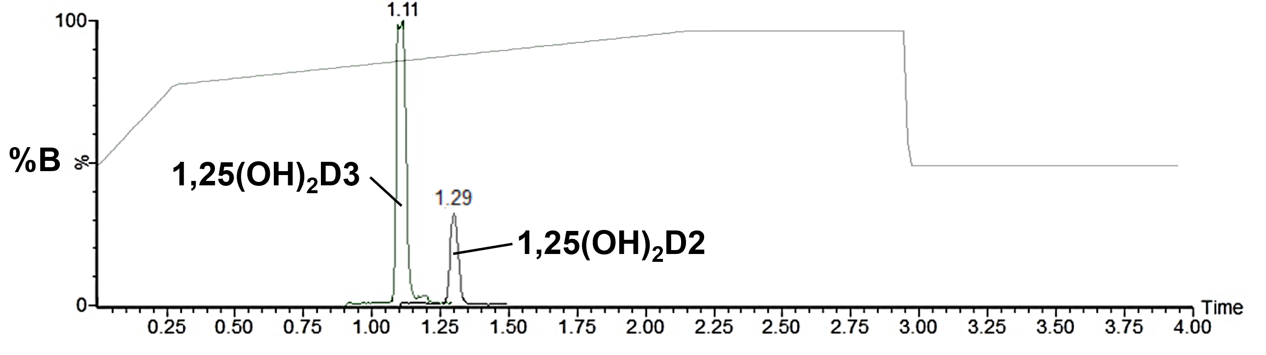

B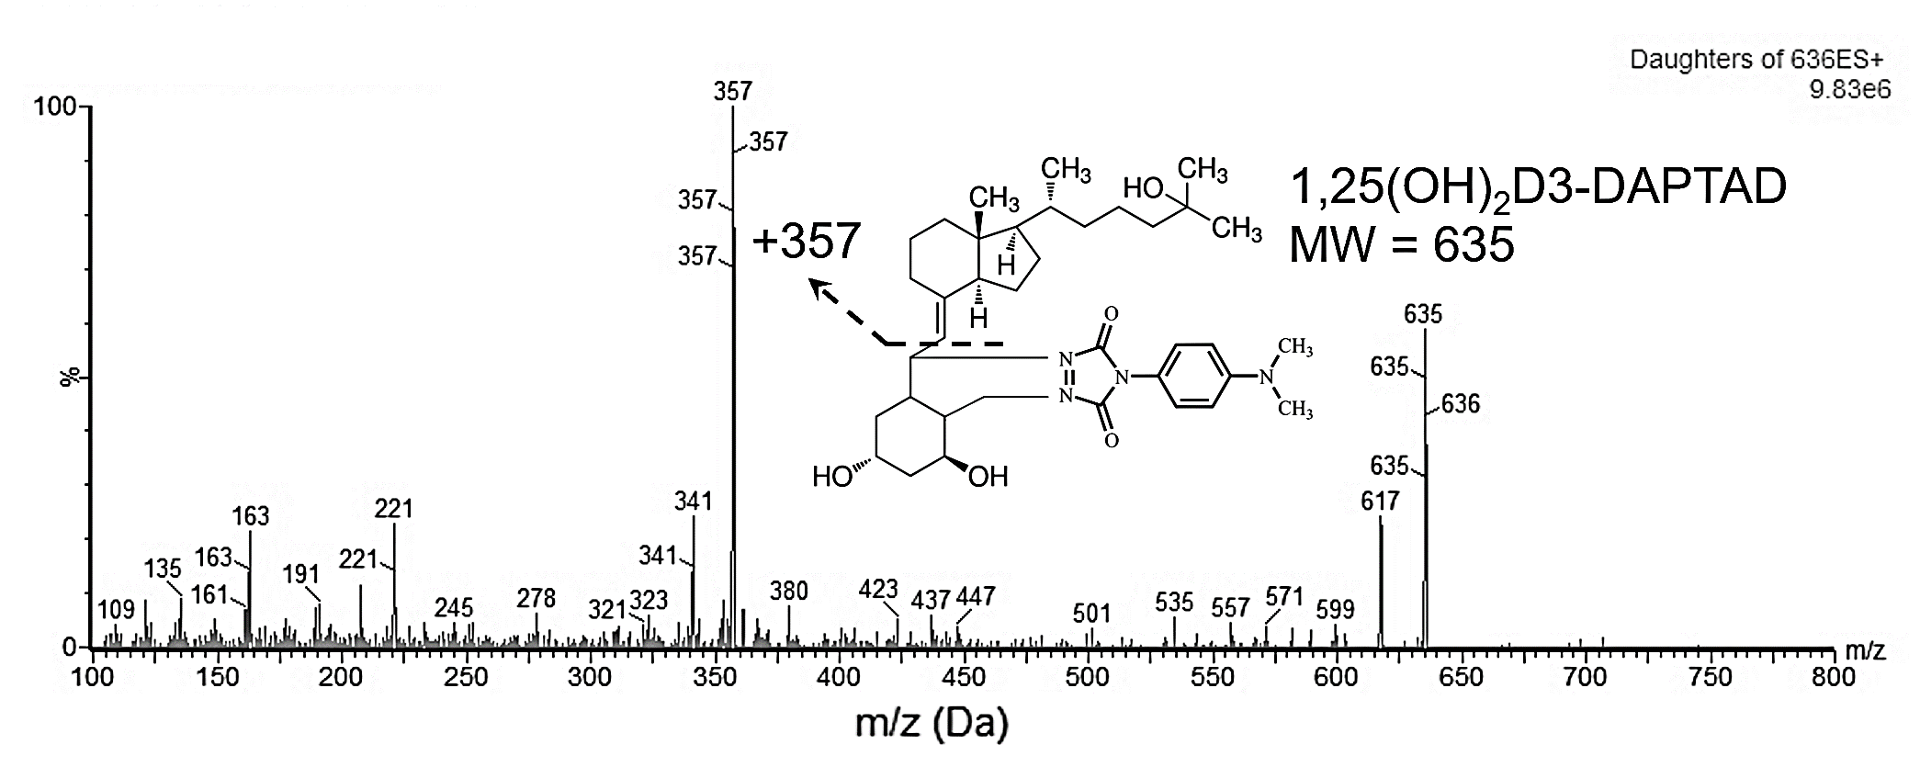

C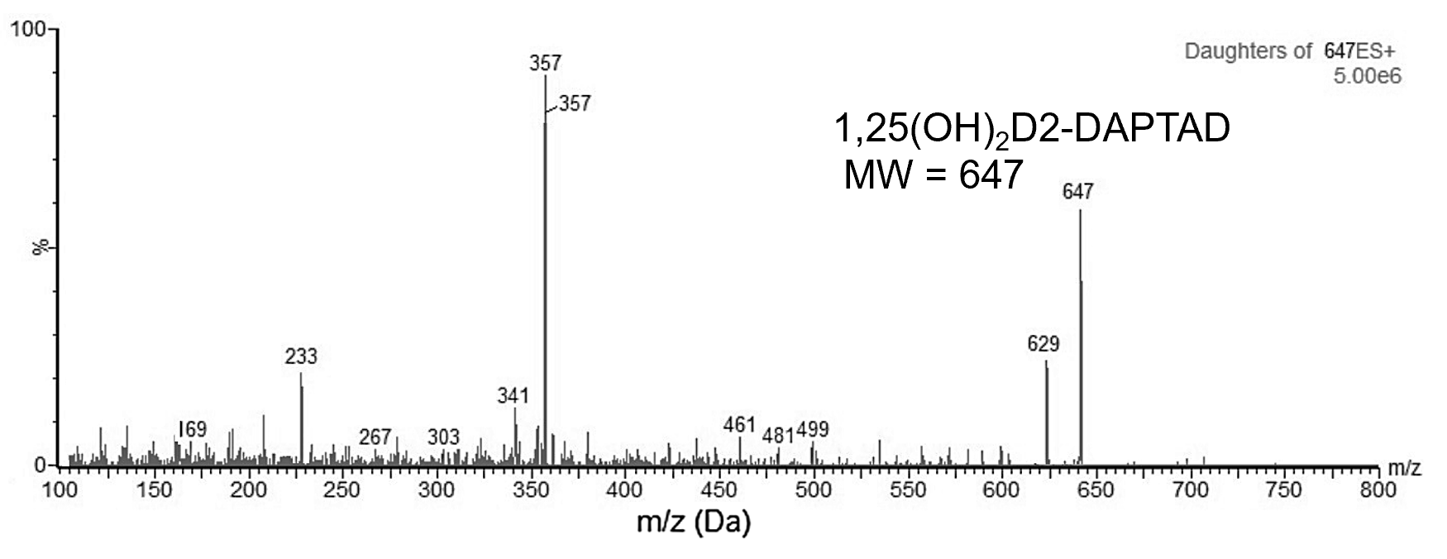

Figure 1A-C Liquid chromatography gradient elution and m/z transition profiles. **(A)** The percentage composition of mobile phase B (methanol in 0.1% formic acid) during a 4-minute gradient run. 1,25(OH)2D3 peak eluted at 1.10 minutes. **(B,C)** Mass spectrum of the precursor ion mass of DAPTAD-derivatised 1,25(OH)2D3 (m/z 635) and 1,25(OH)2D2 (m/z 647) to fragmentation product ion (m/z 357).

A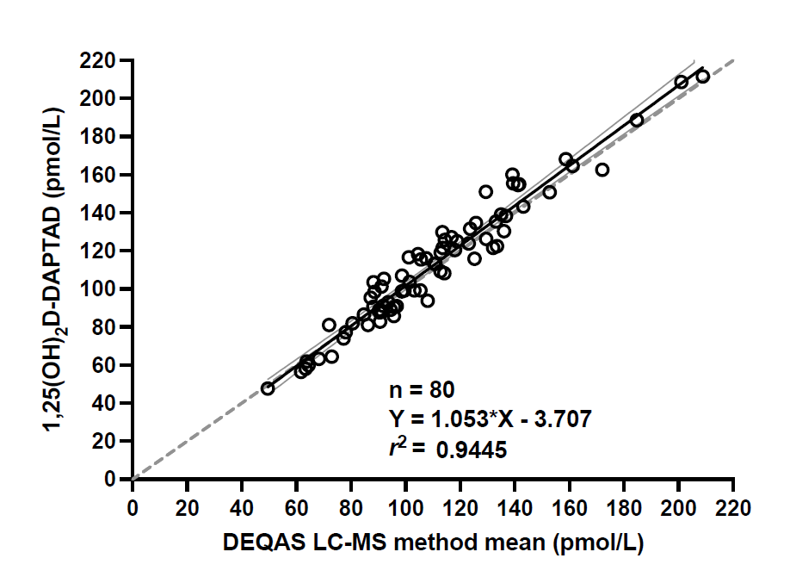

B

Figure 2A-B Comparison of 1,25(OH)2D on DEQAS returns submitted during April 2020 and Jan 2024 with DEQAS LC-MS method group mean (n=80). **(A)** Passing-Bablok regression analysis showing a highly significant correlation (r2=0.9445, p<0.001). The black solid line represents the line of regression, the 95% confidence bands in grey solid line, and the dashed line represents the line of identity. **(B)** Bland-Altman residual plot showing the percentage deviation of the measurements with DEQAS LC-MS group mean values. The dashed lines represent the mean bias. The dotted lines represent ±30% bias limits.

A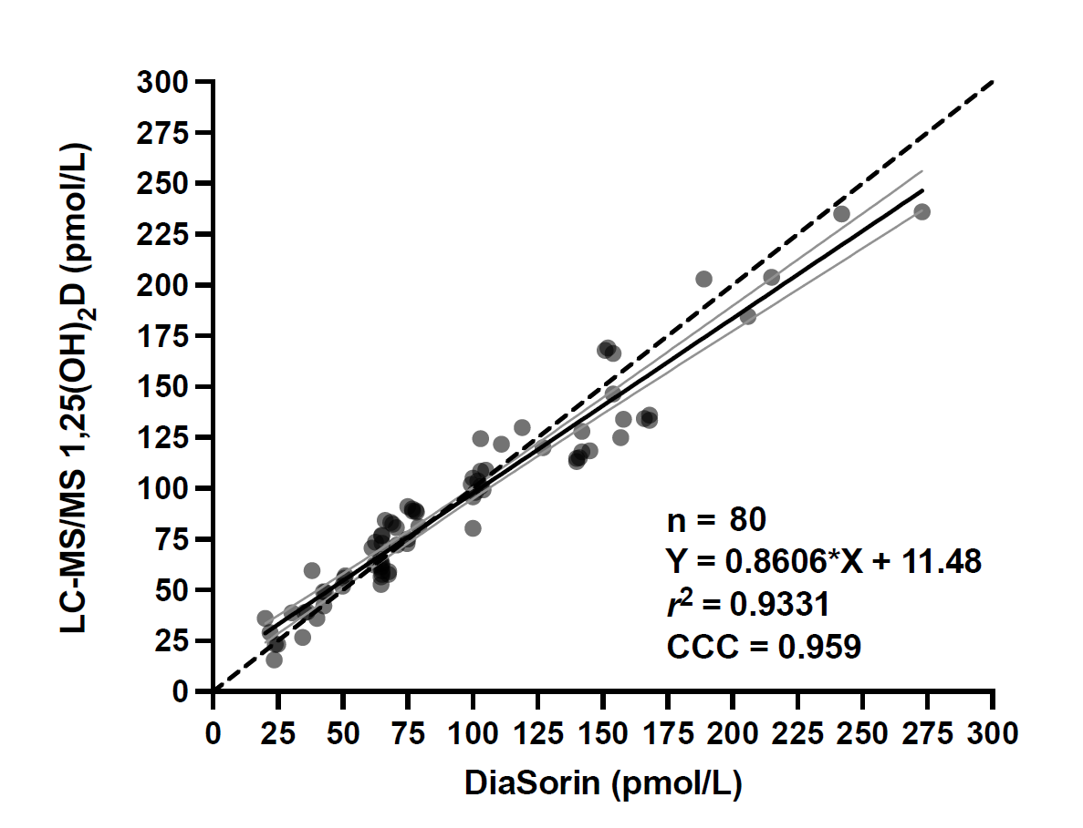

B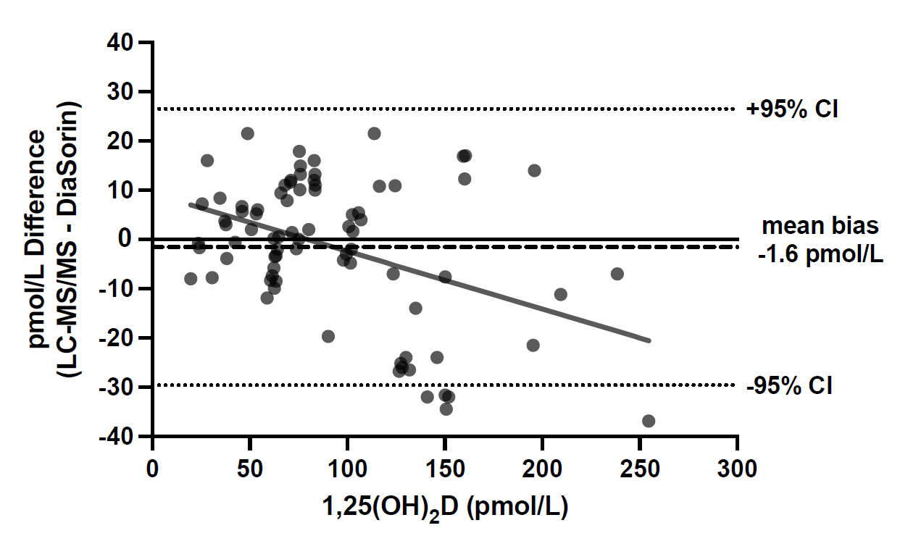

C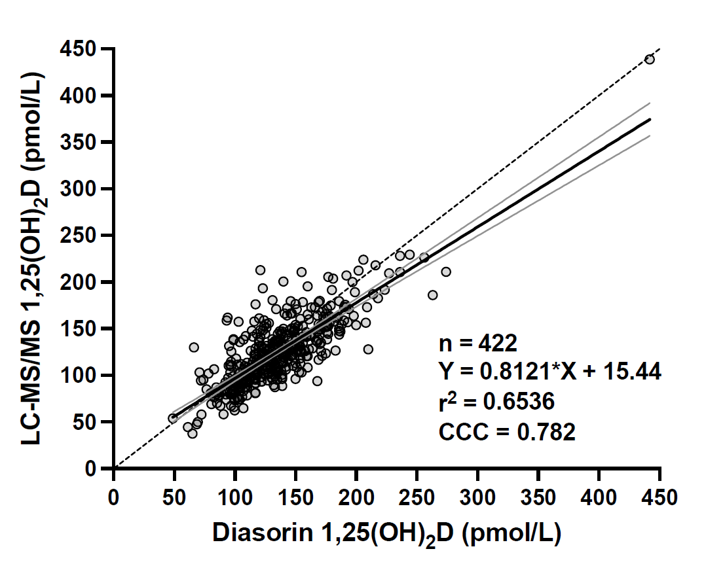

D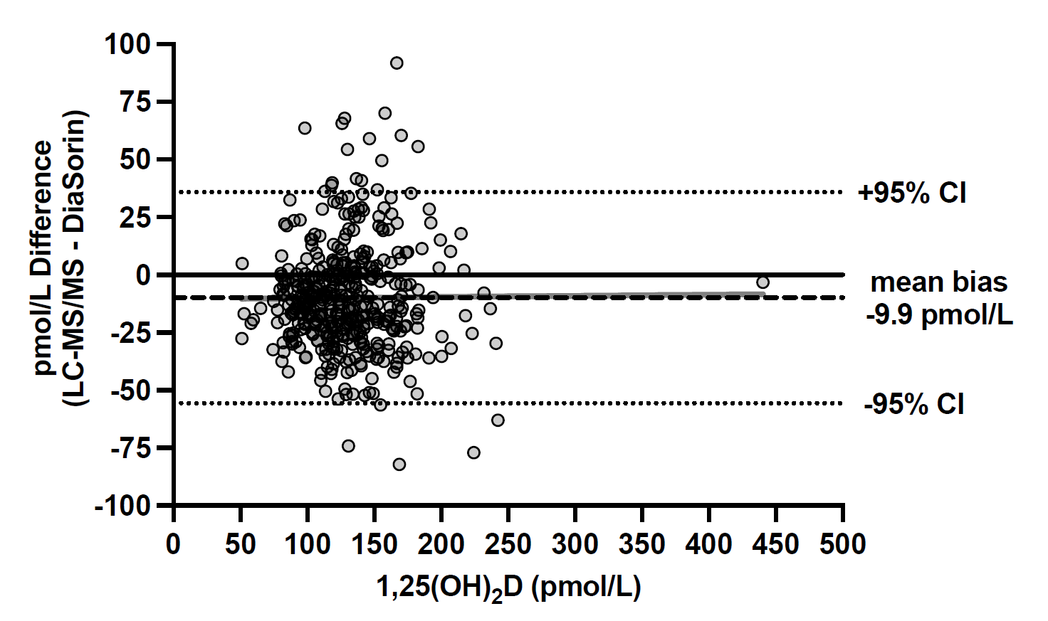

E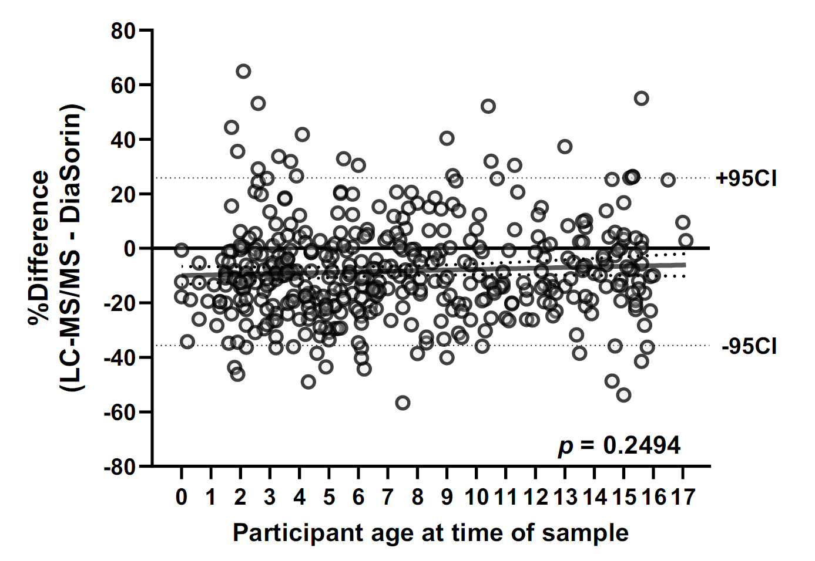

Figure 3A-E Comparison of 1,25(OH)2D values by LC-MS/MS against DiaSorin in **(A-E)** adult and **(C-E)** paediatric cohorts. **(A,C)** Passing-Bablok regression with a black solid line representing the regression lines and the 95% confidence bands in grey solid line. The dashed line represents the line of identity. *CCC* concordance correlation coefficient. **(B,D)** Bland-Altman plots display the deviation of the LC-MS/MS from the DiaSorin immunoassay. **(E)** Percentage deviation between the methods against the age of the participant in the paediatric cohort. The dotted lines represent ±95%CI limits of agreement, with the trend lines in grey.

**Table Legends**

|  |  |
| --- | --- |
| **Parameters** | **Setting** |
| Ion source | Electrospray positive |
| Capillary voltage | 1.7 kV |
| Cone energy | 30 V |
| Collision energy | 27 eV |
| Nebuliser gas flow rate | 7.0 Bar |
| Cone gas flow rate | 150 L/hr |
| Desolvation gas flow rate | 600 L/hr |
| Collison gas flow rate | 0.18 mL/min |
| Source temperature | 150°C |
| Desolvation gas temperature | 200°C |
| **m/z transitions (Precursor > Product)** | |
| 1,25(OH)2D3 | 635>357 |
| 1,25(OH)2D2 | 647>357 |
| 1,25(OH)2D3-[13C3] | 638>357 |

Table 1 Mass spectrometer settings and MRM precursor to product ion transitions for 1,25(OH)2D3/D2.

|  |  |  |  |
| --- | --- | --- | --- |
|  | | **1,25(OH)2D3** | **1,25(OH)2D2** |
| **Linearity, pmol/L**  **(typical *r*2)** | | 0-900 (0.977) | 0-900 (0.985) |
| **LLoQ (LLoD), pmol/L** | | 10 (5) | 10 (5) |
| **Imprecision**  **pmol/L (±SD), %CV** | **Intra-assay (n=6)** | 37.1 (±3.5) 9.4%  75.6 (±5.6) 7.4%  305.5 (±6.2) 2.0% | 39.7 (±3.6) 9.0%  81.5 (±4.9) 6.0%  434.7 (±11) 2.5% |
| **Inter-assay (n=18)** | 33.9 (±2.9) 8.7%  90.1 (±6.0) 6.7%  280.8 (±9.4) 3.4% | 41.3 (±3.8) 9.1%  125.2 (±8.5) 6.8%  287.5 (±13.0) 4.5% |
| **Recovery**  **spiked conc. pmol/L (mean recovery% ±SD)** | **Spiked into vitamin D depleted serum** | +50 (109%±2.1)  +100 (93%±6.5)  +300 (92%±8.2) | +50 (115%±6.5)  +100 (91%±4.6)  +300 (94%±1.2) |
| **Spiked into pooled EDTA plasma\*** | +50 (103%±2.5)  +100 (108%±5.6)  +300 (93%±6.2) | +50 (97%±3.5)  +100 (105%±5.6)  +300 (95%±6.2) |
| **Sample matrix comparison** | **Paired serum/EDTA plasma (n=30)** | $y=1.022x-2.093, r^{2}=0.98, p<0.001$ Limits of agreement: mean (±SD, 95%CI)  -0.33 (3.6, -7.4 to 6.8) pmol/L | |
| *Pooled EDTA plasma contained 164.3 pmol/L of 1,25(OH)2D3 and 19.2 pmol/L of 1,25(OH)2D2 | | | |

Table 2 Performance characteristics of the DAPTAD 1,25(OH)2D LC-MS/MS method. Recovery was determined by spiking fixed amounts of 1,25(OH)2D3 and 1,25(OH)2D2 into vitamin D depleted serum and a pool of EDTA plasma containing endogenous 1,25(OH)2D. Each spiked sample was analysed six times in separate runs.

|  |  |  |  |  |  |  |  |  |  |  |  |
| --- | --- | --- | --- | --- | --- | --- | --- | --- | --- | --- | --- |
| **Cohort** | **Profile** | **n** | **mean** | **SD** | **Min** | **5th Percentile** | **25th Percentile** | **Median** | **75th Percentile** | **95th Percentile** | **Max** |
| Adult pmol/L | 1,25(OH)2D3/total | 80 | 91.2 | 47.4 | 15.6 | 26.8 | 58.1 | 82.9 | 118.4 | 202.1 | 236.1 |
| 1,25(OH)2D2 | 0 | - | - | - | - | - | - | - | - | - |
|  | 1,25(OH)2D, total | 422 | 125.8 | 41.0 | 37.5 | 76.6 | 99.1 | 121.2 | 147.0 | 191.6 | 459.4 |
| Paediatric pmol/L | 1,25(OH)2D3 | 422 | 123.7 | 39.8 | 37.5 | 73.9 | 97.4 | 120.6 | 143.8 | 190.7 | 437.7 |
|  | 1,25(OH)2D2 | 42 | 20.7 | 16.2 | 10.3 | 10.5 | 12.5 | 16.3 | 21.1 | 74.3 | 85.2 |

Table 3. Distribution of 1,25(OH)2D concentrations in the adult and paediatric samples by LC-MS/MS.

|  |  |  |  |  |  |  |  |  |  |
| --- | --- | --- | --- | --- | --- | --- | --- | --- | --- |
|  |  | **Passing-Bablok regression analysis** | | | |  | **Concordance correlation analysis** | | |
| **Paediatric cohort** | **n** | **Slope (95%CI)** | **Intercept (95%CI)** | ***r*2** | ***p*-Value** |  | **CCC** | **95%CI** | **Cb** | |
| 1,25(OH)2D, All | 422 | 0.8121  (0.7554- 0.8688) | 15.44  (7.508-23.38) | 0.6536 | <0.01 |  | 0.782 | 0.743-0.815 | 0.967 | |
| 1,25(OH)2D, D3 only | 380 | 0.7666  (0.7015-0.8318) | 20.86  (11.93- 29.80) | 0.5847 | <0.01 |  | 0.732 | 0.684-0.774 | 0.957 | |
| 1,25(OH)2D, D3+D2 | 42 | 0.9178 (0.7907-1.045) | 5.12 (-15.81-26.05) | 0.8491 | <0.01 |  | 0.914 | 0.845-0.953 | 0.992 | |

Table 4. Passing-Bablok and Lin’s concordance correlation analyses comparing LC-MS/MS and DiaSorin methods in the paediatric cohort, subdivided into those with and without 1,25(OH)2D2 present. *r*2: regression coefficient; CCC concordance correlation coefficient; CI confidence interval; Cb: bias correction.