Title:
Acetate cleavage not direct interspecies electron transfer controls methane production revealed by carbon isotope tracing and genome-centric view

Jian Liu^{1#}, Jiafeng Yu^{1#}, Yang Tan², Run Dang², Meng Zhou³, Marcela Hernández⁴, Eric Lichtfouse⁵, Leilei Xiao^{2*}

¹ Shandong Key Laboratory of Biophysics, Institute of Biophysics, Dezhou University, Dezhou, 253023, P.R. China.
² CAS Key Laboratory of Coastal Environmental Processes and Ecological Remediation, Yantai Institute of Coastal Zone Research, Chinese Academy of Sciences, Yantai 264003, P.R. China.
³ State Key Laboratory of Black Soils Conservation and Utilization, Northeast Institute of Geography and Agroecology, Chinese Academy of Sciences, Harbin 150081, P.R. China
⁴ School of Biological Sciences, University of East Anglia, Norwich NR4 7TJ, UK.
⁵ State Key Laboratory of Multiphase Flow in Power Engineering, International Research Center for Renewable Energy, Xi'an Jiaotong University, Xi'an, Shaanxi, 710049, P.R. China
# These authors contribute equally
* To whom correspondence should be sent:
Leilei Xiao, Yantai Institute of Coastal Zone Research, 17 Chunhui Road, Laishan District, Yantai, Shandong 264003, China. Office number: +86 05352109269, Email: llxiao@yic.ac.cn.
Abstract：
Understanding the source of methane (CH₄) is of great significance for improving the anaerobic fermentation efficiency in bioengineering and mitigating the emission potential of natural ecosystems. Microbes involved in the process named direct interspecies electron transfer coupling with CO₂ reduction, i.e., electrons released from electroactive bacteria to reduce CO₂ into CH₄, have attracted considerable attention for wastewater treatment in the past decade. However, how the synergistic effect of microbiota contributes to this holistic anaerobic carbon metabolism accompanied by CH₄ production still remains poorly understood. This work showed that enhancing lower abundant acetoclastic methanogens and acetogenic bacteria rather than electroactive bacteria contributed to methane production based on a metagenome-assembled genomes network analysis. Natural and artificial isotope tracing of CH₄ precursor further confirmed that CH₄ mainly originated from acetoclastic methanogenesis. These findings underscore the contribution of direct acetate cleavage (acetoclastic methanogenesis) and provide an implication for further regulation of methanogenic strategies.
KEYWORDS: microbiome; biomethane; metagenome-assembled genome; acetate metabolism; antibiotic exposure

1. Introduction
Atmospheric methane (CH₄) is a powerful greenhouse gas, which plays a major role in controlling the Earth’s climate. Depending on the approach used, total CH₄ emissions from natural and anthropogenic sources range between 538 and 884 Tg yr⁻¹ (Saunois et al., 2020), accounting for 16-25% of atmospheric warming to date (Etminan et al., 2016; IPCC, 2014). Specially, the latest comprehensive assessment from the International Energy Agency reported global CH₄ emissions at about 580M metric tons in 2021, of which about 60 % came from human activities (IEA, 2021). A better understanding of the anthropogenic contribution to global CH₄ emissions is therefore critical for a more robust understanding of atmospheric CH₄ change. On the other hand, optimizing biomethane production is also needed to develop sustainable fuels and waste/wastewater treatment (Cavalcante et al., 2021; Xiao et al., 2021a). Despite this importance, microbial CH₄ production in man-made environments is still under debate and remains poorly understood compared to natural ecosystems (De Bernardini et al., 2022; Hultman et al., 2015).
Currently, some strategies explain CH₄ production, including acetoclastic methanogenesis, hydrogenotrophic methanogenesis, and direct interspecies electron transfer (DIET)-CO₂ reduction. Acetate is the classical intermediate in the organic biomass degradation to produce biomethane by acetoclastic methanogens in anaerobic niches (Eq. 1) (Conrad, 2005; Xiao et al., 2020b). Acetoclastic methanogenesis has been estimated to account for two-thirds of the one billion metric tons of CH₄ produced annually in Earth’s biosphere (Conrad, 2005; Prakash et al., 2019), despite only a few methanogens, Methanosarcina and Methanosaeta, known to transform acetate into CH₄ (Holmes and Smith, 2016). Methanosarcina and Methanosaeta also have the potential to reducing CO₂ to CH₄ (Dong et al., 2022), and dominated in the artificial anaerobic system (Eq. 2) (Dong et al., 2022; Wang and Lee, 2021).
Acetoclastic methanogenesis: CH₃COO⁻ + H⁺→CH₄ + CO₂ (Eq. 1)
Hydrogenotrophic methanogenesis: 4H₂ + CO₂ → CH₄ + 2H₂O (Eq. 2)
DIET-CO₂ reduction: 8H⁺ + 8 e⁻ + CO₂ → CH₄ + 2H₂O (Eq. 3)
DIET involves the direct transfer of electrons from electroactive bacteria to methanogenic archaea, which reduces CO₂ into CH₄ (Eq. 3) with higher efficiency compared to mediated interspecies electron transfer (MIET) by the diffusion of H₂/formate (Stams and Plugge, 2009). DIET-CO₂ reduction is thought to be an important process in anaerobic systems, especially for wastewater, because it does not rely on the exchange of diffusible molecules (Jin et al., 2022; Kumar et al., 2021). Nevertheless, Geobacter is the only bacteria with evidence to establish syntrophism with methanogens via DIET (Rotaru et al., 2013; Van Steendam et al., 2019). Therefore, CH₄ generation by DIET-CO₂ is attributed to indirect evidence, and these experimental observations require validation (Van Steendam et al., 2019; Wang and Lee, 2021).
Antibiotics, widely used in human medical practice and livestock husbandry, show a substantial increase in wastewater, threatening the environment and human health (Langbehn et al., 2021; Zhang et al., 2021). Antibiotic residuals alter the composition of microorganisms in wastewater and affect the performance of anaerobic digestion (Yang et al., 2021; Zhi et al., 2019). The influence of different antibiotics on biogas production, however, is unpredictable. Some studies showed a stimulating effect on CH₄ production with the highest increase of 59.97% (Tang et al., 2022; Wang et al., 2022; Zhi and Zhang, 2019). In contrast, an inhibition effect of up to 40% was also reported (Mitchell et al., 2013; Zeng et al., 2021). Antibiotics inhibit the syntrophic or competitive bacteria of methanogenic archaea, which seems to fluctuate CH₄ production in wastewater (Xiao et al., 2021b; Zhi et al., 2019; Zhi and Zhang, 2019). Yet the persistent knowledge gaps about the intrinsic methanogenic strategies have always limited the anaerobic wastewater treatment process and efficiency (Hua et al., 2022; Langbehn et al., 2021; Xiao et al., 2021b).
In this study, Metagenome-assembled genomes (MAGs) analysis identified some functional units, such as electricigens and electron-accepting methanogens, but co-occurrence networks analysis suggested a marginal contribution from DIET-CO₂ reduction. Two hypotheses were proposed: (1) microbiota more than individual microbe actively respond to antibiotic exposure; (2) acetoclastic methanogenesis outcompetes DIET to control wastewater methanation.
2. Materials and methods
2.1 Microcosm experiments
The artificial wastewater for the subsequent experiments was referred to the previous study (Song et al., 2019). For all microcosm experiments, three cycles of vacuum/charging high-purity N₂ were conducted to create the anaerobic environments. Norfloxacin or ciprofloxacin was added as the antibiotics-bearing wastewater. The concentration of the antibiotics was monitored by fixed-point sampling throughout the experimental process. Acetate was used as the substrate for bacteria and methanogen with a final concentration of ~30 mM. Vials were incubated at room temperature (25 °C) and mesophilic temperature (35 °C). Samples were sacrificed in triplicate to test the concentrations of acetate, CH₄, H₂, and CO₂ after 24 days of incubation (Xiao et al., 2020b, 2020a).
2.2 DNA extraction, separation, and sequencing
About 0.5g of sludge was collected on day 8 for metagenomic sequencing, when the antibiotic had a significant effect on the CH₄ concentrations (P< 0.01). The total DNA was extracted using E.Z.N.A.® Soil DNA Kit (Omega Bio-tek, Norcross, GA, U.S.) according to the manufacturer’s instructions. The extracted total DNA was eluted in nuclease-free water, sheared, and sent for paired-end library preparation with fragment insert sizes of approximately 400 nt. Paired-end (PE) libraries were constructed using NEXTflexTM Rapid DNA-Seq Kit (Bio Scientific, Austin, TX, USA). Adapters containing the full complement of sequencing primer hybridization sites were ligated to the blunt end of fragments. The library was sequenced by using Illumina Hiseq Xten (Illumina Inc., San Diego, CA, USA) at Wefindbio Technology Co., Ltd. (Wuhan, China). Because one sample did not get enough sequencing data, only two of the triplicates in the control group were kept for the downstream analysis. Sequence data associated with this project have been deposited in the NCBI Short Read Archive database (Accession Number: PRJNA734822).
2.3 Assembly of metagenomic data sets
The de novo assembly of metagenomic sequences was conducted on a Linux server with 88 CPU cores and 1TB RAM. Trimmomatic was applied to remove adapters and filter low-quality reads. The resulting reads were aligned to the human genome Hg38 by BBmap (http://sourceforge.net/projects/bbmap/) to remove contaminations. The final clean reads of all eight samples were co-assembled using MEGAHIT with default parameters. The final contigs were filtered, and only contigs > 500 bp were selected for downstream analysis. The quality of the assembly was assessed by QUAST.
2.4 Genomic binning and annotation
The binning process was performed with MetaWRAP. Briefly, the assembly was binned with MaxBin2, MetaBAT2, and CONCOCT using the binning module, respectively. The produced bins were refined using the bin_refinment module with completeness > 50, and contamination < 10 as the thresholds. The filtered bins were further improved through the bin_reassembly module, which reassembled the bins by SPAdes. The final bins were quantified through the bin_quant module, which first quantified the contigs by Salmon and calculated the average counts of the whole bins, then normalized each bin as copies per million reads.
The taxonomy annotation of the bins was performed with GTDB-Tk. It first predicted the ORFs of the bins by Prodigal, then 120 single-copy proteins of bacteria and 122 single-copy proteins of archaea were retrieved and aligned with the GTDB database. The concatenated alignment was used to build a phylogenetic tree. Meanwhile, the average nucleotide identity (ANI) of the bins was calculated by FastANI. The taxonomy annotation was performed based on their position on the phylogenetic tree and the ANI similarity.
The ORFs of the bins were predicted by Prodigal, with the default parameters. The final protein sequence files were annotated with eggNOG-Mapper, which aligns the protein sequences to their pre-build database and annotates their function, KEGG assignment, GO assignment, and COG assignment by the best hit.
2.5 Phylogenetic analysis
The genomes were subjected to GTDB-Tk to align the single-copy proteins. Then the concatenated alignments were used to build the phylogenetic tree using IQtree with 100 times bootstrap. Known syntrophic acetate-oxidizing bacteria (SAOBs) were obtained from experiments validated studies (Yu et al., 2022).
2.6 Composition analysis
Kraken2 was applied to assess the microbial composition at the reads level. With Kraken2, the reads were aligned with the RefSeq database, and the taxonomy assignments were selected through the LZW ancestor algorithm. The alpha diversity was calculated at species levels with the Microbiome package (http://microbiome.github.com/microbiome) in R (www.r-project.org). The Bray-Curtis distance and PCoA analysis were calculated based on species count with the Vegan package in R.
2.7 Potential c-type cytochrome prediction
Proteins were considered c-type cytochromes if their sequence contained at least one CXXCH motif for covalent heme-binding (where X can be anything except one of [CFHPW]). The motif screening on the protein sequences was performed with ScanProsite.
2.8 Co-occurrence network analysis
The co-occurrence networks of the MAGs in each group were constructed using the CoNet application in Cytoscape with duplicated abundance data. The Pearson, Spearman, Bray-Curtis, and Kullback-Leibler correlation methods were chosen to evaluate pairwise associations among the MAGs, with the initial threshold of 1000 positive and 1000 negative edges from each method. The compositionality bias was alleviated by 1000 renormalized permutations and 1000 bootstrap scores. Edges with Benjamini-Hochberg adjusted p value less than 0.01 were kept for the co-occurrence networks, which were visualized with the igraph package in R.
2.9 Isotopic analysis and inhibition of acetoclastic methanogenesis
Carbon stable isotope fractionation and artificial abundance isotope tracing with 3% or 6% ¹³CH₃COONa (Merck KGaA, Darmstadt, Germany) as substrates were conducted. Gases collected from the headspace were used to test the δ¹³C-values of CH₄ and CO₂. CH₃F was applied to inhibit the progress of acetoclastic methanogenesis. Some amount of nitrogen was replaced with 1.5% CH₃F gas as previously reported (Xiao et al., 2020b, 2020a).
2.10 Statistical analysis
Data were presented as mean ± standard deviation of triplicate cultures. All statistical analyses were performed with SPSS 19.0 (SPSS Inc., Chicago, USA) and Origin 8.5 (Origin Lab Corporation, USA) software. A one-way analysis of variance with HSD’s test was used to analyze the significance level, and a p-value < 0.05 was considered statistically significant.
3. Results and discussion
3.1 CH₄ production with antibiotic exposure
Anaerobic treatment of eutrophic wastewater is one of the few proven, economical, and friendly strategies. Due to the production of abundant CH₄ during this progress, partitioning of methanogenic strategy would be of great interest to allow better management (Guo et al., 2021; Mancini et al., 2021). Unlike the negative effects of antibiotics on bacteria, these substances created a more favorable environment for biogenic CH₄ production (Figure 1a), especially from the influence of ciprofloxacin. Consequently, the maximum CH₄ yield significantly increased (p = 0.015 for ciprofloxacin, p = 0.023 for norfloxacin).
3.2 Microbiome composition
To unveil the impact of antibiotics on microbial community, the microbial diversity was analyzed based on high-quality reads. The Shannon and Inverse Simpon Index, which reflex the complexity and evenness of the community (Hultman et al., 2015), demonstrated that antibiotics decreased microbial diversity (p = 0.0012 for ciprofloxacin, p = 0.0023 for norfloxacin, Figure 1b). The principal coordinates analysis (PCoA) on the Bray-Curtis distances, which can show the dissimilarity among samples (De Bernardini et al., 2022), further confirmed this tendency with noticeable community differences (p = 0.032, Figure 1c). On the phylum level, both norfloxacin and ciprofloxacin decreased the proportion of Proteobacteria (p = 0.033 for ciprofloxacin, p = 0.041 for norfloxacin) while increased Euryarchaeota (p = 0.041 for ciprofloxacin, p = 0.045 for norfloxacin) (Figure 1d). The favorable CH₄ production performance could have resulted from the increased abundance of methanogens belonging to Euryarchaeota.
Metagenomic binning technology was reported to isolate genomes of individual species (MAGs) from the mixed sequencing data based on sequence characteristics such as abundance, GC percentage, etc. (Chen et al., 2020). Similarly, MAG analysis was applied to explore further the microbiome variation at the species level in this study. Over 100Gbp of high-quality metagenome sequencing data were co-assembled, resulting in 284,942 contigs with an N50 of 9,179 bp (see supplementary material). 246 unique bacterial and archaeal metagenome-assembled genomes (MAGs) were recovered through genome binning from the co-assembly step, including 57 high-quality MAGs (completeness > 95% and contamination <5%) and 189 medium-quality MAGs (completeness > 50% and contamination < 10%). The overall average completeness and contamination were 84% and 2%, respectively. 220 MAGs were classified as bacteria, and the prevalence phyla identified were Proteobacteria (46), Chloroflexi (37), Firmicutes (20), Planctomycetes (20), Spirochaetes (20), and Bacteroidetes (19) (Figure 1e). The relative abundance of one Proteobacteria (MAG.173) sharply decreased with the presence of antibiotics (p = 0.0003 for ciprofloxacin, p = 0.0002 for norfloxacin, Figure 1e). The abundance of other phyla showed slight improvements, such as Thermotogae (MAG.82, p = 0.023 for ciprofloxacin, p = 0.042 for norfloxacin), Planctomycetes (MAG.150, p = 0.037 for ciprofloxacin, p = 0.028 for norfloxacin), and Nitrospirae (MAG.22, p = 0.011 for ciprofloxacin, p = 0.035 for norfloxacin).
3.3 Co-occurrence networks for bacterial and archaeal genomes
Here, co-occurrence networks were constructed (Figure 2). A total of 245, 243, and 243 nodes were retrieved in the control, norfloxacin, and ciprofloxacin groups, respectively, with similar archaeal and bacterial proportions: 89% for bacteria and 11% for archaea (Figure 2a). The network for the control group contained 3,359 edges (Figure 2b). In contrast, these links sharply decreased to 2,208 and 1021 in the groups with antibiotics (Figure 2b), implying weakened interactions between bacteria and archaea or strong selectivity by methanogens with antibiotic exposure.
Sub-networks among bacterial and the two most abundant methanogen MAGs (MAG.91 and MAG.3) were further retrieved (Figure 2c,d). The sub-networks of Methanolinea were constituted with 151 (control), 130 (norfloxacin), and 41 (ciprofloxacin) nodes and 198 (control), 151 (norfloxacin), and 41 (ciprofloxacin) edges. In contrast, the sub-networks of Methanosaeta had 221 (control), 60 (norfloxacin), and 48 (ciprofloxacin) nodes and 220 (control), 116 (norfloxacin), and 46 (ciprofloxacin) edges. The number of nodes and edges of both sub-networks decreased in the presence of antibiotics, especially for ciprofloxacin (Figure 2c,d). The proportion of Methanosaeta-related links exhibited a similarly decreased trend (7%, 5%, and 5%, Figure 2d), further indicating a simplified co-occurrence relationship between functional bacteria and Methanosaeta present in the treatments with antibiotics.
3.4 Genomes for methanation by weak syntrophy via DIET-CO₂ reduction
A phylogenetic analysis based on 120 conserved single-copy genes was performed to identify potential bacteria with DIET capacity (see supplementary material), which may connect a close network with Methanolinea and/or Methanosaeta. Ten MAGs were placed close to known exoelectrogens, 6 of which were Proteobacteria, with 3 of them within the Geobacter clade. MAG.156 placed in this clade was the most abundant genome and favored by norfloxacin (p = 0.037) and ciprofloxacin (p = 0.021) (see supplementary material), suggesting a potential DIET-CO₂ reduction progress. However, after further analysis of multiple c-type cytochromes (CytCs) and e-pili, which generally participate in DIET, MAG.156 had only 17 CytCs and 2 MH-CytCs, less than most exoelectrogen candidates (see supplementary material).
Among these 10 MAGs, the critical component of the conductive pilus, PilA, was also shown in their genome, yet its abundance was low and decreased to almost absent with antibiotics. CyCs and MH-CyCs were also identified in MAG.115 of the Rhodobacter clade, of which the abundance also decreased with antibiotics (p = 0.041 for ciprofloxacin, p = 0.033 for norfloxacin). MAG.154 was in third place of CytC numbers and contained two copies of PilA genes, but its abundance was negligible. The overall abundance of CytCs (p = 0.002 for ciprofloxacin, p = 0.003 for norfloxacin) and PilA (p = 0.041 for ciprofloxacin, p = 0.047 for norfloxacin) in the microbiomes showed decreasing tendencies with antibiotics treatments.
A phylogenetic analysis was performed with the bacterial MAGs and genomes of seven syntrophic acetate-oxidizing bacteria (SAOBs) species from different phyla. Five MAGs were closely placed with known SAOB species, belonging to Firmicutes, Proteobacteria, and Thermotogae (see supplementary material), indicating their acetate oxidizing potential. The most abundant MAG in the control group, MAG.173, was grouped with the experimentally proved SAOB Thiopseudomonas denitrificans (see supplementary material). However, the drastic decrease in abundance with the addition of antibiotics (p = 0.0003 for ciprofloxacin, p = 0.0002 for norfloxacin) suggested that the consumption of acetate diminished (see supplementary material). With very low abundance, some other bins, such as MAG.39 and MAG.103, were grouped with Clostridium ultunense (see supplementary material).
CO₂ reduction to generate CH₄ is presently considered a predominant process in artificial digestion systems (Ajay et al., 2020; Noori et al., 2020). Of which, the core pathway is considered to be an increase in DIET. But many studies have only analyzed the 16S rDNA with some signal of potential electricigens (Martins et al., 2018; Van Steendam et al., 2019), and even undetectable of approved electrogenic bacteria (Cui et al., 2021; Qi et al., 2021). No correlation between increased CH₄ generation and electrical conductivity was observed, suggesting that DIET is partly involved at most (Martins et al., 2018). Many investigations lacked direct experimental evidence for the role of DIET in enhancing the anaerobic digestion performance (Van Steendam et al., 2019).
3.5 Genomes for acetate turnover and methanation
Several bacteria regulated by antibiotics were not linked to MIET or DIET through phylogenetic analysis. Their genomic repertoire was explored, and variable metabolic characteristics were found. Most bacteria stimulated by antibiotics were primarily acetate-producing bacteria by degrading macromolecules, such as polysaccharides (MAG.216), lipids (MAG.22), and proteins (MAG.253). Meanwhile, they all contained the first two enzymes of the Wood-Ljungdahl pathway to convert acetate to acetyl-CoA, showing the potential to provide substrates for methanogens. Methanosaeta sp PtaB.Bin018 (MAG.207 and MAG.3, Figure 3a), the second most abundant methanogen, contained the required enzymes for acetoclastic pathways (Figure 3b,c). Of particular importance, both antibiotics increased their abundance with the highest stimulated effect from ciprofloxacin (p = 0.003 for ciprofloxacin, p = 0.023 for norfloxacin, Figure 3c).

3.6 Prevalent acetoclastic methanogenesis evidenced through isotopic analysis
To link CH₄ production to its precursor, ¹³C values of CH₄ and CO₂ were analyzed on the 6th, 8th, and 10th day (Figure 4a). There was no difference in δ¹³C-CH₄ between the antibiotic-containing and original artificial wastewater with values around -40‰ (Figure 4a), the typical CH₄ sources for acetoclastic methanogenesis. The α values were all below 1.030 at the mid-term of the experiment and maintained at around 1.02 at the late stage (Figure 4b). The natural abundance of carbon isotope fraction experiment showed typical δ¹³C-CH₄ and α values ranging in acetoclastic methanogenesis (Conrad et al., 2021; Conrad and Klose, 2011; Xiao et al., 2020b), implying that ciprofloxacin acted as a positive motivating factor on acetate disproportionation followed by norfloxacin.
When applying the acetoclastic methanogenesis inhibitor methyl fluoride (CH₃F), the acetate consumption (see supplementary material) and CH₄ production (see supplementary material) were severely reduced. CH₃F, an inhibitor of acetoclastic methanogenesis, significantly reduced the efficiency of CH₄ production with a decrease of an order of magnitude. Furthermore, the isotope tracing analysis showed that ¹³C-CH₄ abundance was positively correlated with CH₄ concentration (see supplementary material), confirming that the methyl group of acetate was markedly transferred to CH₄ rather than CO₂ (Li et al., 2018; Xiao et al., 2020b). Thus, acetate was directly cleaved to CH₄ and CO₂, rather than oxidized to two CO₂ in this study. Increasing evidence already suggests that acetate-dependent methanogenesis is significantly enhanced by some conductive materials during anaerobic digestion, whereas CO₂-dependent methanogenesis is reduced (Lü et al., 2020; Yu et al., 2022).
To validate these results from natural carbon, isotope-marked substrates (3% and 6% ¹³CH₃COONa) were used. The CH₄ production scenarios were similar between 3% and 6% ¹³CH₃COONa (Figure 5a,b), indicating the reliable performance of the floxacin in promoting methanogenesis. In general, CH₄ produced in the original wastewater without antibiotics had a low ¹³C abundance (Figure 5c,d). For example, for the 3% ¹³CH₃COONa treatment, ¹³C-CH₄ abundance in the middle (day 15) and end (day 21) was about 2% and 3%, respectively (Figure 5c). When the abundance of ¹³CH₃COONa doubled, ¹³C-CH₄ was about 3% and 8%, respectively (Figure 5d). Antibiotics significantly increased ¹³CH₄ abundance, with ciprofloxacin showing the highest performance reaching 12% (Figure 5c,d). For both ¹³CH₃COONa addition treatments, CH₄ yield and ¹³C-CH₄ abundance showed a close positive correlation (p = 0.0001 and 0.0003, respectively; see supplementary material). Remarkably, ¹³C-CH₄ isotope strongly predicted CH₄ production rates (R² = 0.779 and 0.828, respectively; see supplementary material).
Compared with ¹³C-CH₄ abundance, the ¹³C-CO₂ abundance was very low. No difference in ¹³C-CO₂ abundance was detected between antibiotic-containing and original wastewater (Figure 5e,f). In the 3% of ¹³CH₃COONa treatment, ¹³C-CO₂ was below 1%, typical natural abundance, as well as in the presence of highly ¹³C-labelled sodium acetate (Figure 5e). Similarly, it also maintained a relatively stable and low value under 6% in the ¹³CH₃COONa treatment (Figure 5f). Based on Pearson analysis of CH₄ concentration and ¹³C-CO₂ abundance, no correlation between increased CH₄ yield and CO₂ reduction for methanation was observed (p = 0.864 and 0.705, respectively; see supplementary material).
If the CH₄ production process is completed via the acetoclastic methanogenesis alone in an acetate-rich environment, the energy obtained can be fully utilized by methanogens. However, if it comes from DIET-CO₂ reduction, the same small amount of energy needs to be shared by two kinds of cooperative microorganisms, fermentative bacteria and methanogenic archaea (Roy et al., 2022; Xiao et al., 2020b). Combined with the energy release of methanogenic archaea, acetoclastic methanogenesis releases more energy than CO₂ reduction in a nominal environment. According to the data from a previous study (Bethke et al., 2011), when 1 mol of CH₄ is produced, 32 or 1 kJ of energy is available by acetoclastic methanogenesis or hydrogenotrophic methanogenesis, respectively. In the present study, CO₂ reduction seems to be not the optimal option in terms of survival strategy.
The findings in this work underscore the contribution of acetoclastic methanogenesis to CH₄ production during anaerobic digestion through genome-centric and isotope tracing, implicating that more direct evidence should be taken into account during the research of biomethane production. Nevertheless, this work has certain limits. The experiment was carried out with mimic wastewater at the microcosm level. Studies with industrial bioreactors and real wastewater should be taken in the future.
5. Conclusion
Methanosaeta acted as the leading CH₄ producer. The category of acetate-consuming bacteria showed decreased numbers in wastewaters with antibiotics as well as their proportions in the sub-networks. Herein, the ratio of acetogenic MAGs was enhanced several folds by antibiotics. Methanogens tended to complete methanogenesis and were inspired by acetogenic bacteria. Therefore, it is pertinent that future laboratory or in-situ experimentation should attach importance to acetate turnover to better optimize wastewater treatment and energy recovery strategy.

E-supplementary data for this work can be found in e-version of this paper online.

Acknowledgements
This work was supported by Youth Innovation Promotion Association, CAS (2021213), the National Natural Science Foundation of China (42077025, 42277236), the Youth Science and Technology Innovation Plan of Universities in Shandong (2019KJE007).
Data availability statement
All data needed to evaluate the conclusions in the paper are present in the paper and/or the Supplementary Materials. The metagenomic sequencing data have been deposited in the National Center for Biotechnology Information (NCBI) Short Read Archive database (SRA, https://www.ncbi.nlm.nih.gov/bioproject/PRJNA734822 ).
Conflict of interest
The authors declare that they have no conflict of interest.

References
1. Ajay, C.M., Mohan, S., Dinesha, P., Rosen, M.A., 2020. Review of impact of nanoparticle additives on anaerobic digestion and methane generation. Fuel. 277, 118234.
2. Bethke, C.M., Sanford, R.A., Kirk, M.F., Jin, Q., Flynn, T.M., 2011. The thermodynamic ladder in geomicrobiology. Am. J. Sci. 183–210.
3. Chen, L.X., Anantharaman, K., Shaiber, A., Murat Eren, A., Banfield, J.F., 2020. Accurate and complete genomes from metagenomes. Genome Res. 30, 315–333.
4. Cavalcante, W.A., Gehring, T.A., Zaiat, M., 2021. Stimulation and inhibition of direct interspecies electron transfer mechanisms within methanogenic reactors by adding magnetite and granular actived carbon. Chem. Eng. J. 415, 128882.
5. Conrad, R., 2005. Quantification of methanogenic pathways using stable carbon isotopic signatures: A review and a proposal. Org. Geochem. 36, 739–752.
6. Conrad, R., Klose, M., 2011. Stable carbon isotope discrimination in rice field soil during acetate turnover by syntrophic acetate oxidation or acetoclastic methanogenesis. Geochim. Cosmochim. Acta. 75, 1531–1539.
7. Conrad, R., Liu, P., Claus, P., 2021. Fractionation of stable carbon isotopes during acetate consumption by methanogenic and sulfidogenic microbial communities in rice paddy soils and lake sediments. Biogeosciences. 18, 6533–6546.
8. Cui, Y., Mao, F., Zhang, J., He, Y., Tong, Y.W., Peng, Y., 2021. Biochar enhanced high-solid mesophilic anaerobic digestion of food waste: Cell viability and methanogenic pathways. Chemosphere. 272, 129863.
9. De Bernardini, N., Basile, A., Zampieri, G., Kovalovszki, A., De Diego Diaz, B., Offer, E., Wongfaed, N., Angelidaki, I., Kougias, P.G., Campanaro, S., Treu, L., 2022. Integrating metagenomic binning with flux balance analysis to unravel syntrophies in anaerobic CO₂ methanation. Microbiome. 10, 117.
10. Dong, D., Kyung Choi, O., Woo Lee, J., 2022. Influence of the continuous addition of zero valent iron (ZVI) and nano-scaled zero valent iron (nZVI) on the anaerobic biomethanation of carbon dioxide. Chem. Eng. J. 430, 132233.
11. Etminan, M., Myhre, G., Highwood, E.J., Shine, K.P., 2016. Radiative forcing of carbon dioxide, methane, and nitrous oxide: A significant revision of the methane radiative forcing. Geophys. Res. Lett. 43, 12,614-12,623.
12. Guo, Q., Wang, Y., Qian, J., Zhang, B., Hua, M., Liu, C., Pan, B., 2021. Enhanced production of methane in anaerobic water treatment as mediated by the immobilized fungi. Water Res. 190, 116761.
13. Holmes, D.E., Smith, J.A., 2016. Biologically produced methane as a renewable energy source. Adv. Appl. Microbiol. 97, 1–61.
14. Hua, H., Jiang, S., Yuan, Z., Liu, X., Zhang, Y., Cai, Z., 2022. Advancing greenhouse gas emission factors for municipal wastewater treatment plants in China. Environ. Pollut. 295, 118648.
15. Hultman, J., Waldrop, M.P., Mackelprang, R., David, M.M., McFarland, J., Blazewicz, S.J., Harden, J., Turetsky, M.R., McGuire, A.D., Shah, M.B., VerBerkmoes, N.C., Lee, L.H., Mavrommatis, K., Jansson, J.K., 2015. Multi-omics of permafrost, active layer and thermokarst bog soil microbiomes. Nature. 2015 521:7551 521, 208–212.
16. IEA, Global Energy Review 2021, https://www.iea.org/reports/global-energy-review-2021 (accessed 7.9.23).
17. IPCC, 2014. Climate change 2014: Synthesis report. Cambridge University Press, Cambridge.
18. Jin, H.Y., He, Z.W., Ren, Y.X., Tang, C.C., Zhou, A.J., Liu, W., Liang, B., Li, Z.H., Wang, A., 2022. Current advances and challenges for direct interspecies electron transfer in anaerobic digestion of waste activated sludge. Chem. Eng. J. 450, 137973.
19. Kumar, V., Nabaterega, R., Khoei, S., Eskicioglu, C., 2021. Insight into interactions between syntrophic bacteria and archaea in anaerobic digestion amended with conductive materials. Renewable Sustainable Energy Rev. 144, 110965.
20. Langbehn, R.K., Michels, C., Soares, H.M., 2021. Antibiotics in wastewater: From its occurrence to the biological removal by environmentally conscious technologies. Environ. Pollut. 275, 116603.
21. Li, J., Xiao, L., Zheng, S., Zhang, Y., Luo, M., Tong, C., Xu, H., Tan, Y., Liu, J., Wang, O., Liu, F., 2018. A new insight into the strategy for methane production affected by conductive carbon cloth in wetland soil: Beneficial to acetoclastic methanogenesis instead of CO₂ reduction. Sci. Total Environ. 643, 1024–1030.
22. Lü, C., Shen, Y., Li, C., Zhu, N., Yuan, H., 2020. Redox-active biochar and conductive graphite stimulate methanogenic metabolism in anaerobic digestion of waste-activated sludge: Beyond direct interspecies electron transfer. ACS Sustain. Chem. Eng. 8, 12626–12636.
23. Mancini, E., Tian, H., Angelidaki, I., Fotidis, I.A., 2021. The implications of using organic-rich industrial wastewater as biomethanation feedstocks. Renewable Sustainable Energy Rev. 144, 110987.
24. Martins, G., Salvador, A.F., Pereira, L., Alves, M.M., 2018. Methane production and conductive materials: A critical review. Environ. Sci. Technol. 52, 10241–10253.
25. Mitchell, S.M., Ullman, J.L., Teel, A.L., Watts, R.J., Frear, C., 2013. The effects of the antibiotics ampicillin, florfenicol, sulfamethazine, and tylosin on biogas production and their degradation efficiency during anaerobic digestion. Bioresour. Technol. 149, 244–252.
26. Noori, M.T., Vu, M.T., Ali, R.B., Min, B., 2020. Recent advances in cathode materials and configurations for upgrading methane in bioelectrochemical systems integrated with anaerobic digestion. Chem. Eng. J. 392, 123689.
27. Prakash, D., Chauhan, S.S., Ferry, J.G., 2019. Life on the thermodynamic edge: Respiratory growth of an acetotrophic methanogen. Sci Adv 5, eaaw9059.
28. Qi, Q., Sun, C., Zhang, J., He, Y., Wah Tong, Y., 2021. Internal enhancement mechanism of biochar with graphene structure in anaerobic digestion: The bioavailability of trace elements and potential direct interspecies electron transfer. Chem. Eng. J. 406, 126833.
29. Rotaru, A.-E., Shrestha, P.M., Liu, F., Shrestha, M., Shrestha, D., Embree, M., Zengler, K., Wardman, C., Nevin, K.P., Lovley, D.R., 2013. A new model for electron flow during anaerobic digestion: direct interspecies electron transfer to Methanosaeta for the reduction of carbon dioxide to methane. Energy Environ. Sci. 7, 408–415.
30. Roy, C.K., Toya, S., Hoshiko, Y., Sabidi, S., Mustapha, N.A., Miyazaki, T., Maeda, T., 2022. Effect of sodium tungstate on anaerobic digestion of waste sewage sludge: Enhanced methane production via increased acetoclastic methanogens. J. Environ. Chem. Eng. 10, 107524.
31. Saunois, M., R. Stavert, A., Poulter, B., Bousquet, P., G. Canadell, J., B. Jackson, R., A. Raymond, P., J. Dlugokencky, E., Houweling, S., K. Patra, P., Ciais, P., K. Arora, V., Bastviken, D., Bergamaschi, P., R. Blake, D., Brailsford, G., Bruhwiler, L., M. Carlson, K., Carrol, M., Castaldi, S., Chandra, N., Crevoisier, C., M. Crill, P., Covey, K., L. Curry, C., Etiope, G., Frankenberg, C., Gedney, N., I. Hegglin, M., Höglund-Isaksson, L., Hugelius, G., Ishizawa, M., Ito, A., Janssens-Maenhout, G., M. Jensen, K., Joos, F., Kleinen, T., B. Krummel, P., L. Langenfelds, R., G. Laruelle, G., Liu, L., MacHida, T., Maksyutov, S., C. McDonald, K., McNorton, J., A. Miller, P., R. Melton, J., Morino, I., Müller, J., Murguia-Flores, F., Naik, V., Niwa, Y., Noce, S., O’Doherty, S., J. Parker, R., Peng, C., Peng, S., P. Peters, G., Prigent, C., Prinn, R., Ramonet, M., Regnier, P., J. Riley, W., A. Rosentreter, J., Segers, A., J. Simpson, I., Shi, H., J. Smith, S., Paul Steele, L., F. Thornton, B., Tian, H., Tohjima, Y., N. Tubiello, F., Tsuruta, A., Viovy, N., Voulgarakis, A., S. Weber, T., Van Weele, M., R. Van Der Werf, G., F. Weiss, R., Worthy, D., Wunch, D., Yin, Y., Yoshida, Y., Zhang, W., Zhang, Z., Zhao, Y., Zheng, B., Zhu, Qing, Zhu, Qiuan, Zhuang, Q., 2020. The global methane budget 2000-2017. Earth Syst Sci. Data. 12, 1561–1623.
32. Song, X., Liu, J., Jiang, Q., Zhang, P., Shao, Y., He, W., Feng, Y., 2019. Enhanced electron transfer and methane production from low-strength wastewater using a new granular activated carbon modified with nano-Fe₃O₄. Chem. Eng. J. 374, 1344–1352.
33. Stams, A.J.M., Plugge, C.M., 2009. Electron transfer in syntrophic communities of anaerobic bacteria and archaea. Nat. Rev. Microbiol. 7, 568–577.
34. Tang, T., Liu, M., Du, Y., Chen, Y., 2022. Deciphering the internal mechanisms of ciprofloxacin affected anaerobic digestion, its degradation and detoxification mechanism. Sci. Total Environ. 842, 156718.
35. Van Steendam, C., Smets, I., Skerlos, S., Raskin, L., 2019. Improving anaerobic digestion via direct interspecies electron transfer requires development of suitable characterization methods. Curr. Opin. Biotechnol. 57, 183–190.
36. Wang, M., Ren, P., Wang, Y., Cai, C., Liu, H., Dai, X., 2022. Erythromycin stimulates rather than inhibits methane production in anaerobic digestion of antibiotic fermentation dregs. Sci. Total Environ. 807, 151007.
37. Wang, W., Lee, D.J., 2021. Direct interspecies electron transfer mechanism in enhanced methanogenesis: A mini-review. Bioresour. Technol. 330, 124980.
38. Xiao, L., Lichtfouse, E., Kumar, P.S., Wang, Q., Liu, F., 2021a. Biochar promotes methane production during anaerobic digestion of organic waste. Environ. Chem. Lett. 19, 3557–3564.
39. Xiao, L., Liu, F., Lichtfouse, E., Zhang, P., Feng, D., Li, F., 2020a. Methane production by acetate dismutation stimulated by Shewanella oneidensis and carbon materials: An alternative to classical CO2reduction. Chem. Eng. J. 389, 124469.
40. Xiao, L., Wang, Y., Lichtfouse, E., Li, Z., Kumar, P.S., Liu, J., Feng, D., Yang, Q., Liu, F., 2021b. Effect of antibiotics on the microbial efficiency of anaerobic digestion of wastewater: A review. Front. Microbiol. 11,611613.
41. Xiao, L., Zheng, S., Lichtfouse, E., Luo, M., Tan, Y., Liu, F., 2020b. Carbon nanotubes accelerate acetoclastic methanogenesis: From pure cultures to anaerobic soils. Soil. Biol. Biochem. 150, 107938.
42. Yang, S., Chen, Z., Wen, Q., 2021. Impacts of biochar on anaerobic digestion of swine manure: Methanogenesis and antibiotic resistance genes dissemination. Bioresour. Technol. 324, 124679.
43. Yu, J., Liu, J., Senthil Kumar, P., Wei, Y., Zhou, M., Vo, D.-V.N., Xiao, L., 2022. Promotion of methane production by magnetite via increasing acetogenesis revealed by metagenome-assembled genomes. Bioresour. Technol. 345, 126521.
44. Zeng, S., Sun, J., Chen, Z., Xu, Q., Wei, W., Wang, D., Ni, B.J., 2021. The impact and fate of clarithromycin in anaerobic digestion of waste activated sludge for biogas production. Environ. Res. 195, 110792.
45. Zhang, M., Liu, Y.S., Zhao, J.L., Liu, W.R., Chen, J., Zhang, Q.Q., He, L.Y., Ying, G.G., 2021. Variations of antibiotic resistome in swine wastewater during full-scale anaerobic digestion treatment. Environ. Int. 155, 106694.
46. Zhi, S., Li, Q., Yang, F., Yang, Z., Zhang, K., 2019. How methane yield, crucial parameters and microbial communities respond to the stimulating effect of antibiotics during high solid anaerobic digestion. Bioresour. Technol. 283, 286–296.
47. Zhi, S., Zhang, K., 2019. Antibio+-tic residues may stimulate or suppress methane yield and microbial activity during high-solid anaerobic digestion. Chem. Eng. J. 359, 1303–1315.

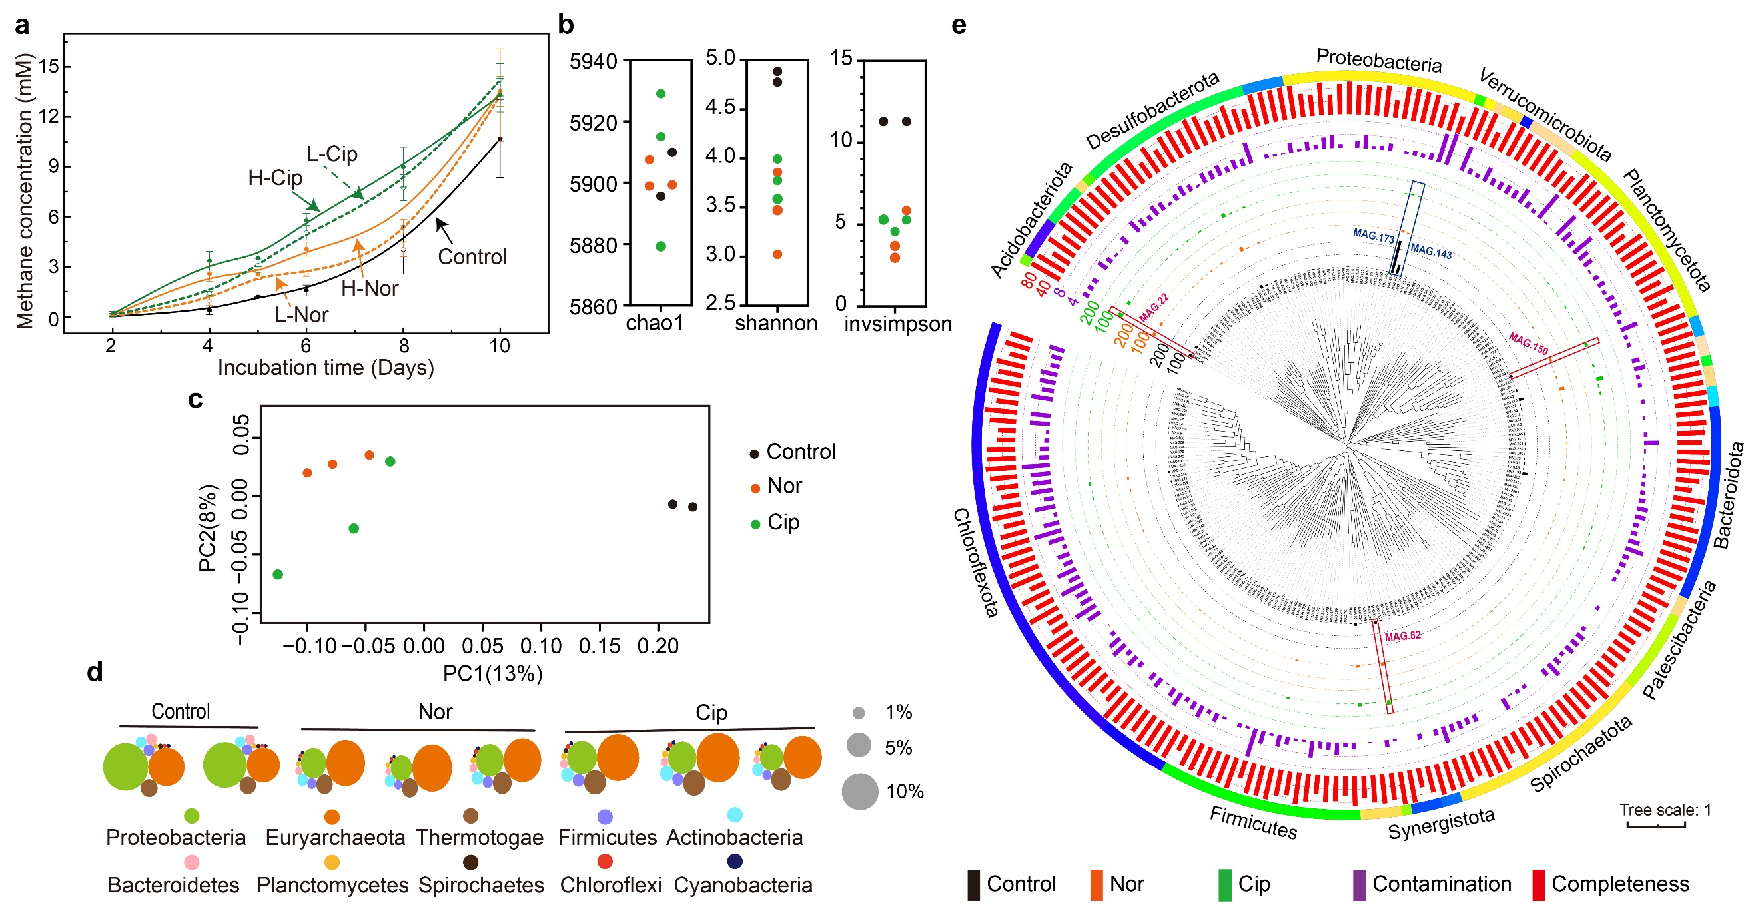

Figure 1 Antibiotics altered CH₄ production and microbial composition. CH₄ production kinetics under different antibiotics treatments (n=12, a). The α diversity index of each sample obtained from reads classification (n=8, b). The principal coordination analysis of the samples based on their Bray-Curtis distances of reads classification (n=8, c). The proportion of the first ten abundant phyla in each sample (n=8, d). Maximum likelihood phylogenomic tree of the bacterial MAGs (e). The bar layers showed the average abundance (copies per million reads) in each group (black for the control group (n=2), orange for norfloxacin group (n=3), and green for ciprofloxacin group (n=3)); the contamination rate (purple, percentage), and the completeness rate (red, percentage); The color stripe outer ring layer showed the phylum levels with more than 5 MAGs labeled beside the ring. The blue box showed significantly decreased MAGs, and the red boxes showed significantly increased MAGs. Nor, norfloxacin; L-Nor, low concentration of norfloxacin (50 mg·L⁻¹); H-Nor, high concentration of norfloxacin (100 mg·L⁻¹); Cip, ciprofloxacin; L-Cip, low concentration of ciprofloxacin (50 mg·L⁻¹); H-Cip, high concentration of ciprofloxacin (100 mg·L⁻¹).

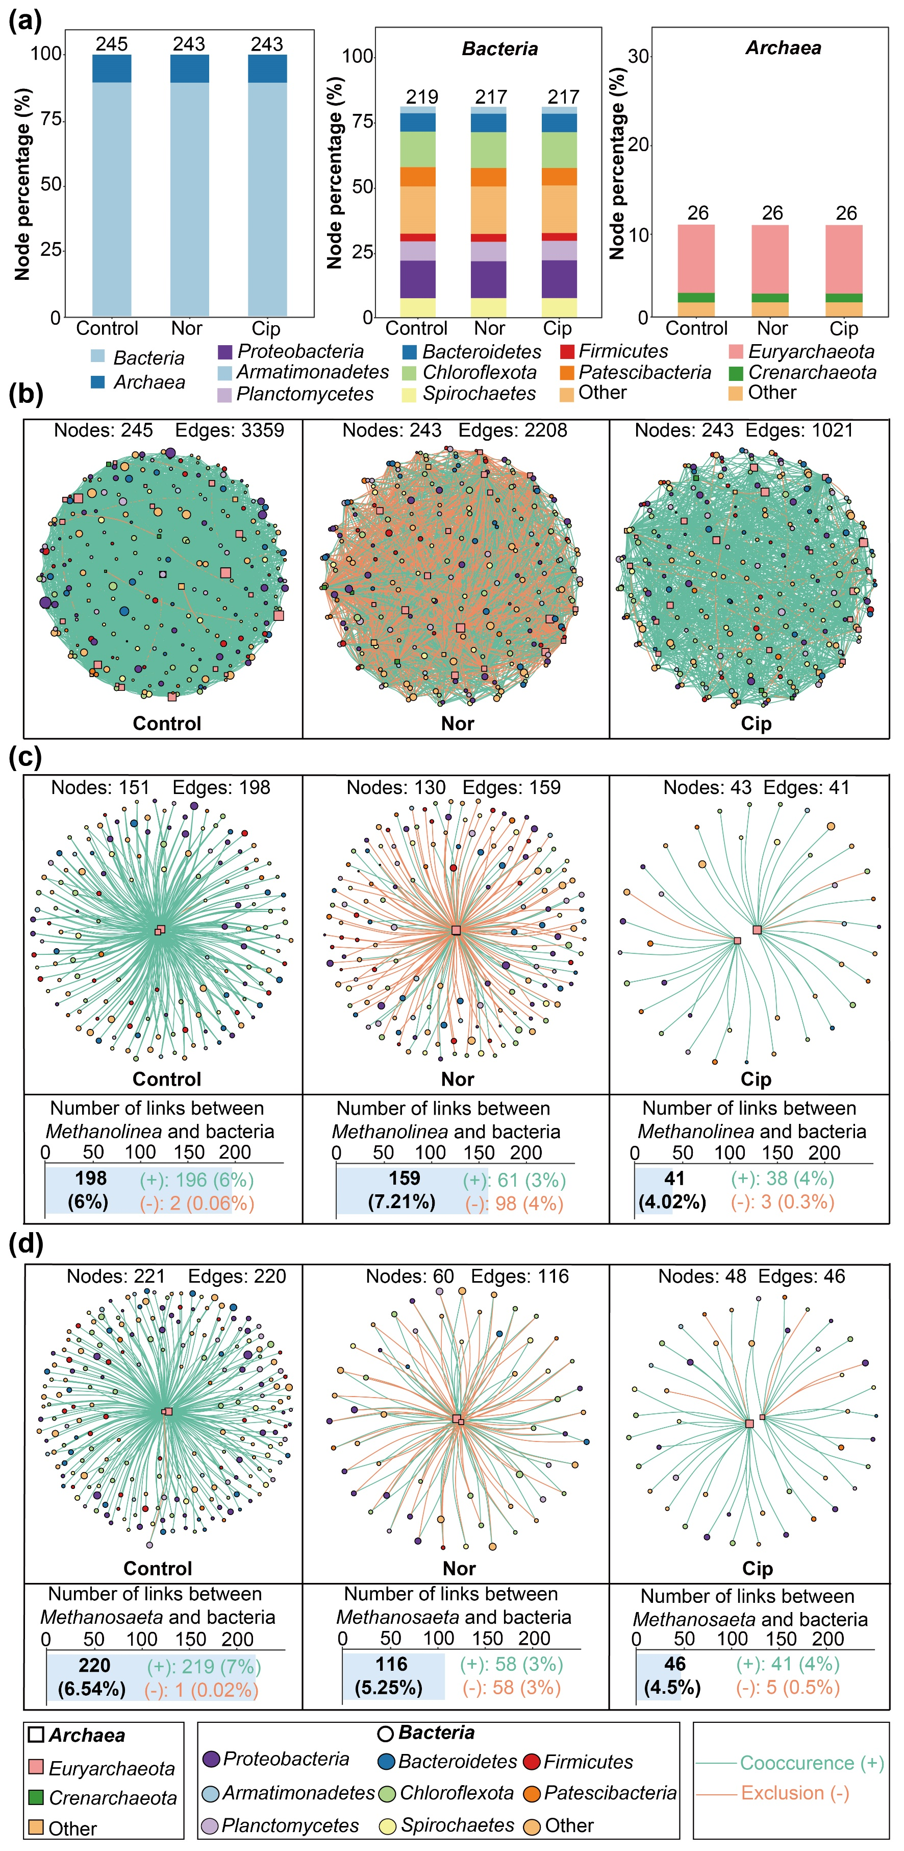
Figure 2 Co-occurrence networks of MAGs. The percentage of different taxa in the nodes of the networks (a). The total number of nodes was shown on the top of the bars. Networks of bacterial and archaeal MAGs in each group (b). Networks of bacterial and Methanolinea MAGs (c). Networks of bacterial and Methanosaeta MAGs (d). The percentage in the parentheses showed the proportion of edges linked to Methanolinea or Methanosaeta in all archaea. Control, control group (n=4); Nor, norfloxacin (n=6); Cip, ciprofloxacin (n=6).

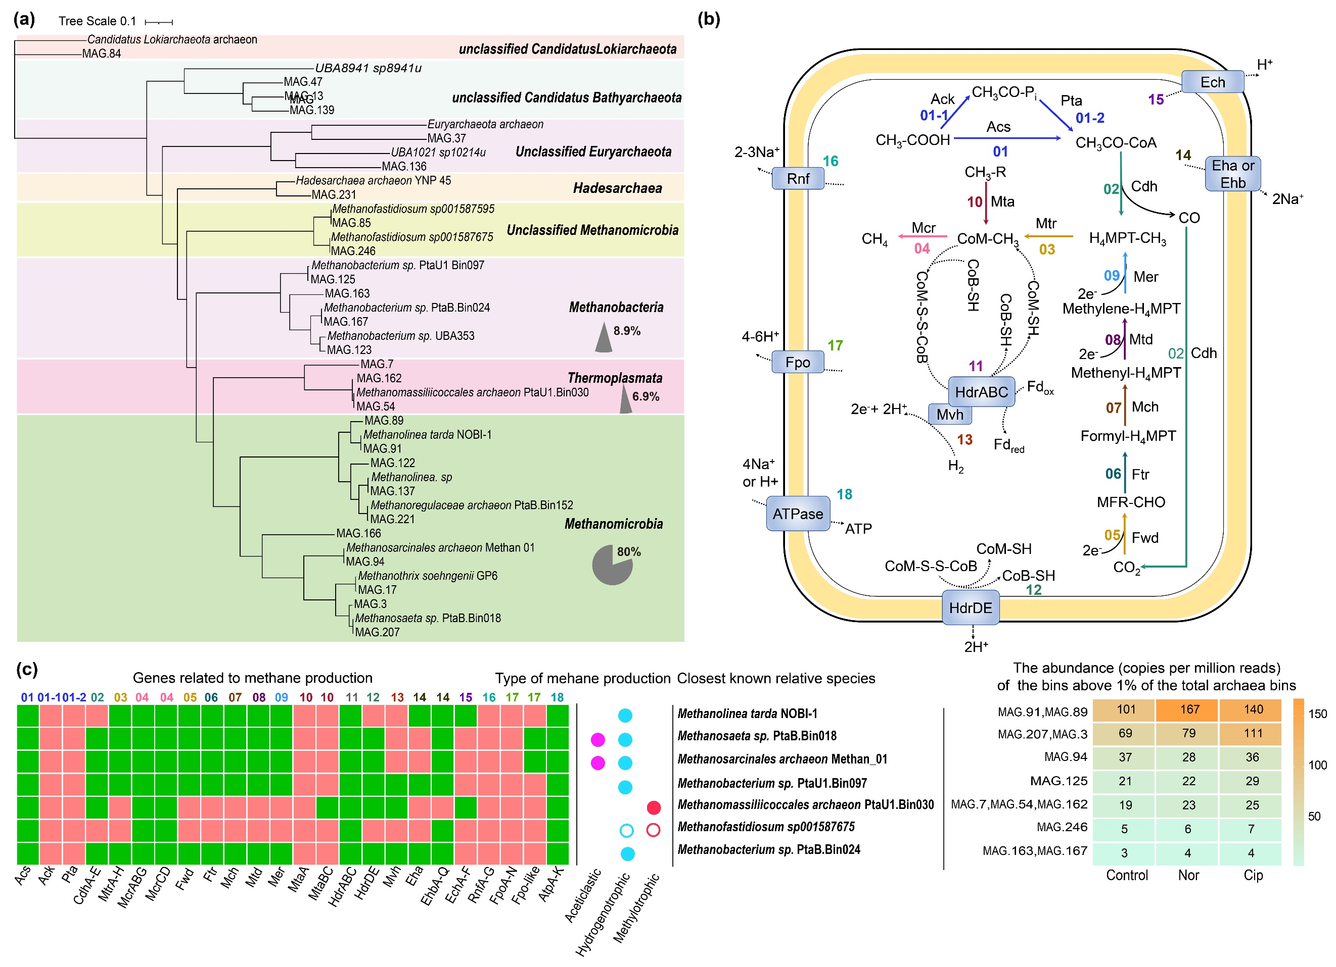

Figure 3 Potential functional microbes and metabolisms for methane production. Maximum likelihood phylogenomic tree showing closest archaeal relatives of MAGs (a). The grey pie charts showed the proportion of MAGs in the corresponding class. Complete methanogenic pathway and closely related genes (b), marked with different colors and numbers for the reactions. Evaluation of the genes required for methanogenesis and the abundance of methanogens (n=8, c). Only the MAGs above 1% of the total archaea were shown. Green and orange boxes showed the presence and absence of the genes in a genome, respectively. Colored circles: acetoclastic methanogenesis (pink); hydrogenotrophic methanogenesis (light blue); methylotrophic methanogenesis (red). Open circles indicated predicted H₂-dependent methylotrophic methanogenesis. The abundance was the average of two (control group, n=2) or three replicates (antibiotic groups, n=3) and normalized as copies per million reads. Ack, acetate kinase; Acs, acetyl-CoA synthase; CoB-SH, coenzyme B; Cdh, carbon monoxide dehydrogenase-acetyl-CoA synthase complex; CoM-SH, coenzyme M; Ech, energy-conserving hydrogenase; Eha and Ehb, energy-converting hydrogenase A and hydrogenase B; Fd, ferredoxin; Fpo, F₄₂₀-H₂-dehydrogenase; Ftr, formylmeth-anofuran-H₄MPT formyltransferase; Fwd, formyl-methanofuran dehydrogenase; H₄MPT, tetrahydromethanopterin; Hdr, heterodisulfide reductase; Mch, methenyl-H₄MPT cyclohydrolase; Mcr, methyl-coenzyme M reductase; Mer, F₄₂₀-dependent methylene-H₄MPT reductase; MFR, methanofuran; Mta, methanol-specific corrinoid protein coenzyme M methyltransferase; Mtd, F₄₂₀-dependent methylene H₄MPT dehydrogenase; Mtr, Na⁺-translocating methyl-H₄MPT-coenzyme-M-methyltransferase; Pta, phosphate acetyltransferase; Rnf, Na⁺-translocating ferredoxin-NAD oxidoreductase.

Figure 4 Isotopic of CH4. δ¹³C-CH₄ (a) and α value (b) in natural carbon isotope fraction. Control, control group (n=3); L-Nor: low concentration of norfloxacin (n=3); H-Nor: high concentration of norfloxacin (n=3); L-Cip: low concentration of ciprofloxacin (n=3); H-Cip: high concentration of ciprofloxacin (n=3).
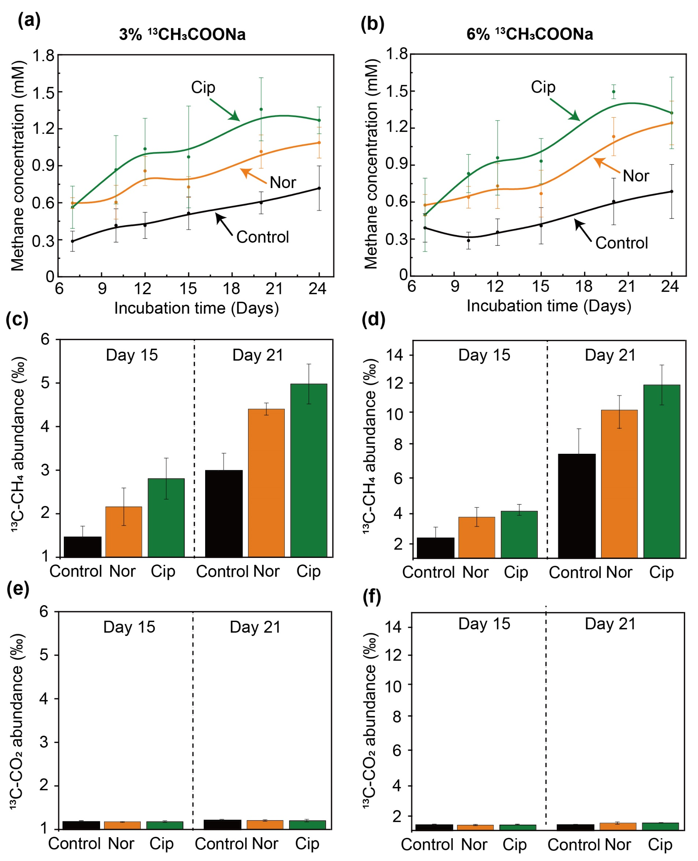

Figure 5 CH₄ production scenario at room temperature with 3% and 6% ¹³CH₃COONa as isotope marked substrates. CH₄ production kinetics (a, b), ¹³C-CH₄ (c, d), and ¹³C-CO₂ (e, f) abundance with the presence of 3% and 6% ¹³CH₃COONa, respectively. Wastewater with 3% ¹³CH₃COONa (a, c, e), wastewater with 6% ¹³CH₃COONa (b, d, f). Data in c, d, e, and f were collected on day 15 (left half) and 21 (right half). Control, control group (n=3); Nor, norfloxacin (n=3); Cip, ciprofloxacin (n=3).

