A Nature-based Solutions framework for embedding climate change mitigation and adaptation into urban land use plans through Strategic Environmental Assessment (SEA)

Amarilis Lucia Casteli Figueiredo Gallardo (corresponding author)
Escola Politécnica, Universidade de São Paulo (USP), Av. Prof. Almeida Prado, 83, 05508-070 São Paulo, SP, Brazil.
Smart and Sustainable Cities Program at the University Nove de Julho – Uninove, Rua Vergueiro, 235/249, 01525-000 São Paulo, SP, Brazil.
amarilisgallardo@usp.br
https://orcid.org/0000-0002-5169-997X

Alan Bond
School of Environmental Sciences, University of East Anglia (UEA), England, UK.
Research Unit for Environmental Sciences and Management, North-West University, Potchefstroom, South Africa
alan.bond@uea.ac.uk
https://orcid.org/0000-0002-3809-5805

Abstract
Climate change impacts comprise a particular challenge for authorities when reconciling the implications of land use planning decisions. Whilst Strategic Environmental Assessment (SEA) is typically applied to the development of urban land use plans, the selection of mitigation and adaptation strategies for climate change impacts can have knock-on effects on nature. However, Nature-based Solutions (NbSs) could provide an innovative means of addressing climate change mitigation and adaptation without these knock-on effects. The main aim of this research is therefore to propose a conceptual framework for embedding NbSs into the main stages of the SEA process to potentially enhance climate change mitigation and adaptation in urban land use planning. This is achieved through a systematic literature review of academic and grey literature sources, with subsequent content analysis. This study demonstrates the value of matching these manifold NbS approaches to climate change impacts potentially addressed in SEA process stages and suggests how this might be achieved in practice focusing on urban land use plans.

Keywords: Strategic Environmental Assessment; Nature based Solutions; climate change; land use plans; framework

1. Introduction

Nature-based solutions (NbSs) are actions designed to create, protect, restore, and manage green and blue spaces that enhance multiple ecosystem services (ES) (Eggermont et al., 2015; Orta-Ortiz and Geneletti, 2022) across a large range of land and sea ecosystems (Seddon et al., 2021) and use natural processes. NbSs comprise approaches for working with nature rather than against it to deliver more sustainable development (Sowinska-Swierkosz and García, 2022). As such, “NbS were often contrasted with grey infrastructures” (Moosavi et al., 2021, p.6), which represent human-engineered interventions. NbSs were first mentioned in 2008 by the World Bank and therefore emerged relatively recently (Nesshöver et al. 2017) from the integration of multiple scientific fields (Sowińska-Świerkosz and García, 2022). Despite criticism regarding uncertainties about the effectiveness of NbSs and controversies surrounding their misuse in greenwashing, human rights, and biodiversity protection arising from some nations, Indigenous peoples, local community groups, and even grassroots organizations, many governments, financial institutions, and corporations have begun using NbSs as part of their sustainability and net-zero carbon strategies (Seddon, 2022). As practical application of NBSs has developed, new challenges and opportunities have arisen (Nesshöver et al. 2017, p. 1224), including in their application to urban land use plans (Mitincu et al. 2023).
NbSs are an innovative means of managing natural systems to meet some of the most important societal challenges, including climate change and biodiversity loss (Seddon et al., 2021), food and water security (Bennett et al., 2016), disaster risk management (Busayo et al., 2022), flood control (Turkelboom et al., 2021), and the loss of blue carbon sinks (Raw et al., 2023), amongst others. One of these societal challenges is the establishment of climate mitigation and adaptation measures (Osaka et al., 2021; Donatti et al., 2022). There are a multitude of types and categories of NbS suggested in the literature to address climate change mitigation and adaptation challenges, such as, forestry, agroforestry, farmland best practices, floodplains, riverbeds and riparian areas recovery, grasslands, wetlands, mangroves, urban parks, bioswales, permeable pavements, green walls, urban drainage system, green gardens, community gardens, green roofs, reefs, seagrasses, beaches and dunes (Lucatello and Alcántara-Ayala, 2024; Papari et al., 2024).
Strategic Environmental Assessment (SEA) is an instrument for developing sustainable spatial and sectoral policies, plans, and programmes which allows better consideration of the environment in decision-making (Fischer, 2003; Nadruz et al., 2018). A general SEA process embraces screening, analysis of environmental effects, identifying and evaluating policy, plan and programme alternatives, evaluation analysis, mitigation of environmental effects, identifying stakeholder concerns, decision, follow-up and monitoring (Noble et al., 2012) (Table 2, later in the paper, sets out more detailed process stages for an SEA process also after Noble et al., 2012). The “SEA process is well-positioned to systematically help strengthen treatment of climate change adaptation and mitigation in planning and development … due to its practical, analytical component, its participation component, and its ability to engage with ethical issues and reconcile competing agendas” (Posas, 2011a, p. 109). This view is mirrored by Nwanekezie et al. (2022) in proposing an SEA framework to guide renewable energy transition. This illustrates a potential role for SEA to oversee disparate policy drivers, ensuring their accommodation when planning to avoid policy conflicts and inconsistencies.
However, including climate change in SEA has shown results ranging from disappointing; mainly related to the failure to consider climate change mitigation, adaptation, and other environmental concerns in an integrated manner and at scales larger than the boundary scales of the land use plans (e.g., Larsen et al, 2012; Nadruz et al., 2018; Wende et al. 2012; Posas, 2011a), to promising; such as, the ability to deal with climate change uncertainties in SEA and the potential of public participation embedded within SEA to deal with the complex nature of climate change and to avoid conflicts with climate change adaptation (Posas, 2011b; Larsen et al., 2013; Doelle and Majekolagbe, 2023; Helbron et al., 2011). Nevertheless, SEA has been considered a useful instrument for integrating climate change mitigation and adaptation into the planning cycle (Larsen et al., 2012; Ledda et al., 2021; Wende et al., 2012).
The interrelationships between climate change mitigation and adaptation have been discussed in the literature. For Landauer et al. (2015) there are synergies, trade-offs, or conflicts between climate change adaptation and mitigation policies and practices; however, there is still value in considering both together in urban areas because of the need to negotiate trade-offs at different scales. On the other hand, Jagers et al. (2008, p. 576) argued "that climate change adaptation poses different moral questions than mitigation" … "based on a distinction between causal and remedial responsibility as well as one between well-off and badly-off agents" and suggested "that theorists need to be clear about which kind of burden their distributive principles concern". For Moser (2012) harmonizing climate change adaptation and mitigation policies can result in well-intended opportunities to offer co-benefits by designing and implementing both in mutually supportive ways but adaptation and mitigation measures must be considered from a system perspective to avoid trade-offs.
Despite the importance of including climate change in SEA (Ledda et al., 2021; Wende et al., 2012) and NbSs in urban planning to assist with the development of climate change mitigation and adaptation (Albert et al., 2019; Voskamp et al., 2021), examples that integrate SEA with NbSs are scarce. The motivation for developing this study is to address this research gap and to build on the pioneering works of Clement and Fischer (2020), Mell and Clement (2020), and Chanchitpricha and Fischer (2022) who discuss the potential integration of NbSs in SEA.
To enlarge the discussion related to embedding climate change into SEA procedures, the main aim of this research is to propose a conceptual framework for embedding NbSs into the main stages of the SEA process to enhance the development of climate mitigation and adaptation strategies in urban land use planning, and to maximise benefit from the integrated application of these separate policy tools. This work has three main objectives: 1) to identify the opportunities for climate change adaptation and mitigation typically detected by SEA, and from these, the key opportunities for NbSs; 2) to identify the kinds of NbSs that can be used to deliver these mitigation and adaptation opportunities; and 3) to develop a framework for embedding these NbSs into SEA. This work can help to explore the role of SEA in mainstreaming climate mitigation and adaptation into urban plans supported through the application of NbSs.

2. Methods

This research is grounded in legal requirements to undertake SEA in many jurisdictions worldwide, alongside extensive national policies that try to address climate change impacts. The legal and policy context is complex and is not based on any one theory. As such, our research is based on inductive theory (after Bryman, 2016) which argues that theory is developed from observations and their interpretation (rather than the other way around as in deductive theory). That is, the approach is to investigate what is argued to work in terms of addressing climate change impacts in different fields of study and attempting to connect them together in a grounded way (a grounded theory approach).
We use a qualitative method founded in the socio-environmental scientific area (Lune and Berg, 2017) to undertake exploratory research founded on the premise that “a topic that has not been researched before, is given a first tentative analysis” (Swedberg, 2020, p. 17). A conceptual framework is “a network, or ‘a plane,’ of interlinked concepts that together provide a comprehensive understanding of a phenomenon or phenomena” (Jabareen, 2009, p.51). Approaches for the subsequent analysis of the literature identified are explained for each of the research questions in turn below.
Our research questions are: 1) what are the opportunities for climate change adaptation and mitigation typically detected by SEA, and from these, what are the key opportunities for NbSs; 2) What kinds of NbSs can be used to deliver these mitigation and adaptation opportunities; and 3) How can these NbSs be embedded into SEA recommendations?
To find, select and analyse relevant literature we begin with a strategy of a systematic literature review (Rother, 2007). This involved a combination of the relevant academic literature identified using the Scopus database as one of the largest index databases ever built (Singh et al., 2021), and grey literature identified using the Google search engine (after Paez, 2017). Grey literature includes text documents published in a non-standard academic format including reports, regulations, policy documents, and guidance that result from governments and organizations’ actions (Bickley et al., 2020), constituting an important source of data from this research.
To achieve the first research objective a systematic literature review (of academic and grey literature) was conducted as presented in Figure 1. This proceeded on the basis of selection of keywords (presented in Figure 1) to restrict the initial search to those sources deemed relevant. Inevitably, different results would be obtained using a different choice of keywords. The search for publications was carried out on May 31, 2023, in Scopus, and on June 1, 2023, in the grey literature. No period was established for the searches, but the oldest search results dated from 2009.

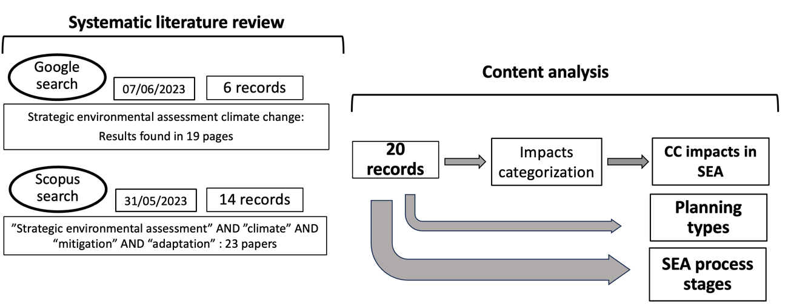
Note: publications from both Google Search and Scopus were discarded because their content did not cover climate change and SEA aspects simultaneously.
Figure 1 – Method steps used for identifying and then analysing the main climate change-related impacts distilled from the academic and grey literature.

To start answering the first research question, we made judgments on the sources’ contents to consider only those materials that cover climate change impacts and SEA simultaneously (Figure 1). These reduced data from Google and Scopus searches to 20 records. All of these 20 records (14 scientific papers and 6 grey material documents) were thoroughly read to identify opportunities to include climate change mitigation and adaptation within the various stages of SEA processes (Noble et al., 2012) using content analysis (Bardin, 2011). This process reveals the climate mitigation and adaptation opportunities addressed in the SEA literature.
To achieve the second research objective, we undertook a systematic literature review (of academic and grey literature again using Scopus and Google) as presented in Figure 2. This followed the same approach as indicated above (for research question 1) over the same dates, with the oldest search results dating from 2016.

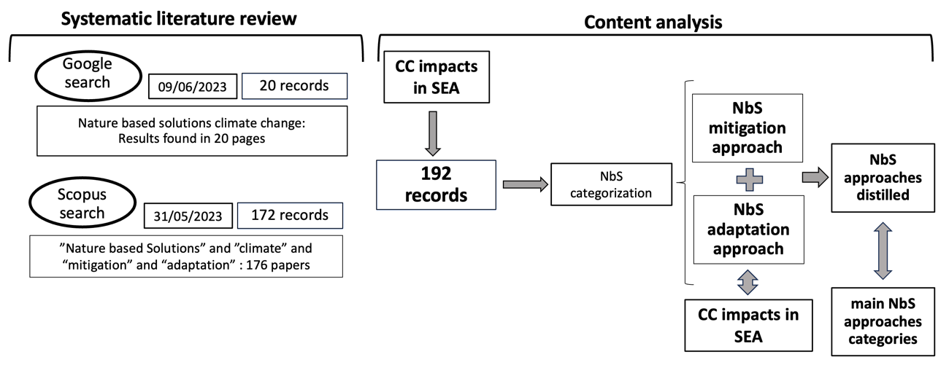
Note: publications from both Google search and Scopus were discarded because they didn’t cover climate change impacts and NbS opportunities for their mitigation or adaptation simultaneously
Figure 2 – Method steps used for Identifying the NbS mitigation and adaptation opportunities for addressing climate change impacts from the academic and grey literature.

To answer the second research question, we made judgments on the sources’ contents to consider only those materials that cover climate change impacts and NbS opportunities for their mitigation or adaptation simultaneously (Figure 3). This corresponded to 192 records from the literature review. All of these 192 records (172 scientific papers and 20 grey material documents as presented as Table E in supplementary material) were thoroughly read and successively analysed to identify specific NbS approaches to address climate change impacts by applying content analysis (Bardin, 2011).
To interpret the data, deductive coding was undertaken based on the categories identified in Seddon et al. (2020; 2021) and Pathak et al. (2022); this was supplemented with inductive coding that allowed additional categories to emerge from the literature that made up the raw data.
We use content analysis for undertaking a systematic examination of material from the literature review (of academic and grey literature) that allows an interpretation of published material contents (Lune and Berg, 2017).
To achieve the third research objective, we used the results of the analysis for research questions 1 and 2 and then built the framework by integrating these two pillars to identify how NbSs can respond to mitigation and adaptation of climate change impacts addressed in a SEA process. This involved matching climate change impacts listed in SEA to the main NbS approaches categories. This allows us to identify how NbSs can respond to mitigation and adaptation of climate change impacts SEA process to be applied in a SEA process of urban land use planning and that constitutes the conceptual framework.

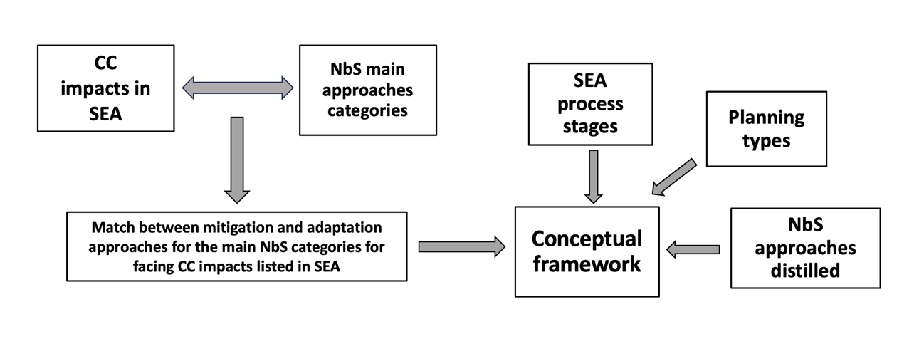
Figure 3 – Method steps used for developing the conceptual framework based on the previous steps of this research.

3. Results

3.1 The main climate change‐related impacts identified in SEA processes

Table 1 presents the opportunities to include climate change mitigation and adaptation in SEA, the tangible climate change impacts, understood as those that damage the physical infrastructure, natural resources and human health (Blavier et al., 2023) they are intended to manage, and the stages of SEA processes in which climate change has been emphasized in each of the 20 analysed records. The scope of the 20 opportunities highlighted in Table 1 mainly refers to criteria, guidelines, or methods to improve the practice of including climate change in SEA. Of these 20 opportunities, only six were tested in planning or SEA cases. In none of the cases analysed were the good practices recommended by the authors routinely and widely considered in SEA practice for including climate change and mitigation aspects. Thus, these opportunities are configured as opportunities for improvement in strengthening the inclusion of climate change in SEA.

Table 1: Explicit opportunities for mitigation and adaptation emerging from the 20 literature sources on SEA.
Opportunities in SEA processes to include climate change mitigation and adaptation* | Tangible climate change impacts acknowledged in the SEA | SEA process stages or elements to include climate change mitigation and adaptation** | Planning types
1. including climate change mitigation and adaptation opportunities in all steps of the SEA process in urban planning | Sea level rise and tidal waves, Temperature increase, Urban heat islands, Extreme weather events, Risk of disasters, Food security, Water scarcity, Greenhouse gas emissions (GHG) | Baseline, monitoring indicators, follow-up | Urban plan
2. five criteria for including climate change adaptation in SEA-driven regional plans and programs | Risk of disasters (floods), Water resources | Objectives, alternatives, monitoring indicators | Regional plan
3. integrate climate change adaptation and disaster risk reduction in SEA for spatial planning | Risk of disasters (cyclones, floods, storm surges,  Food security, salinity intrusion, rough seas, drought), Sea level rise | Baseline | Regional plan, spatial plan
4. translate global or national climate change mitigation and adaptation targets to plan levels of decision-making in all steps of the SEA process | GHG, Sea level rise | Screening, scoping, mitigation, evaluation, public participation, monitoring and follow-up analysis | Sectoral plans (e.g., industrial,  agriculture, transportation and energy plans) and comprehensive plans (e.g.  land, river basin and marine area exploitation plans)
5. reinforce the legal relationship between climate change plans and the SEA Directive with special focus on the screening provisions for both mitigation and adaptation | Afforestation/vegetation, Water resources, Sea level rise | Not specified | climate change plans
6. analyse negative and positive climate synergies and negative and positive environmental synergies for including climate change mitigation and adaptation in SEA. | Flood risk, Vegetation (carbon sink), Extreme events, Air pollution, Land use change | Not specified | Sectoral, local, and comprehensive plans
7. set of criteria in terms of climate change mitigation and adaptation for including in SEA process | GHG emissions, flood, water resources, Urban heat islands | Scoping, mitigation, alternatives, monitoring, cumulative effects, participation | Land use plans  Regional and local plans sectoral plans
8. criteria and good practice for delivering climate change mitigation and adaptation opportunities for all steps of SEA process | Flood, GHG emissions, Soil pollution, Air pollution | Baseline, policy reference, objectives/indicators, alternatives, consultation, monitoring | Local spatial plan
9. use scenarios analysis, particularly in view of the long-term aspect of climate change adaptation measures for SEA | Soil pollution, Land use change | Not specified | Not specified
10. include climate change mitigation and adaptation in all steps of SEA of river basin management plans | Water resources, Risk of flood, Temperature increasement, Sea level rise, Soil pollution, Risk of drought, Changes in biodiversity, Erosion of the coast | Baseline | River basin management plans
11. include response elements and mitigation measures to climate change into the SEA process | Water resources, Biodiversity and ecosystem services, Soil erosion, Air pollution, Flood control and risk | Key issues identification, objectives and indicators, impact evaluation and prediction, follow-up | Watershed development plan
12. include climate change mitigation in steps of the SEA process | GHG emissions | Baseline, alternatives, cumulative effects, public participation, monitoring | Low carbon development plan/oil gas sector plan
13. design of data collection, analysis, and modelling frameworks to deal with climate change mitigation concerns and other related concerns that can be applied in SEA | GHG emissions | Cumulative effects | Large scale renewable plans
14. follow the UNECE SEA Protocol guidelines to assess climate change mitigation measures | GHG emissions | Scoping, public participation, Consulting, monitoring | Renewable energy plan
15. climate change mitigation and adaptation measures can be developed through all steps of the SEA process | GHG emissions, Flood risk, Extreme events, Water resources, carbon sequestration, Wildlife corridors (biodiversity), urban green space | Context and objectives, alternatives, preparing environmental report, consulting, monitoring | Not specified
16. identify, address, and assess climate change mitigation and adaptation effectively in SEA (and biodiversity too) | GHG emissions, Land use change, forestry, Biodiversity, Extreme events (heat waves), Droughts, Water scarcity, Water resources, Flood, Storms and, high wind, Landslides, Sea level rise, Coastal erosion, Cold spells | Screening, Scoping, Alternatives, cumulative effects, mitigation, environmental report, consultation, monitoring | Not specified
17. guidance for climate change mitigation and adaptation responses for spatial and non-spatial PPPs | GHG emissions, Sea level rise  Extreme weather events, Flood, Biodiversity | Screening, Scoping, Alternatives, environmental report, monitoring | Sectoral plan, spatial plan and non-spatial plan
18. integration of methods to address climate change adaptation at all stages of the SEA process | Disaster risks, Water stress, Food insecurity, Health risks, Natural resource depletion, Sea level rise, Drought Extreme events | Objectives, scoping, baseline, mitigation, alternatives, evaluation analysis, monitoring | National sectoral plan
19. guidance for describing how climate change mitigation and adaptation measures can be developed in all steps of the SEA process | Sea level rise, Flood, GHG emissions, Habitat at risks, Biodiversity, Health, Soils, Built environment, Cultural heritage | Screening, Scoping, Alternatives, environmental report, monitoring | Sectoral plan, spatial plan
20. best principles to be adopted for safeguarding climate change mitigation and adaptation consideration in SEA | GHG emissions | Scoping, baseline, mitigation, cumulative effects, decision, follow-up | Not specified
Notes: *1 to 20 – represent the list of papers and documents used in this analysis.
** SEA process stages or elements based on Noble et al. (2012).
Table A in Supplementary material presents all analysed data in Table 1. The complete references of these papers and documents is presented in Table B in Supplementary Material.

According to Table 1, from all of these 20 records, published between 2009 and 2023, over half (12) present guidelines to include both climate change mitigation and adaptation in planning, four addressed climate change mitigation but not climate change adaptation, and the other four only climate change adaptation (Table 1). The vast majority of the 20 sources analysed present guidelines and guidance to improve the integration of climate change mitigation and adaptation into SEA. Some specific aspects, such as, responses, data collection design, scenario analysis, synergies between climate change mitigation and adaptation, and disaster risk reduction, are also discussed in individual papers. This reveals that the main concern is to find ways to strengthen the inclusion of climate change in SEA. All stages of the SEA process are covered in the set of analysed papers. The records analysed also show a diversity of plans, including sectoral and spatial, and of scales from local to transboundary, reinforcing the scope and pervasiveness of the climate change issue (Table 1). All the tangible climate change impacts listed in the SEA literature review are presented in Figure 4.

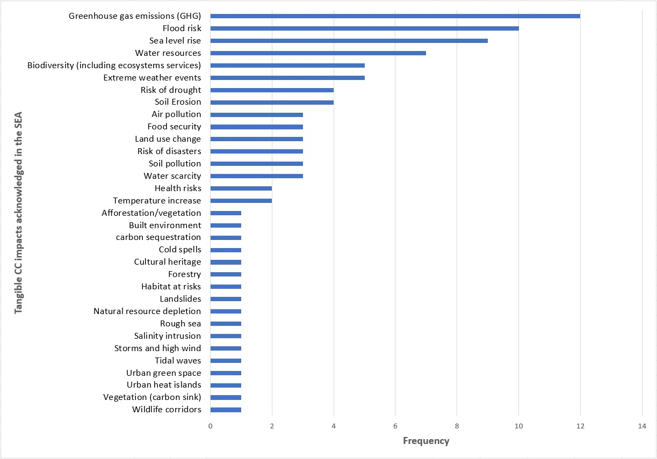
Figure 4 – Distribution of all tangible climate change impacts listed in the SEA literature review.

From Figure 4 it is possible to observe that 33 tangible climate change impacts were mentioned with varying frequencies (we list all climate change impacts as described in the papers, without going into the merits of whether they represent a driver of climate change or an impact per se). However, there are similarities between them. We categorized and thus associated and synthesised them to distill a list of categories of the climate change impacts acknowledged and addressed by the SEA literature (Table 2) in order to simplify associating them with NbSs. Drawing on Table 1, Table 2 also presents a list of SEA process stages mentioned in the literature review as being suitable to embrace the identified climate change mitigation and adaptation impacts. This list shows that all the main stages of the SEA process have some capacity for including climate change impacts.

Table 2: The planning types and the main climate change impacts that are listed in the SEA literature, the SEA process stages mentioned in the literature as being suitable to include climate change mitigation and adaptation.
Distilled climate change impacts that are listed in SEA | SEA process stages suitable to include climate change mitigation and adaptation* | Land use planning types
- GHG (including temperature increase and carbon sequestration)  - Water resources or quality (including water scarcity)  - Air pollution or quality  - Soil resources or quality  - Biodiversity (including afforestation/vegetation and land use change, urban green space, wildlife corridors, forestry)  - Flood risk (including sea level rise)  - Drought risk  - Food security  - Urban heat islands (including land use change)  - Other risks (cyclones, storm surges, salinity intrusion, rough seas, storms, tidal waves, high wind, landslides, cold spells, cultural heritage, built environment, heath, extreme weather events…) | - Policy reference  - Key issues identification  - Context analysis  - Consultation  - Screening  - Scoping  - Objectives  - Indicators (monitoring indicators)  - Baseline  - Alternatives  - Cumulative effects  - Mitigation  - Evaluation Analysis  - Impact evaluation and prediction  - SEA report  - Decision  - Monitoring  - Public Participation  - SEA follow up | - Urban plan  - Regional plan  - Spatial plan  - Sectoral plan (those related to land plans)  - Comprehensive plan  - Local plan  - Climate change plan  - Land use plan  - River basin management plan  - Watershed development plan  - Low carbon development plan/oil gas sector plan  - Large scale renewable plans  - Renewable energy plan  - Non-spatial plan  - National sectoral plan
Note: * also supported by Noble et al. (2012).

3.2 NbSs for climate mitigation and adaptation that can be applied in SEA

Systematic literature review revealed a high number of publications (192 – the full list is presented in Table E in Supplementary Material), produced between 2016 and 2023, describing various types of NbS that cover all of the ten main categories of climate change impacts addressed in SEA demonstrating a tangible connection between them. The climate change impacts addressed in SEA most discussed in the NbSs literature refer, respectively, to GHG, biodiversity and flood risk and the least discussed is air quality followed by drought risk and food security. NbS approaches exclusive for mitigation or adaptation, and those that deliver both mitigation and adaptation, are considered for each climate change impact as presented in Figure 5.

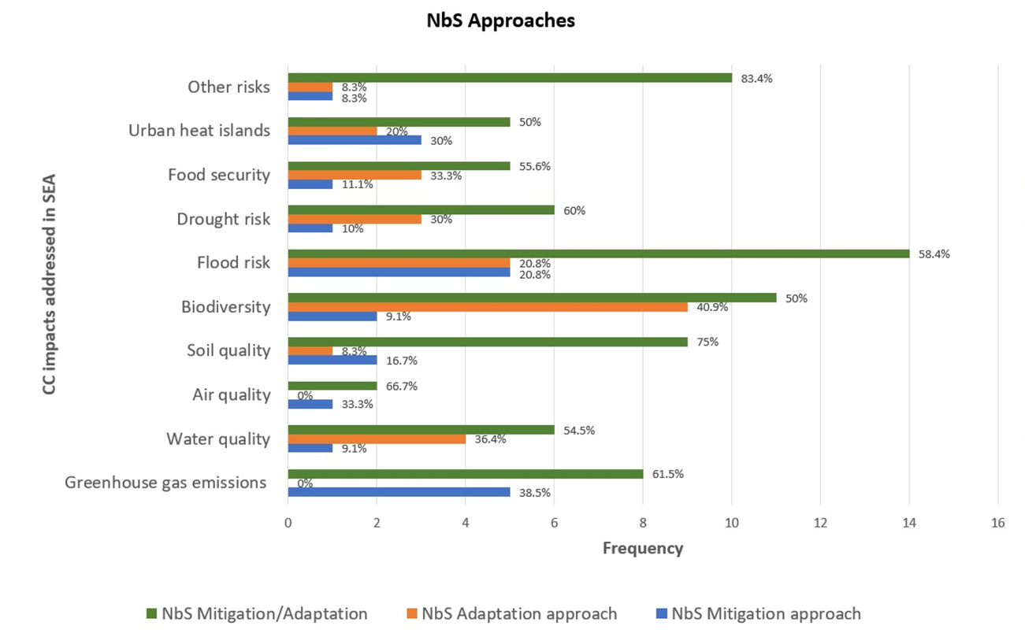
Note: the percentages are related only to each of the climate change impacts individually presented in the reviewed papers and documents.
Tables C1 and C2 in Supplementary Material present the detailed data for this analysis.
Of the 192 publications related to NbSs, 8.33% (16 out 192) to 9.37% (18 out 192) do not provide approaches to mitigate and to adapt climate change, respectively.
Figure 5 – Distribution of NbS climate change mitigation and adaptation approaches to respond to climate change impacts addressed in SEA.

Figure 5 reveals that NbS approaches to both mitigation and adaptation predominate for all ten categories of climate change impacts addressed in SEA, comprising a minimum of 50% (for biodiversity and urban heat islands) reaching up to 83.4% (for other risks). For six climate change impacts addressed in SEA, the number of NbS approaches for adaptation have at least the same frequency of NbS approaches for mitigation. Only for air quality and GHG emissions is there no NbS approach exclusively for adaptation, and for the remaining two climate change impacts categories (urban heat island and soil quality), the number of NbS approaches mentioned for mitigation exceeds the number for adaptation.
The NbSs literature presents several approaches to mitigation, adaptation, or both for all ten climate change impacts categories addressed in the SEA literature. The data behind Figure 5 (see Table C1 and Table C2 in Supplementary Material) indicate a wide range of NbSs and that the same measures can respond to different climate change impacts at the same time, demonstrating their versatility to face climate change problems commonly addressed in SEA. Based on the finding that most reviewed records: i) discuss NbSs both for mitigation and adaptation or for each of these individually; ii) propose the same approaches both to mitigate and to adapt to different climate change impacts addressed in SEA; iii) propose a diversified range of approaches that can be associated with each other to the climate change impacts addressed in SEA, we distilled the main NbS approaches presented in Table 3.

Table 3: Distilling the main NbS mitigation and adaptation approaches categories.
Main NbS approach categories | NbS approaches according to literature review
Blue carbon ecosystems | - mangroves  - salt marshes | - peatlands  - dune systems  - seagrasses and seagrass meadows | - ocean-based carbon dioxide removal (CDR)  - green carbon
Green-blue infrastructure (GBI)/ and Green infrastructure (GI) | - extensive and multifunctional green and blue-green roofs  - roof gardens  - green surfaces  - cool roofs (e.g., reflective roofs)  - green roofs network  - street trees  - parking areas  - parks and urban parks  - woody species  - light-coloured permeable pavements  - urban orchard-gardens  - soil with herbaceous vegetation  - fountains  - grass car parks with protective tiles  - forests and urban forests  - allotment gardens and woods  - green walls, facades and roofs (roof gardens)  - urban green spaces  - urban agriculture  - structures associated to urban networks  - vertical structures and vertical gardens bioswales  - pocket parks | - natural water retention structures  - water bodies (natural and semi-natural)  - hydrographic networks  - waterfront clean and restoration  - (re)constructed wetlands  - built structures for water management  - sustainable urban drainage and water infrastructure  - floodplain restoration  - biosequestration  - soft forms of coastal protection  - natural coastal protection  - rain gardens or wildflowers  - vegetated engineered systems  - rain gardens  - resilient parks  - source control measures (permeable surfaces, filter drains, strips, infiltration trenches, and grass swales)  - site controls (detention basins, filter drains, infiltration basins, and swales)  - measures that restore natural rivers and remove dams  - soil and water bioengineering live fascines  - Indigenous and local Knowledge-led NbSs | - green school grounds and large urban parks  - green space and seawalls  - dryland watershed restoration with rock detention structures  - sand dams  - low-cost rainwater harvesting technique  - roof gardens  - green surfaces  - cool roofs (e.g., reflective roofs)  - green walls  - measures that restore natural rivers as dams removals  - green infrastructure, or the development of soft forms of coastal protection  - ecosystem-based disaster risk reduction  - urban planning strategies  - building layouts and typologies to enhance air circulation for heat removal  - blue-green roof  - community gardens  - afforestation  - green corridors
Blue-infrastructure | - ponds, canals and rivers  - waterbodies and maintaining floodplains  - waterbodies  - sustainable drainage systems  - natural flood management  - stream daylighting’s potential de-culverting  - waterfront clean and restoration wetland management  - drought defense or water treatment | - constructed wetlands and built structures for water management  - ponds and “pondscapes” (networks of ponds)  - water resources (marine, ocean, terrestrial)  - natural flood management  - wetlands  - ponds and grassed waterways floodplain reconnection and restoration | - small rivers and headwaters  - natural floodplains and riparian buffers  - water storage on agricultural field  - discharge during drought periods for rivers from wetlands, mires, fens, and bogs  - depleted aquifers restoration during precipitation periods and winters
Conservation restoration, recovering, regrowing, reforestation, afforestation, rehabilitation of different ecosystems | - peatland restoration and rehabilitation  - forest  - mangrove  - forest management  - landscape restoration  - reversing land degradation and restoring ecosystems  - diverse grassland ecosystems  - coastal habitats, forests and others natural habitats conserved or restored  - agroforestry  - urban trees and forests  - large-scale tree planting such as native revegetation  - forest protection  - conservation agriculture afforestation and reforestation  - mangrove afforestation | - Farmer Managed Natural Regeneration (FMNR)  - conservation and restoration of water resources (marine, ocean, terrestrial)  - protected areas or ecological corridors  - artificial ecosystems  - active forestry  - eradication of invasive mammals from islands  - native woody vegetation or of extensive grasslands conserved and restored  - sediment-dwelling fauna and flora  - large-scale tree planting such as native revegetation  - habitat modification and coastal protection by ecosystem-engineering reef-building bivalves  - living shorelines restored  - tree cover as urban afforestation | - integration of flood flow-routing and habitat suitability calculations for mangrove encroachment  - genetic diversity  - natural habitat  - habitat modification and coastal protection by ecosystem-engineering  - reef-building bivalves  - ecosystem-based adaptation (EbA)  - estuarine intertidal NbS  - clearing invasive plants  - protecting beavers  - biodiversity in grasslands  - technical carbon capture potential of existing land use and conservation practices, REDD+, urban trees, urban forest, low-carbon energy and wood-based construction
Sustainable agriculture and sustainable food systems | - improved agricultural management (including cover crops, no-till, rotational grazing, and sustainable timber management, conservation agriculture, agroecosystems  - seaweed aquaculture | - water storage on agricultural field  - enhance crop-rotation systems and diversity patterns of crops within landscapes  - agro-forestry-like approaches  - urban agrobiodiversity | - numerous NbS related to urban gardening (horticulturalization)  - agro-ecosystem-based adaptation and mitigation and climate-resilient  - agro-ecological production system
Note: Some NbS are described in the articles associated with actions such as restore, recover, increase, reduce, among others; to standardize the citations here, they are all listed as ecosystems that can be managed, recovered or created to represent NbS.
Table D in Supplementary Material presents the detailed data for this analysis.

The literature review demonstrates that there is a wide variety of terms used to characterize NbS approaches; the same type of NbS approach is aimed at more than one climate change impact, and the same NbS approach can be considered appropriate to both mitigate and adapt to one or more climate change impacts too. According to Table 3, in terms of the NbS approach categories, Green Blue Infrastructure (GBI) and Green Infrastructure (GI) appear most frequently among all measures cited in the records of the literature review (only being absent for food security mitigation), with particular mention of their application for GHG mitigation and adaptation (in 23 out 192 records). NbS actions related to conservation, restoration, recovering, regrowing, reforestation, afforestation, rehabilitation of different ecosystems are also frequently cited (but not for urban heat island impacts), with the second most frequently cited NbS being biodiversity (in 17 out 192); these are mostly related to NbSs on a landscape scale to the detriment of more localized NbSs such as those preferentially associated with green and blue infrastructure. Overall, there is a wide range of measures proposed to mitigate and adapt climate change impacts addressed in SEA. Table 3 is not an attempt to create a taxonomic classification for NbSs, rather it is an attempt to join and organize the quoted NbS approaches found in this literature review with this research objective. At the same time, it respects the nomenclature and purpose of the approaches proposed in each publication. The distillation is based on the identification of broader categories of NbSs that include a range of different opportunities that can be employed to respond to different climate change impacts in SEA applied to urban land use planning. This is undertaken purely to build the proposed framework as the starting point for further consideration of NbS opportunities that might be embedded in SEA.

3.3 Framework for integrating NbSs into SEA to enhance climate mitigation and adaptation in urban planning

Table 4 presents the NbS approaches categories that match with the climate change impacts listed in the SEA literature.

Table 4: NbS approaches matched to climate change impacts listed in SEA.

 | Main NbS approach categories
 | Blue carbon ecosystems |  | Green-blue infrastructure (GBI)/ Green infrastructure (GI) |  | Blue-infrastructure |  | Conservation restoration …. of different ecosystems |  | Sustainable agriculture and sustainable food systems
Greenhouse gas emissions
Water quality
Air quality

Soil quality

Biodiversity

Flood risk

Drought risk

Food security

Urban heat islands
Other risks

Mitigation Adaptation Without approach

Note: Tables C1, C2 and D in Supplementary Material present the detailed data for this analysis.

Table 4 illustrates how the five main NbS mitigation and adaptation approaches can address the ten climate change impacts categories listed in SEA. For four climate change impacts – GHG, water resources, biodiversity, and flood risk – there is a wide variety (including all five) of NbS approaches. However, the categorization of adaptation and mitigation measures was exclusively based on proposals from the literature. So, there is a caveat that it may be possible that a NbS approach could be used for adaptation or mitigation despite it not being coded that in Table 3. Figure 6 presents the framework for embedding NbSs into the SEA process to enhance climate mitigation and adaptation in urban land use planning supported by SEA.

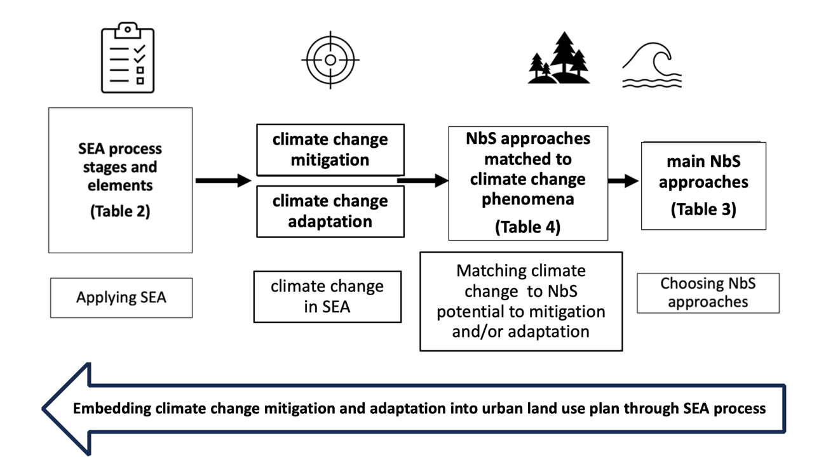
Figure 6 – The conceptual framework to embed NbSs into SEA for enhancing climate mitigation and adaptation in urban land use planning.

Our proposed framework (Figure 6), as an easy and simple tool, can be used during SEA development to specifically address the climate change impacts that arise in different types of land use planning to identify suitable NbS approaches. The sequence of the flowchart represents the way this framework can be used. The arrow at the bottom of Figure 6 highlights that the framework application allows the integration of climate change mitigation and adaptation by using NbSs into planning supported by SEA. Further investigation would then be expected, referring to Table 4, to ensure that appropriate NbSs were proposed to match the particular case. The literature review revealed that throughout the SEA process, there is space to include actions that help address the drivers and impacts of climate change of climate change. Therefore, the framework gives some freedom to identify the best opportunities to implement NbSs when applying SEA. Land use plans, in addition to being more frequent in the SEA literature analyzed, may comprise the most feasible type of plan to expand the use of NbSs via SEA. However, although most plans discussed in the SEA literature are spatial or land use plans, sectoral plans were also mentioned, opening up the opportunity for NbSs to be applied in these contexts also. Thus, at this moment, this framework is not intended to be exhaustive, but indicative of the potential that NbSs can play in supporting the application of SEA to land use plans that effectively employ actions to climate change mitigation and adaptation. Table 5 presents brief examples of how to apply the conceptual framework.

Table 5 – Examples of how to apply the conceptual framework
Land use Plan | SEA process stage or element  (Table 2) | climate change mitigation/  climate change adaptation | NbS approaches  Matched to climate change phenomena  (Table 4) | main NbS approaches  (Table 3)
Master Plan | Key issues identification, scoping, indicators | both | Urban heat island: green infrastructure | urban parks, green roof network, green corridors
Watershed Plan | Scoping, indicators, baseline, evaluation analysis | Only adaptation | Flood risk: blue infrastructure | sustainable drainage systems; water storage on agricultural field
Green Plan | Context analysis, monitoring, evaluation analysis | Only mitigation | Biodiversity: conservation, restoration … of different ecosystems | landscape restoration, tree cover as urban afforestation, natural habitat
Regional Plan | Policy reference,  Baseline,  alternatives | both | Sustainable agriculture: food security | agro-ecological production system, urban gardening (horticulturalization), water storage on agricultural field

Table 5 presents brief examples of how to apply the conceptual framework illustrating in a simplified way how this framework can operate to help integrate climate change by using NbS in SEA processes. Following Figure 6 and Table 5 for each type of land use planning, when developing the SEA process, it is necessary to consider in which stages or elements of SEA the challenges of climate change are included. Table 5 presents some examples of these stages of the SEA process that can better embrace climate change, which in a real application should be chosen and detailed. The next step is to define whether the SEA process would include actions to both mitigate and adapt to climate change or just one of them, in line with the objectives of the land use plan, as well as which climate change threats the planning faces. This definition directs the main NbS approach to five categories that match this climate change threat. Then varied NbS approaches can be chosen. Thus, the framework does not replace analyses, studies, and stages of the SEA process, but provides support to the SEA process so that it considers NbSs as applicable solutions to a wide range of problems associated with climate change, addressing mitigation and adaptation measures.

4. Discussion
The proposed NbS conceptual framework for embedding climate change mitigation and adaptation through SEA is a theoretical contribution to potentially strengthening the recommendations made by Posas (2011a, b), Wende et al. (2012), Larsen et al. (2012); Kørnøv and Wejs (2013); Islam and Zhang (2018), Nadruz et al., (2018), Ledda et al. (2021) and others to properly include climate change in SEA. More than that, it allows us to make detailed and specific recommendations, especially with regards to the actions and measures to deal with climate change impacts, presented in government agency manuals and others found in the grey literature.
The framework is also expected to contribute to overcoming some limitations identified with the integration of climate change impacts into SEA practice as the basis for delivering better land use plans (Ledda et al., 2021). These limitations include the absence of future trends and scenarios, poor provision for mainstreaming adaptation, implicit nature of adaptation objectives and monitoring indicators (Ledda et al., 2021). The diverse typology of NbSs raised in this research could address these deficiencies as they cover a wide range of climate change impacts in varied contexts. This could be achieved through the improvement of the integration of relevant adaptive responses to climate change impacts in SEA. For example, Chanchitpricha and Fischer (2022) verified an absence of GI (related to NbS) in four analysed SEAs in Thailand demonstrating the need to reinforce their consideration. Although the framework is flexible, its conceptual basis is strong and grounded, contributing to solving problems such as the need for more pragmatic steps to include climate change mitigation and adaptation in spatial and urban planning as desired by Wende et al. (2012). The greatest potential of this study in relation to previous work that addresses the integration of climate change in SEA is perhaps the potential of the NbS approaches to detail and contextualize the well-established guidelines to address climate change mitigation and adaptation.
A limited number of publications address SEA and climate change and focus on strengthening this integration, presenting guidelines to achieve this. Only one of the articles analysed (Larsen et al., 2012) discusses the trade-offs between climate change adaptation and mitigation policies and practices and how SEA can harmonize them. This illustrates that there is room for technical discussions beyond what is addressed - integrating climate change and SEA - and ways to enhance these synergies, such as the discussion of NbSs presented here.
From the five distilled categories of NbS approaches, blue carbon ecosystems seem to have little direct connection with the urban environment. However, some land use plans for cities can have a huge influence on blue carbon ecosystems. For Murphy et al. (2023), degradation caused by land use change in coastal development can reinforce the need to protect this blue ecosystem, as a type of NbS, for facing climate change effects. The development of urban wetlands (also a NbS), despite mitigating flooding, can also be carbon sinks although more studies are necessary to better understand their contribution to alleviating this climate change problem (Mitsch and Mander, 2018).
Conservation restoration, recovering, regrowing, reforestation, afforestation, rehabilitation of different ecosystems are NbS approaches with the potential to re-design urban plans for climate change resilience by sequestering carbon and providing more equitable distribution of environmental resources (Chakraborty et al., 2022). Sustainable agriculture and sustainable food systems as NbSs could provide food as well as climate mitigation and adaptation in urban areas (Subedi et al., 2020).

5. Conclusions
This study demonstrates the value of matching NbS approaches to climate change impacts potentially addressed in SEA process stages and explains how this might be done in practice focusing on urban land use planning. This study also explored the potential role of SEA in mainstreaming climate mitigation and adaptation into urban plans supported through the application of NbSs. In this context NbSs can be considered as specific measures to deal with climate change in urban land use planning at different scales for facing climate change impacts pragmatically within SEA. Using the framework developed in this research can potentially be a strategy to overcome the limited practice in relation to strengthening the consideration of climate change in SEA, despite the diversity of guidelines for this purpose.
Recommending diverse NbS approaches to cope with different effects of climate change in urban land use planning can overcome some bottlenecks in the actual SEA practice for addressing climate change. A focus on NbSs can be an innovative means of developing potential actions to address climate change impacts in each of the stages of SEA. But NbS approaches are not the solution to all the effects of climate change; other strategies are also required.
Our framework proposal is not a solution for all problems related to climate change, nor does it mean that climate change impacts in SEA planning should be exclusively addressed using NbSs. We recognize that NbSs, although a recent concept and not yet ubiquitous, has been receiving increasing attention and emphasis from planners and decision-makers worldwide, which may allow the creation of positive synergies with the evaluation of climate change impacts in SEA.
The limitations of the study are related to the indicative nature of the framework, which has room for improvement and adjustment. Future studies can be carried out to confirm the applicability of the framework in practice and can evaluate the scope and effectiveness of NbSs in mitigating and adapting climate change at different planning scales and explore how NbSs can be integrated into sectoral planning for this same purpose. More research is needed to discuss in the context of SEA application how NbS approaches behave at different scales and to connect NbSs with the mitigation hierarchy.
This is a novel, comprehensive study based on academic evidence from two areas of knowledge, which have been subject to calls for integration. The greatest scientific value of this research is that it paves an initial, but well-founded pathway for the development of more in-depth and targeted studies to deal with climate change effects in land-use (and other sectoral) planning.

Acknowledgments
The first author gratefully acknowledges FAPESP (the State of São Paulo Research Foundation) – grant #2023/14.497-6 and grant #2024/01097-2, São Paulo Research Foundation (FAPESP) – for the support to this research.

References
Albert, C., Schröter, B., Haase, D., Brillinger, M., Henze, J., Herrmann, S., ... & Matzdorf, B. (2019). Addressing societal challenges through nature-based solutions: How can landscape planning and governance research contribute? Landscape and urban planning, 182, 12-21.
Bardin, L. (2011). Content analysis. São Paulo: Edições, 70(279), 978-8562938047.
Bennett, G., Cassin, J., & Carroll, N. (2016). Natural infrastructure investment and implications for the nexus: A global overview. Ecosystem Services, 17, 293-297.
Bickley, M. S., Kousha, K., & Thelwall, M. (2020). Can the impact of grey literature be assessed? An investigation of UK government publications cited by articles and books. Scientometrics, 125, 1425-1444.
Blavier, C. L. S., Huerto-Cardenas, H. E., Aste, N., Del Pero, C., Leonforte, F., & Della Torre, S. (2023). Adaptive measures for preserving heritage buildings in the face of climate change: A review. Building and Environment, 110832.
Bryman, A. 2016. Social Research Methods, Oxford, Oxford University Press.
Busayo, E. T., Kalumba, A. M., Afuye, G. A., Olusola, A. O., Ololade, O. O., & Orimoloye, I. R. (2022). Rediscovering South Africa: Flood disaster risk management through ecosystem-based adaptation. Environmental and Sustainability Indicators, 14, 100175.
Chakraborty, T., Biswas, T., Campbell, L. S., Franklin, B., Parker, S. S., & Tukman, M. (2022). Feasibility of afforestation as an equitable nature-based solution in urban areas. Sustainable Cities and Society, 81, 103826.
Chanchitpricha, C., & Fischer, T. B. (2022). The role of impact assessment in the development of urban green infrastructure: a review of EIA and SEA practices in Thailand. Impact Assessment and Project Appraisal, 40(3), 191-201.
Clement, S., Fischer, T.B. (2020). Editorial, Impact Assessment and Project Appraisal, 38:6, 447-448.
Doelle, M., & Majekolagbe, A. (2023). Meaningful public engagement and the integration of climate considerations into impact assessment. Environmental Impact Assessment Review, 101, 107103.
Donatti, C. I., Andrade, A., Cohen-Shacham, E., Fedele, G., Hou-Jones, X., & Robyn, B. (2022). Ensuring that nature-based solutions for climate mitigation address multiple global challenges. One Earth, 5(5), 493-50.
Eggermont, H., Balian, E., Azevedo, J. M. N., Beumer, V., Brodin, T., Claudet, J., ... & Le Roux, X. (2015). Nature-based solutions: new influence for environmental management and research in Europe. GAIA-Ecological perspectives for science and society, 24(4), 243-248.
Fischer, T. B. (2003). Strategic environmental assessment in post-modern times. Environmental impact assessment review, 23(2), 155-170.
Helbron, H., Schmidt, M., Glasson, J., & Downes, N. (2011). Indicators for strategic environmental assessment in regional land use planning to assess conflicts with adaptation to global climate change. Ecological Indicators, 11(1), 90-95.
Islam, M. S., & Zhang, Y. (2018). The potential of strategic environmental assessment to reduce disaster risks through climate change adaptation in the coastal zone of Bangladesh. International Journal of Climate Change Strategies and Management, 11(1), 137-153.
Jabareen, Y. (2009). Building a conceptual framework: philosophy, definitions, and procedure. International journal of qualitative methods, 8(4), 49-62.
Jagers, S. C., & Duus-Otterström, G. (2008). Dual climate change responsibility: on moral divergences between mitigation and adaptation. Environmental Politics, 17(4), 576-591.
Kørnøv, L., & Wejs, A. (2013). SEA screening of voluntary climate change plans: A story of non-compliant discretion. Environmental impact assessment review, 41, 64-69.
Landauer, M., Juhola, S., & Söderholm, M. (2015). Inter-relationships between adaptation and mitigation: a systematic literature review. Climatic change, 131, 505-517.
Larsen, S. V., Kørnøv, L., & Wejs, A. (2012). Mind the gap in SEA: An institutional perspective on why assessment of synergies amongst climate change mitigation, adaptation and other policy areas are missing. Environmental Impact Assessment Review, 33(1), 32-40.
Larsen, S. V., Kørnøv, L., & Driscoll, P. (2013). Avoiding climate change uncertainties in Strategic Environmental Assessment. Environmental Impact Assessment Review, 43, 144-150.
Ledda, A., Di Cesare, E. A., Satta, G., Cocco, G., & De Montis, A. (2021). Integrating adaptation to climate change in regional plans and programmes: The role of strategic environmental assessment. Environmental Impact Assessment Review, 91, 106655.
Lucatello, S., & Alcántara-Ayala, I. (2024). Sustainable Synergy: Strengthening Disaster Risk Reduction in Latin America and the Caribbean through Nature-Based Solutions. International Journal of Disaster Risk Reduction, 104860.
Lune, H., & Berg, B. L. (2017). Qualitative research methods for the social sciences. Pearson.
Mell, I., & Clement, S. (2020). Progressing green infrastructure planning: understanding its scalar, temporal, geo-spatial and disciplinary evolution. Impact Assessment and Project Appraisal, 38(6), 449-463.
Mitincu, C. G., Niţă, M. R., Hossu, C. A., Iojă, I. C., & Nita, A. (2023). Stakeholders’ involvement in the planning of nature-based solutions: A network analysis approach. Environmental Science & Policy, 141, 69-79
Mitsch, W. J., & Mander, Ü. (2018). Wetlands and carbon revisited. Ecological engineering, 114, 1-6.
Moosavi, S., Browne, G. R., & Bush, J. (2021). Perceptions of nature-based solutions for Urban Water challenges: Insights from Australian researchers and practitioners. Urban Forestry & Urban Greening, 57, 126937.
Moser, S. C. (2012). Adaptation, mitigation, and their disharmonious discontents: an essay. Climatic Change, 111(2), 165-175.
Murphy, A., Sherren, K., Frank, B., & Saunders, S. (2023). “Whose carbon is it?” Understanding Municipalities Role in Blue Carbon Ecosystems Management in Canada. Nature-Based Solutions, 100089.
Nadruz, V.N, Gallardo, A. L. C. F., Montaño, M., Ramos, H. R., & Ruiz, M. S. (2018). Identifying the missing link between climate change policies and sectoral/regional planning supported by Strategic Environmental Assessment in emergent economies: lessons from Brazil. Renewable and Sustainable Energy Reviews, 88, 46-53.
Nesshöver, C., Assmuth, T., Irvine, K. N., Rusch, G. M., Waylen, K. A., Delbaere, B., Haase, D., Jones-Walters, L., Keune, H., Kovaks, E., Krauze, K., Kulvik, M., Rey, F., van Dijk, J., Vistad, O. I., Wilkinson, M. E., Wittmer, H. (2017). The science, policy and practice of nature-based solutions: An interdisciplinary perspective. Science of the total environment, 579, 1215-1227.
Noble, B. F., Gunn, J., & Martin, J. (2012). Survey of current methods and guidance for strategic environmental assessment. Impact Assessment and Project Appraisal, 30(3), 139-147.
Nwanekezie, K., Noble, B., & Poelzer, G. (2022). Strategic assessment for energy transitions: A case study of renewable energy development in Saskatchewan, Canada. Environmental Impact Assessment Review, 92, 106688.
Orta-Ortiz, M. S., & Geneletti, D. (2022). What variables matter when designing nature-based solutions for stormwater management? A review of impacts on ecosystem services. Environmental Impact Assessment Review, 95, 106802.
Osaka, S., Bellamy, R., & Castree, N. (2021). Framing “nature‐based” solutions to climate change. Wiley Interdisciplinary Reviews: Climate Change, 12(5), e729.
Paez, A. (2017). Gray literature: An important resource in systematic reviews. Journal of Evidence‐Based Medicine, 10(3), 233-240.
Papari, C. A., Toxopeus, H., Polzin, F., Bulkeley, H., & Menguzzo, E. V. (2024). Can the EU taxonomy for sustainable activities help upscale investments into urban nature-based solutions?. Environmental Science & Policy, 151, 103598
Pathak, A., Hilberg, L. E., Hansen, L. J., & Stein, B. A. (2022). Key Considerations for the Use of Nature-Based Solutions in Climate Services and Adaptation. Sustainability, 14(24), 16817.
Posas, P. J. (2011a). Exploring climate change criteria for strategic environmental assessment. Progress in Planning, 75(3), 109-154.
Posas, P. J. (2011b). Climate change in SEA: learning from English local spatial planning experience. Impact Assessment and Project Appraisal, 29(4), 289-302.
Raw, J. L., Van Niekerk, L., Chauke, O., Mbatha, H., Riddin, T., & Adams, J. B. (2023). Blue carbon sinks in South Africa and the need for restoration to enhance carbon sequestration. Science of the Total Environment, 859, 160142.
Rother, E. T. (2007). Systematic literature review X narrative review. Acta paulista de enfermagem, 20, v-vi.
Seddon, N., Chausson, A., Berry, P., Girardin, C. A., Smith, A., & Turner, B. (2020). Understanding the value and limits of nature-based solutions to climate change and other global challenges. Philosophical Transactions of the Royal Society B, 375(1794), 20190120.
Seddon, N., Smith, A., Smith, P., Key, I., Chausson, A., Girardin, C., ... & Turner, B. (2021). Getting the message right on nature‐based solutions to climate change. Global change biology, 27(8), 1518-1546.
Seddon, N. (2022). Harnessing the potential of nature-based solutions for mitigating and adapting to climate change. Science, 376(6600), 1410-1416.
Singh, V. K., Singh, P., Karmakar, M., Leta, J., & Mayr, P. (2021). The journal coverage of Web of Science, Scopus and Dimensions: A comparative analysis. Scientometrics, 126, 5113-5142.
Subedi, R., Karki, M., & Panday, D. (2020). Food system and water–energy–biodiversity nexus in Nepal: a review. Agronomy, 10(8), 1129.
Swedberg, R. (2020). Exploratory research. The production of knowledge: Enhancing progress in social science, 17-41.
Sowińska-Świerkosz, B., & García, J. (2022). What are Nature-based solutions (NBS)? Setting core ideas for concept clarification. Nature-Based Solutions, 2, 100009.
Turkelboom, F., Demeyer, R., Vranken, L., De Becker, P., Raymaekers, F., & De Smet, L. (2021). How does a nature-based solution for flood control compare to a technical solution? Case study evidence from Belgium. Ambio, 50(8), 1431-1445.
Voskamp, I. M., de Luca, C., Polo-Ballinas, M. B., Hulsman, H., & Brolsma, R. (2021). Nature-based solutions tools for planning urban climate adaptation: State of the art. Sustainability, 13(11), 6381.
Wende, W., Bond, A., Bobylev, N., & Stratmann, L. (2012). Climate change mitigation and adaptation in strategic environmental assessment. Environmental Impact Assessment Review, 32(1), 88-93.

