Tiering biodiversity issues from Strategic Environmental Assessment to Environmental Impact Assessment: exploring documentary evidence from Brazil and England

Abstract
Biodiversity protection is one of the key goals for Environmental Assessment (EA) practice that can most efficiently be achieved through tiering of environmental objectives between Strategic Environmental Assessment (SEA) of sectoral and land use plans and Environmental Impact Assessment (EIA) of projects. This research uses an analytical framework to benchmark some examples of tiering of biodiversity objectives using documentary case studies from Brazil and the United Kingdom; these suggest that EA tiering might still be very limited despite all recommendations to improve it, thereby impacting on the efficiency with which biodiversity goals can be achieved.

Keywords: tiering; strategic environmental assessment; environmental impact assessment; biodiversity

- Introduction
Biodiversity protection means avoiding further loss of one of the world’s environmental resources most dear to humanity (Naeem et al., 2016; Pascual et al., 2021). The discussions related to the Post-2020 Global Biodiversity Framework (agreed as the Kunming-Montreal GBF) of the United Nations (UN) Biodiversity Conference of the Parties (COP 15) for the Convention on Biological Diversity (Obura et al., 2021) has brought biodiversity into the spotlight and has revealed the urgency needed if decision making is to arrest further losses (Obura et al., 2021; Milner-Gulland et al., 2021; Chan et al., 2022). Biodiversity underpins sustainable development as evidenced by the Sustainable Development Goals (SDG), especially SDG 14 (conserve and sustainably use the oceans, seas and marine resources for sustainable development) and SDG 15 (protect, restore and promote sustainable use of terrestrial ecosystems, sustainably manage forests, combat desertification, and halt and reverse land degradation and halt biodiversity loss) (Zhang et al., 2022). Despite this, Díaz (2022, p. 1204) warns that “Policy-makers and the general public are increasingly well-informed about nature, but this has not translated into slowing down its fast deterioration” with Montoya et al. (2017, p. 71) further highlighting the vagueness in the notion of a “safe operating space for biodiversity” which hampers the adoption of policies better able to protect biodiversity.
Environmental Assessment (EA) instruments have been recommended at international level (for example, by United Nations assemblies and through their resolutions) as approaches for protecting the world’s biodiversity (De Santo et al., 2019) and have been “geared up” to facilitate the achievement of the SDGs (Morrison-Saunders et al., 2020, p. 113). These instruments, including Strategic Environmental Assessment (SEA) of sectoral and land use plans, and Environmental Impact Assessment (EIA) of the projects helping to deliver these plans, must promote safeguards to biodiversity (Brownlie and Treweek, 2018; Bond et al., 2021). However, Ryan et al. (2019) argued that criticisms of the ability of EA processes to address spatiotemporal scales of biodiversity issues are rooted in failures to tier information from SEAs to the EIAs supporting the individual projects. Thus, tiering and biodiversity are currently core concerns in EA research (Bond et al., 2021; Gallardo et al., 2022a; Therivel and González, 2021; González and Thérivel, 2022).
Tiering represents “the deliberate, organized transfer of information and issues from one level of planning to another, which is being supported by EAs” (Arts et al., 2011, p. 417). It therefore requires an explicit transfer of information from the SEA level to the EIA level of a planning cycle (Therivel and González, 2021). However, “the need for effective tiering between SEA and EIA” for promoting SEA effectiveness has been recognised (Montaño and Fischer, 2019, p. 103); as has “its capability of influencing strategic decisions” (Oliveira et al., 2013, p. 1190). To influence project design “EIA must explicitly receive and use the SEA information” (Therivel and González, 2021, p. 1). However, EA tiering “potentially remains an unresolved concern” (Pope et al., 2013, p. 3) and persists as a major challenge in most sectoral and regional planning contexts (Vilardo and La Rovere, 2018). Enríquez-de-Salamanca (2023, p. 6) highlighted some difficulties with practicing effective EA tiering, arguing that “they [SEA and EIA] are not isolated silos, as in practice they overlap, and the boundaries are diffuse”.
Thus, although biodiversity protection is part of the goal of EA processes, which relies on tiering between SEA and EIA to be effective, tiering practice is extremely limited, and knowledge of how best to implement it remains sparse. Two recent papers attempted to move from theory to practice in promoting better tiering by identifying crucial aspects needed to foster EA tiering. Therivel and González (2021) reviewed case studies selected where plans or programmes subject to SEA had been followed by projects subject to EIA, and interviewed specialists involved in those cases. They found that “a conscious and explicit transfer of information from the SEA level, and an explicit receipt of this information at the EIA level are necessary prerequisites for effective tiering” (Therivel and González, 2021, p.1). Based on data gathered from interviewing specialists, González and Therivel (2022, p.1) argued that “SEAs can streamline processes by shaping alternatives, anticipating project-level issues and mitigation, and thus setting the terms of reference for EIA for more focused assessments and actions” and revealing that “although more apparent and effective in certain procedural stages, overall, tiering streamlines and strengthens environmental assessment processes”. Such research provides key principles that should be adhered to in tiering, without actually identifying the specific actions that need to be undertaken in order to make tiering work or, indeed, defining what aspects of biodiversity need to be tiered.
González and Therivel (2022) lamented the limited research in IA tiering practice which we begin to address in a limited way through the use of cases studies to investigate the ‘missing link’ (Arts et al., 2011) between SEA and EIA against a framework which benchmarks the biodiversity knowledge that is expected to be transferred. Case studies are one of the most used methods in recent articles on EA tiering (González and Therivel, 2022; Cumming and Tavares, 2022; Therivel and González, 2021; Gallardo et al., 2022a; Coutinho et al., 2019), but none explore tiering across different EA jurisdictions.
For finding evidence of practice, we selected two jurisdictions for SEA regulation and biodiversity based both on accessibility and the high level of contrast between them. Thus, we selected a Brazilian case, where SEA is under development (Gallardo et al., 2021), but for which there are only some local requirements without formal guidelines (Oliveira and Malvestio, 2022), and not yet any national legal obligation for SEA (Nadruz et al., 2018). Nevertheless, as one of the most biodiverse countries in the world (Fearnside, 2016), biodiversity is a critical aspect to be considered in tiering in Brazil. An English case was selected to represent a jurisdiction where SEA is mandatory, and where some driving forces exist for promoting EA tiering (Bond and Fischer, 2022) and because England, although having highly ambitious national pledges for the protection of its remaining biodiversity (Cunningham et al., 2021), ranks 7th out of 240 global countries for biodiversity loss (RSPB, 2021). In both case studies, the plans and projects operate within a context of ecological conservation designations, which inform the EA processes.
In Brazil, SEA is not mandatory at any level of planning (Tshibangu and Montaño, 2019) and the majority of Brazilian SEA cases are supported as safeguard instruments prompted by multilateral development agencies (Tshibangu and Montaño, 2016) or by some private investors or environmental agencies on a voluntary basis for avoiding impacts and conflicts at the project level (Malvestio and Montaño, 2019). The lack of the practice of SEA remains a problem in Brazilian EA at different levels of decision-making (Gallardo et al., 2021), albeit there is some limited application experience in the tourism sector (Lemos et al., 2012) and energy sector (Westin et al., 2014). Attempts to formalize SEA (Vilardo et al., 2020) have been recognized, and some limited evidence of tiering has appeared in connection with a set of large infrastructure projects followed by individual projects (Sánchez and Silva-Sánchez, 2008; Vilardo and Rovere, 2018; Coutinho et al., 2019; Gallardo et al., 2022a).
In England, the majority of SEA and EIA practice takes place in the land use planning sector (Glasson and Therivel, 2019), for which three tiers of assessment can exist. There is always a requirement for SEA of local plans (the actual requirement is for sustainability appraisal, although this still has to be consistent with the obligations of the European Union SEA Directive (European Parliament and the Council of the European Union (2001)) in advance of legal reforms post the UK exiting the European Union). These sustainability appraisals are prepared by local authorities (or groups of local authorities collaborating together), and then for EIA of any projects submitted for planning permission constrained by the local plan. However, it is also possible for neighbourhood plans (also subject to SEA) to be prepared for small geographical areas within the local plan boundaries, where particular neighbourhoods want to take control over planning aspects. In these cases, the neighbourhood plan has to comply with the local plan, and any projects within the boundaries of the neighbourhood plan also have to comply with the neighbourhood plan.
Thus, based on a comparative study of Brazil and England, the main aim of this research is to explore evidence of tiering practice from SEA to EIA with a focus on biodiversity. Our objectives are: 1) to assess whether biodiversity issues are present at different levels of EA studies; and 2) to discuss the extent to which biodiversity issues have been transferred from SEA to EIA as a way to demonstrate EA tiering.
The paper is structured into four more sections after this introduction. The next section focuses on the method, including case study and framework selection. The case studies are highly restricted in terms of their generalisability, and represent the exploratory nature of the research, which focuses on ways to investigate practice as well as methods for determining how to improve practice. The subsequent section focuses on the results where we present the analysis of the framework applied to the case studies and explain what it reveals for understanding biodiversity issues in EA studies and for tiering. The next section presents the discussion of tiering based on our results in the context of existing literature on tiering. In the final section, we outline the broader implications of this research and suggest some ways forward to improve the validity of the findings and to start the process of understanding how to strengthen EA tiering.

2. Methods
This exploratory research comprises an ex-post assessment of case studies using a framework which allows benchmarking the biodiversity knowledge that is expected to be transferred between SEA and EIA. Case studies facilitate active learning and problem-solving by using critical thinking skills (Popil, 2011). Ex-post evaluation schemes have been used as a common strategy by different sectoral authorities in several countries and multilateral lending institutions to evaluate EA practice (Nicolaisen and Driscoll, 2016).
The use of an analytical framework is an approach frequently employed to assess many different aspects and elements of EA practice, such as, EIA (Pinto et al., 2019; Nisbet and João, 2022), SEA (Nilsson et al., 2009), biodiversity (González et al., 2013; Brownlie and Treweek, 2018; Mandai and Souza, 2021; Gutierrez et al.2021; Gallardo et al., 2022b), ecosystem services (Honrado et al, 2013; Tallis et al., 2015).

2.1 SEA and EIA case studies
As SEA remains discretionary in Brazil, the number of known SEAs is small, at around 68 SEA reports conducted from 1997 to 2018 (Tshibangu and Montaño, 2019). Cases of SEA followed by EIA are even less common, as discussed in Sánchez and Silva-Sánchez (2008); Montaño and Fischer (2019); Montaño et al. (2021) and Gallardo et al. (2022a). As there is no institutional SEA repository in Brazil (Montaño et al., 2021), the main recognized Brazilian SEA cases are found through literature searches (Nadruz et al., 2018; Tshinbagu and Montaño, 2019; Gallardo et al., 2022b). For the 68 SEA reports carried out in Brazil, a filter was applied to select those that focused most on biodiversity issues according to the analysis by Gallardo et al. (2022b), which, in theory, means that tiering to EIA was possible. This process identified four SEA reports from different Brazilian states, from which, any projects subject to EIA were identified from their EIA repositories that potentially could have tiered biodiversity knowledge from the SEA.
Following this process, the SEA of the Multimodal Transport and Mineral-Industrial Development Program of the Cacao Region (Bahia state) (http://www.lima.coppe.ufrj.br/images/documentos/projetos/aae_sumario_executivo-porto-sul.pdf) was selected as this satisfied the most criteria in a framework developed to evaluate the coverage of biodiversity impacts in SEA when applied to a representative sample of Brazilian SEAs (Gallardo et al., 2022b). In addition, the decree law (11.235/2008) that approves the environmental and biodiversity protection policy in the state of Bahia, has an article that allows the State to request an SEA to evaluate planning. The main objective of this SEA was to assess the strategic impacts of the group of projects that will follow this program with a view to delivering sustainable development and environmental protection in the region. The Environmental Impact Statement (EIS) Porto Sul Complex (http://licenciamento.ibama.gov.br/Porto/Porto%20Sul%20-%20Bahia/EIA/) is an EIA project derived from the development program analysed in this SEA.
Cumming and Tavares (2022), focusing on national parks, emphasized that tiering across three levels – SEA; an intermediate tier focused on refining spatial scales; and, finally, EIA – can improve ecological conservation connectivity. This underpins the English case study which includes two tiers of SEA and a project EIA which can be analysed for the data scale and detail relevant to ecology, and how this translates from one tier to the next. Therefore the case study will consider one example of the SEA for the Greater Norwich Local Plan, GNLP: https://gnlp.oc2.uk/docfiles/46/GNLP_SA_Reg18(C)_Final.pdf) which is a collaboration between the local authorities of Norwich City Council, Broadland District Council, and South Norfolk District Council. There is a neighbourhood plan adopted within the GNLP for a proposed new town (Rackheath Neighbourhood Plan: https://www.southnorfolkandbroadland.gov.uk/downloads/file/67/rackheath-neighbourhood-plan) which is consistent with the GNLP. Then, planning applications to deliver the housing expected are separately submitted to the local authority (which in this neighbourhood is Broadland District Council), for example, the North Rackheath housing application (https://secure.broadland.gov.uk/MVM/Online/dms/DocumentViewer.aspx?PK=771254&SearchType=Planning%20Application), which has to be consistent with the neighbourhood plan and was subject to Environmental Impact Assessment.
Figure 1 shows some data from the EA vertical tiering in both case studies.

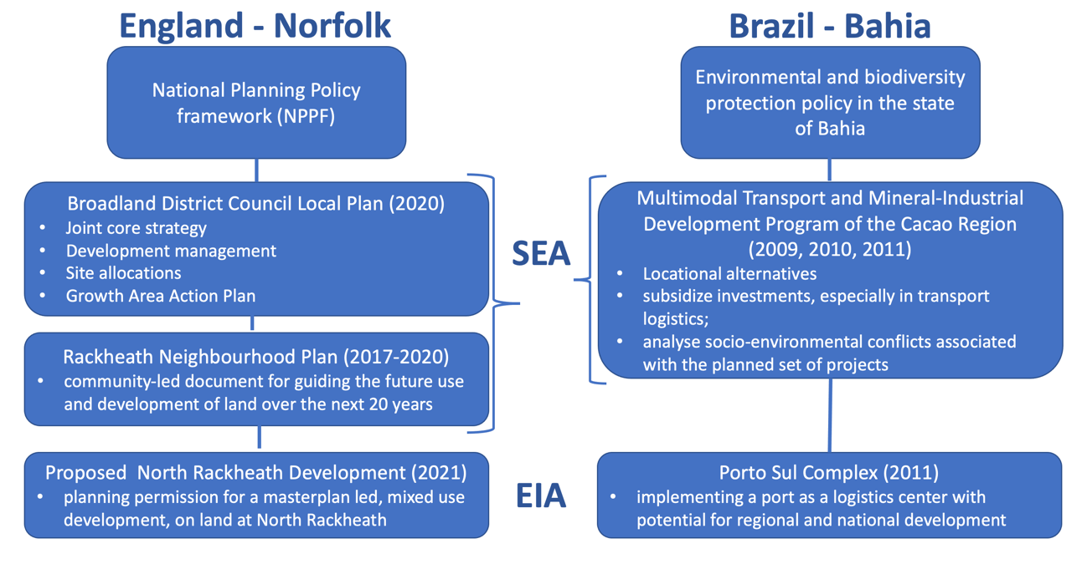
Figure 1 – Brief description of the main features of the EA vertical tiering in English and Brazilian cases.

The selection of case studies does not aim to compare similar planning cases, especially because the planning systems supported by EA processes of both countries are very different (Gallardo and Bond, 2011). The focus on case selection was based on the idea of identifying planning cases at different levels that are representative in the context of each of these countries for prompting EA tiering. This justifies the choice of large sector planning through a group of structuring projects, a recurring economic development in Brazil (Vilardo and Rovere, 2018; Coutinho et al., 2019), and urban land use planning, a common reality in English planning (Carmichael et al., 2019; Glasson and Therivel, 2019). We make no attempt to generalize from these case studies; instead, they are intended to provide learning about the realities of tiering in practice than can form the basis for future research.

2.2 A framework for analysing global biodiversity objectives from SEA to EIA
Gallardo and Bond (2023) recently developed a framework for analysing biodiversity and ecosystem services in EA practice, with a specific focus on tiering. This framework was developed from previous research examining ecosystem services and/or biodiversity within either SEA or EIA or both (for example, González et al., 2013; Honrado et al, 2013; Tallis et al., 2015; Brownlie and Treweek, 2018; Mandai and Souza, 2021; Gutierrez et al. 2021 and Gallardo et al., 2022b). Given its development from the existing literature, its fit to the objectives of the research, and its contemporary nature, this framework was selected as the basis for the analysis. The framework incorporates 18 objectives extracted from the key international biodiversity milestones (Table 1). This defines what aspects of biodiversity are considered in the evaluation of tiering across levels of IA. Gallardo and Bond (2023) acknowledged that the list of objectives were not likely to all be relevant in all EAs, and therefore further categorised them into four groups: 1) those that should always be a consideration in EA; 2) those only relevant where the contextual setting allows; 3) those which are aspirational and therefore related more to objectives-led assessment than baseline-led assessment; and 4) those which rely on IA systems maintaining centralised knowledge systems. Table 1 include keywords and search terms which assist in the content analysis of assessment documents to confirm if one or more of the 18 biodiversity objectives are considered in our case studies, and indicates which of the four categories each of them fit into. Figure 2 describes how the coding process and analysis were undertaken by applying the approach set out in Table 1 to the two case studies.

Table 1 – Analytical Framework for embracing international biodiversity objectives (Gallardo and Bond, 2023).
Main biodiversity objectives distilled | keywords (coding) | Practice group*
1. to reduce threats to biodiversity | Threats, biodiversity, red list | 1
2. to guide actions to conserve biological diversity mainly related to threatened species | diversity, threatened species | 2
3. to conserve wetlands and their resources | wetland | 2
4. to conserve wild flora and fauna and their natural habitats | Wild flora, fauna, natural habitat, wildlife; species; network | 1
5. to conserve terrestrial, marine, and avian migratory species throughout their range (habitat), to protect endangered migratory species | Terrestrial, marine, avian, migratory species, habitat; bird; endangered | 2
6. to protect ecosystem services | Ecosystem services | 1
7. to protect genetic diversity | Genetic diversity | 1
8. to promote the sustainable use of the components of biological diversity | Biological diversity, sustainable | 2
9. to promote the fair and equitable sharing of the benefits arising out of the utilization of genetic resources to meet people’s needs | Genetic diversity | 2
10. to reverse the loss of worldwide forest; to enhance forest-based sustainability benefits; to significantly increase the area of protected forests worldwide and other areas of sustainably managed forests | Afforestation, forest | 2
11. to protect, restore and promote sustainable use of terrestrial ecosystems, sustainably manage forests, combat desertification | Desertification, terrestrial ecosystems ,forest | 2
12. to halt and reverse land degradation | Land, degradation; landscape | 1
13. to increase biodiversity by avoiding any new degradation of land, reduces existing degradation, and restores already degraded land | Biodiversity; land; degradation; maximize | 3
14. to protect biological diversity by managing the risks of Live Modified Organisms (LMOs) | Live modified organisms; risks | 2
15. to propose tools and solutions for implementation and mainstreaming (2050 goals to 2030 milestones) | Tools, solutions, frameworks, guidelines, biodiversity, objectives; SDG goals; approach | 1
16. to undertake an assessment should towards sustainable development and ecosystem health and biodiversity | Ex ante, ecosystem services, biodiversity; sustainable development; assessment | 1
17. to assess the consequences of ecosystem change for human well-being and to enhance the conservation and sustainable use of ecological systems and their contribution to human well-being | Changes, ecosystem services, human well-being | 1
18. to perform regular and timely assessments of knowledge on biodiversity and ecosystem services and their interlinkages at the global level in order to provide a summary of the status of biological diversity to ensure that biodiversity is conserved and used sustainably | Knowledge, status, ecosystem services, biodiversity, biological diversity | 4
* 1) those that should always be a consideration in EA; 2) those only relevant where the contextual setting allows; 3) those which are aspirational and therefore related more to objectives-led assessment than baseline-led assessment; and 4) those which rely on IA systems maintaining centralised knowledge systems. See Gallardo and Bond (2023) for a fuller explanation.

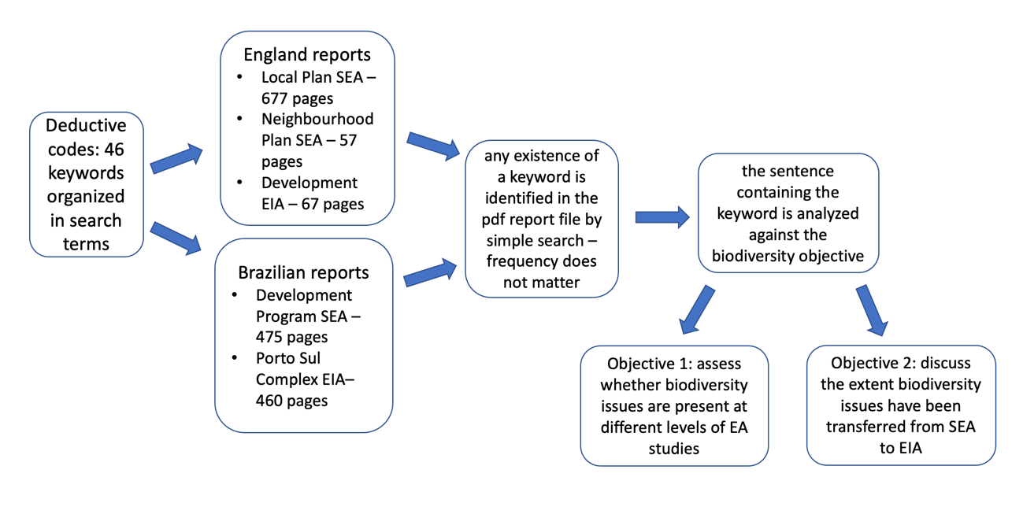
Figure 2 – Brief coding process and analysis used to identify and analyse biodiversity issues in each report.

Using the approach outlined in Figure 2, the case studies were analysed to investigate:
a) the extent to which global biodiversity objectives are addressed at the SEA and EIA levels: a wide sweep was applied to all the content of the analyzed reports to identify whether the objective is present in the document, regardless of the component chapter of the report (alternatives, baseline, mitigation measures, programs, etc.). Thus, this analysis step aimed to reveal evidence of the presence or absence of mention of the biodiversity objective in that report, without judging its efficacy in meeting them, and without recording their frequency of mention.
b) the extent to which there is explicit reference in the lower tier (EIA or SEA) to the treatment of the biodiversity objectives in the upper tier (SEA): the mentions of biodiversity objectives were compared between decision-making levels – two in the Brazilian case and three in the English case – to demonstrate the existence of integration of biodiversity considerations across tiers. As this is an ex-post document analysis, it is also not possible to fully assess the quality of a potential tiering. However, supported by the understanding of tiering proposed by Arts et al. (2011) and Therivel and González, 2021, a simple qualitative scale was proposed for a preliminary assessment of this explicit reference in three categories: – yes – there is explicit reference in the lower tier(s) to the objective mentioned at the higher tier (s); no – there is no explicit reference in the lower tier(s) to the objective mentioned at the higher tier(s); partially – there is partial evidence of reference in the lower tier(s) to the objective mentioned at the higher tier(s). These categories are broad and do not fully characterise the tiering that has taken place from SEA to EIA. As such, they provide some insights as the basis for further study. The initial plan was to use interviews with key stakeholders to explore the extent to which tiering was actively adopted, but the age of the Brazilian case precluded the identification of suitable stakeholders, and therefore limits the extent of learning from the cases. We also note that tiering in EA is considered to operate in two directions. That is, learning from the project level can transfer up to the plan and programme level. In the case studies analysed in this research, the EIAs followed the SEAs, with no subsequent updates of the SEAs to date.

The initial proposal was to undertake interviews with stakeholders involved in the preparation of the documents, in particular, the second and third tier assessment. However, in the Brazilian case the time lag between the assessment being conducted and the research taking place meant that the stakeholders were no longer in post and it was not possible to identify suitable interviewees. The approach taken to focus on documentary evidence is therefore limited in its ability to identify clear examples of tiering. The focus on specific mention of objectives at the higher tier does demonstrate some explicit connection which is being considered as a surrogate for evidence of tiering.

3 Results

Table 2 presents the assessment of whether biodiversity objectives are included at different levels of EA studies for the Brazilian and English cases, and whether there is evidence of tiering them from higher to lower levels.

Table 2 – Results for applying the analytical Framework for embracing global biodiversity objectives to Brazilian case.
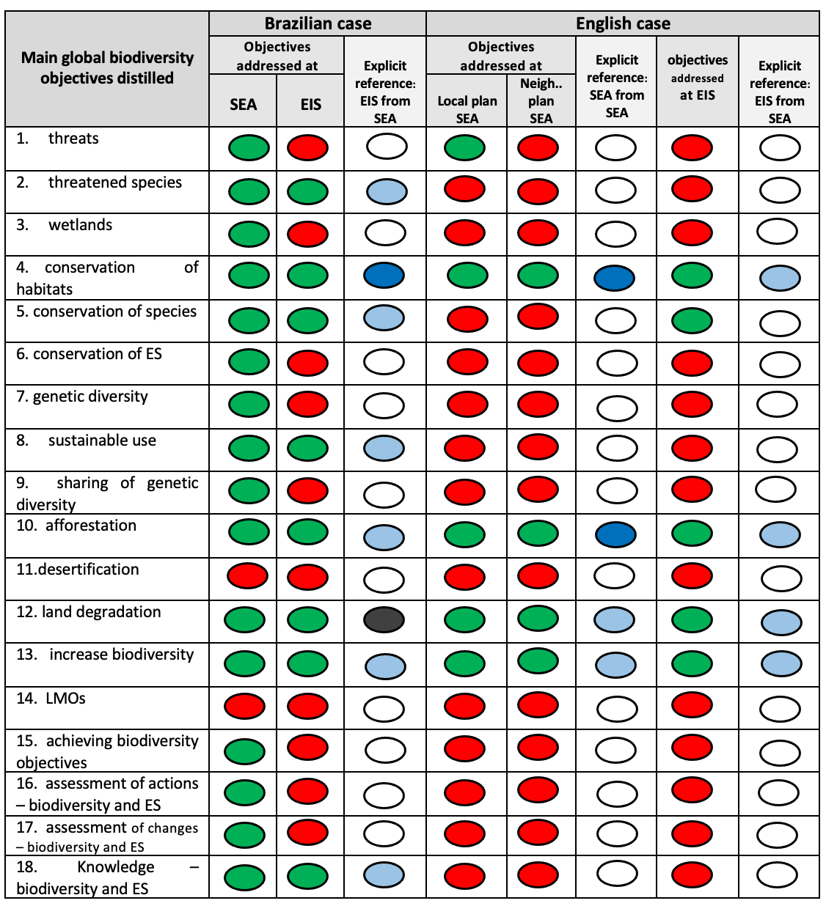
Neigh.. = neighbourhood

Biodiversity objectives are:
present | - absent
Tiering (see section 2.3 for description):
yes | partially | no | objectives missing at one or more levels
Source: the supplementary material presents all the data for both cases.

It would be expected that EA reports in a country as biodiverse as Brazil should refer to a high proportion of the international biodiversity objectives included in the analytical framework. Table 2 reveals that the Brazilian SEA does cover almost all of the global biodiversity objectives (16 out of 18 global biodiversity objectives), supporting a previous observation by Gallardo et al. (2022b) regarding the quality of this SEA report in terms of biodiversity issues. However, the Brazilian EIS only covers half of the biodiversity issues noted in the AAE report. The Porto Sul project is a structuring project that integrates the flow of goods from rail freight transport and covers an extensive area in a diverse landscape, which would not justify this reduction in biodiversity issues.
By contrast, the English SEA reports include only five at the higher level, or four at the lower level, out of 18 global biodiversity objectives. The EIA includes five of the global biodiversity objectives, four of which match the neighbourhood plan SEA and local plan. This low number is unexpected even given the level of biodiversity loss experienced in England. The difference to the Brazilian case is that between the levels of EA studies, both the quantity and types of biodiversity issues considered are broadly equivalent.
Objectives 11 (desertification) and 14 (LMO) are absent in SEA and EIA in both countries, as might be expected for geographical regions not subject to these issues. Nevertheless, the absence of objectives related to ecosystem services and sustainability (objectives 6, 16, 17 and 18) stands out in the English SEAs as their inclusion has been strongly recommended in the practice of EA (Rozas-Vasques et al., 2019; Longato et al., 2021; Partidário et al., 2023). These results point to the need for investigation in England of the narrow scope of biodiversity consideration, as they appear to be at odds with international objectives and obligations. The limited focus on objectives 7 and 9 (related to genetic diversity) does not differ from global practice (Brownlie and Treweek, 2018), however, it is notable that they are mentioned in the Brazilian SEA as this contradicts the previous finding that there is a reluctance to plan strategically for genetic diversity in SEA (Gallardo and Bond, 2023).
Comparing these results with the four main practice groups delineated in Table 1, all four groups of objectives are represented in the Brazilian case. On the other hand, the English case comprises only three of the four groups, with group 2) being represented by only one objective (afforestation), albeit it is not clear whether this really does reflect the context, or whether there are significant omissions – one would not expect a focus on desertification and LMOs in the English case, but all other objectives do seem relevant to the context and therefore suggest omissions in the EAs. Biodiversity objective 13 related to increasing biodiversity is present in all reports in both countries, revealing an initiative to develop studies more to objectives-led assessment than the baseline-led assessment. The lack of inclusion of text relating to objective 18 in the English case reflects the lack of any centralised data record relating to SEA or EIA in the country.
Objective 5 (conservation of species) was considered in the English EIA, without having been mentioned in the two previous SEAs. This can illustrate a situation discussed by Arts and Kalle (2012) when issues not addressed in the earlier SEA (in our case in both SEAs) are considered in the subsequent tier, in the EIA, revealing a context in which some omissions can be amended in the next EA level. The other way of looking at this is that those in charge of the SEA considered that the geographical scale was too great to usefully plan for species conservation. Whether this is appropriate is a debatable point given that species depend on habitats which can best be considered at the larger SEA scales.
Table 3 and Table 4, respectively, illustrate the extent to which biodiversity objectives were passed on between tiers for Brazilian and English cases.

Table 3 – How SEA and EIS reports embrace international biodiversity objectives tiering – Brazilian case.
Main biodiversity objectives distilled | Is there tiering from SEA to EIS? | the extent of tiering between SEA and EIA
2 – threatened species | Partially | despite some actions to conserve biological diversity related to threatened species are found in EIS, the education program does not bring any action related to this as proposed in the SEA.
4 – conservation of habitats | Yes | this objective is explicitly mentioned in the EIS as described in the SEA. In the SEA level there is a focus on strategic issues (regional biodiversity); and in the EIA level it is translated in local programs.
5 – conservation of species | Partially | it is mentioned in the EIS that this population of migratory marine fauna may be affected, some measures to monitor some of this life is proposed, but no target program is proposed as expected by SEA.
8 – sustainable use | Partially | the importance of the sustainable use of fisheries is mentioned in the EIS as highlighted in the SEA, however the EIS does not promote agroecological systems as mentioned in the SEA
10 – afforestation | Partially | although the EIS propose measures to avoid the loss of the forests affected by the project there is no mention for protecting associated fauna as predicted in the SEA.
12 – land degradation | No | the reversion of degraded areas described in the EIS is only planned in places directly affected by the civil work without the ecological consideration provided in the SEA
13 – increase biodiversity | Partially | only some actions to increase biodiversity are proposed in the EIS following the established in the SEA, such as those specific for environmental compensation of activities
18 – knowledge on biodiversity and ES | Partially | although in a narrow approach, some indicators for regular knowledge of biodiversity are indicated in the EIA, the observatory proposed in the SEA is not included in the EIA
Source: the supplementary material presents all the data for each report.
Table 4 – How SEA and EIS reports embrace international biodiversity objectives tiering – English case.
Main biodiversity objectives distilled | Is there tiering from SEA to SEA? | the extent of tiering between SEAs | Is there tiering from SEA to EIS? | the extent of tiering between SEA and EIA
4 – conservation of habitats | Yes | this objective is explicitly mentioned in the neighbourhood plan SEA as described in local plan SEA | Partially | the evaluation is only part of the actions of protection and conservation of wildlife and habitats at a landscape-scale as presented in both previous SEAs.
10 – afforestaion | Yes | this objective is explicitly mentioned in the neighbourhood plan SEA as described in local plan SEA | Partially | the hedgerows and trees are recognized as habitats for bats and present in the area, but there is no mention regarding their preservation.
12 – land degradation | Partially | the neighbourhood plan SEA only presents a way to avoid degradation but not to reverse for example by promoting brownfield development. | Partially | the EIS only focuses on the assessment not the reversion of degraded areas.
13 – increase biodiversity | Partially | the neighbourhood plan SEA reinforces the need to plant trees and mentions the conservation and enhancement of the landscape, but it is not connected to any type of biodiversity net gain as considered in the local plan SEA. | Partially | the EIS recognizes the importance of increasing biodiversity but doesn’t add the biodiversity net gain perspective at the project level.
Source: the supplementary material presents all the data for each report.

Comparing Table 2 with Tables 3 and 4, explicit transfer of information from SEAs to EIAs is rare in both cases, although the English case has more examples (two) than the Brazilian case. Without interviews, it is not possible to ascribe a reason for this, but it can be hypothesized that the statutory nature of both SEA and EIA in England has led to more practice and therefore provided more opportunities to tier.
Objective (12) related to land degradation was unusual in having no indication of any level of tiering in either case study. For the majority of objectives where there was partial transfer of knowledge across tiers, it was found that some important actions foreseen in the SEA were not continued at the level of EA.
Overall, the analysis presents a mixed picture, where there is some evidence of good practice, but considerably more evidence of a lack of tiering, or only partial transfer of knowledge below what had been anticipated with in the SEA.

4. Discussion
Figure 3 summarises the evidence for biodiversity EA tiering taking place in the two case studies (Brazilian and English).

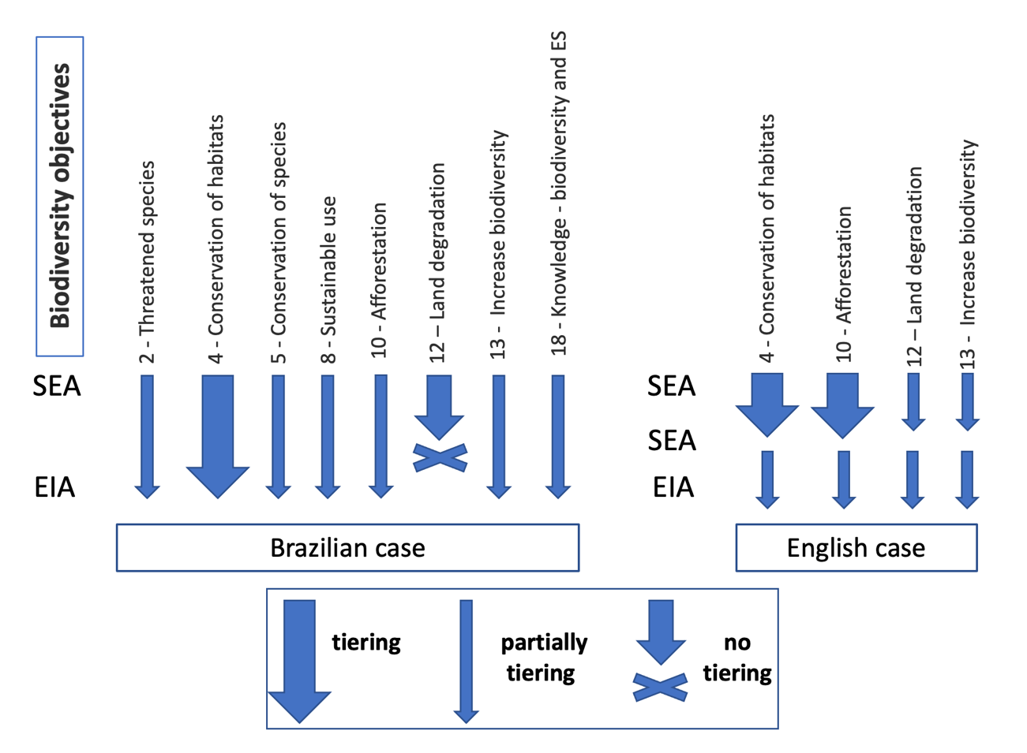
Figure 3 – Exploring potential tiering of biodiversity knowledge from SEA to EIA from the case studies (includes only objectives with reference to biodiversity objectives at both SEA and EIA levels).

Thérivel and González (2021) highlight biodiversity as a relevant environmental issue to be addressed at different tiers of plan-making and EA practice. Figure 3 shows that evidence of explicit tiering of biodiversity knowledge from the SEA to the EIA in the Brazilian case is limited, albeit some tiering practice is evident for seven out of the 18 biodiversity objectives. For the English case, the scope of biodiversity is even smaller (only four out of the 18 biodiversity objectives) than in the Brazilian case and with limited tiering results, albeit the proportion of objectives considered that were tiered (fully or partially) is much higher than in the Brazilian case.
Except for objective 4 for the Brazilian case, the transfer from the planning level to the project level (EIA) was always partial, restricting the potential benefits of EA tiering. The analysis of the Brazilian and English case studies demonstrates that tiering of biodiversity objectives does exist, but is limited, in line with previous findings (Sánchez and Silva-Sánchez, 2008; Coutinho et al., 2019; Gutierrez et al., 2021; Gallardo et al., 2022a).
The partial tiering between the different levels of planning supports the findings of Gallardo et al. (2022a) in which only implicit evidence about ecosystem services was observed in a program followed by projects in the Brazilian transport sector. It also demonstrates little progress since tiering was identified as an opportunity to improve practice in 1999 (Jha-Thakur and Fisher, 2016).
Supported by analyzing two contrasting cases in terms of SEA requirements and biodiversity features, very limited evidence for tiering was found to ensure that international biodiversity targets are transmitted between decision-making levels. Although these cases cannot be generalized, our results are in line with other studies identifying tiering as a weak element of EA practice (e.g., Sánchez and Silva-Sánchez (2008); Noble (2009); Fidler and Noble (2012); Phylip-Jones and Fischer (2015); Gallardo et al. (2022a)).
Coutinho et al. (2019) reinforce a need for a comprehensive and well-sequenced assessment process to achieve EA tiering. The Brazilian case was not conducted in this way, although SEA comes from a legal requirement, it does not bring any specific guidance on how to consider this SEA in subsequent EA studies. The English case, although with much more mature practice in carrying out SEA, including at different levels, due to the results obtained, also reflects a lack of specific guidance on tiering, albeit the level of tiering is higher. It is possible that some considerations made by González and Thérivel (2022, p. 6) related to “the limited degree to which higher-tier SEAs consider lower-tier development locations and types and, indeed, assessment issues, hampers the opportunities to optimise information flows across environmental assessments, particularly in the context of land-use planning” could also explain the limited results obtained for the analysed English case.
Considering the Brazilian case, Sánchez and Silva-Sánchez (2008, p. 522) have argued that “in countries where no agreed-upon framework for SEA exists, if vertical tiering with downstream project EIA is sought when undertaking an SEA, then a careful scoping of strategic issues is more than necessary”. This may reveal the loose connection between SEA and EIA in the Brazilian case since the studies were carried out almost simultaneously and without good scoping aimed at this purpose.
Thérivel and González (2021, p. 9) highlighted that "tiering SEA and EIA presents opportunities to anticipate and tackle issues at the right time (i.e. those ‘ripe for decision’), avoid duplication, and resolve data and knowledge gaps". However, our case study analysis has also illustrated that the lack of important information throughout the levels of the EA process (i.e., missing biodiversity objectives, particularly in the English case study) can compromise the outcome of strategic planning and reduce the scope of EIA efficiency.

5. Conclusions
Our study finds limited evidence of biodiversity tiering considering two contrasting Brazilian and English planning cases. The Brazilian case shows that even though a wide range of biodiversity objectives are considered in planning guided by the SEA and that some may even be present in the EIA, an explicit connection between them is not guaranteed. Likewise, the English case, which shows limited consideration of biodiversity issues even with mature planning in the EA process, also reveals an incomplete connection between tiers.
The use of a framework can be a useful tool so that tiering of information that is important to consider through tiering - such as biodiversity in our study - can be evaluated and, potentially, improved based on the findings. However, evaluation on its own will be insufficient if there are no other initiatives that ensure that tiering is strengthened. The English case reveals that important biodiversity issues are being neglected in land use planning cycles. The Brazilian case shows that despite a broad consideration of biodiversity, and with no obvious process (or appetite) to improve this situation, there is little immediate prospect for improvement.
The research has illustrated the application of an analytical framework to evaluate the extent of tiering between SEA and EIA, for biodiversity impacts. The utility of the method has been demonstrated and it can provide the basis for wider investigations of tiering practice in other jurisdictions. Further research is needed to benchmark existing levels of tiering, to supplement what is perceived to be a weakness, based on currently limited research evidence.
Considering the limitations of our work also supported by the conclusions, we recommend for future studies:
- The framework was developed based only on the authors’ experience supported by literature review and our empirical findings. It must be tested in different contexts and stakeholders to proves its validity and practicability;
- To apply this framework additional filters for its application should be applied based on recent findings of works directly dedicated to tiering, for example: how to build bridges between different decisions tiers, institutional strengthening and interorganizational cooperation (Fischer and Onyango, 2012); to ensure tiering is seen not only in a strictly top-down manner but also as a ‘bottom-up’ effect to surpass limitations in strategic issues (Coutinho et al., 2019); to explore aspects related to who is in charge of undertaking different studies at different tiers, and how to promote a clearer ‘downward’ communication of information (Therivel and González, 2021); to explore some shortcomings, and identify more examples of good tiering practice, across the steps of each EA report (González and Therivel, 2022); to examine the potential benefits of using broader environmental concern related to biodiversity “as an integrative concept and thread for tiering” (Gallardo et al., 2022a, p. 11).
- A focus on documentary evidence alone limits the strength of evidence of tiering taking place, as it relies on some inferences being drawn about connections between biodiversity elements at the different tiers of assessment. As a result, this ex-post analysis of the Brazilian and English cases lacks the additional detail that could have been provided by interviews. Future cases should aim to resolve this significant shortcoming to better understand the tiering practice, and the potential means of improving this practice.

Acknowledgements
After approval.

References
Arts, J., Tomlinson, P., & Voogd, H. (2011). Planning in tiers? Tiering as a way of linking SEA and EIA. Handbook of strategic environmental assessment, 415-436.
Arts, J. & H. Kalle (2012), Tiering - challenges and recent developments, paper 32nd Annual Meeting of IAIA, May 2012, Porto.
Bond, A. J., & Fischer, T. B. (2022). Characterising the collaboration between academia and practice in UK environmental assessment. Environmental Impact Assessment Review, 97, 106899.
Bond, A., Pope, J., Morrison-Saunders, A., & Retief, F. (2021). Taking an environmental ethics perspective to understand what we should expect from EIA in terms of biodiversity protection. Environmental Impact Assessment Review, 86, 106508.
Bond, A., Pope, J., Morrison-Saunders, A., & Retief, F. (2022). Exploring the relationship between context and effectiveness in impact assessment. Environmental Impact Assessment Review, 97, 106901.
Brownlie, S., Treweek, J. 2018. Biodiversity and ecosystem services in impact assessment international Best Practice Principles. Special Publication Series N 3. International Association for Impact Assessment, Fargo (USA). [accessed 2022 Jan 20] https://www.iaia. org/uploads/pdf/SP3-Biodiversity-Ecosystem-Services.pdf.
Carvalho, S., Partidario, M., & Sheate, W. (2017). High speed rail comparative strategic assessments in EU member states. Environmental Impact Assessment Review, 66, 1-13.
Carmichael, L., Townshend, T. G., Fischer, T. B., Lock, K., Petrokofsky, C., Sheppard, A., ... & Ogilvie, F. (2019). Urban planning as an enabler of urban health: Challenges and good practice in England following the 2012 planning and public health reforms. Land use policy, 84, 154-162.
Chan, S., Bauer, S., Betsill, M. M., Biermann, F., Boran, I., Bridgewater, P., ... & Pettorelli, N. (2022). The global biodiversity framework needs a robust action agenda. Nature Ecology & Evolution, 1-2.
Coutinho, M., Bynoe, M., Pires, S. M., Leão, F., Bento, S., & Borrego, C. (2019). Impact assessment: tiering approaches for sustainable development planning and decision-making of a large infrastructure project. Impact Assessment and Project Appraisal, 37(6), 460-470.
Cumming, K., & Tavares, D. (2022). Using strategic environmental assessment and project environmental impact assessment to assess ecological connectivity at multiple scales in a national park context. Impact Assessment and Project Appraisal, 1-10.
Cunningham, C. A., Crick, H. Q., Morecroft, M. D., Thomas, C. D., & Beale, C. M. (2021). Translating area-based conservation pledges into efficient biodiversity protection outcomes. Communications biology, 4(1), 1-5.
De Santo, E. M., Ásgeirsdóttir, Á., Barros-Platiau, A., Biermann, F., Dryzek, J., Gonçalves, L. R., ... & Young, O. (2019). Protecting biodiversity in areas beyond national jurisdiction: An earth system governance perspective. Earth System Governance, 2, 100029.D
Díaz, S. (2022). A fabric of life view of the world. Science, 375(6586), 1204-1204.
Enríquez-de-Salamanca, Á. (2023). SEA and EIA: uncertain boundaries in Spain. Impact Assessment and Project Appraisal, 1-8.
European Parliament and the Council of the European Union (2001), "Directive 2001/42/EC of the European Parliament and of the Council of 27 June 2001 on the assessment of the effects of certain plans and programmes on the environment", Official Journal of the European Communities, L197, pages 30-37.
Fearnside, P. M. (2016). Brazilian politics threaten environmental policies. Science, 353(6301), 746-748.
Fidler, C., & Noble, B. (2012). Advancing strategic environmental assessment in the offshore oil and gas sector: Lessons from Norway, Canada, and the United Kingdom. Environmental Impact Assessment Review, 34, 12-21.
Fischer, T. B., & Onyango, V. (2012). Strategic environmental assessment-related research projects and journal articles: an overview of the past 20 years. Impact Assessment and Project Appraisal, 30(4), 253-263.
Gallardo, A. L. C. F., & Bond, A. (2011). Investigating the effectiveness of environmental assessment of land use change: A comparative study of the approaches taken to perennial biomass crop planting in São Paulo and England. Biomass and bioenergy, 35(5), 2285-2297.
Gallardo, A. L. C. F., & Bond, A. (2023). Delivering an analytical framework for evaluating the delivery of biodiversity objectives at strategic and project levels of impact assessment. Environmental Impact Assessment Review, 99, 107049.
Gallardo, A. L. C. F., Machado, D. M. M., & Kniess, C. T. (2021). Strategic Environmental Assessment in Brazilian Academic Research. Ambiente & Sociedade, 24.
Gallardo, A. L. C. F., Rosa, J. C. S., & Sánchez, L. E. (2022a). Addressing ecosystem services from plan to project to further tiering in impact assessment: Lessons from highway planning in São Paulo, Brazil. Environmental Impact Assessment, 92, 106694.
Gallardo, A. L. C. F., Santos, C. A. C., Bond, A., Moretto, E. M., Montaño, M., & Athayde, S. (2022b). Translating Best Practice Principles into criteria for evaluating the consideration of biodiversity in SEA practice. Impact Assessment and Project Appraisal, 1-13.
Glasson, J and Therivel. R. (2019), Introduction to Environmental Impact Assessment (Routledge, London).
González, A., Hochstrasser, T., Fry, J., Scott, P., Grist, B., Jones, M. (2013). Evaluating Ireland's IBIA as an approach to improving the quality and effectiveness of biodiversity impact assessment. Journal of Environmental Management, 131, pp. 150-160.
González, A., & Therivel, R. (2022). Raising the game in environmental assessment: insights from tiering practice. Environmental Impact Assessment Review, 92, 106695.
Gutierrez, M., Bekessy, S. A., & Gordon, A. (2021). Biodiversity and ecosystem services in strategic environmental assessment: An evaluation of six Australian cases. Environmental Impact Assessment Review, 87, 106552.
Honrado, J. P., Vieira, C., Soares, C., Monteiro, M. B., Marcos, B., Pereira, H. M., & Partidário, M. R. (2013). Can we infer about ecosystem services from EIA and SEA practice? A framework for analysis and examples from Portugal. Environmental Impact Assessment Review, 40, 14-24.
Jha-Thakur, U., & Fischer, T. B. (2016). 25 years of the UK EIA system: strengths, weaknesses, opportunities and threats. Environmental Impact Assessment Review, 61, 19-26.
João, E. (2007). A research agenda for data and scale issues in Strategic Environmental Assessment (SEA). Environmental Impact Assessment Review, 27(5), 479-491.
Lemos, C. C., Fischer, T. B., & Souza, M. P. (2012). Strategic environmental assessment in tourism planning—Extent of application and quality of documentation. Environmental Impact Assessment Review, 35, 1-10.
Longato, D., Cortinovis, C., Albert, C., & Geneletti, D. (2021). Practical applications of ecosystem services in spatial planning: Lessons learned from a systematic literature review. Environmental Science & Policy, 119, 72-84.
Malvestio, A. C., & Montaño, M. (2019). From medicine to poison: how flexible strategic environmental assessment may be? Lessons from a non-regulated SEA system. Impact Assessment and Project Appraisal, 37(5), 437-451.
Mandai, S. S., & de Souza, M. M. P. (2021). Guidelines for the analysis of the inclusion of biodiversity in Environmental Impact Statements. Environmental Impact Assessment Review, 87, 106523.
Milner-Gulland, E. J., Addison, P., Arlidge, W. N., Baker, J., Booth, H., Brooks, T., ... & Watson, J. E. (2021). Four steps for the Earth: mainstreaming the post-2020 global biodiversity framework. One Earth, 4(1), 75-87.
Montaño, M., & Fischer, T. B. (2019). Towards a more effective approach to the development and maintenance of SEA guidance. Impact Assessment and Project Appraisal, 37(2), 97-106.
Montaño, M., Tshibangu, G. M., & Malvestio, A. C. (2021). 23. Strategic environmental assessment in Brazil: an endangered species?. Handbook on Strategic Environmental Assessment, 363.
Montoya, J. M., Donohue, I., & Pimm, S. L. (2018). Planetary boundaries for biodiversity: implausible science, pernicious policies. Trends in ecology & evolution, 33(2), 71-73.
Morrison-Saunders, A., Sánchez, L. E., Retief, F., Sinclair, J., Doelle, M., Jones, M., ... & Pope, J. (2020). Gearing up impact assessment as a vehicle for achieving the UN sustainable development goals. Impact Assessment and Project Appraisal, 38(2), 113-117.
Nadruz, V.N., Gallardo, A. L. C. F., Montaño, M., Ramos, H. R., & Ruiz, M. S. (2018). Identifying the missing link between climate change policies and sectoral/regional planning supported by Strategic Environmental Assessment in emergent economies: lessons from Brazil. Renewable and Sustainable Energy Reviews, 88, 46-53.
Naeem, S., Chazdon, R., Duffy, J. E., Prager, C., & Worm, B. (2016). Biodiversity and human well-being: an essential link for sustainable development. Proceedings of the Royal Society B: Biological Sciences, 283(1844), 20162091.
Nicolaisen, M. S., & Driscoll, P. A. (2016). An international review of ex-post project evaluation schemes in the transport sector. Journal of Environmental Assessment Policy and Management, 18(01), 1650008.
Nilsson, M., Wiklund, H., Finnveden, G., Jonsson, D. K., Lundberg, K., Tyskeng, S., & Wallgren, O. (2009). Analytical framework and tool kit for SEA follow-up. Environmental Impact Assessment Review, 29(3), 186-199.
Nisbet, J., & João, E. (2022). A framework for evaluating enhancement quality as part of the EIA process. Environmental Impact Assessment Review, 96, 106806.
Noble, B. F. (2009). Promise and dismay: The state of strategic environmental assessment systems and practices in Canada. Environmental Impact Assessment Review, 29(1), 66-75.
Obura, D. O., Katerere, Y., Mayet, M., Kaelo, D., Msweli, S., Mather, K., ... & Nantongo, P. (2021). Integrate biodiversity targets from local to global levels. Science, 373(6556), 746-748.
Oliveira, I.D.; Montaño, M.; Souza, M. M. P. (2013). Strategic Environmental Assessment to Improve Infrastructure Impact Assessments in Brazil. Journal of Environmental Protection, 2013.
Oliveira, R.,S. & Malvestio, A. C. (2022). The regulation of Strategic Environmental Assessment in Brazil. Sustainability in Debate, 13(1), 90-90.
Partidário, M., Monteiro, M. B., & Martins, R. (2023). Novel perspectives for multi-actor collaboration in strategic environmental assessment using ST4S. Environmental Impact Assessment Review, 99, 107023.
Pascual, U., Adams, W. M., Díaz, S., Lele, S., Mace, G. M., & Turnhout, E. (2021). Biodiversity and the challenge of pluralism. Nature Sustainability, 4(7), 567-572.
Phylip-Jones, J., & Fischer, T. B. (2015). Strategic environmental assessment (SEA) for wind energy planning: Lessons from the United Kingdom and Germany. Environmental Impact Assessment Review, 50, 203-212.
Pinto, E., Morrison-Saunders, A., Bond, A., Pope, J., & Retief, F. (2019). Distilling and applying criteria for best practice EIA follow-up. Journal of environmental assessment policy and management, 21(02), 1950008.
Pope, J., Bond, A., Morrison-Saunders, A., & Retief, F. (2013). Advancing the theory and practice of impact assessment: Setting the research agenda. Environmental impact assessment review, 41, 1-9.
Popil, I. (2011). Promotion of critical thinking by using case studies as teaching method. Nurse education today, 31(2), 204-207.
Rozas-Vasquez, D., Fuerst, C., & Geneletti, D. (2019). Integrating ecosystem services in spatial planning and strategic environmental assessment: The role of the cascade model. Environmental Impact Assessment Review, 78, 106291.
RSPB (2021), "Biodiversity Loss: The UK’s global rank for levels of biodiversity loss", available at <https://www.rspb.org.uk/globalassets/downloads/projects/48398rspb-biodivesity-intactness-index-summary-report-v5-1-1.pdf>, last accessed 3 February 2023.
Russel, D, J Turnpenny, A Jordan, A Bond, W Sheate and C Adelle (2014), UK National Ecosystem Assessment Follow-on. Work Package Report 9: Embedding an Ecosystem Services Framework in appraisal: Key barriers and enablers. (UNEP-WCMC, LWEC, UK).
Ryan, K., Danylchuk, A., & Jordaan, A. (2019). Consideration of scales in offshore wind environmental impact assessments. Environmental Impact Assessment Review, 75, 59-66.
Sánchez, L. E., & Silva-Sánchez, S. S. (2008). Tiering strategic environmental assessment and project environmental impact assessment in highway planning in São Paulo, Brazil. Environmental Impact Assessment Review, 28(7), 515-522.
Strömmer, K., & Ormiston, J. (2022). Forward-looking impact assessment–An interdisciplinary systematic review and research agenda. Journal of Cleaner Production, 134322.
Tallis, H., Kennedy, C. M., Ruckelshaus, M., Goldstein, J., & Kiesecker, J. M. (2015). Mitigation for one & all: An integrated framework for mitigation of development impacts on biodiversity and ecosystem services. Environmental Impact Assessment Review, 55, 21-34.
Therivel, R., & González, A. (2021). “Ripe for decision”: Tiering in environmental assessment. Environmental Impact Assessment Review, 87, 106520.
Tshibangu, G. M., & Montaño, M. (2016). Energy related strategic environmental assessment applied by multilateral development agencies—An analysis based on good practice criteria. Environmental Impact Assessment Review, 61, 27-37.
Tshibangu, G. M., & Montaño, M. (2019). Outcomes and contextual aspects of strategic environmental assessment in a non-mandatory context: the case of Brazil. Impact Assessment and Project Appraisal, 37(3-4), 334-343.
Vilardo, C., & La Rovere, E. L. (2018). Multi-project environmental impact assessment: insights from offshore oil and gas development in Brazil. Impact Assessment and Project Appraisal, 36(4), 358-370.
Vilardo, C., La Rovere, E. L., Evora, J. E. M., & Montaño, M. (2020). Lost at SEA? Environmental assessment and offshore oil and gas planning in Brazil. Impact Assessment and Project Appraisal, 38(3), 261-268.
Westin, F. F., dos Santos, M. A., & Martins, I. D. (2014). Hydropower expansion and analysis of the use of strategic and integrated environmental assessment tools in Brazil. Renewable and Sustainable Energy Reviews, 37, 750-761.
Williams, A., & Dupuy, K. (2017). Deciding over nature: Corruption and environmental impact assessments. Environmental Impact Assessment Review, 65, 118-124.
Zhang, S., Zhou, Y., Yu, R., Xu, X., Xu, M., Li, G., ... & Yang, Y. (2022). China's biodiversity conservation in the process of implementing the sustainable development goals (SDGs). Journal of Cleaner Production, 338, 130595.

