**Climate pledges: Current national proposals are off-track to meet carbon dioxide removal needs**

*William F. Lambi,ii,*, Thomas Gasseriii, Rosa M. Roman-Cuestaiv, Giacomo Grassiiv, Matthew J. Giddeniii, Carter M. Powisv, Oliver Gedenvi, Gregory Nemetvii, Yoga Pratamaiii, Keywan Riahiiii, Stephen M Smithv, Jan Steinhauseriii , Naomi E. Vaughan*viii,ix*, Harry Smith*viii,ix*,* *Jan C. Minxi,ii*

*i Mercator Research Institute on Global Commons and Climate Change (MCC)*

*ii Priestley International Centre for Climate, University of Leeds*

*iii International Institute for Applied Systems Analysis (IIASA)*

*iv Joint Research Centre, European Commission*

*v School of Enterprise and the Environment, University of Oxford*

*vi German Institute for International and Security Affairs (SWP)*

*vii University of Wisconsin-Madison*

*viii School of Environmental Sciences, University of East Anglia, Norwich NR4 7TJ, UK*

*ix Tyndall Centre for Climate Change Research, University of East Anglia, Norwich NR4 7TJ, UK*

*Corresponding author (lamb@mcc-berlin.net)

**Meeting the Paris Agreement requires deep emissions reductions supported by a scale-up in carbon dioxide removal (CDR). However, our analysis of country reported mitigation pledges shows that current proposals are off-track to meet CDR needs, unless countries dramatically reduce emissions consistent with low energy demand scenarios.**

### The policy problem

Many countries have declared net-zero targets as part of their commitments under the Paris Agreement. In addition to emissions reductions, these national targets imply proposals to sustain or increase carbon dioxide removal. Countries have communicated these proposals in their reporting to the UN Framework Convention on Climate Change (UNFCCC), so far describing contributions from conventional CDR methods in the land use, land-use change and forestry (LULUCF) sector, such as afforestation, as well as novel methods such as direct air capture and storage. Much attention has been given to overall mitigation targets. However, so far, there has been a lack of evaluation and critical reflection on the specific role of carbon dioxide removal in these targets.

### The findings

In our study we found that compared to 2020, the most ambitious national proposals for CDR imply an additional 0.5 GtCO2/year of removals by 2030, and 1.9 GtCO2/year by 2050. Compared to CDR scaling in Paris-consistent scenarios, we found that these national CDR proposals tend to fall short by hundreds of megatons in 2030 to several gigatons in 2050, highlighting a “CDR gap”. However, we find that the most ambitious proposals do come close to levels in a low-demand scenario where CDR requirements are minimised, suggesting that if countries pledge more ambitious emissions reductions consistent with these scenarios, the CDR gap will be closed. As levels of reporting vary, our evaluation of proposed CDR does assume that a number of countries simply maintain their current levels of (conventional) removals. In addition, it remains unknown to what extent firm CDR policies will follow these proposals.

### The study

In our study, we evaluated CDR proposals based on a range of country-submitted reports to the UNFCCC. Importantly, countries describe their climate targets in terms of national greenhouse gas inventory conventions. In the LULUCF sector these are based on direct observations and hence cannot factor out ‘indirect anthropogenic effects’, such as the effect of increased CO2 concentrations on vegetation growth. Since this inflates apparent proposals for CDR when compared to scenario conventions, we discount these indirect effects to focus on direct anthropogenic removals only, consistent with the IPCC definition of CDR. We then added conventional removals to any national proposals for scaling novel CDR. Finally, we benchmark the collective national proposals against CDR in a set of Paris-consistent integrated assessment scenarios, orienting our selection of scenarios to those with relatively moderate levels of CDR scaling - recognizing the existence of both sustainability constraints and limits to the pace of upscaling.

### Messages for Policy

* Prioritise reducing emissions rapidly across all sectors (including from deforestation and land degradation) to minimise our dependency on CDR.
* Report planned emission reductions and removals separately in the NDCs and long-term strategies, while acknowledging the difficulty of isolating only direct anthropogenic effects in country reporting.
* Focus on policies that incentivize further removals on land, supporting afforestation, improved forest management and gains in soil carbon, whilst protecting ecosystems and biodiversity.
* Develop plans to mitigate future risks for removals on land, including the impacts of climate change (such as wildfires) and changes in indirect anthropogenic effects (such as CO2 fertilisation).
* Close the CDR gap by designing “technology push” and “demand pull” policies that promote innovation, development and the upscaling of energy-efficient, scalable, cost-effective novel CDR technologies.

### Source research

Lamb, W. F. et al. The carbon dioxide removal gap. Nat. Clim. Chang. x, x-y (2024).

### Further Reading

1. Smith, S. M. *et al.* *The State of Carbon Dioxide Removal - 1st Edition*. 1–108 [Available at: https://www.stateofcdr.org](https://doi.org/Available%20at:%20https://www.stateofcdr.org) (2023). **Provides a comprehensive analysis of carbon dioxide removal, including technology readiness, current deployment and scaling in scenarios.**
2. Smith, H. B., Vaughan, N. E. & Forster, J. Long-term national climate strategies bet on forests and soils to reach net-zero. *Commun Earth Environ* **3**, 305 Available at: <https://www.nature.com/articles/s43247-022-00636-x> (2022). **Evaluates the carbon dioxide removal levels implied by country scenarios in the long-term mitigation strategies submitted to the UNFCCC.**
3. Buck, H. J., Carton, W., Lund, J. F. & Markusson, N. Why residual emissions matter right now. *Nat. Clim. Chang.* **13**, 351–358 Available at: <https://www.nature.com/articles/s41558-022-01592-2> (2023). **Evaluates the residual emissions implied by country scenarios in the long-term mitigation strategies submitted to the UNFCCC.**
4. Gidden, M. J. *et al.* Aligning climate scenarios to emissions inventories shifts global benchmarks. *Nature* **624**, 102–108 Available at: <https://www.nature.com/articles/s41586-023-06724-y> (2023). **Provides a first alignment of integrated assessment scenarios to national inventory conventions, showing how global mitigation benchmarks shift when aligned to country reporting.**
5. Grassi, G. *et al.* Carbon fluxes from land 2000–2020: bringing clarity to countries’ reporting. *Earth Syst. Sci. Data* **14**, 4643–4666 Available at: <https://essd.copernicus.org/articles/14/4643/2022/> (2022). **Provides a consistent database of national LULUCF emissions and removals based on inventory submissions and other national reporting to the UNFCCC.**

### Figure

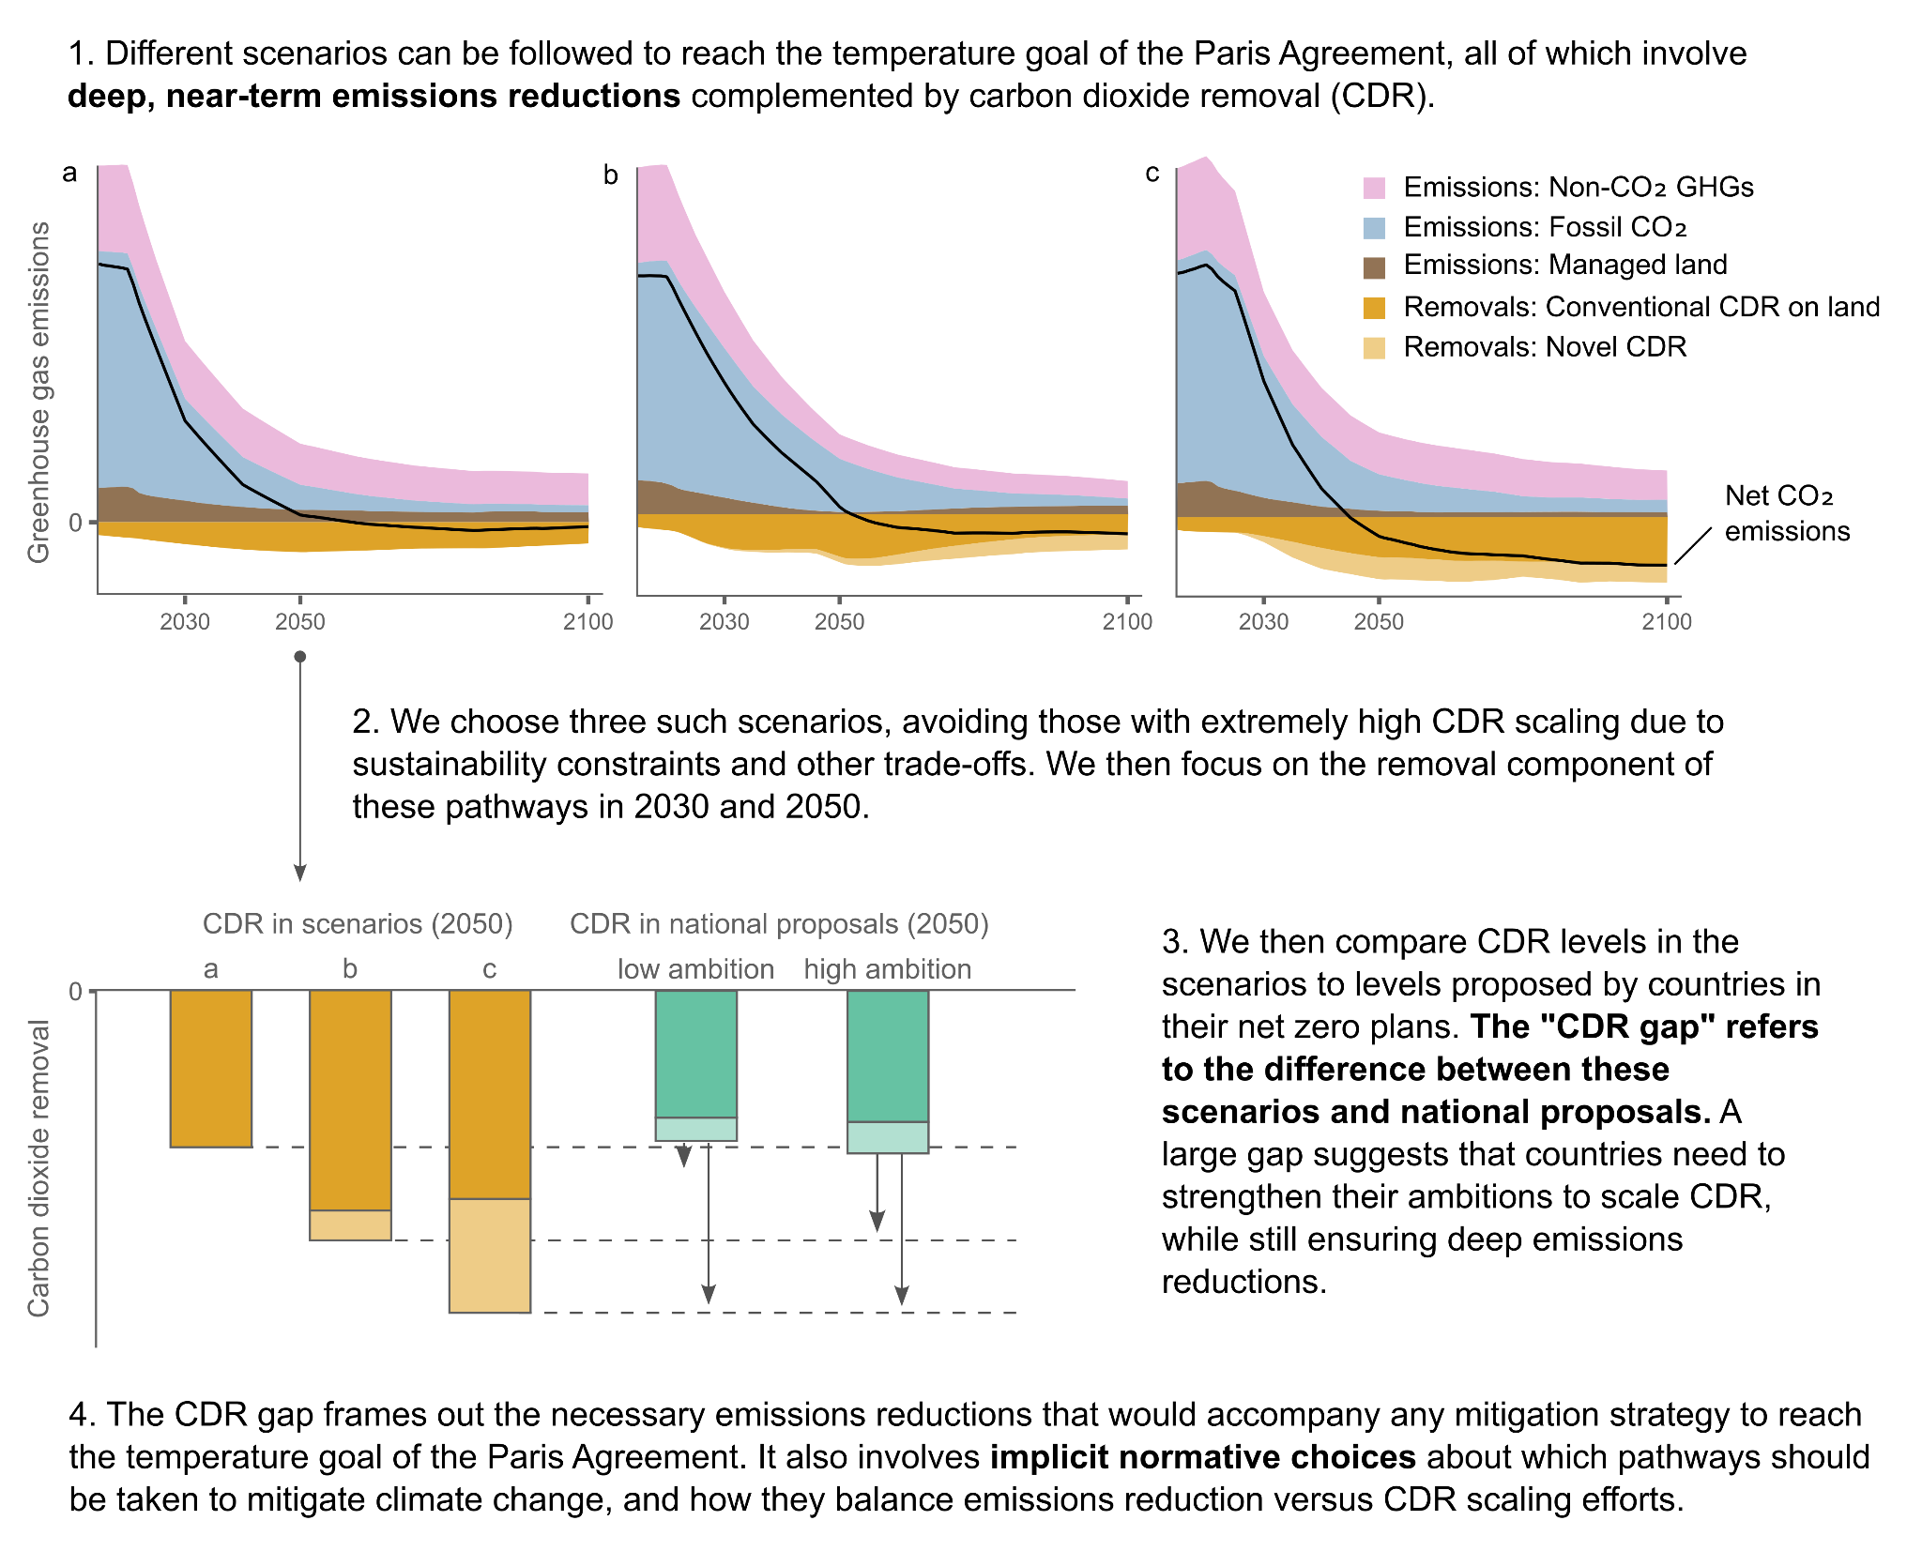

**Figure 1: The carbon dioxide removal gap concept**

### Acknowledgments

This work was supported by the European Union ERC-2020-SyG "GENIE" (951542) grant (W.F.L., J.C.M., G.N., T.G., M.G., Y.P., J.S., K.R.); the UK Natural Environment Research Council “CO2RE Hub” (NE/V013106/1) grant (S.M.S.); the European Union Horizon 2020 “ESM2025” (101003536) and “RESCUE” (101056939) grants (T.G.); the German Federal Ministry of Education and Research “CDRSynTra” (01LS2101A) (J.C.M., O.G.) and “ASMASYS” (01LS2101A) grants (O.G.)

### Competing interests

The authors declare that they have no known competing financial or non-financial interests with respect to this study.