Gold-Catalysed Heck Reaction: Fact or Fiction? Correspondence on “Unlocking the Chain Walking Process in Gold Catalysis”
Peter H. M. Budzelaar,*^{[a]} Manfred Bochmann,*^{[b]} Martina Landrini,^{[c]} and Luca Rocchigiani*^{[c]}
[a] Prof. Dr. P.H.M. Budzelaar
Department of Chemistry, University of Naples Federico II, Via Cintia, I-80126, Naples, Italy
E-mail: p.budzelaar@unina.it
[b] Prof. Dr. M. Bochmann
School of Chemistry, University of East Anglia, Norwich Research Park, NR4 7TJ, Norwich, United Kingdom
E-mail: m.bochmann@uea.ac.uk
[b] M. Landrini, Dr. L. Rocchigiani
Department of Chemistry, Biology and Biotechnology, University of Perugia, Via Elce di Sotto 8, I-06134, Perugia, Italy
E-mail: Luca.Rocchigiani@unipg.it
Supporting information for this article is given via a link at the end of the document.

Abstract: Two recent high-profile publications reported the formation of Heck-type arylated alkenes catalysed by MeDalPhosAuCl / AgOTf (J. Am. Chem. Soc. 2023, 145, 8810) and their cyclisation to tetralines (Angew. Chem. Int. Ed. 2023, e202312786). It was claimed that these were the first demonstrations in gold catalysis of alkene insertion into Au-aryl bonds, β-H elimination and chain-walking by Au-H dications. We show here that in fact this chemistry is a two-stage process. Only the first step, the production of an alkyl triflate ester as the primary organic product by the well-known alkene heteroarylation sequence, involves gold. The subsequent formation of Heck-type olefins and their cyclisation to tetralines represent classical H⁺-triggered carbocationic chemistry. These steps proceed in the absence of gold with identical results. Literature claims of new gold reactivity such as chain walking by the putative [LAuH]²⁺ dication have no basis in fact.
The formation of arylated alkenes by the palladium-catalysed Mizoroki-Heck reaction^{[1]} has become a standard procedure in organic synthesis. The generally accepted mechanism of this reaction involves the coordination of the alkene to a palladium aryl complex, subsequent migratory 2,1-insertion of the alkene into the Pd-Ar bond forming a new C-C bond, and finally release of the product by β-H elimination (Scheme 1a). The organic product is typically a styrene-type conjugated alkene.^{[2,3]}
Even though Pd(II) and Au(III) have the same d⁸ electron configuration and similar coordination chemistries, translating these reaction steps to gold catalysis is far from straightforward.^{[4]} While stoichiometric migratory alkene insertion into Au–C bonds,^{[5]} β-H elimination and alkyl chain walking are not without precedent in gold chemistry, these processes have been discovered only for very specific ligand sets. For example, Bourissou described olefin insertion and chain walking processes for a strongly electron-donating C^P ligands,^{[6]} but already replacing the C^P chelate by a C^N analogue produced stable Au(III) linear alkyl complexes which did not β-H eliminate and showed no H/D scrambling.^{[7]} Other instances where alkene or alkyne insertions did apparently occur turned out to proceed via Au(II) radical intermediates, rather than the familiar coordination-migration pathways.^{[8]} For gold(I) alkyls β-H elimination was found to be a particularly high-energy process.^{[9]} Isolable or spectroscopically observable gold hydrides, of the type that could be expected to be formed in β-H elimination processes, have so far proved unreactive towards alkene insertions.^{[10]}
Scheme 1. (a) General mechanism of Mizoroki-Heck reaction. (b) Principles of gold-catalysed alkene heteroarylation. (c) Gold-catalysed Heck reaction as proposed by Patil et al.[17] (d) Proposed chain-walking mechanism by [LAuH]²⁺ leading to the cyclization of alkenyl arenes to tetralines.[18]
On the other hand, the formation of arylated alkene products by reductive C-C elimination from Au(III)-aryl precursors is a facile process.^{[11]} Nucleophilic attack on alkenes coordinated to Au(III) is also energetically favourable.^{[12]} These reactions steps have been combined to great synthetic effect in the widely applied gold-catalysed heteroarylation of alkenes. Cyclic intramolecular as well as three-component intermolecular heteroarylation systems have been developed (Scheme 1b),^{[13-15]} and the mechanistic principles are well established.^{[16]}
Against this background, we noted a recent report by Patil and co-workers on the gold catalysed formation of Heck-type arylated alkenes, formed by the reaction of p-methoxyiodobenzene with 1-hexene and other olefins. (MeDalPhos)AuCl was used as catalyst precursor, activated by silver triflate.^{[17]} Remarkably, the regioselectivity of the products differed from that observed for palladium catalysis under Mizoroki-Heck conditions, leading to benzyl alkenes rather than the typical styrene derivatives (Scheme 1c). The authors explained the formation of these olefins by a Heck-type reaction sequence, i.e. alkene coordination to an Au(III)-aryl dication, followed by C=C insertion into the Au-Ar bond, and finally product release by β-H elimination (Figure 1c). In a follow-on paper,^{[18]} the same authors reported the conversion of these Heck-type alkenylarenes to tetralines, and explained this reaction as the result of chain-walking by the putative [(MeDalPhos)AuH]²⁺ dication (Scheme 1d). Neither of these reports^{[17,18]} presented firm experimental evidence for the proposed gold-catalysed mechanisms; instead, DFT models of the authors’ preferred mechanisms were given. Subsequently Xia et al. described the application of the same catalyst system to the synthesis of stilbene derivatives, and invoked a similar Heck-type mechanism.^{[19]}
We were particularly concerned about the key species postulated in this catalysis, the [LAu-H]²⁺ dication. Its formulation implies that the gold ion in [LAu]⁺ is considered the most basic entity in the whole system: [LAu]⁺ + H⁺ [LAu-H]²⁺, which is hardly realistic. Indeed the authors themselves showed by DFT calculations that the isomerisation of [LAu-H]²⁺ by shifting H⁺ from gold to the N atom of the hemilabile N^P ligand was exergonic by as much as 23.4 kcal/mol.^{[17]} The resulting (HN⁽⁺⁾-P)Au⁺ complex is perfectly stable but inactive; its formation would shut down the catalysis.
Given the background of gold chemistry summarised above, and in the absence of supporting experimental mechanistic evidence in the original papers, there seemed to be grounds for questioning the assumption of Heck-type gold catalysis. Here we show that, instead of following a palladium-analogous reaction sequence, the production of Heck-type olefins in the gold system actually occurs in two separate stages: (1) gold-catalysed alkene heteroarylation, and (2) proton-triggered carbocationic chemistry. The isomerisation of alkenyl arenes to tetralines has in fact been known for over 40 years, as the product of acid-catalysed carbocationic Friedel-Crafts arene alkylation.^{[20]} We show here that, far from constituting the first case of gold-catalysed catalytic chain walking, both the formation of benzyl alkenes and their cyclisation to tetralines proceed in the complete absence of gold, with identical results.
The elementary steps involved in the presumed Heck-type reactivity were investigated experimentally by NMR spectroscopy in stoichiometric reactions. The oxidative addition of p-iodoanisole to LAuCl (L = MeDalPhos) / 1.1 AgOTf proceeds smoothly as reported by Bourissou and co-workers (Figure 1),^{[21]} leading to the cationic gold(III) aryl iodide 1 and traces of the gold(III) aryl triflate 2. Using 2 equiv of AgOTf and heating to about 328 K for 20 minutes completes the conversion of 1 into 2. The latter was separated from the solid silver salts and investigated under homogeneous conditions.
The X-ray crystal structure of 2 shows the typical square-planar Au(III) P^N chelate, the aryl ring and one triflate anion. The coordinated OTf– binds to gold in trans position to the P donor via a single κ¹ interaction with an oxygen atom, whose bond with sulfur is elongated by about 0.04 Å relative to the non-interacting ones. The second triflate anion is in the outer coordination sphere and no close contact with the cation is observed. In solution at 298 K, the inner- and outer-sphere anions of 2 are in fast exchange on the NMR timescale, and only a single ¹⁹F NMR signal is observed (see SI, Figure S4). Cooling to 218 K led to broadening and then observation of two independent peaks, with decoalescence occurring at around 238 K. The line shape analysis of the VT NMR spectra afforded ΔH‡= 10.5 kcal/mol and ΔS‡=+1 e.u. The activation enthalpy value is consistent with weak ion pairing for the inner-sphere triflate anion. The entropic neutrality is presumably due to the presence of an anion interchange mechanism where no degrees of freedom are gained or lost.
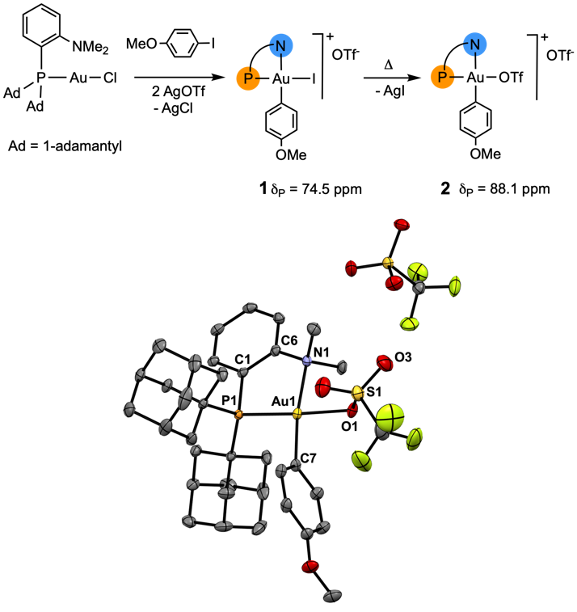
Figure 1. Formation of the gold(III) catalyst precursors, and crystal structure of 2. Thermal ellipsoids are shown at 50% probability and solvent molecules are removed for clarity. Relevant bond distances (Å) and angles (°): Au1–P1 2.2814(8), Au1–N1 2.170(3), Au1–C7 2.034 (3), Au1–O1 2.143(2), O1–S1 1.475(2), O1–S3 1.432 (3), Au1–O1–S1 120.6(1), P1–Au1–N1 87.33(6), P1–Au1–O1 177.10(6).
Adding 2 equiv of 1-hexene to a CD₂Cl₂ solution of 2 at room temperature led to the complete consumption of the Au(III) aryl triflate over the period of ca. 3 hours. In line with Patil et al., the major products of this reaction were identified as the protonated gold(I) complex [(LH)AuOTf]OTf 3 and the olefinic products 4a, 4b and 4c in a 72:17:11 molar ratio. The protonated MeDalPhos ligand showed a high-frequency shifted ammonium proton at δ_{H} = 9.86 ppm, typical of the presence of hydrogen bonding to Au(I).^{[22]} Interestingly, at the earliest stages of the reaction, the formation of two intermediates were observed: the three-coordinate gold(I) [(P^N)Au(1-hexene)]⁺ cation 5^{[23]} and, most significantly, the alkyl trifluoromethylsulfonate ester 6 (Figure 2).

Figure 2. Reaction of 2 with 1-hexene in CD₂Cl₂, kinetic profiles at 298 K and 263 K, and a section of the ¹⁹F ¹H HOESY NMR spectrum of the mixture at 253 K.

Kinetically the overall reaction proceeds in two consecutive steps: first, 2 is consumed to give 5 and the primary organic product 6, followed by HOTf elimination from 6 to generate the final gold complex 3 and the arylalkenes 4. Fitting of the reaction profile with an irreversible, simplified consecutive kinetic model (see SI) afforded k₁ = 1.2 x 10⁻⁴ mM⁻¹ s⁻¹ for the conversion of 2 into 5 and 6 and a slightly slower value for the formation of 4a+4b (k₂ = 5.8 x 10⁻⁵ mM⁻¹ s⁻¹). The formation of 4c was found to have a k₃ = 8.6 x 10⁻⁶ mM⁻¹ s⁻¹.
By replicating the reaction at 263 K, the formation of the intermediates 5 and 6 was slow enough to be followed to a plateau, while the formation of the end products 3 and 4 was minimized (k₁ = 6.6 x 10⁻⁶ mM⁻¹ s⁻¹, k₂ = 1.1 x 10⁻⁶ mM⁻¹ s⁻¹). Further lowering the temperature of the sample to 253 K allowed us to confirm the identity of the intermediates. The gold(I) olefin complex 5 showed a very similar fingerprint to the SbF₆– analogue reported by Bourissou,^{[23]} and its assignment was confirmed by independent synthesis. To the best of our knowledge, there is no literature precedent for the triflate ester 6, so a full NMR characterization was performed which confirmed its identity (see SI). The analysis of the dipolar interactions by ¹⁹F-¹H HOESY NMR (Figure 2) was particularly informative, showing a very strong dipolar coupling between the triflate ¹⁹F signal and its geminal C–H, together with weaker interactions with the benzyl CH₂, the ortho C–H proton of the arene and the γ–CH₂ of the alkyl chain. This pattern of interactions is only compatible with an OTf group placed on the β carbon of the hexyl chain. The most likely path to 6 is displacement of OTf– in 2 by 1-hexene, then nucleophilic attack by OTf– on the hexyl-C2 carbon, followed by rapid alkyl-aryl reductive elimination. In this scenario, anion displacement by the alkene is reasonably the rate limiting step, as no [Au(III)(aryl)(alkyl)]⁺ intermediate was detected.
Under catalytic conditions, an external base was required to regenerate the free-base form of the catalyst that may engage again in oxidative addition.^{[17]} Therefore, we also tested the above reaction in the presence of 2,6-lutidine. Upon adding 1.5 equiv of base to a mixture containing 5 and 6 at 195K, immediate formation of a Au(I) lutidine complex in equilibrium with the olefin adduct was observed. The alkyl triflate 6 did not show any signs of reaction at 195K. Warming to 283 K induced a slow reaction leading to the complete consumption of 6 only after about 3h. Under these conditions, the usual distributions of olefins 4a and 4b was observed, in a conversion of over 80%, together with traces of 4c. Kinetic modeling afforded a deprotonation rate constant of 5.5 x 10⁻⁶ mM^{–1} s⁻¹, which is not significantly different from that in the absence of base. At the end of the reaction, the Au(I) complexes remained as an equilibrium mixture of olefin and 2,6 lutidine adducts.
The stoichiometric pathway described above was found to be active also under catalytic conditions (Scheme 2). In an in situ experiment, 1-hexene, p-iodoanisole, 2,6-lutidine, AgOTf (1.1 equiv) and LAuCl (10 mol%, L = MeDalPhos) were mixed and agitated in CD₂Cl₂ at 253 K. A first ¹H NMR spectrum indicated that no catalytic reaction occurred and that all the Au(I) precatalyst had been converted into the [LAu(2,6-lutidine)]⁺ adduct 7 (δ_{P} = 50.0 ppm). Heating the sample to 328K for 2 minutes triggered oxidative addition of iodoanisole and traces of the Au(III) [(P^N)AuAr(2,6-lutidine)]²⁺ adduct 8 (δ_{P} = 66.7 ppm) formed. Prolonged warming increased the concentration of the Au(III) complex, suggesting that the Au(III) lutidine complex is likely the resting state of the catalyst, and led to the formation of traces of the organic product 4. The analysis of the ¹⁹F NMR spectrum also revealed the presence of minor traces of 6 (δ_{F} = –76 ppm), indicating that the alkyl triflate pathway is active also under these conditions.
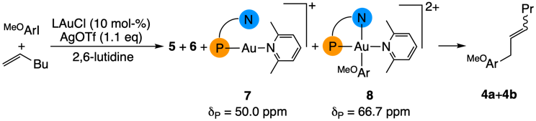
Scheme 2. Speciation of the gold complexes under catalytic conditions (CD₂Cl₂, 298 K) in the presence of 2,6-lutidine as base.
Reactions with the less hindered 3.5-lutidine proceed analogously but also generate a by-product, an alkyl lutidinium salts as the result of triflate substitution in 6 by lutidine (see SI, Figures S17-S19), thus further supporting the heteroarylation pathway.
The original paper on the gold-Heck reaction^{[17]} reported good results with AgOTf as activator but poor outcomes when AgSbF₆ was used as halide scavenger. On the other hand, the proposed mechanism only considered the role of the cationic species, which, if true, would imply that no significant anion effect was to be expected. To shed light on this discrepancy we repeated our studies using AgSbF₆. The reaction of p-iodoanisole with LAuCl in the presence of AgSbF₆ proceeds as seen for AgOTf, to give [(P^N)Au(Ar)I][SbF₆] (9) fast and quantitatively. Addition of 2 equiv 1-hexene to a solution of 9 at 195 K in CD₂Cl₂ provided no indication of the putative dication [(P^N)Au(Ar)(1-hexene)]²⁺.
Shaking the sample repeatedly and warming to 253 K led to the consumption of 9 and 1-hexene, with an outcome that depended on the batch of silver salt used. Using AgSbF₆ which contained significant amounts of water (≥ 0.5 equiv of H₂O per Ag, confirmed by NMR) afforded the 1-aryl-2-hexanol 10,^{[24]} together with [(LH)Au(1-hexene)][SbF₆]₂ as the Au(I) reduction product. The formation of 10 is analogous to the generation of the triflate ester 6, with OH– as nucleophile in place of triflate. When a fresh, “dry” batch of AgSbF₆ was used (H₂O < 0.1 equiv per Ag), the formation of the tetrahydronaphthalene 11^{[25]} was observed instead (Scheme 3). The formation of 11 is most plausibly explained as Friedel-Crafts type arene alkylation by a pendent carbocation, formed upon protonation of the primary product 10 by residual acid H⁺SbF₆ followed by a number of carbocationic C-H shifts. In catalytic mixtures cationic gold(III) species are present which are hard Lewis acids,^{[26]} perfectly capable of reacting with trace moisture under H⁺ release.^{[27]} The possibility of carbocation chemistry in gold(III) systems must therefore always be taken into account.
Involvement of carbocationic rearrangements was invoked also by Gaunt and co-workers to explain the outcome of Cu-catalyzed alkene arylation by iodonium triflates, where a very similar olefin distribution^{[28]} and subsequent formation of tetralines^{[29]} were observed. For this reason, we tested the possible involvement of proton-triggered reactions under gold-free condition (Scheme 4). The triflate ester 6 proved to be too unstable to be isolated in sufficient purity for kinetic measurements, but the reactions of the alcohol PhCH₂CH(OH)Bu 12 and the tosylate PhCH₂CH(OTs)Bu 13 with the strong acid [H(OEt₂)₂][AB₂] (AB₂ = [H₂N{B(C₆F₅)₃}₂–])^{[30]} could be cleanly followed by NMR spectroscopy. The alcohol was selected to replicate the product observed in the AgSbF₆ activated reaction under “wet” conditions, while the tosylate is the closest available analogue to the unstable triflate ester.

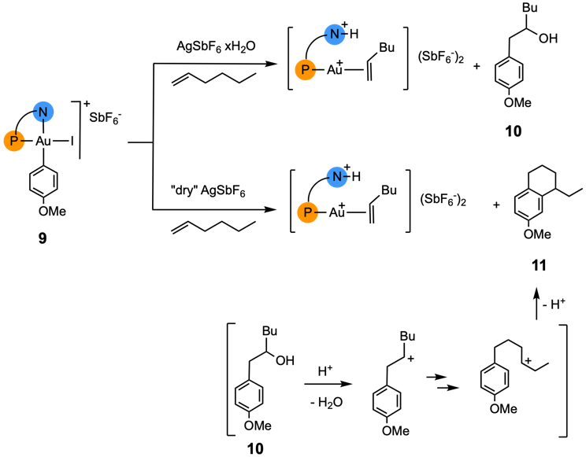
Scheme 3. Heteroarylation reactions with OH⁻ as nucleophile and follow-on reaction to tetrahydronaphthalenes
The alkyl tosylate 13 reacts quickly with a stoichiometric amount of acid at 298 K leading first to the formation of the benzyl olefin 14 in a 80:20 E/Z mixture. As a control, no reaction was observed when 13 was treated with either the protonated Au(I) complex [(LH)AuCl]⁺[AB₂]⁻ or with LAuOTf. The alcohol 12 requires heating to 328 K and gives the benzyl alkene an E/Z ratio of 70:30. The alkene 14 is in turn consumed to produce the tetralin 15. The kinetic profile of the reaction (see SI, Figure S24) shows clearly that the olefin 14 builds up as an intermediate as the direct product of detosylation of the starting material. A further acid-catalysed rearrangement leads to the tetralin via double bond protonation and a series of hydride shifts. The reaction of the alcohol proceeds in a similar manner at 328 K to afford 15 in about 1 hour.
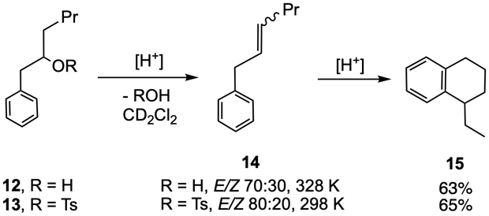
Scheme 4. Acid catalysed HOR elimination to benzyl alkenes and their cyclisation to tetralines (NMR yields are given for 15)
Having established the occurrence of a nucleophile-assisted process in the arylalkene formation, it is nevertheless instructive to compare this with the original alkene insertion mechanism proposed by Patil. Using DFT we have calculated both reaction paths for the full MeDalPhos ligand but simplified the organic substrates (ethene and PhI), partly to obtain a general picture, and partly because of the conformational issues encountered with real substrates.
A full reaction profile is included in the SI; Scheme S1 shows the transformation of key intermediate [LAu(Ph)(C₂H₄)]²⁺. In the competition between insertion and nucleophile attack on the olefin, the nucleophile wins because the trans influence causes the migratory insertion barrier to be high. After nucleophile attack, reductive elimination occurs with an effective barrier lower than that of the insertion path, in agreement with the non-observation of the expected alkyl/aryl intermediate. Both paths consist of very reasonable elementary steps, and calculated barriers for both seem realistic. The present case shows that in the absence of experiments designed to discriminate between alternatives it is easy to go wrong due to the often counter-intuitive nature of organogold chemistry.
In summary, both experimental and theoretical evidence show that the initial product in the putative gold-catalysed Heck reaction with the MeDalPhosAuCl / AgOTf catalyst is a triflate ester, formed via external attack by OTf⁻ on 1-hexene coordinated to a dicationic Au(III) species. This type of nucleophilic attack is low-barrier and is a typical feature of gold(III) alkene chemistry. If considerable concentrations of moisture are present in the system, the corresponding alcohol is formed instead. These reactions are further examples of alkene heteroarylation, a widely applied and well-understood reaction sequence in gold catalysis.
The subsequent conversion of the alkyl ester or alcohol into benzyl alkenes is a proton-initiated carbocationic reaction, as is the cyclisation of the benzyl alkene to tetralin. These reactions also proceed in the complete absence of gold. The chain walking required for tetralin formation is that of a carbocation, an essentially barrierless process. There is therefore no evidence for gold-catalysed alkene insertions, β-H elimination and chain-walking by a hypothetical [LAuH]²⁺ dication. Once again, gold(III) does not exhibit palladium-like reactivity but instead finds energetically more favourable reaction pathways.
Acknowledgements
LR is grateful to the Royal Society of Chemistry (R22-0875640255) and the University of Perugia (Fondo Ricerca di Base di Ateneo 2022) for financial support.
Supporting Information
Experimental procedures, NMR experiments and spectra, kinetic modelling, X Ray crystallography and DFT calculations. Deposition Number 2307500 contains the supplementary crystallographic data for this paper. These data are provided free of charge by the joint Cambridge Crystallographic Data Centre and Fachinformationszentrum Karlsruhe http://www.ccdc.cam.ac.uk/structures
Keywords: gold catalysis• mechanisms • Heck reaction • heteroarylation • carbocations • NMR
[1] (a) R. F. Heck, J. Am. Chem. Soc. 1968, 90, 5518-5526. (b) Y. Fujiwara, I. Moritani, S. Danno, R. Asano, S. Teranishi, J. Am. Chem. Soc. 1969, 91, 7166-7169. (c) T. Mizoroki, K. Mori, A. Azuki. Bull. Chem. Soc. Jpn. 1971, 44, 581. (d) R F. Heck, J. P. Nolley, Jr. J. Org. Chem. 1972, 37, 2320-2322.
[2] R. F. Heck. Acc. Chem. Res. 1979, 12, 146-151.
[3] C. C. C. Johansson Seechurn, M. O. Kitching, T. J. Colacot, V. Snieckus. Angew. Chem. Int. Ed. 2012, 51, 5062 – 5085.
[4] L. Rocchigiani, M. Bochmann. Chem. Rev. 2021, 121, 14, 8364–8451. (b) M. Joost, A. Amgoune, D.Bourissou, Angew. Chem. Int. Ed. 2015, 54, 15022 – 15045.
[5] (a) F. Rekhroukh, R. Brousses, A. Amgoune, D. Bourissou. Angew. Chem. Int. Ed. 2015, 54, 1266 –1269. (b) F. Rekhroukh, L. Estevez, C. Bijani, K. Miqueu, A. Amgoune, D. Bourissou. Organometallics 2016, 35, 995−1001. (c) F. Rekhroukh, C. Blons, L. Estévez, S. Mallet-Ladeira, K. Miqueu, A. Amgoune, D. Bourissou. Chem. Sci. 2017, 8, 4539–4545.
[6] F. Rekhroukh, L. Estevez, S. Mallet-Ladeira, K. Miqueu, A. Amgoune, D. Bourissou. J. Am. Chem. Soc. 2016, 138, 11920−11929.
[7] J. Serra, P. Font, E. D. Sosa Carrizo, S. Mallet-Ladeira, S. Massou, T. Parella, K. Miqueu, A. Amgoune, X. Ribas, D. Bourissou. Chem. Sci. 2018, 9, 3932–3940.
[8] (a) A. Pintus, L. Rocchigiani, J. Fernandez-Cestau, P. H. M. Budzelaar, M. Bochmann. Angew. Chem. Int. Ed. 2016, 55, 12321–12324. (b) A. Pintus, M. Bochmann. RSC Adv. 2018, 8, 2795–2803.
[9] a) G. Ung, G. Bertrand. Angew. Chem. Int. Ed. 2013, 52, 11388 –11391. (b) G. Klatt, R. Xu, M. Pernpointner, L. Molinari, T. Q. Hung, F. Rominger, A. S. K. Hashmi, H. Köppel. Chem. Eur. J. 2013, 19, 3954 – 3961.
[10] (a) E. Y. Tsui, P Müller, J. P. Sadighi. Angew. Chem. Int. Ed. 2008, 47, 8937 –8940. (b) D.-A. Roşca, J. Fernandez-Cestau, D. L. Hughes, M. Bochmann, Organometallics 2015, 34, 2098−2101. (c) D.-A. Roşca, D. A. Smith, D. L. Hughes, M. Bochmann. Angew. Chem. Int. Ed. 2012, 51, 10643 –10646. (d) D.-A. Roşca, J. Fernandez-Cestau, J. Morris, J. A. Wright, M. Bochmann, Science Adv. 2015, 1, e1500761. (e) L. Rocchigiani, J. Fernandez–Cestau, I. Chambrier, P. Hrobarik, M. Bochmann. J. Am. Chem. Soc. 2018, 140, 8287−8302.
[11] A. Nijamudheen, S. Karmakar, A. Datta. Chem. Eur. J. 2014, 20, 14650 – 14658.
[12] (a) Savjani, N.; Roşca, D.-A.; Schormann, M.; Bochmann, M., Angew. Chem. Int. Ed. 2013, 52, 874−877. (b) E. Langseth, A. Nova, E. A. Tråseth, F. Rise, S. Øien, R. H. Heyn, M. Tilset. J. Am. Chem. Soc. 2014, 136, 10104−10115. (c) M. S. Martinsen Holmsen, F. S. Ihlefeldt, S. Øien-Ødegaard, E. Langseth, Y. Wencke, R. H. Heyn, M. Tilset. Organometallics 2018, 37, 1937−1947. (d) M. S. Martinsen Holmsen, A. Nova, D. Balcells, E. Langseth, S. Øien-Ødegaard, E. A. Tråseth, R. H. Heyn, M. Tilset. Dalton Trans. 2016, 45, 14719–14724. (e) D. Balcells, O. Eisenstein, M, Tilset, A. Nova, Dalton Trans. 2016, 45, 5504–5513.
[13] (a) Zhang, G.; Cui, L.; Wang, Y.; Zhang, L., J. Am. Chem. Soc. 2010, 132, 1474-1475. (b) Melhado, A. D.; Brenzovich, W. E.; Lackner, A. D.; Toste, F. D., J. Am. Chem. Soc. 2010, 132, 8885-8887. (c) Ball, L. T.; Green, M.; Lloyd-Jones, G. C.; Russell, C. A., Org. Lett. 2010, 12, 4724. (d) Brenzovich, W. E.; Brazeau, J. F.; Toste, F. D., Org. Lett. 2010, 12, 4728-4731. (e) Tkatchouk, E.; Mankad, N. P.; Benitez, D.; Goddard, W. A., III; Toste, F. D., J. Am. Chem. Soc. 2011, 133, 14293-14300. (f) Ball, L. T.; Lloyd-Jones, G. C.; Russell, C. A., Chem. Eur. J. 2012, 18, 2931-2937. (g) Brenzovich, W. E., Jr; Benitez, D.; Lackner, A. D.; Shunatona, H. P.; Tkatchouk, E.; Goddard, W. A., III; Toste, F. D., Angew. Chem., Int. Ed. 2010, 49, 5519−5522. (h) M. J. Harper, E. J. Emmett, J. F. Bower, C. A. Russell, J. Am. Chem. Soc. 2017, 139, 12386−12389. (i) M. Rigoulet, O. Thillaye du Boullay, A. Amgoune, D. Bourissou, Angew. Chem. Int. Ed. 2020, 59, 16625 – 16630. (j) J. Rodriguez, A. Tabey, S. Mallet-Ladeira, D. Bourissou, Chem. Sci. 2021, 12, 7706–7712. (k) Zhang, S.; Wang, C.; Ye, X.; Shi, X., Angew. Chem. Int. Ed. 2020, 59, 20470−20474. (l) A. G. Tathe, U., A. K. Yadav, C. C. Chintawar, N. T. Patil, ACS Catal. 2021, 11, 4576−4582. (m) C. C. Chintawar, V. W. Bhoyare, M. V. Mane, N. T. Patil, J. Am. Chem. Soc. 2022, 144, 7089−7095. (n) S. C. Scott, J. A. Cadge, G. K. Boden, J. F. Bower, C. A. Russell, Angew. Chem. Int. Ed. 2023, 62, e202301526.
[14] (a) Sahoo, B.; Hopkinson, M. N.; Glorius, F., J. Am. Chem. Soc. 2013, 135, 5505-5508. (b) Hopkinson, M. N.; Sahoo, B.; Glorius, F., Adv. Synth. Catal. 2014, 356, 2794-2800. (c) Dong, B.; Peng, H.; Motika, S. E.; Shi, X., Chem. Eur. J. 2017, 23, 11093-11099.
[15] V. W. Bhoyare, A. G. Tathe, A. Das, C. C. Chintawar, N. T. Patil, Chem. Soc. Rev. 2021, 50, 10422–10450.
[16] M. Rigoulet, K. Miqueu, D. Bourissou,. Chem. Eur. J. 2022, 28, e202202110.
[17] V. W. Bhoyare, E. D. Sosa Carrizo, C. C. Chintawar, V. Gandon, N. T. Patil, J. Am. Chem. Soc. 2023, 145, 8810–8816.
[18] V. W. Bhoyare, A. G. Tathe, V. Gandon, N. T. Patil, Angew. Chem. Int. Ed. 2023, e202312786.
[19] C. Wei, L. Zhang, Z. Xia, Org. Lett 2023, 25, 6808-6812
[20] F. E. Condon, D. L. West, J. Org. Chem. 1980, 45, 2006-2009.
[21] (a) A. Zeineddine, L. Estévez, S. Mallet-Ladeira, K. Miqueu, A. Amgoune, D. Bourissou, Nat. Commun. 2017, 8, 565. (b) J. Rodriguez, A. Zeineddine, E. D. Sosa Carrizo, K. Miqueu, N. Saffon-Merceron, A. Amgoune, D. Bourissou, Chem. Sci. 2019, 10, 7183–7192.
[22] M. Rigoulet, S. Massou, E. D. Sosa Carrizo, S. Mallet-Ladeira, A. Amgoune, K. Miqueu, D. Bourissou, PNAS 2019, 116, 46–51.
[23] M. Navarro, A. Toledo, S. Mallet-Ladeira, E. D. Sosa Carrizo, K. Miqueu, D. Bourissou, Chem. Sci., 2020, 11, 2750–2758.
[24] C. Gao, C. A. Wilhelmsen, J. P. Morken, J. Org. Chem. 2023, 88, 1828-1835.
[25] L. R. Jeffries, S. P. Cook, Org. Lett. 2014, 16, 2026-2029.
[26] D.-A. Roşca, J. A. Wright, M. Bochmann, Dalton Trans. 2015, 44, 20785–20807.
[27] In Patil’s original catalytic conditions (dichloroethane, 80°C) 0.7 equiv of base was found optimal, for the deprotonation of (LH)AuOTf. This leaves sufficient residual acid to initiate carbocationic reactions.
[28] R. J. Phipps, L. McMurray, S. Ritter, H.A. Duong, M. J. Gaunt, J. Am. Chem. Soc. 2012, 134, 10773-10776.
[29] F. Zhang, S. Das, A. J. Walkinshaw, A. Casitas, M. Taylor, M. G. Suero, M. J. Gaunt, J. Am. Chem. Soc. 2014, 136, 8851-8854.
[30] S. J. Lancaster, A. Rodriguez, A. Lara-Sanchez, M. D. Hannant, D. A. Walker, D. L. Hughes and M. Bochmann, Organometallics 2002, 21, 451 – 453.

Entry for the Table of Contents

Experimental and theoretical investigations revealed that contrary to literature reports the putative gold-catalysed Heck reaction is a two-stage process: gold-based heteroarylation followed by gold-free carbocationic rearrangements to olefins and tetrahydronaphthalenes.
Institute and/or researcher Twitter usernames: @carlsbergite, @bochmanngroup, @UniperugiaNews, @UEA_Chemistry

