Journal of

Materials Chemistry A

PAPER



*In situ* tailored strategy to remove capping agents from copper sulfide for building better lithium– sulfur batteries†

Yuwei Zhao,‡a Donghai Wu,‡b Tingting Tang,‡a Chongguang Lyu,a Junfeng Li,c Shunping Ji,c Cheng-zong Yuan,c Kwan San Hui, [](http://orcid.org/0000-0001-7089-7587) d Chenyang Zha, [](http://orcid.org/0000-0002-7491-9146) *ac Kwun Nam Hui [](http://orcid.org/0000-0002-3008-8571) *c and Houyang Chen [](http://orcid.org/0000-0002-3319-5743) *e

Capping agents are frequently used in the chemical synthesis of materials, to precisely tailor the size, shape, and composition, with the expectation of high-performance catalysis. However, the adsorbed capping agents also serve as a physical barrier to restrict the interaction between reactants and catalytically active sites on the material surface. In this article, an *in situ* tailored interface strategy is introduced for effectively removing capping agents (long-chain oleylamine) from the surface of copper sulfide, to maximize the catalytic activity. The interface long-chain molecules of oleylamine are replaced by the

inorganic S2— ion *via* a facile stirring approach without harsh processing conditions or the need for

additional non-commercial materials. The as-cleaned copper sulfide shows greatly enhanced activity toward lithium–sulfur batteries, with an impressive current rate, excellent cycling stability, and great rate capability. These “clean surface” strategies using interface engineering provide a significant insight into the structure–activity relationships to support advancements in electrocatalysis technology in lithium– sulfur batteries.

# Introduction

Capping agent-based synthetic methods are widely used in the field of catalysis, which has powered the development of arti- ficial fertilizers, solar cells, high-strength polymers, electro- catalysis, and alkali metal–sulfur/oxygen batteries.1–9 In a colloidal synthesis process,10,11 long-chain capping agents inhibit the aggregation and overgrowth of catalyst materials at the nanoscale, and modulate the structural characteristics of crystal facets *via* precise interfacial tailoring.10 Specifically, the functionalized surface of catalysts plays a crucial role in lithium–sulfur (Li–S) batteries during redox reactions of soluble polysulfides on the interface,12–14 where better performance

*aKey Laboratory of Flexible Electronics (KLOFE), Institute of Advanced Materials (IAM),*

*Nanjing Tech University, Nanjing 211816, Jiangsu, China. E-mail: iamcyzha@njtech. edu.cn;* [*chenyangzha@um.edu.mo*](mailto:chenyangzha@um.edu.mo)

*bHenan Key Laboratory of Nanocomposites and Applications, Institute of Nanostructured Functional Materials, Huanghe Science and Technology College,*

*Zhengzhou 450006, Henan, China*

*cInstitute of Applied Physics and Materials Engineering (IAPME), University of Macau,*

*Taipa, Macau SAR, 999078, China. E-mail:* [*bizhui@um.edu.mo*](mailto:bizhui@um.edu.mo)

*dEngineering, Faculty of Science, University of East Anglia, Norwich, NR4 7TJ, UK eDepartment of Chemical and Biological Engineering, State University of New York at Bu*ﬀ*alo, Bu*ﬀ*alo, NY 14260-4200, USA. E-mail: hchen23@bu*ﬀ*alo.edu*

† Electronic supplementary information (ESI) available. See DOI: 10.1039/d1ta10105f

‡ These authors contributed equally to this article.

depends on utilization and anchoring of migratory polysulfides on the cathode. In a Li–S cell, sluggish redox reactions derive from the complicated multiphase evolution of solid(S8)–liq- uid(polysulfides)–solid(Li2S) and multistep non-electron- transfer/transfer steps (S8 + 16Li+ + 16e— = 8Li2S).15 Thus, a range of catalytic materials have been developed to power and

regulate the reaction kinetic behaviors of S8/polysulfides/Li2S involving metal oxides and sulfides.15 Metal sulfide, one of the many metal compounds used, has caught the interest of researchers in a variety of fields, particularly in energy storage devices.16,17 These functional materials have several advantages. First, the sulfides have a strong anchoring property, with polysulfide-containing species between the Li atoms of lithium polysulfide (LiPS) and the S atoms of metal sulfides. Second, the metallic/semi-metallic metal sulfides have better electrical conductivity. Finally, metal sulfides can promote polysulfide conversion by an enhanced absorption eﬀect on the interfacial active sites, and so further restrain polysulfide migration. In other words, the diﬀerent molecular structures of polysulfides (Li2S8, Li2S6, Li2S4) have distinct electrochemical properties, resulting in the functional materials having eﬃcient adsorption and activation sites to enhance the multi-chained polysulfide redox reaction. For example, Y. Li and co-workers prepared Cu/ Cu2S materials with electrodes having capacities of 1200 and

400 mA h g—1 for Li–S and Na–S batteries, respectively.18

Meanwhile, these cells could readily sustain about 1000 cycles without the need for sophisticated assembly for battery

engineering. These results indicate that the activated metal sites can significantly accelerate the redox of liquid polysulfides to solid sulfur, and further reduce soluble polysulfide migration in the electrochemical reaction process.17

However, most studies only investigate structure control and catalytic activity.11,19,20 The chemical states of the catalyst surfaces are ignored when long-chain capping agents are employed in the chemical synthesis process at the atomic scale.11,19 In other words, introducing long-chain capping agents brings extra complexity to the system, with complicated coverage surroundings for organic molecules, with non- covalent interactions between the catalysts and reac- tants.10,17,19,20 The surfaces of most catalysts are passivated by a layer of long-chain capped ligands with long hydrocarbon tails, which acts as an insulating layer around each material and compromises the activity by blocking the active sites.10,17,19,20

In this work, two-dimensional copper sulfide nanosheets

were synthesized by the hot-injection method and applied as the catalysts for Li–S cells. Then, we further introduced metal- free polar formamide–(NH4)2S solution to remove the long- chain capping agent, and thus enhanced the activity of the materials, which is an eﬀective and facile procedure to exchange native oleylamine on the copper sulfide surface by S2— ion

Material characterization

Powder X-ray diﬀraction (XRD, Smartlab Rigaku) was used to test the phase and structure of the sample. Scanning electron microscopy (SEM, Gemini instrument operated at 5–15 kV) was adopted to observe the morphology and microstructure. All transmission electron microscopy (TEM) patterns were recor- ded using an FEI Talos F200X transmission electron micro- scope. Fourier transform-infrared (FTIR) spectra were recorded *via* a Nicolet IS10 FTIR spectrophotometer. X-ray photoelectron spectroscopy (XPS) was performed with a Thermo Scientific Nexsa XPS system using monochromatic AlKa radiation and a concentric hemispherical analyzer. All data analyses for XPS were conducted with Avantage soware.

Electrochemical characterization

To assess the electrochemical performance of the sample, CR2032 coin cells were assembled. For fabrication of the cathode, the slurry (70 mg catalyst, 20 mg super-P as the conductive agent, 10 mg polyvinylidene fluoride as the binder, *N*-methyl-2-pyrrolidone as solvent) was cast onto the carbon cloth. To prepare the 0.5 M Li2S6-containing catholyte, 1.6 g

sulfur powder (S ), 0.46 g lithium sulfide (Li S), and 0.69 g

8 2

without high temperature/pressure reaction conditions, complex/sensitive additions, or the use of any non-commercial chemicals. With this interface tailoring, the copper sulfide- based Li–S cells exhibited better specific capacity, better cycling stability, and better rate capability.

# Experiment

Material synthesis

In a typical synthesis, 0.6 g cuprous thiocyanate (CuSCN) and 100 mL oleylamine (OLA) were added into a three-necked flask. Aer reaction under vacuum conditions at 100 ◦C for 30 min, the reaction was then carried out under argon gas. Then, the

system was heated to 250 ◦C and reacted at this temperature for 30 min. Aerwards, the reacted solution was rapidly cooled down to room temperature. The obtained product (Cu1.93S) was

centrifuged with ethanol and collected by centrifugal separa- tion. For a typical ligand-exchange procedure, 150 mg Cu1.93S was dispersed in 6 mL hexane by ultrasonication for 10 min. A 2 mL portion of (NH4)2S (20% aqueous) was dissolved in 20 mL polar formamide (FA) with vigorous shaking to form a uniform dispersion. Then, the above two solutions were mixed and stirred for about 30 min, leading to complete phase transfer of Cu1.93S from hexane to FA (C–Cu1.93S). In a typical synthesis of Cu2S, 0.5 mmol cupric nitrate was mixed with 1 mmol sulfur powder in 21 mL of ethylene glycol, and the as-prepared solu-

tion was transferred into a 30 mL Teflon-lined stainless steel autoclave. The autoclave was sealed and maintained at 160 ◦C for 24 h. Aer, the solution was cooled to room temperature and

the obtained Cu2S products were collected by centrifugation, where the Cu2S products were washed with carbon disulfide and absolute ethanol several times. Finally, the Cu2S products were dried in a vacuum at 60 ◦C for 5 h and used for further

characterization.

lithium nitrate (LiNO3) were dispersed in 20 mL mixed solution of dioxolane/dimethoxyethane (DOL/DME, 1 : 1, v/v) with 1 M lithium bis(trifluoromethanesulfonyl)imide (LiTFSI). The elec- trolyte was gently heated under continuous magnetic stirring to

form a homogeneous solution. In the electrode, the mass ratio of Cu1.93S is 50%, where 0.5 mg cm—2 Cu1.93S couples 1.0 mg cm—2 sulfur, and 1.0 mg cm—2 Cu1.93S couples 2.0 mg cm—2 sulfur. To prepare Li–S batteries in standard CR2032 coin cells,

the cathodes were impregnated with a calculated volume of the

0.5 M Li2S6-containing catholyte. Aer cathode drying, high- purity lithium foils were adopted as the anode, Celgard 2400 membrane was employed as the separator, electrodes were protected by carbon paper, and the electrolyte was composed of 1 M LiTFSI and 0.5 M LiNO3 in DOL/DME (1 : 1 by volume). Galvanostatic charge/discharge measurements were carried out using a NEWARE battery tester. Chronoamperometric curves and cyclic voltammetry measurements were recorded on a Bio- Logic VMP-300 potentiostat.

Computational details

Based on density functional theory (DFT),21–23 we performed first-principles computations and implemented the Vienna *ab initio* Simulation Package (VASP). The ion–electron interaction was described by the projector-augmented wave approach. The exchange-correlation potential was considered using the generalized gradient approximation in the scheme of Perdew– Burke–Ernzerhof. Electronic states were expanded by adopting the plane-wave basis set with a cut-oﬀ of 400 eV. All atomic positions and geometries were fully relaxed until the total

energy and ionic force reached the convergence thresholds of 10—5 eV and 0.1 eV A˚—1, respectively. The Monkhorst–Pack scheme with a 1 × 2 × 1 mesh for substrates was employed. The surface slab models were used to describe the (004) surface

of monoclinic-structured Cu31S16. In the surface, most of the exposed atoms are S atoms, and a few are Cu atoms. In the slab, the four outermost layers were allowed to relax, while the remaining layers were frozen at the optimized atomic bulk

position. A vacuum distance of 10 A˚ was used to avoid interac-

tion between the adjacent slabs.

# Results and discussion

Fig. 1a provides a schematic illustration of long-chain capping agents (oleylamine) coating onto the copper sulfide, which passivates the surface and reduces the active sites. The passiv- ated interface can cause physical separation between poly- sulfides and copper sulfide, which lowers the redox reaction kinetics and increases the “shuttle” eﬀect of the polysulfides, resulting in loss of active materials, anode corrosion, perfor-

mance degradation, and cell failure. Aer ligand exchange (S2—

ion replaces oleylamine), the passivated layer of copper sulfide is removed to reduce steric eﬀects, which increases the eﬀective interaction between polysulfide materials and the electrode electrolyte during running of the Li–S cell.12,24,25 Meanwhile, the interfacial redox reactions and ultrafast electron transfer are greatly optimized. In the typical ligand-exchange procedure (Fig. 1b), the agent-capped copper sulfide (Cu1.93S) in a nonpolar hexane solvent is mixed with formamide (FA)– (NH4)2S solvent. Aer 10 min stirring, complete transfer of Cu1.93S from hexane to the (NH4)2S solvent occurs in the two-

phase solution. Later, the S2— ion-adsorbed Cu1.93S (electro-

static force on the nanoscale) is obtained (C–Cu1.93S) without long-chain capping agents.

The crystal structure of the final product was examined by

powder XRD. As depicted in Fig. 2a, the diﬀraction peaks of C–

results for C–Cu1.93S. Meanwhile, the XPS results are shown in Fig. 2b,c. The Cu2p1/2–S (around 951 eV) and Cu2p3/2–S (around 931 eV) binding confirm the intrinsic Cu–S chemical bonds of the C–Cu1.93S products (Fig. 2b), which match the results of S 2p (Cu–S2p1/2 around 162 eV and Cu–S2p3/2 around 160 eV in Fig. 2c). In the Cu1.93S materials (Fig. S1b and c†), the XPS spectrum of Cu 2p orbitals (around 951 and 931 eV) and S 2p orbitals (around 162 and 160 eV) show the same results, which

reveals that ligand exchange (S2— ion replaces OLA) is a process

of physical adsorption and desorption, without oxidation or reduction reactions. The uniform morphology of the hexagonal two-dimensional nanosheets was identified by both SEM and TEM images (Fig. 2d,e, S2a and b†). The high-resolution TEM

image of the nanosheet side plane reveals lattice fringes of *d* =

0.34 nm, corresponding to the (004) facet of C–Cu1.93S (Fig. 2f).26 In a large piece of nanosheet (Fig. 2g), the selected area electron diﬀraction (SAED) shows a single set of diﬀraction spots with lattice distribution (Fig. 2g, inset), and the high-magnification HRTEM image of C–Cu1.93S also displays highly ordered Cu/S atoms (Fig. 2h), suggesting that each nanosheet of C–Cu1.93S has a well-crystalized materials nature.26–28 The corresponding scanning transmission electron microscopy (STEM) image with elemental mapping (EDS) reveals the uniform distribution of Cu and S atoms, which indicates the distribution of the two constituent species over the entire nanosheet (Fig. 2i–l). In addition, the SEM images of Cu1.93S are shown in Fig. S1d and e,† and the morphology of Cu1.93S and C–Cu1.93S cannot be changed by the ligand-exchange process.

Next, the FTIR spectrum was used to analyze Cu1.93S, with or without treatment with FA-(NH4)2S solvent.10 Aer ligand

exchange (Fig. 3a), the C–Cu1.93S shows a weaker intensity of C–H banding (2800–2900 cm—1). These results confirm the

Cu1.93

S are assigned to monoclinic Cu

31S16

(JCPDS no. 23-0959),

eﬃcacy of the S2— ion for complete removal of the original long-

where the well-defined Bragg peaks can be assigned to C– Cu1.93S products without impurity.26 As a comparison, the XRD

chain organic ligand (oleylamine), forming the C–Cu1.93S material. The spectrum shows broad water peaks around 3442

pattern of Cu

1.93

S is shown in Fig. S1a,† which still matches the

and 1625 cm—1, which are ascribed to the O–H stretching of

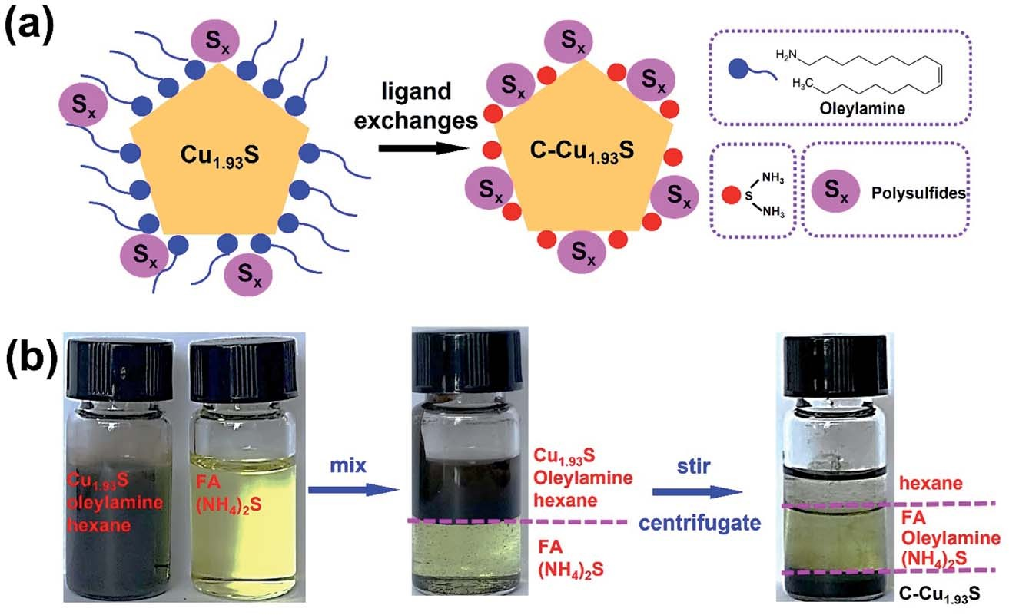

Fig. 1 (a) Schematic illustration of ligand-exchange process of Cu1.93S and C–Cu1.93S. (b) Optical photographs of the ligand-exchange process of Cu1.93S and C–Cu1.93S.

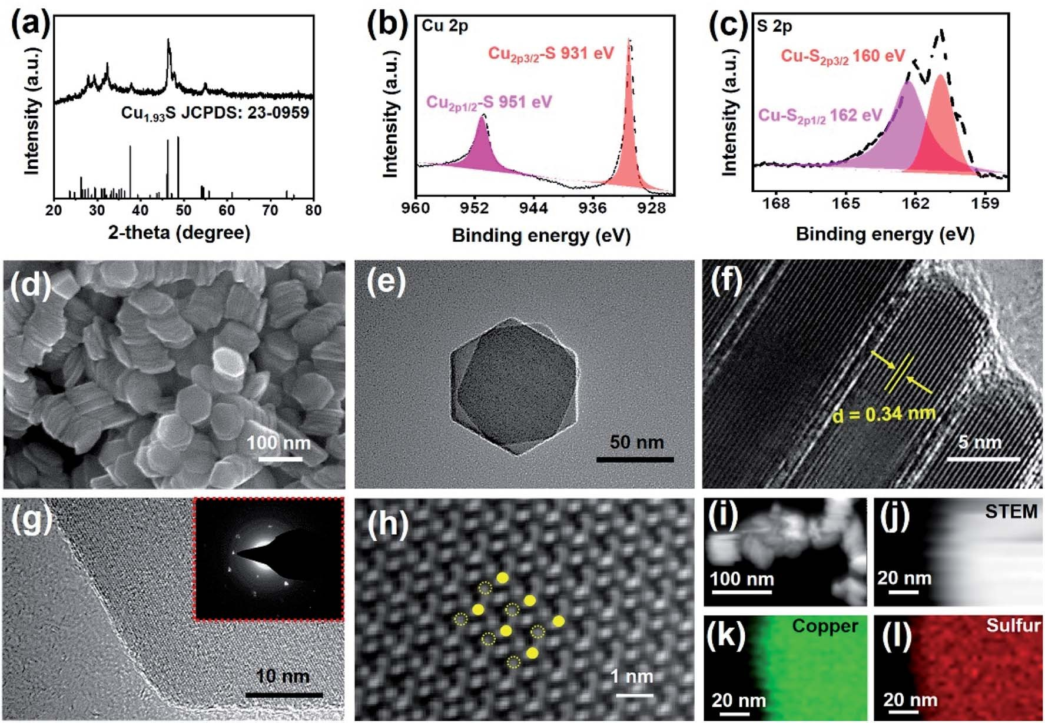

Fig. 2 (a) XRD pattern of C–Cu1.93S. XPS spectra of Cu 2p (b) and S 2p (c) of C–Cu1.93S. SEM image (d), TEM image (e), and HRTEM images (f and g) of C–Cu1.93S with inset of the SAED pattern (g). The high-magnification HRTEM image (h) of C–Cu1.93S with Cu and S atoms represented by solid and dashed rings, respectively. The TEM image (i) of C–Cu1.93S with the corresponding STEM image (j) of C–Cu1.93S and EDS mapping of Cu

(k) and S (l) elements.

water, when the Cu1.93S and C–Cu1.93S materials are tested in air with moisture.29 The results indicate the eﬃcacy of FA–(NH4)2S solvent for the complete removal of long-chain organic ligands, forming high-performance catalytic activated surfaces of C– Cu1.93S.3 The long cycling stability of the C–Cu1.93S- and Cu1.93S- based Li–S cells was also investigated (Fig. 3b). The corre- sponding cells (with 1 mg cm—2 loading) oﬀer large initial

capacities of 1205 and 1085 mA h g—1 at 0.8 mA cm—2, with approximately 98% coulombic eﬃciency, retaining capacities of 905 and 578 mA h g—1 aer 100 cycles, respectively. In Fig. 3c and d, the corresponding charge and discharge profiles are

analyzed to investigate the electrochemical properties of cath- odes based on C–Cu1.93S and Cu1.93S. The first/second discharge plateaus show the high- and low-order polysulfide conversions, respectively, where D*C*1 is from S8/Li2S8/Li2S6 to Li2S4 and D*C*2 is from Li2S4 to Li2S2/Li2S.13,30–33 In Fig. 3e, the C–Cu1.93S-based cell shows 71%, 73%, and 72% for (D*C*2)/(D*C*1 + D*C*2), and 2.4, 2.7, and 2.6 for (D*C*2)/(D*C*1) at the 1st, 50th, and 100th cycle, respectively. As a control, the Cu1.93S-based cell oﬀers 73%, 68%, and 69% for (D*C*2)/(D*C*1 + D*C*2), and 2.7, 2.2, and 2.2 for (D*C*2)/(D*C*1) at the 1st, 50th, and 100th cycles, respectively. In the D*C*2 of the liquid–solid redox reaction (Li2S4 to Li2S2/Li2S), the D*C*2 of the Cu1.93S-based cell presents continuous decay (from 73% to 69%), suggesting uninterrupted polysulfide migration with the cycles of the running cell.4,17,24 Meanwhile, the

polarized voltage diﬀerences (D*V*) were measured at approxi- mately 30% depth of discharge/charge. The diﬀerences in D*V* were 0.22 and 0.26 V (1st cycle), and 0.22 and 0.46 V (100th cycling), for the C–Cu1.93S and Cu1.93S cells, respectively, where the passivated layer of Cu1.93S can cause higher polarization in the Li2S4 redox reaction process.11,13,18 In Fig. 3f, the reversible capacities of C–Cu1.93S cells with 1 and 2 mg cm—2 sulfur

loading reach initial capacities of 1207 and 1023 mA h g—1, retaining 580 and 610 mA h g—1 for 500 cycles at 0.8 mA cm—2, with approximately 99% coulombic eﬃciency, respectively

(Fig. 3f). For the C–Cu1.93S cells, the polarized voltage diﬀer- ences (D*V*) were measured at approximately 30% depth of discharge/charge. The diﬀerences in D*V* are 0.22 and 0.17 V (1st cycle), 0.29 and 0.24 V (250th cycle), and 0.41 and 0.31 V (500th cycle) for the 1 and 2 mg cm—2 mass loadings, respectively

(Fig. S2c–e†). The C–Cu1.93S cell also shows stepwise polariza- tion in the running Li–S cell. In Fig. 3g, the C–Cu1.93S-based cell (1 mg cm—2) shows 71%, 73%, and 72% for (D*C*2)/(D*C*1 + D*C*2),

and 2.5, 2.7, and 2.6 for (D*C*2)/(D*C*1) at the 1st, 250th, and 500th

cycles, respectively. The C–Cu1.93S-based cell (2 mg cm—2) shows 79%, 79%, and 77% for (D*C*2)/(D*C*1 + D*C*2), and 3.9, 3.8, and 3.3

for (D*C*2)/(D*C*1) at the 1st, 250th, and 500th cycles, respectively. Also, the C–Cu1.93S-based cell performance was measured stepwise from 0.5 to 1.5 mA cm—2 to measure the stability of the

cell (Fig. 3h). When the current density increased stepwise from

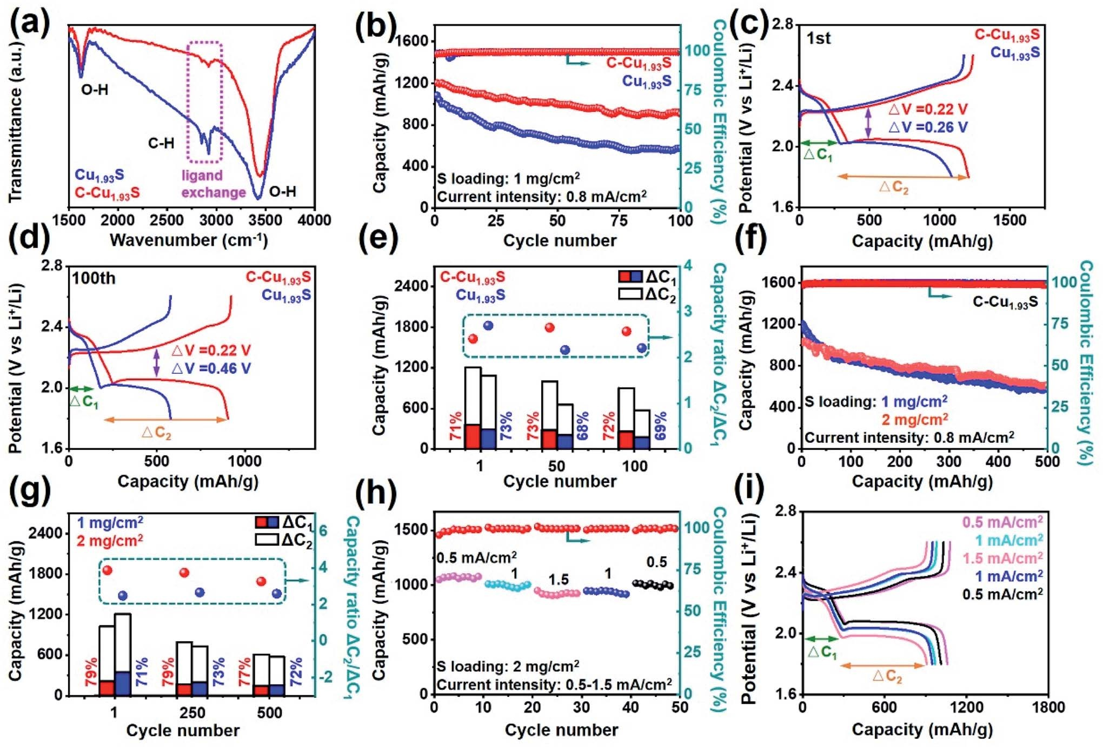

Fig. 3 (a) FTIR spectra of Cu1.93S and C–Cu1.93S. (b) Comparison of the cycling performance of Cu1.93S and C–Cu1.93S-based Li–S cells with the corresponding charge and discharge profiles at the 1st (c) and 100th (d) cycles and ratio image (e) of D*C*2/D*C*1. The cycling stability and coulombic efficiency of C–Cu1.93S-based Li–S cells under different sulfur loading (f) with ratios (g) of D*C*2/D*C*1. Rate performances and coulombic efficiency of C–Cu1.93S-based Li–S cell from 0.5 to 1.5 mA cm—2 (h) with corresponding charge and discharge profiles (i).

0.5 to 1 to 1.5 mA cm—2, the corresponding capacities were 1050, 1010, and 950 mA h g—1, respectively. The cell retained a capacity of 1017 mA h g—1 with a backward current density of

0.5 mA cm—2. Fig. 3i shows the corresponding charge/discharge curves with the current rate from 0.5 to 1.5 mA cm—2. In the

electrochemical analyses of the rate performance (Fig. S2f†), the C–Cu1.93S-based cell showed 70%, 69%, 68%, 69%, and 70% for (D*C*2)/(D*C*1 + D*C*2), and 2.3, 2.2, 2.1, 2.2, and 2.3 for (D*C*2)/(D*C*1)

at 0.5, 1, 1.5, 1, and 0.5 mA cm—2, respectively. These electro-

chemical behaviors also indicate that the C–Cu1.93S electrode

675 mA h g—1 with 1 mg cm—2 sulfur mass loading at 0.8 mA cm—2, maintaining 482 mA h g—1 with an average 99% coulombic eﬃciency aer 50 cycles (Fig. S3c†).

The electrochemical behavior of C–Cu1.93S-based cells was investigated using cyclic voltammetry (CV).16,34 From 1.5 to

2.8 V, the cells were tested with a scan rate of 0.1 mV s—1 (Fig. 4a), or with a modulated scan rate from 0.1 to 1.0 mV s—1

(Fig. 4c). In the CV curves, two reduction processes, for high- order polysulfides (from Li2S8/Li2S6 to Li2S4) and low-order polysulfides (from Li2S4 to Li2S2/Li2S), are represented by the

improves the redox reactions of Li–S. In the high sulfur mass two reduction voltages (*VC* and *VC* ), and the one-step reaction

2

1

loading (5 mg cm—2) with 7.5 ml mg—1 (E/S: electrolyte/sulfur), of Li2S2/Li2S to S8 is shown by one oxidation voltage (*V*A). Aer 5

1

2

the C–Cu1.93S-based Li–S cell exhibits a high initial capacity of

1130 mA h g—1, and maintains 1024 mA h g—1 aer 100 cycles at

3.2 mA cm—2 (Fig. S2g†). Meanwhile, the pure carbon cloth-

cycles with 0.1 mV s—1, the *V*A, *VC* , and *VC* show a stable over- lapping shi without obvious polarization (Fig. 4b). By modu-

lating the scan rate from 0.1 to 1.0 mV s—1, the *I*A, *IC* , and *IC*

based cell shows 0 mA h g—1, which means no lithiation reac- tion, in the range 1.8–2.6 V (Fig. S2h†). A comparison of the SEM images, XRD analysis, and cycling performance of the Cu2S- based cell is presented in Fig. S3a–c.† The XRD patterns (Fig. S3a†) show strong Bragg peaks for Cu2S materials, and the

1 2

reveal orderly increased currents, with a linear dependence of the peak current on the square root of the scan rate (Fig. 4d). The CV-based Randles–Sevcik equation can determine the lithium-ion diﬀusion coeﬃcient.28,33,35,36 The linear relationship

of diﬀusion coeﬃcient and *I*A (or *IC* or *IC* ) suggests better Li-ion

1 2

SEM image (Fig. S3b†) shows an irregular polyhedral morphology. The Cu2S-based cells show an initial capacity of

diﬀusion and electron transfer in the C–Cu1.93S-based cathodes. Therefore, the tailored C–Cu1.93S with (004) facet is favorable for

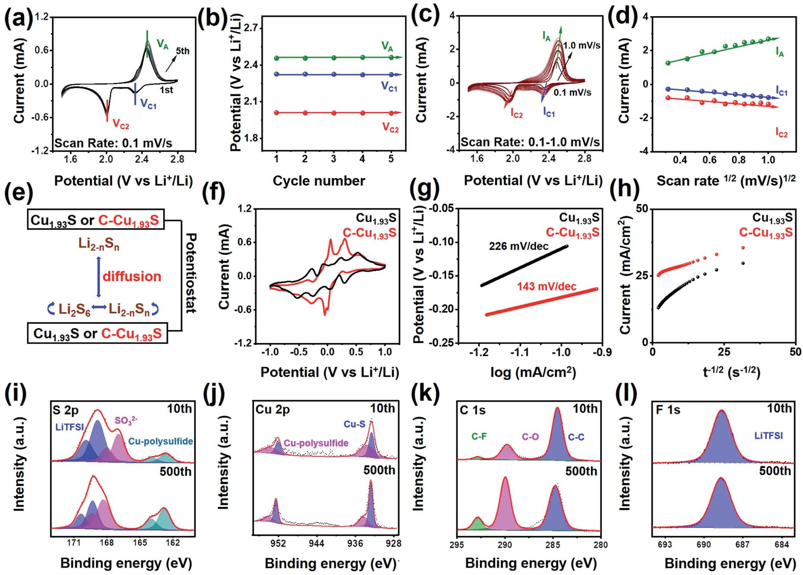

Fig. 4 Stabilized CV curves (a) for a Li2S6-based C–Cu1.93S cell scanned from the 1st to the 5th cycles at 0.1 mV s—1, with the corresponding cathodic and anodic peak potentials from the cycle times showing a linear correlation (b). Rated CV curves from 0.1 to 1.0 mV s—1 (c) with the

corresponding cathodic and anodic peak currents from the square root of the scan rate showing a linear correlation (d). Schematic illustration of a Li2S6-based symmetric cell (e). CV curves (f), Tafel plots (g) and Cottrell plots of the chronoamperometric curves (h) of the C–Cu1.93S- and Cu1.93S-based electrodes. The *in situ* XPS spectra for S 2p (i), Cu 2p (j), C 1s (k), and F 1s (l) from the C–Cu1.93S-based Li–S cells after the 10th and 500th cycles. The measured curves are in black, and the fitted ones are in red.

the solid/liquid/solid phase evolution-based 16-electron redox reactions.15,24,34 Meanwhile, the CV curves for Cu1.93S are shown in Fig. S4.† The CV peak currents increase by increasing the staged scan rate from 0.1 to 0.4 mV s—1, which shows the non- linear tendency of the redox voltage and current, and indi- cates that the diﬀusion of Li+ is limited by the unstable inter-

facial interaction of polysulfide and Cu1.93S (Fig. S4†). In particular, the unstable redox processes of Li2S4 are more obvious in the *I*A and *IC* measurements (Fig. S4b and d†), where the unstable Li2S4 reactions cause degradation of performance of the Li–S cells.16,34 Furthermore, C–Cu1.93S- and Cu1.93S-based cathodes were assembled in the symmetric cells (Fig. 4e), where the same mass of Li2S6 was added into the cells, to further investigate the interfacial reaction of Cu1.93S with or without the

2

passivated layer. Those cells with Li2S6 electrolyte have multiple redox peaks around —0.5 to 0.25 V (Fig. 4f). Therein, the notable intensity of current peaks with well-separated redox pairs can

oﬀer an eﬃcient anchoring function for the multiphase evolu- tion of polysulfides with gainful electrochemical

reversibility.16,31 In addition, C–Cu1.93S enhances the conversion reactions of polysulfides by means of the interfacial active sites without a passivation layer of long-chain oleylamine. Compared with the C–Cu1.93S cathode (143 mV dec—1), the Tafel slope of the Cu1.93S cathode increased to 226 mV dec—1 (Fig. 4g), where the lower Tafel slope could indicate faster charge transfer

kinetics without long-chain oleylamine on the surface.37 The electrochemical impedance spectroscopy Nyquist plots can accurately explain the internal electrochemical characteristics of the symmetric cells (Fig. S3d†). The first semicircle is the resistance (*R*SEI) of the solid electrolyte interface (SEI) layer in the high-frequency area. The lower RSEI of the symmetric C– Cu1.93S-based cell shows the improved redox reaction kinetics. The interfacial state of the chemical binding between poly- sulfides and C–Cu1.93S can be analyzed using *in situ* XPS.38 Two diﬀerent cycles of C–Cu1.93S-based Li–S cells (10th and 500th) aer the aged time are presented in Fig. 4i–l. The S 2p spectrum (Fig. 4i) has three characteristic peaks, where the LiTFSI peaks (around 170–169 eV) could be from the interfacial LiTFSI salt in

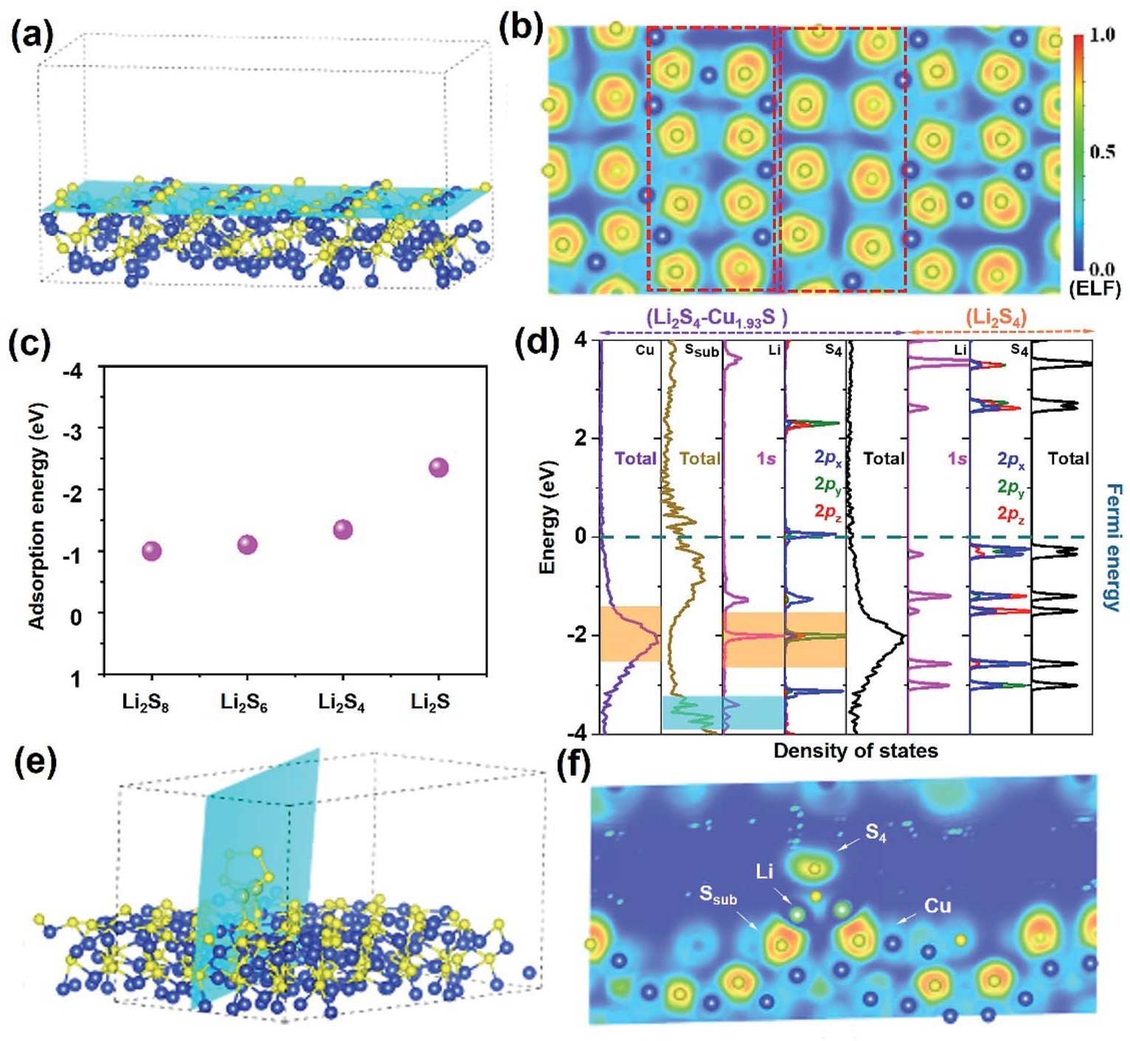

Fig. 5 Crystal structure (a) and electron location function (b) of Cu1.93S at the (004) surface. Binding energy values (c) of Li2S8, Li2S6, Li2S4, and Li2S adsorbed onto the Cu1.93S (004) surfaces. Partial DOS (d), crystal structure (e) and electron location function (f) of Li2S4 adsorbed onto the Cu1.93S (004) surface.

the electrolyte, the SO32— peaks (around 167–168 eV) could be ascribed to the residual sulfur-containing bonds, and the shif- ted Cu–polysulfide peaks (around 162–164 eV) could be the more obvious interactions between polysulfides and Cu sites on the C–Cu1.93S surfaces. Aer 500 cycles, the same tendency of S 2p binding indicates that C–Cu1.93S can enhance the redox reaction kinetics of polysulfides by means of the stable redox

electron migration channel to reduce the ‘‘shuttle eﬀect” of Li–S cells.18,33,39 In the 10th and 500th cycles of a Li–S cell, two characteristic peaks for Cu 2p occur (Fig. 4j). The former (around 954 and 934 eV) can be attributed to the chemical bonds of Cu sites and polysulfides (Cu–polysulfide), while the latter (around 952 and 932 eV) come from the intrinsic chemical bonds of C–Cu1.93S (Cu–S binding). Three characteristic peaks of C 1s around 295–280 eV (Fig. 4k), *i.e.* C–F (around 292 eV), C–O (around 290 eV), and C–C (around 284 eV) bindings, indi- cate the stable SEI aer running the Li–S cell.39 Also, the F 1s spectra (Fig. 4l) show the undivided LiTFSI peaks (around 688 eV) of the fluorinated cathode interface, which is the uniformly distributed F-based species at the interface of the cathodes and indicates a stable SEI.39 In the C–Cu1.93S-based cells aer the 10th or 500th cycles, the discrepancy in the peak intensity/area and half-peak breadth in the XPS spectra are the concentration

of Li and the electrostatic induction in the cathode inter- face.12,38,39 A series of optical photographs show the *in situ* technology for the XPS chamber (Fig. S3e–h†).

The interaction and adsorption behaviors were further investigated using DFT and adopting VASP.21–23,40,41 Based on the above-mentioned TEM and XRD analyses, the (004) facets of C– Cu1.93S (Fig. S5†) were considered as the adsorption interface (Fig. 5a) for electron localization function (ELF) analysis (Fig. 5b). By comparison of the charge density diﬀerences, the symmetrical arrangements of the Cu/S atoms oﬀer diﬀerent active sites states, forming eﬀective anchoring for multiphase/ multistep evolution of redox polysulfide reactions (solid S8 to liquid Li2S8 to liquid Li2S6 to liquid Li2S4 to solid Li2S2/Li2S).17 The binding energies (Fig. 5c) of the most stable adsorption configurations of Li2S8, Li2S6, Li2S4, and Li2S on the Cu1.93S

(004) surface are —0.998, —1.103, —1.345, and —2.35 eV with the

charge density diﬀerence (Fig. S7†), respectively. Then, all possible sites were tested for polysulfides landing on the C– Cu1.93S (004) facet (Fig. S6†). The calculated binding energies were in the moderate range of 0.8–2.5 eV for all Li–S species, indicating that the interactions between the lithium sulfides and the Cu31S16 substrates were neither too strong nor too weak and were beneficial for ion transport.32 Furthermore, the firm

adsorption can eﬀectively immobilize the soluble Li–S species without dissociating the Li–S bond fragments, and maintain the integrity of the polysulfide species.20 Carefully observing the most stable adsorption configurations, one can find that these lithium sulfides prefer to adsorb onto the Cu1.93S (004) surface perpendicularly, except for Li2S. The two Li atoms in the poly- sulfide tend to interact with underlying S atoms, forming Li–S bonds. Meanwhile, in Li2S and Li2S8, the terminal S atoms are liable to interact with neighboring Cu atoms. The calculated Bader charge shows that the charges donated from Li atoms in Li2S, Li2S4, Li2S6, and Li2S8 species to the Cu1.93S (004) surface

are 0.893, 0.887, 0.892, and 0.879|*e*| per atom, respectively.

Diﬀerent from the nearly equal amount of charge transfer from Li atoms, a large diﬀerence in the amount of charge gain of the S atom for Li2S (1.1|*e*| per atom), Li2S4 (0.238|*e*| per atom), Li2S6

(0.140|*e*| per atom), and Li2S8 (0.174|*e*| per atom) species occurs.

Based on the electrons gained or lost in these Li–S species, Li2S has the strongest adsorption capacity compared with the other three species, which could be the higher number of electrons obtained by its S atoms. The S atom in Li2S can interact with the Cu atom in the substrate, forming S–Cu bonds. In S–Cu bonds, Cu atoms also contribute their charges to the S atom. Moreover, density of states (DOS) was applied to theoretically study the detailed interactions of polysulfides and Cu1.93S. The high- soluble Li2S4 molecule was regarded as a typical model for polysulfides, and the more commonly obtained Cu1.93S (004) slab was also taken as an adsorbed substrate (Fig. 5d).31,42 The Fermi level of 2 eV is from intrinsic Li2S4, which is the gap between the lowest unoccupied molecular orbital (LUMO) and highest occupied molecular orbital (HOMO). In the Li2S4 molecule, the S 2p and the Li 1s orbital levels predominantly contribute to the HOMO and LUMO, respectively. When Li2S4 adsorbs onto the Cu1.93S (004) surface (Li2S4–Cu1.93S), the adsorbed model band gap (2 eV) has obscured the nearby Fermi state. In addition, the Cu and S atoms of Cu1.93S have strong interactions with the S and Li atoms of Li2S4 by means of the

overlapping orbitals around —2 and —3.5 eV, where the crystal structure and ELF image of the Li2S4–Cu1.93S model also

represent double sites anchoring (Fig. 5e and f).12,17,24 The stable adsorption of the ELF images of the Li2S8–Cu1.93S, Li2S6– Cu1.93S, and Li2S–Cu1.93S models (Fig. S8†) also exhibit electron distribution aer polysulfide anchoring on the Cu1.93S (004) surface.

# Conclusion

In summary, a feasible *in situ* tailored interfacial engineering strategy is proposed to enhance the catalytic properties of materials by removing the capping agents of long-chain oleyl- amine. By the simple treatment of FA-(NH4)2S solvent, the Li–S cell exhibits remarkable cycling stability (610 mA h g—1 aer 500 cycles) at a high mass loading of 2 mg cm—2 at 0.8 mA cm—2. The

results not only oﬀer a facile strategy for improving the performance of colloidal nanocrystals formed by hot-injection syntheses, but also demonstrate novel insight into the interac- tions between the material surfaces, long-chain capping agents, and reaction interface. More importantly, this approach can be

extended to diﬀerent capping agents and colloidal nanocrystals for further performance improvements.

# Author contributions

Yuwei Zhao and Tingting Tang conceived the project supervised by Chenyang Zha and Kwun Nam Hui. Donghai Wu conducted theoretical calculations supervised by Houyang Chen, Chong- guang Lyu, Junfeng Li and Kwan San Hui. Shunping Ji and Cheng-Zong Yuan assisted in data analysis.

# Conflicts of interest

The authors declare that they have no known competing financial interests or personal relationships that could have appeared to influence the work reported in this paper.

# Acknowledgements

This research was supported by the National Natural Science Foundation of China (Grant No. 61904080), the Natural Science Foundation of Jiangsu Province (Grant No. BK20190670), the Natural Science Foundation of Colleges and Universities in Jiangsu Province (Grant No. 19KJB530008), the Technology Innovation Project for Overseas Scholar in Nanjing, the Start-up Foundation of Nanjing Tech University, the Macau Young Scholars Program (AM2020005), the Science and Technology Development Fund of Macau SAR (File no. 0191/2017/A3, 0041/ 2019/A1, 0046/2019/AFJ, 0021/2019/AIR), University of Macau (File no. MYRG2017-00216-FST and MYRG2018-00192-IAPME),

and UEA funding.

# References

1. M. Wild, L. O. Neill, T. Zhang, R. Purkayastha, G. Minton,

M. Marinescu and G. J. Oﬀer, *Energy Environ. Sci.*, 2015, 8, 3477–3494.

1. J. B. Goodenough, *Energy Storage Materials*, 2015, 1, 158–161.
2. A. Nag, M. V. Kovalenko, J. Lee, W. Liu, B. Spokoyny and

D. V. Talapin, *J. Am. Chem. Soc.*, 2011, 133, 10612–10620.

1. Y. V. Mikhaylik and J. R. Akridge, *J. Electrochem. Soc.*, 2004,

151, A1969–A1976.

1. H. Dai, L. Wang, Y. Zhao, J. Xue, R. Zhou, C. Yu, J. An,

J. Zhou, Q. Chen and G. Sun, *Research*, 2021, 2021, 5130420. 6 Y. Zhu, H. A. Tahini, Y. Wang, Q. Lin, Y. Liang, C. M. Doherty,

Y. Liu, X. Li, J. Lu and S. C. Smith, *J. Mater. Chem. A*, 2019, 7, 14222–14232.

1. Y. Zhu, Z. Chen, W. Zhou, S. Jiang, J. Zou and Z. Shao,

*ChemSusChem*, 2013, 6, 2249–2254.

1. Y. Zhu, W. Zhou, J. Yu, Y. Chen, M. Liu and Z. Shao, *Chem. Mater.*, 2016, 28, 1691–1697.
2. K. Chu, F. Liu, J. Zhu, H. Fu, H. Zhu, Y. Zhu, Y. Zhang, F. Lai and T. Liu, *Adv. Energy Mater.*, 2021, 11, 2003799.
3. Z. Niu and Y. Li, *Chem. Mater.*, 2014, 26, 72–83.
4. Y. Shi, Z. Lyu, Z. Cao, M. Xie and Y. Xia, *Angew. Chem., Int.*

*Ed.*, 2020, 59, 19129–19135.

1. H. Yuan, H. J. Peng, J. Q. Huang and Q. Zhang, *Adv. Mater.*

*Interfaces*, 2019, 6, 1802046.

1. R. Wu, H. Xu, Y. Zhao, C. Zha, J. Deng, C. Zhang, G. Lu,

T. Qin, W. Wang, Y. Yin, C. Zhu, L. Wang, G. Ouyang and

W. Huang, *Energy Storage Materials*, 2020, 32, 216–224.

1. C. Zha, X. Zhu, J. Deng, Y. Zhou, Y. Li, J. Chen, P. Ding, Y. Hu,

Y. Li and H. Chen, *Energy Storage Materials*, 2020, 26, 40–45. 15 H. Ye, M. Li, T. Liu, Y. Li and J. Lu, *ACS Energy Lett*, 2020, 5,

2234–2245.

1. Z. Yuan, H. Peng, T. Hou, J. Huang, C. Chen, D. Wang,

X. Cheng, F. Wei and Q. Zhang, *Nano Lett.*, 2016, 16, 519– 527.

1. D. Liu, C. Zhang, G. Zhou, W. Lv, G. Ling, L. Zhi and Q. Yang,

*Adv. Sci.*, 2018, 5, 1700270.

1. P. Li, L. Ma, T. Wu, H. Ye, J. Zhou, F. Zhao, N. Han, Y. Wang,

Y. Wu, Y. Li and J. Lu, *Adv. Energy Mater.*, 2018, 8, 1800624. 19 H. J. Peng, Z. W. Zhang, J. Q. Huang, G. Zhang, J. Xie,

W. T. Xu, J. L. Shi, X. Chen, X. B. Cheng and Q. Zhang,

*Adv. Mater.*, 2016, 28, 9551–9558.

1. H. Al Salem, G. Babu, C. V. Rao and L. M. R. Arava, *J. Am.*

*Chem. Soc.*, 2015, 137, 11542–11545.

1. P. E. Bl¨ochl, *Phys. Rev. B*, 1994, 50, 17953.
2. G. Kresse and J. Furthmuller, *Phys. Rev. B*, 1996, 54, 11169–

11186.

1. J. P. Perdew, K. Burke and M. Ernzerhof, *Phys. Rev. Lett.*, 1996, 77, 3865.
2. H. Ye, J. Sun, X. Lim, Y. Zhao and J. Lee, *Energy Storage Materials*, 2021, 38, 338–343.
3. C. Zha, X. Gu, D. Wu and H. Chen, *J. Mater. Chem. A*, 2019, 7,

6431–6438.

1. M. Wang, A. Tang, L. Peng, C. Yang and F. Teng, *Chem.*

*Commun.*, 2016, 52, 2039–2042.

1. C. Zha, D. Wu, X. Gu and H. Chen, *J. Energy Chem.*, 2021, 59,

599–607.

1. C. Zha, D. Wu, Y. Zhao, J. Deng, J. Wu, R. Wu, M. Yang,

L. Wang and H. Chen, *J. Energy Chem.*, 2021, 52, 163–169. 29 H. Jeong, Y. Lee, M. Jin, E. Kim, J. Bae and Y. Lee, *Chem. Phys.*

*Lett.*, 2009, 470, 255–258.

1. C. Zha, D. He, J. Zou, L. Shen, X. Zhang, Y. Wang, H. Kung and N. Bao, *J. Mater. Chem. A*, 2014, 2, 16931–16938.
2. Y. Zhao, Z. Zhang, R. Wu, C. Lyu, X. Zhao, H. Xu, J. Xiang,

C. Zha, G. Ouyang and L. Wang, *Mater. Today Energy*, 2021,

21, 100793.

1. Q. Zhang, Y. Wang, Z. W. Seh, Z. Fu, R. Zhang and Y. Cui,

*Nano Lett.*, 2015, 15, 3780–3786.

1. Y. Zhao, H. Yin, Z. Zhang, C. Lyu, X. Zhao, H. Xu, G. Lu,

T. Qin, G. Ouyang, C. Zha and L. Wang, *Sustainable Energy Fuels*, 2021, 5, 3134–3142.

1. H. Ye, J. Sun, S. Zhang, H. Lin, T. Zhang, Q. Yao and J. Y. Lee,

*ACS Nano*, 2019, 13, 14208–14216.

1. H. Ye, J. Sun, S. Zhang, T. Zhang, Y. Zhao, C. Song, Q. Yao and J. Lee, *Chem. Eng. J.*, 2021, 410, 128284.
2. C. Zha, D. Wu, T. Zhang, J. Wu and H. Chen, *Energy Storage Materials*, 2019, 17, 118–125.
3. X. Wang, J. Han, C. Luo, B. Zhang, J. Ma, Z. Li, Y. He,

Q. Yang, F. Kang and W. Lv, *Small*, 2021, 17, 2101538.

1. B. Philippe, M. Hahlin, K. Edstrom, T. Gustafsson,

H. Siegbahn and H. Rensmo, *J. Electrochem. Soc.*, 2016,

163, A178–A191.

1. F. Lindgren, C. Xu, L. Niedzicki, M. Marcinek, T. Gustafsson,

F. Bjorefors, K. Edstrom and R. Younesi, *ACS Appl. Mater. Interfaces*, 2016, 8, 15758–15766.

1. C. Zha, C. Ji, J. Zhang, L. Shen, X. Zhang, S. Dong and N. Bao,

*RSC Adv.*, 2016, 6, 107151–107157.

1. C. Zha, J. Zhang, L. Shen, S. Dong, A. Gupta and N. Bao,

*Chemistryselect*, 2017, 2, 10971–10978.

1. X. Liu, Y. Jiao, Y. Zheng and S. Qiao, *ACS Catal.*, 2020, 10, 1847–1854.