pubs.acs.org/acscatalysis

In Situ Immobilizing Atomically Dispersed Ru on Oxygen-Defective Co₃O₄ for Efficient Oxygen Evolution
Research Article
Cheng-Zong Yuan,∇ Shuo Wang,∇ Kwan San Hui,* Kaixi Wang, Junfeng Li, Haixing Gao, Chenyang Zha, Xiaomeng Zhang, Duc Anh Dinh, Xi-Lin Wu, Zikang Tang, Jiawei Wan,* Zongping Shao,* and Kwun Nam Hui*

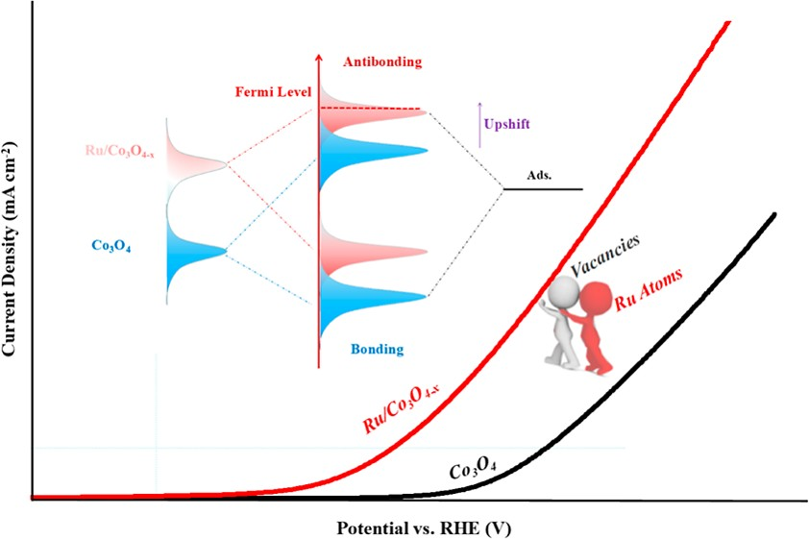
ABSTRACT: The synergistic regulation of the electronic structures of transition-metal oxide-based catalysts via oxygen vacancy defects and single- atom doping is efficient to boost their oxygen evolution reaction (OER) performance, which remains challenging due to complex synthetic procedures. Herein, a facile defect-induced in situ single-atom deposition strategy is developed to anchor atomically dispersed Ru single-atom onto oxygen vacancy-rich cobalt oxides (Ru/Co₃O_{4−x}) based on the spontaneous redox reaction between Ru³⁺ ions and nonstoichiometric Co₃O_{4−x}. Accordingly, the as-prepared Ru/Co₃O_{4−x} electrocatalyst with the coex-
istence of oxygen vacancies and Ru atoms exhibits excellent performances
toward OER with a low overpotential of 280 mV at 10 mA cm⁻², a small Tafel slope value of 86.9 mV dec⁻¹, and good long-term stability in alkaline media. Furthermore, density functional theory calculations uncover that
oxygen vacancy and atomically dispersed Ru could synergistically tailor electron decentralization and d-band center of Co atoms, further optimizing the adsorption of oxygen-based intermediates (*OH, *O, and *OOH) and reducing the reaction barriers of OER. This work proposes an available strategy for constructing electrocatalysts with abundant oxygen vacancies and atomically dispersed noble metal and presents a deep understanding of synergistic electronic engineering of transition-metal-based catalysts to boost oxygen evolution.
KEYWORDS: defect-induced, in situ deposition strategy, oxygen vacancy defects, single-atom doping, electron decentralization, oxygen evolution reaction

INTRODUCTION
Sustainable energy conversion and storage technologies, such as electrocatalytic water electrolysis and rechargeable metal− air batteries, have been regarded as promising pathways for satisfying the global growing appetite for energy and ameliorating the rising environmental problems.¹⁻³ However, these energy-based technologies are severely constrained by the kinetically sluggish oxygen evolution reaction (OER) because of its complex four-electron-transfer steps.⁴⁻⁶ Efficient and durable OER electrocatalysts are urgently required for accelerating reaction rate and reducing reaction barrier. Generally, noble metal-based materials (e.g., IrO₂ and RuO₂) can display superior OER activities; however, scarcity, high price, and instability restrict their practical applications.^{7,8} On this account, considerable efforts have been devoted to developing low-cost OER catalysts to replace noble metal- based materials, such as phosphides, chalcogenides, and hydro(oxy)oxides.⁹⁻¹² However, their activities and stabilities are still insufficient for practical applications. Therefore, the regulation of their electronic structures is a meaningful task to
boost the electrocatalytic performances and enhance the stabilities of transition-metal-based OER electrocatalysts.
Introducing atomically dispersed noble metals into tran- sition-metal-based nanomaterials has been one potential approach to regulate their electronic structures and boost the catalytic performance. For instance, atomically dispersed Pt atoms were anchored onto defective CoSe_{2−x} with Pt−Co−Se moieties via the plasma-photochemical strategy, and an as- prepared CoSe_{2−x}-Pt electrocatalyst with optimal electronic structures could exhibit superior OER performance.¹³ In addition, atomically dispersed Ru species on different PtCu alloys were fabricated by the acid etching and electrochemical leaching approaches, which can also display excellent OER

© 2023 American Chemical Society

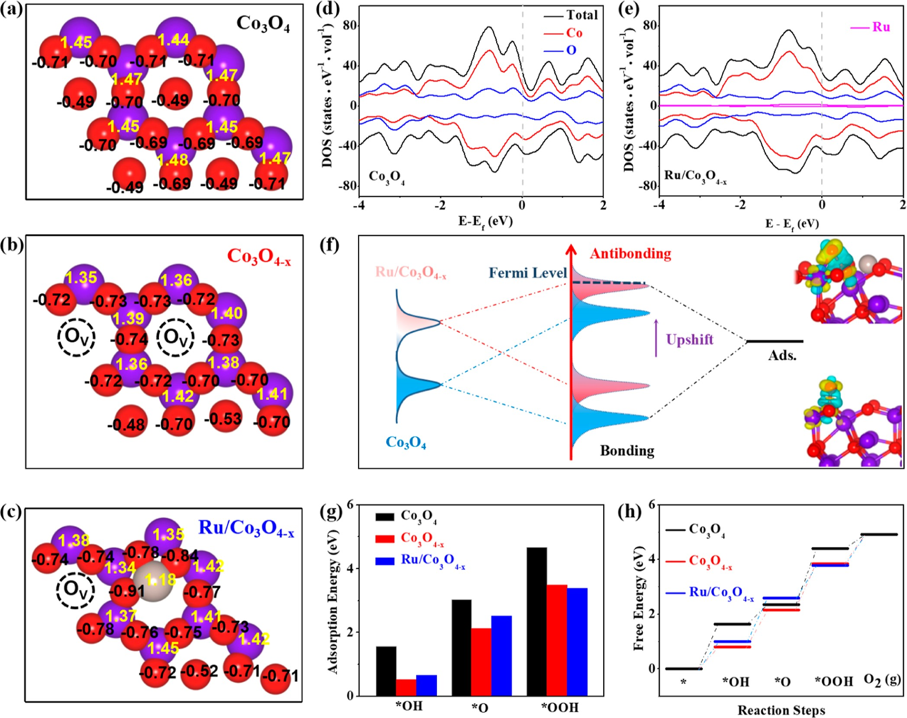
Figure 1. (a) Bader charge numbers of Co₃O₄, (b) Co₃O_{4−x}, and (c) Ru/Co₃O_{4−x}; (d) DOS of Co₃O₄ and (e) Ru/Co₃O_{4−x}; (f) d-band center of Co₃O₄ and Ru/Co₃O_{4−x}; and (g) calculated adsorption energies of *OH, *O, and *OOH on Co₃O₄, Co₃O_{4−x} and Ru/Co₃O_{4−x}. (h) Free energy diagrams of OER over Co₃O₄, Co₃O_{4−x}, and Ru/Co₃O_{4−x}.

activities.¹⁴ Unfortunately, synthetic methods of introducing
boosting the OER properties. More importantly, oxygen

atomically dispersed metal sites into substrate materials are relatively difficult to execute because isolated metal atoms tend to migrate and aggregate during the synthetic process. Thus, developing a facile and efficient synthetic strategy to introduce atomically dispersed metal centers into transition-metal-based electrocatalysts is of great significance in tuning their electronic structures, further enhancing catalytic performances.
Moreover, the selective construction of vacancy defects is promising to regulate the electronic structures and boost the electrocatalytic activities of transition-metal-based cata- lysts.¹⁵⁻¹⁷ For example, Xu et al. synthesized an efficient
vacancy defects in transition-metal oxides can result in low valence states of metal sites and high electron concentrations, which could react with the oxidative noble-metal ions at room temperature.¹⁹⁻²¹ Inspired by this phenomenon, we propose that atomically dispersed metal atoms can be directly anchored onto defective transition-metal-based substrates through this in situ strategy even without the use of any reducing or stabilizing agents.
In this work, low-cost cobalt oxide (Co₃O₄) was selected to be an OER alternative electrocatalyst because of its intrinsic activity. One facile in situ strategy was developed to introduce

Co₃O₄ catalyst with abundant oxygen vacancy defects using the
atomically dispersed Ru into oxygen-defective Co₃O₄ (Ru/

plasma-engraving method, which could exhibit better OER performance than pristine Co₃O₄.¹⁶ Zheng et al. revealed that
Co₃O_{4−x}) via a spontaneous redox reaction between Ru³⁺ and nonstoichiometric Co₃O_{4−x} based on the weak reducing power

due to the existence of oxygen vacancies, new states were
of oxygen vacancy-rich cobalt oxide (Co₃O_{4−x}). Experimental

formed in the Co₃O₄ band gap, and electrons associated with Co−O bonds could be delocalized, thereby finally resulting in high conductivity and remarkable catalytic activities.¹⁸ According to the aforementioned findings, vacancy defects and single-atom doping could be highly effective in regulating electronic structures of the electrocatalysts synergistically and
characterization demonstrated that Ru/Co₃O_{4−x} coexists with oxygen vacancy defects, and atomically dispersed Ru atoms
were obtained successfully. Meanwhile, superior performance toward OER was achieved over the as-prepared Ru/Co₃O_{4−x} electrocatalyst with a low overpotential at 10 mA cm⁻², a small Tafel slope value, as well as excellent long-term stability in the

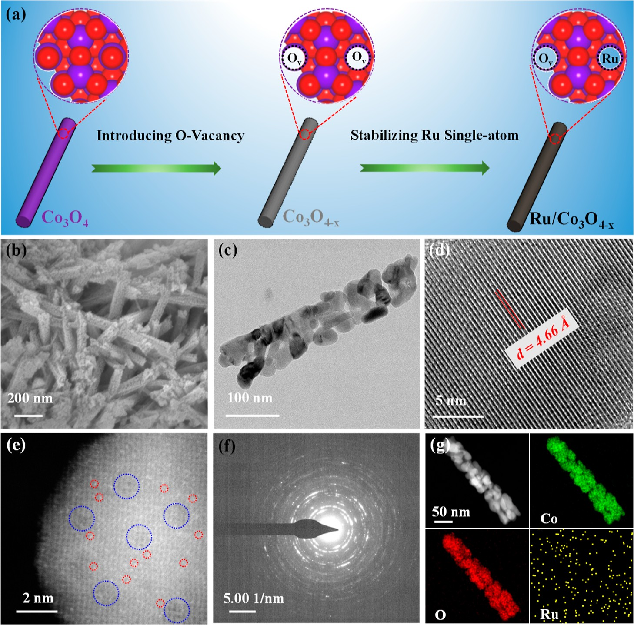
Figure 2. (a) Illustration of preparing Ru/Co₃O_{4−x} electrocatalyst via the defect-induced in situ synthesis strategy. Morphology characterization of as-prepared Ru/Co₃O_{4−x} sample: (b) SEM image, (c) TEM image, (d) HRTEM image, (e) HAADF−STEM image, (f) SAED pattern, and (g) STEM and corresponding elemental mapping images of the as-obtained Ru/Co₃O_{4−x} electrocatalyst.
1 M KOH electrolyte. Furthermore, the density functional however, electron redistribution is observed after introducing
theory (DFT) revealed oxygen vacancy and atomically oxygen vacancies and Ru atoms. Figure 1b shows that the

dispersed Ru could result in the electronic decentralization of Co₃O₄, tuned d-band center, optimized intermediate (*OH,
*O, and *OOH) adsorption, and reduced reaction barriers of OER.

RESULTS AND DISCUSSION
Spin-polarized DFT calculations were first carried out to theoretically verify the feasibility of anchoring atomically
oxygen vacancy makes electrons delocalized around the Co atoms and accumulate around the oxygen vacancy, and the extent of electron delocalization around the Co atoms is further enhanced after loading Ru atoms (Figure 1c). Accordingly, related effects were observed on their DOS due to the electron redistribution and the improved charge distribution asymmetry degrees (Figure 1d,e). Based on the calculated DOS, the d-band center value of the perfect Co₃O₄

dispersed Ru onto oxygen vacancy-rich Co₃O_{4−x} via this
is located at −1.62 eV. After introducing oxygen vacancies and

defect-induced in situ synthesis strategy. According to a previous study,¹³ the mimetic structures of Co₃O_{4−x} were constructed via removing two O atoms from a perfect Co₃O₄ model, and Ru/Co₃O_{4−x} was formed by loading one Ru atom
Ru atoms, the d-band center increased to −1.55 eV (Figure 1f). The d-band center theory reveals that substrates with high electron density near the Fermi level are favorable for oxygen- based species adsorbate adsorption.^{22,23} Moreover, the Sabatier

to the oxygen vacancy. The corresponding simulative
principle indicates that an extremely strong interaction

configurations of Co₃O₄, Co₃O_{4−x}, and Ru/Co₃O_{4−x} are
between active centers and oxygen-based species can be

shown in Figure S1. As expected, the formation energy of Ru/Co₃O_{4−x} is calculated to be −8.51 eV (Figure S2), which is lesser than 0 eV, thereby confirming the relative stability of Ru/Co₃O_{4−x} and the feasibility of this defect-induced in situ synthetic strategy. To explore the roles of oxygen vacancies and Ru atoms in improving the OER activities of Co₃O₄, Bader charge and density of states (DOS) were also conducted. Figure 1a,b, and 1c displays Bader charge numbers of Co₃O₄, Co₃O_{4−x}, and Ru/Co₃O_{4−x}, respectively. The electron distribution in the perfect Co₃O₄ model is almost symmetric;
unbeneficial for the product desorption, whereas a weak interaction is unfavorable for the reactant activation. There- fore, the adsorption energies over Co₃O₄, Co₃O_{4−x}, and Ru/ Co₃O_{4−x} were also conducted. The adsorption configurations and related energies of oxygen-based species during OER are shown in Figures S3 and 1g, respectively. The adsorption energies of *OH over Co₃O₄ and Ru/Co₃O_{4−x} are 1.56 and
0.66 eV, respectively. Similarly, the adsorption energies of *O and *OOH over Co₃O₄ and Ru/Co₃O_{4−x} are also improved, indicating that the adsorption of intermedia over Co₃O₄ can be

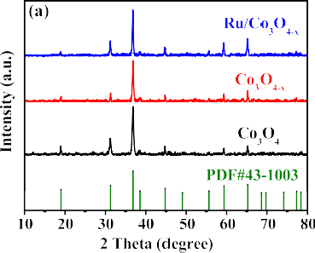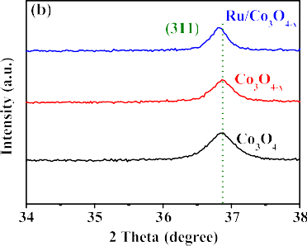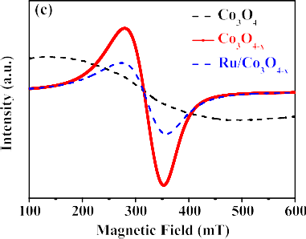

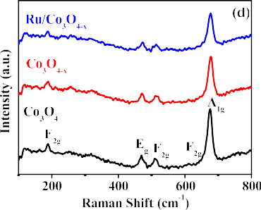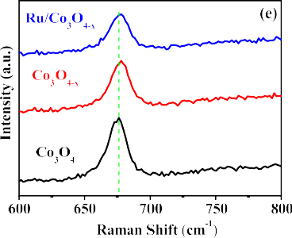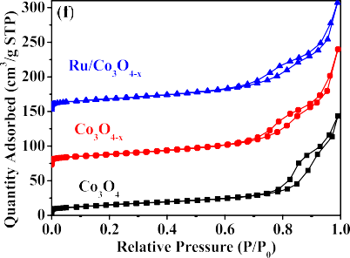
Figure 3. (a) XRD and (b) high-resolution XRD patterns of Co₃O₄, Co₃O_{4−x}, and Ru/Co₃O_{4−x}. (c) EPR spectra of Co₃O₄, Co₃O_{4−x}, and Ru/ Co₃O_{4−x}. (d) Raman and (e) high-resolution Raman spectra of Co₃O₄, Co₃O_{4−x}, and Ru/Co₃O_{4−x}. (f) Nitrogen adsorption−desorption isotherms of Co₃O₄, Co₃O_{4−x}, and Ru/Co₃O_{4−x} samples.

greatly optimized via the oxygen vacancies and Ru atoms,
after NaBH₄ solution treatment and Ru atom loading. The

which can be further verified by the differences in charge density (Figure S4). In addition, the potential determination steps and reaction barriers of OER over Co₃O₄, Co₃O_{4−x}, and Ru/Co₃O_{4−x} were investigated. Figure S5 exhibits the OER process with different intermedia in an alkaline electrolyte. Remarkably, the potential determination step (Figure 1h) over Co₃O₄ and Co₃O_{4−x} is *O + H₂O_{(l)} → *OOH + H⁺ + e⁻. Meanwhile, it changes into *OH → *O + H⁺ + e⁻ on the surface of Ru/Co₃O_{4−x}, which is due to the fact that Ru atoms can also work as active sites. The OER reaction barrier over Co₃O₄ was calculated to be 0.82 eV, and it was reduced to 0.44 eV for Co₃O_{4−x} and further reduced to 0.38 eV for Ru/ Co₃O_{4−x}. The results confirm that oxygen vacancy defects and atomically dispersed Ru can synergistically regulate the electron redistribution of Co₃O₄, improve the adsorption of intermediates, and greatly lower the reaction barrier of OER. Based on the calculated results, we propose a facile defect- induced in situ synthetic strategy for the deposition of
HRTEM images of Co₃O₄ (Figure S9), Co₃O_{4−x} (Figure S10), and Ru/Co₃O_{4−x} (Figure 2d) exhibit clear crystal lattice fringes, declaring the exposed (111) crystal face and the retention of Co₃O₄ crystal structures. The inductively coupled plasma atomic emission spectroscopy (ICP-AES) confirms that the Ru amount of Ru/Co₃O_{4−x} sample is approximately 1.99 wt %. Even with high Ru loading, no aggregated species of Ru are detected in the HRTEM image of Ru/Co₃O_{4−x}. High-angle annular dark field−scanning transmission electron microscopy (HAADF−STEM) image of Ru/Co₃O_{4−x} (Figure 2e) evidently reveals the Ru atoms (circled bright dots) are individually dispersed onto the Co₃O_{4−x} substrate. The selected area electron diffraction (SAED) pattern of Ru/ Co₃O_{4−x} (Figure 2f) exhibits polycrystalline diffraction rings, revealing that it consisted of Co₃O₄ crystalline grains and Ru atoms. STEM and corresponding elemental mapping images proved that Ru atoms are uniformly dispersed in Ru/Co₃O_{4−x}, and no Ru nanoparticles or clusters were observed (Figure 2g).

atomically dispersed Ru on oxygen vacancy-rich Co₃O_{4−x}
The powder X-ray diffraction (XRD) was further performed

(Figure 2a). The original Co₃O₄ nanorods (Figure S6) were experimentally prepared by one hydrothermal approach followed by calcining. In order to introduce oxygen vacancies into Co₃O₄ nanorods, NaBH₄ solution treatment was adopted.^{18,24} As shown in Figure S7, the optimized Co₃O_{4−x} treated by 0.05 M NaBH₄ (denoted as Co₃O_{4−x}) exhibited the best OER activity among all the Co₃O_{4−x} samples treated with different NaBH₄ concentrations. Thus, the optimized Co₃O_{4−x} was selected as the substrate to support Ru atoms. The well- designed Ru/Co₃O_{4−x} electrocatalyst was finally obtained via the reaction between Ru³⁺ and oxygen vacancies in aqueous solution, as illustrated Figure 2a. The SEM images of as- prepared Co₃O_{4−x} (Figure S8) and Ru/Co₃O_{4−x} (Figure 2b) illustrate the morphology of nanorods, demonstrating that the synthetic process would not alter the morphology structures of pristine Co₃O₄. The TEM image of Ru/Co₃O_{4−x} in Figure 2c further proves the retention of Co₃O₄ nanorod morphology
for exploring the crystal structures of Co₃O₄, Co₃O_{4−x}, and Ru/Co₃O_{4−x}. All the diffraction patterns of Co₃O₄-based samples (Figure 3a) are in good agreement with the standard patterns of Co₃O₄ (PDF # 43-1003), and no new peak of Ru nanoparticles is detected in Ru/Co₃O_{4−x}. Notably, the (111) diffraction peak of Ru/Co₃O_{4−x} (Figure 3b) shifts to a lower angle compared with that of Co₃O₄, which is due to the increase in the interplanar space, suggesting the existence of Ru atom doping. The low-temperature electron paramagnetic resonance (EPR) spectra in Figure 3c show that all samples possess strong EPR signals at g = 2.001 because of oxygen vacancies.^{25,26} Notably, the signal of Co₃O_{4−x} is greatly increased compared with that of Co₃O₄, thereby conforming that oxygen vacancies are successfully introduced. Moreover, the signal of Ru/Co₃O_{4−x} is reduced, which signifies the reaction of oxygen vacancies and Ru³⁺. Raman spectra of pure Co₃O₄, Co₃O_{4−x}, and Ru/Co₃O_{4−x} display similar,

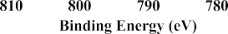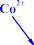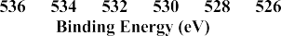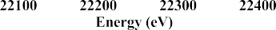

Figure 4. High-resolution XPS spectra of Co 2p in (a) Co₃O₄, (b) Co₃O_{4−x}, and (c) Ru/Co₃O_{4−x} and O 1s in (d) Co₃O₄, (e) Co₃O_{4−x}, and (f) Ru/Co₃O_{4−x}. (g) Ru K-edge XANES region, (h) corresponding k3-weighted χ(k) function of EXAFS, and (i) fitting curves for Ru/Co₃O_{4−x}.

hence suggesting their identical same structure information. Figure 3d presents three obvious evident Raman peaks located at 467, 510, and 675 cm⁻¹, corresponding to E_{g}, F_{2g}, and A_{1g} modes of crystalline Co₃O₄, respectively.²⁷⁻²⁹ Strikingly, the peaks of Co₃O_{4−x} and Ru/Co₃O_{4−x} are slightly shifted and
than the ICP−MS result, suggesting that Ru atoms are dispersed on the surfaces of Co₃O_{4−x}. The high-resolution Co 2p XPS spectrum of Co₃O₄ (Figure 4a) displays two fitted peaks (at 781.2 and 796.4 eV) for Co²⁺ and two fitted peaks (at 779.4 and 794.5 eV) for Co³⁺, respectively.³²⁻³⁴ Although

broadened (Figure 3e) due to the existence of oxygen
the Co 2p spectrum of Co₃O_{4−x} (Figure 4b) shows similar

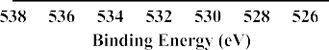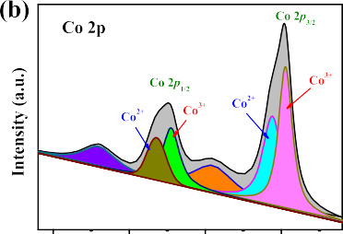vacancies and Ru doping.^{30,31} From Brunauer−Emmett−Teller (BET) analysis (Figure 3f), Co₃O₄, Co₃O_{4−x}, and Ru/Co₃O_{4−x} samples possess specific surface areas of 54.7, 63.2, and 65.7 m²/g, respectively. The large surface area of Ru/Co₃O_{4−x} is due to the continuous ultrasonication and stirring treatment, illustrating that this synthetic strategy could not alter the surface areas greatly. Therefore, the enhancement of the electrocatalytic activities of Ru/Co₃O_{4−x} should originate from the coexistence of oxygen vacancies and Ru atoms rather than the changes in the surface area.
To analyze chemical compositions and electronic properties of as-prepared electrocatalysts, X-ray photoelectron spectros- copy (XPS) measurements are performed, as shown in Figures 4 and S11−S14. In survey spectra (Figure S11) of Co₃O₄, Co₃O_{4−x}, and Ru/Co₃O_{4−x}, Co and O elements are detected in all the samples, whereas Ru is only observed in the Ru/ Co₃O_{4−x} sample, thereby confirming the introduction of Ru via the defect-induced in situ deposition strategy. Moreover, the content of Ru in Ru/Co₃O_{4−x} according to the XPS quantitative analysis is approximately 3 wt %, which is higher
fitted peaks, the ratio of Co²⁺/Co³⁺ is increased, suggesting the existence of more oxygen vacancies in Co₃O_{4−x}. For the Ru/ Co₃O_{4−x}, the binding energy of Co 2p_{3/2} (Figure 4c) positively shifted from 779.3 to 779.7 eV owing to electron transfer from Ru to Co sites, stating the strong electron coupling effect between Ru atoms and Co₃O_{4−x} substrates. In O 1s spectra of Co₃O₄ and Co₃O_{4−x} (Figure 4d,4e), the increased peak intensity of Co₃O_{4−x} at 531.0 eV suggests that abundant oxygen vacancies are generated on the material surfaces caused by NaBH₄ solution treatment. Notably, the amount of oxygen vacancies in Ru/Co₃O_{4−x} is reduced (Figure 4f) after Ru atom loading, thereby further certifying the reaction between oxygen vacancies and Ru³⁺, which is in good accordance with EPR results. Ru 3p spectra in Figures S12−S14 show that the peaks of Ru species at 461.7 and 483.8 eV are only clearly detected in the Ru/Co₃O_{4−x} sample. Interestingly, the binding energies of Ru species in Ru/Co₃O_{4−x} are higher than those of Ru⁰ but lower than those of Ru⁴⁺,³⁵ thereby indicating that a special state of Ru^{δ+} in Ru/Co₃O_{4−x} originated from the spontaneous redox reaction between Ru³⁺ and oxygen vacancies. To further

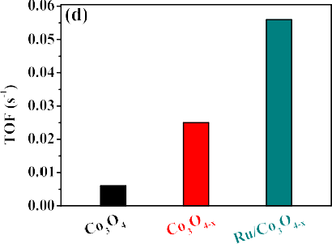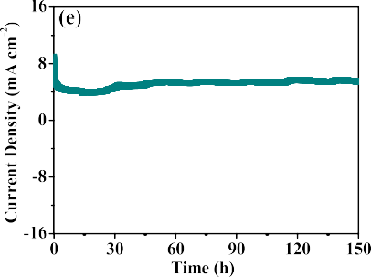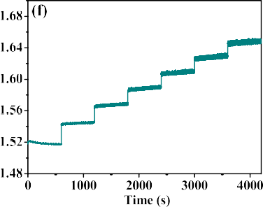
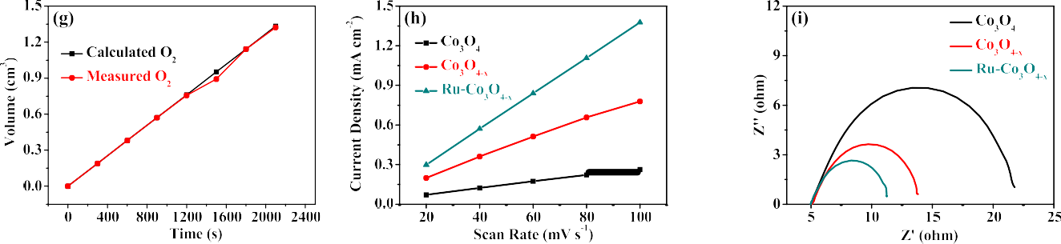
Figure 5. Electrochemical oxygen evolution performance. (a) OER polarization curves; (b) overpotentials at a current density of 10 mA cm⁻² and corresponding current densities at potential of 1.7 V; and (c) Tafel slope of Co₃O₄, Co₃O_{4−x}, Ru/Co₃O_{4−x}, and commercial RuO₂. (d) TOF values of Co₃O₄, Co₃O_{4−x}, Ru/Co₃O_{4−x}. (e) i−t curve, (f) multistep chrono−potentiometric curve, and (g) measured and theoretical yields of O₂ over Ru/Co₃O_{4−x}. (h) Double-layer capacitances (C_{dl}) and (i) electrochemical impedance spectroscopy of Co₃O₄, Co₃O_{4−x}, and Ru/Co₃O_{4−x}.

explore the chemical state and atomic structural information of Ru in Ru/Co₃O_{4−x}, X-ray absorption near-edge structure (XANES) analysis was performed at the Ru K-edge. Figure 4g shows that the energy absorption edge of Ru/Co₃O_{4−x} is
up to 118.8 mA cm⁻², which is better than those of Co₃O₄ (35.1 mA cm⁻²), Co₃O_{4−x} (78.4 mA cm⁻²), and commercial RuO₂ (60.5 mA cm⁻²), demonstrating that oxygen vacancies and atomically dispersed Ru could synergistically boost the

located between the Ru foil and RuO₂, suggesting the state of
OER performance. The Ru/Co₃O₄ sample without oxygen

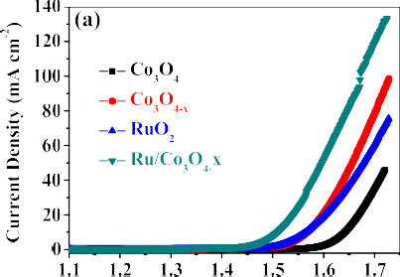
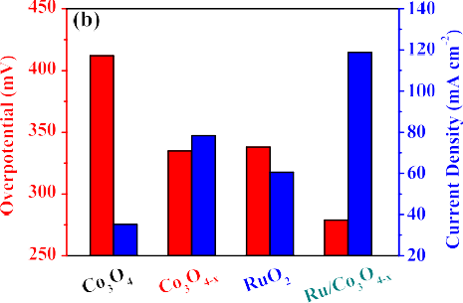
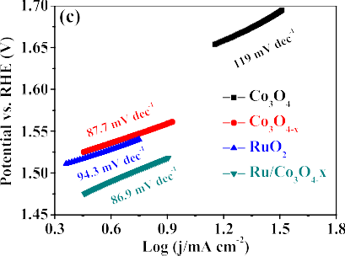
positively charged Ru^{δ+} species. In Figure 4h, no Ru−Ru bond at a distance of 2.32 Å was detected in the extended X-ray absorption fine structure (EXAFS) of Ru/Co₃O_{4−x}, which directly proves the absence of Ru clusters or Ru nanoparticles. Based on the EXAFS (Figure 4h) and fitting curve results (Figure 4i), prominent peaks from Ru−O and Ru−Co contributions are observed, further confirming the feasibility of the defect-induced in situ deposition strategy for anchoring atomically dispersed Ru onto defect-rich Co₃O_{4−x}.
The electrocatalytic activities of the OER over as-prepared electrocatalysts were measured in oxygen-saturated 1 M KOH solution using a three-electrode system. The linear sweep voltammetry (LSV) curve of Ru/Co₃O_{4−x} (Figure 5a) exhibits a sharp increase in the anodic current beyond potential at 1.41 V vs. RHE, manifesting the best catalytic performance among all the samples. The Ru/Co₃O_{4−x} needs one overpotential of 280 mV to achieve a current density of 10 mA cm⁻², which is smaller than Co₃O₄ (412 mV), Co₃O_{4−x} (338 mV), and commercial RuO₂ (335 mV). Moreover, the current density (Figure 5b) at high potential (1.7 V) over Ru/Co₃O_{4−x} reaches
vacancies was also prepared, and the corresponding LSV curve (Figure S15) shows the poor OER activity of Ru/Co₃O₄, which further proves the synergistic effect of oxygen vacancy and atomically dispersed Ru for enhanced OER. In addition, Ru/Co₃O_{4−x} exhibits a small Tafel slope (Figure 5c) of 86.9 mV dec⁻¹, lower than Co₃O₄ (119 mV dec⁻¹) Co₃O_{4−x} (87.7 mV dec⁻¹), and commercial RuO₂ (94.3 mV dec⁻¹), which suggests its favorable OER kinetics. Based on the amount of metal sites, the turnover frequency (TOF) values of Co₃O₄, Co₃O_{4−x}, and Ru/Co₃O_{4−x} are shown in Figure 5d. Similar to the aforementioned results, the Ru/Co₃O_{4−x} displays a TOF value of 0.056 s⁻¹, which is higher than Co₃O_{4−x} (0.025 s⁻¹) and Co₃O₄ (0.006 s⁻¹), thereby further demonstrating that the oxygen vacancies and Ru atoms could synergistically enhance the OER performance of Co₃O₄. The amperometric i−t test in Figure 5e shows a negligible performance degradation, indicating its good stability of Ru/Co₃O_{4−x} in alkaline media, which is benefited by the strong electron coupling effect between Ru atoms and Co₃O_{4−x} substrates. Figure 5f shows a multistep chrono−potentiometric curve over Ru/Co₃O_{4−x}

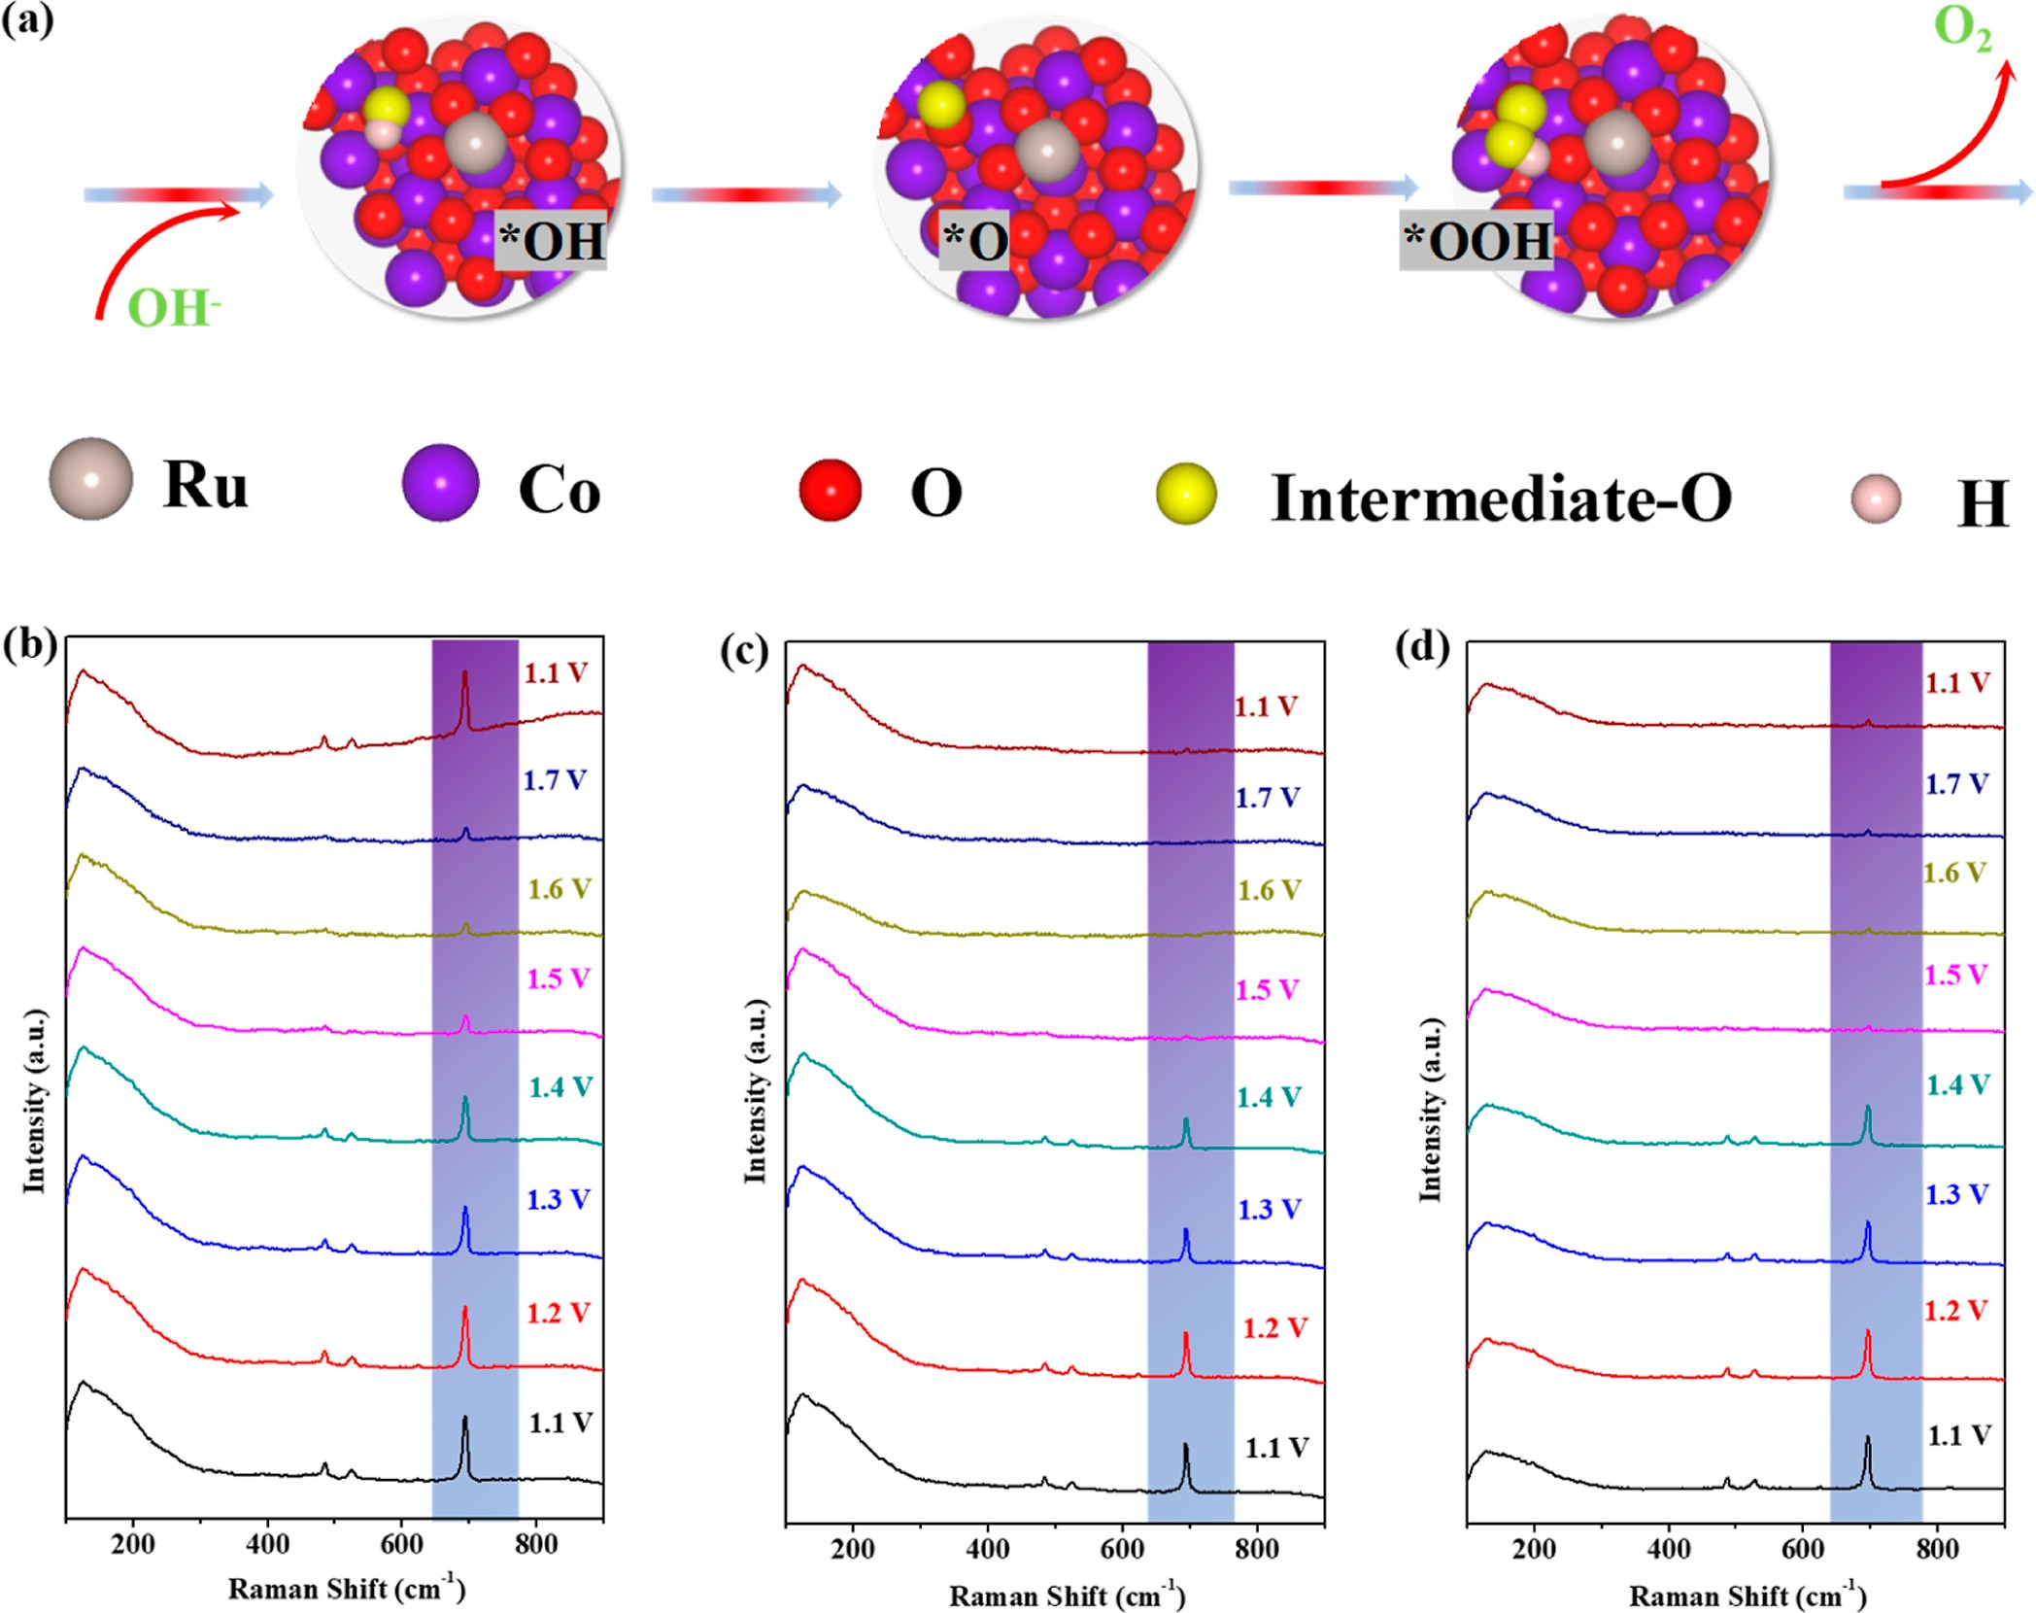
Figure 6. (a) OER process over the Ru/Co₃O_{4−x} in an alkaline electrolyte. In situ Raman spectra of (b) Co₃O₄, (c) Co₃O_{4−x}, and (d) Ru/Co₃O_{4−x} measured at different anodic potentials.

with current densities that range from 10 to 60 mA cm⁻², where the corresponding potential immediately changes at the beginning current density and remains unchanged for each step, indicating the excellent mass transports and stability of the Ru/Co₃O_{4−x}. In addition, the yield of produced O₂ over the Ru/Co₃O_{4−x} electrocatalyst in Figure 5g reveals a high Faradic efficiency of 99% during the OER, declaring these obtained catalytic currents originate exclusively from the
Surface reconstruction could occur over metal-based electrocatalysts at high applied potentials during the OER process.³⁶⁻³⁸ Depending on intrinsic properties of the electrocatalysts and their catalytic mechanism, surface reconstruction can be reversible or irreversible.^{39,40} Operando Raman measurements were conducted to investigate the surface reconstruction and active sites of Co₃O₄, Co₃O_{4−x} and Ru/Co₃O_{4−x} electrocatalysts (Figure S19). Figure 6a

oxygen evolution. Double-layer capacitances (C_{dl}) are
displays the conceivable OER process over Ru/Co₃O_{4−x}.

measured (Figures S16−S18 and 5h) to explore the nature of the OER activity promotion of Ru/Co₃O_{4−x}. Ru/Co₃O_{4−x} shows a large C_{dl} value of 13.6 mF cm⁻², which is higher than Co₃O_{4−x} (7.27 mF cm⁻²) and Co₃O₄ (2.41 mF cm⁻²), indicating more active centers on Ru/Co₃O_{4−x} are generated from oxygen vacancies and Ru atom doping. Furthermore, the Nyquist plot in Figure 5i shows that Ru/Co₃O_{4−x} possesses a lower frequency range semicircle diameter (6.3 Ω), which is smaller than Co₃O_{4−x} (8.8 Ω) and Co₃O₄ (16.7 Ω), implying the faster charge transfer over the Ru/Co₃O_{4−x} electrocatalyst. Accordingly, the coexistence of atomically Ru atoms and
During the OER process, the Raman peaks of the Co₃O₄ electrocatalyst in Figure 6b gradually decrease above a potential of 1.4 V, and no newly evolved Raman peak is observed, suggesting that the surface of Co₃O₄ was transferred into amorphous species during OER steps.^{27,41} Moreover, Raman characteristic peaks of Co₃O₄ recovered at the end of OER suggest that the surface reconstruction is reversible over Co₃O₄. As for the Co₃O_{4−x} (Figure 6c) and Ru/Co₃O_{4−x} (Figure 6d) electrocatalysts, the Raman signals also attenuate as the potential increases beyond 1.4 V. However, surface reconstruction phenomena become irreversible because of the

oxygen vacancies contributes to more active sites and faster
existence of oxygen vacancies.⁴² The XRD of Ru/Co₃O_{4−x}

charge transfer, thereby greatly improving the OER perform- ance of Ru/Co₃O_{4−x}.
after OER was conducted, and the pattern in Figure S20 displays that the main crystal phase of Ru/Co₃O_{4−x} did not

change, which proves that the reconstruction has occurred on the surfaces of electrocatalysts. More importantly, the Raman characteristic peaks of Ru/Co₃O_{4−x} measured at 1.5, 1.6, 1.7, and 1.1 V at the end of the OER are higher than those of Co₃O_{4−x}, confirming that Ru atoms could improve the durability of Co₃O_{4−x} during OER due to the strong electron coupling effect between Ru atoms and Co₃O_{4−x} substrates.⁴³ The XPS of Ru/Co₃O_{4−x} after OER is also performed and shown in Figure S21. Likewise, the Co−OH bond was detected in the O 1s spectrum, confirming the reconstruction on the surface during OER.⁴⁴ Operando Raman measurements illustrate the irreversible transformation into amorphous species on Ru/Co₃O_{4−x} surfaces during OER, which leads to more active sites while the Ru atoms enhance the electro- catalytic stability.

CONCLUSIONS
In summary, defect-induced in situ single-atom deposition strategy was reported to construct electrocatalysts with oxygen vacancy and single-atom catalysts for enhanced OER perform- ances. During this process, atomically dispersed Ru has been
Perth, Western Australia 6845, Australia; Email: zongping.shao@curtin.edu.au
Kwun Nam Hui − Joint Key Laboratory of the Ministry of Education, Institute of Applied Physics and Materials Engineering, University of Macau, Taipa 999078 Macau SAR, P. R. China; orcid.org/0000-0002-3008-8571;
Email: bizhui@um.edu.mo
Authors
Cheng-Zong Yuan − Joint Key Laboratory of the Ministry of Education, Institute of Applied Physics and Materials Engineering, University of Macau, Taipa 999078 Macau SAR, P. R. China; Jiangxi Province Key Laboratory of Cleaner Production of Rare Earths, Ganjiang Innovation Academy, Chinese Academy of Sciences, Ganzhou 341119, China; orcid.org/0000-0002-4767-8957
Shuo Wang − Joint Key Laboratory of the Ministry of Education, Institute of Applied Physics and Materials
Engineering, University of Macau, Taipa 999078 Macau SAR, P. R. China
Kaixi Wang − Joint Key Laboratory of the Ministry of

directly anchored onto oxygen vacancy-rich cobalt oxides
Education, Institute of Applied Physics and Materials

based on the spontaneous redox reaction between Co₃O_{4−x} and Ru³⁺ ions. Noticeably, the as-prepared Ru/Co₃O_{4−x}
Engineering, University of Macau, Taipa 999078 Macau SAR, P. R. China

electrocatalyst with oxygen vacancy defects and Ru single
Junfeng Li − Joint Key Laboratory of the Ministry of

atom exhibited excellent OER performance, which is much better than those of Co₃O₄, Co₃O_{4−x}, and commercial RuO₂. Moreover, owing to the strong interaction between Ru atoms and Co₃O_{4−x} supports, outstanding long-term durability was also achieved over this Ru/Co₃O_{4−x} electrocatalyst. DFT calculation revealed that the electron decentralization and d- band center of Co₃O₄ can be synergistically tailored by oxygen vacancies and Ru atoms, thereby leading to optimized
Education, Institute of Applied Physics and Materials Engineering, University of Macau, Taipa 999078 Macau SAR, P. R. China
Haixing Gao − Joint Key Laboratory of the Ministry of Education, Institute of Applied Physics and Materials Engineering, University of Macau, Taipa 999078 Macau SAR, P. R. China
Chenyang Zha − Joint Key Laboratory of the Ministry of

adsorption of oxygen-based intermediates and lowered
Education, Institute of Applied Physics and Materials

reaction barriers. This defect-induced in situ single-atom deposition strategy paves a new route to construct electro- catalysts with oxygen vacancy and single atoms for enhanced electrocatalytic oxygen evolution.
■

ASSOCIATED CONTENT
*sı Supporting Information
The Supporting Information is available free of charge at
https://pubs.acs.org/doi/10.1021/acscatal.2c04946.
Materials’ synthesis, materials’ characterizations, electro- chemical measurement, DFT computational calculations and corresponding additional data including optimized configurations, formation energies, SEM, TEM, XPS, CV, LSV, XRD, in situ Raman, and OER performance comparison (PDF)
■

AUTHOR INFORMATION
Corresponding Authors
Kwan San Hui − School of Engineering, Faculty of Science, University of East Anglia, Norwich NR4 7TJ, U.K.;
orcid.org/0000-0001-7089-7587; Email: k.hui@ uea.ac.uk
Jiawei Wan − State Key Laboratory of Biochemical Engineering, Institute of Process Engineering, Chinese Academy of Sciences, Beijing 100190, China; orcid.org/ 0000-0002-9008-2323; Email: jwwan@ipe.ac.cn
Zongping Shao − WA School of Mines: Minerals, Energy and Chemical Engineering (WASM-MECE), Curtin University,
Engineering, University of Macau, Taipa 999078 Macau SAR, P. R. China
Xiaomeng Zhang − Jiangxi Province Key Laboratory of Cleaner Production of Rare Earths, Ganjiang Innovation Academy, Chinese Academy of Sciences, Ganzhou 341119, China
Duc Anh Dinh − VKTech Research Center, NTT Hi-Tech Institute, Nguyen Tat Thanh University, Ho Chi Minh City 700000, Viet Nam
Xi-Lin Wu − College of Geography and Environmental Science, Zhejiang Normal University, Jinhua 321004, China;
orcid.org/0000-0002-0056-7782
Zikang Tang − Joint Key Laboratory of the Ministry of Education, Institute of Applied Physics and Materials Engineering, University of Macau, Taipa 999078 Macau SAR, P. R. China
Author Contributions
∇C.-Z.Y. and S.W. contributed equally to this work.
Notes
The authors declare no competing financial interest.
■

ACKNOWLEDGMENTS
This work was funded by the Science and Technology Development Fund, Macau SAR (File no. 0191/2017/A3, 0041/2019/A1, 0046/2019/AFJ, 0021/2019/AIR, and 0007/

2021/AGJ), University of Macau (File no. MYRG2018-00192- IAPME, MYRG2020-00187-IAPME, and MYRG2022-00223-
IAPME), UEA fund, National Key R&D Program (2022YFB3504302, 2021YFB3500801, 2019YFC1908405,
and 2019YFC1907304), and Open Funding Project of the Jiangxi Province Key Laboratory of Cleaner Production of Rare Earths (E03MYB0309). C.Z. Yuan acknowledges the UM Macao Postdoctoral Fellowship and Associateship. This work was financially supported by the National Natural Science Foundation of China (grant no. 52022097), Foundation of the
  - Yao, Y.; Hu, S.; Chen, W.; Huang, Z.-Q.; Wei, W.; Yao, T.; Liu, R.; Zang, K.; Wang, X.; Wu, G.; Yuan, W.; Yuan, T.; Zhu, B.; Liu, W.; Li, Z.; He, D.; Xue, Z.; Wang, Y.; Zheng, X.; Dong, J.; Chang, C.-R.; Chen, Y.; Hong, X.; Luo, J.; Wei, S.; Li, W.-X.; Strasser, P.; Wu, Y.; Li,
Y. Engineering the electronic structure of single atom Ru sites via compressive strain boosts acidic water oxidation electrocatalysis. Nat. Catal. 2019, 2, 304−313.
  - Yan, X.; Jia, Y.; Yao, X. Defective Structures in Metal
Compounds for Energy-Related Electrocatalysis. Small Struct. 2021, 2, 2000067.
  - Xu, L.; Jiang, Q.; Xiao, Z.; Li, X.; Huo, J.; Wang, S.; Dai, L.

Youth Innovation Promotion Association of CAS (2020048).
Plasma-Engraved Co₃O₄ Nanosheets with Oxygen Vacancies and

The DFT calculations are performed at High Performance Computing Cluster (HPCC) of Information and Communi- cation Technology Office (ICTO) at the University of Macau.
High Surface Area for the Oxygen Evolution Reaction. Angew. Chem., Int. Ed. 2016, 55, 5277−5281.
  - Yi, H.; Liu, S.; Lai, C.; Zeng, G.; Li, M.; Liu, X.; Li, B.; Huo, X.;
Qin, L.; Li, L.; Zhang, M.; Fu, Y.; An, Z.; Chen, L. Recent Advance of

REFERENCES
Transition-Metal-Based Layered Double Hydroxide Nanosheets:

- Sanati, S.; Morsali, A.; García, H. First-row transition metal- based materials derived from bimetallic metal−organic frameworks as highly efficient electrocatalysts for electrochemical water splitting. Energy Environ. Sci. 2022, 15, 3119−3151.
- Su, H.; Song, S.; Gao, Y.; Li, N.; Fu, Y.; Ge, L.; Song, W.; Liu, J.; Ma, T. In Situ Electronic Redistribution Tuning of NiCo₂S₄ Nanosheets for Enhanced Electrocatalysis. Adv. Funct. Mater. 2022, 32, 2109731.
- Qiang, F.; Feng, J.; Wang, H.; Yu, J.; Shi, J.; Huang, M.; Shi, Z.;
Synthesis, Properties, Modification, and Electrocatalytic Applications.
Adv. Energy Mater. 2021, 11, 2002863.
- Wang, Y.; Zhou, T.; Jiang, K.; Da, P.; Peng, Z.; Tang, J.; Kong, B.; Cai, W.-B.; Yang, Z.; Zheng, G. educed Mesoporous Co₃O₄ Nanowires as Efficient Water Oxidation Electrocatalysts and Super- capacitor Electrodes. Adv. Energy Mater. 2014, 4, 1400696.
- Xi, G.; Ye, J.; Ma, Q.; Su, N.; Bai, H.; Wang, C. In Situ Growth of Metal Particles on 3D Urchin-like WO₃ Nanostructures. J. Am. Chem. Soc. 2012, 134, 6508−6511.
- Pan, X.; Xu, Y.-J. Defect-Mediated Growth of Noble-Metal (Ag,

Liu, S.; Li, L.; Dong, L. Oxygen Engineering Enables N-Doped Porous
Pt, and Pd) Nanoparticles on TiO₂ with Oxygen Vacancies for

Carbon Nanofibers as Oxygen Reduction/Evolution Reaction
Photocatalytic Redox Reactions under Visible Light. J. Phys. Chem. C

Electrocatalysts for Flexible Zinc-Air Batteries. ACS Catal. 2022, 12, 4002−4015.
(4) Zhang, Y. C.; Han, C.; Gao, J.; Pan, L.; Wu, J.; Zhu, X.; Zou, J. J.
2013, 117, 17996−18005.
(21) Li, H.; Zhang, L. Oxygen vacancy induced selective silver deposition on the {001} facets of BiOCl single-crystalline nanosheets

NiCo-Based Electrocatalysts for the Alkaline Oxygen Evolution
for enhanced Cr(VI) and sodium pentachlorophenate removal under

Reaction: A Review. ACS Catal. 2021, 11, 12485−12509.
- Yuan, C.-Z.; Hui, K. S.; Yin, H.; Zhu, S.; Zhang, J.; Wu, X.-L.; Hong, X.; Zhou, W.; Fan, X.; Bin, F.; Chen, F.; Hui, K. N. Regulating Intrinsic Electronic Structures of Transition-Metal-Based Catalysts and the Potential Applications for Electrocatalytic Water Splitting. ACS Mater. Lett. 2021, 3, 752−780.
- Lee, J.; Kumar, A.; Yang, T.; Liu, X.; Jadhav, A. R.; Park, G. H.;
Hwang, Y.; Yu, J.; Nguyen, C. T. K.; Liu, Y.; Ajmal, S.; Kim, M. G.; Lee, H. Stabilizing the OOH* intermediate via pre-adsorbed surface oxygen of a single Ru atom-bimetallic alloy for ultralow overpotential oxygen generation. Energy Environ. Sci. 2020, 13, 5152−5164.
- You, B.; Sun, Y. Innovative strategies for electrocatalytic water splitting. Acc. Chem. Res. 2018, 51, 1571−1580.
- Suryanto, B. H. R.; Wang, Y.; Hocking, R. K.; Adamson, W.;
Zhao, C. Overall electrochemical splitting of water at the
visible light. Nanoscale 2014, 6, 7805−7810.
- Zhang, L.; Jia, Y.; Gao, G.; Yan, X.; Chen, N.; Chen, J.; Soo, M. T.; Wood, B.; Yang, D.; Du, A.; Yao, X. Graphene defects trap atomic Ni species for hydrogen and oxygen evolution reactions. Chem 2018, 4, 285−297.
- Chen, H.; Chen, S.; Zhang, Z.; Sheng, L.; Zhao, J.; Fu, W.; Xi,
S.; Si, R.; Wang, L.; Fan, M.; Yang, B. Single-Atom-Induced Adsorption Optimization of Adjacent Sites Boosted Oxygen Evolution Reaction. ACS Catal. 2022, 12, 13482−13491.
- Zheng, Y.; Fu, K.; Yu, Z.; Su, Y.; Han, R.; Liu, Q. Oxygen
Vacancies in Catalyst for VOCs Oxidation: Synthesis, Character- ization, Catalytic Effects. J. Mater. Chem. A 2022, 10, 14171−14186.
- Yang, S.; Liu, Y.; Hao, Y.; Yang, X.; Goddard, W. A.; Zhang, X.
L.; Cao, B. Oxygen-Vacancy Abundant Ultrafine Co₃O₄/Graphene Composites for High-Rate Supercapacitor Electrodes. Adv. Sci. 2018,

heterogeneous interface of nickel and iron oxide. Nat. Commun.
2019, 10, 5599.
5, 1700659.
- Luo, S.; Li, X.; Zhang, B.; Luo, Z.; Luo, M. MOF-Derived

- Feng, C.; Faheem, M. B.; Fu, J.; Xiao, Y.; Li, C.; Li, Y. Fe-based
Co₃O₄@NC with Core−Shell Structures for N₂ Electrochemical

electrocatalysts for oxygen evolution reaction: progress and
Reduction under Ambient Conditions. ACS Appl. Mater. Interfaces

perspectives. ACS Catal. 2020, 10, 4019−4047.
- Yu, M.; Budiyanto, E.; Tüysüz, H. Principles of Water Electrolysis and Recent Progress in Cobalt-, Nickel-, and Iron-Based Oxides for the Oxygen Evolution Reaction. Angew. Chem., Int. Ed. 2021, 61, No. e202103824.
- Luo, M.; Sun, W.; Xu, B. B.; Pan, H.; Jiang, Y. Interface engineering of air electrocatalysts for rechargeable zinc−air batteries. Adv. Energy Mater. 2021, 11, 2002762.
- Suen, N. T.; Hung, S. F.; Quan, Q.; Zhang, N.; Xu, Y. J.; Chen,
2019, 11, 26891−26897.
- Wang, J.; Gao, R.; Zhou, D.; Chen, Z.; Wu, Z.; Schumacher, G.; Hu, Z.; Liu, X. Boosting the Electrocatalytic Activity of Co₃O₄ Nanosheets for a Li-O₂ Battery through Modulating Inner Oxygen Vacancy and Exterior Co³⁺/Co²⁺. ACS Catal. 2017, 7, 6533−6541.
- Ding, D.; Shen, K.; Chen, X.; Chen, H.; Chen, J.; Fan, T.; Wu,
Y.; Li, Y. Multi-Level Architecture Optimization of MOF-Templated Co-Based Nanoparticles Embedded in Hollow N Doped Carbon Polyhedra for Efficient OER and ORR. ACS Catal. 2018, 8, 7879−

H. M. Electrocatalysis for the oxygen evolution reaction: recent
7888.

development and future perspectives. Chem. Soc. Rev. 2017, 46, 337− 365.
(13) Zhuang, L.; Jia, Y.; Liu, H.; Wang, X.; Hocking, R. K.; Liu, H.; Chen, J.; Ge, L.; Zhang, L.; Li, M.; Dong, C. L.; Huang, Y. C.; Shen, S.; Yang, D.; Zhu, Z.; Yao, X. Defect-Induced Pt-Co-Se Coordinated Sites with Highly Asymmetrical Electronic Distribution for Boosting Oxygen-Involving Electrocatalysis. Adv. Mater. 2019, 31, 1805581.
- Wang, Y.; Zhu, Y. Q.; Xie, Z.; Xu, S. M.; Xu, M.; Li, Z.; Ma, L.; Ge, R.; Zhou, H.; Li, Z.; Kong, X.; Zheng, L.; Zhou, J.; Duan, H. Efficient Electrocatalytic Oxidation of Glycerol via Promoted OH* Generation over Single-Atom-Bismuth-Doped Spinel Co₃O₄. ACS Catal. 2022, 12, 12432−12443.
- Wei, M.; Huang, S.; Wang, Y.; Liu, Y.; He, Y.; Wang, C.; Yang,
L. Nanostructured Ru-doped Co₃O₄ as an efficient electrocatalyst for

oxygen reduction reaction in alkaline medium. J. Alloys Compd. 2020,
827, 154207.
- Wang, C.; Qi, L. Heterostructured Inter-Doped Ruthenium- Cobalt Oxide Hollow Nanosheet Arrays for Highly Efficient Overall Water Splitting. Angew. Chem., Int. Ed. 2020, 59, 17219−17224.
- Wu, Z.; Sun, L.-P.; Yang, M.; Huo, L.-H.; Zhao, H.; Grenier, J.-
C. Facile synthesis and excellent electrochemical performance of reduced graphene oxide−Co₃O₄ yolk-shell nanocages as a catalyst for oxygen evolution reaction. J. Mater. Chem. A 2016, 4, 13534−13542.
- Ning, F.; Shao, M.; Zhang, C.; Xu, S.; Wei, M.; Duan, X. Co₃O₄@ layered double hydroxide core/shell hierarchical nanowire arrays for enhanced supercapacitance performance. Nano Energy 2014, 7, 134−142.
- Li, J.; Zhou, H.; Jian, Z.; Li, H.; Guan, X.; Xing, Y.; Zhang, S.;
Xu, H. Improved Electrocatalytic Activity of Three-Dimensional OpenStructured Co₃O₄@MnO₂ Bifunctional Catalysts of Li-O₂ Batteries by Inducing the Oriented Growth of Li₂O₂. ACS Sustainable Chem. Eng. 2021, 9, 5334−5344.
- Li, P.; Wang, M.; Duan, X.; Zheng, L.; Cheng, X.; Zhang, Y.;
Kuang, Y.; Li, Y.; Ma, Q.; Feng, Z.; Liu, W.; Sun, X. Boosting oxygen evolution of single-atomic ruthenium through electronic coupling with cobalt-iron layered double hydroxides. Nat. Commun. 2019, 10, 1711.
- Chemelewski, W. D.; Lee, H. C.; Lin, J. F.; Bard, A. J.; Mullins,
C. B. Amorphous FeOOH oxygen evolution reaction catalyst for photoelectrochemical water splitting. J. Am. Chem. Soc. 2014, 136, 2843−2850.
- Deng, Y.; Handoko, A. D.; Du, Y.; Xi, S.; Yeo, B. S. In Situ Raman Spectroscopy of Copper and Copper Oxide Surfaces during Electrochemical Oxygen Evolution Reaction: Identification of CuIII Oxides as Catalytically Active Species. ACS Catal. 2016, 6, 2473− 2481.
- Zhu, K.; Zhu, X.; Yang, W. Application of in situ techniques for the characterization of NiFe-based oxygen evolution reaction (OER) electrocatalysts. Angew. Chem., Int. Ed. 2019, 58, 1252−1265.
- Fan, K.; Zou, H.; Lu, Y.; Chen, H.; Li, F.; Liu, J.; Sun, L.; Tong, L.; Toney, M. F.; Sui, M.; Yu, J. Direct observation of structural

P.; Gliech, M.; de Araujo, J. F.; Reier, T.; Dau, H.; Strasser, P.
2 3 4

Reversible amorphization and the catalytically active state of crystalline Co₃O₄ during oxygen evolution. Nat. Commun. 2015, 6, 8625.
- Huang, J.; Sheng, H.; Ross, R. D.; Han, J.; Wang, X.; Song, B.; Jin, S. Modifying redox properties and local bonding of Co₃O₄ by CeO₂ enhances oxygen evolution catalysis in acid. Nat. Commun. 2021, 12, 3036.
- Xiao, Z.; Huang, Y. C.; Dong, C. L.; Xie, C.; Liu, Z.; Du, S.; Chen, W.; Yan, D.; Tao, L.; Shu, Z.; Zhang, G.; Duan, H.; Wang, Y.; Zou, Y.; Chen, R.; Wang, S. Operando Identification of the Dynamic Behavior of Oxygen Vacancy-Rich Co₃O₄ for Oxygen Evolution Reaction. J. Am. Chem. Soc. 2020, 142, 12087−12095.
- Solomon, G.; Landström, A.; Mazzaro, R.; Jugovac, M.; Moras, P.; Cattaruzza, E.; Morandi, V.; Concina, I.; Vomiero, A. NiMoO₄@ Co₃O₄ Core−Shell Nanorods: In Situ Catalyst Reconstruction toward High Efficiency Oxygen Evolution Reaction. Adv. Energy Mater. 2021, 11, 2101324.
- Zhao, Z.; Liu, Y.; Wan, F.; Wang, S.; Zhang, N.; Liu, L.; Cao, A.; Niu, Z. Free-standing nitrogen doped graphene/Co(OH)₂ composite films with superior catalytic activity for aprotic lithium- oxygen batteries. Chin. Chem. Lett. 2021, 32, 594−597.

