Single-atom tailoring of Li₂S to Form Li₂S₂ for building better lithium-sulfur batteries
Chang Liu,^{a, b, +} Shuo Wang,^{a, +} Yuwei Zhao,^{b, +} Chongguang Lyu,^{b} Rong Wu,^{b} Jianglu Xiang,^{b} Junfeng Li,ª Kwan San Hui,^{c} Chenyang Zha,^{a, b, *} Kwun Nam Hui,^{a, *}

ª Joint Key Laboratory of the Ministry of Education, Institute of Applied Physics and Materials Engineering (IAPME), University of Macau, Avenida da Universidade, Taipa, Macau SAR, 999078, China
^{b} Key Laboratory of Flexible Electronics (KLOFE), Institute of Advanced Materials (IAM), Nanjing Tech University, Nanjing 211816, Jiangsu, China
^{c} Engineering, Faculty of Science, University of East Anglia, Norwich, NR4 7TJ, United Kingdom

⁺ These authors contributed equally.
* Corresponding authors:
chenyangzha@um.edu.mo (C. Zha)
iamcyzha@njtech.edu.cn (C. Zha)
bizhui@um.edu.mo (K.N. Hui)

Abstract
The Li₂S-based cathodes to couple with Li-free anodes are regarded as a commercially available approach to overcome the safety risk of lithium metal anodes. However, the passivated Li₂S instinct leads to a high activation potential in the initial charging process, and the notorious shuttle effect of polysulfide is inevitable upon cell cycling. Here we create a single atom tailoring strategy by comproportionation reactions (Li₂S + S = Li₂S₂) to from the liquid Li₂S₂ catholyte, where the Li₂S₂ cell enables a lower potential barrier and allows for the 3.0 V activation voltage without any other material modification. Meanwhile, the polar conducting material TaB₂ is introduced to restrain the migration of polysulfides and provide fast redox reaction kinetics. With those ingenious tailoring of cell designs, the Li₂S₂-TaB₂ cell (Li₂S₂ content of 91 wt%) exhibits stable capacity (initial capacity of 597 mAh/g at 4 mg/cm² Li₂S₂ loading), excellent cycling stability (500 cycles at 2.4 mA/cm²).

Introduction
Lithium sulfide (Li₂S) is a promising candidate to use as the Li-containing cathode in lithium-sulfur (Li-S) batteries, which can couple with Li-free anode with more practical safety performances to evade the problematic pure Li metal anode. Meanwhile, the Li₂S has the advantages of higher melting point (938 ºC) and lower density (1.66 g/cm³) which is better than those of S₈ (115 ºC and 2.07 g/cm³, respectively). The better thermal ability (up to 800 °C) of Li₂S are favored with the application fields of Li-S battery, including firefighting robots, space exploration and high temperature sensor…which are however impossible in the S₈-based Li-S cells. Unfortunately, the application of the Li₂S cathode suffers from several issues which are an enormous overpotential barrier, poor utilization of material, and shuttle effect of polysulfide and so on. Studies have revealed that particle size tailoring may greatly help to improve the above problems, for example, mechanical milling, structural designing and solvated strategy of Li₂S, hyperthermal reduction of Li₂SO₄, and redox mediator of additive, further to low the overpotential of Li₂S, optimize reaction kinetics, and restrain migration of polysulfide. However, these modified strategies either increase the additional assembly processes of batteries, or add non-commercial additives, or require materials which is sensitive for H₂O/O₂. Accordingly, a novel strategy is attractive to develop a facile method powering the performance of commercially available Li₂S particles with micron size.
Ionic crystal Li₂S has a highly stable instinct of antifluorite structure which is consists of stronger bond energy with the higher standard enthalpy of formation, causing it is far from the cyclic molecular structure of elemental S₈. In the first charge stage, the micron-sized Li₂S cathode has nearly 0 mAh/g capacity in the 1.7-2.8 V, which is the normal voltage range of Li-S cells. After a higher working potential activating (up 4.0 V vs Li⁺/Li), the surface small particles of bulk Li₂S are delithiated to form the solvated polysulfides (Li₂S₂), and those polysulfides generate more nucleation sites by the comproportionation reactions, and finally to complete the bulk Li₂S activation process. The activation potential of Li-S cell does charge up to 4.0 V (even over 3.0 V) which can cause electrolyte decomposition, poor cycle performance, and low Coulombic efficiency. Therefore, the synthesis of Li₂S₂, replacing the Li₂S, is supposed to completely solve the poor ionic/electronic conductivity of Li₂S. According to density-functional theory, Li₂S₂ is a semiconductor with an energy gap of 1.8 eV, which is much smaller than 3.5 eV of Li₂S, indicating the available intrinsic charge carriers of Li₂S₂ are more than that of Li₂S in an order of magnitude difference. Unfortunately, the Li₂S₂ has been isolated from Li-S batteries due to the high difficulty and challenge in synthesis.
Herein, we create a single atom tailoring approach that offers an effective strategy to reconstitute the molecular structure of commercial Li₂S and to form high activity of Li₂S₂ without high temperature, complex/sensitive additions. The liquid Li₂S₂ catholyte is prepared via comproportionation reactions which is a simple mixed method of commercially available solutions (ethanol/carbon disulfide) and particles (Li₂S/S₈). By taking advantage of the high electrochemical activity of Li₂S₂, Li-S cell shows a little potential barrier after only 3.0 V charging voltage. For the shuttle effect of polysulfide, the polar conducting material TaB₂ promotes the anchoring effect and enhances the conversion of polysulfides, rendering accelerated redox reaction in the cell cycling. Attributed to these features, the Li₂S₂-TaB₂ cathodes exhibit stable capacity (about 500 mAh/g at 2.4 mA/cm²), excellent cycling stability (500 cycles), remarkable sulfur loading (4.0 mg/cm²), high-rate capability up to 5.0 mA/cm².

Results and discussion
The host material of polysulfide is analyzed, and X-ray diffraction (XRD) pattern in Fig. 1a verifies the successful formation of TaB₂. The sharp Bragg’s peaks imply its high crystallinity and indicate hexagonal phase of TaB₂ (JCPDS No. 38-1462, P6/mmm, standard a = b = 0.3098 nm, c = 0.3227 nm). Furthermore, X-ray photoelectron spectroscopy (XPS) illustrates the surface state of the TaB₂, and the spectrums of Ta 4f and B 1s are shown in Fig. 1b and 1c, respectively. Among the four deconvolution peaks show in Fig. 1b, four peaks are corresponding to Ta⁴⁺ and Ta⁵⁺ states, and come from the intrinsic structure of TaB₂. The deconvoluting peaks of B 1s spectrums are matched with the results of Ta 4f spectrums. Those multi-chemical bonds (Ta⁴⁺/Ta⁵⁺) can offer more interfacial multi-actives for guiding powered the nucleation and growth of Li₂S₂/Li₂S, and then to enhance the complicated 16-electron transfer/nontransfer-based multiphase evolution processes (solid S₈/liquid polysulfides/solid Li₂S). In the following, the scanning electron microscopy (SEM) images (Fig. 1d with inset) and transmission electron microscopy (TEM) image (Fig. 1e) show morphology of TaB₂ materials, which is consisted of hexagonal sheets. The selected area electron diffraction (SAED) of TaB₂ (inset of Fig. 1e) shows a highly crystalized structure which can enhance redox reaction kinetics via overcoming trap/defect in the electrode transfer processes. Next, high-resolution transmission electron microscopy (HRTEM) image (Fig. 1f) shows 0.206 nm of lattice distance, corresponding to the XRD analysis of TaB₂ (JCPDS No. 38-1462). The high-angle annular dark-field imaging (HADDF-TEM) image (Fig. S1a) focus on one individual TaB₂ material and illustrates the spatial correlation between Ta and B atoms (Fig. S1b-c). The density of state (DOS) of density-functional theory (DFT) describes TaB₂ electron orbital states with spin polarization (spin up/down), containing Ta/B orbits (Fig. 1g). The continuous DOS emerging at the Fermi level indicates that TaB₂ exhibits metallic behavior, which is dominated by a strong hybridization of B and Ta orbitals. The Fermi surface comes from an ionic bond or from the covalent hybridization in which interactions between Ta and B states near the Fermi level give rise to the high electrical conductivity in TaB₂. Meanwhile, the electron location function (ELF) is applied to analyze states of electron cloud distribution at (101) planes of Ta/B atoms (Fig. 1h). The perfect electron localization (lone-pair/covalent electrons), uniform electron density, and electron-deficient state represent 1.0, 0.5 and 0, respectively. When electron transfers between Ta/B atoms of (101) planes (Fig. 1i), most of the area of ELF is around by 0.5, which is beneficial for electrons transfer through such a uniform electron cloud state. Also, the crystal structure and electron location function of TaB₂ at (001) and (100) planes are given in Fig. S2.
To demonstrate chemical conversion of liquid Li₂S₂, those different dissolved strategies are compared with each other for visual inspection. To achieve so, the solid reactants are added in different solutions with 1 min shaking, and then observe for visual inspection. It can be seen in the Fig. 2a, the solid Li₂S (46 mg) and S₈ (32 mg) are not dissolved in CS₂ (1.56 ml), and partially dissolved in C₂H₅OH (1.56 ml), respectively. In the mixed solution of CS₂ (0.16 ml) and C₂H₅OH (1.40 ml), the Li₂S (46 mg) and S₈ (32 mg) can completely dissolve in them where the comproportionation reaction of chemical equation is 8Li₂S + S₈ = 8Li₂S₂. Furthermore, the electrochemical performances of TaB₂-based Li₂S₂ cells are investigated. Fig. 2b depicts the cyclic voltammetry (CV) profiles of TaB₂-based Li₂S₂ cell in the potential range of 1.5-3.0 V versus Li⁺/Li at a scan rate of 0.2 mV/s. The CV curve shows a pronounced cathodic peak centered at 2.4 V, and the broad anodic peaks between 1.8 and 2.8 V. Interestingly, the Li₂S₂ cells own lower cathodic peak comparing with bulk Li₂S cells, revealing the Li₂S₂ cells have better reaction kinetics to low energy barrier of conversion by the reconstruction of molecular structure. Next, the cycling performances of TaB₂-based Li₂S₂ cells are shown in Fig. 2c. When the cells are activated to 3.0 or 4.0 V with the current density of 2.4 mA/cm², those cells (S loading: 2.0 mg/cm²) exhibit a stable capacity of 598 or 572 mAh/g, maintain 445 or 439 mAh/g after 500 cycles with Coulombic efficiency of over 99 %, respectively (Fig. 2c). The electrochemical behavior of Li₂S₂ on the galvanostatic first-charge voltage profile is shown in Fig. 2d. During the 3.0 or 4.0 V activating, those Li₂S₂ cells both have little initial overpotential peaks in which Li₂S₂ is a semiconductor, and p-orbits coming from the S₂²⁻ ions optimize electronic properties to maintain a high concentration of polysulfides, and further enhance themselves comproportionation reaction. Also, the corresponding discharge curve reveals two-stage electrochemical reactions (Fig. 2e), where the first discharge plateau shows the high-order polysulfide conversion (∆C₁: S₈ to Li₂S₄), and the second plateau represents low-order polysulfide conversion (∆C₂: Li₂S₄ to Li₂S₂/Li₂S). After 3.0 V of first charge voltage (Fig. 2f), those ratios of (ΔC₂)/(ΔC₁+ΔC₂) shows 65, 68 and 66 %, the ratios of ΔC₂/ΔC₁ display 1.9, 2.0 and 1.9 which are corresponding to the 10, 250 and 500 cycling with 2.4 mA/cm², respectively. When the first charge voltage rises to 4.0 V, the ratios of (ΔC₂)/(ΔC₁+ΔC₂) are 66, 67 and 65 %, and the ratios of ΔC₂/ΔC₁ reveal 1.9, 2.0 and 1.9 which belongs to the 10, 250 and 500 cycling with 2.4 mA/cm², respectively. In the ΔC₂ processes of liquid-solid redox reaction (Li₂S₄ to Li₂S₂/Li₂S), sluggish two-phase evolution and solid-state diffusion barrier both cause the migration of polysulfides cannot be avoided. In the TaB₂-based Li₂S₂ cells, these values of (ΔC₂)/(ΔC₁+ΔC₂) are around by 2.0 after 3.0/4.0 V activation, which shows an effective contribution to the ΔC₂ capacity, and a stable utilization of Li₂S₄ in the Li-S cell cycling. To demonstrate the application potential of the TaB₂-based Li₂S₂ cell, the high sulfur loading cell are prepared (Fig. 2g). Under the 4.0 mg/cm² sulfur and 2.4 mA/cm² (3.0 V charging), TaB₂-based Li₂S₂ cell exerts 597 mAh/g, maintains 328 mAh/g after 500 cycles with 99 % Coulombic efficiency. The performances of similar Li-S cells in the literatures are outlined in Table S1. Those TaB₂-based Li₂S₂ cells shows a better performance than other reported other electrodes in the Li-S cells in which TaB₂ materials offer efficient electron conduction and strong chemical/physical confinement to optimize reaction kinetics and suppress shuttle effect of polysulfides. The rate performances and corresponding charge-discharge profiles are displayed in Fig. 2h-i. With further cycling at 1.0, 2.0, 3.0, 4.0 and 5.0 mA/cm², the TaB₂-based Li₂S₂ cells presents reversible capacities of 640, 580, 480, 430 and 408 mAh/g, respectively. Fig. 2i shows charge/discharge voltage curves in the Li-S cell cycling. Two clear plateaus are corresponded to S₈ to polysulfides and to Li₂S₂/Li₂S in the discharging curve, and the one plateau of charging stage exhibits the oxidation process from Li₂S₂/Li₂S to S₈.
Furthermore, the redox reaction behaviors of TaB₂-based Li₂S₂ cells are investigated by cyclic voltammetry (CV). Two reduction peaks come from the reduction of sulfur (S₈) into polysulfides and subsequent transition into Li₂S₂/Li₂S. The corresponding one oxidation peak demonstrates one-step oxidation of Li₂S₂/Li₂S (Fig. 3a). By the rated scanning from 0.2 to 1.0 mV/s, the increased redox peak positions are ordered polarization, where the corresponding peak currents with the square root of the scan rate reveals a linear relationship (Fig. 3b). In addition, Randles-Sevcik equation (Ip = 2.69 x 10⁵n^{1/2} A D_{Li}^{1/2} V_{Li}^{1/2} C_{Li}) is carried out to analyze the diffusion coefficient of lithium ions (D_{Li}⁺), where Ip is the current maximum, A is the electrode area, N is the number of transferred electrons, D is the diffusion coefficient, C is the concentration, and V is the scan rate. The diffusion coefficient of D_{Li}⁺ shows a linear relationship with Ip to further indicate the stable redox reactions between S₈ and Li₂S₂/Li₂S in the TaB₂-based Li₂S₂ cells. Next, electrochemical impedance spectroscopy (EIS) of Nyquist plots can accurately explain the internal electrochemical characteristics of TaB₂-based Li₂S₂ cells (Fig. 3c). The first semicircles are the resistance (R_{SEI}) of solid electrolyte interface (SEI) layer in the high frequency area and generated by the decomposition of the electrolyte. The second semicircles (R_{ct}) of Nyquist reflect electrochemical reaction kinetics which involves the interface change, phase evolution/transition, material structure/size transition. The Warburg impedance (Z_{w}) is directly linked to the diffusion of lithium ions in the low-frequency area. Those slightly shifts of R_{SEI}/R_{ct}/Z_{w} values suggest better electrolyte infiltration with fast charge transport in the TaB₂-based Li₂S₂ cells after 250 and 500 cycles. To analyze the interrelation between the cathode interface and polysulfides, the XPS is applied to further analyze the factors which can power the electrochemical properties of TaB₂-based Li₂S₂ electrodes. The XPS spectra (Fig. 3d-f) demonstrate major elements in the electrodes where one run 1 time (1st) and another run 500 times (500th) after aged time. Fig. 3d shows six characteristic peaks of S 2p around by 172-160 eV. Those Ta-S_{x} peaks exist in the 1st and 500th cycling, which indicates a stable anchoring for the efficient electron transport and enhanced redox reactions on the TaB₂ surface. The peaks of LiTFSI salt (bis-trifluoromethane sulfonimide lithium salt) and polysulfides could be from the S=O/S–N bonds and residual sulfur molecules during the Li-S cell working. The peaks of XPS Ta 4f are nearby 20-40 eV (Fig. 3e), where the obtained Ta⁵⁺-S and Ta⁴⁺-S peaks are resulting from the interfacial interactions between Ta sites and polysulfides, while the Ta⁵⁺ and Ta⁴⁺ peaks are assigned to the intrinsic TaB₂ in agreement with the standard XPS data. Fig. 3f shows four characteristic peaks of B 1s approximately 180-196 eV, the Ta⁵⁺-B-Li, Ta⁴⁺-B-Li, Ta⁵⁺-B, and Ta⁴⁺-B bindings also matched with the S 2p and Ta 4f results.
In order to better understand the interplay between polysulfides and TaB₂, first principle calculations are carried out using the Vienna ab Initio Simulation Package (VASP). Those adsorption behaviors of polysulfides, including Li₂S₈, Li₂S₆, Li₂S₄, Li₂S₂, and Li₂S, are explored on the most stable configuration of the TaB₂ (101) and (001) surface, which are more commonly obtained. The adsorption energy (E_{ads}) is calculated by E_{ads} = E_{total} - E_{sub} - E_{Li-S}, where E_{total} are the total energies of the whole system, E_{sub} are the total energies of the substrate, and E_{Li-S} are the total energies of molecular clusters of Li₂S₈, Li₂S₆, Li₂S₄, Li₂S₂ or Li₂S, respectively. Electronic structure methods allow directly studying the chemical transformations in molecular systems involving breaking and making of chemical bonds and the associated changes in the electronic structure. Under the circumstances, negative E_{ads} suggests stronger adsorption capability in which polysulfides can be adsorbed on the substrate steadily (Fig. 4a). Those E_{ads} of those polysulfides on the TaB₂ (101) surface are extraordinarily negative (-7.57 eV for Li₂S₈, -6.31 eV for Li₂S₆, -9.92 eV for Li₂S₄, -5.85 eV for Li₂S₂ and -5.31 eV for Li₂S, respectively). For comparison, those E_{ads} of Li₂S₈, Li₂S₆, Li₂S₄, Li₂S₂, and Li₂S cluster on the TaB₂ (001) surface are calculated to be -1.59, -4.53, -5.11, -5.38 and -6.37 eV, respectively, where the charge density difference for the most stable adsorption configurations of Li₂S₈, Li₂S₆, Li₂S₄, Li₂S₂ and Li₂S molecules on TaB₂ (101) and (001) facets are shown in the Fig. S3 and Fig. S4, respectively. Those results of the E_{ads} ensure an effectively reversible polysulfides adsorption-conversion process, to further restrain migration and accelerate conversion kinetics of polysulfides in Li-S cell running. Furthermore, the interactional relationship between the electronic state and chemical bonding can be analyzed by the crystal orbital Hamilton population (COHP) analysis, which can offer the quantifying the bond strength by computing Hamilton-weighted populations of localized atomic orbitals. The high soluble Li₂S₄ molecule is regarded as a challenging candidate of polysulfides, and the TaB₂ (101) and (001) surfaces also are taken as an adsorbed substrate (Fig. 4d-e). When Li₂S₄ on the (101) surface, the areas of anti-bonding states (orange) and bonding states (blue) are 0.24 and 0.25, respectively. When Li₂S₄ on the (001) surface, the areas of anti-bonding states and bonding states are 2.83 and 2.59, respectively. Integrating the COHP (ICOHP) of Li₂S₄ adsorbed (101) surface (-8.08 eV) has a more negative value than (001) surface (-6.36 eV), which indicates a stronger covalent interaction between Li₂S₄ and TaB₂, and further benefits the adsorption of intermediate Li₂S₄ and decreases of the potential barrier of redox reactions. Moreover, the density of states (DOS) is employed to confirm and visualize different types of bonding in the Li₂S₄ adsorbs on the TaB₂ (101) and (001) surface. For the intrinsic Li₂S₄, the gap of Fermi level is about 2 eV (Fig. 4d) where S(Li₂S₄) 2p orbital have dominantly contributed to the highest occupied molecular orbital (HOMO), and Li(Li₂S₄) 1s orbital constitutes the lowest unoccupied molecular orbital (LUMO). When Li₂S₄ adsorbs on the TaB₂ (101) surface (Li₂S₄-TaB₂), Ta/B atoms have strong interaction with Li/S atoms nearby 3.5, -3 and -5 eV which is overlapping of 3d(Ta), 2p(B), 1s(Li) and 2p(S) orbitals (Fig. 4d). Around the 3.5, -3 and -5 eV, Ta/B atoms also have strong interaction with Li/S atoms by the overlapping of 2p(B), 1s(Li) and 2p(S) orbitals in the Li₂S₄ adsorbs on the TaB₂ (001) surface (Fig. 4e). Above DFT calculations strongly support experimental observations, and polar conducting material TaB₂ can efficiently restrain shuttle effect of polysulfides.

Conclusion
In summary, liquid Li2S₂ is proposed to activate redox reaction without the potential barrier of intrinsic Li2S. Benefit from carbon disulfide/ethanol cosolvent strategy, the liquid Li₂S₂ directly drips into the electrode without any complex manufacturing process and/or non-commercial additives where this facile preparation is suitable for the currently commercially available. The TaB₂-based Li₂S₂ cathode exhibits large specific capacity, impressive rate capability, and excellent cycling stability even at high sulfur loading. More importantly, our results present tailored engineering of molecular formula that can offer a new viewpoint to prepare high performance and commercialized Li-S batteries.

Supplementary material
Supplementary data associated with this article can be found in the online version at DOI…

Declaration of interests
The authors declare that they have no known competing financial interests or personal relationships that could have appeared to influence the work reported in this paper.

Authorship contribution statements
Chang Liu and Yuwei Zhao conceived the project supervised by Chenyang Zha. Shuo Wang conducted theoretical calculation supervised by Kwun Nam Hui. Chongguang Lyu carried out SEM characterizations. Rong Wu, Jianglu Xiang, Kwan San Hui and Junfeng Li assisted in data analysis. All authors participated in the discussion of the manuscript.

Acknowledgements
This research was supported by the National Natural Science Foundation of China (Grant No. 61904080), the Natural Science Foundation of Jiangsu Province (Grant No. BK20190670), the Natural Science Foundation of Colleges and Universities in Jiangsu Province (Grant No. 19KJB530008), the Technology Innovation Project for Overseas Scholar in Nanjing, the Start-up Foundation of Nanjing Tech University, the Macau Young Scholars Program (AM2020005), the Science and Technology Development Fund of Macau SAR (File no. 0191/2017/A3, 0041/2019/A1, 0046/2019/AFJ, 0021/2019/AIR), University of Macau (File no. MYRG2017-00216-FST and MYRG2018-00192-IAPME), the UEA funding, the DFT calculations were performed at High Performance Computing Cluster (HPCC) of Information and Communication Technology Office (ICTO) at University of Macau, and the authors also acknowledge Prof. Yanguang Li (Soochow University) for valuable discussions.

Figure
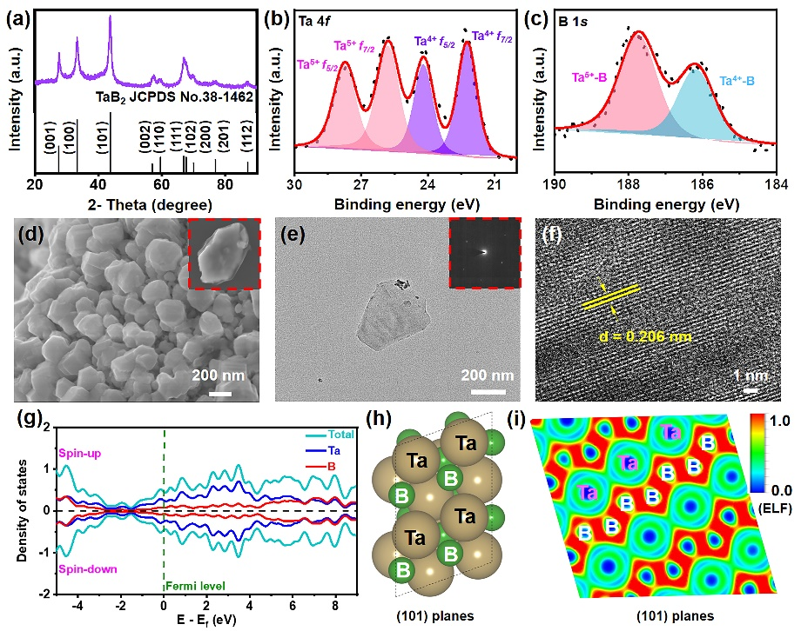
Fig. 1. XRD pattern (a) of TaB₂. XPS spectra of Ta 4p (b) and B 1s (c) of TaB₂. SEM image (d) with an inset of high magnification of TaB₂. HRTEM image (e) with an inset of SAED pattern, and a high-magnification HRTEM image (f) of TaB₂. PDOS (g) of TaB₂, and crystal structure (h) and ELF (i) for TaB₂ (101) planes.

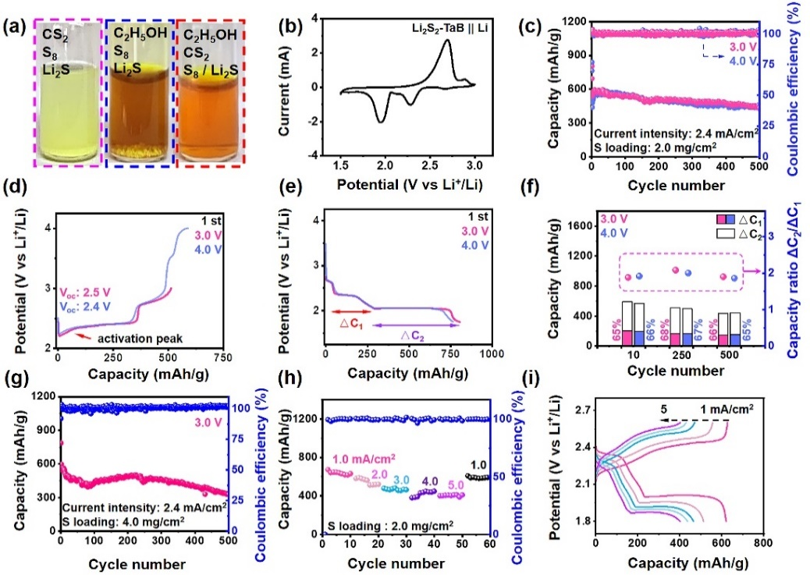
Fig. 2. Optical images (a) of the various solvents. First-cycle CV curves (b) of liquid Li₂S₂-based TaB₂ cells. The cycling performance (c), first charge profiles (d), first discharge profiles (e), and ratio image of ΔC₂/ΔC₁ (f) under different activated potential from 3.0 to 4.0 V in the liquid Li₂S₂-based cells. The cycling performance (g) with high sulfur loading. Rate performances (h) with the corresponding charge and discharge profiles (i).

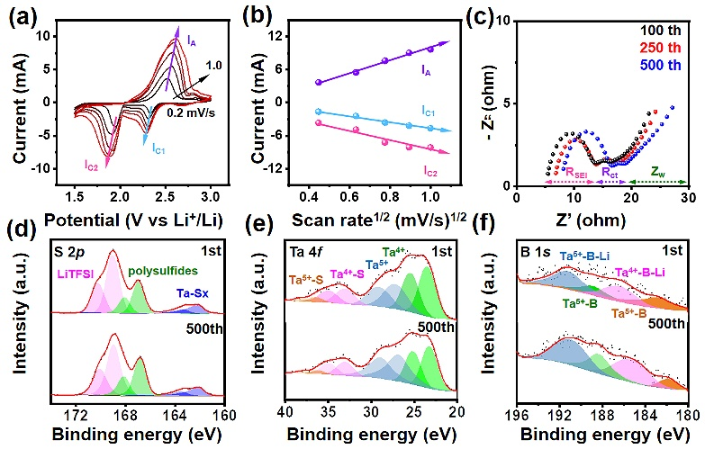
Fig. 3. Rated CV curves from 0.2 to 1.0 mV/s (a) with the corresponding cathodic and anodic peak currents from the square root of the scan rate showing a linear correlation (b). Nyquist plots of cell cycling at the 100th, 250th and 500th cycles (c). S 2p (d), Ta 4f (e), and B 1s (f) spectra of the XPS from Li₂S₂-based TaB₂ cells after 1st and 500th cycles. The measured curves are in black, and the fitted ones are in red.

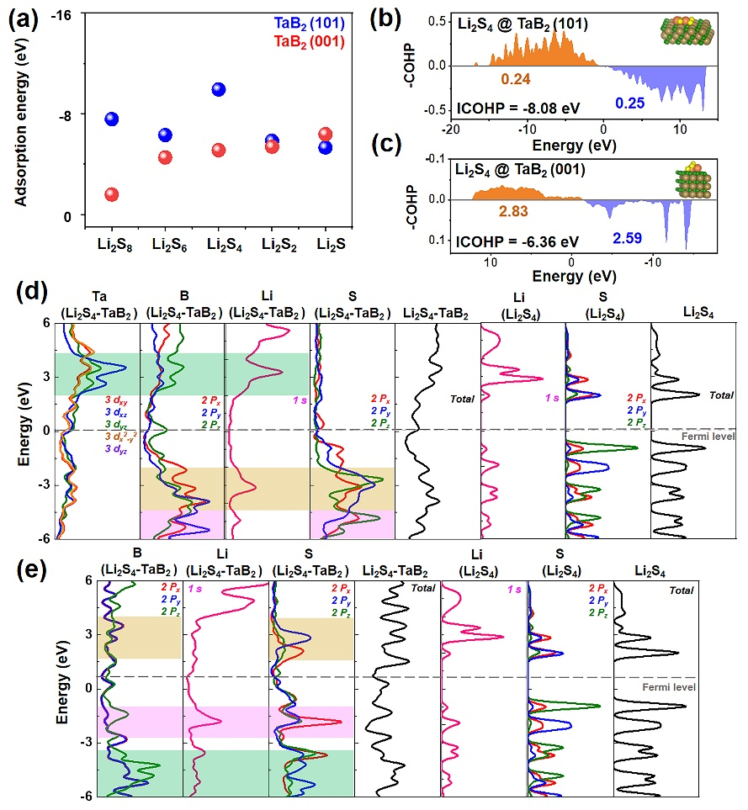
Fig. 4. Binding energy values (a) of Li₂S₈, Li₂S₆, Li₂S₄, Li₂S₂ and Li₂S adsorbed on the TaB₂ (101) and (001) surfaces. COHP curves (b-c) and PDOS (d-e) of Li₂S₄ adsorbed on the TaB₂ (101) and (001) surfaces, respectively.

