Supporting Information

Zeolitic imidazolate framework-derived Co-Fe@NC for rechargeable hybrid sodium–air battery with a low voltage gap and long cycle life
Haixing Gaoª, Siqi Zhuª, Yao Kangª, Duc Anh Dinh^{b}, Kwan San Hui^{c,*}, Feng Bin^{d}, Xi Fan^{e}, Fuming Chen^{f}, Azhar Mahmood^{g}, Jianxin Geng^{i}, Weng-Chon (Max) Cheong^{h,*}, Kwun Nam Hui^{a,*}

ªJoint Key Laboratory of the Ministry of Education, Institute of Applied Physics and Materials Engineering, University of Macau, Avenida da Universidade, Taipa, Macau SAR, 999078, China
^{b}NTT hi-tech Insitute, Nguyen Tat Thanh University, Ho Chi Minh city 700000, Vietnam
^{c}School of Engineering, University of East Anglia, Norwich, NR4 7TJ, United Kingdom
^{d}State Key Laboratory of High-Temperature Gas Dynamics, Institute of Mechanics, Chinese Academy of Science, Beijing 100190, PR China
^{e}Ningbo Institute of Materials Technology, Engineering, Chinese Academy of Sciences, Ningbo, 315201, China
^{f}State Key Laboratory of Optic Information Physics and Technologies, School of Physics and Telecommunication Engineering, South China Normal University, Guangzhou, China 510006, China
^{g}Center for Advanced Analytical Science, School of Chemistry and Chemical Engineering, Guangzhou University, Guangzhou 510006, P. R. China
^{h}Department of Physics and Chemistry, Faculty of Science and Technology, University of Macau, Macao SAR, 999078, P. R. China

^{i}Beijing University of Chemical Technology, College of Energy, 15 North Third Ring East Road, Chaoyang District, Beijing, CN 100029

* Corresponding author
Kwun Sam Hui, E-mail: k.hui@uea.ac.uk
Weng-Chon (Max), E-mail: maxcheong@um.edu.mo
Kwun Nam Hui, E-mail: bizhui@um.edu.mo

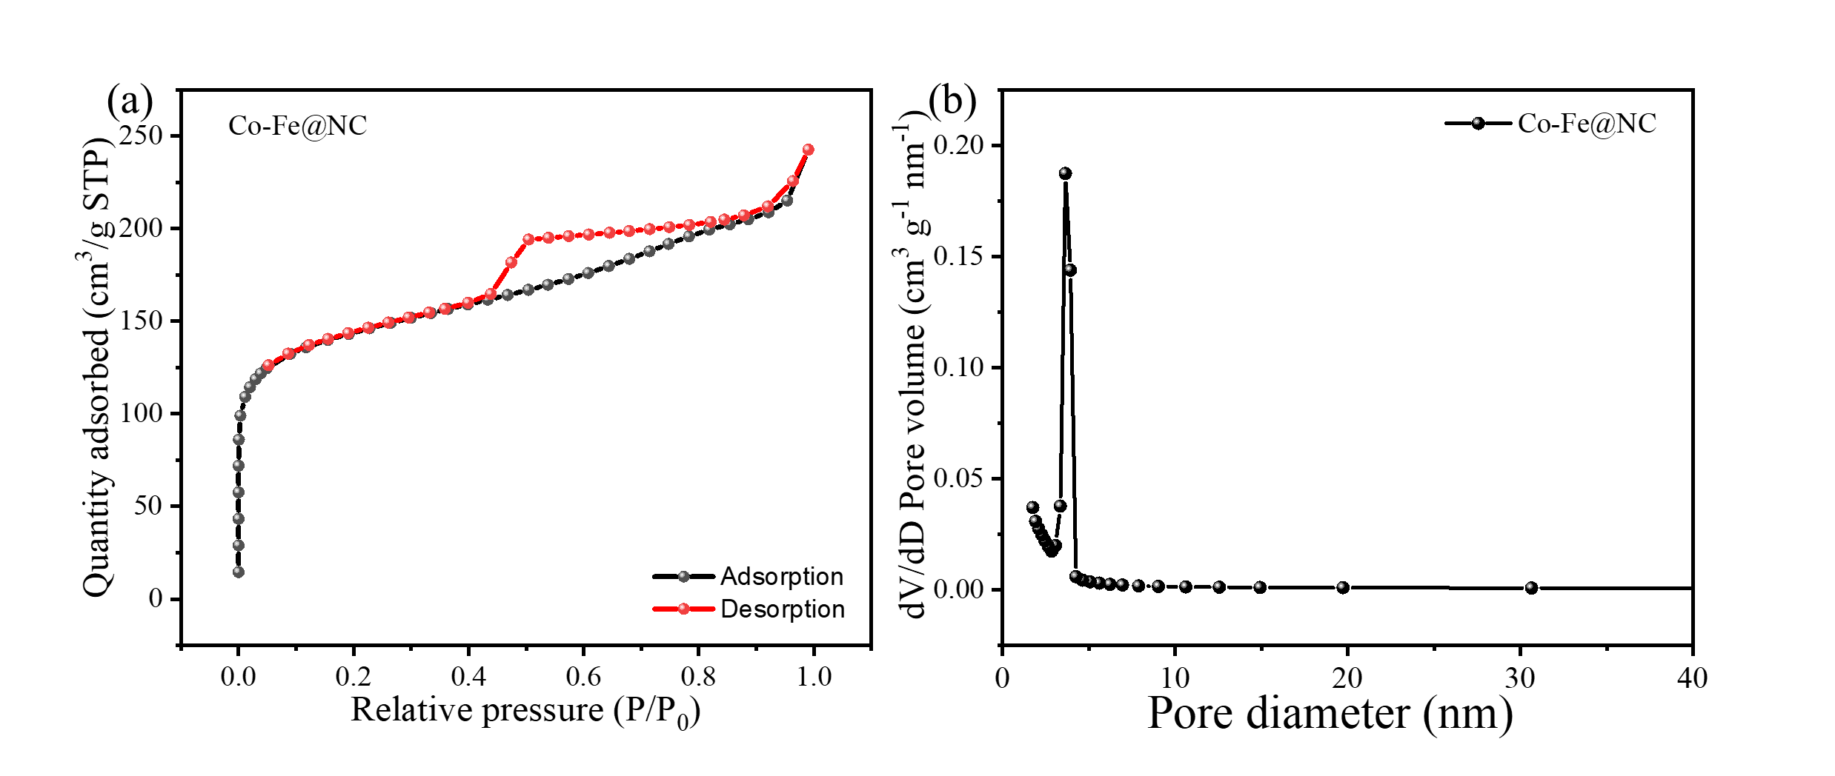
Fig. S1 Nitrogen adsorption and desorption isotherm curves and pore size distribution curve of Co-Fe@NC.
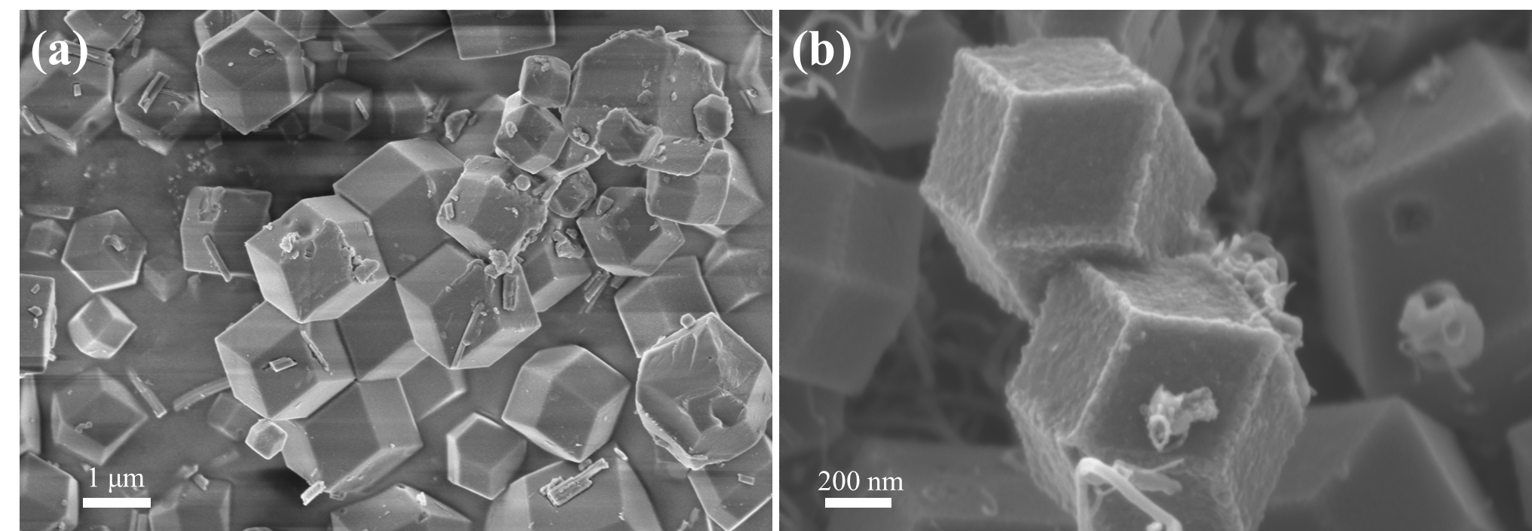
Fig. S2 SEM images of (a) FeCoZn-ZIFs and (b) Co-Fe@NC.
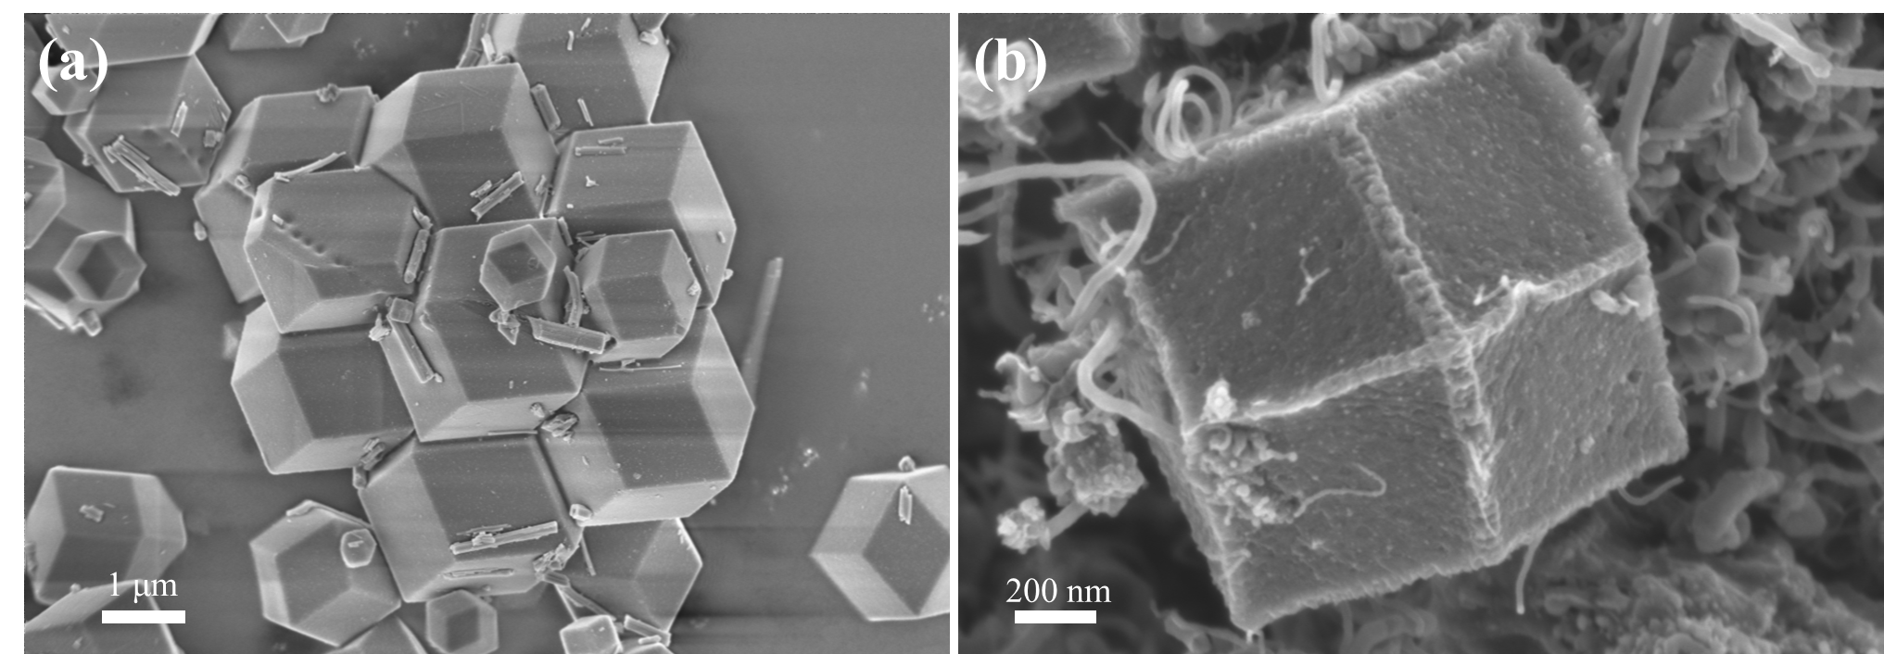
Fig. S3 SEM images of (a) FeZn-ZIFs and (b) Fe@NC.
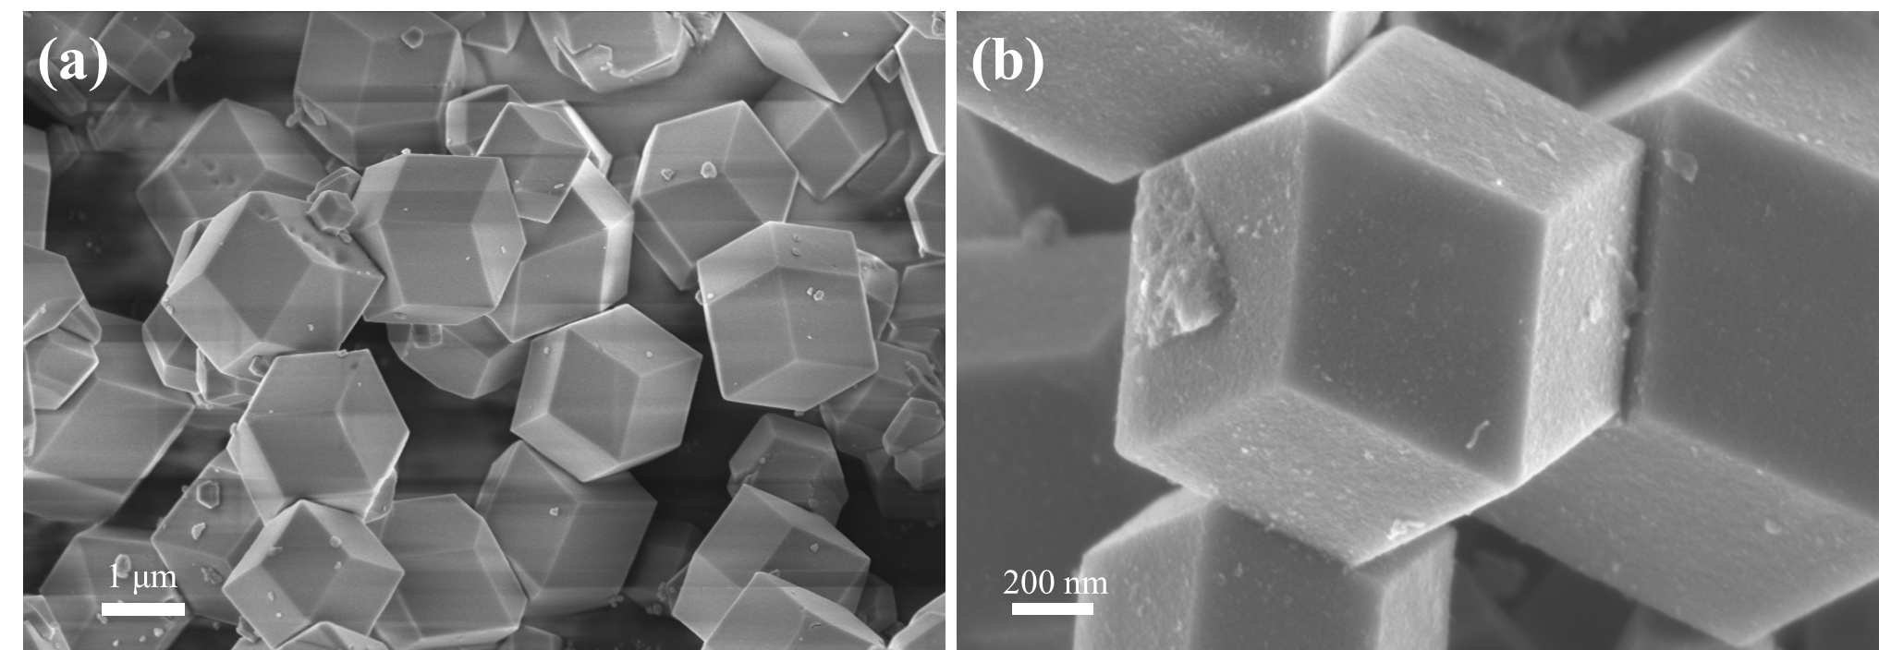
Fig. S4 SEM images of (a) CoZn-ZIFs and (b) Co@NC.
Fig. S5 TEM of Co-NC.
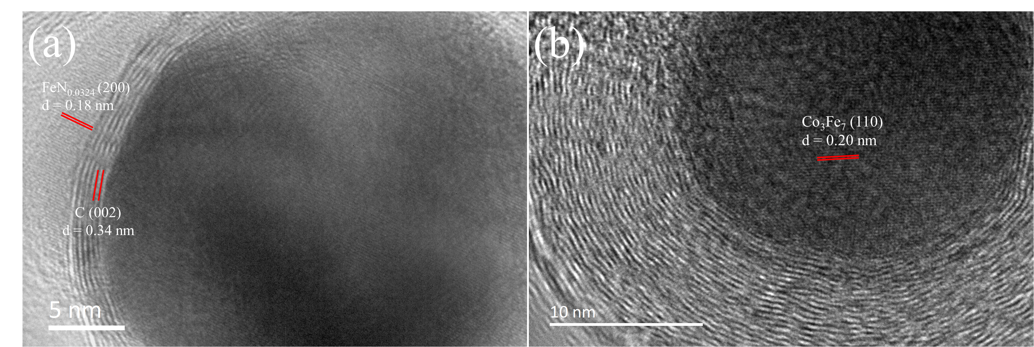
Fig. S6 (a,b) HRTEM of Co-Fe@NC.
Fig. S7 Potential dependence of calculated kinetic current density (J_{k}).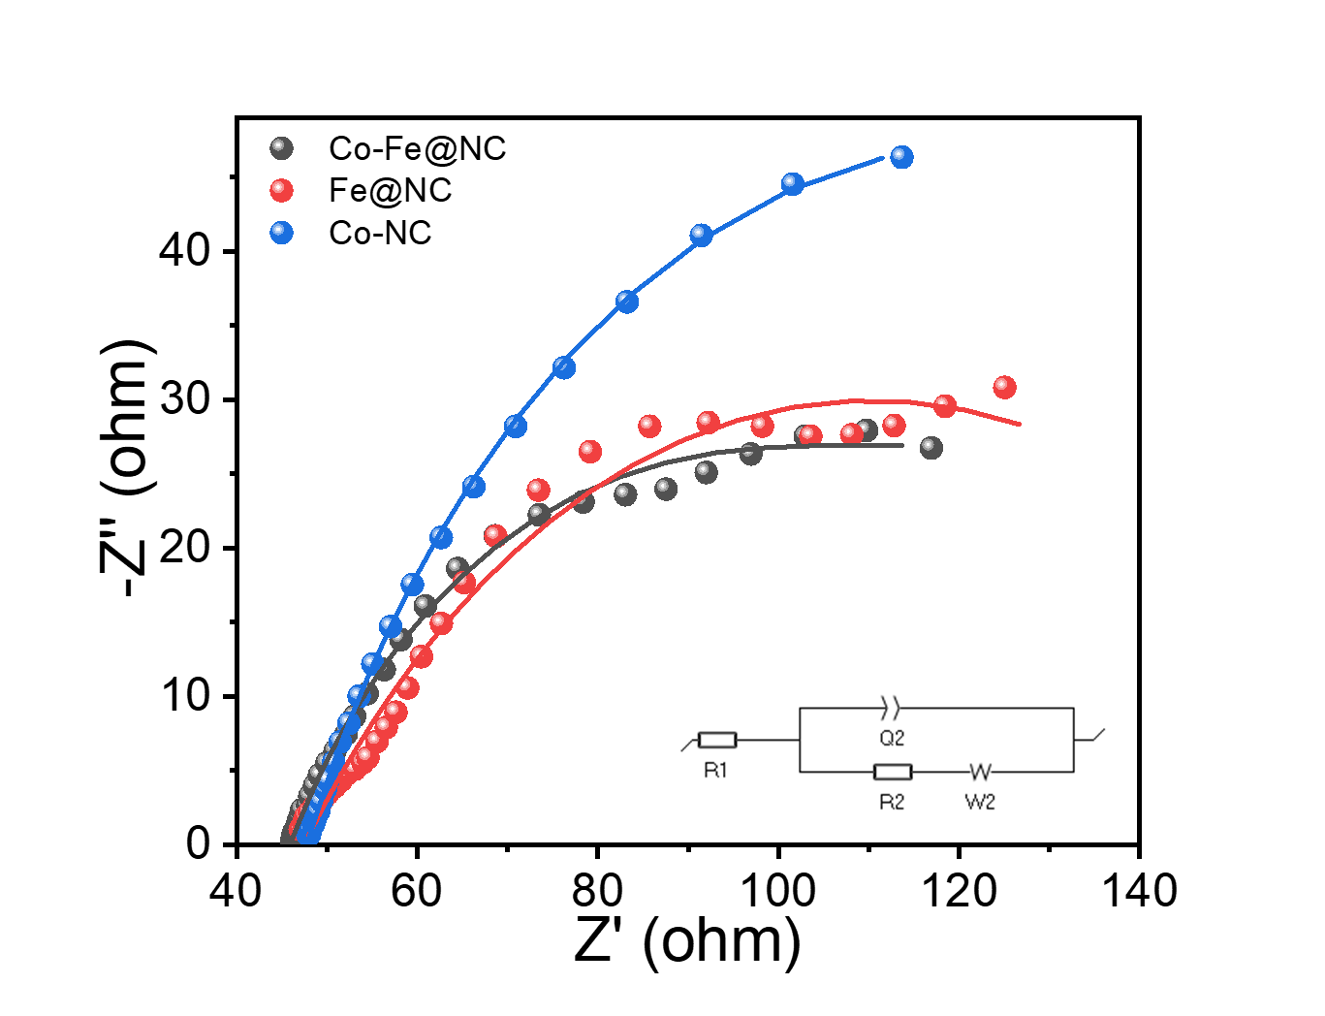
Fig. S8 The Nyquist plots of Co-NC, Fe@NC, and Co-Fe@NC. Symbols represent experimental EIS data, and the line represents the fit to the equivalent circuit given in the inset. Where, R1 denotes solution series resistance, Q2 represents constant phase element, R2 means charge transfer resistance, and W2 refers to Warburg diffusion element.
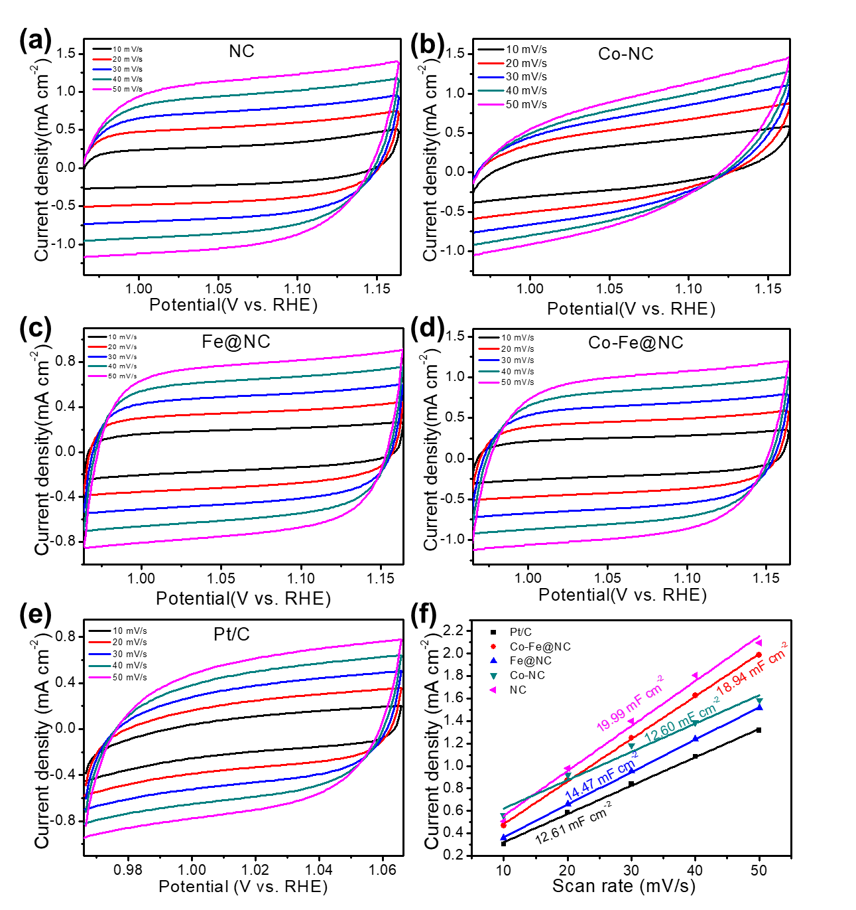
Fig. S9 The CV curves(a-e) of all electrocatalysts at different scan rates in the nonFaradaic potential range; (f) the C_{dl} of all electrocatalysts.

Fig. S10 LSV curve of Co-Fe@NC at a rotating speed of 1600 rpm in the RRDE test.

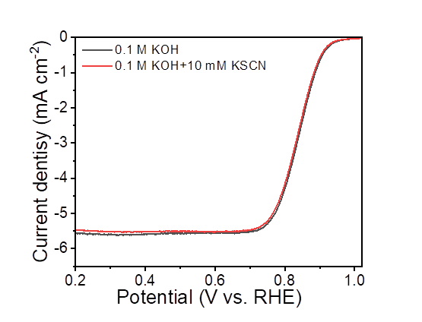
Fig. S11 ORR polarization plots of Co-Fe@NC with and without 10 mM KSCN in 0.1 M KOH.
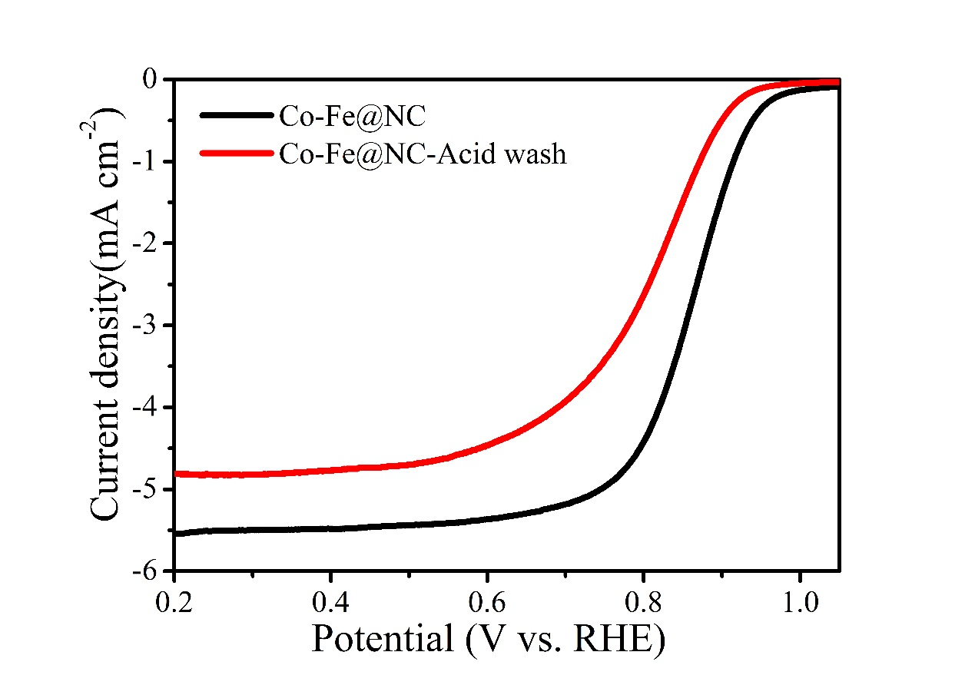
Fig. S12 LSV curves tested at 1600 rpm with a scanning sweep of 2 mV/s of Co-Fe@NC, before and after acid wash.

Fig. S13 The i–t curve at 0.80 V vs. RHE of Co-Fe@NC and 20% Pt/C in O₂-saturated 0.1 M KOH at a rotating speed of 1600 rpm.
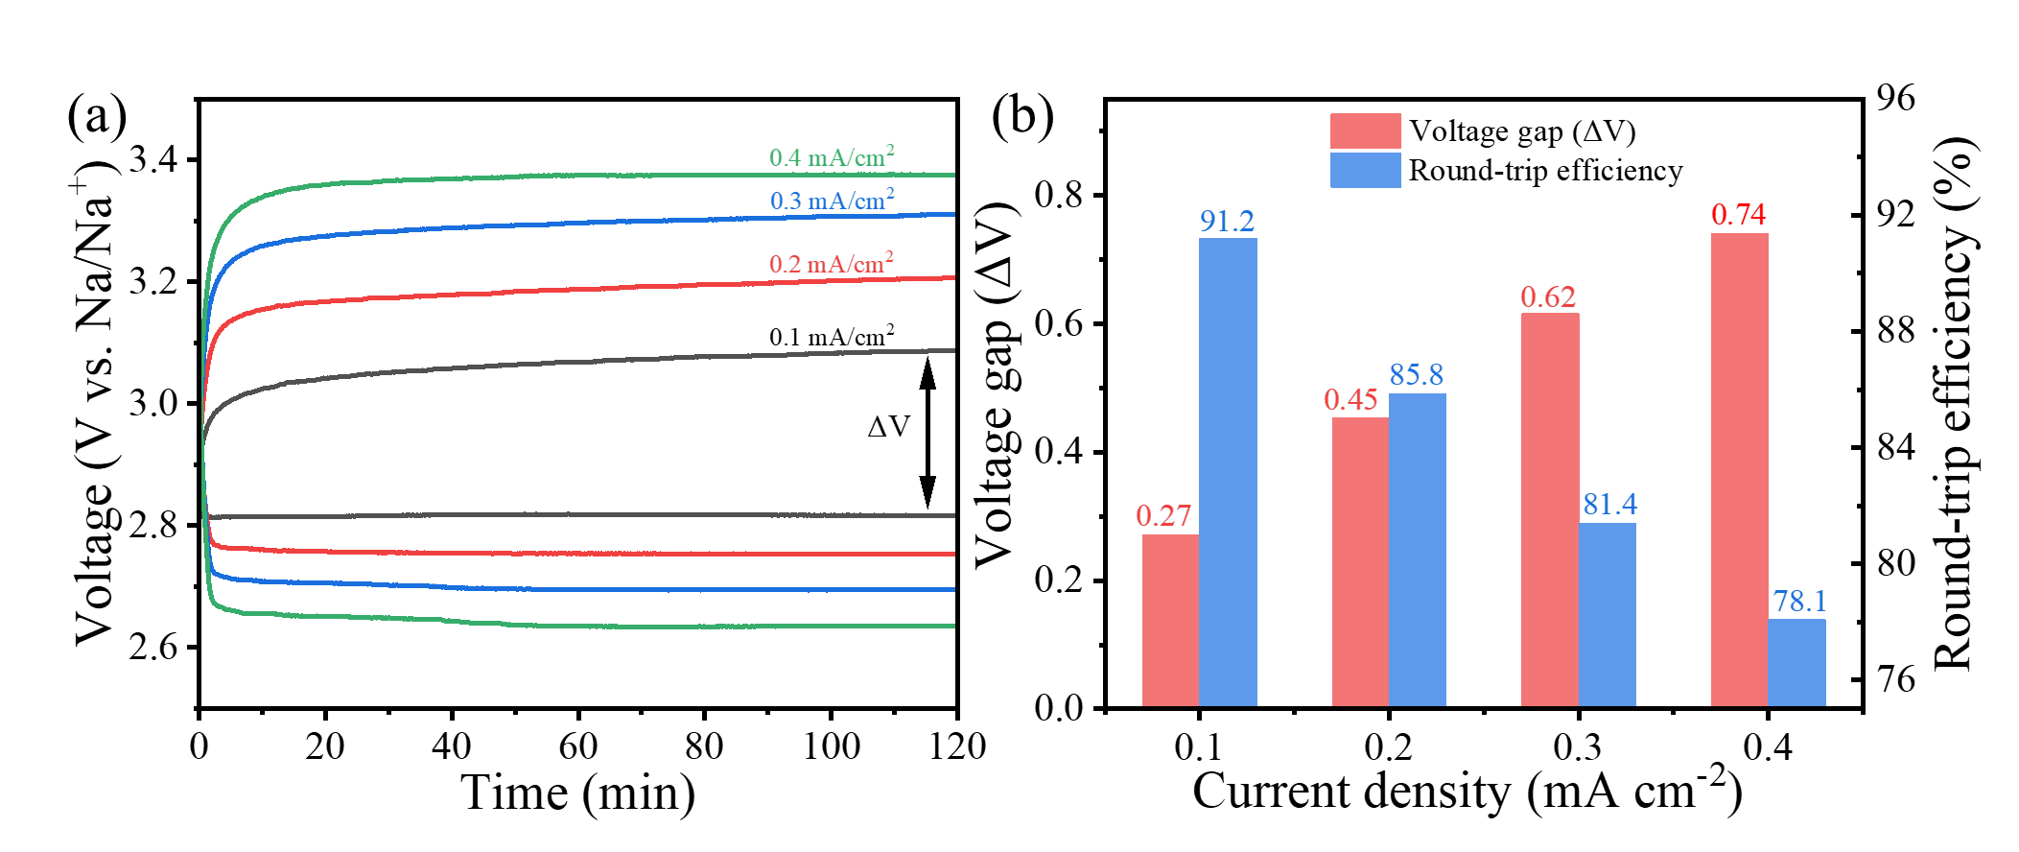
Fig. S14 (a) Discharge and charge curves of hybrid Na–air batteries with Co-Fe@NC as cathode catalyst at different current densities; (b) Comparison of the voltage gap and round-trip efficiency of the Co-Fe@NC at different current densities.

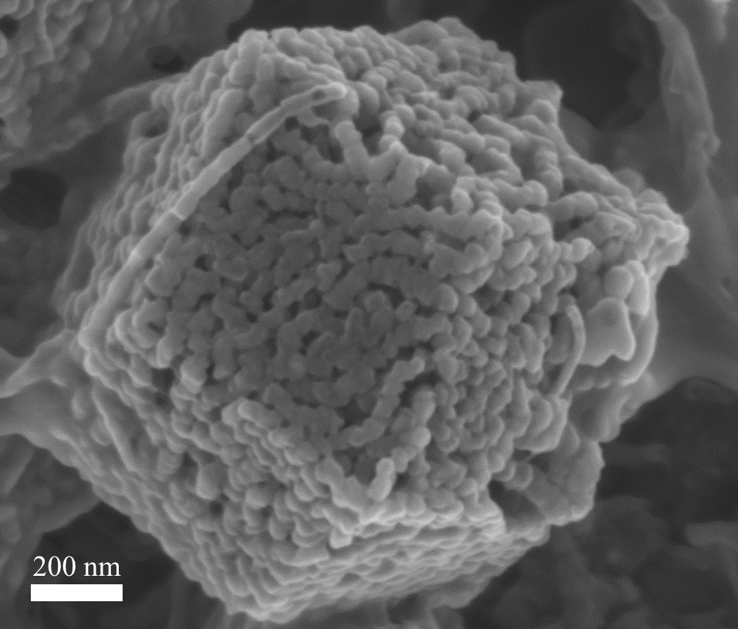
Fig. S15 SEM images of Co-Fe@NC after long-term cycling test of HSAB.
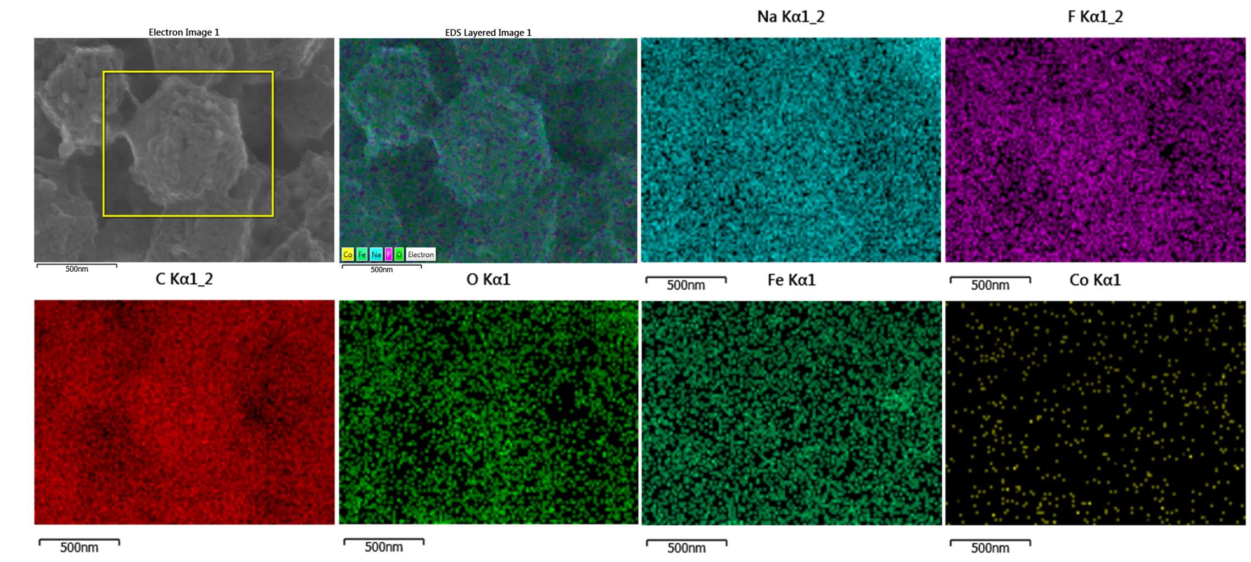
Fig. S16 Mapping images of Co-Fe@NC after long-term cycling test of HSAB. Among them, Na comes from sodium hydroxide solution and fluorine comes from Nafion.

Table S1 Summary of the specific surface area, pore volume, and pore diameter of Co-Fe@NC.
Sample | BET surface area (m²/g) |  | Total pore volume  (cm³/g) | Average pore diameter  (nm)
Co-Fe@NC |  | 451.16 | 0.38 | 3.33

Table S2 Metal content of as-prepared materials measured by ICP-OES.
Sample | Fe / mg/L | Co / mg/L
Co-Fe@NC | 17.07 | 1.08
Fe@NC | 20.92 | --
Co-NC | -- | 2.38

Table S3 Comparison of simulated EIS parameters for Co-Fe@NC, Fe@NC, and Co-NC: solution series resistance (R_{s}) and charge transfer resistance (R_{ct}).
Electrocatalyst | R_{s} | R_{ct}
Co-Fe@NC | 45.9 | 84.8
Fe@NC | 47.5 | 122.9
Co-NC | 47.5 | 152.2

Table S4 Summary of various recently reported ORR electrocatalysts.

Catalysts | Onset potential (V vs. RHE) | Half-wave potential (V vs. RHE) | Ref.
Co-Fe@NC | 1.02 | 0.86 | This work
Fe@Fe_{SA}-N-C-900 |  | 0.83 | J. Energy Chem. 61 (2021) 612–621
Fe-2-WNPC-NCNT | 0.95 | 0.83 | ACS Appl. Mater. Interfaces 2021, 13, 21, 24710–24722
Fe/OES | 1.0 | 0.85 | Angew. Chem. Int. Ed. 2020, 59, 7384 –7389
Fe₃C@3DNC-1-900 |  | 0.861 | Int. J. Hydrogen Energ. 45 (2020) 13272-13281
CNCo-5@Fe-2 | 0.971 | 0.861 | Appl. Catal. B-Environ. 261 (2020) 118224
CAN-Pc(Fe/Co) | 1.04 | 0.84 | Angew. Chem. Int. Ed. 2019, 58,14724 –14730
D-BNGFe-2-900 | 0.95 | 0.82 | ACS Sustain. Chem. Eng. 2019, 7, 19104−19112
Fe₃C@Fe,N,S-GCM | 0.98 | 0.779 | Carbon 150 (2019) 93-100
Fe/N-HCNFs |  | 0.83 | ChemistrySelect 2019, 4, 722–728
Fe@C–NG/NCNTs | 0.93 | 0.84 | J. Mater. Chem. A, 2018, 6,516–526
Co/NCNT/NG | 0.96 | 0.85 | J. Mater. Chem. A, 2018, 6, 3926
Table S5. Discharge/charge voltage, overpotential gap, round trip efficiency, power density, and cycles of hybrid sodium-air battery made by different air electrodes catalyst.
Cathodic catalyst | Discharge/charge voltage@current density | Voltage gap | Round trip efficiency (%) | Cycles/Current density  (mA cm⁻²) | Power density  (mW cm⁻²) |  | Catholyte | Ref.
Co-Fe@NC | 2.82/3.09 | 0.27 | 91.2 | 175/0.1  (700 h) |  | 5.39 mW cm⁻²  (2695 mW/g) | 1 M NaOH | This work
Pt/C+RuO₂ | 2.79/3.34 | 0.55 | 83.5 | 100/0.1  (400 h) |  | 4.79 mW cm⁻²  (2395.0 mW/g) | 1 M NaOH | This work
Co-N-C | 2.8/3.11@0.1 | 0.31 | 85.8 | 20/0.1 |  | N.A. | 1 M NaOH | ¹
Pt3Ni1/Ni_{x}Fe LDHs | 2.91/3.41@0.01 | 0.5 | 85.4 | 350/0.01  (near to 117 h) |  | N.A. | O₂-saturated 0.1 M NaOH | ²
MA-Fe-N/CNT | 2.95@0.05 | N.A. | N.A. | over 250 h |  | 4.63 | 0.1 M NaOH | ³
D-Co-PBA | 2.75/2.9@0.01 | 0.15 | 94.83 | 1000/0.01 |  | N.A. | O₂-saturated 0.1 M NaOH | ⁴
Pt/V-Co(OH)₂-O_{v} |  | 0.07 | 93.2 | 1000/0.01 |  | 407 mW g⁻¹ | O₂-saturated 0.1 M NaOH | ⁵
MOF-NCNTs | 2.80/3.10@0.1 | 0.30 | 90.32 | 35/0.1 |  | N.A. | 1 M NaOH | ⁶
Na₂CoPO₄F | 2.94/3.34@0.01 | 0.40 | ~88 | 30 |  | N.A. | 0.1 M NaOH | ⁷
NixCo_{3−x}(PO₄)₂ | 2.76/3.54@0.01 | 0.78 | 78 | 50/0.01 |  | N.A. | 0.1 M NaOH | ⁸
Mn₂O₃ | @5mAg⁻¹ | 0.33 | 90 | 75/2.5mAg⁻¹ |  | 200 mW g⁻¹ | 0.1 M NaOH | ⁹
Bi₂Ru₂O₇ | @0.01 | 0.211 | 93.58 | 50/0.01 |  | 156.32 mWg⁻¹ | 0.1 M NaOH | ¹⁰
P-Tl₂Ru₂O₇ | 3.07/3.23@0.01 | 0.16 | 95 | 50/0.01 |  | 186.5 mW g-1 | 0.1 M NaOH | ¹¹
Tl₂Rh₂O₇ | @0.01 | 0.208 | 93.65 | 50/0.01 |  | 159.9 mW g⁻¹ | 0.1 M NaOH | ¹²
P-Bi₂Rh₂O_{6.8} | @0.01 | 0.17 | 94.9 | 50/0.01 |  | 181.2 mW g⁻¹ | 0.1 M NaOH | ¹³
Carambola-shaped VO₂ | 2.81/3.45@0.01 | 0.64 | 81 | 50 |  | 104 mW g⁻¹  (260 μW cm⁻²) | 0.1 M NaOH | ¹⁴
SnS₂ | @5 mA g⁻¹ | 0.52 | 83 | 40/5 mAg⁻¹  (400 h) |  | 300 mW g⁻¹ | 0.1 M NaOH | ¹⁵
Co₃(PO₄)₂ | 2.82/3.41@0.05 | 0.59 | ~83 | 50 |  | N.A. | 0.1 M NaOH | ¹⁶
α-MnO₂ |  | 0.7 | 81 | 20/15 mA g⁻¹ |  | N.A. | 0.1 M NaOH | ¹⁷

Reference
1. Zhu, J.; Qu, T.; Su, F.; Wu, Y.; Kang, Y.; Chen, K.; Yao, Y.; Ma, W.; Yang, B.; Dai, Y.; Liang, F.; Xue, D., Highly dispersed Co nanoparticles decorated on a N-doped defective carbon nano-framework for a hybrid Na-air battery. Dalton Trans. 2020, 49 (6), 1811-1821.
2. Yu, X.; Kang, Y.; Wang, S.; Hui, K. S.; Hui, K. N.; Zhao, H.; Li, J.; Li, B.; Xu, J.; Chen, L.; Shao, H., Integrating PtNi nanoparticles on NiFe layered double hydroxide nanosheets as a bifunctional catalyst for hybrid sodium–air batteries. J. Mater. Chem. A 2020, 8 (32), 16355-16365.
3. Noh, W. Y.; Kim, E. M.; Kim, K. Y.; Kim, J. H.; Jeong, H. Y.; Sharma, P.; Lee, G.; Jang, J.-W.; Joo, S. H.; Lee, J. S., Immobilizing single atom catalytic sites onto highly reduced carbon hosts: Fe–N₄/CNT as a durable oxygen reduction catalyst for Na–air batteries. J. Mater. Chem. A 2020, 8 (36), 18891-18902.
4. Kang, Y.; Wang, S.; San Hui, K.; Li, H.-F.; Liang, F.; Wu, X.-L.; Zhang, Q.; Zhou, W.; Chen, L.; Chen, F.; Hui, K. N., [Fe(CN)₆] Vacancy-boosting Oxygen Evolution Activity of Co-based Prussian Blue Analogues for Hybrid Sodium-air Battery. Mater. Today Energy 2020, 100572.
5. Kang, Y.; Wang, S.; Liu, Y.; Hui, K. S.; Li, H.; Ng, K. W.; Liang, F.; Geng, J.; Hong, X.; Zhou, W.; Hui, K. N., Unveiling the Origin of Catalytic Sites of Pt Nanoparticles Decorated on Oxygen-Deficient Vanadium-Doped Cobalt Hydroxide Nanosheet for Hybrid Sodium–Air Batteries. ACS Appl. Energ. Mater. 2020, 3 (8), 7464-7473.
6. Wu, Y. Q.; Qiu, X. C.; Liang, F.; Zhang, Q. K.; Koo, A.; Dai, Y. N.; Lei, Y.; Sun, X. L., A metal-organic framework-derived bifunctional catalyst for hybrid sodium-air batteries. Appl. Catal. B-Environ. 2019, 241, 407-414.
7. Sharma, L.; Gond, R.; Senthilkumar, B.; Roy, A.; Barpanda, P., Fluorophosphates as Efficient Bifunctional Electrocatalysts for Metal–Air Batteries. ACS Catal. 2019, 43-50.
8. Senthilkumar, B.; Irshad, A.; Barpanda, P., Cobalt and Nickel Phosphates as Multifunctional Air-Cathodes for Rechargeable Hybrid Sodium-Air Battery Applications. ACS Appl. Mater. Interfaces 2019, 11 (37), 33811-33818.
9. Parveen, N.; Khan, Z.; Ansari, S. A.; Park, S.; Senthilkumar, S. T.; Kim, Y.; Ko, H.; Cho, M. H., Feasibility of using hollow double walled Mn₂O₃ nanocubes for hybrid Na-air battery. Chem. Eng. J. 2019, 360, 415-422.
10. Kim, M.; Ju, H.; Kim, J., Single crystalline Bi₂Ru₂O₇ pyrochlore oxide nanoparticles as efficient bifunctional oxygen electrocatalyst for hybrid Na-air batteries. Chem. Eng. J. 2019, 358, 11-19.
11. Kim, M.; Ju, H.; Kim, J., Dihydrogen phosphate ion functionalized nanocrystalline thallium ruthenium oxide pyrochlore as a bifunctional electrocatalyst for aqueous Na-air batteries. Appl. Catal. B-Environ. 2019, 245, 29-39.
12. Kim, M.; Ju, H.; Kim, J., Single crystalline thallium rhodium oxide pyrochlore for highly improved round trip efficiency of hybrid Na–air batteries. Dalton Trans. 2018, 47 (42), 15217-15225.
13. Kim, M.; Ju, H.; Kim, J., Highly efficient bifunctional catalytic activity of bismuth rhodium oxide pyrochlore through tuning the covalent character for rechargeable aqueous Na–air batteries. J. Mater. Chem. A 2018, 6 (18), 8523-8530.
14. Khan, Z.; Senthilkumar, B.; Park, S. O.; Park, S.; Yang, J.; Lee, J. H.; Song, H.-K.; Kim, Y.; Kwak, S. K.; Ko, H., Carambola-shaped VO₂ nanostructures: a binder-free air electrode for an aqueous Na–air battery. J. Mater. Chem. A 2017, 5 (5), 2037-2044.
15. Khan, Z.; Parveen, N.; Ansari, S. A.; Senthilkumar, S. T.; Park, S.; Kim, Y.; Cho, M. H.; Ko, H., Three-dimensional SnS₂ nanopetals for hybrid sodium-air batteries. Electrochim. Acta 2017, 257, 328-334.
16. Senthilkumar, B.; Khan, Z.; Park, S.; Seo, I.; Ko, H.; Kim, Y., Exploration of cobalt phosphate as a potential catalyst for rechargeable aqueous sodium-air battery. J. Power Sources 2016, 311, 29-34.
17. Khan, Z.; Park, S.; Hwang, S. M.; Yang, J.; Lee, Y.; Song, H.-K.; Kim, Y.; Ko, H., Hierarchical urchin-shaped α-MnO₂ on graphene-coated carbon microfibers: a binder-free electrode for rechargeable aqueous Na–air battery. NPG Asia Mater. 2016, 8 (7), e294-e294.

