RESEARCH ARTICLE

www.small-journal.com

Interface Coordination Stabilizing Reversible Redox of Zinc for High-Performance Zinc-Iodine Batteries
Song Chen, Qianwu Chen, Jizhen Ma, Jianjun Wang, Kwan San Hui, and Jintao Zhang*

Introduction
The redox chemistry of metals at the liquid–solid interface is crucial interest for the reversible energy storage in rechargeable batteries using active metals, such as lithium (Li), sodium (Na),

S. Chen, Q. Chen, J. Ma, J. Zhang
Key Laboratory for Colloid and Interface Chemistry Ministry of Education
School of Chemistry and Chemical Engineering Shandong University
Jinan 250100, China
E-mail: jtzhang@sdu.edu.cn
J. Wang
State Key Laboratory of Crystal Materials Shandong University
Jinan 250100, China
K. S. Hui
School of Engineering Faculty of Science University of East Anglia Norwich NR4 7TJ, UK

The ORCID identification number(s) for the author(s) of this article can be found under https://doi.org/10.1002/smll.202200168.

and potassium (K).[1] Alternatively, zinc with large theoretical capacity (gravimetric capacity −820 mAh g−1 and volumetric capacity −5855 mAh cm−3), appropriate low potential (−0.762 V versus standard hydrogen electrode) and good stability than alkaline metals, is particularly attrac- tive in the scientific and technological areas.[2] For example, the alkaline zinc- manganese dioxide batteries have been commercially used as the specific primary battery.[3] Notably, the mercury was origi- nally added to provide the corrosion pro- tection. Currently, the formation of zinc alloy and the addition of corrosion inhibi- tors are adopted to inhibit the corrosion from hydrogen evolution reaction.[4] To achieve the reversible conversion between electrical energy and chemical energy, zinc is also coupled with numbers of cathode materials including manganese oxides, vanadium oxides, and organic compounds to fabricate rechargeable batteries.[5] The additional rechargeability with long opera- tion requires for the robust zinc anode. Especially, the smooth plating/striping of
Zn is of importance in addressing the nonuniform electrodepo- sition that would result in the active material loss and safety issues.[6]
Aqueous Zn batteries (AZBs) have attracted extensive attention due to good safety, cost-effectiveness, and environmental benignity. However, the sluggish kinetics of divalent zinc ion and the growth of Zn dendrites severely dete- riorate the cycling stability and specific capacity. The authors demonstrate modulation of the interfacial redox process of zinc via the dynamic coordina- tion chemistry of phytic acid with zinc ions. The experimental results and theoretical calculation reveal that the in-situ formation of such inorganic– organic films as a dynamic solid-electrolyte interlayer is efficient to buffer the zinc ion transfer via the energy favorable coordinated hopping mechanism
for the reversible zinc redox reactions. Especially, along the interfacial coating layer with porous channel structure is able to regulate the solvation struc- ture of zinc ions along the dynamic coordination of the phytic acid skeleton, efficiently inhibiting the surface corrosion of zinc and dendrite growth.
Therefore, the resultant Zn anode achieves low voltage hysteresis and long cycle life at rigorous charge and discharge circulation for fabricating highly robust rechargeable batteries. Such an advanced strategy for modulating ion transport demonstrates a highly promising approach to addressing the basic challenges for zinc-based rechargeable batteries, which can potentially be extended to other aqueous batteries.
Typically, the reduction of Zn2+ ions near the surface tends to deposit on the identical crystal Zn surface.[7] In addition to the polarization caused by ion diffusion, the uneven distribu- tion of ion flux and electric field would also lead to the forma- tion of Zn dendrites.[8] Additionally, along with the hydrogen evolution reaction, the passivation of highly active zinc would result in the formation of inert zinc (hydro) oxides (e.g., Zn₄SO₄(OH)₆·xH₂O), which would accelerate the electro- chemical polarization.[9] The highly conductive substrates with porous structure (e.g., graphite fiber, CNT framework, Cu mesh) have been applied to lower the surface charge den- sity for the uniform deposition of zinc.[10] Especially, graphene with a low lattice mismatch with Zn have guided the orienta- tion deposition of zinc plates via the homoepitaxial growth.[11] Except for the negative effect of textured interphases, the addi- tional requirements for substrates needs the critical choice of chemical systems that are sensitively matched with zinc.[12] It has been demonstrated that the solid-electrolyte interphase (SEI) commonly formed in non-aqueous electrolytes is respon- sible for the ion migration, but electron insulation, thus dic- tating the uniform distribution of metal ions for dendrite-free

deposition. However, it is highly challenging to regulate the structure and composition of SEI that is spontaneously formed with the consumption of suitable electrolyte.[13] Alternatively, the nanoporous coating on zinc foil would physically modulate zinc ion flux ions for the homogeneous nucleation to create smooth zinc deposition.[14] To circumvent the obstacles of lim- iting current density, the recent creative construction of tunable microporous membranes is crucial to optimize ion transport process on the basis of the tunable structure and chemistry.[15] Nevertheless, the interface-regulated ion transport in electro- chemical redox reactions is rare, yet analogous to be observed for selective ion exchange along the biological buffer layer (e.g., cell membrane).
We developed a facile one-step layer coating strategy via the in-situ coordination of phytic acid with zinc ions that ena- bles the formation of artificial solid-electrolyte interlayer (SEI) to regulate zinc ions migration along the established tunnels (Scheme 1a). Phytic acid (PA), a natural organic molecule with six phosphate groups, is able to coordinate with Zn2+ ions to construct a 3D molecular network for realizing the rapid transfer of Zn2+ ions. Different from the conventional trans- port mechanism of metal ions in aqueous solution combined with solvation and ion atmosphere, the dynamic coordination process endows the electromigration of local ions through the coordinated hopping mechanism in which zinc ions dynami- cally coordinated with phosphate groups are rapidly transferred along the inner channels for the smooth striping and plating of zinc (Scheme 1b). Importantly, the energy barrier for zinc deposition can be reduced through the reasonable design of channel structures for suppressing the solvation structure of Zn2+ ions. The hydrogen evolution reaction can be effectively inhibited due to the decrease of activated water molecules at the interface. The strategy opens a new pathway to fabricate
the dynamic buffer layer for the reversible metal anode that has vast space for promising applications.

Results and Discussion
The metal dendrite growth generally stems from the inhomoge- neous ion diffusion and deposition which is highly dependent on the electrode/electrolyte interface structure and chemistry. As depicted in Scheme 1a, Zn2+ ions tend to deposit on the active sites due to the electrical and concentration gradients as well as the crystallographic orientation deposition, thus resulting in the dendrite growth and the potential safety issues. Especially, the corrosion of zinc surface is induced by the activated water stemming from the solvated zinc ions (Zn(H₂O) 2+)[7,16] which aggravates the formation of zinc (hydr)oxide (e.g., Zn(OH)₂, ZnO) and severe polarization, would thus disturb the even dis- tribution of ion flux. The solvation structure of Zn2+ ions on the pure Zn and coated Zn surface are checked by the Raman spectroscopy (Figure 1a). Typically, the Zn2+ ions complexes exist in two forms in solutions, namely Zn2+-(H₂O)₆·SO 2− (sol- vent separated ion pair, SSIP) and Zn2+(H₂O)₅·OSO 2− (contact ion pair, CIP) according to the association degree. Most of Zn2+ ions exist in the form of outer-sphere complexes, resulting in high water molecular activity. Increasing the concentration of ZnSO₄ can increase the number of inner-sphere complexes to a certain extent but is limited (Figure 1b). Notably, the coating layer with ion transfer channels can be easily formed via the coordination of phytic acid with metal ions (PA-M, M = Zn2+, Co2+, Ni2+), which provide a buffer layer for regulating the inter- face structure before the interphase coupling of electron and ion. In the presence of chelating agent, the formation of coor- dination compounds, PA-Co and PA-Ni would remove “free”
6
4
3

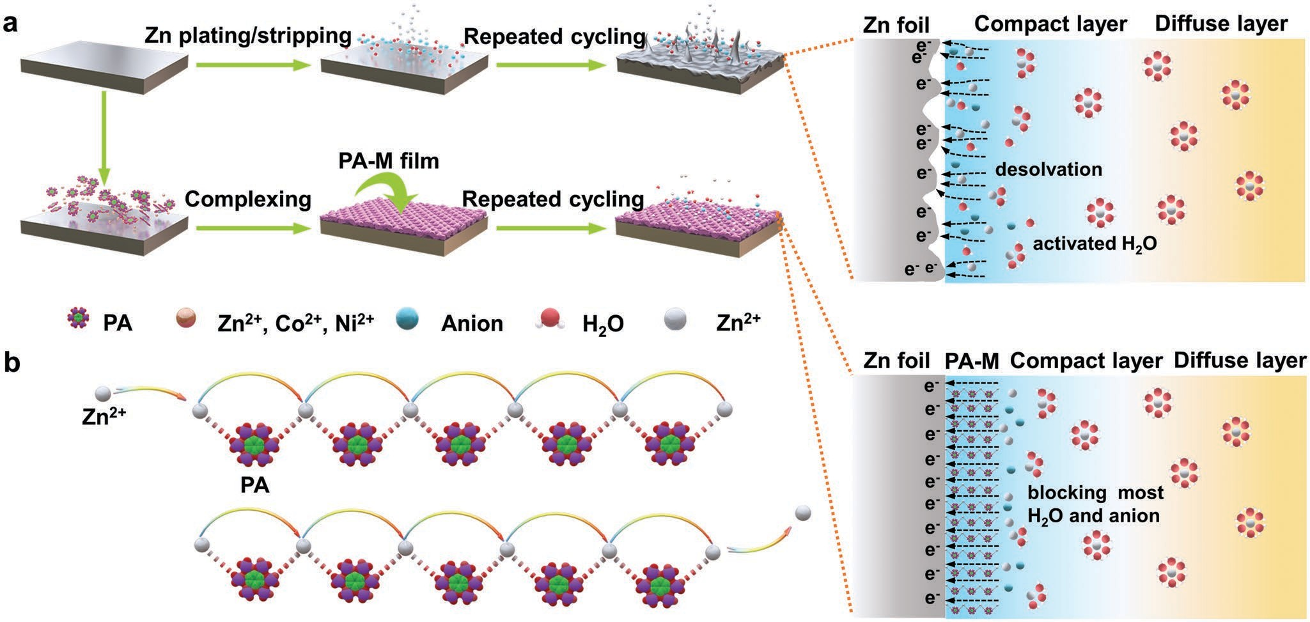
Scheme 1. The formation process of PA-M films and the proposed interface reactions. a) Scheme illustrations for interface reactions with and without PA-M films on the Zn surface. b) The proposed dynamic coordination process of Zn2+ ions via coordinated hopping mechanism.

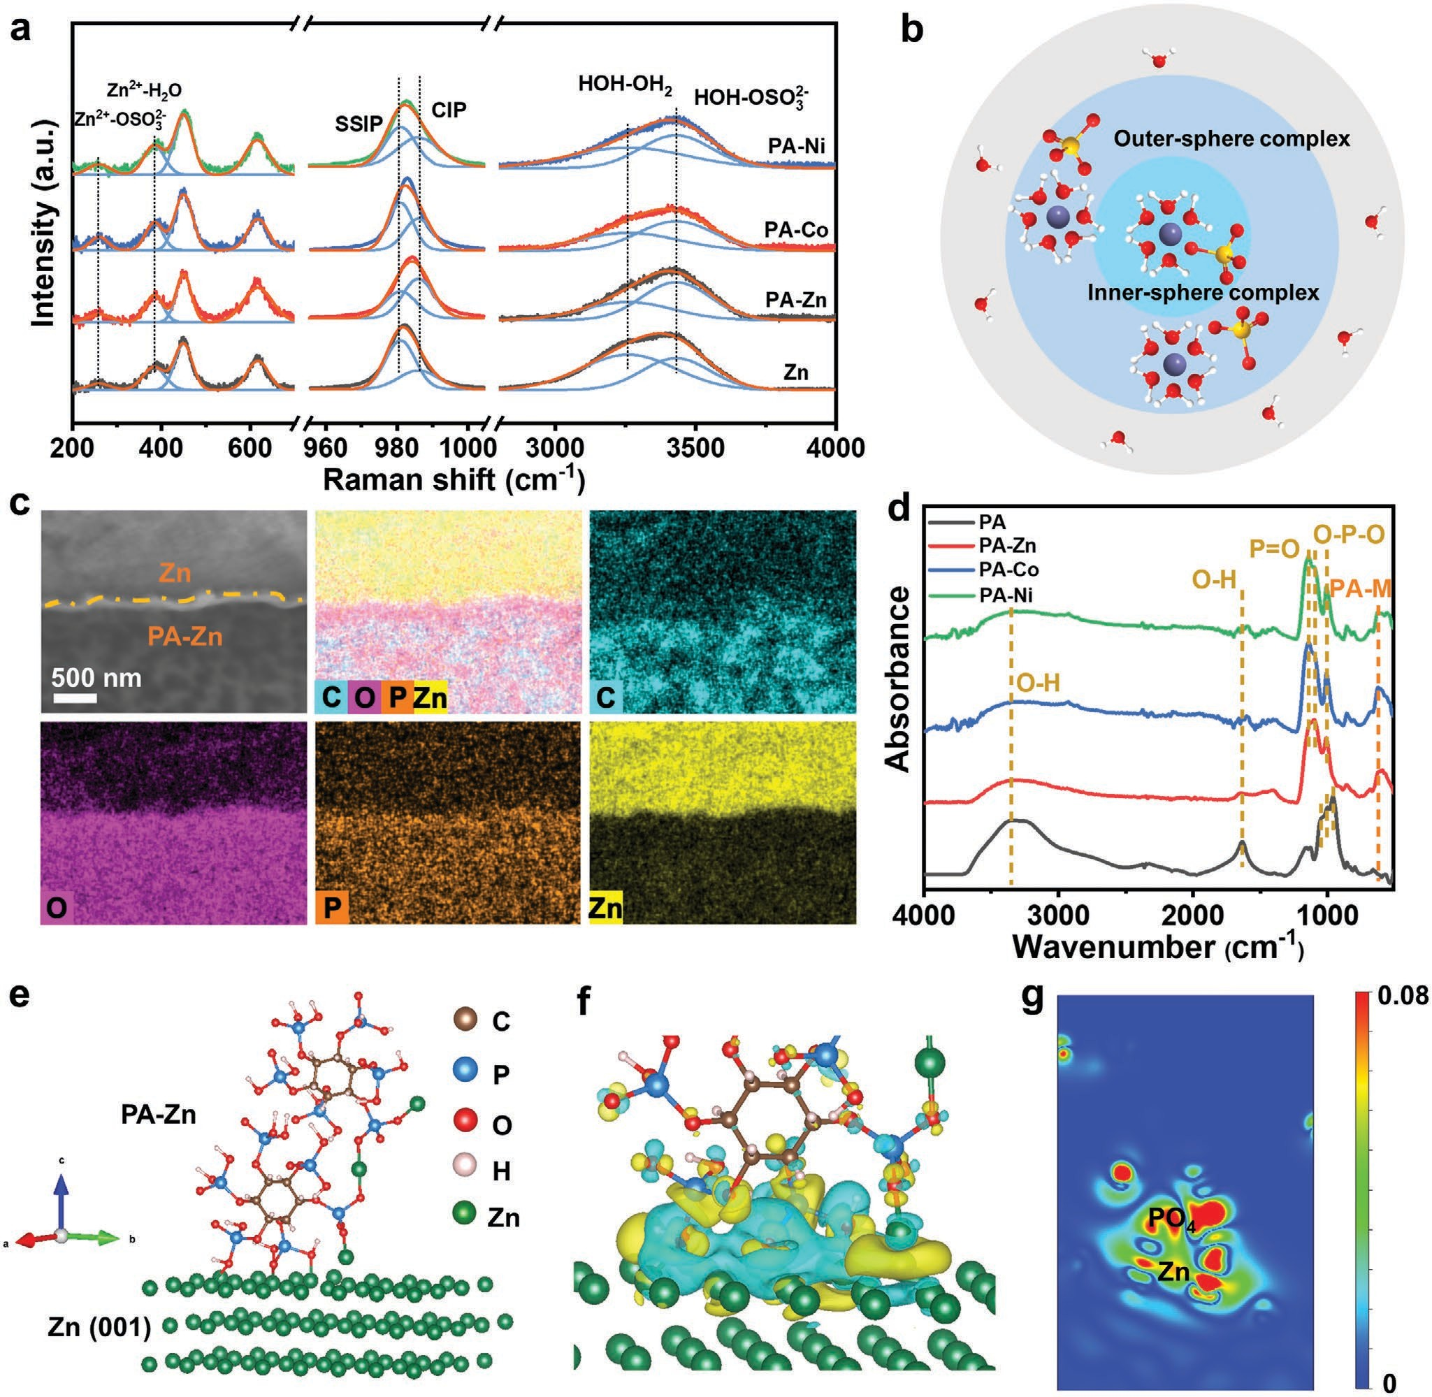
Figure 1. Morphology and structure characterization of PA-M. a) Raman spectroscopy of 2 m ZnSO₄ on the surface of Zn, PA-Zn, PA-Co, and PA-Ni films. b) Scheme illustration of ZnSO₄ solution structure. c) SEM and EDS mapping images of PA-Zn film and Zn interface. d) FTIR of phytic acid solution and PA-M films. e) Atomic structure of PA-Zn/Zn (001). f) Differential charge density diagram at the PA-Zn/Zn (001) interface and g) the corresponding slice.

metal ions (e.g., Co2+ and Ni2+ ions) and can alter their redox potentials rendering those ions inactive in the reaction with zinc metal.[17] According to the peak of SO 2−, the percentage
desolvation of Zn2+ ions, which is of importance in rejecting most water molecules and inhibits the formation of large sized zinc complexes with low charge density (Zn(H O) 2+SO 2−).

4 2 6 4

of contact ion pair (CIP) is increased to 59%, 43%, and 45% for PA-Zn, PA-Co, and PA-Ni, respectively, in comparison with that of 34% for Zn.[7,18] Moreover, the blue shift of the stretching vibration of OH further indicates the decreased number of active water molecules with H-bond. The buffer layer would inhibit the intimate contact with most water molecules. Impor- tantly, the coordination with phytic acid would induce the
Thus, the migration rate would be enhanced to exclude the neg- ative effect of ion diffusion. Especially, dynamic coordination process is expected to regulate homogeneous ion migration along the biomimetic channels, which is analogous to the rapid proton transfer along hydrogen-bonded water molecules via the Grotthuss mechanism (Scheme 1b).[19] The PA-M complex films are expected to regulate the uniform zinc ion transfer for

improving the electrochemical performance through a unique ion migration mechanism.[20]
The existence of the interfacial layer is observed by the clear dividing line between the un-covered surface and the film area with uniform distribution of C, O, P, and M elements (Figure 1c and Figure S1, Supporting Information). With pro- longing the soaking time, the surface is gradually coated with PA-M films (Figures S2 and S3, Supporting Information). However, many cracks appear on the surface of the films due to the residual stress,[21] when the growth time is extended to 30 min. Considering that the grown film should have a certain thickness to accumulate the fluctuation during continuous charging and discharging, the optimal growth time is 15 min to maintain the integrated interface layer.[22] The atomic force microscopy (AFM) tests exhibit the different thicknesses are
≈301, ≈253, and ≈336 nm for PA-Zn, PA-Co, and PA-Ni films, respectively (Figure S4a–f, Supporting Information), as a result of the complexation ability of metal ions with phytic acid and the film compactness.[23] The root-mean-square (RMS) rough- ness value was calculated to be 10.7 nm for the pure Zn foil, but significantly increased to 34.7, 43.9, and 45.4 nm after coating of PA-Zn, PA-Co, and PA-Ni film due to the formation of nanostructured grains. Furthermore, the Young’s modulus of PA-Zn, PA-Co, and PA-Ni films were calculated to be 28.7, 12.2, and 16.7 Gpa through the force–separation curves (Figure S4g–i, Supporting Information). Different from the tra- ditional flexible organic film and brittle inorganic film, PA-M films with appropriate modulus has not only certain mechan- ical stability to maintain the porous structure, but also good compressibility and ductility due to the organic skeleton of phytic acid molecules. Especially, the interface coordination effect allows the inorganic–organic layer tightly coated on the surface of zinc foil.[24] No additional peak except for Zn on XRD patterns (Figure S5, Supporting Information) of PA-M films suggests the amorphous nature of coating layers. As shown in Figure 1d, the broad peak at 3300 cm−1 is attributed to the vibra- tion of OH with the relatively decreased intensity after com- plexing with metal ions. The peaks at 1052, 1001, and 959 cm−1 are assigned to the stretching vibration of PO, asymmetric and symmetric stretching vibration of OPO, respectively, and the blue-shift of such peaks for PA-M films is attributed to the weak hydrogen bonding interaction. Notably, the new peaks located at 629, 626, and 628 cm−1 are corresponding to the existence of coordination structures in PA-Zn, PA-Co, and PA-Ni films, respectively.[25] The highest wavenumber for PA-Zn would be contributed to the strongest bonding ability.[26] According to the X-ray photoelectron spectroscopy (XPS) curves (Figure S6a, Supporting Information), C, O, P, and related metal elements (Zn, Co, Ni) are detected in PA-M films. The high-resolution spectra revealed the formation of metal oxides and phosphates (Figure S6b,c, Supporting Information). The model of PA-Zn/ Zn (001) was established to understand the interaction between PA-Zn film and Zn substrate (Figure 1e). The obvious charge delocalization across the PA-Zn/Zn (001) interface (Figure 1f) demonstrate the strong chemical interaction between PA-Zn film and Zn substrate, which would enhance the adhesion to the zinc foil and thus regulate the solvation structure of inter- facial ions prior to coupling with electron from the metal sub- strate (Figure 1g).[9]
From the contact angle test (Figure 2a,b and Figure S7, Sup- porting Information), the enhanced hydrophilic properties of PA-M layers in comparison with the pure Zn foil (110.7°) would facilitate the transfer of Zn2+ ions, leading to low interfacial resistance.[27] Additionally, the linear sweep voltammetry (LSV) measurement was performed to identify the HER activity of Zn and PA-M (Figure 2c). In comparison the high HER potentials of PA-Co (−1.53 V), PA-Ni (−1.51 V), and Zn (−1.71 V) due to the intrinsic activity,[28] the more negative potential for HER at the PA-Zn electrode (−1.77 V versus Ag/AgCl) is required to achieve a current density of 10 mA cm−2, demonstrates the protective effect to retard zinc corrosion. In comparison, two peaks at
−1.52 and −1.62 V for PA-Zn are corresponding to the different oxidation status of zinc in zinc oxide and phosphate, respec- tively.[29] Especially, the observable reduction of zinc phosphate before hydrogen evolution reaction suggests that Zn2+ ions coordinated with phosphate are dynamically involved in the Zn deposition.
With prolonging immersion into the electrolyte, the sur- face corrosion with the vertical growth of corrosion prod- ucts, Zn₄SO₄(OH)₆·xH₂O are observed on the zinc surface, exhibiting the severe water-induced corrosion (Figure 2d and Figure S8a, Supporting Information).[30] In striking contrast, the smooth surface of PA-Zn without observable impurity suggests the good inhibition against the surface corrosion (Figure S8b, Supporting Information), but the other coating layers are less effective with the formation of parallel plates (Figure S8c,d, Supporting Information). The similar profiles of Tafel plots (Figure S9, Supporting Information) suggest the surface coating does not increase surface polarization. Nonetheless, the PA-Zn exhibits that the current density of 1.41 mA cm−2 is smaller than those of Zn (3.31 mA cm−2), PA-Co (2.69 mA cm−2), and PA-Ni (1.96 mA cm−2). The PA-Zn film as artificial SEI would suppress the corrosion reaction by isolating water molecules and electrode. The high-resolution XPS (Figure 2f) demon- strates the good stability of PA-Zn film with the similar Zn 2p_{3/2} signal, but for the slightly increased proportion of ZnO bond (31.4% to 38.3% after the anti-corrosion ability test). The results suggest the inevitable formation of zinc oxide. In con- trast, the disappearance of Co and Ni signals after immersing in electrolyte for 3 days would be attributed to the substitution with Zn2+ ion due to the weak coordination abilities of Co2+ and Ni2+ ions. To verify this, the titrations of Zn2+, Co2+, and Ni2+ ions to phytic acid exhibit the gradually decreasing pH owing to the coordination of metal ions with phosphate group and the release of hydrogen ions. The stronger the coordina- tion ability of metal ions with phytic acid, the faster the pH drops. Therefore, the coordination ability of metal ions is in the order of Zn2+ > Ni2+ > Co2+ (Figure 2e). Hence, the absence of cobalt and nickel elements on the XPS results (Figure 2g,h) is attributed to the stronger coordination ability of zinc ions with phosphate ions in comparison with cobalt and nickel ions. The replacement of cobalt and nickel ions further demonstrates the dynamic coordination process, which would benefit to the ion migration along the coordination skeletons. The results dem- onstrate that the coating layers depending on the coordination ability are able to reject the large fraction of water molecules encountering the zinc surface, thus suppressing the water- induced corrosion.

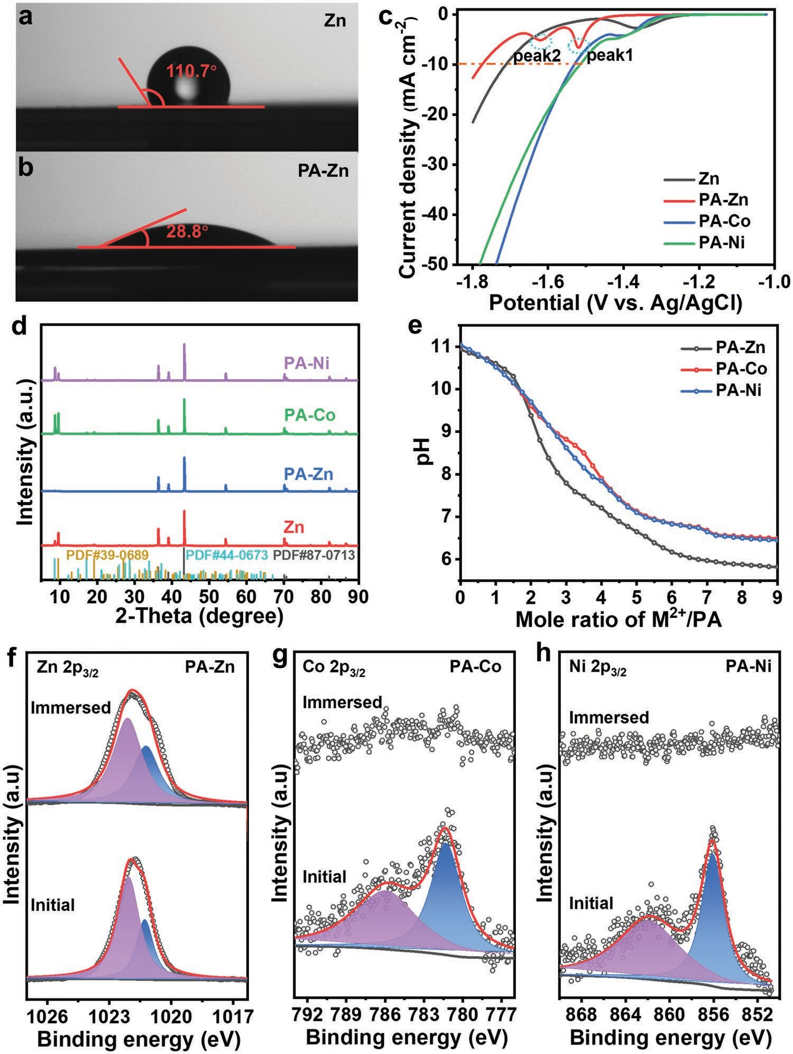
Figure 2. Anti-corrosion ability studies of PA-M. a,b) The wetting angle test for Zn and PA-Zn. c) Hydrogen evolution reaction (HER) curves of Zn, PA-Zn, PA-Co, and PA-Ni. d) XRD patterns of Zn and the coated Zn foils after corrosion test. e) Titration curves of phytic acid with Zn2+, Co2+, and Ni2+ ions. f–h) XPS spectra of Zn 2p_{3/2}, Co 2p_{3/2}, and Ni 2p_{3/2} at the initial stage and after being immersed in electrolyte for 3 days.

The metal deposition generally takes place from the diffusion of solvated ions from the bulk solution to the interface along with the gradual desolvation across the electrochemical double layer, and subsequently forming naked ions prior to receiving electrons from the electrode. Therefore, the deposition kinetics are governed by the ion migration barrier and solvation chem- istry.[30,31] To gain deep insight into the Zn2+ ion migration pro- cess in the PA-Zn films, the climbing nudged elastic band (CI- NEB) methods were employed to evaluate the ions migration barrier energies.[32] Typically, Zn2+ ions would be transferred between adjacent phosphate groups by a “hand-in-hand” way
between Zn1 and Zn2, along with the formation and cleavage of coordination bonds (Figure 3a). In contrast, the direct hop- ping mechanism indicates that Zn2+ ions are also transferred across the gaps from Zn1′ through Zn2′ to Zn3′ (Figure 3b and Figure S10, Supporting Information). As shown in Figure 3c, the migration barrier energies for the coordination process and the direct hopping mechanism are 0.31 and 0.53 eV, respec- tively. Obviously, it is more energy favorable for the Zn2+ migra- tion way via the “hand-in-hand” migration process along the coordinated phosphate groups. The transport of zinc ions on adjacent phosphate groups is accompanied by the formation

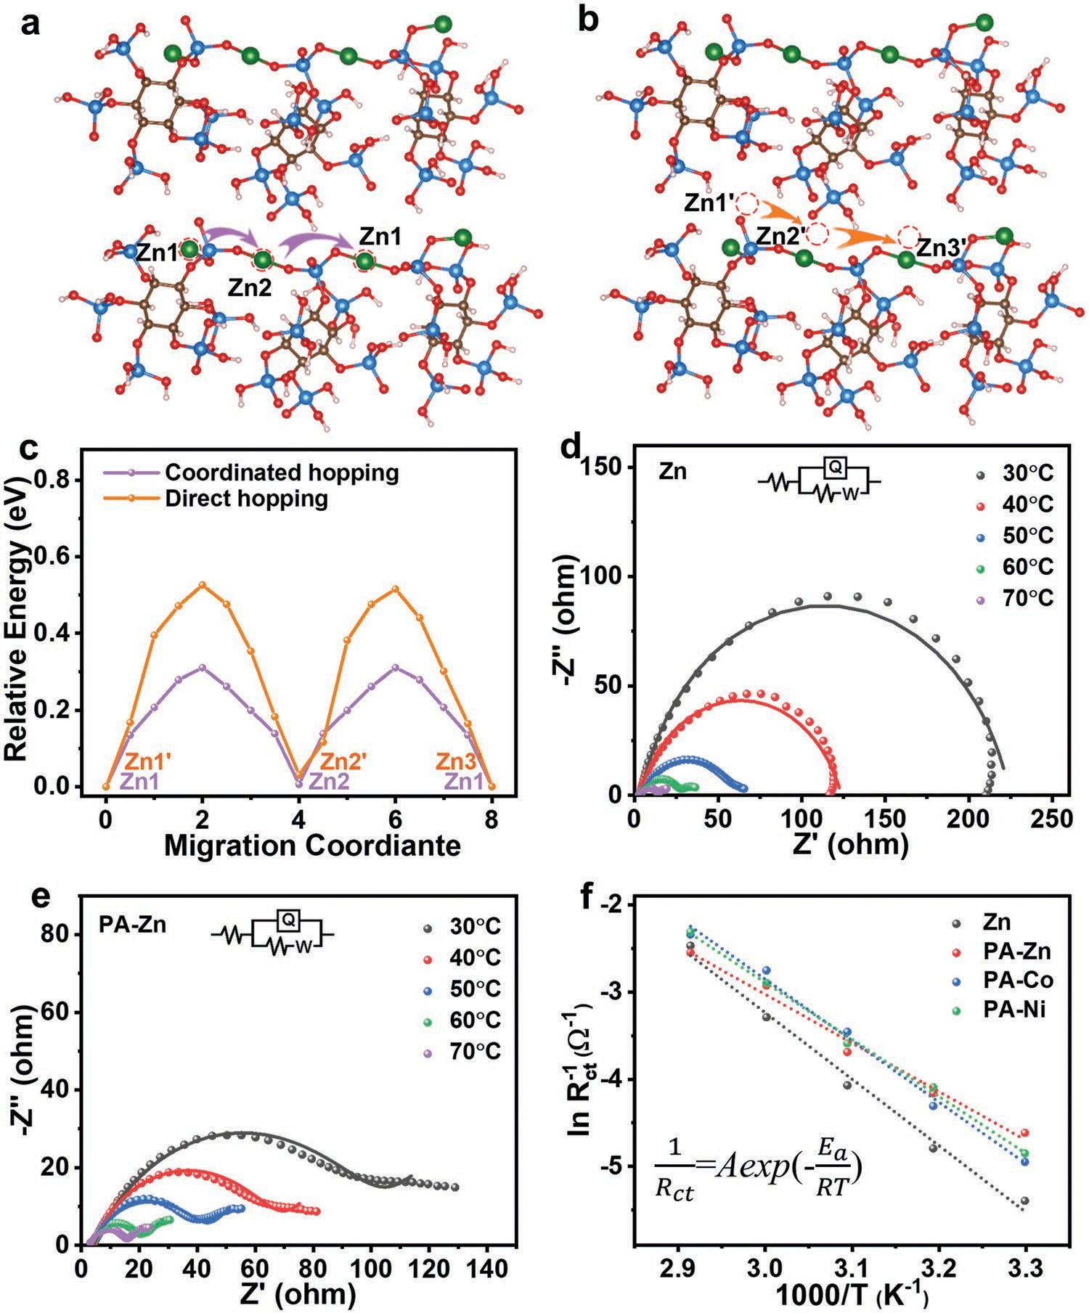
Figure 3. Calculations of Zn2+ migration energy barrier. The proposed migration pathways through a) coordinated hopping mechanism and b) the direct hopping mechanism. c) The corresponding energy barrier patterns for two migration mechanisms. Nyquist plots of d) Zn and e) PA-Zn at dif- ferent temperatures. f) Arrhenius curves to deduce activation energies for Zn electrodes with and without coatings.

and cleavage of coordination bonds, which is similar to the for- mation and concomitant cleavage of covalent bonds in proton transport. More importantly, the Zn2+ ion transference number calculated ( tZn2+ , Figure S11, Supporting Information) is only
0.35 for the pure Zn foil due to the large solvation structure
of Zn²⁺ ions in aqueous electrolyte. The tZn2+ values are sig- nificantly increased to 0.86, 0.65, and 0.74 for PA-Zn, PA-Co, and PA-Ni films possibly due to the desolvation process. Espe-
cially, the coordination with phosphate groups would tailor the solvation sheath to retard the typical solvation structure of Zn(H₂O) 2+ complex in aqueous solution. However, the trans- port of Zn2+ ions in PA-Co and PA-Ni films via the coordinated hopping mechanism would be broken due to the presence of additional coordination ions (e.g., Co2+ and Ni2+), thus resulting in the relatively slow migration rate. Notably, PA-Zn layer can
6
be fabricated in a large scale via the automatic coating mode (Figure S12, Supporting Information). The calculated electrical resistivities (Figure S13, Supporting Information) of PA-Zn, PA-Co, and PA-Ni are 1.39 × 104, 2.34 × 104, and 2.35 × 104 Λ cm, respectively. The low electron conductivity for an artificial layer due to the electronic insulation is crucial to regulate the ionic conductivity for homogenous deposition of zinc under the PA-M films.[33] The results suggest that the presence of the buffer layer significantly block the most water molecules and accelerate the Zn2+ ions’ diffusion rate.
The electrochemical kinetics is further investigated through the electrochemical impedance spectra (EIS) of symmetric cells (Figure S14, Supporting Information). The Nyquist plot of Zn symmetric cell shows a semicircle with the corresponding charge transfer resistance (R_{ct}) of 375.2 Λ. The R_{ct} values are

decreased to 246.4, 316.4, and 313.6 Λ for PA-Zn, PA-Co, and PA-Ni symmetric cells, respectively, which suggests fast charge diffusivity into the Zn electrode with a coating layer.[34] Two semicircles on Nyquist plots for PA-Co and PA-Ni symmetric cells indicate the increasing film resistance, corresponding to the front semicircle. In striking contrast, only one charge transfer semicircle on Nyquist plots of the PA-Zn symmetric cell shows the negligible film resistance. Therefore, the homo- geneous Zn deposition can be achieved under the uniform ions flux with the rapid ion transport kinetics. The activation energy (E_{a}) for zinc deposition is quantitatively evaluated by fitting charge transfer resistance (R_{ct}) and temperature (T) according to the Arrhenius equation (Figure 3d,e, and Figure S15 and Tables S1–S4, Supporting Information). E_{a} represents the inter- facial charge transfer barrier which is governed by two factors, namely the electron transfer and ion migration. Considering the high electron conductivity of metal Zn (1.67 × 107 S m−1),[35] the key barrier for charge transfer process is stemmed from the ion migration significantly depending on the solvation chem- istry. The calculated E_{a} for Zn, PA-Zn, PA-Co, and PA-Ni are 64.42, 46.37, 58.65, and 54.26 kJ mol−1, respectively (Figure 3f). The largest E_{a} for the pure Zn suggests the high barrier needed for Zn2+ ion desolvation at the interface of electrode- aqueous electrolyte prior to receiving electron from electrode. The reduced activation energy for PA-M further prove that the coating film acting as an artificial solid-state interface rejects water molecules for the desolvation in advance and accelerates the Zn2+ ion migration via the coordination process, resulting in homogenous zinc deposition.
To verify the interfacial stability of PA-M films, the ZnZn
symmetric cells and CP (carbon paper)-Zn asymmetric cells were both assembled. As shown in Figure 4a, the decreased voltage hysteresis suggests the low deposition energy barrier of zinc with the PA-M films, which would facilitate the homoge- neous nucleation of zinc for uniform deposition (Figure S16, Supporting Information). Additionally, the different polariza- tion is mainly related to the changing transport process of Zn2+ ions in these films. The presence of Co2+ and Ni2+ ions would limit the rapid transfer of Zn2+ ions in PA-Co and PA-Ni due to the blocking of coordination sites in the presence of Co2+ and Ni2+ ions. For the cycling stability, the Zn foil with a polariza- tion voltage of 49 mV exhibits obvious fluctuation and causes the short circuit after ≈60 h (Figure S17, Supporting Informa- tion). The coating of buffer layers significantly enhances the lifespan with smaller polarization potentials of 38, 48, and 40 mV for PA-Zn, PA-Co, and PA-Ni, respectively. Along with the large fluctuation and gradually short circuit for PA-Co and PA-Ni symmetric cells after 171 and 193 h, however, the PA-Zn symmetric cell showed very good stability without obvious fluctuation for more than 1000 h. When the current den- sity increased to 5 mA cm−2 (Figure 4b), the PA-Zn electrode gives a much lower overpotential of 52 mV, than those at Zn, PA-Co, and PA-Ni symmetric cells as well as recently reported results (Figure 4c), and achieves a long lifespan of over 500 h. At the high current density, the gradual formation of inert materials (e.g., Zn₄SO₄(OH)₆·xH₂O) on the zinc surface would exacerbate the polarization and aggravate the uneven distribu- tion of ion flux for the Zn dendrite growth.[36] In the present
case, the coating layer is effective to modulate the interfacial
micro-environment for suppressing the common solva- tion structure of an ion complex in a dilute solution, but also enhances ion migration via the dynamic coordination channels. Considering the sensitive dependent of deposition current on the surface properties of Zn electrode,[37] the significant cur- rent decay at the zinc foil, PA-Co and PA-Ni would be contrib- uted to the rapid deposition of zinc at the energetically favorable sites and the subsequent formation of concentration gradient as a result of the ion exhaustion near the electrode surface. The uneven polarization would result in the preferable dendrite growth.[38] In contrast, the stable current density (Figure S18, Supporting Information) suggests the gradual deposition of zinc at the PA-Zn electrode. For the pure Zn, the morphology evolution after the continuous plating/striping process pre- sented the formation of small particles on the surface after the initial cycle owing to the non-uniform deposition of Zn2+ ions (Figure S19a, Supporting Information). With the exten- sion of cycling time, the flaky zinc dendrites were observed on the surface of zinc with pitting corrosion (Figure S19b, Supporting Information), exhibiting the vertical orientation deposition (Figure 4d and Figure S19c, Supporting Informa- tion). In contrast, the typical uniform surface of PA-Zn is with negligible structure change (Figure 4e and Figure S19d–l, Sup- porting Information). The uniform composition (Figures S20 and S21, Supporting Information) and integral film with strong mechanical strength (Figure S22, Supporting Information) are well-maintained. In the present case, the zinc ion among the coordination skeleton of the coating layers would establish the super-saturated status, possibly leading to the less concentra- tion changes. Furthermore, the coordination migration through the porous matrix would establish the homogeneous ion distri- bution and suppress the solvation of a zinc ion complex. There- fore, the structural integrity with negligible surface change can be maintained even after long-term plating/stripping. In the CP-Zn cells, the voltage-capacity profiles (Figure 4f,g and Figure S23, Supporting Information) exhibit the lowest voltage gap of 70 mV at the PA-Zn electrode than those of Zn (114 mV), PA-Co (80 mV), and PA-Ni (77 mV), suggesting the favorable plating/stripping process due to the low energy bar- rier. The energy favorable coordinated hopping mechanism for the PA-Zn film would facilitate the rapid transfer of Zn2+ ions. As for Zn asymmetric cell, uneven deposition of zinc and high desolvation energy resulted in the short cycling life and high
voltage hysteresis.
To demonstrate the practical applications of the advanced zinc anode, the aqueous ZnI₂ battery was fabricated with the iodine loaded N, P co-doped porous carbon (Figure S24, Sup- porting Information) as a cathode in consideration of the abun- dant iodine element in seawater.[39] As shown in Figure 5a, the reversible redox peaks with the largest area is related to the enhanced specific capacity of the battery with PA-Zn anode. In addition, the small potential difference between the redox peaks suggests the good reversibility of zinc with the fast conversion process of iodine. The energy storage process can be achieved through the fast reaction kinetics with the dominant capacitive feature (Figure S25, Supporting Information). The improved transfer kinetics was also proved by in situ Raman spectroscopy (Figure 5b). The peaks at 106.4 and 161.6 cm−1, corresponding
to the intermediate active species of I − and I −, respectively

3 5

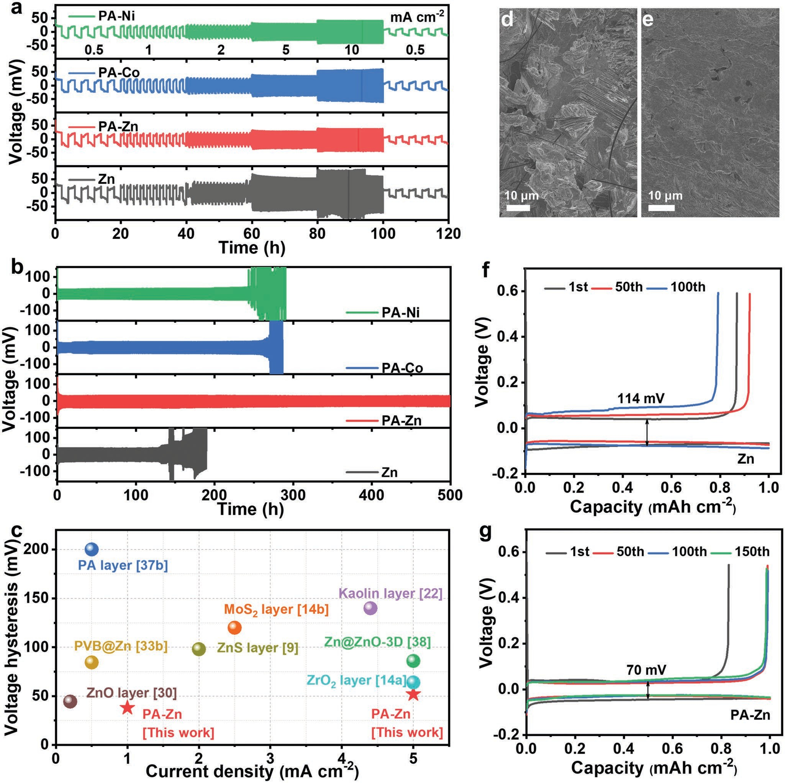
Figure 4. Electrochemical performance of ZnZn symmetric cells and CP-Zn asymmetric cells. a) Rate performances of symmetric cells at current densities from 0.5 to 10 mA cm−2. b) Cycling stability of symmetric cells at 5 mA cm−2 with a specific capacity of 1 mAh cm−2. c) Comparison of elec- trochemical properties of PA-Zn symmetric cell with previously reported anodes with different coating layers. SEM images of d) Zn and e) PA-Zn after 200 cycles. Voltage–capacity curves of f) Zn and g) PA-Zn at the selected cycles for CP-Zn (carbon paper-Zn/PA-M) cells at 2 mA cm−2 with the capacity of 1 mAh cm−2.

disappear before 1.21 V for ZnI₂ battery with PA-Zn anode.[40] In contrast, the peaks of active species for pure Zn disappear at 1.16 V (Figure S26, Supporting Information). The advanced anode endows the fast transfer ability of Zn2+ ions and thus accelerates the electrochemical reaction process.
The charge transfer resistance for Zn, PA-Zn, PA-Co, and PA-Ni are 148, 76, 124, and 89 Λ, respectively (Figure S27, Supporting Information), further demonstrates the favorable
charge transfer for PA-Zn. As a result, the ZnI₂ batteries with PA-Zn, PA-Co, and PA-Ni anode exhibits an enhanced ini- tial discharging capacity of 261.1, 208.9, and 221.2 mAh g−1 at
0.5 C, respectively (Figure 5c), in comparison with that of Zn (198.3 mAh g−1). Moreover, the ZnI₂ batteries with PA-Zn, PA-Co, and PA-Ni anodes also harvest excellent rate performance with a high specific capacity of 177.5, 140.9, and 147.6 mAh g−1 at the large rate of 10 C, respectively, superior to that of pure

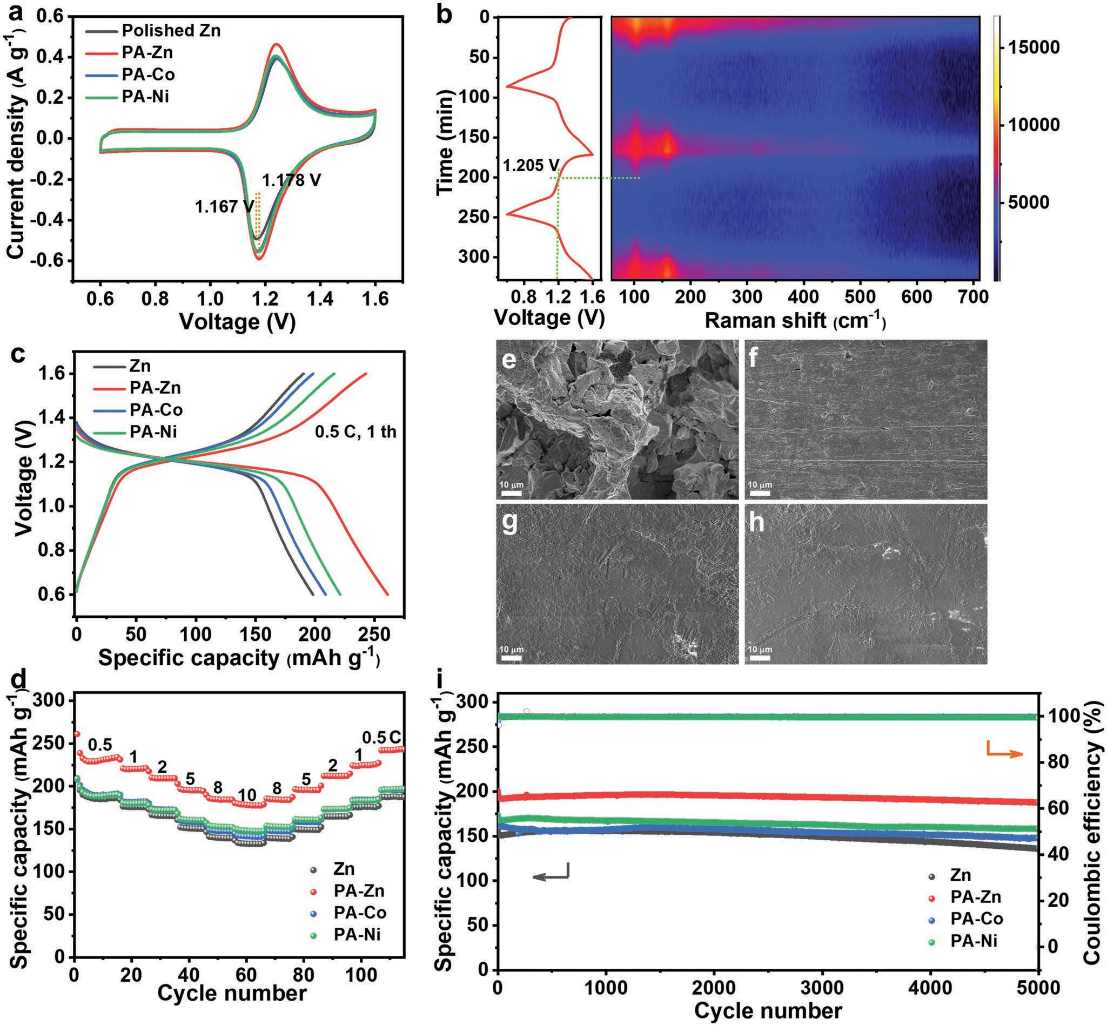
Figure 5. Electrochemical performance of rechargeable ZnI₂ batteries. a) CV curves of ZnI₂ batteries with Zn and coated Zn anodes at 0.1 mV s−1.
b) In-situ Raman spectra and the corresponding voltage–time curves of ZnI₂ battery with PA-Zn anode. c) Voltage–capacity curves for the first charge–discharge process at 0.5 C. d) Rate performance. SEM images of e) Zn, f) PA-Zn, g) PA-Co, and h) PA-Ni after rate test. i) Long-term cycling performance at 5 C.

Zn (132.6 mAh g−1, Figure 5d). The coated film can not only improve the reaction kinetics, but also control the uniform ions flux distribution on the surface of zinc anode. Hence, the modi- fied Zn anode displays a smooth surface after the rate test. In contrast, the obvious dendrite growth of Zn is contributed to the nonuniform deposition of zinc and/or severe surface cor- rosion (Figure 5e–h). In comparison with the capacity decay of 13% for the bare Zn anode (Figure 5i), the capacity retentions of PA-Zn, PA-Co, and PA-Ni anodes are 93.6%, 88.4%, and 91.1% after 5000 cycles, showing the good reversibility and the long life-span. Especially, the maintained capacity of 187.7 mAh g−1 for the PA-Zn anode is higher than those for Zn, PA-Co, and
PA-Ni (135.9, 147.5, and 158.0 mAh g−1, respectively). The in-situ formation of coordinated PA-Zn skeleton with rapid Zn2+ ions transfer ability would endow the high specific capacity.

Conclusion
In summary, the ion transport behavior at the solution–elec- trode interface is regulated by a buffer layer of a phytic acid– metal complex film which is in-situ formed on the surface of Zn foil via simple immersion method. The dynamical coordi- nation process enables the rapid migration of zinc ions via an

energy favorable coordinated hopping mechanism according to Density Functional Theory (DFT) calculation and experi- mental characterizations. Especially, the formation of interfa- cial coating layer with channel structure along the phytic acid skeleton, analogous to a porous buffer layer is able to regulate the solvation structure of zinc ions by rejecting the active water molecules and the potential coordinated anion (SO 2−). There- fore, the surface corrosion of zinc and dendrite growth can be inhibited for the reversible plating and stripping. Benefit from the unique interfacial buffer layer, the uniform zinc electrode in symmetric cell can be well-maintained up to 500 h at a larger current density of 5 mA cm−2, over three times longer than that of bare zinc foil (≈120 h). Furthermore, the aqueous zinc-iodine battery with PA-Zn cathode exhibited a large specific capacity of 261.1 mAh g−1 and long lifespan of 5000 cycles. This work demonstrates the highly promising applications of coordination chemistry to modulate the interface electrochemical process that enable broad spaces for optimizing uniform metal deposi- tion and rechargeable batteries.
4

Experimental Section
Material Preparation: In the typical preparation procedure, the dilute PA solution of 5 g L−1 was added into the aqueous solution with 5 mm M(NO₃)₂.6H₂O (M = Zn, Co, Ni), respectively under vigorous stirring for 30 min. The pH of the mixed solution was adjusted to ≈6 by adding an adequate amount of 3 m NaOH solution. After that, the Zn foil was immersed into the above solutions for 15 min. Afterwards, the obtained Zn foils were taken out and washed with ultrapure water for three times and dried in air. The samples were named as PA-Zn, PA-Co, and PA-Ni, respectively.
Characterization Measurements: The scanning electron microscopy (SEM, Gemini SEM 300, Carl Zeiss Microscopy GmbH) was used to characterize the morphologies of samples. The X-ray diffraction method (Rigaku Dmax X-ray diffractometer with Ni-filtered Cu K irradiation) was performed to collect the crystallographic phases of samples. XPS measurement was conducted with a photoelectron spectrometer (ESCALAB 250). FTIR spectra were collected on the Bruker spectrometer (INVENIO-S). Atomic force microscopy (AFM) (Bioscope Resolve) was used to determine the thickness of the film and mechanical property of samples. Raman spectroscopy was conducted on LabRAM HR800 (HORIBA JY) with 633 nm laser. To obtain the solvated structure of ions on the PA-M complex films, the residual electrolyte on Zn foil was removed by clean tissue.
Electrochemical Measurements: Symmetric cells were assembled by coupling with Zn or PA-M in 2 m ZnSO₄ electrolyte with a glass fiber separator using CR2032 coin-type cell. Tafel plot and Chronoamperometry test were conducted in a three-electrode configuration with Ag/AgCl electrode as the reference electrode and a graphite rod as the counter electrode on a CHI 760E electrochemical workstation. The electrochemical impedance spectroscopy (EIS) was tested in an Autolab electrochemical workstation (PGSTAT302N) in the frequency range of 100 KHz to 10 mHz with AC amplitude of 10 mV. In the ZnI₂ batteries, the N, P co-doped carbon was prepared according to the authors’ previous work with some modifications. 33 wt% iodine was encapsulated through melting method. The electrode was prepared by mixing the active materials, acetylene black, and poly(tetrafluoroethylene) (PTFE) binder with the mass ratio of 7:2:1. The resultant slurry was cast onto the titanium foil and dried at 60 °C for 8 h in a vacuum oven. The galvanostatic charge–discharge was carried out with a Neware Battery Test System. The area loading of composite for each electrode was ≈6 mg cm−2.
Theoretical Calculations: The authors have employed the first- principles[41] to perform DFT calculations within the generalized gradient
approximation (GGA) using the Perdew–Burke–Ernzerhof (PBE)[42] formulation. They have chosen the projected augmented wave (PAW) potentials[43] to describe the ionic cores and take valence electrons into account using a plane wave basis set with a kinetic energy cutoff of 450 eV. Partial occupancies of the Kohn–Sham orbitals were allowed using the Gaussian smearing method and a width of 0.05 eV. The k-points of 2 × 2 × 1 had been used to optimize the authors’ interface structures, which is the Zn (001) surface. The electronic energy was considered self-consistent when the energy change was smaller than 10−6 eV. A geometry optimization was considered convergent when the energy change was smaller than 0.05 eV Å−1. Grimme’s DFT-D3 methodology[44] was used to describe the dispersion interactions among all the atoms in adsorption models. What’s more, Zn ions migration barrier energies had been evaluated using the climbing nudged elastic band (CI-NEB) methods.

Supporting Information
Supporting Information is available from the Wiley Online Library or from the author.

Acknowledgements
This work was financially supported by the National Natural Science Foundation of China (22175108), the Natural Scientific Foundation (ZR2020JQ09) and Taishan Scholars Program (No. tsqn20161004) of Shandong Province, Project for Scientific Research Innovation Team of Young Scholar in Colleges, Universities of Shandong Province (2019KJC025). The authors also acknowledge the assistance of the Analytical Center for Structural Constituent and Physical Property of Core Facilities Sharing Platform, Shandong University and the National Synchrotron Radiation Laboratory (NSRL) at the University of Science and Technology of China.

Conflict of Interest
The authors declare no conflict of interest.

Data Availability Statement
The data that support the findings of this study are available from the corresponding author upon reasonable request.

Keywords
advanced Zn anodes, coordination chemistry, desolvation energy barrier, electrode-electrolyte interfaces, Zn-I₂ batteries

  - a) M. Zhu, S. Li, B. Li, Y. Gong, Z. Du, S. Yang, Sci. Adv. 2019, 5, eaau6264; b) H. Yuan, J. Nai, H. Tian, Z. Ju, W. Zhang, Y. Liu, X. Tao,
X. W. D. Lou, Sci. Adv. 2020, 6, eaaz3112; c) P. Hundekar, S. Basu,
X. Fan, L. Li, A. Yoshimura, T. Gupta, V. Sarbada, A. Lakhnot,
R. Jain, S. Narayanan, Y. Shi, C. Wang, N. Koratkar, Proc. Natl. Acad. Sci. USA 2020, 117, 5588.

www.advancedsciencenews.com www.small-journal.com

  - L. Ma, M. A. Schroeder, O. Borodin, T. P. Pollard, M. S. Ding,
C. Wang, K. Xu, Nat. Energy 2020, 5, 743.
  - M. Winter, R. J. Brodd, Chem. Rev. 2004, 104, 4245.
  - a) S. B. Wang, Q. Ran, R. Q. Yao, H. Shi, Z. Wen, M. Zhao,
X. Y. Lang, Q. Jiang, Nat. Commun. 2020, 11, 1634; b) H. Jia,
Z. Wang, M. Dirican, S. Qiu, C. Y. Chan, S. Fu, B. Fei, X. Zhang, J. Mater. Chem. A 2021, 9, 5597.
  - a) G. Fang, J. Zhou, A. Pan, S. Liang, ACS Energy Lett. 2018, 3, 2480;
b) S. Chen, K. Li, K. S. Hui, J. Zhang, Adv. Funct. Mater. 2020, 30, 2003890; c) C. Wu, H. Tan, W. Huang, W. Li, K. N. Dinh, C. Yan,
W. Wei, L. Chen, Q. Yan, Adv. Funct. Mater. 2020, 30, 2003187;
d) J. Zhao, H. Ren, Q. Liang, D. Yuan, S. Xi, C. Wu, W. Manalastas,
J. Ma, W. Fang, Y. Zheng, C.-F. Du, M. Srinivasan, Q. Yan, Nano Energy 2019, 62, 94; e) Z. Liu, Y. Yang, S. Liang, B. Lu, J. Zhou, Small Struct. 2021, 2, 2100119.
  - W. Du, E. H. Ang, Y. Yang, Y. Zhang, M. Ye, C. C. Li, Energy Environ. Sci. 2020, 13, 3330.
  - H. Yang, Z. Chang, Y. Qiao, H. Deng, X. Mu, P. He, H. Zhou, Angew. Chem., Int. Ed. 2020, 59, 9377.
  - Q. Yang, G. Liang, Y. Guo, Z. Liu, B. Yan, D. Wang, Z. Huang, X. Li, J. Fan, C. Zhi, Adv. Mater. 2019, 31, 1903778.
  - J. Hao, B. Li, X. Li, X. Zeng, S. Zhang, F. Yang, S. Liu, D. Li, C. Wu, Z. Guo, Adv. Mater. 2020, 32, 2003021.
  - a) L. Wang, N. Li, T. Wang, Y. Yin, Y. Guo, C. Wang, Electrochim. Acta 2017, 244, 172; b) Y. Zeng, X. Zhang, R. Qin, X. Liu, P. Fang,
D. Zheng, Y. Tong, X. Lu, Adv. Mater. 2019, 31, 1903675; c) Q. Zhang,
J. Luan, L. Fu, S. Wu, Y. Tang, X. Ji, H. Wang, Angew. Chem., Int. Ed.
2019, 58, 15841.
  - J. Zheng, Q. Zhao, T. Tang, J. Yin, C. D. Quilty, G. D. Renderos,
X. Liu, Y. Deng, L. Wang, D. C. Bock, C. Jaye, D. Zhang,
E. S. Takeuchi, K. J. Takeuchi, A. C. Marschilok, L. A. Archer, Science
2019, 366, 645.
  - J. Zheng, J. Yin, D. Zhang, G. Li, D. C. Bock, T. Tang, Q. Zhao,
X. Liu, A. Warren, Y. Deng, S. Jin, A. C. Marschilok, E. S. Takeuchi,
K. J. Takeuchi, C. D. Rahn, L. A. Archer, Sci. Adv. 2020, 6, eabb1122.
  - M. Q. Xu, W. S. Li, X. X. Zuo, J. S. Liu, X. Xu, J. Power Sources 2007,
174, 705.
  - a) P. Liang, J. Yi, X. Liu, K. Wu, Z. Wang, J. Cui, Y. Liu, Y. Wang,
Y. Xia, J. Zhang, Adv. Funct. Mater. 2020, 30, 1908528; b) S. Bhoyate,
S. Mhin, J. E. Jeon, K. Park, J. Kim, W. Choi, ACS Appl. Mater. Inter- faces 2020, 12, 27249.
  - J. Zhi, S. Li, M. Han, P. Chen, Sci. Adv. 2020, 6, eabb1342.
  - Z. Wei, Y. Zhang, L. Zhao, J. Liu, X. Li, J. Phys. Chem. A 2005, 109, 1337.
  - Y. D. Tsai, C. C. Hu, C. C. Lin, Electrochim. Acta 2007, 53, 2040.
  - X. Wang, Y. Wan, W. Hu, I. M. Chou, J. Cao, X. Wang, M. Wang,
Z. Li, Geochim. Cosmochim. Acta 2016, 181, 126.
  - a) X. Wu, J. J. Hong, W. Shin, L. Ma, T. Liu, X. Bi, Y. Yuan, Y. Qi,
T. W. Surta, W. Huang, J. Neuefeind, T. Wu, P. A. Greaney, J. Lu,
X. Ji, Nat. Energy 2019, 4, 123; b) Q. Zhao, A. Song, W. Zhao, R. Qin,
S. Ding, X. Chen, Y. Song, L. Yang, H. Lin, S. Li, F. Pan, Angew. Chem., Int. Ed. 2021, 60, 4169.
  - J. Song, B. Zhou, H. Zhou, L. Wu, Q. Meng, Z. Liu, B. Han, Angew. Chem., Int. Ed. 2015, 54, 9399.
  - R. Yan, W. He, T. Zhai, H. Ma, Appl. Surf. Sci. 2018, 442, 264.
  - C. Deng, X. Xie, J. Han, Y. Tang, J. Gao, C. Liu, X. Shi, J. Zhou,
S. Liang, Adv. Funct. Mater. 2020, 30, 2000599.
  - R. Yan, X. Gao, W. He, R. Guo, R. Wu, Z. Zhao, H. Ma, RSC Adv.
2017, 7, 41152.
  - Z. Li, L. Wu, S. Dong, T. Xu, S. Li, Y. An, J. Jiang, X. Zhang, Adv. Funct. Mater. 2020, 31, 2006495.
  - L. Gao, C. Zhang, M. Zhang, X. Huang, X. Jiang, J. Alloys Compd.
2009, 485, 789.
  - a) H. Shi, E.-H. Han, F. Liu, S. Kallip, Appl. Surf. Sci. 2013, 280, 325; b) A. Zając, L. Dymińska, J. Lorenc, M. Ptak, J. Hanuza, J. Mol. Struct. 2018, 1156, 483.
  - a) M. Liu, J. Cai, H. Ao, Z. Hou, Y. Zhu, Y. Qian, Adv. Funct. Mater.
2020, 30, 2004885; b) R. Yuksel, O. Buyukcakir, W. K. Seong,
R. S. Ruoff, Adv. Energy Mater. 2020, 10, 1904215.
  - J. Sun, M. Ren, L. Yu, Z. Yang, L. Xie, F. Tian, Y. Yu, Z. Ren, S. Chen, H. Zhou, Small 2019, 15, 1804272.
  - a) K. Pandi, T. R. N. Kumar, S. K. Lakhera, B. Neppolian, Energy Technol. 2020, 8, 2000481; b) C.-H. Kim, J.-H. Lee, W.-S. Shin, Bull. Korean Chem. Soc. 2010, 31, 789.
  - X. Xie, S. Liang, J. Gao, S. Guo, J. Guo, C. Wang, G. Xu, X. Wu,
G. Chen, J. Zhou, Energy Environ. Sci. 2020, 13, 503.
  - Y. Chu, S. Zhang, S. Wu, Z. Hu, G. Cui, J. Luo, Energy Environ. Sci.
2021, 14, 3609.
  - J. Paier, R. Hirschl, M. Marsman, G. Kresse, J. Chem. Phys. 2005,
122, 234102.
  - a) X. Liang, Q. Pang, I. R. Kochetkov, M. S. Sempere, H. Huang,
X. Sun, L. F. Nazar, Nat. Energy 2017, 2, 17119; b) J. Hao, X. Li,
S. Zhang, F. Yang, X. Zeng, S. Zhang, G. Bo, C. Wang, Z. Guo, Adv. Funct. Mater. 2020, 30, 2001263.
  - N. Zhang, S. Huang, Z. Yuan, J. Zhu, Z. Zhao, Z. Niu, Angew. Chem., Int. Ed. 2021, 60, 2861.
  - J. Ming, J. Guo, C. Xia, W. Wang, H. N. Alshareef, Mater. Sci. Eng.: R 2019, 135, 58.
  - A. Pei, G. Zheng, F. Shi, Y. Li, Y. Cui, Nano Lett. 2017, 17, 1132.
  - a) C. J. Lan, C. Y. Lee, T. S. Chin, Electrochim. Acta 2007, 52, 5407;
b) Z. Zhao, J. Zhao, Z. Hu, J. Li, J. Li, Y. Zhang, C. Wang, G. Cui,
Energy Environ. Sci. 2019, 12, 1938.
  - J. Y. Kim, G. Liu, G. Y. Shim, H. Kim, J. K. Lee, Adv. Funct. Mater.
2020, 30, 2004210.
  - a) Y. Yang, S. Liang, J. Zhou, Curr. Opin. Electrochem. 2021, 30, 100761; b) Y. Yang, S. Liang, B. Lu, J. Zhou, Energy Environ. Sci. 2022, 15, 1192.
  - K. Li, S. Chen, S. Chen, X. Liu, W. Pan, J. Zhang, Nano Res. 2018, 12, 549.
  - a) G. Kresse, J. Furthmiiller, Comput. Mater. Sci. 1996, 6, 15;
b) G. Kresse, J. Furthmüller, Phys. Rev. B 1996, 54, 11169.
  - J. P. Perdew, K. Burke, M. Ernzerhof, Phys. Rev. Lett. 1996, 77, 3865.
  - a) G. Kresse, D. Joubert, Phys. Rev. B 1999, 59, 1758; b) P. E. Blochl,
Phys. Rev. B 1994, 50, 17953.
  - S. Grimme, J. Antony, S. Ehrlich, H. Krieg, J. Chem. Phys. 2010, 132, 154104.

