RESE ARCH ARTICL E

Investigation of Electrocatalytic behavior of mesoporous strontium selenide nanowires for hydrogen evolution reaction

Muhammad Faisal Iqbal¹ | Zhiying Chen² | Xincheng Zhang² |
Mahmood Ul Hassan³ | Kwun Nam Hui⁴ | Kwan San Hui⁵ | Yuyang Yang ² | Guijun Li ⁶ | Meng Zhang²

¹College of Chemistry and Life Sciences, Zhejiang Normal University, Jinhua, China
Summary
Tremendous efforts have been directed to synthesize electrocatalysts for hydro- gen evolution reaction but the electrocatalytic behavior of alkaline metal-based selenides has been rarely reported. Herein, SrSe nanowires have been synthe- sized using the solvo-hydrothermal process at various temperatures, and the synthesis has been confirmed using different techniques. The employed tem- perature affects the structure of the strontium selenides and has significantly influenced the hydrogen evolution reaction. Owing to the mesoporous nature and the greater specific and electrochemical surface area, the SrSe nanowires synthesized at 200◦C exhibit a greater number of active sites and show an over- potential of 127 mV to approach the current density of 10 mA cm^{—2} in 1 M KOH electrolyte. The SrSe nanowires also exhibit a greater turnover frequency of 41.20 ms^{—1} at the fixed reversible hydrogen electrode potential of 500 mV. The electrocatalyst SrSe nanowires reveal a Tafel slope of 135 mV dec^{—1}, which is better than synthesis at other temperatures. The SrSe nanowires maintained the current density for 24 h chronoamperometry test in 1 M KOH electrolyte. The test results inspire further investigation and indicate the leading potential of SrSe nanowires for hydrogen evolution application.
KEYWOR DS
electrolytes, hydrogen evolution reaction, strontium selenide nanowires, Tafel slope, temperature
²College of Electronics and Information Engineering, Shenzhen University, Shenzhen, China
³Materials Growth and Simulation Laboratory, Department of Physics, University of the Punjab, Lahore, Pakistan
⁴Joint Key Laboratory of the Ministry of Education, Institute of Applied Physics and Materials Engineering, University of Macau, Macau SAR, China
⁵Engineering, Faculty of Science, University of East Anglia, Norwich, UK
⁶College of Physics and Optoelectronic Engineering, Shenzhen University, Shenzhen, China

Correspondence
Meng Zhang, College of Electronics and Information Engineering, Shenzhen University, Shenzhen 518060, China.
Email: zhangmeng@connect.ust.hk

Funding information
Guangdong Basic and Applied Basic Research Foundation, Grant/Award Number: 2021A1515011858; Natural Science Foundation of Shenzhen University, Grant/Award Number: 860-000002110423

| INTRODUCTION

Incredible methodologies have been adopted to overcome the swelling energy crises, but unfortunately, these have produced the stern environmental problem.^{1,2} The pro- duction of carbon dioxide from fossil fuels has seriously
twisted the general air and also has resulted in water pol- lution.³⁻⁵ Therefore, pursuing clean energy resources has become a challenging task to balance the rapidly growing technology of the world.⁶⁻⁸ Owing to abundance occur- ring, eco-friendly, high mass storage density, and long storage time, hydrogen has been considered a reliable

energy resource in the future.⁹⁻¹¹ Hydrogen energy has potential applications in various fields, such as for the production of steel, aluminum, and ammonia gas,¹² transport vehicles, to produce clean electricity, and hydro-treating of petroleum.^{11,13} Hydrogen is an econom- ical and reliable resource. According to a report, the annual production of hydrogen energy is 44.5 million worldwide.¹³ Hydrogen energy can be produced from sev- eral methods, that is, reforming of natural gas, solar tech- nologies, electrochemical water splitting and other fossil fuels with by-products of CO_{2.}¹⁴ Among these methods, the hydrogen energy from water splitting has been con- sidered the clean resource without any by-product.^{15,16} However, the hydrogen production from electrochemical water splitting is only around 4% of total hydrogen pro- duction, while the remaining 96% of production consists of fossil fuel products.^{17,18}
The efficiency of hydrogen production through water splitting depends upon the structure of the electrocata- lysts. Various electrocatalysts, for example, precious tran- sition metals like Platinum (Pt), Rhodium (Ru), Iridium (Ir), and Palladium (Pd),¹⁹⁻²¹ polyaniline-based ZnS nanoparticles,¹⁴ transition metal carbides,²² nitrides,²³ oxides,²⁴ phosphides,²⁵ sulfides,^{26,27} selenides,²⁸ tellurides,²⁹ MXenes, and perovskite electrocatalysts, have been fabricated to for the hydrogen production from water splitting. However, some factors such as environ- mental, cost, limited reserves, and stability of the electro- catalysts hinder the practical applications.^{22,30-32} Perovskite materials have also been employed as electro- catalysts, but these are complex structures along with oxygen, and oxygen may hinder and occupy the active sites. MXenes are a new family of materials, and their synthesis is challenging. The synthesis of the MXenes is strongly dependent on the MAX phase and strong acids, usually, hydrofluoric acid.³³⁻³⁵
Tremendous efforts have been directed to synthesize the metal chalcogenides. Oxide has a sluggish reaction for the hydrogen evolution reaction (HER) process. Metal sulfides and selenides electrocatalysts have similarities but the Se-H bond has smaller energy as compared to S-H bonds, making the metal selenides suitable for the HER process. Moreover, sulfides show expansion and become oxidized in the atmosphere. The atomic radius of the Se element is greater than sulfur, which causes the decrease in ionization energy of selenium. Selenides exhibit greater electrical conductivity than sulfides due to selenium's metalloid nature.^{19,36-38} Several attempts have been engaged to fabricate the selenide electrocatalysts for HER, but these are limited to transition metal-based sele- nides electrocatalysts, for example, indium-selenide,³⁹ nickel selenide nanostructures,⁴⁰ Ni-WSe₂ nanostructures,⁴¹ Fe-doped nickel selenide,⁴² CoSe_{2,}⁴³
molybdenum selenide,⁴⁴ etc. Post-transition elements have also been incorporated with transition metal sele- nides for the HER process, that is, NiCoS_{x}Se_{y} nanosheets,⁴⁵ Fe₂PdSSe_{2,}⁴⁶ nitrogen and phosphorus- doped cobalt selenides,⁴⁷ CoSe₂/C,⁴⁸ etc. However, the alkali and alkaline metal-based selenides have not been explored effectively. Alkali and alkaline-based electrode structures exhibit good electrochemical characteristics for batteries and supercapacitor applications.⁴⁹⁻⁵³ Owing to good electrochemical characteristics, alkali and alkaline- based electrode structures should be explored for the HER process to meet the challenges for commercial pur- poses. Usually, strontium exhibits the Sr⁺² oxidation states and strontium-based materials exhibit high electri- cal conductivity, reactivity, and thermal and chemical stability. Moreover, strontium-based compounds have potential applications in various fields.⁵³⁻⁵⁶ Hence, alka- line metal-based strontium selenides should also be explored as electrocatalysts for the HER process to meet the challenges of industries.
Furthermore, the impacts of the electrolyte are the
prerequisite to evaluating the performance of the electro- catalysts.⁵⁷⁻⁵⁹ In this essence, the alkaline compounds in various electrolytes should also be considered and explored for the HER process until the existing problems of practical applications are solved. Strontium selenides- based electrocatalysts for the HER process have been found limited. In this work, several strategies have been adopted to explore the strontium selenide-based electro- catalysts for the HER process.
Herein, strontium selenide (SrSe) has been synthesized using the solvo-hydrothermal process at temperatures of 80◦C, 140◦C, and 200◦C for HER activity. SrSe nanopallets, hybrid of SrSe nanowires and nanopallets, and SrSe nano- wires were synthesized at 80◦C, 140◦C, and 200◦C, respec- tively. Detailed structural and morphological analyses have been performed, which reveals the successful synthesis of SrSe nanowires at 200◦C. HER activity has been evaluated in acidic (H₂SO₄, HCl), neutral (NaCl), and alkaline (KOH) electrolytes on nickel foam (NF) substrate. It is found that SrSe nanowires exhibit a good HER activity in 1 M KOH with an overpotential of 127 mV to approach the current density of 10 mA cm^{—2} and a Tafel slope of 135 mV on NF substrate.

| EXPERIMENTAL SECTION

| Chemical reagents

The chemical reagents include strontium nitrate (>99.5%, Sigma Aldrich), selenium powder (>99%, Macklin), hydrazine (>98%, Sigma Aldrich), H₂SO₄, HCl, NaCl

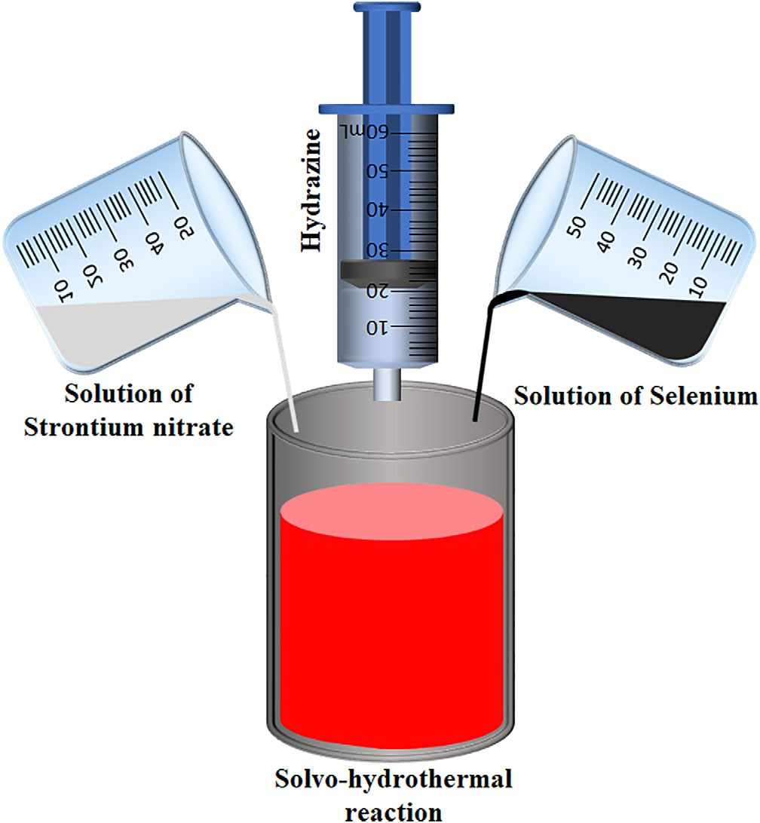

FIGURE 1 Schematic illustration for the synthesis of SrSe nanowires

(>99.5%, Sigma Aldrich), KOH (>99.5%, Sigma Aldrich), deionized water, autoclaves, and glass wares.

| Synthesis of strontium selenide
Spectroscopy (XPS, AXIS SUPRA+), scanning electron microscope (SEM, Model-FEI Scios), high-resolution transmission electron microscope (HRTEM, Model-Talos F200s), and energy-dispersive X-ray spectroscopy (EDS, Model-Super-X EDS Detector). Specific surface area and pore diameter has been measured using the Brunauer Emmett Teller (BET, ASAP2460) technique.

2.4 | Electrochemical measurements for HER

HER was performed using the three electrodes system using the Zahner Zennium TR8M electrochemical worksta- tion. The three electrodes setup consists of a reference elec- trode (Ag/AgCl), a counter electrode (carbon rod), and working electrodes (prepared samples). The paste of the
electrocatalysts was prepared into 5 mL ethanol, Nafion as a binder (5 μL), and 2.2 mg of the sample and deposited on NF substrate (1 × 1 cm²). The prepared electrodes were
dried at 60◦C in an electric furnace for 24 h. Linear sweep voltammetry (LSV) was performed at the scan rate of
10 mV s^{—1}, in to 5 mM H₂SO₄ (pH 2.5), 5 mM HCl (pH 2.9), 1 M NaCl (pH 7.2), and 1 M KOH (pH 13.90). The
cyclic voltammetry for the nonfaradaic area, the electro- chemical impedance spectroscopy, and the chronoampero- metry test were also performed for the HER process.
The overpotential was measured using the LSV data, which was transformed into reversible hydrogen elec- trode (RHE) potential using Equation (1),
◦

The solutions of strontium nitrate (0.8 M) and selenium powder (0.8 M) were prepared in 30 mL of deionized water into two separate beakers and the ultra-sonication was per-
ERHE
= EAg/AgCl
+ EAg/AgCl
+ (0.059 × pH), (1)

formed for 30 min at room temperature. After that, these solutions were mixed into an autoclave (100 mL) and 20 mL of hydrazine (35%) was added as a reducing agent using the syringe. The scheme has been illustrated in Figure 1. Similarly, a mixture of the solutions was prepared three times and the solvo-hydrothermal process was per- formed at 80◦C, 140◦C, and 200◦C in the same electric oven for 24 h. After completion of the reaction, products were washed and centrifuged with the mixture of ethanol and deionized water (500 mL, 1:1), 0.01 M HNO₃ and again with deionized water and dried at 60◦C in a vacuum tube (OTF-1200X) for 36 h.

| Characterization

The structure and morphology of the synthesized prod- ucts have been confirmed using the X-ray Diffractometer (XRD, Model-Rigaku Mini Flex 600), X-ray Photoelectron
where E_{Ag/AgCl} and E◦_{Ag/AgCl} were measured and the absolute thermodynamic potential of the Ag/AgCl elec- trode, respectively. The 0.059 is the correction faction for the specified pH of the electrolytes. The overpotential was measured at the state of art, the current density of 10 mA cm^{—2}. The Tafel slope was measured from the lin- ear part from the potential vs RHE (V) and log of current density (mA cm^{—2}) of LSV data, which satisfied Equation (2), and turnover frequency (TOF) was mea- sured using Equation (3),
η = a+ 2.303RT * log j, (2)

αnF

TOF = jA , (3)
2n * F

where F and n are, respectively, the Faraday constant (96 485 A s mol^{—1}) and the involved number of electrons

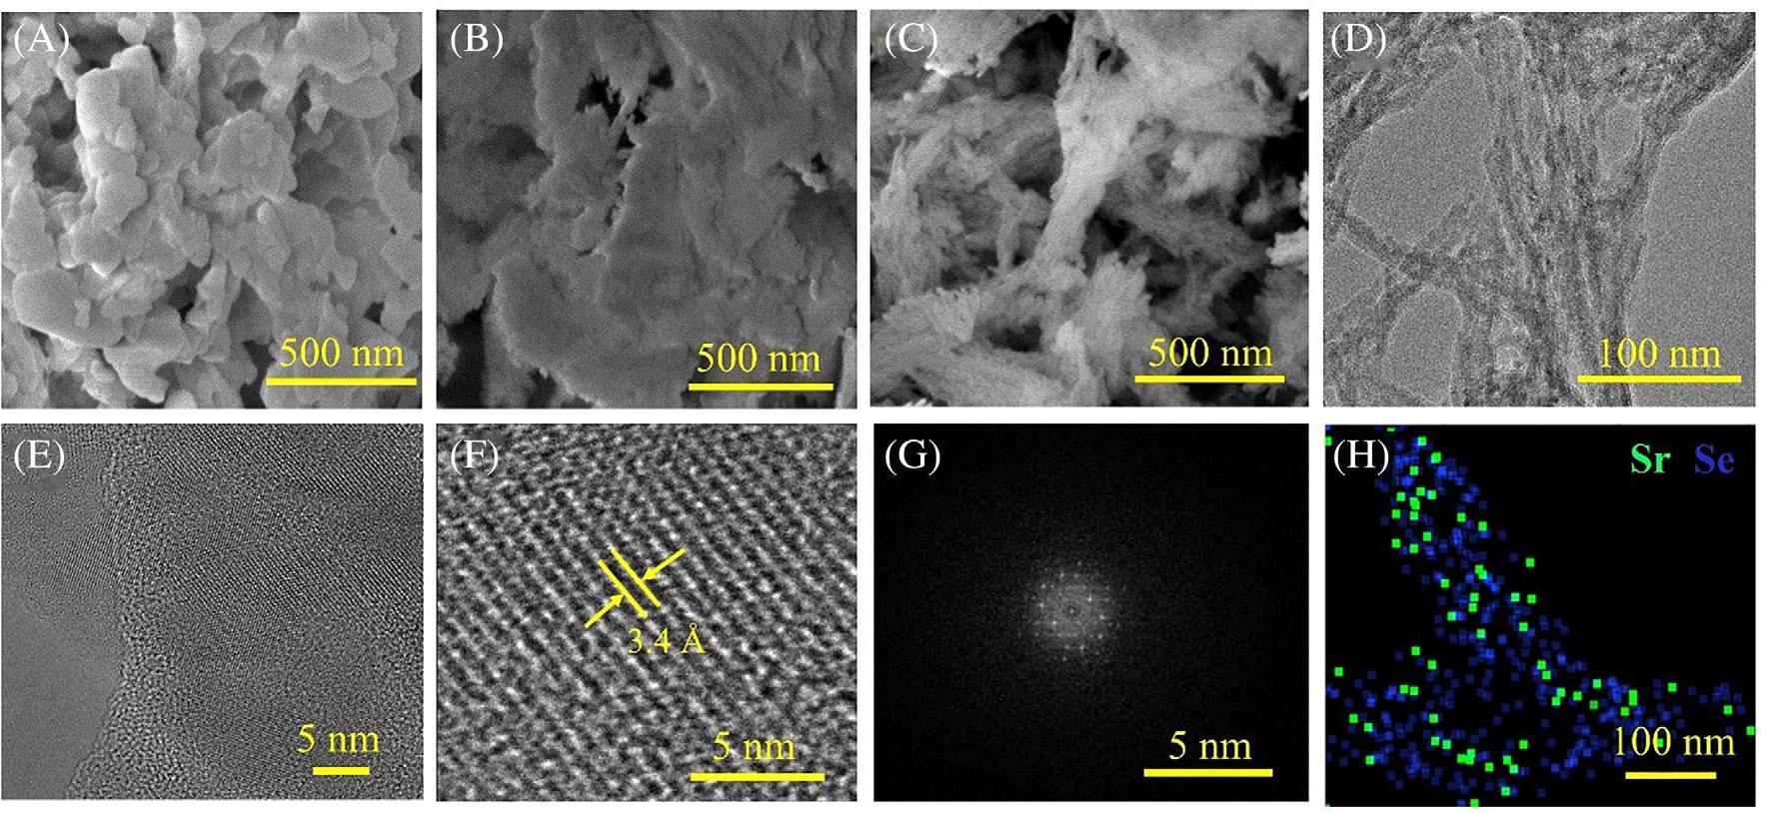

FIGURE 2 Scanning electron microscope images of (A) SrSe nanopallets, (B) hybrid morphology of SrSe nanowires and nanopallets,
(C) SrSe nanowires. (D, E) transmission electron microscope (TEM) images of SrSe nanowires, (F) interlayer spacing from the digital micrograph of highresolution TEM images of SrSe nanowires, (G) fast Fourier transform image, and (H) energydispersive X-ray spectroscopy mapping of SrSe nanowires

in the HER process, at the specified current density (j), and area of the NF substrate (A).Exchange current den- sity (J_{exc}) was calculated using Equation (4),
structure and HER activity. SEM reveals that the synthe- sis of SrSe at 80◦C exhibited a stack of interconnecting nanopallets-like morphology (Figure 2A). The selenium powder showed the aggregates of cotton-like fibbers

Jexc = RT nAFR_{ct}
, (4)
(Figure S1, detailed SI file). It can be concluded that SrSe was synthesized at 80◦C, slightly transformed from nano- fibers of selenium powder and the growth nucleation

where R and T are the universal gas constant and room temperature, respectively. R_{ct} is the charge transfer resis- tance, which has been obtained from the Nyquist plot. The electrochemical surface area (A_{ECSA}) was measured from non-Faradaic CV curves at various scan rates using Equation (5),⁶⁰

A_{ECSA} = Cdl , (5)
C_{s}

where C_{dl} is the double-layered specific capacitance and C_{s} is the general specific capacitance. The value of C_{s} is in the range of 20–60 μF cm^{—2} for a flat area. In the pre-
sent case, a medium value of C_{s} (40 μF cm^{—2}) has been
used for A_{ECSA} measurement.⁶¹

| RESULTS AND DISCUSSIONS

Morphology plays an important role to evaluate the syn- thesis process and characteristics of the synthesized materials for energy storage and conversion devices. The morphologies of the SrSe synthesis at different tempera- tures were examined using the SEM to evaluate the
occurred in the horizontal plane. SEM images of SrSe at 80◦C reveal that the synthesis temperature affected the reaction and led to the change in morphology. The SrSe synthesis at a higher temperature of 140◦C, shows a dual shape, consisting of nanopallets and nanowires (Figure 2B), which means, the growth process was influ- enced by the temperature and the growth nucleation occurs in both horizontal and vertical directions. When the temperature of the synthesis process increases to 200◦C, the morphology of SrSe was effectively changed showing the bundles of nanowires (Figure 2C). The clus- ters and interconnecting nanowires of strontium sele- nides provided evidence of the temperature effects on the growth process. The nucleation of the precursors hap- pened in the vertical shape and led to the successful syn- thesis of the SrSe nanowires.
Morphology of SrSe has also been performed using the TEM and HRTEM along with EDS mapping. TEM and HRTEM images of SrSe at 80◦C and 140◦C have been shown in the SI file. TEM and HRTEM images of the SrSe nanowires synthesized at 200◦C revealed well- defined nanowires with a diameter of a few nanometers (Figure 2D-F). HRTEM images of SrSe nanowires have been magnified using the digital micrograph software

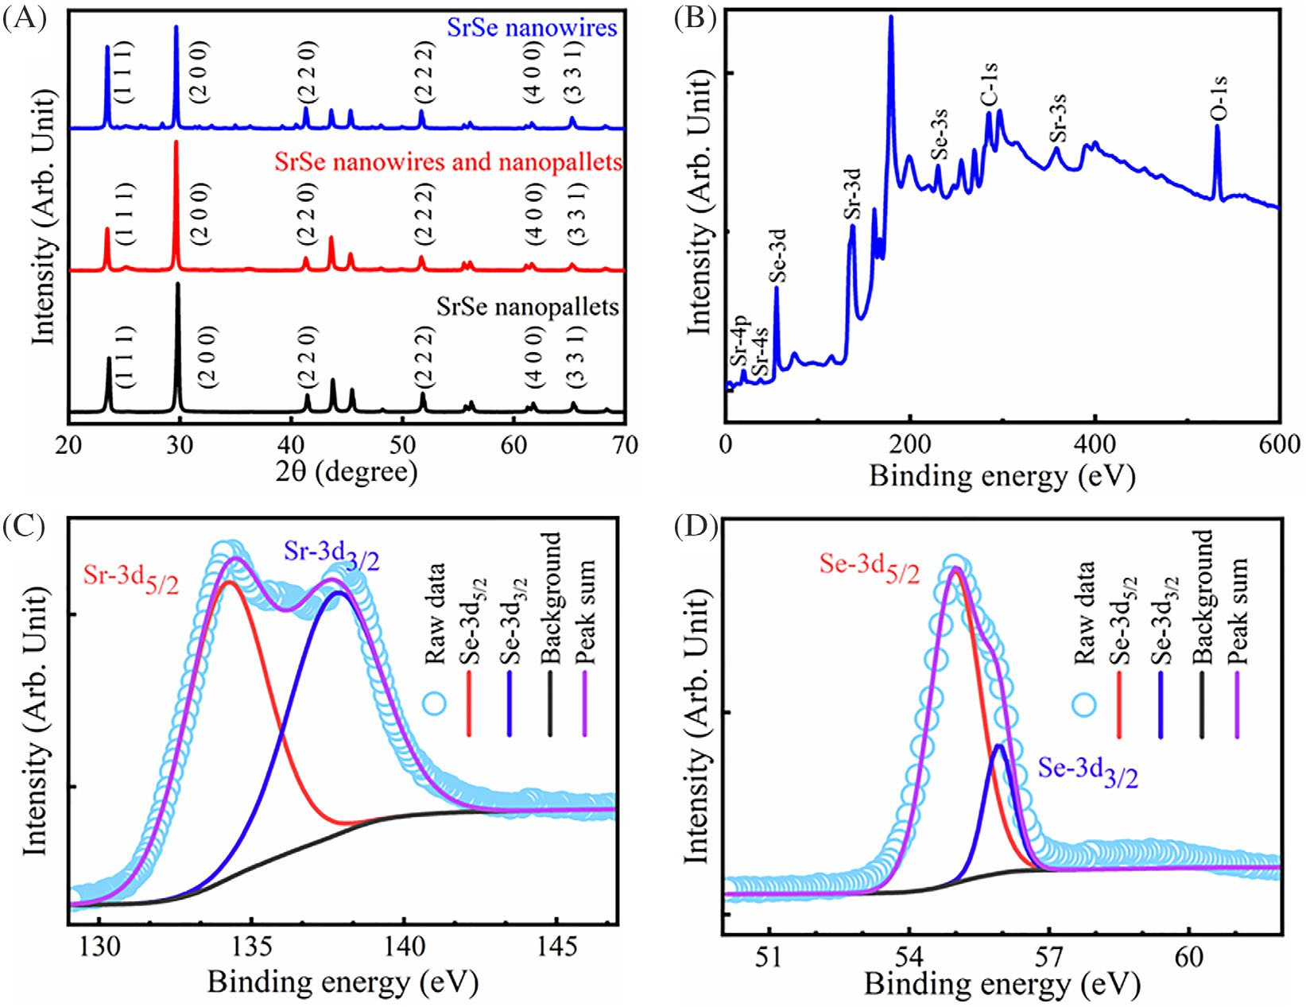

FIGURE 3 (A) Xray diffractometer pattern. (B) X-ray photoelectron spectroscopy (XPS) survey spectrum, XPS spectrum of
(C) strontium element, and (D) selenium element for SrSe nanowires

and the measured inter planner spacing is 3.4 Å (Figure 2F), while the fast Fourier transform (FFT) image reveals the dominant crystal phenomena for SrSe nano- wires (Figure 2G). The EDS mapping shows the uniform distribution of the strontium (green color) and selenium (blue color) atoms in the form of nanowires (Figure 2H), which is consistent with the SEM, TEM, and HRTEM indications. The uniqueness in the morphology confirms the successful synthesis of SrSe nanowires at 200◦C.
The structural properties of the synthesized electroca- talysts SrSe were subsequently examined using the XRD. XRD patterns of SrSe synthesized at different tempera- tures are similar, and they exhibit some peaks at the
same position in 2θ angle (Figure 3A) located at 23.60◦,
29.77◦, 41.48◦, 43.77◦, 45.60◦, 48.21◦, 51.85◦, 55.62◦,
56.14◦, 61.30◦, 61.82◦, and 65.44◦. However, some addi- tional peaks have been observed at 25.08, 26.45, 28.26,
31.61, 32.90, 34.97, 36.26, and 36.10, for SrSe nanowires synthesized at 200◦C, which provides evidence of the reactivity of strontium and selenium in SrSe nanowires. The peaks at 23.60◦, 28.26◦, 41.48◦, 51.85◦, 61.30◦, and
65.44◦ correspond to the planes (1 1 1), (2 0 0), (2 2 0),
(2 2 2), (4 0 0), and (3 3 1), respectively, which are well- matched with the JCPS card numbers of 98-005-3949 and 182 720, and reveal the cubic phase of strontium
selenides. Some peaks are not matched to the existed data for strontium selenide as the XRD data of the strontium selenides have been found very limited. However, the appeared peaks are well-matched with the cubic phase of the SrSe. The additional peaks may be due to some unknown phase of the strontium selenides, but the major peaks are identical to the cubic phase and provide evi- dence of successful synthesis of the SrSe nanowires.
Structural analysis was further confirmed using the XPS with Al Kα source and passing energy of 50 eV. The XPS data were analyzed using the CASAXPS software
and the binding energy of the elements was calibrated for compensation of the charge using the carbon energy C 1 s (284.8 eV).⁶² The XPS survey spectrum (Figure 3B) shows the coexistence of strontium (Sr-3 s, 4 s, 4p and 3d) and selenium (Se-3 s and 3d) elements, and confirms their reaction and the successful synthesis of SrSe nano- wires at 200◦C, (Figure 3B).^{63,64} The XPS spectrums for SrSe at 80◦C and 140◦C have also represented the co- existence of strontium and selenium (Figure S4). The XPS spectrum of SrSe at 80◦C shows the splitting of strontium at 134.10 and 138.58 eV, corresponding to Sr- 3d_{5/2} and Sr-3d_{3/2}, while the energy peaks of selenium at
55.35 and 56.30 eV correspond to Se-3d_{5/2} and Se-3d_{3/2}, respectively (Figure S4B,C). Similarly, SrSe synthesized at

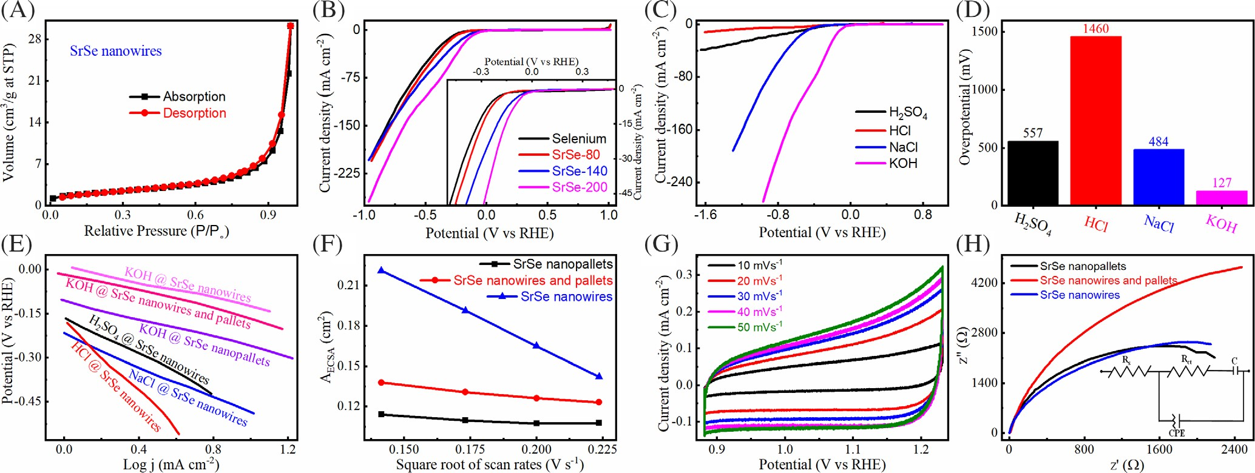

FIGURE 4 (A) N₂ adsorption and desorption isotherm curves for SrSe nanowires (B) Comparative linear sweep voltammetry (LSV) curves in 1 M KOH (C) Comparative LSV curves of SrSe nanowires in various electrolytes (D) Comparison of overpotential of SrSe nanowires in various electrolytes (E) Tafel plots with corresponding medium and electrocatalysts (F) A_{ECSA} variations in 1 M KOH (G) Non- faradaic CV curves for SrSe nanowires, in 1 M KOH (H) Nyquist plot with the fitting circuit in 1 M KOH

140◦C also shows the splitting of strontium at 133.96 and
137.48 eV corresponding to the Sr-d_{5/2} and Sr-3d_{3/2}, while the splitting of selenium at 54.67 and 55.30 eV corre- sponds to the Se 3d_{5/2}, respectively (Figure S5C,D). The SrSe nanowires also showed the same behavior for the splitting strontium at 133.45 and 137.20 eV and the split- ting of selenium at 54.30 and 55.10 eV (Figure 3C,D). The peaks split around 133.45 and 137.20 eV corresponding to the Sr-3d_{5/2} and Sr-3d_{3/2} states of strontium. The presence of Se-3d_{5/2} confirms the divalent nature of Se with a — 2 valence state.⁶⁴⁻⁶⁶ The very minor shifting of the binding energy peaks may be due to hydrazine, the influence of temperature, or the incorporation of oxygen from the environment. Furthermore, the atomic ratio of strontium and selenium was found as 26.51% and 32.62%, respec- tively, in SrSe nanowires. The stoichiometric ratio of SrSe nanowires is also approximately 1:1. The successful reac- tion of divalent strontium atom with divalent selenium confirms the synthesis of SrSe structure.
The BET-specific surface area and pore volume of dif- ferent SrSe have been measured using the N₂ adsorption– desorption isotherm curve. The N₂ adsorption–desorption isotherm curves of SrSe nanopallets, hybrid of SrSe nano-
wires and nanopallets, and SrSe nanowires have been shown in Figure S5A, and Figure 4A, respectively. The related measured data have also been summarized in Table S1. The SrSe nanowires show a greater specific sur- face area of 7.63 m²g^{—1} and a total pore volume of
0.047 m³g^{—1} as compared to SrSe nanopallets and hybrid
of SrSe nanowires and pallets, which might be due to the unique morphology of SrSe nanowires. The pore diame- ter has been found in the range of mesoporous range and
suggests the mesoporous structure, with a larger specific surface area for SrSe nanowires, synthesized at 200◦C.

| Hydrogen evolution reaction (HER)

The LSV of the electrocatalysts, including SrSe nanopal- lets, the hybrid of SrSe nanowires and nanopallets, and SrSe nanowires, has been performed in the potential win- dow of 0 and —2 V at the scan rate of 10 mV s^{—1}. The obtained LSV data in various electrolytes (5 mM H₂SO₄, 5 mM HCl, 1 M NaCl and 1 M KOH) on NF substrate were converted into RHE potential. In all employed elec- trolytes, SrSe nanowires attained a greater current den- sity as compared to SrSe nanopallets and the hybrid of SrSe nanowires and nanopallets, which might be due to the greatest A_{ECSA} and specific surface area of SrSe nano- wires (Figure 4B and S4A-C).⁶⁷ The SrSe nanowires revealed the well-defined LSV curves in 1 M KOH elec- trolytes, as compared to other electrocatalysts, as pre- sented in the inset of Figure 4B. SrSe nanopallets and the hybrid of SrSe nanowires and nanopallets have been dis- cussed in SI file with details and the related measured values are summarized in Table S2.
The SrSe nanowires revealed a good HER activity and exhibited a greater current density during the LSV testing in 1 M KOH electrolyte as compared to other electrolytes (Figure 4C). However, the electrocatalysts on NF show some instability and dissociation in a neutral medium, 1 M NaCl electrolyte. The electrocatalyst, SrSe nanowires produced strong bubbling and provided evidence of hydrogen evolution during LSV testing. The overpotential

is the first spine parameter to evaluate the HER activity of the electrocatalysts.⁶⁸ SrSe nanowires exhibited a good overpotential of 127 mV to approach the state-of-the-art current density of 10 mA cm^{—2}, and showed the onset potential of —0.525 V/_{Ag/AgCl} in an alkaline medium (1 M KOH), which is better than the HER activity in other electrolytes. The comparison of the overpotential in vari- ous electrolytes for SrSe nanowires has been given in Figure 4D showing the significant difference in overpo- tential in different electrolytes. However, the perfor- mance of the SrSe nanowires is very poor in 1 m HCl electrolyte. SrSe nanopallets and the hybrid of the SrSe nanowires and nanopallets also showed a better overpo- tential in 1 M KOH electrolyte and the measured overpo- tentials have been summarized in Table S2. Hence, the role of the electrolytes is also dominant with the perfor- mance of the electrocatalysts for the HER process. The better overpotential of SrSe nanowires may be attributed to the greater specific surface area, mesoporous nature, and morphology at a temperature of 200◦C. Resultantly, the SrSe nanowires exhibited a greater number of active sites for the HER process. The intercalation of the elec- trocatalyst and the electrolyte (1 M KOH) ions was suit- able, which promoted the adsorption and desorption of the hydrogen ions at the active sites and improved the HER activity. The alkaline metal-based SrSe nanowires exhibited a good overpotential of 127 mV, which has been compared to the other electrocatalyst, especially, the selenides-based electrocatalyst at the same current density of 10 mA cm^{—2}. The literature survey revealed that the overpotential of different electrocatalysts was observed as nickel cobalt selenide@118 mV in 1 M KOH,⁴⁵ Ag₂Se@405 mV, WSe₂@302 mV and Ag₂Se/1 T- WSe₂ nanosheets@140 mV in 1 M KOH,⁶⁹ NiSe₂ nanosheets@197 mV and NiSe nanoflakes@217 mV in
0.5 H₂SO_{4,}⁴⁰ NiSe₂/Ni₃Se4/NF-1@185 mV and NiSe₂/ Ni₃Se4/NF-4@145 mV in 1 M KOH,⁷⁰ FeSe₂@263 mV,
CoSe₂@166 mV, and (Co,Fe)Se₂@ 124 mV in 1 M KOH,⁷¹ hollow CoSe₂/MoSe₂@168 mV in 1 M KOH,⁷² MoSe₂-ts@MoS₂-ts@186 mV in 0.5 H₂SO_{4,}⁷³ MoSe₂@170 mV in 1 M KOH,⁷⁴ Mo(S_{1—x}Se_{x})₂@161 mV in 0.5 M H₂SO_{4,}⁷⁵ MoS₂/SnS₂@288 mV in 0.5 M H₂SO_{4,}⁷⁶ PyCoPc/GO-800@253 mV in 1 M KOH,⁷⁷ Ni-
WSe₂@215 mV in 0.5 M KOH,⁴¹ etc. The observation reveals that the performance of the simple of SrSe nano- wires is good and the comparative results will inspire the researchers to explore the alkaline metal-based electroca- talysts in detail for the HER process.
Tafel slope and TOF are the crucial parameters to eval- uate the HER activity of the catalysts.⁷⁸ SrSe nanowires exhibited the smallest Tafel slope of 135 mV dec^{—1} as com- pared to SrSe nanopallets (155 mV dec^{—1}) and the hybrid of SrSe nanowires and nanopallets (156 mV dec^{—1}) in 1 M
KOH. Owing to the good Tafel slope of SrSe nanowires in 1 M KOH, the Tafel slope of the SrSe nanowires was also measured as 318, 598 and 264 mV dec^{—1}, in H₂SO₄, HCl and NaCl electrolytes, respectively, and the corresponding plots have been presented in Figure 4E. The Tafel slopes of the SrSe nanopallets and the hybrid of the SrSe nanowires and nanopallets have been measured and summarized in Table S2 and the corresponding plots are shown in Figure S6D. The Tafel slope of the SrSe nanowires was found better compared to other electrocatalysts in1 M KOH and revealed the fast HER activity. The smaller Tafel slope of the SrSe nanowires might be due to greater A_{ECSA} and the number of active sites, which facilitated the adsorption and desorption processes of the active hydrogen atoms. The Tafel slope of the alkaline metal-based SrSe nanowires has also been compared with other selenides-based structures: Nickel cobalt selenide@144 mV dec^{—1} in M KOH,⁴⁵ Ag₂Se@245, WSe₂@254 mV dec^{—1} and Ag₂Se/1 T-WSe nanosheets@125 mV dec^{—1} in M KOH,⁶⁹ pristine WSe₂@152 mV dec^{—1} in 0.5 M KOH⁴¹ and ReSe₂ bulk @136.20 mV dec^{—1} in M KOH.⁷⁹ The comparative results show that the simply synthesized SrSe nanowires have potential applications HER process. The CV nonfaradaic curves were performed in 1 M KOH to measure the A_{ECSA} of the electrocatalysts. SrSe nanowires exhibited the largest A_{ECSA} at various scan rates, as compared to SrSe nanopal- lets and the hybrid of SrSe nanowires and nanopallets (Figure 4F) in 1 M KOH. The A_{ECSA} decreases linearly with the square root of the scan rates and measured A_{ECSA} at various scan rates in 1 M KOH electrolyte has been sum- marized in Table S3. The nanofaradaic curves for SrSe nanowires in 1 M KOH at various scan rates are shown in Figure 4G, while the non-faradaic CV curves for SrSe nano- pallets and hybrid morphology of SrSe nanowires and pal- lets have been presented in Figure S6E,F. The good Tafel slope of SrSe nanowires is definitely due to greater A_{ECSA}, which exhibits the more active sites, promotes the transfer of electrons, and facilitates the HER process. Moreover, the nanowires-like structure controls the direction of the charge and increases the adsorption and desorption of the hydrogen atoms at the active sites, and, therefore, enhances the HER activity for SrSe nanowires. TOF was also mea- sured at the fixed RHE potential of 500 mV. The SrSe nano- wires show fast HER activity with a good TOF of
26.70 ms^{—1} in 1 M KOH electrolyte as compared to in other electrocatalysts and electrolytes (summarized in Table S2). EIS was also performed in the range of 0.1 to 10⁵ Hz and the Nyquist plot from EIS data reveals that SrSe nanopallets and SrSe nanowires followed a similar trend, which was different from the hybrid of SrSe nanowires and nanopal- lets (Figure 4H). They showed a smaller charge transfer resistance in alkaline 1 M KOH electrolyte as compared to other electrocatalysts. The charge transfer resistance (R_{ct})

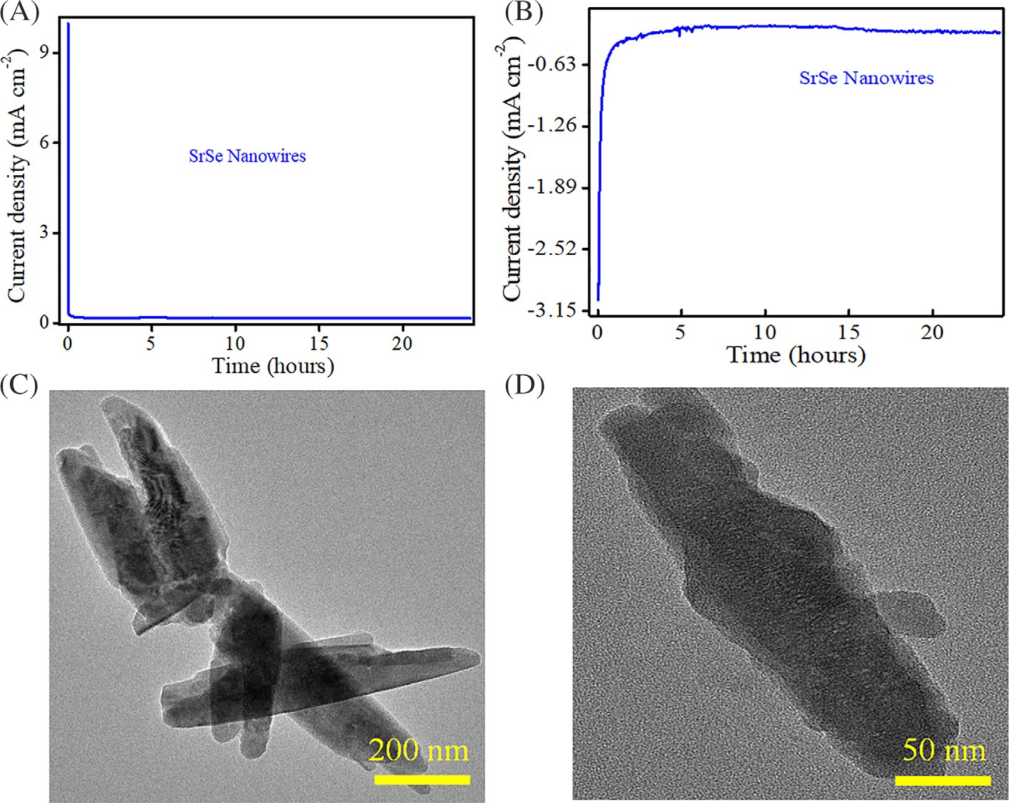
FIGURE 5
(A) Chronoamperometry stability curve in forward biased in 1 M KOH
(B) Chronoamperometry stability curve after 190 d in revised biased in 1 M KOH. Transmission electron microscope images after 190 d and Chronoamperometry stability test at different resolutions (C) 200 nm and
(D) 50 nm for SrSe nanowires

was measured using the equivalent circuit (inset of Figure 4H), which shows that the electrocatalysts exhibit the capacitive behavior and showed the same solution and charge transfer resistance, without the Warburg compo-
nent. The R_{ct} was employed to measure the J_{exc}. The mea- sured R_{ct} was 0.796, 1.640, and 0.967 Ω and the J_{exc} was 16.230, 7.830, and 13.300 mA cm^{—2}, for SrSe nanopallets,
the hybrid of SrSe nanowires and nanopallets, and SrSe nanowires in 1 M KOH electrolyte, respectively. Moreover, the SrSe nanowires exhibited the smallest R_{ct} of 0.967 Ω
with the largest J_{exc} of 0.013 mA cm^{—2} in 1 M KOH, as
compared to other electrolytes. Furthermore, the EIS mea- surements of the SrSe nanowires in other electrolytes were
R_{ct} of 34.800 Ω with J_{exc} of 0.37 mA cm^{—2} in 1 M NaCl, R_{ct} of 127 Ω with J_{exc} of 0.10 mA cm^{—2} in 1 M HCl, and R_{ct} of
38.80 Ω with J_{exc} of 0.33 mA cm^{—2} in 1 M H₂SO₄. Thus, the
J_{exc} current density was good in alkaline electrolyte, 1 M KOH, which might be due to the smooth flow of charge carriers and good intercalation of the electrolyte ion, which facilitates the conduction process for HER. The good HER activity in 1 M KOH electrolyte for SrSe nanowire may be attributed due to nanowires-like unique morphology, greater A_{ECSA} and specific surface area, which facilitate the transport of charge carriers on soft NF substrate and enhanced the HER activity.^{80,81}
The stability of the electrocatalyst is a fundamental and significant parameter for the evaluation of the HER activity. The stability of SrSe nanowires has been performed using chronoamperometry at 1.0 V in 1 M KOH electrolyte for 24 h. The current density got several seconds for
adjustment and after that exhibited the almost same cur- rent density for 24 h (Figure 5A). The electrocatalyst exhib- ited the current density of 9.98 mA cm^{—2} earlier but abruptly dropped to 0.188 mA cm^{—2} until 0.724 h. The SrSe nanowires attained the current density of 0.176 mA cm^{—2} at 1.03 h and remained constant until 24 h. The stability test of SrSe nanowires has also been performed after 190 d, in a revised biased region at —1.0 V, in 1 M KOH electro- lyte for 24 h. The SrSe nanowires exhibited similar behavior in revised regions, and exhibited a greater current density of —3.04 mA cm^{—2} at earlier (Figure 5B). However, the cur- rent density abruptly reduced and reached
—0.418 mA cm^{—2} at 1.21 h. The SrSe nanowires exhibited a lower current density of —0.238 mA cm^{—2} from a time interval of 8.6 to 14.20 h in the revised region. After that, the current density gradually increased to —0.275 mA cm^{—2} at 16 h and approached —0.292 mA cm^{—2} at the end of 24 h. The smoothness of current density even after 190 d of the test predicted the good stable nature of the electrocata- lysts consisting of SrSe nanowires. The greater number of TOF and J_{exc} reveals that the SrSe nanowires are conduc- tive enough, stand for a long time without decay in the cur- rent density, and provide evidence of the stable structure.
Furthermore, the morphological stability of the elec- trocatalyst, SrSe nanowires has also been performed using the SEM and TEM of different magnifications and resolutions. The SEM images show the bundles of nano- wires, which are slightly dispersed in 1 M KOH during 24 h stability test but they maintain the nanowires-like shape (Figure S7). Moreover, the TEM images at different

resolution magnifications show the “soft” shape of nano- wires with a slightly greater diameter at the end of the stability test after 190 d (Figure 5C,D). Hence, the electro- catalyst consisting of SrSe nanowires also exhibited a sim- ilar shape and morphology even after 24 h stability test after 190 d. The greater number of active sites at the suit- able synthesis condition and unidirectional morphology causes the smooth electrons transfer process and results in better HER activity of the SrSe nanowires. So, it can be concluded that SrSe nanowires can be an effective elec- trocatalyst for the hydrogen evolution process.

| CONCLUSION

The SrSe nanowires have been successfully synthesized at 200◦C using the solvo-hydrothermal process. The growth nucleation of the precursors occurred in the verti- cal direction at 200◦C for the unique morphology of the nanowires with a large number of active sites inside the strontium selenide. The large A_{ECSA}, specific surface area, mesoporosity, and active sites jointly promoted the charge transfer for the HER process and the SrSe nano- wires reveal better HER activity in 1 M KOH electrolyte. The SrSe nanowires exhibit the overpotential of 127 mV to approach the current density of 10 mA cm^{—2} and a Tafel slope of 135 mV dec^{—1}. The SrSe nanowires show a greater TOF of 41.20 ms^{—1} at the fixed RHE potential of 500 mV. The greater TOF and J_{exc} reveal that the meso- porous SrSe nanowires facilitate the adsorption and desorption of the hydrogen atoms at the inside active sites and enhanced the HER reactivity in the 1 M KOH electrolyte. The electrocatalyst, SrSe nanowires also maintain the current density for 24 h providing evidence for the stable structure. Hence, the alkaline metal-based SrSe nanowires can be an effective electrocatalyst for HER. The test results will inspire the researchers to explore more about alkaline-based electrocatalysts.

ACKNOWLEDGEMENT
This work was financially supported by Guangdong Basic and Applied Basic Research Foundation (No. 2021A1515011858) and Natural Science Foundation of Shenzhen University under grant 860-000002110423.

CONFLICT OF INTEREST
All authors have participated in this manuscript and have no conflict of interest.

REFERENCES
- Chen L, Guo Y, Wang H, et al. Imidazolate-mediated assem- bled structures of co-LDH sheets for efficient electrocatalytic oxygen evolution. J Mater Chem A. 2018;6:4636-4641.
- Yang Y, Zhang K, Lin H, et al. MoS2–Ni3S2 Heteronanorods as efficient and stable Bifunctional Electrocatalysts for overall water splitting. ACS Catal. 2017;7:2357-2366.
- Shao Y, El-Kady MF, Sun J, et al. Design and mechanisms of asymmetric Supercapacitors. Chem Rev. 2018;118:9233-9280.
- Chu S, Majumdar A. Opportunities and challenges for a sus- tainable energy future. Nature. 2012;488:294-303.
- Jin H, Hong Y, Yoon J, et al. Lanthanide metal-assisted synthe- sis of rhombic dodecahedral MNi (M = Ir and Pt) nanoframes toward efficient oxygen evolution catalysis. Nano Energy. 2017; 42:17-25.
- Liu Y, Li Y, Kang H, Jin T, Jiao L. Design, synthesis, and energy-related applications of metal sulfides. Mater Horiz. 2016;3:402-421.
- Yuan C, Wu HB, Xie Y, Lou XW. Mixed transition-metal oxides: design, synthesis, and energy-related applications. Angew Chem Int Ed. 2014;53:1488-1504.
- Tang S, Qiu W, Xiao S, Tong Y, Yang S. Harnessing hierarchi- cal architectures to trap light for efficient photoelectrochemical cells. Energ Environ Sci. 2020;13:660-684.
- Xu S, Zhao H, Li T, et al. Iron-based phosphides as electrocata- lysts for the hydrogen evolution reaction: recent advances and future prospects. J Mater Chem A. 2020;8:19729-19745.
- Khan QU, Ishaq MW, Begum N, et al. Nanoscale CuTe electro- catalyst immobilized at conductor surface for remarkable hydrogen evolution reaction. Int J Hydrogen Energy. 2021;46: 18729-18739.
- Xiao L, Chen J, Wu Y, et al. Effects of pressure levels in three- cascade storage system on the overall energy consumption in the hydrogen refueling station. Int J Hydrogen Energy. 2021;46: 31334-31345.
- Dubouis N, Grimaud A. The hydrogen evolution reaction: from material to interfacial descriptors. Chem Sci. 2019;10:9165-9181.
- Zou X, Zhang Y. Noble metal-free hydrogen evolution catalysts for water splitting. Chem Soc Rev. 2015;44:5148-5180.
- Iqbal MF, Yang Y, Hassan MU, et al. Polyaniline grafted meso- porous zinc sulfide nanoparticles for hydrogen evolution reac- tion. Int J Hydrogen Energy. 2022;47:6067-6077.
- Chandrasekaran S, Yao L, Deng L, et al. Recent advances in metal sulfides: from controlled fabrication to electrocatalytic, photocatalytic and photoelectrochemical water splitting and beyond. Chem Soc Rev. 2019;48:4178-4280.
- Roger I, Shipman MA, Symes MD. Earth-abundant catalysts for electrochemical and photoelectrochemical water splitting. Nat Rev Chem. 2017;1:3.
- Govind Rajan A, Martirez JMP, Carter EA. Why do we use the materials and operating conditions we use for heterogeneous (photo)electrochemical water splitting? ACS Catal. 2020;10: 11177-11234.
- Xu Y, Wang C, Huang Y, Fu J. Recent advances in electrocata- lysts for neutral and large-current-density water electrolysis. Nano Energy. 2021;80:105545.
- Peng X, Yan Y, Jin X, et al. Recent advance and prospectives of electrocatalysts based on transition metal selenides for efficient water splitting. Nano Energy. 2020;78:105234.
- Sheng W, Zhuang Z, Gao M, Zheng J, Chen JG, Yan Y. Corre- lating hydrogen oxidation and evolution activity on platinum at different pH with measured hydrogen binding energy. Nat Commun. 2015;6:5848.

- Li Y, Zhang H, Xu T, et al. Under-water Superaerophobic pine- shaped Pt Nanoarray electrode for ultrahigh-performance hydrogen evolution. Adv Funct Mater. 2015;25:1737-1744.
- Tang Y, Yang C, Sheng M, et al. Phosphorus-doped molybde- num carbide/MXene hybrid architectures for upgraded hydro- gen evolution reaction performance over a wide pH range. Chem Eng J. 2021;423:130183.
- Peng X, Pi C, Zhang X, Li S, Huo K, Chu P. Recent Progress of transition metal nitrides for efficient Electrocatalytic water splitting. Sustain Energy Fuels. 2019;3:366-381.
- Zhu Y, Lin Q, Zhong Y, Tahini HA, Shao Z, Wang H. Metal oxide-based materials as an emerging family of hydrogen evo- lution electrocatalysts. Energ Environ Sci. 2020;13:3361-3392.
- Zhang C, Xia MS, Liu ZP, et al. Self-assembly mesoporous FeP film with high porosity for efficient hydrogen evolution reac- tion. ChemCatChem. 2020;12:2589-2594.
- Peng K, Wang H, Gao H, Wan P, Ma M, Li X. Emerging hierar- chical ternary 2D nanocomposites constructed from montmo- rillonite, graphene and MoS₂ for enhanced electrochemical hydrogen evolution. Chem Eng J. 2020;393:124704.
- Hegazy MBZ, Berber MR, Yamauchi Y, Pakdel A, Cao R, Apfel UP. Synergistic Electrocatalytic hydrogen evolution in Ni/NiS nanoparticles wrapped in multi-heteroatom-doped reduced graphene oxide Nanosheets. ACS Appl Mater Inter- faces. 2021;13:34043-34052.
- Chen Y, Zhang J, Guo P, et al. Coupled Heterostructure of Mo–
Fe selenide Nanosheets supported on carbon paper as an inte- grated Electrocatalyst for efficient hydrogen evolution. ACS Appl Mater Interfaces. 2018;10:27787-27794.
- Bradwell DJ, Osswald S, Wei W, Barriga SA, Ceder G, Sadoway DR. Recycling ZnTe, CdTe, and other compound semiconductors by Ambipolar electrolysis. J Am Chem Soc. 2011;133:19971-19975.
- Jang YJ, Lee J, Lee J, Lee JS. Solar hydrogen production from zinc telluride photocathode modified with carbon and molyb- denum sulfide. ACS Appl Mater Interfaces. 2016;8:7748-7755.
- Li X, Fang Y, Wang J, et al. Ordered clustering of single atomic Te vacancies in atomically thin PtTe2 promotes hydrogen evo- lution catalysis. Nat Commun. 2021;12:2351.
- Ashok A, Kumar A, Ponraj J, Mansour SA. Development of co/Co₉S₈ metallic nanowire anchored on N-doped CNTs through the pyrolysis of melamine for overall water splitting. Electrochim Acta. 2021;368:137642.
- Ronchi RM, Arantes JT, Santos SF. Synthesis, structure, prop- erties and applications of MXenes: current status and perspec- tives. Ceram Int. 2019;45:18167-18188.
- Cui C, Cheng R, Zhang H, et al. Ultrastable MXe- ne@Pt/SWCNTs' Nanocatalysts for hydrogen evolution reac- tion. Adv Funct Mater. 2020;30:2000693.
- Luo J, Matios E, Wang H, Tao X, Li W. Interfacial structure design of MXene-based nanomaterials for electrochemical energy storage and conversion. InfoMat. 2020;2:1057-1076.
- Zhou Y-N, Zhu Y-R, Chen X-Y, Dong B, Li Q-Z, Chai Y-M. Carbon–based transition metal sulfides/selenides nanostruc- tures for electrocatalytic water splitting. J Alloys Compd. 2021;
852:156810.
- Anantharaj S, Ede SR, Sakthikumar K, Karthick K, Mishra S, Kundu S. Recent trends and perspectives in electrochemical water splitting with an emphasis on sulfide, selenide, and
phosphide catalysts of Fe, co, and Ni: a review. ACS Catal. 2016;6:8069-8097.
- Iqbal MF, Ashiq MN, Zhang M. Design of Metals Sulfides with carbon materials for Supercapacitor applications: a review. Energ Technol. 2021;9:2000987.
- Petroni E, Lago E, Bellani S, et al. Liquid-phase exfoliated indium-selenide flakes and their application in hydrogen evo- lution reaction. Small. 2018;14:1800749.
- Bhat KS, Nagaraja HS. Nickel selenide nanostructures as an electrocatalyst for hydrogen evolution reaction. Int J Hydrogen Energy. 2018;43:19851-19863.
- Kadam SR, Enyashin AN, Houben L, Bar-Ziv R, Bar-Sadan M. Ni–WSe₂ nanostructures as efficient catalysts for electrochemi- cal hydrogen evolution reaction (HER) in acidic and alkaline
media. J Mater Chem A. 2020;8:1403-1416.
- Zou Z, Wang X, Huang J, Wu Z, Gao F. An Fe-doped nickel selenide nanorod/nanosheet hierarchical array for efficient overall water splitting. J Mater Chem A. 2019;7:2233-2241.
- Kim JK, Park GD, Kim JH, Park S-K, Kang YC. Rational design and synthesis of extremely efficient macroporous CoSe₂–CNT composite microspheres for hydrogen evolution reaction.
Small. 2017;13:1700068.
- Deng S, Yang F, Zhang Q, et al. Phase modulation of (1T-2H)- MoSe2/TiC-C Shell/Core arrays via nitrogen doping for highly efficient hydrogen evolution reaction. Adv Mater. 2021;33: 2006056.
- Ma S, Huang J, Zhang C, et al. One-step in-situ sprouting high- performance NiCoS_{x}Se_{y} bifunctional catalysts for water elec- trolysis at low cell voltages and high current densities. Chem Eng J. 2022;435:134859.
- Majhi KC, Yadav M. Sphere-shaped bimetallic Sulphoselenide: an efficient Electrocatalyst for hydrogen evolution reaction. Energy Fuel. 2021;35:12473-12481.
- Liang W, Gao J, Wang X, et al. Nitrogen and phosphorus co- doped non stoichiometric cobalt selenides (Co_{0.85}Se) ultrathin nanosheets as highly efficient electrocatalysts for the hydrogen evolution reaction. Mater Chem Phys. 2022;278:125693.
- Yue H, Yang D, Yu B, Lu Y, Zhang W, Chen Y. Porous inter- woven CoSe₂/C microsphere: a highly efficient and stable non- precious electrocatalyst for hydrogen evolution reaction. J Mater Sci. 2019;54:14123-14133.
- Xu H, Shen M. The control of lithium-ion batteries and super- capacitors in hybrid energy storage systems for electric vehi- cles: a review. Int J Energy Res. 2021;45:20524-20544.
- Ajuria J, Redondo E, Arnaiz M, Mysyk R, Rojo T, Goikolea E. Lithium and sodium ion capacitors with high energy and power densities based on carbons from recycled olive pits. J Power Sources. 2017;359:17-26.
- Iqbal MZ, Faisal MM, Ali SR. Integration of supercapacitors and batteries towards high-performance hybrid energy storage devices. Int J Energy Res. 2021;45:1449-1479.
- Chen X, Zhang Y. The main problems and solutions in practi- cal application of anode materials for sodium ion batteries and the latest research progress. Int J Energy Res. 2021;45:9753- 9779.
- Iqbal MF, Ashiq MN, Razaq A, Saleem M, Parveen B, Hassan MU. Excellent electrochemical performance of gra- phene oxide based strontium sulfide nanorods for supercapaci- tor applications. Electrochim Acta. 2018;273:136-144.

- Sereshti H, Zamiri Afsharian E, Esmaeili Bidhendi M, Rashidi Nodeh H, Afzal Kamboh M, Yilmaz M. Removal of phosphate and nitrate ions aqueous using strontium magnetic graphene oxide nanocomposite: isotherms, kinetics, and thermodynam- ics studies. Environ Prog Sustain Energy. 2020;39:13332.
- Ni G-X, Shu B, Huang G, Lu WW, Pan H-B. The effect of stron- tium incorporation into hydroxyapatites on their physical and biological properties, journal of biomedical materials research part B: applied. Biomaterials. 2012;100B:562-568.
- Mishra SB, Mishra AK, Revaprasadu N, et al. Strontium aluminate/polymer composites: morphology, luminescent properties, and durability. J Appl Polym Sci. 2009;112:3347- 3354.
- Zhong C, Deng Y, Hu W, Qiao J, Zhang L, Zhang J. A review of electrolyte materials and compositions for electrochemical supercapacitors. Chem Soc Rev. 2015;44:7484-7539.
- Li F, Han G-F, Noh H-J, Ahmad I, Jeon I-Y, Baek J-B. Mechan- ochemically assisted synthesis of a Ru catalyst for hydrogen evolution with performance superior to Pt in both acidic and alkaline media. Adv Mater. 2018;30:1803676.
- Chakraborty B, Beltr´an-Suito R, Hlukhyy V, Schmidt J,
Menezes PW, Driess M. Crystalline copper selenide as a reli- able non-Noble electro(pre)catalyst for overall water splitting. ChemSusChem. 2020;13:3222-3229.
- Yu Y, Jiang K, Luo M, et al. Self-activated catalytic sites on Nanoporous dilute alloy for high-efficiency electrochemical hydrogen evolution. ACS Nano. 2021;15:5333-5340.
- Wang X-D, Xu Y-F, Rao H-S, et al. Novel porous molybdenum tungsten phosphide hybrid nanosheets on carbon cloth for effi- cient hydrogen evolution. Energ Environ Sci. 2016;9:1468-1475.
- Zhang X, Liu T, Guo T, et al. High-performance MoC Electro- catalyst for hydrogen evolution reaction enabled by surface sul- fur substitution. ACS Appl Mater Interfaces. 2021;13:40705- 40712.
- Zhao Y, Jin B, Zheng Y, Jin H, Jiao Y, Qiao S-Z. Charge state manipulation of cobalt selenide catalyst for overall seawater electrolysis. Adv Energy Mater. 2018;8:1801926.
- Chen T, Tan Y. Hierarchical CoNiSe2 nano-architecture as a high-performance electrocatalyst for water splitting. Nano Res. 2018;11:1331-1344.
- Liu H, Qian X, Niu Y, Chen M, Xu C, Wong K-Y. Hierarchical Ni-MoSe_{x}@CoSe₂ core-shell nanosphere as highly active bifunctional catalyst for efficient dye-sensitized solar cell and alkaline hydrogen evolution. Chem Eng J. 2020;383:123129.
- Wang Z, Yang Q, Liu W, et al. Optical porous hollow-boxes assembled by SrSO₄/TiO₂/Pt nanoparticles for high perfor- mance of photocatalytic H2 evolution. Nano Energy. 2019;59: 129-137.
- Yuan F, Wang S, Liang K, et al. Ni nanodendrites prepared by a low-temperature process as electrocatalysts for hydrogen evo- lution reaction in alkaline solution. Mol Catal. 2021;516: 112006.
- Wu Q, Dong A, Yang C, Ye L, Zhao L, Jiang Q. Metal-organic framework derived Co3O4@Mo-Co3S4-Ni3S2 heterostructure supported on Ni foam for overall water splitting. Chem Eng J. 2021;413:127482.
- Muska M, Wang Y, Yang J, et al. Quasi-monolayer Ag₂Se/1T- WSe₂ Nanosheets for enhanced Electrocatalytic hydrogen
evolution and charge storage. ACS Appl Nano Mater. 2022;5: 6410-6421.
- Tan L, Yu J, Wang H, et al. Controllable synthesis and phase- dependent catalytic performance of dual-phase nickel selenides on Ni foam for overall water splitting. Appl Catal Environ. 2022;303:120915.
- Xue Y, Wang X, Zhu M, et al. Construction of hollow structure cobalt iron selenide polyhedrons for efficient hydrogen evolu- tion reaction. Int J Energy Res. 2020;44:12045-12055.
- Tang X, Zhang J-Y, Mei B, et al. Synthesis of hollow CoSe₂/- MoSe₂ nanospheres for efficient hydrazine-assisted hydrogen evolution. Chem Eng J. 2021;404:126529.
- Sharma MD, Mahala C, Basu M. 2D thin sheet Heterostruc- tures of MoS₂ on MoSe₂ as efficient Electrocatalyst for hydro- gen evolution reaction in wide pH range. Inorg Chem. 2020;59: 4377-4388.
- Chang YS, Chen CY, Ho CJ, et al. Surface electron accumula- tion and enhanced hydrogen evolution reaction in MoSe2 basal planes. Nano Energy. 2021;84:105922.
- Lin Z, Lin B, Wang Z, et al. Facile preparation of 1T/2H-Mo (S_{1-x}Se_{x})₂ nanoparticles for boosting hydrogen evolution reac- tion. ChemCatChem. 2019;11:2217-2222.
- Xiao X, Wang Y, Xu X, Yang T, Zhang D. Preparation of the flower-like MoS₂/SnS₂ heterojunction as an efficient electroca- talyst for hydrogen evolution reaction. Mol Catal. 2020;487: 110890.
- Chen L, Sagar RUR, Chen J, et al. Cobalt phthalocyanine as an efficient catalyst for hydrogen evolution reaction. Int J Hydro- gen Energy. 2021;46:19338-19346.
- Zhu C, Gao D, Ding J, Chao D, Wang J. TMD-based highly effi- cient electrocatalysts developed by combined computational and experimental approaches. Chem Soc Rev. 2018;47:4332- 4356.
- Guo X, Wu T, Zhao S, et al. Band structure engineering of W replacement in ReSe₂ nanosheets for enhancing hydrogen evo- lution. Chem Commun. 2022;58:2682-2685.
- Zhuang P, Sun Y, Dong P, et al. Revisiting the role of active sites for hydrogen evolution reaction through precise defect adjusting. Adv Funct Mater. 2019;29:1901290.
- Xiao W, Liu P, Zhang J, et al. Dual-functional N dopants in edges and basal plane of MoS₂ Nanosheets toward efficient and durable hydrogen evolution. Adv Energy Mater. 2017;7: 1602086.

SUPPORTING INFORMATION
Additional supporting information can be found online in the Supporting Information section at the end of this article.

