Insights into electrode architectures and lithium-ion transport in polycrystalline V₂O₅ cathodes of solid-state batteries
Zhenjiang Yu¹, Hongmei Shan²*, Yunlei Zhong³, Guo Hong⁴*, Kwan San Hui⁵, Xia Zhang⁶, Kwun Nam Hui¹*
- Institute of Applied Physics and Materials Engineering, University of Macau, Avenida da Universidade, Taipa, Macau SAR, 999078, China
- School of Materials, Sun Yat-sen University, Guangzhou, 510275, China
- Key Laboratory of Multifunctional Nanomaterials and Smart Systems, Division of Advanced Materials, Suzhou Institute of Nano-Tech and Nano-Bionics, Chinese Academy of Sciences, Suzhou, 215123 China
- Department of Materials Science and Engineering & Center of Super-Diamond and Advanced Films, City University of Hong Kong, 83 Tat Chee Avenue, Kowloon, Hong Kong SAR 999077, China
- School of Engineering, Faculty of Science, University of East Anglia, Norwich, NR4 7TJ, United Kingdom
- Institute of Applied Materials, Helmholtz Centre Berlin for Materials and Energy, Hahn-Meitner-Platz 1, Berlin, 14109, Germany
*Corresponding authors. E-mail addresses: bizhui@umac.mo (Kwun Nam Hui); hongmeishan1226@163.com (Hongmei Shan); guohong@cityu.edu.hk (Guo Hong)
Abstract
Polymer-based solid-state batteries (SSBs) have received increasing attentions due to the absence of interfacial problems in sulfide/oxide-type SSBs, but the lower oxidation potential of polymer-based electrolytes greatly limits the application of conventional high-voltage cathode such as LiNi_{x}Co_{y}Mn_{z}O₂ (NCM) and lithium-rich NCM. Herein, we report on a lithium-free V₂O₅ cathode that enables the applications of polymer-based solid-state electrolyte (SSE) with high energy density due to the microstructured transport channels and suitable operational voltage. Using a synergistic combination of structural inspection and non-destructive X-ray computed tomography (X-CT), we interpret the chemo-mechanical behaviors that determines the electrochemical performance of the V₂O₅ cathode. Through detailed kinetic analyses such as differential capacity and galvanostatic intermittent titration technique (GITT), we elucidate that the hierarchical V₂O₅ constructed through microstructural engineering exhibits smaller electrochemical polarization and faster Li-ion diffusion rates in polymer-based SSBs than those in the liquid lithium batteries (LLBs). By the hierarchical ion transport channels created by the nanoparticles against each other, superior cycling stability (~91.7% capacity retention after 100 cycles at 1 C) is achieved at 60 ºC in polyoxyethylene (PEO)-based SSBs. The results highlight the crucial role of microstructure engineering in designing Li-free cathodes for polymer-based SSBs.
Graphical Abstract

Since 1990, the global growing rapidly demands for electricity, energy storage technologies have become a significant research front. Despite liquid-state lithium-ion batteries (LLBs) have played a major role in the field of energy storage with the long cycle life and high energy density,¹⁻³ the aspects such as their power density, availability, and safety problems caused by lithium dendrites remain to be completely addressed.⁴ Because of the non-flammability and good workability of the polymer-based electrolyte, SSBs are expected to be an important alternative to LLBs.⁵⁻⁷ Furthermore, SSBs not only improve the energy density and cycle life, but also broaden the operating temperature range.⁸⁻¹⁰ Given these merits of SSB, it therefore deserves extensive research to advance the next generation of electrochemical storage systems for the sustainable development of our society.
The non-flammable nature of the SSEs makes it possible to use lithium metal in SSBs, promising high-performance energy storage systems due to the low reduction potential (-3.04 V vs. SHE) and high specific capacity (theoretical specific capacity of 3860 mAh/g).¹¹ When lithium metal is used as the anode, the cathode does not need to be matched with a conventional high-voltage material such as a layered lithium transition metal oxide (NCM) cathode, considering the sufficient lithium on the side of the metal electrode. Therefore, the selection of a lithium-free cathode becomes a key research topic as we seek to achieve high energy density and long cycle life. Vanadium pentoxide (V₂O₅) is a promising host for a layered crystal structure that enables reversible lithium ion insertion/extraction.^{12, 13} It also has the advantages of abundant raw material resources, low cost and ease of synthesis compared to other commercial cathodes.¹⁴⁻¹⁶ However, the intrinsic defects of the bulk V₂O₅, such as volume variation, low electric conductivity (10⁻²-10⁻³ S/cm), and small lithium-ion diffusion coefficient (≈10⁻¹² cm²/s), lead to poor rate performance and unstable cycling.¹⁷⁻¹⁹ To optimize ion and electron transport, V₂O₅ is usually designed as nanoscale particles with smaller size, higher specific surface area, and shorter ion transfer distance.²⁰⁻²³ However, nanostructured materials are seriously hampered in energy storage applications due to the disadvantages of self-aggregation and poor initial coulombic efficiency caused by nano-size effects.²⁴ Studies have shown that self-aggregation can be prevented if microstructured materials with scales up to tens or even hundreds of microns are used.²⁵⁻²⁷ Therefore, it is crucial to design microscale materials self-assembled from nanoscale crystals in order to avoid self-aggregation and achieve long cycle life.
Herein, we design hierarchical V₂O₅ microspheres assembled by nanoscale particles against each other and investigate the dynamic diffusion behavior of lithium ions in SSBs and LLBs. Using nanoindentation/scratch testing and 3D roughness reconstruction, micromechanical characteristics of polymer-based electrolytes are intuitively observed. X-CT visually demonstrate that hierarchical V₂O₅ present an intact structure after electrochemical cycling, i.e. “what you see is what you get”. SSBs at 60 ºC present excellent rate capabilities at 0.1 C (305.6 mAh/g), 0.5 C (280.3 mAh/g), 1 C (261.4 mAh/g), and 2 C (240.5 mAh/g), showing a higher rate capability than LLBs at room temperature. This superior rate capability is further confirmed by the differential capacity profiles, where the cathodic peak of LLBs are almost missing when the current density reaches 2 C. The unique structural advantage of hierarchical V₂O₅ microspheres enhances cycling stability and energy density of SSBs. The directed construction of battery materials is expected to give a strong impetus to the field of high energy density batteries, especially the application of lithium-free cathodes in it.
V₂O₅ microspheres are synthesized by hydrothermal method based on the classical self-assembly principle, as shown in Figure S1. The nucleation process is thermodynamically driven and the droplets size increases with solubility.²⁸ According to the Gibbs-Thomson equation,²⁹ the nucleation of V₂O₅ can also be regarded as a diffusion-controlled process. Hierarchical V₂O₅ microsphere consists of short rods nanocrystals with a diameter of about 200 nm (Figure 1), and it can be described as SR-sphere V₂O₅ (hereinafter referred to simply as V₂O₅ microspheres unless otherwise specified). This special structure is expected to facilitate the penetration of PSEs, thus enabling efficient charge transfer. The primary nanoparticles are similar in size and shape, and the secondary particles (V₂O₅ microspheres) formed by self-assembly are also similar (Figure 1a). In addition, the observed lattice fringe spacing is 0.34 nm, which matches the primary crystal plane (110) (Figure 1b). Figure 1c shows the layered crystal structure of V₂O₅, such a layered structure facilitates lithium ion transport along the two-dimensional layer. The primary nanoparticles gradually grow into V₂O₅ microspheres with a diameter of about 5 μm (Figure 1d). SEM element mapping also shows a homogeneous distribution of V and O elements in V₂O₅, further indicating that we obtained a homogeneous multilevel spherical structure (Figure 1e). This hierarchical structure is expected to favor the rapid transport of charge in the three-dimensional direction.
X-ray diffraction (XRD) is performed to identify the phase of V₂O₅ (Figure 1f) .The main diffraction peaks are 15.36°, 20.28°, 21.73°, 26.15°, 31.03°, 32.39°, and 34.31°, corresponding to (200), (001), (101), (110), (301), (011), and (310) lattice planes of the V₂O₅ (JCPDS no.41-1426, space group: Pmmn a=11.516, b=3.566, c=4.373). The results show that pure orthorhombic shcherbinaite phase V₂O₅ is obtained. The chemical valence of vanadium in V₂O₅ microspheres is investigated by XPS. A typical survey spectrum of V₂O₅ sample indicates that V is located at 516.98 eV and O is located at 529.8 eV (Figure S2).³⁰ The peak for C can be attributed to the absorption of CO₂ on the sample surface. The two peaks at 517.0 and 524.5 eV correspond to the V 2p_{3/2} and V 2p_{1/2} components, which can be ascribed to V⁵⁺ (Figure 1g).³¹ The peaks at 516.1 and 523.2 eV of the oxidation state V⁴⁺ may be caused by residual VO₂.³² However, the lower deconvoluted V⁴⁺ (VO₂) peak suggests that +5 valence is the major oxidation state of vanadium. This further illustrates that the prepared V₂O₅ is the main vanadium oxide phase.
Raman spectroscopy is used to further inspect the structure and composition of V₂O₅ (Figure 1h). The peaks at 195.6 and 302.4 cm⁻¹ can be assigned to A_{g} modes due to the stretching vibration of the (V₂O₂)_{n} unit corresponding to the chain translation.³³ The bending vibration of O_{C}-V-O_{B} bond and V-O_{B}-V bond occur around 281.5 and 403.1 cm⁻¹, respectively. The peak at 524.5 cm⁻¹ is characteristic of V₃O (A_{g} mode).³⁴ The low wave number at 143.4 cm⁻¹ and the high wave number at 992 cm⁻¹ are caused by the skeleton bent vibration and stretching of the vanadium atoms attached to oxygen atoms through double bonds, respectively. These are important clues to the nature of the V₂O₅ lamellar structure.³⁵ Finally, all the vibrational modes can be indicated for orthorhombic V₂O₅.³⁴ Furthermore, we use N₂ adsorption-desorption isotherms to confirm the specific surface area and pore volume of the as-prepared V₂O₅ (Figure 1i). The measured surface area and the average pore size are 67.77 m²/g and 9.539 nm, respectively. The prepared hierarchical V₂O₅ microstructures with large surface area are expected to ensure short diffusion distances of Li⁺ to improve the rate capability.
Advanced nanoindentation technology is further performed to measure mechanical performance of the PSEs.³⁶ As can be seen from Figure 2a, the loading curve is forward progressing, and followed by the unloading curve, showing a typical type of nanoindentation test. The hardness and elastic modulus of the PSEs specimens are 0.034 GPa and 0.0026 GPa, respectively. In addition, the AFM images of indentations and scratches produced during the nanomechanics tests are shown in Figure 2b-d. We obtain the three-dimensional (3D) plots without indentation and at different indentation depths (2 μm and 5 μm). It can be seen that when a lower external force is applied (Figure 2c), the PSEs specimens can recover to the initial form better, while when a larger external force is applied, the PSEs specimens cannot recover to the initial form (Figure 2d).
3D imaging helps to interpret sample characteristics at the electrode and electrolyte level, and makes images directly understandable.³⁷⁻³⁹ For the first time, we characterize the surface flatness of a solid electrolyte film at the macroscopic level using an advanced 3D roughness reconstruction technique, in which the surface state of the solid electrolyte film is visually mapped according to fluctuations in color and depth, to determine the effect of the magnitude of its surface roughness on the compatibility of the electrode/electrolyte interface (Figure 2e,f). The average roughness (R_{a}) and roughness height (R_{z}) derived from the quantitative curves are about 4.87 and 2.04 µm (Figure 2g), respectively, further illustrating the flatness of the electrolyte film surface. The two-dimensional (2D) height distribution (Figure 2e) and 3D reconstructed images (Figure 2f) indicate that the solid electrolyte film is homogeneous, which is conducive to improving the interfacial contact at room temperature and thus reducing the interfacial resistance.⁴⁰
The electrochemical behavior of the V₂O₅ microsphere electrode is studied using cyclic voltammetry (CV) curves. The three cathodic peaks at potentials of 3.304, 3.095, and 2.170 V (Figure 3a) indicate that the Li⁺ ions undergo a three-step intercalation in the active material, from V₂O₅ to Li_{0.5}V₂O₅, then to LiV₂O₅, and finally to Li₂V₂O₅, respectively,⁴¹ The observed three anodic peaks correspond to the Li⁺ de-intercalation process, which is reverse cathodic reaction. Whether cathodic or anodic, the peak of the first cycle is essentially at the same position as the third cycle, indicating negligible electrochemical polarization (Figure 3a). However, the redox peaks of LLBs do not overlap very well, indicating that the electrochemical reaction is irreversible (Figure S3a).
We further confirm the reversibility of the intercalation/de-intercalation using the capacity-voltage curve at 0.5 C (Figure 3b and S3b). The results show that the initial charge/discharge profiles of both SSBs and LLBs exhibit three distinguishable voltage platform, which match well with the CV curves in Figure 3a, indicating a continuous phase transition from α-V₂O₅ to ε-Li_{0.5}V₂O₅ to δ-LiV₂O₅ to γ-Li₂V₂O₅ after the initial cycle. The rate capabilities are evaluated at different C-rates from 0.1 to 2 C, as shown in Figure 3c and S3c. The SSBs exhibit excellent rate capabilities at 0.1 C (305.6 mAh/g), 0.5 C (280.3 mAh/g), 1 C (261.4 mAh/g), and 2 C (240.5 mAh/g), as shown in Figure 3d. Figure 3e show that SSBs display better cycling performance than LLBs. After 100 electrochemical cycles at 1 C, the capacity of the SSBs is 205.6 mAh/g, with a retention rate of 91.7%, which is much higher than that of the LLBs (58.7%) (Figure 3e). In addition, the Coulombic efficiency remains stable around 99.86%. The excellent electrochemical performance and negligible polarization deduced from the CV curves may be closely related to the microstructural stability during the electrochemical cycling. To demonstrate the close correlation between the microstructure and electrochemical properties of the electrode material, we further synthesize uniform microflower sphere V₂O₅ (Figure S4a,b) and it can be abbreviated as MF-sphere. V₂O₅ microsphere presents better electrochemical performance and capacity retention (~91.7%) than MF-sphere (~73%) after 100 cycles at 1 C (Figure S5). V₂O₅ microsphere (SR-sphere) exhibits better cycling performance than MF-sphere V₂O₅, indicating the excellent structural stability of V₂O₅ microsphere. The MF-sphere V₂O₅ has the highest initial capacity, which is related to its nanosheet-like structure, but its capacity decays rapidly, indicating the structural instability of MF-sphere V₂O₅. To gain insights into the excellent electrochemical performance of SSBs mainly because of the stability of the electrode material, we examine the morphology of the V₂O₅ electrode (Figure S6) after 20 electrochemical cycles at 0.1 C using SEM. It can be seen that V₂O₅ in LLBs show large cracks (Figure S6a), while the structure of V₂O₅ in SSBs remain more intact (Figure S6b), demonstrating that the long cycle performance of the LLBs being inferior to that of the SSBs.
The kinetic behavior of Li⁺ diffusion and the chemical diffusion coefficient of Li⁺ (D_{Li}⁺) during charging and discharging of the V₂O₅ electrode are further investigated using galvanostatic intermittent titration technique (GITT) (Figure 4a,b). The diffusion coefficient of Li⁺ in SSBs is higher than that of LLBs, ranging from 1-12*10⁻¹² cm²/s (Figure 4c,d), which ensures the excellent electrochemical performance of SSBs. Combined with the platform of charge/discharge curves (Figure 3b), it can be found that the diffusion coefficient varies with the phase transition.
Differential capacity curves (dQ/dV) are carried out to reveal the origin of the different electrochemical behavior of SSBs and LLBs during charging/discharging process (Figure 5). In the voltage range of 2.0-3.8 V, the differential capacity curves of both SSBs and LLBs contain three corresponding redox peaks (Figure 5a-d) due to the phase transition of V₂O₅ microspheres and the intercalation and deintercalation of Li⁺ during electrochemical cycling. Compared with LLBs (Figure 5c,d), the peak position in SSBs are almost unchanged (Figure 5a,b), which indicates that hierarchical V₂O₅ microspheres can significantly reduce their charge/discharge polarization. There are three main reasons for this: first, the electrolyte can fully infiltrate inside the hierarchical structure; second, the two-dimensional layer channel facilitates the rapid transport of lithium ions; finally, the smaller primary particle size in the V₂O₅ microsphere material shortens the transport path and provides an effective 3D transport channel at the secondary particle scale for intercalation/de-intercalation of Li⁺. Even after 100 electrochemical cycles, the peak shape of the SSBs is well maintained, clearly demonstrating the structural integrity of the electrode architecture. In addition, the electrochemical impedance spectroscopy (EIS) is used to investigate the interfacial resistance of the SSBs before and after electrochemical cycling (Figure S7). The high frequency region represents the resistance of charge transfer (R_{ct}). It can be seen that the R_{ct} (130 Ω) after cycling is smaller than the R_{ct} (148 Ω) before cycling, indicating that the wettability of the SSEs and solid V₂O₅ electrode becomes better as the electrochemical cycle proceeds.
Non-destructive X-ray computed tomography (X-CT) technique become more and more critical for studying and understanding electrode architecture.⁴²⁻⁴⁶ The use of x-ray imaging allows linking electrochemical performance studies to SSEs microstructures, contributing to an understanding of the working mechanism and prompting a systematic search for more compatible electrolyte materials. We spatially visualize the 3D microstructure of the electrode and single active particle (Figure 6) after 20 electrochemical cycles at 0.1 C using lab-based X-CT. Figure 6a clearly and directly show the 3D architecture and 2D slices of the electrode. It can be seen that active materials are uniformly distributed in the conductive agents and binders. Moreover, the electrode structure remains relatively intact without pulverization and collapse, which is the root cause of the better electrochemical performance. Figure 6b shows the details of individual V₂O₅ microsphere and 2D slices along Z axis. After repeated insertion and removal of Li⁺, the particle exhibits good spherical morphology and microstructural integrity with negligible structural degradation. To observe the cross-sections, we slice the particle from the surface to the bulk, and the slices present an intact structure.
In summary, we have developed a hierarchical V₂O₅ microspheres as lithium-free cathode material and realized high-performance polymer-based solid-state batteries (SSBs). The rapid Li-ion transport in SSBs at 60 ºC was explicitly established through dynamically qualitative and quantitative measurement. A detailed micromechanical characteristic of the PSEs was intuitively unveiled by the nanoindentation/scratch testing and 3D roughness reconstruction. X-ray tomography provided spatially resolved information of the electrode and single V₂O₅ microsphere in a non-destructive way. The diffusion coefficient of lithium ions in SSBs was in the range of 1-12*10⁻¹² cm²/s, which was higher than that of LLBs, ensuring the excellent electrochemical performance of SSBs. The excellent rate performance was further confirmed by the differential capacitance curves, where the redox peaks of the LLBs almost disappeared when the applied current density reached 1 C, while the redox peaks of the SSBs remained distinctive after 100 cycles, which was attributed to the high structural stability of the V₂O₅ microspheres in the SSBs. The desirable rate capability and cycling performance are found to be intrinsically entwined with hybrid transport channels, such as two- and three-dimensional diffusion pathways due to their inherent structure and self-assembled nanoparticles against each other. This work projected a novel pathway to re-engineering Li-free cathode materials for high-performance energy storage. Li-free cathodes with high operational voltage and specific capacity would continue attracting great research efforts by both experimentalists and theoreticians.
ACKNOWLEDGMENT
This work was supported by University of Macau (File no. 006/2022/ALC), the Natural Science Foundation of Shandong Province (File no. ZR2022QB178), City University of Hong Kong (Project No. 9020002), Shenzhen Science and Technology Innovation Committee (SGDX20201103093600003), and the Science and Technology Development Fund, Macau SAR (FDCT0006/2021/AKP).
REFERENCES
1. Tarascon, J.-M.; Armand, M., Issues and challenges facing rechargeable lithium batteries. Nature 2001, 414, 359-367.
2. Sun, C.; Rajasekhara, S.; Goodenough, J. B.; Zhou, F., Monodisperse porous LiFePO₄ microspheres for a high power Li-ion battery cathode. J. Am. Chem. Soc. 2011, 133 (7), 2132-5.
3. Wang, L., Yu, Z., Zhong, Y., Wen, Z., Tang, Y., Hong, G. Controllable and Homogeneous Lithium Electrodeposition via Lithiophilic Anchor Points. J. Phys. Chem. Lett. 2022, 13, 5977−5985.
5. Kamaya, N.; Homma, K.; Yamakawa, Y.; Hirayama, M.; Kanno, R.; Yonemura, M.; Kamiyama, T.; Kato, Y.; Hama, S.; Kawamoto, K.; Mitsui, A., A lithium superionic conductor. Nat. Mater. 2011, 10 (9), 682.
6. Kimura, Y., Tomura, A., Fakkao, M., Nakamura, T., Ishiguro, N., Sekizawa, O., Amezawa, K.. 3D operando imaging and quantification of inhomogeneous electrochemical reactions in composite battery electrodes. J. Phys. Chem. Lett. 2020, 11(9), 3629-3636.
7. Sun, Q., Xiang, Y., Liu, Y., Xu, L., Leng, T., Ye, Y., Cheng, T. Machine Learning Predicts the X-ray Photoelectron Spectroscopy of the Solid Electrolyte Interface of Lithium Metal Battery. J. Phys. Chem. Lett. 2022, 13(34), 8047-8054.
8. Ohta, N.; Takada, K.; Zhang, L.; Ma, R.; Osada, M.; Sasaki, T., Enhancement of the High-Rate Capability of Solid-State Lithium Batteries by Nanoscale Interfacial Modification. Adv. Mater. 2006, 18 (17), 2226-2229.
9. Li, J.; Lin, Y.; Yao, H.; Yuan, C.; Liu, J., Tuning thin-film electrolyte for lithium battery by grafting cyclic carbonate and combed poly(ethylene oxide) on polysiloxane. ChemSusChem 2014, 7 (7), 1901-1908.
10. Xu, Y., Wang, K., An, Y., Liu, W., Li, C., Zheng, S., Ma, Y. Rapid ion transport induced by the enhanced interaction in composite polymer electrolyte for all-solid-state lithium-metal batteries. J. Phys. Chem. Lett. 2021, 12(43), 10603-10609.
11. Zhamu, A.; Chen, G.; Liu, C.; Neff, D.; Fang, Q.; Yu, Z.; Xiong, W.; Wang, Y.; Wang, X.; Jang, B. Z., Reviving rechargeable lithium metal batteries: enabling next-generation high-energy and high-power cells. Energy Environ. Sci. 2012, 5 (2), 5701-5707.
12. Cheah, Y. L.; Aravindan, V.; Madhavi, S., Chemical Lithiation Studies on Combustion Synthesized V₂O₅ Cathodes with Full Cell Application for Lithium Ion Batteries. J. Electrochem. Soc. 2013, 160 (8), A1016-A1024.
13. Kong, D.; Li, X.; Zhang, Y.; Hai, X.; Wang, B.; Qiu, X.; Song, Q.; Yang, Q.-H.; Zhi, L., Encapsulating V₂O₅ into carbon nanotubes enables the synthesis of flexible high-performance lithium ion batteries. Energy Environ. Sci. 2016, 9 (3), 906-911.
14. Wang, S.; Zhang, P.; Tan, H.; Fan, X.; Huang, K., V₂O₅ nanosheets anchored on graphitized carbon nanofibers network for free-standing cathode on performance-improved lithium ion batteries. J. Power. Sources 2019, 419, 106-111.
15. Wang, C.; Zhang, L.; Al-Mamun, M.; Dou, Y.; Liu, P.; Su, D.; Wang, G.; Zhang, S.; Wang, D.; Zhao, H., A Hollow-Shell Structured V₂O₅ Electrode-Based Symmetric Full Li-Ion Battery with Highest Capacity. Adv. Energy Mater. 2019, 9 (31). 1900909.
16. Zhang, N.; Dong, Y.; Jia, M.; Bian, X.; Wang, Y.; Qiu, M.; Xu, J.; Liu, Y.; Jiao, L.; Cheng, F., Rechargeable Aqueous Zn–V₂O₅ Battery with High Energy Density and Long Cycle Life. ACS Energy Lett. 2018, 3 (6), 1366-1372.
17. Xiong, C.; Aliev, A. E.; Gnade, B., Fabrication of Silver Vanadium Oxide and V₂O₅ Nanowires for Electrochromics. ACS Nano 2008, 2, 293-301.
18. Wang, L.; Wang, Y.; Zhu, X.; Zhao, Y., Conventional synthesis of V₂O₅/graphite composites with enhanced lithium ion storage. J. Alloy Compd. 2019, 792, 418-423.
19. Opar, D. O.; Nankya, R.; Raj, C. J.; Jung, H., In-situ functionalization of binder-free three-dimensional boron-doped mesoporous graphene electrocatalyst as a high-performance electrode material for all-vanadium redox flow batteries. Appl. Mater. Today 2021, 22. 100950.
20. Yue, Y.; Liang, H., Micro- and Nano-Structured Vanadium Pentoxide (V₂O₅) for Electrodes of Lithium-Ion Batteries. Adv. Energy Mater. 2017, 7 (17). 1602545.
21. Liu, P.; Zhu, K.; Gao, Y.; Luo, H.; Lu, L., Recent Progress in the Applications of Vanadium-Based Oxides on Energy Storage: from Low-Dimensional Nanomaterials Synthesis to 3D Micro/Nano-Structures and Free-Standing Electrodes Fabrication. Adv. Energy Mater. 2017, 7 (23), 1700547.
22. Tan, H. T.; Rui, X.; Sun, W.; Yan, Q.; Lim, T. M., Vanadium-based nanostructure materials for secondary lithium battery applications. Nanoscale 2015, 7 (35), 14595.
23. Niu, C.; Meng, J.; Wang, X.; Han, C.; Yan, M.; Zhao, K.; Xu, X.; Ren, W.; Zhao, Y.; Xu, L.; Zhang, Q.; Zhao, D.; Mai, L., General synthesis of complex nanotubes by gradient electrospinning and controlled pyrolysis. Nat. Commun. 2015, 6, 7402.
24. Lee, J. M.; Singh, G.; Cha, W.; Kim, S.; Yi, J.; Hwang, S.-J.; Vinu, A., Recent Advances in Developing Hybrid Materials for Sodium-Ion Battery Anodes. ACS Energy Lett. 2020, 5 (6), 1939-1966.
25. Yu, Z.; Wang, J.; Wang, L.; Xie, Y.; Lou, S.; Jiang, Z.; Ren, Y.; Lee, S.; Zuo, P.; Huo, H.; Yin, G.; Pan, Q.; Wang, J., Unraveling the Origins of the “Unreactive Core” in Conversion Electrodes to Trigger High Sodium-Ion Electrochemistry. ACS Energy Lett. 2019, 4 (8), 2007-2012.
26. Yu, Z.; Li, R.; Cai, K.; Yao, Y.; Deng, J.; Lou, S.; Lu, M.; Pan, Q.; Yin, G.; Jiang, Z.; Wang, J., Unraveling the advances of trace doping engineering for potassium ion battery anodes via tomography. J. Energy Chem. 2021, 58, 355-363.
27. Huang, B., Cheng, L., Li, X., Zhao, Z., Yang, J., Li, Y., Cao, G., Layered Cathode Materials: Precursors, Synthesis, Microstructure, Electrochemical Properties, and Battery Performance. Small 2022, 18, 2107697.
28. Gentry, S. T.; Kendra, S. F.; Bezpalko, M. W., Ostwald Ripening in Metallic Nanoparticles: Stochastic Kinetics. J. Phys. Chem. C 2011, 115 (26), 12736-12741.
29. Peng, X.; Schlamp, M.; Kadavanich, A.; Alivisatos, A. P., Epitaxial Growth of Highly Luminescent CdSe/CdS Core/Shell Nanocrystals with Photostability and Electronic Accessibility. J. Am. Chem. Soc. 1997, 119, 7019-7029.
30. Silversmit, G.; Depla, D.; Poelman, H.; Marin, G. B.; De Gryse, R., Determination of the V2p XPS binding energies for different vanadium oxidation states (V⁵⁺ to V⁰⁺). J. Electron. Spectrosc., 2004, 135 (2-3), 167-175.
31. Li, H.; Zhai, T.; He, P.; Wang, Y.; Hosono, E.; Zhou, H., Single-crystal H₂V₃O₈ nanowires: a competitive anode with large capacity for aqueous lithium-ion batteries. J. Mater. Chem. 2011, 21 (6), 1780-1787.
32. Li, M.; Sun, G.; Yin, P.; Ruan, C.; Ai, K., Controlling the formation of rodlike V₂O₅ nanocrystals on reduced graphene oxide for high-performance supercapacitors. ACS Appl. Mater. Interfaces 2013, 5 (21), 11462.
33. Rose, M.; Johnson, C.; Owens, T., Limiting factors for carbon-based chemical double-layer capacitors. J. Power Sources 1994, 47, 303-312.
34. Horrocks, G. A.; Likely, M. F.; Velazquez, J. M.; Banerjee, S., Finite size effects on the structural progression induced by lithiation of V₂O₅: a combined diffraction and Raman spectroscopy study. J. Mater. Chem. A 2013, 1 (48). 15265-15277.
35. Ramana, C. V.; Smith, R. J.; Hussain, O. M.; Massot, M.; Julien, C. M., Surface analysis of pulsed laser-deposited V₂O₅ thin films and their lithium intercalated products studied by Raman spectroscopy. Surf. Interface Analy. 2005, 37 (4), 406-411.
36. Liang, S.; Yu, Z.; Ma, T.; Shi, H.; Wu, Q.; Ci, L.; Tong, Y.; Wang, J.; Xu, Z., Mechanistic Insights into the Structural Modulation of Transition Metal Selenides to Boost Potassium Ion Storage Stability. ACS Nano 2021, 15 (9), 14697-14708.
37. Yu, Z.; Xie, Y.; Xie, B.; Cao, C.; Zhang, Z.; Huo, H.; Jiang, Z.; Pan, Q.; Yin, G.; Wang, J., Uncovering the underlying science behind dimensionality in the potassium battery regime. Energy Storage Mater. 2020, 25, 416-425.
38. Zhang, X.; Ma, T.; Fang, T.; Gao, Y.; Gao, S.; Wang, W.; Liao, L., A novel MoS₂@C framework architecture composites with three-dimensional cross-linked porous carbon supporting MoS₂ nanosheets for sodium storage. J. Alloys. Compd. 2020, 818. 152821.
39. Zhang, X.; Fang, T.; Gao, Y.; Liao, L.; Ma, T.; Gao, S.; Wang, M., Dual-functionalized coating engineering toward buffering mechanical stress of the Si anode. Mater. Today Energy 2020, 18. 100561.
40. Yu, Z.; Zhang, X.; Fu, C.; Wang, H.; Chen, M.; Yin, G.; Huo, H.; Wang, J., Dendrites in Solid-State Batteries: Ion Transport Behavior, Advanced Characterization, and Interface Regulation. Adv. Energy Mater. 2021, 11 (18). 2003250.
41. Cao, A. M.; Hu, J. S.; Liang, H. P.; Wan, L. J., Self-assembled vanadium pentoxide (V₂O₅) hollow microspheres from nanorods and their application in lithium-ion batteries. Angew Chem Int Ed Engl 2005, 44 (28), 4391.
42. Lou, S., Liu, Q., Zhang, F., Liu, Q., Yu, Z., Mu, T., Wang, J. Insights into interfacial effect and local lithium-ion transport in polycrystalline cathodes of solid-state batteries. Nat. Commun., 2020,11(1), 5700.
43. Tan, S.; Shadike, Z.; Li, J.; Wang, X.; Yang, Y.; Lin, R.; Cresce, A.; Hu, J.; Hunt, A.; Waluyo, I.; Ma, L.; Monaco, F.; Cloetens, P.; Xiao, J.; Liu, Y.; Yang, X.-Q.; Xu, K.; Hu, E. Additive engineering for robust interphases to stabilize high-Ni layered structures at ultra-high voltage of 4.8 V. Nat. Energy 2022, 7, 484−494.
44. Yu, Z., Shan, H., Zhong, Y., Zhang, X., Hong, G. Leveraging Advanced X‑ray Imaging for Sustainable Battery Design. ACS Energy Lett. 2022, 7, 3151−3176.
45. Li, J.; Sharma, N.; Jiang, Z.; Yang, Y.; Monaco, F.; Xu, Z.; Hou, D.; Ratner, D.; Pianetta, P.; Cloetens, P.; Lin, F.; Zhao, K.; Liu, Y. Dynamics of particle network in composite battery cathodes. Science 2022, 376 (6592), 517−521.
46. Zhang, F., Lou, S., Li, S., Yu, Z., Liu, Q., Dai, A., Wang, J. Surface regulation enables high stability of single-crystal lithium-ion cathodes at high voltage. Nat. Commun., 2020, 11(1), 3050.
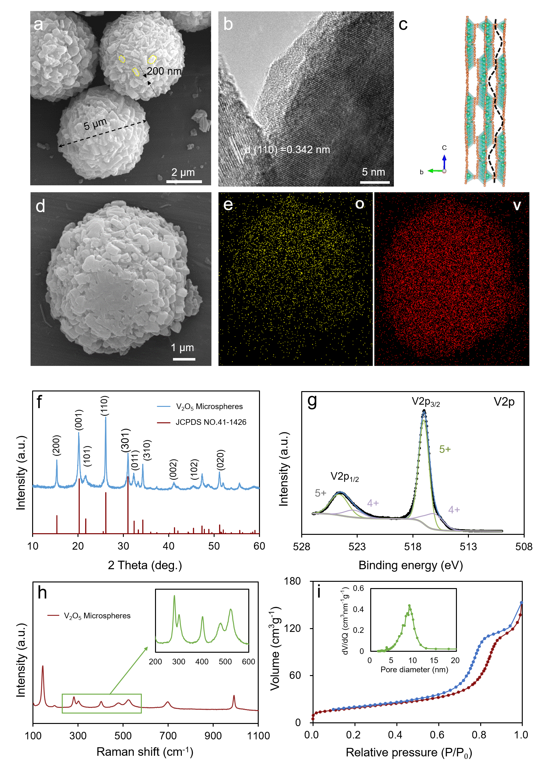
Figure 1. The morphologies and structures of V₂O₅ microspheres. (a, d) SEM image of V₂O₅ microsphere at different magnifications. (b) High magnification TEM image of V₂O₅ microsphere. (c) Crystal structure of V₂O₅. (e) Element mapping of O and V. (f) X-ray diffraction pattern of V₂O₅, (g) X-Ray Photoelectron Spectroscopy and fitted plot of the V 2p core level, (h) Raman spectra of V₂O₅. (i) N₂ adsorption-desorption isotherms of V₂O₅.

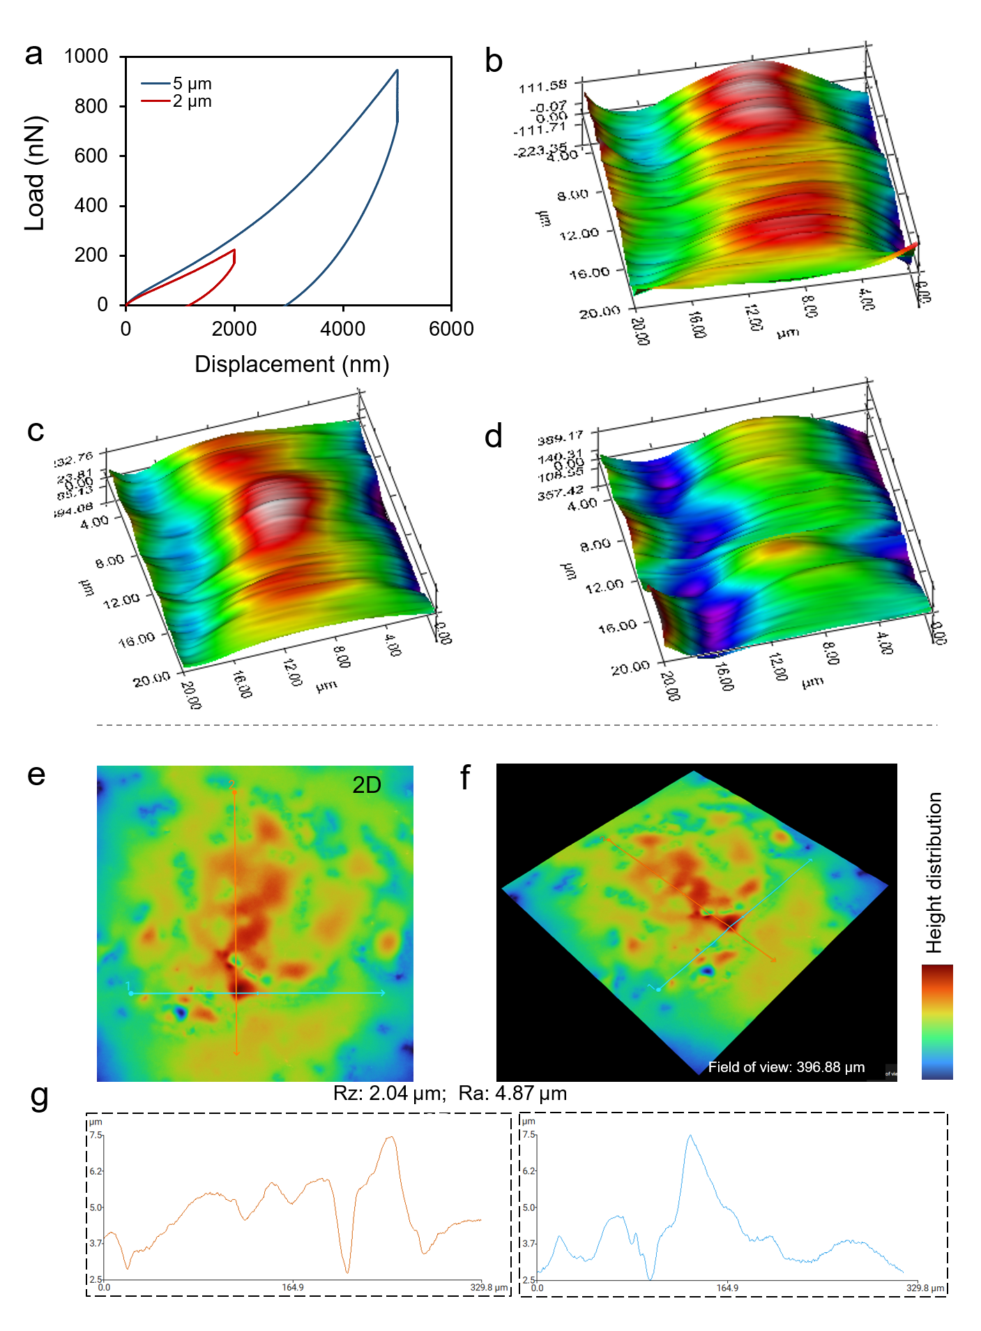
Figure 2. Nanoindentation technology and 3D roughness reconstruction to measure mechanical performance of the PSEs. (a) Load−displacement curves. (b) The AFM images of without indentation and with 2 (c) and 5 μm (d) depths of indentation. (e) 2D image of of the PSEs. (f) 3D roughness reconstruction of the PSEs. (g) The roughness profiles of the corresponding electrode.
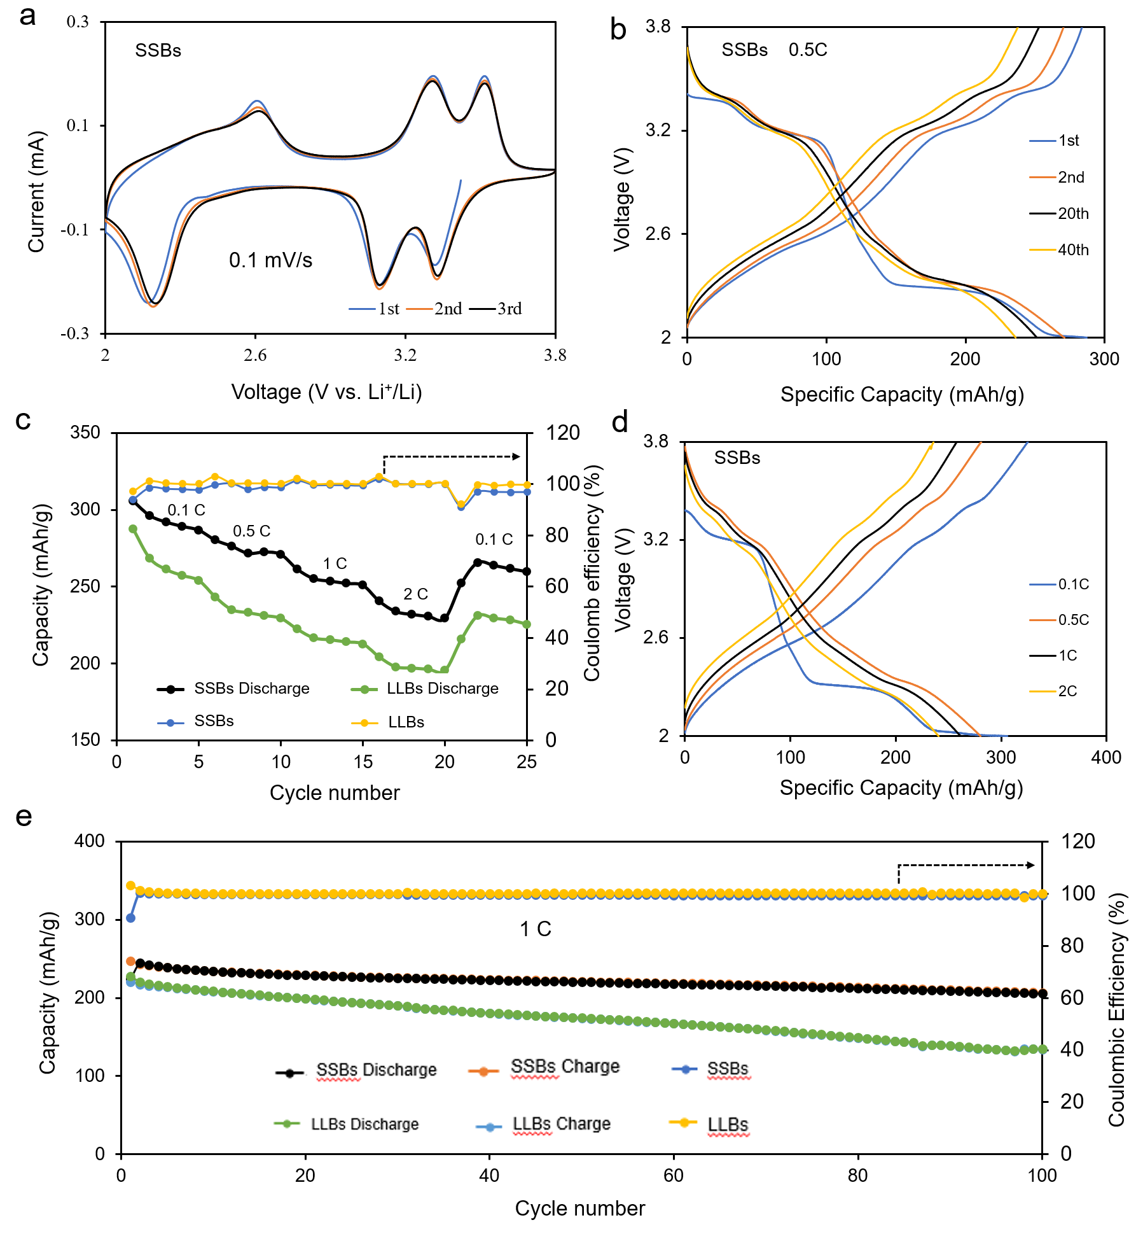
Figure 3. Electrochemical performance of SSBs and LLBs. (a) The first three CV curves of SSBs acquired at a scan rate of 0.1 mV/s. (b) Voltage profiles of SSBs for selected cycles at 0.5 C. (c) Rate performance of SSBs and LLBs from 0.1 to 2 C. (d) Representative voltage profiles of SSBs at various C-rate. (e) Long cycling performance at 1 C.
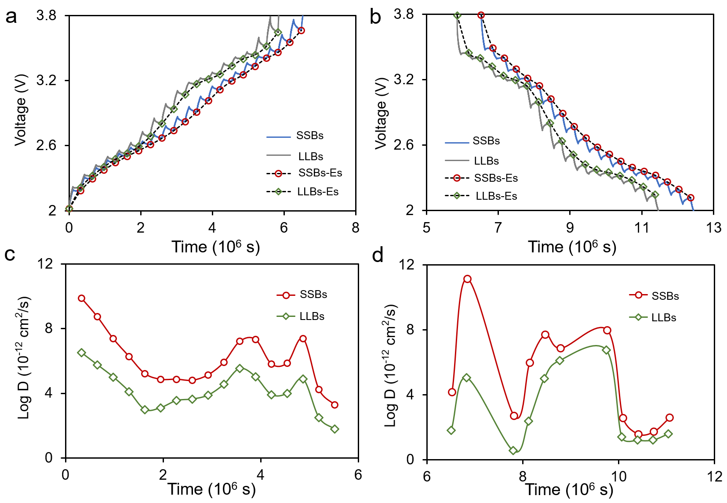
Figure 4. GITT curves of the V₂O₅ microsphere during the charge (a) and discharge (b). The calculated Li⁺ diffusion coefficients in the (c) charge and (d) discharge process.
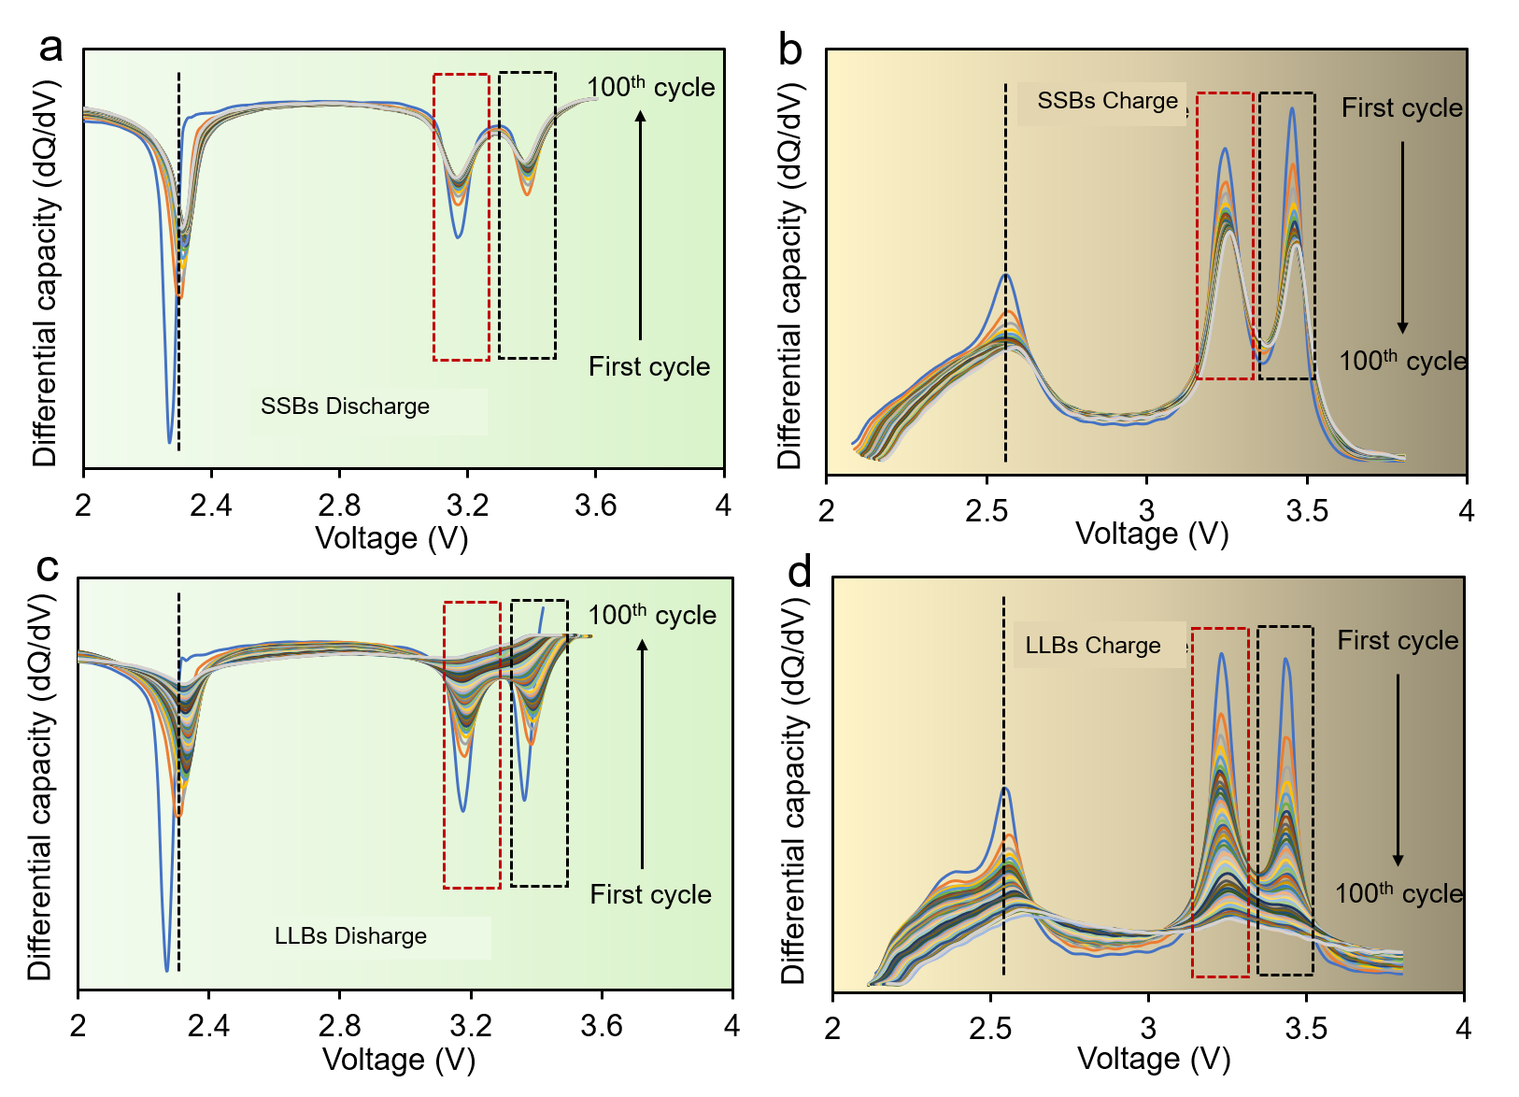
Figure 5. Differential capacity curves of SSBs in the process of discharge (a) and charge (b) at 1 C from the 1st to 100th cycles. Differential capacity curves of LLBs in the process of discharge (c) and charge (d) at 1 C from the 1st to 100th cycles.

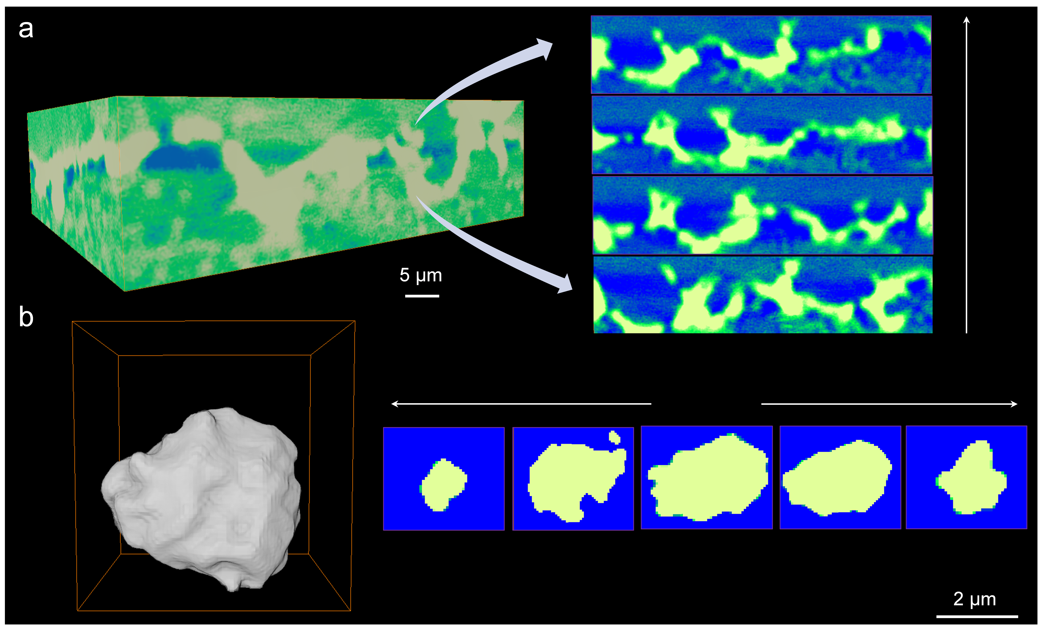
Figure 6. X-ray tomography of the cycled V₂O₅ microsphere in SSBs. (a) 3D microstructure of the electrode. (b) 3D microstructure of single particle and 2D slices.

