**Title: ‘A healthy lifestyle is a journey’: Exploring health perceptions and self-defined facilitators to health through photo-elicitation**

**Abstract**

**Objective:** The aim of this study was to explore health perceptions and self-defined facilitators to health in general population. An additional aim of the study was to assess if these perceptions were connected with the context of the Covid-19 pandemic.

**Design:** We applied photo-elicitation method by gathering original photographs and narratives (captions) via social media and e-mails. Participants (*N*=50) were asked to answer the question: ‘*What does it mean to be healthy?’*. Data were collected online in Poland. We generated and interpreted the main themes associated with common perceptions of health and self-defined facilitators to health using polytextual thematic analysis.

**Results:** The health perception themes were, health as: a ‘long journey’; keeping balance; and self-acceptance. The main facilitators to health were: enjoyment of activities that are part of a healthy lifestyle; planning time for rest; contact with nature, and supportive relationships. Participants’ perceptions of how Covid-19 impacted on their health differed.

**Conclusions:** The findings provide evidence for individual health perceptions and self-defined facilitators to health and can support the development of future health interventions.

**Keywords:** *health perception, photo elicitation, visual methodologies, Covid-19*

**Introduction**

An abundance of sources providing health-related online advice may lead to diverse perceptions of what constitutes positive health behaviours (Ragusa & Crampton, 2019).. The Internet has become a major source of health advice (Lu et al., 2018). In Poland, it is common to search for health information in the Internet (Płaciszewski et al., 2022), whereas overall trust in healthcare system is limited (Lewandowski et al., 2021). Considering the diversity of messages from mass media regarding health (Lignowska et al., 2016) and the variety of health perceptions, the definition of health is not set in general population, hence there is a need to better understand how individuals perceive health.

Individual health perceptions may be affected by many physical, emotional, and social factors (Cloninger & Zohar, 2011). It is possible that understanding of health may be also influenced by perceived health condition, especially in terms of mental health, chronic diseases, or ability to perform daily activities (Gumà, 2021). Moreover, current research provide diverse health perceptions in different age and gender groups (Borraccino et al., 2019; Deeks et al., 2009; Platzer et al., 2021). It would be interesting to explore if there are any common perceptions of what constitutes health and what facilitates healthy lifestyle in general population.

Recent scientific debate proposes several broad features to define health, and promotes inclusion of malaise and coping strategies as crucial aspects of the definition of health (Leonardi, 2018). It is suggested that the concept of health, well-being, individual ability, and quality of life, are interconnected (Tengland, 2006). Considering multifactorial, broad definitions of health, it is important to explore perceptions of health in the general population.

Stronger focus on health promotion is recommended in Poland, among other European countries (World Health Organization. Regional Office for Europe et al., 2019). Life expectancy in Poland is lower than average in the European Union, and Polish people report being in good health less often than other nationalities (OECD/European Observatory on Health Systems and Policies, 2021). The Polish health care system is classified as one of the least effective, among other European countries, which is mainly the result of limited financing (Smarżewska et al., 2022). There are health promotion programs in Poland usually organised at a national level by the government, although typically with no clear plans for implementation by local authorities (Arsenijevic & Groot, 2022). An exploration of the individual perceptions of health would support the development of effective and sustainable health promotion programs and interventions. Public engagement can facilitate intervention tailoring to participants’ needs and their experiences (Crocker et al., 2018). Evidence-based, participatory process of health priority-setting supports effectiveness of health policies and increase health equity (McGregor et al., 2014). We observe mixed patterns in terms of patient involvement in Polish health system. Responsiveness and communication are rated high, but need for autonomy and receiving prompt care are still unmet (World Health Organization. Regional Office for Europe et al., 2019) Since health-related needs may be associated with individual experiences and health prospects (Dolan & Tsuchiya, 2005), potential participants of health interventions should be treated as important stakeholders in the process of setting health priorities. Healthcare systems would benefit from community involvement (Batalden et al., 2016). However, health priorities are often affected by industrial or trade policies and do not reflect real healthcare needs of potential beneficiaries (Ollila, 2005). Many healthcare systems lack participatory public involvement to ensure alignment with actual health priorities within population (Farmakas et al., 2017; Sabik & Lie, 2008).

Perceived health priorities may be influenced by the Covid-19 pandemic, a major global health concern since 2020 (Ruetzler et al., 2020). Co-designing and co-implementation of health promotion programs were important for effective health interventions during the Covid-19 pandemic (Singh et al., 2020). Moreover, the pandemic has had an impact on health behaviours and perceptions of health (Naughton et al., 2021). The pandemic has affected overall trust in public health services, emphasising the importance of health and well-being (Jarynowski et al., 2020). Therefore, there is an urgent need to explore perceptions of health in general (Balanzá–Martínez et al., 2020), as new trends and new perceptions may have emerged in the common understanding of health.

Photo-elicitation method has potential to explore individuals’ perceptions of health and perceived behaviours that facilitate healthy lifestyle. In this method, research questions are explored through photographs and narratives delivered by study participants (Bates et al., 2017). Qualitative studies, such as photo-elicitation, drive creativity among participants and enable them to explore the concealed understanding of well-known concepts and challenge the general perception of important social issues (Chamberlain et al., 2018). Nonverbal forms of expressing oneself help to explore topics that are too complex or vulnerable for verbal forms of data gathering. Photo-elicitation may have positive implications for participants, as they can deconstruct and re-evaluate their experiences by the act of photographing and presenting the meaning of their photographs (Harper, 2002).

Qualitative visual methods have delivered valuable narratives and provided meaningful research insights across a number of areas including: investigating eating behaviours (Patricia et al., 2017; Thompson et al., 2015); food preparation practices (Mills et al., 2017); family food choices (Johnson et al., 2010, 2011; Lachal et al., 2012; Ramalho et al., 2016; Sharma & Chapman, 2011) and health inequalities (Hodgetts et al., 2007). Visual methods have enabled a broader understanding of disease perception, e.g., for prostate cancer (Oliffe & Bottorff, 2007) and Alzheimer’s disease (Shell, 2014). Photo-elicitation studies have been successfully conducted to explore attitudes towards physical activity with adolescents (Fernández-Prieto et al., 2019; Hill, 2015; Strachan & Davies, 2015), physical activity with women (Fleury et al., 2009), and in activity tracking (Gorm & Shklovski, 2017).

Photo-elicitation can shed light on social and cultural dimensions of health, as well as the internalised concepts of physical and mental well-being (Ortega-Alcázar & Dyck, 2012). Despite considerable research on various aspects of health-related behaviours, little is known about how people self-define what they mean by health and health-related behaviours. Defining what health means would facilitate the development of health promotion interventions as this would allow for better tailoring of further programs to the actual perceptions of health in general population. Knowing how people perceive health in general could support designing health interventions, and could improve communication with potential participants. It would also enable to focus on health priorities reported by potential participants.

**Current study**

This study used the photo-elicitation method by gathering photographs with corresponding narratives (photograph captions). The overarching study aim was to capture individual perceptions of health, and to identify main facilitators to health in general population. An additional aim of the study was to assess if these understandings were affected by the context of the Covid-19 pandemic.

**Method**

The phenomena were investigated by asking participants to respond to the question ‘*What does it mean to you to be healthy?*’ by taking a photograph and writing a detailed caption. The study used a semi-structured, participant-driven format (Bates et al., 2017), meaning that participants could submit any original photographs, taken by them, which they considered relevant to the topic. The study was conducted online in Poland, with the photographs submitted via social media (chosen by the participants) or email. Data were gathered between July and December, 2020.

**Participants**

Inclusion criteria for the study were: age above 18 years, consent to participate in the study and consent for the publication of photographs via social media (Twitter, Facebook, and Instagram), on the study website and in the subsequent study publications and presentations. To submit a photograph with a caption, participants needed to have an internet connection and social media account or email address. The participants needed to be able to read and understand Polish in order to read the study materials and consent.

Fifty participants took part in the current study (see Table 1 for complete demographics), and all provided full consent to participate in the study. Most participants (*n* = 41) submitted just one photograph; however, 9 people submitted 2-10 photographs. The length of the photo captions varied, on average the captions were 275 words long (*SD*= 69.15).

*(Table 1 to be inserted here)*

**Procedure**

The study advertisement was published on the website, and the social media channels of the *‘Name of the project [blinded for peer review]’* (Instagram, Facebook, Twitter). It contained information about the study aim and participation requirements. Participants could post their response through social media channels or send them directly to the study coordinator (IPP) via e-mail. We instructed participants to take an original photograph which captures their answer to the question: ‘*What does it mean to you to be healthy?*’. They had to caption every photograph with a complementary description (minimum 200 words, no set maximum limit). Participants could access a study information sheet online including supporting questions helping to define the photograph’s caption (Supplementary Material 1). We followed guidelines for participant-driven form of photo elicitation interviewing (Bates et al., 2017), and provided participants with a series of open-ended questions, however the content of captions was guided by the participants’ photographs. All participants delivered original photographs with accompanying captions. The main aim for the captions was to describe the photograph and to explain how the photograph is related to one’s perception of health. Further, participants were asked to describe how they maintain health and what is important for them to achieve healthy lifestyle. Additional questions concerned perceived connection between the Covid-19 pandemic and potential depiction of it in the photograph. All captions were delivered in a written form.

All participants were instructed to follow copyright laws and they were advised against invading anyone’s privacy, as well as capturing illegal or inappropriate content. Photographs had to capture participants themselves, or their surroundings. If participants wanted to capture other people, they were instructed to take their consent to appear in the photographs. We asked participants to be mindful of their own safety when taking photographs. All participants’ information and study consents were gathered via a Qualtrics survey, no matter if the responses were published on social media, or sent directly to the study coordinator via e-mail. Therefore, we ensured that all study participants were familiarised with detailed rules of the study.

**Data collection**

The majority of participants (72%, n=36) delivered their responses via e-mail, others posted their responses on Instagram (28%, n= 14). Participants who posted their photographs on social media were asked to tag the project account and they were encouraged to challenge their friends to participate by tagging them in the post. We identified responses posted via Instagram by linking them to the consent gathered simultaneously through the Qualtrics form. The incentive to participate was an opportunity to have the picture displayed at the virtual exhibition on the *‘Name of the project [blinded for peer review]’* website. The exhibition included all the photographs submitted. We obtained consent from each participant to publish their photographs.

**Data analysis**

Photographs with corresponding captions were analysed to generate and interpret the main themes connected with the participants’ perceptions of health and self-defined facilitators to health. Visual and narrative data were analysed using thematic analysis (Braun & Clarke, 2006) and polytextual thematic analysis (Gleeson, 2020) approaches. Following guidelines of polytextual thematic analysis, we assumed that verbal and visual data were linked. After familiarisation with submitted photographs and complementary captions, the data were coded and grouped into the research categories: the perceptions of health, the facilitators to health, and Covid-19 effects, by the first coder (IPP). We followed iterative process of polytextual thematic analysis (Gleeson, 2020), moving back and forth from photographs to captions. Afterwards, the codes and categories were indexed in a preliminary thematic map. Next, 25 percent of the study data were independently coded by the second coder (DK), who also provided feedback on the themes. Disagreements between the two coders were further discussed until consensus was met. The narratives were then translated through systematic, iterative process, in line with recommendations for cross-language quotes in qualitative research (van Nes et al., 2010).

The final set of themes was formulated using an iterative approach and defined through discussion between the two lead coders (IPP and DK). Both coders read the full data set, familiarising themselves with all photographs and captions. The decision to stop data gathering was based on the agreement of both coders that no new topics and themes were noticeable in the photographs and captions, therefore the study was deemed to have reached sufficient data saturation (Saunders et al., 2018). We also conducted member-checking, following the guidelines of Synthesized Member Checking (Birt et al., 2016) to check for accuracy of the findings. The summaries of the generated themes were presented to study participants, who were asked to provide their feedback on the preliminary findings. We investigated if participants accepted generated research categories and themes, if they would like to change anything, what they agreed and disagreed with. Eight participants were included in this process (16%), they reemphasised the key study findings and further discussed the importance of health perceived as self-acceptance, ability to accept own life circumstances and possibilities. We integrated their feedback with existing codes. Analysis was conducted using the NVivo 12 software.

**Ethics**

All participants were provided with study information prior to giving consent and taking part. Ethical approval was granted by *(reference blinded for peer review),* approval number: 03/P/12/2019. General Data Protection Regulation (GDPR) issues were discussed and resolved with the data protection officer at the University, legal issues concerning copyrights were consulted with the law department at the first author’s University. All participants gave permission for the publication of photographs where they were identifiable.

**Results**

The analytic process determined a range of themes, which were associated with each of the three main categories of the project – health perceptions, facilitators to health, and Covid-19 effects. Table 2 presents a summary of the themes identified under each category, and these are discussed in turn below under the category headings, with illustrative photographs and quotes from captions.

*(Table 2 to be inserted here)*

**Health perceptions**

***Theme 1: Health as a ‘long journey’***

Health was frequently described as a ‘long journey’ with multiple choices or directions that can be taken. The participants mentioned how their effort in relation to health-related practices needs to be sustained and ongoing in order to achieve a healthy lifestyle.

The concept of ‘journey’ emphasises that staying healthy is a long-term and ongoing process. Participants often referred to perseverance as the way to maintain healthy behaviours. One participant submitted a narrative and photograph (Figure 1), literally illustrating health as a journey: *‘A healthy lifestyle is a journey. You can’t take shortcuts, you need to go step by step, following a trail. It’s working on new habits and that is a process. You can’t do it just like that. This process always requires time.’*

*(Figure 1 to be inserted here)*

Participants discussed the importance of daily minor decisions, based on their health goals. Following objectives on a daily basis was reported as crucial to achieve healthy lifestyle: *‘Choosing health always involves a large number of daily decisions, sometimes really hard ones. We don’t even realise how many decisions we make every day.’*

A lot of participants reported motivation as a key factor to continue the process of sustaining healthy habits. Motivation was often referred to as a main resource that empowered participants to achieve their intermediate goals and persevere in their efforts towards healthy lifestyle.

***Theme 2: Health as keeping balance***

Within this theme, study participants reflected on the need to achieve equilibrium in terms of what is important for them and what they can and want to do to be healthy. Diverging occasionally from eating healthily was mentioned as a part of well-balanced lifestyle. Participants emphasised that labelling food as ‘healthy’ and ‘unhealthy’ does not support good dietary choices:

*‘I intertwine healthy food choices with conscious ‘sins’ – I don’t punish myself for eating pizza, tiramisu, or a piece of chocolate, but I treat this as an exception, not a part of my daily menu.’*

Participants commented that a well-balanced, healthy diet is the one that includes their favourite food and does not cause feelings of guilt. Both photographs and captions illustrated objections to strict, low-calorie, and monotonous diets. One participant described her attitude towards eating favourite sweets:

*‘It’s not easy, because for a long time I used to easily give in to my cravings, however I don’t want to go crazy, and I allow myself a moment of weakness without feeling guilty after eating, for instance marshmallows, that I really love.’*

Participants often reported their efforts to sustain healthy behaviours as a search for an equilibrium. Both extremes – either an obsessively strict lifestyle or an explicitly unhealthy way of living – are contradictory to health. One participant submitted a photograph of a sculpture of an acrobat balancing on the rope (Figure 2) with the following caption:

*‘Our family believes that it’s important to take care of the right balance. In order not to go to the extreme, one cannot go overboard in any way. Not taking care of your health – unhealthy diet, lack of physical activity, alcohol and smoking, lead to diseases. On the other hand, extreme lifestyle of taking care of one’s health may also cause problems.’*

*(Figure 2 to be inserted here)*

Within this theme, study participants reflected on allowing for special occasions that are important part of life and often hinder the practices that society considers healthy. Keeping balance also meant not overusing unhealthy substances such as alcohol, avoiding smoking, avoiding excessive screen use (e.g., mobile phones, tablets), and getting enough sleep.

***Theme 3: Health as self-acceptance***

This theme reflects the importance of acceptance in terms of own appearance, body type, and body imperfections. Self-acceptance also refers to acknowledgement of individual preferences that constitute a healthy lifestyle. Participants reported that being consistent with their own values and interests was the foundation of health behaviour change and maintenance.

The narratives and photographs in this theme opposed an idealistic vision of a healthy appearance. Participants commented that they tend to follow a holistic approach towards their health, and avoid focusing on getting a perfect, flawless body: *‘Always striving for perfection, having everything tip-top. I’m trying to unlearn this. It’s not about a perfect body, an exact body weight, but about health and overall fitness.’*

For some participants, it was particularly important to accept body imperfections. Embracing things commonly considered as flaws supported participants in focusing on health: *‘I don’t strive for a flat belly, but for a healthy body. I’ve got cellulite as most women do, and I don’t hide it.’*

Self-acceptance was also described as a resource related to mindful living and gratitude. Positive acknowledgement of one’s own life and self were associated with the ability to maintain a healthy lifestyle: *‘I eat well, run, jump, go through life in harmony with myself, I just want to be Sarah (name changed). I’m grateful for what I have, and for good people, I met.’*

To stay healthy (both psychologically and physically), the participants indicated they needed to adjust, accept the situation and effectively adapt to it. Effective adaptation often defined whether health was maintained or not in the long term.

**Facilitators to health**

***Theme 1: Enjoyment of activities that are part of healthy lifestyle***

Having a positive attitude towards health behaviours was one of the main factors mentioned as supportive for long-term maintenance. If health behaviours evoke positive emotions, people are more likely to continue their pursuit for a healthy lifestyle (Fredrickson & Joiner, 2018). Those positive emotions are usually associated with personalising one’s way to achieve a healthy lifestyle and making choices that are enjoyable.

Allowing oneself to cherish food experiences was often described as a health priority in the captions and captured in the photographs (Figure 3). One participant described food on two dimensions: as a source of pleasure, and as a source of energy to live. Personal satisfaction from healthy eating may be a part of healthy lifestyle:

*‘I LOVE EATING! Food gives me energy to work, energy for the whole day. Eating has always been a pleasure for me, since I was a kid. I can’t imagine a healthy lifestyle without food. What is health to me? I answer simply – a plate full of food!’*

*(Figure 3 to be inserted here)*

Another aspect of health, commonly mentioned in the photos and captions, was physical activity. The participants always stressed that it should be an activity that is adjusted to personal abilities and preferences. Some participants mentioned physical activity as a part of their daily routine. It was perceived as a regular positive experience: *‘Physical activity, especially walking, gives me an immense pleasure. I try to walk 5km daily, however, lately I succeeded to increase the distance to 10 km daily.’*

The ability to experience positive emotions and derive satisfaction from a healthy lifestyle was associated with a positive attitude towards healthy choices. One person commented that the appropriate perspective on health-related choices is a foundation of healthy lifestyle in her family: *‘For me, healthy choices are not something I’m forced into, I actually enjoy making them.’*

Participants also reflected on the satisfaction that they get from the process of pursuing a healthy lifestyle itself. Using personal resources to cope with difficulties and overcome individual barriers supported the maintenance of health behaviours.

***Theme 2: Planning time for rest***

This theme describes participants’ need for finding time to rest and relax. We observed a consistent theme – the necessity to plan free time and allow oneself to renounce overloading duties. According to participants’ narratives, leisure activities should be planned in the same way as other activities (e.g., professional responsibilities) are planned.

Some participants referred to the stereotype that resting is for lazy or weak people. Both photographs and captions often broke this stereotype, emphasizing the importance of leisure activities and rest in sustaining a healthy lifestyle. Sometimes, the only photograph submitted by a participant was a photograph showing them resting (e.g., Figure 4). As modern society tends to force a fast-paced lifestyle, the participants had to change their perspective. Some of them mentioned that they are still learning to take time to rest:

*‘I learn to rest. In the past, I would say that resting is for the weak ones. Today I know that it’s an extremely important part for maintaining health. One can’t always be on the go, because sooner or later, the batteries will run out. Surprisingly, a lot of new ideas come to my mind when I’m lazing around.’*

*(Figure 4 to be inserted here)*

Appreciation of leisure time and resting was also reported as a skill that needs to be learned. Work-life balance was described as a skill that can be improved or as a behaviour that requires perseverance and planning. One person mentioned that it was not always obvious for her to plan time for rest:

*‘Some days I allow myself to rest more, I don’t check emails then, I don’t work on anything in particular, I take up a book or a movie completely unrelated to my work. In the past, I didn’t allow myself for that. Every minute spent this way was less valuable for me. Now, I appreciate this time, since I know that it lets me gather energy for new projects.’*

Resting was presented in this theme as health-related behaviour. To build and sustain a regular resting routine, participants often committed to planned breaks and allowed themselves to be less productive during some period of their lives.

***Theme 3: Supportive relationships***

Maintaining supportive relationships with significant others was often presented as one of the participants’ facilitators to health. The participants reported that social support is crucial to achieve healthy lifestyle. The narratives revealed an active and self-determined attitude towards building and maintaining relationships, not a passive expectation of support from the social environment.

The most common topic within this theme was respecting one’s own personal boundaries. The captions delivered a strong sense of autonomy in relations with other people. Decisions about social life were perceived as healthy when they were based on their own interpersonal boundaries:

*‘It depends on ourselves, who we meet and which relationships we build. It depends on ourselves who we invite to our houses and our lives. It’s defining our own boundaries and respecting them, it’s caring for our privacy.’*

Many participants described their regular physical activity as being in a group or with a friend. Being surrounded by people who are supportive and share the same hobbies helps to maintain health behaviours. There were several photographs of people being physically active in groups (Figure 5).

(Figure 5 to be inserted here)

In line with the photographs and the captions, relationships that support a healthy lifestyle are always a result of personal choice. The participants presented a proactive attitude towards shaping their own social life and maintaining relations that are beneficial for their mental and physical health.

***Theme 4: Contact with nature***

Contact with nature was reported as one of the most important facilitators to health. Access to natural settings supported mental health. Moreover, outdoor activity was associated with a high level of satisfaction from a healthy lifestyle.

The narratives and photographs in this theme frequently related to the Covid-19 pandemic. The participants often described their need for contact with nature as a chance to escape from the threatening Covid-19 circumstances. Outdoor settings were often considered as safe places during the pandemic. Due to the fact that open spaces or forests are not as crowded as urban areas, the participants also appreciated a lack of Covid-19-related restrictions when spending time in natural settings. One participant described mountain trekking as a way to escape from the pandemic:

*‘It’s not without significance that, nowadays, during a worldwide pandemic, trekking is a form of spending free time without having contact with other people. It’s only me and stunning, clean nature.’*

Some participants, however, expressed their need for contact with nature regardless of the Covid-19 pandemic. The participants expressed that spending time in natural settings contributed to mental health in all circumstances. One participant commented that seeking a healthy lifestyle led him to outdoor physical activity, which is now his relaxation routine. He submitted a photograph of himself during outdoor physical activity (Figure 6):

*‘Thanks to the fact that I started to eat well and exercise, I can enjoy beautiful landscapes and the true beauty of nature!!! I found my hobby… My oasis of peace, that lets me wind down and recharge my batteries after a hard day.’*

(Figure 6 to be inserted here)

Contact with nature was perceived by the participants as a good way to build and maintain physical activity. Spending time in natural settings often meant stepping out of a stressful daily routine and taking time to rest and calm down. We observed a tendency to search for opportunities for outdoor activities during Covid-19 pandemic, as outdoor activity often meant the escape from the restrictions.

**Covid-19 and health**

Individual differences in terms of links between health perceptions and Covid-19 were observed in participants’ narratives. The only theme unambiguously related to the Covid-19 pandemic was need for contact with nature (described above). Natural settings were perceived as an escape from the pandemic restrictions and the risk of contracting Covid-19. Moreover, the participants emphasised that it was important for their health to avoid crowded areas. One person submitted a photograph of an empty main square as his perception of health during the Covid-19 pandemic (Figure 7).

*(Figure 7 to be inserted here)*

In the narratives, we developed two themes related to the Covid-19 pandemic: (a) disruption in maintaining healthy habits, (b) motivation to engage in health behaviours. With regard to the perception of the Covid-19 pandemic as disruption in maintaining health behaviours, the participants often mentioned deterioration in their general health and well-being. Most of the narratives emphasised that problem-solving and a resource-based attitude supported the participants in overcoming health difficulties:

*‘This situation worsened my physical and mental health entirely which later influenced my constant bad mood. One may say that my general health deteriorated. My solution to improve my health were (and still are) multiple travels in the company of loved one to the accessible locations that are considered to be Polish natural wonders.’*

There was a large number of participants who reported the Covid-19 pandemic as motivation to engage in health behaviours. The pandemic circumstances prompted the participants to focus on healthy eating habits, increasing physical activity, and overall care for their health and immune system. Setting new goals related to health and establishing eating routines were ways to cope with difficulties and mental challenges caused by the pandemic. One participant described eating a healthy breakfast as a steady routine that helped to endure fast-paced and uncertain circumstances. She submitted a photograph of a healthy meal as her perception of health during the pandemic (Figure 8):

*‘I chose this photo because, besides working at full capacity, in the constant madness of masks, hands’ disinfecting, and stressful thoughts like: ‘will I get infected from a client today?’, I set a daily goal for myself to eat healthy, and nutritious breakfast. I didn’t have this routine before the pandemic, breakfasts consisted of what I found in the fridge, I often ate expensive bars or sandwiches in a hurry at school, but the Covid-19 era made me introduce at least the smallest change in my everyday life (since my whole reality got stuck still).’*

*(Figure 8 to be inserted here)*

For some participants, the Covid-19 pandemic was an opportunity to become aware of health and introduce health behaviours because the lockdowns were associated with less responsibilities and more free time. Therefore, some participants took time to reflect on their health behaviours and decided to act on them:

*‘Ironically, the pandemic influenced my health in a positive way, since the quarantine gave me more time for mindful figuring out healthy meals, looking for information, products, and experimenting with new dishes, it was also an opportunity for frequent bike rides, especially that the weather was good.’*

It is worth adding that some participants did not mention Covid-19 in the submitted photographs and captions at all, and some wrote explicitly that Covid-19 was not related to their perception of health.

**Discussion**

The photographs with accompanying narratives delivered broad health perceptions and facilitators to health . Results focus on positive aspects of health, personal and contextual resources to maintain health, and describe behaviours that support healthy lifestyle. The results correspond with current definitions of health (Leonardi, 2018) and included themes related to: health perceived as a process, searching for balance in life, and self-acceptance. Also, the connections between health, well-being, ability, and quality of life (Tengland, 2006) were prominent in our findings, as people reported that they value positive experiences and relationships, contact with nature, and time for rest, in terms of maintaining their own health. Perceptions of health and facilitators to health refer broadly to mental health from the perspective of human strength, not an absence of illness. This is in line with current definitions on mental health across different cultures (Kobau et al., 2011; Vaillant, 2012). Positive outlook on perceptions of health and facilitators to health may contribute to facing one of main challenges of Polish health system, which is deficiency in health promotion and disease prevention (World Health Organization. Regional Office for Europe et al., 2019). The presented themes advocate the need for promoting self-motivated behaviours that enable maintaining health, rather than focusing promotion on possible negative results of unhealthy lifestyles. At the same time, existing health promotion programs in Poland typically concern specific health conditions and their possible negative consequences, and fail to promote the benefits of a healthy lifestyle in general (Pataj, 2015). Knowledge of self-defined factors that constitute health and facilitate maintaining healthy lifestyle could support development of effective health promotion programs in Poland and other countries. Photo elicitation provided an effective and suitable platform to gather data related to internalised perceptions of health.

**Health perceptions**

Sustaining health was perceived as a continuous process, which was expressed in the narratives from the theme: *Health as a ‘long journey’ with multiple choices/directions.* Achieving a healthy lifestyle and staying healthy requires sustained motivation to maintain health behaviours (Kwasnicka et al., 2019). Participants reported that maintenance of motivation is supported by the individual sense of responsibility for their actions, and daily efforts to make healthy choices. These perceptions are in line with the self-determination theory (Deci & Ryan, 2008), which promotes the sense of autonomy as one of the key factors influencing sustained behaviour.

The perception of health as a long journey also relates to the habit formation process (Gardner & Lally, 2018), referring to initial self-regulation and repetition of health behaviours in the same context as determinants of successful habit formation. The process of maintaining a healthy lifestyle also includes self-regulation skills to enable coping with lapses and relapses (Kwasnicka et al., 2013), which is particularly important for health behaviour maintenance (Kwasnicka et al., 2016). Being able to come back to healthy habits after a lapse or relapse was perceived as an inherent part of the ‘health journey’(Bouton, 2000).

The findings suggest that health is also perceived as an ability to keep balance. The idea of a balanced lifestyle emphasises the need to look at health as a continuum, not a two-dimensional concept, where people can label things as ‘healthy’ or ‘unhealthy’. The study results support the compensatory health beliefs model, that introduces the notion of beliefs about counterbalancing unhealthy behaviours with healthy ones (Rabia et al., 2006). Dietary restraint was described as demotivating and contradictory to health, in accordance with existing evidence (Herman & Mack, 1975; Ogden, 1993; Putterman & Linden, 2004). Health perceived as a continuum and search for balance in life was previously reported in qualitative studies (Emami et al., 2000). Moreover, the concept of balance has been demonstrated to be effective in communication about general health, and may support the process of health behaviour change (Lipworth et al., 2011).

Another group of health perceptions related to positive acknowledgement of self and life circumstances. Participants emphasised that acceptance of one’s own appearance and body imperfections was a foundation for further attempts to improve health. Self-acceptance was presented by participants as a factor supporting their mental health, and a foundation to cope with psychological crisis. This is in line with existing evidence, which suggests that self-acceptance may be beneficial for improving the sense of good health and well-being (Su et al., 2019; Tibubos et al., 2019).

**Facilitators to health**

The results of the study indicated that positive emotions connected to healthy lifestyle are an important health priority supporting long-term behavioural maintenance. The ability to experience positive emotions is connected with mental health (Vaillant, 2012). The sense of pleasure from health behaviours are the main influences on behaviour change maintenance here, in line with Regulatory Fit Theory (Higgins, 2005), which assumes that behaviour may be influenced by regulatory goals, as well as in line with the evidence (Landry et al., 2018; Sabatini et al., 2019). Participants reported that they tend to adjust physical activity to personal preferences when they build and maintain physical activity habits. This is in line with current evidence that satisfactory, repeated physical activity leads to long-term health behaviour change maintenance (Wild & Woodward, 2019). Moreover, the photographs and narratives provided descriptions of positive emotions being evoked by activities that are part of healthy lifestyle. Positive affect experienced during health behaviours may be beneficial for long-term behaviour change (Van Cappellen et al., 2018), and it is recommended that health interventions should assist personal attempts to enjoy a healthy lifestyle (Whitehead, 2005).

Prominent among the facilitators to health, participants reported their need for rest. Planning leisure activities was an inherent part of a healthy lifestyle. This relates broadly to the Ego Depletion Theory (Baumeister, 2003; Hagger et al., 2010), which presents self-regulation as a limited resource – rest and positive affect are required to restore personal resources. Planning to rest may be beneficial for holistic health interventions, as it supports overall stress management skills (Harris et al., 2021).

Another health-related priority reported in this study was maintaining relationships that support healthy lifestyle and mental health. Social support is one of the most important predictors of mental health (Kobau et al., 2011), also throughout the Covid-19 pandemic (Waters et al., 2022). Participants reported a self-determining attitude towards their social life, including setting interpersonal boundaries. This approach is in line with the framework for investigating dyadic relationship processes and health, implying that social support or control, relationship satisfaction and other social process variables are key determinants of physiological states, affect, health behaviours, and health (Pietromonaco & Collins, 2017; Uchino, 2009). Unsupportive relationships were often described as contradictory to general health and the sense of well-being. Studies have shown that social relationships influence human health to great extent (Braithwaite & Holt-Lunstad, 2017; Pietromonaco & Collins, 2017; Umberson & Karas Montez, 2010), and relationship distress may have negative effects on health (Kiecolt-Glaser & Wilson, 2017).

Participants described outdoor activities in natural settings as crucial for their health, which is in line with the evidence that contact with nature offers multiple health benefits (Frumkin et al., 2017). Participants reported that exposure to natural settings supports their mental health in a significant way, in accordance with previous studies (Triguero-Mas et al., 2015). Contact with nature facilitates emotional well-being, cognitive functioning, and a range of other mental health assets. Moreover, studies suggest that access to natural settings is crucial for public health (Baur & Tynon, 2010; Shanahan et al., 2015). Nature in the urban environment may also support resilience for maintaining health during the pandemic circumstances.. Nature was perceived as a space to escape from Covid-19 safety measures and the risk of contracting Covid-19. This supports current evidence for contact with nature as a crucial factor to maintain health behaviours and to recover from mental health deterioration during the Covid-19 lockdowns (Buckley & Westaway, 2020; Pouso et al., 2021).

**Covid-19 and health**

The study provided descriptions of health behaviours related to the pandemic, that followed two main patterns: (a) the Covid-19 pandemic as disruption in maintaining health behaviours, (b) the Covid-19 pandemic as motivation to engage in health behaviours. The connections between the Covid-19 pandemic and health perceptions and facilitators to health were mixed. They were based on individual experiences, personal strategies to respond to health threatening situations, and to relieve psychological tension. Most of the participants reported a resource-based approach that helped them to overcome difficulties during the pandemic. The pandemic worsened the sense of well-being and mental health of many participants. The Covid-19 pandemic and lockdowns have been previously reported as disruptive to maintaining health behaviours (Naughton et al., 2021), with a strong focus on negative mental health outcomes (Arora & Grey, 2020; Cullen et al., 2020; Dawson & Golijani-Moghaddam, 2020; Lima et al., 2020; Zvolensky et al., 2020). Furthermore, participants often reported decreased physical activity during the pandemic, which is consistent with other studies (Castañeda-Babarro et al., 2020).

In contrast, the study also provided broad evidence for the Covid-19 pandemic as a source of motivation to engage in health behaviours. Psychological distress may be balanced by relaxation routines, and that became possible during the pandemic (Grandey et al., 2021). Other studies also suggested that the pandemic may have had some positive effects resulting from changes in daily life during the pandemic (Cornell et al., 2021), such as more time spent with family, or increased work flexibility. According to the evidence provided by this study, the pandemic increased personal focus on the field of eating behaviours, as it enabled people to prepare homemade meals, and to educate themselves about nutrition. The pandemic became a cue to raise personal awareness about health, and establish new, healthy routines.

Moreover, some participants reported no observed connections between the Covid-19 pandemic and their health behaviours. This emphasises the need to answer the question about the factors that differentiate people in terms of their degree of coping with the Covid-19 pandemic. This study delivered preliminary evidence for multiple factors that may influence the relationship between the pandemic and health behaviours. These may be pre-existing health conditions and health behaviours, overall mental health, individual differences and preferences, previous health-related habits, or life circumstances. Other studies also underline the role of demographic factors (such as age) as moderators of health behaviours during the pandemic (Anaki & Sergay, 2021; Bergman et al., 2020). Furthermore, the individuals’ understandings and personal attitudes towards the pandemic-related challenges, may be significant when considering any forms of health promotion during or after the Covid-19 pandemic (Zhang et al., 2020).

**Study strengths and limitations**

The photo-elicitation method proved to be useful for exploring individual perceptions of health and facilitators to health, making it easier for them to express internalised topics that are usually hard to elaborate on. Participants presented their original photographs, which was valuable in terms of presenting real experiences and environment. We used open participant-driven format (Bates et al., 2017), which enabled participants to describe their own perceptions, without being influenced by any health definitions or health-related perspectives presented by researcher. It is one of the few studies to use photo-elicitation in a fully online context. The online form effective in terms of recruitment. We were able to conduct qualitative research, following Covid-19 pandemic restrictions and safety measures. The study included good variation in terms of participants’ backgrounds, SES, and age, and captured a wide variety of experiences and opinions. Moreover, the study gave voice to the target population that is often bombarded with ‘healthy living’ messages but rarely asked to clarify what health means to them.

This study differs in that we did not interview study participants as is typical for photo-elicitation studies. Such data-prompted interviews may have evoked further themes and narratives (Kwasnicka et al., 2015). If we had been able to use follow-up questions and probes in an interview context, we may have obtained more detailed information. However, we consider the present process of using photographs with complementary captions to be a cost-effective and wide-range alternative that can enable researchers to collect rich and diverse data. The online form of the study does not reach potential participants who do not use the Internet. The majority of participants (68%) had higher education, even though we have not observed differences between participants with different education levels. Moreover, we did not identify individual health conditions or illnesses that may have influenced personal perceptions of health. Data were published online, therefore openness to disclose personal information about health conditions may have been limited. There is also a possibility that some of participants produced answers that were perceived by them as socially desirable. Nonetheless, this study set an opportunity to explore health perceptions and facilitators to health in the extraordinary circumstances of the Covid-19 pandemic.

**Implications for practice and future health interventions**

Our findings may support development of future health promotion programs and health interventions. Knowledge of health perceptions and perceived facilitators to health may support in engaging potential participants, as well as defining form, process, and goals of health promotion programs and health interventions. Our recommendations, that refer to health perceptions, are: (1) providing support for long-term perspective, educating about resources to maintain health behaviours, and to cope with lapses or changing circumstances; (2) referring to balanced lifestyle and finding personal equilibrium in terms of own health to encourage potential participants; (3) emphasising the role of acceptance of life circumstances and own appearance as important elements of health behaviour change process. The key take-home messages for future health promotion programs and health interventions, in terms of self-defined facilitators to health, are (1) proposing health behaviours that evoke positive emotions and constitute pleasurable experiences on personal level, (2) promoting rest as health behaviour, (3) emphasising the role of meaningful relationships or enabling participants to build them throughout the program, (4) encouraging participants to spend time in nature and developing opportunities for outdoor activities within communities. Major health concerns, such as the COVID-19 pandemic, may have diverse implications and require further investigation. They may cause disruption in health and well-being or opposite – increase in motivation to focus on health and maintain health behaviours.

**Conclusion**

The study described broad and holistic perceptions of health. Participants emphasised looking at health as a process and searching for balance in life. Health was also defined as the act of self-acceptance – accepting one’s body – and the ability to adapt to life circumstances, which facilitated health behaviours. The findings show that a sense of enjoyment was a basis for starting and maintaining healthy habits. They also show the importance of rest and leisure as a crucial health behaviour. The study emphasised the need for contact with nature – especially during the Covid-19 lockdowns. Health was also associated with building and maintaining supportive relationships. Although the study provided evidence for Covid-19 as a major difficulty for maintaining healthy habits, the pandemic was broadly perceived as a source of motivation to focus on health. Further research to explore cultural context of health perceptions and facilitators to health may be beneficial for better understanding of what constitutes health in general population. Future studies could also address particular segments of population to assess if there are unique perceptions of health across different groups. In terms of methodology, it could be valuable to conduct data-prompted interviews with participants after the phase of collecting photographs with accompanying captions. This participant-driven research, using photo-elicitation, can provide relevant health definition and a source of *know-how* for future health interventions.

**Data Availability Statement:** The data that support the findings of this study are available from the corresponding author, *(blinded for peer review)*, upon reasonable request.

**Declaration of Conflicting Interest:** The authors declare that they have no competing interests with respect to the research, authorship, and/or publication of this article.

**Funding:** The project was carried out within the HOMING program of the Foundation for Polish Science co-financed by the European Union under the European Regional Development Fund; grant number *(blinded for peer review)*.**References**

Anaki, D., & Sergay, J. (2021). Predicting health behavior in response to the coronavirus disease (COVID-19): Worldwide survey results from early March 2020. *PLOS ONE*, *16*(1), e0244534. https://doi.org/10.1371/journal.pone.0244534

Arora, T., & Grey, I. (2020). Health behaviour changes during COVID-19 and the potential consequences: A mini-review. *Journal of Health Psychology*, *25*(9), 1155–1163. https://doi.org/10.1177/1359105320937053

Arsenijevic, J., & Groot, W. (2022). Health promotion policies for elderly—Some comparisons across Germany, Italy, the Netherlands and Poland. *Health Policy*, *126*(1), 69–73. https://doi.org/10.1016/j.healthpol.2020.01.013

Balanzá–Martínez, V., Atienza–Carbonell, B., Kapczinski, F., & De Boni, R. B. (2020). Lifestyle behaviours during the COVID‐19 – time to connect. *Acta Psychiatrica Scandinavica*, *141*(5), 399–400. https://doi.org/10.1111/acps.13177

Batalden, M., Batalden, P., Margolis, P., Seid, M., Armstrong, G., Opipari-Arrigan, L., & Hartung, H. (2016). Coproduction of healthcare service. *BMJ Quality & Safety*, *25*(7), 509–517. https://doi.org/10.1136/bmjqs-2015-004315

Bates, E. A., McCann, J. J., Kaye, L. K., & Taylor, J. C. (2017). “Beyond words”: A researcher’s guide to using photo elicitation in psychology. *Qualitative Research in Psychology*, *14*(4), 459–481. https://doi.org/10.1080/14780887.2017.1359352

Baumeister, R. F. (2003). Ego depletion and self-regulation failure: A resource model of self-control. *Alcoholism, Clinical and Experimental Research*, *27*(2), 281–284. https://doi.org/10.1097/01.ALC.0000060879.61384.A4

Baur, J. W. R., & Tynon, J. F. (2010). Small-Scale Urban Nature Parks: Why Should We Care? *Leisure Sciences*, *32*(2), 195–200. https://doi.org/10.1080/01490400903547245

Bergman, Y. S., Cohen-Fridel, S., Shrira, A., Bodner, E., & Palgi, Y. (2020). COVID-19 health worries and anxiety symptoms among older adults: The moderating role of ageism. *International Psychogeriatrics*, *32*(11), 1371–1375. https://doi.org/10.1017/S1041610220001258

Birt, L., Scott, S., Cavers, D., Campbell, C., & Walter, F. (2016). Member Checking: A Tool to Enhance Trustworthiness or Merely a Nod to Validation? *Qualitative Health Research*, *26*(13), 1802–1811. https://doi.org/10.1177/1049732316654870

Borraccino, A., Pera, R., & Lemma, P. (2019). “What being healthy means to me”: A qualitative analysis uncovering the core categories of adolescents’ perception of health. *PLOS ONE*, *14*(6), e0218727. https://doi.org/10.1371/journal.pone.0218727

Bouton, M. E. (2000). A learning theory perspective on lapse, relapse, and the maintenance of behavior change. *Health Psychology: Official Journal of the Division of Health Psychology, American Psychological Association*, *19*(1S), 57–63. https://doi.org/10.1037/0278-6133.19.suppl1.57

Braun, V., & Clarke, V. (2006). Using thematic analysis in psychology. *Qualitative Research in Psychology*, *3*(2), 77–101. https://doi.org/10.1191/1478088706qp063oa

Buckley, R., & Westaway, D. (2020). Mental health rescue effects of women’s outdoor tourism: A role in COVID-19 recovery. *Annals of Tourism Research*, *85*, 103041. https://doi.org/10.1016/j.annals.2020.103041

Castañeda-Babarro, A., Arbillaga-Etxarri, A., Gutiérrez-Santamaría, B., & Coca, A. (2020). Physical Activity Change during COVID-19 Confinement. *International Journal of Environmental Research and Public Health*, *17*(18), Article 18. https://doi.org/10.3390/ijerph17186878

Chamberlain, K., McGuigan, K., Anstiss, D., & Marshall, K. (2018). A change of view: Arts-based research and psychology. *Qualitative Research in Psychology*, *15*(2–3), 131–139. https://doi.org/10.1080/14780887.2018.1456590

Cloninger, C. R., & Zohar, A. H. (2011). Personality and the perception of health and happiness. *Journal of Affective Disorders*, *128*(1), 24–32. https://doi.org/10.1016/j.jad.2010.06.012

Cornell, S., Nickel, B., Cvejic, E., Bonner, C., McCaffery, K. J., Ayre, J., Copp, T., Batcup, C., Isautier, J., Dakin, T., Dodd, R., & Judd, J. (2021). Positive outcomes associated with the COVID‐19 pandemic in Australia. *Health Promotion Journal of Australia*, 10.1002/hpja.494. https://doi.org/10.1002/hpja.494

Crocker, J. C., Ricci-Cabello, I., Parker, A., Hirst, J. A., Chant, A., Petit-Zeman, S., Evans, D., & Rees, S. (2018). Impact of patient and public involvement on enrolment and retention in clinical trials: Systematic review and meta-analysis. *BMJ*, *363*, k4738. https://doi.org/10.1136/bmj.k4738

Cullen, W., Gulati, G., & Kelly, B. D. (2020). Mental health in the COVID-19 pandemic. *QJM: An International Journal of Medicine*, *113*(5), 311–312. https://doi.org/10.1093/qjmed/hcaa110

Dawson, D. L., & Golijani-Moghaddam, N. (2020). COVID-19: Psychological flexibility, coping, mental health, and wellbeing in the UK during the pandemic. *Journal of Contextual Behavioral Science*, *17*, 126–134. https://doi.org/10.1016/j.jcbs.2020.07.010

Deci, E. L., & Ryan, R. M. (2008). Self-determination theory: A macrotheory of human motivation, development, and health. *Canadian Psychology/Psychologie Canadienne*, *49*(3), 182–185. https://doi.org/10.1037/a0012801

Deeks, A., Lombard, C., Michelmore, J., & Teede, H. (2009). The effects of gender and age on health related behaviors. *BMC Public Health*, *9*(1), 213. https://doi.org/10.1186/1471-2458-9-213

Divine, R. L., & Lepisto, L. (2005). *Analysis of the healthy lifestyle consumer* [Text]. https://doi.org/info:doi/10.1108/07363760510611707

Dolan, P., & Tsuchiya, A. (2005). Health priorities and public preferences: The relative importance of past health experience and future health prospects. *Journal of Health Economics*, *24*(4), 703–714. https://doi.org/10.1016/j.jhealeco.2004.11.007

Emami, A., Benner, P. E., Lipson, J. G., & Ekman, S.-L. (2000). Health as Continuity and Balance in Life. *Western Journal of Nursing Research*, *22*(7), 812–825. https://doi.org/10.1177/01939450022044773

Farmakas, A., Theodorou, M., Galanis, P., Karayiannis, G., Ghobrial, S., Polyzos, N., Papastavrou, E., Agapidaki, E., & Souliotis, K. (2017). Public engagement in setting healthcare priorities: A ranking exercise in Cyprus. *Cost Effectiveness and Resource Allocation : C/E*, *15*, 16. https://doi.org/10.1186/s12962-017-0078-3

Fernández-Prieto, I., Canet, O., & Giné-Garriga, M. (2019). Physical Activity Perceptions in Adolescents: A Qualitative Study Involving Photo Elicitation and Discussion Groups. *Journal of Adolescent Research*, *34*(3), 302–322. https://doi.org/10.1177/0743558417712612

Fleury, J., Keller, C., & Perez, A. (2009). Exploring Resources for Physical Activity in Hispanic Women, Using Photo Elicitation. *Qualitative Health Research*, *19*(5), 677–686. https://doi.org/10.1177/1049732309334471

Fredrickson, B. L., & Joiner, T. (2018). Reflections on Positive Emotions and Upward Spirals. *Perspectives on Psychological Science*, *13*(2), 194–199. https://doi.org/10.1177/1745691617692106

Frumkin, H., Bratman, G. N., Breslow, S. J., Cochran, B., Kahn Jr, P. H., Lawler, J. J., Levin, P. S., Tandon, P. S., Varanasi, U., Wolf, K. L., & Wood, S. A. (2017). Nature Contact and Human Health: A Research Agenda. *Environmental Health Perspectives*, *125*(7), 075001. https://doi.org/10.1289/EHP1663

Gardner, B., & Lally, P. (2018). Modelling Habit Formation and Its Determinants. In B. Verplanken (Ed.), *The Psychology of Habit: Theory, Mechanisms, Change, and Contexts* (pp. 207–229). Springer International Publishing. https://doi.org/10.1007/978-3-319-97529-0_12

Gleeson, K. (2020). Polytextual thematic analysis for visual data: Analysing visual images. In *A Handbook of Visual Methods in Psychology*. Routledge.

Gorm, N., & Shklovski, I. (2017). Participant Driven Photo Elicitation for Understanding Activity Tracking: Benefits and Limitations. *Proceedings of the 2017 ACM Conference on Computer Supported Cooperative Work and Social Computing*, 1350–1361. https://doi.org/10.1145/2998181.2998214

Grandey, A. A., Sayre, G. M., & French, K. A. (2021). “A blessing and a curse”: Work loss during coronavirus lockdown on short-term health changes via threat and recovery. *Journal of Occupational Health Psychology*, *26*(4), 261–275. https://doi.org/10.1037/ocp0000283

Gumà, J. (2021). What influences individual perception of health? Using machine learning to disentangle self-perceived health. *SSM - Population Health*, *16*, 100996. https://doi.org/10.1016/j.ssmph.2021.100996

Hagger, M. S., Wood, C., Stiff, C., & Chatzisarantis, N. L. D. (2010). Ego depletion and the strength model of self-control: A meta-analysis. *Psychological Bulletin*, *136*(4), 495–525. https://doi.org/10.1037/a0019486

Harper, D. (2002). Talking about pictures: A case for photo elicitation. *Visual Studies*, *17*(1), 13–26. https://doi.org/10.1080/14725860220137345

Harris, R. M., Kesaraju, A., Jordan, J. J., McDade, R., & Brassell, J. (2021). Do Right! Relax and Restore: An African American Community-Based Holistic Health Initiative. *Journal of African American Studies*, *25*(1), 65–81. https://doi.org/10.1007/s12111-020-09510-6

Herman, C. P., & Mack, D. (1975). Restrained and unrestrained eating. *Journal of Personality*, *43*(4), 647–660. https://doi.org/10.1111/j.1467-6494.1975.tb00727.x

Higgins, E. T. (2005). Value From Regulatory Fit. *Current Directions in Psychological Science*, *14*(4), 209–213. https://doi.org/10.1111/j.0963-7214.2005.00366.x

Hill, J. (2015). Girls’ active identities: Navigating othering discourses of femininity, bodies and physical education. *Gender and Education*, *27*(6), 666–684. https://doi.org/10.1080/09540253.2015.1078875

Hodgetts, D., Radley, A., Chamberlain, K., & Hodgetts, A. (2007). Health Inequalities and Homelessness: Considering Material, Spatial and Relational Dimensions. *Journal of Health Psychology*, *12*(5), 709–725. https://doi.org/10.1177/1359105307080593

Jarynowski, A., Wójta-Kempa, M., Płatek, D., & Czopek, K. (2020). *Attempt to Understand Public Health Relevant Social Dimensions of COVID-19 Outbreak in Poland* (SSRN Scholarly Paper ID 3570609). Social Science Research Network. https://doi.org/10.2139/ssrn.3570609

Johnson, C. M., Sharkey, J. R., & Dean, W. R. (2011). It’s all about the children: A participant-driven photo-elicitation study of Mexican-origin mothers’ food choices. *BMC Women’s Health*, *11*(1), 41. https://doi.org/10.1186/1472-6874-11-41

Johnson, C. M., Sharkey, J. R., McIntosh, A. W., & Dean, W. R. (2010). ‘I’m the Momma’: Using photo-elicitation to understand matrilineal influence on family food choice. *BMC Women’s Health*, *10*(1), 21. https://doi.org/10.1186/1472-6874-10-21

Kiecolt-Glaser, J. K., & Wilson, S. J. (2017). Lovesick: How Couples’ Relationships Influence Health. *Annual Review of Clinical Psychology*, *13*(1), 421–443. https://doi.org/10.1146/annurev-clinpsy-032816-045111

Kobau, R., Seligman, M. E. P., Peterson, C., Diener, E., Zack, M. M., Chapman, D., & Thompson, W. (2011). Mental Health Promotion in Public Health: Perspectives and Strategies From Positive Psychology. *American Journal of Public Health*, *101*(8), e1–e9. https://doi.org/10.2105/AJPH.2010.300083

Kwasnicka, D., Dombrowski, S. U., White, M., & Sniehotta, F. (2016). Theoretical explanations for maintenance of behaviour change: A systematic review of behaviour theories. *Health Psychology Review*, *10*(3), 277–296. https://doi.org/10.1080/17437199.2016.1151372

Kwasnicka, D., Dombrowski, S. U., White, M., & Sniehotta, F. F. (2015). Data-prompted interviews: Using individual ecological data to stimulate narratives and explore meanings. *Health Psychology: Official Journal of the Division of Health Psychology, American Psychological Association*, *34*(12), 1191–1194. https://doi.org/10.1037/hea0000234

Kwasnicka, D., Dombrowski, S. U., White, M., & Sniehotta, F. F. (2019). ‘It’s not a diet, it’s a lifestyle’: A longitudinal, data-prompted interview study of weight loss maintenance. *Psychology & Health*, *34*(8), 963–982. https://doi.org/10.1080/08870446.2019.1579913

Kwasnicka, D., Presseau, J., White, M., & Sniehotta, F. F. (2013). Does planning how to cope with anticipated barriers facilitate health-related behaviour change? A systematic review. *Health Psychology Review*, *7*(2), 129–145. https://doi.org/10.1080/17437199.2013.766832

Lachal, J., Speranza, M., Taïeb, O., Falissard, B., Lefèvre, H., Moro, M.-R., & Revah-Levy, A. (2012). Qualitative research using photo-elicitation to explore the role of food in family relationships among obese adolescents. *Appetite*, *58*(3), 1099–1105. https://doi.org/10.1016/j.appet.2012.02.045

Landry, M., Lemieux, S., Lapointe, A., Bédard, A., Bélanger-Gravel, A., Bégin, C., Provencher, V., & Desroches, S. (2018). Is eating pleasure compatible with healthy eating? A qualitative study on Quebecers’ perceptions. *Appetite*, *125*, 537–547. https://doi.org/10.1016/j.appet.2018.02.033

Leonardi, F. (2018). The Definition of Health: Towards New Perspectives. *International Journal of Health Services: Planning, Administration, Evaluation*, *48*(4), 735–748. https://doi.org/10.1177/0020731418782653

Lewandowski, R., Goncharuk, A. G., & Cirella, G. T. (2021). Restoring patient trust in healthcare: Medical information impact case study in Poland. *BMC Health Services Research*, *21*(1), 865. https://doi.org/10.1186/s12913-021-06879-2

Lignowska, I., Borowiec, A., & Slonska, Z. (2016). The relationship between audience mentality and attitudes towards healthy lifestyle promotion in the mass media. *Global Health Promotion*, *23*(3), 36–44. https://doi.org/10.1177/1757975914567514

Lima, C. K. T., Carvalho, P. M. de M., Lima, I. de A. A. S., Nunes, J. V. A. de O., Saraiva, J. S., de Souza, R. I., da Silva, C. G. L., & Neto, M. L. R. (2020). The emotional impact of Coronavirus 2019-nCoV (new Coronavirus disease). *Psychiatry Research*, *287*, 112915. https://doi.org/10.1016/j.psychres.2020.112915

Lipworth, W. L., Hooker, C., & Carter, S. M. (2011). Balance, Balancing, and Health. *Qualitative Health Research*, *21*(5), 714–725. https://doi.org/10.1177/1049732311399781

Lu, X., Zhang, R., Wu, W., Shang, X., & Liu, M. (2018). Relationship Between Internet Health Information and Patient Compliance Based on Trust: Empirical Study. *Journal of Medical Internet Research*, *20*(8), e9364. https://doi.org/10.2196/jmir.9364

McGregor, S., Henderson, K. J., & Kaldor, J. M. (2014). How Are Health Research Priorities Set in Low and Middle Income Countries? A Systematic Review of Published Reports. *PLOS ONE*, *9*(10), e108787. https://doi.org/10.1371/journal.pone.0108787

Mills, S., White, M., Wrieden, W., Brown, H., Stead, M., & Adams, J. (2017). Home food preparation practices, experiences and perceptions: A qualitative interview study with photo-elicitation. *PLoS ONE*, *12*(8). https://doi.org/10.1371/journal.pone.0182842

Naughton, F., Ward, E., Khondoker, M., Belderson, P., Marie Minihane, A., Dainty, J., Hanson, S., Holland, R., Brown, T., & Notley, C. (2021). Health behaviour change during the UK COVID-19 lockdown: Findings from the first wave of the C-19 health behaviour and well-being daily tracker study. *British Journal of Health Psychology*, *26*(2), 624–643. https://doi.org/10.1111/bjhp.12500

*OECD/European Observatory on Health Systems and Policies*. (2021). OECD Publishing, Paris/European Observatory on Health Systems and Policies.

Ogden, J. (1993). The measurement of restraint: Confounding success and failure? *International Journal of Eating Disorders*, *13*(1), 69–76. https://doi.org/10.1002/1098-108X(199301)13:1<69::AID-EAT2260130109>3.0.CO;2-Z

Oliffe, J. L., & Bottorff, J. L. (2007). Further Than the Eye Can See? Photo Elicitation and Research With Men. *Qualitative Health Research*, *17*(6), 850–858. https://doi.org/10.1177/1049732306298756

Ollila, E. (2005). Global health priorities – priorities of the wealthy? *Globalization and Health*, *1*(1), 6. https://doi.org/10.1186/1744-8603-1-6

Ortega-Alcázar, I., & Dyck, I. (2012). Migrant narratives of health and well-being: Challenging ‘othering’ processes through photo-elicitation interviews. *Critical Social Policy*, *32*(1), 106–125. https://doi.org/10.1177/0261018311425981

Pataj, M. (2015). Social campaigns promoting health in Poland—Case studies. *Zeszyty Prasoznawcze*, *58*(2 (222)), 449–462.

Patricia, G. E., Vizcarra, M., Palomino, A. M., Valencia, A., Iglesias, L., & Schwingel, A. (2017). The photo-elicitation of food worlds: A study on the eating behaviors of low socioeconomic Chilean women. *Appetite*, *111*, 96–104. https://doi.org/10.1016/j.appet.2016.12.040

Pietromonaco, P. R., & Collins, N. L. (2017). Interpersonal Mechanisms Linking Close Relationships to Health. *The American Psychologist*, *72*(6), 531–542. https://doi.org/10.1037/amp0000129

Płaciszewski, K., Wierzba, W., Ostrowski, J., Pinkas, J., & Jankowski, M. (2022). Use of the Internet for Health Purposes—A National Web-Based Cross-Sectional Survey among Adults in Poland. *International Journal of Environmental Research and Public Health*, *19*(23), Article 23. https://doi.org/10.3390/ijerph192316315

Platzer, F., Steverink, N., Haan, M., de Greef, M., & Goedendorp, M. (2021). A healthy view? Exploring the positive health perceptions of older adults with a lower socioeconomic status using photo-elicitation interviews. *International Journal of Qualitative Studies on Health and Well-Being*, *16*(1), 1959496. https://doi.org/10.1080/17482631.2021.1959496

Pouso, S., Borja, Á., Fleming, L. E., Gómez-Baggethun, E., White, M. P., & Uyarra, M. C. (2021). Contact with blue-green spaces during the COVID-19 pandemic lockdown beneficial for mental health. *Science of The Total Environment*, *756*, 143984. https://doi.org/10.1016/j.scitotenv.2020.143984

Putterman, E., & Linden, W. (2004). Appearance Versus Health: Does the Reason for Dieting Affect Dieting Behavior? *Journal of Behavioral Medicine*, *27*(2), 185–204. https://doi.org/10.1023/B:JOBM.0000019851.37389.a7

Rabia, M., Knäuper, B., & Miquelon, P. (2006). The eternal quest for optimal balance between maximizing pleasure and minimizing harm: The compensatory health beliefs model. *British Journal of Health Psychology*, *11*(1), 139–153. https://doi.org/10.1348/135910705X52237

Ragusa, A. T., & Crampton, A. (2019). Doctor Google, Health Literacy, and Individual Behavior: A Study of University Employees’ Knowledge of Health Guidelines and Normative Practices. *American Journal of Health Education*, *50*(3), 176–189. https://doi.org/10.1080/19325037.2019.1590259

Ramalho, J. de A. M., Lachal, J., Bucher-Maluschke, J. S. N. F., Moro, M.-R., & Revah-Levy, A. (2016). A qualitative study of the role of food in family relationships: An insight into the families of Brazilian obese adolescents using photo elicitation. *Appetite*, *96*, 539–545. https://doi.org/10.1016/j.appet.2015.10.023

Ruetzler, K., Szarpak, L., Filipiak, K. J., Ladny, J. R., & Smereka, J. (2020). The COVID-19 pandemic—A view of the current state of the problem. *Disaster and Emergency Medicine Journal*, *0*(0), Article 0. https://doi.org/10.5603/DEMJ.a2020.0015

Sabatini, F., Ulian, M. D., Perez, I., Pinto, A. J., Vessoni, A., Aburad, L., Benatti, F. B., Lopes de Campos-Ferraz, P., Coelho, D., de Morais Sato, P., Roble, O. J., Unsain, R. F., Schuster, R. C., Gualano, B., & Scagliusi, F. B. (2019). Eating Pleasure in a Sample of Obese Brazilian Women: A Qualitative Report of an Interdisciplinary Intervention Based on the Health at Every Size Approach. *Journal of the Academy of Nutrition and Dietetics*, *119*(9), 1470–1482. https://doi.org/10.1016/j.jand.2019.01.006

Sabik, L. M., & Lie, R. K. (2008). Priority setting in health care: Lessons from the experiences of eight countries. *International Journal for Equity in Health*, *7*(1), 4. https://doi.org/10.1186/1475-9276-7-4

Saunders, B., Sim, J., Kingstone, T., Baker, S., Waterfield, J., Bartlam, B., Burroughs, H., & Jinks, C. (2018). Saturation in qualitative research: Exploring its conceptualization and operationalization. *Quality & Quantity*, *52*(4), 1893–1907. https://doi.org/10.1007/s11135-017-0574-8

Shanahan, D. F., Lin, B. B., Bush, R., Gaston, K. J., Dean, J. H., Barber, E., & Fuller, R. A. (2015). Toward Improved Public Health Outcomes From Urban Nature. *American Journal of Public Health*, *105*(3), 470–477. https://doi.org/10.2105/AJPH.2014.302324

Sharma, S., & Chapman, G. (2011). Food, Photographs, and Frames: Photo Elicitation in a Canadian Qualitative Food Study. *Cuizine: The Journal of Canadian Food Cultures / Cuizine : Revue Des Cultures Culinaires Au Canada*, *3*(1), 0–0. https://doi.org/10.7202/1004726ar

Shell, L. (2014). Photo-Elicitation with Autodriving in Research with Individuals with Mild to Moderate Alzheimer’s Disease: Advantages and Challenges. *International Journal of Qualitative Methods*, *13*(1), 170–184. https://doi.org/10.1177/160940691401300106

Singh, I., Pavarini, G., Juma, D., & Farmer, M. (2020). Multidisciplinary research priorities for the COVID-19 pandemic. *The Lancet Psychiatry*, *7*(7), e36. https://doi.org/10.1016/S2215-0366(20)30228-5

Smarżewska, D., Wereda, W. S., & Jończyk, J. A. (2022). Assessment of the Health Care System in Poland and Other OECD Countries Using the Hellwig Method. *International Journal of Environmental Research and Public Health*, *19*(24), 16733. https://doi.org/10.3390/ijerph192416733

Strachan, L., & Davies, K. (2015). Click! Using photo elicitation to explore youth experiences and positive youth development in sport. *Qualitative Research in Sport, Exercise and Health*, *7*(2), 170–191. https://doi.org/10.1080/2159676X.2013.867410

Su, H., Wang, L., Li, Y., Yu, H., & Zhang, J. (2019). The mediating and moderating roles of self-acceptance and self-reported health in the relationship between self-worth and subjective well-being among elderly Chinese rural empty-nester. *Medicine*, *98*(28), e16149. https://doi.org/10.1097/MD.0000000000016149

Tengland, P.-A. (2006). The goals of health work: Quality of life, health and welfare. *Medicine, Health Care, and Philosophy*, *9*(2), 155–167. https://doi.org/10.1007/s11019-005-5642-5

Thompson, C., Cummins, S., Brown, T., & Kyle, R. (2015). What does it mean to be a ‘picky eater’? A qualitative study of food related identities and practices. *Appetite*, *84*, 235–239. https://doi.org/10.1016/j.appet.2014.09.028

Tibubos, A. N., Köber, C., Habermas, T., & Rohrmann, S. (2019). Does self-acceptance captured by life narratives and self-report predict mental health? A longitudinal multi-method approach. *Journal of Research in Personality*, *79*, 13–23. https://doi.org/10.1016/j.jrp.2019.01.003

Uchino, B. N. (2009). Understanding the Links Between Social Support and Physical Health: A Life-Span Perspective With Emphasis on the Separability of Perceived and Received Support. *Perspectives on Psychological Science*, *4*(3), 236–255. https://doi.org/10.1111/j.1745-6924.2009.01122.x

Vaillant, G. E. (2012). Positive mental health: Is there a cross-cultural definition? *World Psychiatry*, *11*(2), 93–99. https://doi.org/10.1016/j.wpsyc.2012.05.006

Van Cappellen, P., Rice, E. L., Catalino, L. I., & Fredrickson, B. L. (2018). Positive affective processes underlie positive health behaviour change. *Psychology & Health*, *33*(1), 77–97. https://doi.org/10.1080/08870446.2017.1320798

van Nes, F., Abma, T., Jonsson, H., & Deeg, D. (2010). Language differences in qualitative research: Is meaning lost in translation? *European Journal of Ageing*, *7*(4), 313–316. https://doi.org/10.1007/s10433-010-0168-y

Waters, L., Algoe, S. B., Dutton, J., Emmons, R., Fredrickson, B. L., Heaphy, E., Moskowitz, J. T., Neff, K., Niemiec, R., Pury, C., & Steger, M. (2022). Positive psychology in a pandemic: Buffering, bolstering, and building mental health. *The Journal of Positive Psychology*, *17*(3), 303–323. https://doi.org/10.1080/17439760.2021.1871945

Whitehead, D. (2005). In pursuit of pleasure: Health education as a means of facilitating the “health journey” of young people. *Health Education*, *105*(3), 213–227. https://doi.org/10.1108/09654280510595272

Wild, K., & Woodward, A. (2019). Why are cyclists the happiest commuters? Health, pleasure and the e-bike. *Journal of Transport & Health*, *14*, 100569. https://doi.org/10.1016/j.jth.2019.05.008

World Health Organization. Regional Office for Europe, Policies, E. O. on H. S. and, Sowada, C., Sagan, A., Kowalska-Bobko, I., Badora-Musiał, K., Bochenek, T., Domagała, A., Dubas-Jakóbczyk, K., Kocot, E., Mrożek-Gąsiorowska, M., Sitko, S. J., Szetela, A. M., Szetela, P., Tambor, M., Więckowska, B., & Zabdyr-Jamróz, M. (2019). *Poland: Health system review*. World Health Organization. Regional Office for Europe. https://apps.who.int/iris/handle/10665/325143

Zhang, M., Li, Q., Du, X., Zuo, D., Ding, Y., Tan, X., & Liu, Q. (2020). Health Behavior Toward COVID-19: The Role of Demographic Factors, Knowledge, and Attitude Among Chinese College Students During the Quarantine Period. *Asia Pacific Journal of Public Health*, *32*(8), 533–535. https://doi.org/10.1177/1010539520951408

Zvolensky, M. J., Garey, L., Rogers, A. H., Schmidt, N. B., Vujanovic, A. A., Storch, E. A., Buckner, J. D., Paulus, D. J., Alfano, C., Smits, J. A. J., & O’Cleirigh, C. (2020). Psychological, addictive, and health behavior implications of the COVID-19 pandemic. *Behaviour Research and Therapy*, *134*, 103715. https://doi.org/10.1016/j.brat.2020.103715

Figure 1. Legs on the forest trail



Figure 2. A sculpture of an acrobat balancing on the rope over the river

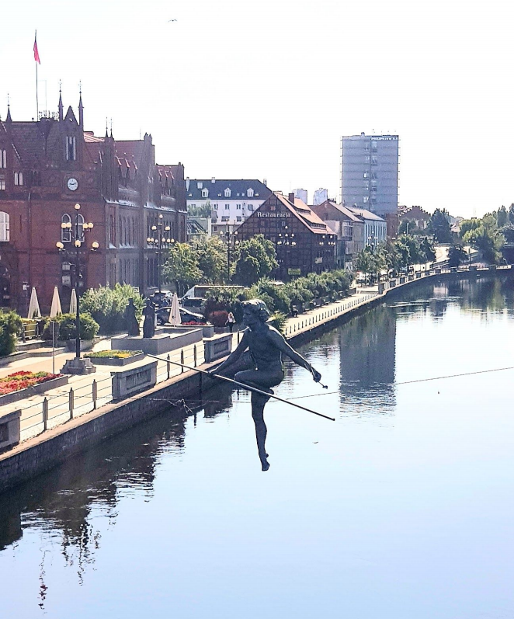

Figure 3. Participant eating a waffle with whipped cream

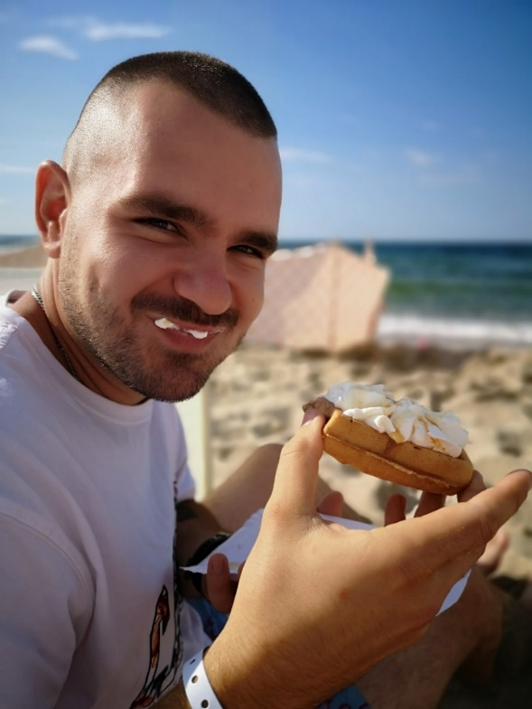

Figure 4. Participant sitting on a giant chair in the mountains.

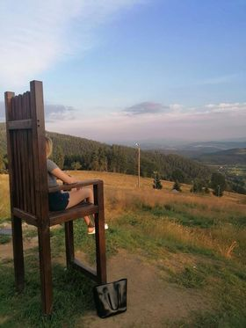

Figure 5. A group of cyclists

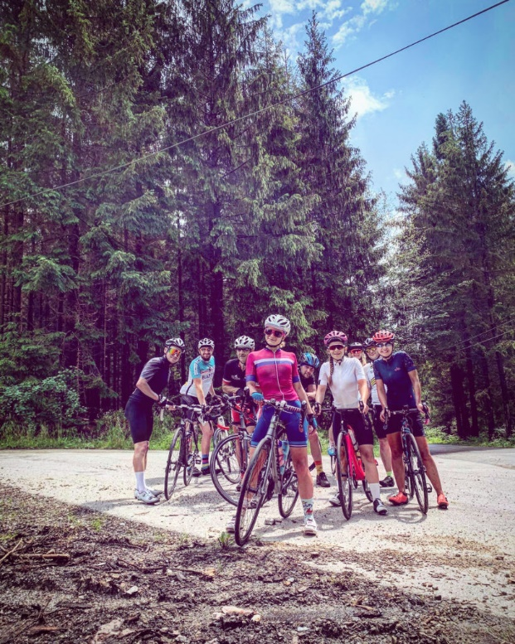

Figure 6. Participant expressing his enjoyment during outdoor activity

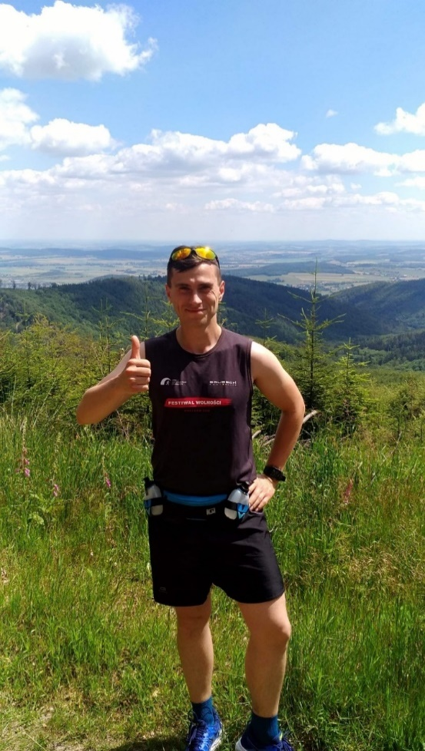

Figure 7. Empty main square in Wroclaw, Poland

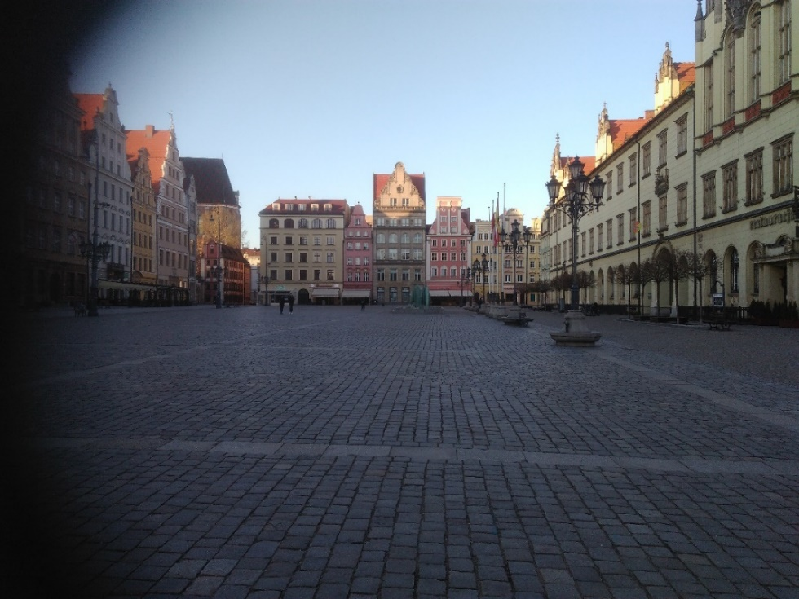

Figure 8. A bowl with fruit and walnuts

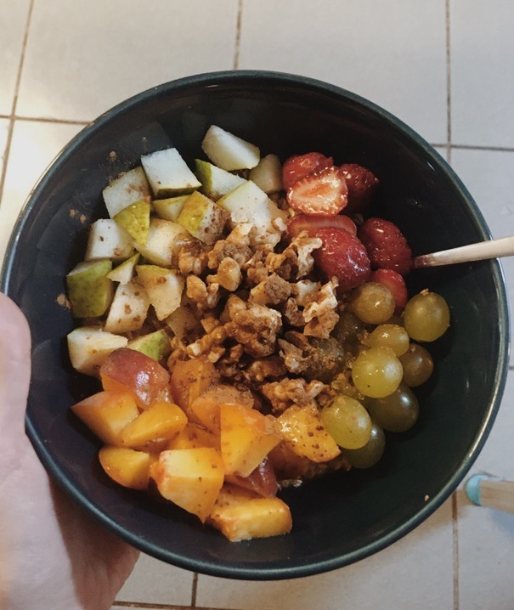

Table 1. Participant demographics

|  |  |
| --- | --- |
| **Participant characteristics** | **Number (%)** |
| Age (18-71, *M*=35.64, *SD*=13.86)  18-29  30-44  45-59  > 60 | 20 (40%)  19 (38%)  7 (14%)  4 (8%) |
| Gender  Women  Men  Other | 34 (68%)  15 (30%)  1 (2%) |
| Nationality  Polish  Ukrainian | 46 (92%)  4 (8%) |
| Employment  Full-time or part-time  Unemployed  Retired | 37 (74%)  10 (20%)  3 (6%) |
| Education  Primary level  Secondary level  Bachelor’s degree  Master’s degree  Doctoral degree  Other (unspecified) | 2 (4%)  14 (28%)  6 (12%)  25 (50%)  1 (2%)  1 (2%) |
| Place of living  Big city (more than 500,000 inhabitants)  Medium-size city (100,000 – 500,000 inhabitants)  Small town (less than 100,000 inhabitants)  Rural area | 20 (40%)  3 (6%)  16 (32%)  11 (22%) |

Table 2. Theme categories and generated themes

|  |  |
| --- | --- |
| **Theme category** | **Themes** |
| Health perceptions | * Health as a ‘long journey’ * Health as keeping balance * Health as self-acceptance | |
| Facilitators to health | * Enjoyment of activities that are part of healthy lifestyle * Planning time for rest * Supportive relationships * Contact with nature | |
| Covid-19 and health | * The Covid-19 pandemic as disruption in maintaining healthy behaviours * The Covid-19 pandemic as motivation to engage in health behaviours | |

Supplementary Material 1

**Participants’ instructions**

*What do you need to do to take part?*

1. Take a picture that answers the question: ‘What does it mean to you to be healthy?’ You don’t have to be a professional photographer and you don’t have to use any special equipment. The most important thing is what you want to capture.

*You have to be the author of the photograph. Remember not to invade anyone’s privacy when taking the picture – the best idea is to take a picture of yourself or your surroundings. Do not photograph illegal content, or anything that violates confidentiality or infringes copyrights. Do not photograph inappropriate objects (e.g., nudity). Ensure that you are safe when taking the picture. If you want to take photo of other people, ask for their consent (link to Qualtrics form).*

1. Describe your photo (minimum 200 words). Here are some supporting questions: What does the photo show? How does it relate to your health? Why is it important to you? Is there anything else that you would like to add regarding this photo or your health behaviours? Have your health changed during the COVID-19 pandemic? If yes, how has it changed? Is it visible in the photo?
2. If you publish your photo to social media (Facebook, Instagram or Twitter), tag ‘*Choosing Health’* and your friends that you would like to challenge to take part. You can also send your photo with caption to: *(blinded for peer review)*.
3. Go to: (*link to Qualtrics form*), read the information sheet and consent to participate in our study. If you want to send us photographs of other people, please make sure that they fill in this for too!
4. If you consent, your photo will be published on our social media account and your photo will be part of a virtual exhibition of this study. We are looking forward to finding out – what does it mean for you personally to be healthy!