Ultra-sensitive detection of circulating tumour DNA enriches for patients with greater risk of recurrence in clinically localised prostate cancer

Conflict of interest statement
Niall Corcoran:
Honoraria: Bayer Pharmaceuticals; Janssen; Astra Zeneca
Grant support: Astra Zeneca; Janssen; Bayer

Authors
Bernard Pope^{1-4*}, Gahee Park^{5-7*}, Edmund Lau^{1,2}, Jelena Belic ⁵⁻⁷, Radoslaw Lach⁵⁻⁷, Anne George⁷⁻¹¹, Patrick McCoy¹, Anne Nguyen¹, Corrina Grima¹, Bethany Campbell¹, Chol-hee Jung², Emma-Jane Ditter^{6,12}, Hui Zhao^{6,12}, CR-UK/Prostate Cancer UK, ICGC, The PPCG, David C. Wedge¹³, Daniel S. Brewer^{14,15}, Andy G. Lynch¹⁶, Harveer Dev⁵⁻⁷, Vincent J. Gnanpragasam^{8,9,11}, Nitzan Rosenfeld^{6,12}, Christopher M. Hovens^{1,18,19}, Niall M. Corcoran^{1,18,20,21#}, Charles E. Massie^{5-7#†}

BP/NC/EL/CH/PM/AN/CG/BC 1 Department of Surgery, University of Melbourne, 5th Floor Clinical Sciences Building, Royal Melbourne Hospital, Grattan Street, Parkville, VIC, 3050, Australia
BP/EL/CJ 2 Melbourne Bioinformatics, The University of Melbourne, Carlton, VIC, 3053, Australia
BP 3 Department of Medicine, School of Clinical Sciences, Monash University, Melbourne, VIC, 3800, Australia
BP 4 Department of Clinical Pathology, The University of Melbourne, Victorian Comprehensive Cancer Centre, Melbourne, VIC, 3000, Australia
GP/JB/RL/CM 5 Early Cancer Institute, University of Cambridge, Department of Oncology, Hutchison Research Centre, Box 197, Cambridge Biomedical Campus, Cambridge, CB2 0XZ
GP/JB/RL/CM/AJD/HZ/NR 6 Cancer Research UK Cambridge Centre, Cambridge Biomedical Campus, Cambridge, UK.
GP/JB/RL/CM/AG 7 Department of Oncology, University of Cambridge, Hutchison-MRC Research Centre, Cambridge Biomedical Campus, Cambridge, UK
AG/VG 8 Department of Surgery, Division of Urology, University of Cambridge, Cambridge, UK;
AG/VG 9 Department of Urology, Cambridge University Hospitals NHS Foundation Trust, Cambridge, UK;
AG 10 Academic Urology Group, Department of Surgery, University of Cambridge, Cambridge, UK;
AG/VG 11 Cambridge Urology Translational Research and Clinical Trials, Cambridge Biomedical Campus, Cambridge, UK
AJD/HZ/NR 12 Cancer Research UK Cambridge Institute, University of Cambridge, Cambridge, UK
DW 13 Manchester Cancer Research Centre, University of Manchester, Manchester, UK
DB 14 Norwich Medical School, University of East Anglia, Norwich, Norfolk, UK
DB 15 Earlham Institute, Norwich, UK
AGL 16 School of Medicine, University of St Andrews, St Andrews, UK
AGL 17 School of Mathematics and Statistics, University of St Andrews, St Andrews, UK
NC/CH 18 Department of Urology, Western Health, Footscray, VIC 3011, Australia
CH 19 Australian Prostate Cancer Research Centre, Melbourne, VIC, Australia
NC 20 Department of Urology, Royal Melbourne Hospital, Parkville, VIC 3050, Australia
NC 21 Victorian Comprehensive Cancer Centre, Parkville, VIC 3050, Australia

* These authors made an equal contribution
# These authors made an equal contribution
† Deceased 5 May 2023

Word count (main text, excluding figures and bibliography): 741

Aims
Circulating tumour DNA (ctDNA) has clinical applications as a "liquid biopsy" due to its short half-life, non-invasive collection modalities, and propensity for sampling across populations of tumour cells [1]. While ctDNA detection has been successfully demonstrated in metastatic prostate cancer [2], localised disease yields low levels of ctDNA, making detection difficult using conventional methods [3]. In this study, we assessed the limits of detection of ctDNA in localised prostate cancer using the high-sensitivity INVAR method [4] and tested the hypothesis that ctDNA detection is associated with high-risk disease. Tumour information was used to create marker panels of patient-specific mutations which were used to identify ctDNA molecules in patient-matched plasma samples. After initial background error calculations and filtering steps, the detected ctDNA fraction was estimated using a global integrated mutant allele fraction (IMAF), using the background-subtracted mean allele fraction across the patient-specific loci in each sample. Patient-specific scores were compared to the threshold value for classification, which was calculated using data from control samples and set to 95% specificity.

Methods
A total of 118 individuals with clinically localised prostate cancer from Australia and the UK were analysed. All plasma samples were obtained pre-prostatectomy; immediately prior to surgery in Australia, and at the time of surgical consent in the UK. An additional 27 healthy, prostate cancer-free male individual plasma samples were used as controls. All primary tumour samples were derived from radical prostatectomy for pathologically-confirmed prostate cancer and were hormone-naïve at treatment. Blood plasma cell-free DNA samples were profiled with custom targeted sequencing panels using the Agilent SureSelect XT HS target enrichment system (Agilent Technologies), with a mean of 2380 patient-specific target loci per sample. We adhered to consistent standard operating procedures and implemented time intervals between cohort extractions to maintain sample integrity and minimise contamination risk. Survival analyses using biochemical recurrence and metastasis-free survival as endpoints were assessed by Cox regression to understand the relationship between ctDNA detection and disease progression.

Results
Using the INVAR method, we detected ctDNA in 19 localised prostate cancer patients (16%), with an average IMAF of 2.55x10⁻⁴ with a range of 1.17x10⁻⁵ to 1.85x10⁻³. A comparison of the clinical characteristics of positive and negative samples is shown in Table 1. Within the cohort, there was a reasonably good representation of the clinical spectrum of localised disease, and a consistent association between ctDNA detection and more aggressive clinical features.

Kaplan-Meier curves were used to assess the relationship between ctDNA detection and disease progression (Figure 1). Comparing patients categorised according to the detection of ctDNA by INVAR at the time of prostatectomy, we observed a significant association for ctDNA positive individuals having both shorter biochemical recurrence-free survival (p = 0.0001, log-rank test; hazard ratio = 3.3, 95% CI = [1.4, 8.1]) and shorter metastasis-free survival (p = 0.0055, log-rank test; hazard ratio = 2.8, 95% CI = [1.1, 7.1])) compared with ctDNA negative individuals.

On multivariable analysis, the detection of ctDNA pre-treatment was positively associated with an increased risk of both biochemical recurrence and development of metastasis. This showed statistical significance for recurrence but not metastasis, where the ISUP grade group was dominant in the model. Despite this, ctDNA detection was a stronger predictor than pre-treatment PSA and pathological stage, which are both well-established prognostic variables for metastases. We interpret these results with caution however, given the relatively few metastatic events observed for the number of variables included in the model.

Conclusions
Our study provides clear insights into the required analytical sensitivity and potential utility of ctDNA mutation analysis in localised prostate cancer. We found that in ctDNA positive cases, there was a significant association with biochemical recurrence after surgical intervention. This raises the potential for including ctDNA detection as an additional tool for patient stratification post biopsy in future neo/adjuvant treatment trials aiming to assess the impact of treatment escalation in men at high risk of relapse with current standard of care treatment alone.

A limitation of our study is that the Australian cohort was enriched for individuals with high risk and was therefore poorly suited to find significant associations with disease recurrence in competition to already known variables such as high grade.

A limitation of INVAR is that it requires the primary tumour to have undergone WGS. However, as the cost of WGS continues to fall, it is increasingly being incorporated into routine clinical care. In addition, better upfront risk stratification may lead to treatment escalation/de-escalation, which may have economic benefits in the longer term.

Figures
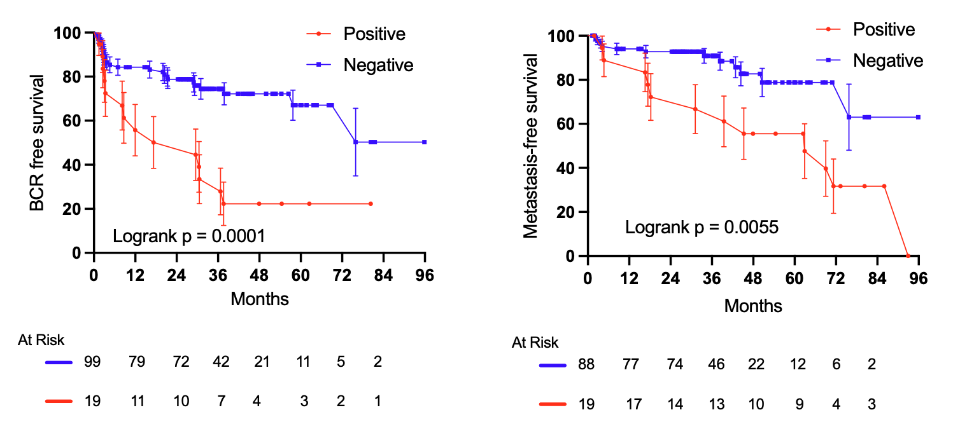

Figure 1: Kaplan-Meier curves demonstrating (A) biochemical- and (B) metastasis-free survival in patients categorised according to the detection of ctDNA by INVAR at the time of prostatectomy.

Tables
Table 1. Clinical and Pathological Characteristics Comparison: ctDNA-Positive vs. ctDNA-Negative Samples. The p-values indicate whether there is a significant difference between the positive and negative groups. For age and PSA at tumour collection, the p-value is computed by the Mann-Whitney U test. Differences in proportions across categories in pathological T stage and post prostatectomy PSA nadir are computed using Fisher's exact test. Differences in proportions across clinical T stage, biopsy ISUP grade group, prostatectomy ISUP grade group, Cambridge prognostic group, and salvage radiation are computed using Chi-squared tests. P-values less than 0.05 are in bold. ISUP = International Society of Urological Pathology; GG = Gleason grade; PSA = prostate-specific antigen. Medians were reported as median (quartile 1, quartile 3), and frequencies as “number (percentage)”.

Acknowledgments
We dedicate this article to the memory of Charles (Charlie) Massie, co-lead author of the study, who sadly passed away just before journal submission. Charlie was a highly talented scientist who earned the highest respect from his peers and the broader community for his dedication to improving the lives of people affected by cancer. His inspirational life gives us energy to carry forward this work. BP was supported by a Victorian Health and Medical Research Fellowship from the Victoria State Government. This research was supported by The University of Melbourne’s Research Computing Services and the Petascale Campus Initiative. Analysis of the Australian samples was funded through the PRECEPT program grant, co-funded by Movember and the Australian Federal Government (PI NMC). C.E.M. and H.D. were supported by the Cancer Research UK Cambridge Centre, John Black Charitable Foundation and Prostate Cancer Foundation. H.D. and V.J.G. acknowledge infrastructure support from the National Institute for Health Research (NIHR) Cambridge Biomedical Research Centre (BRC-1215- 20014). The views expressed are those of the authors and not necessarily those of the NIHR or the Department of Health and Social Care.

Bibliography
[1] Heitzer E, Haque IS, Roberts CES, Speicher MR. Current and future perspectives of liquid biopsies in genomics-driven oncology. Nat Rev Genet 2019;20:71–88. https://doi.org/10.1038/s41576-018-0071-5.
[2] Ku S-Y, Gleave ME, Beltran H. Towards precision oncology in advanced prostate cancer. Nat Rev Urol 2019;16:645–54. https://doi.org/10.1038/s41585-019-0237-8.
[3] Hennigan ST, Trostel SY, Terrigino NT, Voznesensky OS, Schaefer RJ, Whitlock NC, et al. Low abundance of circulating tumor DNA in localized prostate cancer. JCO Precis Oncol 2019;3. https://doi.org/10.1200/PO.19.00176.
[4] Wan JCM, Heider K, Gale D, Murphy S, Fisher E, Mouliere F, et al. ctDNA monitoring using patient-specific sequencing and integration of variant reads. Sci Transl Med 2020;12. https://doi.org/10.1126/scitranslmed.aaz8084.

