‘Literature is for everyman’? Critical Quarterly’s democratic literary culture
The inaugural issue of Critical Quarterly, published in March 1959, began with a short editorial in which founding editors C. B. Cox and A. E. Dyson stated, ‘literature is for everyman’. Cox and Dyson sought to democratise F. R. Leavis’s ‘minority culture’ by creating what they called an ‘expanding élite’. To do this, they sought to bring the specialist knowledge of an academic literary journal to a wider audience beyond the university, a readership which included schoolteachers, sixth-formers and general readers. CQ therefore published articles of varying depth and specialisation, from short close readings of single poems to surveys of recent criticism of canonical texts, which could be used as the basis for A-level English lessons. Cox and Dyson also organised regular Critical Quarterly Society conferences for this non-university audience (and archival research at the John Rylands Library in Manchester sheds light on how important these activities were to Cox in particular). The CQ project was broadly popular (in the 1960s the journal was sold to more than half the grammar schools in Britain), but it was not without its flaws: the word ‘everyman’ is emblematic of the early CQ’s dependence on male contributors, and the schoolteacher audience was drawn mainly from the grammar schools. Further, these non-specialists were seen more as a passive audience than an active base of contributors: to use the distinction made by Raymond Williams in the conclusion to Culture and Society (1958), CQ’s communication with this non-specialist audience was a one-way ‘transmission’ rather than a two-way ‘conversation’. After considering the CQ example, this paper asks how we might enact a similar project today, albeit one which gets closer to a democratic ‘conversation’ between academic literary critics or scholars and a non-specialist, non-university audience.

‘Literature is for everyman’? Critical Quarterly’s democratic literary culture
The inaugural issue of Critical Quarterly, published in March 1959, began with a short Foreword in which founding editors C. B. Cox and A. E. Dyson stated their aims for the journal. It concluded:
We are hoping, then, that The Critical Quarterly will be mainly constructive in its emphasis […] If we can help to keep alive the belief that literature is for everyman—for everyman, that is, who will pay it the courtesy of a creative response—and that it is still one of the major pleasures of life, we shall feel we have achieved at least one of our aims.

The word ‘everyman’, taken as it is from the medieval morality play, was dated in 1959, and it is emblematic of what James Robert Wood has called ‘the dominance of male voices’ at CQ under Cox and Dyson’s editorship. However, the motto ‘literature is for everyman’ was meant to be a bold statement of intent for a democratising project. As the pair wrote in a later essay, titled ‘Literary Criticism’ (1972): ‘The aim of our journal was to promote high standards in common educated discourse, to make literature accessible to any student with goodwill, and, in Northrop Frye’s words, to prevent it from “stagnating among groups of mutually unintelligible élites”.’ Rather than an organ for the sharing of knowledge between specialists, Cox and Dyson sought to use CQ to bring the specialist knowledge of an academic journal to a wider audience beyond the university, a readership which included schoolteachers, sixth-formers and general readers. (Indeed, one of the titles originally considered for the journal was ‘Communication’, although in the end they decided this was ‘too dull’.) This paper will look closely at how Cox and Dyson sought to communicate specialist knowledge to non-university audiences in two ways: through the editorial policies of the journal, as well as through the regular Critical Quarterly Society conferences, which ran twice a year from 1961 until at least 1992. The CQ project was broadly popular (in the 1960s the journal was sold to more than half the grammar schools in Britain), but it was not without its flaws. In particular, these non-specialists were seen more as a passive audience than an active base of contributors: to use the distinction made by Raymond Williams in the conclusion to Culture and Society (1958), CQ’s communication with this non-specialist audience was a one-way ‘transmission’ rather than a two-way ‘conversation’. After considering the CQ example, this paper asks how we might enact a similar project today, albeit one which gets closer to a democratic ‘conversation’ between academic literary critics or scholars and a non-specialist, non-university audience.
In the motto ‘literature is for everyman’ as well as the arguments of the later essay, Cox and Dyson were consciously defining themselves in opposition to F. R. Leavis’s Cambridge-based journal Scrutiny, which ran from 1932 until it folded in 1953, as well as the Oxford-based Essays in Criticism, established by F. W. Bateson in 1951. It would pay to briefly sketch out this intellectual context. The 1950s was a decade when, as Matthew Taunton puts it, ‘the powerful influence of F. R. Leavis could be felt everywhere in the discipline of English Literature’, and while Cox and Dyson had both been trained in Leavisite practical criticism at Cambridge’s Pembroke College from 1949 to 1954, they rejected Leavis’s pessimism about contemporary culture. This pessimism had been articulated by Leavis in the infamous and influential essay ‘Mass Civilization and Minority Culture’ (1930), in which he argued ‘culture is at a crisis’. Under threat from mass-produced goods, the cinema, and the tabloid press, the future of culture – which, for Leavis, meant the literary tradition – depended on ‘a very small minority’ of expert critics with specialist knowledge about literature. Leavis argued: ‘The minority capable not only of appreciating Dante, Shakespeare, Donne, Baudelaire, Conrad (to take major instances) but of recognizing their latest successors constitute the consciousness of the race’. Though Cox and Dyson shared with Leavis the ‘belief that understanding of great literature creates tolerance and wisdom,’ they found his cultural pessimism to be stifling for contemporary writers. As Dyson put it in a 1960 editorial, Leavis ‘adopted towards contemporary literature an unfortunately negative approach; his standards of excellence are such that only a few writers in any century could hope to come up to them’. The effect of this was recalled by Cox in his 1992 memoir, The Great Betrayal: ‘During our years at Cambridge Tony [Dyson] and I were typical in taking almost no interest in contemporary verse. We read Dylan Thomas, of course, but our attitude tended to be one of contempt.’ This contempt for contemporary poets had a profoundly negative effect on Cox’s own creative practice: ‘Leavis’s scorn was easy to imitate, and made my own personal writings seem feeble (as they were, but they were beginnings on which I might have built.).’
Despite their reservations about Leavis’s pessimism, Cox and Dyson did publish a symposium titled ‘Our Debt to Dr Leavis’ in CQ’s third issue, dated September 1959. The three contributors, Raymond Williams, R. J. Kaufmann and Alun Jones, were all broadly positive about Leavis’s work; Williams, for instance, wrote that Leavis ‘is the most interesting critic of his generation, […] his educational influence has been central to the best work of the period, and […] his life’s work is a major contribution to our culture.’ Himself a graduate of Cambridge English, Williams had previously offered a notable critique of Leavis’s minority culture in the seminal Culture and Society (1958). In particular, Williams questioned the centrality of literature to Leavis’s idea of culture:
the ways in which we can draw on other experience are more various than literature alone. For experience that is formally recorded we go, not only to the rich source of literature, but also to history, building, painting, music, philosophy, theology, political and social theory, the physical and natural sciences, anthropology, and indeed the whole body of learning. We go also, if we are wise, to the experience that is otherwise recorded: in institutions, manners, customs, family memories.

Later, in the book’s conclusion, Williams writes of the importance of contemporary culture, in particular:
A culture, while it is being lived, is always in part unknown, in part unrealized. The making of a community is always an exploration, for consciousness cannot precede creation, and there is no formula for unknown experience. A good community, a living culture, will, because of this, not only make room for but actively encourage all and any who can contribute to the advance in consciousness which is the common need.

Despite Cox and Dyson’s acceptance of Leavis’s definition of literature as culture, Williams’s description in this second quotation bears some relation to Cox and Dyson’s rejection of the pessimistic tendencies of Leavis’s cultural criticism and their hope, described in CQ’s first foreword, that the journal will be ‘mainly constructive in its emphasis’. In what follows, I seek to position Cox and Dyson’s editorial policies at the journal and their work organising the Critical Quarterly Society conferences as examples of an ongoing attempt to, in Williams’s words, ‘not only make room for but actively encourage all and any who can contribute to the advance in consciousness which is the common need.’
As editors, Cox and Dyson were committed to contemporary writing; the journal published contemporary poetry from the very first issue, and fiction as early as 1968. They dedicated what they themselves called ‘an appreciable amount of space to the publication of new poets such as Philip Larkin, Ted Hughes, Thom Gunn, R. S. Thomas and Sylvia Plath’. They also looked beyond the British Isles, publishing poetry by international writers such as the Barbadian poet Kamau Brathwaite. This active engagement with new writers and commitment to publishing contemporary work was one of the ways in which Cox and Dyson sought to democratise literary culture. As the pair wrote in 1972: ‘From the beginning, we committed ourselves optimistically to faith in the possibility of an expanding élite’. The term ‘expanding élite’ is, to a great extent, an oxymoron (and it is certainly less ambitious an idea than ‘literature is for everyman’), but it is still illustrative of the modification Cox and Dyson were attempting to make to Leavis’s ‘minority culture’. While acknowledging the place of canonical writers such as Dante, Shakespeare, Donne, Baudelaire and Conrad, Cox and Dyson sought to do what Leavis never actually did: to ‘recogniz[e] their latest successors’. They did so by publishing contemporary writing and the criticism of this writing at a time when, as Malcolm Bradbury observes, this writing ‘had almost no place in the teaching of English in British universities.’ In doing so, Cox and Dyson hoped to expand Leavis’s canon and ‘turn literary criticism away from puritanism and towards intelligent celebration of creative achievements.’
It is worth noting briefly that the motivation behind this ‘expanding élite’ was social as well as literary. Of the generation of working and lower-middle class children who benefitted from the increase in free grammar school places between the wars, those who were fortunate enough to go on to university and an academic career would have graduated by the mid-1950s and taken their first teaching positions in universities or schools by the time CQ was founded in 1958. Dyson, who had grown up in poverty in Paddington, was acutely aware of his own social mobility, and would go on to describe himself and his contemporaries as ‘the generation that, as it seems, had the luck’. Cox had also attended a local grammar school, and so, too, had a number of CQ’s regular contributors, including Malcolm Bradbury, David Lodge, Richard Hoggart, Ted Hughes and Raymond Williams. Williams and Hoggart were also members of CQ’s honorary committee, whose names were published on the journal’s masthead and promotional material. The above list of names corresponds, again, with what Wood has called the ‘dominance of male voices’ in CQ, although it should be remembered that these men were, like Cox and Dyson, mostly ‘scholarship boys’ from working and lower-middle class backgrounds who were entering into an academic sphere which had until then been dominated by the privately-educated upper and upper-middle classes.
Cox and Dyson therefore sought to create an ‘expanding élite’ by extending Leavis’s definition of culture to include contemporary literary activity, and by broadening Leavis’s minority group of critics to a wider social demographic. But the two men also shared a distinct ambition to cultivate an audience beyond those whose job it was to think and talk about literature. If literary culture does contain, as Leavis argued, ‘the finest human experience of the past’, then it follows that this experience should be communicated to as wide a readership as possible. As Taunton writes: ‘CQ conceived of its readership in a completely different way’ to Scrutiny and Essays in Criticism. ‘Rather than being “by academics, for academics”, the magazine sought a much wider audience and emphasis was placed in particular on the need to address readers in schools.’ As Cox himself wrote in 1992: ‘We believed that it is worth devoting a life to presenting, teaching, and celebrating great art, of both past and present, and that academic criticism can be of benefit to the general reader.’ The term ‘general reader’ is, like ‘everyman’, a vague one – Williams might well have said that there is no general reader, only ways of seeing readers as general – but it is useful to compare Cox and Dyson’s imagined non-specialist, non-university ‘everyman’ with the implied reader of Hoggart’s The Uses of Literacy (1957), published the year before CQ was founded. Hoggart writes in the preface that his work is addressing ‘first of all the serious “common reader” or “intelligent layman” from any class.’ This reader
is an elusive figure, and popularization a dangerous undertaking: but it seems to me that those of us who feel that writing for him is an urgent necessity must go on trying to reach him. For one of the most striking and ominous features of our present cultural situation is the division between the technical languages of the experts and the extraordinary low level of the organs of mass communication.

There is an obvious parallel between Hoggart’s ‘technical languages of the experts’ and Cox and Dyson’s aim ‘to promote high standards in common educated discourse, to make literature accessible to any student with goodwill, and, in Northrop Frye’s words, to prevent it from “stagnating among groups of mutually unintelligible élites”.’ Hoggart, like Cox and Dyson, sought to broaden the audience for specialist literary knowledge to include those from outside the university. But whereas Hoggart expresses – or at least hints at – a doubt as to whether this ‘elusive’ figure really does exist at all, Cox and Dyson do not offer any extended argument about the real existence or specific location of this ‘everyman’ or ‘general reader’, beyond their being outside the university. Atherton notes that these terms have ‘a rhetorical vagueness that would presumably allow any of the journal’s readers to imagine themselves part of this group’; while this is undoubtedly true, that is not an entirely negative matter.
As editors, Cox and Dyson therefore published a range of articles of varying depth and specialisation. In the first issue, for example, short close readings of single lyric poems by Philip Larkin and William Blake, each under four pages long, appeared alongside longer articles of academic literary criticism and scholarship, such as Raymond Williams’s reading of Dylan Thomas’s Under Milk Wood, at nine pages long. The latter is an example of specialist knowledge being transmitted through the journal to other specialists within the same field, in this case literary studies, whereas the shorter pieces were written for their educative function: they were meant to be accessible for undergraduate students as well as sixth-formers and general readers from outside the institutions of formal education. Jonathan Culler calls this ‘interpretative criticism’ – the kind of writing ‘which in principle if not in practice requires only the text of a poem and the Oxford English Dictionary, [and] offers but a more thorough and perceptive version of what every reader does for himself.’ As Culler puts it: ‘Citing no special knowledge which it deems to be crucial and from which it might derive its authority, interpretative criticism seems best defended as a pedagogic tool which offers examples of intelligence for the encouragement of others.’ This is a novel position for an academic journal to take: teaching readers, rather than sharing knowledge among specialists.
This effort to publish a ‘teaching’ literary criticism for a non-university audience was accompanied by an attempt to redefine the university itself – and particularly the university English school – within the pages of the journal. The second issue, dated June 1959, published an article by Dyson titled ‘Literature—in the Younger Universities’ as part of a wider symposium on teaching literature in various settings. In it, Dyson argued that the university should function as a centre of culture and liberal values, and that the English Literature degree should be central to an idea of the university as ‘a living and civilising force’. Dyson argued that the university – particularly the provincial university – should be a ‘cultural centre for the whole community, a guardian of values, and an inspirer of humane activity in local and national affairs’. The university could be ‘a place where all those interested in education, ideas and human beings can join together for study, discussion, and if necessary for action.’ This would serve an important social function for our ‘mechanised society’, as Dyson argued:
it remains true that most parts of Britain are still rich in cultural and traditional resources—architecture, song, history, drama, local skills—and that a modern university ought to recognise a living responsibility for these which no-one else (landed families, the Church, even the Ministry of Works) is any longer able to bear.

Dyson here appreciates the importance of what Williams called ‘experience […] more various than literature alone’, however he does, like Leavis, position the university English faculty as central to his social model for a democratic culture, seeing it as
the core from which a revival of liberal values could emerge. […] I personally should like to see develop a number of close liasons [sic.] which ought to exist, but seldom do. First, between junior staff and students […] Then, there might well be a link between the university itself, both staff and students, and those in the town and locality who attend W.E.A. [Workers’ Educational Association] or Extra-Mural classes, school teachers, voluntary workers in sociology and local government, sixth formers, clergy, foreigners visiting under British Council or other auspices, political workers of all parties, and anyone interested in world affairs. […] The types of cultural activity sponsored by a healthy English department, especially drama, film and debating, could provide an initial meeting ground; and a bar or coffee bar for formal and informal meetings would provide the atmosphere of a club.’

There is an obvious resemblance here between the community of thought which Dyson describes above and the ‘expanding élite’ that CQ sought to establish. The university is, in this ideal, an institutional base for ‘cultural activity’ which crosses the boundary from the professional academics at the university campus to interested members of the public. The term ‘cultural centre’ anticipates a term that Leavis himself would use a decade later in the introduction to English Literature in Our Time and the University (1969), which collects the six Clark Lectures he gave at Cambridge in 1967. Leavis described the idea of a university as a ‘creative centre, for the civilized world,’ but he did not suggest as Dyson did the same kind of practical connections between the university and the wider social world. Leavis and Dyson had reached this same conclusion that the university should be a ‘creative centre’ or a ‘cultural centre’ by following a line of thought originating from ‘Mass Civilization and Minority Culture’, namely the question of how to communicate the ‘subtlest and most perishable parts’ of a specifically literary culture to the wider society and in so doing make possible ‘our power of profiting by the finest human experience of the past’. Leavis never offered as concrete a suggestion as Dyson’s, in part because he believed that the preservation of the literary tradition among a minority of professional academics was sufficient on its own. Dyson, on the other hand, attempted here to imagine how the specialist knowledge preserved in the English department might benefit the wider community beyond the university. This ideal model of how the ‘cultural centre’ might interact with its periphery, though difficult to achieve in practice, gave Cox and Dyson something to work towards.
Cox and Dyson’s idea of an ‘expanding élite’ was also inspired by their own experiences as W.E.A. tutors in the early 1950s. As Cox recounts in his memoir, he began teaching with the W.E.A. in 1952, while still a postgraduate researcher at Cambridge. His first class was a ten-week course called ‘The Countryside in Literature’, which he taught in the small village of Methwold in southwest Norfolk. Although, as Cox puts it, ‘Village classes rarely included more than one or two real “workers” (such as farm labourers), and were mainly middle-class housewives, with perhaps a vicar’s wife or the local school-teacher’, the experience was formative: ‘The people I met, the teaching challenges, felt so much more real to me than my so-called “research” on Henry James. […] In those days after the war the W.E.A. performed miracles in keeping alive literary and cultural debate.’ The opposition Cox makes between his classroom teaching and postgraduate work is unhelpful – his teaching would not be possible without the ‘so-called “research”’ undertaken by himself and his predecessors – but it does emphasise the importance, for Cox especially, of using academic knowledge to serve teaching, in particular the teaching of non-university learners. Williams himself was also an adult education tutor, both through the W.E.A. as well as through the Oxford Delegacy for Extra-Mural Studies, where he taught from 1946 to 1961. Much of Williams’s writing in the 1950s and 1960s was influenced by this work, particularly his first book, Reading and Criticism (1950). In the preface, Williams writes:
This book is designed for the general reader, to help him in the reading and criticism of literature. Wherever possible it limits theoretical discussion and concentrates on practical reading. There are analyses of poems, of prose extracts, and of one complete work, Conrad’s Heart of Darkness. There is a series of exercises in practical criticism, and a short syllabus and reading-list. […] The book has been written with the ordinary private reader in mind, but it is additionally hoped that it will be useful as a reading manual in literature classes, whether university tutorial classes or the less formal kinds of adult education.

This project closely resembles Cox and Dyson’s use of interpretative criticism to ‘teach’ non-specialist readers; like CQ’s short close readings of single lyric poems, Williams teaches by example, for the benefit of interested general readers as well as his fellow educators.
While Williams mentions university and adult education tutors in the above preface, but the key non-university demographic with whom Cox and Dyson wished to engage was secondary school English teachers. As Carol Atherton writes, the pair ‘explicitly courted’ this readership as part of an attempt ‘to bridge the gap between those working in university departments of English and their colleagues in secondary education.’ Indeed, in a 1962 letter to CQ’s Honorary Committee (which, it should be noted, included both Williams and Hoggart), Cox explicitly stated: ‘We believe that there should be more contact between universities and schools’. Alongside the shorter pieces referred to above, CQ’s inaugural issue carried a contribution which was clearly intended for teachers in particular: G. K. Hunter’s short article ‘Hamlet Criticism’, which provided a brief historical survey of the reception and criticism of the play that could be easily adapted into a lesson for sixth formers, and from there into the kind of short essays they would be expected to write for their A level exams. Interestingly, Leavis had himself enacted a similar project with Scrutiny. As Ian MacKillop writes in his biography of Leavis: ‘Scrutiny went out of its way to interest teachers and recruit them to “The Scrutiny Movement in Education”. It was militant: the Leavisian mission was to build a public and foster a minority.’ Leavis did so because he recognised that ‘Scrutiny needed a professional constituency: it could not rely on simply being a magazine for “literary people”.’ Like Leavis, Cox and Dyson worked to ‘recruit’ a schoolteacher audience for CQ, but, crucially, they did so for different reasons: for Leavis, this audience was a means to an end, as it would provide a social and financial base for Scrutiny and its minority elite. For Cox and Dyson, however, engagement with schoolteachers was part of their wider ambition to democratise literary culture. For this reason, they sought closer contact than Leavis had attempted through Scrutiny.
One way Cox and Dyson sought to make an actual engagement with non-university readers was through the Critical Quarterly Society conferences, which ran twice a year from 1961 until at least 1992. Material related to these conferences (including leaflets, advertisements, and correspondence between Cox and the invited speakers) is held in the Critical Quarterly Archive at the John Rylands Library in Manchester. Unlike a conventional academic conference, where research is presented by professional academics within or between specialisms, these conferences were a forum for ‘the general discussion of literary questions’ between academics and contemporary writers on the one hand, and schoolteachers, students, or interested general readers on the other. This was an extension of their established editorial policy of publishing shorter pieces of criticism which would ‘teach’ the non-university reader, alongside the more familiar academic article which communicates specialist knowledge between professional academics. The first conference was held at Bangor in 1961 and advertised as being ‘intended, in the first place for professional teachers of literature’, but it was also open to CQ’s general readers: ‘some of our regular readers might also be interested, and so we are throwing open the score or so of remaining places to anyone who would like to come.’ This first conference was a success, and the Critical Quarterly Society then held similar conferences at Bangor and Scarborough in 1962. In July 1963, they held their first four-day conference ‘For young people under 21’ at Manchester. As Atherton points out, this age range ‘encompassed both A-level students and undergraduates.’ These conferences for young people – which were held during the Christmas and Easter holidays – would go on to become immensely popular and were regularly oversubscribed. Victor Sage, who was a PhD student of Dyson’s at the University of East Anglia, remembers the audience at the Keele conference in 1966 being made up of ‘masses and masses of sixth formers from up and down the country and their teachers.’
The popularity of these conferences was due in part to the profile of the visiting speakers Cox and Dyson managed to attract. Sylvia Plath and Ted Hughes’s last public appearance together was at the Bangor conference for English teachers in the summer of 1962. The August 1963 conference in London, titled ‘Literature Today’, featured Hoggart, Angus Wilson, Stephen Spender, and R. S. Thomas as visiting speakers. But the conferences were also popular due to their direct relevance for sixth formers hoping to go on to study English at university. The conferences were held at universities (most of them at Hulme Hall in Manchester), with lectures, seminars, meals and accommodation all based on campus. This, along with the presence of undergraduates below the age of 21, exposed sixth formers to university life. Similarly, each conference featured a ‘Practical Criticism Game’ in which the course members submitted unseen passages for the lecturers to try to date against the clock. Candidates were often asked to date unseen passages in Oxford and Cambridge entrance exams and interviews, and as Wood points out, ‘the implicit rationale’ behind this game at the conferences was that
if students were to perform well at this task themselves, [then] when it was no longer a game but a question in a Cambridge scholarship examination, it might make the difference between them winning a place at a college and being shut out.

As well as this, set texts for A level English exams were covered at the conferences because of their specific relevance to sixth formers. Part of the conference secretary Joan Darlington’s job was to research and prepare reports for Cox with ‘details of the “A” level courses of the various Boards’.
The CQ conferences were especially important to Cox, who spent as much time corresponding with teachers and their pupils as he did editing journal proofs or writing to academics and creative writers. In 1969, on the Friday before Christmas, a Cheshire schoolgirl wrote to Cox to ask if she could attend the Manchester conference which was due to begin on January 3rd: ‘I am anxious to attend the course, and I understand that you had promised to see whether a few extra pupils could be admitted’. Cox wrote straight back on the Monday to let her know that whilst it was too late to enrol her officially, ‘there is no reason why you should not come to the lectures and seminars.’ This exchange is emblematic of Cox’s generosity towards these sixth formers and his willingness to make concessions so that as many students as possible could benefit from these projects. (And while this particular student, Hilary Mantel, went on to study Law at university rather than English, it would be unfair to see that as a failing on Cox’s part.)

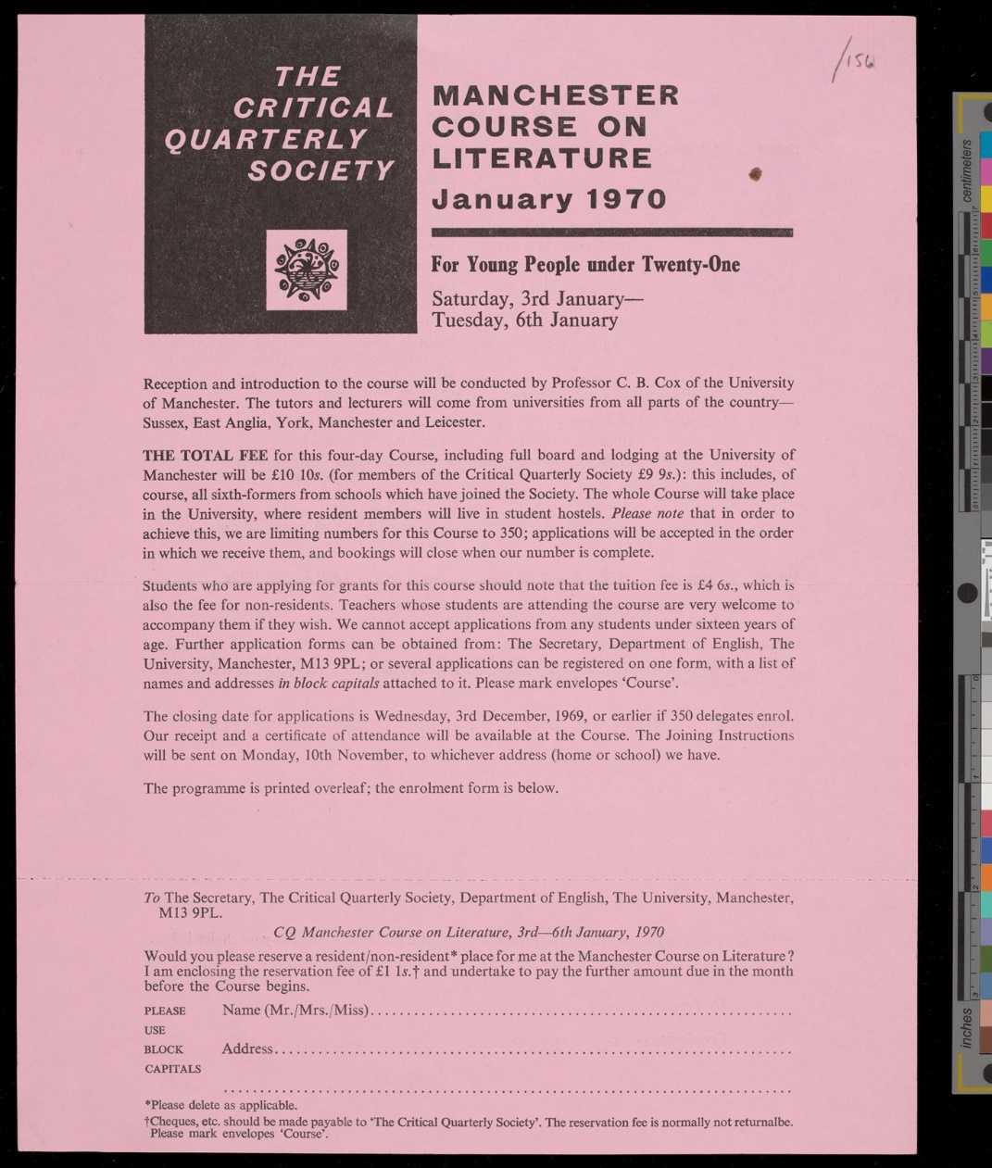
Fig. 1. Manchester Course on Literature, January 1970, Critical Quarterly Society, p. 1. CQA2/2/4/156, Critical Quarterly Archive, John Rylands Research Institute and Library, University of Manchester. Copyright of the University of Manchester.

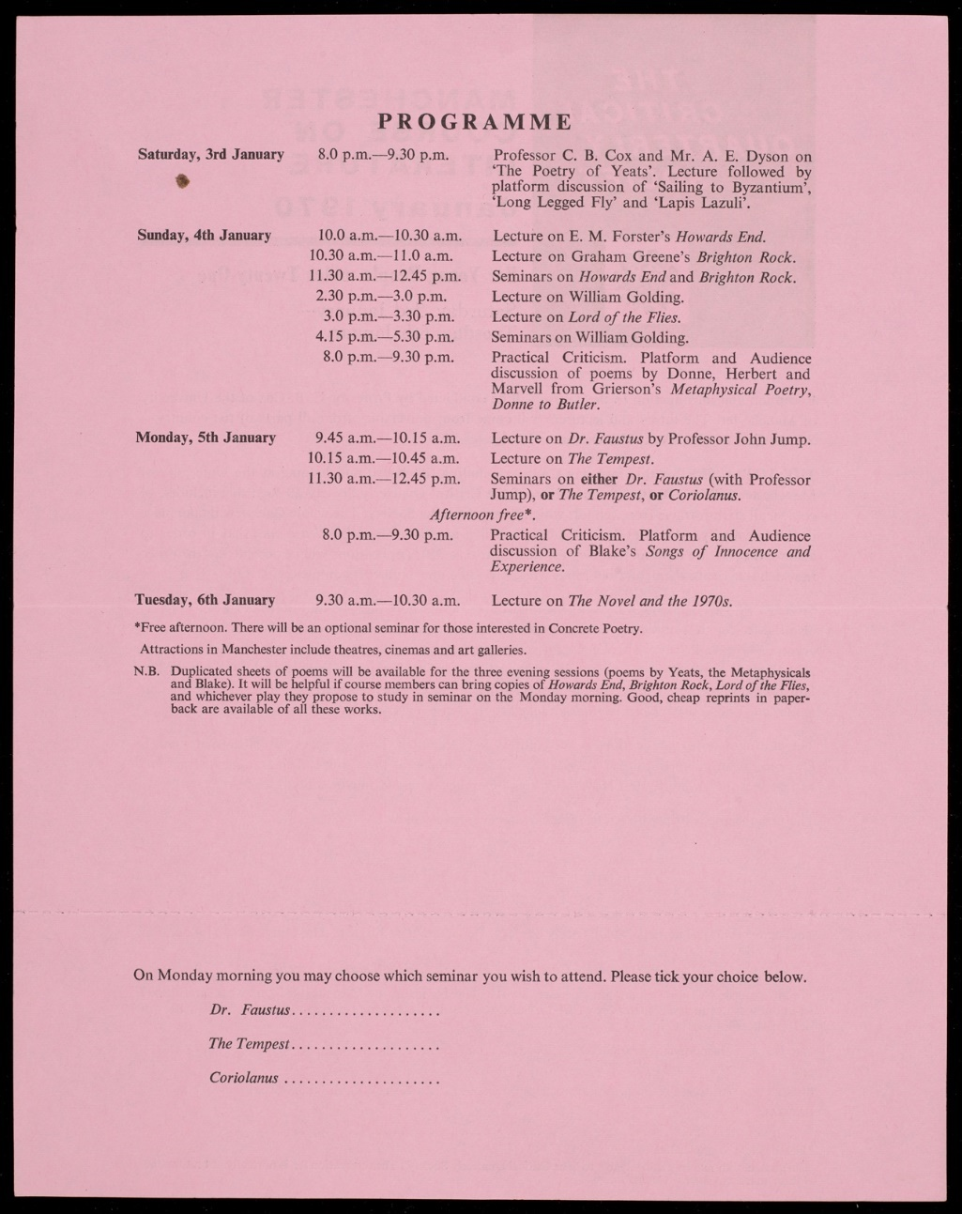
Fig. 2. Manchester Course on Literature, January 1970, Critical Quarterly Society, p. 2. CQA2/2/4/156, Critical Quarterly Archive, John Rylands Research Institute and Library, University of Manchester. Copyright of the University of Manchester.

Despite the obvious benefit to sixth-formers attending these conferences, the CQ project had two major shortcomings. The first was that the ongoing interaction with schools and schoolteachers favoured the grammar schools to an overwhelming degree. Most of the archived correspondence sent between Cox and various headteachers shows this. In a 2008 retrospective, Cox remarked in a somewhat triumphalist tone that ‘throughout the 1960s we were selling to more than half the grammar schools in Britain’, but made no mention of the secondary moderns or comprehensives. As individuals, Cox and Dyson each saw the increase of free grammar school places between the wars as the catalyst for their own trajectory from childhood poverty to secure, well-paid positions as university academics – as quoted above, Dyson described them as ‘the generation that, as it seems, had the luck’. But in depending on the grammar school in this way, Cox and Dyson fell for what Williams calls ‘the ladder version of society’. In the conclusion to Culture and Society, Williams writes that ‘the ladder is a perfect symbol of the bourgeois idea of society, because, while undoubtedly it offers the opportunity to climb, it is a device which can only be used individually: you go up the ladder alone’. Williams continues: ‘the boy who has gone from a council school to Oxford or Cambridge is of course glad that he has gone, and he sees no need to apologize for it, in either direction. But he cannot then be expected to agree that such an opportunity constitutes a sufficient educational reform.’ Cox and Dyson, however, seemingly did see their own individual social mobility in this way.
The second major shortcoming was that CQ’s non-university audience was a fundamentally passive one. As Atherton points out, the schoolteacher audience ‘occupied a relatively restricted space within the ideal community that Cox and Dyson envisaged’; they were not seen as ‘potential contributors’ to the journal and the ‘overwhelming majority of articles were written by academics’. To Atherton, CQ was limited to ‘a process in which professional academics and writers carried on a dialogue that schoolteachers could only spectate on, with opportunities to participate being restricted to attendance at conferences.’ But even when they did attend conferences, their participation was limited to discussion periods, group activities, and the practical criticism game. Teachers, students, or members of the public were not invited to give presentations, lead their own seminars, or address the conference as a whole, and there was no mechanism in place for them to challenge or enter into a dialogue with the visiting speakers. In the conclusion to Culture and Society, Williams reminds us that ‘much of what we call communication is, necessarily no more in itself than transmission: that is to say, a one-way sending.’ To ‘complete communication’ there must also be ‘active reception’ and ‘living response’. CQ was, then, both in the journal and at the conferences, simply transmitting ideas to these wider audiences, rather than engaging them in an active conversation. Cox and Dyson’s efforts – publishing shorter pieces of interpretative criticism, putting on huge conferences for sixth-formers, and so on – were only democratising reception, not response. The teachers, sixth-formers, undergraduates, and non-university readers could not enter into the written discourse of the journal by submitting articles, and they could not make any significant contribution at the conferences.
In light of this, we can see that when CQ’s first issue proclaimed ‘literature is for everyman’, this in fact meant that the enjoyment and understanding of creative works is for everyone, reading is for everyone, reception is for everyone; but Cox and Dyson failed to realise the importance of response to the democratisation of culture. There is an important link between CQ’s cultural transmissions and the phrases ‘expanding élite’, ‘cultural centre’, and ‘core’: each depends upon a spatial metaphor which places at the centre a singular body of knowledge, in this case the literary canon. While Cox and Dyson did make important modifications to Leavis’s minority culture, any project which is based on the idea of a singular cultural tradition leaves little room for – or, indeed, actively prevents – the flourishing of contemporary cultural activity in areas beyond that centre. A model which begins to embrace ‘living response’ would therefore have to begin by moving away from the idea of a ‘cultural centre’ and instead theorise a more pluralist construction, where various points, none of them centred or central, are put into contact with one another.
Today CQ has a different emphasis and a different readership, and few academic journals have attempted to reach a non-university audience in the same way. Perhaps the most visible is English, published by the English Association, an organisation which, as they put it on their website, ‘represents teachers of English across the education sector’. English is described as ‘a platform for scholars and educators to reflect on the key questions facing our discipline today’, and the journal has a readership made up of ‘schoolteachers as well as academics’. Membership fees are modest: £50 a year for an individual standard membership and £25 a year for concessions, including students, postdoctoral researchers, early-career teachers, retirees, and the unwaged. However, as was the case with CQ, the project undertaken by English is yet another example of democratic transmission rather than democratic conversation: the contributors are largely trained academics (including salaried members of faculty as well as postgraduate researchers), rather than schoolteachers or interested general readers.
How might we enact a similar project to democratise literary culture, albeit one which incorporates active reception and living response? In some ways the conditions are more favourable in 2023 than they were in 1958. Cox and Dyson set their valuable example long before the advent of the internet. An online publication could share contemporary criticism and writing to a large audience without the difficulties (or indeed the overheads) of running a quarterly print journal. In the same way, online conferencing software has, since the coronavirus pandemic, been made widely available and affordable: Zoom, for instance, can be downloaded and used without paying a subscription fee. Again, however, without active participation an online journal or online conference is still no more than an exercise in popular transmission. Organisers and tutors would have to make an effort to involve any non-specialist, non-university readers in the conversation by inviting them to make their own contributions. This could be as simple as publishing a series of short close readings written by teachers, students, or general readers, or inviting these non-university participants to give shorter spoken addresses at a conference. Put simply, unless non-university readers are conceived of not just as an audience but also as a base of potential contributors, then there is no option for a ‘living response’.
Despite the technological advances, there are many more pressures facing academic workers in 2023 than there were in 1958. Much of the labour that goes into producing a quarterly journal is unpaid and undertaken by academics at a time when social, political, and financial pressures have brought the university (and the humanities in particular) to a point of crisis. Conversely, when Cox was hired at Hull in 1954, he was told ‘that [the] three-year probationary period was only a formality, and that [he] had a safe job for life.’ Once hired, his duties were similarly relaxed:
When I arrived I was asked to prepare lectures on the novel from Defoe to the present day, and I had a great deal of preparation to complete. But once I had broken the back of this work, I enjoyed an easy life. My total teaching load was about seven hours a week. On a typical day I would take a tutorial at 9.30 am, adjourn for coffee and possibly talk to friends until lunch. After lunch I might give a lecture. Older lecturers rarely published; many left the university after degree day in mid-June for a vacation in France or Italy, and would not return until the first week in October. Philip Larkin once said to me that the English middle classes always look after their own. In the eighteenth and nineteenth centuries they found younger sons comfortable posts as curates and vicars in the Church of England. In the twentieth century they found them sinecures in universities.

Not only are the sinecures gone, but the British media is now more than ever marked by a broader philistinism which routinely undermines the work done in universities. The Times, for instance, published in June 2023 a column by Emma Duncan titled ‘We should cheer the decline of humanities decrees’. In this context, any project to democratise literary culture is not only made far more difficult, but far more urgent, too.

C. B. Cox and A. E. Dyson, ‘Foreword’ in Critical Quarterly 1.1 (1959): 3-4.
James Robert Wood, ‘Upward mobility, betrayal, and the Black Papers on education’, CQ 62.2 (2020), pp. 79-104 (p. 93).
C. B. Cox and A. E. Dyson, ‘Literary Criticism’ in C. B. Cox and A. E. Dyson (eds.) The Twentieth-Century Mind: History, Ideas, and Literature in Britain, 3 vols. (Oxford: Oxford University Press, 1972, vol. 3, pp. 440-63 (p. 441).
Brian Cox, The Great Betrayal: Memoirs of a Life in Education (London: Chapman, 1992), p. 109.
Cox, The Great Betrayal, p. 119.
Matthew Taunton, ‘Critical Quarterly, Leavisism, and UEA’, CQ 61.2 (2019), pp. 5-14 (p. 5).
F. R. Leavis ‘Mass Civilization and Minority Culture’ [1930] in F. R. Leavis, Education and the University (Cambridge: Cambridge University Press, 1979), pp. 141-171 (pp. 143-5).
Brian Cox, ‘Critical Quarterly and Hull’, CQ 50.1-2 (2008), pp. 1-4 (p. 3).
A. E. Dyson, ‘Editorial’, CQ 2.1 (1960), pp. 3-5 (p. 5).
Cox, The Great Betrayal, p. 111.
Cox, The Great Betrayal, p. 79.
Raymond Williams, ‘Our Debt to Dr Leavis’, CQ 1.3 (1959), pp. 245-247 (p. 245).
Raymond Williams, Culture and Society 1780-1950 [1958] (London: Vintage, 2017), p. 334.
Williams, Culture and Society, p. 438.
Cox and Dyson, CQ 1.1, p. 4.
See C. P. Snow, ‘Character Sketches from an Unpublished Novel’, CQ 10.1-2 (1968), pp. 176-183.
Cox and Dyson, ‘Literary Criticism’, p. 441.
Cox and Dyson, ‘Literary Criticism’, p. 441.
Malcolm Bradbury, ‘Critical years: some thoughts on Brian Cox and CQ’, Critical Quarterly 35.4 (1993), pp. 31-35 (p. 32).
Cox, The Great Betrayal, p. 79.
A. E. Dyson to C. B. Cox, 5th October 1987, COX1/2/7/33, Brian Cox Papers, John Rylands Research Institute and Library, University of Manchester.
Wood, ‘Upward Mobility, Betrayal, and the Black Papers on Education’, p. 93.
Taunton, ‘Critical Quarterly, Leavisism, and UEA’, p. 7.
Cox, The Great Betrayal, p. 112.
Richard Hoggart, The Uses of Literacy [1957] (London: Penguin, 2009), pp. xxix-xxx.
Cox and Dyson, ‘Literary Criticism’, p. 441.
Carol Atherton, ‘Public Intellectuals and the Schoolteacher Audience: The First Ten Years of Critical Quarterly’, English 58.220 (2009), pp. 74-94 (p. 84).
Jonathan Culler, Structuralist Poetics [1975] (Abingdon: Routledge, 2002), pp. xiii-xiv.
A. E. Dyson, ‘Literature—in the Younger Universities’, CQ 1.2 (1959), pp. 116-123 (p. 117).
Dyson, ‘Literature—in the Younger Universities’, p. 117.
Dyson, ‘Literature—in the Younger Universities’, p. 120.
Dyson, ‘Literature—in the Younger Universities’, p. 117.
Dyson, ‘Literature—in the Younger Universities’, pp. 120-121.
F. R. Leavis, English Literature in Our Time and the University (Cambridge: Cambridge University Press, 1969), p. 9.
Cox, The Great Betrayal, pp. 94-95.
Raymond Williams, Reading and Criticism (London: Frederick Muller, 1950), p. ix.
Atherton, Public Intellectuals and the Schoolteacher Audience’, p. 78.
C. B. Cox and A. E. Dyson to CQ Honorary Committee, 10th April 1962, CQA2/1/3/48, Critical Quarterly Archive, John Rylands Research Institute and Library, University of Manchester.
Ian MacKillop, F. R. Leavis: A Life in Criticism (London: Allen Lane, 1995), p. 208.
Cox, The Great Betrayal, p. 119.
Cox, The Great Betrayal, p. 119.
A. E. Dyson, ‘Editorial’, CQ 3.1 (1961), p. 3.
See, for example, the leaflet for the 1966 Keele Conference, CQA2/2/4/159.
Atherton, ‘Public Intellectuals and the Schoolteacher Audience’, p. 87.
Victor Sage, ‘Kindness and its limits’, CQ 61.2 (2019), pp. 15-25 (p. 19).
Jeremy Noel-Tod, ‘Critical Quarterly and modern poetry’, CQ 61.2 (2019), pp. 26-31 (p. 28).
Wood, ‘Upward Mobility, Betrayal, and the Black Papers on Education’, p. 86.
Joan Darlington to C. B. Cox, 26th July 1976, CQA2/2/4/16.
Hilary Mantel to C. B. Cox, 19th December 1969, CQA2/2/4/128.
C. B. Cox to Hilary Mantel, 22nd December 1969, CQA2/2/4/127.
Brian Cox, ‘Critical Quarterly and Hull’, CQ 50.1-2 (2008), pp. 1-4 (p. 3).
A. E. Dyson to C. B. Cox, 5th October 1987, COX1/2/7/33.
Williams, Culture and Society, p. 433.
Williams, Culture and Society, p. 434.
Atherton, ‘Public Intellectuals and the Schoolteacher Audience’, p. 91.
Williams, Culture and Society, pp. 396, 415.
‘English: The Journal of the English Association’ (2023) < https://englishassociation.ac.uk/english/> [accessed 1st October 2023].
Cox, ‘Critical Quarterly and Hull’, p. 2.
Cox, ‘Critical Quarterly and Hull’, p. 2.
Emma Duncan, ‘We should cheer decline of humanities degrees’ (15th June 2023) <https://www.thetimes.co.uk/article/we-should-cheer-decline-of-humanities-degrees-5pp6ksgmz> [accessed 1st October 2023].

