Effect of surface wettability on evaporation rate of droplet array
M. Mohib Ur Rehman¹, Alexandros Askounis², Gyoko Nagayama (長山 暁子)^{3, a)}
¹ Graduate School of Engineering, Kyushu Institute of Technology, Kitakyushu, Fukuoka 804-8550, Japan
² School of Engineering, University of East Anglia, Norwich NR4 7TJ, United Kingdom
³ Department of Mechanical Engineering, Kyushu Institute of Technology, Kitakyushu, Fukuoka 804-8550, Japan
Corresponding Author:
Gyoko Nagayama
Email: nagayama.gyoko725@mail.kyutech.jp

ABSTRACT
The evaporation of droplets in an array is hindered by adjacent droplets because of vapor-mediated interactions. Existing theoretical models for predicting the evaporation rate of droplets in the array neglect the important factor of surface wettability. In this work, we developed a model involving a contact angle function to accurately predict the evaporation rate of droplets with an arbitrary contact angle in the array. Fick’s first and second laws were solved for evaporating droplets in the array by using steady-state three-dimensional numerical simulations, to derive the contact angle function. The proposed model was experimentally validated for arrayed droplets evaporating on flat hydrophilic and hydrophobic surfaces. We show that the contact angle function approaches unity on hydrophilic surfaces, which implies that the proposed model coincides with Wray et al.’s model. On the other hand, the contact angle function is much lower than unity on hydrophobic surfaces, indicating a low evaporation rate of droplets in the array. The findings of this study are expected to advance our understanding of droplet evaporation in arrays in a wide range of scientific and engineering applications.
I. INTRODUCTION
The evaporation of a single isolated droplet on a solid surface has been extensively studied for basic scientific understanding.^{1–9} However, droplets are typically encountered in arrays and surrounded by several adjacent droplets, particularly in industrial applications such as inkjet printing,¹⁰ spray cooling,¹¹ perspiration on human skin,¹² and DNA mapping,¹³ which affects their evaporation kinetics. The recent COVID-19 pandemic highlighted the need to understand the evaporation of arrays of virus-laden droplets on different surfaces for predicting virus survival.^{14–16} In these applications, the vapor density near the liquid–vapor (lv) interface of a droplet in the array increases when adjacent droplets are present.¹⁷ Local vapor accumulation around the droplet reduces the evaporation rate, prolonging its evaporation time compared with an isolated droplet under identical conditions.¹⁸ This phenomenon is called "shielding effect," owing to the analogy between the vapor cloud in mass transfer and the electronic cloud in quantum mechanics.¹⁹
Current diffusion-based theoretical models can accurately predict the evaporation rate of an isolated droplet on a flat surface.^{20–23} However, in identical conditions, these models overestimate the evaporation rate of a droplet in an array.²⁴ In this context, Carrier et al. introduced the concept of "super-droplet" and proposed an analytical expression that describes how its evaporation is hindered by the presence of adjacent droplets.²⁵ A basic assumption of this model is that an array of droplets with an arbitrary contact angle can be considered as a single flat super-droplet. However, this assumption prevents the model from accurately predicting the evaporation rate when the distance between individual droplets in the array is larger than a threshold value.²⁶ To address this limitation, Wray et al.²⁷ proposed a theoretical model assuming that droplets in the array interact only in the gas domain through diffusion. Wray et al.’s model is capable of considering the relative size and position of each droplet in the array to accurately predict the evaporation rate of droplets.²⁷ Their predictions were experimentally validated by Edwards et al.,²⁸ who used an interferometric technique to directly measure the individual evaporation rate of droplets on hydrophilic glass surfaces for ten different array configurations.
However, Wray et al.’s model²⁷ is applicable only to droplets on hydrophilic surfaces (so-called thin droplets) in the array. Therefore, the model is inappropriate to predict the evaporation rates of droplets arrays on hydrophobic surfaces.^{29,30} In this study, we propose a generalized model that considers the important factor of surface wettability for accurately predicting the evaporation rate of droplets in array.
II. PROBLEM DESCRIPTION AND THEORETICAL MODELING
An array of N water droplets is considered to evaporate on flat hydrophilic and hydrophobic surfaces. The central droplet of the array is considered as the reference droplet, and it can be surrounded by $n_{d}$ (1–4) adjacent droplets in different configurations, as shown in Fig. 1. The reference droplet is separated from its adjacent droplets by a constant distance $d_{s}$ [mm] that ranges from 0 to 80 $R_{d }$, where $R_{d }$[mm] is the contact radius of the reference droplet. All the droplets in the array have identical $R_{d}$ and identical contact angle $θ$. The ambient temperature T and relative humidity RH are maintained constant at 25$℃$ and 40%, respectively. Vapor continuously diffuses from the lv interface with saturation density $ρ_{s}$ [g/m³] to the ambient with density $ρ_{∞}$. The external and internal flows in the liquid and gas regimes, respectively, are considered too weak to influence the evaporation rate.^{31,32} Furthermore, the effect of gravity on the shape of the droplets is negligible since $R_{d}$ is smaller than the capillary length (sessile droplets).³³ For an isolated droplet with an arbitrary contact angle evaporating on a flat surface, the instantaneous evaporation rate ${\dot{m}}_{iso}$ [kg/s] is given by²⁰
${\dot{m}}_{iso}=-2πR_{d}D(T)\left(ρ_{s}-ρ_{∞}\right)\frac{1}{\sqrt{1+\cos{θ}}}$, | (1)
where the diffusion coefficient $D\left(T\right)=$22.5$×$10⁻⁶(T/273.15)^{1.8}[m²/s].³⁴ The vapor density $ρ_{s}$ at the lv interface is considered to be saturated at ambient temperature T and is calculated as $ρ_{s}(T)={MP}_{s}(T)/R_{g}T$, where $P_{s}(T)$ [Pa] is the saturated partial vapor pressure, $M$ [kg/mol] is the vapor molecular weight, and $R_{g}$ [J/(mol$∙$K)] is the universal gas constant. The ambient density corresponding to relative humidity RH is calculated using $ρ_{∞}=RH×ρ_{s}(T)$.
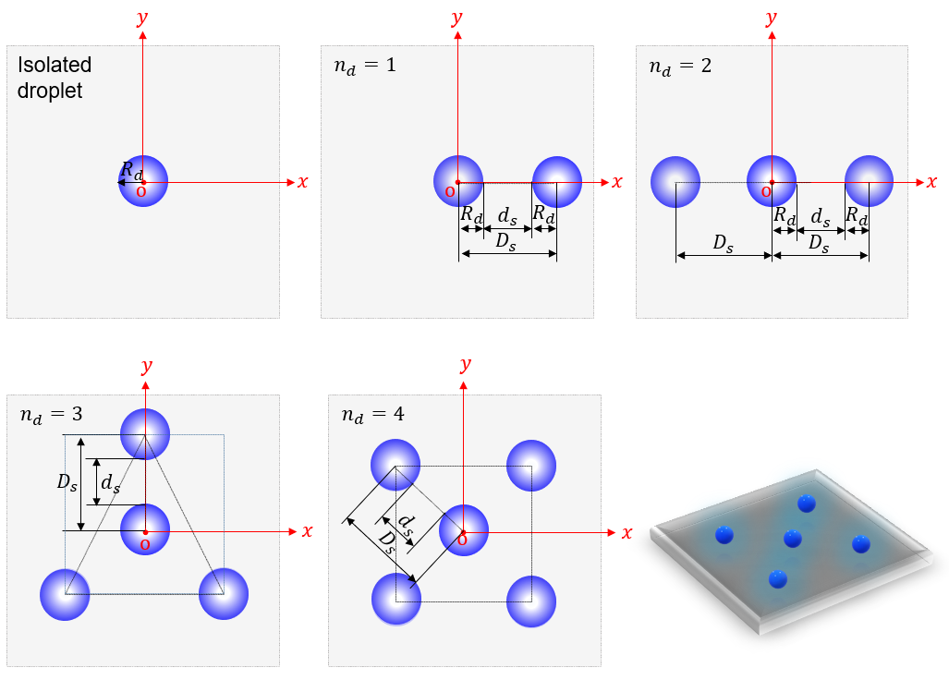
FIG. 1. Schematics of droplet array configurations. The origin of the co-ordinate system is located at center of the reference droplet.
For a reference droplet surrounded by $n_{d}$ adjacent droplets, the evaporation rate ${\dot{m}}_{o}$ can be calculated using Wray et al.’s model:²⁷
$${\dot{m}}_{o}={\dot{m}}_{iso}-\frac{2}{π}\sum_{k=1}^{N}{{\dot{m}}_{ad,k}\sin^{-1}}\left(\frac{R_{d}}{D_{s,k}}\right).$$ | (2)
Here, $D_{s}$ [mm] is the distance between the centers of two adjacent droplets in the array, and it is given by $D_{s}=d_{s}+{2R}_{d}$ as shown in Fig. 1; ${\dot{m}}_{ad}$ is the evaporation rate of adjacent droplets, and k is the number of individual droplets in the array range from 1 to N (total number of droplets). The evaporation rates ${\dot{m}}_{o}$ and ${\dot{m}}_{ad}$ are analogous to the evaporation flux $\dot{m}/A_{lv}$ because the surface area of the lv interface, given by $A_{lv}=2π{R_{d}}^{2}/\left(1+cosθ\right)$ [mm²], is identical for all the droplets. However, ${\dot{m}}_{o}$ and ${\dot{m}}_{ad}$ are unknown and depend on vapor interactions between the droplets. Therefore, Eq. (2) is a system of $N×N$ linear equations that should be solved simultaneously. To simplify Eq. (2), Edwards et al.²⁸ rewrote the system of equations in a square matrix as follows:
$${\dot{m}}_{o}={∅^{-1}\dot{m}}_{iso},$$ | (3)
where $∅$ is an $N×N$ suppression matrix. The off-diagonal elements capturing the interactions between droplets can be calculated as $∅_{ij}={\frac{2}{π}sin}^{-1}\left(\frac{R_{d}}{D_{s,ij}}\right)$; the diagonal elements represent the interaction of a droplet with itself and hence are one. Here, the subscripts i and j represent the row and column of the suppression matrix $∅$. For the prediction of the evaporation rate of reference droplet ${\dot{m}}_{o}$ in Eq. (3), the suppression matrix $∅$ can be reduced to the order $1×N$. Matrix ${\dot{m}}_{iso}$ has an order of $N×1$ and contains constants. Further information about the model can be found in the supplementary material of Edwards et al.²⁸ Since the effect of surface wettability is ignored in Eq. (3), we propose a contact angle function $f(θ)$ to improve Wray et al.’s model as follows:
$${\dot{m}}_{o}={∅^{-1}\dot{m}}_{iso}f(θ).$$ | (4)
Here, $f(θ)$ was obtained through three-dimensional numerical simulations by solving Fick’s first and second laws for steady-state mass transfer.
III. SIMULATION SYSTEM
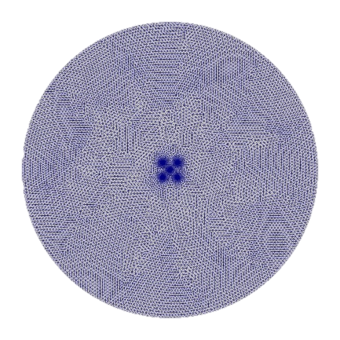
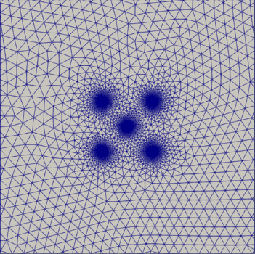
In the simulation system, only the lv interface of the droplet was considered as the solid–liquid–vapor (slv) interface near the contact line can be ignored for flat surfaces.³⁵ The droplet evaporation could be considered in a quasi-steady state as the time required for the vapor density to adapt to changes in the droplet shape scales as R_{d} ²/D.²² The droplet’s shape was assumed to be constant in the simulation system, and the evaporation rate was a function of R_{d} and $θ$ at a given instance under ambient conditions.²² A cylinder with a radius and height of 100 $R_{d}$, with $R_{d}=$ 1 mm, was used as the simulation domain, as depicted in Fig. 2(a), and it enclosed a droplet array on a surface located at the bottom of the system. A non-structured tetrahedral grid was used for the spatial discretization of the simulation domain, and the total number of grid elements ranged between 1 and 3 million. Figure 2(b) shows the grid in the xy-plane of the simulation domain, and Fig. 2(c) shows an enlarged view of the grid in the vicinity of the droplet array. The element size of the simulation grid was refined in the vicinity of the lv interface of the droplets to improve the simulation accuracy. Simulation grids were generated using the preprocessor SALOME,³⁶ and the maximum aspect ratio and skewness of the tetrahedral elements in them were below 5 and 0.85, respectively. Thus, it was ensured that the grid quality was not compromised by the presence of a sharp curvature at the lv interface of the droplets in the simulation domain. Only the vapor diffusion from the lv interface to the gas domain was simulated, and the internal flow of the droplet was ignored because the liquid was not included in the simulation domain.
(a)
(b)
(c)
$$x$$
$$y$$
$$o$$

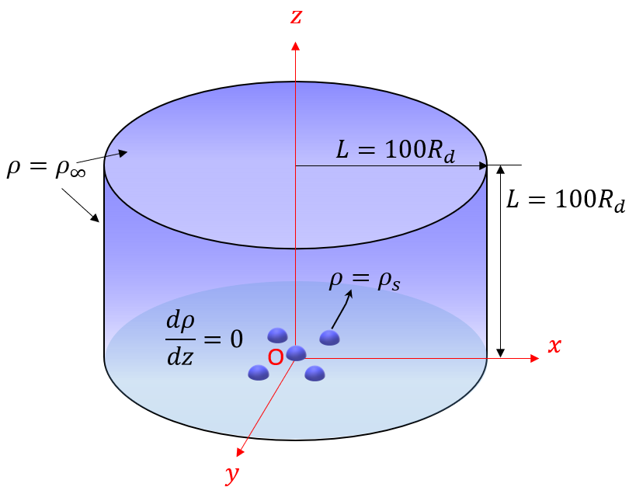
FIG. 2. Simulation system: (a) the domain with boundary conditions, (b) the grid in the xy-plane of the simulation domain, and (c) an enlarged view of the grid in the vicinity of the droplet array.
Fick’s second law can be written as a three-dimensional Laplace equation in terms of the vapor density $ρ$:³⁷
$$\frac{d^{2}ρ}{dx^{2}}+\frac{d^{2}ρ}{dy^{2}}+\frac{d^{2}ρ}{dz^{2}}=0.$$ | (5)
The mass transfer rate based on Fick’s first law can be written as
$$\dot{m}=-A_{lv}D(T){\left.\frac{dρ}{dn}\right|}_{lv}.$$ | (6)
Here, $\frac{dρ}{dn}$ [kg/m⁴] is the vapor density gradient normal to the lv interface, and $\hat{n}$ is a unit vector normal to the lv interface.
The cylindrical system was adopted for simplicity, and is shown in Fig. 2(a). The boundary conditions were as follows: (1) at the lv interface of the droplet, the saturated vapor density $ρ_{s}$ was 23$g/{m^{3}}$ at the ambient temperature T=25$℃$; (2) at the top and side boundaries connected to an air–vapor mixture in the far field, the ambient vapor density $ρ_{∞}$ was 9$g/{m^{3}}$ at $RH=40\%$; and (3) at the bottom wall, we considered dρ/dz = 0 since there was no vapor penetration into the wall. The contact angle of all the droplets was identical and in the range of 10$°$ to 170$°$, and the number of adjacent droplets $n_{d}$ varied between 0 and 4. The separation distance d_{s} ranged from R_{d} to 80R_{d}.
TABLE I. Grid size independence for isolated and reference droplets for $θ={90}^{°}$.
Grid  type | Grid size  [$×{10}^{6}$ tetrahedrons] | Evaporation rate -$\dot{m} [×{10}^{-9}kg/s]$
 |  | Isolated droplet | Reference droplet  ($n_{d}=4 , d_{s}/R_{d}=$10)
Coarse | 0.1 | 1.5 | 1.2
Medium | 0.72 | 2.0 | 1.6
Fine | 1.2 | 2.3 | 1.7
Very fine | 2.8 | 2.3 | 1.7

TABLE II. Domain size independence for isolated and reference droplets for $θ={90}^{°}$.
Domain type | Domain size L  [$×R_{d}$ mm] | Evaporation rate -$\dot{m} [×{10}^{-9}kg/s]$
 |  | Isolated droplet | Reference droplet  ($n_{d}=4 , d_{s}/R_{d}=$10)
Small | 5 | 2.7 | 2.2
Medium | 50 | 2.4 | 1.8
Large | 100 | 2.3 | 1.7
Very large | 150 | 2.3 | 1.7

The grid and domain independence were confirmed for all simulations, and the main results are summarized in Tables I and II. Four different grid sizes (i.e., coarse, medium, fine, and very fine) and four different domain sizes (i.e., small, medium, large, and very large) were considered in the analysis. For all simulations, the fine grid type and large domain were chosen to obtain accurate results (see Tables I and II). The edge size of the simulation cell (i.e., the tetrahedron) varied between 0.2$R_{d}$ and 0.002$R_{d}$ across the domain for the fine grid type, and the size of the large domain was fixed at 100$R_{d}$. Further increasing the grid and domain size had no significant effect on the simulation results. The governing equations, Eqs. (5) and (6), were solved using the finite volume method in OpenFOAM.³⁸ The Gauss linear scheme was adopted as the Laplacian scheme for discretization, and surface normal gradients were corrected. The simulation results were visualized using the post-processor ParaView.³⁹
IV. EXPERIMENTAL MATERIALS AND METHODS
An untreated cover glass of 24 mm × 24 mm (Matsunami Glass) with a Young contact angle (static) $θ_{Y}$ of 50$°$ $±$ 2$°$ was used as a hydrophilic surface. Hydrophobic surfaces with $θ_{Y}=$ 120$°$ $±$ 3$°$ were prepared by spraying a commercial water-repellent coating (FK super water-repellent) evenly onto the cover glass and drying the sprayed glass in a draft chamber for 60 min. A scanning probe microscope (SPM, Shimadzu, SPM-9700HT) was used to observe the surface morphologies of the hydrophilic and hydrophobic surfaces, and images obtained with it are shown in Fig. 3. The average surface roughness Ra [$nm$] was found to be 0.75 $±$ 0.43 nm for hydrophilic surfaces and 231 $±$ 87 nm for hydrophobic surfaces. Since Ra of both hydrophilic and hydrophobic surfaces was on the nanometer scale, the surfaces were considered to be flat surfaces.

(a)
(b)
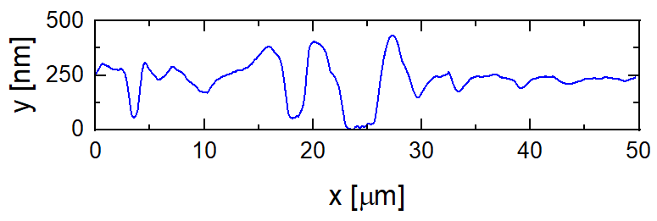
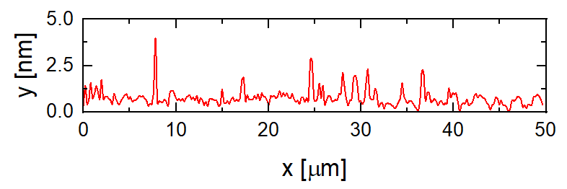

FIG. 3. SPM images and cross-sectional profiles of (a) hydrophilic and (b) hydrophobic surfaces. The insets show Young contact angles (static) at the flat surfaces.
A detailed schematic of the experimental setup is presented in Fig. 4. Deposition positions for the droplet array were manually marked on the rear side of the transparent cover glass, and 1 µL pure water droplets were carefully deposited on the marks with a micropipette (Hamilton, 701 RN), with the aid of a vertically aligned microscope (Sightron, nano capture SP725S). The number of adjacent droplets $n_{d}$ was set to four, and the separation distance was 10 $R_{d}$. The droplets in the array were allowed to evaporate naturally in a measurement cell under controlled ambient conditions in an environmental chamber (Espec, TBL-4HWOP3A). The measurement cell was made of transparent acrylic to prevent convection around the droplets during evaporation. The dynamics of the reference droplet was recorded using a horizontally oriented digital microscope (Keyence, VHX-200) with a backlight source. The contact angle, contact radius, and volume of the reference droplet were then calculated from recorded videos using an open-source image analysis code (ImageJ, v-1.53)⁴⁰. A thermo recorder (T&D Corporation, TR-72Ui) was used to measure the temperature and relative humidity in the measurement cell during droplet evaporation. Experiments were repeated five times for each measurement of isolated droplets and the reference droplet in arrays on hydrophilic and hydrophobic surfaces. The uncertainty of the results was calculated using the mean and standard deviation of the experimental dataset.
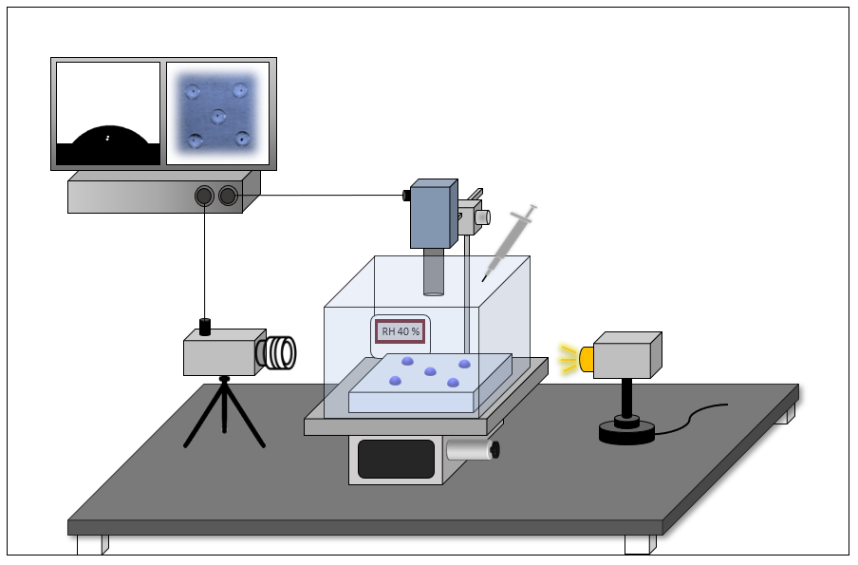
Environmental Chamber
Stage
Light Source
Computer
Horizontal Microscope
Vertical Microscope
Micro Pipette
Sensor
Glass
$$T=25℃, RH=40\%$$
FIG. 4. Schematic of the measurement system used for the evaporation of a droplet array under constant temperature and humidity.
V. RESULTS AND DISCUSSION
The vapor density distribution in the xy-plane at the bottom of the simulation domain is shown in Fig. 5, and the normalized local vapor density along the z-axis is shown in Fig. 6. For a given contact angle $θ$, an increase in the number of adjacent droplets $n_{d}$ increased the vapor density near the reference droplet, thereby suppressing the reference droplet’s evaporation rate. For a given $n_{d}$, the vapor density near the reference droplet increased significantly as the contact angle increased. This implies that the vapor density profiles in the diffusion domain depended on the surface wettability.
n_{d}  $$θ$$ | 0 | 1 | 2 | 3 | 4
$${10}^{o}$$ | 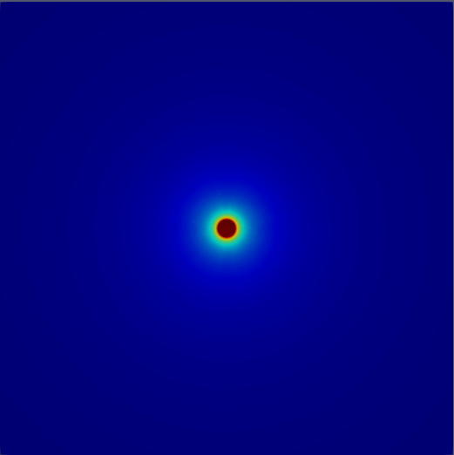  y  O  x | 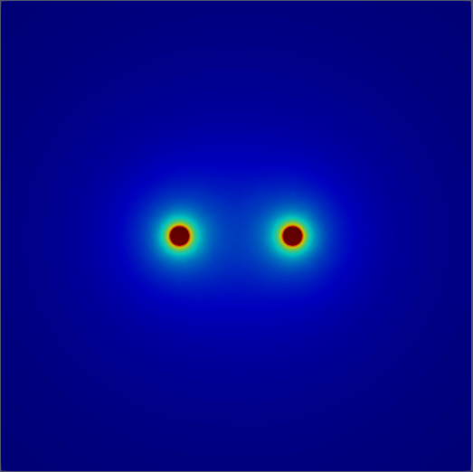  $$10R_{d}$$ | 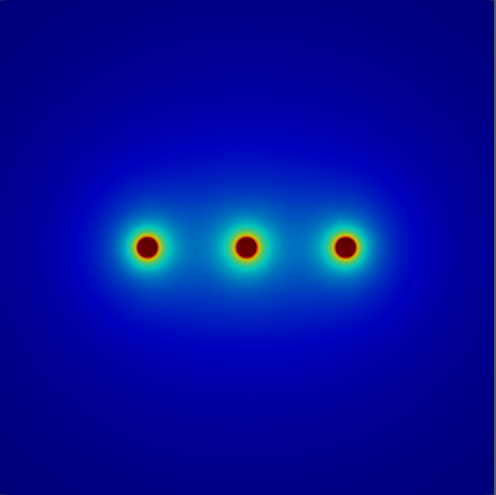 | 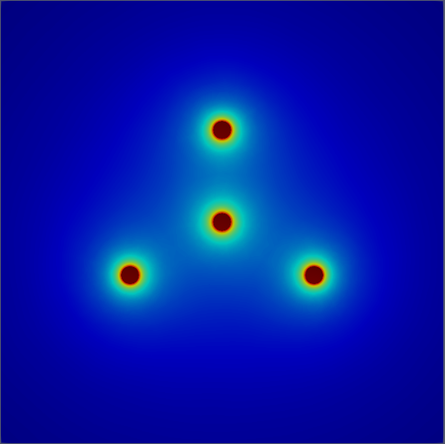 | 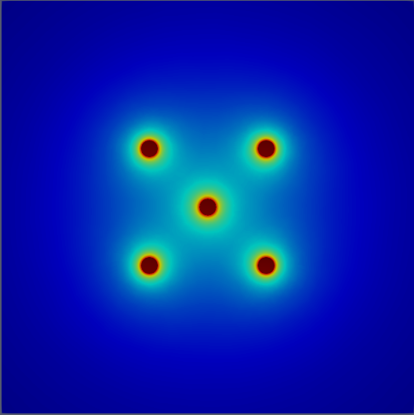
$${50}^{o}$$ | 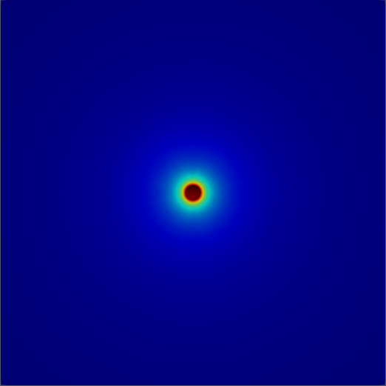 | 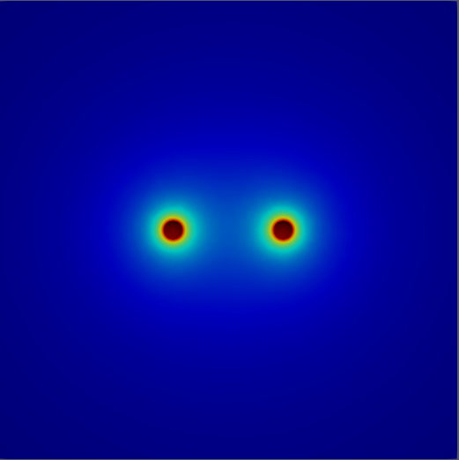 | 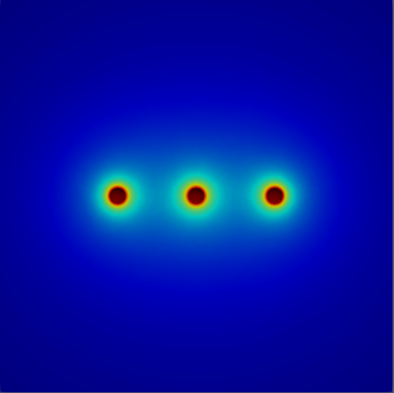 | 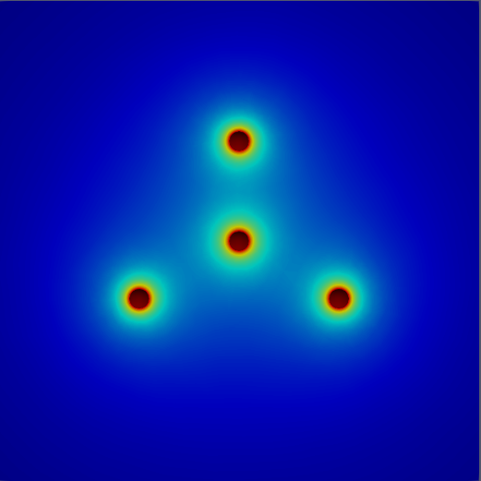 | 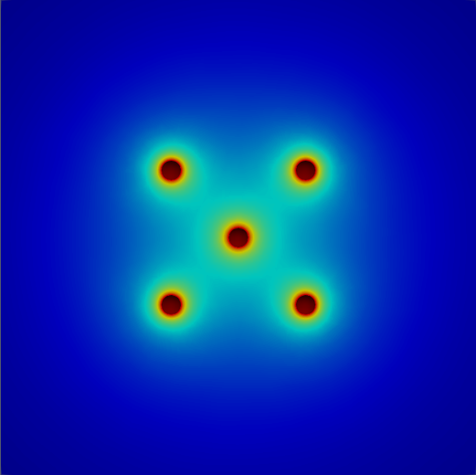
$${90}^{o}$$ | 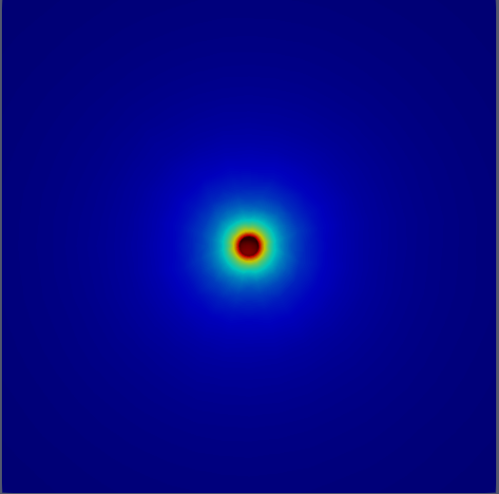 | 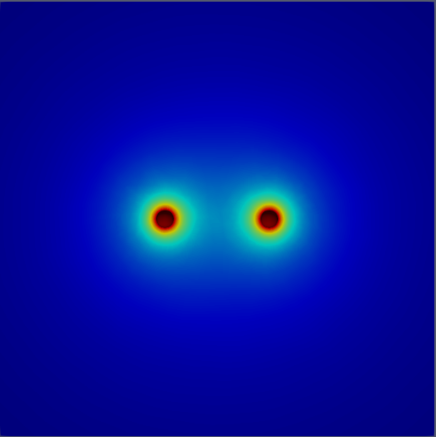 | 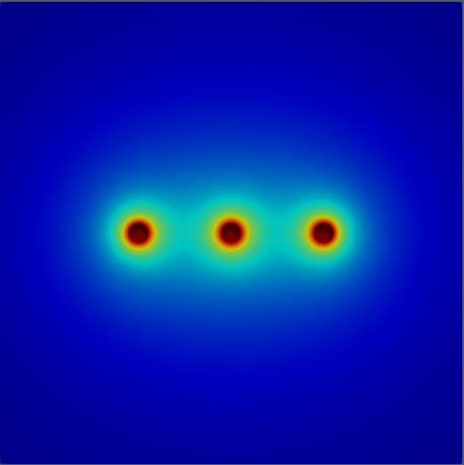 | 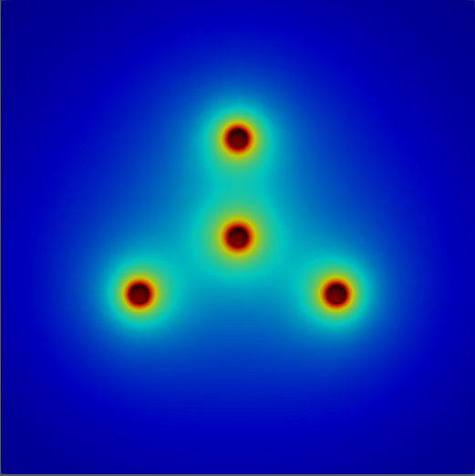 | 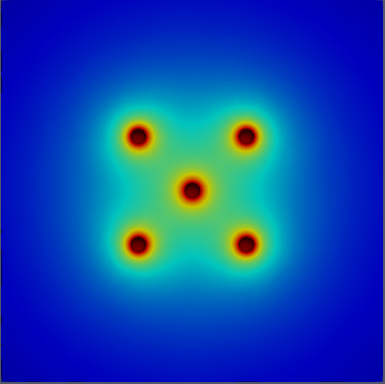
$${130}^{o}$$ | 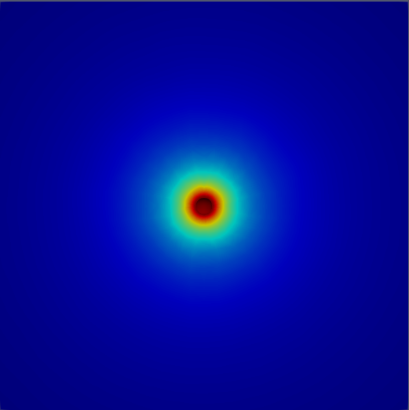 | 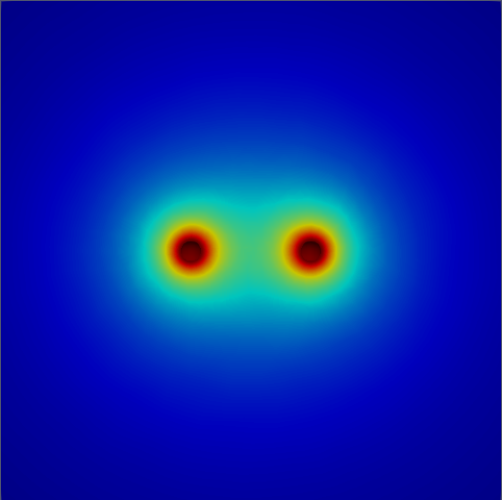 | 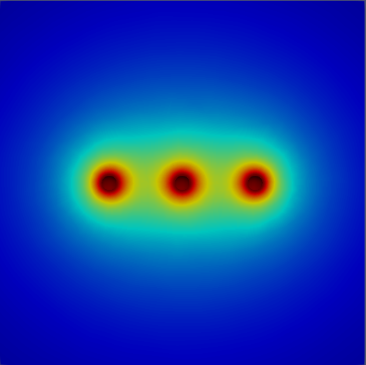 | 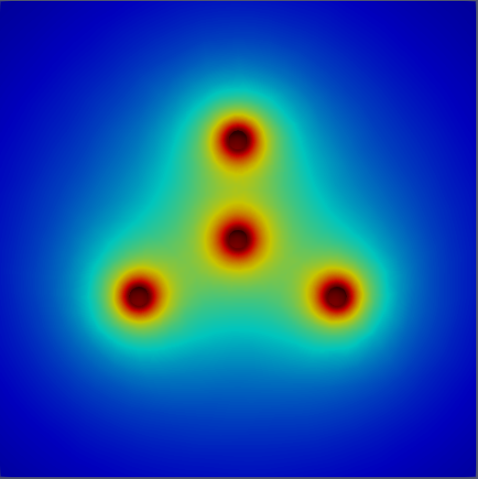 | 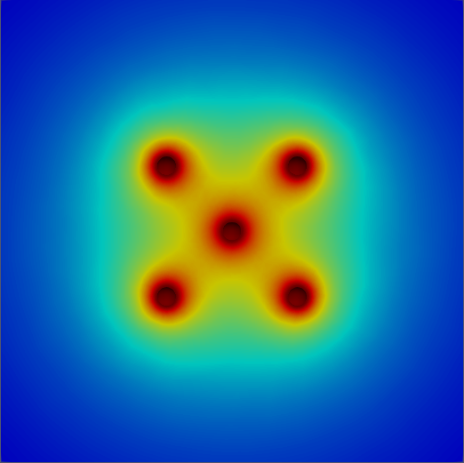
$${170}^{o}$$ | 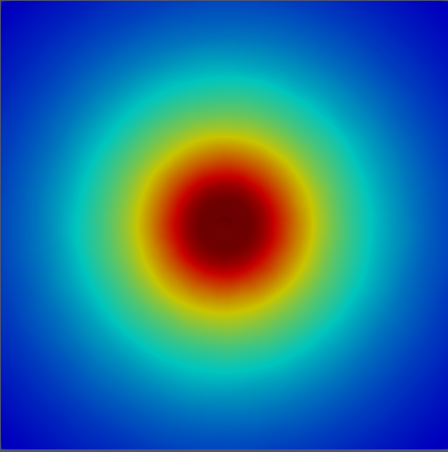 | 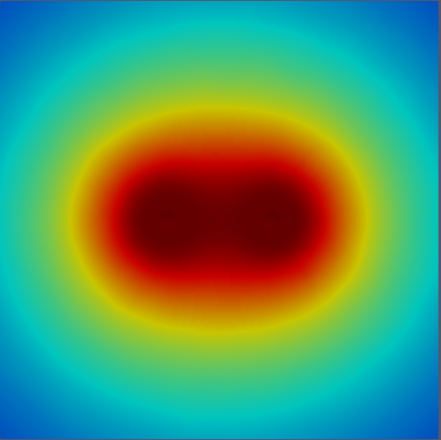 |  | 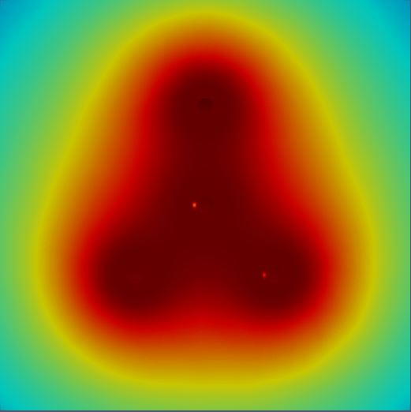
(a)
d_{s}  $$θ$$ | $$R_{d}$$ | $${2.5R}_{d}$$ | $${5R}_{d}$$ | $${10R}_{d}$$ | $${20R}_{d}$$
$${90}^{o}$$ | 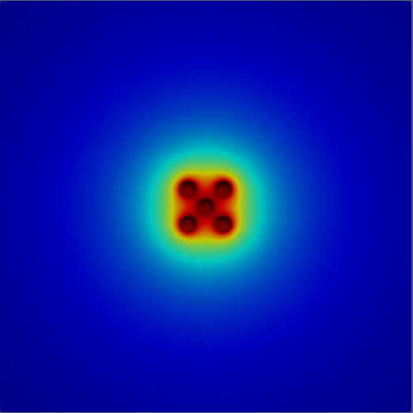 | 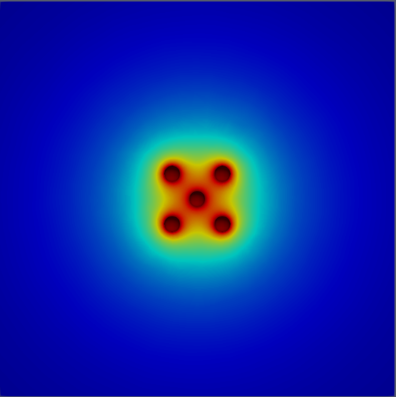 | 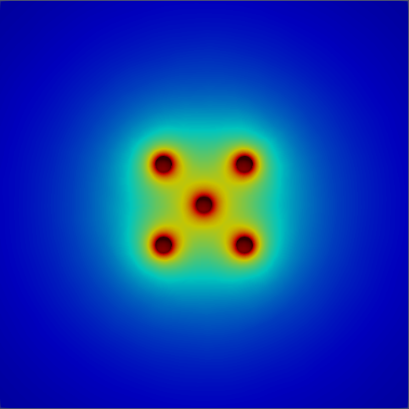 |  | 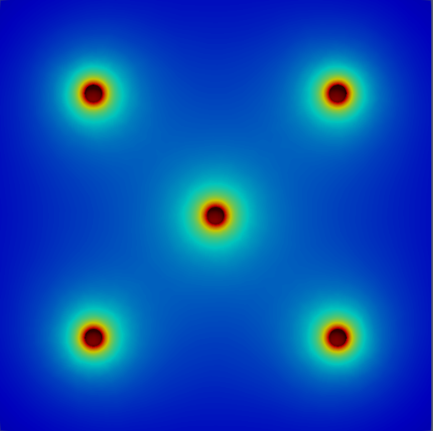
Vapor density [g/m³]
$ρ_{∞}$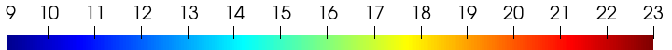$ρ_{s}$
(b)
FIG. 5. Vapor density distribution in the xy-plane at the bottom of the simulation domain: (a) effect of contact angle $θ$ and number of adjacent droplets $n_{d}$ for $d_{s}$ = 10 $R_{d}$, where $R_{d}=$ 1mm, and (b) effect of separation distance $d_{s}$ for $θ{=90}^{o}$.
y
(b)
(a)
FIG. 6. Normalized vapor density along the z-axis for droplet evaporation in an array for (a) different contact angles and (b) different numbers of adjacent droplets. The dotted lines represent RH=40%.
Figure 7 shows the relationships between the contact angle, dimensionless separation distance ${d_{s}}/{R_{d}}$, and the evaporation rate of the reference droplet ($n_{d}=$ 4). In Fig. 7(a), the normalized evaporation rate ${{\dot{m}}_{0}}/{{\dot{m}}_{iso}}$ (based on Eq. 4) of the reference droplet is plotted against ${d_{s}}/{R_{d}}$ in the contact angle range ${10}^{°}$–${170}^{°}$. A value of one for the ratio ${{\dot{m}}_{0}}/{{\dot{m}}_{is0}}$ (dashed line) indicates that the reference droplet’s evaporation rate was identical to that of the isolated droplet under identical conditions. Notably, the larger the contact angle of the isolated droplet, the greater was the value of ${\dot{m}}_{is0}$. On one hand, ${{\dot{m}}_{0}}/{{\dot{m}}_{is0}}$ significantly decreased with a decrease in ${d_{s}}/{R_{d}}$, showing that the droplet separation distance was the primary factor in the reduction of the evaporation rate of droplet arrays. As shown in Fig. 5(b), the local vapor density near the reference droplet relatively increased in the presence of adjacent droplets when the separation distance decreased. Apparently, an extended saturated vapor cloud surrounding the reference droplet hindered vapor diffusion in the computation domain, resulting in the reduction of ${{\dot{m}}_{0}}/{{\dot{m}}_{is0}}$ irrespective of the contact angle. As the separation distance increased, ${{\dot{m}}_{0}}/{{\dot{m}}_{is0}}$ approached unity, and the reference droplet’s evaporation resembled that of an isolated droplet. On the other hand, the dependence of ${{\dot{m}}_{0}}/{{\dot{m}}_{is0}}$ on the contact angle can be readily discerned in Fig. 7(a), showing that the contact angle was a secondary factor influencing the evaporation rate of droplet arrays. In particular, deviations of ${{\dot{m}}_{0}}/{{\dot{m}}_{is0}}$ from unity became significant as the droplet contact angle increased. This is because the area of the saturated vapor cloud surrounding the reference droplet increased with the contact angle, as shown in Fig. 6(a) (right most column of $n_{d}$ = 4). It was found that ${{\dot{m}}_{0}}/{{\dot{m}}_{is0}}$ was close to unity at ${d_{s}}/{R_{d}}=$ 80 for the cases with ${θ≤130}^{°}$, and a longer separation distance was required for ${θ=170}^{°}$. Thus, the separation distance and contact angle are correlated factors that have a synergetic effect on ${{\dot{m}}_{0}}/{{\dot{m}}_{is0}}$.
Wray et al.’s model (Eqs. (2) and (3)) plotted in Fig. 7(a) (black line) overlapped with the present numerical results for ${θ=10}^{°}$ (black circle) and ${50}^{°}$ (red circle), while it deviated from the numerical results for hydrophobic case, ${θ≥90}^{°}$, especially in the region of small separation distances. Although we verified that Wray et al.’s model²⁷ is applicable to the hydrophilic droplets in the array, apparently, this model could not capture the effect of the contact angle on the evaporation rate. Since Fig. 7(a) shows the importance of surface wettability for predicting the evaporation rate of droplets in the array, surface wettability was incorporated into f(θ), as shown in Eq. (4).
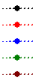
Numerical  simulation | $$θ$$  $$\left[°\right]$$ | $${\dot{m}}_{is0}$$  [$×{10}^{-9} kg/s$]
 | 10 | 1.56
 | 50 | 1.75
 | 90 | 2.30
 | 130 | 3.83
 | 170 | 19.51

(a)
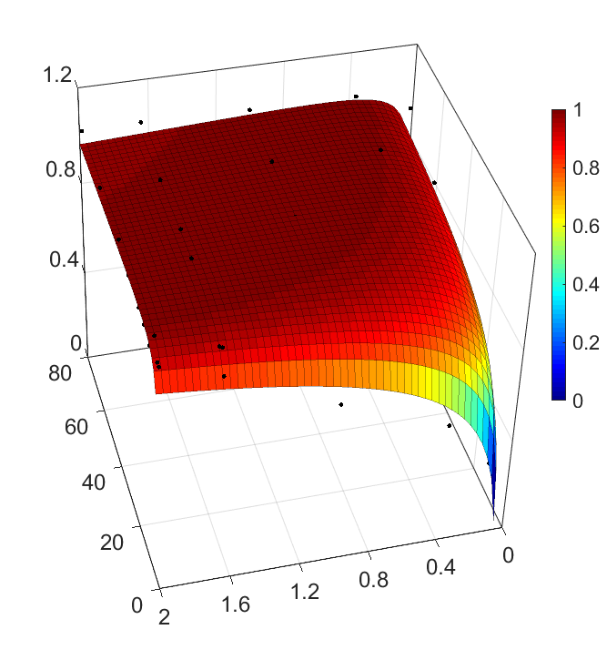
(c)
$$\frac{{\dot{m}}_{o,num}}{{\dot{m}}_{0,th}}$$
(b)
$$1+cosθ$$
$$d_{s}/R_{d}$$
FIG. 7. Effect of the contact angle and dimensionless separation distance ${d_{s}}/{R_{d}}$ on (a) the evaporation rate of the reference droplet normalized by the evaporation rate of the isolated droplet ${{\dot{m}}_{0}}/{{\dot{m}}_{is0}}$, (b) the evaporation rate of the reference droplet normalized by the prediction of Eq. (3) ${{\dot{m}}_{0,num}}/{{\dot{m}}_{0,th}}$, and (c) the contact angle function $f\left(θ\right)$.
To obtain $f(θ)$, we plotted the numerically determined evaporation rate of the reference droplet normalized by Eq. (3), ${{\dot{m}}_{0,num}}/{{\dot{m}}_{0,th}}$, against ${d_{s}}/{R_{d}}$ and $1+cosθ$, as shown in Fig. 7(b). Similar to Fig. 7(a), a decrease in the separation distance ${d_{s}}/{R_{d}}$ and an increase in the contact angle term $1+cosθ$ caused a reduction in ${{\dot{m}}_{0,num}}/{{\dot{m}}_{0,th}}$. Through MATLAB⁴¹ analysis, $f(θ)$ was obtained by fitting the dataset in Fig. 7 with a quadratic function as follows:
$f\left(θ\right)=a+bx+cx^{2},$ where $x=ln\left[\frac{d_{s}}{R_{d}}\left(1+cosθ\right)\right].$ | (7)
Table III presents the values of coefficients a, b, and c in Eq. (7) for different numbers of adjacent droplets $n_{d}$, and the values are valid for the contact angle range $θ={10}^{°}–{170}^{°}$and for the separation distance range $d_{s}=R_{d}–80R_{d}$. In Fig. 7(c), $f\left(θ\right)$ is plotted as a function of the contact angle and separation distance. For $f\left(θ\right)$ = 1, Wray et al.’s model²⁷ coincides with the present model for the hydrophilic cases. However, $f\left(θ\right)$ apparently decreases in the hydrophobic cases, which should be considered in the prediction of the evaporation rate of a droplet in arrays on hydrophobic surfaces.
TABLE III. Model coefficients for different numbers of adjacent droplets.
Number of adjacent droplets  $$n_{d}$$ | Model coefficients
 | a | b | c
1 | 0.9 | 0.056 | -0.008
2 | 0.8 | 0.116 | -0.016
3 | 0.74 | 0.166 | -0.022
4 | 0.7 | 0.176 | -0.023

FIG. 8. Model validation for different array configurations. The contact angle of droplets in an array was set to $θ={90}^{°}$.
The ${\dot{m}}_{0}$ value predicted by Eq. (4) was compared with the simulation results in Fig. 8, and a good agreement was found for different array configurations for $θ={90}^{°}$. To validate the present model, we performed experiments involving evaporation of droplets in isolation and in arrays on flat hydrophilic and hydrophobic surfaces under identical conditions. The time history of experimental data of the evaporating reference droplet on hydrophilic and hydrophobic surfaces is presented in Fig 9. As shown in Figs. 9(a) and 9(b), temporal variations of the ambient temperature and relative humidity in the measurement cell were small, in the ranges of $T=25±2℃$ and $RH=40±3\%$. This eliminated the possibility of the ambient conditions influencing the experimental results. Figures 9(c) and 9(d) show that three evaporation modes, namely constant contact radius (CCR), constant contact angle (CCA), and mixed modes, existed for all cases. For hydrophilic surfaces, the evaporation of the isolated droplet was similar to that of the reference droplet in the array, with the CCR mode being dominant. However, for droplet evaporation on hydrophobic surfaces, the contributions of the CCA and mixed modes were significant. Figure 9(c) shows that the CCR mode's duration for the droplet evaporating in the array was longer than that for the isolated droplet. Hydrophobic surfaces showed a longer CCR mode duration than hydrophilic surfaces, because of the slower change of the droplet shape and longer pinning period resulting from the presence of adjacent droplets. Similar results for the durations of the CCA and mixed modes are presented in Fig. 9(d), and they show longer durations of these modes for the reference droplet compared with their durations for the isolated droplet. Figure 9(e) shows the time history of the droplet volume during evaporation. The reference droplet (closed squares) evaporated more slowly than the isolated droplet (open circles), on the same surface under the same ambient conditions. In particular, the reference droplet on a hydrophobic surface (blue) evaporated much slower than that on a hydrophilic surface (red) for the same array configuration of $n_{d}$ = 4 and ${d_{s}}/{R_{d}}=10$. This confirmed our earlier inference from Fig. 7 that the surface wettability should be considered for predicting droplet evaporation in an array.
(b)
(a)
(c)
(d)
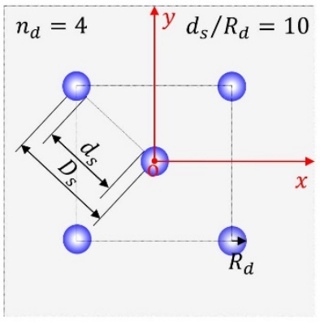

(e)
FIG. 9. Temporal variations of the measured (a) temperature, (b) relative humidity, (c) contact radius, (d) contact angle, and (e) droplet volume during droplet evaporation on hydrophilic ($θ_{Y}={50}^{°}$, red) and hydrophobic surfaces ($θ_{Y}={120}^{°}$, blue) in isolation (open circles) and in arrays (closed squares). The configuration of the droplet array was set to $n_{d}$ = 4 and ${d_{s}}/{R_{d}}=10$. Markers in the subfigures are consistent, and their labels correspond to the legend in Fig. 9(e).
In the CCA and CCR modes of evaporation, $R_{d}$ and $θ$ was reduced from initial values (see Figs. 9(c) and (d)). This decrease caused $d_{s}/R_{d}$ to increase and f(θ) to be equal to 1. This significantly affected ${\dot{m}}_{0}$, as shown in Fig. 7, and was therefore considered in the theoretical prediction based on Eq. (4). The time-dependent f(θ) and $d_{s}/R_{d}$ were calculated from temporal data of $R_{d}$ and $θ$, and they are presented in Fig. 10 for reference droplets evaporating on hydrophilic and hydrophobic surfaces. Figure 10(a) shows that f(θ) approached one for both the hydrophilic (red) and hydrophobic (blue) surfaces as the evaporation progressed because of decrease in $θ$, as shown in Fig. 9(d). However, f(θ) was much lower for the hydrophobic surface at the onset of evaporation compared with f(θ) for the hydrophilic surface. As time progressed, $d_{s}/R_{d}$ increased on both the hydrophilic and hydrophobic surfaces as the $R_{d}$ of reference droplet decreased during its evaporation in CCA mode. These findings are consistent with the data shown in Fig. 7.
- (b)
FIG. 10. Temporal evolution of (a) $f(θ)$ and (b) $d_{s}/R_{d}$ during droplet evaporation in arrays on hydrophilic (red) and hydrophobic surfaces (blue). The configuration of the droplet array was set to $n_{d}$ = 4 and ${d_{s}}/{R_{d}}=10$.
(b)
(a)
FIG. 11. Theoretical and experimental evaporation rates ${\dot{m}}_{o}$ for a reference droplet on (a) hydrophilic and (b) hydrophobic surfaces. The configuration of the droplet array was set to $n_{d}$ = 4 and ${d_{s}}/{R_{d}}=$10.
The mass of the reference droplet during evaporation was first calculated from its measured volume V in Fig. 9(e), and the variation of the droplet mass with time (i.e., gradient) was calculated in MATLAB⁴¹. Since the calculated gradients were nonlinear, the linearized fitting ${\dot{m}}_{o}=p\left(Sin(t-π)\right)+q{\left(t-10\right)}^{2}+0.95r$ was used to determine ${\dot{m}}_{o}$ from experiments. Here, t is the time, and p, q, and r are coefficients determined by curve-fitting the experimental data. A comparison of the experimentally and theoretically obtained ${\dot{m}}_{o}$ values is shown in Fig. 11. Since Eq. (1) was proposed for an isolated droplet’s evaporation,¹⁴ it overpredicted evaporation rates on hydrophilic and hydrophobic surfaces. As shown in Fig. 11, Eq. (1) deviated significantly from the experimental results at the beginning of evaporation. When f(θ) approaches 1 and $d_{s}/R_{d}$ increased beyond 10 at the end of evaporation (see Fig.10), the effect of the adjacent droplet on the evaporation of the reference droplet could be ignored. Therefore, ${\dot{m}}_{0}$ predicted by Eq. (4) for the reference droplet agreed with ${\dot{m}}_{iso}$ predicted by Eq. (1) for the isolated droplet, as shown in Fig. 11. In Fig. 11(a), the present model can be seen to agree well with Wray et al.’s model²⁷ and with the experimental results for the evaporation rate of the reference droplet on a hydrophilic surface. However, as shown in Fig. 11(b), for a hydrophobic surface, the present model does not agree with Wray et al.’s model,²⁷ but shows good agreement with the experimental evaporation rate of the reference droplet. This observation confirms that surface wettability is an important factor influencing droplet evaporation, especially for hydrophobic surfaces.
VI. CONCLUSION
We demonstrate that a droplet in a droplet array evaporates more slowly than an isolated droplet under identical conditions. The reduction on the evaporation rate of the droplet in an array result from the synergetic effect of the separation distance and surface wettability, because of vapor-mediated interactions between droplets. Although the primary factor of the reduction on the evaporation rate is the separation distance, the secondary factor of surface wettability is particularly important for hydrophobic surfaces. The contact angle function introduced in the present model should not be ignored when predicting the evaporation rates of droplets in arrays on hydrophobic surfaces. Since the solid–liquid–vapor (slv) interface also contributes to droplet evaporation,³⁵ the effect of the slv interface on droplet evaporation in an array will be investigated in a future study. The insights obtained in the present study are expected to pave the way for wider engineering and medical applications of droplet-array-based devices.
ACKNOWLEDGMENTS
This work was supported by the Ministry of Education, Science and Culture of the Japanese Government through the Grant-in Aid for Scientific Research, Project No. 22H01416, and the Initiative for Realizing Diversity in the Research Environment by Ministry of Education, Culture, Sports, Science and Technology, Japan.
AUTHOR DECLARATIONS
Conflict of Interest
The authors have no conflicts to disclose.
Author Contributions
M. Mohib Ur Rehman: Investigation, Methodology, Data curation, Formal analysis, Writing - original draft. Alexandros Askounis: Conceptualization, Writing - review & editing. Gyoko Nagayama: Conceptualization, Supervision, Writing - review & editing, Funding acquisition.
REFERENCES
¹ X. Yu and J. Xu, Appl. Phys. Lett. 116, 253903 (2020).
² I.G. Hwang, J.Y. Kim, and B.M. Weon, Appl. Phys. Lett. 110, 31602 (2017).
³ C.-C. Hsu, T.-W. Su, C.-H. Wu, L.-S. Kuo, and P.-H. Chen, Appl. Phys. Lett. 106, 141602 (2015).
⁴ F. Carle, B. Sobac, and D. Brutin, Appl. Phys. Lett. 102, 61603 (2013).
⁵ L. Bansal, S. Hatte, S. Basu, and S. Chakraborty, Appl. Phys. Lett. 111, 101601 (2017).
⁶ Y. Kita, A. Askounis, M. Kohno, Y. Takata, J. Kim, and K. Sefiane, Appl. Phys. Lett. 109, 171602 (2016).
⁷ A.E. Korenchenko and A.A. Zhukova, Phys. Fluids 34, 42102 (2022).
⁸ A. Paul and P. Dhar, Phys. Fluids 33, 122010 (2021).
⁹ S. Tonini, G.E. Cossali, E.A. Shchepakina, V.A. Sobolev, and S.S. Sazhin, Phys. Fluids 34, 73312 (2022).
¹⁰ P.M. Theiler, F. Lütolf, and R. Ferrini, Opt. Express 26, 11934 (2018).
¹¹ J.D. Benther, J.D. Pelaez-Restrepo, C. Stanley, and G. Rosengarten, Int. J. Heat Mass Transf. 178, 121587 (2021).
¹² T. Kokalj, H. Cho, M. Jenko, and L.P. Lee, Appl. Phys. Lett. 96, 163703 (2010).
¹³ J. Jing, J. Reed, J. Huang, X. Hu, V. Clarke, J. Edington, D. Housman, T.S. Anantharaman, E.J. Huff, B. Mishra, B. Porter, A. Shenker, E. Wolfson, C. Hiort, R. Kantor, C. Aston, and D.C. Schwartz, Proc. Natl. Acad. Sci. 95, 8046 (1998).
¹⁴ R. Bhardwaj and A. Agrawal, Phys. Fluids 32, 61704 (2020).
¹⁵ Z.(贺子龙) He, S.(邵思尧) Shao, J.(李家骐) Li, S.S. Kumar, J.B. Sokoloff, and J.(洪家荣) Hong, Phys. Fluids 33, 13309 (2021).
¹⁶ S. Chatterjee, J.S. Murallidharan, A. Agrawal, and R. Bhardwaj, Phys. Fluids 33, 21701 (2021).
¹⁷ S. Hatte, K. Pandey, K. Pandey, S. Chakraborty, and S. Basu, J. Fluid Mech. 866, 61 (2019).
¹⁸ H. Chen, Q. An, H. Zhang, C. Li, H. Fang, and Z. Yin, Phys. Fluids 34, 82010 (2022).
¹⁹ F.G.H. Schofield, A.W. Wray, D. Pritchard, and S.K. Wilson, J. Eng. Math. 120, 89 (2020).
²⁰ D. Hu, H. Wu, and Z. Liu, Int. J. Therm. Sci. 84, 300 (2014).
²¹ Y.O. Popov, Phys. Rev. E 71, 36313 (2005).
²² H. Hu and R.G. Larson, J. Phys. Chem. B 106, 1334 (2002).
²³ J.M. Stauber, S.K. Wilson, B.R. Duffy, and K. Sefiane, J. Fluid Mech. 744, R2 (2014).
²⁴ D.J. Fairhurst, J. Fluid Mech. 934, F1 (2022).
²⁵ O. Carrier, N. Shahidzadeh-Bonn, R. Zargar, M. Aytouna, M. Habibi, J. Eggers, and D. Bonn, J. Fluid Mech. 798, 774 (2016).
²⁶ K. Pandey, S. Hatte, K. Pandey, S. Chakraborty, and S. Basu, Phys. Rev. E 101, 43101 (2020).
²⁷ A.W. Wray, B.R. Duffy, and S.K. Wilson, J. Fluid Mech. 884, A45 (2020).
²⁸ A.M.J. Edwards, J. Cater, J.J. Kilbride, P. Le Minter, C. V Brown, D.J. Fairhurst, and F.F. Ouali, Appl. Phys. Lett. 119, 151601 (2021).
²⁹ H. Zhang, Y. Kita, D. Zhang, G. Nagayama, Y. Takata, K. Sefiane, and A. Askounis, Heat Transf. Eng. 41, 1654 (2020).
³⁰ D. Orejon, K. Sefiane, and M.E.R. Shanahan, Langmuir 27, 12834 (2011).
³¹ M.R. Barmi and C.D. Meinhart, J. Phys. Chem. B 118, 2414 (2014).
³² E. Dietrich, S. Wildeman, C.W. Visser, K. Hofhuis, E.S. Kooij, H.J.W. Zandvliet, and D. Lohse, J. Fluid Mech. 794, 45 (2016).
³³ T.W.G. van der Heijden, A.A. Darhuber, and P. van der Schoot, Langmuir 34, 12471 (2018).
³⁴ T.R. Marrero and E.A. Mason, J. Phys. Chem. Ref. Data 1, 3 (1972).
³⁵ M.M.U. Rehman and G. Nagayama, Colloids Surfaces A Physicochem. Eng. Asp. 656, 130419 (2023).
³⁶ V. Bergeaud and V. Lefebvre, in Proc. SNA + MC2010 Jt. Int. Conf. Supercomput. Nucl. Appl. + Monte Carlo 2010 Tokyo (Japan, 2010), p. 1630.
³⁷ A. Fick, Ann. Phys. 170, 59 (1855).
³⁸ H.G. Weller, G. Tabor, H. Jasak, and C. Fureby, Comput. Phys. 12, 620 (1998).
³⁹ J.P. Ahrens, B. Geveci, and C.C. Law, in Vis. Handb. (2005).
⁴⁰ C.A. Schneider, W.S. Rasband, and K.W. Eliceiri, Nat. Methods 9, 671 (2012).
⁴¹ MATLAB and Statistics Toolbox Release 2012b, The MathWorks, Inc., Natick, Massachusetts, United States.

