This is the author’s final version of the work, as accepted for publication
following peer review but without the publisher’s layout or pagination.
The definitive version is available at

Delivering an analytical framework for evaluating the delivery of biodiversity objectives at strategic and project levels of impact assessment

Amarilis Lucia Casteli Figueiredo Gallardo* - Universidade de São Paulo/Universidade Nove de Julho, São Paulo, Brazil; Email amarilisgallardo@usp.br

Alan Bond - University of East Anglia, United Kingdom; North-West University, South Africa, Email alan.bond@uea.ac.uk

*corresponding author

Delivering an analytical framework for evaluating the delivery of biodiversity objectives at strategic and project levels of impact assessment

- Impact assessment (IA) instruments are core to protecting biodiversity
- A novel analytical framework of 18 global biodiversity objectives is developed
- A method is established for applying the analytical framework to documentary sources
- A research agenda is proposed for improving biodiversity tiering in impact assessment

Abstract
Biodiversity is under pressure because of human development and is therefore protected through the Convention on Biological Diversity, amongst other international policies. Impact assessment (IA) instruments are seen as a valuable tool for helping to protect biodiversity at different levels of decision making but are argued to work independently at policy and plan-level (Strategic Environmental Assessment, SEA) as opposed to project level (Environmental Impact Assessment, EIA), creating inefficiencies in knowledge transfer that threaten biodiversity protection. This paper aims to benchmark the biodiversity coverage in both SEA and EIA literature to better understand the potential for transferring biodiversity knowledge from SEA to EIA (known as tiering). An analytical framework of global biodiversity objectives is distilled from international policy drivers that impact assessment processes should address. This novel framework is then applied to literature to determine the extent to which these biodiversity objectives are addressed at each level of assessment. The analytical framework includes 18 objectives which are divided into four main application groups within SEA and EIA practice in order to identify potential for improving tiering of biodiversity knowledge in IA. This work marks the starting point for a research agenda aimed at improving tiering of biodiversity assessment in impact assessment.

Keywords: analytical framework; environmental impact assessment; strategic environmental assessment; biodiversity; tiering

1. Introduction
The global threats to biodiversity demand an immediate response from policymakers and scientists (Mace et al., 2014). International treaties and policies for biodiversity can be seen as a solid foundation for the stimulation of actions leading to the protection of biodiversity as evidenced by averted species extinctions (Bolam et al., 2021). However, there is a plethora of international or multilateral agreements which do not all achieve their purpose of guaranteeing biodiversity protection (Pearce, 2007; Al-Abdulrazzak et al., 2017). This includes a failure to achieve any of the Aichi Biodiversity targets agreed by parties to the Convention on Biological Diversity (CBD) in 2010 by 2020 (Leadley et al., 2022, p.597). The CBD is recognized as the main international legal instrument for "the conservation of biological diversity, the sustainable use of its components and the fair and equitable sharing of the benefits arising out of the utilization of genetic resources" that had been ratified by 196 nations at the time of writing (CBD, 2022). According to Moranta et al. (2022), biodiversity has been globally recognised as one of the major international challenges since the agreement of the CBD.
Since the CBD was signed, through to the most recent Post-2020 Global Biodiversity Framework (GBF) published in 2021 and agreed as the Kunming-Montreal GBF at the 15th Conference of the Parties (COP 15 – held in December 2022) (Hughes et al., 2022; Chan et al., 2022), impact assessment (IA) instruments have taken a special place for protecting biodiversity (Treweek et al., 2005; Bond et al., 2021; Mandai and Souza, 2021; Milner-Gulland et al., 2021). Although “impact assessment alone cannot resolve global challenges of biodiversity loss and deterioration of ecosystem services that underpin human wellbeing; these issues must be dealt with at a strategic political level” (Brownlie et al., 2013, p.29), the main IA instruments have been recognized as pivotal for implementing international biodiversity goals as required by international law (Craik, 2017).
According to Milner-Gulland et al. (2021, p. 76) biodiversity mainstreaming, defined as “the process of embedding biodiversity considerations into policies, strategies, and practices of key public and private actors that impact or rely on biodiversity, so that biodiversity is conserved, and sustainably used, both locally and globally”, can be facilitated through SEA and EIA (IA instruments). This is in accordance with Xu et al. (2021) who claimed that biodiversity needs to be analysed with science-policy interfaces at all levels to support decision-making.
In terms of improving the efficiency of knowledge transfer across levels of decision making, Lee and Wood (1978) conceptualized tiering of actions through IA (see figure 1). This conceptualization has been frequently referenced since in IA-related literature to argue for transfer of evidence across tiers of IA (for example, in Wood, 1988; Lee and Walsh, 1992; Arts et al., 2011; Therivel, 2004; Sánchez and Silva-Sánchez, 2008; Coutinho et al., 2019; Therivel and González, 2021).

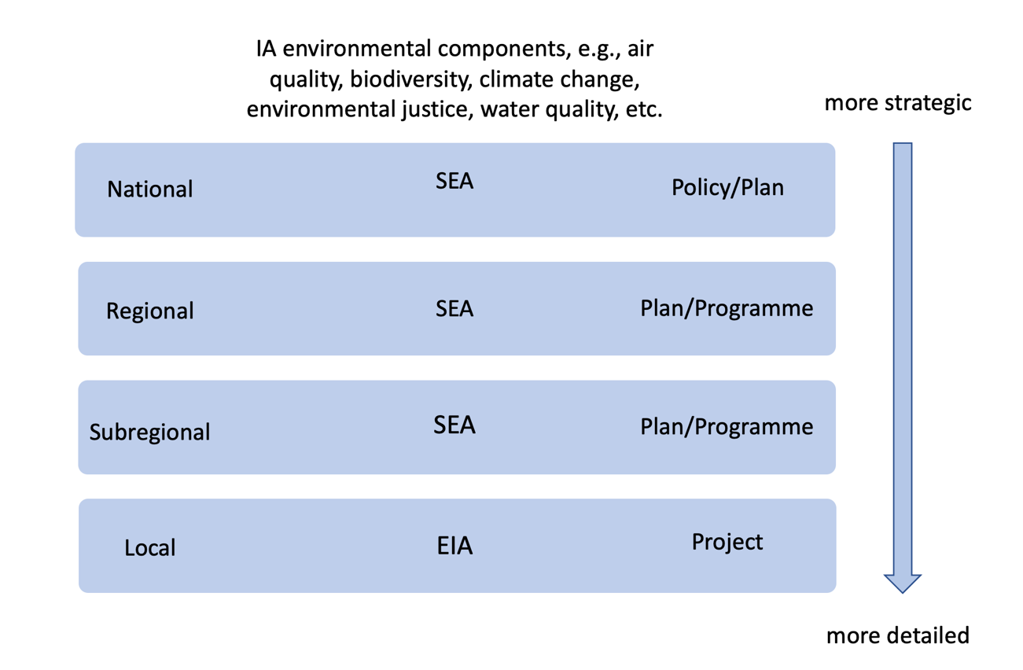
Figure 1 – Tiering of IA instruments for streamlining environmental issues across decision tiers (policies, plans, programmes and projects). Adapted from Lee and Wood (1978), Arts et al. (2011), Therivel and González (2019), and Therivel and González (2021).

The advantages of IA tiering were recognized in the early years of the world’s first EIA legislation: the 1969 National Environmental Policy Act (NEPA). Wood (2003) cited US Council on Environmental Quality (the official body set up within the Office of the President to oversee implementation of NEPA) guidance published in 1981 which specifically refers to and promotes the advantages of tiering. Arts et al. (2011, p.417) define tiering as “the deliberate, organized transfer of information and issues from one level of planning to another, which is being supported by EAs”. Thus, tiering is regarded as being essential for improving the efficiency and effectiveness of IA to support decisions (González and Therivel, 2022), and support the flow of information of different types of environmental issues between assessment tiers (Therivel and González, 2021; Gallardo et al., 2022a).
Some suggestions to encourage tiering on biodiversity-related issues have recently been proposed. Coutinho et al. (2019) emphasized that tiering from SEA to EIA can help to identify critical areas for biodiversity and ecosystems and help to protect or conserve them. Gallardo et al. (2022a) discussed the use of the ecosystem concept as a thread to facilitate tiering in IA and Cumming and Tavares (2022) emphasized that a multi-tiered approach can help to conserve ecological connectivity within and between the boundaries of national parks. In terms of conservation strategies for protecting biodiversity, a tiered approach has also appeared as a key aspect. Eigenbrod et al. (2010) explored how tiering increases the representation of ecosystem services into multiple (tiered) management strategies. Humphries et al. (2020) discussed a tiered approach in a governance context in order to protect marine genetic resources in the context of marine biological diversity of areas beyond national jurisdiction (BBNJ agreement). Hassanali (2021) specifically understands the importance of tiering as the link between IA instruments and one of the most recent international biodiversity policies; he proposes a tiered approach to EIA to deliver conservation and sustainable use of biological diversity in BBNJ areas under the United Nations Conventions on the Law of the SEA (UNCLOS).
The main aim of this research is to propose an analytical framework for benchmarking global biodiversity objectives in SEA and EIA. This will act as the first step in developing a research agenda for improving tiering by facilitating the identification of the extent to which SEA and EIA, independently, currently help to achieve these biodiversity objectives. To achieve this aim, we established two objectives: 1) develop an analytical framework which distils global objectives from the main international policies aiming to protect biodiversity; 2) apply the analytical framework to literature encompassing the assessment of biodiversity in SEA and EIA to determine the extent to which the global biodiversity objectives are currently addressed.
This research is timely because of the challenges of the Post 2020 GBF (Hoban et al., 2020; Laikre et al., 2020; Leadley et al., 2022) and because the growth in the use of SEA in the world (from a mandate in 60 countries – Fundingsland Tetlow and Hanusch, 2012, to 90 – Milner-Gulland et al. 2021), allied to universal application of EIA (Bond et al., 2021), mean that the opportunities for tiering are greater than they have ever been. Both instruments are specifically mentioned in the CBD to fulfill a central role in the protection of biodiversity (Treweek et al., 2005).
The paper is structured in three further sections. The next section presents the method for distilling the key global biodiversity policy objectives and develops an analytical framework to connect these to their consideration in both SEA and EIA. The following section sets out the literature search strategy for identifying relevant SEA and EIA literature focusing on biodiversity assessment and applies the analytical framework to determine the extent to which the global biodiversity policy objectives are addressed in both SEA and EIA from literature. In the final section, we discuss the limitations of this research, its wider implications, and present our conclusions.

2. Building the analytical framework
For proposing the analytical framework, we developed exploratory research supported by systematic literature and documentary review analysis. Our model is rooted in identifying patterns derived from biodiversity international policy drivers. This is used to build a feasible analytical framework following some guidelines for carrying out socio-environmental scientific research discussed by Lune and Berg (2017) and Roudgarmi (2011). The analytical framework is then applied, in the next section, across a broad and recent list of international research and practice related to SEA and EIA to identify where and how those patterns are implemented.

2.1. Method for building the analytical framework

Identifying and establishing a timeline of the main objectives of the international policy drivers for consideration of biodiversity started with an exploration of the agreement of the CBD. As the first comprehensive attempt to identify this timeline for applying to IA instruments we preferred to consider only those related to CDB to avoid bias and to maintain a global focus. To further ensure the global relevance of the analytical framework, regional biodiversity protection policies have been excluded. This includes omitting the Biodiversity Strategy for 2030 and the Green Deal among others, proposed by European Union (EU) (Hermoso et al., 2022) or Natura 2000 sites among others European directives (González et al., 2013) which we recognise as being highly significant within EU member states.
The analytical framework was developed by searching on the CBD website to identify other biodiversity policies recognized as being international, both by governments, experts, and non-governmental organizations and preparing a brief description for each of them; these are termed ‘biodiversity milestones’. From each recognized milestone, we extract its main objectives followed by successive stages of content analysis of the policy objectives of each main biodiversity milestone. Overlap between objectives of multiple policies were identified and duplicates deleted to culminate in a list of distilled objectives for the protection of biodiversity internationally that comprises the analytical framework (Figure 2). Table 1 shows an example of how the process presented in Figure 2 was applied to build the framework (Table A in supplementary material, presents all the data).

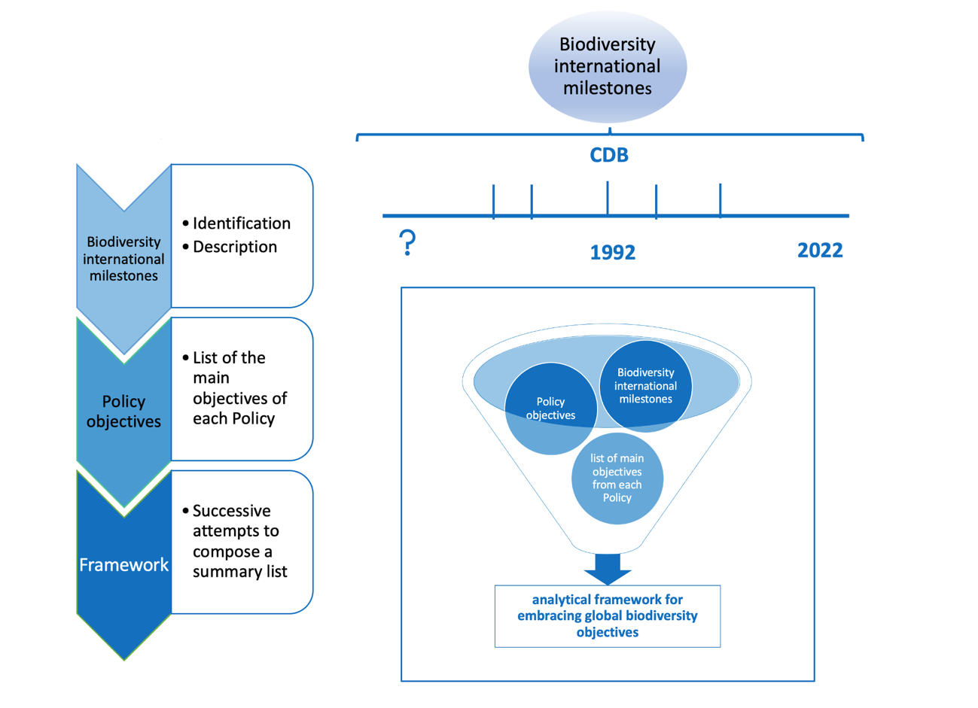
Figure 2 – Delivering the analytical framework from the distilled objectives of the protection of international biodiversity from the main biodiversity milestones.

Table 1 – An example of the steps adopted to distill the main global biodiversity objectives from each biodiversity international milestone.
Biodiversity International Milestone | Policy Objectives | Main Objectives | List of Biodiversity objectives that comprise the analytical framework
The IUCN Red List of Threatened Species (Red List) | to become the world’s most comprehensive information source on the global extinction risk status of animal, fungus and plant species…. to highlight taxa threatened with extinction…  to provide scientifically based information on the status of species… and subspecies at a global level, to draw attention to the magnitude and importance of threatened biodiversity…. | to guide actions to conserve biological diversity mainly related to threatened species. | 1. to reduce threats to biodiversity
The IUCN Red List of Threatened Species (Red List) |  |  | 2. to guide actions to conserve biological diversity mainly related to threatened species
The Millennium Ecosystem Assessment | the objective of the MA was to assess the consequences of ecosystem change for human well-being and the scientific basis for action needed to enhance the conservation and sustainable use of those systems and their contribution to human well-being. | to assess the consequences of ecosystem, change for human well-being and to promote the scientific basis for action needed to enhance the conservation and sustainable use of ecological systems and their contribution to human well-being. | 6. to protect ecosystem services
The Millennium Ecosystem Assessment |  |  | 17. to assess the consequences of ecosystem change for human well-being and to enhance the conservation and sustainable use of ecological systems and their contribution to human well-being

2.2 Analytical Framework from the distilled international biodiversity objectives
A list of 18 international biodiversity milestones (Table 2) was established. We extracted themes from each of these and a main objective associated with each of them; this comprises the analytical framework. Thus, one milestone may have contributed to the building of one or more objectives (Table A, in supplementary material, presents all the data). It is coincidental that there are the same number of themes as there are international biodiversity milestones.

Table 2 – Analytical Framework for embracing international biodiversity objectives.

Analytical framework for embracing international biodiversity objectives
Themes | Main objectives distilled
Reducing threats to biodiversity | 1. to reduce threats to biodiversity
Actively protecting biological diversity of threatened species | 2. to guide actions to conserve biological diversity mainly related to threatened species
Wetland conservation | 3. to conserve wetlands and their resources
Conservation of wild flora, fauna, and natural habitats | 4. to conserve wild flora and fauna and their natural habitats
Conservation of terrestrial, marine, and avian migratory species | 5. to conserve terrestrial, marine, and avian migratory species throughout their range (habitat), to protect endangered migratory species
Conservation of ecosystem services | 6. to protect ecosystem services
Protection of genetic diversity | 7. to protect genetic diversity
Sustainable use of biological diversity | 8. to promote the sustainable use of the components of biological diversity
Fair and equitable sharing of genetic diversity benefits | 9. to promote the fair and equitable sharing of the benefits arising out of the utilization of genetic resources to meet people’s needs
To promote afforestation and conservation | 10. to reverse the loss of worldwide forest; to enhance forest-based sustainability benefits; to significantly increase the area of protected forests worldwide and other areas of sustainably managed forests
To combat desertification | 11. to protect, restore and promote sustainable use of terrestrial ecosystems, sustainably manage forests, combat desertification
To halt and reverse land degradation | 12. to halt and reverse land degradation
To increase biodiversity | 13. to increase biodiversity by avoiding any new degradation of land, reduces existing degradation, and restores already degraded land
To manage risks of LMO | 14. to protect biological diversity by managing the risks of Live Modified Organisms (LMOs)
to propose tools and solutions for achieving biodiversity objectives | 15. to propose tools and solutions for implementation and mainstreaming (2050 goals to 2030 milestones)
To undertake ex ante assessment of actions affecting ecosystem services and biodiversity | 16. to undertake an assessment should towards sustainable development and ecosystem health and biodiversity
To assessment implications of changes in ecosystem services for human well-being | 17. to assess the consequences of ecosystem change for human well-being and to enhance the conservation and sustainable use of ecological systems and their contribution to human well-being
To maintain up-to-date knowledge of ecosystem services and biodiversity | 18. to perform regular and timely assessments of knowledge on biodiversity and ecosystem services and their interlinkages at the global level in order to provide a summary of the status of biological diversity to ensure that biodiversity is conserved and used sustainably
International Biodiversity Milestones*: The IUCN Red List of Threatened Species (Red List); CITES - Convention on International Trade in Endangered Species of Wild Fauna and Flora; The Ramsar Convention; The Bern Convention; The Bonn Convention (the Convention on Migratory Species); Convention on Biological Diversity (CBD); United Nations Forest Instrument; Agenda 21; UN Convention to Combat Desertification; The Cartagena Protocol on Biosafety to the Convention on Biological Diversity; The Millennium Ecosystem Assessment; Aichi Biodiversity Targets (Strategic Plan 2011-2020); The Nagoya Protocol on ABS; IPBES: Intergovernmental Science-Policy Platform on Biodiversity and Ecosystem Services; Sustainable Development Goals; Post-2020 Global Biodiversity Framework – 2020: (2030 actions targets); Global Biodiversity Outlook (GBO) (there are 5 reports); BBNJ (biological diversity areas beyond national jurisdiction) agreement under the United Nations Convention of the Law of the Sea (UNCLOS)
* all the 18 international biodiversity milestones considered in this study.

To apply this analytical framework, a thematic analysis has to be conducted involving identification, analysis, and description of themes or patterns in order to organize and interpret the data from the scientific and grey literature review. The methodological approach was based on Braun and Clark (2014); Fereday and Muir-Cochrane (2006) and Guest et al. (2011) through an inductive process that develops codes from the literature and categorizes these into themes relevant to the protection of biodiversity in the impact assessment (IA) context. Based on the themes derived to represent the main objectives distilled from the biodiversity policies, a list of coding words can be established for further exploring the extent to which international biodiversity policies are delivered through SEA and EIA. For this purpose, a content analysis was recommended as a well-established tool for undertaking systematic examination of published material allowing an interpretation of its meaning within the whole text (Lune and Berg, 2017).
The 18 objectives can be divided into four main groups in relation to IA practice:
- Those that should always be a consideration where ecology is scoped into the terms of reference for the assessment as they are considered core to IA for environmental components. These include objectives relating to reducing threats to biodiversity (1), conservation of flora, fauna and habitat (4), conservation of ecosystem services (6), genetic diversity (7), halt and reverse land degradation (12), to propose tools to meet objectives (15) (inherent in consideration of alternatives and development of mitigation measures), undertake ex ante assessment of risks to biodiversity (16), assess implications for human well-being of changes in ecosystem changes) (17).
- Those that are only relevant where the contextual setting allows (for example, objectives relating to threatened species (2), wetlands (3), migratory species (5), sustainable use of biological diversity (8), equitable sharing of genetic diversity benefits (9), promoting/conserving afforestation (10), combat desertification (11), manage risks to LMO (14).
- Those which are aspirational and therefore related more to objectives-led assessment than the baseline-led assessment that typifies EIA and SEA practice. This includes the objective related to increasing biodiversity (13). Whilst we note some disagreement over the validity of such objectives, for example in small island settings (Spatz et al., 2017), our role is not to judge the objectives that exist.
- Those which rely on IA systems maintaining centralized knowledge systems. This includes the objective to maintain knowledge of ecosystem services and biodiversity (18).
These groupings are important when considering the analysis of literature against the analytical framework. The contextual elements are likely to be less frequently identified in practice (if at all). The aspirational objective (13) is likely to depend on current policies in given jurisdictions related to no net loss (NNL) policies (more than 100 countries are developing or implementing them – Bull and Milner-Gulland, 2020) or net gain of biodiversity policies, such as France, Chile, South Australia (Maron et al., 2018) and the UK (Hooper et al., 2021). The objective related to maintenance of knowledge systems (18) is reliant on jurisdictions maintaining these for IA purposes (see, for example, Sánchez and André, 2013; Sánchez and Morrison-Saunders, 2013).

3. Testing the analytical framework on EIA and SEA literature
Whilst reviewing EIA and SEA reports would be the optimal way of representing IA global practice – practical constraints (including language barriers; access to sufficiently representative samples; the large number of reports needed to be evaluated) mean that it is not practicable to use this approach in a single study. Therefore, we used academic literature and grey literature as a surrogate for global practice. Then, the analytical framework developed from the international policy objectives was applied to SEA and EIA literature to determine the extent to which the international biodiversity policies are currently addressed. This was a two-step process: 1) locating the relevant literature to evaluate; and 2) applying the analytical framework to this literature.

3.1 Identifying the EIA and SEA literature relevant to biodiversity protection

The first step comprises a systematic literature review approach to find and select evidence of the application of SEA and EIA to the delivery of global biodiversity objectives. As IA can be considered an area of knowledge strongly influenced by practice (Bond and Pope, 2012) academic sources also includes discussion of practical examples.
Nevertheless, Haddaway and Bayliss (2015) have emphasized the importance of grey literature in research related to biodiversity issues, especially that denominated as ‘practitioner-generated research’ that includes different types of organisational and government reports. For this purpose, we undertook a grey literature search using the Google search engine (Paez, 2017) for undertaking a systematic documentary review (Figure 3). Following Haddaway et al. (2015), based on an assumption that the most relevant sources will appear in the first sets of search results, we screened the first 60 search records acknowledging that both language and location (the search was undertaken in the UK) can bias the results. As such, the approach is strongly influenced by its practicability, and it is recognised that it is not likely to be comprehensive. Nevertheless, opportunities remain to identify further grey literature which is cited in academic sources.
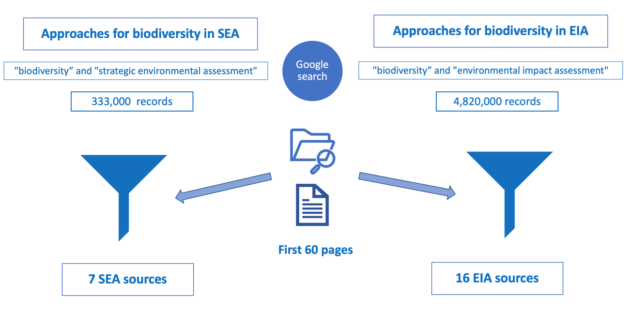
Figure 3 – Selecting technical material related to SEA and EIA and biodiversity issues by Google search.

The academic literature review was carried out primarily using the Scopus database as it is recognized as one of the largest index databases ever built (Burnham, 2006). The Scopus database search was conducted on 20th April 2022, without setting any start date constraints for the publication period, using three different sets of associated keywords and applying 3 successive filters (see Figure 4) in order to select the sources that would be evaluated using the analytical framework.
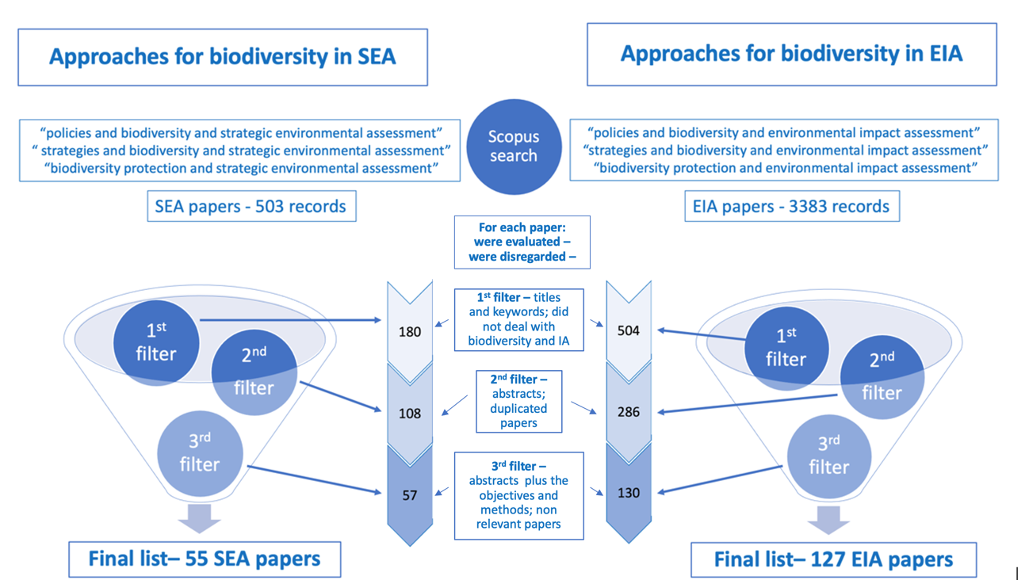
Figure 4 – Selecting papers related to SEA and EIA and biodiversity issues by Scopus search.

From the Scopus search, 503 papers on SEA (between 1996 and April 2022) and 3383 papers on EIA (between 1991 and April 2022) were found, which after being filtered resulted, respectively, in 55 papers on SEA and 127 papers on EIA (Figure 4). We also added the records (technical documents) from the grey literature (7 results for SEA and 16 results for EIA) to give a final sample of 62 documentary sources for SEA and 143 documentary sources for EIA (Figure 3).

3.2 Applying the analytical framework to literature encompassing the assessment of biodiversity in SEA and EIA

To explore which 18 international biodiversity objectives are and are not met in the IA international literature we applied the analytical framework (Table 2) to both the SEA (62 documentary sources) and EIA (143 documentary sources). The themes identified in the analytical framework (Table 2) were used for developing keywords and associated search terms as the basis for content analysis (see Table 3). It may be possible to find several keywords, but only if the theme established by the biodiversity objective was met following content analysis was it confirmed that a particular documentary source had achieved this objective. Any single documentary source could address more than one theme of biodiversity and, consequently, one or more of the 18 biodiversity objectives (Table 2).
Table 3 – The keywords and search terms developed from the themes identified in Table 2.
Themes | keywords (coding) | Search terms
Reducing threats to biodiversity | Threats, biodiversity, red list | Threat OR biodivers* OR red list
Actively protecting biological diversity of threatened species | diversity, threatened species | Conserv* AND biodivers* OR “biological diversity” AND “threatened species”
Wetland conservation | wetland | Wetland AND conserv*
Conservation of wild flora, fauna, and natural habitats | Wild flora, fauna, natural habitat, wildlife; species; network | Conserve* AND biodivers* OR “biological diversity” OR fauna OR flora OR habitat
Conservation of terrestrial, marine, and avian migratory species | Terrestrial, marine, avian, migratory species, habitat; bird; endangered | Conserv* OR protect AND migrat*
Conservation of ecosystem services | Ecosystem services | “ecosystem services” AND protect OR conserv*
Protection of genetic diversity | Genetic diversity | “genetic diversity” AND protect OR conserv*
Sustainable use of biological diversity | Biological diversity, sustainable | Sustainable AND divers*
Fair and equitable sharing of genetic diversity benefits | Genetic diversity | Fair OR equit* AND shar* AND biodiver* OR genetic
To promote afforestation and conservation | Afforestation, forest | *forest*
To combat desertification | Desertification, terrestrial ecosystems ,forest | Desert* OR forest
To halt and reverse land degradation | Land, degradation; landscape | Degradation OR land
To increase biodiversity | Biodiversity; land; degradation; maximize | Biodivers* AND restor* OR “net gain” OR offset” OR “no net loss”
To manage risks of LMO | Live modified organisms; risks | “live modified organisms” OR LMO
to purpose tools and solutions for achieving biodiversity objectives | Tools, solutions, frameworks, guidelines, biodiversity, objectives; SDG goals; approach | biodivers* OR “biological diversity” AND tool OR solution OR guide* OR framework OR objectives OR goals
To undertake ex ante assessment of actions affecting ecosystem services and biodiversity | Ex ante, ecosystem services, biodiversity; sustainable development; assessment | “ecosystem services” OR biodiver* OR “biological diversity” AND assess* AND sustain*
To assessment implications of changes in ecosystem services for human well-being | Changes, ecosystem services, human well-being | Ecosystem AND change AND well-being OR “well-being” OR wellbeing
To maintain up-to-date knowledge of ecosystem services and biodiversity | Knowledge, status, ecosystem services, status, biodiversity, biological diversity | “ecosystem services” OR biodiverse* OR “biological diversity” AND knowledge OR communication OR summar*

The analysis then proceeds by searching all of the documentary sources (Tables B and C in supplementary data) using the search terms in Table 3. From this analysis, the identified text was checked to ensure it did match the objective associated with the theme. Table 4 presents some examples of text extracts from analysed documentary sources to illustrate how this process worked. Figure 5 and Figure 6, respectively, present the results from the application of the analytical framework firstly in relation to the objectives identified in the documentary sources for SEA and EIA and then the same results categorised into the four groups of practice established in section 2.2.

Table 4 – Examples of how SEA and EIA material embrace international biodiversity objectives.
 | Examples in SEA sample | Examples in EIA sample
1 | “an assessment approach and a unique case study in which spatial prioritization tools were used to support strategic assessment of a large development plan in Western Australia that affect threatened ecological communities and their habitats” (SEA – number 17) | “an assessment for threatened species under environmental legislation be improved through strictly enforced minimum survey requirements” (EIA – number 8)
2 | “to present how southern Africa's citizen science-based ‘early warning system for biodiversity’ is used to support land-use planning and conservation decisions, including Red List (threatened species), strategic and project-based EIA and national protected area expansion and implementation strategies” (SEA – number 13) | “two important gaps have to be addressed if we are to conserve marine biodiversity in international waters: the science-policy interfaces and the need for transformative change” (EIA – number 19)
3 | “to promote SEA by using land use and cover change to analyze projected urban development on wetland protection areas in terms of biodiversity and the ES provision” (SEA – number 6) | “to improve EIA for projects that affecting tidal wetlands and their surrounding landscapes, they have to include classification of hydrogeomorphic units and consideration of their responses to biological and environmental stressors” (EIA – number 108)
4 | “the IBIA methodology is proposed to examines current key issues in biodiversity impact assessment, inclusive SEA, to ensure that potential negative impacts on both protected nature conservation sites and species and wider biodiversity are efficiently identified in a timely manner, quantified and subsequently avoided or mitigated,  while enhancing positive effects (SEA – number 29) | “methods were analysed to create numerical equivalence between sites affected by development and proposed conservation offset sites. Application of biodiversity offsetting metrics in development impact and mitigation assessments is thought to standardize biodiversity conservation outcomes, sometimes termed yield by those conducting these calculations” (EIA – number 57)
5 | “a methodology for biodiversity evaluations within the process of SEA is presented and applied it to the estimation of the effect of two Regional Plans of Development on all bird species inhabiting the Castilla y León region (Spain)” (SEA – number 46). | “species-distribution models (SDM) are tools with potential to inform EIS as evidence to support project-licensing decisions in the Amazon region (Brazil)” (EIA – number 75)
6 | “a methodology to integrate the concept of ecosystem services in all phases of the SEA process for a sub-urban plan is proposed” (SEA – number 28) | “how impacts on biodiversity and ecosystem services are assessed on corridors and what mitigation measures are discussed to manage these impacts and to what extent do these measures approximate to best practice” (EIA – number 13)
7 | “a proactive way of promoting conservation and sustainable use of biodiversity in ABNJ through the incorporation of SEA in the BBNJ Agreement with regarding to marine genetic resources” (SEA – number 1) | “the use of environmental DNA (eDNA), traces of genetic material left behind by individual organisms in their environment, within EIA is evaluated. Several key issues are identified for eDNA information within a generic EIA framework for marine environments” (EIA – number 2)
8 | “the use of SEA as a tool for the conservation and sustainable use of biodiversity and draws on international experience to outline some of the issues that need to be addressed to make this application effective” (SEA – number 32) | “The authors discuss key challenges for assessing the impact of regulations on the use and trade of wildlife (i.e. sustainable), and offer a practical approach to overcome them. This framework and process can be applied to any regulation, species or country context” (EIA – number 28)
9 | Not found | “guidelines (comprises 60 indicators) are established for the analysis of the inclusion of biodiversity in EISs using a systematic approach based on scientific papers, CBD, and a survey with 43 EIA practitioners. The guidelines also include the levels of biological diversity (ecosystem, species, and genetic diversity),” (EIA – number 14).
10 | “the present study aimed to transform forest inventories into composite, clear and consensual value assessments, to provide support to land use decisions in forest areas by using a GIS to support land use planning procedures, such SEA” (SEA – number 41). | “A fuller assessment of trade-offs between conservation and other values will be necessary to make good decisions for each project and site being developed, including potentially modifying parts of the route to minimize impacts; also the assessment of the relationship between the proposed route with the distribution of mines across countries and the proportion of deforestation and forest near routes.” (EIA – number 30).
11 | “a combination of methods involving matrix assessment, incorporation of expert judgment and trend analysis was employed to analyze and predict the environmental impacts upon eight selected environmental indicators: water resource availability, soil erosion, soil salinization, forest destruction, land desertification” (SEA – number 31) | ”EIA for new mining projects must assess and mitigate the cumulative region-wide effects on forests, while existing protected areas must be strengthened to ensure they are not directly or indirectly compromised by mining activities“ (EIA – number 20)
12 | “This article discusses the development and application of SEA methodology that aims to investigate the implications of agricultural restructuring and decline for biodiversity conservation in the mountain areas of Europe; and it describes the engagement of stakeholder panels in each study area and the use of causal chain analysis for understanding the likely implications for land use and biodiversity of strategic drivers of change under alternative scenarios for agriculture and rural policy and for biodiversity management” (SEA – number 40) | “the effectiveness of agricultural and, latterly, EIA authorisation procedures in stemming biodiversity loss resulting from cultivation in the lowlands of the Cape Floristic Region, a global biodiversity hotspot. Owing to an activity-based focus, agri-environmental regulation has been largely unable to mitigate the cumulative effects of large-scale land clearance in threatened ecosystems” (EIA – number 112)
13 | “to propose a method that “scales up” the implementation of the mitigation hierarchy (no net loss) from the project-level to a landscape-scale approach on the basis of spatial indices that are used to (1) set priorities for impact avoidance and (2) pre-identify sites as candidates for offset provision by using SEA“ (SEA –number 3) | “the methodology provides a useful tool for EIA studies to compare the effectiveness of different avoidance or mitigation measures and resize them if necessary to maximize habitat “(EIA – number 36)
14 | Not found | “consider the full range of factors affecting biodiversity. These include direct drivers of change associated with a proposal (e.g. land conversion, vegetation removal, emissions, disturbance, introduction of invasive alien species or genetically modified organisms, etc.)” (EIA – number 105)
15 | “to introduce biodiversity policy integration (BPI) as an analytical approach for assessing the ecological performance of nonenvironmental sectors and highlight SEA as a way to operationalize it to reach SDG both to protect biodiversity and ES” (SEA – number 7) | “the potential role of NNL policies in reconciling these SDGs is explored in order to mitigate all infrastructure impacts on biodiversity. To achieve SDGs 9 alongside 14 and 15, capitalizing on the global coverage of mandatory compensation policies and rapidly transforming them into robust NNL policies should be an urgent priority” (EIA – number 38)
16 | “to introduce biodiversity policy integration (BPI) as an analytical approach for assessing the ecological performance of nonenvironmental sectors and highlight SEA as a way to operationalize it to reach SDG both to protect biodiversity and ES” (SEA – number 7) | “EIA supports its political context and associated societal goals, and those goals typically reflect some form of sustainable development. Given that the appropriate level of biodiversity protection is a moral consideration, we take an environmental ethics perspective to explain how different levels of protection are associated with different ethical positions on a spectrum from anthropocentrism through to ecocentrism” (IEIA – number 11)
17 | “The objective of this research is to explore how ecosystem services have been considered in the development of spatial plans at different scales by considering a sample of SEA reports” (SEA – number 49) | “the OPAL (Offset Portfolio Analyzer and Locator) is presented which quantifies the impacts of development on habitat and ecosystem services, and facilitates the selection of mitigation activities to offset losses. Its application with an oil and gas extraction facility in Colombia is presented. OPAL is the first tool to provide direct consideration of the distribution of ES among people in a mitigation context” (EIA – number 76).
18 | “the ESMERALDA project is a flexible methodology for mapping and assessment of ES in terms of the implementation of EU 2020 targets and SEA in this context is presented as a way to mainstream ecosystem services in real-life decisions” (SEA – number 9) | “to assess the effectiveness of such policies at a European Union (EU) scale, land use changes are simulated and their impacts on biodiversity and ecosystem services indicators are discussed” (EIA – number 70)
Notes:
1-Table B in supplementary material presents coding for all SEA references.
2-Table C in supplementary material presents coding for all EIA references.
3- the words highlighted in bold represent the keywords.

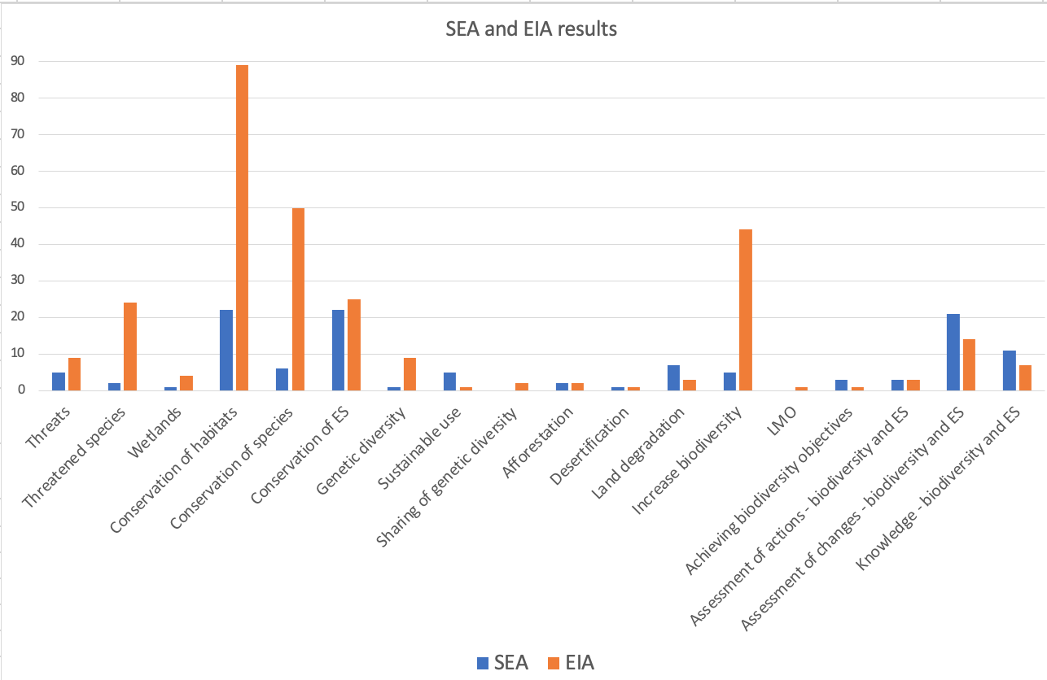
Figure 5 – Distribution of the number of SEA and EIA documentary sources that address the 18 main biodiversity objectives.

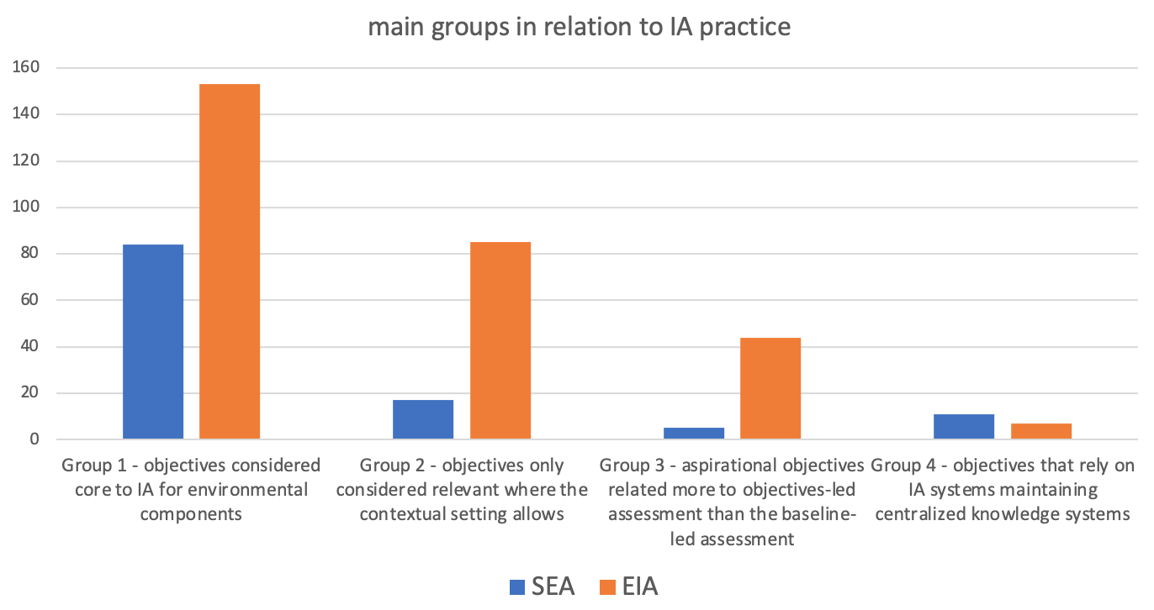
Figure 6 – Distribution of the number of SEA and EIA documentary sources that address the four main groups of biodiversity objectives.

The interpreted data presented in Figure 5 show that for two objectives (9 – sharing of genetic diversity, and 16 – LMO), no SEA papers were found, but that all objectives were found in at least one EIA paper. The first EIA papers (1991) found were published 5 years before those found for SEA papers (1996), but around the same period that the CBD was being debated and then agreed (in 1992).
With the caveat that our sample of documentary sources, although comprehensive, is not exhaustive, it is not possible to associate statements between the frequency of documentary sources and the importance of the biodiversity objective for the IA practice. A high frequency of documentary sources found for a given objective could be considered evidence that the objective has been widely considered in IA practice, but the opposite situation does not necessarily demonstrate a lack of consideration in practice. It is also possible that the bias of the literature review towards academic publications has missed other types of publication (for example, biodiversity assessment guidelines produced by professional institutes) that do address these biodiversity objectives. However, the data in Figure 5, analyzed in the context of these assumptions, provide valuable clues as to the extent to which some global biodiversity objectives are currently addressed or not addressed in IA practice.
Some suggestions can be made about IA practice in relation to the four main groups of biodiversity objectives (Figure 6) in the context of feeding a research agenda for improving IA tiering through SEA to EIA.
Evidence that the objectives of group (1), which include those that are expected to be included in EIA and SEA (subject to scoping), are addressed in both SEA and EIA is clear from our sample. With regards to Objective 7, although the data show the difficulty of capturing the genetic level of biodiversity at the strategic level as already highlighted by Treweek et al. (2005) and Brownlie and Treweek (2018), evidence is found for the project level. This demonstrates that regardless of the level of planning, strategic or individual initiatives, the ecological components of biodiversity have been relatively widely discussed in the IA literature. Even the fact that only a few sources have discussed the issue of mainstreaming the 2050 goals to the 2030 milestones – addressed by Objective 15 – it reinforces the importance of this group to foster IA tiering. As the majority of these objectives is widely discussed, IA tiering has the potential to increase efficiency.
The objectives related to group (2) that refer to those that are relevant only when the context allows are largely present in our sample of SEA and EIA documentary sources. The proportion of referencing is much higher in the EIA sample than the SEA sample, and two objectives are absent from the SEA sample (9 and 14). The higher frequency with which objectives are addressed in the EIA documentary sources allow us to suggest that contextual aspects of the protection of endangered and migratory species tend to be a more relevant agenda in the practice of IA at the project level, although it remains possible that SEA practice is deficient and further study would be needed to check this. There is very low evidence of IA considering LMOs (Objective 14) thus far, although this is not unexpected given the likely rarity of activities subject to IA actually involving the use of LMOs. And the paucity of evidence on sharing of genetic diversity benefits (Objective 9). Other objectives, such as Objective 3, to conserve wetlands, and Objective 11, to combat desertification, are relevant only in specific geographical locations, which necessarily reduces their representation across the literature globally. However, IA tiering with this group of objectives should also be pursued but with a more restricted scope and reinforcing issues that should be emphasized at a strategic level from those at a project level in particular contexts.
The objective that represents group (3) is also present in the samples of SEA and EIA documentary sources, but they are very frequent in EIA practice. This is notably due to the guidelines for including the mitigation hierarchy, mainly at the level of engineering projects. This objective, related to increasing biodiversity, could play a very important role in improving IA tiering, especially when supported and strengthened in the policies of certain jurisdictions that specifically prescribe the net gain of biodiversity for this purpose. There is a commitment from IA research to propose different solutions for helping the biodiversity protection agenda (to implement the mitigation hierarchy). It allows us to consider a path that is potentially being unconsciously paved to reinforce the promotion of IA tiering through these biodiversity objectives. These also allow us to consider that there are plenty of sources to reinforce the conscious transfer of biodiversity objectives from the planning level to the project level. Objective 13 can also confirm this premise from the SEA level to the EIA level.
The objective that represents group (4) is also present in both samples of SEA and EIA documentary sources, surely driven by jurisdictions that maintain knowledge systems. This objective could also play an important role in fostering SEA tiering for EIA as a knowledge repository for the entire planning cycle.
Figure 7 presents the relative frequency for SEA and EIA documentary sources with respect to each of the 18 biodiversity objectives. For ease of analysis, an arbitrary cut off of 4 documentary sources referring to the specific objective was used to help distinguish between the frequency with which various objectives are addressed at the SEA level as opposed to the EIA level. Selecting 4 documentary sources as the cut off point illustrates the greatest difference between these tiers of IA.

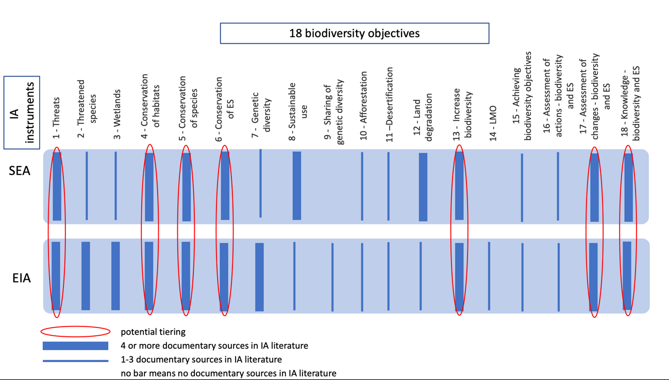
Figure 7 – Potential tiering between SEA and EIA documentary sources linked by biodiversity objectives.

Figure 7 does reveal that those objectives that are referenced more at EIA level than SEA level (objectives 2, 3 and 7). Objectives 2 and 3 fall into group 2 objectives where the context is important in determining their relevance – and the context may only be clear at the project level. Objective 7 is more difficult to interpret as the level at which genetic diversity is considered is subject to some debate in relation to biodiversity no net loss (Niner et al., 2018; Hoban et al., 2020). For example, arguments that compensation can be delivered away from a project site is favoured by many developers – this tends to favour maintenance of diversity at strategic levels and not at project levels. However, local communities losing nearby genetic diversity can object vehemently to such approaches – which might explain a reluctance to plan strategically for genetic diversity and therefore cite it in SEAs.
Objectives 9 and 14 have little reference at the EIA level, but no reference at the SEA level. These are, again, group 2 objectives and so the result is not unexpected.
For objectives 1, 4, 5, 6, 13, 17 and 18, there is some evidence that there is relatively frequent consideration in both EIA and SEA. From the literature, prompts can be identified which help to explain how tiering can be facilitated. For example, to encourage tiering considering to reducing threats to biodiversity (objective 1), conservation actions considering red list species can be guided at the SEA level using Citizen Science-based as a tool (Barnard et al., 2017) whose data can be confirmed and detailed at the EIA level project, for example, through indicators for a listing of threatened ecosystems by individual projects (Botts et al., 2020).
To conserve wild flora and fauna and their natural habitats (objective 4), at the strategic level, SEA can support land-use planning integrated to conservation decisions (Barnard et al., 2017; Ives et al., 2015) or even can be used to implement policies such as Antarctic Treaty Parties (Convey et al., 2012). For tiering this information to EIA level, data can be evaluated considering the differences in species richness (Bueno and Peres, 2020), by using different approaches for restoration (Ugwu et al., 2019) guided by the quality of baseline biodiversity studies and the predictions made about the impacts of the development on biodiversity used to inform EIAs (Dias et al., 2022).
With the consideration of conserving terrestrial, marine and avian migratory species (objective 5), SEA can be used for representing an ecosystem-based marine spatial planning for conserving different fish’s species (Grip and Blomqvist, 2020) this information must be transferred to the lower decision-making level and can feed species-distribution models for inform EIA reports (Carneiro et al., 2016).
Regarding to protect ES (objective 6), at a strategic level, land use and cover change (LUCC) can be used as a tool in SEA for evaluating the conservation of ES in urban development (Rojas et al., 2019) that can be detailed at the EIA level by using a framework for including ES in mitigation (Tallis et al., 2015).
With the purpose to increase biodiversity (objective 13), at the SEA level we can find proposals related to developing the mitigation hierarchy at the landscape scale (Bigard et al., 2020) and in planning (Dupont et al., 2018) that can be detailed at the EIA level by engaging social and cultural values of individual projects (Heiner et all, 2019), or by using a multi-stakeholder analysis to design offsets principles of large infrastructure projects (Martin et al., 2016), and detailing different ecosystems restoration in meeting offset requirements (for example, marine ecosystem – Jacob et al., 2018).
With regard to the assessment of changes in biodiversity and ES (objective 17) to undertake an assessment towards sustainable development, for example, some principles are proposed at a strategic level to achieve sustainable outcomes for biodiversity and ES (Brownlie and Treweek, 2018) whose can be detailed at the EIA level by using expert interviews (Hugé et al., 2020).
Considering performing assessments of knowledge on biodiversity and ES (objective 18), at the strategic level, we can use a methodology for mapping and evaluating ES in terms of the implementation of a biodiversity policy applied to SEA (for example, EU 2020 targets – Geneletti et al., 2018) that can be detailed at the EIA level by assessing its effectiveness by using some simulations and indicators (Schulp et al., 2016).

4. Discussion and Conclusions
Our proposed analytical framework with 18 distilled biodiversity objectives is a contribution to the literature in its own right and has proved to be a robust and feasible way to assess whether the main themes of international biodiversity policies are being considered in IA practice. Our proposal adds to the urgent need to propose actions in an integrated manner to reverse the trend of global biodiversity loss (Leadley et al., 2022) and to add efforts to build “a robust action agenda” (Chan et al. 2022, p.1) for implementing the Kunning-Montreal GBF (Hughes et al., 2022).
As highlighted by Milner-Gulland et al. (2021, p.76) “the ‘mainstreaming’ of biodiversity can help address these challenges by translating high-level goals into meaningful and inclusive actions at multiple scales throughout society”. The first use of this analytical framework showed that there is a comprehensive sample – 205 records – of documentary sources related to SEA (143) and EIA (62) practices that deliver proposals to meet these objectives. The use of literature review for identifying linkages between biodiversity attributes is also used by Harrison et al. (2014) and by Thakur et al. (2020) for proposing an integrative conceptual framework for exploring soil biodiversity.
Considering that all 18 objectives have some analysis mirrored in the sets of papers analyzed from the literature, the practice of IA, in accordance with Craik (2017), is helping to shed light on biodiversity goals. Some biodiversity objectives are widespread showing that certain biodiversity issues are widely enshrined in the IA literature and a variety of methods may already be available to capture these elements of biodiversity in current IA practice as proved by the methods developed by Brownlie and Treweek (2018); Mandai and Souza (2021); Gutierrez et al. (2021); Gallardo et al. (2022b).
Those objectives not often present in the literature can be explained in three ways. The first is a limitation in the literature search on this issue, restricting the identification of a larger number of papers. Such a limitation can potentially be overcome in future studies, albeit there is no perfect way of systematically searching for such literature. Nevertheless, considerations of both types of grey literature: ‘file drawer research’ of unpublished academic research, and ‘practitioner-generated research’ including different types of organisational and government reports, can be at least partially identified through a combination of databases, including the increasing trend for online pre-print platforms, supplemented with Google and Google Scholar searches, and careful tracking of grey literature cited in sources identified through more traditional academic routes. The second is that much of the IA ​​literature focuses on theory rather than on the practice of achieving specific outcomes (Pope et al., 2013; Costanzo; Sánchez, 2019). The third is that the majority of those objectives belonging to Group 2 objectives reflect a limited proportion of the earth’s surface, and a correspondingly lower proportion of papers in the IA literature, for example, those related to wetlands (Westbrook; Noble, 2013) and desertification (Egidi et al., 2021).
Table 2 provides an analytical framework against which the biodiversity coverage of IA processes can be evaluated for comprehensiveness, bearing in mind the caveat that not all objectives are relevant to all contexts (for example, objectives related to desertification are rarely relevant to specific SEA or EIA cases). Their application to the SEA and EIA literature demonstrated that these objectives are, to a greater or lesser extent, present in the IA literature.
An important question would be how to facilitate tiering of the assessment of biodiversity from higher planning to project levels. Our framework does not answer this question but has started the process of investigating how to improve tiering by clarifying which objectives should be the focus for evaluation, and also where there potentially might be existing gaps in practice. This provides the benchmark for future exploration of how best to tier knowledge on biodiversity from the planning to the project level. As examples, objective 4 and objective 13 are represented in both SEA and EIA literature, and the specific focus highlighted in the previous section does indicate that there is potential for a flow of information between assessment tiers as discussed by Therivel and González (2021) and Gallardo et al. (2022a).
The importance of biodiversity objectives being considered in the SEA planning cycle for the EIA aims to ensure that the strategic aspects of biodiversity are not only present but detailed at the level of local actions in individual projects or initiatives. It was chosen not to determine specific metrics and detailed guidelines to be applied in each IA tiered context because it is understood that this proposal, although innovative and unprecedented, is still an outline to be improved with future studies. The more than 205 technical sources on good SEA and EIA practices and biodiversity demonstrate the connection between these themes and that there are many proposals and paths to test and perhaps even detail the operationalization of the framework proposed here.
A limitation of this research was the non-application of our proposed framework to SEA and EIA report samples. We recommend that future research address this limitation which, through application to different jurisdictions in separate research projects, can contribute to the development of a more global understanding of the extent to which EIA and SEA help to achieve biodiversity objectives, and may start to help identify barriers and enablers of good practice. Likewise, it is recommended that future studies can expand, detail, and even particularize the proposed framework considering other relevant national policies and guidance. This can extend to developing regional analytical frameworks where relevant. Further work will also be needed to develop an evaluation system for determining the success of achievement of biodiversity objectives at SEA and EIA levels, and to develop specific guides on tiering between the two levels. As such, much work remains to be completed. Nevertheless, this paper has presented an overall framework within which this future work can be embedded.
Based on the conclusions, constrained by the limitations, a research agenda can be outlined as the basis for identifying opportunities for improving tiering of biodiversity issues in IA:
- The framework was deliberately developed based on international policy. In specific regions, there may be some merit in developing regional analytical frameworks that better represent more localized policies, and more localized biodiversity contexts;
- The application of the framework to academic and grey literature helped to demonstrate the utility of the framework. Nevertheless, it may be a weak surrogate for actual practice, and its application to representative samples of Environmental Impact Statements is a necessary next step;
- There is a need to develop proposals for evaluating the achievement of objectives at both levels of IA and as a measure to evaluate IA tiering between them;
- Ultimately, the research needs to identify specific barriers and enablers of tiering of biodiversity knowledge through the tiers of IA. Some hints and suggestions already exist in the literature as outlined in section 3.2, but there needs to be a more systematic development of recommendations associated with each objective listed in the analytical framework.

References

Al-Abdulrazzak, D., Galland, G. R., McClenachan, L., & Hocevar, J. (2017). Opportunities for improving global marine conservation through multilateral treaties. Marine Policy, 86, 247-252.
Arts, J., Tomlinson, P., & Voogd, H. (2011). Planning in tiers? Tiering as a way of linking SEA and EIA. Handbook of strategic environmental assessment, 415-436.
Barnard, P., Altwegg, R., Ebrahim, I., Underhill, L.G. (2017). Early warning systems for biodiversity in southern Africa – How much can citizen science mitigate imperfect data? Biological Conservation, 208, pp. 183-188.
Bigard, C., Thiriet, P., Pioch, S., Thompson, J.D. (2020). Strategic landscape-scale planning to improve mitigation hierarchy implementation: An empirical case study in Mediterranean France. Land Use Policy, 90, art. no. 104286.
Bolam, F. C., Mair, L., Angelico, M., Brooks, T. M., Burgman, M., Hermes, C., ... & Butchart, S. H. (2021). How many bird and mammal extinctions has recent conservation action prevented?. Conservation Letters, 14(1), e12762.
Bond, A., & Pope, J. (2012). The state of the art of impact assessment in 2012. Impact Assessment and Project Appraisal, 30(1), 1-4.
Bond, A., Pope, J., Morrison-Saunders, A., & Retief, F. (2021). Taking an environmental ethics perspective to understand what we should expect from EIA in terms of biodiversity protection. Environmental Impact Assessment Review, 86, 106508.
Botts, E.A., Skowno, A., Driver, A., Holness, S., Maze, K., Smith, T., Daniels, F., Desmet, P., Sink, K., Botha, M., Nel, J., Manuel, J. (2020). More than just a (red) list: Over a decade of using South Africa's threatened ecosystems in policy and practice. Biological Conservation, 246, art. no. 108559
Braun, V., & Clarke, V. (2014). What can “thematic analysis” offer health and wellbeing researchers? International journal of qualitative studies on health and well-being, 9(1), 26152.
Brownlie, S., King, N., & Treweek, J. (2013). Biodiversity tradeoffs and offsets in impact assessment and decision making: can we stop the loss? Impact Assessment and Project Appraisal, 31(1), 24-33.
Brownlie, S., Treweek, J. 2018. Biodiversity and ecosystem services in impact assessment international Best Practice Principles. Special Publication Series N 3. International Association for Impact Assessment, Fargo (USA). [accessed 2022 Jan 20] https://www.iaia. org/uploads/pdf/SP3-Biodiversity-Ecosystem-Services. pdf
Bueno, A.S., Peres, C.A. (2020). The role of baseline suitability in assessing the impacts of land-use change on biodiversity. Biological Conservation, 243, art. no. 108396
Bull, J. W., & Milner‐Gulland, E. J. (2020). Choosing prevention or cure when mitigating biodiversity loss: Trade‐offs under ‘no net loss’ policies. Journal of Applied Ecology, 57(2), 354-366.
Burnham, J. F. (2006). Scopus database: a review. Biomedical digital libraries, 3(1), 1-8.
Business and Biodiversity Offsets Programme (BBOP). 2018. Glossary. BBOP, Washington, D.C. 3 rd updated edition.
Carneiro, L.R.D.A., Lima, A.P., Machado, R.B., Magnusson, W.E. (2016). Limitations to the use of species-distribution models for environmental-impact assessments in the Amazon. PLoS ONE, 11 (1), art. no. e0146543.
Chan, S., Bauer, S., Betsill, M. M., Biermann, F., Boran, I., Bridgewater, P., ... & Pettorelli, N. (2022). The global biodiversity framework needs a robust action agenda. Nature Ecology & Evolution, 1-2
CBD (2022)- https://www.cbd.int/convention/articles/?a=cbd-01
Convey, P., Hughes, K.A., Tin, T. Continental governance and environmental management mechanisms under the Antarctic Treaty System: Sufficient for the biodiversity challenges of this century? (2012) Biodiversity, 13 (3-4), pp. 234-248.
Coutinho, M., Bynoe, M., Pires, S. M., Leão, F., Bento, S., & Borrego, C. (2019). Impact assessment: tiering approaches for sustainable development planning and decision-making of a large infrastructure project. Impact Assessment and Project Appraisal, 37(6), 460-470.
Costanzo, B. P., & Sánchez, L. E. (2019). Innovation in impact assessment theory and practice: How is it captured in the literature?. Environmental Impact Assessment Review, 79, 106289.
Cumming, K., & Tavares, D. (2022). Using strategic environmental assessment and project environmental impact assessment to assess ecological connectivity at multiple scales in a national park context. Impact Assessment and Project Appraisal, 1-10.
Craik, A. N. (2017). Biodiversity Inclusive Impact Assessment. Biodiversity and Nature Protection Law (Elgar Encyclopedia of Environmental Law).
Dias, A. M., Cook, C., Massara, R. L., & Paglia, A. P. (2022). Are Environmental Impact Assessments effectively addressing the biodiversity issues in Brazil?. Environmental Impact Assessment Review, 95, 106801.
Dupont, V., Schoukens, H., Born, C.-H. Belgium (2018). Biodiversity Offsets: European Perspectives on No Net Loss of Biodiversity and Ecosystem Services, pp. 55-89.
Egidi, G., Cividino, S., Paris, E., Palma, A., Salvati, L., & Cudlin, P. (2021). Assessing the impact of multiple drivers of land sensitivity to desertification in a Mediterranean country. Environmental Impact Assessment Review, 89, 106594.
Eigenbrod, F., Anderson, B. J., Armsworth, P. R., Heinemeyer, A., Gillings, S., Roy, D. B., ... & Gaston, K. J. (2010). Representation of ecosystem services by tiered conservation strategies. Conservation letters, 3(3), 184-191.
Fereday, J., & Muir-Cochrane, E. (2006). Demonstrating rigor using thematic analysis: A hybrid approach of inductive and deductive coding and theme development. International journal of qualitative methods, 5(1), 80-92.
Fundingsland Tetlow, M., & Hanusch, M. (2012). Strategic environmental assessment: the state of the art. Impact Assessment and Project Appraisal, 30(1), 15-24.
Gallardo, A. L. C. F., Dos Santos, C.C.A., Bond, A., Mateus Moretto, E., Montaño, M., & Athayde, S. (2022a). Translating Best Practice Principles into criteria for evaluating the consideration of biodiversity in SEA practice. Impact Assessment and Project Appraisal, 1-13.
Gallardo, A. L. C. F., Rosa, J. C. S., & Sánchez, L. E. (2022b). Addressing ecosystem services from plan to project to further tiering in impact assessment: Lessons from highway planning in São Paulo, Brazil. Environmental Impact Assessment, 92, 106694.
Geneletti, D., Adem Esmail, B., Cortinovis, C. (2018). Identifying representative case studies for ecosystem services mapping and assessment across Europe. One Ecosystem, 3, art. no. e25382
González, A., Hochstrasser, T., Fry, J., Scott, P., Grist, B., Jones, M. (2013). Evaluating Ireland's IBIA as an approach to improving the quality and effectiveness of biodiversity impact assessment. Journal of Environmental Management, 131, pp. 150-160
González, A., & Therivel, R. (2022). Raising the game in environmental assessment: insights from tiering practice. Environmental Impact Assessment Review, 92, 106695.
Gutierrez, M., Bekessy, S. A., & Gordon, A. (2021). Biodiversity and ecosystem services in strategic environmental assessment: An evaluation of six Australian cases. Environmental Impact Assessment Review, 87, 106552.
Guest, G., MacQueen, K. M. Namey, E. E. Applied thematic analysis. Sage publication, 2011.
Grip, K., Blomqvist, S. Marine nature conservation and conflicts with fisheries (2020). Ambio, 49 (7), pp. 1328-1340.
Haddaway, N. R., & Bayliss, H. R. (2015). Shades of grey: two forms of grey literature important for reviews in conservation. Biological Conservation, 191, 827-829.
Haddaway, N. R., Collins, A. M., Coughlin, D., & Kirk, S. (2015). The role of Google Scholar in evidence reviews and its applicability to grey literature searching. PloS one, 10(9), e0138237.
Harrison, P. A., Berry, P. M., Simpson, G., Haslett, J. R., Blicharska, M., Bucur, M., ... & Turkelboom, F. (2014). Linkages between biodiversity attributes and ecosystem services: A systematic review. Ecosystem services, 9, 191-203.
Hassanali, K. (2021). Internationalization of EIA in a new marine biodiversity agreement under the Law of the Sea Convention: A proposal for a tiered approach to review and decision-making. Environmental Impact Assessment Review, 87, 106554.
Heiner, M., Hinchley, D., Fitzsimons, J., Weisenberger, F., Bergmann, W., McMahon, T., Milgin, J., Nardea, L., Oakleaf, J., Parriman, D., Poelina, A., Watson, H., Watson, K., Kiesecker, J. (2019). Moving from reactive to proactive development planning to conserve Indigenous community and biodiversity values. Environmental Impact Assessment Review, 74, pp. 1-13.
Hermoso, V., Carvalho, S. B., Giakoumi, S., Goldsborough, D., Katsanevakis, S., Leontiou, S., ... & Yates, K. L. (2022). The EU Biodiversity Strategy for 2030: Opportunities and challenges on the path towards biodiversity recovery. Environmental Science & Policy, 127, 263-271.
Hoban, S., Bruford, M., Jackson, J. D. U., Lopes-Fernandes, M., Heuertz, M., Hohenlohe, P. A., ... & Laikre, L. (2020). Genetic diversity targets and indicators in the CBD post-2020 Global Biodiversity Framework must be improved. Biological Conservation, 248, 108654.
Hooper, T., Austen, M., & Lannin, A. (2021). Developing policy and practice for marine net gain. Journal of Environmental Management, 277, 111387.
Hugé, J., de Bisthoven, L.J., Mushiete, M., Rochette, A.-J., Candido, S., Keunen, H., Dahdouh-Guebas, F., Koedam, N., Vanhove, M.P.M. (2020). EIA-driven biodiversity mainstreaming in development cooperation: Confronting expectations and practice in the DR Congo Environmental Science and Policy, 104, pp. 107-120.
Hughes, A., Shen, X., Corlett, R., Li, L., Luo, M., Woodley, S., ... & Ma, K. (2022). Challenges and possible solutions to creating an achievable and effective Post-2020 Global Biodiversity Framework. Ecosystem Health and Sustainability, 8(1), 2124196
Humphries, F., Gottlieb, H. M., Laird, S., Wynberg, R., Lawson, C., Rourke, M., ... & Jaspars, M. (2020). A tiered approach to the marine genetic resource governance framework under the proposed UNCLOS agreement for biodiversity beyond national jurisdiction (BBNJ). Marine Policy, 122, 103910.
Ives, C. D., Biggs, D., Hardy, M. J., Lechner, A. M., Wolnicki, M., & Raymond, C. M. (2015). Using social data in strategic environmental assessment to conserve biodiversity. Land use policy, 47, 332-341.
Jacob, C., Buffard, A., Pioch, S., Thorin, S. (2018). Marine ecosystem restoration and biodiversity offset Ecological Engineering, 120, pp. 585-594.
Laikre, L., Hoban, S., Bruford, M. W., Segelbacher, G., Allendorf, F. W., Gajardo, G., ... & Vernesi, C. (2020). Post-2020 goals overlook genetic diversity. Science, 367(6482), 1083-1085.
Leadley, P., Gonzalez, A., Obura, D., Krug, C. B., Londoño-Murcia, M. C., Millette, K. L., ... & Xu, J. (2022). Achieving global biodiversity goals by 2050 requires urgent and integrated actions. One earth, 5(6), 597-603.
Lee, N. & F Walsh (1992). Strategic environmental assessment: an overview, Project Appraisal, 7(3), pages 126-136.
Lee, N. & C Wood (1978). "EIA—a European perspective", Built Environment, pages 101-110.
Lune, H., & Berg, B. L. (2017). Qualitative research methods for the social sciences. Pearson.
Mace, G. M., Reyers, B., Alkemade, R., Biggs, R., Chapin III, F. S., Cornell, S. E., ... & Woodward, G. (2014). Approaches to defining a planetary boundary for biodiversity. Global Environmental Change, 28, 289-297.
Mandai S. S., de Souza M. M. P. 2021. Guidelines for the analysis of the inclusion of biodiversity in Environmental Impact Statements. Environmental Impact Assessment Review. 87:106523.
Maron, M., Brownlie, S., Bull, J. W., Evans, M. C., von Hase, A., Quétier, F., ... & Gordon, A. (2018). The many meanings of no net loss in environmental policy. Nature Sustainability, 1(1), 19-27.
Martin, N., Evans, M., Rice, J., Lodhia, S., Gibbons, P. (2016). Using offsets to mitigate environmental impacts of major projects: A stakeholder analysis. Journal of Environmental Management, 179, pp. 58-65.
Milner-Gulland, E. J., Addison, P., Arlidge, W. N., Baker, J., Booth, H., Brooks, T., ... & Watson, J. E. (2021). Four steps for the Earth: mainstreaming the post-2020 global biodiversity framework. One Earth, 4(1), 75-87.
Moranta, J., Torres, C., Murray, I., Hidalgo, M., Hinz, H.,& Gouraguine, A. (2022). Transcending capitalism growth strategies for biodiversity conservation. Conservation Biology, 36(2), e13821.
Niner, H. J., Ardron, J. A., Escobar, E. G., Gianni, M., Jaeckel, A., Jones, D. O., ... & Gjerde, K. M. (2018). Deep-sea mining with no net loss of biodiversity—an impossible aim. Frontiers in Marine Science, 53.
Paez, A. (2017). Gray literature: An important resource in systematic reviews. Journal of Evidence‐Based Medicine, 10(3), 233-240.
Pearce, D. (2007). Do we really care about biodiversity?. Environmental and resource economics, 37(1), 313-333.
Pope, J., Bond, A., Morrison-Saunders, A., & Retief, F. (2013). Advancing the theory and practice of impact assessment: Setting the research agenda. Environmental impact assessment review, 41, 1-9.
Rojas, C., Munizaga, J., Rojas, O., Martínez, C., Pino, J. (2019). Urban development versus wetland loss in a coastal Latin American city: Lessons for sustainable land use planning. Land Use Policy, 80, pp. 47-56.
Roudgarmi, P. (2011). Qualitative research for environmental sciences: A review. Journal of Food, Agriculture & Environment, 9(3&4), 871-879.
Sánchez, L E and André, P (2013), "Knowledge management in environmental impact assessment agencies: A study in Québec, Canada", Journal of Environmental Assessment Policy and Management, 15(3).
Sánchez, L E and Morrison-Saunders, A (2011), "Learning about knowledge management for improving environmental impact assessment in a government agency: The Western Australian experience", Journal of Environmental Management, 92, pages 2260-2271.
Sánchez, L. E., & Silva-Sánchez, S. S. (2008). Tiering strategic environmental assessment and project environmental impact assessment in highway planning in São Paulo, Brazil. Environmental Impact Assessment Review, 28(7), 515-522.
Schulp, C.J.E., Van Teeffelen, A.J.A., Tucker, G., Verburg, P.H. (2016). A quantitative assessment of policy options for no net loss of biodiversity and ecosystem services in the European Union. Land Use Policy, 57, pp. 151-163.
Spatz, D. R., Zilliacus, K. M., Holmes, N. D., Butchart, S. H., Genovesi, P., Ceballos, G., ... & Croll, D. A. (2017). Globally threatened vertebrates on islands with invasive species. Science advances, 3(10), e1603080.
Tallis, H., Kennedy, C.M., Ruckelshaus, M., Goldstein, J., Kiesecker, J.M. (2015). Mitigation for one & all: An integrated framework for mitigation of development impacts on biodiversity and ecosystem services. Environmental Impact Assessment Review, 55, pp. 21-34.
Thakur, M. P., Phillips, H. R., Brose, U., De Vries, F. T., Lavelle, P., Loreau, M., ... & Cameron, E. K. (2020). Towards an integrative understanding of soil biodiversity. Biological Reviews, 95(2), 350-364.
Therivel, R (2004). Strategic Environmental Assessment in Action (Earthscan, London).
Therivel, R., & González Del Campo, A. (2019). Guidance on strategic environmental assessment–environmental impact assessment tiering. EPA Research Report (2019-SE-DS-21).
Therivel, R., & González, A. (2021). “Ripe for decision”: Tiering in environmental assessment. Environmental Impact Assessment Review, 87, 106520.
Treweek, J., Therivel, R., Thompson, S., Slater, M. 2005. Principles for the use of strategic environmental assessment as a tool for promoting the conservation and sustainable use of biodiversity. Journal of Environmental Assessment Policy and Management. 7(02):173-199.
Ugwu, E.I., Ekeleme, A.C., Okolie, S.T.A., Ibe, O.P., Chieke, C.F., Ibearugbelem, H.O., Omeje, M., Awoyera, P.O., Ede, A.N. (2019). Mitigating biodiversity destruction through environmental impacts assessment of infrastructural projects. Journal of Physics: Conference Series, 1378 (4), art. no. 042086.
Westbrook, C. J., & Noble, B. F. (2013). Science requisites for cumulative effects assessment for wetlands. Impact Assessment and Project Appraisal, 31(4), 318-323.
Wood, C . (1988). EIA in plan making, in P Wathern (editor) Environmental Impact Assessment: Theory and Practice (Routledge, London) pages 98-114.
Wood, C. (2003). Environmental Impact Assessment: A Comparative Review (Prentice Hall, Edinburgh.
Xu, H., Cao, Y., Yu, D., Cao, M., He, Y., Gill, M., & Pereira, H. M. (2021). Ensuring effective implementation of the post-2020 global biodiversity targets. Nature Ecology & Evolution, 5(4), 411-418.

