Doctoral Education as if People Matter -

Critical Issues for the Future

Marie-Louise Österlind, Pam Denicolo and

Britt-Marie Apelgren (Eds.)

CHAPTER 8

Towards a Person-Centred Discourse in Doctoral Supervisor Development
Matthew Sillence

Abstract
This chapter employs critical discourse analysis to examine the language of national and institutional policy and practice documents. These texts inform the design of doctoral supervisor continuing professional development at one UK university, and appear to reflect a bias favouring regulatory processes over people. Although rhetoric emphasises systems and functional interactions between supervisors and doctoral researchers, this study identifies themes that frequently relate to personhood. It proposes a model of supervisor development that engages with disciplinary knowledge, the workplace and institution through person-centred pedagogy.

Keywords
Supervisors –Discourse – Pedagogy
- Introduction
In the United Kingdom, supervisor development is influenced by both national and institutional policy and practice documentation, with most professional development programmes focusing on regulatory and pedagogical matters rather than doctoral researcher support and development (Taylor 2021, 186), reflecting observations from the literature review by Huet, Casanova and Garcia in the previous chapter. The increasing scholarship around supervisor continuing professional development (CPD) emerges in tandem with concerns about the working conditions of doctoral researchers before and during the Covid-19 pandemic (Metcalfe, Wilson, and Levecque 2018; Office for Students 2020), which is explored by Reeves in chapter 10.
- Research Aims
The premise of this chapter is that texts play a key role in CPD. They can be examined not simply for factual information, but for rhetoric, reflecting the views of McCulloch in chapter 2 and Lu in chapter 4 that the language used to describe higher education policies and practices affect how individuals experience the university. Adopting criteria from critical discourse analysis (hereafter, CDA), it aims to:
- Demonstrate how the language of national and institutional policy documents and reports construct ideas of the doctoral process and the researcher
- Demonstrate how the language of materials for supervisor CPD within the Faculty of Arts and Humanities constructs the doctoral process and researcher
- Identify the pedagogical affordances and constraints of these ideas of doctoral education
- Propose a realignment of policy, procedure and pedagogy in supervisor CPD to address these constraints
- Managerialism in Doctoral Education
A focus on regulation in higher education has been associated with the wider ideological and organisational trends of ‘New Management’ and ‘New Public Management’ (Deem, Hillyard and Reed 2007). Ronald Barnett has also identified the growing complexity of administrative procedures within the UK university (2011, 46), which is leading to the kind of ‘super-complexity’ that Denicolo, Reeves and Duke note in chapter 6 . Within a doctoral context, ‘managerialism’ encourages researchers to organise their personal and professional lives to obviate problems (Kelly, 2017, 49-51). This discourse interprets events, such as the non-completion of a thesis, as a form of ‘mis-management’ (Owler, 2010). From an institutional perspective, the doctorate itself can appear distinctly and inherently entropic.
- Modelling Doctoral Education
Doctoral education, however, is not a system of self-managing individuals. Elliott et al. (2020), building on Barnett (2016, 135-6), have drawn attention to a complex ecosystem of academic, emotional, social and psychological support. The ‘Doctoral Learning Ecology Model’ (hereafter, DLEM) outlines four domains: discipline, institution, workplace, and person. Together these form a holistic, and potentially more realistic, view of doctoral education as it is experienced by doctoral researchers.
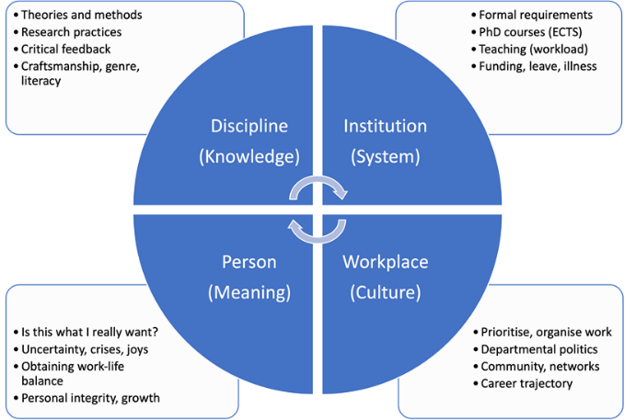

figure 1 Doctoral Learning Ecology Model. Copyright Elliot, Bengtsen, Guccione & Kobayashi (2020). Reproduced with permission of the authors.
- Doctoral Pedagogy
Over the last two decades, educationalists have explored ways of facilitating doctoral learning. For example, supervisors may employ active listening techniques, which involve attending to the words and behaviour of the student, seeking clarification and adopting a non-judgemental attitude (Bengtsen, 2016; Godskesen & Wichmann-Hansen, 2013). Psychologist and educationalist, Carl Rogers, outlined the benefit of active listening for both learning and wellbeing (Rogers, 1980, pp. 116, 155). Even when disciplinary knowledge is discussed, an individual may feel valued, or ‘prized’ by being heard (Bengtsen, 2016, pp. 115-121; Rogers, 1980, pp. 151, 271-272).
Doctoral researchers can also develop ‘academic literacies’. This involves examining what counts as knowledge, the identity and position of the researcher. It may also address uncomfortable ‘truths’, namely the power relations involved in research activity, or the reason for different approaches in different fields (Bastalich et al., 2014; Magyar & Robinson-Pant, 2011).
There is also a value of modelling academic behaviours and thought processes explicitly through ‘cognitive apprenticeship’. This approach makes tacit knowledge explicit, and helps doctoral researchers manage this quantitatively and qualitatively (Austin, 2009; Collins & Kapur, 2006; Posselt, 2018). Affective and cognitive experiences can be channelled through reflective writing to enhance doctoral researchers’ annual progress reviews (Brew & Peseta, 2004; Cahusac de Caux et al. 2017; Manathunga et al., 2010), whilst at the same time supporting supervisors.
Each of these aspects of doctoral learning stress student support and development and are essentially person-centred. Researcher developers have advocated person-centred models for doctoral students (Elliott et al., 2020, pp. 45-59), but it appears that discourse in supervisor CPD in UK universities has yet to follow the same path.
- Methodology
  - Dataset
Between 2010 and 2012, in the Faculty of Arts and Humanities at the University of East Anglia, supervisors were briefed on key institutional policies and procedures, including monthly reporting mechanisms, annual progress reviews, probationary requirements and interruptions to study. From 2013, the Faculty created fictional scenarios to exemplify problems that can emerge during a doctorate (Eley & Jennings, 2005).
The dataset comprised 30 documents, produced by 5 different organisations: the Quality Assurance Agency for Higher Education (QAA), Research Councils UK (RCUK, now UK Research and Innovation), the University of East Anglia (UEA), the UK Council for Graduate Education (UKCGE), and Vitae. The form of each document varied, and included those in PDF, Microsoft Word and PowerPoint. All national policy documents considered in this study are in the public domain, accessible as current documents, or archived through the Web Archive. The training materials are not publicly available and were produced by the researcher as scripts for screencasts, worksheets and guidance documents. The research protocol was reviewed and approved in 2020 by the Faculty Research Ethics Sub-Committee.
As this study is concerned with the analysis of language, each document format required conversion to raw text and was imported into qualitative data analysis software (NVivo). Due to the relatively small number of documents, conversion errors (such as character encoding, leading or trailing white space, or split words) were amended manually.

  - Word Frequency Analysis
Word frequency analysis was performed in NVivo for the 1,000 most frequent words in the source texts. This performed a count of each word and generated a weighted percentage based on all words in each document. Stop words were applied by default, with some manually added that were common but not necessarily meaningful in this context, such as ‘education’ or ‘research’.
The second stage involved thematic coding of words with a count of >=100 (0.18%-3.63% weighted values). Words with a count of <100 were also coded and, where appropriate, merged (as in the case of synonyms) or created as sub-codes. The code book was revised fourteen times and reviewed by another colleague, who categorised these independently to form higher-level themes.

  - Critical Discourse Analysis
The purpose of CDA is the identification of rhetorical features in texts to demonstrate 1) how social issues are constructed/reflected; 2) how institutional power relations are negotiated and performed; and 3) how certain ideologies are produced and reinforced. Paltridge and Hyland’s (2012, p. 186-203) CDA framework is a systematic search for features that signal the genre of a text, namely the framing of a particular domain and relevance for a particular audience. It explores the connotations of key words and phrases to establish related topics and higher-level themes.
CDA highlights how certain topics are addressed more frequently and prominently (foregrounding), and others less so (backgrounding). It considers the ways in which these topics are introduced across each genre, and how individuals who act or are subject to action (agents and patients) are addressed and discussed. CDA is also concerned with linguistic elements, such as modal verbs, that convey not simply action but intention, such as ‘should’ or ‘must’. Certain words can be indicators of formality and certainty, such as ‘obligation’ or ‘possibility’. Phrases that signify increased specificity or definition such as roles, groups or categories.
The following section introduces the findings from the dataset for each rhetorical feature: genre, connotation, foregrounding, backgrounding, topicalization, agent-patient relations, levels of formality, degrees of certainty, levels of technicality. The final part of this chapter provides a discussion of these findings in relation to the four research aims outlined in the introduction.
- Findings
  - Genre
Genres of texts are crucial to CDA and can be determined by both domain and audience. Document domain can be either explicit, such as the word ‘policy’ in the title of the document, or implicit, conveyed elsewhere in the body of the document. The documents in this study fall into two domains: policy and practice. The context of use also allows these domains to be sub-divided into national and institutional levels. An example of the types of documents assembled for this study have been mapped to the matrix below, with the number of documents in parentheses.

table 1 Documents mapped to genre sub-domains, and examples of readers.
 | National | Institutional
Policy | Quality assurance (6) | Research Degree Policies (13)
 | Managers  Directors | Supervisors  Managers  Directors  Students
Practice | Supervisor CPD (2)  Supervisors  Managers  Directors | Code of Practice (1)  Supervisors  Students  Supervisor CPD (8)  Supervisors

Documents are produced by national regulatory bodies and the university, but they are designed for different readers, shown here in italics. Institutional supervisor CPD, for example, is very specifically aimed at academic staff within that institution, but supervisor CPD at a national level may be read by supervisors, managers or directors of departments or Graduate Schools or Colleges. Whereas some readers may move between sub-domains, postgraduate researchers - who are not employees of the university in the UK - may be more concerned with certain sub-domains and not others.

  - Connotation
The possible meanings of words are interpreted based on context, and coded accordingly. For example, ‘experience’ may be discussed in relation to level of academic development rather than as a broader existential category. The table below lists the higher-level codes created in NVivo. These have been separated into key themes and rhetorical features from CDA.

table 2 Themes and rhetorical features of the CDA framework
Code | CDA Features
Activities  Collaborative  Course  Epistemological  Experiential  Interpersonal  Labour  Metrics  Obstacles  Ontological  Processual  Psychological  Relational  Subjectivity | Agent-patient relations  Degrees of certainty  Levels of formality  Levels of technicality

The coding distribution across the 30 texts varies. ‘Activities’ covers all 30 documents, as do references to ‘degree courses’ (30), followed by ‘labour’ (28) and more abstract themes, namely ‘ontological’ (28), ‘processual’, ‘relational’ (27), ‘collaborative’, ‘epistemological’, ‘experiential’ (26). The codes that cover fewer texts (=<25) comprise ‘pedagogical’ (25), ‘metrics’ (22), ‘interpersonal’ (21), ‘obstacles’ (20), ‘subjectivity’ (16) and ‘psychology’ (14).

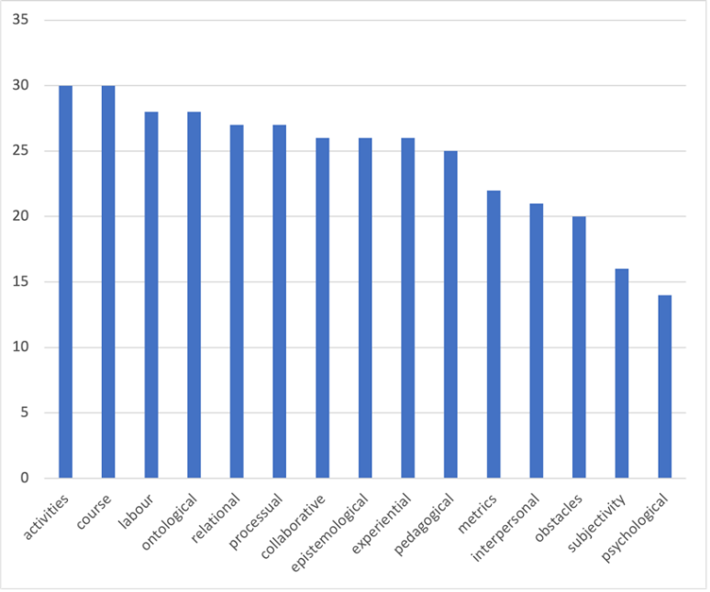

figure 2 Number of documents per theme in the dataset.
Word frequency analysis is the method used to determine whether or not certain themes are foregrounded or backgrounded. The reordering of the themes by total number of references reveal a split between those above 500 and those below 400.

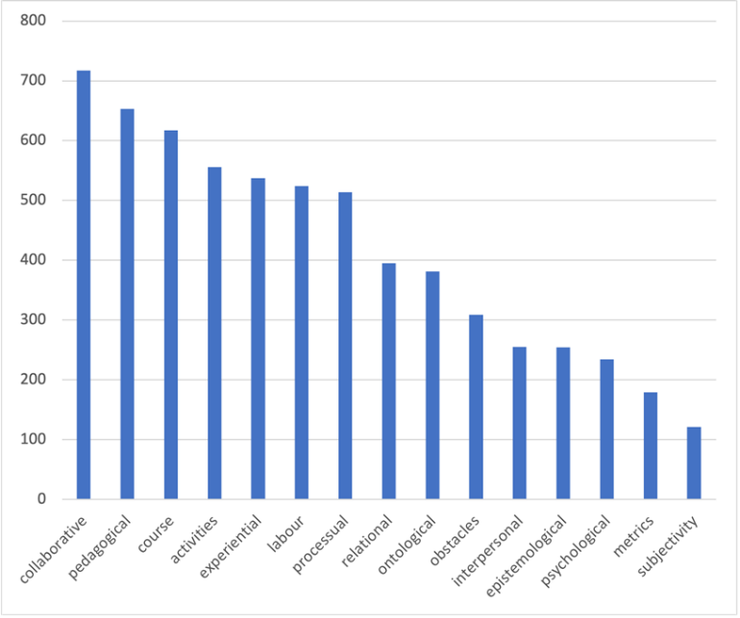

figure 3 Number of references per theme in the dataset.
  - Foregrounding
The most frequent codes (>500) are categorised as foregrounded themes. The most frequent are ‘collaborative’ (717), ‘pedagogical’ (653), ‘course’ (617), ‘activities’ (556), ‘experiential’ (537), ‘labour’ (524), and ‘processual’ (514). Although each of these themes encompasses a variety of sub-codes, they all appear to focus on the educational system.

  - Backgrounding
The themes that appear less frequently in the dataset (<400) are ‘relational’ (395), ‘ontological’ (381), ‘obstacles’ (309), ‘interpersonal’ (255), ‘epistemological’ (254), ‘psychological’ (234), ‘metrics’ (179), and ‘subjectivity’ (121). Unlike the foregrounded themes, these are primarily existential, concerned more with lived experience. There are two significant features of the backgrounded themes. The first is that of all of the ‘relational’ sub-codes that connote communication, the most significant omission is ‘listening’. Secondly, under the theme ‘obstacles’ the sub-code ‘problem’ is mentioned only 36 times, with the more generic term ‘issues’ appearing much more frequently (116), followed by ‘concerns’ (38), ‘difficulty’ (30), ‘stress’ (28) and ‘conflict’ (23). This is much lower relative to other themes than anticipated.
  - Topicalization
The thematic overview above provides a picture of word frequency across the dataset. It does not, however, demonstrate how topics are addressed in different genres. This section demonstrates the percentage of references for foregrounded themes according the genre matrix above: national policy, institutional policy, national practice and institutional practice.

table 3 Foregrounded themes coverage in genre sub-domains.
 | National policy | National practice | Institutional Policy | Institutional Practice
Collaborative | 7.3% | 9.3% | 3.3% | 1.76%
Pedagogical | 6.03% | 3.18% | 2.61% | 3.65%
Course | 1.52% | 3.9% | 4.09% | 2.88%
Activities | 3.13% | 4.38% | 3.4% | 0.78%
Experiential | 3.53% | 3.13% | 1.18% | 1.71%
Labour | 2.51% | 2.82% | 0.98% | 0.59%
Processual | 3.56% | 2.23% | 0.63% | 0.88%

The table above reveals a number of significant points. Firstly, ‘collaborative’ sub-codes that address how individuals work together are more prominent at a national level than within institutional documents. ‘Pedagogical’ sub-codes also feature more prominently at national policy level than in other sub-domains. There is also a marked distinction between national and institutional levels for three themes: ‘experiential’, ‘labour’ and ‘processual’. This suggests that national policy and practice texts address the educational system to a greater degree than institutional texts.

  - Agent-patient relations
The subjects of the policy and practice texts are namely those who act (agents) and receive, respond or are subject to actions (patients). Both feature prominently in the texts across the genres, averaging 23.95% of all references coded. The terms which feature most prominently are ‘students’ (757), ‘institutions’ (479), and ‘supervisors’ (451). Related terms include ‘postgraduate researchers’ (309) and ‘candidates’ (267), which have been disaggregated from ‘student’ as they hold different connotations, which are treated in the discussion below. The following table summarises the percentage coverage of these references across the four genres.

table 4 Coverage of agents/patients across the genre sub-domains.
 | National policy | National practice | Institutional Policy | Institutional Practice
Student | 17.2% | 7.4% | 4.61% | 11.64%
Institution | 0.84% | 0.91% | 2.42% | 0.75%
Supervisor | 3.73% | 13.15% | 1.99% | 5.53%
Postgraduate researchers | 2.78% | 0.43% | 0% | 0%
Candidate | 0.53% | 8.61% | 5.21% | 1.39%

The coincidence of each of these entities can also be revealed through matrix coding, with ‘student’/’candidate’/’postgraduate researcher’ forming one axis, and ‘institution’/’supervisor’ the other. The following table shows the number of intersecting references between each entity.

table 5 Matrix query of references for doctoral researchers, supervisors and the institution.
 | Supervisor | Institution
Student | 108 | 34
Candidate | 27 | 9
Postgraduate researchers | 41 | 33

The highest co-occurrence is between the terms ‘student’ and ‘supervisor’, which is of particular importance for this study for the supervisor CPD. Excerpts from the dataset suggest that students and supervisors are presented in five ways:

Contact | …contact between research student and supervisor varies depending on… (ed_21)
Relationship | If a research student-supervisor relationship is not working well… (ed_01)
Agreement | Supervisors and research students agree between… (ed_21)
Responsibility | Research students and supervisors are jointly responsible… (ed_21)
Awareness and communication | …for ensuring that students and supervisors are aware of… (ed_06)

When these figures are mapped to the genre matrix, the highest coincidence of doctoral researcher and supervisor is within national policy (94), followed by institutional practice (8), national practice (3), and institutional policy (3). The term ‘candidate’ does not co-occur with ‘supervisor’ at all within national policy texts, but does appear in national practice documents (14), followed by institutional practice (12) and only rarely in institutional policy (1). Significantly, ‘postgraduate researcher’ and ‘supervisor’ co-occurrences are completely absent in institutional policy and practice documents, and for national practice, but they feature more prominently in national policy (41).

  - Levels of formality
Formal language averages 9.85% across the four genres of the dataset. The most frequent are terms related to ‘regulation’ (992), ‘health’ (298), ‘permission’ (192), ‘appropriateness’ (171), and ‘obligation’ (128).

table 6 Levels of formality coverage in genre sub-domains.
 | National policy | National practice | Institutional Policy | Institutional Practice
Regulation | 3.38% | 2.82% | 3.11% | 2.88%
Health | 2.49% | 1.33% | 0.2% | 0.2%
Permission | 1.69% | 0.8% | 2.56% | 1.31%
Appropriateness | 1.02% | 0.32% | 0.72% | 0.18%
Obligation | 0.15% | 0% | 0.18% | 0.25%

How each of these formal themes apply to the different agents in the dataset is summarised below.

table 7 Matrix query of levels of formality and agent/patient.
 | Candidate | Institution | Postgraduate researchers | Student | Supervisor
Appropriateness | 7 | 0 | 2 | 30 | 15
health | 0 | 28 | 90 | 32 | 25
obligation | 6 | 3 | 0 | 12 | 4
permission | 10 | 7 | 2 | 36 | 29
regulation | 45 | 12 | 9 | 112 | 29

The highest coincidences of themes for each agent are ‘regulation’/’student’ (112), ‘health’/’postgraduate researchers’ (90), ‘regulation’/’candidate’ (45), ‘permission’/’student’ (36), ‘health’/’student’ (32), and ‘appropriateness’/’student’ (30).
Regulatory language covers a range of phenomena relating to ‘student’ or ‘candidate’, including ‘appeal’, ‘complaints’, ‘examination’, ‘probation’, ‘progress’, ‘registration’, ‘review’, ‘rules’, ‘submission’, ‘supervision’ and ‘suspension’.
Most references within the ‘health’/’postgraduate researchers’ or ‘student’ categories mention mental health and wellbeing, and are limited to 5 out of the 30 documents in the dataset.
Permissive language relates to situations in which doctoral researchers can exercise choice or initiate a process:
Students may choose to register for… (ed_21)
Full-time students may undertake paid employment… (td_01)
Language addressing ‘appropriateness’ involving doctoral researchers casts the latter in the role of patient (receiving or subject to action), with the agent being the higher education provider, supervisors or particular processes:
‘Providers ensure that each student has an appropriately skilled and knowledgeable supervisory team…’ (ed_01)
‘Research students have appropriate opportunities for developing research, personal and professional skill…’ (ed_21)

  - Degrees of certainty
The language of policy and practice not only exhibits formality, but necessarily addresses uncertainty, which has a role in decision making. The average coverage of this theme is 2.36% across the dataset. This is sub-coded into three categories: ‘possibility’ (255), ‘unlikelihood’ (11) and ‘impossibility’ (6). Taking ‘possibility’ as the foregrounded sub-code, the highest coverage can be found in institutional policy (2.97%), closely followed by national practice (2.56%) and national policy (2.31%), with institutional practice least frequent (1.1%). Language of possibility occurs across the dataset (22 documents). It concerns four phenomena:
External influence | …of circumstances or concerns that may affect their work… (ed_01)
Sanctions | The student may be required to intercalate/withdraw… (td_02)
Awareness | Candidates may be unfamiliar with oral examinations… (ed_04)
Solutions | …to enhance their practice, which may include workshops and programmes… (ed_03)

  - Levels of technicality
Related to the formal language of the documents in the dataset, are terms that describe and define entities and processes within the higher education context. Although this averages 4.32% across the dataset, the level of precision is most pronounced in national practice (6.76%) and policy (6.57%), with institutional policy (2.77%) and practice (1.18%) respectively. A matrix query between the sub-codes of levels of technicality and the agents in the documents reveals several patterns.

table 8 Matrix query of levels of levels of technicality and agent/patient.
 | Candidate | Institution | Postgraduate researchers | Student | Supervisor
ensuring | 10 | 6 | 1 | 24 | 14
inclusion | 9 | 6 | 14 | 60 | 31
information | 2 | 1 | 1 | 21 | 1
need | 3 | 2 | 10 | 25 | 17
quality | 1 | 0 | 0 | 7 | 2
relevance | 0 | 1 | 1 | 12 | 5
role | 4 | 2 | 7 | 6 | 29
skills | 1 | 1 | 0 | 6 | 4
specificity | 2 | 4 | 10 | 10 | 7
The first is that language relating to responsibility (‘ensuring’) is weighted towards the doctoral researcher and supervisor:
…the supervisors and other relevant staff members ensure that research students receive sufficient support… (ed_01)
To ensure consistency of supervision, supervisors working in industry or professional practice are made aware of and enabled to… (ed_21)
The same is true of terms of ‘inclusion’ or ‘within’, namely, when entities are grouped together and subject to particular processes:
Effective induction programme, including for international students (ed_05)
Information requirements are connected to students, and needs relate mostly to postgraduate researchers, students and supervisors. Significantly, language related to defined roles occurs more frequently for supervisors:
How and where are the roles and responsibilities of research students and supervisors made clear and accessible? (ed_01)
…set of roles involved in modern research supervisors. (ed_03)
Supervisors also tend to mediate the institution’s responsibilities, rather than hold them in full, notably if the term ‘provider’ is included in this matrix query.
- Discussion
  - Constructions Of The Doctoral Process and Researcher
The language of national and institutional policy documents and reports construct the doctoral process and doctoral candidate in ways that foreground the educational system and background themes that are existential. National policy and practice texts are concerned with the workplace context, working conditions, career trajectory, and processes of the doctorate itself. The genre matrix shows that doctoral researchers and supervisors are typically presented in the third person, rather than being addressed directly in the second person or providing insights in the first person. This suggests a discourse of agents and patients as entities interacting within a system, rather than communicative subjects.
There are also three distinct terms in operation: ‘candidate’, ‘student’ and ‘postgraduate researcher’. Whereas ‘student’ and to a lesser degree, ‘candidate’ are more prominent across all policy and practice texts, the designation ‘postgraduate researcher’ is used comparatively rarely, and is omitted completely at institutional level. This may be intended to reinforce a distinction between staff and students as two different entities.
Although regulatory language is common across the dataset, it is significant that ‘obligations’ are less prominent than might be expected given the concerns surrounding managerialism. Language concerning ‘permission’ features more frequently, which suggests that both supervisors and students can exercise choice, but subject to protocol.
The discussion of ‘health’ - primarily in the form of mental health - is less frequent within institutional documentation. Overall, most documents in the dataset address uncertainty to some extent. They focus on external influences on the doctoral project or researcher, sanctions applied to the individual, speculation on the level of awareness that the researcher might possess, and solutions to address their perceived deficit. Each of these cases can be seen as problem-oriented.
  - Doctoral Constructs In Continuing Professional Development
How these doctoral constructs operate within the context of supervisor CPD demonstrates that pedagogy in national practice and institutional practice are closely aligned in terms of coverage, although both at a lower level than national policy. Across the dataset, however, the interaction of doctoral researchers and supervisors is generally functional, comprising contact, relationship, agreement, responsibility, awareness and communication. Significantly, this is characterised by transmission rather than dialogue. When considering the degree of specificity in discussing the different agents/patients within the university, there is more attention surrounding role definition for supervisors than for doctoral researchers. Supervisors also tend to mediate the institution’s responsibilities rather than hold them outright.
  - Pedagogical Affordances And Constraints
Although the texts in this dataset belong to different genres, perhaps the most significant indicator from CDA concerns those themes that are foregrounded at the expense of others. This may help academic development teams to understand why CPD is designed in certain ways.
The last decade of national and institutional policy and practice documentation remains focused on systemic issues and procedures, and these have also clearly influenced the scenario-based activities used in workshops with supervisors at the University of East Anglia. Although these concern people, they do so within a framework that foregrounds and exemplifies particular procedures, such as failing to prepare probationary documentation, addressing problems of student progress in the event of serious illness, social isolation, frustrated access to resources, and a lack of academic support and guidance.
These scenarios develop supervisors’ attention to the ‘facts’ of a reported case to encourage experiential learning. However, they do not reflect accurately the underlying themes highlighted by this study. For example, ‘obstacles’ across the dataset are less prominent in the policy and practice texts than might be assumed.
  - A Person-Centred Discourse
The language of policy and practice changes the perception of what is important in doctoral education. By removing the CDA coding of rhetoric and focusing on the remaining themes, the findings of this study can be mapped to the DLEM quadrants proportionally based on their coding frequency.

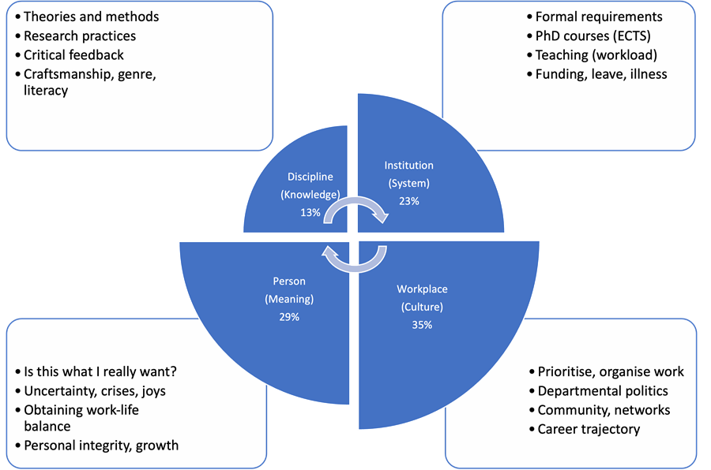

figure 4 Modified Doctoral Learning Ecology Model.
The modified DLEM shows that focus on the person is much more prominent (29% of all coded references). The largest remains the workplace (35%) - the educational environment - with disciplinary themes afforded least attention (13%). The implications of this analysis are twofold. Firstly, although the two domains most closely associated with managerialism (institution, workplace) account for over half of doctoral education discourse within the dataset, they do not preclude references to the person. Secondly, the disciplinary domain is discussed least frequently, which suggests that there is scope for supervisors to develop this area because of their role in the intellectual development of doctoral researchers.

  - Implications for Supervisor CPD
In the final part of this discussion, I consider some of the implications of placing the person at the centre of doctoral supervisor development discourse. Rather than focus on briefing supervisors on policy and procedures, and delivering workshop scenarios that are essentially problem-oriented, supervisor CPD can draw on five pedagogical practices to facilitate both alignment and deeper engagement with the disciplinary, workplace and institutional domains of the DLEM.

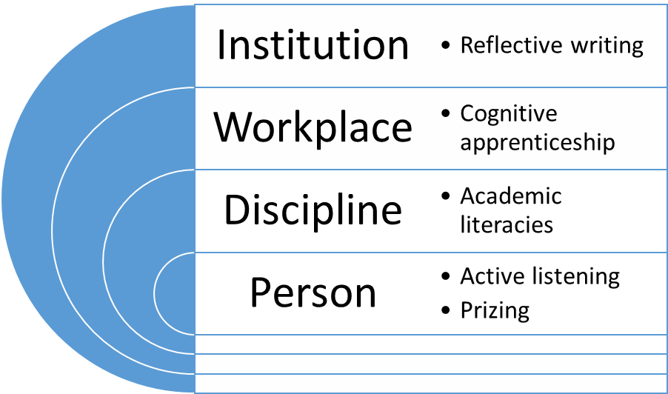

figure 5 Person-centred CPD model.
A person-centred approach begins with active listening to address the communicative oversight in policy and practice documentation. It better reflects the dialogic approach to learning observed in supervisory practice. Furthermore, as the entropic model of doctoral researchers and the doctorate appears to be rhetorical rather than factual, supervisors could benefit from adopting a ‘prizing’ attitude, viewing students’ experiences as formative and contributing to their identity rather than as problems to be solved.
In order to facilitate a disciplinary dialogue, supervisors can introduce the concept of academic literacies to explore the ways that knowledge is enacted in the academy, and cultural practices operate in disciplines. They can also support doctoral researchers by slowing down the thinking process and making behaviours and tasks within the academic workplace much more explicit through the process of ‘cognitive apprenticeship’.
Finally, both supervisor and doctoral researcher can use reflective writing in their interactions to better understand their place within the institution. Encouraging the latter to write in this way provides a clearer professional trajectory for both parties, and may serve as a first step towards greater reflexivity, a concept discussed in greater detail by Dowle in chapter 13.
- Conclusion
Placing the person at the core of supervisor development introduces a syntropic discourse, which highlights growth, complexity and fulfilment rather than one that is characterised by functional and transmissive interactions. The national and institutional documentation used by supervisors in their professional development employ a rhetoric that can appear managerial, but in fact incorporates important issues of personhood. Academic developers in the UK may benefit from reading between the lines of discourse to strengthen this theme in CPD. In doing so, doctoral supervisors and researchers become valued and empowered individuals within the doctoral ecosystem rather than simply subject to it.

References
Austin, A. E. (2009). Cognitive Apprenticeship Theory and Its Implications for Doctoral Education: A Case Example from a Doctoral Program in Higher and Adult Education. International Journal for Academic Development 14, 173-183.​
Barnett, R. (2011). Being a University. Abingdon, Routledge.
Barnett, R. (2016). Understanding the University: Institution, idea, possibilities. Abingdon, Routledge.
Bastalich, W., Behrend, M. & Bloomfield, R. (2014). Is non-subject based research training a ‘waste of time’, good only for the development of professional skills? An academic literacies perspective. Teaching in Higher Education, 19(4), 373-384.
Bengtsen, S.E. (2016). Doctoral Supervision: Organization and Dialogue. Aarhus, Aarhus Universitetsforlag.​
Brew, A. & Peseta, T. (2004). Changing postgraduate supervision practice: a programme to encourage learning though reflection and feedback. Innovations In Education & Teaching International 41(1), 5-22.
Cahusac de Caux, B. K. C. D., Lam, C. K. C., Lau, R., Hoang, C. H., & Pretorius, L. (2017). Reflection for learning in doctoral training: Writing groups, academic writing proficiency and reflective practice. Reflective Practice, 18(4), 463–473.
Collins, A., & Kapur, M. (2014). Cognitive Apprenticeship. In R. K. Sawyer (Ed.), The Cambridge Handbook of the Learning Sciences (2nd ed., pp. 109–127). Cambridge University Press.
Deem, R., Hillyard, S. & Reed, M. (2007). Knowledge, higher education, and the new managerialism. the changing management of UK universities. Oxford, Oxford University Press.
Eley, A. R. & Jennings, R. (2005). Effective Postgraduate Supervision: Improving the Student-Supervisor Relationship. Maidenhead, Open University Press.​
Elliot, D. L., Bengtsen, S. S., Guccione, K., & Kobayashi, S. (2020). The Hidden Curriculum in Doctoral Education. Palgrave Pivot.
Godskesen, M. & Wichmann-Hansen, G. (2013). Aktiv lytning i ph.d.-vejledning - et værktøj til udvikling af dialogiske kompetencer. Dansk Universitetspædagogisk Tidsskrift 8(15), 145-157.
Hill, G. & Vaughan, S. (2018). Conversations about research supervision – Enabling and accrediting a community of practice model for research degree supervisor development. Innovations in Education and Teaching International 55(2), 153-163.
Kelly, F. (2017). The Idea of the PhD: The Doctorate in the Twenty-First Century Imagination. London, Routledge.
Kumar, V. & Stracke, E. (2017). Reframing doctoral examination as teaching. Innovations in Education and Teaching International: 1-9.​
Magyar, A. & Robinson-Pant, A. (2011). Special Issue on University Internationalisation--Towards Transformative Change in Higher Education. Internationalising Doctoral Research: Developing Theoretical Perspectives on Practice. Teachers and Teaching: Theory and Practice 17(6), 663-676.
Manathunga, C., Peseta, T. & McCormack, C. (2010). Supervisor development through creative approaches to writing. International Journal For Academic Development 15(1), 33-46.
Metcalfe, J., Wilson, S. & Levecque, K. (2018). Exploring wellbeing and mental health and associated support services for postgraduate researchers. Ghent University and the Institute for Employment Studies. Cambridge, Vitae (CRAC).​
Office for Students. (2020). Coronavirus Briefing Note (No. 6). https://www.officeforstudents.org.uk/media/989e5582-cb4b-442e-944b-9cc6c1327d92/coronavirus-briefing-note-postgraduate-research-students.pdf
Owler, K. (2010). A ‘Problem’ to Be Managed? Completing a PhD in the Arts and Humanities. Arts and Humanities In Higher Education 9(3), 289-304.
Paltridge, B. (2012). Discourse Analysis: An introduction (2nd ed.). London, Bloomsbury Publishing.
Posselt, J. (2018). Normalizing Struggle: Dimensions of Faculty Support for Doctoral Students and Implications for Persistence and Well-Being. The Journal of Higher Education, 1-26.
Rogers, C. (1980). A Way of Being. Boston, Houghton Mifflin Company.
Taylor, S. (2016). UK Professional Standards Framework (UKPSF) Dimensions of the Framework for Doctoral Supervisors. Higher Education Academy.​
Taylor, S., Kiley, M., & Humphrey, R. (2018). A Handbook for Doctoral Supervisors (2nd ed.). Routledge.
Taylor, S. & McCulloch, A. (2017). Mapping the landscape of awards for research supervision: A comparison of Australia and the UK. Innovations in Education and Teaching International, 1-14.​
Taylor, S., Kiley, M., & Holley, K. A. (Eds.). (2020). The Making of Doctoral Supervisors: International Case Studies of Practice (1st ed.). Routledge.

Structured self-reflection is key to the national recognition process for supervisors through the UKCGE: https://supervision.ukcge.ac.uk/
The text files (named ‘ed’/’td’) and code books can be found at: https://github.com/matthewsillence/educational_discourse

