Supplementary Information

Supplementary Table 1

Quality Assessment Checklist for Prevalence Meta-Analysis
1 | Was the study population and index trauma clearly specified and defined?
Descriptive statistics were reported on participant demographics (including age range and mean, gender, ethnicity) and frequency of trauma type/nature within the participant pool reported |  | 2
Some description statistics provided about the sample but some missing information (e.g. authors did not report frequency of trauma type/nature or provide enough information about demographic variables). |  | 1
No clear description of sample demographics or index trauma characteristics |  | 0
2 | Was the participation rate of eligible persons at least 50%?
More than 50% of eligible and approached participants took part |  | 2
Less than 50% of those approached took part, but there was no significant difference in non-response characteristics (such as age, gender) between those who participated and those who did not |  | 1
Less than 50% of those approached took part, and differences between those who took part and those who did not were not reported or highlighted significant differences. Or, response was not reported |  | 0
3 | Was follow up time for PTSD assessment appropriate and meaningful?
An appropriate time frame (>4 weeks) since trauma was reported |  | 2
No information given regarding time frame since trauma. Or, assessment <4 weeks since trauma |  | 0
4 | Were objective, standard criteria used for the assessment of Post-Traumatic Stress Disorder?
Diagnostic interview or self-report questionnaire shown to demonstrate good levels of validity and reliability in the assessment of PTSD adhering to DSM criteria for PTSD i.e. cluster-based algorithm |  | 2
Diagnostic interview or self-report questionnaire shown to demonstrate good levels of validity and reliability in the assessment of PTSD adhering to DSM criteria for PTSD using a cut-off score or grouping analysis such as LPA or LCA |  | 1
Diagnostic interview or self-report without utilising DSM criteria (e.g. not conforming to cluster-based algorithm or cut-off score or grouping analysis). Or poor validity and reliability. |  | 0
5 | Were objective, standard criteria used for the assessment of the Dissociative Subtype of Post-Traumatic Stress Disorder?
Diagnostic interview or self-report questionnaire shown to demonstrate good levels of validity and reliability, adhering to DSM-5 criteria for PTSD-DS i.e. based on depersonalisation and derealisation only |  | 2
Diagnostic interview or self-report questionnaire shown to demonstrate good levels of validity and reliability, however not adhering to DSM-5 criteria for PTSD-DS i.e. based on other domains of dissociation outside of just depersonalisation and derealisation |  | 1
Diagnostic interview or self-report questionnaire shown to demonstrate good levels of validity, however domains of dissociation assessed not reported. Or poor validity and reliability |  | 0
Note. Where 2 = well addressed, 1 = partially addressed, 0 = poorly addressed/not addressed/not reported

This tool was developed by Mr. William White for a meta-analysis undertaken in partial fulfilment of a Doctorate in Clinical Psychology. The development of this tool was based on the Assessment Tool for Observational Cohort and Cross-Sectional Studies (National Heart Lung and Blood Institute, 2014), combining with modified questions from other prevalence and risk factor studies that would be appropriate for use in this review (Hoy et al., 2012; Munn et al., 2014).

Supplementary Table 2

Sample risk-of-bias scores by individual item and total
Sample No. | Author | Item 1 | Item 2 | Item 3 | Item 4 | Item 5 | Total | Quality
1 | Abu-Rus et al. (2020) | 1 | 2 | 0 | 2 | 2 | 7 | High
2 | Acar et al. (2019) | 1 | 0 | 0 | 2 | 1 | 4 | Low
3 | Armour, Elklit et al. (2014) | 2 | 2 | 2 | 1 | 1 | 8 | High
4 | Armour, Karstoft et al. (2014) | 2 | 0 | 0 | 1 | 1 | 4 | Low
5 | Blevins et al. (2014) | 2 | 0 | 0 | 1 | 2 | 5 | Medium
6 | Boysan et al. (2017) | 2 | 0 | 2 | 2 | 2 | 8 | High
7 | Briere et al. (2005) | 1 | 2 | 0 | 2 | 1 | 6 | Medium
8 | Burton et al. (2018) | 2 | 0 | 0 | 1 | 2 | 5 | Medium
9 | Caroppo et al. (2021) | 2 | 0 | 0 | 2 | 0 | 4 | Low
10 | Choi et al. (2019) | 2 | 2 | 0 | 2 | 2 | 8 | High
11 | Choi et al. (2017) | 2 | 2 | 0 | 1 | 2 | 7 | High
12 | Cloitre et al. (2012) | 2 | 0 | 2 | 0 | 1 | 5 | Medium
13 | Criswell et al. (2018) | 2 | 0 | 2 | 2 | 2 | 8 | High
14 | Daniels et al. (2016) | 1 | 0 | 0 | 1 | 2 | 4 | Low
15 | Dorahy et al. (2017) | 1 | 1 | 0 | 0 | 1 | 3 | Low
16 | Durham et al. (2020) | 2 | 2 | 0 | 1 | 2 | 7 | High
17 | Eidhof et al. (2019) | 2 | 0 | 0 | 2 | 2 | 6 | Medium
18 | Frewen et al. (2015) | 1 | 2 | 0 | 1 | 2 | 6 | Medium
19 | Frewen et al. (2019) | 1 | 0 | 0 | 2 | 2 | 5 | Medium
20 | Guetta et al. (2019) | 1 | 2 | 0 | 1 | 2 | 6 | Medium
21 | Hansen, Hyland et al. (2016) | 1 | 2 | 2 | 1 | 2 | 8 | High
22 | Hansen et al. (2019) | 2 | 1 | 2 | 2 | 2 | 9 | High
23 | Hansen et al. (2019) | 2 | 1 | 2 | 1 | 2 | 8 | High
24 | Hansen, Müllerová et al. (2016) | 2 | 2 | 0 | 1 | 2 | 7 | High
25 | Hansen, Müllerová et al. (2016) | 2 | 2 | 0 | 1 | 2 | 7 | High
26 | Harricharan et al. (2020) | 1 | 0 | 0 | 1 | 2 | 4 | Low
27 | Hill et al. (2020) | 1 | 0 | 0 | 1 | 2 | 4 | Low
28 | Kenny et al. (2020) | 2 | 2 | 0 | 2 | 2 | 8 | High
29 | Kenny et al. (2020) | 2 | 2 | 0 | 2 | 2 | 8 | High
30 | Kim et al. (2019) | 2 | 2 | 0 | 2 | 2 | 8 | High
31 | Lebois et al. (2021) | 1 | 2 | 0 | 2 | 2 | 7 | High
32 | Li et al. (2019) | 2 | 2 | 0 | 2 | 1 | 7 | High
33 | Mulder et al. (1998) | 2 | 2 | 0 | 2 | 1 | 7 | High
34 | Müllerová et al. (2016) | 2 | 2 | 0 | 1 | 1 | 6 | Medium
35 | Naish et al. (2021) | 2 | 0 | 2 | 2 | 2 | 8 | High
36 | Nejad et al. (2007) | 2 | 0 | 0 | 0 | 1 | 3 | Low
37 | Özdemir et al. (2015) | 2 | 0 | 0 | 2 | 1 | 5 | Medium
38 | Powers et al. (2017) | 1 | 2 | 2 | 2 | 2 | 9 | High
39 | Putnam et al. (1996) | 1 | 0 | 0 | 0 | 1 | 2 | Low
40 | Richard-Malenfant et al. (2019) | 1 | 0 | 0 | 2 | 2 | 5 | Medium
41 | Ross et al. (2020) | 2 | 2 | 0 | 2 | 2 | 8 | High
42 | Ross et al. (2018) | 2 | 0 | 0 | 1 | 1 | 4 | Low
43 | Sierk et al. (2021) | 2 | 2 | 2 | 2 | 1 | 9 | High
44 | Stein et al. (2013) | 1 | 0 | 2 | 2 | 2 | 7 | High
45 | Steuwe et al. (2012) | 1 | 0 | 0 | 2 | 2 | 5 | Medium
46 | Swart et al. (2020) | 2 | 2 | 0 | 2 | 2 | 8 | High
47 | Tsai et al. (2015) | 2 | 0 | 0 | 2 | 2 | 6 | Medium
48 | van der Kolk et al. (1996) | 1 | 0 | 0 | 2 | 0 | 3 | Low
49 | Verbeck et al. (2015) | 2 | 0 | 0 | 2 | 1 | 5 | Medium
50 | Wolf, Lunney et al. (2012) | 1 | 0 | 0 | 1 | 1 | 3 | Low
51 | Wolf, Lunney et al. (2012) | 1 | 0 | 2 | 1 | 2 | 6 | Medium
52 | Wolf, Miller et al. (2012) | 2 | 2 | 0 | 1 | 1 | 6 | Medium
53 | Zoet et al. (2018) | 2 | 2 | 0 | 1 | 2 | 7 | High
Note. 0-4 high risk/low quality, 5-6 moderate risk/quality, 7-10 low risk/high quality

Supplementary Figure 1
Proportion of samples rated as a low, moderate or high risk-of-bias for each quality assessment item
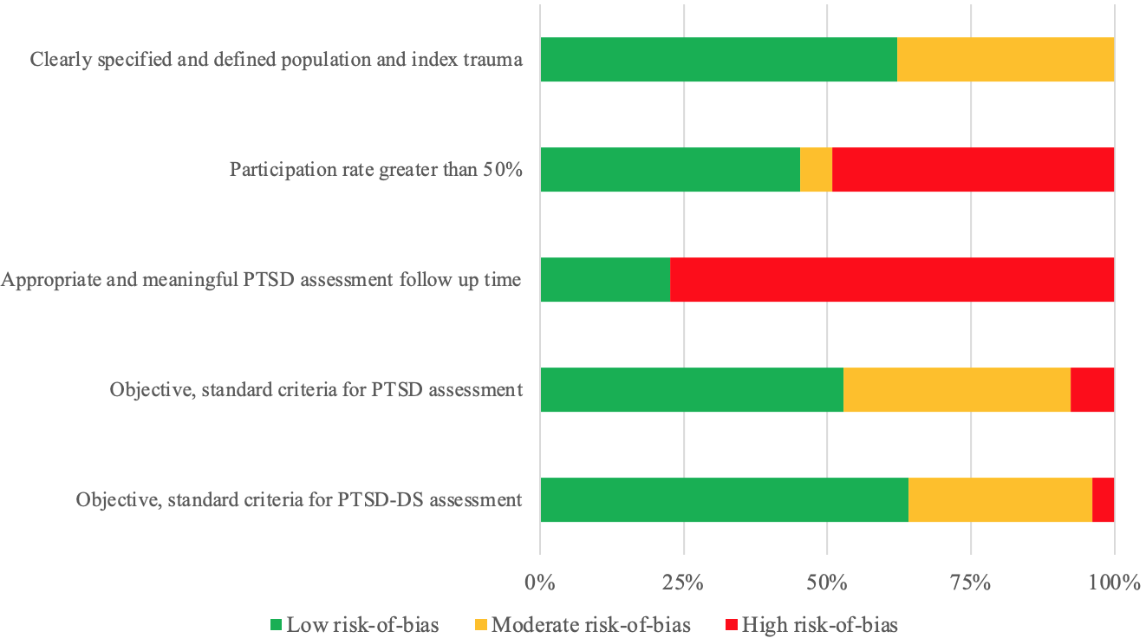

Supplementary Table 3

Pooled prevalence of PTSD-DS as a proportion of PTSD for diagnostic/clinical cut-off samples utilising DSM-5 criteria for dissociation (i.e., excluding LCA and LPA samples and those using broader criteria for dissociation; k = 23)
Meta-analysis subgroup | k | n | Pooled Prevalence (%) | 95% CI | Q test | I²
PTSD DSM criteria used‡ (β = -0.2041 [95% CI = -0.4406, 0.0324], p = 0.09)
DSM-5 | 16 | 1180 | 48.2 | (34.2, 62.3) | 285.9* | 95.5
DSM-III or DSM-IV | 6 | 1926 | 28.3 | (17.6, 40.3) | 289.7* | 96.1
Dissociation measure completion (β = 0.1271 [95% CI = -0.0882, 0.3423], p = 0.25)
Self-report | 10 | 1435 | 49.4 | (32.0, 66.9) | 174.5* | 97.1
Interview | 13 | 1804 | 36.4 | (24.3, 49.4) | 244.3* | 96.3
Age group‡ (β = 0.3444 [95% CI = 0.0410, 0.6477], p = 0.03)
Child | 4 | 949 | 62.9 | (50.2, 74.7) | 11.4** | 82.0
Adult | 16 | 1867 | 36.7 | (24.7, 49.6) | 376.3* | 96.4
Note. k = number of samples; n = number of participants; CI = confidence interval
* p < 0.0001, where the degrees of freedom (df) = k – 1
** p < 0.01, where the degrees of freedom (df) = k – 1
† Sample 26 removed as used both DSM-IV and DSM-5 when assessing for PTSD
‡ Several samples were removed due to populations formed of both children and adults, or age group not reported

Supplementary Table 4

Pooled prevalence of PTSD-DS as a proportion of PTSD for all LCA/LPA samples (i.e., excluding diagnostic and clinical cut-off samples; k = 17)
Meta-analysis subgroup | k | n | Pooled Prevalence (%) | 95% CI | Q test | I²
PTSD DSM criteria used (β = -0.0872 [95% CI = -0.3022, 0.1278], p = 0.43)
DSM-5 | 8 | 1750 | 25.0 | (10.9, 42.7) | 328.5* | 98.6
DSM-III or DSM-IV | 9 | 2850 | 18.2 | (10.1, 28.1) | 196.8* | 97.4
Dissociation criteria (β = -0.0648 [95% CI = -0.2912, 0.1616], p = 0.57)
DSM-5 (Dereal / Depers) | 11 | 3503 | 23.1 | (11.3, 37.5) | 311.3* | 98.8
Broader dissociation | 6 | 1634 | 18.0 | (10.7, 26.7) | 83.7* | 94.6
Dissociation measure completion (β = 0.0940 [95% CI = -0.1589, 0.3468], p = 0.47)
Self-report | 13 | 3506 | 23.1 | (12.6, 35.6) | 429.9* | 98.6
Interview | 4 | 1094 | 15.9 | (12.7, 19.3) | 6.7 | 55.6
Occupation (β = -0.0532 [95% CI = -0.2918, 0.1853], p = 0.66)
Military | 5 | 1378 | 18.4 | (12.9, 24.6) | 32.0* | 87.6
Civilian | 12 | 3759 | 22.5 | (11.3, 36.1) | 429.7* | 98.8
Note. k = number of samples; n = number of participants; CI = confidence interval; Dereal = derealisation; Depers = depersonalisation
* p < 0.0001, where the degrees of freedom (df) = k – 1

Supplementary Figure 2

Funnel plot to assessing publication bias

