Figure captions

**Figure 1.** Mean scores for comprehension (top) and production (bottom) across 10 Arab countries with a sample of 24-month-olds (N = 33). Each dot represents a child.

**Figure 2.** Comprehension and production model fits to raw Egyptian data. Top panel is high and low SES for comprehension data, while bottom panel is high and low SES for production (understands and says) data, with boys and girls represented in blue and purple respectively. Points indicate actual means, lines indicate model fit.

**Figure 3.** 10th percentile quantiles for word comprehension (left) and word production (right) in the short Arabic CDI Words Only, based on Egyptian data. Black solid line indicates the 50th percentile.

**Figure 4.** Model fits to data from the non-Egyptian sample. Top panel indicates high and low SES for the comprehension data, bottom panel indicates high and low SES for the production data, with boys and girls represented in blue and purple respectively. Points indicate means, solid lines indicate fit from the models based on the Other Dialects data itself, dotted lines indicate fit from the model based on the Egyptian data, refit to this sample.

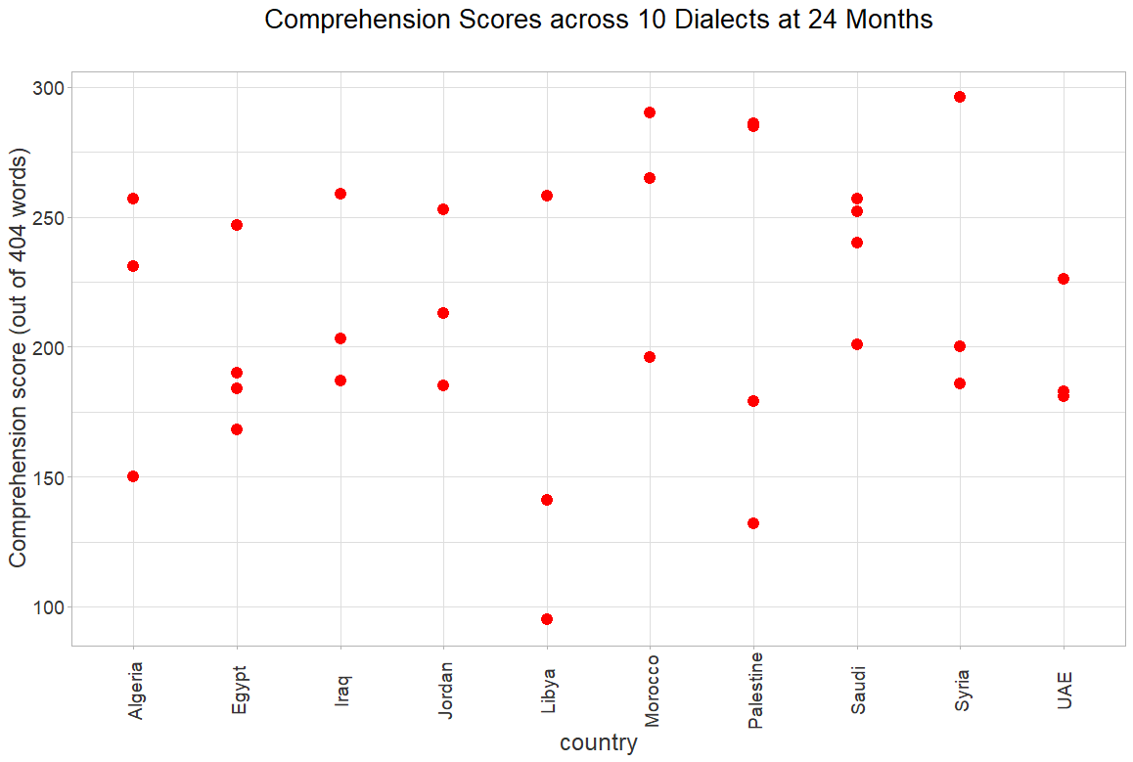

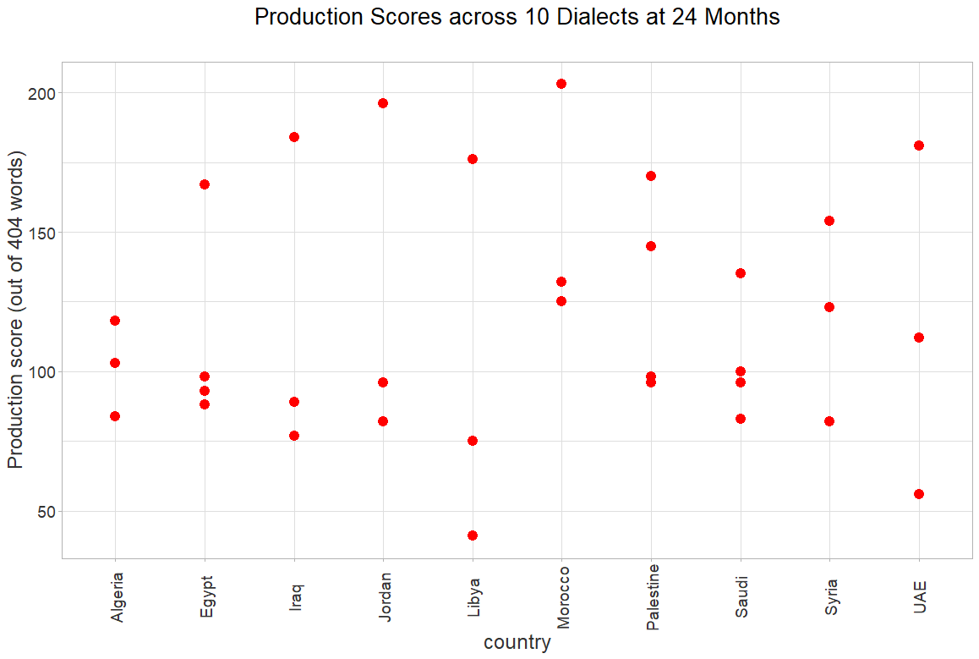

Figure 1

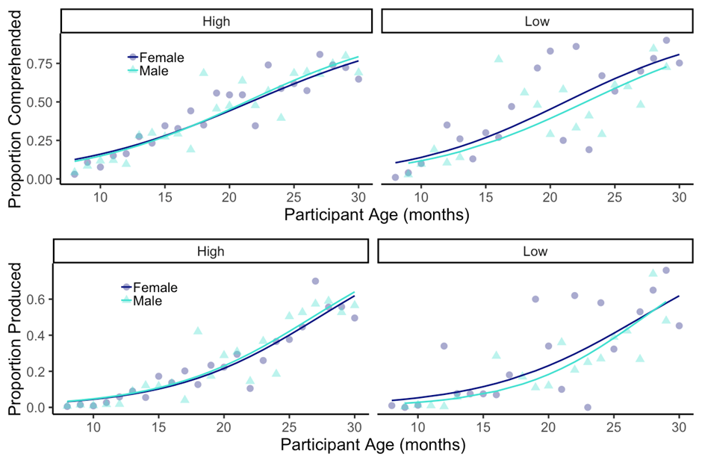

Figure 2



Figure 3

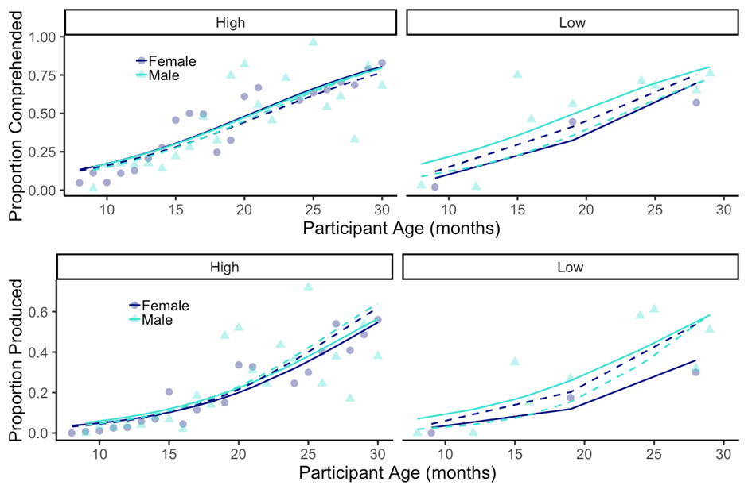

Figure 4