Appendix to the article “Breaking out of silos: explaining cross-departmental interactions in two European bureaucracies.”
Francesca Pia Vantaggiato, Hussein Kassim, Sara Connolly

The European Commission and the Council Secretariat as organizations
A brief description of the salient features of the Commission and the Council Secretariat provides a useful point of reference for the analysis. Although both form part of the EU administration (Stevens and Stevens 2001, Kassim 2014), they differ from each other in important respects. The Commission was entrusted under the founding treaties of what is now the European Union with responsibilities for proposing policy initiatives, managing EU policy, overseeing compliance by governments and private actors with EU rules, and negotiating trade agreements with third countries and in international organizations. The Commission is hybrid body, combining political and administrative functions. Whereas the Commission contributes actively to EU policy making and enforcement, the role of the Council Secretariat is to serve the European Council and the Council of the European Union. As well as differing in mission and structure, the two bodies differ in size. At the time of the surveys, the European Commission had 31,280 employees, while the Council Secretariat had 3,190.

The Commission is hybrid body, combining political and administrative functions. The former are carried out by a College of Commissioners, each with his or her private office or cabinet, and headed by the Commission President. The College is appointed formally by a dual mandate, comprising a majority vote of members of the European Parliament, who are directly elected by EU citizens, and of the European Council, which brings together the leaders of member governments. The latter are the responsibility of the Commission services – a permanent administration, which is organized into departments or Directorates General with policy (22), support (16), and external functions (4). There are around 40 in total. Directorates-General are further sub-divided, like ministries in a national government, into directorates and divisions. They are headed respectively by a Director General, Directors, and Head of Unit.

Whereas the Commission contributes actively to EU policy making and enforcement, the role of the Council Secretariat is to serve the European Council and the Council of the European Union. The European Council is the EU’s most senior body, composed of the heads of state and government of the member states. Although it has no formal law-making function, the European Council is the EU’s supreme decision-making institution, takes decisions concerning the strategic direction and course of the EU, and issues guidelines that may lead to legislation. It meets several times a year. The Council of the European Union, by contrast, is the EU’s main legislative body (with the European Parliament). It meets more or less continuously. The Council brings together delegates from the EU member states at three levels: working parties, where national experts from the capital or the permanent mission that all member governments have in Brussels, meet for initial discussions of the Commission’s legislative proposals; the Committee of Permanent Representatives, where the ambassadors and deputy ambassadors who head member state missions in Brussels meet weekly to filter positions arrived at by the working parties; and ministerial meetings, which convene periodically by policy area to consider outstanding political points, before deciding whether to approve, amend or reject a Commission’s proposal.

The main responsibilities of the Council Secretariat, as set out on its homepage, are as follows:
- ‘to assist, advise and help coordinate the work of the Council and the European Council …
- to support the Council presidency [which rotates among the member states] in negotiations within the Council and with other EU institutions
- to provide logistical support and handle the practical organisation of meetings (including meeting rooms, document production and translation)
- to prepare draft agendas, reports, notes and minutes of meetings at all levels
- When necessary, the GSC also handles the practical organisation of high-level meetings with heads of state and government or ambassadors from non-EU countries.
In addition, the GSC legal service gives opinions to the Council and its committees, in order to ensure that Council acts are lawful and well-drafted. It also represents the Council in judicial proceedings before the European Court of Justice, the General Court and the Civil Service Tribunal’ (General Secretariat of the Council 2018).

The GSC is organized into nine departments. The Secretary General, who heads the organization, has a private office and a number of directly attached services, including ‘General and Institutional Policy’ (GIP), which is responsible for coordination internally within the GSC, prepares and supports the work of the European Council and its President, and coordinates externally on behalf of the Council with other EU institutions. Eight of the GSC’s departments are Directorates-General (DGs). DG A and DG F, provide horizontal services across the breadth of the Council. DG A is responsible for all aspects of meeting organization, including protocol, buildings, logistics, finance, translation, security, communication and IT. It also includes human resources and personnel administration. The Legal Service provides legal advice at all levels of the Council and is responsible for ensuring that legal texts in all EU official languages are consistent. The remaining DGs (B, C, D, E and G) each cover very broad policy areas.

Appendix Table 1 - Questions asked in the surveys of the European Commission and the Council Secretariat
Q34a – European Commission (EC) | Q33a – General Secretariat of the Council (GSC)
‘How frequently are you in contact with the following inside the Commission?’  - Colleagues in my unit other than the Head of Unit  - My Head of Unit or deputy Head of Unit  - Colleagues in my directorate outside my unit  - Colleagues in my Directorate General outside my Directorate  - Colleagues in other Directorates General  - Legal service  - Secretariat General  - My Commissioner  - Other Commissioners  - Members of my cabinet  - Members of other cabinets | ‘In order to get your job done, how frequently are you in contact with the following individuals inside the GSC?’  - Colleagues in my unit other than my head of unit (N/A if you are a manager)  - My line manager  - Colleagues in my directorate outside my unit  - Colleagues in my DG outside my directorate  - Colleagues in other DGs in the GSC (policy)  - Colleagues in other DGs in the GSC (admin)  - Legal Service  - Media and Communication  - Document Management  - Secretary General or private office of the Secretary General  - Colleagues in GIP  - President of the European Council and private office

Appendix Table 2 - Reply options concerning frequency of contact and our numeric coding scheme
Frequency | Coding
Daily | 5
At least once a week | 4
At least once a month | 3
Several times a year | 2
Yearly | 1
Never/Does not apply/Other | 0

Figures
The upper part of figures 1a and 1b shows the original matrix dataset for the question on internal contacts. The lower part of the figures shows the same matrix with rows and columns permuted in order to form homogenous blocks.

Figure 1a - Original data vs Co-clustered data GSC survey Internal contacts

Figure 2a - Original data vs Co-clustered data EC survey Internal contacts

Figure 5 - GSC - Distribution of respondents by task

Figure 6 - EC - Distribution of respondent by task

In Figure 7 we examine the three rows of the blockmodel of GSC employees by their main tasks. They are labelled according to their patterns of communication with the rest of the organisation. The numbers on the horizontal axis refer to the number of respondents; the percentages in the bar charts refer to the proportion of respondents performing that task who are classified in the respective block. Thus, for example, 250 respondents are translators, and 47% of them are classified as ‘siloed’. In contrast, 47 respondents support the Council in its negotiations and 74% of them are boundary-spanners.
Figure 7 – GSC – Blockmodel of Internal Contacts by Task
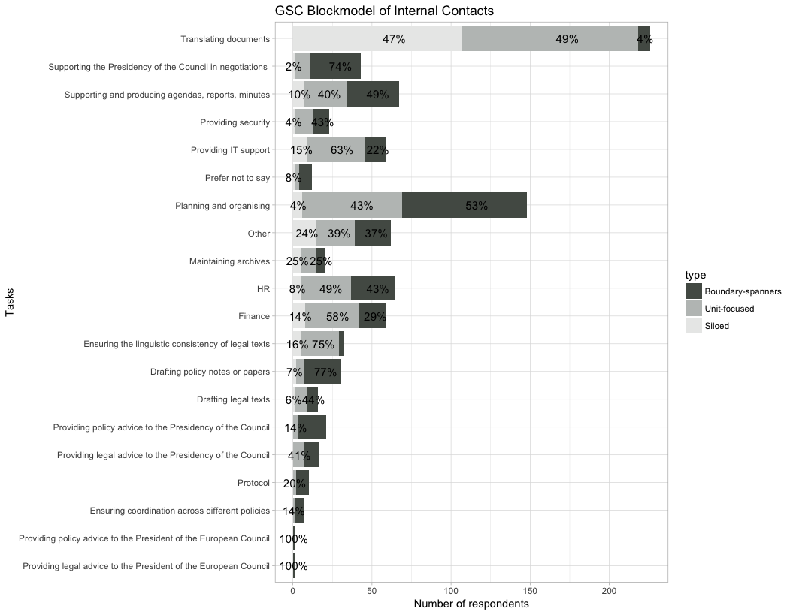

In Figure 8 we examine the three rows of the blockmodel of European Commission employees by their main tasks.
Figure 8 – European Commission - Blockmodel of Internal Contacts by Task
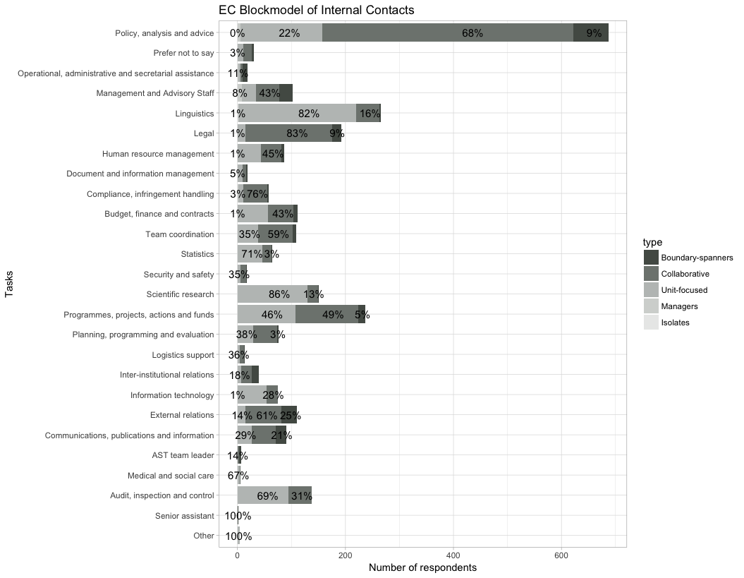

Figure 9 - GSC - Blockmodel of Internal Contacts by Task and DG

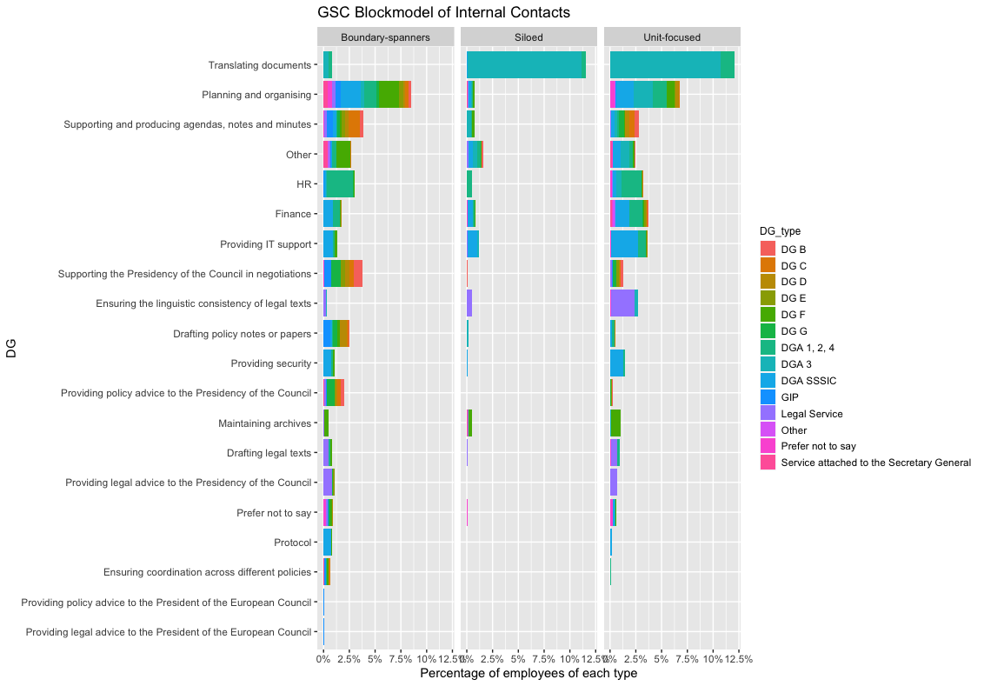

Figure 10 - European Commission - Blockmodel of Internal Contacts by Task and (selected) DGs
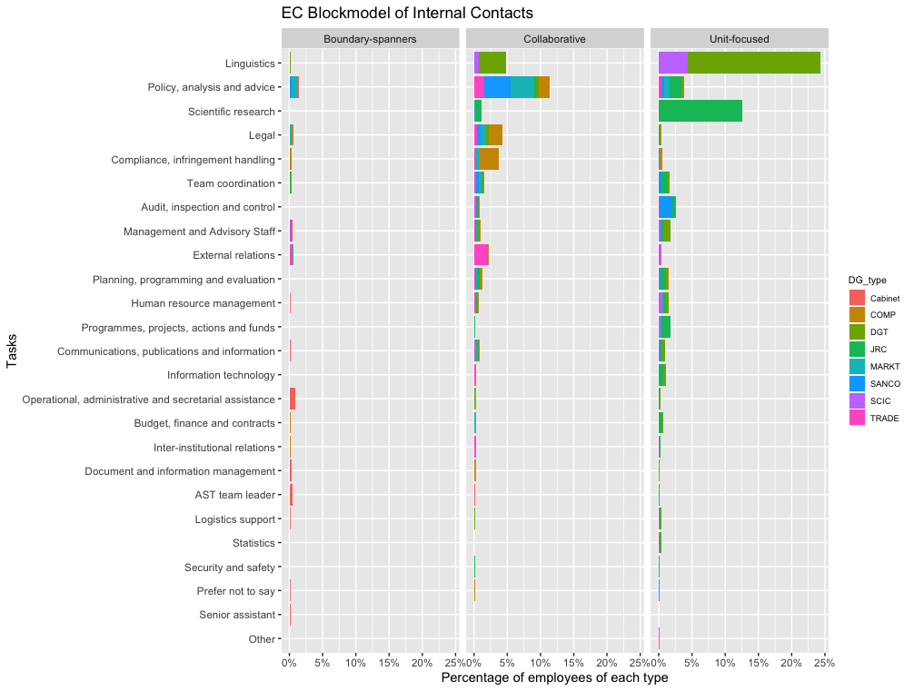

A full list of departments can be found on the European Commission’s homepage at https://ec.europa.eu/info/departments_en?field_core_topics_target_id_entityreference_filter=All&field_core_ecorganisation_value_i18n=All&field_department_tasks_tid_entityreference_filter=All, checked 25 February 2018
Council Secretariat homepage at http://www.consilium.europa.eu/en/general-secretariat/, checked 25 February 2018
The structure of the Council Secretariat is described on the organization’s homepage at http://www.consilium.europa.eu/media/32329/gsc-organisation-chart-en.pdf, checked 25 February 2018

