Supporting information

Constituents of Two Dioscorea Species that Potentiate Antibiotic Activity against MRSA
Gugu F. Sibandze,†,§ Paul Stapleton,† and Simon Gibbons*,†,‡
† Research Department of Pharmaceutical and Biological Chemistry, UCL School of Pharmacy, University College London, 29-39 Brunswick Square London, WC1N 1AX.
§ Eswatini Institute for Research in Traditional Medicine, Medicinal and Indigenous Food Plants, University of Eswatini, Private Bag 4, Kwaluseni, Eswatini, M201

* Email: s.gibbons@uea.ac.uk

Contents

List of Tables

Table S1: Effect of the Compounds on the Intracellular Accumulation of Ethidium Bromide in the S. aureus 1199B strain 3
Table S2: ¹H NMR data (500 MHz; multiplicities and coupling constants), ¹³C NMR data (125 MHz) and HMBC correlations of 3, recorded in CDCl₃. 17
Table S3: ¹H NMR data (500 MHz; multiplicities and coupling constants), ¹³C NMR data (125 MHz) and HMBC correlations of 4, recorded in CDCl₃. 24

List of Figures

Figure S1: Accumulation of EtBr by S. aureus SA-1199B in the Presence of Increasing Concentrations of, from Left to Right; Reserpine, 4, 1 and 2. 3
Figure S2: HR-ESI-MS spectrum of 1 in positive ion mode. 4
Figure S3: HR-ESI-MS spectrum of 2 in positive ion mode. 4
Figure S4: ¹H NMR spectrum of 1, recorded in benzene-d₆, 500 MHz. 5
Figure S5: ¹³C NMR spectrum of 1 recorded in benzene-d₆, 125 MHz. 6
Figure S6: DEPT-135 spectrum of 1, recorded in benzene-d₆, 125 MHz. 7
Figure S7: HMQC spectrum of 1, recorded in benzene-d₆. 8
Figure S8: HMBC spectrum of 1, recorded in benzene-d₆. 9
Figure S9: COSY spectrum of 1, recorded in benzene-d₆. 10
Figure S10: ¹H NMR spectrum of 2, recorded in benzene-d₆, 500 MHz. 11
Figure S11: ¹³C NMR spectrum of 2, recorded in benzene-d₆, 125 MHz. 12
Figure S12: DEPT-135 spectrum of 2, recorded in benzene-d₆, 125 MHz. 13
Figure S13: HMQC spectrum of 2, recorded in benzene-d₆. 14
Figure S14: HMBC spectrum of 2, recorded in benzene-d₆. 15
Figure S15: COSY spectrum of 2, recorded in benzene-d₆. 16
Figure S16: ¹H NMR spectrum of 3, recorded in chloroform-d, 500 MHz. 18
Figure S17: ¹³C NMR spectrum of 3, recorded in chloroform-d, 125 MHz. 19
Figure S18: DEPT-135 spectrum of 3, recorded in chloroform-d, 125 MHz. 20
Figure S19: HMQC spectrum of 3, recorded in chloroform-d. 21
Figure S20: HMBC spectrum of 3, recorded in chloroform-d. 22
Figure S21: COSY spectrum of 3, recorded in chloroform-d. 23
Figure S22: ¹H NMR spectrum of 4, recorded in chloroform-d, 500 MHz. 25
Figure S23: ¹³C NMR spectrum of 4, recorded in chloroform-d, 125 MHz. 26
Figure S24: DEPT-135 spectrum of 4, recorded in chloroform-d, 125 MHz. 27
Figure S25: HMQC spectrum of 4, recorded in chloroform-d. 28
Figure S26: HMBC spectrum of 4, recorded in chloroform-d. 29
Figure S27: COSY spectrum of 4, recorded in chloroform-d 30
Figure S28: ¹H NMR spectrum of the (R)-MPTA ester of 1. 31
Figure S29: ¹H NMR spectrum of the (S)-MPTA ester of 1. 32

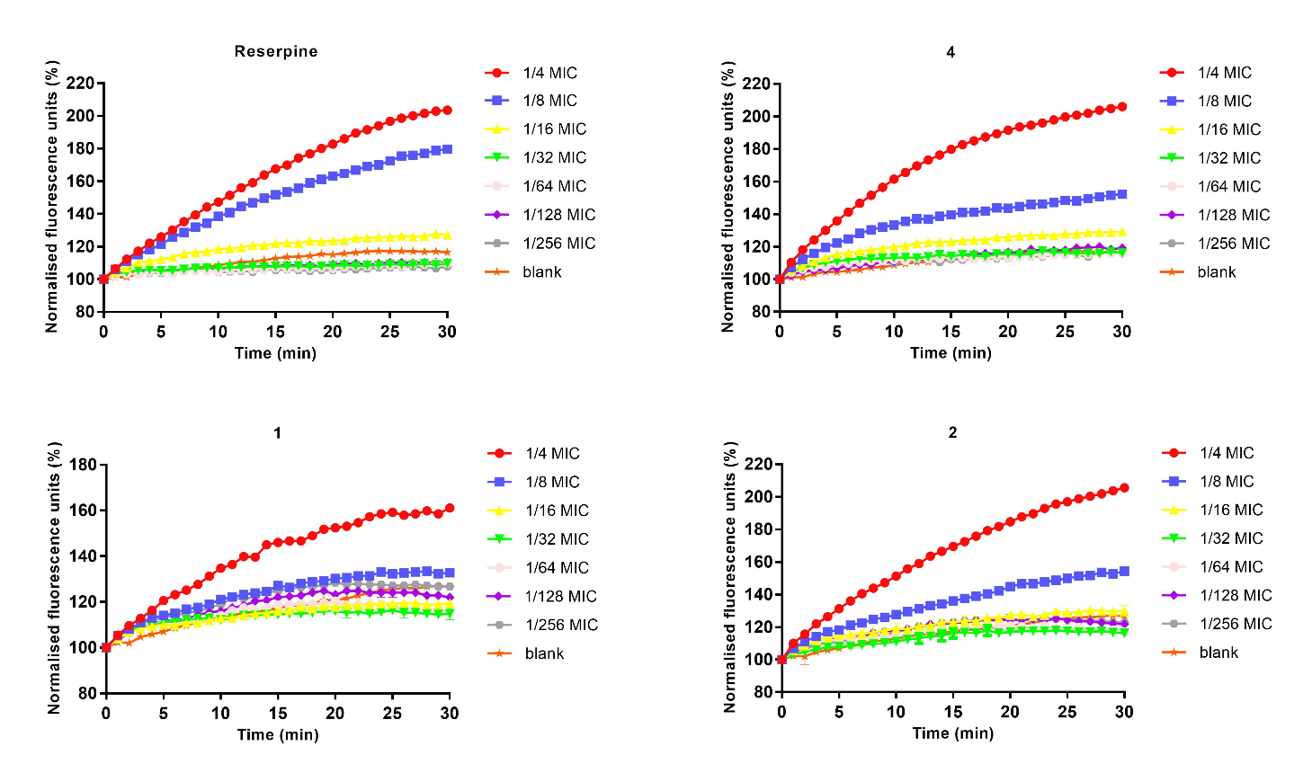

Figure S1: Accumulation of EtBr by S. aureus SA-1199B in the Presence of Increasing Concentrations of, from Left to Right; Reserpine, 4, 1 and 2.

Table S1: Effect of the Compounds on the Intracellular Accumulation of Ethidium Bromide in the S. aureus 1199B strain

compound (1/4 MIC) | S. aureus 1199B (NorA)
 | ∆ slope |  | RFF (RFF = RF_{treated} – RF_{untreated})^{b}
1 |  | 1.04 |  | 34.45
2 |  | 2.45 |  | 78.89
4 |  | 2.68 |  | 89.60
reserpine |  | 2.88 |  | 87.08
^{b} [where RFtreated is the relative fluorescence of the treated sample and RFuntreated is the relative fluorescence of the blank

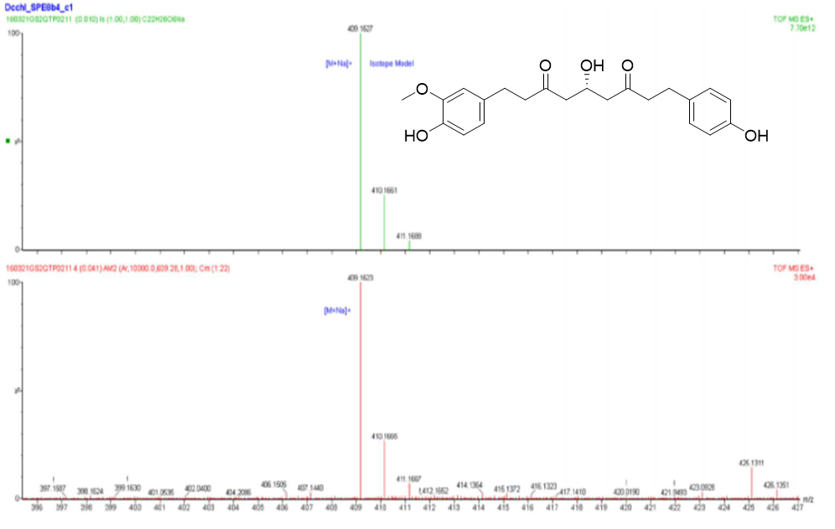

Figure S2: HR-ESI-MS spectrum of 1 in positive ion mode.

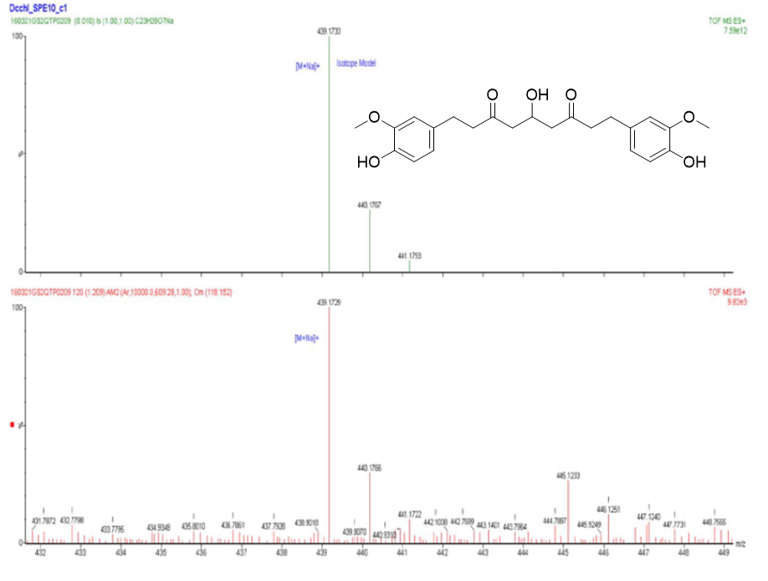

Figure S3: HR-ESI-MS spectrum of 2 in positive ion mode.

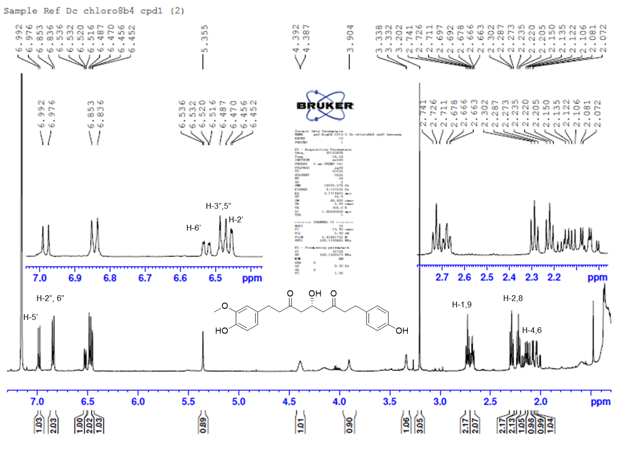

Figure S4: ¹H NMR spectrum of 1, recorded in benzene-d₆, 500 MHz.
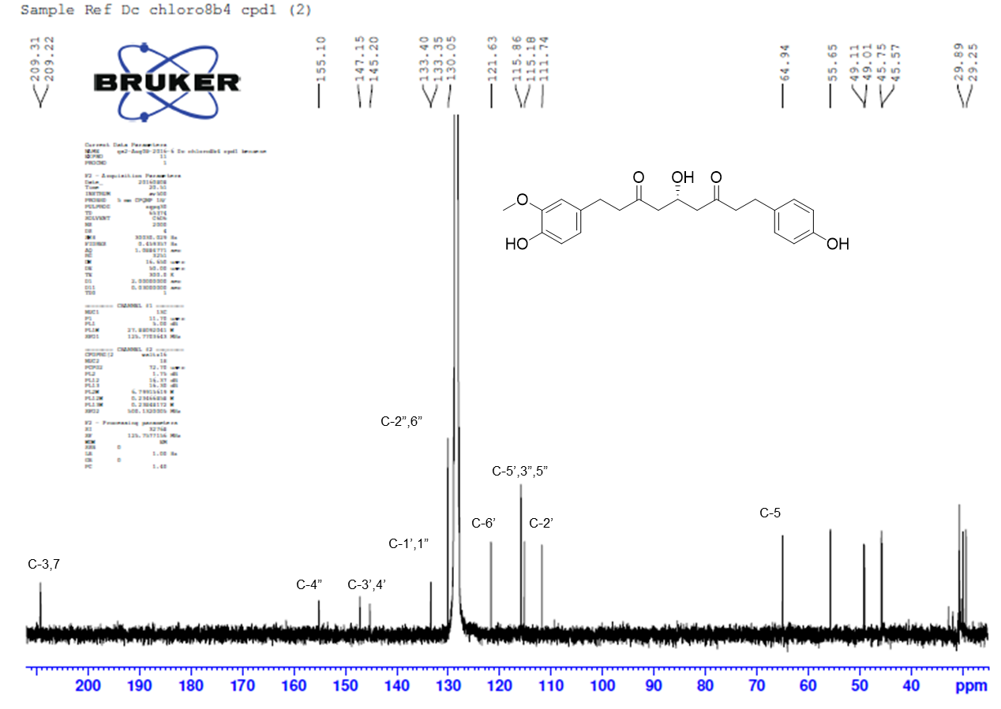

Figure S5: ¹³C NMR spectrum of 1 recorded in benzene-d₆, 125 MHz.

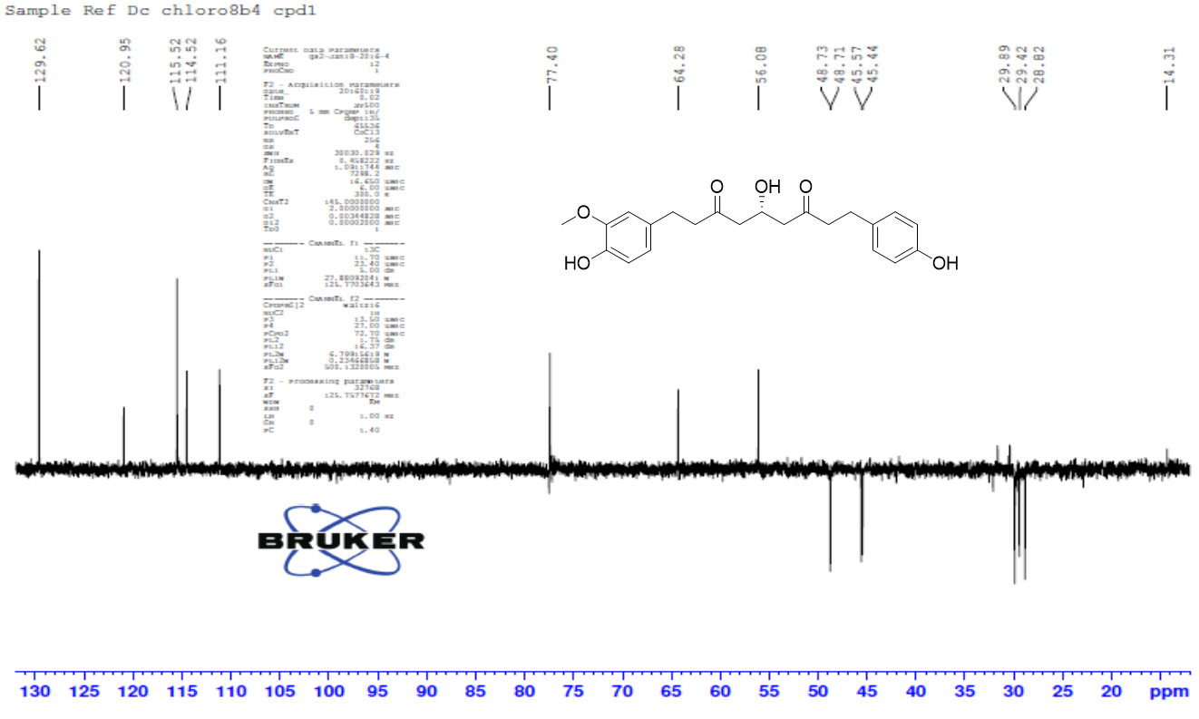

Figure S6: DEPT-135 spectrum of 1, recorded in benzene-d₆, 125 MHz.

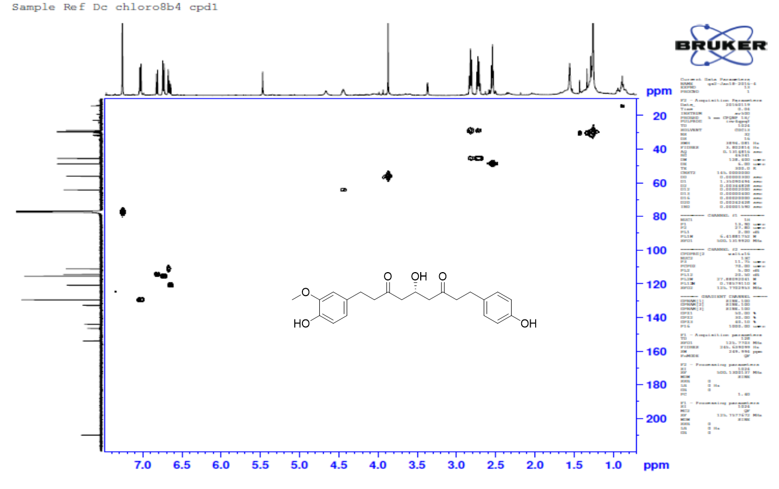
Figure S7: HMQC spectrum of 1, recorded in benzene-d₆.

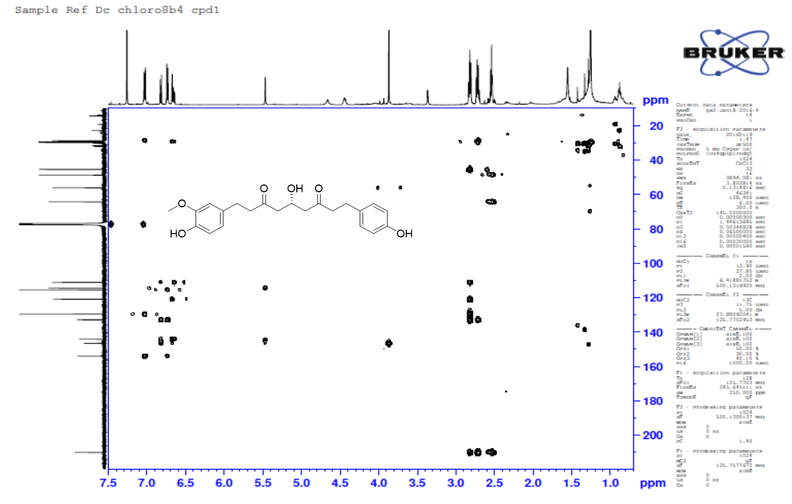

Figure S8: HMBC spectrum of 1, recorded in benzene-d₆.

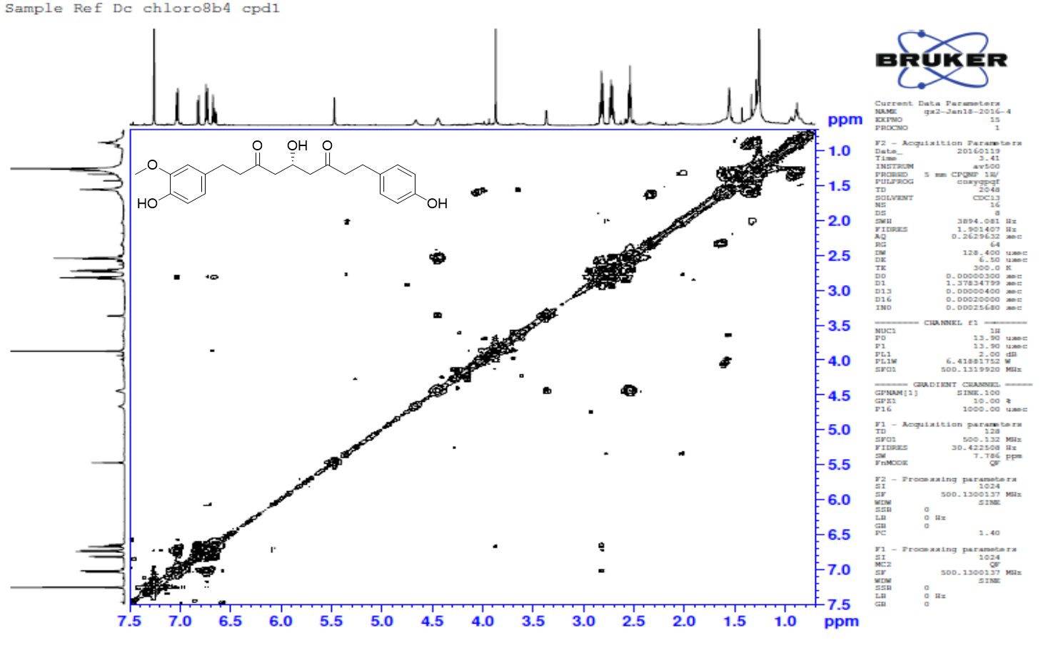

Figure S9: COSY spectrum of 1, recorded in benzene-d₆.
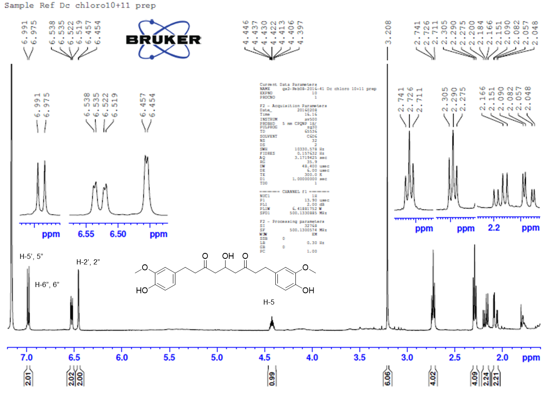

Figure S10: ¹H NMR spectrum of 2, recorded in benzene-d₆, 500 MHz.
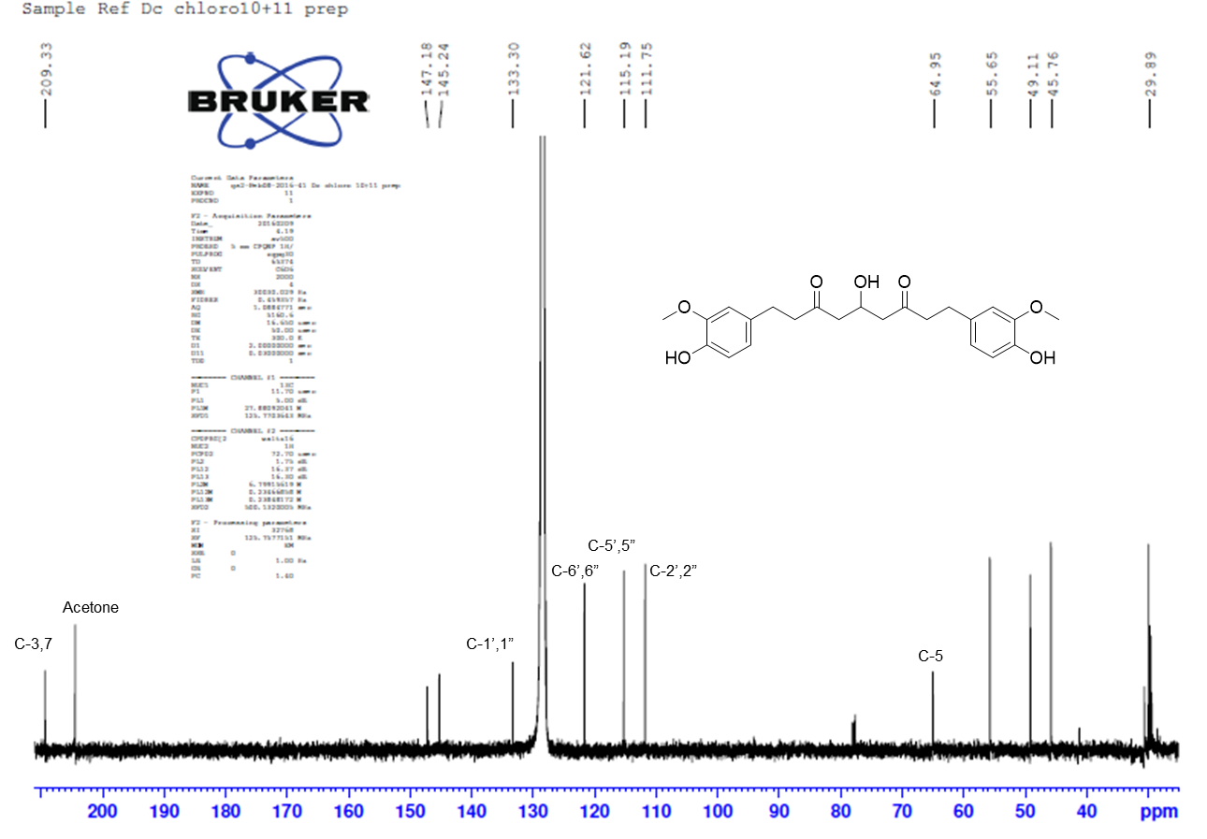

Figure S11: ¹³C NMR spectrum of 2, recorded in benzene-d₆, 125 MHz.

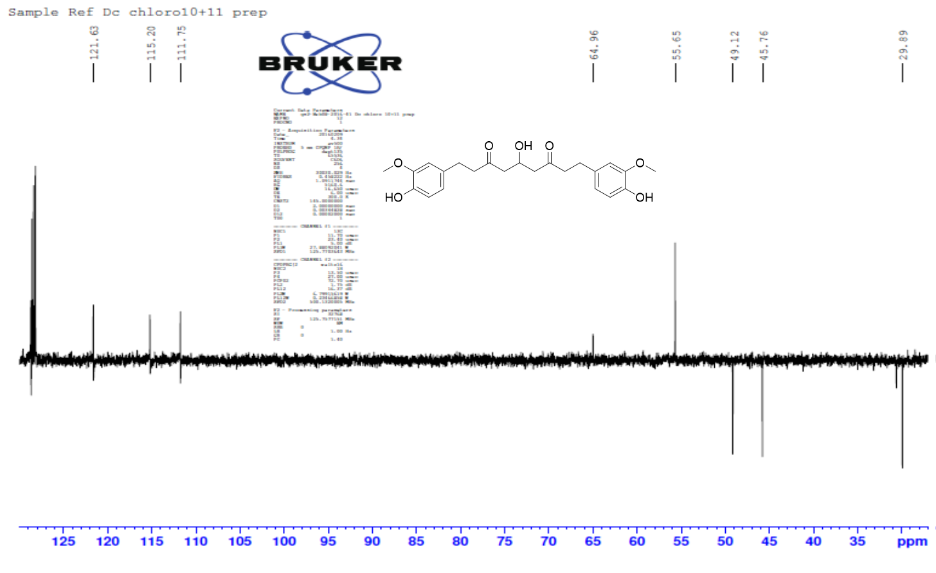

Figure S12: DEPT-135 spectrum of 2, recorded in benzene-d₆, 125 MHz.

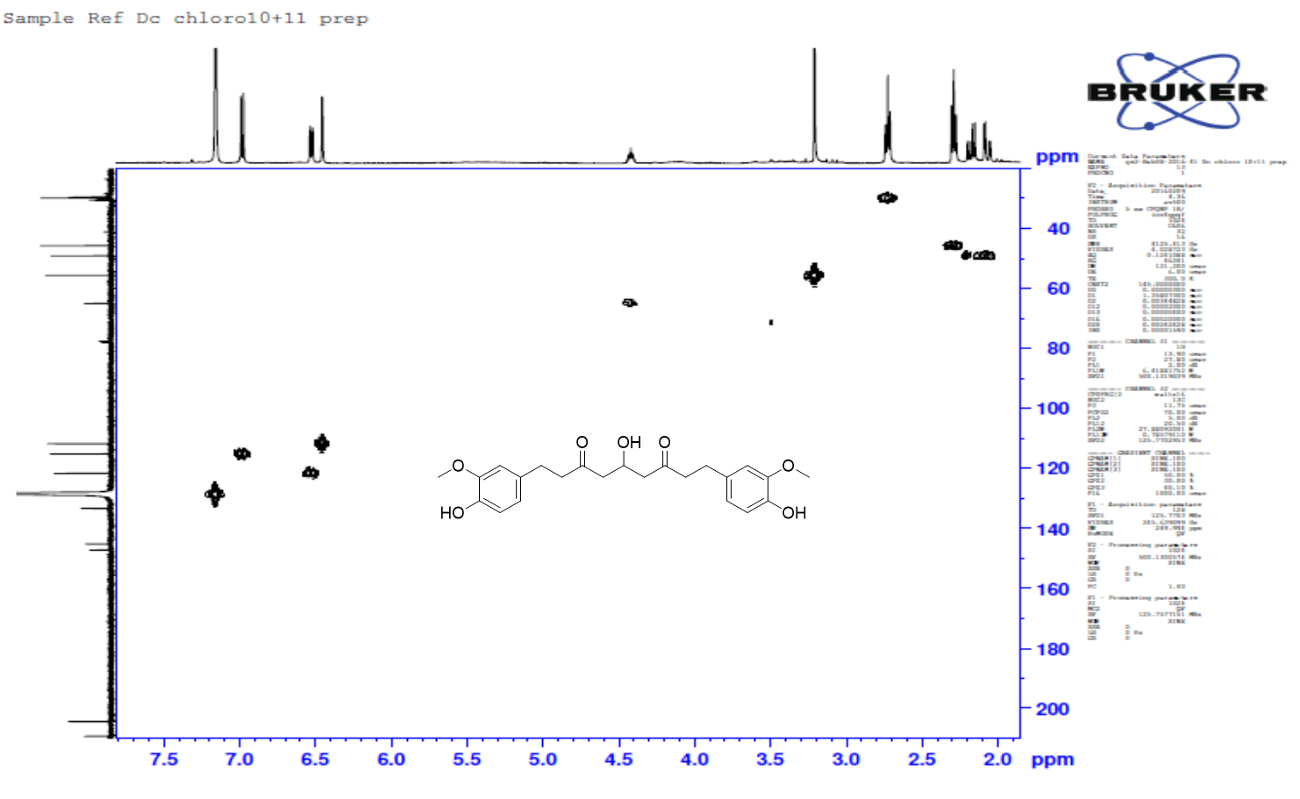
Figure S13: HMQC spectrum of 2, recorded in benzene-d₆.

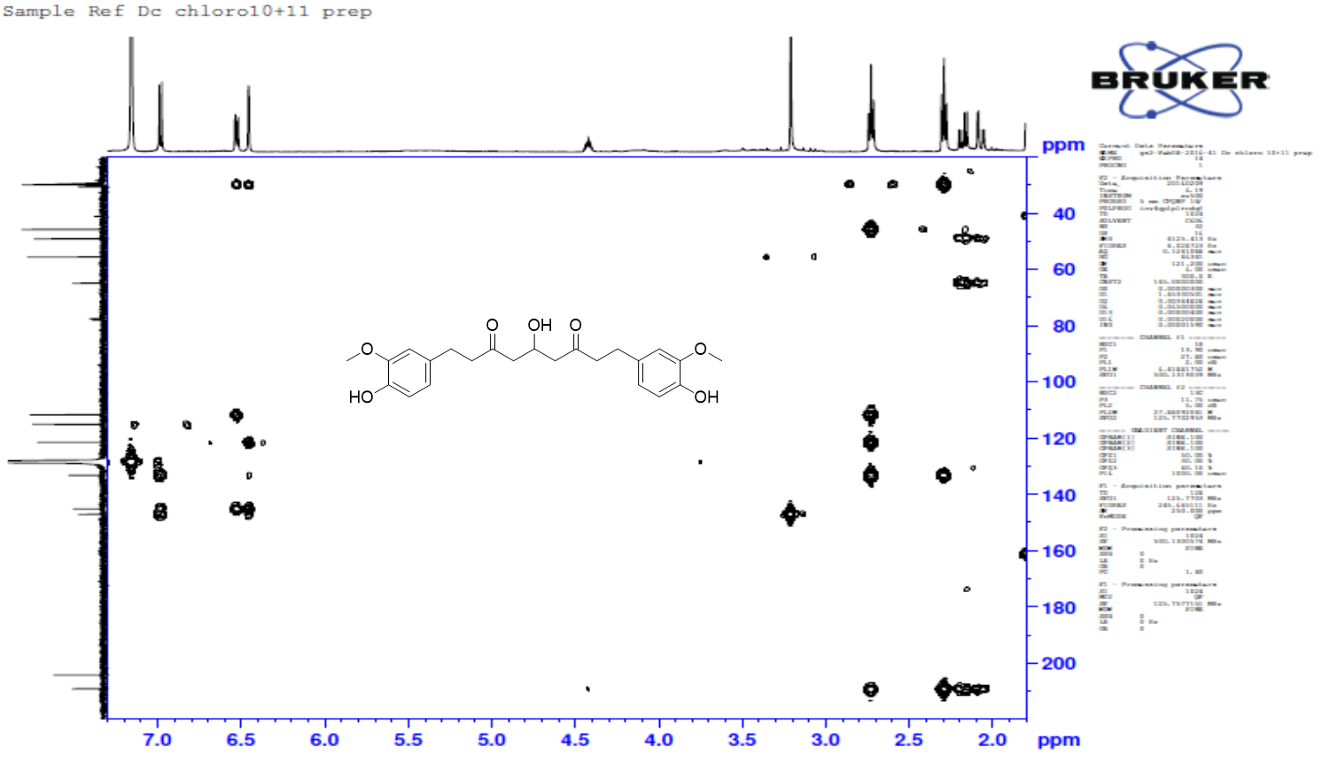

Figure S14: HMBC spectrum of 2, recorded in benzene-d₆.
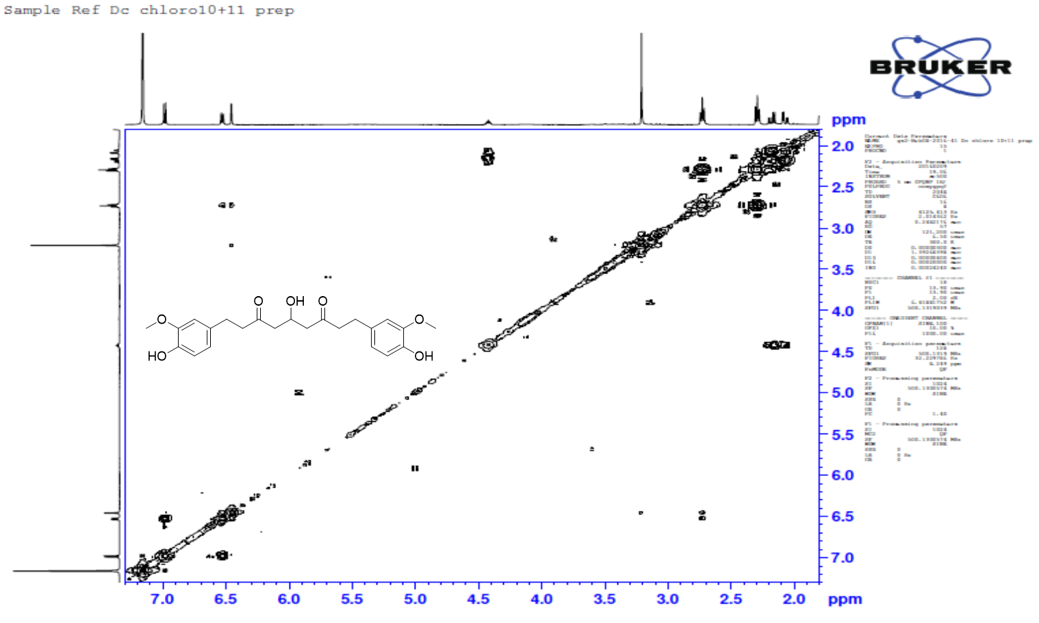

Figure S15: COSY spectrum of 2, recorded in benzene-d₆.

Table S2: ¹H NMR data (500 MHz; multiplicities and coupling constants), ¹³C NMR data (125 MHz) and HMBC correlations of 3, recorded in CDCl₃.

no. | ¹H | ¹³C | ²J | ³J
1 (2H) | 4.19 (t, J = 6.5) | 64.8 | C-9’ | C-3
2 – 3 (4H) | 1.71 – 1.60 (m) overlapped | 29.9 – 28.9 |  | C-1
4 (2H) | 1.41 – 1.25 (m) overlapped) | 26.2
5 – 27 (46H) | 1.41 – 1.25 (m) overlapped) | 29.9 – 28.9 |  | C-4, C-28
28 – 29 (4H) | 1.71 – 1.60 (m) overlapped | 24.9 | C-30 | C-32
30 – 31 (4H) | 2.34 (t, J = 7.5) | 33.9 | C-32 | C-28
32 |  | 178.4
1’ |  | 127.4
2’ | 7.04 (d, J = 2.0) | 109.5 | C-1’, C-3’ | C-7’, C-4’, C-6’, C-5’
3’ |  | 148.1
4’ |  | 146.9
5’ | 6.92 (d, J = 8.3) | 114.9 | C-6’, C-4’ | C-1’
6’ | 7.07 (dd, J = 8.3, 2.0) | 123.2 | C-5’ | C-2’, C-7’
7’ | 7.62 (d, J = 15.8) | 144.8 | C8’ | C-2’, C-6’, C-9’
8’ | 6.31 (d, J = 15.8) | 115.9 | C9’, C-7’ | C-1’
9’ |  | 167.6
OCH₃ – 4’ | 3.93 (s) | 56.1 | C-4’
[chemical shift in ppm; coupling constants (Hz); multiplicity of proton signals: s; singlet, d; doublet, t; triplet, m; multiplet, dd; doublet of doublets]

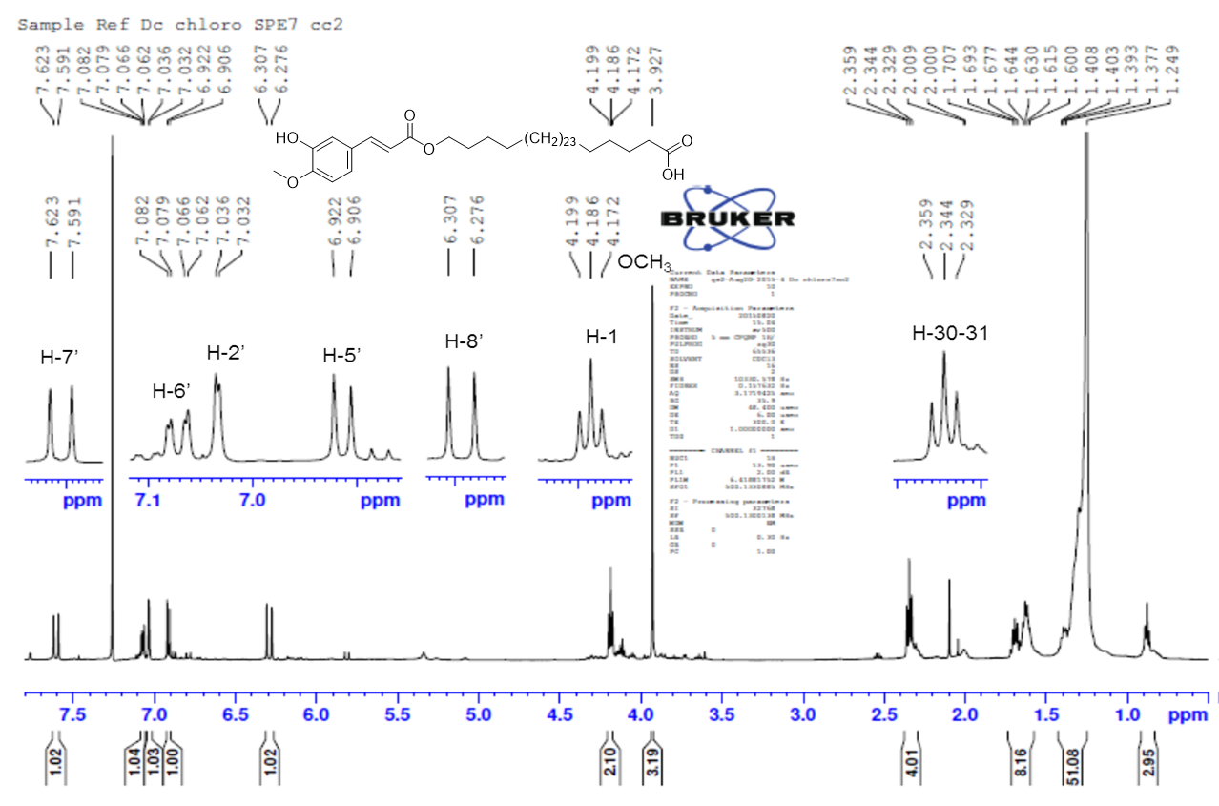

Figure S16: ¹H NMR spectrum of 3, recorded in chloroform-d, 500 MHz.

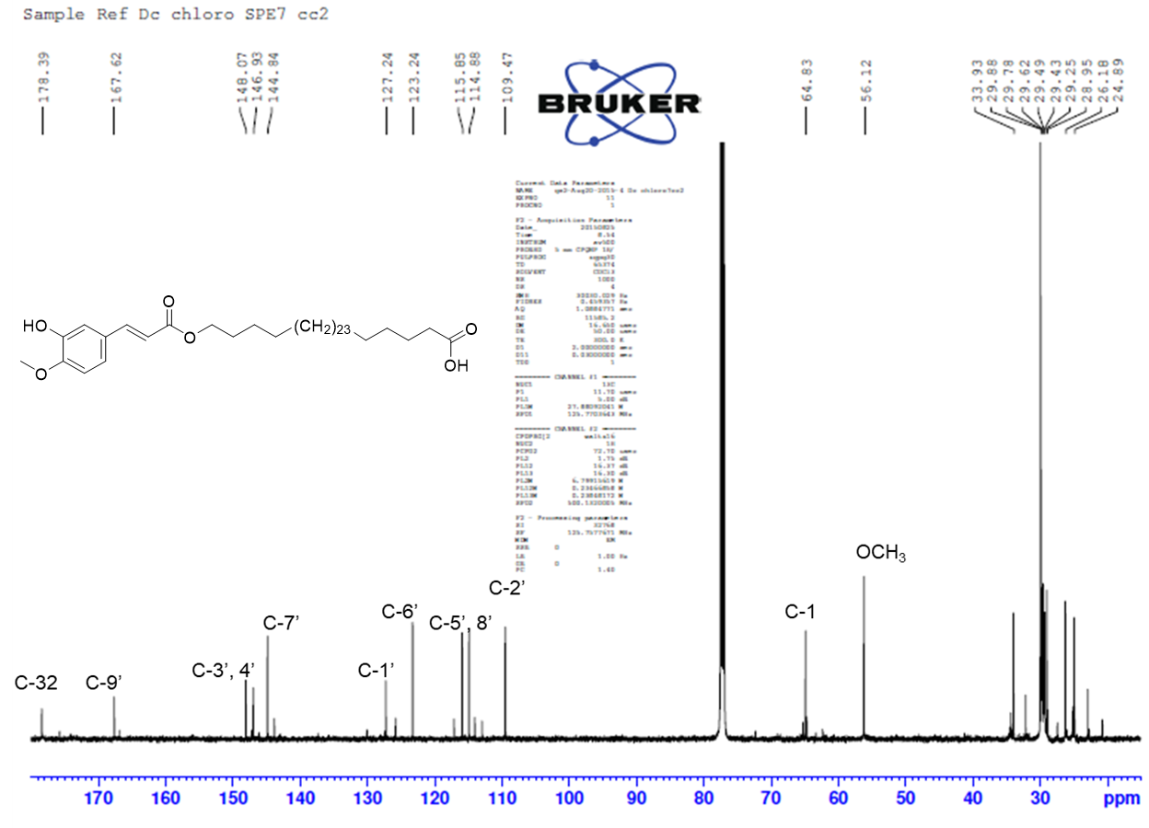

Figure S17: ¹³C NMR spectrum of 3, recorded in chloroform-d, 125 MHz.
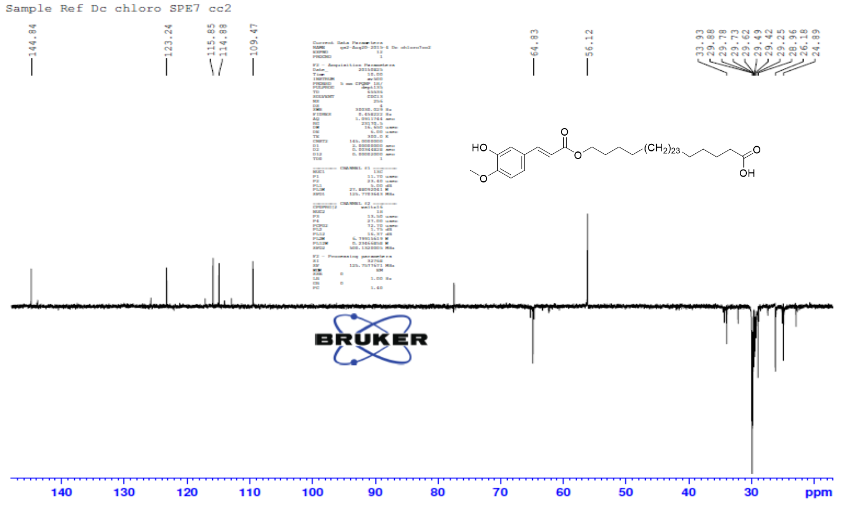

Figure S18: DEPT-135 spectrum of 3, recorded in chloroform-d, 125 MHz.

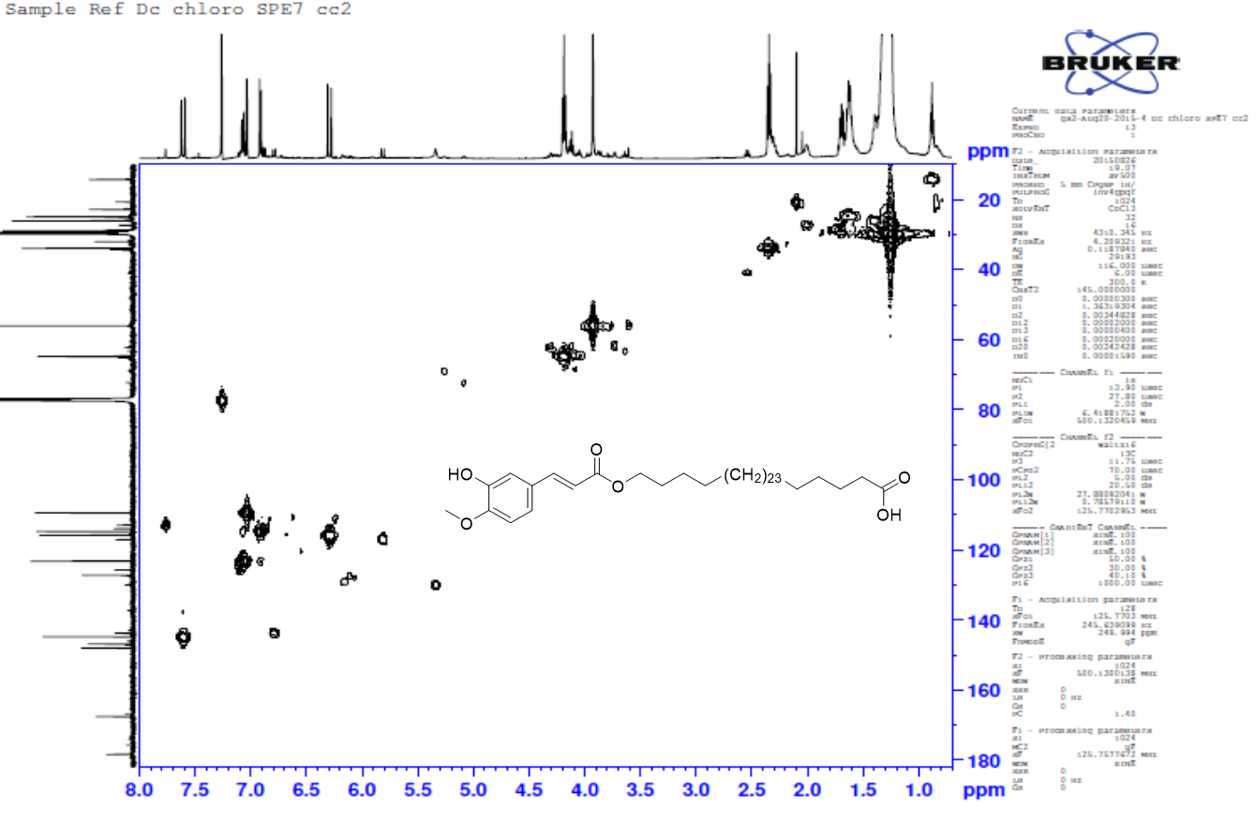

Figure S19: HMQC spectrum of 3, recorded in chloroform-d.
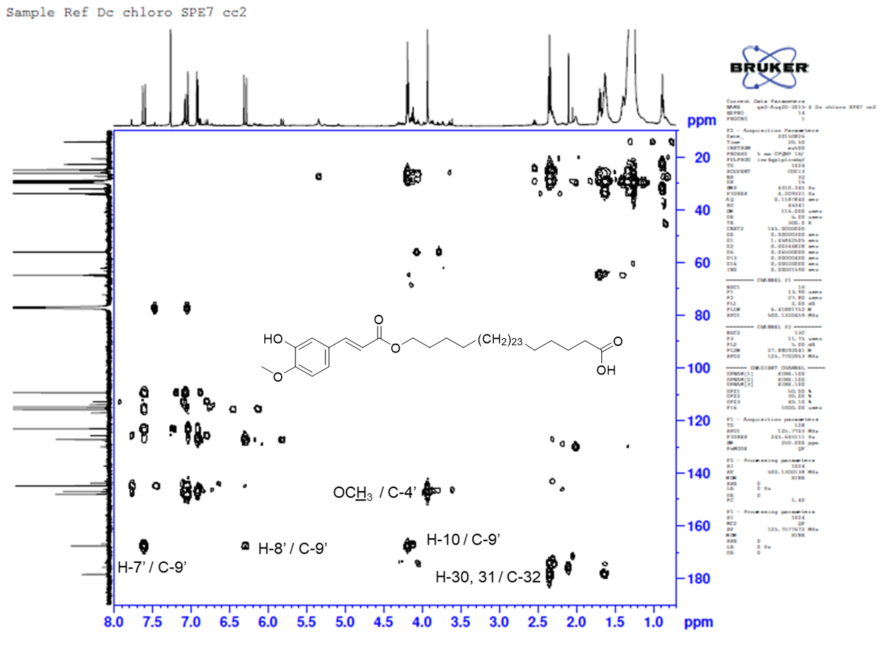

Figure S20: HMBC spectrum of 3, recorded in chloroform-d.

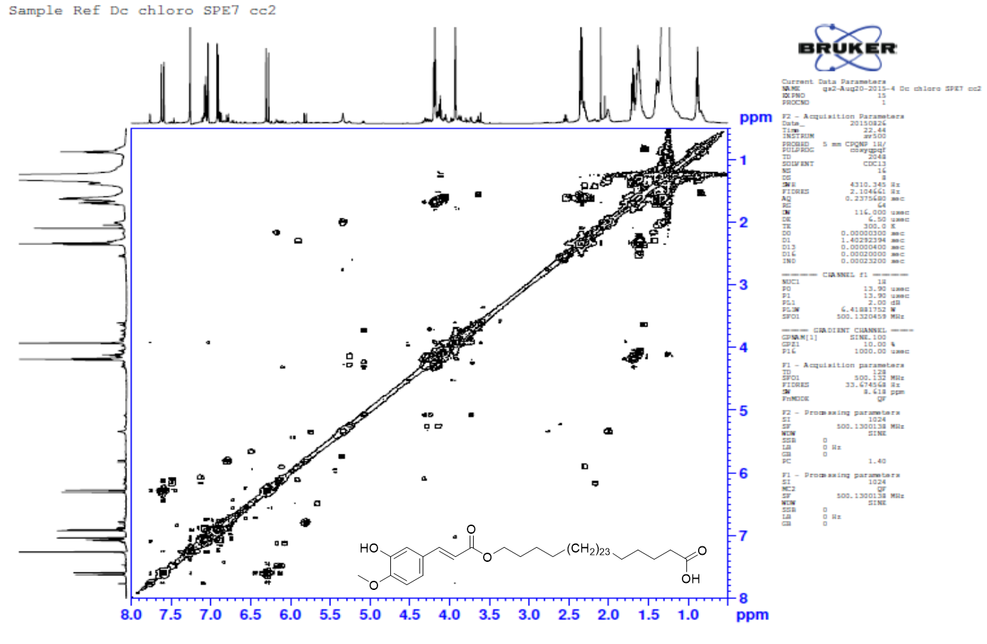

Figure S21: COSY spectrum of 3, recorded in chloroform-d.

Table S3: ¹H NMR data (500 MHz; multiplicities and coupling constants), ¹³C NMR data (125 MHz) and HMBC correlations of 4, recorded in CDCl₃.

Position | ¹H | ¹³C | ²J | ³J | ¹³C  CDCl₃, 125 MHz
1 |  | 149.3 |  |  | 149.1
2 |  | 133.9 |  |  | 133.8
3 |  | 152.3 |  |  | 152.1
4 | 6.26 (d, J = 1.8) | 104.6 | C-3, C-5 | C-6, C-7 | 104.5
5 |  | 138.5 |  |  | 138.2
6 | 6.50 (d, J = 1.8) | 108.0 | C-1 | C-4 | 107.8
7 | 2.84, 2.90 (m) | 36.5 | C-5, C-8 | C-6 | 36.8
8 | 2.80, 2.87 (m) | 32.4 | C1’, C-2’ | C-6’ | 32.2
1’ |  | 127.9 |  |  | 127.8
2’ |  | 153.7 |  |  | 153.5
3’ | 6.76 (d, J = 7.5) | 115.5 | C-2’ |  | 115.4
4’ | 6.86 (ddd, J = 7.5, 7.0, 1,0) | 121.0 |  | C-2’ | 120.9
5’ | 7.09 (dd, unresolved) | 127.5 | C-6’ |  | 127.3
6’ | 7.09 (d, J = 7.5), overlapped | 130.5 |  | C-2’ | 130.4
OCH₃ – 2 | 3.87 (s) | 61.2 |  | C-2 | 61.0
OCH₃ – 3 | 3.80 (s) | 56.0 |  | C-3 | 55.8
OH – 1 | 5.73 (brd)
OH – 2’ | 4.72 (brd)
[chemical shift in ppm; coupling constants (Hz); multiplicity of proton signals: s; singlet, d; doublet, m; multiplet, brd; broad; dd; doublet
of doublets]

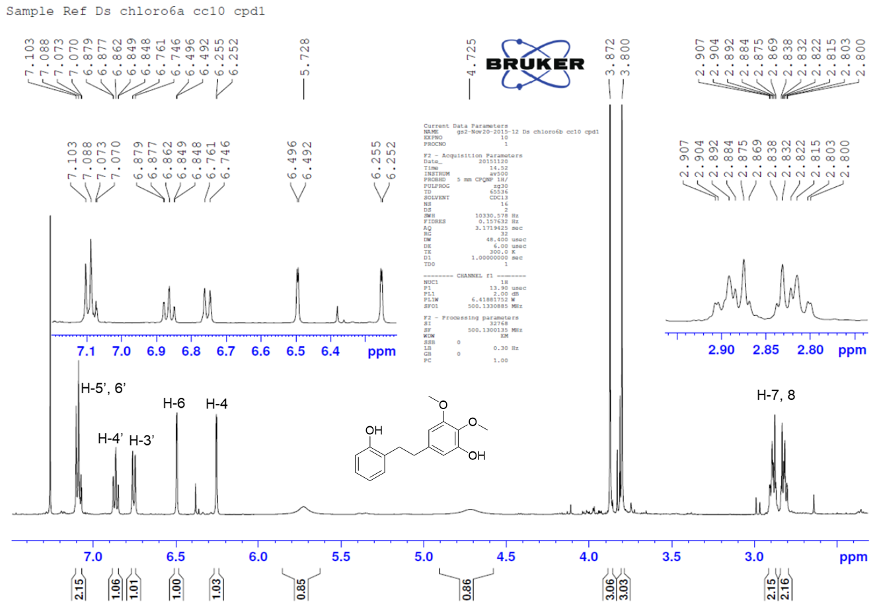

Figure S22: ¹H NMR spectrum of 4, recorded in chloroform-d, 500 MHz.

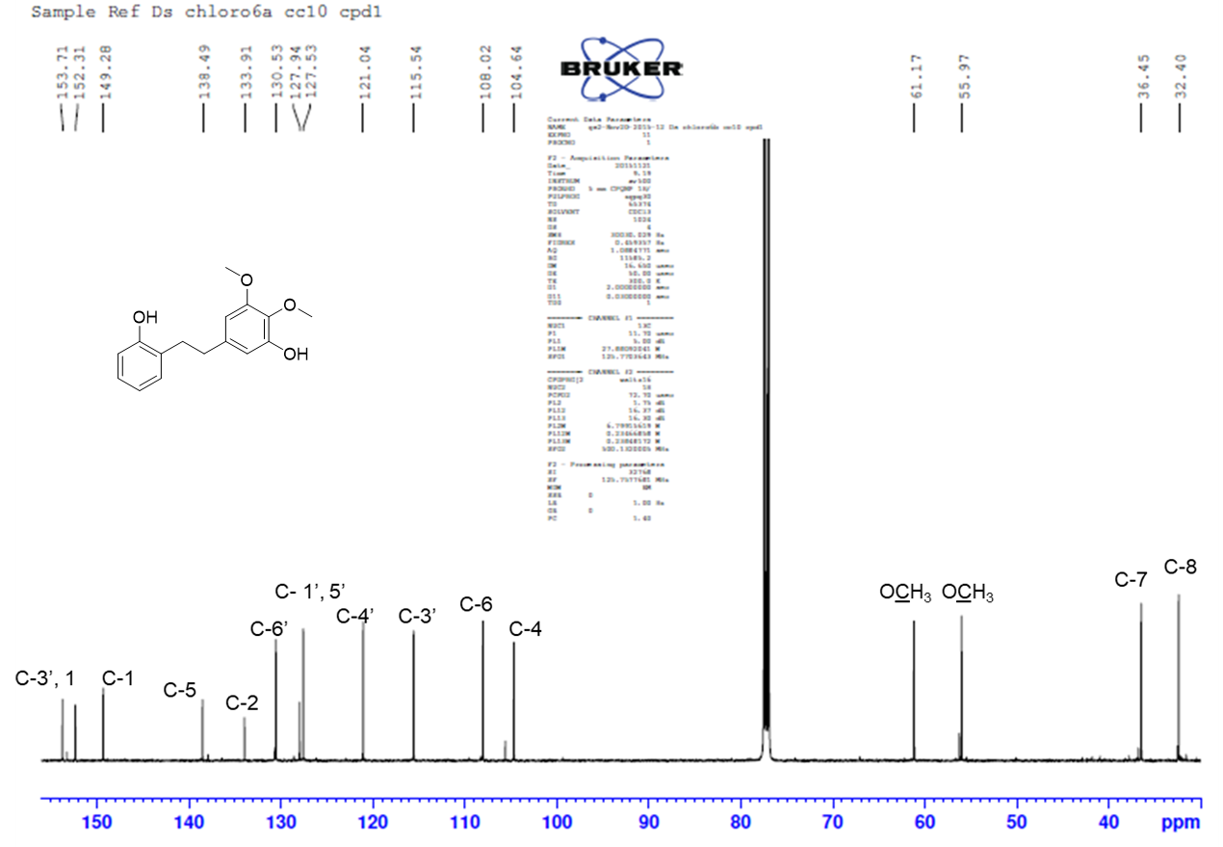

Figure S23: ¹³C NMR spectrum of 4, recorded in chloroform-d, 125 MHz.
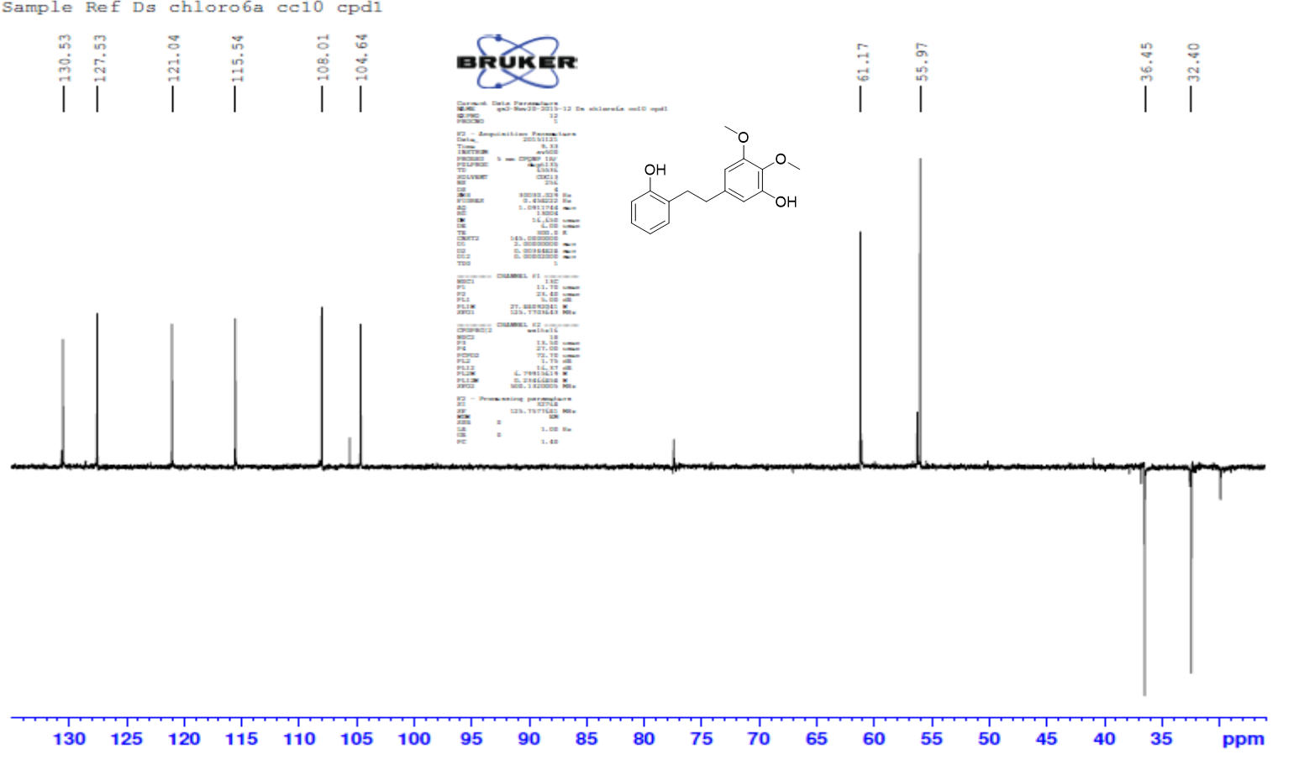

Figure S24: DEPT-135 spectrum of 4, recorded in chloroform-d, 125 MHz.

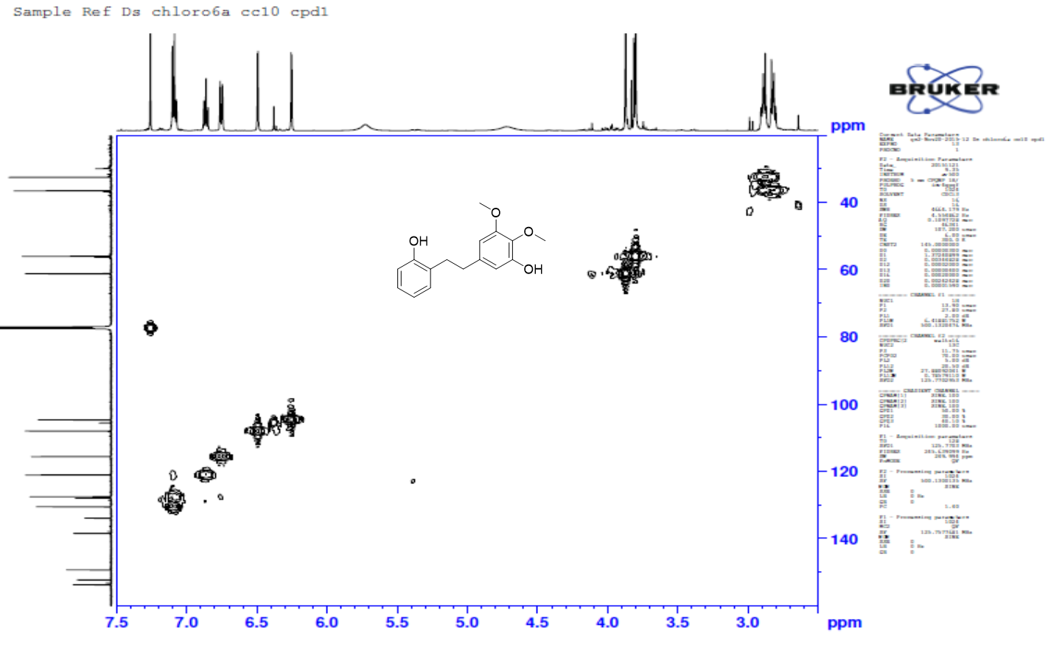

Figure S25: HMQC spectrum of 4, recorded in chloroform-d.

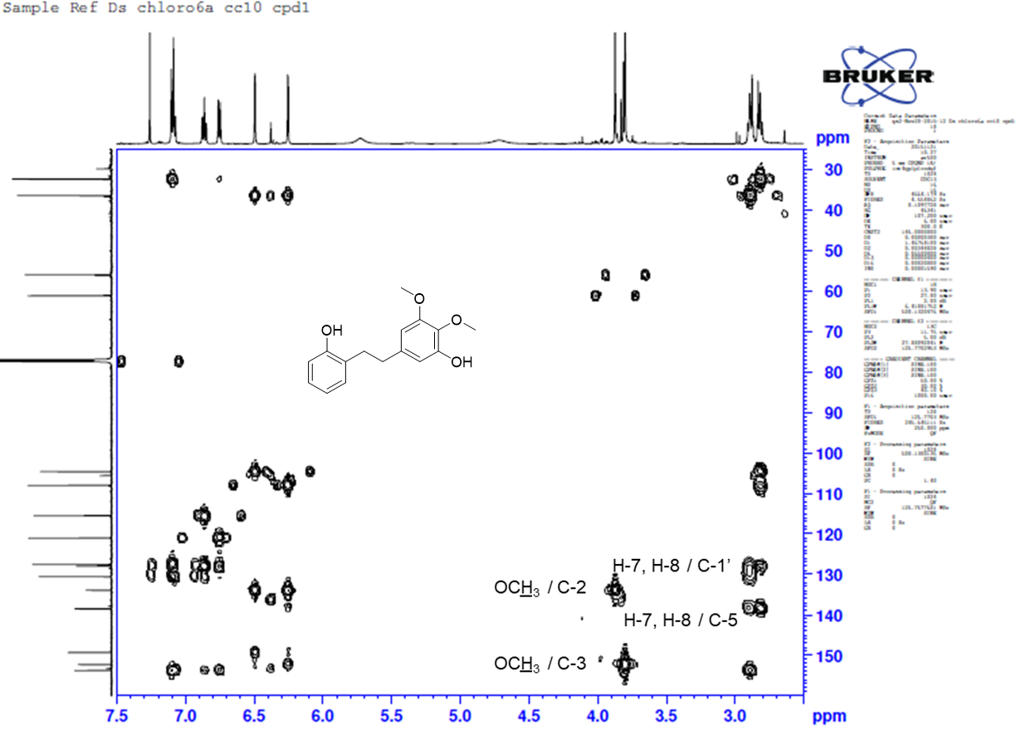

Figure S26: HMBC spectrum of 4, recorded in chloroform-d.

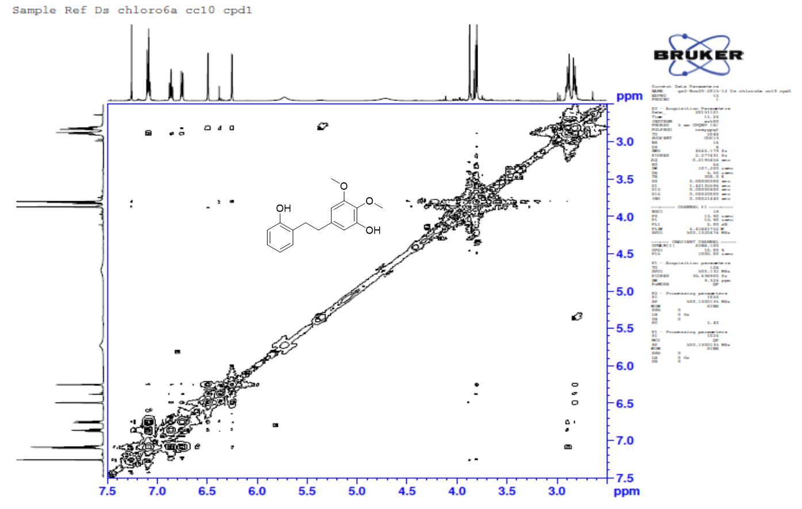

Figure S27: COSY spectrum of 4, recorded in chloroform-d
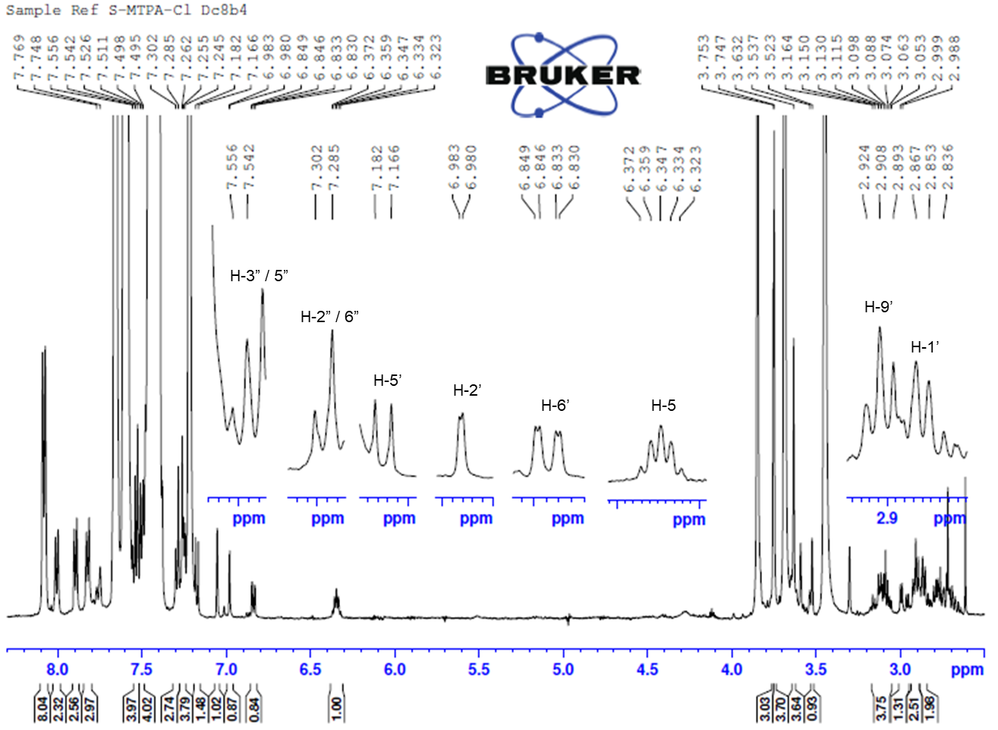

Figure S28: ¹H NMR spectrum of the (R)-MPTA ester of 1.
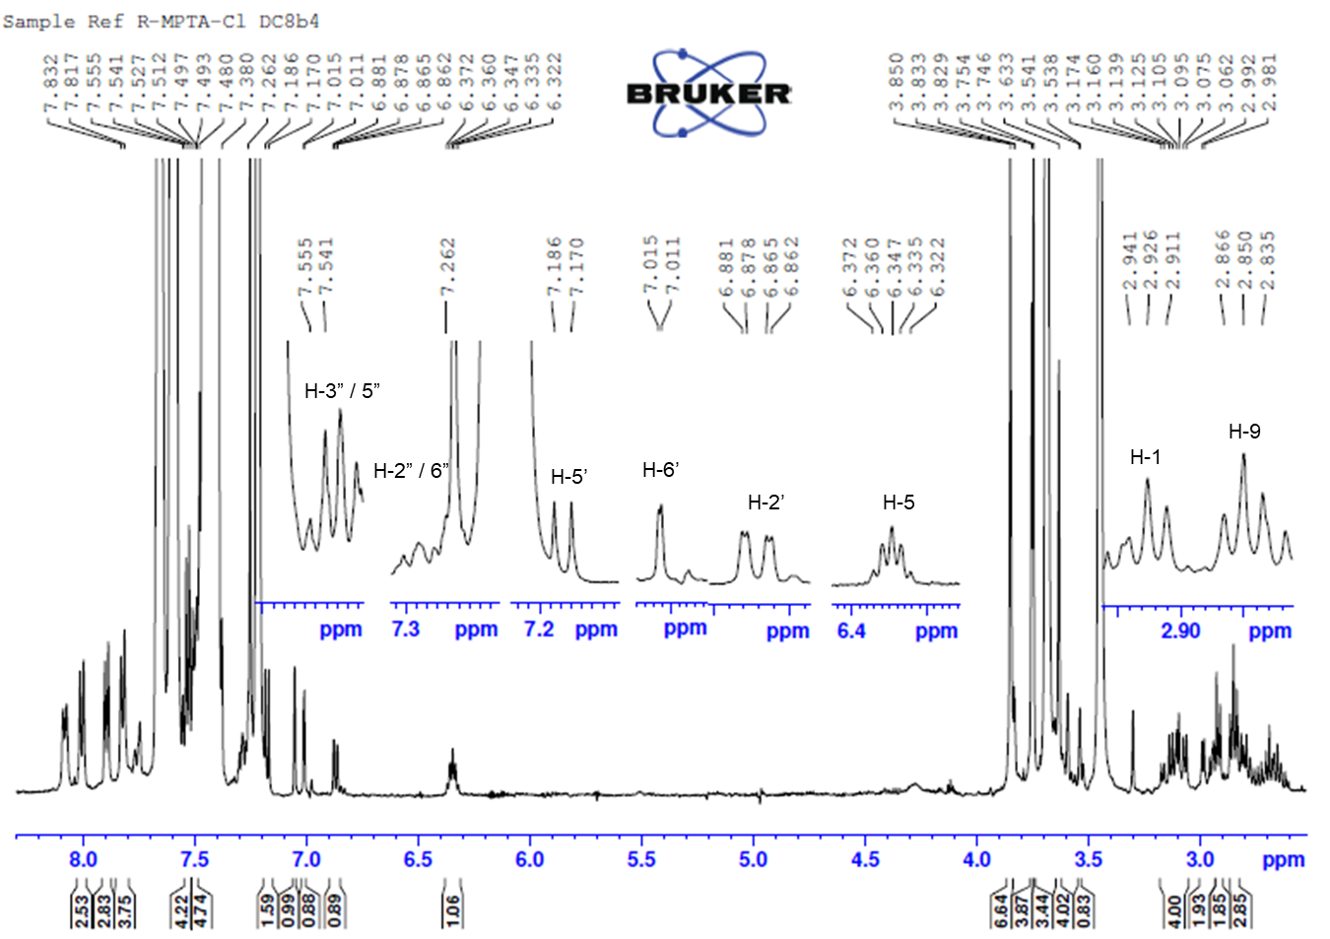

Figure S29: ¹H NMR spectrum of the (S)-MPTA ester of 1.

