Characterisation of Particle Mass and Number Concentration on the East Coast of the Malaysian Peninsula during the Northeast Monsoon

Doreena Dominick^{a,b}, Mohd Talib Latif ^{a,c,*}, Liew Juneng ^{a,c}, Md Firoz Khanª, Norhaniza Amil^{c,d}, Mohammed Iqbal Mead^{e,f}, Mohd Shahrul Mohd Nadzir ^{a,c,}, Phang Siew Moi^{e}, Azizan Abu Samah ^{e}, Matthew J. Ashfold^{g}, William T. Sturges^{h}, Neil R. P. Harris^{i}, Andrew D. Robinson^{i}, John A. Pyle^{i,j}

ª Centre for Tropical Climate Change System (IKLIM), Institute for Climate Change, Universiti Kebangsaan Malaysia, 43600 Bangi, Selangor, Malaysia
^{b} Centre for Atmospheric Chemistry, University of Wollongong, Wollongong, NSW, 2522 Australia
^{c} School of Environmental and Natural Resource Sciences, Faculty of Science and Technology, Universiti Kebangsaan Malaysia, 43600 Bangi, Selangor, Malaysia
^{d} School of Industrial Technology (Environmental Division), Universiti Sains Malaysia, 11800 Penang, Malaysia
^{e} Institute of Ocean and Earth Sciences, University of Malaya, 50603 Kuala Lumpur, Malaysia
^{f} School of Earth, Atmospheric and Environmental Science, University of Manchester, Brunswick Street, Manchester M139PL, United Kingdom
^{g} School of Biosciences, University of Nottingham Malaysia Campus, Jalan Broga, 43500 Semenyih, Selangor, Malaysia
^{h} School of Environmental Sciences, University of East Anglia, Norwich Research Park, NR4 7TJ, Norwich, United Kingdom
^{i} Department of Chemistry, University of Cambridge, Lensfield Road, Cambridge, CB2 1EW, United Kingdom
^{j} National Centre for Atmospheric Science, NCAS-Climate, UK

*Corresponding author
Phone: + 60389213822
Fax: + 603-89253357
Email: talib@ukm.my

Abstract
Particle mass concentrations (PM₁₀, PM_{2.5} and PM₁) and particle number concentration ((PNC); 0.27 μm ≤ Dp ≤ 34.00 μm) were measured in the tropical coastal environment of Bachok, Kelantan on the Malaysian Peninsula bordering the southern edge of the South China Sea. Statistical methods were applied on a three-month hourly data set (9th January to 24th March 2014) to study the influence of north-easterly winds on the patterns of particle mass and PNC size distributions. The 24-h concentrations of particle mass obtained in this study were below the standard values detailed by the Recommended Malaysian Air Quality Guideline (RMAQG), United States Environmental Protection Agency (US EPA) and European Union (EU) except for PM_{2.5}, which recorded a 24-h average of 30 ± 18 µg m⁻³ and exceeded the World Health Organisation (WHO) threshold value (25 µg m⁻³). Principal component analysis (PCA) revealed that PNC with smaller diameter sizes (0.27 – 4.50 μm) showed a stronger influence, accounting for 57.6% of the variability in PNC data set. Concentrations of both particle mass and PNC increased steadily in the morning with a distinct peak observed at around 8.00 h, related to a combination of dispersion of accumulated particles overnight and local traffic. In addition to local anthropogenic, agricultural burning and forest fire activities, long-range transport also affects the study area. Hotspot and backward wind trajectory observations illustrated that the biomass burning episode (around February-March) significantly influenced PNC. Meteorological parameters influenced smaller size particles (i.e. PM₁ and Dp (0.27 - 0.43 μm)) the most.

Keywords: Aerosols, multivariate analysis, meteorology, long-ranged transport, biomass episodes

1. Introduction
Regional and local atmospheric aerosols are formed from various complex interactions within the atmosphere and originate from both natural and anthropogenic sources . In Southeast Asia, biomass burning is an important source of aerosols in addition to daily emissions from traffic and industrial processes . These particles originate from a combination of long-range transport from regional sources and also local sources of both natural and anthropogenic origins . The combustion of peat soil and waste from vegetation are major contributors of aerosols from biomass burning. Aerosols from biomass burning usually contain high amounts of organic pollutants and are able to travel far from their sources, due to their fine size and stability characteristics . Other sources of fine particles in these areas are expected to be the combustion of fuel by motor vehicles and industrial processes . The accumulation of fine particles via several processes, such as particle gas interaction and condensation, will eventually generate coarse mode aerosols in the atmosphere . These processes will add to the coarse particles in the atmosphere originating from natural processes such as windblown dust and ocean spray.
The measurement of particle concentrations in ambient air within different size ranges is usually based on particle mass and particle number concentrations . Particle mass (PM) concentration is one of the common parameters used to determine the concentration of particulate matter. Particulate matter with aerodynamic sizes below 2.5 micrometres (PM_{2.5}) has been widely used for the measurement of particle concentration and composition . Particle number concentration (PNC) is based on the number of particles of different sizes . Previous studies have shown that ultra-fine particles (UFP) dominate the PNC and cumulative surface area and are therefore capable of carrying large concentrations of adsorbed or condensed toxic air pollutants . As PNC includes a variation of sizes, it is able to indicate the possible sources of particles and the interaction between particles that generate larger particles in the atmosphere through coagulation processes .
The application of multivariate analysis to complex and large data sets for classification and modelling purposes has attracted scientific interest over the last few years and is now routinely used in most fields of application . In this study, principal component analysis (PCA) was applied to allow for the reduction of the dimensionality of the data and the extraction of the most significant parameters relating to spatial and temporal variations . Hierarchical agglomerative cluster analysis (HACA) was utilised to group large data into clusters with similar characteristics within the groups but with differing characteristics between the groups . In addition, multiple linear regression (MLR) was used to predict relationships between input and output variables without detailing the causes of these relationships . This multivariate analysis (PCA, HACA and MLR) has been widely applied in previous studies such as those by .
The main objective of this study was to analyse the distribution patterns of particle mass and number concentration in a tropical coastal environment during a period of northeast monsoon in Southeast Asia. In addition, we aim to identify the particle diameter that contributes most significantly to the coastal ambient air using PCA and HACA respectively during this seasonal event. The wind trajectories were used to identify the movement of air and possible sources of particles during the campaign in the winter season.
2. Methodology
2.1. Background of the study area
The observations were conducted at the University of Malaya’s Bachok, Kelantan Research Station (N 6.0086; E 102.4259) located on the east coast of the Malaysian Peninsula, within 100 m of the waters' edge of the South China Sea (Supplementary 1). The eastern coastal regions of the Malaysian Peninsula, including the states of Kelantan, Terengganu, Pahang and Johor (Mersing and Johor Bahru district), are within the East Coast Economic Region (ECER, #29) programme. These areas are among the major suppliers to the agricultural and food sector of the Malaysian economy. A report by ECER (2011) mentioned that Kelantan's economy is primarily agrarian including rice, rubber and tobacco production. Fishing and livestock rearing are also important economic activities. The district of Bachok, Kelantan can be considered a rural area with primary economic activity from tobacco/kenaf plantations. The climate is tropical with an average temperature of between 21 °C and 32 °C throughout the year. Generally, the wind circulation system in the study area is influenced by seasonal monsoons. North-easterly winds dominate the rainy seasons while south-westerly winds dominate the dry seasons. The rainy season occurs from November to middle of January where winds were blowing in from China which brings the monsoonal rains to the study area. The dry season usually occurs from June through October but sometime the dry season also happen during late January to March as observed in this sampling period.

[Supplementary 1]

2.2 Instrumentation and data processing
Measurements of particle mass and number concentration were made using a the multi-channel GRIMM Environmental Dust Monitor (GRIMM EDM-SVC 365, GRIMM Aerosol Technik, Germany. The instrument was set up on a tower approximately 30 m above ground level. Equipped with a global positioning system (GPS), the aerosol monitoring system consisted of an aerosol spectrometer (Model 179) attached directly to the Nafion inlet tube where the air enters. The aerosol spectrometer employs a state-of-the art optical particle counter, thereby allowing in-situ measurements of the particle distribution with a diameter size of between 0.25 μm and 32 μm . In brief, ambient air is directly fed into the measuring cell at a rate of 1.2 L min⁻¹ using a volume-controlled pump and passes through the GRIMM spectrometer cell that has been designed as a single particle detection and counting system. All aerosol particles passing through the measurement cell are classified by its 31 size distribution channels.
The particle mass measurements were obtained by applying the theoretical mass equation and measurement principle based on the light-scattering technology for single particle counts . The phases involved in the conversion process were: First, particle diameter data which were converted into particle volumes using the mean particle diameter between the thresholds of the 31 different channels. Second, the particle mass was estimated by multiplying the obtained count volume with the corresponding specific density factors. Then, these were added to the total mass of each particulate matter channel . Data were recorded at 1-min intervals in a comma-separated value (CSV) data file and 365-SVC-Count-data-V2-5 software was used for further data processing. This procedure complies with several international standards for ambient air monitoring i.e. the EN12341 (Standard gravimetric measurement method for the determination of the PM₁₀ or PM_{2.5} mass concentration of suspended particulate matter), EN14907 (Standard gravimetric measurement method for the determination of the PM_{2.5} mass fraction of suspended particulate matter), US-EPA Designated Reference and Equivalent Method and GOST-R (Russian Standard) , the instrument validity has been evaluated by several studies . In this study, for calibration purposes, three crucial steps were carried out. First, we did the zero filter test to make sure that the instrument is properly installed and there is no leaking of the sampling tube. Secondly, we ran air pump testing to make sure that the aerosol is going to the right tube. Next, a trial run of the system for 24-h where our validation test resulted with coefficient of determination, R² value of 0.988, 0.994 and 0.997 for PM₁₀, PM_{2.5} and PM₁, respectively after regression analysis between our instrument GRIMM EDM-SVC 365 (particle number converted to mass concentration) and GRIMM 180 (direct reading of mass concentration).
In this study, a three-month hourly average concentration data set from January (9th – 21st January 2014); February (6th – 27th February 2014) and March (1st – 24th March 2014) were used. Hourly data sets were obtained from the valid three month 1-min interval concentrations. The dates selected are based on the availability of all parameters. No imputation procedure was adopted for the treatment of missing data. Data sets obtained from GRIMM EDM-SVC 365 consist of particle mass concentrations (PM₁₀, PM_{2.5} and PM₁) as well as the particle number concentration (PNC) in the diameter size range 0.27 – 34 μm. The measurement unit for PM is microgram per cubic metre (µg m⁻³) while PNC is in per cubic centimetre (#cm⁻³). In addition, we also recorded meteorological parameters with mini outdoor Environmental Dust Monitor, (GRIMM EDM 164, GRIMM Aerosol Technik, Germany). The meteorological parameters monitored were ambient temperature (°C), relative humidity (%), wind speed (m/s) and atmospheric pressure (hPa).

2.3. Multivariate analyses
PCA is a statistical technique which only takes into account the most significant and meaningful variables while the less significant variables are excluded from the whole data set with a very minimal loss of original information . Variables which explain the largest proportion of variability within the original data are grouped in first component (PC) . The factor loadings after rotation are used in the interpretation of the results because they reflect how much the variable contributes to that particular PC and to what extent one variable is similar to another. The higher the factor loading of that variable, the more the variable contributes to the variation accounted for in the particular PC .
Cluster analysis is a statistical tool suited to the analysis of particle size distribution data in order to reduce their complexity . HACA is the most common technique used to classify observed data into clusters with high homogeneity (similar) levels within groups and also heterogeneity (different) levels between groups . HACA was performed using Ward's method and the Euclidean distance was used to measure any similarities . The distance between two clusters was computed as the distance between the two closest elements in the two clusters .
MLR is a statistical technique that allows us to predict the variability between the independent variable and the dependent variable based on the coefficient of determination, R² value. In addition, MLR also provides information on the influence level of each parameter independent variable by comparing the standardised coefficients. In this study, PCA, HACA and MLR analyses were applied to a total of 26 variables using XLSTAT 2014 (Addinsoft, France) and the Statistical Package for the Social Sciences (SPSS) statistics Base 19 software (IBM, USA).

2.4. Wind pattern and hotspot observations
The regional paths of air masses was analysed using the Hybrid-Single Particle Lagrangian Integrated Trajectory (HYSPLIT) model . Back trajectory analyses were used to determine the origin of air masses at the study area (Bachok). The Global Data Assimilation System (GDAS) from NOAA's Air Resources Laboratory was used as input data for the model. The trajectories were driven using gridded meteorological data at six-hour time intervals with calculations set for 30m, 150m and 500 m above ground level for 24 h, 72h and 120 h, respectively. The results were presented as the mean trajectories of the clusters obtained for each month (January to March, 2014).
Monthly wind rose and hotspots plots were prepared using Igor Pro 6.22A (WaveMetrics, USA). A wind rose was applied to investigate the circulation and distribution of local wind patterns. One-minute interval wind speed (m/s) and direction (°) data over the study period were used. Hotspot observation data were downloaded from the National Aeronautics and Space Administration-Land Atmosphere Near-Real-Time Capability for Earth Observing System (EOS) - Fire Information for Resource Management System (FIRMS) (http://firms.modaps.eosdis.nasa.-gov/download/). The hotspot data were coupled with cluster mean trajectories data to investigate the influence of wind direction and biomass burning within the study area.

3. Results and Discussion
3.1 General description of weather conditions
Hourly average meteorological data consisting of temperature, humidity, wind speed and pressure were used to evaluate the weather conditions during measurement periods. The minimum value for temperature was 20.5 °C and relative humidity 64.5% with the average value of 26.2 °C and 86.3% respectively. The maximum temperature value (31.7 °C) was recorded on 16th March 2014. Meanwhile, within the study period, nearly 8% of the total relative humidity values recorded the maximum value (100%). The hourly wind speed varied between 0.3 m s⁻¹ and 8.8 m s⁻¹ with a median value of 2.8 m s⁻¹. The hourly pressure values ranged from 1002.9 hPa to 1013.9 hPa where the average value was 1009.0 hPa.
Daily meteorological behaviour within the sampling periods is illustrated in Fig. 1(a). Patterns during January 2014 were not clear due to incomplete data but clear fluctuation patterns were evident during February and March 2014. According to the Malaysian Meteorological Department, MMD (2014), almost all areas in Malaysia have recorded temperatures higher than the mean long term in February and March. This is a normal condition due to the northeast monsoon but during this study period, a slight extreme condition to normal was observed. One of the factors that contributed to this condition was a typically tropical weather system in the eastern part of country which had moved far to the west of the Pacific Ocean; this created a stable atmosphere and reduced the amount of rainfall/moisture. However, from the middle of March 2014 onwards, the east coast and the north of the Malaysian Peninsula received a significant amount of rainfall . The diurnal pattern of the humidity showed an inverse trend with temperature and wind speed but a reverse trend with atmospheric pressure (Fig. 1(b)). The humidity reached its peak value when the temperature was at its lowest around 7.00 h to 8.00 h. Slightly before noon, the humidity level decreased steadily towards the afternoon (around 18.00 h) while the temperature and wind speed showed increased trends. Atmospheric pressure showed two peaks; the first peak was in the late morning (10.00 – 11.00 h) and the second peak was around midnight and early morning (24.00 – 1.00 h).

[Figure 1]
3.2 Characteristics of Particle Mass Concentration
The results of the particle mass concentrations (PM₁, PM_{2.5} and PM₁₀) recorded at Bachok from 9th January to 24th March 2014 are presented in Table 1. The 24-h concentration of PM₁, PM_{2.5} and PM₁₀ ranged from 6 to 64 µg m⁻³, 8 to 75 µg m⁻³ and 9 to 77 µg m⁻³ respectively. The 24-h average concentration of PM_{2.5} recorded at the sampling station (30 ± 18 µg m⁻³) was below the maximum allowable values suggested by the United States Environmental Protection Agency, US EPA (35 µg m⁻³) but exceeded the limit suggested by the WHO (25 µg m⁻³). However, the 24-h average concentration of PM₁₀ (31 ± 18 µg m⁻³) recorded here was below the values suggested by the Recommended Malaysian Air Quality Guideline (RMAQG) (150 µg m⁻³), WHO (50 µg m⁻³), US EPA (150 µg m⁻³) and the European Union, EU (50 µg m⁻³). In addition, the 24-h average concentration of PM₁ was 25 ± 16 µg m⁻³.

[Table 1]

The concentrations of PM₁₀ recorded in this study were a similar level to those recorded at the Malaysian background station (Jerantut, Pahang) located in the middle of the Malaysian Peninsula and were lower compared to the PM₁₀ concentrations recorded in urban and semi-urban areas in Malaysia . Another Malaysian study by Tahir et al. (2013) recorded lower concentrations of PM₁₀ and PM_{2.5} of 25 µg m⁻³ and 14 µg m⁻³ , respectively. Studies that also recorded lower concentrations when compared to this study include research by Tsai et al. (2005) in southern Taiwan for PM₁, PM_{2.5} and PM_{10.}

3.3. Characteristics of PNC
PCA was applied to the normalised hourly PNC data set to determine the most significant particle diameters (Dp) that would explain the variation in the particles data set (Table 2). The PCA results showed four factors that described 93.07% of the cumulative variance. Factor 1 influenced 57.64% of the variability in the PNC data set, followed by Factor 2 (25.42%), Factor 3 (6.43%) and the lowest was Factor 4 (3.58%). The distributions of total number of particle concentration are shown in Supplementary 2. The number of particle concentrations that are larger than 7.0 µm were consistently approaching zero (nearly zero), which explained that Dp > 7.0 µm does not significantly contribute to the variability of the data set. Based on both results, it is clearly shown that the PNC variation at Bachok station was dominantly influenced by fine particle diameters. Therefore, further analysis here has been limited to the PNC size range 0.27 to 4.5 µm only. This cut-off-point will provide a better understanding about the PNC characteristics at the study area.
[Table 2]
[Supplementary 2]

The hourly average concentration of PNC_{(0.27-4.5µm)} recorded in this study ranged from 67 to 4721 #cm⁻³ with an average concentration of 471 ± 651 #cm⁻³ (Table 1). The PNC concentration found in this study was far below the concentration of PNC recorded in Singapore by Betha et al. (2013) (3.4 × 10⁴ #cm⁻³ during the south-west monsoon and 2.9 × 10⁴ #cm⁻³ during the northeast monsoon). However, the aforementioned study was focused on particles with the diameter size range of 0.0056 to 0.56 µm. Another study in Chiang Mai, Thailand by Tippayawong et al. (2006) on total PNC with a diameter size of 0.3 – 10 µm during winter recorded a much higher concentration at 8.0 × 10⁶ #m⁻³. Meanwhile, Cheung et al. (2013) recorded a PNC of 1.39 × 10⁴ #cm⁻³ PNC in Taiwan for particles with a diameter size of 10 – 429 nm (0.01 – 0.429 µm) during the summer. Photochemical reactions were found to be the main sources of fine particles in Taiwan during the summer. Comparisons made with other regions also show significant differences. For example a study carried out at El Arenosillo Station (Spain), which is in a coastal-rural area, by Sorribas et al. (2011) recorded PNC as low as 8.7 × 10³ #cm⁻³ for particles with a diameter size of 14 – 673 nm (0.014 – 0.673 µm). A study carried out in a rural area of Finland by Laakso et al. (2003) for particles with a diameter size of 10 – 500 nm (0.01 – 0.5 µm) recorded 2.1 × 10³ #cm⁻³ of PNC. All the observations indicate that the concentration of PNC is significantly influenced by the background characteristics of the sampling station, in addition to the instrumentation characteristics.
The PNC variations were then determined by applying HACA on the significant particle size data set. The results showed that PNC of 0.27 μm ≤ Dp ≤ 4.50 μm clustered into four modes (Fig. 2). Mode 1 was formed of particle sizes 0.27 μm to 0.43 μm. Mode 2 consisted of particle sizes in the range of 0.48 μm to 0.90 μm. Mode 3 consisted of particles from 1.15 μm to 2.25 μm and Mode 4 was made up of particles of sizes 2.75 μm to 4.50 μm. Modes 1, 2 and 3 are made up of fine particles, which can be further classified as PM₁ for Mode 1 and 2 and PM_{2.5} for Mode 3. Mode 4 can be classified as coarse particles (i.e. particles ≥ 2.5 μm). The classification of the different particle diameters was expected to be influenced by the location of the study area, surrounding weather conditions and daily local activities.
[Figure 2]

This study area is located on the coast with a relatively high influence from sea spray/marine aerosols on the particle concentration. The primary-natural sources of fine particles are mostly sea spray and crustal material. Fine particle concentrations can also be influenced by primary-anthropogenic sources, for example, trace metals, oily residues, agriculture activities and open burning. Secondary-natural and -anthropogenic sources of fine particles are the oxidation of reduced precursor gases such as sulfur oxides, nitrogen oxides and organics emitted naturally (by the oceans and wetlands) or anthropogenically (for example fossil fuel combustion, motor vehicle exhaust, animal husbandry, sewage and fertilizer) respectively. Secondary fine particle products includes sulfates, organics and nitrates . Further to the origin of fine particles, fine mode aerosol in the form of non-sea-salt sulfate, formed by gas-to-particle conversion of dimethyl sulfide (DMS), dominates submicron fine particles in marine environment . The movement of fine particle pollution from urban and nearby sources might be significant reasons to have high PNC or fine mode aerosol at coastal environment due to the seaward or land-sea breeze. Similarly, the monsoonal effect cannot be ignored as a factor affecting the variability of fine particles. It has been observed that the biomass fire events noticeably intensified in the Chinese inland regions during the south-west monsoon. Thus, the transboundary effect on fine particle pollution is considerable in this costal environment. In contrast, the natural sources of coarse particles are primarily windblown dust, erosion and sea spray in coastal areas . A study by Almeida et al. (2005) identified that the sea spray is the significant source of coarse mode aerosol at coast site. The sea spray forms from the droplet via the mechanism of bubble bursting is typically occurred in a wind stream at the range of 10 – 32 m s⁻¹ . The maritime transport of air mass sea-land breeze governs the compositions of sea spray to the coarse aerosol particles .
3.3. Daily variations of PNC and Particle Mass Concentration
The daily PNC variation patterns are similar to the results obtained for particle mass where both showed higher concentrations during March compared to January and February 2014 (Fig. 3). All four modes of PNC were found to be higher in March compared to January and February 2014 (Fig. 3(a)). From February until March 2014, Malaysia and Southeast Asia experienced dry seasons and this phenomenon led to a high number of biomass burning hot spots, especially in both the coastal area and the area to the northeast of Malaysia (Indo-China) causing the high particle number and mass concentrations (Fig. 4(i)).
In addition, there is a significant possibility that the particle concentration in Bachok was also influenced by the local movement of particles from areas along the east coast of the Malaysian Peninsula, as suggested by the wind rose (easterly component) in Fig. 5 and overall wind trajectories based on different height and residence time (e.g. (i) 24 h and 30 m, (ii) 72 h and 150 m and (iii) 120 h and 500 m) in Supplementary 3. There were more hot spots observed on the Malaysian Peninsula during February and March 2014 (Fig. 4(ii)(b – c)) compared with January 2014 (Fig. 4(ii)(a)). Wind rose results showed that during January 2014 (Fig. 5), there was a strong influence of wind from the northeast while during February – March 2014, the influences were both north-easterly and southerly winds (Fig. 5(b – c)). The region to the south of the study site has a large area of peat soil under agriculture (crops/husbandry) . As mentioned in the ECER report, (ECER (2011), the east coast of the Malaysian Peninsula is characterised by agriculture (i.e. fruits, vegetables, kenaf/tobacco) with a total of 237 813 ha of peat swap forest . Therefore, agricultural burning and forest fire activities are the major local sources of PN as well as particle mass concentration at the study area.
[Figure 3]
[Figure 4]
[Figure 5]
[Supplementary 3]
In addition to local biomass burning activities, the PNC at the study area during the study periods has also been influenced by transboundary sources. This was explained by the fire hotspot count and backward trajectories analysis as illustrated in Fig. 4(i) and Fig. 4(ii). The figures demonstrate that during the study period, there were high numbers of fire hotspots throughout the Southeast Asia region, including the study area, indicating biomass burning activities. Most hotspot counts were seen in Indo-China (Cambodia, Vietnam and Laos) and the Philippines. January was mostly influenced by hotspot from Indo-China while February and March were greatly influenced by hotspot in Borneo and the Philippines. A study by Gautam et al. (2013) reported that during March to April, Indo-China experiences wild land forest fires, agricultural crop burning and forest conversion fires which contribute to intense biomass burning episodes. Hence, during this study period, long-range transport of fine particles did have an effect on ambient air.

3.4. Diurnal pattern of PNC, PM and their Correlation with Meteorological Factors
The overall diurnal patterns of PNC (i.e. within the range of 0.27 μm ≤ Dp ≤ 4.50 μm) and particle mass (PM₁₀, PM_{2.5} and PM₁) are presented in Fig. 6 (a (i) – (iv)) and Fig. 6 (b (i) – (iii)) respectively. Diurnal patterns for PNC are illustrated using Mode 1, Mode 2, Mode 3 and Mode 4. Generally, both PNC and particle mass showed that the overall diurnal pattern can be grouped into three sets based on variable concentrations. The first set includes 5.00, 6.00, 7.00, 8.00 and 9.00 h and shows the highest concentrations. This corresponds to the emissions originating from the accumulation of particles overnight from local sources coupled with emissions by early morning traffic. The second set (1.00, 2.00, 3.00 and 4.00 h) recorded moderate concentrations of pollutant variables while the third set (10.00, 11.00, 12.00, 13.00, 14.00, 15.00, 16.00, 17.00, 18.00, 19.00, 20.00, 21.00, 22.00, 23.00 and 24.00 h) showed the lowest concentrations of pollutants. This phenomenon shows that wind speed influenced the uplifting of particle number thus particle mass as well. High concentrations of particles were reduced when the sea breeze started to develop around 9.00 h and when the temperature increased (Fig. 6(a)). The high concentrations of PNC and particle mass, especially in the morning, were very clear in February and March compared to the PNC and particle mass recorded in January. This phenomenon may be due to the influence of local biomass burning between February and March.

[Figure 6]

The overall patterns of particle mass concentrations obtained at Bachok were quite different compared with urban area studies. In urban areas, a very distinct bimodal pattern (morning and evening peaks) can be seen where these two peaks are closely related to rush hour traffic, but this pattern did not appear in this study. This is likely to be due to the style of living and economic activities of people in the study area. The burning of waste in the evening for example is a normal activity in the study area. PNC and particle mass concentration increased steadily in the morning and reached a peak concentration around 7.00 h – 8.00 h. Concentrations then dropped significantly towards midday (9.00 h to 12.00 h) when the sea breeze starts to develop around 9.00 h. These low concentrations of PM were continuous throughout the afternoon. This phenomenon could be influenced by traffic peak hours occurring in the morning and the vertical distribution of PM due to low stability of the atmosphere, the increasing level of temperature, wind speed and mixing height. High surface temperatures increase evaporation processes as well as increase the mixing height. This situation increases the movement of surface particles towards the upper part of the atmosphere, therefore promoting particle dilution .
Further analysis on the statistical relationship between hourly meteorological variables and pollutant variables were conducted to determine the correlation between PNC and PM to meteorological factors. The dependent variables were: four modes of PNC (0.27 μm ≤ Dp ≤ 4.50 μm) and particle mass (PM₁₀, PM_{2.5} and PM₁) while the independent variables were the meteorological variables temperature (T), humidity (H), wind speed (W) and pressure (P). The equations obtained for PNC and particle mass with the regression coefficient of determination (R²) are illustrated in Eq. 1(i) – 1(iv) and 2(v) – 2(vii) respectively.

(a) PNC:
Mode 1 = 0.152(H) + 0.045(P) - 0.536(T) – 0.071(W) + 25.075 R² = 0.462 Eq. 1(i)
Mode 2 = 0.111(H) + 0.089(P) - 0.482(T) + 0.020(W) + 11.243 R² = 0.311 Eq. 1(ii)
Mode 3 = 0.145(H) + 0.127(P) - 0.433(T) + 0.070(W) + 6.696 R² = 0.278 Eq. 1(iii)
Mode 4 = 0.163(H) + 0.160(P) - 0.444(T) – 0.036(W) + 11.092 R² = 0.354 Eq. 1(iv)

(b) Particle Mass:
PM₁ = 0.135(H) + 0.081(P) - 0.536(T) – 0.021(W) + 23.532 R² = 0.417 Eq. 2(v)
PM_{2.5} = 0.140(H) + 0.092(P) - 0.535(T) – 0.004(W) + 22.478 R² = 0.413 Eq. 2(vi)
PM₁₀ = 0.138(H) + 0.094(P) - 0.536(T) – 0.006(W) + 22.6 R² = 0.413 Eq. 2(vii)

Based on Eq.1(i) - 2 (vii), meteorological variables used in this study influenced the PNC and particle mass variability moderately. Mode 1 showed the highest coefficient of determination, R² value (0.462) which explained 46.2% of particles with a diameter in the range 0.27 μm to 0.43 μm contributed to by the four meteorological variables. Among the four meteorological variables, W has affected the PNC variability differently. W influenced Mode 1 and Mode 4 negatively, while Mode 2 and Mode 3 were influenced positively.
The relationship between particle size distribution and wind speed were complicated due to the facts that it’s always related to the velocity of the particles origin and wind direction. The tendency of submicron (Mode 1) and fine particles (Mode 2 and 3) shows inverse relationship to wind speed. As for the observation by Karar and Gupta (2006) and Tiwari et al. (2014), the strong wind flush pollutants out of the system and vice versa for low wind speed. Similar observation reported by several other researchers i.e. the dispersion or dilution of fine particles are generally pronounced during windy conditions . However, the submicron particles at coast site is believed to be originated from local or nearby sources. The fine aged particles in Mode 2 and Mode 3 might be influenced by the transboundary biomass fire events due to the monsoonal north east strong wind as observed by Khan et al. (2015). The intensity of wind circulation reacts differently to Mode 4 coarse particles. As noted above and recorded by Khan et al. (2015), more than 90% PNC are dominated to fine mode. Thus, the fewer PNC at coarse Mode 4 demonstrates non-significant correlation to the linear regression equation which might be possible reason to show up negative correlation coefficient. Coincidentally, a fragmentation theory was reported by Kok (2011) in which predicted that smaller particles are produced with higher wind speed. This model explains the dependency of aerosol diameter on the wind friction speed and consistent to the relation of wind speed and Mode 4.
The effects of the meteorological variables on particle mass are greater compared with PNC (Eq. 2(v) – 2 (vii). The highest R² value was recorded by PM₁. The contribution of the four meteorological variables to the PM₁ is 41.7% (0.417) (Eq. 2(v)). The H, P, T and W influenced particle mass concentrations equally where H and P show positive effects while T and W show negative effects. In terms of correlation, both PNC and particle mass show a negative significant difference with temperature and wind speed but positive significant differences with humidity at p < 0.01. Only Mode 3 and Mode 4 showed positive significant differences with pressure at p < 0.01. A study in Lanzhou, China by Wang et al. (2009) obtained similar results where the concentrations of all four studied parameters (i.e.: TSP, PM₁₀, PM_{2.5} and PM₁) showed negative correlations with wind speed during the summer, autumn and winter. Another study by Tiwari et al. (2014) in Delhi, India also reported the similar result. These results show that meteorological parameters play a significant role in both the number concentration and size distribution of aerosol particles in the Bachok area, particularly for smaller particle sizes (Mode 1 and PM₁). They are closely associated with pollutant concentrations as they influence physical as well as chemical processes. Smaller particles are relatively small in mass and can suspend in the ambient air for a longer time compared with heavier particles. Therefore, they have a higher tendency to react with precursor reservoir created in the chemical processes, for example oxidation of sulphur and iodine from the ocean by hydroxide (OH), ozone (O₃₎ and/or ultraviolet (UV).

3.5 Lognormal fitting of particle mass distribution

The mass distribution of aerosol particles collected weekly (Monday-Sunday) from January, February and March, 2014 is shown in Fig. 7. A lognormal fitting model was applied to the mass distribution of aerosol particles to estimate the two statistical terms: mass median diameter (MMD, 2014); geometric standard deviation (GSD). The total mass concentration of the particular mode was also calculated. Generally, there were two modes in the mass distribution which are represented by coarse mode particles (larger than 2 to 3 μm in diameter) and accumulation mode particles (between about 0.1 and 2.5 μm in diameter) . However, in this study, our data set was recorded mostly between the accumulation mode and coarse mode, therefore, there is only one peak observed in the fine mode of mass distribution.

[Figure 7]

The observed peak concentrations were slightly higher in January than the other two months, with weekdays recording higher concentrations of mass (Fig. 7(i) – (iii)). A sharp peak appeared in the fine mode ranges of 1.5 to 2.0 μm in each month. The variability of the modal concentration was particularly high on several days in January 2014 (Fig. 7 (i)). For example, the Thursday (60 μg m⁻³), Saturday (49 μg m⁻³) and Sunday (48 μg m⁻³) showed abruptly high concentrations of mass. The MMD on the other hand was shifted to 2.03 μm with a larger GSD (1.57) compared to other days. In February 2014 (Fig. 7(ii)), the modal concentration recorded the highest value on Monday (38 μg m⁻³) and the lowest on the Saturday (19 μg m⁻³) whereas the MMD demonstrated a reverse trend. During March, 2014 (Fig.7 (iii)), the modal concentration variability showed an increasing pattern of Tuesday (35 μg m⁻³) > Thursday (26 μg m⁻³) = Wednesday (26 μg m⁻³) > Friday (24 μg m⁻³) > Monday (22 μg m⁻³) > Saturday (19 μg m⁻³) > Sunday (16 μg m⁻³). The MMD and GSD recorded for each month ranged from 1.52 to 2.03 and 1.32 to 1.57 respectively. There was less noticeable shifting in MMD values within the three months. The recorded GSD values were also fairly stable. From these results, it can be suggested that the mass concentration is mainly associated with the fine mode. The MMD value increases while the mass concentration of particles peaks abruptly, particularly on high pollution days as compared to low pollution days. Thus, the results of the size distribution suggest that the growth of aerosol particles in the fine mode might be due to the condensation of gases, or coagulation of smaller particles, or mixing of the regional aerosol into the pre-existing particles during pollution days. Furthermore, the origin of the mean cluster of the backward trajectories showed that the aerosol particles might be transported from a similar north-easterly direction as well as having a local contribution by the movement of particles from the east coast of the Malaysian Peninsula which was shown by the wind rose. The biomass fire hotspots noted to the northeast of the trajectory plots may influence the distribution of aerosol particles that peaked at the fine mode (Fig. 4(i)).

Conclusions

In this study PNC, (0.27 μm ≤ Dp ≤ 34.00 μm) and particle mass (PM₁₀, PM_{2.5} and PM₁) distributions were investigated in the tropical climate atmosphere of Bachok, Malaysia. PCA results showed that the variation in the PNC database was dominated by particle sizes of below 4.5 µm (0.27 - 4.50 μm) at 57.6%. The results demonstrate that the concentrations of all 24-h PM concentrations in the study area can be considered low compared to the recommended levels suggested by the RMAQG, the US EPA and the EU. Nevertheless, the 24-h average concentration of PM_{2.5} (30 ± 18 µg m⁻³) exceeds the level recommended by the WHO standard value (25 µg m⁻³). This situation was explained by the study location, tropical weather conditions and surrounding activities. The local and long-range transport of air pollutants, particularly from biomass burning can contribute to elevated particle concentrations in the study area. Despite the fact that Bachok is located in a rural coastal area, local anthropogenic emission sources (such as motor vehicles and agricultural activities as well as motor vehicles) contribute to air pollution in the study area. This can be shown by the hot spot count together with wind rose plotting as well as the presence of a high peak in the morning (7.00 – 8.00 h), when people in these communities commute to their workplace. This peak is also influenced by the dispersion of accumulated particles as the sea breeze develops during the day.
The consistency shown in the particle distribution and GSD values suggests that the particles originate from similar sources. Furthermore, wind speed, temperature, humidity and pressure were found to greatly influence the smaller size particle (i.e. PM₁ and Dp (0.27 - 0.43 μm) concentrations in Bachok. The presented results underline the significance of continuously monitoring both particle number and mass concentrations including the ultrafine range in order to enhance air quality evaluation. Further comprehensive studies on local and long-range effects with complete information on emission inventory, weather, meteorological and gaseous parameters are therefore essential in order to run the chemical transport model for better understanding of the complex ambient air.

ACKNOWLEDGEMENTS
The authors would like to thank Universiti Kebangsaan Malaysia for the Research University Grants (ICONIC-2013-004 and DIP-2014-005), and the Ministry of Education for the Fundamental Research Grant (FRGS/1/2013/STWN01/UKM/02/2). We also acknowledge a grant from the UK National Environment Research Council for support through its International Opportunities Fund (Grant NE/J016012/1; Grant IF002-2013) for International Collaboration on Measurement of Globally-important Gases in the Atmosphere of the Tropical Maritime Continent. We are gratefully acknowledge the NOAA Air Resources Laboratory (ARL) for the provision of the HYSPLIT transport and dispersion model and/or READY website (http://www.arl.noaa.gov/ready.html) and NASA's Earth Observing System Data and Information System (EOSDIS) on the Fire Information for Resource Management System (FIRMS) (https://firms.modaps.eosdis.nasa.gov) used in this publication. Special thanks to Dr Rose Norman for proofreading this manuscript.
References
Almeida, S.M., Pio, C.A., Freitas, M.C., Reis, M.A., Trancoso, M.A., 2005. Source apportionment of fine and coarse particulate matter in a sub-urban area at the Western European Coast. Atmos Environ 39, 3127-3138.
Anand, S., Mayya, Y., 2015. Coagulation in a spatially inhomogeneous plume: Formation of bimodal size distribution. J Aerosol Sci 84, 9-13.
Andreas, E.L., 1998. A new sea spray generation function for wind speeds up to 32 m s-1. J Phys Oceanogr 28, 2175-2184.
Aouizerats, B., Van Der Werf, G.R., Balasubramanian, R., Betha, R., 2015. Importance of transboundary transport of biomass burning emissions to regional air quality in Southeast Asia during a high fire event. Atmos Chem Phy 15, 363-373.
Betha, R., Spracklen, D.V., Balasubramanian, R., 2013. Observations of new aerosol particle formation in a tropical urban atmosphere. Atmos Environ 71, 340-351.
Brook, R.D., Rajagopalan, S., Pope, C.A., Brook, J.R., Bhatnagar, A., Diez-Roux, A.V., Holguin, F., Hong, Y., Luepker, R.V., Mittleman, M.A., Peters, A., Siscovick, D., Smith, S.C., Whitsel, L., Kaufman, J.D., 2010. Particulate matter air pollution and cardiovascular disease: An update to the scientific statement from the american heart association. Circulation 121, 2331-2378.
Byčenkienė, S., Plauškaitė, K., Dudoitis, V., Ulevicius, V., 2014. Urban background levels of particle number concentration and sources in Vilnius, Lithuania. Atmos Res 143, 279-292.
Charlson, R.J., Lovelock, J.E., Andreae, M.O., Warren, S.G., 1987. Oceanic phytoplankton, atmospheric sulphur, cloud albedo and climate. Nature 326, 655-661.
Charron, A., Birmili, W., Harrison, R.M., 2008. Fingerprinting particle origins according to their size distribution at a UK rural site. J Geophys Res Atmos 113.
Chatterjee, S., Hadi, A.S., 2013. Regression analysis by example. John Wiley & Sons.
Cheung, H., Chou, C.-K., Jayaratne, E., Morawska, L., 2015. Impact of particle formation on atmospheric ions and particle number concentrations in an urban environment. Atmos Res 157, 127-136.
Cheung, H.C., Chou, C.C.K., Huang, W.R., Tsai, C.Y., 2013. Characterization of ultrafine particle number concentration and new particle formation in an urban environment of Taipei, Taiwan. Atmos Chem Phy 13, 8935-8946.
Dall'Osto, M., Monahan, C., Greaney, R., Beddows, D.C.S., Harrison, R.M., Ceburnis, D., O'Dowd, C.D., 2011. A statistical analysis of North East Atlantic (submicron) aerosol size distributions. Atmos Chem Phy 11, 12567-12578.
Dawson, J., Adams, P., Pandis, S., 2007. Sensitivity of PM_{2.5} to climate in the Eastern US: a modeling case study. Atmos Chem Phy 7, 4295-4309.
Delfino, R.J., Sioutas, C., Malik, S., 2005. Potential role of ultrafine particles in associations between airborne particle mass and cardiovascular health. Environ Health Perspect, 934-946.
Dominick, D., Juahir, H., Latif, M.T., Zain, S.M., Aris, A.Z., 2012. Spatial assessment of air quality patterns in Malaysia using multivariate analysis. Atmos Environ 60 172-181.
Draxler, R.R., Rolph, G., 2003. HYSPLIT (HYbrid Single-Particle Lagrangian Integrated Trajectory) model access via NOAA ARL READY website (http://www. arl. noaa. gov/ready/hysplit4. html). NOAA Air Resources Laboratory, Silver Spring. Md.
ECER, 2011. East Coast Economic Region (ECER), Kuala Lumpur , Malaysia.
EPA, 1996. Sources and Emissions of Atmospheric Particles. United States Environmental Protection Agency (EPA), Washington, DC
Friedlander, S.K., 2000. Smoke, dust, and haze. Oxford University Press New York.
Fujii, Y., Iriana, W., Oda, M., Puriwigati, A., Tohno, S., Lestari, P., Mizohata, A., Huboyo, H.S., 2014. Characteristics of carbonaceous aerosols emitted from peatland fire in Riau, Sumatra, Indonesia. Atmos Environ 87, 164-169.
Gautam, R., Hsu, N.C., Eck, T.F., Holben, B.N., Janjai, S., Jantarach, T., Tsay, S.-C., Lau, W.K., 2013. Characterization of aerosols over the Indochina peninsula from satellite-surface observations during biomass burning pre-monsoon season. Atmos Environ 78, 51-59.
GRIMM, 2011. Environ-EDM 365. Grimm Aerosol Technik GmbH Ainring Germany.
Grimm, H., Eatough, D.J., 2009. Aerosol measurement: The use of optical light scattering for the determination of particulate size distribution, and particulate mass, including the semi-volatile fraction. J Air Waste Manage Assoc 59, 101-107.
Harrison, R.M., Deacon, A.R., Jones, M.R., Appleby, R.S., 1997. Sources and processes affecting concentrations of PM₁₀ and PM_{2.5} particulate matter in Birmingham (UK). Atmos Environ 31, 4103-4117.
Heintzenberg, J., 1989. Fine particles in the global troposphere. A review. TELLUS, SER B CHEM PHYS METEOROL 41, 149-160.
Hueglin, C., Gehrig, R., Baltensperger, U., Gysel, M., Monn, C., Vonmont, H., 2005. Chemical characterisation of PM_{2. 5}, PM₁₀ and coarse particles at urban, near-city and rural sites in Switzerland. Atmos Environ 39, 637-651.
Ibarra-Berastegi, G., Sáenz, J., Ezcurra, A., Ganzedo, U., Díaz de Argandoña, J., Errasti, I., Fernandez-Ferrero, A., Polanco-Martínez, J., 2009. Assessing spatial variability of SO₂ field as detected by an air quality network using Self-Organizing Maps, cluster, and Principal Component Analysis. Atmos Environ 43, 3829-3836.
Jolliffe, I.T., 1986. Principal component analysis. Springer, New York.
Juneng, L., Latif, M.T., Tangang, F.T., Mansor, H., 2009. Spatio-temporal characteristics of PM₁₀ concentration across Malaysia. Atmos Environ 43, 4584-4594.
Kanawade, V.P., Tripathi, S.N., Bhattu, D., Shamjad, P.M., 2014. Sub-micron particle number size distributions characteristics at an urban location, Kanpur, in the Indo-Gangetic Plain. Atmos Res 147–148, 121-132.
Karar, K., Gupta, A., 2006. Seasonal variations and chemical characterization of ambient PM₁₀ at residential and industrial sites of an urban region of Kolkata (Calcutta), India. Atmos Res 81, 36-53.
Kassomenos, P.A., Vardoulakis, S., Chaloulakou, A., Paschalidou, A.K., Grivas, G., Borge, R., Lumbreras, J., 2014. Study of PM₁₀ and PM_{2.5} levels in three European cities: Analysis of intra and inter urban variations. Atmos Environ 87, 153-163.
Khan, M.F., Latif, M.T., Amil, N., Juneng, L., Mohamad, N., Nadzir, M.S.M., Hoque, H.M.S., 2015. Characterization and source apportionment of particle number concentration at a semi-urban tropical environment. Environ Sci Pollut Res, 1-16.
Kok, J.F., 2011. Does the size distribution of mineral dust aerosols depend on the wind speed at emission? Atmos Chem Phy 11, 10149-10156.
Laakso, L., Hussein, T., Aarnio, P., Komppula, M., Hiltunen, V., Viisanen, Y., Kulmala, M., 2003. Diurnal and annual characteristics of particle mass and number concentrations in urban, rural and Arctic environments in Finland. Atmos Environ 37, 2629-2641.
Langner, M., Draheim, T., Endlicher, W., 2011. Particulate Matter in the Urban Atmosphere: Concentration, Distribution, Reduction–Results of Studies in the Berlin Metropolitan Area, Perspectives in Urban Ecology. Springer, pp. 15-41.
Latif, M.T., Dominick, D., Ahamad, F., Khan, M.F., Juneng, L., Hamzah, F.M., Nadzir, M.S.M., 2014. Long term assessment of air quality from a background station on the Malaysian Peninsula. Sci Total Environ 482-483, 336-348.
Lau, J., Hung, W.T., Cheung, C.S., 2009. Interpretation of air quality in relation to monitoring station's surroundings. Atmos Environ 43, 769-777.
Masiol, M., Squizzato, S., Ceccato, D., Rampazzo, G., Pavoni, B., 2012. A chemometric approach to determine local and regional sources of PM 10 and its geochemical composition in a coastal area. Atmos Environ 54, 127-133.
McKenna Jr, J.E., 2003. An enhanced cluster analysis program with bootstrap significance testing for ecological community analysis. Environ Model Softw 18, 205-220.
McMurry, P.H., 2000. A review of atmospheric aerosol measurements. Atmos Environ 34, 1959-1999.
MMD, 2014. Monthly Weather Bulletin. Malaysian Meteorological Department (MMD), Ministry of Science, Technology and Innovation (Mosti), Petaling Jaya. Malaysia.
Mooibroek, D., Schaap, M., Weijers, E., Hoogerbrugge, R., 2011. Source apportionment and spatial variability of PM 2.5 using measurements at five sites in the Netherlands. Atmos Environ 45, 4180-4191.
Moreda-Piñeiro, J., Turnes-Carou, I., Alonso-Rodríguez, E., Moscoso-Pérez, C., Blanco-Heras, G., López-Mahía, P., Muniategui-Lorenzo, S., Prada-Rodríguez, D., 2014. The Influence of Oceanic Air Masses on Concentration of Major Ions and Trace Metals in PM_{2.5} Fraction at a Coastal European Suburban Site. Water Air Soil Pollut 226, 1-15.
MWAQC, 2008. Plan to Improve Air Quality in the Metropolitan Washington, DC-MD-VA Region: State Implementation Plan (SIP) for Fine Particle (PM_{2.5}) Standards. Metropolitan Washington Air Quality Committee (MWAQC), Metropolitan Washington, DC
Nathans, L.L., Oswald, F.L., Nimon, K., 2012. Interpreting multiple linear regression: A guidebook of variable importance. Practical Assessment, Research & Evaluation 17, 2.
Paschalidou, A.K., Karakitsios, S., Kleanthous, S., Kassomenos, P.A., 2011. Forecasting hourly PM10 concentration in Cyprus through artificial neural networks and multiple regression models: Implications to local environmental management. Environ Sci Pollut Res 18, 316-327.
Pires, J.C.M., Sousa, S.I.V., Pereira, M.C., Alvim-Ferraz, M.C.M., Martins, F.G., 2008. Management of air quality monitoring using principal component and cluster analysis-Part I: SO₂ and PM₁₀. Atmos Environ 42, 1249-1260.
Putaud, J.-P., Raes, F., Van Dingenen, R., Brüggemann, E., Facchini, M.-C., Decesari, S., Fuzzi, S., Gehrig, R., Hüglin, C., Laj, P., 2004. A European aerosol phenomenology—2: chemical characteristics of particulate matter at kerbside, urban, rural and background sites in Europe. Atmos Environ 38, 2579-2595.
Querol, X., Alastuey, A., Moreno, T., Viana, M., Castillo, S., Pey, J., Rodríguez, S., Artiñano, B., Salvador, P., Sánchez, M., 2008. Spatial and temporal variations in airborne particulate matter (PM₁₀ and PM_{2.5}) across Spain 1999–2005. Atmos Environ 42, 3964-3979.
Radzi Bin Abas, M., Oros, D.R., Simoneit, B.R.T., 2004. Biomass burning as the main source of organic aerosol particulate matter in Malaysia during haze episodes. Chemosphere 55, 1089-1095.
Reddington, C.L., Yoshioka, M., Balasubramanian, R., Ridley, D., Toh, Y.Y., Arnold, S.R., Spracklen, D.V., 2014. Contribution of vegetation and peat fires to particulate air pollution in Southeast Asia. Environ Res Lett 9.
Shrestha, S., Kazama, F., 2007. Assessment of surface water quality using multivariate statistical techniques: A case study of the Fuji river basin, Japan. Environ Model Softw 22, 464-475.
Smith, L.I., 2002. A tutorial on principal components analysis. Cornell University, USA 51, 52.
Sorribas, M., De La Morena, B., Wehner, B., López, J., Prats, N., Mogo, S., Wiedensohler, A., Cachorro, V., 2011. On the sub-micron aerosol size distribution in a coastal-rural site at El Arenosillo Station (SW–Spain). Atmos Chem Phy 11, 11185-11206.
Szigeti, T., Mihucz, V.G., Óvári, M., Baysal, A., Atılgan, S., Akman, S., Záray, G., 2013. Chemical characterization of PM_{2.5} fractions of urban aerosol collected in Budapest and Istanbul. Microchem J 107, 86-94.
Tahir, N.M., Suratman, S., Fong, F.T., Hamzah, M.S., Latif, M.T., 2013. Temporal distribution and chemical characterization of atmospheric particulate matter in the eastern coast of Peninsular Malaysia. Aerosol Air Qual Res 13, 584-595.
Technik, G., 2006. GRIMM Ambient Dust Monitor# 365 USER MANUAL, Grimm Aerosol Technik GmbH, Ainring Germany.
Tippayawong, N., Pengchai, P., Lee, A., 2006. Characterization of ambient aerosols in Northern Thailand and their probable sources. Int J Environ Sci Technol 3, 359-369.
Tiwari, S., Bisht, D., Srivastava, A., Pipal, A., Taneja, A., Srivastava, M., Attri, S., 2014. Variability in atmospheric particulates and meteorological effects on their mass concentrations over Delhi, India. Atmos Res 145, 45-56.
Tsai, J.-H., Chang, K.-L., Lin, J.J., Lin, Y.-H., Chiang, H.-L., 2005. Mass-size distributions of particulate sulfate, nitrate, and ammonium in a particulate matter nonattainment region in southern Taiwan. J Air Waste Manage Assoc 55, 502-509.
Varmuza, K., Filzmoser, P., 2008. Introduction to multivariate statistical analysis in chemometrics. CRC press.
Von Bismarck-Osten, C., Weber, S., 2014. A uniform classification of aerosol signature size distributions based on regression-guided and observational cluster analysis. Atmos Environ 89, 346-357.
Wahid, N.B.A., Latif, M.T., Suratman, S., 2013. Composition and source apportionment of surfactants in atmospheric aerosols of urban and semi-urban areas in Malaysia. Chemosphere 91, 1508-1516.
Wang, S., Feng, X., Zeng, X., Ma, Y., Shang, K., 2009. A study on variations of concentrations of particulate matter with different sizes in Lanzhou, China. Atmos Environ 43, 2823-2828.
Weber, K., Eliasson, J., Vogel, A., Fischer, C., Pohl, T., van Haren, G., Meier, M., Grobéty, B., Dahmann, D., 2012. Airborne in-situ investigations of the Eyjafjallajökull volcanic ash plume on iceland and over north-western Germany with light aircrafts and optical particle counters. Atmos Environ 48, 9-21.
Wegner, T., Hussein, T., Hämeri, K., Vesala, T., Kulmala, M., Weber, S., 2012. Properties of aerosol signature size distributions in the urban environment as derived by cluster analysis. Atmos Environ 61, 350-360.
WI, 2010. A Quick Scan of Peatlands In Malaysia. Wetlands International, Malaysia (WIM), Petaling Jaya, Malaysia, p. 50.
Xiaoai, G., Grimm, H., Pesch, M., Keck, L., Spielvogel, J., Schneider, F., Brunnhuber, W., 2010. New Methods for Real-Time Measurement of Environmental Airborne Particles, Bioinformatics and Biomedical Engineering (iCBBE), 2010 4th International Conference on, pp. 1-4.
Yan, J., Chen, L., Lin, Q., Li, Z., Chen, H., Zhao, S., 2015. Chemical characteristics of submicron aerosol particles during a long-lasting haze episode in Xiamen, China. Atmos Environ 113, 118-126.

Table 1: Descriptive data on particle mass concentration (n = 54) and particles number concentration (n = 1171)
Particle Size | Period measurement (hour, h) | Unit | Min | Max | Median | Average | SD
PM₁ | 24 | µg m⁻³ | 6 | 64 | 21 | 25 | 16
PM_{2.5} | 24 | µg m⁻³ | 8 | 75 | 24 | 30 | 18
PM₁₀ | 24 | µg m⁻³ | 9 | 77 | 25 | 31 | 18
PNC_{(0.27-4.5µm)} | 1 | #cm⁻³ | 67 | 4721 | 216 | 471 | 651
*Note: SD= standard deviation, Min= Minimum, Max = Maximum

Table 2: Factor loading for principle component analysis after varimax rotation with Kaiser normalization on three- month particle number concentration with diameter range from 0.27 µm to 34.00 µm (Values in bold are the strong factory loading (> 0.70 and above)).

Particle diameter,  Dp (µm) | Component
Particle diameter,  Dp (µm) | Mode 1 | Mode 2 | Mode 3 | Mode 4
0.27 | 0.88 | -0.01 | 0.19 | -0.07
0.29 | 0.92 | 0.00 | 0.15 | -0.06
0.33 | 0.96 | 0.00 | 0.11 | -0.06
0.38 | 0.97 | 0.00 | 0.09 | -0.05
0.43 | 0.98 | 0.00 | 0.06 | -0.04
0.48 | 0.99 | 0.00 | 0.01 | -0.04
0.54 | 0.99 | 0.00 | 0.02 | -0.04
0.62 | 0.99 | 0.00 | 0.01 | -0.03
0.68 | 0.99 | 0.00 | 0.00 | -0.03
0.75 | 0.99 | 0.00 | -0.01 | -0.03
0.90 | 0.99 | 0.00 | -0.01 | -0.02
1.15 | 0.99 | 0.00 | -0.01 | -0.01
1.45 | 0.98 | 0.00 | -0.01 | 0.02
1.80 | 0.96 | 0.01 | 0.01 | 0.08
2.25 | 0.90 | 0.03 | 0.05 | 0.18
2.75 | 0.95 | 0.03 | 0.13 | 0.15
3.25 | 0.96 | 0.02 | 0.18 | 0.11
3.75 | 0.91 | 0.02 | 0.28 | 0.12
4.50 | 0.82 | 0.04 | 0.46 | 0.15
5.75 | 0.49 | 0.16 | 0.82 | 0.02
7.00 | 0.07 | 0.60 | 0.72 | -0.15
8.00 | 0.03 | 0.95 | 0.12 | -0.10
9.25 | 0.00 | 0.93 | 0.29 | -0.15
11.25 | -0.02 | 0.94 | 0.24 | -0.08
13.75 | -0.01 | 0.96 | 0.19 | -0.08
16.25 | 0.00 | 0.99 | 0.00 | -0.01
18.50 | 0.01 | 0.79 | -0.01 | 0.38
22.50 | 0.02 | 0.89 | -0.18 | 0.28
27.50 | 0.02 | 0.81 | -0.15 | 0.52
31.00 | 0.00 | 0.75 | -0.13 | 0.50
34.00 | 0.03 | 0.15 | 0.01 | 0.92
Eigenvalue | 17.87 | 7.88 | 1.99 | 1.11
% of Variance | 57.64 | 25.42 | 6.43 | 3.58
Cumulative % | 57.64 | 83.06 | 89.49 | 93.07

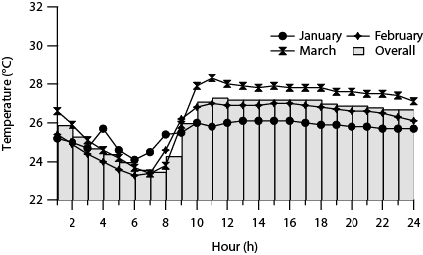
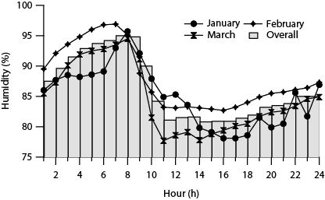
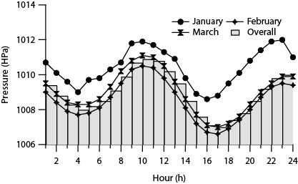
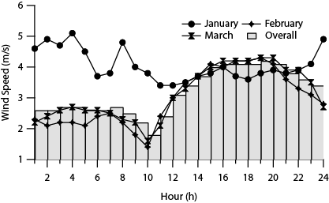
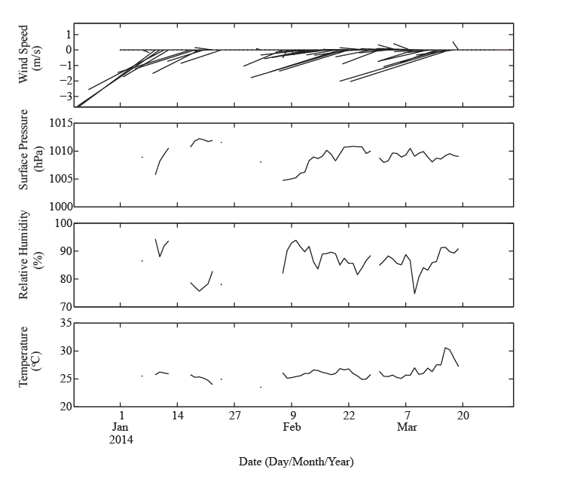
b(i)
b(iii)
b(ii)
b(iv)
(a)

Fig. 1. Variation on meteorological variables during three months sampling periods (January
to March, 2014) in Bachok area :(a) Daily variation; (b) Diurnal variation
Mode 1
Mode 4
Mode 2
Mode 3
Fig. 2. Dendrogram of hourly average of PNC (0.27 μm ≤ Dp ≤ 4.50 μm) for three-month periods (January – March, 2014)

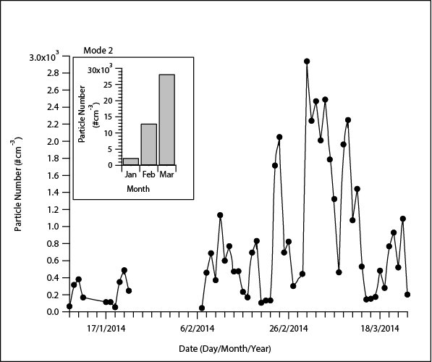
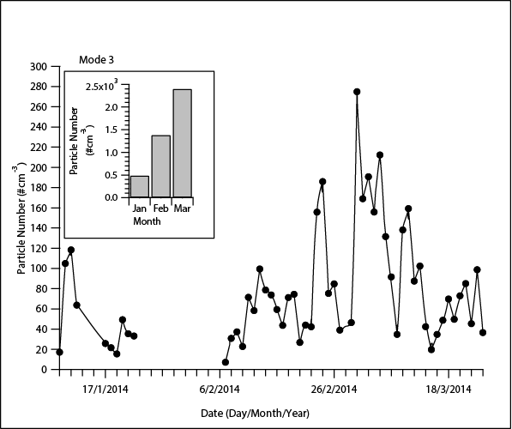
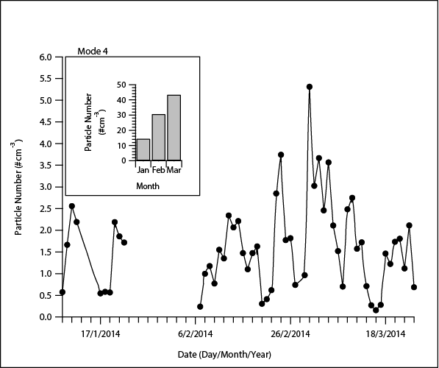
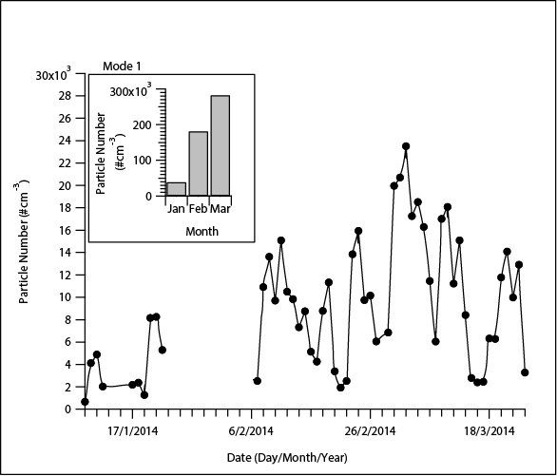
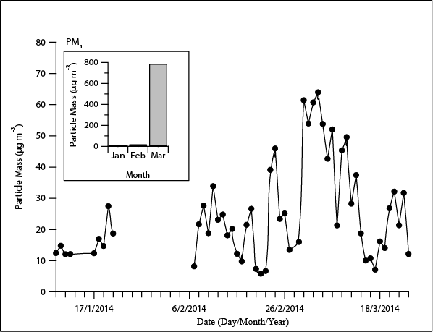
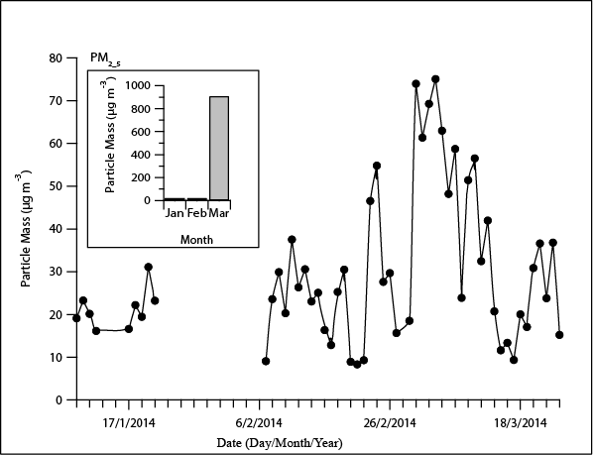
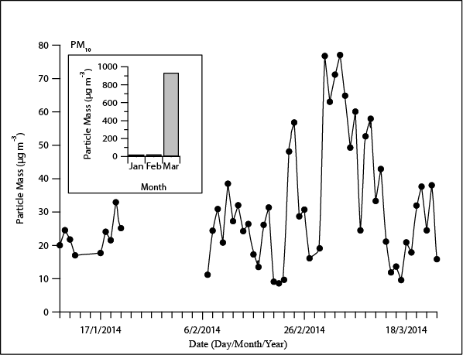
Biomass Episode
(a)(ii)
Biomass Episode
(a)(iii)
Biomass Episode
(a)(iv)
Biomass Episode
(a)(i)
Biomass Episode
Biomass Episode
Biomass Episode
(b)(i)
(b)(ii)
(b)(iii)

Fig.3. Daily and monthly variation on pollutants from January to March, 2014 in Bachok: (a) Particle Number, (b) Particle Mass

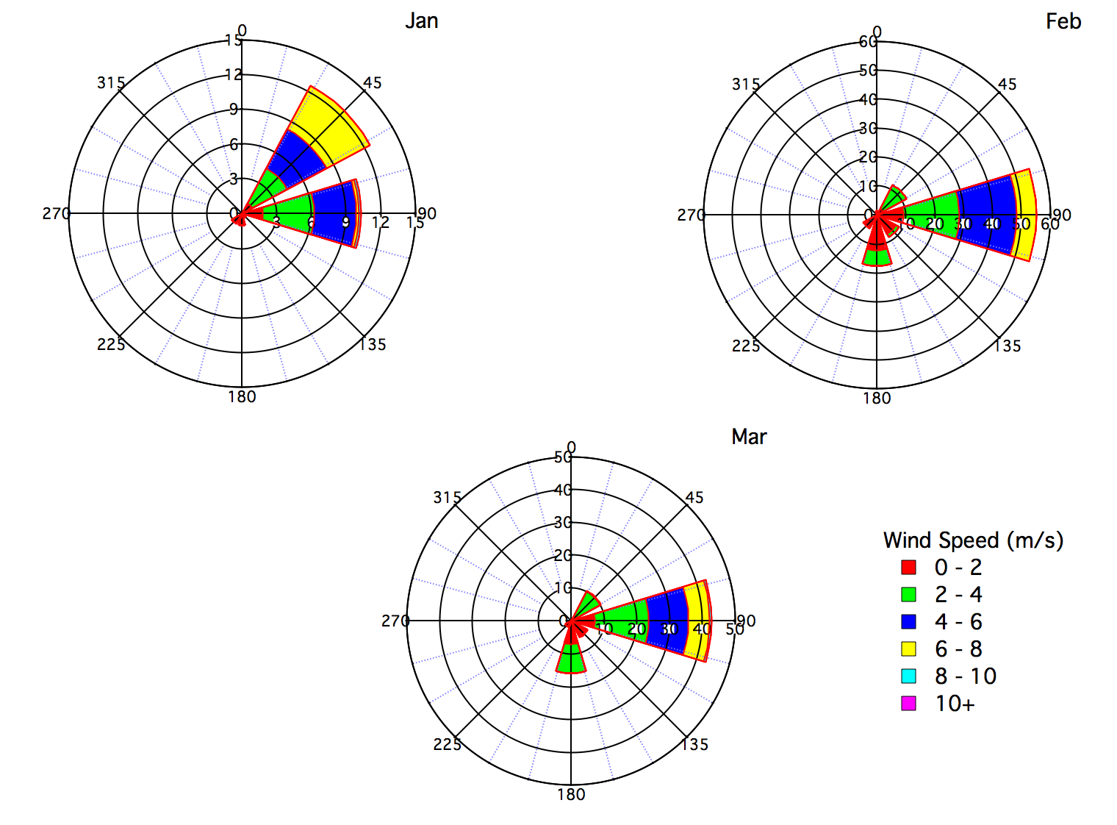
b(i)
b(iii)
b(ii)
a(i)
a(ii)
a(iii)
a(iv)

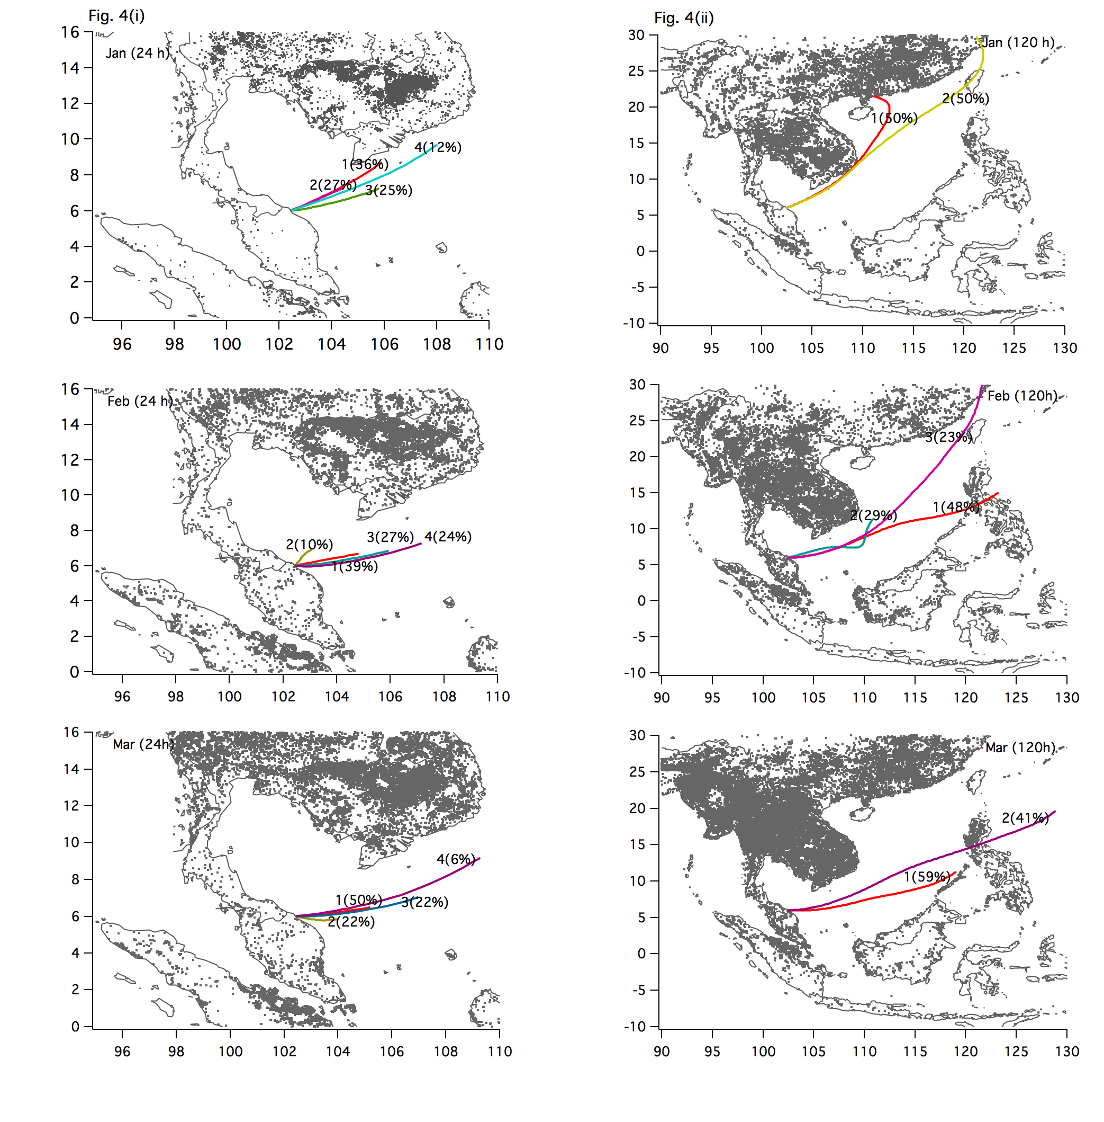
b(i)
b(iii)
b(ii)
a(i)
a(ii)
a(iii)
a(iv)

Fig. 6. Diurnal variation on pollutants in Bachok for January to March, 2014: (a) Particle Number , (b) Particle Mass
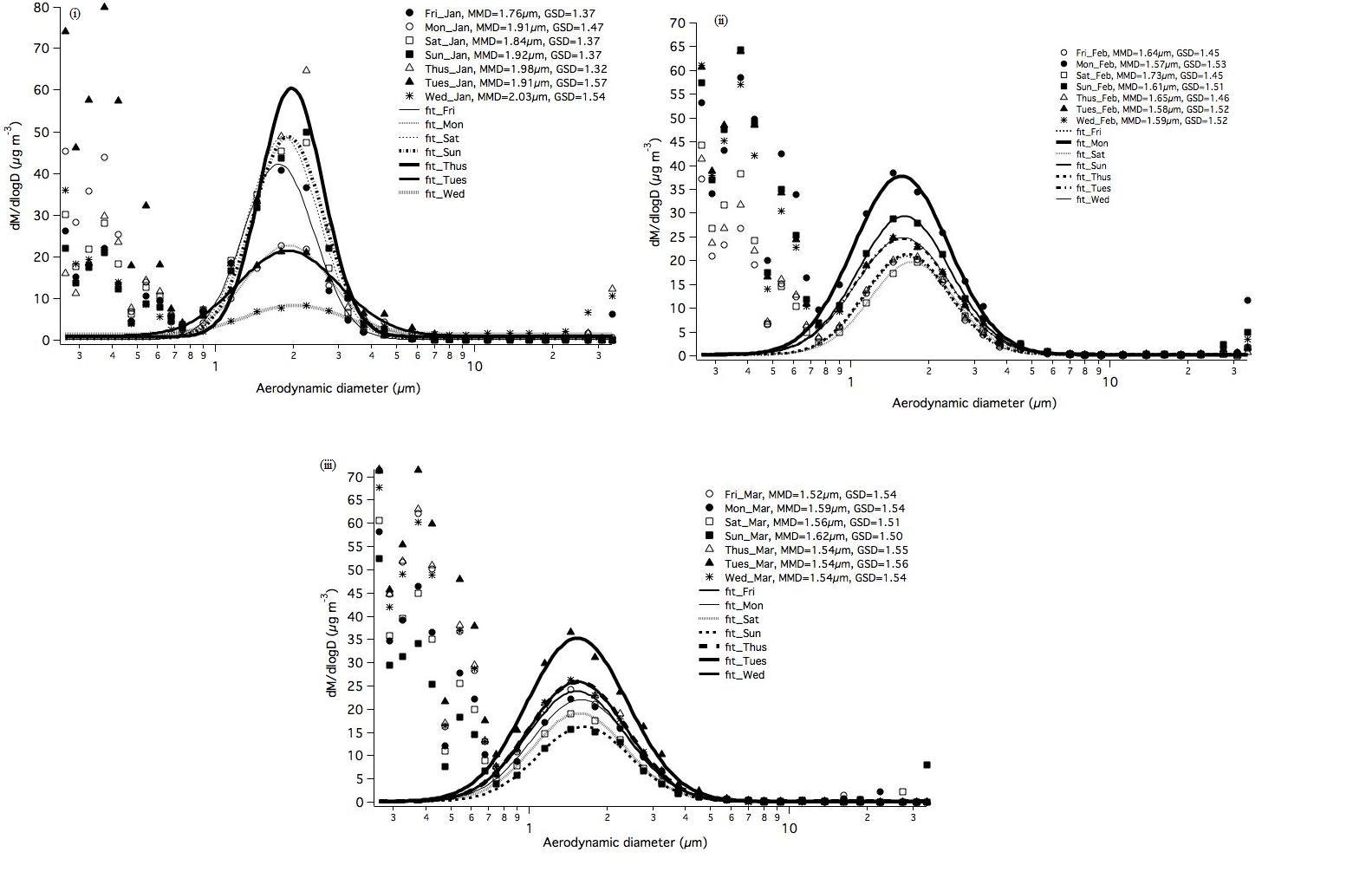

Fig. 7. Lognormal fitting on particle mass distribution for weekly (Monday- Sunday) for each month at Bachok, Kelantan (i) January 2014, (ii) February 2014 and (iii) March 2014

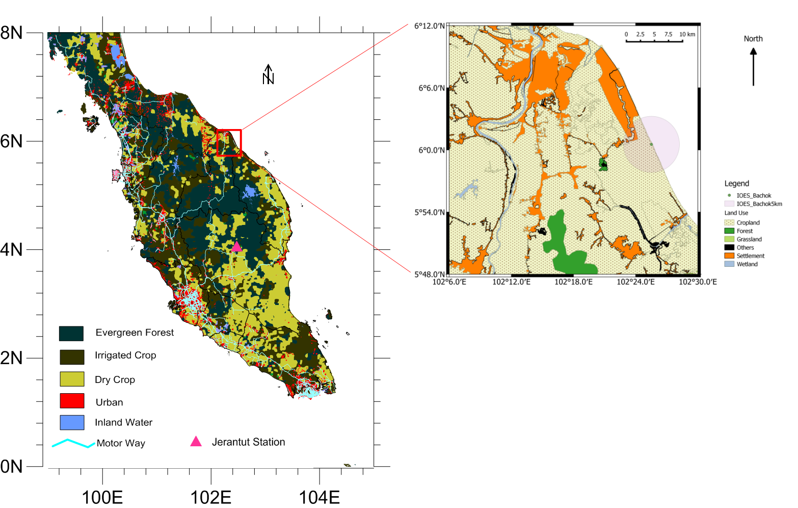
Supplementary 1. Location and the land use map of study area, Bachok Kelantan, Malaysia
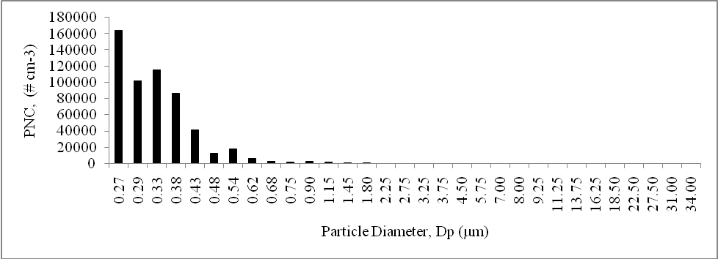

Supplementary 2. Distribution of total number of particles for three-month period (January – March, 2014) in Bachok

