Hot Melt Extruded Transdermal Films based on Amorphous Solid Dispersions in Eudragit RS PO: The Inclusion of Hydrophilic Additives to Develop Moisture-Activated Release Systems

Esra’a Albarahmieh^{a,1}, Sheng Qiª, Duncan Q.M.Craig^{b*}

ª School of Pharmacy, University of East Anglia, Norwich, Norfolk NR4 7TJ, UK
^{b} University College London School of Pharmacy, 29-39 Brunswick Square, London WC1N 1AX, UK
¹ Current address: School of Applied Medical Sciences, German Jordanian University, 35247 Amman 11180, Jordan

*Correspondence author: duncan.craig@ucl.ac.uk

Abstract

A series of Eudragit RS PO-based hot melt extruded films were evaluated as potential transdermal systems, with particular emphasis on the inclusion of hydrophilic excipients to allow water sorption, which in turn would allow drug release on application to the skin. More specifically, sucrose, methyl cellulose, xanthan gum (Xantural®75), poloxamer (Pluronic®F127), Gelucire 44/14 were added to Eudragit RS PO and assessed in terms of physical structure (modulated temperature DSC (MTDSC), thermogravimetric analysis (TGA), powder XRD (PXRD), scanning electron microscopy(SEM)) and in vitro drug release and permeation properties. In addition, the effect of prior hydration on drug permeation was studied for selected systems. Phase separation was noted for sucrose, methylcellulose (high loading), xanthan gum (high loading), poloxamer and Gelucire 44/14 (high loading) using both visual observation and MTDSC. PXRD studies indicated drug crystallization within the phase separated systems. SEM studies broadly followed the same pattern. Dissolution studies indicated that the hydrophilic excipients considerably enhanced the release rate, while Franz diffusion cell studies showed a much greater variability in effectiveness, which we ascribe to the paucity of water of hydration present which would not allow swellable additives such as xanthan to release the drug. However, films containing Gelucire 44/14 emerged as the most satisfactory systems, despite the higher additive loaded systems showing drug phase separation. This may be related to emulsification rather than swelling on contact with water, as noted for the permeation studies involving pre-hydration. This strategy therefore presents a promising approach for triggered transdermal drug delivery, activated by hydration from the skin itself.

Keywords:

Transdermal, polymeric drug delivery systems, amorphous, solid dispersions, hot melt extrusion, hydration, excipients, physicochemical characterization.

1. Introduction

Hot melt extrusion (HME) technology presents a range of opportunities to design innovative drug delivery systems, including patches within the field of transdermal delivery. HME possesses several advantages over traditional solvent casting methods for the preparation of patches, including continuous processing and avoidance of residual solvent [1-4]. Similarly, the transdermal route offers potential advantages of improved drug pharmacokinetics, elimination of gastrointestinal absorption problems and the hepatic first pass effect, reduction of dosing and improved patient compliance [5,6].

In this study we investigate a new approach whereby we include hydrophilic agents in inert HME films which, on hydration, will potentially facilitate drug release. The model drug used was ibuprofen ([2-(4-isobutyl-phenyl) propionic acid], C₁₃H₁₈O₂, molecular weight 206.28). Despite having the most favourable safety profile of the non-steroidal anti-inflammatory agents (NSAIDs) [7], ibuprofen may nevertheless cause gastrointestinal tract (GIT) problems if administered orally, hence there is continued interest in developing a transdermal delivery approach for ibuprofen that can circumvent such problems [8-13]. The selection of ibuprofen in this study for processing via HME is also of particular interest, particularly in relation to possible improvements in polymer extrudability due to the ability of this drug to act as a plasticizer during processing [14-15].

In this work, Eudragit RS PO was used as the base polymer. This material is a glassy copolymer synthesized from acrylic acid and methacrylic acid esters with 5% of functional quaternary ammonium groups and has been used to prepare numerous dosages forms due to its biocompatibility and biological safety [16-17]. It is one of the recognized materials for hot melt extrusion [18] as well as for transdermal applications [19-21]. Indeed, the relatively high viscosity of Eudragit RS PO on heating while dispersive mixing leading to molecular amorphous dispersion has been previously noted [22-23]. Therefore, the high concentration and thermodynamic activity of ibuprofen that can be achieved in this polymer may enhance its skin permeability. Here, hydrophilic excipients were investigated for formulation with Eudragit RS PO to enable creation of moisture-triggered delivery systems that may be hydrated by the skin itself. Sucrose, methyl cellulose and xanthan gum were selected due to their hydrophilicity and tolerable immunological profiles for skin applications. Pluronic® F127 or poloxamer 407 and Gelucire 44/14 were also used as amphiphilic excipients that can act as solubilising agents. Pluronic® F127 is a non-ionic tri-block copolymer of polyoxyethylene(PEO)-polyoxypropylene(PPO)-polyoxyethylene (PEO) [24] with an HLB value of 22 [25]; this material is considered to be non-irritant and non-sensitising in topical and transdermal applications [26-27]. Gelucire® 44/14, with HLB value of 14, is a mixture of monoesters, diesters and triesters of glycerol, and monoesters and diesters of polyethylene glycols [28] that belongs to the lauryl polyoxylglycerides (macroglycerides) family. Because of its numerous pharmaceutical applications, such as self-emulsification [29], and biocompatibility [27,30], this material was investigated as an adjuvant to modulate the drug release properties from the transdermal patch systems.

Here we examine the effects of hydrophilic agent inclusion on the physical structure and in vitro drug release properties of ibuprofen dispersions in Eudragit RS PO. More specifically, we explore the concept of using a system which is inert on storage but which acts as an occlusive layer when placed on the stratum corneum, thereby resulting in water uptake into the film. This water would then alter the structure of the film so as to allow drug permeation; such alterations may include plasticization, swelling or emulsification. Furthermore, the use of an amorphous solid dispersion of the drug in the film may maximise the thermodynamic activity of the drug compared to the crystalline form, in turn aiding permeation. Here, we examine the relationship between composition, structure and release in order to evaluate the approach but also as a means of identifying the most promising systems for further study and development.

2. Materials and Methods

2.1 Materials

Crystalline ibuprofen was kindly donated by BASF (25 US Quality) and Eudragit RS powder (PO) grade by Evonik Röhm Pharma polymers. Other excipients possessing hydrophilic character used include sucrose (Sigma-Aldrich), methylcellulose (Colorcon), Xantural®75 (CPkelco), Pluronic® F127 (BASF), Gelucire 44/14 (Gattefossé SA, Saint Priest, France).

2.2. Methods

2.2.1 Preparation of hot melt extruded ibuprofen based on Eudragit RS PO

Physical mixtures of the drug and the carrier blend of Eudragit and other hydrophilic excipients were prepared by simple mixing in a pestle and mortar. The mixes were fed into a co-rotating twin screw extruder (Haake Minilab II Micro Compounder, Thermo Scientific, Germany) equipped with a slit (sheet) die (orifice). Determination of the minimum ratio between these components was based on 30% w/w ibuprofen loading. Each batch size was formulated with total weight of 10 grams. Temperatures of 90-100˚C from the feed to the die end were used according to the formulation prepared and a screw speed was set at 100 rpm for four minutes, which was found to be suitable for the extrusion of these mixtures. The resultant extruded films were cooled along a customised conveyer belt to room temperature. These films were separated into unit doses (patches) of roughly equal size (approximately 24 mm³). The films were stored between aluminium sheets, except for the ones containing Gelucire 44/14, which were stored between silicone sheets due to their high tack. The extrudable mixtures obtained as described above were characterised using techniques of MTDSC, PXRD and SEM and compared when appropriate with the equivalent physical mixes. The level of tackiness of the films was measured qualitatively for the current purposes by holding these films between thumb and index finger; for further developmental studies more quantitative methods such as texture analysis are available. The in vitro drug release experiment (dissolution test) and in vitro permeation studies were also carried out for the selected optimised formulations. These experiments are detailed in the following sections.

2.2.2 Analytical methods

Modulated temperature DSC (MTDSC) measurements were carried out using TA Instrument DSC Q1000, equipped with a refrigerated cooling system (RCS). Calibration was performed prior to each analysis; temperature calibration was performed using indium, benzoic acid and n-octadecane, while heat capacity calibration was performed using aluminium oxide. Data were analysed using TA Universal Analysis 2000 software and nitrogen was used as the purge gas through the DSC cell at a flow rate of 50 ml/min. TA instruments standard pans were used for all calorimetric studies and the mass of each empty sample pan was matched to the mass of the empty reference pan within ±0.05 mg and all measurements were performed in triplicate. For the MTDSC experiments, an amplitude of ±0.265°C, period of 100 seconds and underlying heating rate of 1°C/min were used. The samples were subjected to two steps in this method. The first step was equilibration at -70˚C, isothermal heating for 5 minutes followed by a second step of heating to 100˚C. The glass transition temperatures (Tgs) were in all cases taken at the midpoint of the transitions from the reversing heat flow signals. All measurements were performed in triplicate. Thermal stability of the materials was studied using thermogravemetric analysis, which was performed using TGA Q5000 IR (TA Instruments, U.K). Samples (10.00-12.00 mg) were subjected to a single step of heating from 30°C to 300˚C at a heating rate of 10˚C min⁻¹. All TGA runs were performed in open aluminium pans with a dry nitrogen gas purged at flow rates of 25 ml min⁻¹ and 10 ml min⁻¹ through the furnace and TGA head, respectively. Data were treated mathematically using TA Universal Analysis 2000 software to illustrate weight loss percentage and weight derivative loss signals. The extrusion temperatures were selected on the basis of their being below the decomposition temperature of the component with the lowest thermal stability (see Appendix A). The water content in the hydration study was also measured using TGA and samples (~10 mg) were heated at 10°C/min from 30°C to 250°C.

Qualitative powder X-ray diffraction (PXRD) was used to detect crystalline ibuprofen in the extruded samples as compared to the respective physical mixes. Analysis was performed using an X-ray powder diffractometer (ARL Xtra, manufactured by Thermo Fisher Scientific) equipped with X-ray tube (Copper, wavelength of 1.540562 Angstrom) over the 2Ө range from 2 to 60 degrees, scanning speed of 1.2˚/min (step: 0.01 degree, 0.5 sec/step) using a 40 kV generator and a 20 mA stream.

Scanning electron microscopy (SEM) was used to visualise crystalline ibuprofen of the extruded samples and thus detecting any sign of phase separation on that basis. For that purpose, morphological features of the surface and cross sections of the extruded formulations were examined. The samples were mounted onto stubs using double-sided tape and were gold coated, in order to increase conductivity of the electron beam, by a Polaron SC7640 sputter gold coater manufactured by Quorum Technologies (UK), using Plasma current of 20 mA, Voltage: 2.1 kV for 30 seconds. The photographs taken were obtained using scanning electron microscope (JSM 5900LV, manufactured by JEOL,Japan) fitted with a tungsten (W) filament, acceleration voltage of 20 kV and 10 mm working distance.

2.2.3 In vitro drug release (dissolution) studies

Drug release studies were performed using the paddle and vessel assembly with the addition of a stainless steel basket. The design of this hybrid basket-paddle system was adapted from Grundy et al. [31], yielding the advantage of high agitation from the paddle apparatus combined with floatation prevention using the basket apparatus.

Hot melt extruded films based on Eudragit RS PO, formulated with different hydrophilic excipients at 30% (w/w) drug loading were cut manually and the dimensions were measured with an electronic digital caliper (MS092 Toolzone Vernier Caliper, UK). The films had similar dimensions of approximately 6mm x 4mm x 1mm (length, diameter, thickness). In all the experiments under sink condition, the dissolution medium consisted of 900 ml phosphate buffer solution (PBS, pH 7.2) was maintained at 37.0 ±0.1°C using a dissolution bath (Copley Apparatus, UK), and the stirring rate was set at 100 rpm. Samples (5 mL) were withdrawn at specified time intervals, replacing the same volume with the fresh dissolution medium. The samples were then filtered using a 0.20 µm filter (Sartorious stedim biotech Minisart®) and analyzed using UV spectrophotometer (PerkinElmer, Lambda XLS) at λ_{max} determined for ibuprofen (223 nm).

2.2.4 In vitro permeation (diffusion) studies

In vitro drug permeation testing is an important tool for the characterisation of transdermal systems and has been shown, in some cases at least, to provide a good correlation with biological response [32]. A Franz Cell diffusion system (PermeGear Inc., Hellertown, PA, USA) composed of six 9-mm vertical diffusion cells with identical characteristics were used to measure the release of ibuprofen from different formulae through silicone membranes. Jacketed Franz cells were connected to a water bath maintained at 37°C. However, the measured temperature in the donor chambers was approximately 32±1°C, mimicking normal skin temperature [33]. The receptor chambers were filled with 5ml phosphate buffer (pH 7.2). The silicone membranes (Specialty Silicone Products Inc.,USA, 102 µm thickness) were cut into suitable sizes to cover the diffusion areas of the diffusion cells (0.79 cm²), and were placed between donor and receptor chambers. Silicone membranes were selected because of their rate limiting characteristics akin to those of skin [34]. These membranes were soaked previously in isopropyl myristate (IPM) for 1 hour, as the latter has bipolar properties that tend to mimic the biochemical composition of the skin [35-36].

Eudragit RS PO-based hot melt extruded films (approximate dimensions of 6mm x 4mm x 1mm) loaded with ibuprofen at 30% w/w loading were tested.The sampling ports and the donor chambers were covered with double layers of Parafilm® to minimise evaporation from the openings. The receptor solution was maintained in sink conditions with respect to the drug and stirred at a fixed speed of 500 revolutions per minute. Aliquots of 0.2 ml were taken of the receptor phase, at specified time intervals, and evaluated spectrophotometrically at a wavelength of 223 nm. To best characterise the permeation properties of ibuprofen in the used experiment design without vehicle influence i.e. Eudragit RS PO, a saturated solution of ibuprofen in PBS medium (pH 7.2) was run in a similar procedure to the extruded films using a volume of 0.3 ml to fill the donor chamber.

2.2.5 Hydration study

To probe the influence of hydration on the enhancement of ibuprofen permeation across silicon membranes, the release from 10% (w/w) xanthan gum), 10% (w/w) Gelucire 44/14) and 20% (w/w) Gelucire 44/14 was assessed under two conditions, namely Test 1 and Test 2.

In Test 1, the extruded films in the Franz-diffusion donor chamber were immersed with 0.3 ml (maximum capacity of this chamber) of the phosphate buffer medium (pH=7.2), which is also used in the receptor phase; this took place just before testing. The second condition (Test 2) was exposing fresh films to a controlled relative humidity of 95% at 25°C using DVS machine (TA Q5000 SA analyzer, TA Instruments Ltd., UK). The films were held at this humidity level for 3 hours to achieve near equilibrium at this condition prior application to the Franz Cell diffusion system. Samples were placed into tared hemi-sphere quartz sample crucibles (180 μL). Analyses were performed using TA Universal Analysis 2000 software.

All results of in vitro release and permeation studies were expressed as mean±standard deviation. Statistical analysis involved application of ANOVA and t-tests as appropriate. These tests were performed using Analysis toolPak software from Microsoft®office 2013.

3. Results and Discussion

3.1 Impact of hydrophilic excipients on solid-state properties of drug-loaded Eudragit RS PO films

For the majority of the extruded films, transparent systems were produced even at drug loadings of 30% (w/w) ibuprofen. The amount of hydrophilic excipient added to the parent polymer (Eudragit RS PO) was initially selected at two levels for each system, low (6:1:3 Eudragit RS PO: additive: ibuprofen) and high (1:6:3 Eudragit RS PO: additive: ibuprofen). The higher loading was only possible for methylcellulose and xanthan gum; the second level was not achievable for sucrose, poloxamer and Gelucire 44/14 as the extruded material was liquid and could not stream into the outlet (die). Instead, a higher excipient level of 5:2:3 Eudragit RS PO: additive: ibuprofen was used with Gelucire 44/14 with only the low levels used (6:1:3) for sucrose and poloxamer. Table 1 summarises the systems under study based on these initial tests.

The visual examination of the successfully extruded films is described in Table 1, along with the reference terms for each formulation. It was noted that the high xanthan gum and methyl cellulose as well as the low sucrose systems all showed a cloudy appearance; this may be a reflection of either the excipient or the drug. There were also differences in the physical appearance in terms of texture, with the methylcellulose showing a rough and cracked appearance.. Extruded films which contained Gelucire 44/14 were found to have the highest observed tack, whereas films containing poloxamer, sucrose or low level of xanthan gum (FM5) showed medium tack profiles. This is an important feature to address, as tack or “stickiness” would facilitate the film adhering to the skin but may also be a difficulty associated with large-scale manufacture.

Table 1: Overview of the appearance and tactile properties of Eudragit RS PO-based hot melt extruded films loaded with ibuprofen

Carrier system(s)  With drug loading of  30% w/w | Carrier composition (% w/w polymer :additive) | Formula code | Extrusion temperature  (°C) | Translucency | Appearance
Eudragit RS PO | 70 | FM0  (Control) | 100 | √ | Smooth, no cracks, low tack.
Eudragit RS PO/ Sucrose ratio | 60:10 | FM1 | 100 | X | Smooth, no cracks, medium tack.
Eudragit RS PO/  Methyl cellulose  ratios | 60:10 | FM3 | 100 | √ | Rough, no cracks, low tack.
Eudragit RS PO/  Methyl cellulose  ratios | 10:60 | FM4 | 100 | X | Rough, cracked, no tack.
Eudragit RS PO/ Xanthan gum ratios | 60:10 | FM5 | 100 | √ | Smooth, no cracks, medium tack.
Eudragit RS PO/ Xanthan gum ratios | 10:60 | FM6 | 100 | X | Smooth, sporadic cracks, low tack.
Eudragit RS PO/ Poloxamer ratio | 60:10 | FM7 | 90 | √ | Smooth, no cracks, medium tack.
Eudragit RS PO/ Gelucire 44/14 ratios | 60:10 | FM9 | 90 | √ | Smooth, no cracks, high tack.
Eudragit RS PO/ Gelucire 44/14 ratios | 50:20 | FM10 | 90 | √ | Smooth, no cracks, high tack.

The MTDSC responses of representative samples are shown in Figures 1-3. The reversing heat flow signals were used to assign the glass transition temperature (midpoint-Tg), whereas the melting endotherm was identified from the total heat flow signals. Dehydration of sorbed water (residual) led to broad endothermic peaks in non-reversing signals over an approximate temperature range of 30 to 90°C exemplified in Figure 2.

From these DSC studies, it was found that extruded formulations of FM0 (Eudragit RS PO and ibuprofen), FM3 (low level of methylcellulose), FM5 (low level of xanthan gum) and FM9 (low level of Gelucire 44/14) were characterized by single glass transition temperatures drawn from reversing heat signals (mean values) around 9.6±0.2°C, -3.5±1.6°C, -6.7 ± 0.9 °C and 1.5±0.7°C, respectively (Figure 1). This implies a one-phase system (i.e. a molecular dispersion of drug and the carrier blend) at these extruded compositions.

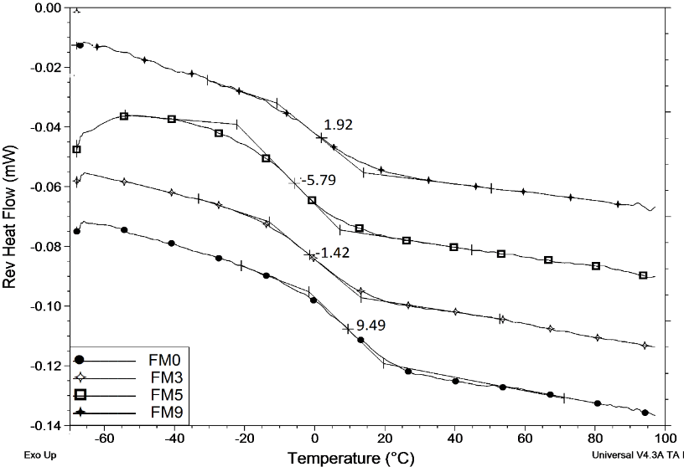

Figure 1: MTDSC reversing heat flow signals for hot melt extruded films (see Table 1 or text for their compositions)

On the other hand, phase separation can be observed in all other extruded formulations as shown in Figure 2-3.The addition of sucrose (FM1) or high level of methyl cellulose (FM4) led to melting endotherms around 51.2±1.2°C or 60.8±0.2 (Tm _{(onset)}), respectively. We tentatively interpret these peaks as depressed melting point of ibuprofen, implying that the inclusion of these excipients at this composition has led to crystallization of the ibuprofen (Tm _{(onset)} 75.7±0.2˚C). Similarly, inclusion of high level of Xantural® 75 (xanthan gum) resulted in multiple peaks which indicates a relatively complex phase separation profile (Figure 2). Likewise, the formulation containing an increased level of Gelucire 44/14 (FM10; Figure 2) resulted in a glass transition at 21.8±0.4°C. However, a second phase was detected with an exotherm having an extrapolated onset temperature around 5.4±1.1°C and peak temperature at 17.6±0.2°C, followed by an endothermic melting peak (Tm _{(onset)} 29.3±1.5°C). It is not clear whether this peak represents ibuprofen or Gelucire 44/14 although this issue will be addressed using PXRD in a subsequent section.

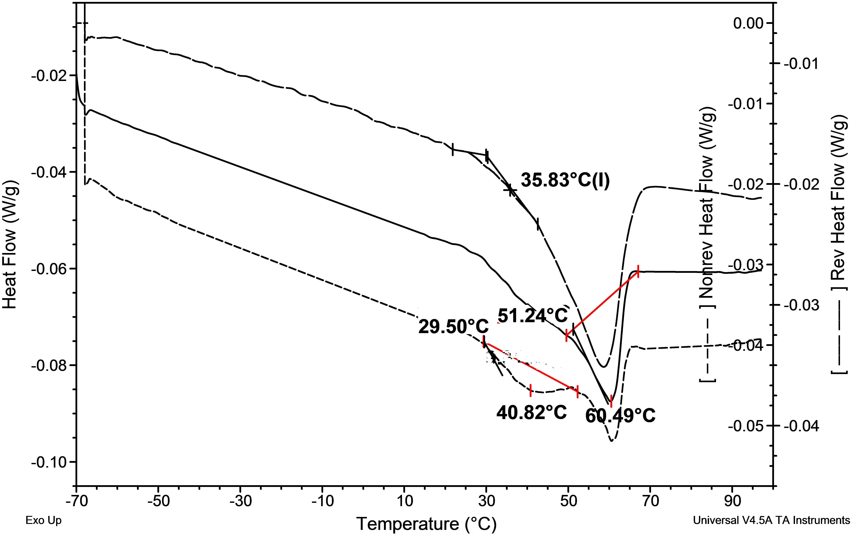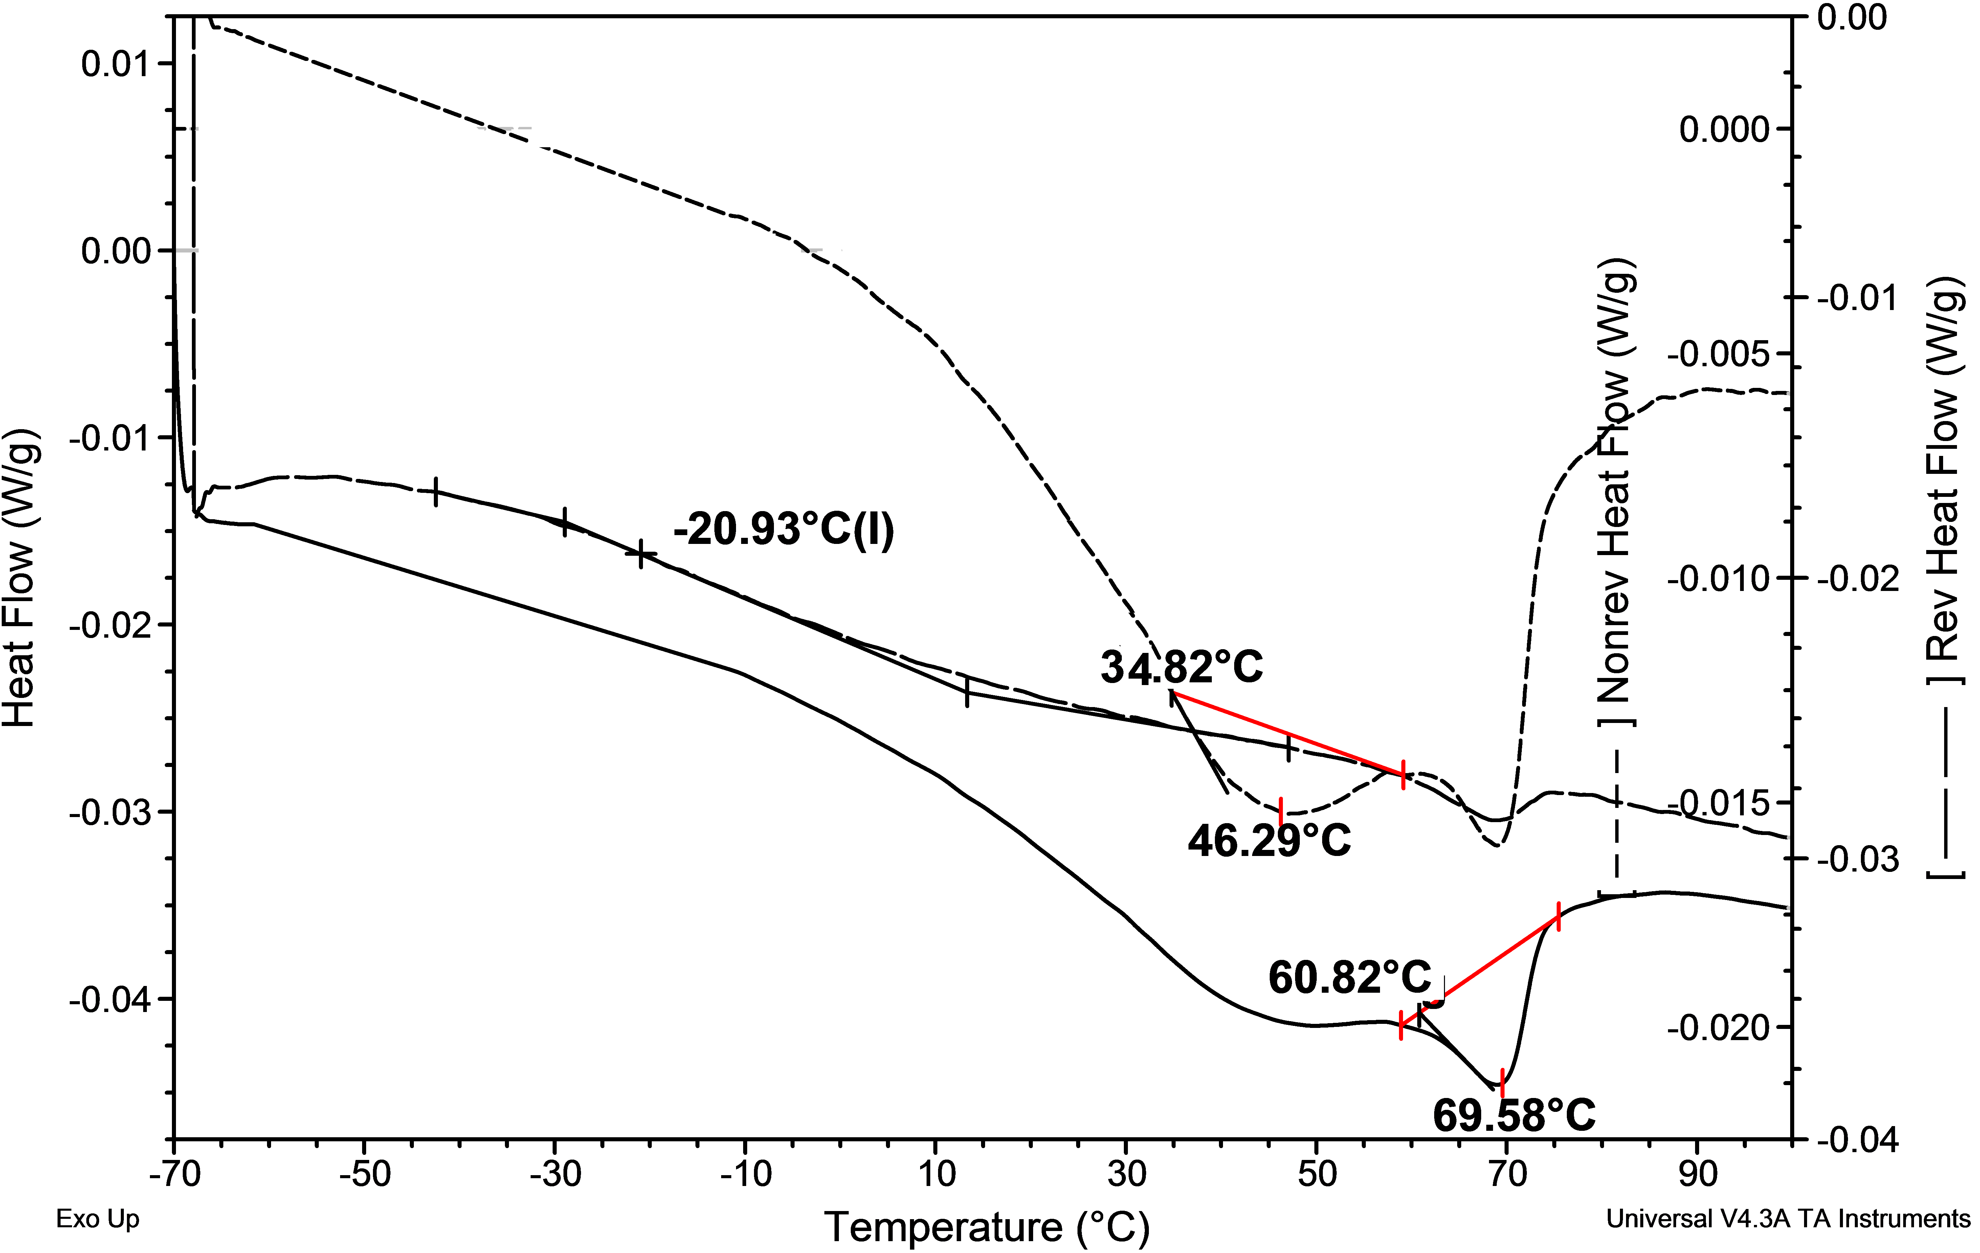
FM1 FM4
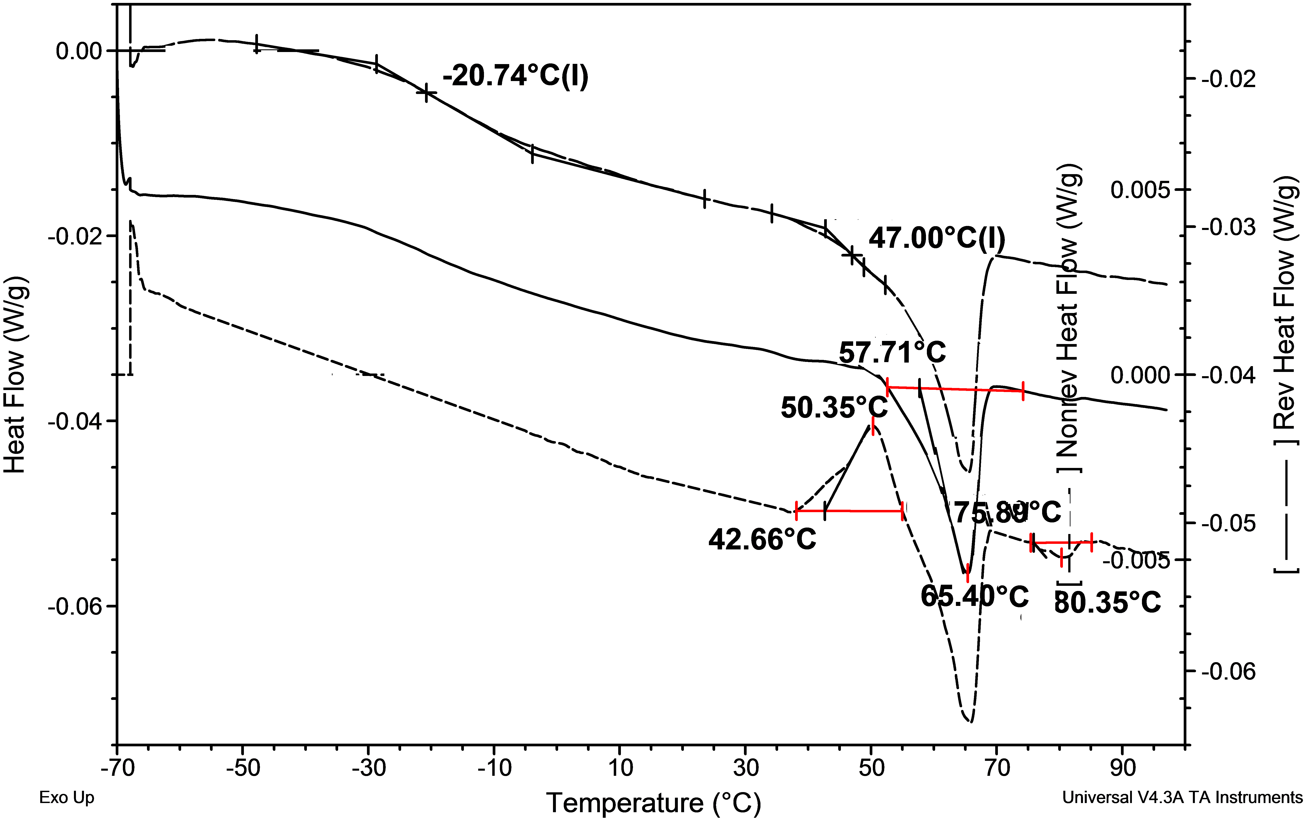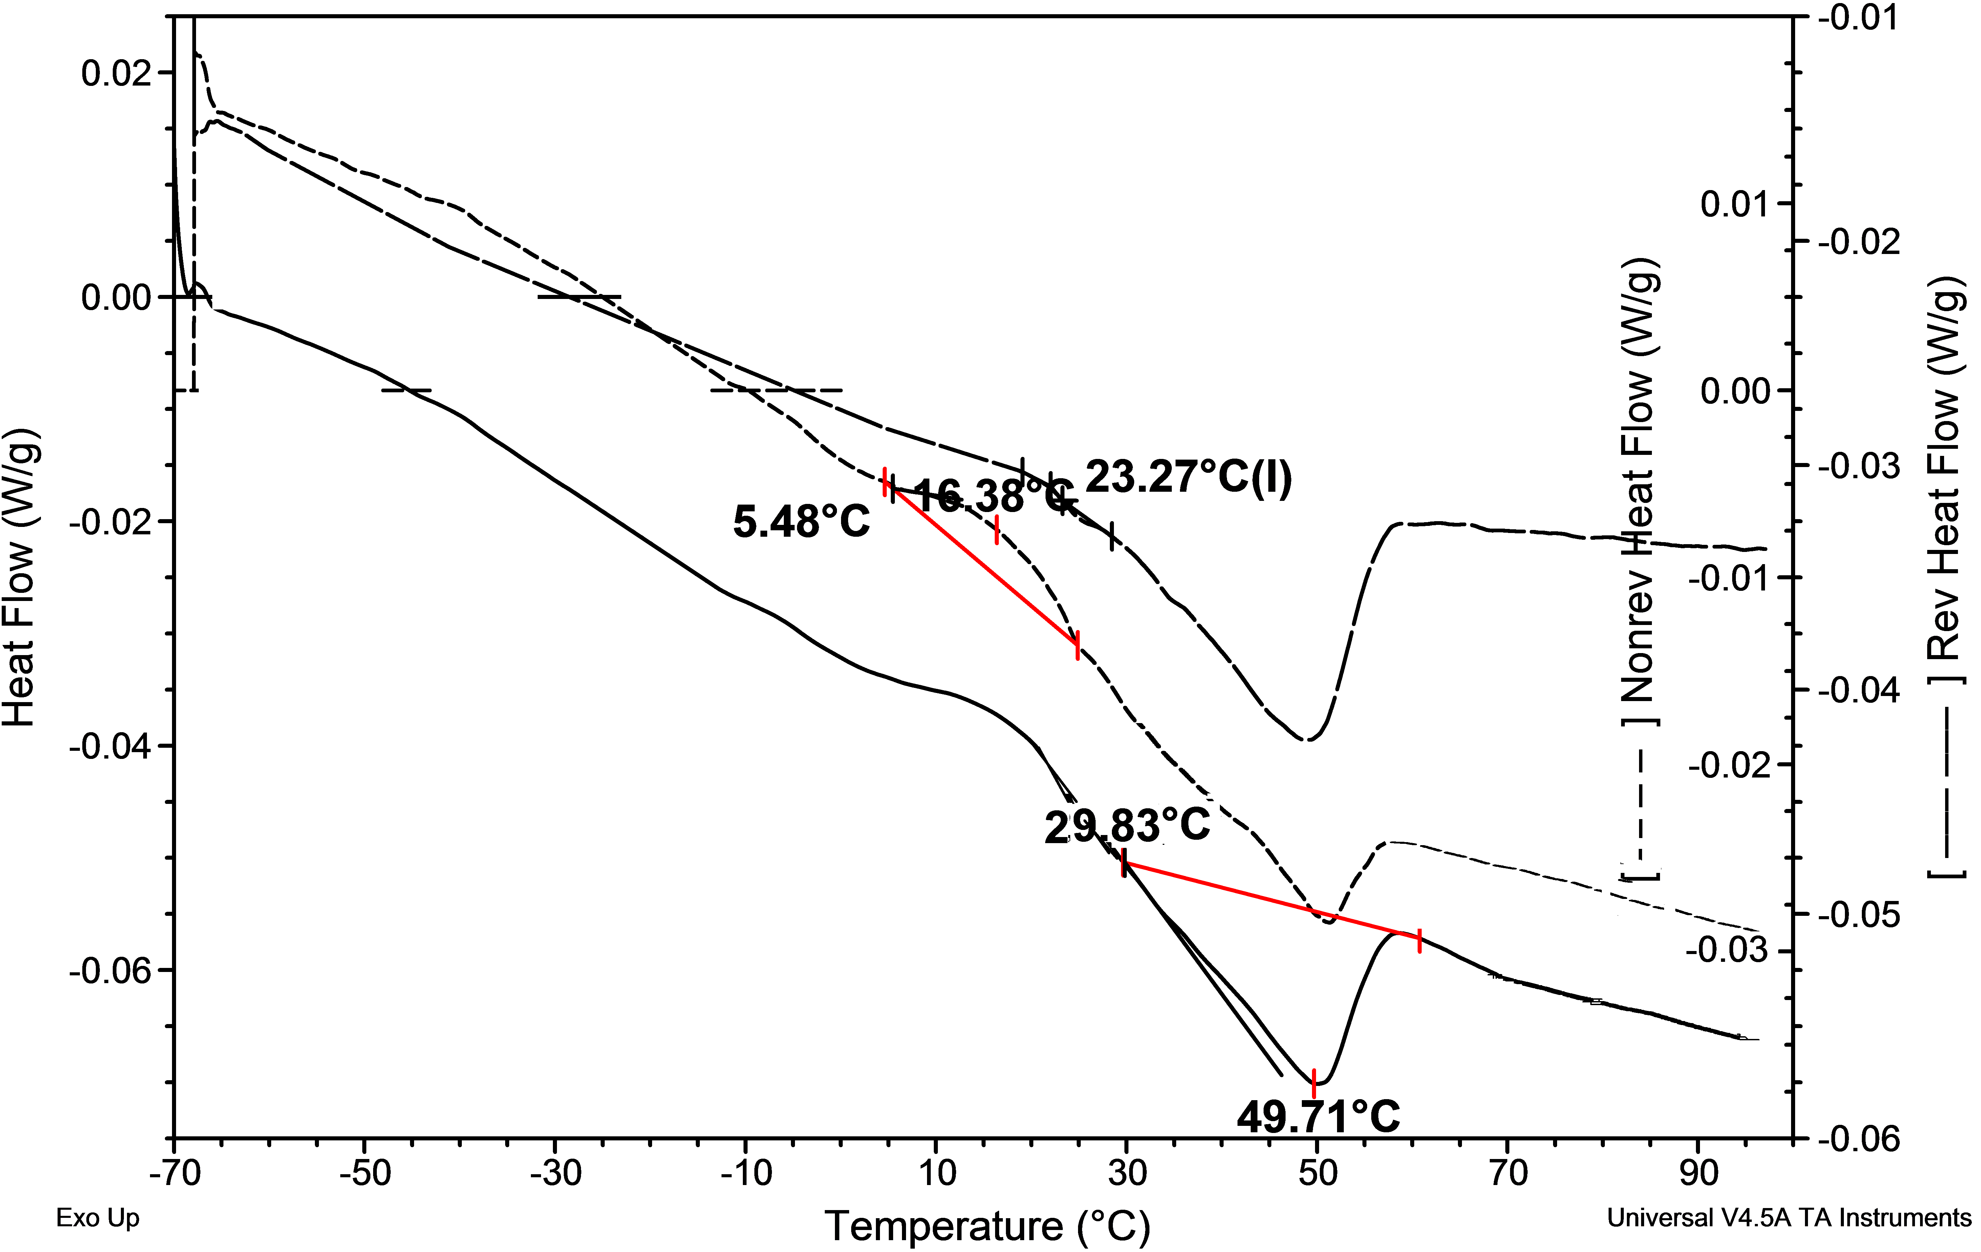
FM6 FM10

Figure 2: MTDSC heating scan of hot melt extruded ibuprofen for FM1 composition (Sucrose, Eudragit RS PO and ibuprofen; 1:6:3), FM4 (high level of Methylcellulose, Eudragit RS PO and ibuprofen; 6:1:3), FM6 (high level of Xanthan gum, Eudragit RS PO and ibuprofen; 6:1:3) and FM10 (high level of Gelucire 44/14, Eudragit RS PO and ibuprofen; 2:5:3) compositions

Phase separation was also evident in the poloxamer (Pluronic® F127) system (FM7) as illustrated in Figure 3. It is believed that Pluronic® F127 is separating rather than the drug, as a melting transition was noted with an extrapolated onset temperature at 47.4±2.9°C and peak temperature at 56.2±1.9°C which correlated well with the values obtained from the melting of this semi-crystalline polymer (Pluronic® F127) in the physical mix of FM7 (extrapolated onset temperature at 49.5±0.8°C and peak temperature at 53.5±0.1°C). A mean glass transition temperature at -5.4±1.5°C was also observed.

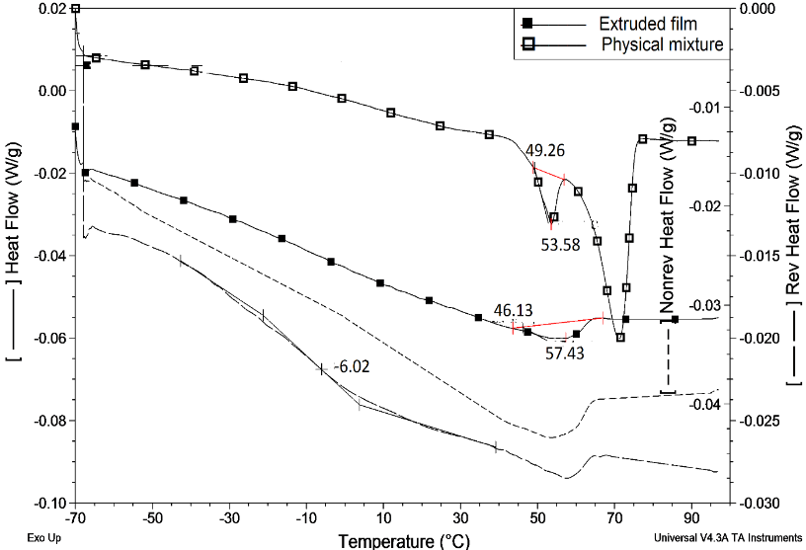

Figure 3: MTDSC heating scan of FM7 hot melt extruded film containing poloxamer Eudragit RS PO ibuprofen ratio of (1:6:3)

Powder XRD

X-ray powder diffraction profiles are shown in Figure 4 for three formulations as examples of typical responses, with both extrudates and physical mixes shown as well as the profiles of the raw materials. Figure 4A and B shows the response of crystalline ibuprofen to facilitate identification of phase separation of the drug. Figure 4A shows the responses of the poloxamer systems (FM7) while Figure 4B shows the responses of the Gelucire 44/14 (low and high additive content, FM9 and FM10).

Broad halo scattering profiles were obtained for the extruded films of FM0 (Eudragit RS PO and ibuprofen), FM3 (low level of methyl cellulose), FM5 (low level of xanthan gum), and FM9 (low level of Gelucire 44/14), indicate homogenous amorphous systems in each case (data not shown). However, peaks from the halo patterns for extruded films of FM1 (Eudragit RS PO 60% (w/w) and sucrose 10% (w/w) as carriers), FM4 (high level of methyl cellulose) and FM6 (high level of xanthan gum), indicating the presence of crystalline ibuprofen. These observations were consistent with the previous MTDSC results and the visual observations. However, the PXRD pattern of the FM7 extruded sample identified both poloxamer and ibuprofen crystals as shown in Figure 4(A).

In Figure 4(B), the higher levels of Gelucire 44/14 in FM10 extruded films showed peaks corresponding to ibuprofen crystals but not to Gelucire 44/14 itself. Thus, it could be inferred that the phase separation of the FM10 extruded films resulted in drug crystallization rather than the lipid itself, with the corresponding melting endotherm observed in the MTDSC profile (Figure 2). This is a surprising result, as one usually associated lipids with being in the crystalline form at temperatures below their melting points.

Figure 4: X-ray powder diffraction profiles comparing crystalline raw materials with the corresponding physical mixtures and their equivalent hot melt extruded films for (A) FM7 composition (poloxamer, Eudragit RS PO and ibuprofen), (B) FM9 (low level of Gelucire 44/14, Eudragit RS PO and ibuprofen) and FM10 (high level of Gelucire 44/14, Eudragit RS PO and ibuprofen) compositions

Scanning electron microscopy

SEM studies were conducted on the extruded samples with exemplar images given in Figure 5. Some degree of phase separation was evident in all tested films except FM0 (ibuprofen and Eudragit RS PO), FM5 (low level of xanthan gum) and FM9 (low level of Gelucire 44/14) films. Films comprising higher levels of methylcellulose (FM4) or containing sucrose (FM1) showed protruding or lined crystals, both on the surface and cross section of these extrudates. Similarly, at higher levels of xanthan gum (FM6) and at 10% (w/w) poloxamer (FM7), the resulting extruded films showed crystalline structures, but mainly on the surface. Interestingly, the formulation of FM3 films (low levels of methylcellulose) showed fine granules which may be related to ibuprofen crystals. Drug recrystallization in these samples was undetected using MTDSC or PXRD, suggesting that the small amount of crystalline material present may be below detection limits of these methods, which have been reported to be approximately 5% [37].

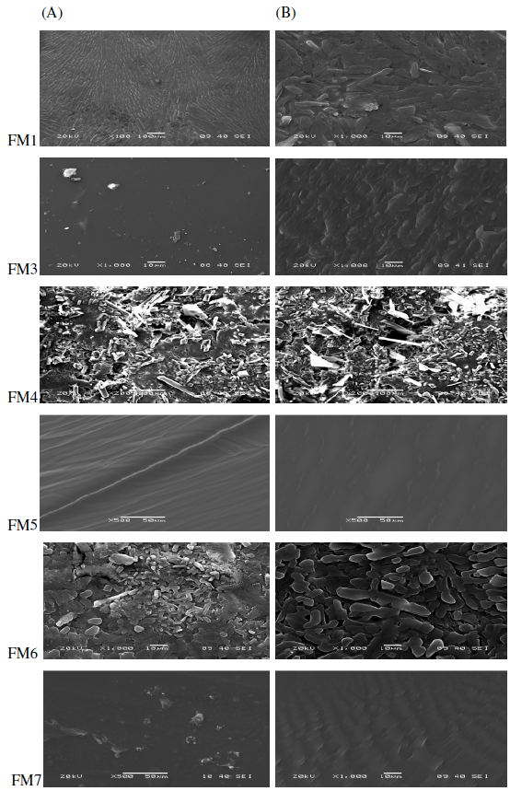

Figure 5: SEM morphological features of the surfaces (column A) and cross sections (column B) obtained for different fresh extruded films loaded with ibuprofen (see text or Table 1 for their compositions)

For the films containing Gelucire 44/14, the surface morphology of the low lipid loaded films (FM9) did not indicate phase separation, while needle-shape crystals appeared for the higher lipid content (FM10) films (data not shown). It was noted that the SEM imaging process itself did appear to cause damage to these lipid-loaded film surfaces, as evidenced by visible macroscopic changes; such effects are well known and are a result of the heating effects generated by the use of the electron beam. Therefore, SEM is not suitable to detect morphological features of these samples.

To summarise, the purpose of the study thus far is to address two approaches that are potentially important for transdermal flux of an agent (drug): (i) the generation of molecular dispersions in enhancing effective drug concentration or its activity by developing extruded films; and (ii) the influence of using a hydrophilic component to allow hydration on contact with the skin and activate and/or improve the drug release. For some compositions, the hot melt extrusion process has resulted in the production of transparent films, with a single glass transition temperature (MTDSC analysis), the absence of crystalline diffraction peaks of ibuprofen and the absence of crystals as detected using SEM, all of which indicate molecular dispersions of the drug in the films. These outcomes were associated with the following compositions; FM0 (Eudragit RS PO as a carrier), FM5 (low level of xanthan gum), and FM9 (low level of Gelucire 44/14). It was therefore concluded that ibuprofen was molecularly dissolved in these films at a 30% (w/w) drug concentration. Separation of the drug phase as crystallites can be observed in all other formulations, particularly FM1 (with sucrose), FM4 (high level of methylcellulose) and FM6 (high level of xanthan gum) films.

3.2 Comparison of the in vitro release of ibuprofen from hot melt extruded formulations

Hot melt extruded films of ibuprofen in Eudragit RS PO alone (control) and with sucrose, methyl cellulose, xanthan gum, poloxamer and Gelucire 44/14 were evaluated for their release behaviour using in vitro drug release testing in phosphate buffer (pH 7.2) at 37°C over 24 hours.

As illustrated in Table 2, the films formulated with Eudragit RS PO alone (FM0) showed poor drug release. In the case of formulations containing Eudragit RS PO in combination with sucrose (FM1) or low level of methyl cellulose (FM3), no statistically significant change in cumulative percent release was found (P>0.05). However, hot melt extruded films of FM4 (high level of methylcellulose), FM5-FM6 (formulated with xanthan gum), FM7 (poloxamer) and FM9-FM10 (formulated with Gelucire 44/14) demonstrated enhanced release profiles.

Table 2: Ibuprofen extruded formulations, extent of phase separation (number of observed phases) and physical appearance along with drug crystalline state and in vitro release in phosphate buffer (pH 7.2) at 37°C (see text or Table 1 for their compositions)

Formulation Code | Ibuprofen release at 24 hours  (w/w %) | Number of observed phases | Detected crystalline ibuprofen
FM0 | 21.6±0.2 | One | X
FM1 | 21.8±0.3 | Three | √
FM3 | 25.5±0.1 | One | √
FM4 | 99.0±0.2 | Two | √
FM5 | 82.7±0.1 | One | X
FM6 | 94.4±0.7 | Three | √
FM7 | 42.9±2.5 | Two | √
FM9 | 58.2±3.0 | One | X
FM10 | At 4 hours: 98.1±1.2 | Two | √

Based on the enhanced release and as is evident from Table 2, formulations of FM5 films (10% (w/w) xanthan gum and 60% (w/w) Eudragit RS PO as carriers) and FM9 films (10% (w/w) Gelucire 44/14 and 60% (w/w) Eudragit RS PO as carriers) appear to be the most encouraging formulations, as they also present a potential for promoting drug permeation through ibuprofen amorphous dispersion. However, FM7 films with 10% (w/w) poloxamer and FM10 films with 20% (w/w) Gelucire 44/14 were found to be extremely effective for improved and rapid ibuprofen delivery, despite the fact that these formulations contain crystalline ibuprofen as predicted from PXRD results. This therefore raises the issue of whether molecular dispersion is indeed a prerequisite for effective performance in terms of their permeation (flux) properties.

3.3 In vitro release (permeation) studies of the selected formulations

3.3.1 Permeation evaluation

Permeation evaluation was performed using an in vitro model of Franz diffusion cells fitted with silicone membranes. As a benchmark, saturated solutions of ibuprofen in PBS (pH 7.2) were examined (data not shown) and the permeation of the total amount of the ibuprofen was almost completed after 6 hours with circa 97.8% cumulative percent permeation.

In Figure 6, films based only on Eudragit RS PO (FM0) showed poor ibuprofen permeability due to the very low release from the extruded films. However, in contrast to the observed enhanced release (dissolution) behaviour, the ibuprofen permeation profile from the FM5 extruded films (10% (w/w) xanthan gum and 60 % (w/w) Eudragit RS PO as carriers) was even lower than control films containing Eudragit RS PO alone (data not shown here). This can be explained by swelling characteristics of the xanthan gum polymer included in these films; this hydrophilic polymer requires a sufficiency of water to swell and enhance drug release [38-39], as shown in Figure 7. However, the only available water to be absorbed therein was the evaporated water from the receptor medium in the Franz cells, which appears not to be enough for this swelling to take place.

For poloxamer loaded films (FM7), the permeation profile was enhanced with circa 26% drug permeation after three days in comparison with a total of about 9% drug permeated after the same period from the control films (FM0) as seen in Figure 6. The inclusion of Gelucire 44/14 in Eudragit RS PO films showed a maximum of circa 22% of the total drug permeated after three days from FM9 films which contained the lower Gelucire content (10% w/w). However, a marked increase in the permeation was detected using FM10 formulation (higher Gelucire content) as compared to other formulations tested here. More specifically, these films showed a permeation of nearly 45% of the loaded ibuprofen after four days (Figure 6). However, the drug permeation was still not complete over the course of the experiment i.e. five to seven days. This may be related to lack of sufficient hydration and will be explored in the following section.

Figure 6: Ibuprofen diffusion profiles from hot melt extruded films of FM0, FM7, FM9 and FM10 formulations tested approximately at 32°C and permeated across silicone membranes into phosphate buffer solution (pH=7.2) at 37°C. Each data point represents the mean±S.D. of no less than three measurements

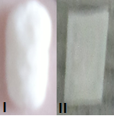

Figure 7: Photographs illustrating the swelling changes of the hot melt extruded films of ibuprofen with Eudragit RS PO and xanthan gum (FM5) post the dissolution experiment:(I) swelled, and removed from Franz cells post testing: (II) no swelling

3.3.2 Evaluation of hydration influence on ibuprofen permeation from hot melt extruded formulations in vitro

Hydration corresponds to one of the most effective and safe penetration enhancement techniques to breach the skin barrier [40]. To explore how hydration may also affect permeation from optimized formulations, two categories of films were selected. Firstly, films whereby the ibuprofen is not crystalline in the fresh samples were selected (FM5 (10% (w/w) xanthan gum) and FM9 (10% (w/w) Gelucire 44/14)). The second type of film chosen is the one that achieved the maximum permeation of the drug, namely, the FM10 (20% (w/w) Gelucire 44/14) films. The relationship between drug permeation and hydration level inside the Franz cells was examined.

Figure 8 shows the permeation profiles of untreated (non-hydrated) samples compared to the samples hydrated using 0.3 ml of the phosphate buffer (pH=7.2) in ‘Test 1’. It is clear that this pre-hydration provoked a significant enhancement in the permeation profiles (P<0.05). The maximum drug permeation was 85.4% after 72 hours from FM5 films (xanthan gum), 98.9% after 96 hours from FM9 films (low level of Gelucire 44/14) and around 94.3% after 5 hours from FM10 films (higher level of Gelucire 44/14).

Additionally the samples were conditioned at a controlled level of humidity using the DVS at 95%RH/25°C for three hours and examined for their in vitro permeation behaviour (Figure 9, Test 2). The water content of these samples was measured using TGA and compared to the non-hydrated samples as shown in Figure 9. This increase in the water content resulted in a profound change of the drug permeation in comparison with non-hydrated samples (control) as depicted in Figure 8. An increase in the percent of the drug permeated was noticed but in a slower rate than samples exposed to the hydration level in ‘Test 1’ (Figure 10).

(A)

(B)

(C)

Figure 8: Ibuprofen diffusion profiles from hot melt extruded films of (A) FM5 (60% (w/w) Eudragit RS PO and 10% (w/w) xanthan gum as carriers), (B) FM9 (60% (w/w) Eudragit RS PO and 10% (w/w) Gelucire 44/14 as carriers) and (C) FM10 (50% (w/w) Eudragit RS PO and 20% (w/w) Gelucire 44/14 as carriers) tested approximately at 32°C and permeated across silicone membrane into phosphate buffer solution (pH=7.2) at 37°C. Control: samples without hydration. Test 1: each sample was placed in 0.3 ml of PBS (pH=7.2) in the donor chamber of the Franz cells. Test 2: samples were moistened at 95%RH/25°C for three hours prior testing in the Franz cells. Each data point represents the mean±S.D. of no less than three measurements

Figure 9: Summary of the measured percentage water contents of different hot melt extruded films (see text for their compositions) determined by TGA on freshly basis immediately after extrusion (before treatment) and after incubation at 95%RH/25°C for three hours in the DVS (after treatment)

Figure 10: The time corresponding to 80% or higher of the average cumulative percentage permeation of the ibuprofen (over 96 hours) from hot melt extruded films of Eudragit RS PO-based films containing Xanthan gum (FM5 composition), Gelucire 44/14 (FM9 and FM10 compositions) tested approximately at 32°C and permeated across silicone membrane into phosphate buffer solution (pH=7.2) at 37°C. Test 1: each sample was placed in 0.3 ml of PBS (pH=7.2) in the donor chamber of the Franz cells. Test 2: samples were moistened at 95%RH/25°C for three hours prior testing in the Franz cells

The samples of FM5(xanthan gum) films had clearly swelled after being hydrated in Test 1 and Test 2, assuming the shape of the diffusion area (circular) of the Franz cells. Similarly, FM9 films exposed to hydration were swelled and jellified adapting the shape of the diffusion area. This could take place as a function of the swelling of Gelucire 44/14 in these systems as expected after contact with aqueous medium as other Gelucires [41]. With the increase in both hydration level (Test 1) and increased amount of hydrophilic component in the FM10 formulation (20% (w/w) Gelucire 44/14) compared to FM9, the samples became homogenous liquid-like emulsions. Figure 10 exemplifies the shape deformation of different films after permeation experiment or otherwise after being hydrated externally under glass slides to illustrate the liquid-like consistency of FM10 films following Test 1.

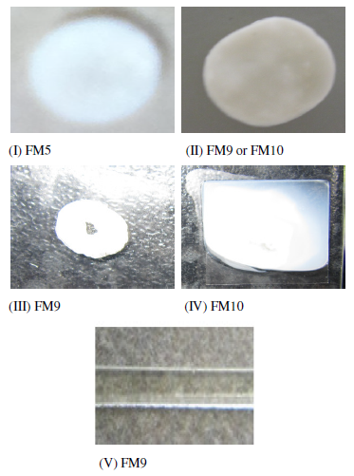

Figure 11: Representative photographs of shape and consistency changes of hot melt extruded films removed from Franz cells post testing (I,II) and exposed to 0.3 ml PBS (pH=7.2) at 32°C to imitate Test 1 condition over three hours and under glass slides (III,IV). (I) FM5 films (10% (w/w) xanthan gum) after Test 1 and Test 2. (II) FM9 films after Test 1 and Test 2 or FM10 after Test 2. (III) FM9 films (10% (w/w) Gelucire 44/14). (IV) liquid-like emulsion of hydrated FM10 films (20% (w/w) Gelucire 44/14). (V) Represnts an example of the shape of these films prior testing

Overall, pre-hydration was essential to achieve improved drug permeation from the studied systems. The greatest permeation was noted for the higher hydration conditions (Test 1) applied to the higher Gelucire content FM10 films. This lipid excipient is associated with favourable solubilisation [42-43], permeation enhancement [30] and self-emulsifying [27, 44-46], hence while the consistency and performance need to be considered in conjunction for any system that can be used in practice, the inclusion of this excipient does appear to show particular promise as a means of achieving water-induced release of the drug from the transdermal film.

4. Conclusions

Hot melt extruded films of ibuprofen (30%(w/w)) were prepared using Eudragit RS PO alone and in combination with different hydrophilic additives to develop transdermal systems with suitable drug release and permeability triggered by hydration from the skin itself. Changes of the molecular distribution of the drug took place with different compositions (carrier excipient type and the ratio used), with films composed of Eudragit RS PO, ibuprofen and lower amounts of xanthan gum (FM5) or Gelucire 44/14 (FM9) noted as being molecular dispersions.
These compositions, together with formulations that showed superior release profiles with acceptable physical features, were selected for further study and included FM7 (poloxamer) and FM10 (~20% (w/w) Gelucire 44/14) films. Pre-hydration, especially in films containing Gelucire 44/14, was notably influential and indicated that water sorption from the skin could potentially act as a trigger for drug release for these systems. Of the candidate systems studied, those containing Gelucire 44/14 were considered to be particularly promising as, depending on the level included, the key features of molecular dispersion, suitable film characteristics and favourable release performance under conditions of low hydration are all achievable. The study has therefore indicated that it is indeed possible to develop systems that may release the incorporated drug triggered by low hydration, as may be achieved using an occlusive film system applied to the stratum corneum.

Acknowledgements

The author would like to thank German Jordanian University for their financial support. We would also like to acknowledge the contribution made by Professor Adrian Williams (University of Reading) as some of the key concepts associated with project arose as a result of discussions with him.

Appendix A

Table A.1: Summary of the thermal properties of the raw materials (as received) intended for processing via HME, as estimated from the used TGA and MTDSC techniques. *: Tg was measured for amorphous sample prepared by quench cooling method.**: corresponds to the onset of the secondary endothermic peak while the leading melting endotherm corresponds to the small leading shoulder-like endotherm at 32.1±1.4°C (Tm _{(onset)}): see Figure A.1.

Tested material | Estimated thermal stability range (°C) | Estimated melting point temperature (Tm_{(onset)},°C) | Estimated glass transition temperature  (Mid-point Tg,°C)
Ibuprofen | <140 | 75.7±0.2 | -43.4±0.2
Eudragit RS PO | <170 | - | 53.3±0.5
Sucrose | <187 | 175.2±1.8 | -
Methyl cellulose | <200 | - | 103.0±0.1
Xantural®75 | <235 | - | 37.7±2.6
Pluronic® F127 | <163 | 54.2±1.2 | -63.5±0.7
Gelucire 44/14 | <150 | 39.5±0.8* | -

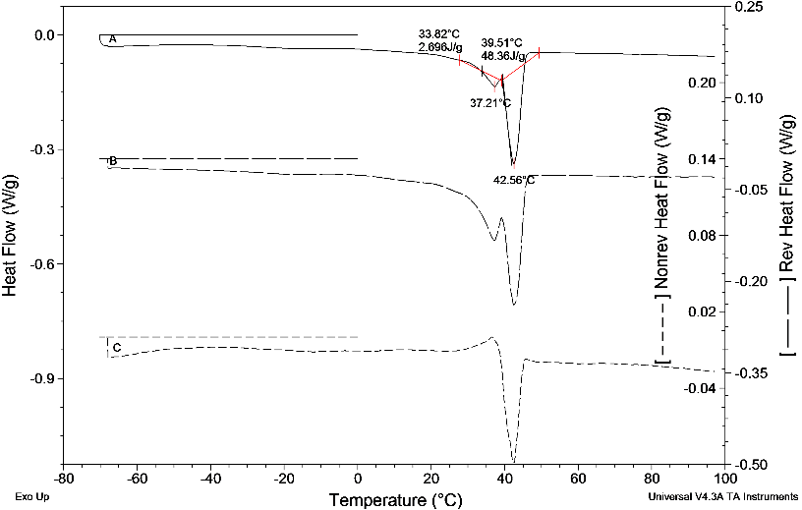

Figure A.1: MTDSC heating scan of Gelucire 44/14 in standard aluminium pans. Underlying scan rate of 1°C min⁻¹ with a modulation amplitude of ±0.265°C and a period of 100 seconds

References

[1] Breitenbach, A., Drews, R., Messe, C., Wolff, H-M. (2009). Transdermal delivery of (R)-3, 3-Diphenyl-propylamin-monoestern. US Patent 2009/0274761A1.

[2] Crowley, M.M., Justin, M.K., Koleng, J.J., Zhang, F. (2009). Process for the preparation of a hot-melt extruded laminate. EP2010366 A2.

[3] Munjal, M., Stodghill, S.P., Elsohly, M.A., Repka, M.A. (2006). Polymeric systems for amorphous Delta 9-tetrahydrocannabinol produced by a hot-melt method. Part I: chemical and thermal stability during processing. J Pharm Sci. 95(8): 1841-1853.

[4] Palem, C.R., Kumar B.S., Maddineni, S., Gannu, R., Repka, M.A., Yamsani, M.R. (2013). Oral transmucosal delivery of domperidone from immediate release films produced via hot-melt extrusion technology. Pharm Dev Tech. 18(1): 186-195.

[5] Cevec, G., Vierl, U. (2010). Nanotechnology and the transdermal route: A state of the art review and critical appraisal. J Control Release. 141: 277-299.

[6] Delgado-Charro, M.B., Guy, R.H. (2001). Transdermal Drug Delivery, in Drug Delivery and Targeting for Pharmacists and Pharmaceutical Scientists (ed Hillery, A.M., Lloyd, A.W., Swarbrick, J). London and New York: Taylor & Francis. Ch8: 208-236.

[7] Potthast, H., Dressman, J.B., Junginger, H.E., Midha, K.K., Oeser, H., Shah, V.P., Vogelpoel, H., Barends, D.M. (2005). Biowaiver monographs for immediate release solid oral dosage forms: Ibuprofen. J Pharm Sci. 94(10): 2121-2131.

[8] Al-Saidan SM. (2004). Transdermal self-permeation enhancement of ibuprofen. J Control Release. 100(2): 199-209.

[9] Bazigha KAR., Eman FA, Sahar AF, Heyam SS, Saeed,AK. (2010). Development and evaluation of ibuprofen transdermal gel formulations. Tropical J. of Pharm.Res. 9:355-363.

[10] Cilurzo F, Minghetti P, Casiraghi A, Tosi L, Pagani S, Montanari L. (2005). Polymethacrylates as crystallization inhibitors in monolayer transdermal patches containing ibuprofen. Eur J Pharm Biopharm .60(1): 61-66.

[11] Ghosh B, GB P, Akmisher R, Parcha V. (2010). Transdermal delivery of ibuprofen and its prodrugs by passive diffusion and iontophoresis. Int J Pharm Pharm Sci. 2(1):79-85.

[12] Iervolino M, Cappello B, Raghavan SL, Hadgraft J. (2001). Penetration enhancement of ibuprofen from supersaturated solutions through human skin. Int J Pharm .212(1): 131-141.

[13] Stott PW, Williams AC, Barry BW. (1998). Transdermal delivery from eutectic systems: enhanced permeation of a model drug, ibuprofen. J Control Release .50(1–3): 297-308.

[14] Kidokoro, M., Shah, N., Malick, A.W., Infeld, M.H., McGinity, J.W. (2001). Properties of Tablets Containing Granulations of Ibuprofen and an Acrylic Copolymer Prepared by Thermal Processes. Pharm Dev Tech. 6(20): 263-275.

[15] Siepmann, F., Le Brun, V., Siepmann, J. (2006). Drugs acting as plasticizers in polymeric systems: A quantitative treatment. J Control Release. 115: 298-306.

[16] Fujimori, J., Yoshihashi, Y., Yonemochi, E., Terada, K. (2005). Application of Eudragit RS to thermo-sensitive drug delivery systems .ІІ. Effect of temperature on drug permeability through membrane consisting of Eudragit RS/PEG 400 blend polymers. J Control Release. 102: 49-57.

[17] Josephine, L.J., Mehul, R.T., Wilson, B., Shanaz, B., Bincy, R. (2011). Formulation and in-vitro evaluation of floating microspheres of Anti-Retro viral drug as a gastro-retentive dosage form. Int J Res Pharm Chem. 1(3): 519-527.

[18] Andrews, G.P., Jones, D.S., AbuDiak, O., Margeston, D.N., McAllister, M.S. (2009). Hot-melt extrusion: an emerging drug delivery technology. Pharm Tech Europe. 21(1): 18-23.

[19] Cilurzo, F., Tosi, L. (2006). Transdermal Patches Having A Silicone Adhesive Matrix Stabilized With Methacrylic Coploymers. US Patent 2006/0015077 A1.

[20] Gohel, M.C., Nagori, S.A. (2009). Fabrication of Modified Transport Fluconazole Transdermal Spray Containing Ethyl Cellulose and Eudragit RS 100 as Film Formers. AAPS PharmSciTech. 10(2): 684-691.

[21] Kusum, D.V., Saisivam, S., Maria, G.R., Deepti, P.U. (2003). Design and evaluation of matrix diffusion controlled transdermal patches of verapamil hydrochloride. Drug Dev In Pharm. 29(5): 495-503.

[22] Kim, B.K., Hwang, S.J., Park, J.B., Park, H.J. (2002). Preparation and characterization of drug-loaded polymethylacrylate microspheres by an emulsion solvent evaporation method. J Microencapsul. 19(6): 811-822.

[23] Kolter, K., Karl, M., Gryczke, A. (2010). Hot-Melt Extrusion with BASF Pharma Polymers. Extrusion Compendium. 2nd Edition. Germany ISBN 978-3-00-039415-7.

[24] Cunha-Filho, M.S.S., Alvarez-Lorenzo, C., Martinez-Pacheco, R., Landin, M. (2012). Temperature-Sensitive Gels for Intratumoral Delivery of β-Lapachone: Effect of Cyclodextrins and Ethanol. The Scientific World Journal. 1-8.

[25] Chi, S-C., Tan, H-K, Chun, H-W. (1996). Anti-inflammatory and analgesic transdermal gel. US patent 5527832.

[26] Escobar-Chávez, J.J., López-Cervantes, M., Naïk, A., Kalia, Y.N., Quintanar-Guerrero, D., Ganem-Quintanar, A. (2006). Applications of thermo-reversible pluronic F-127 gels in pharmaceutical formulations. J Pharm Sci. 9(3): 339-358.

[27] Rowe, R., Sheskey, P.J., Quinn, M.E.ed. (2009). Handbook of Pharmaceutical Excipients. 6th Edition. London. Chicago: Pharmaceutical Press.

[28] Antunes, A.B., Geest, B.G. Vervaet, C., Remon, J.P. (2013). Gelucire 44/14 based immediate release formulations for poorly water-soluble drugs. Drug Dev In Pharm. 39(5): 791-798.

[29] Barker, S., A., Yap, S., Yuen, K., McCoy, C., Murphy, J., Craig, D.Q.M. (2003). An investigation into the structure and bioavailability of α-tocopherol dispersions in Gelucire® 44/14. J Control Release. 91: 477-488.

[30] Li, X., Nie, S., Kong, J., Li, N., Ju, C., Pan, W. (2008). A controlled-release ocular delivery system for ibuprofen based on nanostructured lipid carriers. Int J Pharm. 363: 177-182.

[31] Grundy, J.S., Anderson, K.E., Rogers, J.A., Foster, R.T. (1997). Studies on dissolution testing of the nifedipine gastrointestinal therapeutic system .I. Description of a two-phase in vitro dissolution test. J Control Release. 48:1-8.

[32] Pellet, M.A., Roberts, M.S., Hadgraft, J. (1997a). Supersaturated solutions evaluated with an in vitro stratum corneum tape stripping technique. Int J Pharm. 151: 91-98.

[33] Green, B.G., Lederman, S.J., Stevens, J.C. (1979). The effect of skin temperature on the perception of roughness. Sensory Processes. 3: 327-333.

[34] Pellett, M.A., Castellano, S., Hadgraft, J., Davis, A.F. (1997b). The penetration of supersaturated solutions of piroxicam across silicone membranes and human skin in vitro. J Control Release. 46(3): 205-214.

[35] Megrab, N.A., Williams, A.C., Barry, B.W. (1995). Oestradiol permeation through human skin and silastic membrane: effects of propylene glycol and supersaturation. J Control Release. 36: 277-294.

[36] Raghavan, S.L., Trividic, A., Davis, A.F., Hadgraft, J. (2000). Effect of cellulose polymers on supersaturation and in vitro membrane transport of hydrocortisone acetate. Int J Pharm. 193: 231-237.

[37] Shah, B., Kakumanu, V.K., Bansal, A. (2006). Analytical Techniques for Quantification of Amorphous/Crystalline Phases in Pharmaceutical Solids. J Pharm Sci. 95(8): 1641-1665.

[38] Verhoeven, E., Vervaet, C., Remon, J.P. (2006). Xanthan gum to tailor drug release of sustained-release ethylcellulose mini-matrices prepared via hot-melt extrusion: in vitro and in vivo evaluation. Eur J Pharm Biopharm. 63(3): 320-330.

[39] Mundargi, R.C., Patil, S.A., Agnihortis, S., Aminabhavi, T. (2007). Evaluation of acrylamide-grafted-xanthan gum copolymer matrix tablets for oral controlled delivery of antihypertensive drugs. Carbohydr Polym. 69(1): 130-141.

[40] Benson, H.A.E. (2005). Transdermal Drug Delivery: Penetration Enhancement Techniques. Curr Drug Deliv. 2: 23-33.

[41] Sutananta, W., Craig, D. Q. M., Newton, J. M. (1995). An evaluation of the mechanisms of drug release from glyceride bases. J Pharm Pharmacol. 47: 182-187.

[42] Karatas, A., Yuksel, N., Baykara, T. (2005). Improved solubility and dissolution rate of piroxicam using Gelucire® 44/14 and labrasol. II Farmaco. 60: 777-782.

[43] Kawakami, K., Miyoshi, K., Ida, Y. (2004). Solubilization behaviour of poorly soluble drugs with combined use of Gelucire® 44/14 and cosolvent. J Pharm Sci. 93: 1471-1479.

[44] Kale, A.A., Patravale, V.B. (2008). Design and Evaluation of Self-Emulsifying Drug Delivery Systems (SEDDS) of Nimodipine. AAPS PharmSciTech. 9(1): 191-196.

[45] Chambin, O., Jannin, V., Champion, D., Chevalier, C., Rochat-Gonthier, M., Pourcelot, Y. (2004). Influence of cryogenic grinding on properties of a self-emulsifying formulation. Int J Pharm. 278: 79-89.

[46] Kallakunta, V.R., Eedara, B.B., Jukant, R., Ajmeera, R.K., Bandari, S. (2013). A Gelucire 44/14 and labrasol based solid self emulsifying drug delivery system: formulation and evaluation. J Pharm Invest. 1-12.

