Environmental knowledge, pro-environmental behaviour and energy savings in households: An empirical study

Mary Pothitou*¹, Richard F. Hanna², Konstantinos J. Chalvatzis^{3,4}

¹Cranfield Energy, School of Energy, Environment and Agrifood (SEEA), Cranfield University, MK43 0AL, United Kingdom
²Centre for Environmental Policy, Imperial College London, SW7 1NA, United Kingdom
³Norwich Business School, University of East Anglia, Norwich, NR4 7TJ, United Kingdom
⁴Tyndall Centre for Climate Change Research, University of East Anglia, Norwich, NR4 7TJ, United Kingdom

Abstract
In this paper we evaluate the impact of knowledge about environmental and energy issues on potential pro-environmental behaviour in households, specifically relating to behaviours, attitudes and habits towards energy use. Our results are based on an empirical survey and we find significant correlations which indicate that residents with positive environmental values and greater environmental knowledge are more likely to demonstrate energy behaviours, attitudes and habits which lead to energy saving activities in households. This is further supported through a Principal Component Analysis (PCA), which suggests that energy saving behaviour may also vary according to gender and employment status. Conversely, we find only limited evidence of statistical associations between environmental predisposition and knowledge, and ownership and frequency of use of household appliances. We argue that our results contribute to the significant body of literature supporting the role of knowledge in active engagement with energy issues. This study is timely following closely policy developments in active consumer engagement by the European Commission.

Keywords:
Pro-environmental behaviour, energy behaviour, attitudes, habits, environmental predisposition, environmental knowledge.
*Corresponding Author. E-mail address: marypothitou@yahoo.com. Current address: Technologies for Sustainable Built Environments (TSBE) Centre, University of Reading, m.pothitou@pgr.reading.ac.uk, Tel.: 0118 378 4670.
1. Introduction
Energy consumption in households comprises over a quarter of total energy use in the UK [1]. Human behaviour is one of the main factors that can influence domestic energy consumption, together with the physical properties of the dwelling, climate, number and demographic profile of occupants, household income, lifestyle, and appliance ownership and use [2-5]. Indeed, variation in residents’ behaviour can cause significant differences in energy consumption between dwellings with otherwise similar characteristics (e.g. household size, income, and building energy performance) [3, 6]. It is therefore important to understand influences upon behaviour in households as these in turn have implications for domestic energy use. In this respect, strategies to stimulate pro-environmental behaviour represent one means of modifying behaviour in households in order to promote energy conservation and reduce environmental impact [7].
Pro-environmental behaviour is a form of environmental action that ‘consciously seeks to minimize the negative impact of one’s actions on the natural and built world’ [8, p.240], and ‘only refers to those personal actions that are directly related to environmental improvement’ [9, p.325]. Such environmental actions can be performed individually or collectively, and may be direct or indirect in their approach to mitigating harm to, and improving, the environment [9]. Pro-environmental behaviours can also be influenced by internal factors such as environmental awareness, values and attitudes [10] and external factors such as social norms, interaction with other individuals and financial constraints [11, 12].
In this study we assess how environmental knowledge influences pro-environmental behaviour in households. We establish and confirm links between knowledge about the environment and energy, actions on energy conservation and attitudes towards these actions through the analysis of empirical survey data. This paper strengthens the literature on environmental and energy knowledge and action and we argue that the results are useful to policy makers, green marketing, and other parties who are interested in enhancing pro-environmental behaviour.
A number of studies contend that people with greater environmental knowledge are more likely to behave responsibly in order to protect the environment, while this positive effect on pro-environmental behaviour may be constrained by cultural factors [11, 13]. This is further supported by Zsóka et al., who argue that environmental knowledge and pro-environmental behaviour are self-reinforcing, for example when people search for information on environmental issues [14].
Conversely, it has also been contended that high levels of individual environmental knowledge may not necessarily lead to the development of positive environmental attitudes [15]. For instance, while increased environmental awareness and concern may result from advanced environmental knowledge, this may not be sufficient to induce pro-environmental behaviour [14, 16]. Moreover, Bartiaux [17] and Oguz et al. [18] did not identify a significant correlation between knowledge of environmental issues and pro-environmental behaviour [17, 18].

  - Aim of the study
This paper presents empirical research based on a survey of 249 households in two parishes located in Peterborough. The study focuses on assessing the influence of individuals’ values and knowledge on pro-environmental behaviour associated with household energy consumption. This can inform strategies to reduce excessive residential energy use through interventions such as information provision which aim to influence occupants’ energy behaviour.
The aim of this study is to test the relationship between household occupants’ environmental predisposition and knowledge versus their (i) energy behaviour, attitudes and habits; (ii) ownership and frequency of use of household appliances. The latter is supported by detailed data from the survey on a range of different household appliances. Additionally, the statistical analysis assesses the influence of demographics, i.e. gender and employment on all of the above variables. In terms of the sample demographics, the findings are broadly generalizable to the population of England with respect to gender, proportion of full-time employees and residents living in semi-detached houses. Nevertheless, the study sample is characterised by a high proportion of retired people and respondents living in either bungalows or detached dwellings and therefore the conclusions apply to these demographics specifically.
The importance of studying retired households is underlined in the literature which suggests that older people of retirement age have higher household occupancy rates and therefore tend to consume energy in the home for longer periods of time [19]. However, while it has been shown that in the UK, retired households spend a greater proportion of their disposable income on energy in the home, non-retired households spend more money on household fuel in absolute terms [20]. Moreover, the link between older residents and their level of household energy consumption compared to younger residents depends on many factors including their health, income and lifestyle [21]. Finally, retired people also tend to be intensive users of Information Communication Technology (ICT) systems because of their abundance of free time and need for company [22].
This paper is structured as follows. Sections 2 and 3 outline the methodological approach to the survey and statistical analysis respectively. The findings of this empirical study are presented in section 4 and are evaluated against the literature on household energy behaviour, considering how individuals’ environmental predisposition and knowledge influence their pro-environmental behaviour in terms of household energy use. The final section reflects on the implications of the findings for policy and strategies to manage residential energy use.

2. Methodology
For the purpose of this study, a questionnaire was delivered to 800 households in two parishes within Peterborough unitary authority in spring 2013. The questionnaire was designed to be completed by hand in the absence of the researchers and delivery boxes were located in publicly accessible buildings and a post office for return by the respondents. In total, 249 completed surveys were received, which represents a response rate of 31%.

The questionnaire was developed with reference to methodological guidance on survey design and question formulation [23-26]. A combination of multiple-choice and five-point Likert scale questions [27] was included in the survey. Moreover, with respect to household appliances, respondents were asked to insert exact numbers indicating ownership and frequency of use. The survey methodology was selected in order to collect a wide range of data from a relatively large sample of respondents [28, 29] in a cost effective way [27]. Nevertheless, we acknowledge that there is a risk of self-selection bias since environmentally-motivated residents might have been more likely to complete the survey. As we did not conduct a post-survey evaluation of non-responses, it is not possible to know the precise nature of any potential non-response biases.
Table 1 maps the variables measured by individual survey questions against the relevant theoretical constructs which pertain to environmental predisposition [30-33], knowledge of environmental issues [34, 35], energy habits and attitudes [26, 36-38] as well as energy behaviour related to appliance ownership and use [2, 39, 40].
We recognize that behaviours, attitudes and habits in relation to energy consumption in homes are distinct from each other, and variables measured through the questionnaire are mapped according to whether they represent behaviours, attitudes and habits. In general terms, energy behaviour can be described as the actions that residents take when using energy in their households [4]. Attitudes refer to “a psychological tendency that is expressed by evaluating a particular entity with some degree of favor or disfavor” [41, p.1]. According to Ajzen's [42] Theory of Planned Behaviour, which explains the attitude-behaviour relationship, attitudes are one predictor of intent to behave, alongside subjective norms and perceptions of control over behaviour. In a broad sense, habits involve repetitive actions towards the achievement of satisfactory outcomes. Habitual behaviour is mediated by a mental process involving the recognition of particular situations which lead to the formation and enactment of habitual actions [7].

Table 1. Selected concepts used for the questionnaire

3. Data
3.1 Sample of population
The study sample comprises a marginally higher proportion of women than men, which is broadly representative of the equal gender splits in East England and England (Figure 1a). Likewise, the proportion of survey respondents employed full time is similar to that for East England and for England as a whole (Figure 1b). As mentioned above, the survey sample comprises a significantly higher proportion of retired people (44%) and residents living in a detached house or bungalow (71%) compared to the local region or nationally. With respect to residence building type, Figure 1(c) shows only 1.5% of respondents lived in a terrace or end terrace property, which is under representative of the regional and national proportions (23% and 24.5%, respectively). Furthermore, 53% of the respondents lived in properties with between 6 and 9 rooms, while an additional 30% resided in properties with 10 to 13 rooms. It is therefore likely that higher income residents are over represented and lower income residents under represented, compared to the equivalent proportions for East England and England. However, household income data was not available from the survey.

Figure 1. Representativeness of selected demographics from the study sample compared regional and national geographies from the 2011 Census

3.2 Statistical analysis methods
Two non-parametric statistical tests were applied to the survey data using SPSS (Statistical Package for the Social Sciences) version 21 for Windows. Firstly, Spearman’s rank correlations were generated between variables representing predisposition and knowledge, and variables related to energy behaviour, attitude and habits. Hypotheses were formulated from the theoretical literature to support an expected correlation in one direction, and therefore significant correlations were identified at the 1% level, using a one-tailed test. Secondly, the Fischer exact test was employed to investigate statistical relationships, against the null hypothesis, between predisposition and knowledge, and appliance ownership and use. Fischer’s exact test was selected as a more accurate test compared to Chi-Square, because the latter produces an approximate correlation [43].
Further to this, a Principle Components Analysis (PCA) was conducted to determine the relative strength of relationships between 17 variables associated with predisposition, knowledge, energy behaviours, habits and attitudes, as well as two demographic variables: gender and employment status. Two of the four variables relating to knowledge were not considered to be relevant to the aims of this analysis and were excluded in this test (‘Zero carbon homes’ and ‘Government's initiatives to reduce CO₂ emissions’). This is because our study is concerned with forms of environmental knowledge rather than awareness of specific policy initiatives. Variables representing appliance ownership and associated frequency of use were also excluded from the PCA, since it was not possible to generate a positive definite correlation matrix with these variables included.

4.0 Results and Discussion

4.1 Correlation Analysis: Predisposition and Knowledge versus Energy Behaviour / Attitudes / Habits
Spearman’s rank correlations were generated in order to investigate survey variables relating the environmental values and knowledge of respondents with the energy behaviour, attitudes and habits. Tables 2 to 5 present those correlations which were significant at the 1% level and these are discussed in turn in sections 4.1.1 - 4.1.4 below with reference to hypotheses drawn from the theoretical literature. All the Spearman’s rank correlations generated are shown in Appendix 1, and Section 4.1.5 discusses these with respect to non-significant correlations in particular.

4.1.1 Valuing the environment versus energy attitudes and behaviour
More than half of the respondents to our survey (52%) considered that the environment and the economy were equal priorities, compared to 29% who assigned higher priority to the economy and 19% who gave higher priority to the environment. Nevertheless, two correlations indicate a positive association between valuing the environment and (1) the attitude that saving energy in the home would help to protect the environment, and (2) the installation of energy saving light-bulbs throughout the home (Table 2). There is, however, only a limited literature which has examined the relationship between how people value the environment and their energy attitudes and behaviour.
With respect to the former correlation, an empirical study by Bamberg indicates that more environmentally-concerned individuals believe that they can achieve a higher level of behavioural control over any pro-environmental behaviours they engage in, compared to less environmentally concerned individuals [44]. A higher level of environmental-concern is also demonstrated to be an indirect, rather than direct determinant of pro-environmental behaviour, which depends upon the specifics of situations in which decisions are made [44]. In any case, it is likely that individuals must possess environmental values in the first place in order to carry out pro-environmental behaviours [38, 45]. Further to this, and in relation to rural household energy use in the developing world, a review by Kowsari and Zeriffi finds that predisposition towards valuing and protecting the environment enhances the adoption of positive attitudes, leading to the performance of energy saving habits [31].
The second significant correlation above is supported by an empirical study of UK households which indicates that environmental predisposition and valuing the environment is a driver of consumers’ decisions to install energy efficient appliances and technologies in their homes [46]. Similarly, Arkesteijn and Oerlemans found that residents in Dutch households were more likely to adopt green electricity if they perceived themselves to have a higher level of environmental responsibility [47].

Table 2. Predisposition versus energy attitudes and behaviour

4.1.2 Knowledge of greenhouse gas emissions versus energy saving behaviour
In our survey, 55% of respondents indicated that they had a moderate or good knowledge of carbon dioxide (CO₂) emissions from household energy use, compared to 44% who reported little or no knowledge of household CO₂ emissions. Respondents’ knowledge of greenhouse gas (GHG) emissions from household energy consumption is positively correlated with action to reduce household energy use, in the case of two similar but independent correlations, i.e. (1) steps to reduce household energy use over the past year, and (2) active reduction of energy consumption (Table 3).
A number of studies have found a relationship between higher environmental awareness and the purchase of environmentally friendly products, which is more likely where individuals have stronger pro-environmental beliefs [38, 45]. Nevertheless, and with respect to energy consumption specifically, individuals with a higher environmental awareness can be both efficient and inefficient in their use of energy. Inefficient use of energy may result where their behaviour is driven by other factors which they consider to be more important than saving energy [48].
Successive national surveys by the Energy Saving Trust (EST) and Department for Environment, Food and Rural Affairs (DEFRA) demonstrated that concerns about climate change increased respondents’ willingness to use energy efficient light-bulbs from 2006 to 2009 [49]. Survey respondents who had already installed energy saving light-bulbs in their home further indicated they were prevented or discouraged from installing more such light-bulbs, for reasons of practicality or comfort – specifically, incompatible light fittings or poor light quality [35, 49]. Nevertheless, and as Hobson contends, household practices do not change through the acquisition of ‘better’ scientific knowledge alone, but through the links that individuals make between wider environmental concerns and their own everyday experiences [50].

Table 3. Knowledge of GHG emissions versus energy saving behaviour

4.1.3 Knowledge of energy saving versus behaviour
Most of our survey participants (86%) reported that they possessed moderate or good levels of knowledge about electricity saving, with a further 4% indicating that they had expert knowledge. Only 10% reported that they had little or no knowledge of electricity saving. Two correlations indicate that a high level of energy saving knowledge is associated with behaviour which reduces household energy consumption, i.e. (1) steps to reduce household energy use, and (2) active reduction of energy consumption at home. A study of eight households in Japan investigated the impact of installing an online, interactive information system which residents could access online to learn about their energy consumption [45]. Data on household and appliance energy use revealed that residents’ electricity consumption decreased by 9% on average over a 40-weekday period after installation of the system, compared to an equal period of time prior to installation. This outcome was attributed to energy-saving behaviours such as better management of appliance electricity use, including reducing the time such devices operate in standby mode [51].
A similar information system was installed in almost 200 Dutch households, which residents could access online, and through which they were provided advice on energy conservation and customized feedback about any energy savings that they had achieved [52]. Five months after the installation of the information system, residents participating in this experiment had reduced their electricity use by 5% compared to before the system was fitted. In comparison, a control group of households did not have the information system installed, and their energy consumption actually increased by 0.7% over the same period. The experimental group also exhibited higher levels of knowledge on how to conserve energy compared to the control group, following installation of the system [52]. Elsewhere, energy monitors have been shown to increase residential users’ energy consciousness, indicating that prior to the installation of such monitors, energy consumption is largely an unconscious, habitual process [53].
Table 4 shows that in our survey, greater knowledge of household energy saving is further positively associated with three variables relating to the adoption of more energy efficient appliances in the home, i.e. (1) the purchase of household energy efficient devices in general, and (2) the use of energy saving light-bulbs throughout the house.
A study of ‘green’ consumers in the UK indicates that numerous factors influenced their decisions to purchase and install energy efficient appliances or technologies in their households, including intentions to save energy, money or the environment, consumer income, attitudes and lifestyle, product characteristics and price [46]. Two barriers to the uptake of energy efficient products that are frequently mentioned by consumers are product utility and the greater expense of energy efficient products [35]. In a survey conducted by EST/DEFRA in 2009, respondents reported that they looked for and bought energy efficient appliances with the Energy Saving Recommended logo [49]. This suggests that energy labeling can help consumers make energy conscious purchases of new or replacement household appliances [35].
Apart from the adoption of energy efficient technology, increased knowledge of household energy saving is statistically associated with the use of thermostats or radiator valves to control heating consumption (Table 4). This is supported by a survey of 600 Swedish households, which revealed that those households which received direct feedback on their heating consumption, through bills from their energy supplier, generally kept a lower indoor temperature in their houses than residents living in apartments where their heating costs were all inclusive in their monthly rent [48]. However, it was more common for study participants to lower indoor temperature for reasons of improving their comfort (51% of respondents), rather than to save energy or money (27% of respondents) [48].

Table 4. Knowledge of energy saving versus behaviour

4.1.4 Knowledge of energy saving versus attitudes and habits
Knowledge of household energy saving is positively correlated with two variables, representing attitudes in the survey: these are (1) reducing household consumption would help to protect the environment, and (2) reducing energy use at home would save money (Table 5). An additional correlation suggests that there is negative association between knowledge of energy saving and the attitude that it would be inconvenient to reduce household energy usage.
In the literature, various personality and perceptual characteristics have been related to energy saving behaviour, including factors such as, concern for environmental issues, price concern, and personal comfort [33, 54]. Residents categorized as ‘committed environmentalists’ in a survey of over 1,200 households in Devon, England, were considerably more likely to forgo some level of comfort in order to save energy, compared to those classified as ‘non—environmentalists’ [33]. With respect to price concern, saving money has been observed to be a primary reason why consumers purchase energy monitors for their households [53].
In our study, a positive correlation is also indicated between knowledge of energy saving in the home and the modification of habits to reduce household energy use (Table 5). Such a relationship is likely to vary according to the nature of different energy saving habits. For example, in UK households, it has been observed that energy saving behaviours which caused greater discomfort or required greater commitment, such as reducing the heating temperature, were less likely to be performed in comparison to habitual energy saving practices, such as turning lights off when not in use [33]. In addition, it does not necessarily follow that awareness of practices which consume more energy may lead to changes in habits to reduce energy use. This is exemplified by a study based on interviews with Danish households, which reveals that while several families were aware that leaving their appliances on standby contributed to a considerable portion of their electricity consumption, this did not prompt them to switch off their appliances when not in use [9]. Moreover, households’ knowledge of their actual energy consumption is generally limited, and where they do engage in energy saving behaviour, they are more likely to take symbolic actions, rather than significant measures, to save energy [2].

Table 5. Knowledge of energy saving versus attitudes and habits

4.1.5 Non-significant correlations
Appendix 1 presents every Spearman’s rank correlation tested in this study between environmental values and knowledge, and energy behaviour, attitudes and habits. Correlations are indicated in Appendix 1 according to whether they are significant at a 1% or 5% level, or not significant. Several observations can be made with respect to the distribution of non-significant and significant correlations across the variables tested, and these observations can be linked to the literature discussed above. Firstly, valuing the environment does not correlate significantly with most of the behaviour, attitude or habit variables included in our survey (except in two cases). As noted in section 4.1.1, this may be a consequence of the indirect nature and context-dependence of environmental values’ influence upon pro-environmental behaviour [44].
Secondly, knowledge of electricity saving correlates with more energy behaviour, attitudes and habit variables at a higher significance level compared to knowledge of CO₂ emissions. This might be explained in part by the uncertain role of environmental knowledge as a driver of pro-environmental actions. Section 4.1.2 refers to literature which contends that even where people possess higher awareness of environmental impacts, they may not necessarily engage in more energy efficient behaviour [48, 50].
Thirdly and lastly, paying more for electricity instead of changing behaviour, heating all or parts of the home and reducing temperature or turning off heating, do not correlate with valuing the environment, knowledge of energy saving or CO₂ emissions. Two of these variables are about heating and one is about willingness to pay for higher consumption. As noted in Section 4.1.4, UK residents have been observed to be less likely to perform energy saving behaviours with a higher perceived level of discomfort or commitment [33], such as lowering the heating temperature.

4.2 Principal Component Analysis
A principal component analysis (PCA) was applied to seventeen variables using oblique (Direct oblimin) rotation and the regression method of calculating factor scores, based on the assumption that the underlying components are correlated with each other. This assumption is considered to be appropriate for survey data on environmental values and knowledge, and closely related attitudes, behaviours and habits.
The sampling adequacy for the PCA test (Kaiser-Meyer-Olkin (KMO) value of 0.79) falls within the 0.7 to 0.8 range rated as ‘Good’ by Hutcheson and Sofroniou [55]. Six components were acted using Kaiser’s criterion of a minimum eigenvalue of 1, so that together, the extracted components account for 62.3% of the variance (Figure 2).

Figure 2. Total Variance Explained by Initial and Extracted Components

Tables 6 and 7 present the relationships between the variables and components, within the pattern and structure matrices generated by oblique rotation. While the pattern and structure matrices show the relative contribution of variables which load onto specific components, the structure matrix also reflects the relationships between components. All factor loadings achieve the minimum level of 0.4 required to be considered statistically significant [43].
The clusters of factor loadings suggest that the six components represent respectively: (1) Reducing household energy use; (2) Knowledge, reducing household energy use and gender; (3) Adopting energy efficient technology and employment; (4) Reducing household energy use and gender; (5) Valuing the environment and economy and paying more for electricity instead of changing behaviour; (6) Adopting energy efficient technology, regulating heating temperature and changing energy habits.
The outcome of the PCA indicates that different behaviours to reduce household energy use are linked with each other (Component 1). In addition, such energy reducing behaviour is also associated with gender and knowledge of GHG emissions (Components 2 and 4). The link between environmental knowledge and energy saving behaviour has already been discussed in section 4.1.2 above. With respect to gender, separate studies suggest that women are more likely to perform pro-environmental behaviour which leads to energy saving in households [39, 56]. Nevertheless, analysis of UK time use data by Torriti et al. suggests that women’s higher rate of household occupancy during weekdays, contributes to higher electricity consumption at home [57].
Tables 6 and 7 also indicate that the adoption of energy efficient technologies is clustered together with employment (Component 3), as well as changing energy habits and the regulation of heating temperature (Component 6). With respect to component 3, an international review of multiple studies found the effect of residents’ employment status on household electricity consumption to be inconclusive [58]. Similarly, an empirical study in the UK showed that high electricity consumption in homes was not influenced by the employment status of occupants [59]. Component 6 might be explained by the positive behaviour ‘spillover effect’, through which the adoption of one environmental behaviour follows another [60]. Finally, our PCA indicates that there is a statistical relationship between valuing the environment and economy, and willingness to pay more for electricity in order to maintain existing energy behaviour (Component 5). However, it is not possible to deduce from the PCA how variables are correlated, or determine independent and dependent variables, i.e. which action came first.

Table 6. Principal Component Analysis / Pattern Matrix^{(i)}

Table 7. Principal Component Analysis / Structure Matrix^{(i)}
4.3 Appliance ownership and use
In our survey, we have identified a high proportion of respondents with a moderate or good knowledge of energy saving and a substantial proportion with a reasonable knowledge of GHG emissions from households (Sections 4.1.2 and 4.1.3). However, many of the survey participants owned multiple appliances and demonstrated high levels of appliance use and demonstrated high levels of appliance use, with obvious implications for electricity consumption. This is supported by Ellegard and Palm, who argue that increasing environmental awareness and knowledge of energy saving may not be sufficient on its own to reduce energy consumption in households [61]. One reason for this is the rapid growth in ownership of household appliances and poor levels of understanding amongst residents of how much energy each of these devices consume, even amongst those who are knowledgeable about energy and environmental issues [61].
However, our analysis only obtained a limited number of significant Fischer exact test correlations between environmental predisposition and knowledge, and appliance ownership and use. As indicated in Table 8, only one of these correlations was significant at the 99% confidence level, between valuing the environment versus frequency of use of microwaves. In addition, three correlations are indicated at the 95% confidence level. Two of these correlations are between valuing the environment and the frequency of use of electric ovens and computers, respectively. The third of these correlations indicates that knowledge of CO₂ emissions is associated with how often occupants used electric showers. In most cases the direction of statistical association for the Fischer exact test correlations is inconclusive or at best tentative (Table 8). Further to this, it was not possible to obtain a valid principal component analysis (PCA) while including appliance ownership and use variables from the survey.

Table 8. Predisposition and Knowledge versus Appliance ownership and use (Fischer Exact Test)

Therefore, this section presents an evaluation based on descriptive statistics from our survey pertaining to appliance ownership and use. These are of interest because increasing ownership and usage of appliances has been demonstrated to impact significantly on household electricity consumption in Europe [62]. In the group of eleven IEA countries (IEA-11) for example, domestic electrical appliances were responsible for approximately two-thirds of the doubling of European electricity demand between 1973 and 1998. Kitchen and utility appliances such as refrigerators and clothes washing machines mainly impacted upon the growth of appliance electricity consumption in the early 1980s, while more recent growth in electricity use is due to home electronics and kitchen gadgets [62].
At a national scale in Great Britain, the ownership of domestic appliances has increased steadily since the early 1970s. Between 1973 and 1991 the level of ownership for household utility or kitchen appliances such as washing-machines increased by 22% (from 67% to 89%), dishwasher ownership increased by 12% (owned by 1 % and 13% of households in 1973 and 1990, respectively), while the increase of freezer ownership is remarkable (from 3% in 1973 to 38% in 1991, respectively) [63]. Higher levels of appliance ownership and use in households have resulted in a doubling of electricity consumption in the UK between 1972 and 2002, from 44TWh to 89TWh per annum [64].
With respect to ‘entertainment’ appliances, the ownership of colour-television sets increased from 49% in 1976 to an average of 1.6 sets per household in 1994 [63], and 2.4 TVs respectively in 2004 [51]. By 2004, the electronic sector, including televisions, video recorders, and external power supply units (digital TV adapters), accounted for 17.3 TWh, which is equivalent to more than 16% of the total electricity consumed in the residential sector. Televisions contributed most to the total consumption from domestic electronic appliances in 2004 (around 40%), while external power supply units used 18% of the equivalent total in 2000 [64].
Our survey provides evidence of multiple ownership of ‘entertainment’ appliances in households, such that 9% of respondents owned three LCD / Plasma TV or three desktop computers / laptops, compared to 21% and 26% of respondents who owned two of these devices, respectively (Figure 3). In terms of kitchen / utility devices, one washing machine, kettle and microwave oven were owned by more than 90% of study participants, whereas less than half owned one electric hot water system or electric shower. Notably, 29% of households possessed two refrigerator / fridge-freezer units with an additional 6% owning three such units (Figure 3).

Figure 3. Ownership of household appliances

In turn, the frequency of use of these appliances varies considerably, both between the different types of appliances and across the respondents (Table 9). In relation to ‘utility appliances’, the median frequency of use was higher for dishwashers (3 times per week) compared to washing machines (2 times per week) and tumble dryers (once per week). With respect to ‘kitchen appliances’, as might be expected, kettles were used much more frequently than microwaves (median of 4 times per day versus 0 times per day, respectively). The median hours of use for ‘entertainment appliances’ was twice as great for LCD / plasma TVs (4 hours per day) in comparison to desktop or laptop computers (2 hours per day).
These frequencies are comparable to those observed in separate studies of UK households. For example, in the UK, in 2007 the average time spent watching television was 3.6 hours per day [65]. Building Research Establishment (BRE) [66] and Yohanis [4] found that washing machines were used more frequently than tumble dryers, while the latter were used less in the summer. As with the households in our survey, Yohanis observed that the highest frequency of use for either of these two appliances was ten times per week or more [4]. Nevertheless, both studies found higher overall levels of use of tumble dryers and washing machines than in our survey: 4 times per week for washing machines [66], and 2-3 times per week for tumble dryers [4, 66], although the usage of tumble dryers was revealed by BRE to decrease to a median of 0 during the summer [66].

Table 9. Frequency of household appliance use

5. Conclusion
Energy production and use are at the spotlight of any attempt to control and reduce GHG emissions. While work in the broader energy decarbonisation field makes use of technological advancements in renewable energy and energy storage [67, 68], a step change is required from the energy consumption domain. In this context, the household sector has an increasingly important role to play, not least because of the proliferation of rooftop solar energy [69], smart meters and sensors that all contribute to a paradigm shift from energy consumers to energy prosumers [70, 71].
Our study focused on the early stage of development (pre-prosumer) of the energy user and specifically on the links between environmental predisposition and behaviour, attitude and habits in energy use. In this context we confirmed the positive relationship between environmental predisposition and activities that aim to reduce energy consumption (such as the replacement of incandescent with low energy lightbulbs). Similarly we found a positive correlation between knowledge about GHG emissions and energy saving, and actions to reduce energy use. In general, knowledge played a key role in a number of examined activities the respondents engaged in such as behavioural changes that helped them reduce energy consumption and even changes in purchasing patterns. Most strikingly, knowledge about energy saving had an impact on respondents’ perception of the convenience or inconvenience of actions to save energy.
The strong role of knowledge is supported further by Mills & Schleich [72] who argue that most studies [73, 74] reveal education level and the adoption of energy efficient technology to be positive correlated. The authors’ study in 2010 [72] also found that socio-economic factors like higher education levels, higher income, larger households, and higher electricity prices have a positive correlation with participants’ knowledge about the energy efficiency label of appliances. Our study has investigated the role of environmental values and knowledge in influencing energy behaviour, habits and attitudes of household energy consumers. As such, we have not examined the influence of education or household income on knowledge or energy conservation in households.
Further research should seek to both expand the survey base and investigate the latter stages of the “consumer to prosumer” development to include those households which actively participate in the energy market with energy generation for their own consumption, and those which trade with the grid, as well as providing auxiliary services to the grid. This work is particularly timely in the light of the broader EU-wide discussion of what essentially constitutes “consumer emancipation” that has already been triggered at a political level [75].

Acknowledgements
The authors would like to thank the survey participants in the community studied as well as the anonymous reviewers for their useful comments.

Appendix
Appendix 1. All correlations extracted from the survey (significant at 0.01 and 0.05 level, and non-significant)

References
[1] Department of Energy and Climate Change (DECC). Digest of United Kingdom Energy Statistics 2015. London, UK: DECC; 2015. <https://www.gov.uk/government/uploads/system/uploads/attachment_data/file/454482/DUKES_2015_internet_content.pdf> [accessed 2015-11-11]
[2] Jensen, J. O. Measuring Consumption in Households: Interpretations and Strategies. Ecol Econom 2008; 68 (1–2): 353–361.
[3] Vassileva, I., Dahlquist, E., Wallin, F., & Campillo, J. Energy consumption feedback devices’ impact evaluation on domestic energy use. Applied Energy 2013; 106: 314-320.
[4] Yohanis, Y. G. Domestic energy use and householders' energy behaviour. Energy Policy 2012; 41: 654-665.
[5] Pothitou, M., Kolios, A., Varga, L., & Gu, S. A framework for targeting household energy savings through habitual behavioural change. Int J. Sustainable Energy 2014: 1-15.
[6] Vassileva I, Dahlquist E, Wallin F. Analytical comparison between electricity consumption and behavioral characteristics of Swedish households in rented apartments. Applied Energy 2012; 90 (1):182–188.
[7] Steg, L., & Vlek, C. Encouraging pro-environmental behaviour: An integrative review and research agenda. J. Environ Psychol 2009; 29 (3): 309-317.
[8] Kollmuss, A., & Agyeman, J. Mind the gap: why do people act environmentally and what are the barriers to pro-environmental behaviour? Environ Educ Research 2002; 8 (3): 239-260.
[9] Jensen, B. B. Knowledge, Action and Pro-environmental behaviour, Environ Educ Research 2002; 8 (3): 325-334.
[10] Blok, V., Wesselink, R., Studynka, O., & Kemp, R. Encouraging sustainability in the workplace: a survey on the pro-environmental behaviour of university employees. J. Cleaner Prod 2015; 106: 55-67.
[11] Vicente-Molina, M. A., Fernández-Sáinz, A., & Izagirre-Olaizola, J. Environmental knowledge and other variables affecting pro-environmental behaviour: comparison of university students from emerging and advanced countries. J. Cleaner Prod 2013; 61: 130–138.
[12] Mainieri, T., Barnett, E., Valdero, T., Unipan, J., & Oskamp, S. Green buying: the influence of environmental concern on consumer behaviour. J Social Psychol 1997; 137 (2): 189-204.
[13] Kennedy, E. H., Beckley, T. M., McFarlane, B.L., & Nadeau, S. Why we don’t walk the talk: understanding the environmental values/behaviour gap in Canada. Hum Ecol Review 2009; 16 (2): 151-160.
[14] Zsóka, A., Marjainé Szerényi, Z., Széchy, A., & Kocsis, T. Greening due to environmental education? Environmental knowledge, attitudes, consumer behaviour and everyday pro-environmental activities of Hungarian high school and university students. J. Clean Prod 2013; 48: 126–138.
[15] Diamantopoulos, A., Schlegelmilch, B.B., Sinkovics, R.R., & Bohlen, G.M. Can socio-demographics still play a role in profiling green consumers? A review of the evidence and an empirical investigation. J. Business Research 2003; 56: 465– 480.
[16] Bamberg, S., & Möser, G. Twenty years after Hines, Hungerford and Tomera: A new meta-analysis of psycho-social determinants of pro-environmental behaviour. J. Environ Psychol 2007; 27 (1): 14-25.
[17] Bartiaux, F. Does environmental information overcome practice compartmentalisation and change consumers’ behaviours? J. Cleaner Prod 2008; 16 (11): 1170-1180.
[18] Oguz, D., Çakci, I., & Kavas, S. Environmental awareness of university students in Ankara, Turkey. African J Agricult Research 2010; 5: 2629-2636.
[19] Pachauri, S. Eds in Toth, F.L. Energy for Development: Resources, Technologies, Environment. Springer, Dordrecht, Netherlands; 2012.
[20] Office for National Statistics. Full Report: Household Energy Spending in the UK, 2002-2012. The National Archives, London, UK; 2014.
[21] Intergovernmental Panel on Climate Change. Climate Change 2014: Mitigation of Climate Change, Cambridge University Press, New York, USA; 2014.
[22] Buse, C.E. When you retire, does everything become leisure? Information and communication technology use and the work/leisure boundary in retirement. New Med Soc 2009; 11 (7): 1143-1161.
[23] Langevin, J., Gurian, P. L., & Wen, J. Reducing energy consumption in low income public housing: Interviewing residents about energy behaviours. Applied Energy 2013; 102: 1358-1370.
[24] Dowd, A., Ashworth, P. Carr-Cornish, S., & Stenner, K. Energymark: Empowering Individual Australians to Reduce their Energy Consumption. Energy Policy 2012; 51: 264–276.
[25] Cayla J.-M., Maizi, N., & Marchand, C. The role of income in energy consumption behaviour: Evidence from French households data. Energy Policy 2011; 39: 7874-7883.
[26] Marechal, K. Not Irrational but Habitual: The Importance of ‘Behavioural Lock-in’ in Energy Consumption. Ecol Econom 2010; 69 (5): 1104–1114.
[27] Wilkinson, D., & Birmingham, P. Using Research Instruments. A Guide for Researchers. London: Routledge Falmer; 2003.
[28] Groat, L., & Wang, D. Architectural Research Methods. New York: John Wiley & Sons, Inc; 2002.
[29] Hunt, A. Your Research Project – How to Manage it. Oxford: Routledge; 2005.
[30] Zhang, T., Siebers, P. O., & Aickelin, U. A Three-dimensional Model of Residential Energy Consumer Archetypes for Local Energy Policy Design in the UK. Energy Policy 2012; 47: 102–110.
[31] Kowsari, R., & Zerriffi, H. Three Dimensional Energy Profile: A Conceptual Framework for Assessing Household Energy Use. Energy Policy 2011; 39 (12): 7505–7517.
[32] van den Bergh, J. C. J. M. Environmental regulation of households: An empirical review of economic and psychological factors. Ecolog Econom 2008; 66: 559-574.
[33] Barr, S., Gilg, A.W., & Ford, N. The Household Energy Gap: Examining the Divide between Habitual and Purchase-related Conservation Behaviours. Energy Policy 2005; 33 (11): 1425–1444.
[34] Yu, B., Zhang, J., & Fujiwara, A. Analysis of the Residential Location Choice and Household Energy Consumption Behaviour by Incorporating Multiple Self-selection Effects. Energy Policy 2012; 46: 319–334.
[35] Whitmarsh, L., Upham, P., Poortinga, W., McLachlan, C., Darnton, A., Devine-Wright, P., Demski, C., & Sherry-Brennan, F. Public Attitudes, Understanding, and Engagement in Relation to Low Carbon Energy: A Selective Review of Academic and Non Academic Literatures. Report for Research Council UK (RCUK) Energy Programme. Swindon: Research Councils UK; 2011.
[36] Chen, J., Taylor, J. E., & Wei, H.-H. Modeling Building Occupant Network Energy Consumption Decision-making: The Interplay between Network Structure and Conservation. Energy and Build 2012; 47: 515–524.
[37] Wada, K., Akimoto, K., Sano, F., Oda, J., & Homma, T. Energy efficiency opportunities in the residential sector and their feasibility. Energy 2012; 48: 5-10.
[38] Gadenne, D., Sharma,B., Kerr, D., & Smith, T. The Influence of Consumers’ Environmental Beliefs and Attitudes on Energy Saving Behaviours. Energy Policy 2011; 39 (12): 7684–7694.
[39] Thogersen, J., & Gronhoj, A. Electricity Saving in Households – A Social Cognitive Approach. Energy Policy 2010; 38 (12): 7732–7743.
[40] Gram-Hanssen, K. Consuming technologies – developing routines. J. Cleaner Prod 2008; 16 (11): 1181-1189.
[41] Eagly, A.H., & Chaiken, S. The psychology of attitudes. FL: Harcourt Brace Jovanovich College Publishers, Orlando; 1993.
[42] Ajzen, I. The theory of planned behavior. Organiz Behav Hum Decis Proc 1991; 50: 179–211.
[43] Field, A. Discovering Statistics Using SPSS. 3rd Ed. London: SAGE; 2009.
[44] Bamberg, S. How does environmental concern influence specific environmentally related behaviors? A new answer to an old question. J. Environ Psychol 2003; 23 (1): 21–32.
[45] Pickett-Baker, J., & Ozaki, R. Pro-environmental products: marketing influence on consumer purchase decision. The J Consum Market 2008; 25 (5): 281-293.
[46] Caird, S., Roy, R., & Herring, H. Improving the energy performance of UK households: Results from surveys of consumer adoption and use of low- and zero carbon technologies. Energy Efficiency 2008; 1(2): 149–166.
[47] Arkesteijn, K., & Oerlemans, L. The early adoption of green power by Dutch households: an empirical exploration of factors influencing the early adoption of green electricity for domestic purposes. Energy Policy 2005; 33 (2): 183–196.
[48] Linden, A.-L., Carlsson-Kanyama, A., & Eriksson, B. Efficient and inefficient aspects of residential energy behaviour: what are the policy instruments for change? Energy Policy 2006; 34 (14): 1918–1927.
[49] Department for Environment, Food and Rural Affairs (DEFRA). Public attitudes and behaviours towards the environment - tracker survey. London (UK): Department for Environment, Food and Rural Affairs; 2009.
[50] Hobson, K. Thinking Habits into Action: The Role of Knowledge and Process in Questioning Household Consumption Practices. Local Environ: Int J. Justice Sustain 2003: 8 (1): 95–112.
[51] Ueno, T., Sano, F., Saeki, O., & Tsuji, K. Effectiveness of an energy-consumption information system on energy savings in residential houses based on monitored data. Applied Energy 2006; 83 (2): 166-183.
[52] Abrahamse, W., Steg, L., Vlek, C., & Rothengatter, T. The Effect of Tailored Information, Goal Setting, and Tailored Feedback on Household Energy Use, Energy-related Behaviours, and Behaviour Antecedents. J. Environ Psychol 2007; 27 (4): 265–276.
[53] Buchanan, K., Russo, R., & Anderson, B. Feeding back about eco-feedback: How do consumers use and respond to energy monitors? Energy Policy 2014; 73: 138–146.
[54] Samuelson, C.D., & Biek, M. Attitudes toward energy conservation: a confirmatory factor analysis. J Applied Social Psychol 1991; 21 (7): 549–568.
[55] Hutcheson, G.D., & Sofroniou, N. The Multivariate Social Scientist. London: SAGE; 1999.
[56] Olli, E., Grendstad, G., & Wollebaak, D. Correlates of environmental behaviours: Bringing back social context. Environ and behave 2001; 33: 181–208.
[57] Torriti, J., Hanna, R., Anderson, B., Yeboah, G. & Druckman, A. Peak residential electricity demand and social practices: Deriving flexibility and greenhouse gas intensities from time use and locational data. Indoor Built Environ 2015; 24 (7): 891-912.
[58] Jones, R.V., Fuertes, A., & Lomas, K.J. The socio-economic, dwelling and appliance related factors affecting electricity consumption in domestic buildings. Renew. Sustain. Energy Rev. 2015; 43: 901–917.
[59] Jones, R.V., & Lomas, K.J. Determinants of high electrical energy demand in UK homes: Socio-economic and dwelling characteristics. Energy and Build 2015; 101: 24-34.
[60] Poortinga, W., Whitmarsh, L., & Suffolk, C. The introduction of a single-use carrier bag charge in Wales: Attitude change and behavioural spillover effects. J. Environ Psychol 2013; 36: 240-247.
[61] Ellegård, K., & Palm, J. Visualizing energy consumption activities as a tool for making everyday life more sustainable. Applied Energy 2011; 88: 1920-1926.
[62] Cabeza, L.F., Urge-Vorsatz, D., McNeil, M.A., Barreneche, C., & Serrano, S. Investigating greenhouse challenge from growing trends of electricity consumption through home appliances in buildings. Renew. Sustain. Energy Rev. 2014; 36: 188-193.
[63] Mansouri, I., Newborough, M., & Probert, D. Energy Consumption in UK Households: Impact of Domestic Electrical Appliances. Applied Energy 1996; 54 (3): 211-285.
[64] Energy Saving Trust (EST). The rise of the machines - A review of energy using products in the home from the 1970s to today. London (UK): Energy Saving Trust; 2006. <http://greengumption.co.uk/live/wp-content/uploads/TheRiseOfTheMachines.pdf> [accessed 2015-10-7].
[65] Bertoldi, P., & Atanasiu, B. Electricity Consumption and Efficiency Trends in European Union. Status Report 2009. Luxembourg: Publications Office of the European Union; 2009.
[66] Building Research Establishment (BRE). Energy Follow-Up Survey 2011. Report 9: Domestic appliances, cooking & cooling equipment. Report number 288143. London (UK): Building Research Establishment; 2013.
[67] Zafirakis D., Chalvatzis K.J., Baiocchi G., & Daskalakis G. Modeling of financial incentives for investments in energy storage systems that promote the large-scale integration of wind energy. Applied Energy 2013; 105: 138-154.
[68] Zafirakis D., Chalvatzis K.J., & Kaldellis J.K. “Socially just” support mechanisms for the promotion of renewable energy sources in Greece. Renew. Sustain. Energy Rev. 2013; 21: 478-493.
[69] Cole, W., Lewis, H., Sigrin, B., & Margolis, R. Interactions of rooftop PV deployment with the capacity expansion of the bulk power system. Applied Energy 2016; 168: 473-481.
[70] Brange, L., Englund, J., & Lauenburg, P. Prosumers in district heating networks - A Swedish case study. Applied Energy 2016; 164: 492-500.
[71] Salpakari, J., & Lund, P. Optimal and rule-based control strategies for energy flexibility in buildings with PV. Applied Energy 2016; 161: 425-436.
[72] Mills, B., & Schleich, J. What’s driving energy efficient appliance label awareness and purchase propensity? Energy Policy 2010; 38 (2): 814-825.
[73] Scott, S. Household energy efficiency in Ireland: A replication study of ownership of energy saving items. Energy Economics 1997; 19: 187-208.
[74] Organisation for Economic Co-operation and Development (OECD). Greening Household Behaviour: The Role of Public Policy. Paris: OECD; 2011.
[75] EU Commission. Delivering a New Deal for Energy Consumers. COM (2015) 339 final. <https://ec.europa.eu/energy/sites/ener/files/publication/Energy_consumers_en.pdf> [accessed 2016-02-20]

Environmental knowledge, pro-environmental behaviour and energy savings in households: An empirical study

Table 1. Selected concepts used for the questionnaire
Latent construct | Questionnaire item
Predisposition | Valuing the environment in relation to economic considerations.
Knowledge | Carbon dioxide (CO₂) emissions from household energy consumption.  Electricity saving in the home.  Zero carbon homes.  Government's initiatives to reduce CO₂ emissions.
Energy Attitudes | Paying more for household electricity versus changing consumption behaviour.  Reducing my household’s consumption would help protect the environment.  It would save me money to reduce my household’s energy consumption.  Reducing my household’s energy consumption would be inconvenient.  During the past year I have taken steps to reduce my household’s energy use.
Energy Behaviours | I am always actively reducing my energy consumption.  Upgrading insulation or heating system to increase energy efficiency.  Buying energy efficient appliances to help to reduce electricity consumption.  I know at least three things to reduce my household’s energy consumption.  Having energy-saving light bulbs throughout the house?.
Energy Habits | Changing habits to reduce household energy consumption.  Using the main thermostat or radiator valves to use heating more carefully.  When using your heating, are some parts of your home less heated or not heated.  Do you reduce the temperature on your thermostat or turn your heating off when you are -Absent for half a day; -Absent for one day; -Absent for two days or more; -At night time?
Appliance ownership and use:  1) Ownership of appliances  2) Frequency / duration of appliance use | Number of ‘entertainment appliances’ (LCD / Plasma TV; Computer (desktop / laptop), ‘utility appliances’ (Dishwasher; Washing machine; Tumble dryer; Steam iron; Electric shower; Electric hot water system), ‘kitchen appliances’ (Microwave; Electric oven; Kettle; Fridge / Fridge-Freezer; Deep freezer).  How often / long (times per week / day; hours per day) the following appliances are used per household: ‘entertainment appliances’; ‘utility appliances’; ‘kitchen appliances’.

Table 2. Predisposition versus energy attitudes and behaviour
Description  of the correlation | Correlation Category | Hypothesis | Supporting Example References | Expected direction of correlation | Spearman’s rank results | Significance level (1-tailed) | % of respondents
Valuing the environment versus reducing my household’s consumption would help protect the environment | Predisposition versus attitude | The more people value the environment, the more they are likely to reduce household energy use | [31, 38, 44, 45] | Positive | 0.23 | 1% | 91
Valuing environment versus having energy-saving light bulbs throughout the house | Predisposition versus behaviour | The more an individual values the environment, the higher the likelihood that they have fitted energy-saving light bulbs | [46, 47] | Positive | 0.18 | 1% | 91

Table 3. Knowledge of GHG emissions versus energy saving behaviour
Description  of the correlation | Correlation Category | Hypothesis | Supporting Example References | Expected direction of correlation | Spearman’s rank results | Significance level (1-tailed) | % of respondents
Knowledge of GHG emissions from household energy consumption versus I am always actively reducing my energy consumption | Knowledge versus attitude | Individuals who have greater awareness of CO₂ emissions from household energy use are more likely to be active in reducing their energy consumption | [38, 45, 48] | Positive | 0.30 | 1% | 98
Knowledge of GHG emissions from household energy consumption versus during the past year I have taken steps to reduce my household’s energy use | Knowledge versus attitude | Where individuals have greater awareness of CO₂ emissions from household energy use, it is more likely they have taken steps to reduce it | [35, 49, 50] | Positive | 0.21 | 1% | 98
Table 4. Knowledge of energy saving versus behaviour
Description  of the correlation | Correlation Category | Hypothesis | Supporting Example References | Expected direction of correlation | Spearman’s rank results | Significance level (1-tailed) | % of respondents
Knowledge of energy saving in the home versus during the past year I have taken steps to reduce my household’s energy use | Knowledge versus energy attitude | The greater the knowledge, the higher the likelihood that individuals have taken steps to reduce their household energy use | [51, 52, 53] | Positive | 0.38 | 1% | 98
Knowledge of energy saving in the home versus I am always actively reducing my energy consumption | Knowledge versus energy attitude | Individuals who have greater knowledge of household energy savings are more likely to be active in reducing their energy consumption | [51, 52, 53] | Positive | 0.47 | 1% | 98
Knowledge of energy saving in the home versus buying energy efficient appliances to help to reduce electricity consumption | Knowledge versus energy behaviour | The greater the knowledge of household energy savings, the more people are likely to purchase energy efficient equipment | [35, 46, 49] | Positive | 0.27 | 1% | 98
Knowledge of energy saving in the home versus having energy-saving light bulbs throughout the house | Knowledge versus energy behaviour | The greater the knowledge about household energy savings, the more people are expected to use low-energy light bulbs | [35, 49] | Positive | 0.21 | 1% | 98
Knowledge of energy saving in the home versus using the main thermostat or radiator valves to use heating more carefully | Knowledge versus energy habit | The more individuals know about household energy savings, the more likely they are to use thermostat or radiator valves to control their heating | [48] | Positive | 0.29 | 1% | 97

Table 5. Knowledge of energy saving versus attitudes and habits
Description  of the correlation | Correlation Category | Hypothesis | Supporting Example References | Expected direction of correlation | Spearman’s rank results | Significance level (1-tailed) | % of respondents
Knowledge of energy saving in the home versus it would save me money to reduce my household’s energy consumption | Knowledge versus attitude | The more individuals know about energy saving in the home, the more they are likely to consider that reducing their energy use would save them money | [53] | Positive | 0.23 | 1% | 98
Knowledge of energy saving in the home versus reducing my household’s energy consumption would be inconvenient | Knowledge versus attitude | The greater the knowledge, the less the perception of inconvenience in household energy saving | [33, 54] | Negative | -0.23 | 1% | 97
Knowledge of energy saving in the home versus changing habits to reduce household energy consumption | Knowledge versus habit | The more individuals know about household energy savings, the more they are likely to achieve them by changing their habits | [2, 9, 33] | Positive | 0.34 | 1% | 98

Table 6. Principal Component Analysis / Pattern Matrix^{(i)}
Component number  Survey variable | 1 | 2 | 3 | 4 | 5 | 6
Reducing household energy use would help protect environment | 0.80
Save money to reduce household energy use | 0.80
Know of 3 things to reduce household energy use | 0.73
Taken steps to reduce household energy use | 0.48
Knowledge of CO2 from households |  | 0.82
Knowledge of saving electricity |  | 0.62
Gender |  | -0.59 |  | 0.48
Always actively reducing household energy use |  | 0.41
Upgrade insulation or heating to increase energy efficiency |  |  | 0.74
Employment |  |  | 0.68
Reducing household energy use is inconvenient |  |  |  | -0.81
Value environment and economy |  |  |  |  | 0.84
Paying more for electricity instead of changing behaviour |  |  |  |  | 0.47
Using the main thermostat or main radiator valves to control heating |  |  |  |  |  | 0.71
Energy saving light-bulbs throughout the house |  |  |  |  |  | 0.67
Buy energy efficient appliances to reduce electricity consumption |  |  |  |  |  | 0.65
Changing habits to reduce household electricity use |  |  |  |  |  | 0.53
^{(i)}Rotation Method: Oblimin with Kaiser Normalization. Rotation converged in 24 iterations. Factor score calculation method: Regression
Components identified:
1: Reducing household energy use
2: Knowledge, reducing household energy use and gender
3: Adopting energy efficient technology and employment
4: Reducing household energy use and gender
5: Valuing the environment and economy and paying more for electricity instead of changing behaviour
6: Adopting energy efficient technology, regulating heating temperature and changing energy habits
Table 7. Principal Component Analysis / Structure Matrix^{(i)}
Component number  Survey variable | 1 | 2 | 3 | 4 | 5 | 6
Reducing household energy use would help protect environment | 0.80
Save money to reduce household energy use | 0.76
Know of 3 things to reduce household energy use | 0.74
Taken steps to reduce household energy use | 0.62 | 0.43
Knowledge of CO₂ from households |  | 0.80
Knowledge of saving electricity |  | 0.69
Gender |  | -0.56 |  | 0.47
Always actively reducing household energy use | 0.54 | 0.55 |  | 0.44
Upgrade insulation or heating to increase energy efficiency |  |  | 0.75
Employment |  |  | 0.67
Reducing household energy use is inconvenient |  |  |  | -0.81
Value environment and economy |  |  |  |  | 0.85
Paying more for electricity instead of changing behaviour |  |  |  |  | 0.46
Buy energy efficient appliances to reduce electricity consumption | 0.43 |  | 0.42 |  |  | 0.71
Using the main thermostat or main radiator valves to control heating |  |  |  |  |  | 0.71
Changing habits to reduce household electricity use | 0.50 |  |  |  |  | 0.66
Energy saving light-bulbs throughout the house |  |  |  |  |  | 0.64
^{(i)}Rotation Method: Oblimin with Kaiser Normalization. Factor score calculation method: Regression
Components identified:
1: Reducing household energy use
2: Knowledge, reducing household energy use and gender
3: Adopting energy efficient technology and employment
4: Reducing household energy use and gender
5: Valuing the environment and economy and paying more for electricity instead of changing behaviour
6: Adopting energy efficient technology, regulating heating temperature and changing energy habits

Table 8. Predisposition and Knowledge versus Appliance ownership and use (Fischer Exact Test)
Type of Appliance | Description of the correlation | Fischer’s exact test result | Observations (Fischer’s exact  test) | Significance level  (2-tailed Fischer’s exact test) | % of respondents
Electric oven | Valuing the environment versus electric oven use | 25.4 | Direction of statistical association inconclusive | 5% | 47
Computer  (Desktop / Laptop) | Valuing the environment versus computer use | 24.7 | Direction of statistical association inconclusive | 5% | 51
Microwave oven | Valuing the environment versus microwave oven use | 28.2 | Direction of statistical association inconclusive | 1% | 48
Electric shower | Knowledge of CO₂ emissions versus electric shower use | 23.9 | Some indication of an association between a moderate knowledge of CO₂ emissions and less frequent use of an electric shower, while little knowledge of CO₂ emissions is associated higher frequencies of electric shower use. | 5% | 36.5

Table 9. Frequency of household appliance use
Type of Appliance | Frequency of appliance use  (% of respondents)
Type of Appliance | Min | 1st Quartile | 2nd Quartile / Median | 3rd Quartile | 4th Quartile / Max
Utility Appliances | Number of uses per week
Dishwasher | 0 | 1 | 3 | 6 | 14
Washing machine | 0 | 1 | 2 | 4 | 24
Tumble dryer | 0 | 0 | 1 | 3 | 14
Steam iron | 0 | 0 | 1 | 2 | 7
Electric shower | 0 | 2 | 5 | 9 | 37
Kitchen / Entertainment appliances | Hours of use per day
Electric oven | 0 | 0.75 | 0.75 | 1 | 10
LCD or Plasma TV | 1 | 3 | 4 | 5 | 24
Computer (desktop / laptop) | 0 | 0.5 | 2 | 4 | 25
Kitchen appliances | Number of uses per day
Kettle | 1 | 3 | 4 | 6 | 40
Microwave oven | 0 | 0 | 0 | 1 | 20

Appendix 1. All Spearman's Rank correlations extracted from the (significant at 0.01 and 0.05 level, and non-significant)
Dependent Variable |  | Independent Variable
 |  |  | Value environment and economy |  | Knowledge of CO2 from households |  | Knowledge of Saving Electricity
Know of 3 things to reduce household energy use | Correlation Coefficient |  | 0.023 |  | 0.023 |  | .296**
 | Sig. (2-tailed) |  | 0.728 |  | 0.053 |  | 0
 | N |  | 225 |  | 241 |  | 242
Reducing household energy use would help protect environment | Correlation Coefficient |  | .227** |  | .147* |  | .216**
 | Sig. (2-tailed) |  | 0.001 |  | 0.022 |  | 0.001
 | N |  | 227 |  | 243 |  | 244
Save money to reduce household energy use | Correlation Coefficient |  | -0.008 |  | .149* |  | .232**
 | Sig. (2-tailed) |  | 0.908 |  | 0.02 |  | 0
 | N |  | 227 |  | 243 |  | 244
Reducing household energy use is inconvenient | Correlation Coefficient |  | -0.081 |  | -0.054 |  | -.226**
 | Sig. (2-tailed) |  | 0.223 |  | 0.406 |  | 0
 | N |  | 226 |  | 240 |  | 241
Taken steps to reduce household energy use | Correlation Coefficient |  | 0.076 |  | .208** |  | .379**
 | Sig. (2-tailed) |  | 0.257 |  | 0.001 |  | 0
 | N |  | 227 |  | 243 |  | 244
Always actively reducing household energy use | Correlation Coefficient |  | 0.109 |  | .298** |  | .470**
 | Sig. (2-tailed) |  | 0.1 |  | 0 |  | 0
 | N |  | 228 |  | 244 |  | 245
Upgrade insulation or heating to increase energy efficiency | Correlation Coefficient |  | -0.075 |  | 0.095 |  | .222**
 | Sig. (2-tailed) |  | 0.263 |  | 0.141 |  | 0.001
 | N |  | 226 |  | 241 |  | 242
Buy energy efficient appliances to reduce electricity consumption | Correlation Coefficient |  | 0.002 |  | 0.053 |  | .268**
 | Sig. (2-tailed) |  | 0.973 |  | 0.413 |  | 0
 | N |  | 226 |  | 242 |  | 243
Changing habits to reduce household electricity use | Correlation Coefficient |  | 0.118 |  | .164* |  | .337**
 | Sig. (2-tailed) |  | 0.077 |  | 0.011 |  | 0
 | N |  | 226 |  | 242 |  | 243
Energy saving light bulbs throughout the house | Correlation Coefficient |  | .179** |  | 0.115 |  | .207**
 | Sig. (2-tailed) |  | 0.007 |  | 0.073 |  | 0.001
 | N |  | 227 |  | 243 |  | 244
Paying more for electricity instead of changing behaviour | Correlation Coefficient |  | 0.034 |  | -0.027 |  | -0.113
 | Sig. (2-tailed) |  | 0.614 |  | 0.673 |  | 0.078
 | N |  | 228 |  | 244 |  | 245
Using the main thermostat or main radiator valves to control heating | Correlation Coefficient |  | -0.108 |  | .139* |  | .292**
 | Sig. (2-tailed) |  | 0.105 |  | 0.031 |  | 0
 | N |  | 225 |  | 241 |  | 242
Heating all or parts of home | Correlation Coefficient |  | 0.051 |  | -0.021 |  | -0.041
 | Sig. (2-tailed) |  | 0.448 |  | 0.746 |  | 0.53
 | N |  | 225 |  | 242 |  | 242
Reduce temperature or turn off heating | Correlation Coefficient |  | -0.019 |  | 0.137 |  | 0.234
 | Sig. (2-tailed) |  | 0.908 |  | 0.362 |  | 0.118
 | N |  | 40 |  | 46 |  | 46
* Correlation is significant at the 0.05 level (2-tailed).
** Correlation is significant at the 0.01 level (2-tailed).
Non-significant correlations
N=Number of cases

Environmental knowledge, pro-environmental behaviour and energy savings in households: An empirical study

Figure 1. Representativeness of selected demographics from the study sample compared regional and national geographies from the 2011 Census
(a) Gender
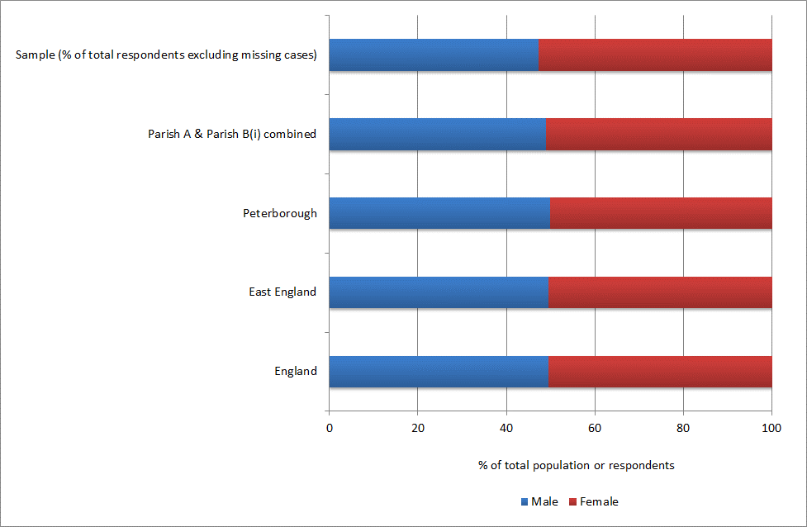
(b) Employment status
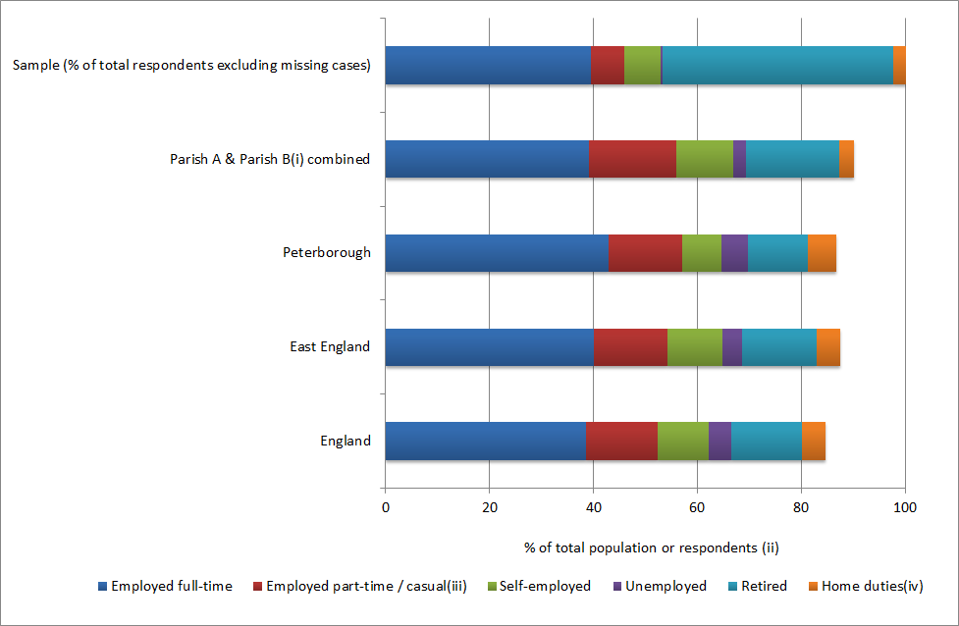
(c) Residence building type
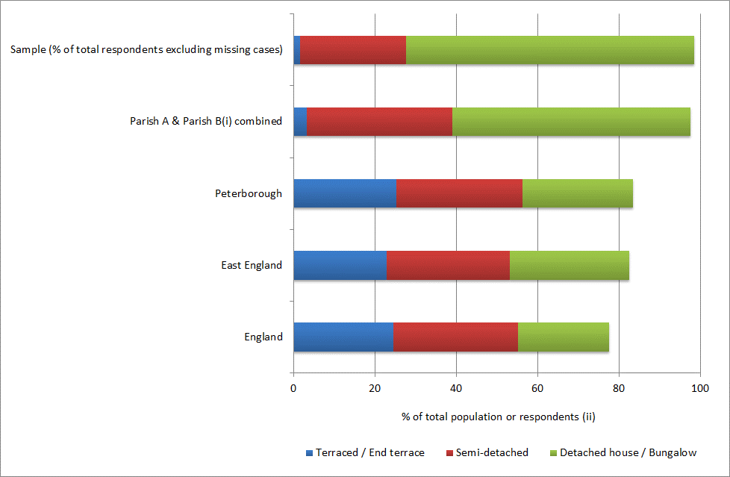
Notes to Figure 1 (a, b, c)
^{(i)} For reasons of data confidentiality, the names of the two participating parishes have been withheld.
^{(ii)} Proportions of total population of Census data only include employment or building type categories featured in our survey and therefore do not sum to 100% in Figures 1 (b) and (c).
^{(iii)}Please note that the category for part-time workers in the Census data may or may not include causal workers.
^{(iv)}The category of home duties is compared with the category ‘looking after home or family’ from the Census 2011.

Figure 2. Total Variance Explained by Initial and Extracted Components
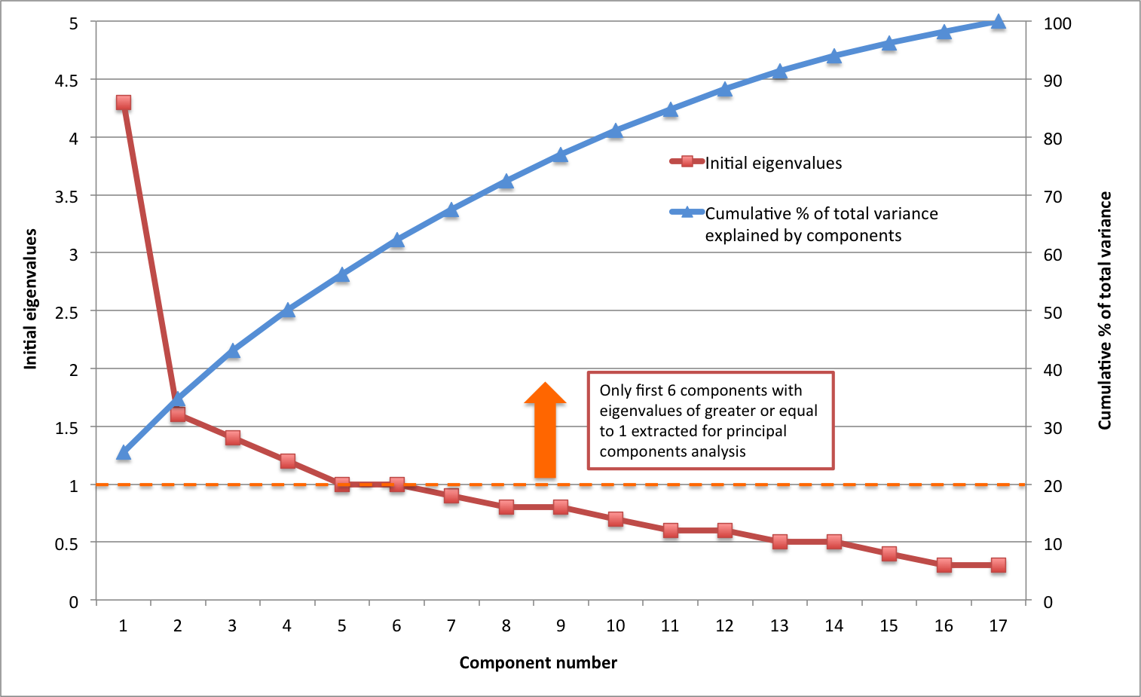

Figure 3. Ownership of household appliances
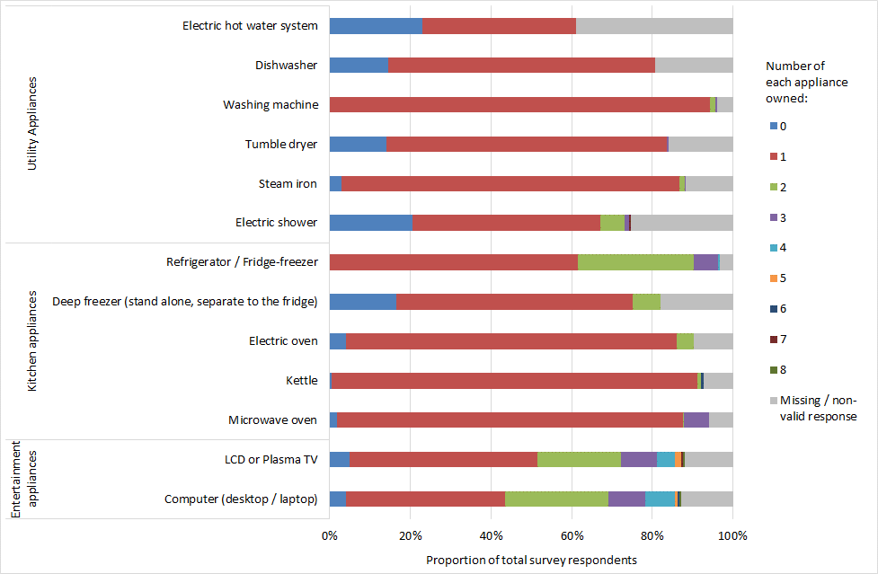

This includes all heated rooms in the dwelling, i.e. bedrooms, bathrooms, living room, kitchen etc.

