Revisiting the global net CO₂ emissions transfers via international trade: The impact of trade heterogeneity of China

Xuemei Jiang, Quanrun Chen, Dabo Guan, Kunfu Zhu, Cuihong Yang

Summary
To revisit global net CO₂ emissions transfers via international trade for year 2007, this study employs a new worldwide, multiregional input-output table in which China’s production is separated into domestic use, processing exports and non-processing exports. The results show that processing exports in China involves relatively lower CO₂ emissions than other production types for the same output levels. Therefore, if processing exports are not appropriately distinguished, net CO₂ emission exports from China to other regions will be distorted; the relative bias occasionally reaches 15%. Net emission exports from regions other than China are also distorted, particularly for regions that use considerable Chinese processing exports as intermediates, such as the USA, European Union and East Asia. Given that processing exports prevail in a large number of developing countries such as Mexico and Vietnam, one should carefully interpret measurements of net emission transfers via international trade by utilizing the ordinary worldwide, multiregional input-output model.

Keywords: multiregional input-output table, net emissions transfers, processing trade, China

Introduction
In today’s globalized world, production processes are increasingly fragmented across countries. Therefore, local consumptions in one country are increasingly satisfied by global supply chains (Hubacek et al., 2014). This phenomenon has attracted extensive scholarly and policy debates on the allocation of greenhouse gas (GHG) emissions, particularly CO₂ emissions; these are responsibilities linked to international trade because international trade causes net emissions transfers (refer to, e.g., Ahmad and Wyckoff, 2003; Liu and Ma, 2011; Wiedmann, 2009; Peters et al., 2011).
Because it includes detailed descriptions of production chains, the environmental input-output (EIO) model has been widely accepted for tracing the net CO₂ emissions transfers via international trade (abbr. as net CO₂ emissions transfers in the following) and the environmental footprints from consumption across global supply chains (Hubacek et al., 2014). There are two significant types of models: the single-region input-output model (SRIO, refer to, e.g., Su and Ang, 2010; Su et al., 2013; Liu et al., 2013) and the multiregional input-output model (MRIO, refer to, e.g., Peters et al., 2011; Feng et al., 2013). Most single-region emission studies adopt the SRIO model because its data requirement is low. With the wide availability of global MRIO databases, the MRIO model has gradually become mainstream because it records the flows of goods and services as well as embodied emissions along the global supply chain across countries (refer to Wiedmann et al. (2007) for reviews, and Peters et al. (2011) and Feng et al. (2013) for recent applications). Peters et al. (2011), for example, employ an MRIO model to quantify the net CO₂ emissions transfers across 113 countries from 1990 to 2008.
China and its trade-linked emissions have received intense interests compared to other countries because of China’s dual role as both the world’s largest exporter and the world’s largest CO₂ emitter (see, e.g. Minx et al., 2011; Feng et al., 2013; Jiang et al., 2015). One feature of China’s international trade, however, is its prevalence of processing exports, in which firms import parts and components from abroad under favorable tariff treatment and assemble them for export. Thus, there is significant heterogeneity between the production of processing exports and non-processing exports. Generally, processing exports have much lower CO₂ emission intensities than non-processing exports and it has been proven that if processing exports are not appropriately distinguished, China’s export-linked CO₂ emissions are seriously overestimated (Dietzenbacher et al., 2012; Su et al. 2013; Weitzel and Ma, 2014).
However, all of these discussions are based on the SRIO model (refer to, e.g., Dietzenbacher et al., 2012; Su et al., 2013; Weitzel and Ma, 2014). To our knowledge, there is no literature that discusses the impact of trade mode heterogeneity (i.e., processing trade versus non-processing trade) on the measurements of net emissions transfers based on an MRIO model. In addition to CO₂ emissions embodied in China’s exports that can be well captured by an SRIO model, heterogeneity of trade influences the measurements of CO₂ emissions embodied in China’s imports. Production for domestic use and non-processing exports requires more domestic products and less imports as intermediates than to produce an equal amount of processing exports (Ma et al., 2015). As a result, if the processing trade is not distinguished, the linkages between productions for processing exports and domestic products will be overestimated, while the linkages between productions for non-processing exports and domestic products will be underestimated. In this context, China’s exports of CO₂ emissions to other regions are distorted. Moreover, many countries rely on China’s exports as intermediate inputs; therefore, the distortion of China’s exports-linked emissions may lead to a subsequent distortion of CO₂ emissions embodied in other countries’ related final products. All of these errors may distort the picture of global net CO₂ emissions transfers and the links between local consumption and global emissions.
In this study, we employed a new worldwide MRIO table that distinguishes China’s production types into production for domestic use (D), processing exports (P) and non-processing exports (N) (abbreviated as the WIOD-DPN table, Chen et al., 2014) to revisit the net CO₂ emissions transfers. We also compared the estimation biases in global net CO₂ emissions transfers when trade heterogeneity of China is not considered. In addition, the processing production activities of China generated considerable CO₂ emissions. Given the high dependency on carbon-intensive coal of China, we also simulated the extent of CO₂ emissions reductions assuming the same amount of processing products of China were produced by other countries, to provide implication for China’s and global climate change mitigations policies.

Materials and Methods
In this study, we selected the World Input-Output Database (WIOD) as our starting point to further disaggregate China’s productions into production for domestic use (D), processing exports (P) and non-processing exports (N). Although the WIOD does not have the most detailed coverage of countries and products, it does have one unique feature that is necessary for our study: it includes inter-country supply-use tables that can be transformed into a symmetric global MRIO table by product*product type. Notably, the Chinese SRIO table that distinguishes among production types D, P and N is by product*product type (also known as the DPN table, refer to e.g., Lau et al., 2006; Chen et al., 2012). The same product*product type allows a link between the global MRIO table and the Chinese DPN table, generating a “new” WIOD-DPN table. So far, three China’s DPN tables have been available, for year 2002, 2007 and 2010, respectively. Among them, the DPN table of year 2007 has the most disaggregated sector classification with 135 sectors, which provide a good basis to match WIOD with 59 products. DPN table of year 2002 has a more aggregated sector classification of 42 sectors, and DPN table of year 2010 is updated based on table of 2007 (Chen et al., 2012). Therefore we combined the Chinese semi-survey-based DPN table of 2007 with inter-country input-output table taken from WIOD, and compiled our WIOD-DPN table for 2007. This WIOD-DPN table covers 59 products in 40 countries/regions and the Rest of the World (RoW), in which China’s productions are distinguished into three types. Regarding CO₂ emissions, we first transformed the CO₂ emissions data in WIOD from industry type into product type, then we adopted the recommendation of Jiang et al. (2015) to use intermediate energy in an input-output table to proportionally decompose the CO₂ emissions of China by three production types. All of the China’s disaggregation by production type in the WIOD-DPN table are calibrated to ensure that a re-aggregation would result in an official WIOD release for 2007.
With respect to measurements, in accordance with Peters et al.’s (2011) methods, we defined the difference between the production-based and consumption-based emissions of a given country r as a “net emission transfer”—i.e., E_T^{r}=E_P^{r} – E_C^{r}, where E_P^{r} are the production-based emissions of country r and E_C^{r} are the consumption-based emissions of country r. The net emissions transfers of country r can be expressed equivalently as “emissions embodied in international trade”—i.e., E_T^{r}=E_ex^{r} – E_im^{r}, where E_ex^{r} are the emissions generated in country r because of all of the final demands of other countries and E_im^{r} are the emissions generated in other countries because of the final demands of country r. These net emissions transfers can also be measured at the bilateral level. Let E_ex(F^{r}) indicate the emissions exports from country r to country k (i.e., the emissions generated in country r because of all of the final demands of country k), E_im(F^{r}) indicate the emissions imports of country r from country k (i.e., the emissions generated in country k because of all of the final demands of country r). The net emissions transfers between country r and country k can be measured as E_T(F^{r}) = E_ex(F^{r}) – E_im(F^{r}).
For a full description of the data compilation and measurements methods, refer to the Supporting Information (SI).

Net CO₂ emissions transfers based on the WIOD-DPN table

For simplicity, we aggregated the detailed results into 13 regions: the USA, the European Union (27 member states, hereinafter abbreviated as EU-27), East Asia (Japan, South Korea and Taiwan), Australia, Canada, China, Brazil, Russia, India, Indonesia, Mexico, Turkey, and the Rest of World (RoW). Figure 1 provides the comparisons between production-based and consumption-based CO₂ emissions based on our WIOD-DPN table in 2007. Similarly to the literature on global net CO₂ emissions transfers, such as Peters et al. (2011), Davis and Caldeira (2010) and Kanemoto et al. (2014), our results show that developed countries have net imports of emissions and developing countries have net exports of emissions.

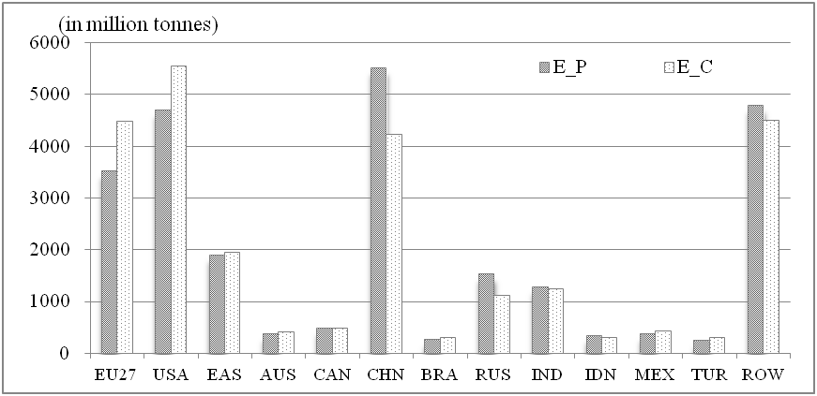
Figure 1. Production-based and consumption-based CO₂ emissions by region in 2007. Region codes: AUS: Australia; BRA: Brazil; CAN: Canada; CHN: China; EAS: East Asia (Japan, South Korea and Taiwan); EU-27: European Union 27 Member States; IND: India; IDN: Indonesia; MEX: Mexico; RUS: Russia; TUR: Turkey; USA: the United States of America; and RoW: Rest of the World.

As previously noted, the differences between production-based and consumption-based CO₂ emissions lie in net emissions transfers, i.e., ${E_{T}}^{r}={E_{ex}}^{r}−{E_{ℑ}}^{r}$. One advantage of our WIOD-DPN table is that it can trace China’s exported emissions to different production types. As figure 2a indicates, production for domestic use, processing and non-processing exports represented 59.5%, 4.2% and 36.3%, respectively, of China’s exported CO₂ emissions for 2007. Although production for domestic use (D) does not directly result in final products used in other countries, it provides intermediates for the production of final products consumed in other countries. Feng et al. (2013) tracked CO2 emissions embodied in trade among China’s provinces and other countries. They find that 57% of China’s emissions are related to goods that are consumed outside of the province where they are produced, especially for highly developed coastal provinces. This suggests that considerable production of domestic use (D) in China are served as intermediate inputs in coastal regions and then consumed as final products in other countries. The statistics of WIOD-DPN table confirmed this deduction: 7.4 billion USD of China’s products were used as intermediates worldwide in 2007, including the production types D, P and N, which contributed 5.5, 0.3 and 1.6 billion USD, respectively. It is therefore not surprising that production type D dominated China’s exported CO₂ emissions in figure 2a.
The emissions embodied in processing exports (P) and non-processing exports (N) are caused by the intermediate exports as well as final goods’ exports. According to the WIOD-DPN table, 283 and 326 billion USD of China’s processing exports were sold as intermediates and final goods to other countries, respectively, in 2007; this is smaller than that of non-processing exports, which represented 542 billion USD as intermediates and 259 billion USD as final goods. Therefore, figure 2a shows that non-processing exports (N) represented a larger share of China’s exported CO₂ emissions than processing exports (P).
For contrast, we also include China’s imported CO₂ emissions pattern in figure 2b. By subtracting imported emissions from exported emissions, it is found that China has net exports of CO₂ emissions to all of the other regions, particularly the USA, EU27 and East Asia. In 2007, the net CO₂ exports from China to these three regions were 847 million tones, representing 65.4% of China’s total net exported CO₂ emissions.

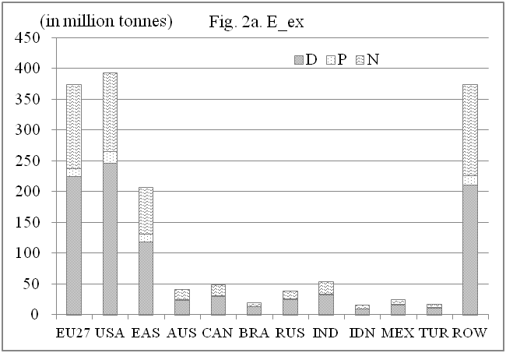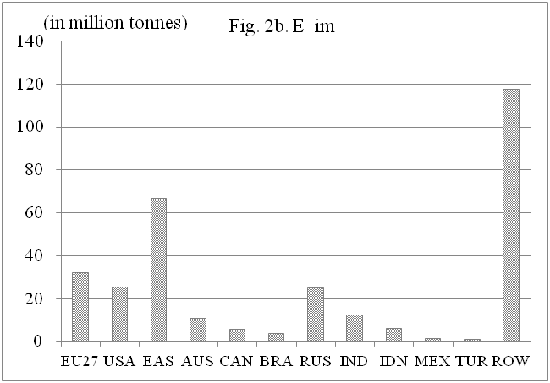
Figure 2. (a) China’s exported CO₂ emissions, by production type and by region, 2007. (b) China’s imported CO₂ emissions, by region, 2007. Region codes are the same as figure 1 and the same as below.

The biases of measurements of net CO₂ emissions transfers when trade heterogeneity in China is not considered

In most cases, the WIOD-DPN table is not available and we must rely on an ordinary WIOD table to obtain our estimations of the net CO₂ emissions transfers. In this section, we explored the extent to which distinguishing among China’s production types influences our estimations, i.e., the results based on an ordinary WIOD table minus the results based on WIOD-DPN table. In figure 3a, we first compared the estimation biases of the exported and imported CO₂ emissions for regions other than China, where the bars represent the overestimation (positive) or underestimation (negative) degrees in millions of tonnes. Figure 3a shows that both emissions exports and imports have been overestimated for most regions (except India and Indonesia); these are shown as positive bars in figure 3a. The distortion extents of exported emissions are much lower than those of imported emissions. Therefore, we found overestimations of net CO₂ emissions transfers based on an ordinary WIOD table for most regions (figure 3b). More specifically, the highest bias in net imported CO₂ emission is found for the USA, totaling 34.7 million tonnes, which is followed by EU27 (16.5 million tonnes) and East Asia (11.4 million tonnes). This is reasonable because these three regions are China’s top three processing-trade trading partners. According to China’s custom releases, the USA, EU27 and East Asia represented 19.2%, 30.6%, and 17.2% of China’s processing exports in 2007, respectively.
In contrast, India and Indonesia have overestimations of exported emissions and underestimations of imported emissions (figure 3a). This is because that the imports of India and Indonesia from China are dominated by non-processing products, while that of other regions are dominated by processing products. As aforementioned, while the emissions embodied in China’s processing exports are overestimated based on the ordinary WIOD table, the emissions embodied in China’s non-processing exports are underestimated. The dominance of non-processing imports of India and Indonesia from China led to an underestimation of their imports of CO₂ emissions. With respect to the net emissions transfers, the ordinary WIOD overestimated the net exported emissions of India and Indonesia at 2.7 million tonnes and 0.2 million tonnes, respectively (figure 3b).
Note that the global sum of exported CO₂ emissions should equal the sum of global imported CO₂ emissions, regardless of whether WIOD or the WIOD-DPN table is employed. Therefore, the sum of global biases in net CO₂ emission transfers should equal zero, and we omitted the results for China in figure 3. In contrast to most other regions, we found an 83-million-tonnes overestimation of net CO₂ exported emissions for China. Specifically, China’s exports and imports of CO₂ emissions are overestimated; however, the exported emissions have been seriously overestimated at 149 million tonnes, which is much higher than the imported emissions of 66 million tonnes.
In relative terms, we calculated the results by using the WIOD-DPN table as the denominators and the biases that results from the ordinary WIOD table minus the results based on the WIOD-DPN table as the numerators. China’s trade-linked CO₂ emissions have been the most distorted; the estimation biases of exported and imported emissions reached 9.3% and 21.7%, respectively. For the remaining regions, the estimation biases of exported emissions ranged from 0.01%-0.4% across regions, and imported emissions biases ranged from 0.3-2.7% (figure 3a). With respect to net emissions transfers, we found larger biases; the average bias of net emission transfers reached 5% of the total net emissions transfers (figure 3b). In certain regions, such as East Asia and Canada, the relative biases of net emission transfers reached 20.6% and 14.9%, respectively.

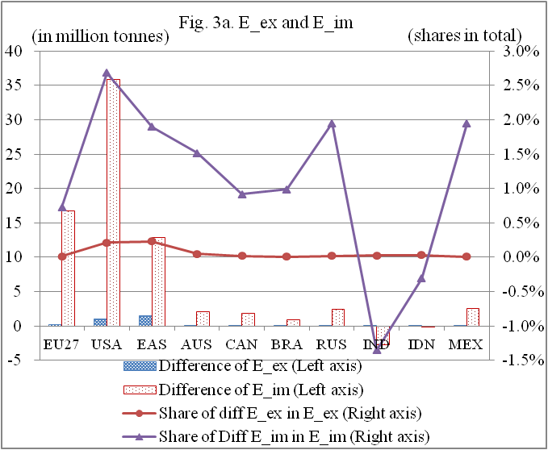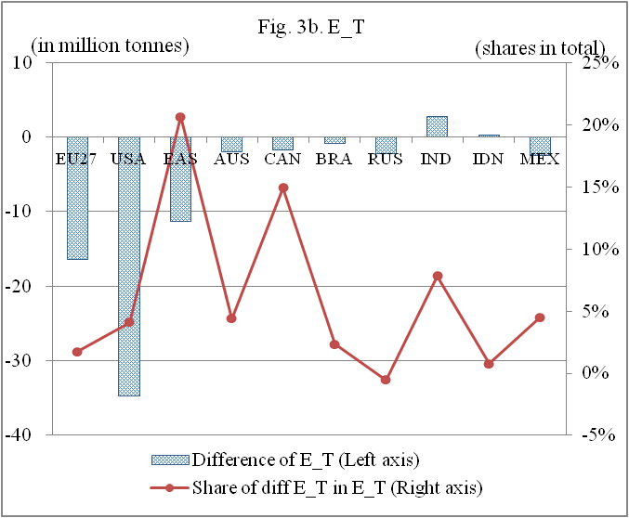
Figure 3. (a) The estimation biases of CO₂ emissions embodied in exports and imports (the WIOD-DPN table versus the ordinary WIOD table) and their shares in totals by region in 2007; (b) The estimation biases of net CO₂ emission transfers (the WIOD-DPN table versus the ordinary WIOD table) and their shares in totals by region in 2007.

Figure 4 further describes the biases of net CO₂ emissions transfers at the bilateral level, where the bars represent the distorted degrees in millions of tonnes. Notably, the sums of the net overestimation/underestimation degrees in figure 4 equal the degrees shown in figure 3b. For example, the net transfer of CO₂ emissions between the USA, on the one hand, and China, on the other hand, have been underestimated at 45.8 million tonnes, although the net transfer of CO₂ emissions between the USA and East Asia have been overestimated at 5.4 million tonnes (figure 4). To sum over all regions, we found the net CO₂ emission transfers of USA have been underestimated 34.7 million tons (in other words, the net imported CO₂ emissions of USA have been overestimated 34.7 million tons), which is equivalent to the results in figure 3b.
Because our results are symmetric for any pair of regions, we also omitted the results for China in figure 4. Among all bilateral net CO₂ emission transfers with China, the net imported CO₂ emissions of the USA from China has been the most overestimated (at 45.8 million tonnes), followed by EU27 (18.5 million tonnes), RoW (4.5 million tonnes), Mexico (3.3 million tonnes), Canada (2.3 million tonnes) and Australia (2.2 million tonnes). India’s net imported emissions from China have been seriously underestimated at 3.4 million tonnes.
The failure to distinguish China’s trade mode also distorts the net CO₂ emission transfers of countries other than China. East Asia’s net imported CO₂ emissions from the USA and EU27, for example, are overestimated at 5.4 and 2.8 million tonnes, respectively. This is not surprising, however, because the USA, EU27 and East Asia were China’s top three trading partners for processing trade in 2007.

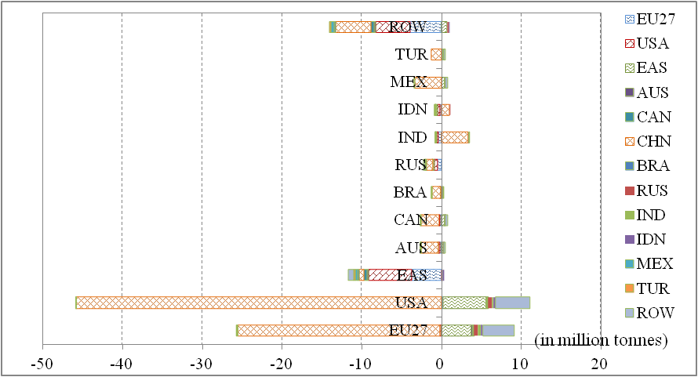
Figure 4. The biases of net CO₂ emission transfers at bilateral trade (WIOD-DPN table versus ordinary WIOD table) in 2007.

Discussion: What if China’s processing exports were conducted in other countries?

Overall, Chinese processing exports generated (directly and indirectly) 68.7 million tonnes of CO₂ emissions (figure 2a). Despite the small proportion of China’s total emission, this emission is equivalent to the entire CO₂ emission for 2007 of medium-sized countries such as Austria (69.7 million tonnes), the Philippines (71.8 million tonnes) and Vietnam (93.6 million tonnes). In contrast to other production types, processing exports primarily involve assembly and packaging activities in which firms import parts and components from abroad and then assemble them for export. One consequence is that processing exports primarily require electricity instead of fossil fuels as energy inputs. One well-known fact regarding China is that it largely relies on coal-fired power for its electricity generation (more than 80% in 2007), and its electricity generation is much more carbon-intensive than the world average. Assuming that processing exports solely require electricity as energy inputs, in this section we simulated the changes of global CO₂ emissions under scenarios in which China’s processing activities were conducted in country i instead of in China. That is, let $φ_{CHN}$ indicates the CO₂ emissions per kWh from electricity in China, and $μ_{CHN}$ indicates the total CO₂ emissions of China generated by processing exports activities. By assuming that the production activity of processing exports only require electricity as energy input, we can roughly estimate that the productions of processing exports in China required kWh of electricity. Then define $φ_{i}$ as the CO₂ emissions per kWh from electricity in country i, we can estimate the “new” total CO₂ emissions if country i replaces China in processing productions as $μ_{i}=$. In Table 1, we summarize our simulation results.

Table 1. CO₂ emissions if China’s processing exports were conducted in other countries
Target  Country/  Region | CO₂ emissions per kWh from electricity generation  (in grams CO₂)* | CO₂ emissions if China’s processing exports were conducted in the target country  (in million tonnes) | Processing imports from China  (in billion USD)
China | 758 | 68.67
EU27 | 362 | 32.81 | 116.73
USA | 549 | 49.77 | 186.25
East Asia | 455 | 41.22 | 105.11
Australia | 907 | 82.17 | 10.89
Canada | 205 | 18.57 | 15.72
Brazil | 73 | 6.61 | 7.28
Russia | 323 | 29.26 | 6.83
India | 928 | 84.07 | 8.37
Indonesia | 692 | 62.69 | 2.06
Mexico | 547 | 49.56 | 17.32
Turkey | 478 | 43.31 | 4.99
RoW | 642 | 58.16 | 127.78
* The CO₂ emissions data per kWh from electricity by country generation is extracted from the IEA (www.iea.org); the East Asia data are the average of Korea and Japan and the RoW data are those of Non-Annex I Parties. The processing exports from China to each region are also listed as a reference.

One observation of Table 1 is that most regions have lower CO₂ emission intensity per kWh of electricity generation than China. Brazil and Canada, for example, have extremely low CO₂ emission intensity because their electricity generations largely rely on renewable energy (mainly hydro-power). If Brazil rather than China was the country that conducted processing activities, the same Chinese processing export levels (totaling 609 billion USD in 2007) would emit 6.61 million tonnes of CO₂ and global CO₂ emissions would be reduced by as much as 62 million tonnes. In the scenarios in which the USA, EU or East Asia conducted Chinese processing activities, global CO₂ emissions reductions would be approximately 19-35 million tonnes. From the perspective of global climate-change mitigation, it appears that China must further reduce its CO₂ electricity generation emission intensity to ensure that these considerable processing activities can continue to be concentrated there. Thus, China should prioritize improvement in energy-usage efficiency and an increase of the proportion of renewable energy used in electricity generation, among other measures (refer to, e.g., Fan et al., 2007; Zhang and Cheng, 2009; Du et al., 2013; Xu et al., 2014).

Conclusions

In this study, we employed a global, multiregional input-output tables in which China’s productions are differentiated into production for domestic use, processing exports and non-processing exports (WIOD-DPN table) to revisit the net CO₂ emissions transfers via international trade among countries/regions for 2007. In addition to China, countries such as Mexico, Indonesia and Vietnam have considerable processing exports (WTO, 2011). By focusing China, we also want to elucidate the extent of the issues to which the trade mode heterogeneity influences the measurement of global net CO₂ emissions transfers.
In general, the results show very similar trends to that of the previous literature on global net CO₂ emission transfers; developed countries often have net imports of CO₂ emissions and developing countries often have net exports of CO₂ emissions. However, underestimations/overestimations of net CO₂ emissions transfers exist, particularly for China. China has net exports of CO₂ emissions to all of the other regions. Without appropriate consideration of China’s heterogeneity of trade, China’s net exports of CO₂ emissions are seriously overestimated. Among all regions, the net exported CO₂ emissions from China to the USA and EU27 are the most overestimated at 45.8 and 18.5 million tonnes, respectively, followed by Mexico (3.3 million tonnes), Canada (2.3 million tonnes) and Australia (2.2 million tonnes). There are also two regions, India and Indonesia, that have underestimations of net imported CO₂ emissions; the net imported CO₂ emissions of India and Indonesia from China are underestimated at 3.4 and 1.0 million tonnes, respectively.
The failure to distinguish China’s processing trade also distorts the balances of embodied emissions in the trade of countries other than China. The USA, EU27 and East Asia were China’s top three trading partners for processing trade in 2007. Therefore, the embodied CO₂ emissions in their bilateral trade have been the most influenced. The net imported emissions to East Asia from the USA and EU27, for example, are overestimated at 5.4 and 2.8 million tonnes, respectively.
At the aggregate level, we found that both emissions exports and imports have been overestimated for most regions (except for India and Indonesia) and that the exported emissions are coincidently lower than that of imported emissions. Therefore, estimates based on the ordinary WIOD table overestimated the net emission transfers for most regions, ranging from 0.6 to 45.8 million tonnes. For India and Indonesia, we found the underestimations of exported emissions and overestimations of imported emissions. Therefore, the ordinary WIOD overestimated the net exported emissions of India and Indonesia, at 2.7 million tonnes and 0.2 million tonnes, respectively.
Moreover, because of China’s high dependency on coal as primary energy inputs, that country’s CO₂ emission intensity is much higher than in most developed and developing countries. We also found that the global CO₂ emissions would decrease by 19-62 million tonnes if China’s processing activities were shifted to other countries such as the USA, Europe or Brazil. Our results should sound a warning for China’s future sustainable development, particularly regarding processing trade. As global climate-change mitigation becomes increasingly important, China may consider prioritizing the reduction of CO₂ emission intensity, particularly in electricity generation, to avoid possible transfers of processing activities out of China.

Acknowledgments
The paper acknowledges the fundings from the National Natural Science Foundation of China (71103176 , 71125005, 71201162 and 71473246). We are grateful to editor Kuishuang Feng and two anonymous referees whose comments and suggestions have helped significantly in improving the paper.

References
Ahmad, N. and A. Wyckoff. 2003. Carbon Dioxide Emissions Embodied in International Trade of Goods, OECD science, Technology and Industry Working Paper 15.
Chen, Q., Zhu, K., Chen, X., Liu, P., Tian, K., Yang, L. and Yang, C., 2014. Distinguishing the Processing trade in the World Input-Output Table: A Case of China. The 22nd Input-Output Conference, Lisbon, https://www.iioa.org/conferences/22nd/papers.html.
Chen, X. K., Cheng, L., Fung, K. C., Lau, L., Sung, Y. W., Yang, C. H., Zhu, K. F., Pei, J. S. and Duan, Y. W. (2012) Domestic Value Added and Employment Generated by Chinese Exports: A Quantitative Estimation, China Economic Review 23, 850-864.
Davis S. J. and K. Caldeira. 2010. Consumption-based accounting of CO₂ emissions. Proceedings of the National Academy of Sciences of the United States of America (PNAS) 107(12), 5687–5692.
Dietzenbacher, E., Pei, J. S. and Yang, C. H. 2012. Trade, Production Fragmentation, and China’s Carbon Dioxide Emissions, Journal of Environmental Economics and Management 64, 88-101.
Duan, Y., Yang, C., Zhu, K. and Chen, X. (2012). Does the Domestic Value Added Induced by China's Exports Really Belong to China? China and World Economy, 20(5): 83-102.
Du, K., Lu, H., Yu, K., 2013. Sources of the potential CO₂ emission reduction in China: A nonparametric meta frontier approach, Applied Energy 115(15), 491–501.
Fan, Y., Liu, L. C., Wu, G., Tsai, H. T., Wei, Y. M., 2007. Changes in carbon intensity in China: Empirical findings from 1980–2003, Ecological Economics 62, 683–691.
Feng, K., Steven J., Davis, Sun, L., Lie, X., Guan, D.,, Liu, W., Liu, Z. and Hubacek, K., 2013. Outsourcing CO₂ within China，Proceedings of the National Academy of Sciences of the United States of America (PNAS), 110(28), 11654–11659.
Hubacek, K., K. Feng, J. C. Minx, S. Pfister, and N. Zhou. 2014. Teleconnecting Consumption to Environmental Impacts at Multiple Spatial Scales. Journal of Industrial Ecology 18(1): 7-9.
Inomata, S., 2013, Trade in Value Added: An East Asian Perspective, ADBI Working Paper Series No. 451, available at
http://www.adbi.org/files/2013.12.10.wp451.trade.in.value.added.east.asian.perspective.pdf
Jiang, X., Zhu, K., Green, C. 2015. China’s energy saving potential from the perspective of energy efficiency advantages of foreign-invested enterprises, Energy Economics, 49(5): 104-112.
Kanemoto, K.; Moran, D.; Lenzen, M., and Geschke, 2014. A. International trade undermines national emission reduction targets: New evidence from air pollution. Global Environmental Change 24 (1), 52−59.
Lau, J. L., X. Chen, L. K. Cheng, K. C. Fung, J. Pei, Y. Sung, Z. Tang, Y. Xiong, C. Yang and K. Zhu, 2006. Estimates of U. S.-China Trade Balances in Terms of Domestic Value-Added, Stanford Center for International Development, Working Paper No. 295. Available online at: http://siepr.stanford.edu/publicationsprofile/1059.
Liu, L. and Ma, X., 2011. CO₂ Embodied in China's Foreign Trade 2007 with Discussion for Global Climate Policy, Procedia Environmental Sciences 5, 105-113.
Liu, Z., Guan, D., Brown, D., Zhang, Q., He, K. and Liu, J., 2013. Energy Policy: A Low-Carbon Road Map for China, Nature 500, 143–145.
Ma, H. Wang, Z. and Zhu, K. 2015. Domestic Content in China’s Exports and its Distribution by Firm Ownership, Journal of Comparative Economics, 43(1), 3-18 .
Minx, J. C., Baiocchi, G., Peters, G. P., Weber, C. L., Guan, D., & Hubacek, K. (2011). A “carbonizing dragon”: China’s fast growing CO₂ emissions revisited. Environmental science & technology, 45(21), 9144-9153.
Peters, G. P., J. C. Minx, C. L. Weber and O. Edenhofer. 2011. Growth in emission transfers via international trade from 1990 to 2008, Proceedings of the National Academy of Sciences of the United States of America (PNAS) 108(21), 8903-8908.
Su, B. and Ang, B. W., 2010. Input–output analysis of CO2 emissions embodied in trade: the effects of spatial aggregation, Ecological Economics 70 (1), 10-18
Su, B., Ang, B. W. and Low, M., 2013. Input-output analysis of CO2 emissions embodied in trade and the driving forces: Processing and normal exports. Ecological Economics 88, 119-125.
Tukker A. and Dietzenbacher E., 2013. Global Multiregional Input-Output Frameworks: An Introduction and Outlook, Economic Systems Research 25(1), 1-19.
Weitzel, M. and Ma, T. 2014. Emissions embodied in Chinese exports taking into account the special export structure of China, Energy Economics 45, 45-52.
Wiedmann, T., 2009. A Review of Recent Multi-Region Input-Output Models Used for Consumption-Based Emission and Resource Accounting. Ecological Economics 69(2), 211-222.
Wiedmann, T., M. Lenzen, Turner, K. and J. Barrett. 2007. Examining the Global Environmental Impact of Regional Consumption Activities - Part 2: Review of Input-Output Models for the Assessment of Environmental Impacts Embodied in Trade. Ecological Economics 61(1), 15-26.
WTO, 2011. Trade Pattern and Global Value Chains in East Asia: From Trade in Goods to Trade in Tasks, WTO publications, available at: http://onlinebookshop.wto.org.
Xu, J. H., Fleiter, T., Fan, Y., Eichhammer, W., 2014. CO₂ emissions reduction potential in China’s cement industry compared to IEA’s Cement Technology Roadmap up to 2050, Applied Energy 130, 592–602.
Zhang, X. P., Cheng, X. M., 2009. Energy consumption, carbon emissions, and economic growth in China, Ecological Economics 68(10), 2706–2712

Please refer to Tukker and Dietzenbacher (2013) for a thorough outlook of available global MRIO databases.
Chinese custom statistics by trade mode are conducted at the product level; therefore, the Chinese DPN is compiled at the product level. Please refer to Lau et al. (2006) and Chen et al. (2012) for the details of framework and compilations.
We argued that our study with a single year 2007 does not lose generality. The proportion of processing exports in China’s total exports persistently remained above 50% in 2000-2010 and only started to decline rapidly ever since 2010 (Duan et al., 2012). It is reasonable to expect that the distinction of trade heterogeneity of China would influence the estimation of emissions exports and imports, not only for China, but also for its trading partners in the entire period 2000-2010, when processing exports are prevailing.
Refer to www.wiod.org.
Customs statistics show that processing exports represented approximately half of Chinese merchandise exports in 2007. Our results show that Chinese processing exports are slightly lower than non-processing exports in 2007. This is primarily because our results include service exports that only non-processing trade can provide. In addition, customs statistics are expressed in FOB (Free on Board) prices, whereas our results are expressed in basic prices from which transportation, wholesale and retail margins are excluded. Therefore, the margins of processing exports are allocated to service exports (non-processing) in our WIOD-DPN table.
In 2007, India imported respective $4.4 billion and $9.1 billion of processing and non-processing products from China. Indonesia imported respective $1.0 billion and $3.2 billion of processing and non-processing products from China. In contrast, most other regions imported equivalent or more processing products rather than non-processing products from China. For example, USA imported respective $125 billion and $58 billion, East Asia imported respective $56 billion and $34 billion of processing and non-processing products from China.
The CO₂ emissions by country are taken from the International Energy Agency (IEA) (2010). About the Authors Xuemei Jiang is an associate professor at Capital University of Economics and Business (Beijing, China). Quanrun Chen is an assistant professor, and Kunfu Zhu is an associate professor at University of International Business and Economics (Beijing, China). Dabo Guan is a professor in University of East Anglia (Norwich, UK). Cuihong Yang is a professor at Academy of Mathematics and Systems Science, Chinese Academy of Sciences (Beijing, China) Address correspondence to: Eric Masanet McCormick School of Engineering and Applied Science Northwestern University Evanston, IL 60208-3109, USA Email: eric.masanet@northwestern.edu http://ersal.mccormick.northwestern.edu Address correspondence to: Eric Masanet McCormick School of Engineering and Applied Science Northwestern University Evanston, IL 60208-3109, USA Email: eric.masanet@northwestern.edu http://ersal.mccormick.northwestern.edu Address correspondence to: Dabo Guan School of International Development, University of East Anglia, Norwich, NR4 7TJ, United Kingdom

