Assessment of Socioeconomic Costs to China’s Air Pollution
Yang Xia¹, Dabo Guan^{1,2,*}, Xujia Jiang², Liqun Peng², Heike Schroeder¹, Qiang Zhang²
¹ Tyndall Centre for Climate Change Research, School of International Development, University of East Anglia, Norwich NR4 7TJ, UK
² Ministry of Education Key Laboratory for Earth System Modeling, Center for Earth System Science, Tsinghua University, Beijing 100084, People’s Republic of China
* Correspondence email: dabo.guan@uea.ac.uk

Abstract
Particulate air pollution has had a significant impact on human health in China and it is associated with cardiovascular and respiratory diseases and high mortality and morbidity. These health impacts could be translated to reduced labor availability and time. This paper utilized a supply-driven input-output (I-O) model to estimate the monetary value of total output losses resulting from reduced working time caused by diseases related to air pollution across 30 Chinese provinces in 2007. Fine particulate matter (PM_{2.5}) pollution was used as an indicator to assess impacts to health caused by air pollution. The developed I-O model is able to capture both direct economic costs and indirect cascading effects throughout inter-regional production supply chains and the indirect effects greatly outnumber the direct effects in most Chinese provinces. Our results show the total economic losses of 346.26 billion Yuan (approximately 1.1% of the national GDP) based on the number of affected Chinese employees (72 million out of a total labor population of 712 million) whose work time in years was reduced because of mortality, hospital admissions and outpatient visits due to diseases resulting from PM_{2.5} air pollution in 2007. The loss is almost the annual GDP of Vietnam in 2010. The proposed modelling approach provides an alternative method for health-cost measurement with additional insights on inter-industrial and inter-regional linkages along production supply chains.
Keywords: PM_{2.5}, health, input-output analysis, indirect losses

- Introduction
Fine particulate matter (PM_{2.5}) is the main factor that contributes to smog in urban China^{1,2}, and the PM_{2.5} concentration in Beijing during 2013 significantly exceeded the health standard suggested by the World Health Organization (WHO)³. PM_{2.5} air pollution has caused increasing numbers of hospital admissions and outpatient visits because of concomitant diseases, which has inspired research to measure the monetary value of PM_{2.5} induced health impacts in China. This research develops an integrated modelling approach to estimate direct and indirect economic losses (measured by the value of total outputs) in 30 Chinese provinces during 2007 caused by impacts on health of PM_{2.5} pollution. The adopted method provides an alternative approach for health-cost measurement apart from human capital (HC)⁴ and contingent valuation (WTP)^{5,6} approaches with new additional insights in health impacts resulting labor constraints as well as inter-industrial and inter-regional linkages along production supply chains. Compared with the focus of HC and WTP approaches on patients’ economic burden⁷⁻⁹, the proposed I-O analysis is able to assess the health impacts on a national economy by capturing interlinkages between industries and regions. With such advantage, I-O model has been widely applied in risk, impact and inter-dependency analyses of disaster studies¹⁰, CO₂ emissions outsourcing¹¹ and ecological footprints¹²⁻¹⁴. Meanwhile, natural disasters can be either relatively sudden-onset (flood, hurricane) or ‘persistent’ (drought, air pollution) and affect physical and human capital differently. Although the damages to human capital are difficult to be quantified, they can also cause disruption to economic activities because labor is another primary input during production. Therefore, both inter-industrial/regional linkages and health impacts are important for all disaster risk analyses and they can all largely raise the total economic losses, suggesting that direct economic loss is an insufficient indicator for risk assessment and management¹⁵. Thus, apart from mortality, PM_{2.5} induced morbidity (hospital admissions and outpatient visits) was also taken into consideration in this study and they were converted into labor year loss to feedback to a supply-driven economic model. This study is the first to assess the economic losses triggered by ailments related to PM_{2.5} air pollution in China by integrating risk, impact and inter-dependency analyses into health-cost measurement.
- Selective Review on Health-Cost Assessment and I-O Applications
Mortality and morbidity induced by PM air pollution can cause significant labor time loss. On the one hand, existing studies on health-cost assessment require us to consider inter-industrial/regional linkages. When we translate health impacts into monetary terms, contingent valuation/willingness to pay (WTP) and human capital (HC) are the two commonly used approaches for measuring the direct economic losses caused by PM_{2.5} pollution. They are based on the WTP among households to reduce the mortality risk associated with a particular disease and the potentially productive years of life loss and discounted value of future earnings respectively. Previous studies at the national level showed that the mean total health costs (mortality, chronic disease and countable hospital costs related to ambient air pollution) in urban China in 2003 were approximately 519.90 billion Yuan based on the WTP approach⁶. At the provincial level, Wang and Mullahy (2006)¹⁶ predicted a total of 286 thousand Yuan as the WTP for saving a statistical life in Chongqing, which is 4-times higher than the results under the HC approach. Kan and Chen (2004)¹⁷ applied the Chongqing study onto Shanghai in 2001 and found that the total economic losses amounted to 625.4 million US dollars. However, firstly, although the HC method has long been employed in economic and health studies as a means of measuring the expected lifetime earnings that would have been realized without disease or death¹⁸, it tends to attach heavier weight on labor force than students, homemakers and the elderly¹⁹ and fails to capture the individual willingness to pay to reduce the risk of premature mortality. Wan, et al. ⁷ and Wan, et al. ⁸ proposed a computable general equilibrium (CGE) model to assess the health impact of the ambient air pollution on the national economy in China during 2000. They also compared the results of HC approach and CGE model and concluded that results from these two approaches could provide distinctive implications for policymakers as the HC approach stems from the patients’ perspectives while the CGE model focus on the impacts on the entire national economy. They also pointed out that evaluating a life according to individual contribution to the society tends to underestimate the values for children and the elderly. Compared with the HC approach, a CGE model is able to feedback pollution resulting health impacts to national economic activities by capturing the sectoral inter-relationships⁷⁻⁹. Using income as a measurement in health cost estimation could be misleading in the case of China, because there maintains serious income gap. Indeed, the HC approach fails to quantify the monetary costs associated with pain and suffering caused by morbidity²⁰, which has been however taken into consideration in this study. Secondly, compared with the HC approach, the WTP approach is based on each respondent’s risk perception. However, the results could still remain controversial because risk perceptions are extremely different under various social and health insurance systems¹⁷. Similar to the HC approach, such method also regards patients as the study objects and focuses more on patients’ economic burden of diseases rather than the losses in value-added and national GDP. Compared with the focus of both the HC and WTP approaches regarding the monetary benefit of reductions in mortality and morbidity, our study lays out a model to feed the pollution-induced health impacts back to the national economy and our proposed modelling framework assesses the impacts of mortality and morbidity on national economy through the lenses of reduced labor supply, which is defined as ‘total economic losses’ in this paper. Thirdly, both approaches merely focus on the direct economic losses resulting from health impacts but ignore the cascading indirect economic losses occurred through inter-industrial and inter-regional linkages on the supply side of the economy. In this case, the CGE model and I-O analysis are able to capture the inter-industrial and inter-regional linkages but neither of them is superior to the other. For example, a CGE model appears to be overly optimistic on market flexibility²¹ and idealistic as it neglects the dynamic feature of a real economy⁷. It also imposes high data requirements for parameters. Therefore, with the simplicity of I-O analysis, here, we proposed a supply-driven I-O model to provide an alternative method in assessing the overall economic losses resulting from PM_{2.5}-induced health impacts with a specific focus on labor constraints on the supply side of the economy as well as indirect economic losses resulting from the inter-industrial and inter-regional linkages.
On the other hand, the important role of human capital urges to incorporate impacts on human capital, such as health impacts into I-O model and I-O analysis is suitable for disaster risk studies to measure the indirect economic losses occurred along interconnected production supply chain. When assessing the vulnerability of a system in the face of threats and risks, it is crucial to consider both systems per se and inter-dependencies among the systems under consideration²². Significant efforts have been devoted to modelling how risks’ effects propagate across inter-connected systems of infrastructure and industries. The Leontief I-O model was established as a meaningful tool to capture the industrial or regional inter-connectedness, which has been modified into different forms, such as the supply-driven I-O model/Ghosh model²³ and inoperability I-O model (IIM)^{22,24}. They have been widely applied in risk, impact and inter-dependency analyses of disaster studies¹⁰, CO₂ emissions outsourcing¹¹ and ecological footprints¹²⁻¹⁴.
Rose (2004)²⁵ noted that research results obtained from disaster-induced economic disruptions based on direct effects were misleading because these studies ignored indirect economic losses. Similarly, Hallegatte (2008)¹⁵ argued that direct economic losses was an insufficient indicator for risk assessment and management. By presenting an adaptive regional I-O (ARIO) model for disaster modelling, he concluded that the ratio of total to direct economic losses increases as the disaster impact increases. Direct economic losses include the destruction of physical constructions, whereas indirect economic losses refer to perturbations to consumption and production caused by direct economic loss. In our study, we defined direct economic losses as the reductions in industrial value added due to pollution resulting health impacts and indirect economic losses as the cascading losses occurred through inter-industrial and inter-regional linkages. When evaluating indirect economic losses, an I-O model successfully quantifies a circular economy. An economy is viewed as a system that contains inter-connected sectors or industries, where each sector produces a distinct commodity²⁴. An I-O model is utilized to describe the equilibrium behavior of an economy at both regional and national levels²⁶. As the current frontier extended to risk assessment and management, the Leontief I-O model was used to assess indirect losses from disruptions, including complexity, accidents and willful attacks²⁷. Cho et al. (2001)¹⁰ confirmed that an I-O model was effective for evaluating earthquake-induced indirect economic losses in a regional economy. Indeed, an I-O model is able to capture both the backward and forward linkages among industries and regions. In addition to reducing consumption in the ‘upstream’ sectors that supply inputs, changes in a sector’s output could also affect those ‘downstream’ sectors, to whom it sells its outputs. This opposite way of thinking observes the inter-connectedness within economic systems from an opposite direction by focusing on supply-driven impacts on production²³. In the study of a national power outage that consisted of multiple small outages, Crowther and Haimes (2005)²⁸ combined demand-side and supply-side calculations and found that the national power outage caused economic losses in both sectors that provided power for essential operations and sectors requiring power. Guan et al. (2014)³ quantified sectoral annual emission contributions to PM_{2.5} pollution in China as well as socioeconomic factors causing PM_{2.5} pollution during 1997 to 2010. However, existing studies that have applied I-O models mainly focused on emissions embodied in production and consumption instead of integrating health impacts with economic losses in a circular economy. Therefore, an I-O model could be used to estimate the indirect economic losses caused by the health impacts of PM air pollution on the supply side when labor is viewed as a primary production factor and labor productivity is constrained because of PM_{2.5}-induced diseases. My study here and its proposed economy-wide modelling approach tend to provide an alternative method for health-cost measurement with new additional insights cascading effects of labor constraints on the supply-side of the economy due to inter-industrial and inter-regional linkages compared with the traditional measures of economic value of air pollution resulting health impacts.

- Methods and Data
This study adopts an integrated modelling approach by (see SI – Supporting Information Figure 1): feeding air pollutants inventories^{29,30} (Multi-resolution Emission Inventory for China, http://www.meicmodel.org) into air quality simulation models (e.g. the offline-coupled Weather Research and Forecasting model and Community Multi-scale Air Quality model)^{31,32} to produce gridded PM_{2.5} concentrations (horizontal resolution 12 km); those provincial concentration levels are inputs for an integrated exposure-response model to estimate air pollution induced provincial mortality and morbidity counts^{17,33}; the health impact can be translated into loss of labor availability and productivities; a supply-driven multi-regional input-output model is developed to calculate direct and indirect economic production impact due to labor time loss²¹ (see SI Figure 1). A major methodological contribution of this research is three-fold, which is explained below. Full description of the 5-stage methodology framework and related literature review are available in SI.
3.1 Health Impact Estimation
An integrated exposure-response (IER) model was applied to link PM_{2.5} concentration with mortality (ischemic heart disease (IHD), chronic obstructive pulmonary disease (COPD), stroke and lung cancer (LC)), as well as morbidity induced by hospital admissions (cardiovascular and respiratory diseases) and outpatient visits (all causes). For mortality, the relative risk (RR) was calculated based on the excessive PM_{2.5} concentration beyond the counter-factual concentration threshold by:
For z≥z_{cf},
RR_{IER}(z) = 1+α｛1-exp[-ɤ(z-z_{cf})^{δ}]｝ (1)
where z represents the PM_{2.5} exposure in micrograms per meter cubed and z_{cf} is the counter-factual concentration below which we assume there is no additional health risk. The RR is 1 when the concentration is below the threshold value of 10 μg/m³. δ is the strength of the PM_{2.5} association with mortality risk and ɤ is the ratio of RR at low-to-high exposures³³. The calculated RR was then converted into an attributable fraction (AF) by:
$AF=\frac{RR−1}{RR}$ (2)
Next, mortality attributable to PM_{2.5} air pollution was calculated by:
E = AF×B×P (3)
where E is PM_{2.5} induced mortality counts, B is the national level incidence of a given health effect and P is population exposed.
The calculation steps were similar for morbidity while RR was calculated based on the log-linear response function³⁴⁻³⁷ and is shown as:
(4)
where β is the parameter that describes the slope of the curve and is the exposure-response coefficient which is used to quantify the relationship between different levels of PM_{2.5} exposure and its resulting health effects³⁸. We obtained the coefficients for cardiovascular and respiratory diseases hospital admissions from models for vulnerable subgroups of population³⁹, and the coefficient for outpatient visits was derived from time-series analysis on effects of total suspended particulates (TSP) on daily unscheduled outpatient visits⁴⁰. A detailed account of both the model and calculations can be found in SI Section 2.3.
3.2 Loss of Labor Time from Health Impacts
The translation of mortality, hospital admissions and outpatient visits counts into labor year loss involved industry re-categorization and sectoral allocation of provincial mortality and morbidity counts. Provincial counts of PM_{2.5} induced mortality and morbidity were firstly scaled down to provincial counts of mortality and morbidity among the labor force using provincial employment-total population ratios. Then, China’s 30 industries were regrouped into 4 sectors (natural resources and mining, manufacturing, construction and services). Provincial counts of PM_{2.5} induced mortality and morbidity among labor force were distributed into these 4 sectors according to different respiratory condition incidence rates. Additionally, within the same sector, industrial counts of mortality and morbidity were calculated based on industrial-provincial output ratios. Moreover, industrial mortality and morbidity counts were converted into labor year loss based on the average labor time loss for each case of PM_{2.5} induced mortality, hospital admissions and outpatient visits. Each incidence of mortality and hospital admissions will cause 250 and 13.9 working days lost, respectively. An equivalence of 5 to 30 working days with a daily 4 hours working time loss was estimated as the lower and upper boundaries for each outpatient with a mean number of 17.5 working days with a daily 4 hours throughout the year. The reduced percentages of industrial labor years were calculated by comparing the decreases in industrial labor years with its original labor years without diseases induced mortality and morbidity, which were assumed to be 8 hours per day and 250 days throughout 2007⁴¹. For detailed information, see SI Section 2.4.
3.3 Supply-driven I-O Model
A supply-driven I-O model is able to capture the forward linkages among industries in a circular economy by observing the effects of changes in primary inputs on industrial gross production changes⁴². It suggests:
x’ = i’Z + v’ (5)
B= Z/x (6)
x = G’ v, G = (I-B)⁻¹ (7)
where Z is the intermediate transaction matrix which records the transactions between industries, B denotes the allocation coefficient matrix, x is the industrial output vector, v is industrial value-added vector and G is the Ghosh inverse matrix which measures the impacts on output resulting from a dollar change in value-added. As labor is viewed as primary input in our study, the reductions in industrial value-added were estimated by multiplying industrial reduced percentages in labor years with original industrial value-added, which were then used as inputs in the supply-driven I-O model. The allocation coefficients in supply-driven I-O models are considered more stable in centrally planned economies, wherein exogenous primary supply drives the models and determines total inputs, intermediate outputs and final outputs⁴³. By considering health impacts (mortality and morbidity) as a constraint on labor service, we suggest that the supply-driven I-O model is a useful tool for assessing the indirect economic impacts caused by degraded health conditions in China. Detailed explanation of the model is described in SI Section 2.5 and 2.6.
  - Data Source for Mortality and Morbidity-induced Labor Year Loss and Uncertainties
When scaling down the provincial counts of PM_{2.5} induced mortality and morbidity to provincial counts of mortality and morbidity among labor, the provincial employment data was obtained from the Chinese Statistical Yearbook⁴¹. For simplicity, we summed the counts of respiratory and cardiovascular diseases for hospital admissions. Counts of mortality, hospital admissions and outpatient visits were assigned into 4 sectors in each province following the US sector categorization according to the occupational respiratory condition incidence rates (1.5%, 2.1%, 1.2% and 1.8% for natural resources and mining, manufacturing, construction and services, respectively) which were obtained from the Census of Fatal Occupational Injuries in the US⁴⁴. The impacted labor were further distributed into industries according industrial-provincial output ratios⁴¹. Labor year loss for hospital admissions were calculated by multiplying hospital admissions counts by time required for respiratory disease hospital admissions which was provided by respiratory disease hospital admissions costs and time analysis⁴⁵.
Although the counts of outpatient visits include all-cause outpatient visits, time required for each outpatient visit was assumed according to PM_{2.5} induced respiratory tract infections due to the lack of detailed classification of diseases and the different time length required for medical treatment. Differing from the overnight admissions, outpatient visits in this paper include medical consultation, purchasing medication, receiving medical treatment as well as the emergency department (ED) visits. Epidemiological studies have shown the adverse effects of PM_{2.5} pollution on the respiratory health system and each incidence would require 5 to 10 days’ treatment till recovery according to different severity of respiratory condition^{46,47}. We assumed a daily 4 hours’ working time loss for treatment. Indeed, in the absence of effective patient follow-up in China, respiratory condition patients, including acute asthma patients and chronic obstructive pulmonary disease (COPD) patients, will suffer the higher risks for ED revisits or readmissions during post-discharge^{48,49}. For simplicity, overnight readmissions were not considered in this paper. Therefore, for the case of severest health outcomes, each outpatient was assumed to have 2 times more follow-up revisits and thus, a maximum of 3 incidences of respiratory disease and the resulting outpatient visits during 2007 and each incidence would take an equivalence of 10 working days and 4 hours per day for treatment, while for the least severe case, it would take an equivalence of 5 working days and 4 hours per day for treatment and each outpatient will have only 1 incidence of outpatient visit during 2007. In this respect, we estimated the lower and upper boundaries for working time loss per outpatient as 5 to 30 working days with a daily 4 hours during a year. When the mean number of outpatient visits induced working time loss is adopted, each outpatient will lose an equivalence of 17.5 working days with a daily 4 hours during the year, accounting for almost 3.5% of the original labor time.
Although the upper boundary seems to be relatively high, we suggest that it is because of the inclusion of ED revisits and the long waiting time in Chinese particular medical system. This upper boundary, to some extent, can be offset by the potential underestimation in the hospitalization as we did not consider any readmissions or non-medically attended illness. We believe that the provision of such lower and upper boundaries can be used to compare the least severe case with the most extreme situation where all outpatients suffer the severest health outcomes, and also show the potential benefits of medical system reform to improve the overall effectiveness.
It is worth noting that this study follows the US sector categorization and the occupational respiratory condition incidence rates from the US study⁴⁴. This is firstly due to the lack of systematic and comprehensive dataset in China. To be aligned with the occupational employment rates requires us to follow the same sector categorization as the US. Secondly, as the occupational disease protection is less developed and the professional responsibilities for occupational health and safety inspection are less clear in China compared with the US, Chinese workers would suffer higher respiratory health risks and thus, the occupational respiratory condition incidence rates would be higher in Chinese sectors than those from the US. In this respect, the employed US occupational respiratory condition incidence rates could provide a basis for conservative estimations of sectoral PM_{2.5} induced mortality and morbidity counts. Additionally, as the use of these incidence rates would affect the sectoral allocation of mortality and morbidity counts, a sensitivity analysis was conducted to test the results’ variation following two alternative sectoral allocation approaches (see SI Section 3.3 and 3.4) which shows no significant variation in final results. Furthermore, uncertainties might also come from the assumptions in labor year loss for each case of PM_{2.5} induced mortality, hospital admissions and outpatient visits. We assumed that each worker in China worked 8 hours per day and 250 days during 2007. Each case of PM_{2.5} resulting mortality would cause a total of 250 working days lost while each hospital admission took 13.9 days⁴⁵ during 2007. We also assumed 5 to 10 working days and 4 hours per day as the lower and upper boundaries for working time lost for each outpatient with a mean number of 17.5 working days and 4 hours per day during the year. Such boundaries were estimated under the background of the particular ongoing medical system in China. They were also based on the time range required for respiratory diseases’ convalescence and increasing risks for ED revisits in the absence of effective follow-up care in China. (see SI Section 2.4.2).
  - Data Source for Input-Output Tables
The reduced industrial value-added were calculated based on the reduced percentage in labor year due to PM_{2.5} contaminant diseases and the original industrial value-added provided by the 2007 input-output table. The Chinese input-output table provides information regarding inter-industry transaction flows across 30 industries in each of the 30 provinces and other economic agents³. It contains detailed vectors in final demand categories, including rural and urban household consumption, government expenditure, fixed capital formation, capital inventory changes and exports, as well as in value-added, including labor salary, net production tax, fixed capital depreciation and operation profit. This study specifically focuses on labor as the primary inputs during production process and uses the reductions in labor year as an indicator for reductions in industrial value-added.
- Results
The national direct economic losses in 2007, referring to the totality of sectoral value-added loss across 30 Chinese provinces due to PM_{2.5} induced mortality and morbidity amounted at 146.25 billion Yuan. This number can range from 66.83 to 225.67 billion Yuan according to different levels of severity for PM_{2.5} induced health outcomes. Meanwhile, the indirect economic losses, referring to the additional output loss due to inter-industrial and inter-regional linkages along production supply chains doubled. The total economic losses amounted at 346.26 billion Yuan (～1.1% of GDP in 2007) with the lower and upper boundaries from 157.84 to 534.68 billion Yuan, which is approximately 0.5-1.6% of China’s gross domestic product (GDP) during 2007. Figure 1 illustrates the provincial and regional labor year loss in percentage, regional direct economic losses and the total economic losses for the intermediate case, where each PM_{2.5} induced mortality, hospital admission and outpatient will lose 250 and 13.9 working days as well as an equivalence of 17.5 working days with a daily 4 hours, respectively. In this case, the total economic losses resulting from PM_{2.5} induced health impacts and its resulting labor time loss reached 346.26 billion Yuan. Coastal provinces were more likely to suffer great economic losses as a result of health impacts caused by PM_{2.5} air pollution. Jiangsu and Shandong provinces experienced the greatest economic losses in 2007, which amounted at 55.90 and 47.41 billion Yuan, occupying 0.17% and 0.14% of the national GDP, respectively. Other coastal provinces, including Shanghai, Zhejiang and Guangdong, also suffered significant provincial GDP loss. In addition, interior provinces, such as Hebei and Henan were also expected to experience substantial output reductions of 23.45 and 26.76 billion Yuan in 2007. It is worth noting that all provinces with higher proportions of the total national economic losses have larger PM_{2.5} induced mortality and morbidity counts (Henan 9.4 million; Shandong 7.8 million; Jiangsu 6.4 million; and Hebei 5.7 million) and all of them have large population sizes, which is demonstrated in Figure 2. It is also noticeable that the above estimation followed the industrial respiratory conditions incidence rates during 2007 from the Bureau of Labor Statistics in the US due to the lack of industry injury and illness data in China. The respiratory conditions incidence rates employed in this study suggest that manufacturing sector has the highest respiratory condition incidence rate at 2.1% during 2007, compared with 1.5%, 1.2% and 1.8% for natural resources and mining, construction and services sectors, respectively. This indicates the high respiratory condition health risks in manufacturing sector and its related potential hospital admissions, outpatient visits and the resulting labor year loss. Therefore, the manufacturing sector could not only promote considerable economic benefits but also is more likely to result in great economic losses in the face of serious PM_{2.5} pollution and the resulting health risks.
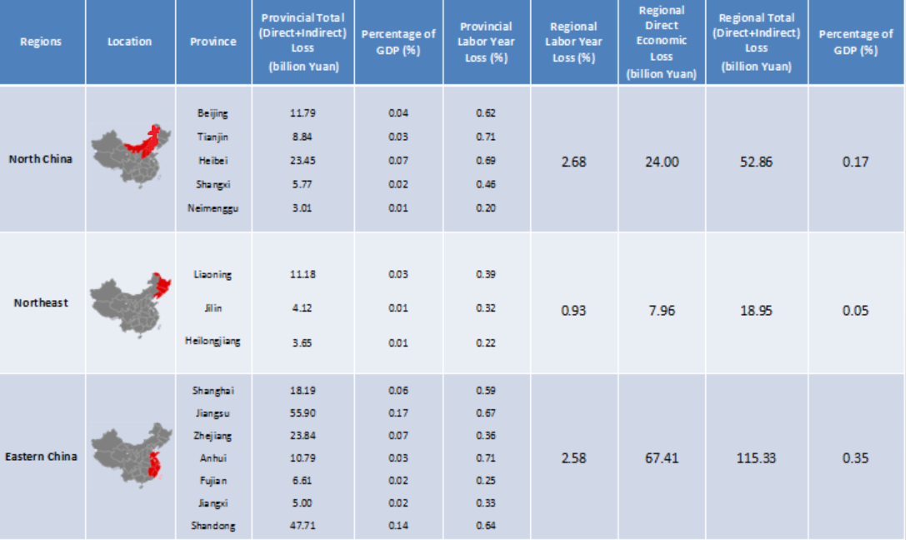
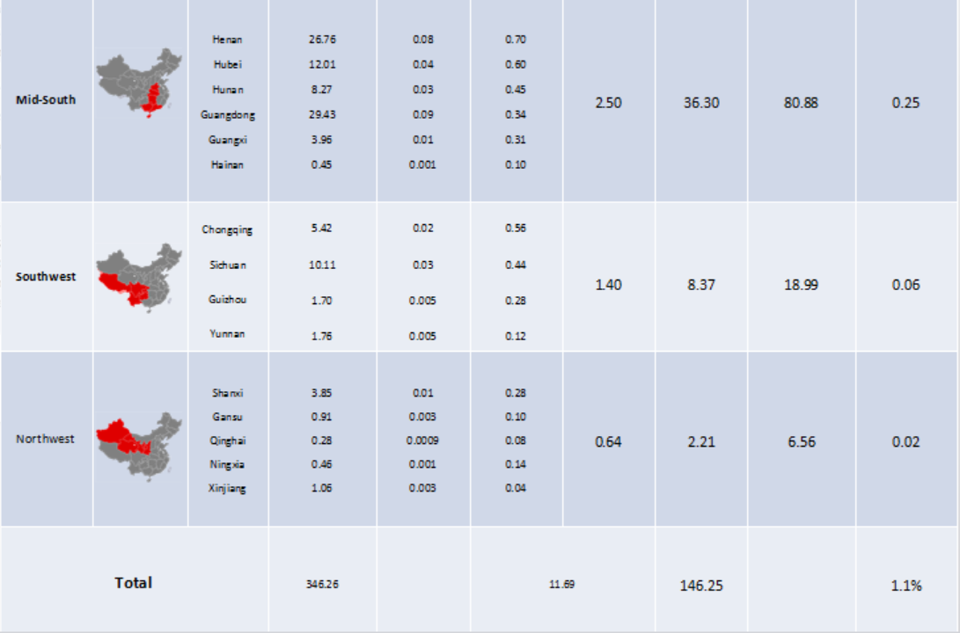
Figure 1. Provincial and regional total (direct and indirect) economic losses and reduced labor years (%).
As can be seen from Figure 1, column ‘Location’ demonstrates the regional location and column ‘Province’ shows the provinces belonging to the corresponding region. ‘Provincial Total (Direct+Indirect) Economic Loss’ and ‘Regional Total (Direct+Indirect) Economic Loss’ involve both direct economic losses measured by monetary value of reduced value-added and indirect economic losses cascaded through inter-industry or inter-regional relationships within a province or a region. ‘Percentage of GDP’ measures the proportion of total economic loss (provincial or regional) to the national GDP during that year which equals to 32,961 billion Yuan. It helps understand how much each province or region contributes to the total national economic losses. ‘Provincial Labor Year Loss’ and ‘Regional Labor Year Loss’ were obtained by comparing labor year loss due to air pollution induced mortality and morbidity within a province or a region with the original labor year in that province or region without disease-induced mortality and morbidity. All workers were assumed to work 8 hours per day and 250 days per year without air pollution resulting diseases during 2007 and the labor year loss was measured as reduced percentages. It helps clarify that the provinces or regions with heavier reliance on labor-intensive industries are more likely to suffer greater labor constraints.

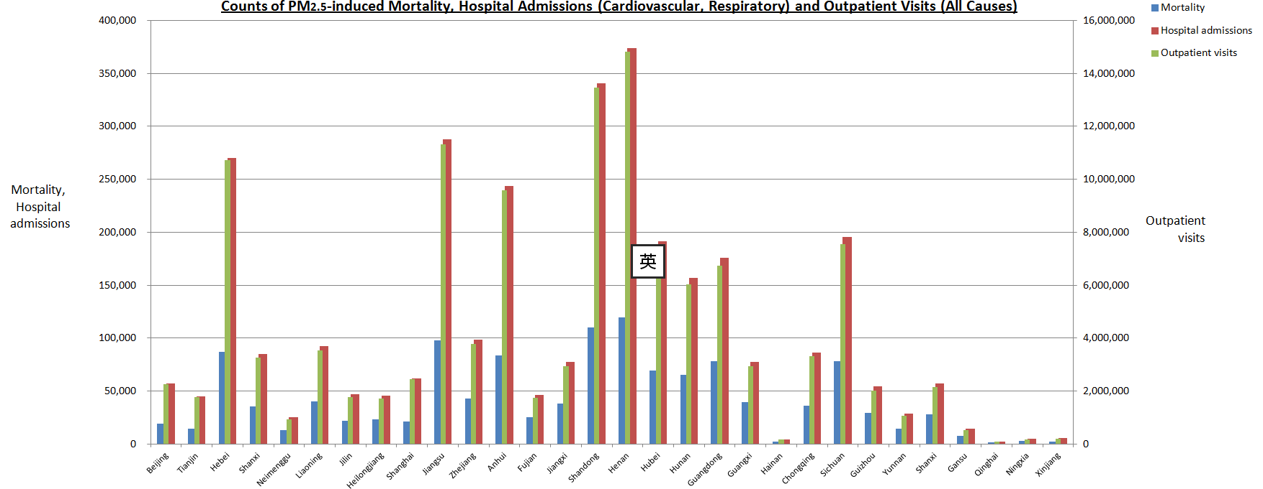
Figure 2. 2007 PM_{2.5} induced mortality and morbidity counts including hospital admissions (cardiovascular and respiratory diseases) and outpatient visits (all causes) for 30 provinces in China.
Figure 2 shows the mortality counts focus on four PM_{2.5} induced diseases, including ischemic heart disease (IHD), chronic obstructive pulmonary disease (COPD), stroke and lung cancer (LC). For morbidity, we focus on cardiovascular and respiratory diseases hospital admissions and outpatient visits as respondents reported that cardiovascular and respiratory diseases occupy the greatest proportions among respondents exposed to particulate air pollution¹⁴. Provincial mortality and morbidity counts were calculated using an integrated exposure-response (IER) model (see Method and SI Section 2.3). Provincial counts of mortality and hospital admissions are shown on the left y-axes while provincial counts of outpatient visits are shown on the right y-axes.

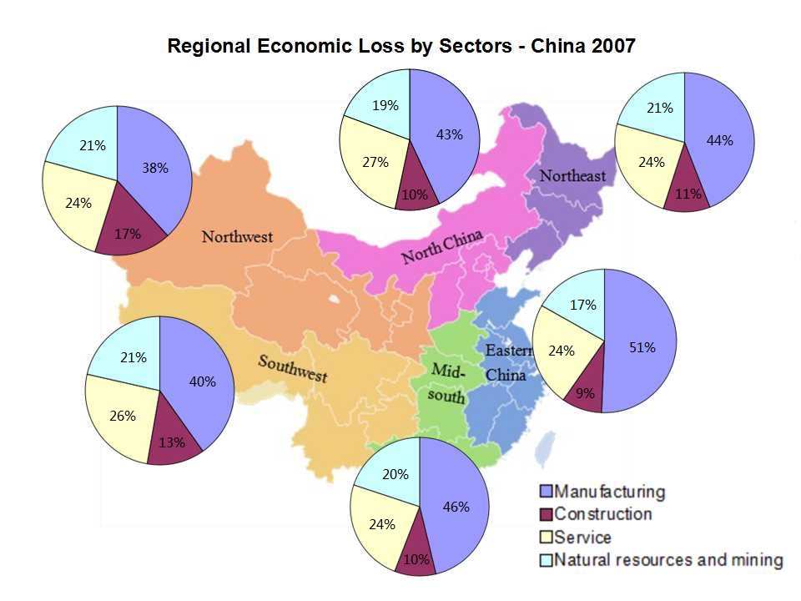
Figure 3. Regional total economic loss in China in 2007 categorized by 4 sectors.
Figure 3 presents the economic losses by sectors across China resulting from PM_{2.5} pollution in 2007 when the total economic losses reach 346.26 billion Yuan. The pie charts compare the regional economic losses attributable to four sectors in 6 Chinese regions. 30 industries in each province were re-categorized into 4 sectors and 30 provinces were grouped into 6 regions. Provincial economic losses under the same sector were summed up if they are within the same region. Regional sector-specific economic losses were then compared with total regional economic losses to evaluate sectors with greater vulnerability to labor year loss induced by PM_{2.5} contaminant diseases in each region. For detailed explanation of calculation and industry re-categorization, see SI Section 2.4 and 3.4. The greatest economic losses were observed in the manufacturing and service sectors at 163.76 and 84.64 billion Yuan, respectively, which accounted for 47.3% and 24.4% of the total estimated economic losses, respectively. These results appear to be consistent with China’s evolving industrial structure in its current stage. The percentages of value-added by the secondary (manufacturing) and territory (services) sectors to the total GDP were 46.9% and 42.9%, reflecting increases of 5.6% and 11.4% compared with 1990 level. Manufacturing sector still dominates the national economic growth in China while services sector continues growing. They both heavily rely on labor forces and other connected sectors. This could exacerbate total output loss in both sectors in the face of labor constraints caused by PM_{2.5} induced mortality and morbidity in 2007. In Eastern China where economic growth rely on the manufacturing sector, PM_{2.5} pollution caused significant reductions in labor-intensive value-added in the manufacturing sector. Thus, the reductions in manufacturing’s total output accounted for a considerable 51% of its total regional output loss. In addition, in certain provinces in North China where the service sector is burgeoning, PM_{2.5} induced mortality and morbidity also resulted in great economic losses in service sector, accounting for 27% of its total output reduction. In the Northwest and Southwest where the manufacturing sector is less developed but construction sector contributes a large share to the total regional GDP, the reduced value-added had the greatest impact on the construction sector, accounting for 17% and 13% of the total economic losses, respectively.

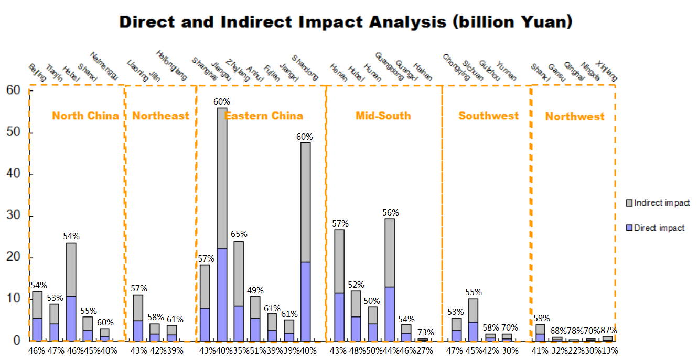
Figure 4. Provincial direct and indirect effects analysis, China, 2007.
Figure 4 compares the direct and indirect economic losses of health impacts induced by PM_{2.5} air pollution in the intermediate case where total economic losses arrive at 346.26 billion Yuan. Each bar shows the provincial total economic losses resulting from labor year loss due to air pollution induced mortality and morbidity, consisting of both direct and indirect economic losses in that province. The purple area denotes the provincial direct economic losses referring to the provincial reduced value-added while the gray area is the provincial indirect economic losses cascaded through inter-industrial and inter-regional relationships on the supply side of the economy and their percentages were presented on the bottom and top of each bar for comparisons. It is clear that large proportion of provincial total economic losses come from indirect economic loss across almost all 30 Chinese provinces. The two provinces with the greatest total output loss were Jiangsu and Shandong, which also suffered the greatest indirect economic losses. In Jiangsu, the indirect economic losses amounted at 33.70 billion Yuan, which accounted for 60% of its total economic losses. The percentage was the same in Shandong, where the indirect losses amounted to 28.76 billion Yuan. Surprisingly, in all 30 provinces except Anhui and Hunan, indirect economic losses outnumbered direct economic losses which underscore the significance of capturing the ripple effects accumulated along inter-industrial and inter-regional linkages in a circular economy. This concept is fairly meaningful, especially in provinces such as Gansu, Qinghai, Ningxia and Xinjiang, where industrial structures are primarily based on raw and pre-processed products and exports to other regions. In such cases, although direct economic losses caused by reduced industrial value-added in the province were relatively small, the indirect cascading economic losses could contribute a significant part to its total economic losses. Provinces such as Jiangsu where the industrial production processes rely heavily on importing intermediate products from other industries could suffer severe economic losses due to reduced value-added and output in industries or sectors within other provinces. As each sector has backward linkages with the sectors that provide its inputs and forward linkages with those to which it sells its outputs, changes in the value-added in one sector would influence both the upstream and downstream sectors through inter-connectedness among industries and regions.

- Conclusion
Direct economic losses represent only a small fraction of total economic losses caused by any disruptive events. Some disruptive events, such as the PM_{2.5} air pollution could result in little physical capital damages but great labor constraints on production capacity due to PM_{2.5} related diseases. Indeed, the cascading indirect economic losses of reduced labor year could be considerable due to inter-industrial and inter-regional relationships. On the one hand, both labor constraints and inter-industrial and inter-regional relationships should be taken into consideration in health costs measurement and economic loss estimation during disaster aftermath. On the other hand, the idea of integrating risk analysis, impact analysis and inter-dependency analysis is significant for identifying key sectors and thus, it appears to be equally meaningful in developing effective post-disaster economic recovery strategies and more sustainable policies. In addition, since manufacturing still dominates the national economy in China, especially in Eastern China, from which most of its products are labor-intensive, expansion beyond the region’s geography and natural endowment cannot occur without accumulating human capital, learning and innovation processes⁵⁰. This indicates that without sufficient adaptation measures and implementations, the economic growth of Eastern China is more likely to be hindered by any long term environmental stress that has adverse effects on human health. Nevertheless, the arguments above do not mean that China should turn back to natural resources; rather, they indicate that each region should develop its ability of pursuing a policy agenda to improve its capacity in diversifying its outputs beyond mundane resources and labor-intensive tasks and also, to explore its geographical advantages⁵¹⁻⁵³. This requires policymakers to broaden the current industrial structure reforms⁵⁴⁻⁵⁶. Our results highlight the potential risks associated with China’s current industrial structure and emphasize the importance of moving from traditional primary sectors focus towards less labor-intensive sector focus⁵⁷ in the face of serious air pollution and increasing frequency of extreme weather events. This research brings out important implications for integrating risk, impact and inter-dependency analyses into health costs measurement.
New research connects with uncertainties to certain degree. Firstly, this study follows the US sector categorization and the occupational respiratory condition incidence rates from the US study in order to achieve alignment due to the lack of systematic and comprehensive dataset in China. Secondly, labor year loss for each case of PM_{2.5} induced mortality, hospital admissions and outpatient visits were estimated based on assumptions due to data limits and they do not necessarily exclude holidays, weekends and the problem of double-counting. Thirdly, our study summed counts of hospital admissions for both cardiovascular and respiratory diseases and focused on respiratory tract infections for outpatient visits. This is due to the lack of data on time required for each disease’s treatment. Fourthly, due to the limited data available for regional age structure among labor, we have to use the averaged age structure across all regions. By scaling down the total affected population to affected counts among labor using provincial labor-population ratio, we considered labor as an aggregated group aged 16-65 without differentiating the different RR for various age groups among labor. Future research should devote more in differentiating health risks for at different age levels among labor in each region. Further, our application of a static supply-driven I-O model, to some extent, neglects the feedback of changing output into further changes in value-added as well as some possible nonlinear relationships between labor inputs and economic outputs (for further discussion, see SI Section 2.7). Besides, our sensitivity analysis shows the main variation comes from the assumption on outpatient visits-induced labor time loss. We suggest that the potential reason could be the majority of PM_{2.5} affected counts are outpatients and the particular context of Chinese medical system, which on the other hand, reveals the potential benefits of medical system reform, especially in improving the overall effectiveness of outpatient visits and patients’ follow-up care. Besides, more studies are required in the future for differentiating the PM_{2.5} induced diseases and the time required for outpatient visits. Further sensitivity results and discussions are included in SI Section 3.
Acknowledgements
This study was supported by the Natural Science Foundation of China (41328008 and 41222036), the UK Economic and Social Research Council (ES/L016028/1) Natural Environment Research Council (NE/N00714X/1) and British Academy Grant (AF150310).
References
1 Zhao, H. Y. et al. Assessment of China's virtual air pollution transport embodied in trade by a consumption-based emission inventory. Atmos. Chem. Phys. Discuss. 14, 25617-25650, doi:10.5194/acpd-14-25617-2014 (2014).
2 Huo, H. et al. Examining Air Pollution in China Using Production- And Consumption-Based Emissions Accounting Approaches. Environmental Science & Technology 48, 14139-14147, doi:10.1021/es503959t (2014).
3 Guan, D. et al. The socioeconomic drivers of China’s primary PM2. 5 emissions. Environmental Research Letters 9, 024010 (2014).
4 Johnson, T. M., Liu, Feng., Newfarmer, Richard. Clear water, blue skies: China's environment in the new century. (The World Bank, 1997).
5 Kan, H., Chen, B., Wang, H. Economic Assessment of Health Impact Due to Particulate Air Pollution in Urban Areas of Shanghai. Chinese Health Economics 23, 8-11 (2004).
6 Zeng, X., Jiang, Y. Evaluation of value of statistical life in health costs attributable to air pollution. China Environmental Science 30, 284-288 (2010).
7 Wan, Y., Yang, H. & Masui, T. Health and economic impacts of air pollution in China: A comparison of the general equilibrium approach and human capital approach. Biomedical and Environmental Sciences 18, 427 (2005).
8 Wan, Y., Yang, H. & Masui, T. Air pollution-induced health impacts on the national economy of China: demonstration of a computable general equilibrium approach. Reviews on environmental health 20, 119-140 (2004).
9 Nam, K.-M., Selin, N. E., Reilly, J. M. & Paltsev, S. Measuring welfare loss caused by air pollution in Europe: A CGE analysis. Energy Policy 38, 5059-5071 (2010).
10 Cho, S. et al. Integrating transportation network and regional economic models to estimate the costs of a large urban earthquake. Journal of Regional Science 41, 39-65 (2001).
11 Feng, K. et al. Outsourcing CO2 within China. Proceedings of the National Academy of Sciences 110, 11654-11659 (2013).
12 McDonald, G. & Patterson, M. Ecological footprints of New Zealand and its regions, 1997/98. (Ministry for the Environment, 2003).
13 McDonald, G. W. & Patterson, M. G. Ecological footprints and interdependencies of New Zealand regions. Ecological Economics 50, 49-67 (2004).
14 Wiedmann, T., Minx, J., Barrett, J. & Wackernagel, M. Allocating ecological footprints to final consumption categories with input–output analysis. Ecological economics 56, 28-48 (2006).
15 Hallegatte, S. An Adaptive Regional Input‐Output Model and its Application to the Assessment of the Economic Cost of Katrina. Risk analysis 28, 779-799 (2008).
16 Wang, H. & Mullahy, J. Willingness to pay for reducing fatal risk by improving air quality: a contingent valuation study in Chongqing, China. Science of the Total Environment 367, 50-57 (2006).
17 Kan, H. & Chen, B. Particulate air pollution in urban areas of Shanghai, China: health-based economic assessment. Science of the Total Environment 322, 71-79 (2004).
18 Bradley, C. J., Neumark, D., Luo, Z. & Schenk, M. Employment and cancer: findings from a longitudinal study of breast and prostate cancer survivors. Cancer investigation 25, 47-54 (2007).
19 Liljas, B. How to Calculate Indirect Costs in Economic Evaluations. PharmacoEconomics 13, 1-7, doi:10.2165/00019053-199813010-00001 (1998).
20 Segui-Gomez, M. & MacKenzie, E. J. Measuring the public health impact of injuries. Epidemiologic Reviews 25, 3-19 (2003).
21 Li, J., Crawford-Brown, D., Syddall, M. & Guan, D. Modeling Imbalanced Economic Recovery Following a Natural Disaster Using Input-Output Analysis. Risk Analysis 33, 1908-1923, doi:10.1111/risa.12040 (2013).
22 Santos, J. R. & Haimes, Y. Y. Modeling the Demand Reduction Input‐Output (I‐O) Inoperability Due to Terrorism of Interconnected Infrastructures*. Risk Analysis 24, 1437-1451 (2004).
23 Miller, R. E. & Blair, P. D. Input-output analysis: foundations and extensions. (Cambridge University Press, 2009).
24 Haimes, Y. Y. & Jiang, P. Leontief-based model of risk in complex interconnected infrastructures. Journal of Infrastructure systems 7, 1-12 (2001).
25 Rose, A. in Modeling spatial and economic impacts of disasters 13-36 (Springer, 2004).
26 Liew, C. J. The dynamic variable input-output model: An advancement from the Leontief dynamic input-output model. The Annals of Regional Science 34, 591-614 (2000).
27 Santos, J. R. Inoperability input‐output modeling of disruptions to interdependent economic systems. Systems Engineering 9, 20-34 (2006).
28 Crowther, K. G. & Haimes, Y. Y. Application of the inoperability input—output model (IIM) for systemic risk assessment and management of interdependent infrastructures. Systems Engineering 8, 323-341 (2005).
29 Zhang, Q. et al. Asian emissions in 2006 for the NASA INTEX-B mission. Atmos. Chem. Phys. 9, 5131-5153, doi:10.5194/acp-9-5131-2009 (2009).
30 Lei, Y., Zhang, Q., He, K. B. & Streets, D. G. Primary anthropogenic aerosol emission trends for China, 1990–2005. Atmos. Chem. Phys. 11, 931-954, doi:10.5194/acp-11-931-2011 (2011).
31 Zhang, Y., Liu, P., Pun, B. & Seigneur, C. A comprehensive performance evaluation of MM5-CMAQ for the Summer 1999 Southern Oxidants Study episode—Part I: Evaluation protocols, databases, and meteorological predictions. Atmospheric Environment 40, 4825-4838, doi:http://dx.doi.org/10.1016/j.atmosenv.2005.12.043 (2006).
32 Lin, J. et al. China’s international trade and air pollution in the United States. Proceedings of the National Academy of Sciences 111, 1736-1741, doi:10.1073/pnas.1312860111 (2014).
33 Jiang, X. et al. Revealing the Hidden Health Costs Embodied in Chinese Exports. Environmental Science & Technology, 1-8, doi:10.1021/es506121s (2015).
34 Huang, D., Xu, J. & Zhang, S. Valuing the health risks of particulate air pollution in the Pearl River Delta, China. Environmental Science & Policy 15, 38-47 (2012).
35 Tang, D. et al. Health benefits of improving air quality in Taiyuan, China. Environment international 73, 235-242 (2014).
36 Voorhees, A. S. et al. Public health benefits of reducing air pollution in Shanghai: A proof-of-concept methodology with application to BenMAP. Science of the Total Environment 485, 396-405 (2014).
37 He, K. et al. Co-benefits from energy policies in China. Energy 35, 4265-4272 (2010).
38 Aunan, K. & Pan, X.-C. Exposure-response functions for health effects of ambient air pollution applicable for China–a meta-analysis. Science of the Total Environment 329, 3-16 (2004).
39 Henschel, S. & Chan, G. Health risks of air pollution in Europe–HRAPIE project. (2013).
40 Xu, X., Li, B. & Huang, H. Air pollution and unscheduled hospital outpatient and emergency room visits. Environmental Health Perspectives 103, 286 (1995).
41 Statistics, N. B. o. China Statistical Yearbook 2007. (2008).
42 Dietzenbacher, E. In vindication of the Ghosh model: a reinterpretation as a price model. Journal of regional science 37, 629-651 (1997).
43 Oosterhaven, J. On the plausibility of the supply‐driven input‐output model. Journal of Regional Science 28, 203-217 (1988).
44 Statistics, B. o. L. (ed Bureau of Labor Statistics) (http://www.bls.gov/iif/oshcfoi1.htm#2007 2007).
45 Sun, J., Li, J. & An, W. 呼吸系统疾病患者住院费用与住院日分析(Respiratory disease hospital admissions costs and time analysis). 中国医院管理(Chinese Hospital Management) 30, 49-50 (2010).
46 Peasah, S. K. et al. The cost of acute respiratory infections in Northern India: a multi-site study. BMC public health 15, 330 (2015).
47 Arbex, M. A. et al. Impact of Urban Air Pollution on Acute Upper Respiratory Tract Infections. (INTECH Open Access Publisher, 2011).
48 Schatz, M., Rachelefsky, G. & Krishnan, J. A. Follow-up after acute asthma episodes: what improves future outcomes? Proceedings of the American Thoracic Society 6, 386-393 (2009).
49 Jackson, C., Shahsahebi, M., Wedlake, T. & DuBard, C. A. Timeliness of Outpatient Follow-up: An Evidence-Based Approach for Planning After Hospital Discharge. The Annals of Family Medicine 13, 115-122 (2015).
50 Mauricio Mesquita, M. Fear of China: Is there a future for manufacturing in Latin America? World Development 35, 355-376 (2007).
51 Guan, D. & Barker, T. S. Low Carbon Development in the least developed region: A case study of Guangyuan, Sichuan province, southwest China. Natural Hazards 62, 243-254 (2012).
52 Zhang, Q., He, K. & Huo, H. Policy: Cleaning China's air. Nature 484, 161-162 (2012).
53 Liu, Z. et al. Climate Policy: Steps to China’s carbon peak. Nature 522, 279-281 (2015).
54 Guan, D. et al. Determinants of stagnating carbon intensity in China. Nature Clim. Change 4, 1017-1023 (2014).
55 Liu, Z. et al. Energy Policy: A low-carbon roadmap for China. Nature 500 (2013).
56 Lindner, S. & Guan, D. A hybrid-unit energy input-output model to evaluate embodied energy and life cycle emissions for China’s Economy. Journal of Industrial Ecology 18, 201-211 (2014).
57 Lindner, S., Liu, Z., Guan, D., Geng, Y. & Li, X. CO2 emissions from China’s power sector at the provincial level: Consumption versus production perspectives. Renewable and Sustainable Energy Reviews 19, 164-172, doi:http://dx.doi.org/10.1016/j.rser.2012.10.050 (2013).

