Impacts of grassland management on wader nest predation rates in adjacent nature reserves

Samuel G. Leigh^{1*}, Jennifer Smart² & Jennifer A. Gill¹

¹School of Biological Sciences, University of East Anglia, Norwich Research Park, Norwich NR4 7TJ, UK
²RSPB Centre for Conservation Science, RSPB, The Lodge, Sandy, Bedfordshire, SG19 2DL, UK

Correspondence: Samuel G. Leigh, Centre for Agri-environment Research, School of Agriculture, The University of Reading, PO BOX 237, Reading, RG6 6AR, UK, Tel: +44(0)1183784397, Email: s.leigh@pgr.reading.ac.uk

Short Title: Grassland management effects on wader nest predation

Keywords

edge effects; waders; agri-environment schemes; nest predation; wet grassland; red foxes; lapwings; redshanks

Abstract

Wetlands have undergone significant loss and degradation over the past century, primarily through agricultural development. In the UK, wet grassland habitats support important breeding wader populations, but agricultural intensification has led to severe population declines. Management on nature reserves can be successful at attracting breeding waders, but productivity has been limited by the impacts of generalist predators of nests and chicks in these relatively small areas. Targeting agri-environment management to form buffer zones around reserves has been proposed as a potential strategy to improve landscape connectivity. However, the implications of such strategies for predator movement and activity are unknown. Here we assess whether predation rates of wader nests and predator activity within and across a wet grassland reserve are influenced by whether adjacent farmland is under agri-environment scheme (AES) management for breeding waders. In fields adjacent to AES-managed land, fox activity was higher and nest predation rates remained constant with increasing distance from the reserve edge into the reserve. Conversely, fox activity and wader nest predation rates were lower in fields close to the reserve edge and adjacent to commercial land, and increased with distance from the reserve edge although only to levels seen elsewhere on the reserve. This suggests that predators concentrate activity away from commercial farmland, and that the consequences for nest predation of deploying AES around nature reserves will likely depend on the extent to which they attract breeding waders and the strength of any consequent density-dependent effects on predation rates.

Introduction

Since the start of the 20th century, human activity has reduced global wetland habitats to around half of their total historical area (OECD 1995), and wetlands are currently under greater threat than forest ecosystems (Zedler & Kercher 2005) despite providing important services, including flood protection, carbon sequestration and recreation (Millenium Ecosystem Assessment 2005). Wetland vulnerability is likely to increase in the future, as demand for water increases, and as sea level rise exerts additional pressures in coastal zones (Nicholls, Hoozemans, & Marchand 1999; Watkinson, Gill, & Hulme 2004), with serious consequences for many species that are dependent on wetland habitats (Ramsar 2013).
In Western Europe, lowland wet grasslands support important wading bird populations, many of which have undergone very serious declines in recent decades. Increased stocking densities, drainage and conversion of grasslands to arable cropping have had significant and widespread impacts on many wader species (Benstead et al. 1997; Wilson, Ausden, & Milsom 2004). For example, in the UK, breeding populations of redshank (Tringa totanus) and lapwing (Vanellus vanellus) declined by 29% and 38%, respectively, between 1982 and 2002 (Wilson et al. 2005), and are now listed as Species of European Concern (Birdlife International 2004). Breeding populations of these species are increasingly restricted to nature reserves that are isolated within a matrix of intensively managed agricultural land (Wilson, Ausden, & Milsom 2004; Smart et al. 2008). Despite management of wet grasslands being very effective at attracting breeding waders to reserves (Smart et al. 2006; Eglington et al. 2008; Durant et al. 2008), reversing population declines has been difficult to achieve as productivity is typically limited by high levels of predation of nests and chicks by generalist predators (Andren 1992; Stillman et al. 2006; Macdonald & Bolton 2008a). Predator control and exclusion can be effective at reducing levels of nest predation, but their efficacy is variable and their use can be controversial and costly (Bolton et al. 2007; Smith et al. 2010; Malpas et al. 2013). Identifying cost-effective methods of reducing levels of nest predation is therefore a major focus of current research (Stillman et al. 2006; Gibbons et al. 2007; Bodey, Smart, & Smart 2010). For example, there is evidence that nest predation rates vary in relation to sward heights within fields (Bodey, Smart, & Smart 2010), and the presence of areas of tall vegetation in the surrounding landscape (Laidlaw et al. 2015), suggesting a role for management of such landscape features.
Given the effectiveness of group mobbing of predators by breeding waders (Macdonald & Bolton 2008b; Eglington et al. 2009), increasing the size of local breeding populations may be an effective means of reducing the impact of predation, and deploying AES around reserves could facilitate such local population increases by acting as spill-over areas for the reserve. The targeted deployment of agri-environment schemes (AES) at landscape scales has been proposed as a potential approach to improve their effectiveness (Emery & Franks 2012). Although there is no formal AES for creating “buffer zones”, targeted deployment of AESs around existing core wildlife areas, such as nature reserves, could potentially reduce adverse impacts from edge effects on reserves. Lawton et al. (2010) suggested that the creation of buffer zones should be a conservation priority to reduce some of the risks associated with small and diffusely distributed wildlife populations. As reserves can be effective in supporting breeding wader populations (Wilson, Vickery, & Pendlebury 2007), targeted deployment of AES management for breeding waders around nature reserves could potentially be an effective landscape approach to enhancing breeding wader populations (Smart et al. 2014), particularly if nest predation is reduced. However, predators could also be attracted to AES fields and/or increase their search effort in these areas (Wilson, Vickery, & Pendlebury 2007; Eglington et al. 2009). Increased predator disturbance of nests at reserve edges has been observed in forest ecosystems, and these effects were influenced by the nature of the adjacent habitat (Malt & Lank 2007). Assessing the influence of AES deployment on patterns of nest predation in adjacent nature reserves is therefore an important step in identifying the type of land management that is needed to improve breeding wader sustainability. In this study, we explore the influence of deployment of AES management on patterns of 1) wader nest distribution, 2) wader nest predation rates and 3) predator activity and distribution in adjacent nature reserve fields. As commercial and AES-managed land differ primarily in the presence of wet features that attract waders, we predict that (i) wader nests will be aggregated in reserve fields and adjacent AES land, but (ii) nest predation rates, predator activity and distribution will be unaffected by the management of AES fields, as the distribution of wet features (that are only found in reserve and AES fields) has little influence on nest predation rates or predator distribution (Bellebaum & Bock 2009; Eglington et al. 2009).

Methods

STUDY SITE

This study was carried out during the wader breeding season (April to July 2013) at Berney Marshes, a wet grassland reserve in the Norfolk Broads, eastern England (52°35’N 01°35’E). The reserve has 108 grassland fields (totalling 486 ha, Fig. 1) managed for breeding waders, by maintaining a mosaic of sward heights and shallow wet features throughout the breeding wader season. All fields within the reserve are managed under Higher Level Stewardship (HLS) AES for waders, although management intensity goes beyond the requirements of the AES as reserve fields are typically wetter with more wet features (mean ± SE proportion of fields covered in water early season: Berney Reserve = 0.18 ± 0.02; Norfolk Broads AES = 0.04 ± 0.004; RSPB unpublished data) and lower grazing intensities (Eglington et al. 2008). Some fields on the reserve, however, were unsuitable for breeding waders during the study period and were not used for data collection (Fig 1.) Fields directly adjacent to the reserve were those that shared a boundary with a reserve field and are managed commercially for arable crops or livestock, with some fields under the same wader AES management as the reserve fields (Table 1). Fields are separated by ditches (~4-6 m wide x 1.5-2 m deep), but are connected by gateways both within the reserve and to adjacent fields. The reserve boundary to the east runs adjacent to the River Yare. Natural England and the RSPB have been working with local landowners to enter commercial grassland into AES agreements designed to benefit breeding waders. Consequently, the remainder of the reserve edge now has adjacent fields that are a mix of commercial grassland, arable cultivation or fields under one of three AES management options: breeding wader, wintering wader or grassland target features (Fig. 1; Table 1). As both breeding and wintering wader options are attractive to breeding waders, these two options were combined to form the management category ‘Wader AES’ and all other field management types were combined into the category ‘Commercial land’.

WADER NEST DISTRIBUTION

Standardised searches for wader nests took place on 89 fields throughout the reserve (Fig. 1a), with 10 minute scan searches from a vehicle for open-nesting lapwings and 20 minute searches on foot to flush concealed-nesting redshank from areas with vegetation of sufficient height to conceal nests (4-6 per field; fields with more waders present were searched more in order to identify as many nests as possible). The position of all nests was recorded on a Garmin eTrex™ GPS unit and uploaded onto a map of Berney Marshes created in ArcMap by digitising features from OS OpenData™.
A total of 156 wader nests were located, and their distribution was compared to randomly located points across the reserve. Initially, 200 random points (a number likely to be similar to the final number of nests, which was not known at this point) were generated in ArcMap using the ‘Create Random Points’ tool, and exclusion of points that fell in ditches, tracks and open water reduced this to 153 random points. Two measures of distance and field management from the reserve edge were used: (1) the shortest ‘direct distance’ (Lahti 2001; Chalfoun 2002; Batáry & Báldi 2004) from each nest and random point to the nearest reserve edge was calculated and the adjacent field management (AES or commercial) was recorded; (2) as fields are separated by ditches which form a potential barrier to terrestrial predator movement, the shortest ‘constrained distance’ to the reserve edge was also calculated and adjacent field management was recorded, by restricting routes to the available gateways and causeways between fields on the reserve and at the reserve edge (Table 2).

WADER NEST PREDATION RATES

Previous studies deploying nest cameras have shown that red foxes (Vulpes vulpes) are the most common nest predator at this site (Eglington et al. 2009). Most nests are predated at night and only foxes have been recorded predating nests at night at this site (RSPB unpublished data). No nocturnal avian nest predators are active on the site, but a range of diurnally active avian nest predators are present. Consequently, nocturnal predation events are likely to involve mammalian predators, while diurnal events could involve avian or mammalian predators.
For each nest, the length and breadth (to the nearest 0.1 mm) and mass (to the nearest g) of each egg were used to calculate the estimated hatch and lay date of each nest, following Green (1986). Nests were visited every five days and, if no adult was seen incubating, the nest was visited to see if it was still active. Nests were considered successful if chicks were in the nest or if the nest lining contained small post-hatching shell fragments (Seymour, Harris, & White 2004). Predated nests were characterised by removal of eggs or the presence of predated remains before expected hatch dates. The fate of all 156 nests was recorded, including failures due to flooding, trampling or abandonment. Nests that suffered partial predation but hatched at least one egg were considered successful. The daily nest predation rate for each species was estimated using the Mayfield method (Mayfield 1961), in which the total number of nests predated is divided by the total number of days the nests were under observation, to account for the increased likelihood of locating nests that survived for longer periods.
Small iButton Thermochron® temperature data loggers recording temperature every 8 minutes were deployed in ~60% of nests, and the timing of predation events was identified from the steep and permanent drop in nest temperature. Nocturnal predation events were defined as those occurring between the end of civil twilight (dusk) and the start of civil twilight (dawn), using Civil Twilight hours for south England.

PREDATOR ACTIVITY AND DISTRIBUTION

Mammalian predator distribution was assessed using scat transects and track plots. Red fox scat (faeces) deposition transects were carried out in March and June 2013 around all study fields, after an initial visit in January to clear scats that had accumulated over winter (Fig. 1b). Scat transects took place by walking along one field edge (the length of which was recorded in ArcMap), and mapping and collecting all scats within ~5 m of the field edge. All surveys were carried out within the same few days of each month to minimise effects of variation in scat decomposition rates, detection probability and prey digestibility (Gese 2004).
Track plots were created by removing 1m² of turf and replacing with compacted sand to a depth of ~5 cm, and ~25 g of bait (low-protein Pedigree Chappie© dog food, a short-range bait that attracts foxes over a range of ~3–5 m; Österholm 1964; Eglington et al. 2009) was buried in the centre of each plot at ~2 cm depth. Soil was then sieved over the entire track plot and watered, to prevent desiccation which can impair the identification of predator footprints. Track plots were placed in all fields along the reserve boundary (Fig. 1c) during the peak nesting period for waders (April), resulting in track plots being placed in 6-7 fields (one per field) adjacent to each management type (Fig. 1c). All track plots were checked daily over nine consecutive nights and the presence of mammalian predator footprints was recorded. Previous deployment of cameras on track plots (Eglington et al. 2009) has shown that this is a reliable method for identifying mammalian species at Berney Marshes. Once a mammalian predator had visited a track plot, it was no longer monitored.
Ten-minute point counts of known avian nest predators on this site (carrion crows (Corvus corone), magpies (Pica pica), rooks (Corvus frugilegus) and jackdaws (Corvus monedula) (Laidlaw et al. 2015)) were carried out on four different days within each field during April 2013 and an average count of corvids per hour was calculated for each field.

DATA ANALYSIS

Generalised linear models (GLM) were used with the response and explanatory variables and model structures described in Table 2. Field identity was initially included as a random effect in all models but was excluded as it explained virtually none of the variation in any of the response variables (standard deviations of random effects in all models < 0.001). To assess variation in daily nest predation rates we used Mayfield’s logistic regression, in which success or failure (hatched or predated nests) was modelled with exposure days as the binomial denominator (Hazler 2004). Models were constructed to compare (i) all hatched and predated nests and (ii) all hatched nests and nocturnally predated nests. To account for any seasonal variation in nest predation, the nest initiation date (days from 1 March) was included as a covariate in all nest predation models.
To assess whether fox distribution within the reserve varied with adjacent field management a similar approach to that used to model nest predation rates was adopted. In this case fox scat presence or absence (only 9% of transects had more than 1 scat) was modelled with transect length (m²) as the binomial denominator and, for track plots, visitation (or not) by foxes was modelled with the number of nights each plot was active as the binomial denominator (maximum of nine nights for track plots that were never visited by foxes).
To assess whether corvid distribution within the reserve varied with adjacent field management, we carried out an analysis of the average number of corvids per field (mean of four counts) as the response variable and direct distance from the field to the reserve boundary and nearest adjacent field management as predictors.
The fullest model for each analysis was simplified by removing terms from the model, starting with the highest order interaction terms and comparing the new model to its predecessor using chi-squared tests. If there was a significant increase in deviance following term removal, this term was retained within the minimal adequate model. If models showed evidence of overdispersion a quasi-binomial distribution was used and models were compared using F tests (Crawley 2012). All analyses were carried out in R version 3.0.3 (R Core Team 2014).

Results

INFLUENCE OF ADJACENT FIELD MANAGEMENT ON NEST DISTRIBUTION

Of the 156 nests monitored, 31 were redshank and 125 were lapwing (Fig. 1a). As lapwing and redshank nest locations did not differ significantly in their direct or constrained distance from the reserve edge (direct: t₁₅₄ = 0.25, P = 0.81; constrained: t₁₅₄ = 0.23, P = 0.82), data for both species were pooled for analyses of nest distribution and predation rates. The mean (range) distance of wader nests from wader AES land was: direct distance = 176 m (3-630 m); constrained distance = 345 m (34-749 m), and from commercial land: direct distance = 208 m (0-552 m); constrained distance = 418 m (90-788 m). Nests were significantly closer to the reserve edge than random locations using the direct measure (mean distance ± SE: nests = 196 m ± 9, random = 230 m ± 12) but not the constrained distance to reserve edge (Table 3, Analysis 1). There was no evidence that the adjacent field management type influenced the distribution of wader nests and no evidence of an interaction between distance from edge and field management (Table 3).

INFLUENCE OF ADJACENT FIELD MANAGEMENT ON NEST PREDATION

Of the 156 wader nesting attempts that were monitored, 78 (71 lapwing and 7 redshank) hatched, 60 (47 lapwing and 14 redshank) were predated and 18 (7 lapwing and 11 redshank) were either trampled, flooded, deserted or their fate could not be determined. Overall, the daily nest predation rate and proportion of nests that hatched were 0.032 day⁻¹ and 57.2% for lapwing, and 0.051 day⁻¹ and 21.8% for redshank.
Of the 28 lapwing nests and 10 redshank nests that were predated and for which temperature profiles were available, 76% of predation events were nocturnal (89% of lapwing, 40% of redshank predation events). As not all nests had temperature loggers, two analyses were carried out; one with all lapwing nests (n = 118) and one with only lapwing nests (n = 96) containing a logger. There were too few redshank nests for analyses of predation rates. Nest initiation dates for lapwing nests did not differ significantly when adjacent fields were commercial or AES managed (adjacent field type defined by direct distance: t_{1,116} = 1.8, P = 0.42 and defined by constrained distance: t_{1,116} = 1.04, P = 0.30).
Neither direct distance to reserve edge nor adjacent field management type influenced lapwing nest predation rates or nocturnal predation rates (Table 3, Analysis 2a,c). However, lapwing nest predation rates were significantly higher when adjacent land was under wader AES management compared to commercial land when using constrained distances (Table 3, Analysis 2b). Adjacent management and distance effects also interacted such that lapwing nest predation rates in fields adjacent to wader AES fields varied little with distance from the edge (Fig. 2b), while nest predation rates in fields adjacent to commercial land rose with increasing distance from reserve edge there was greater uncertainty in predicted nest predation rates further from the reserve edge, where there were fewer nests (Fig. 2a; Table 3, Analysis 2b). Nocturnal nest predation rates did not vary with adjacent land management but increased with increasing constrained distance from reserve edge (Fig. 2d; Table 3, Analysis 2d).

INFLUENCE OF ADJACENT FIELD MANAGEMENT ON PREDATOR DISTRIBUTION

Mammalian predators
Only fox prints were recorded on track plots, and 29 of the 33 (88%) plots were visited by foxes over their nine day duration (Fig. 1c). As all plots were located on the reserve edge, no distance effects were tested, but the probability of fox use of plots was ~30% greater in fields adjacent to wader AES fields compared to commercial land (Fig. 3; Table 3, Analysis 3a). During fox scat surveys, 84 and 23 fox scats were found on the first and second surveys, respectively. Fox scat distribution did not vary significantly in relation to direct or constrained distance from the reserve edge, and was not influenced by adjacent management type (Table 3, Analysis 3b,c).

Avian predators
Corvid predators were recorded in 22% of the study fields. Neither management type of adjacent fields nor distance from the reserve edge to the centre of each field explained the distribution and abundance of corvids across the reserve (Table 3, Analysis 3d).

Discussion

Targeting of agri-environment management adjacent to nature reserves has been proposed as a potential strategy to buffer wildlife sites, but little is known about the consequences of such targeting (Batáry et al. 2015). Our study shows that nest predation rates for lapwing breeding on a wet grassland reserve are higher on fields adjacent to AES-managed fields than to commercial farmland. The presence of red foxes, the main wader nest predator in this area, was also greater in areas of the reserve adjacent to land managed for breeding waders. Although AES management adjacent to breeding wader habitat will increase the contiguous area of suitable breeding wader habitat, nest predators may also be attracted to these areas. Our study also shows the importance of using distance measures which capture constraints to predator movements when assessing patterns of predator activity and predation across the landscape.

NEST DISTRIBUTION

Although wader nests were more likely to be located closer to the reserve edge than would be expected by chance, this effect was only apparent with direct distance to the reserve edge (Table 3). There was also no effect of adjacent land management on wader nest distribution within the reserve (Table 3), and wader nests were located throughout the whole reserve (Fig 1a). Wader nest distribution is influenced by conditions within fields (e.g. areas of standing water are attractive to them; Smart et al. 2006, Eglington et al. 2008, Bellebaum & Bock 2008), while areas with features (e.g. trees) which may restrict views and provide cover for predators are often avoided (Galbraith 1998; Wallander, Isaksson, & Lenberg 2006). These local-scale features may also influence the nest distribution across this reserve.

PREDATOR DISTRIBUTION

During both the track plot surveys and scat transects, the only mammalian predators detected were red foxes. Mustelid predators are present at Berney but at low densities (Robertson 2009). Fox scat presence was not influenced by the adjacent field management type or distance from the reserve edge but use of reserve-edge track plots by foxes was greater in areas adjacent to fields with wader AES management than fields under commercial management. Scat transects spanned periods before and after peak wader breeding activity while track plots were deployed during the peak period only, and it is likely that this greater temporal resolution of the track plot surveys was needed to identify these associations. Fox scat distribution may also be influenced by the distribution of other prey types such as small mammals (Laidlaw et al. 2013). The concentration of fox track plot use in areas of the reserve adjacent to fields managed for waders may reflect greater search effort by foxes and potentially affect within-field patterns of distribution. By contrast, the distribution of corvid predators did not vary with adjacent field management or with distance from the reserve edge. In agricultural areas, avian predator distribution is often concentrated around buildings and trees (Wallander, Isaksson, & Lenberg 2006; MacDonald & Bolton 2008b), and the locations of features such as these may influence the distribution of these mobile species more than within-field conditions.

NEST PREDATION RISK

Patterns of fox distribution, but not corvid distribution, broadly matched patterns of nest predation rates, with nests adjacent to wader AES fields (where fox activity was greater) being more likely to be predated than those adjacent to commercial land. The presence of wader AES fields adjacent to the reserve appear to have little effect on predation rates across the reserve (Fig. 2b), while the reduction in nest predation rates in areas of the reserve close to commercial land (Fig. 2a) could be due to fewer foraging opportunities for foxes in these areas. This suggests that foxes may concentrate their activity away from commercial land and adjacent areas, and that breeding wader habitat may attract foxes irrespective of whether it occurs on the reserve or farmland (Fig. 2d). Kentie et al. (2015), however, found the opposite; that wader nest predation rates on commercial land were higher than on reserves in the Netherlands.
Constraints on predator movement can influence their distribution and the consequent risks for their prey. Here we used measures of direct distance, which are commonly used in studies exploring edge effects, and constrained distance, which took account of potential aquatic barriers to terrestrial predator movements. Patterns of nest predation within the reserve were detected using constrained but not direct distances, which highlights the importance of using metrics of relevance to the movement behaviour of the species in question.

CONSERVATION IMPLICATIONS

Mammalian predation of wader nests has been identified as a key factor limiting efforts to reverse ongoing declines in breeding wader populations (MacDonald & Bolton 2008a; Macdonald & Bolton 2008b; Bellebaum & Bock 2009). While predator control can be effective in reducing nest predation rates in some situations, it is not sufficiently effective to reverse population declines (Bolton et al. 2007), and raises legitimate ethical concerns. Our study suggests that targeted deployment of AES management for breeding waders around reserves has the potential to increase the area of contiguous habitat managed for waders, but that mammalian predators can also be attracted to these areas. Although this study was carried out on only one reserve in a single year, the nest predation rates that were recorded were typical for lapwings in wet grassland at this site in other years (Laidlaw et al. 2015), and at sites across Europe where nest predation by mammalian predators is unsustainably high (Macdonald & Bolton 2008b). The scale and pattern of AES deployment may therefore be important in determining the response of both breeding waders and the predators that are currently limiting their recovery.
Across Western Europe, agricultural expansion and intensification have left only highly fragmented patches of wet grassland within a wider landscape of arable crops and intensively managed grassland. With reductions in AES funding as a result of Common Agricultural Policy (CAP) reform, there is a need to ensure that existing and future schemes deliver real benefits for wildlife conservation (Kleijn et al. 2004; Batáry et al. 2011). Converting commercially managed land to AES at the edge of reserves has the potential to increase the area of contiguous habitat managed for breeding waders and thus increasing the size of breeding populations. However, the consequences for nest predation rates will depend on the magnitude of these increases and the strength of consequent density-dependent effects on hatching success, for example as a result of more effective group mobbing of predators (Macdonald & Bolton 2008b).

Acknowledgements

We thank Mark Smart, the Berney Marshes RSPB staff and Danielle Peruffo for help with logistics and nest-finding, Becky Laidlaw for help with GIS, Deepa Senapathi for help with statistics and two anonymous referees for very helpful comments on the manuscript. This study was undertaken as part of an MSc in Applied Ecology and Conservation at UEA, and funding support was provided by RSPB and UEA.

References
Andren, H. (1992) Corvid Density and Nest Predation in Relation to Forest Fragmentation: A Landscape Perspective. Ecology, 73, 794–804.
Angelstam, P. (1986) Predation on ground-nesting densities and habitat edge. Oikos, 47, 365–373.
Batáry, P. & Báldi, A. (2004) Evidence of an edge effect on avian nest success. Conserv. Biol., 18, 389–400.
Batáry, P., Baldi, A., Kleijn, D. & Tscharntke, T. (2011) Landscape-moderated biodiversity effects of agri-environmental management: a meta-analysis. P. R. Soc. B, 278, 1894–1902.
Batáry, P., Dicks, L. V., Kleijn, D. & Sutherland, W.J. (2015) The role of agri-environment schemes in conservation and environmental management. Conserv. Biol., 00, 1–11.
Bellebaum, J. & Bock, C. (2009) Influence of ground predators and water levels on Lapwing Vanellus vanellus breeding success in two continental wetlands. J. Ornithol., 150, 221–230.
Benstead, P., Drake, M., Jose, P., Mountford, O., Newbold, C. & Treweek, J. (1997) The Wet Grassland Guide: Managing Floodplain and Costal Wet Grasslands for Wildlife. Sandy: RSPB.
Birdlife International. (2004) Birds in Europe: Population Estimates, Trends and Conservation. Cambridge: Bird International.
Bodey, T., Smart, J. & Smart, M. (2010) Reducing the impacts of predation on ground-nesting waders: a new landscape-scale solution? Asp. Appl. Biol., 100, 167–164.
Bolton, M., Tyler, G., Smith, K. & Bamford, R. (2007) The impact of predator control on lapwing Vanellus vanellus breeding success on wet grassland nature reserves. J. Appl. Ecol., 44, 534–544.
Chalfoun, A. (2002) Nest predators and fragmentation: a review and meta-analysis. Conserv. Biol., 16, 306–318.
Crawley, M.J. (2012) Statistics: An Introduction Using R, 2nd edn. Ascot: Wiley-Blackwell.
Durant, D., Tichit, M., Fritz, H. & Kerneis, E. (2008) Field occupancy by breeding lapwings Vanellus vanellus and redshanks Tringa totanus in agricultural wet grasslands. Agric. Ecosyst. Environ., 128, 146–150.
Eglington, S.M., Gill, J.A., Bolton, M., Smart, M.A., Sutherland, W.J. & Watkinson, A.R. (2008) Restoration of wet features for breeding waders on lowland grassland. J. Appl. Ecol., 45, 305–314.
Eglington, S.M., Gill, J. a., Smart, M. a., Sutherland, W.J., Watkinson, A.R. & Bolton, M. (2009) Habitat management and patterns of predation of Northern Lapwings on wet grasslands: The influence of linear habitat structures at different spatial scales. Biol. Conserv., 142, 314–324.
Emery, S.B. & Franks, J.R. (2012) The potential for collaborative agri-environment schemes in England: Can a well-designed collaborative approach address farmers’ concerns with current schemes? J. Rural Stud., 28, 218–231.
Galbraith, H. (1998) Effects of egg size and composition on the size, quality and survival of lapwing Vanellus vanellus chicks. J. Zool., 214, 383–398.
Gese, E.M. (2004) Survey and census techniques for canids. Canids: foxes, wolves, jackals and dogs (eds C. Sillero-Zubiri),, M. Hoffman), & D.W. Macdonald), Gland & Cambridge: IUCN, Gland, Switzerland & Cambridge, UK.
Gibbons, D.W., Amar, A., Anderson, G.Q.A., Bolton, M., Bradbury, R.B., Eaton, M.A., Evans, A.D., Grant, M.C., Gregory, R.D., Hilton, G.M., Hirons, G.J.., Hughes, J., Johnstone, I., Newbery, P., Peach, W.J., Ratcliffe, N., Smith, K.W., Summers, R.W., Walton, P. & Wilson, J.D. (2007) The Predation of Wild Birds in the UK: A Review of Its Conservation Impact and Management. Sandy: RSPB.
Green, R.E. (1986) The Management of Lowland Wet Grassland for Breeding Waders. Peterborough: Nature Conservancy Council (NCC).
Hazler, K.R. (2004) Mayfield Logistic Regression : A Practical Approach for Analysis of Nest Survival. The Auk, 121, 707–716.
Kentie, R., Both, C., Hooijmeijer, J.C.E.W. & Piersma, T. (2015) Management of modern agricultural landscapes increases nest predation rates in Black-tailed Godwits Limosa limosa. Ibis, 157, 614–625.
Kleijn, D., Berendse, F., Smit, R., Gilissen, N., Smit, J., Brak, B. & Groeneveld, R. (2004) Ecological effectiveness of agri-environment schemes in different agricultural landscapes in The Netherlands. Conserv. Biol., 18, 775–786.
Lahti, D. (2001) The ‘edge effect on nest predation’ hypothesis after twenty years. Biol. Conserv., 99, 365–374.
Laidlaw, R.A., Smart, J., Smart, M.A. & Gill, J.A. (2013) Managing a food web: impacts on small mammals of managing grasslands for breeding waders. Anim. Conserv., 16, 207–215.
Laidlaw, R.A., Smart, J., Smart, M. & Gill, J.A. (2015) Influence of landscape structure on nest predation rates of grassland-breeding waders. Ibis, 157, 700–712.
Lawton, J., Brotherton, P.N.., Brown, V.K., Elphick, C., Fitter, A.H., Forshaw, J., Haddow, R.W., Hilborne, S., Leafe, R.N., Mace, G.M., Southgate, M.P., Sutherland, W.A., Tew, T.E., Varley, J. & Wynne, G.R. (2010) Making Space for Nature : A Review of England ’ S Wildlife Sites and Ecological Network. Report to DEFRA.
MacDonald, M.A. & Bolton, M. (2008) Predation of Lapwing Vanellus vanellus nests on lowland wet grassland in England and Wales: effects of nest density, habitat and predator abundance. J. Ornithol., 149, 555–563.
Macdonald, M.A. & Bolton, M. (2008) Predation on wader nests in Europe. Ibis, 150, 54–73.
Malpas, L.R., Kennerley, R.J., Hirons, G.J.M., Sheldon, R.D., Ausden, M., Gilbert, J.C. & Smart, J. (2013) The use of predator-exclusion fencing as a management tool improves the breeding success of waders on lowland wet grassland. J. Nat. Conserv., 21, 37–47.
Malt, J. & Lank, D. (2007) Temporal dynamics of edge effects on nest predation risk for the marbled murrelet. Biol. Conserv., 140, 160–173.
Mayfield, H. (1961) Nesting success calculated from exposure. Wilson Bull., 73, 255–261.
Millenium Ecosystem Assessment. (2005) Ecosystems and Human Well-Being: Wetlands and Water Synthesis. Washington: World Resources Institute.
Natural England. (2012) Higher Level Stewardship: Environmental Stewardship Handbook. Peterborough: Naturall England.
Nicholls, R.J., Hoozemans, F.M.J. & Marchand, M. (1999) Increasing flood risk and wetland losses due to global sea-level rise : regional and global analyses. Glob. Environ. Chang., 9, S69–S87.
OECD. (1995) DAC Guidelines on Aid and Environment: Sustainable Use of Wetlands. Paris: OECD.
Österholm, H. (1964) The significance of distance receptors in the feeding behaviour of the Fox, Vulpes vulpes L. Acta Zool. Fenn., 106, 1–31.
R Core Team. (2014) R: A language and environment for statistical computing. R Foundation for Statistical Computing, Vienna, Austria. URL http://www.R-project.org/.
Ramsar. (2013) The Ramsar Convention Manual: A Guide to the Convention on Wetlands. Gland: Ramsar.
Robertson, A. (2009) Distribution and Habitat Preference of Mustelids and Small Mammals in Wet Grassland: Implication for Breeding Waders. MSc thesis, University of East Anglia.
Seymour, A.S., Harris, S. & White, P.C.L. (2004) Potential effects of reserve size on incidental nest predation by red foxes Vulpes vulpes. Ecol. Modell., 175, 101–114.
Smart, J., Amar, A., O’Brien, M., Grice, P. & Smith, K. (2008) Changing land management of lowland wet grasslands of the UK: impacts on snipe abundance and habitat quality. Anim. Conserv., 11, 339–351.
Smart, J., Gill, J.A., Sutherland, W.J. & Watkinson, A.R. (2006) Grassland-breeding waders: identifying key habitat requirements for management. J. Appl. Ecol., 43, 454–463.
Smart, J., Wotton, S.R., Dillon, I.A., Cooke, A.I., Diack, I., Drewitt, A.L., Grice, P. V & Gregory, R.D. (2014) Synergies between site protection and agri- environment schemes for the conservation of waders on lowland wet grasslands. Ibis, 00, 1–15.
Smith, R.K., Pullin, A.S., Stewart, G.B. & Sutherland, W.J. (2010) Effectiveness of predator removal for enhancing bird populations. Conserv. Biol., 24, 820–9.
Stillman, R.A., Macdonald, M.A., Bolton, M.R., Caldow, R.W.G. & West, A.D. (2006) Management of Wet Grassland Habitat to Reduce the Impact of Predation on Breeding Waders : Phase 1 Final Report. CEH/RSPB report to DEFRA.
Wallander, J., Isaksson, D. & Lenberg, T. (2006) Wader nest distribution and predation in relation to man-made structures on coastal pastures. Biol. Conserv., 132, 343–350.
Watkinson, A.R., Gill, J. a. & Hulme, M. (2004) Flying in the face of climate change: a review of climate change, past, present and future. Ibis, 146, 4–10.
Wilson, A.M., Ausden, M. & Milsom, T.P. (2004) Changes in breeding wader populations on lowland wet grasslands in England and Wales: causes and potential solutions. Ibis, 146, 32–40.
Wilson, A.M., Vickery, J.A., Brown, A., Langston, R.H.W., Wotton, S. & Vanhinsbergh, D. (2005) Changes in the numbers of breeding waders on lowland wet grasslands in England and Wales between 1982 and 2002. Bird Study, 52, 55–69.
Wilson, A., Vickery, J. & Pendlebury, C. (2007) Agri-environment schemes as a tool for reversing declining populations of grassland waders: Mixed benefits from Environmentally Sensitive Areas in England. Biol. Conserv., 136, 128–135.
Zedler, J.B. & Kercher, S. (2005) Wetland Resources: Status, Trends, Ecosystem Services, and Restorability. Annu. Rev. Environ. Resour., 30, 39–74.

Table 1 Definitions and categorisation of the field management currently taking place on Berney Marshes and adjacent land, with the percentage length of the reserve edge in each management type. AES management descriptions are adapted from Natural England (2012).
Management category | Management details | Description of management | Percentage of the total reserve edge length (%)
Wader AES | Breeding wader | HK9/11/13 | 19
Wader AES | Breeding wader | Fields are managed specifically for breeding waders by creating and maintaining a series of shallow wet features and a varied sward structure during the breeding season. Grazing timing and intensity is restricted to avoid trampling of nests. | 19
Wader AES | Wintering wader | HK10/12/14 | 30
Wader AES | Wintering wader | Fields are managed for wintering waders and wildfowl by creating and maintaining wet features during the winter period although these are often also wet during the breeding season. There are no grazing restrictions during the breeding season. | 30
Commercial land | Grassland target features | HK15 | 14
Commercial land | Grassland target features | Management involves maintaining and restoring moderately species-rich, semi-improved and enclosed unimproved grassland. There are no grazing restrictions during the breeding season. | 14
Commercial land | Commercial grassland | Fields have high livestock densities during the breeding wader season and are managed solely for grazing or silage. | 30
Commercial land | Arable | Winter wheat. | 7

Table 2 Descriptions of the models used in each of the three analyses, and of the variables used in each of the models.
Analysis | Predator Movement | Response variable | Explanatory variables and random effects
Analysis 1. Influence of adjacent field management on wader nest distribution
1a | Direct | Location type | Direct nest distance, Field management, Direct nest distance * Field Management
1b | Constrained | Location type | Constrained nest distance, Field management, Constrained nest distance * Field management
Analysis 2. Influence of adjacent field management on predation rates
2a | Direct | Nest predation rate | Direct nest distance, Field management, Nest initiation date, Direct nest distance * Field management
2b | Constrained | Nest predation rate | Constrained nest distance, Field management, Nest initiation date, Constrained nest distance * Field management
2c | Direct | Nocturnal nest predation rate | Direct nest distance, Field management, Nest initiation date, Direct nest distance * Field management
2d | Constrained | Nocturnal nest predation rate | Constrained nest distance, Field management, Nest initiation date , Constrained nest distance * Field management
Analysis 3. Influence of adjacent field management on predator activity and distribution
3a | N/A | Mammalian presence | Field management
3b | Direct | Fox scat presence | Direct scat distance, Field management, Direct scat distance * Field Management
3c | Constrained | Fox scat presence | Constrained scat distance, Field management, Constrained scat distance * Field management
3d | Direct | Corvid abundance | Direct field distance, Field management, Direct field distance * Field management
Response variable descriptions
Analysis | Variables | Distribution | Explanation
1a,b | Location type | Binomial (logit) | Wader nest or random location
2a,b | Nest predation rate | Binomial (logit) | Nest outcome (Predated or Hatched); (R code; cbind(nest outcome, exposure days)
2c,d | Nocturnal nest predation rate | Binomial (logit) | Nest outcome (Nocturnally predated or Hatched); (R code; cbind(nest outcome, exposure days)
3a | Mammalian presence | Binomial (logit) | Absence/presence or mammal prints
3b,c | Fox scat presence | Binomial (logit) | Absence/presence of fox scat; (R code; cbind(scat presence, transect length)
3d | Corvid predator rate | Quasi-poisson | Average number of corvid predators per field
Explanatory variable descriptions
Analysis | Variables | Explanation & Factor levels
1a; 2a; 3b | Direct nest/scat distance | Shortest distance from each nest or scat to the reserve edge, measured using the ‘Spatial Analyst Proximity’ tool in ArcMap™ (v10.1)
1b; 2b; 3c | Constrained nest/scat distance | Shortest distance via a gateway or ditch crossing from each nest or scat to the reserve edge, measured using the ‘Measure’ tool in ArcMap™ (v10.1)
3d | Direct field distance | Shortest distance from the centre of each field to the reserve edge, measured using the ‘Spatial Analyst Proximity’ tool in ArcMap™ (v10.1)
1a,b; 2a,b; 3a-d | Field Management | Management type of fields adjacent to reserve edge (Commercial land or Wader AES)
2a-d | Nest initiation date | The date the nest was laid (days from 1 March)

Table 3 Results of GLMs of factors influencing wader nest distribution, the probability of nest predation and predator distribution. Estimates and confidence intervals (CI) are only presented for significant variables retained by model comparison (bold). Terms retained in the minimal model are shown but, where no minimal model was found, all terms present in the maximal model are shown for completeness. In all models the reference field management category was commercial land and therefore parameter estimates are given for wader AES. See Table 2 for descriptions of variables and analyses.
Analysis | Predictor terms in models | z/t statistic | P |  | Estimate (95% CIs)
1a-b. Influence of adjacent field management on wader nest distribution
1a | Direct nest distance | 2.21 | 0.028 |  | 0.0019 (0.00024 to 0.0036)
1b | Constrained nest distance | -0.90 | 0.37
 | Field management | -1.24 | 0.22
 | Field management x constrained nest distance | 0.89 | 0.37
2a-b. Influence of adjacent field management on predation rates
2a | Direct nest distance | -0.36 | 0.34
 | Field management | -0.30 | 0.16
 | Nest initiation date | 2.98 | 0.0061 |  | 0.031 (0.0094 to 0.051)
 | Field management x direct nest distance | 0.91 | 0.28
2b | Constrained nest distance | 2.13 | >0.001 |  | 0.0037 (0.00027 to 0.0073)
 | Field management | 2.25 | 0.018 |  | 2.25 (0.37 to 4.31)
 | Nest initiation date | 2.76 | 0.010 |  | 0.030 (0.0074 to 0.50)
 | Field management x constrained nest distance | -1.95 | 0.049 |  | -0.0042 (-0.0085 to -0.0000060)
2c-d. Influence of adjacent field management on nocturnal predation rates
2c | Direct nest distance | -1.65 | 0.31
 | Field management | -1.16 | 0.84
 | Nest initiation date | 2.25 | 0.043 |  | 0.031 (0.0011 to 0.057)
 | Field management x direct nest distance | 1.41 | 0.15
2d | Constrained nest distance | 2.26 | 0.027 |  | 0.0027 (0.00031 to 0.0050)
 | Field management | -0.19 | 0.67
 | Nest initiation date | 2.54 | 0.022 |  | 0.038 (0.0059 to0.066)
 | Field management x constrained nest distance | 0.05 | 0.96
3a-c. Influence of adjacent field management on fox activity and distribution
3a | Field management | 2.51 | 0.012 |  | 0.079 (0.17 to 1.41)
3b | Direct scat distance | 0.17 | 0.87
 | Field management | 1.11 | 0.27
 | Field management x direct scat distance | -0.44 | 0.66
3c | Constrained scat distance | -1.47 | 0.14
 | Field management | -0.66 | 0.58
 | Field management x constrained scat distance | 0.92 | 0.36
3d. Influence of adjacent field management on corvid predator activity and distribution
3d | Direct distance | -0.17 | 0.52
 | Field management | 0.28 | 0.64
 | Field management x direct distance | -0.61 | 0.55

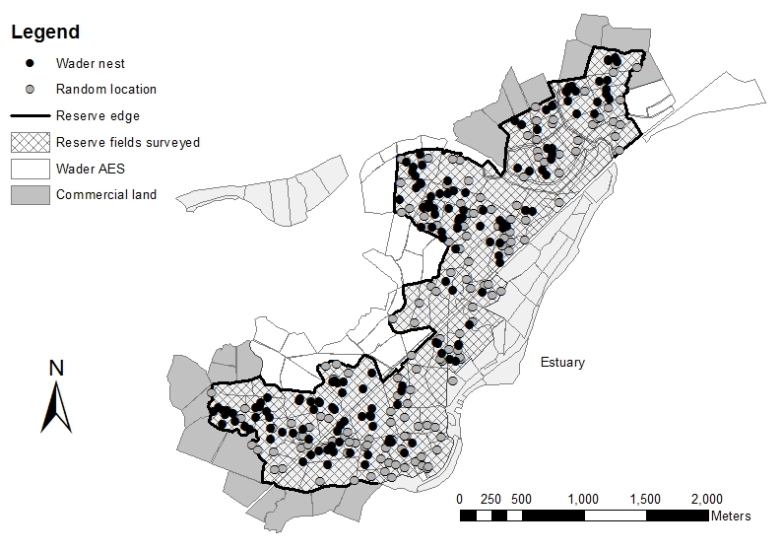
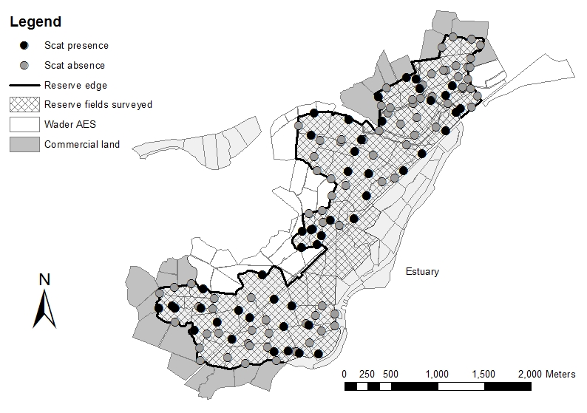
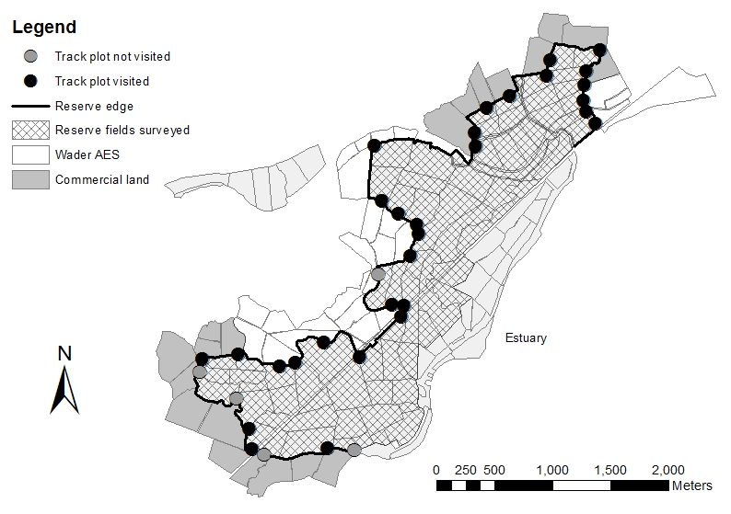
Figure 1 The distribution of a) surveyed wader nests and random points b) transects with (black circles) and without (grey circles) fox scats and c) visited (black circles) and unvisited (grey circles) track plots at Berney Marshes in Norfolk, in 2013.

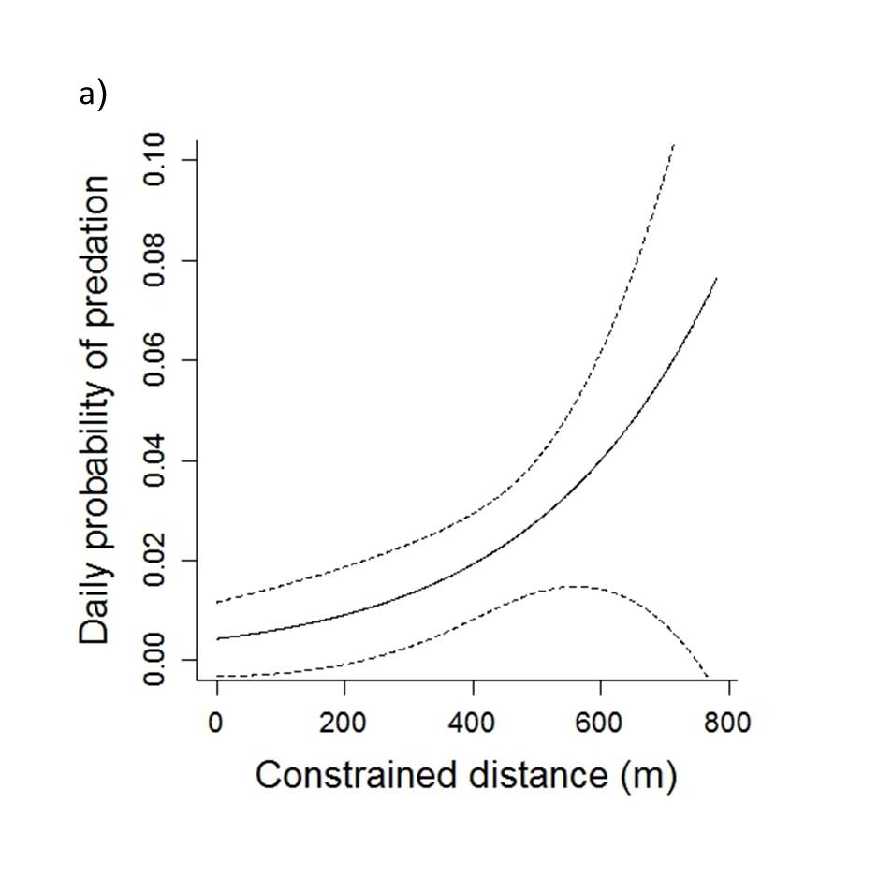 | 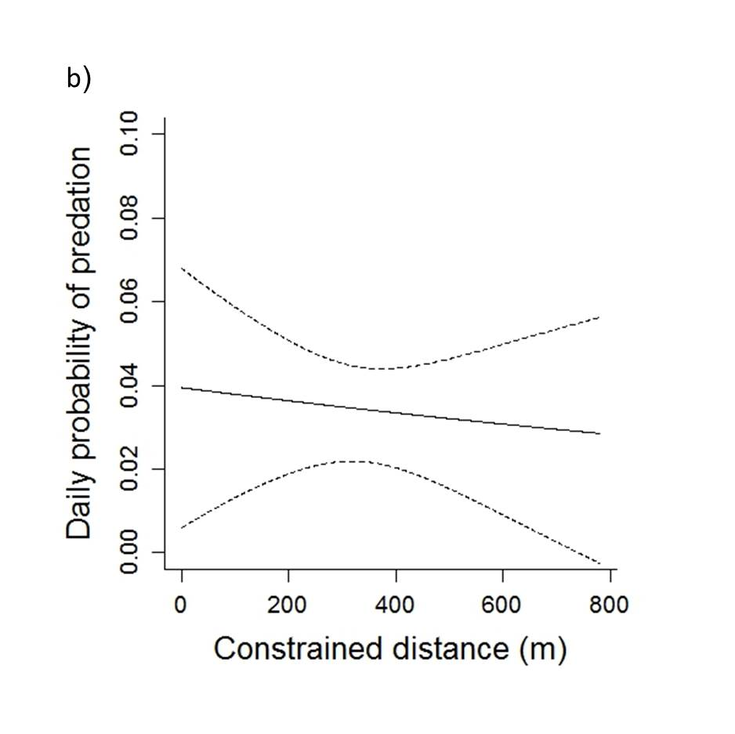
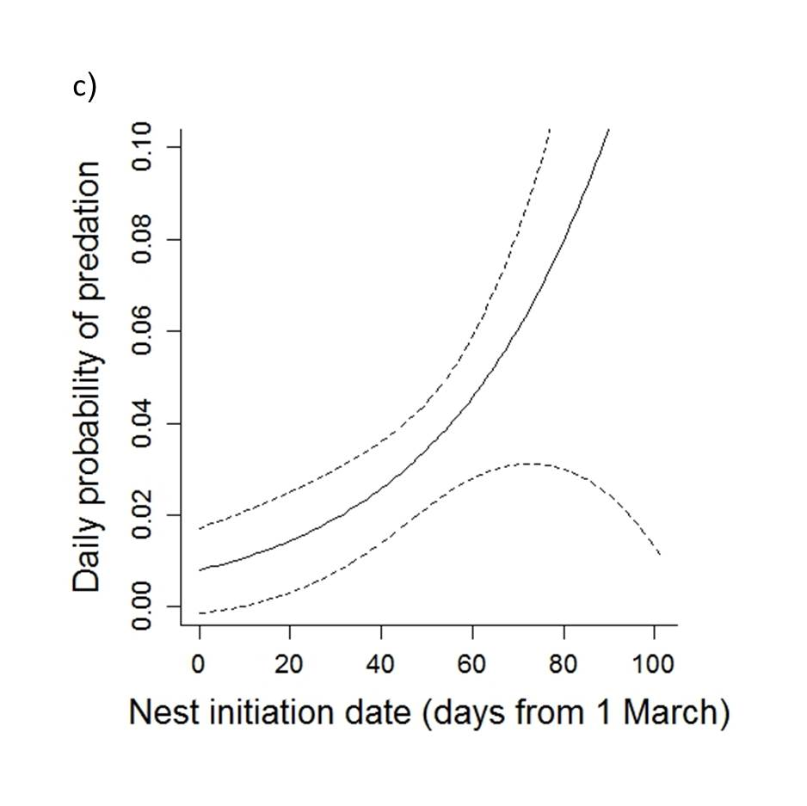 | 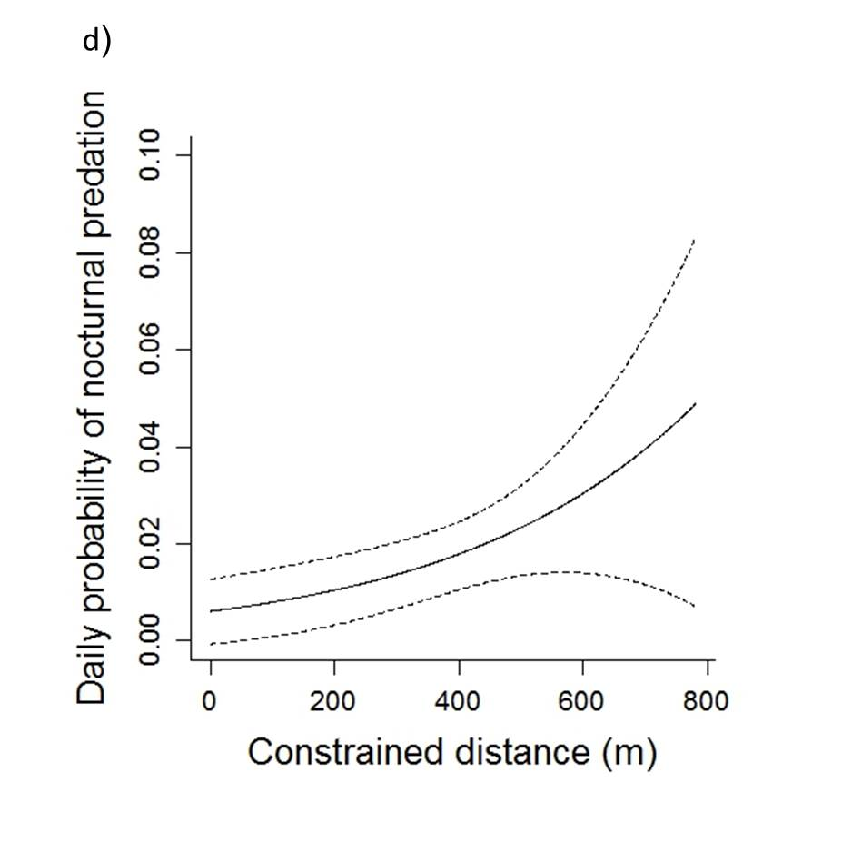
Figure 2 Predicted daily lapwing nest predation probability in relation to constrained distance (at mean nest initiation date = 49) from nests to the reserve boundary adjacent to a) commercial land b) wader AES and predicted daily nest predation probability in relation to c) nest initiation date (at mean constrained distance = 373m). Predicted daily lapwing nocturnal nest predation probability in relation to d) constrained distance from nests to the reserve boundary (dashed lines indicate 95% predicted confidence intervals).

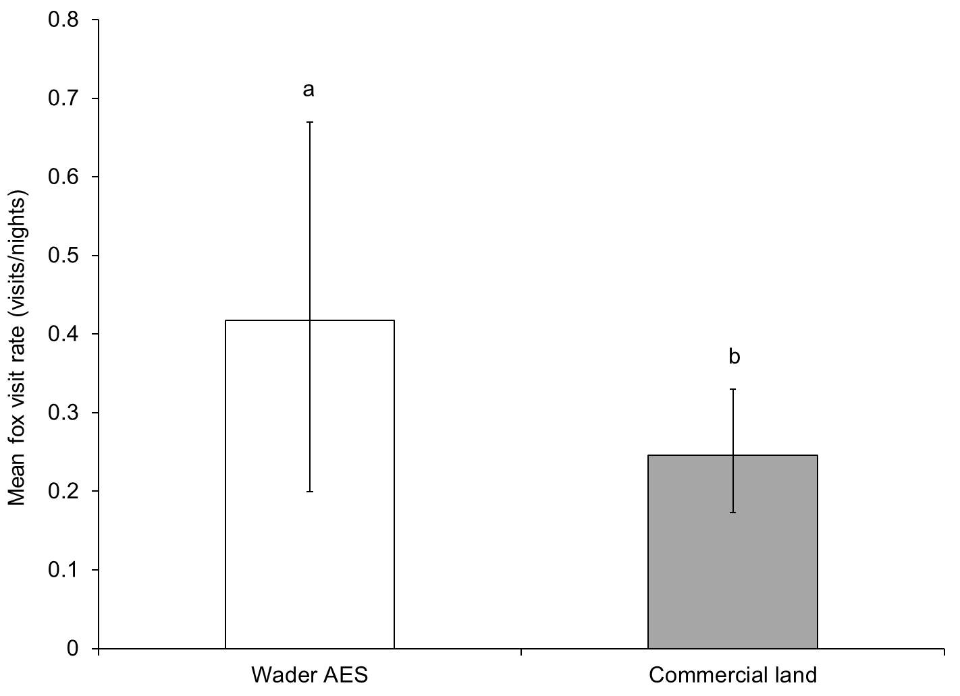
Figure 3 Mean daily probability of fox visitation (visits/nights ± 95% CIs) to track plots adjacent to wader AES managed fields and commercial land at Berney Marshes, Norfolk (letters indicate significant differences).

