The Effect of Historical Events on the Speed of Price Evolution Indexed by an Operational Time for China’s Futures Market
Ren Zhang, Youwei Li, Donal Mckillop

Abstract
This paper investigates the effect of historical events on the speed of price evolution on China’s futures market. The effect of historical events is analyzed by estimating multiple structural breaks in the MDH (mixture of distributions hypothesis) regressions for operational time. The conditional means of the best model show that some futures products’ prices exhibit short-term downturn in 2008 when the financial crisis occurred. However, the financial crisis does not slow down the speed of price evolution.

1. Introduction
The non-normality of security price returns has attracted a large number of studies. The observed distributions are commonly called leptokurtic because of the narrower body of the distribution and fatter tails. One explanation suggested for the leptokurtosis in speculative market prices is the serial correlation in the time series of absolute or squared returns. This assertion, however, cannot explain the determinants behind these dynamic dependencies. An approach for rationalizing the strong contemporaneous correlation in price series is provided by the mixture of distributions hypothesis (MDH) developed by Clark (1973), in which a stochastic time variable (operational time) as opposed to calendar time was subordinated to the price process, and this operational time can be approximated by a physically observed variable: trading volume (or number of trades). According to the MDH theory, price changes and trading volumes are driven by the same underlying latent information flow that influences the expectations of market practitioners to result in price volatilities.
The MDH has been modified by researchers in recent decades including Tauchen and Pitts (1983), which refined Clark’s specification by including trading volume as an endogenous variable. Lamoureux and Lastrapes (1990) put the information arrival variable into ARCH (autoregressive conditional heteroskedasticity)/ GARCH (generalized autoregressive conditional heteroskedasticity) models to find the source of the autocorrelation in price change variance. Andersen (1996) divided trading activities into two parts: one part was related to information arrivals whereas another one was not. Other research tended to discover if the dynamic of price volatility and volume share long run or short run behaviour (Bollerslev and Jubinski, 1999; Ane and Rangau, 2008). These studies are all based on the assumption that the price change variance and trading activity are simultaneously directed by the information arrival process.
The aforementioned literatures give an explanation about how information arrivals actually affect price evolution and trading activity. Clark (1973) suggested that price evolved at different rate each day (or other identical calendar time intervals such as two days, one week and so on) because the accumulations of the number of information arrivals are different each day. In other words, different speed of price evolution each day is due to the fact that information is available to traders at a varying rate. On a day when a large volume of information is available, it may violate previous expectations of traders, trading is brisk and the price evolves faster. On a day when a small volume of information is available, trading is slow and price evolves slowly. Namely, information arrivals causing price volatility and change in trading volume depends on different availability of information to traders and change in traders’ expectations for markets. For example, in futures markets, a large number of traders, at any time are waiting for more profitable opportunities with their own expectations about a futures contract’s price. When new information arrives, traders’ expectations and futures price change. Those inside traders may have the information earlier and then change their trading behaviour. Other traders may only learn of uncertain information or obtain the information slower than inside traders. Thus, different expectations among traders cause traders to buy or sell assets in different directions, which results in significant trading activity and price changes. On the other hand, new information may be perceived by all traders to change their expectations in the same way, and then move price in the same direction. Under this situation, high price changes go with low volume (but above average trading volume).
Therefore, market price volatilities are caused by the new information flow arrivals which also lead to great variations on trading volume, and the changes on price and volume should be positively correlated. Volume of trading thus can be an operational clock to measure the speed of price evolution. For modelling price movement on operational time, Clark (1973) introduced a subordinated stochastic process (SP), and its test results displayed that the SP outperformed the stable paretian hypotheses developed by Mandelbrot (1963) by providing higher likelihoods, and it considers the leptokurtosis in the distribution of price change series, therefore surpasses the normal distribution.
The speed of price changes sometimes could slow down or become faster due to the effect of historical events such as policy changing or economic shocks. When “good” or “bad” events occur, the accumulation of the number of information arrivals increase, asset prices thus appear to sharply increase or decline and price evolves at a faster rate with active trading behaviour; whereas during less eventful periods, prices evolve slowly with dull trading activities. The effects of historical events on the speed of price changes can be investigated by estimating possible structural breaks and then compare the price evolution in different segments divided by those breaks in a time series. Kim (2003) investigated the effect of historical events on the price change of Korea Composite Stock Price Index (KOSPI). He estimated multiple structural breaks on the SP linear regression models developed by Clark (1973). His empirical results are robust in supporting Clark’s conclusion and showed that the estimated breakpoints were very well related to the real historical events.
For the method of estimating structural breaks, a large number of studies focus on testing a single change point or a known number of breaks. Some studies, however, estimate multiple structural changes and develop the methodologies to investigate the structural change at unknown time or unknown number of break points (Andrews et al., 1996; Grcia and Perron, 1996; Liu et al., 1997; Bai and Perron, 1998, 2003). A popular methodology is that by Bai and Perron (1998, 2003) where they estimated multiple structural shifts employing less restrictions compared to previous approaches. Their approach accommodates the serial correlation and heteroskedasticity in the errors. They also allowed for different distributions for the errors and the regressors across segments. Due to these advantages, the method developed by Bai and Perron (1998, 2003) is used to estimate structural breaks in this paper. Based on Kim’s idea, we investigate the structural breaks on the SP linear regression model where operational time is approximated by the cumulative volume of trading. Eight main futures products related to agriculture, metal and energy in China’s three dominant futures exchanges are examined in this paper. As most of the past studies associated with the MDH or the relationship between price volatility and trading activity focus primarily on the markets of western industrial nations, little evidence has been reported for the eastern emerging markets, especially for China’s developing futures market. We initiate this study to attempt filling in the gap. The number of breakpoints is selected by using Bayesian information criterion (BIC) suggested by Yao (1988). Our findings provide evidence of whether estimated structural breakpoints are close to real historical events. In addition, the Shanghai Futures Exchange (SHFE)’s data covers the period to June 2009, enabling the impact of the recent economic crisis to be assessed.
The remainder of the study is organized as follows: Section 2 introduces the data used. Eight futures contracts are investigated with delivery month, contract period and the number of observation detailed. Section 3 gives details of the methodology. The content of this section includes the subordinated stochastic process and the models developed by Clark (1973), the sequential method developed by Bai and Perron (1998, 2003) for identifying breakpoints, and the criterion of specifying the minimum number of observations per segment while estimating structural breaks. Section 4 presents empirical findings and the discussion related to each contract. Finally, section 5 summarises the article and provides the conclusions.

2. Data
Eight daily futures return series selected from three dominant Chinese futures exchanges are investigated in this study. Futures contracts are hard wheat and the cotton selected from the CZCE (the China Zhengzhou Commodity Exchange); soybean meal, soybean No.1 and corn selected from the DCE (the Dalian Commodity Exchange); copper, aluminium, and fuel oil selected from the SHFE (the Shanghai Futures Exchange). The number of observations, delivery month and the duration of contracts are displayed in Table 2.1.
Table 2.1 shows that there are six delivery months: January, March, May, July, September and November for the hard wheat futures contract, the soybean No.1 contract and the corn contract. The delivery months of the cotton futures contract are from January to December. There is no delivery in February when the Chinese New Year occurs. The delivery month of the soybean meal contract are January, March, May, July, August, September, November and December. The three futures products in the SHFE all have the same delivery months from January through to December.
The sample period for each contract is different because each product began at a different date and data availability differs across exchanges. Because the data used is not readily available, the sample period for the DCE’s contracts end in 2007. The CZCE data ends on 30 June 2008, one year longer than that of the DCE’s data. The sample series’ lengths of the SHFE’s contracts are available until 30 June 2009. The time series of daily observations for each product are obtained by rolling over the compounded continued returns consecutively between each nearest delivery contract of the product. It should be noted that the number of observations in these time series are less than the real trading days after removing jumps and gaps in price data especially for the hard wheat contract.

3. Methodology
3.1. The Subordinated Stochastic Process (SP)
Now we suppose that discrete stochastic processes are usually indexed by a calendar time in a straightforward form: 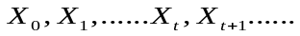 Instead of indexing by the integers 0, 1,2,…t, t+1…, the process could be indexed by a set of numbers 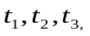…… ,where these numbers are themselves a realization of a stochastic process with positive increments, so that 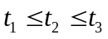……This means that if T(t) is a positive stochastic process, a newly formed process X(T(t)) is thought to be subordinated to the parent process X(t). T (t) is called the directing process (operational time). The distribution of 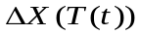is deemed to be subordinate to the distribution of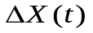 , where presents the individual effects in the price evolution process, T(t) is a operational clock measuring the speed of price evolution. X (T (t)) is the price process itself.
Using the MDH process, Clark (1973) developed a contemporaneous relation between speculative asset price volatility and trading activity. Three regression models are proposed to construct the relationship between these two variables. After adjusting price changes by “volume clock”, the best estimate can be obtained by utilizing the model in which original price change series can be better adjusted to the normal distribution.
Three models developed by Clark (1973) are as follows:
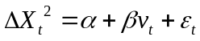 (3.1)
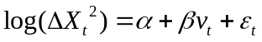 (3.2)
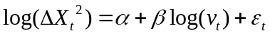 (3.3)
Where v_{t} denotes trading volume. Test results in Clark (1973) suggested that both model (2) and model (3) were good in explaining price changes. However, the linear specification in model (1) was the worst with a low F statistics for the correlation of two variables. Our empirical test also shows an inferior result for model (1). Therefore, it is not considered or reported in this paper.
It should be noted that, model (3) presents a lognormal-normal distribution for price changes. The “lognormal-normal” describes a process,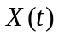 whose independent increments 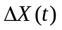are normally distributed, directed by a process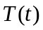, whose independent increments are lognormally distributed. This process was strongly supported by the empirical tests in Clark’s paper to be the best obtainable regression. The kurtosis of the price changes had been reduced by a very significant amount after adjusting returns by the logarithm of volume data.
To adjust price changes by operational time, the distribution of the adjusted return series can be found in the following way: If the estimated volume clocks, 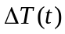=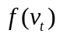, are given as 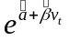by model (2), and 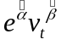by model (3), then 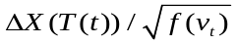, the price returns adjusted by the estimated volume clocks should be distributed as . Based on Clark’s theory, it should be normally distributed or lognormal-normally distributed.
3.2. Multiple Structural Breaks
We use Bai and Perron’s multiple linear regression models with m breaks. Observations then are partitioned into m+1 regimes:
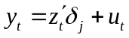 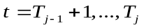 (3.4)
Where 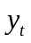 denotes the observed dependent variable at time t ; 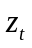are vectors of the independent variable, and 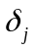(j =1,…,m+1) are the corresponding vectors of coefficients; 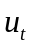is the disturbance at time t. The break points (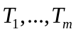) are unknown. We now change the linear regression model (3.4) into matrix form:
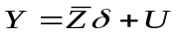 (3.5)
Where Y=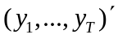, 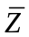is the matrix which diagonally partitions Z at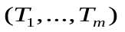,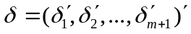, U=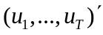. The estimation process is based on the least-squares principle. Thus, for each m-partition, are the associated least-squares estimates, which obtained by minimizing the sum of squared residuals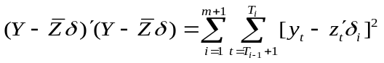. Now we assume 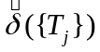as the estimated matrixes of coefficient based on the given m-partition. In other words, the estimated regression parameters are the estimates associated with the m-partition {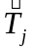}. If we substitute these in the objective function and denote the resulting sum of squared residuals as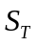, the estimated break points 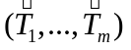are such that =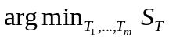, where the minimization is taken over all partitions. Therefore the break point estimators are global minimisers of the objective function.
The idea of estimating break points presented above is based on calculating the global minimisers of the sum of squared residuals. Now consider the piecewise linear regression method suggested by Guthery (1974) to compute the global minimisers of the objective function. The piecewise linear function begins with an ordering of the observations and applies a dynamic program. With a sample of size T, the total number of possible segments is at most T (T+1)/2.The global sum of squared residuals for any m-partition and for any value of m must be a particular linear combination of these T (T+1)/2 sums of squared residuals. The estimates of the break dates, the m-partition, correspond to this linear combination which must have a minimal value of sum of squared residuals, so that an optimal partition can be selected over all possible m-partitions.
The computation of the estimates, 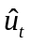and can be carried out by applying OLS segment by segment without constraints among them. Once the sums of squared residuals of the relevant partitions have been computed, a dynamic programming algorithm can be used to compare possible combinations, and then find a partition which achieves a global minimization over the entire sum of squared residuals. This method essentially proceeds through a sequential examination of optimal one-break partitions. The optimal partition resolves the following recursive problem:
(3.6)
It simply minimizes over the set of possibilities obtained by assuming the first j elements have been optimally partitioned in m-1+1 parts and that m+1 part consists of the last T-j+1 elements. The optimal partitions can be obtained by iteratively using this dynamic program.
Before estimating structural breaks, it is very important to pre-specify a further parameter, the minimum fraction of observations allocated to any one segment, or the minimum number of observations per segment h, where 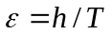.It may be considered as a bandwidth or trimming parameter imposed by researchers, and hence affects the asymptotic distribution. Results of the estimation are quite sensitive to the different choices of this parameter as a small bandwidth may results in the considerable size distortion when different variances in the errors across segments or serial correlation are allowed. When allowing different variances across segments or serial correlation is taken into account, a higher value of or h should be used, the minimum fraction of observations allocated to one segment may be imposed by =0.10, =0.15, =0.20, =0.25. Letsymbolizes the break fractions and 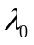=0, 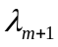=1; 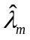 denotes the fractions of the estimates of the break points. The maximum number of breaks considered should be eight rather than nine when =0.10, because allowing nine break points results in the estimates to be exactly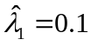, 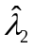=0.2, 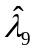=0.9. Similarly, the maximum number of breaks estimated should be five when =0.15; when =0.20, this number is considered to be three, and should be two when =0.25 (Bai and Perron 2003: 14). Due to the consideration of larger observations (greater than 100) for each segment, and simultaneously considering a not small number of breaks, we estimate structural breaks to the selected time series with =0.15 (the maximum number of breaks is five).

4. Empirical Findings
4.1. Empirical Findings for the CZCE
4.1.1. The Hard Wheat Contract
Table 4.1.1 displays the preliminary statistics of the daily returns of the CZCE’s contracts. The results show that the kurtosis and the Jarque-Bera statistics are significantly reduced for the returns adjusted by operational time. However, they are still far from the normal distribution. The hard wheat returns exhibits a positive skewness of 0.6891, and the value of the kurtosis, 10.641, is significantly different from normality. The Jarque–Bera statistic is too large and the corresponding P-value indicates that returns are significantly different from the normal distribution. The moments of hard wheat returns adjusted by Clark’s model (2) and model (3) show both the skewness and the kurtosis have decreased. Values of the kurtosis for returns adjusted by model (2) and model (3) are reduced to 2.363 and 2.366 respectively which are both lower than three. However, although the Jarque-Bera statistics are reduced from 6886.016 to 46.302 after adjusting returns by model (2) and to 45.989 after adjusting returns by model (3), they are still too high to accept normality.
To investigate the effect of historical events on the asset returns adjusted by volume clocks, we apply the sequential methods to estimate multiple structural breaks in two models. Figure 4.1.1 shows the RSS and BIC for the hard wheat returns adjusted by two models. The information criterion (BIC) selects three breaks for the returns adjusted by model (2). However, because of the well-known fact that information criteria are often downward-biased (Zeileis and Kleiber, 2005a), Bai and Perron argue in favor of the presence of an additional break. Moreover, the decrease of the RSS when passing from a three breaks model to a four breaks model is not very small. These results may be summarized as pointing to a four breaks model. Similar to returns adjusted by model (2), Figure 4.1.1-2 reveals that the BIC selects three breaks for the returns adjusted by model (3). However, due to the possibility of downward-bias of the BIC and a nontrivial decrease on the RSS when passing from a three break model to a four break model, we chose the model with four breakpoints.
Breakpoints estimates for the CZCE’s returns adjusted by model (2) and model (3) are given in Table 4.1.2. We investigate the speed of futures price evolution by allowing for these structural breaks. The moments of the CZCE’s returns adjusted by model (2) and model (3) with estimated multiple structural breaks are exhibited in Table 4.1.3. The Jarque-Bera statistics show that the null hypothesis that returns are normally distributed cannot be rejected at 1 per cent significance level for the third regime and the fifth regime for the hard wheat returns adjusted by model (2); whereas the null hypothesis cannot be rejected at 1 per cent significance level for the third, fourth and fifth regimes for returns adjusted by model (3). These results suggest that model (3) can be chosen as the best obtainable regression for operational time for the hard wheat contract as more regimes of returns adjusted by this model are normally distributed. Accordingly, we chose the four breakpoints estimated by model (3) as the best estimation.
Figure 4.1.2 shows the conditional mean of the hard wheat returns adjusted by model (3) (the middle line). The effect of historical events on the speed of price evolution can be revealed by observing the conditional means of model (3) with four breaks. The return series is divided by four breakpoints into five sections, and in each section, it progresses at different levels. The first segment shows a relatively higher level of returns which indicates a faster rate of price evolution for the hard wheat contract. Price evolves at a slow rate in the second segment and then becomes slower in the third section as lower levels of returns are displayed in these two regimes. Conditional mean shows more volatility in the fourth section with return level being slightly higher than that of in the third section. The fifth section shows a faster rate of evolution compared with the second, third and the fourth section. However it is still slower than the first.
To reveal the effect of historical events on the speed of price evolution, it is necessarily to investigate if the estimated breakpoints are intimately related to the real historical events. Zhang et al., (2008) pointed out that there is a structural break on 31 August 1998 for the hard wheat contract. They described that China’s futures market experienced a strong growth (with a chaos) from 1993 to 1995. Chinese government adopted measures to rectify the market during this period. In August 1998, an order enacted by government came into force to cut down the number of futures exchange from 15 to three, and the number of products from 35 to 12. This event had a strong influence on the history of China’s futures market, and therefore a structural break occurred. Figure 4.1.3 shows a peak in price series during 1995 and then prices gradually goes down before the first breakpoint on 09/08/1998. Returns series displays bigger clusters with more and higher extreme values in the first regime.
After 1998, China’s economy was affected by the Asian financial crisis. Futures market, on the one hand, developed through encouraging government’s policy; on the other hand, cracking down severely on futures exchanges and products result in a 30 per cent to 40 per cent yearly decline of trading volume until 2003. Price evolved at a very low rate during this period. Figure 4.1.3 exhibits a relatively lower price level and narrower returns from the first breakpoint to the second breakpoint on 12/09/2001. After the second breakpoints, price evolves slower than that of in the last regime with very narrow returns oscillating around zero. Wheat prices during this period were low because of the weak demand and oversupply. “9.11 Event” may affect the CZCE since it seriously impacted on the CBOT. China formal joining of the WTO in December 2001 is supposed as a breakpoint since it brought about increase of wheat’s import. Although hard wheat price rose after November 2002 to July 2003 due to yields’ reduction, it did not lead to much increase on the speed of price evolution. From the third breakpoint to the fourth breakpoint, 14/12/2005, China’s economy prospered as it walked out of the Asian financial crisis. Lots of papers and reports focused on its high economic growth and remarkable GDP. Large number of investors began buying long which resulted in an increase of futures market price. Figure 4.1.3 exhibits an increase on the hard wheat price after the third break. However, return series does not appear much fluctuated or extremely high. This might have happened because although a larger number of investors during this period had similar expectations of markets to move price in one direction, some of investors were still waiting and holding on the fence, so that price kept at a relatively stable level (slightly going down) and evolved at a moderate speed. After the fourth breakpoint, against the backdrop of the highly increasing economy in China in 2006 (10.7 per cent GDP growth rate), commodities’ trading in futures markets was brisk. In addition, many reports introduced higher grain and crops price and downward stocks throughout the world during this year (global spot grain price increase 12.83 per cent and futures price increase 30.48 per cent in 2006 compared with 2005, Zhu (2007)). CRB (Commodity Research Bureau) Index reveals that globally the Continuous Commodity Index (CCI) reaches 365.25 point in 2006, rises 100 per cent compared with the lowest point183.52 in 2002. Figure 4.1.3 exhibits a significant climb on hard wheat’s price and strong volatilities of returns. In spite of the global financial crisis in August 2007, price evolution keeps a higher rate in the fifth regime compared with the last three regimes, but slightly slower than that of in the first regimes.
4.1.2. The Cotton Contract
Raw cotton returns in Table 4.1.1 displays a negative skewness of -0.4188 and a kurtosis of 7.995 significantly greater than three. The Jarque-Bera statistic and the P-value indicate that the null hypothesis of normality is rejected. After adjusting the cotton returns by model (2) and model (3), the values of kurtosis fall to 2.823 and 2.819 respectively. However, due to greater absolute values of skewness, the Jarque-Bera statistics are still too high at 35.157 and 33.482, and the P-values are almost zero which indicates the rejections of normality.
The RSS and BIC for the cotton returns are shown in Figure 4.1.4. The BIC selects one break for the returns adjusted by model (2). The RSS rapidly decreases from a one break model to a two break model, and there is only a small decrease thereafter. We chose the model with two breaks. The BIC also chooses one break for the returns adjusted by model (3). However, due to the possibility of the downward-bias of the BIC, and there is a significant decline on the RSS from a one break model to a two break model, we choose two breaks for returns adjusted by model (3).
The moments of the adjusted cotton’s returns for model (2) and model (3) with an estimated two structural break are displayed in Table 4.1.3. The kurtosis of returns in all regimes for both model (2) and model (3) are very close to that of the normal distribution, and values of the kurtosis in each regime of model (3) are lower than those of model (2). Owing to high absolute values of the skewness for model (2), the Jarque-Bera statistics are high and P-values show that returns are significantly different from normality. The absolute values of the skewness of the first and the third regimes for model (3) are also high, the Jarque-Bera statistics and the P-values of returns in these regimes reject normal distribution. However, the absolute value of the skewness in the second regime is very low which results in a lower Jarque-Bera statistic at 8.057. The null hypothesis cannot be rejected at the 1 per cent significance level. The results suggest that model (3) and the corresponding estimated two breakpoints shown in Table 4.1.2 are the best for the cotton returns indexed by operational time.
Figure 4.1.5 displays the conditional mean of the cotton returns adjusted by model (3) with two breaks. The first regime shows a relatively higher level of returns which indicates a faster rate of price evolution for the cotton contract. Price evolves at a slower rate in the second regime. In the third regime, there is a very small increase of the conditional mean which indicates a slightly faster rate compared to the second regime.
Figure 4.1.6 exhibits price movement of the cotton contract in three regimes divided by two structural breaks. The first breakpoint, 28/10/2005, is very close to the fourth breakpoint of the hard wheat series, 14/12/2005. As aforementioned in chapter 5.1.1, during 2003 and 2005, China’s economy gradually walked away from the Asian financial crisis and grew very fast. Traders tended to buy long in futures market rather than sell short. These led to a significant increase of commodities price. Figure 4.1.6 shows a growth trend and higher volatilities on returns on the cotton’s futures price before the first break. It should be noted that cotton price plunged with lowered returns during the second half year of 2004 due to a good harvest and a large amount of cotton imports. However, they climbed up in 2005 (Changjiang Futures, 2006). Changjiang Futures (2006) point out that there was a surge around the end of 2005 on cotton’s price and returns when investors shifted their expectations optimistically. This might result in the appearance of the first structural break in return series. From the first break to the second break, 22/10/2007, although there is a significant upward movement on the grain and crops’ prices in both domestic and international markets, cotton futures price did not show big volatilities. It moved stably. Cotton price series in Figure 4.1.6 displays a relative smooth trend with a rise at the beginning of the second regime. Returns in this regime keep oscillating within a narrow range from -0.01 to 0.01 which indicates a slower rate of price evolution. After the second breakpoint, cotton price rose due to increasing demand by textiles industry and the gloom expectation for yields. Returns began more fluctuated. However, due to the global economic recession, there is a downward movement on cotton’s price after March 2008.
4.2. Empirical Findings for the DCE
4.2.1. The Soybean Meal Contract
Table 4.2.1 exhibits the preliminary statistics of returns of the selected DCE’s contracts. Values of the kurtosis and the Jarque-Bera statistics are significantly reduced after adjusting returns by operational time. But they are still too high to normality. The soybean meal series shows a positive value of the skewness 0.07116 and the kurtosis 5.327 which are much higher than that of the normal distribution. The Jarque-Bera statistics and the P-value indicate that the normal distribution is rejected. After adjusting returns by model (2) and model (3), values of the kurtosis are much lower than that of the raw return. Both of them are lower than three. However, the absolute values of the skewness increase for the adjusted returns, so that the Jarque-Bera statistics are still at high levels of 38.500 and 42.706 respectively which are too far from the normal distribution.
Figure 4.2.1 displays the RSS and the BIC for the soybean meal returns adjusted by two models. The BIC for model (2) selects three breakpoints (see Figure 4.2.1-1) and there is no a rapid decrease on the RSS from a three break model to a four break model, the results may point to a three break model. Figure 4.2.1-2 gives the RSS and the BIC for the soybean meal returns adjusted by model (3). Both the RSS and the BIC select a four breakpoint model.
The moments of the soybean meal returns adjusted by model (2) and model (3) with estimated multiple structural breaks are displayed in Table 4.2.3. The Jarque-Bera statistic for the second regime is very close to that of normal distribution at 5.067 with the P-value insignificantly different from the normal distribution at 5 per cent for model (2). The Jarque-Bera statistics for returns adjusted by model (3) in the second regime, the third regime and the fifth regime are close to that of normality, and the P-values are insignificantly different from the normal distribution at 5 per cent, 1 per cent and 1 per cent significance levels. These results indicate that model (3) can be selected as the best obtainable regression for operational time, and we chose corresponding four estimated breaks shown in Table 4.2.2 as the best estimation.
Figure 4.2.2 shows the conditional mean of the soybean meal returns adjusted by model (3) with four breakpoints. In the first regime, price evolves fast but oscillated. After evolving at a slow rate in the second regime, price moves at the fastest rate in the third regime until a plunge appears in the fourth regime. The fifth regime shows a slower rate of price evolution than that of the third and fourth regime. However, it is faster than that of the second regime.
Figure 4.2.3 displays price and return time series of the soybean meal contract in different regimes divided by four breakpoints for model (3). The first break point, 21/02/2002, is estimated where Chinese government promulgated a measure to differentiate between the genetic modified soybean and the non-genetic modified soybean. Decrease of import of the genetic modified soybean and active trading of the non-genetic modified soybean in China’s domestic market resulted in an increase on soybean meal’s price after the first breakpoint. However, return series does not significantly rise until the second breakpoint 11/09/2003. From the second breakpoint to the third breakpoint, 31/08/2004, due to the falling yields worldwide and strong demand in China’s domestic market, soybean meal’s price jumped rapidly with a peak at March 2004. Returns highly oscillate during this period and trading is brisk. From the third breakpoint to the fourth breakpoint, 20/10/2005, soybean meal’s price appears significant volatilities with a big fall and then a following rebound. Due to the expectation of market downturn and the breakout of “bird flu” in July 2004, market went down sharply until February 2005. Thereafter, it strongly fluctuated by different investors’ expectations. After four years increase and a short term oscillation, soybean meal’s price displays a relative stability at a lower level after the fourth breakpoint. Global soybean and soybean meal’s price decreased during this period.
4.2.2. The Soybean No.1 Contract
Table 4.2.1 shows a negative value of the skewness, -0.1256, for the soybean No.1 returns. Value of the kurtosis 5.968 is much higher than that of the normal distribution. The Jarque-Bera statistic and the P-value indicate that the null hypothesis is rejected. After adjusting returns by model (2) and model (3), values of the kurtosis are substantially reduced and they are very close to normality. However, the absolute values of skewness are increased which may result in high values of the Jarque-Bera. The P-values indicate that the null hypothesis is rejected.
Figure 4.2.4 displays the RSS and BIC for the soybean No.1 returns adjusted by model (2) and model (3). The BIC selects two structural breaks for returns, whereas the RSS suggests a minimum value of a four break model. Because of the downward- biased estimation of the BIC, and after a two break model, the RSS shows a considerable slide. These results may suggest a three break model for returns adjusted by model (2). The BIC suggests the selection of two breaks for returns adjusted by model (3). However, the RSS shows a rapid decrease after a two break model. We choose three as the estimated number of breaks.
Table 4.2.3 shows the moments of the soybean No.1 returns adjusted by model (2) and model (3) with estimated multiple structural breaks. The Jarque-Bera statistics and the P-values show that returns are normally distributed cannot be rejected at 1 per cent significance level for returns in the second regimes for both model (2) and model (3). However, compared with model (2), the absolute value of the skewness and Jarque-Bera statistic for model (3) are higher, although values of the kurtosis are very close to three, Moreover, there are two estimated coefficients for different regimes being insignificantly different from zero for model (3), but there is only one for model (2). Therefore, we choose model (2) as the best obtainable estimation for operational time for the soybean No.1 contract. The estimated breakpoints for returns adjusted by model (2) (see Table 4.2.2) are the best estimation.
The conditional mean of the soybean No.1 returns adjusted by model (2) is shown in Figure 4.2.5. The first regime displays the slowest rate of price evolution. Price evolves at the fastest rate in the second regime and then gradually slows down in the third regime and fourth regime. However, they are both faster than that of in the first regime.
Figure 4.2.6 exhibits price and return time series of the soybean No.1 contract. Price movement is very similar to that of the soybean meal contract. The first breakpoint is exactly the same as that of the soybean meal contract at 11/09/2003. The second breakpoint is close to that of the soybean meal contract at 24/06/2004, and the third breakpoints, 06/07/2005, is not far from that of the soybean meal contract (20/10/2005). From the first breakpoint to the second, price surges and returns strongly oscillate in a wide range due to the increasing demand of soybean and reduction of the supply. From the second breakpoint to the third breakpoint, price and returns are very unstable with alternate fall and rise until the third breakpoint where both price and returns drop down afterwards.
4.2.3. The Corn Contract
The preliminary statistics of corn returns are given in Table 4.2.1. Results show a positive value of the skewness, 0.6302, and a value of the kurtosis, 7.935, which are much higher than that of the normal distribution. The Jarque-Bera statistic is very high at 712.433. The null hypothesis that returns are normally distributed is rejected. The skewness and the kurtosis are significantly reduced after adjusting returns by model (2) and model (3). However the null hypotheses are rejected as the Jarque-Bera statistics are still too high to normality and the P-values are almost zero.
The RSS and the BIC for corn returns are shown in Figure 4.2.7. Both the RSS and BIC indicate four breaks for the returns adjusted by model (2). The BIC indicates two breakpoints for returns adjusted by model (3), whereas the RSS suggests a four break model. We choose three as the estimated number of breaks.
The moments of the adjusted corn returns for model (2) and model (3) with estimated multiple structural breaks are given in Table 4.2.3. Results are very robust for this contract: only returns adjusted by model (2) in the second regime are significantly different from normality. The Jarque-Bera statistics of model (3) with three breaks show that the null hypothesis cannot be rejected by returns in all regimes which may indicate that model (3) can be chosen as the best obtainable regression for operational time.
The conditional mean of the corn returns adjusted by model (3) is shown in Figure 4.2.8. Returns in the first regime and the second regime display slower rate of price evolution compared with the third regime where price evolves at the fastest rate. Returns in the fourth regime shows a slower rate than that of in the third regime, however, it is slightly faster than that of in the first and in the second regime.
Figure 4.2.9 exhibits price and return time series of the corn contract. Because the Chinese government promulgated measures to reduce the agricultural tax and decrease corn’s export, corn’s supply and storage increased in 2004. Before that, planting and yields of corn had been reduced for some years. An equilibrium between supply and demand appeared during 2004 and the first half year of 2005 (Yiming, 2007). Corn’s price became very stable with a slight upward trend until the appearance of the first break, 10/06/2005. Return series during this period oscillate in a narrow range except for a jump at the beginning of 2005. From the first breakpoint to the second breakpoint, 23/12/2005, Corn’s price shows a downward trend due to the RMB appreciation and outbreak of the “bird flu” (Da An, 2005; Gaobo, 2005). Returns during this period oscillate in a narrower range compared to the first regime. From the second breakpoint to the third breakpoint, 26/01/2007, agricultural commodities’ price and oil’s price significantly increased in global market. Corn’s price climbed up due to optimistic expectation of the export and the demand of fuel industry. Returns during this period exhibit strong volatilities and oscillations in a wider range. Although corn’s price jumps in the fourth quarter of 2006 and keeps a high level throughout the fourth regime due to falling yields and soaring grain price in global market, there are no strong volatilities on returns.
4.3. Empirical Findings for the SHFE
4.3.1. The Aluminium Contract
Table 4.3.1 exhibits the preliminary statistics of returns of the selected SHFE’s contracts. Values of the kurtosis and the Jarque-Bera statistics are considerably reduced after adjusting returns by operational time except the fuel oil contract whose Jarque-Bera statistics of the adjusted returns are higher than that of the raw returns. The aluminium contract shows a negative value of the skewness -0.4350 and a value of the kurtosis 7.624. They are much higher than that of the normal distribution. The Jarque-Bera statistic is very high at 2171.649. The P-value rejects the null hypothesis that returns are normally distributed. Both the absolute values of the skewness and values of the kurtosis are much smaller after adjusting returns by model (2) and model (3). However, the Jarque-Bera statistics are still too high to normality. The null hypotheses are rejected as the P-values are almost zero.
Figure 4.3.1 shows the RSS and the BIC for aluminium returns adjusted by model (2) and model (3). The BIC selects three breaks for returns adjusted by model (2), whereas the RSS displays the lowest values at a four break model. We choose four breaks for the aluminium returns adjusted by model (2). Both the BIC and the RSS choose a four break models for returns adjusted by model (3).
The moments of the aluminium returns adjusted by model (2) and model (3) with estimated structural breaks are shown in Table 4.3.3. The Jarque-Bera statistics show that the null hypotheses that returns are normally distributed cannot be rejected at 1 per cent significance level for the second regime of returns adjusted by model (2), whereas the null hypotheses cannot be rejected at 1per cent significance level for the second regime and the third regime of returns adjusted by model (3). These results suggested that model (3) can be selected as the best obtainable regression for operational time. The corresponding four breaks estimated by model (3) are chosen as the best estimation (see Table 4.3.2).
In Figure 4.3.2, the conditional mean of the aluminium returns adjusted by model (3) show that price evolves faster in the first regime than that of in the second regime where price evolves at the slowest rate. Price evolves at a faster rate in the third regime compared to the first regime and the second regime, but is slower compared to the fourth regime. The fourth regime displays the fastest rate of the price evolution among five regimes. Price evolves slower in the fifth regime compared to the fourth regime, but still faster than that of in the first, second and third regimes.
Figure 4.3.3 displays price and return time series of the aluminium contract in different regimes divided by four breakpoints for model (3). The first break, 10/12/2001, is estimated where price of aluminium was the lowest since March 1999. This may be due to the gloomy global economy in 2001 and weak demand for aluminium, as well as the impact of “9.11 Event” (Lin, 2006). Returns oscillate in a narrow range before the first breakpoint. From the first breakpoint to the second breakpoint, 08/10/2003, global economy had not completely recovered during this period. At the same time, aluminium’s yields in China significantly increased. These might influence the aluminium price moving stably at a low level. Returns in this regime are narrower than that of in the first regime. From the second breakpoint to the third breakpoint, the economy in Europe and America grew faster. Economy in Asia walked out of the Asian financial crisis. A bull market appeared during this period. Returns show strong volatilities as price increase during the period from the third breakpoint to the fourth breakpoint, 16/02/2008. This may be due to a surge of commodities’ price in global markets, and supply could not meet the demand of the aluminium; price soared with very strong return volatilities and the briskest volume of trading. However, price and return, as well as trading volume decreased during the second half year of 2007 (especially after October 2007) where global economy was impacted by deteriorative financial situation. After a short rebound at the beginning of 2008, price slumped with the economic downturn until November 2008, where the lowest point appeared. Returns oscillated narrower during this period. Price climbs up in 2009 because the Chinese government turned to adopt the easy monetary policy and injected a large amount of money to stimulate economy and to activate domestic consumptions, demand and employment.
4.3.2. The Copper Contract
The moments of the copper returns and the moments of returns adjusted by model (2) and model (3) are shown in Table 4.3.1. Raw returns show a negative value of skewness -0.1658 and a higher value of the kurtosis, 5.255, compared with that of the normal distribution. The Jarque-Bera statistic and the P-value reject the null hypothesis that returns are normally distributed. After adjusting returns by model (2) and model (3), values of the kurtosis are reduced to 2.878 and 3.239 respectively. However, the absolute values of the skewness are increased after adjusting returns by the two models to -0.4012 and -0.3774 respectively. The Jarque-Bera statistics are still too high at 67.584 and 64.269. The null hypotheses are rejected as the P-value is almost zero.
The RSS and the BIC for copper returns are shown in Figure 4.3.4. The BIC indicates three breaks for the returns adjusted by model (2). However, there is only a very slight increase when moving from three breaks to four breaks. Additionally, because of the downward-biased estimation of the BIC, and the RSS indicate a four break model, we choose four as the estimated number of breaks for returns adjusted by model (2). Both the BIC and the RSS select four as the estimated number of the structural breaks for returns adjusted by model (3).
The moments of the copper returns adjusted by model (2) and model (3) with estimated four breaks are displayed in Table 4.3.3. The Jarque-Bera statistics show that the null hypothesis that returns are normally distributed cannot be rejected at 1 per cent significance level for the second regime and the third regime of returns adjusted by model (2). The null hypothesis cannot be rejected at 5 per cent and 1 per cent for the second regime, the third regime and the fifth regime of returns adjusted by model (3). Results suggest that model (3) can be selected as the best regression for operational time. The corresponding four breakpoint estimated by model (3) shown in Table 4.3.2 are chosen as the best estimation of structural breaks.
Figure 4.3.5 shows the conditional mean of the copper returns adjusted by model (3). Similar to the aluminium returns, copper price evolves at the slowest rate in the second regime. In the third regime, price evolves faster than that of the first regime and the second regime, but it is still slower than that of the fourth regime where price evolves at the fastest rate. Price evolution is slightly slower compared to the fourth regime. However, it is still faster than that of the first, second and third regime.
Figure 4.3.6 exhibits price and return time series of the copper contract in different regimes divided by four breakpoints for model (3). In the first and second regimes, Price moves at low levels with small volatilities on returns. Around the first structural break, 22/02/2002, copper’s price displays the lowest point due to the bleak markets in America, Europe and Japan. From the first breakpoint to the second breakpoint, 26/05/2003, global economy was growing with a stable pace. China had a high demand on copper. These result in a small growth on the copper price with continuous small volatilities on returns and trading volumes. From the second break to the third break, 09/02/2006, copper’s price climb significantly due to economy boom. Returns oscillate in a wider range. There is a soar on copper’s price from the third break to the fourth break, 08/11/2007 due to significant increase of commodities’ price in global markets and strong demand. Returns show strong volatilities during this period. After the fourth break, price slumped until the end of 2008 due to the global financial crisis and economic downturn. Price climbed up since 2009 due to Chinese government’s easy monetary policy and strong investment. Returns and trading volume in this period significantly fluctuate.
4.3.3. The Fuel Oil Contract
The moments of the fuel oil returns in Table 4.3.1 exhibit a negative value of skewness -0.3986 for the fuel oil’s raw returns. The Jarque-Bera statistic is too high and the P-value is almost zero which result in a rejection of the null hypothesis that returns are normally distributed. After adjusting returns by model (2) and model (3), values of the kurtosis are reduced from 4.26 to 3.597 and 3.552 respectively. However, the absolute values of skewness increase significantly to 0.8025 and 0.7760 from 0.3986. The Jarque-Bera statistics are not reduced but raised from 106.212 to 140.052 and 129.644 after adjusting returns by model (2) and model (3). The P-values reject the null hypotheses.
The RSS and the BIC for fuel oil returns adjusted by model (2) and model (3) are shown in Figure 4.3.7. The BIC indicates zero breaks for returns adjusted by model (2) whereas the RSS suggests the minimum values of a four break model. We chose a one break model. The BIC chooses one break for returns adjusted by model (3). However, the RSS suggests a four break model. We select two as the estimated number of structural breaks.
Table 4.3.3 displays the moments of the fuel oil returns adjusted by model (2) and model (3) with estimated structural breaks. Results show that values of the kurtosis for returns adjusted by model (2) and model (3) in each regime are not too far from normality. However, the absolute values of skewness are much higher than that of the raw return. All the Jarque-Bera statistics are still very high (but lower than the returns without dividing by breaks) and all the P-values are almost zero which indicates rejection of the null hypothesis that returns are normally distributed. It is difficult to decide which model is better for operational time given the results shown in the Table. We compare the multiple R-squared and adjusted R-squared between two models. The multiple R-squared for model (2) is 0.9566 which is less than that of model (3) 0.9569. The adjusted R-squared for model (2) is 0.9564, less than that of model (3) 0.9566. Therefore, we select model (3) as the better obtainable regression for operational time. Two estimated breakpoints shown in Table 4.3.2 are the better estimations of the structural breaks.
The conditional mean of the fuel oil returns adjusted by model (3) is exhibited in Figure 4.3.8. The second regime shows the slowest rate of price evolution compared to the first regime (only slightly slower than that of in the first regime) and the third regime. Price evolves at the fastest rate in the third regime.
Figure 4.3.9 displays price and return time series of the fuel oil contract in different regimes divided by two breakpoints for model (3). Although results provided in Table 4.3.3 show that returns in all regimes reject the normality, the estimated breakpoints are very close to the real events. The first breakpoint, 02/04/2007, is very close to the point (January 2007) where a valley bottom appears after fuel oil price had kept moving at a high level for two years since 2005. From the first breakpoint to the second breakpoint, 17/07/2008, crude oil price in global market soar to the historically highest point $147 per barrel in July 2008 due to strong demand and scarce supply, as well as buying long by the international hedge funds. Fuel oil price on the SHFE also surged to the highest point in history in the same month. Return series and volume of trading are less fluctuated during this period. After the second breakpoint, fuel oil plunged to the lowest point in November 2008 due to the global economic recession, and then climbed up again in 2009 when many countries injected huge amount of money into banks and made policies to stimulate the economy. Returns and volume of trading strongly oscillate during this period which may because of the uncertain expectations and speculations.

5. Conclusion
This paper analyzes the effect of historical events on the speed of price evolution of futures products selected from China’s futures market. The effects of historical events are investigated by allowing multiple structural breaks. We use models where price processes are indexed by trading volume as an operational time instead of calendar time. There are two competing models employed in this paper. We choose the one which adjust returns to be closer to the normal distribution as the best obtainable regression. Those breaks estimated by the best model are selected as the pertinent breakpoints. Based on the empirical results, we obtain the following conclusions:
- Allowing structural breaks in the models for operational time can be a practical method to measure the speed of price evolution.
Empirical results show that those structural breaks estimated by models for operational time are very close to the real historical events. These historical events significantly influence the speed of price evolution: most of the estimated structural breaks appear in 2003, 2005-2006 and 2008. In 2003, China’s economy emerged from the Asian financial crisis, American and European economies gradually revived from recession, futures prices increased and price evolution quickened. During 2005 to 2006, commodities’ price in global markets grew rapidly due to an economic boom. Most of the contracts examined in this paper show that prices evolve at fast rates during this period. During the second half of 2007 and in 2008, the global economy went into recession due to the impact of the subprime crisis and problem among financial institutions. Products’ prices in futures markets particularly cotton, sugar, aluminium, copper and fuel oil were affected by the crisis and slumped in 2008, but then quickly recovered in 2009 due to the Chinese government’s stimulating actions. Although during the economic downturn in 2008, some futures contracts’ prices (such as cotton, aluminium and copper) show short-term decreases or fluctuations, our findings suggest that the current global recession does not slow down the speed of price evolution of Chinese futures products.
- Returns adjusted by model (3) are closer to the normal distribution compared with model (2).
Seven selected futures contracts suggest model (3) as the best obtainable regression for operational time. The corn contract is the most robust as returns in all regimes cannot reject normality. Model (2) is only supported in the case of soybean No.1 contract. The fuel oil contract is a special case where there is no regime being normally distributed for adjusted fuel oil returns. We select model (3) as the best regression due to higher values of the multiple R-squared and the adjusted R-squared for this contract.
- Price evolves slowly during the less eventful period, whereas it evolves at a faster rate as more information arrives.
Our results to some extent support the MDH theory that price changes and trading volumes are driven by the same underlying latent information. When an historical event brings new information arrivals (especially when the information is uncertain or traders have different expectations for markets), price changes and trading volumes are active and result in a fast price evolution. Empirical findings suggest that prices evolve at fast rates during 2005 to 2006 and 2007 to 2008 when commodities’ price surged and the financial crisis spread worldwide. Futures prices evolve at slower rates from 2000 to 2002. During that period the Chinese economy was recovering from the Asian financial crisis and worldwide economic inactivity. It was a less eventful period.
In summary, this study gives a full picture of price movement from 1990s to the present for the main futures products traded in China. With the Chinese economy growing rapidly in recent decades, there has been increased international attention focused on its influence in the global economy. As one of the most important financial instruments and an emblem of mature capital market, futures trading possess the irreplaceable power for price discovery and minimization of the transaction risk.
China’s futures market was established in 1992. It has grown from a “toddler” to a modern derivatives market. In 2009, there were 2.16 billion lots (trading units) commodity futures contracts traded in China’s futures market, and total turnover amounted to ¥130.5 trillion. Trading volume accounted for 43 per cent of the total commodity futures volume in global futures markets. New futures products have also increased in recent years from 18 in 2007 to 23 in 2009, and now encompass most of the essential commodities. At present, DCE (Dalian Commodity Exchange) is one of the top two soybean futures markets and the biggest non-genetically modified soybean futures market in the world. Copper’s price in SHFE (Shanghai Futures Exchange) has become one of the preferred reference prices for top international copper companies. More recently, in spring 2010, saw the introduction of stock index futures in China which has broadened futures trading into financial instruments. This represents a progress both to globalization and maturity.
In the “post –crisis era”, there are expectations of a “new world order” and a possible “market reshuffling”. China as a new growth engine of the world economy will attract a significant international investment, business and commercial activities. China’s futures market, therefore, can be expected to play a significant and ever expanding role in providing reliable price information and risk protection for international traders.

Tables:
Table 2.1: Products, Delivery Month and Sample Period for China’s futures contracts
Series Delivery month Contract Period No.of Daily Obs
CZCE
Hard Wheat Jan, Mar, May, July, Sep, Nov July 1993-June 2008 3,012
Cotton Jan, Mar – Dec June 2004-June 2008 1,000
DCE
Soybean Meal Jan,Mar,May,July,Aug,Sep,Nov,Dec July 2000-June 2007 1,662
Soybean No.1 Jan, Mar, May, July, Sep, Nov Mar 2003-June 2007 1,264
Corn Jan, Mar, May, July, Sep, Nov Sep 2004-Sep 2007 728
SHFE
Copper Jan - Dec Jan 1999-June 2009 2,395
Aluminium Jan - Dec Jan 1999-June 2009 2,546
Fuel oil Jan - Dec Apr 2004-June 2009 1,177
Note: This investigation originally includes ten futures contracts. Two additional contracts are: white sugar selected from the CZCE and soybean oil selected from the DCE. However, due to their short sample spans (they were both first introduced in 2006), we do not report the results in this paper.

Table 4.1.1: Moments of the CZCE’s Returns
Mean S.D. Skewness Kurtosis Jarque-Bera P-value
Hard Wheat -6.060x10⁻⁴ 1.174x10⁻² 6.891x10⁻¹ 10.641 6886.016 0.000
Adjusted by
Model 2 2.120x10⁻¹⁵ 2.072 -5.796x10⁻³ 2.363 46.302 0.000
Model 3 3.260x10⁻¹⁵ 2.077 -1.213x10⁻² 2.366 45.989 0.000
Cotton -6.000x10⁻⁴ 6.829x10⁻³ -4.188x10⁻¹ 7.995 1055.027 0.000
Adjusted by
Model 2 6.020x10⁻¹⁶ 1.987 -4.538x10⁻¹ 2.823 35.157 0.000
Model 3 4.769x10⁻¹⁶ 1.956 -4.424x10⁻¹ 2.819 33.482 0.000

Table 4.1.2: Estimated Breakpoints for the CZCE’s Contracts
Model 2 Model 3
Hard Wheat Breakpoints (h=0.15)
08/07/1998 09/08/1998
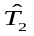 05/11/2001 12/09/2001
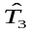 24/09/2003 01/08/2003
20/10/2005 14/12/2005
Cotton Breakpoints (h=0.15)
15/03/2006 28/10/2005
05/07/2007 22/10/2007

Table 4.1.3: Moments of Adjusted CZCE’s Returns
Model Regime Mean S.D. Skewness Kurtosis Jarque-Bera P-value
Hard Wheat
Model2 Reg1 6.930X10⁻¹⁶ 2.054 -4.049x10⁻² 2.233 15.256 0.000
(Breaks=4) Reg2 -7.140X10⁻¹⁶ 1.903 2.000X10⁻² 2.319 14.658 0.001
Reg3 1.450X10⁻¹⁵ 1.818 2.029x10⁻¹ 2.571 6.069 0.048*
Reg4 3.420X10⁻¹⁵ 2.036 -1.439X10⁻² 2.255 10.866 0.004
Reg5 1.990x10⁻¹⁶ 2.104 -1.954x10⁻¹ 2.466 8.781 0.012*

Model3 Reg1 1.980X10⁻¹⁶ 2.044 -7.849x10⁻² 2.233 16.296 0.000
(Break=4) Reg2 5.280X10⁻¹⁶ 1.918 -1.133X10⁻² 2.309 13.972 0.001
Reg3 3.230X10⁻¹⁶ 1.872 1.726X10⁻¹ 2.392 8.389 0.016*
Reg4 1.262X10⁻¹⁶ 1.988 -3.218x10⁻² 2.359 8.767 0.013*
Reg5 -1.050x10⁻¹⁵ 2.101 -2.024x10⁻¹ 2.487 8.552 0.015*

Cotton
Model2 Reg1 -3.370X10⁻¹⁵ 2.091 -3.639X10⁻¹ 2.718 10.771 0.005
(Breaks=2) Reg2 -3.680X10⁻¹⁶ 1.819 -4.002X10⁻¹ 2.382 10.529 0.005
Reg3 -8.710X10⁻⁴ 1.877 -6.918x10⁻¹ 3.215 25.816 0.000

Model3 Reg1 -7.800X10⁻¹⁶ 2.163 -4.162X10⁻¹ 2.569 12.344 0.002
(Break=2) Reg2 -1.872x10⁻¹⁵ 2.010 -9.520x10⁻² 2.341 8.057 0.020*
Reg3 -1.640X10⁻¹⁵ 1.887 -6.252X10⁻¹ 3.204 16.125 0.000
Note: *Insignificant at 0.01; **Insignificant at 0.5; ***Insignificant at 0.1.

Table 4.2.1: Moments of the DCE’s Returns
Mean S.D. Skewness Kurtosis Jarque-Bera P-value
Soybean Meal 3.740x10⁻⁵ 1.158x10⁻² 7.116x10⁻² 5.327 323.268 0.000
Adjusted by
Model 2 3.320x10⁻⁵ 2.129 -3.389x10⁻¹ 2.627 38.500 0.000
Model 3 1.960x10⁻⁵ 2.147 -3.428x10⁻¹ 2.559 42.706 0.000

Soybean No.1 2.210x10⁻⁴ 8.697x10⁻³ -1.256x10⁻¹ 5.968 462.957 0.000
Adjusted by
Model 2 4.970x10⁻¹⁶ 2.037 -4.425x10⁻¹ 2.944 39.853 0.000
Model 3 1.310x10⁻¹⁶ 2.043 -4.429x10⁻¹ 2.939 39.772 0.000

Corn -1.100x10⁻⁴ 6.093x10⁻³ 6.302x10⁻¹ 7.935 712.433 0.000
Adjusted by
Model 2 1.810x10⁻¹⁵ 1.765 2.062x10⁻¹ 2.316 17.518 0.000
Model 3 9.520x10⁻¹⁶ 1.779 2.012x10¹ 2.329 16.786 0.000

Table 4.2.2: Estimated Breakpoints for DCE’s Contracts
Model 2 Model 3
Soybean Meal Breakpoints (h=0.15)
08/08/2001 21/02/2002
11/09/2003 11/09/2003
01/04/2005 31/08/2004
_ 20/10/2005

Soybean No.1 Breakpoints (h=0.15)
11/09/2003 12/09/2003
24/06/2004 25/06/2004
06/07/2005 16/08/2005

Corn Breakpoints (h=0.15)
10/06/2005 10/06/2005
23/12/2005 23/12/2005
29/08/2006 26/01/2007
30/01/2007 _

Table 4.2.3: Moments of Adjusted DCE’s Returns
Model Regime Mean S.D. Skewness Kurtosis Jarque-Bera P-value
Soybean Meal
Model2 Reg1 1.920X10⁻¹⁶ 2.284 -3.222X10⁻¹ 2.282 14.539 0.001
(Breaks=3) Reg2 -1.840X10⁻¹⁵ 1.945 -2.564X10⁻¹ 2.649 5.067 0.078**
Reg3 6.800X10⁻¹⁶ 2.044 -8.789X10⁻¹ 3.799 36.055 0.000
Reg4 -4.870X10⁻¹⁶ 2.023 -4.279X10⁻¹ 2.807 19.946 0.000

Model3 Reg1 -1.360X10⁻¹⁵ 2.131 -3.621X10⁻¹ 2.604 10.640 0.005
(Break=4) Reg2 -3.550X10⁻¹⁵ 1.964 -2.593X10⁻¹ 2.599 5.636 0.060**
Reg3 1.180X10⁻¹⁵ 2.046 -8.955X10⁻² 3.848 7.286 0.036*
Reg4 1.800X10⁻¹⁵ 2.018 -4.735X10⁻¹ 2.895 9.834 0.007
Reg5 1.980X10⁻¹⁵ 1.930 -3.665X10⁻¹ 2.899 8.277 0.020*
Soybean No.1
Model2 Reg1 -3.020X10⁻¹⁵ 1.896 -5.529x10⁻¹ 2.972 17.847 0.000
(Breaks=3) Reg2 -1.470X10⁻¹⁵ 2.011 -5.534x10⁻¹ 2.967 9.298 0.010*
Reg3 1.920X10⁻¹⁶ 2.023 -6.695X10⁻¹ 3.530 21.322 0.000
Reg4 -1.550X10⁻¹⁵ 1.966 -4.616x10⁻¹ 2.997 15.445 0.001

Model3 Reg1 -3.010X10⁻¹⁵ 1.882 -6.563X10⁻¹ 3.147 25.440 0.000
(Breaks=3) Reg2 -1.350x10⁻¹⁵ 1.997 -5.558x10⁻¹ 3.306 9.304 0.010*
Reg3 2.960X10⁻¹⁶ 2.003 -7.246X10⁻¹ 3.649 27.615 0.000
Reg4 1.880X10⁻¹⁶ 2.016 -4.066x10⁻¹ 2.811 11.850 0.003
Corn
Model2 Reg1 9.450X10⁻¹⁶ 1.457 2.571X10⁻¹ 2.590 2.827 0.243***
(Breaks=4) Reg2 -2.080X10⁻¹⁵ 1.376 7.648X10⁻¹ 3.259 11.232 0.004
Reg3 -9.330X10⁻¹⁶ 1.773 7.269X10⁻² 2.296 3.145 0.208***
Reg4 5.660X10⁻¹⁵ 1.697 -2.925x10⁻¹ 2.494 2.443 0.295***
Reg5 -1.190x10⁻¹⁵ 1.757 -8.778x10⁻² 2.203 4.048 0.132***

Model3 Reg1 1.380X10⁻¹⁵ 1.433 3.589X10⁻² 2.601 1.074 0.584***
(Breaks=3) Reg2 -4.280X10⁻¹⁶ 1.376 6.999X10⁻¹ 3.217 9.332 0.010*
Reg3 -4.140X10⁻¹⁶ 1.822 -5.177X10⁻² 2.342 4.469 0.107***
Reg4 9.510X10⁻¹⁶ 1.829 -1.101x10⁻¹ 1.995 6.528 0.038*
Note: *Insignificant at 0.01; **Insignificant at 0.05; ***Insignificant at 0.1.

Table 4.3.1: Moments of the SHFE’s Returns

Mean S.D. Skewness Kurtosis Jarque-Bera P-value
Aluminium -2.910x10⁻⁶ 9.192x10⁻³ -4.350x10⁻¹ 7.624 2171.649 0.000
Adjusted by
Model 2 6.250x10⁻¹⁶ 2.079 -7.269x10⁻² 2.528 23.907 0.000
Model 3 -2.330x10⁻¹⁵ 2.034 -1.277x10⁻¹ 2.483 32.534 0.000

Copper 6.120x10⁻⁴ 1.431x10⁻² -1.658x10⁻¹ 5.255 532.931 0.000
Adjusted by
Model 2 -2.280x10⁻¹⁵ 2.201 -4.012x10⁻¹ 2.878 67.584 0.000
Model 3 1.830x10⁻¹⁶ 2.159 -3.774x10⁻¹ 3.239 64.279 0.000

Fuel Oil 4.290x10⁻⁴ 1.641x10⁻² -3.986x10⁻¹ 4.261 106.212 0.000
Adjusted by
Model 2 -1.220x10⁻¹⁵ 2.082 -8.025x10⁻¹ 3.597 140.052 0.000
Model 3 -1.710x10⁻¹⁵ 2.091 -7.760x10⁻¹ 3.552 129.644 0.000

Table 4.3.2: Estimated Breakpoints for SHFE’s Contracts
Model 2 Model 3
Aluminium Breakpoints (h=0.15)
10/12/2001 10/12/2001
08/10/2003 08/10/2003
30/12/2005 23/01/2006
06/12/2007 16/02/2008

Copper Breakpoints (h=0.15)
22/02/2002 22/02/2002
26/05/2003 26/05/2003
09/12/2005 09/02/2006
19/11/2007 08/11/2007

Fuel Oil Breakpoints (h=0.15)
15/10/2007 02/04/2007
_ 17/07/2008

Table 4.3.3: Moments of Adjusted SHFE’s Returns
Model Regime Mean S.D. Skewness Kurtosis Jarque-Bera P-value
Aluminium
Model2 Reg1 -7.510X10⁻¹⁶ 1.735 -1.399X10⁻¹ 2.242 18.001 0.000
(Breaks=4) Reg2 -1.290X10⁻¹⁵ 1.741 2.220X10⁻¹ 2.410 8.596 0.017*
Reg3 1.460X10⁻¹⁵ 2.035 -1.058X10⁻¹ 2.258 12.286 0.002
Reg4 1.880X10⁻¹⁶ 2.189 -5.699x10⁻¹ 2.806 19.667 0.000
Reg5 -3.410x10⁻¹⁵ 2.255 -3.609x10⁻¹ 2.508 15.349 0.001

Model3 Reg1 -1.190X10⁻¹⁵ 1.727 -1.451X10⁻¹ 2.231 17.985 0.000
(Breaks=4) Reg2 -3.529X10⁻¹⁵ 1.987 -2.308X10⁻¹ 2.397 9.076 0.010*
Reg3 2.054X10⁻¹⁵ 1.862 -1.279X10⁻¹ 2.388 8.980 0.011*
Reg4 1.140x10⁻¹⁵ 2.199 -5.728x10⁻¹ 2.792 19.941 0.000
Reg5 8.850X10⁻¹⁶ 2.093 -3.443x10⁻¹ 3.416 13.154 0.001

Copper
Model2 Reg1 -4.238X10⁻¹⁵ 1.962 -4.040X10⁻¹ 3.010 19.678 0.000
(Breaks=4) Reg2 -3.548X10⁻¹⁵ 1.876 -2.792X10⁻¹ 2.704 6.358 0.047*
Reg3 1.987X10⁻¹⁶ 2.034 -3.077X10⁻¹ 3.044 8.067 0.020*
Reg4 -2.960X10⁻¹⁵ 2.112 2.964X10⁻¹ 4.052 22.698 0.000
Reg5 -4.550x10⁻¹⁵ 2.004 2.670x10⁻¹ 3.565 12.010 0.003

Model3 Reg1 -4.928X10⁻¹⁵ 2.015 -2.822X10⁻¹ 2.898 9.905 0.007
(Break=4) Reg2 -2.670X10⁻¹⁶ 1.958 -2.556X10⁻¹ 2.690 5.690 0.053**
Reg3 2.856X10⁻¹⁶ 2.126 -1.950X10⁻¹ 3.204 4.109 0.147**
Reg4 -4.472X10⁻¹⁵ 1.929 3.895X10⁻¹ 3.262 10.376 0.005
Reg5 -4.420x10⁻¹⁵ 2.108 -1.927x10⁻¹ 3.500 7.992 0.022

Fuel Oil
Model2 Reg1 -2.920X10⁻¹⁵ 1.915 -7.834X10⁻¹ 3.619 88.343 0.000
(Breaks=2) Reg2 2.260X10⁻¹⁵ 2.319 -9.050x10⁻¹ 3.558 50.642 0.000

Model3 Reg1 -1.530X10⁻¹⁵ 1.930 -7.685X10⁻¹ 3.591 69.836 0.000
(Breaks=2) Reg2 7.850X10⁻¹⁶ 2.046 -9.104X10⁻¹ 3.863 40.921 0.000
Reg3 -5.040X10⁻¹⁶ 2.392 -8.862X10⁻¹ 3.270 30.407 0.000
Note: *Insignificant at 0.01; **Insignificant at 0.05; ***Insignificant at 0.1.

Figures:

Figure 4.1.1: RSS and BIC for Hard Wheat Models with up to Five Breaks
- Model 2 2. Model 3
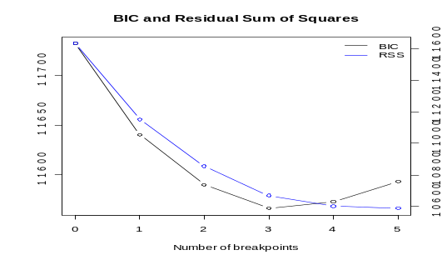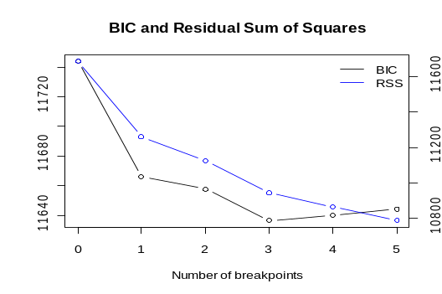

Figure 4.1.2: Conditional Means of Operational Time for the Hard Wheat Returns Adjusted by Model (3) 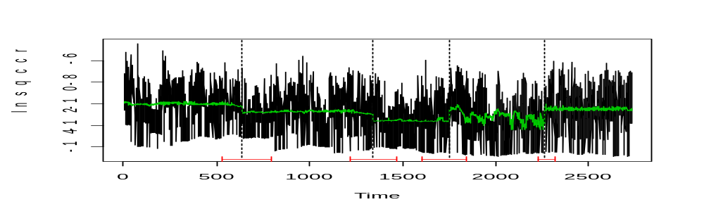

Figure 4.1.3: Price and Return Series of the Hard Wheat Contract
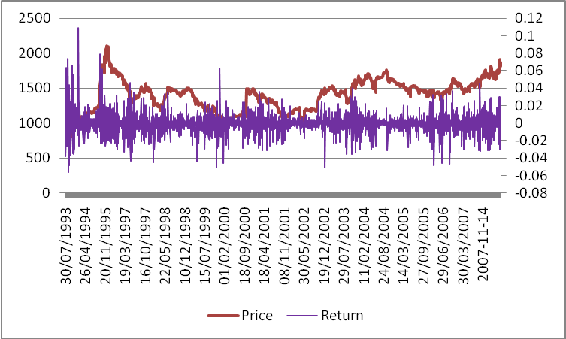

Figure 4.1.4: RSS and BIC for Cotton Models with up to Five Breaks
- Model 2 2. Model 3
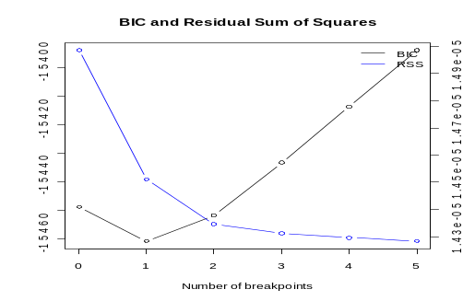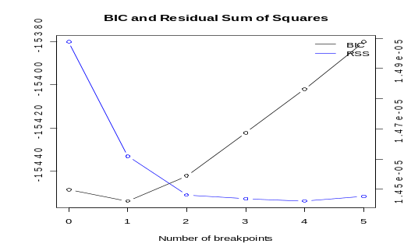

Figure 4.1.5: Conditional Means of Operational Time for the Cotton’s Returns Adjusted by Model (3)
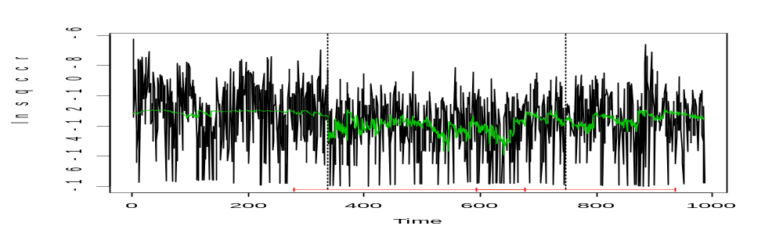
Figure 4.1.6: Price and Return Series of the Cotton Contract
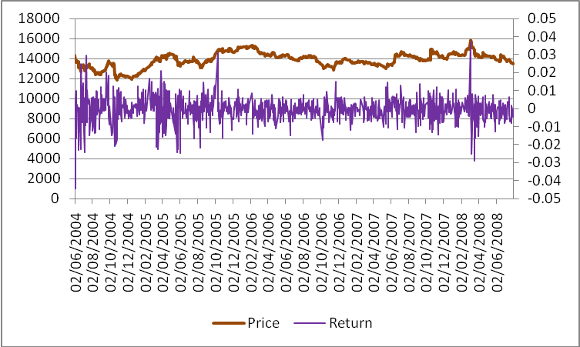

Figure 4.2.1: RSS and BIC for Soybean Meal Models with up to Five Breaks
1.Model 2 2. Model 3 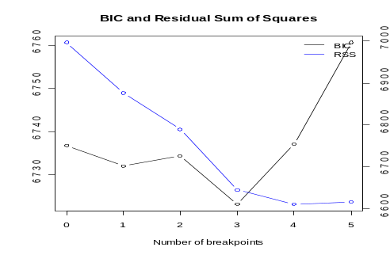 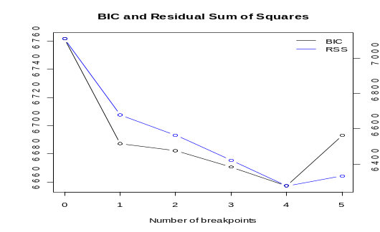

Figure 4.2.2: Conditional Means of Operational Time for the Soybean Meal’s Returns Adjusted by Model (3)
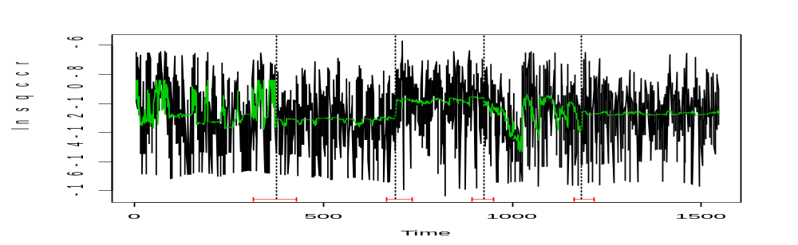

Figure 4.2.3: Price and Return Series of the Soybean Meal Contract
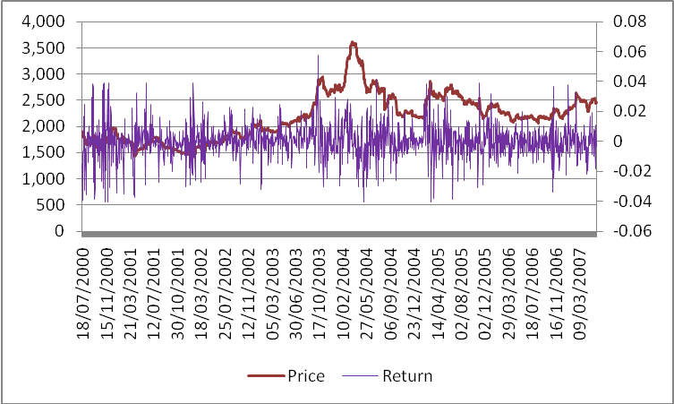

Figure 4.2.4: RSS and BIC for Soybean No.1 Models with up to Five Breaks
- Model 2 2. Model 3
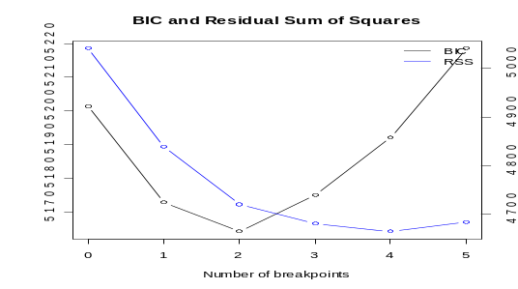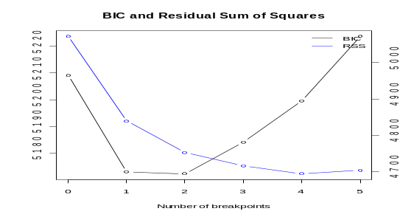

Figure 4.2.5: Conditional Means of Operational Time for the Soybean No.1’s Returns Adjusted by Model (2)
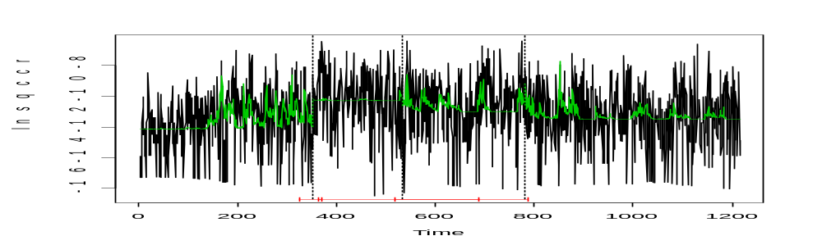

Figure 4.2.6: Price and Return Series of the Soybean No.1 Contract
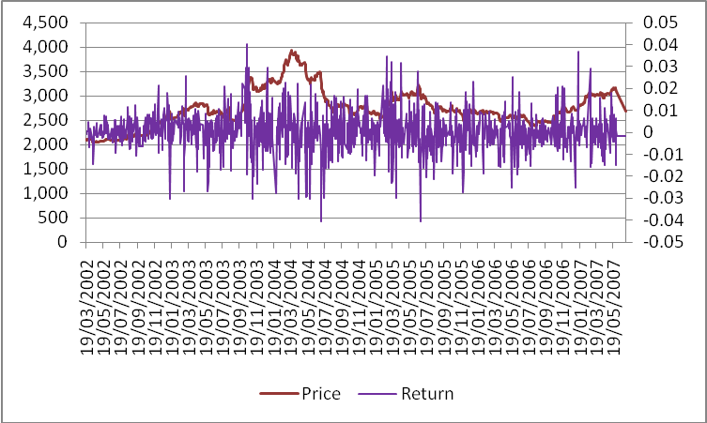

Figure 4.2.7: RSS and BIC for Corn Models with up to Five Breaks
- Model 2 2.Model 3
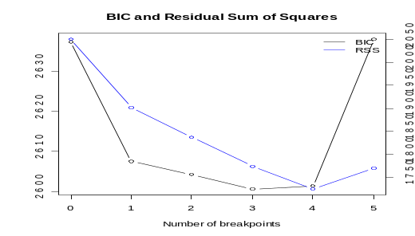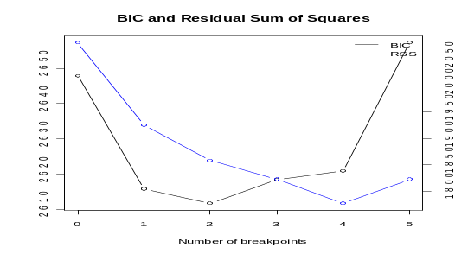

Figure 4.2.8: Conditional Means of Operational Time for the Corn’s Returns Adjusted by Model (3)
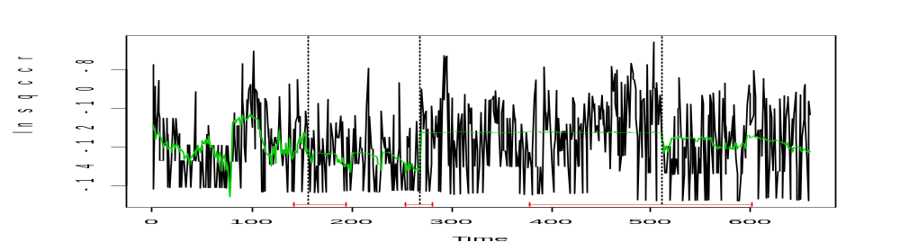

Figure 4.2.9: Price and Return Series of the Corn Contract
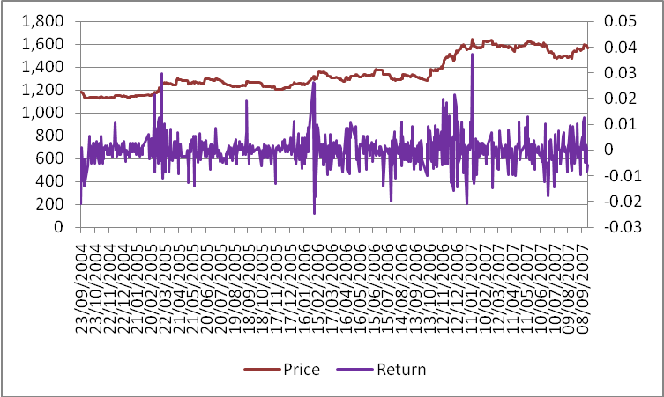

Figure 4.3.1: RSS and BIC for Aluminium Models with up to Five Breaks
- Model 1 2. Model 2
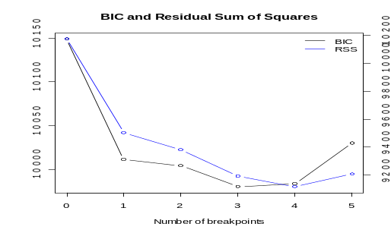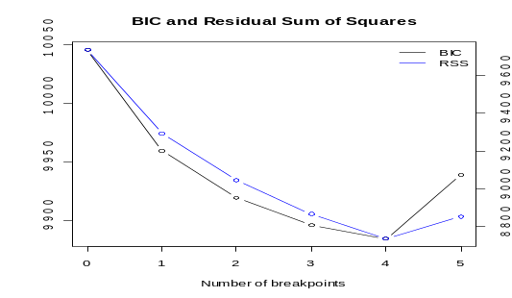

Figure 4.3.2: Conditional Means of Operational Time for the Aluminium’s Returns Adjusted by Model (3)
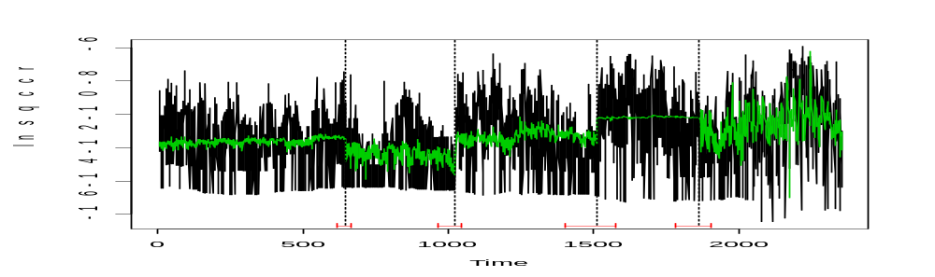

Figure 4.3.3: Price and Return Series of the Aluminium Contract
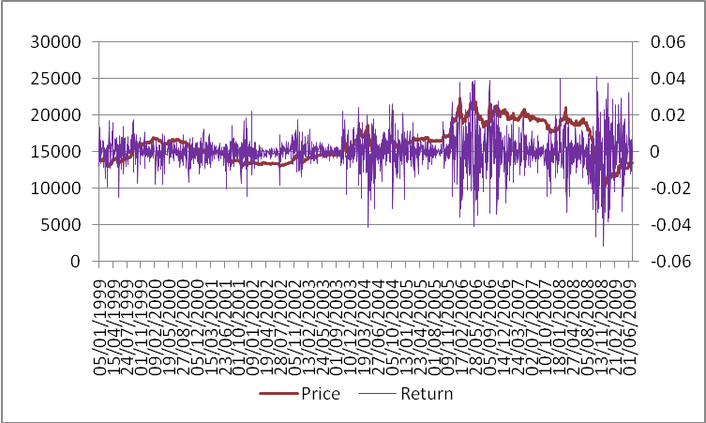

Figure 4.3.4: RSS and BIC for Copper Models with up to Five Breaks
- Model 2 2. Model 3
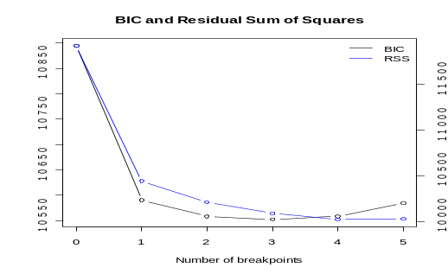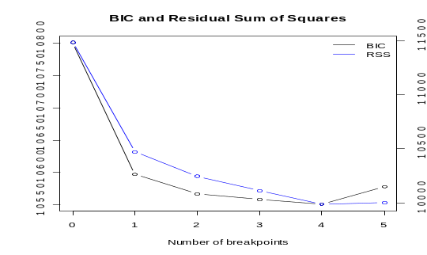

Figure 4.3.5: Conditional Means of Operational Time for the Copper’s Returns Adjusted by Model (3)
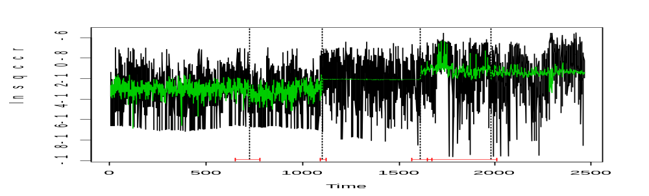

Figure 4.3.6: Price and Return Series of the Copper Contract
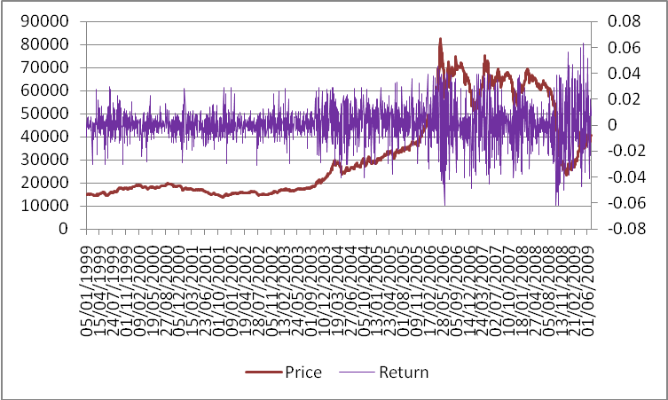

Figure 4.3.7: RSS and BIC for Fuel Oil Models with up to Five Breaks
- Model 2 2. Model 3
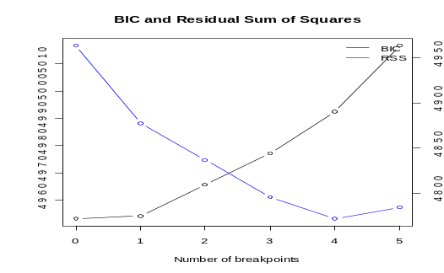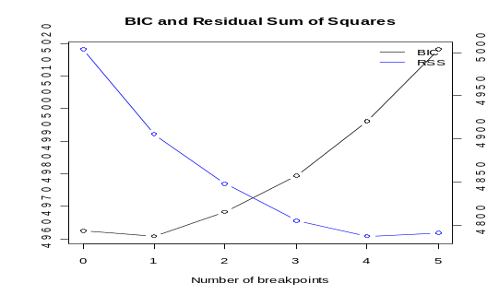

Figure 4.3.8: Conditional Means of Operational Time for the Fuel Oil’s Returns Adjusted by Model (3)
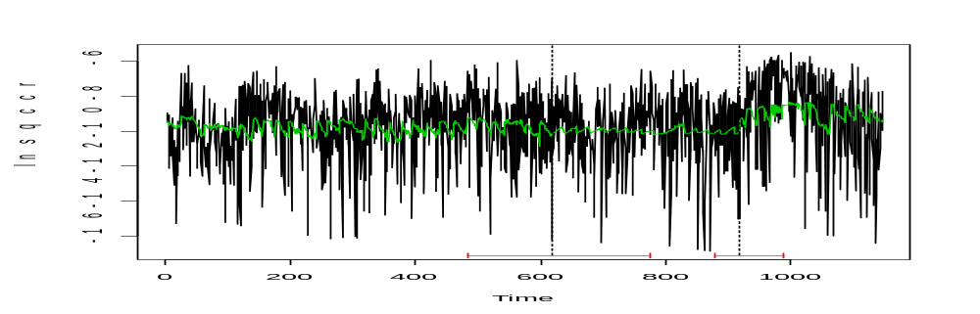

Figure 4.3.9: Price and Return Series of the Fuel Oil Contract
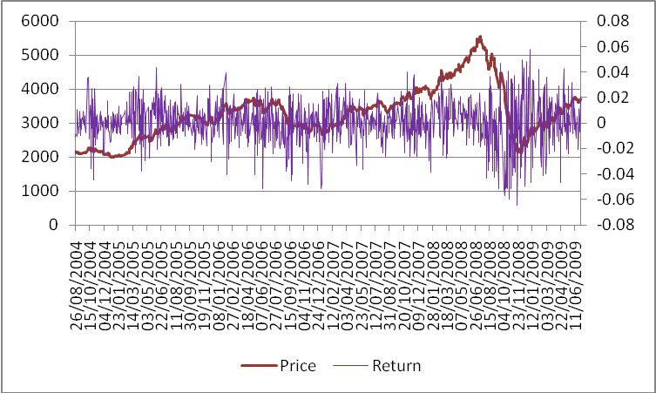

Reference:
Admati, A.R.and Pfleiferer, P. (1988) ‘A theory of Intraday Patterns: Volume and Price Variability’, Review of Financial Studies, 1: 3-40.
Andrews,D.W.K.(1991) ‘Heteroscedasticity and Autocorrelation Consistent Covariance Matrix Estimation’, Econometrica, 59:817-56.
Andrews,D.W.K. and Monahan, J.C.(1992) ‘An Improved Heteroscedasticity and Autocorrelation Consistent Covariance Matrix Estimator’, Econometrica, 60: 953-66.
Andrews, D.W.K. (1993) ‘Tests for Parameter Instability and Structural Change with Unknown Change Point’, Econometrica, 61:821-56.
Andrews, D.W.K. and Ploberger,W. (1994) ‘Optimal Tests when a Nuisance Parameter is Present Only under the Alternative’, Econometrica, 62:1383-414.
Andrews, D.W.K., Lee, I. and Ploberger, W. (1996) ‘Optimal Changepoint Tests for Normal Linear Regression’, Journal of Econometrics, 70: 9-38.
Andersen, T.G. (1996) ‘Return Volatility and Trading Volume: an Information Flow Interpretation of Stochastic Volatility’, Journal of Finance, 51:169-204.
Ane, T. and Geman, H. (2000) ‘Order Flow, Transaction Clock, and Normality of Asset Returns’, Journal of Finance, 55: 2259-84.
Aiolfi, M.and Timmermann, A. (2004) ‘Structural Breaks and the Performance of Forecast Combinations’, Research Working Paper, Bocconi University and UCSD.
Ane, T. and Rangau, L.U. (2008) ‘Does Trading Volume Really Explain Stock Returns Volatility?’, Journal of International Financial Markets, Institutions and Money, 18: 216-35.
Bellman, R. and Roth, R. (1969) ‘Curve Fitting by Segmented Straight Lines’, Journal of the American Statistical Association, 64: 1079-84.
Bai, J. (1994a) ‘Least Squares Estimation of a Shift in Linear Processes’, Journal of Time Series Analysis, 15: 453-72.
Bai, J. (1997a) ‘Estimation of a change point in multiple regression models’, Review of Economic and Statistics, 79:551-63.
Bai, J. and Perron, P. (1998) ‘Testing For and Estimation of Multiple Structural Changes’, Econometrica, 66: 47-79.
Bollerslev, T. and Jubinski, D. (1999) ‘Equity Trading Volume and Volatility: Latent Information arrivals and Common Long-run Dependence’, Journal of Business and Economic Statistics, 17: 9-21.
Bai, J. and Perron, P. (2003) ‘Computation and Analysis of Multiple Structural Change Models’, Journal of Applied Econometrics, 18:1-22.
Clark, P.K. (1973) ‘A Subordinated Stochastic Process with Finite Variance for Speculative Prices’, Econometrica , 41:135-56.
Clark, T.E.and McCracken, M.W. (2002) ‘Forecast-Based Model Selection in the Presence of Structural Breaks’, Research Working Paper. Federal Reserve Bank of Kansas City.
Callaway, R.E. (1989) ‘Evidence of the Nonstationary of the Variance Rate of Return of New York Stock Exchange Listed Common Stock’, Financial Review, 24:199-214.
Chang, C.W. and Chang, J.S.K. (1996) ‘Pricing Catastrophe Insurance Futures Call Spreads: A Randomized Operational Time Approach’, Journal of Risk and Insurance, 63: 599-617.
Changjiang Futures (2006) ‘Summarizing Cotton Futures Market for 2005 and the expectation for 2006’, www.sdny.gov.cn.
Changjiang Futures (2007) ‘Summarizing Cotton Futures Market for 2006 and the expectation for 2007’, www.sdny.gov.cn.
Changjiang Futures (2008) ‘Summarizing Cotton Futures Market for 2007 and the expectation for 2008’, www.sdny.gov.cn.
Downing, C. and Zhang, F. (2004) ‘Trading Activity and Price Volatility in the Municipal Bond Market’, Journal of Finance, 59: 899-931.
Da An (2005) ‘Corn Domestic Price Stop Increase, Futures Price Continuously Fall’, http://www.jlagri.gov.cn/daan/info.
Epps, T.W. and Epps, M.L. (1976) ‘The Stochastic Dependence of Security Price Changes and Transaction Volumes: Implication for the Mixture-of-Distributions Hypothesis’, Econometrica, 44: 305-21.
Edelman, D. and Gillespie, T. (2000) ‘The Stochastically Subordinated Poisson Normal Process for Modeling Financial Assets’, Annals of Operations Research, 100: 133-64.
Fisher, W.D. (1958) ‘on Grouping for Maximum Homogeneity’, Journal of the American Statistical Association, 53:789-98.
Gnednenko, B.V.and Kolmogorov, A.N. (1954) ‘Limit Distributions for Sums of Independent Random Variables’, Cambridge, Mass: Addison-Wesley Publishing Company.
Guthery, S.B. (1974) ‘Partition Regression’, Journal of the American Statistical Association, 69: 945-47.
Glosten, L.R. and Milgrom, P.R. (1985) ‘Bid, Ask, and Transaction Prices in a Specialist Market with Heterogeneously Informed Traders’, Journal of Financial Economics, 14: 71-100.
Garcia, R. and Perron, P. (1996) ‘An Analysis of the Real Interest Rate under Regime Shifts’, Review of Economics and Statistics, 78:111-25.
Gaobo (2005) ‘Monthly Comment on Corn’, http://www.sdny.gov.cn/art/2005/12/5.
Harris, L.(1986) ‘Cross-Security Tests of the Mixture of Distributions Hypothesis’, Journal of Financial and Quantitative Analysis, 21: 39-46.
Harris, L. (1987) ‘Transaction Data Test of the Mixtures of Distributions Hypothesis’, Journal of Financial and Quantitative Analysis, 22: 127-41.
Hall, J.A., Brorsen, B.W. and Irwin, S.H. (1989) ‘The Distribution of Futures Prices: A Test of the Stable Paretain and the Mixture of Normals Hypotheses’, Journal of Financial and Quantitative Analysis, 24:105-16.
Holden, C.W. and Subrahmanyam, A. (1992) ‘Long-Lived Private Information and Imperfect Competition’, Journal of Finance, 47: 247-70.
Harris,M. and Raviv, A. (1993) ‘Differences of Opinions Make a Horse Race’, The Review of Financial Studies, 6: 473-506.
Howison, S. and Lamper, D. (2001) ‘Trading Volume in Models of Financial Derivatives’, Applied Mathematical Finance, 8:119-35.
Hendry, D.F. and Mizon, G.E. (2001) ‘Forecasting in the Presence of Structural Breaks and Policy Regime Shifts’, Working Paper. Oxford University.
Kendall, M.G. (1953) ‘the Analysis of Economic Time Series: Part I, Prices’, Journal of the Royal Statistical Society, 96: 11-25.
Karpoff, J.M. (1987) ‘The Relationship Between Price Changes and Trading Volume: A Survey’, Journal of Financial and Quantitative Analysis, 22: 109-26.
Kim, I.M. (1997) ‘Detecting the Number of Structural Breaks’, Economics Letters, 57:145-8.
Kim, I.M. (2003), ‘Operational Time of the Korea Stock Markets’, Economics Letters, 78: 181-5.
Levy, P. (1925) Calcul des Probabilites, Paris: Gauthier-Villars.
Lamoureux, C.G. and Lastrapes, W.D. (1990) ‘Heteroskedasticity in Stock Return Data: Volume Versus GARCH Effects’, Journal of Finance, 45:221-9.
_(1994) ‘Endogenous Trading Volume and Momentum In Stock Return Volatility’, Journal of Business & Economic Statistics, 12:253-60.
Liu, J., Wu, S. and Zidek, J.V. (1997) ‘on Segmented Multivariate Regressions’, Statistica Sinica, 7: 497-525.
Liesenfeld, R. (1998) ‘Dynamic Bivariate Mixture Models: Modeling the Behavior of Prices and Tradng Volume’, Journal of Business & Economic Statistics, 16:101-9
Lobato, I. and Velasco, C. (2000) ‘Long Memory in Stock Market Trading Volume’, Journal of Business and Economic Statistics, 18: 410-27.
Liesenfeld, R. (2001) ‘A Generalized Bivariate Mixture Model for Stock Price Volatility and Trading Volume’, Journal of Econometrics, 104:141-78
Liangmao Futures (2006) ‘White Sugar Futures Report 2006 (The First half Year of 2006), http://www.51qh.com.
- (2007), ‘White Sugar Futures Report 2007 (The First half Year of 2007), http://www.51qh.com.
Lin, Y.H. (2006), ‘The Factor That Affect Aluminium Price’ http://www.dlqh.net.
Mandelbrot, B. (1963) ‘The Variation of Certain Speculative Prices’, Journal of Business, 36: 394-419.
Mandelbrot, B. and Taylor, H. (1967) ‘on the Distribution of Stock Price Difference’, Operations Research, 15:1057-62
O’Hara, M. (1995) ‘Market Microstructure Theory’, Cambridge, MA: Basil Blackwell.
Perron, P. (1989) ‘The Great Crash, the Oil Price Shock and the Unit Root Hypothesis’, Econometrica, 57: 1361-1401.
Perron, P.(2005) ‘Dealing with Structural Breaks’, Working Paper. Boston University.
Rice, J.(1995) ‘Mathematical Statistics and Data Analysis’, North Scituate: Duxbury Press.
Schwarz, G. (1978) ‘Estimation the Dimension of a Model’, Annals of Statistics, 6: 461-4.
Shalen, C.T. (1993) ‘Volume, Volatility, and the Dispersion of Beliefs’, Review of Financial Studies, 6:405-34.
Tauchen, G. and Pitts, M. (1983) ‘The Price Variability-Volume Relationship on Speculative Markets’, Econometrica, 51: 485-505.
Upton, D. E. and Shannon, D.S. (1979) ‘The Stable Paretian Distribution, Subordinated Stochastic Processes, and Asymptotic Lognormality: An Empirical Investigation’, Journal of Finance, 34:1031-9.
Wilkinson, G.N. and Roger, C.E. (1973) ‘Symbolic Description of Factorial Model For Analysis of Variance’, Applied Statistic, 22: 392-9.
Westerfield, R. (1977) ‘the Distribution of Common Stock Price Changes: An Application of Transactions Time and Subordinated Stochastic Models’, Journal of Financial and Quantitative Analysis, 12: 743-65.
Watanabe, T. (2000) ‘Bayesian Analysis of Dynamic Bivariate Mixture Models: Can They Explain the Behaviour of Returns and Trading Volume?’ Journal of Business & Economic Statistics, 18: 199-210.
Yao, Y.-C. (1988) ‘Estimating the Number of Change–Point via Schwarz’ Criterion’, Statistics and Probability Letters, 6: 181-9.
Yiming (2007) ‘Review of Domestic Corn Market (2006)’, http://sh.shuangliao.gov.cn
Zeileis, A. and Kleiber, C. (2005b), ‘Validating Multiple Structural Change Models-A Case Study’, Journal of Applied Econometrics, 20: 685-90.
Zeileis, A., and C. Kleiber (2005a), ‘Validating Multiple Structural Change Models-An Extended Case Study’, unpublished thesis, http://epub.wu-wien.ac.at.
Zhu, X.F.(2007) ‘Global Grain Price Rose Rapidly in 2006’, China Grain Economy, 3:45-7.
Zhang, R., Mckillop, D.and Li, Y. (2008) ‘The Distributional Properties of the Selected Contracts Traded on the China’s Futures Market’, working paper, Management School of Queen’s University Belfast.

