Naturally Nitrogen and Calcium-doped Nanoporous Carbon from Pine Cone with Superior CO₂ Capture Capacities
Bingjun Zhu,ª Congxiao Shang^{b} and Zhengxiao Guoª*
ª Department of Chemistry, University College London, 20 Gordon Street, London WC1H 0AJ, United Kingdom; email: z.x.guo@ucl.ac.uk;
^{b} School of Environmental Sciences, University of East Anglia, Norwich NR4 78TJ, United Kingdom.
Keywords: green materials, biomass, carbon, carbon capture, carbon dioxide, pine cone
Abstract: A highly effective nanoporous CO₂ sorbent with naturally-doped nitrogen and calcium elements, derived from pine-cone biomass, shows superior CO₂ capture performance. The sorbent was produced from carbonisation and KOH activation of dried pine cones, and possess a highly nanoporous structure with a specific surface area and a pore volume up to 2110 m²/g and 0.89 cm³/g, respectively. The highest CO₂ uptake of 20.9 wt% (under 1 bar CO₂ and 25 °C) was achieved in a porous structure with relatively high levels of nitrogen and calcium dopants inherited from the biomass precursor. Further porosity and elemental analyses show that CO₂ sorption is enhanced by both highly developed ultramicroporous structure (<0.7 nm) and well-dispersed nitrogen and metal dopants in carbon sorbents.

Introduction
Carbon capture and storage (CCS) is considered as one of the effective solutions to reduce excessive CO₂ emission and mitigate climate change.¹ Particularly in fossil fuel fired power plants, CO₂ can be captured either before or after fuel combustion, i.e. pre- or post- combustion carbon capture. Another major difference is the CO₂ concentration in the gas stream: about 15-50% and 5-15% for the pre- and the post- combustion, respectively.^{2,3} Porous carbon stands out as a competitive contender for both pre-combustion and post-combustion CO₂ captures among various sorbents, including amines, zeolites and metal-organic frameworks, because of its relatively low cost and easy production, e.g. from low-cost biomass/waste precursors. Porous carbon also shows good stability in both moisture and chemical environments, and can be readily regenerated thermally or by evacuation.³
Some of the porous carbons are directly derived from polymeric precursors, such as resorcinol and formaldehyde,⁴ terephthalaldeyhde and melamine,⁵ polypyrrole⁶ and resorcinol and hexamethylenetetramine⁷, with a corresponding CO₂ uptake of 13.8, 14.1, 16.9 and 17.6 wt%, under 1 bar CO₂ and 25 °C, respectively. Recently, porous carbon sorbents derived from metal-organic frameworks (MOFs) show excellent CO₂ uptakes at high CO₂ pressures, due to porosities inherited from the well-developed and highly microporous framework of the precursor materials.⁸⁻¹¹ Such porous carbons may also act as stable and high-capacity support for amines to produce even higher capacity chemi-sorbents for CO₂, replacing porous silica.¹² However, such precursors consume considerable amount of chemicals to make and also require strict control of synthesis conditions, particularly an issue for mass production in scaling-up conditions. On the other hand, biomass precursors, e.g. biomass wastes, have attracted considerable attention, due to their low-cost and renewable abundance. Bio-wastes are usually rich in lignocellulosic compounds and can be directly carbonised and activated to produce porous carbon. Examples include yeast,¹³ fungi,¹⁴ African palm shells¹⁵ and celtuce leaves,¹⁶ and their corresponding CO₂ uptakes are 20.9, 15.3, 19.3 and 19.1 wt%, under 1 bar CO₂ and 25 °C, respectively. Moreover, biomass also contains other useful elements, such as nitrogen and metals, which may enhance CO₂ adsorption by introducing active sites on the surface of the resulting carbon sorbents. There are few publications indicating the beneficial effects of metal doping on CO₂ uptake, because it is difficult to produce truly atomic metal doping in synthetic carbons, whereas attempts to use metal salts for the purpose always lead to relatively large metal clusters, which reduce the number of active sites and add considerable weight to the sorbent, leading to reduced CO₂ capacities per unit mass. One of our earlier studies produce porous carbon sorbents from pyrolysed leaves, which show high specific surface areas over 2000 m²/g and excellent CO₂ uptakes up to 19.4 wt% under 1 bar CO₂ at 25 °C.¹⁷ Further investigation suggests magnesium and calcium are well preserved in the resulting carbon sorbents to enhance CO₂ uptake, but the metal contents are relatively low.¹⁷
Pine cone is the woody fruit of a pine tree. A major component of a pine cone is the dense and tough scale, which is a carbon-rich biomass waste. Pine cones have been used for the production of activated carbon for the removal of heavy metals and organic compounds in contaminated water.¹⁸ However, CO₂ capture performance of pine cone-derived carbon has never been studied and its chemistry has not been discussed in detail. Particularly, the metal and nitrogen dopants inherited from pine cones are likely to be different, compared to the leaf-derived carbons.
Here, porous carbon was derived from pine cones by means of chemical activation with KOH. Corresponding characterisations show excellent CO₂ uptake of 20.9 wt% at 25 °C and 1 bar CO₂, matching the highest reported CO₂ uptake (21.2 wt%) on biomass derived carbons at the same condition in the recent literature.¹⁹ Elemental analysis also reveals that calcium is the only residual metallic element in carbon sorbents and it positively influences the CO₂ capture of the sorbent.

Experimental Methods
Sample Preparation
Fallen pine cones from a pine tree (Spruce) were picked up in Linnainmaa, Tampere, Finland. The scales of the pine cones were peeled off and washed clean, which were then dried in a vacuum oven at 80 °C overnight. Subsequently, the dried scales were carbonised at 600 °C for an hour in a horizontal tube furnace (VTF 15/75/450, Lenton, UK) under flowing nitrogen gas, at a ramping rate of 3 °C/min and dwelling time of an hour. The carbonised scales were grounded into smaller particles. Each carbon sample of 0.4g was mixed with potassium hydroxide (Fisher Scientific, UK) in KOH/carbon mass ratios of 1:1, 2:1 and 3:1, respectively, in 10 ml distilled water. The mixture was agitated for 30 mins in an ultrasonic bath to obtain a uniform suspension of carbon in the KOH solution. The solution was then dried in a vacuum oven at 80 °C to obtain a solid mixture of KOH and carbon. The chemical activation of carbon was then carried out at 600, 700 and 800 °C in the furnace, respectively, with constant flow of nitrogen for an hour. The corresponding ramping rate remained at 3 °C/min. The activated carbon samples were thoroughly washed by distilled water. For comparison, another KOH/carbon=2:1 and 700 °C sample was washed with 1M HCl acid to remove metal elements within the sample. Finally, all the samples were dried in the vacuum oven at 80 °C overnight. The samples are marked as PCx-y, where PC stands for pine cone-derived carbon, x:1 is the mass ratio of KOH/carbon and y is the chemical activation temperature. The acid washed sample was marked as PC2-700H.
Characterisations
Surface morphologies of porous carbon were imaged under a field-emission scanning electron microscope (SEM, JSM 6301F, JEOL, Japan). High-resolution images of nanoporous structures were captured by a transmission electron microscope (TEM, JEOL 2100, Japan). The chemical compositions of porous carbon samples were analysed by X-ray photoelectron spectrometry (XPS, K-ALPHA, Thermo Scientific, USA). The identity and composition of elements and compounds were retrieved from the NIST XPS online database by searching their corresponding binding energies in the database system.²⁰ Sample porosities were characterised by means of an automated gas sorption analyser (Autosorb-iQ C, Quantachrome, USA). The specific surface area, specific micropore surface area, micropore volume and pore size distribution were calculated by the Non-Local Density Functional Theory (slit/cylindrical pores) equilibrium model (NLDFT) based on their corresponding nitrogen sorption isotherm at -196 °C. The total pore volume was derived from the amount of adsorbed gas at the partial pressure P/P₀=0.99. CO₂ uptakes of porous carbon were measured by the same gas sorption analyser from 0.01 to 1 bar at 0 and 25 °C, respectively. The sample tube was immersed in an ice-water mixture bath for the 0 °C test and a thermostatic water bath for the 25 °C. Before the CO₂ adsorption test, the sample was degassed in vacuum at 150 °C overnight to remove any residual sorbates, such as moisture. The CO₂ adsorption isotherms at 0 °C were also used to calculate ultramicropore volumes (pore size<0.7nm) by the “CO₂ on carbon at 273 K NLDFT” model. The heat of adsorption was calculated by the Clausus-Clapeyron Equation based on the CO₂ adsorption isotherms at 0, 25 and 50 °C. In addition, N₂ sorption isotherms of the water-washed and acid-washed samples PC2-700 and PC-700H were measured at 25 °C by the same method. The corresponding results were used to calculate their single component selectivities (CO₂ uptake/N₂ uptake) under different pressures. Furthermore, a thermogravimetric analyser (Setsys, Setaram, France) was used to test cyclic performance of CO₂ adsorption under temperature swing between 25 and 120 °C in both dry and wet (85% N₂ + 15% CO₂) gas flow conditions. The temperatures were maintained for an hour at both 25 and 120 °C for the adsorption and desorption of the sorbent, respectively. The wet gas was achieved by passing the gas mixture through a water trap at ambient temperature. A single cycle wet N₂ adsorption test was also carried out to analyse the influence of water on CO₂ adsorption.

Results and Discussion
Morphologies of Pine Cone-derived Carbon
Figure 1 shows the preparation procedure and morphological changes from the original pine cone scales to porous carbon particles. The dried pine cone scales are yellowish brown in colour, and turned black after carbonisation (Figure 1a).
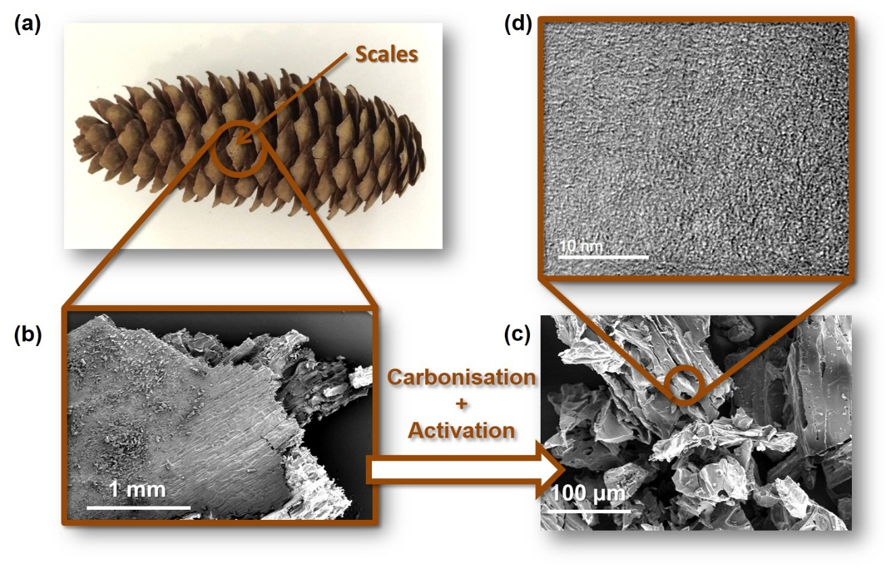
Figure 1: (a) A photograph of a pine cone and its scales; SEM images of (b) a piece of dried scale and (c) porous carbon particles after KOH activation; (d) A high resolution TEM image of nanoscale porous carbon fragments.
Figure 1b shows that a piece of pine cone scale exhibits relatively rough surface and well-aligned cellulose fibres. Although the shape of the scale remains after carbonisation at 600 °C, the sample becomes crispy and thus is grounded into particles for subsequent mixing with the KOH solution. After chemical activation (Figure 1c), the sample turned into porous carbon particles of random shapes and varied sizes. Pores of micrometre sizes can be also seen at the surface of these particles. The high-resolution TEM image, Figure 1d, reveals a relatively amorphous microstructure, enriched with small carbon segments and micropores.
Porous Structure of Pine-Cone derived Carbon
The porous structures of pine cone-derived carbon were analysed by means of nitrogen and CO₂ sorption at -196 and 0 °C, respectively. The specific cumulative surface area (up to 40 nm, S_{N2}), specific micropore surface area (S_{Micro}), total pore volume (V_{N2}), micropore volume (V_{Micro}, <2 nm) and ultramicropore volume (V_{CO2,} <0.7nm) are summarised in Table 1.
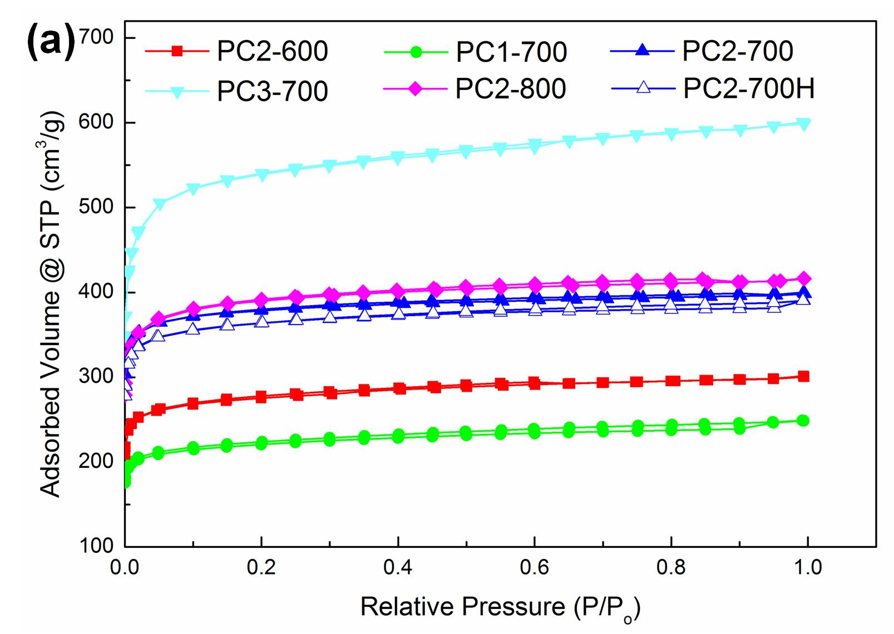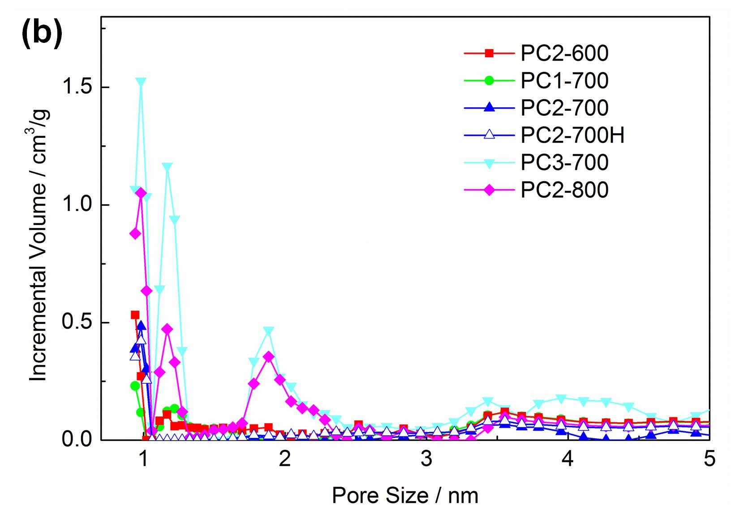
Figure 2: (a) N₂ sorption isotherms at -196 °C and (b) corresponding pore size distribution of pine cone-derived carbon sorbents.
Table 1 Porosity characteristics of pine cone-derived carbon.
Method | N₂ sorption |  |  |  | CO₂ sorption
Sample | S_{N2} /m²/g | S_{Micro} /m²/g | V_{N2}/cm³/g | V_{Micro} /cm³/g | V_{CO2}/cm³/g
PC2-600 | 1260 | 1220 | 0.47 | 0.41 | 0.28
PC1-700 | 1170 | 1140 | 0.39 | 0.34 | 0.28
PC2-700 | 1680 | 1670 | 0.61 | 0.56 | 0.34
PC2-700H | 1640 | 1610 | 0.60 | 0.53 | 0.32
PC3-700 | 2110 | 2060 | 0.89 | 0.78 | 0.32
PC2-800 | 1650 | 1620 | 0.64 | 0.58 | 0.30
All the N₂ sorption isotherms in Figure 2a are of Type-I sorption characteristics, which indicate that all carbon sorbents possess microporous structures. The pore size distributions of the porous carbon sorbents, derived from their corresponding N₂ sorption isotherms, Figure 2b, show three major peaks in the micropore size range (<2 nm) at 0.7, 1.2 and 1.9 nm, respectively. There is also a weak and broad peak at 3.5 nm, which suggests the existence of a small proportion of mesopores. Table 1 shows the porosities of carbon sorbents are mainly influenced by the KOH/carbon mass ratio and the activation temperature. On the one hand, both specific surface area and pore volume have an approximately linear relationship with the KOH/carbon mass ratio, and the sample PC3-700 prepared at 700 °C and KOH/carbon=3:1 shows the highest specific surface area of 2110 m²/g and pore volume of 0.89 cm³/g. However, PC2-700 exhibits the highest ultramicropore volumes of 0.34 cm³/g. It indicates a higher KOH/carbon ratio helps to develop a porous structure with a higher specific surface area and pore volume, but it also enlarges the sizes of micropores, which results in a reduced ultramicropore volume.
On the other hand, activated with the same KOH/carbon mass ratio (KOH/carbon=2:1), the sample shows a significant increase in both specific surface area and pore volume, when the activation temperature rises from 600 to 700 °C. However, the 700 and 800 °C treated samples have similar specific surface area and pore volumes, but the ultramicropore volume is reduced from 0.34 to 0.30 cm³/g. The amount of reduction in ultramicropore volume is almost equal to the amount of increased total pore volume (from 0.61 to 0.64 cm³/g). It has been mentioned in the literature that KOH and carbon react differently at different activation temperatures. Below 700 °C, the chemical activation reaction is mainly based on the dehydration of KOH and the gasification of carbon, which removes carbon atoms to generate porous structures. Above 700 °C, it is the reduction of CO₂, K₂O and K₂CO₃ by carbon that further develops the porous structure.²¹ The slightly reduced surface area and increased pore volume suggests the higher activation temperature may not encourage the development of more ultra-micropores but enlarge the size of existing pores.
In addition, in Figure 2a, the PC2-700H isotherm is at a similar position to PC2-700 with slightly lower N₂ uptake, which indicates the HCl acid wash has a limited influence on the resulting porous structure. It is also reflected in Table 1 that PC2-700H and PC2-700 show very similar porosity characteristics.
Chemical Analysis on Pine-Cone derived Carbon
The surface chemistry of pine-cone derived carbon is characterised by XPS and the characterisation results are summarised in Table 2. As in the case of leaf-derived carbon, the device only detects carbon and oxygen elements, which originate from the lignocellulosic compounds (cellulose, lignin, hemicelluloses and pectin) in pine cones.^{22,23} Other anticipated elements, such as nitrogen and metals, are not detected, because the thicknesses of cellulosic fibres and cell walls are beyond the detection limit of XPS. Therefore, it cannot collect the information of elemental compositions below.
After carbonisation, potassium and silicon elements become detectable. The emergence of potassium may be caused by the decomposition of cell membranes and the subsequent release of potassium cations in the cell cytoplasm. Figure 3a is the high resolution XPS K-2p spectrum of the carbonised pine cone PC0-600 and it shows two peaks at 295.6 and 292.9 eV, which correspond to the binding energies of K-2p1/2 and 2p3/2 electrons, respectively. Silicon is another element detected after carbonisation, which may be due to damaged cell structure caused by carbonisation, considering silicon is an essential element in plant cell walls. After KOH activation, the proportion of silicon is increased from 0.3 to 0.8 wt%, because the chemical activation reaction further etches fibres and cells, exposing more silicon compounds. Figure 3d is the high resolution XPS Si-2p spectrum of the activated sample PC2-700. The hill in the spectrum starts from 105 to 100 eV, which covers the binding energies of a range of oxidised silicon. The curve can be deconvoluted into three sub-peaks at 103.6, 102.6 and 101.5 eV, which correspond to Si⁴⁺, Si³⁺ and Si²⁺ oxidised states of silicon.²⁴
Table 2 Chemical composition of pine cone-derived carbon
Sample | Chemical composition (at%)
 | C | O | N | K | Ca | Si
Pine Cone | 89.2 | 10.8 | 0 | 0 | 0 | 0
PC0-600 | 83.9 | 12.7 | 0 | 3.1 | 0 | 0.3
PC2-600 | 81.3 | 16.0 | 1.3 | 0 | 0.6 | 0.8
PC1-700 | 86.5 | 12.1 | 0.5 | 0 | 0.4 | 0.5
PC2-700 | 83.4 | 15.0 | 0.5 | 0 | 0.5 | 0.6
PC2-700H | 83.7 | 14.8 | 1.0 | 0 | 0 | 0.5
PC3-700 | 86.5 | 12.0 | 0.5 | 0 | 0.4 | 0.6
PC2-800 | 86.2 | 12.2 | 0.5 | 0 | 0.7 | 0.4
Nitrogen and calcium are the two elements detected after KOH activation. The potassium peak disappeared in the spectrum after the sample was washed by distilled water, which indicates both intrinsic (from cells) and extrinsic (from KOH) potassium can be removed from the carbon structure by distilled water washing. The emergence of nitrogen may originate from the etching of cell walls by means of chemical activation and the fixation of nitrogen due to the reaction between pectin and intracellular proteins.²⁵ Figure 3b is the high resolution XPS N-1s spectrum, which shows a single peak centred at 400.0 eV. It corresponds to the binding energy of pyrrolic type of nitrogen.²⁶ It has been reported in literature that the amount of nitrogen in carbon decreases with the increasing KOH/carbon weight ratio and activation temperature.^{6,27} However, it can be concluded from Table 2 that nitrogen content does not vary much with the increasing KOH/carbon mass ratio. It is mentioned previously that the cell structure is etched by means of chemical activation and it exposes more chemical compounds inside. A higher KOH/carbon mass ratio can lead to a higher degree of etching and thus exposing more nitrogen–containing compounds within cells, which balances the reduced nitrogen content caused by chemical activation.
Figure 3: High resolution XPS spectra of chemical elements in pine cone-derived carbon.
Besides nitrogen, calcium is another element that was detected after chemical activation. Figure 3c is the high resolution XPS Ca-2p spectrum with two peaks at 350.8 and 347.3 eV corresponding to the binding energies of Ca-2p1/2 and 2p3/2 electrons. It indicates calcium exists in the form of +2 cations. It has been reported in some biological studies that calcium plays the cross-linking role in cell walls, which is bound with pectin.²⁸ In an earlier study on residual potassium in carbon, the author proposes that the residual potassium may exist in the form of extra-framework cations.²⁹ In the case of pine cone-derived carbon, the potassium is washed away by distilled water and calcium becomes the residual metal in the resulting carbon structure. Then, the calcium cations may be still bound with the resulting carbon structure, which originates from lignocellulosic compounds, including pectins. After the sample was washed by 1M HCl acid, all metal elements were removed, but the silicon remained in the carbon structure.
CO₂ Uptakes of Pine-Cone Derived Carbon
The CO₂ adsorption capacities of pine-cone derived carbon are carried out from 0.01 to 1 bar CO₂ at the temperatures of 0 and 25 °C, respectively. Their CO₂ adsorption isotherms are plotted in Figure 4 and the corresponding CO₂ uptakes at 1 and 0.15 bar CO₂ are summarised in Table 3.
It can be concluded from the figure that PC2-700 shows the highest CO₂ uptake of 20.9 wt% under 1 bar CO₂ and 25 °C. This capacity almost matches the highest reported CO₂ uptake of a biomass-derived carbon sorbent in the literature so far (only that derived from sawdust shows a capacity of 21.2 wt%).¹⁹ It is also close to the highest reported CO₂ uptake of a polymer-derived carbon sorbent (polyacrylonitrile, 22.6 wt%) at the same temeprature.³⁰ It should be noted that the activation of PC2-700 uses a smaller amount of KOH than that of PC3-700; hence, an optimised KOH/carbon ratio can reduce the cost of the manufacturing process and the amount of generated waste.
In contrast, at 0 °C, PC3-700 and PC2-700 possess very similar CO₂ uptakes of 34.4 and 34.2 wt%, respectively. Compared with PC2-700, PC3-700 shows a further developed porous structure with a similar level of nitrogen content. However, it possesses a lower calcium level than that of PC2-700; this implies that CO₂ uptake is not only influenced by porous structures but also by the intrinsic metal dopants from the pine cone precursor. However, PC3-700 also shows a slightly smaller ultramicropore volume than that of PC2-700 (about 4% smaller). Some earlier studies in the literature have proposed that ultra-micropore (< 0.7 nm) has the dominant influence on the CO₂ uptake of non-doped carbon sorbents, due to enhanced adsorption potential in ultramicropores.^{6, 19} Therefore, it is important to distinguish further the influences of microporosity and metal dopants.
PC2-700 and PC2-700H were washed by distilled water and 1M HCl acid, respectively. Table 1 indicates PC2-700 and PC2-700H possess similar porous structures with slightly smaller ultramicropore volume (similar to that of PC3-700, also about 4% smaller). Table 2 shows that calcium is washed away by 1M HCl in PC2-700H. In addition, it has been discussed in the literature that pyridinic and pyrrolic nitrogens are two common types of nitrogen dopants in carbon materials.⁶ Pyridinic nitrogen possesses much higher basicity than pyrrolic nitrogen, due to the lone pair of electrons. In contrast, pyrrolic nitrogen shows alkalescence.³¹ In the present case, a small amount of nitrogen is detected in both samples (≤ 1 at%) and it only exists in the pyrrolic form. PC2-700H shows almost double the nitrogen content of PC2-700, but exhibits a reduced CO₂ uptake of 20.0 wt% at 1 bar of CO₂ and 25 °C, Table 3. Even under 0.15 bar, PC2-700H still shows 1 wt% less the CO₂ uptake of PC2-700H. Furthermore, the N₂ sorption isotherms and CO₂/N₂ selectivities of PC2-700 and PC-700H at 25 °C, Figure 4d, clearly show that, although PC2-700 and PC2-700H possess similar porous structures, the difference between their CO₂/N₂ selectivities is significantly greater in the low pressure regime than at higher pressures. This is another indication of enhanced CO₂ binding at relatively low pressures by metal doping, since the natural metal dopants are preserved in the water-washed sample PC2-700 but removed from the acid-washed PC2-700H.

Table 3 CO₂ uptakes of pine-cone derived carbon sorbents under 1 bar CO₂.
Sample | CO₂ uptake / wt%
 | 1 bar |  | 0.15 bar
 | 0 °C | 25 °C | 0 °C | 25 °C
PC1-700 | 27.4 | 18.4 | 12.5 | 7.2
PC2-700 | 34.2 | 20.9 | 12.0 | 6.6
PC2-700H | 32.5 | 20.0 | 11.0 | 5.6
PC3-700 | 34.4 | 19.4 | 10.4 | 4.7
PC2-600 | 27.2 | 16.6 | 10.4 | 5.1
PC2-800 | 30.5 | 18.9 | 10.3 | 5.2
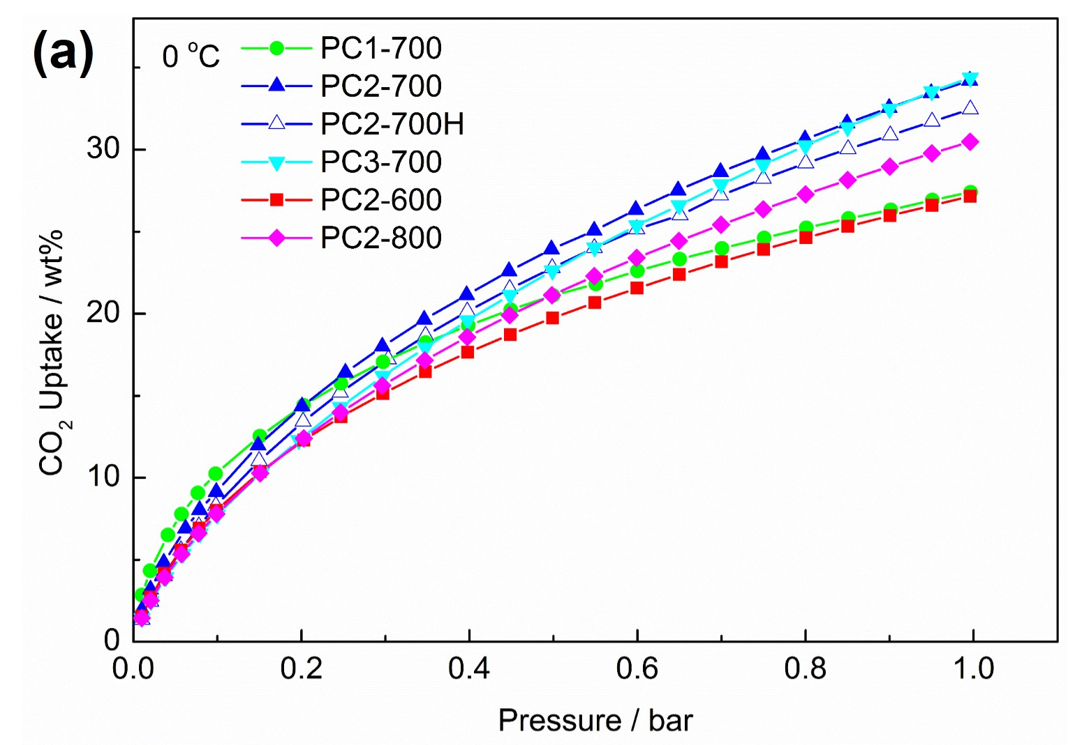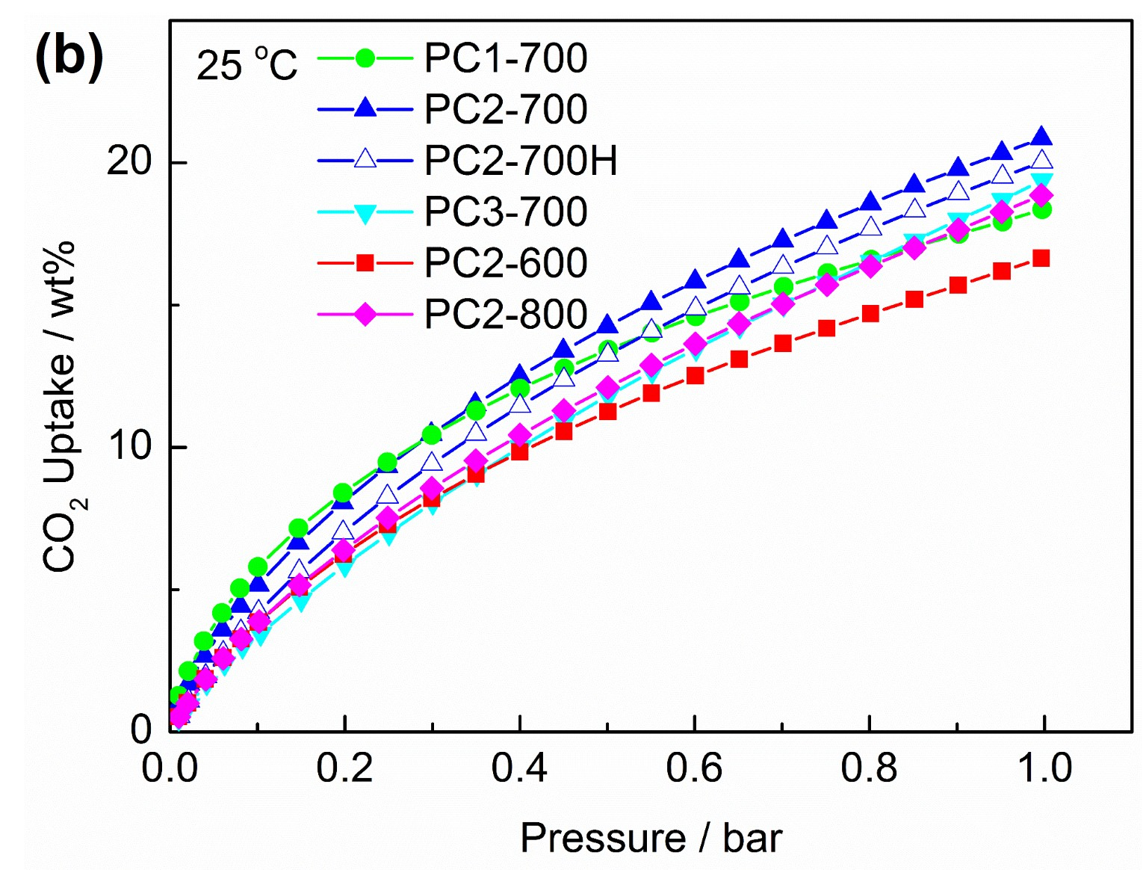
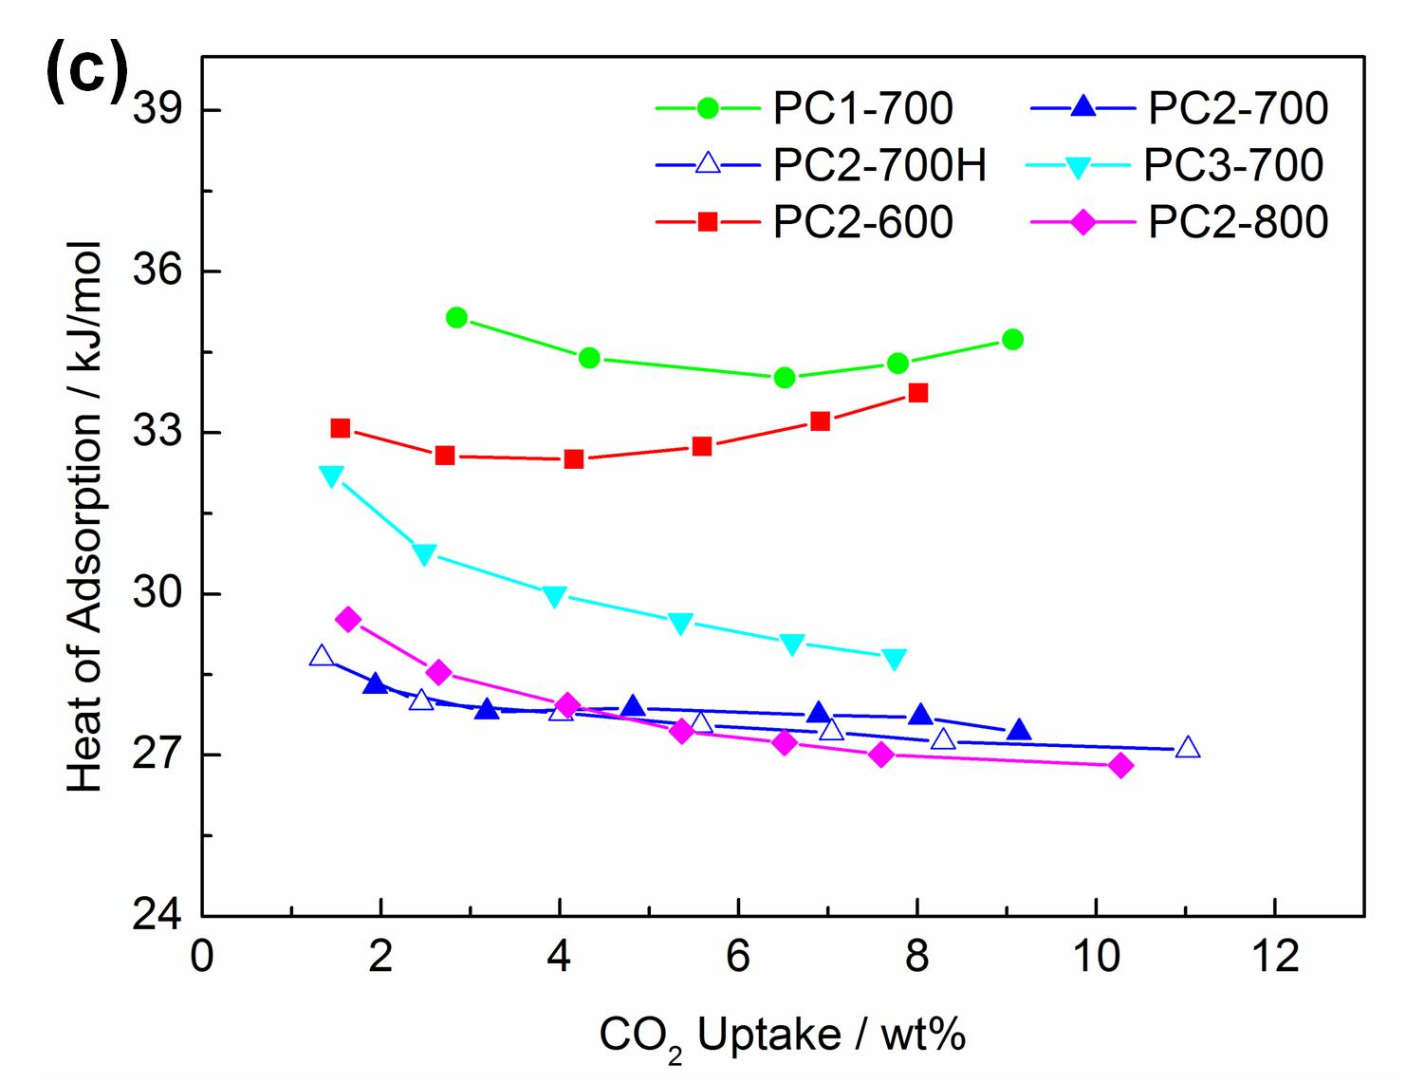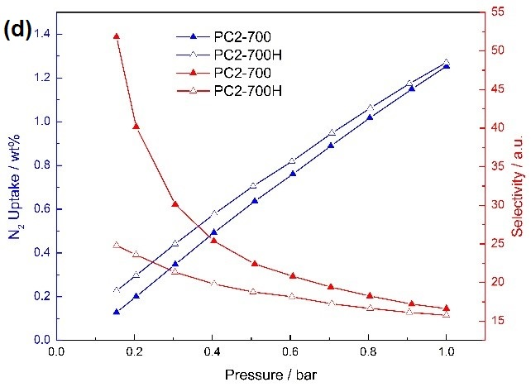
Figure 4: CO₂ adsorption isotherms of pine cone-derived carbon at (a) 25 and (b) 0 °C from 0.01 to 1 bar; (c) their corresponding heats of adsorption; (d) N₂ sorption isotherms and CO₂/N₂ selectivities of PC2-700 and PC-700H at 25 °C.
In addition to the single cycle CO₂ adsorption tests, multi-cycle CO₂ adsorption tests were carried out on the PC2-700 by means of temperature swing between 25 and 120 °C, using a (85% N₂ and 15% CO₂) gas mixture to mimic CO₂ concentration in the flue gas from post-combustion power plants. The results can be compared with CO₂ uptakes under pure CO₂. Furthermore, in order to clarify the influence of water/moisture on CO₂ adsorption, the cyclic tests were comparatively carried out for both dry and wet gas flow under identical temperature-swing conditions.
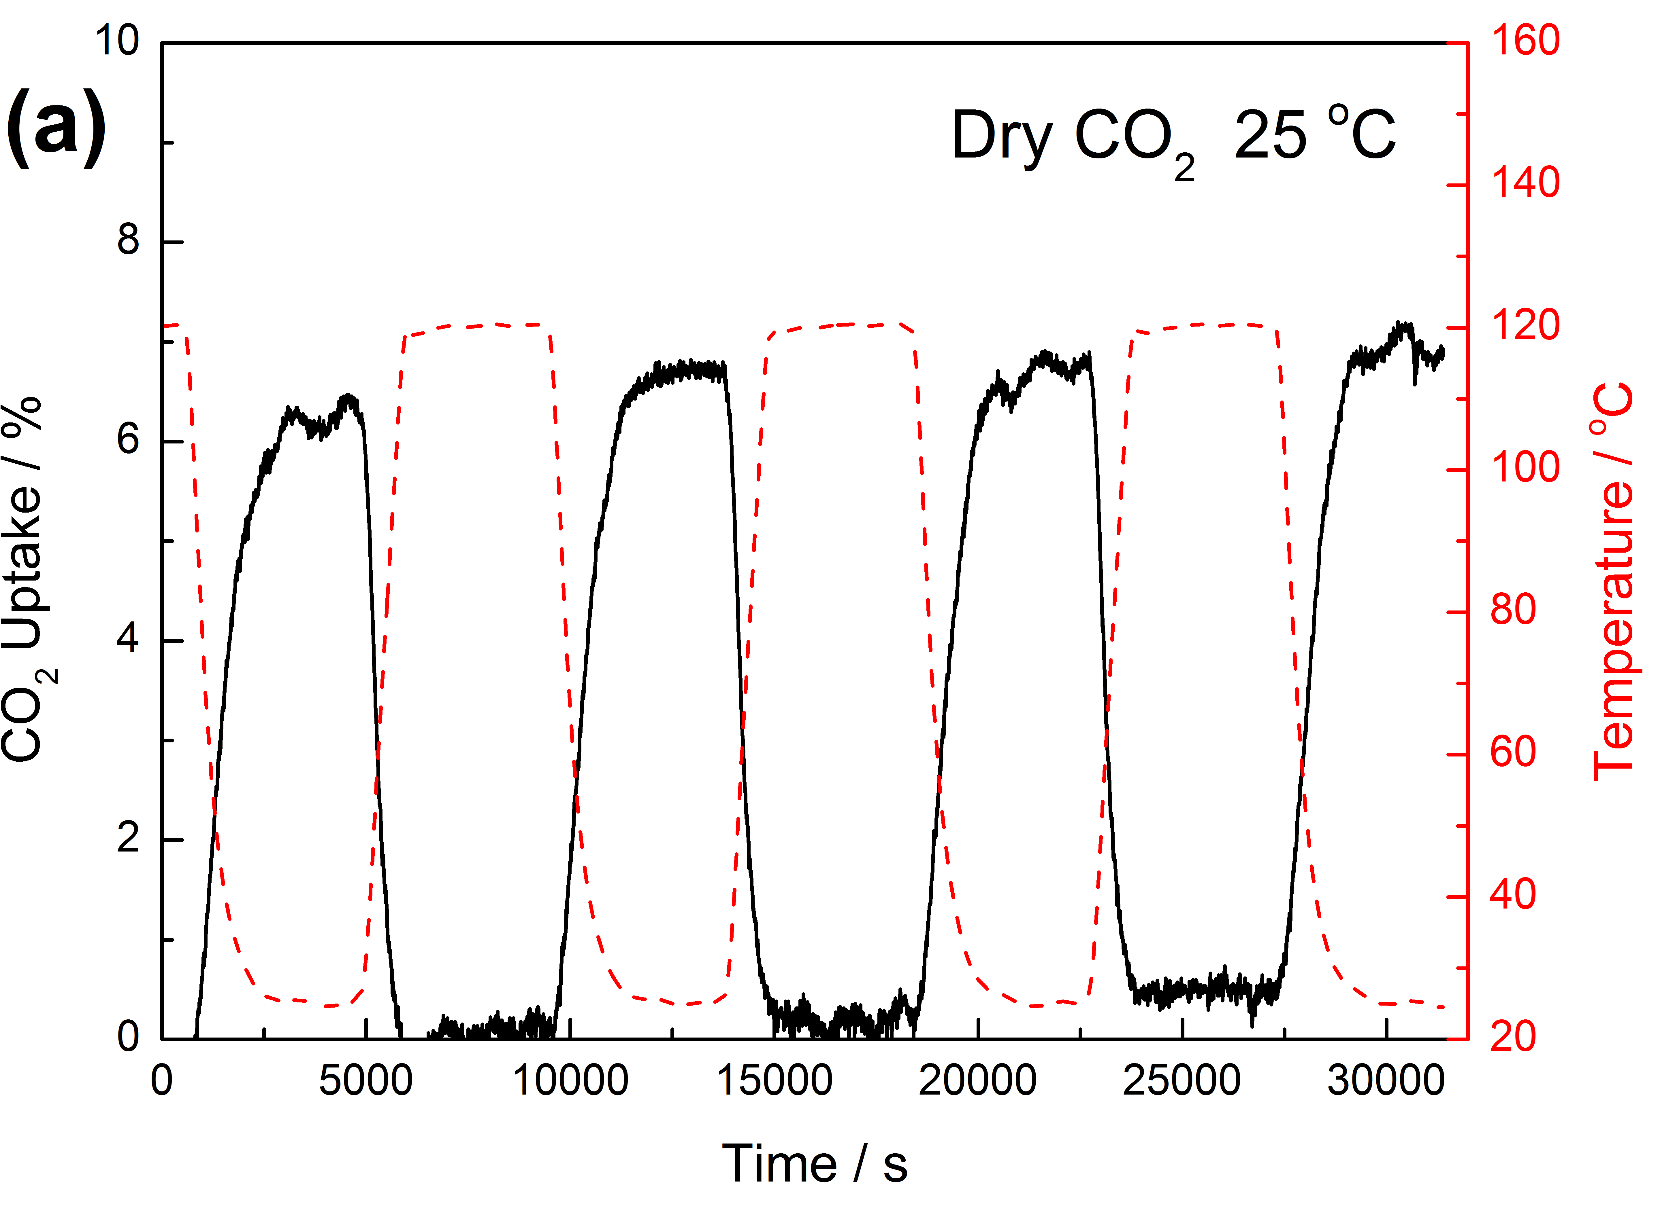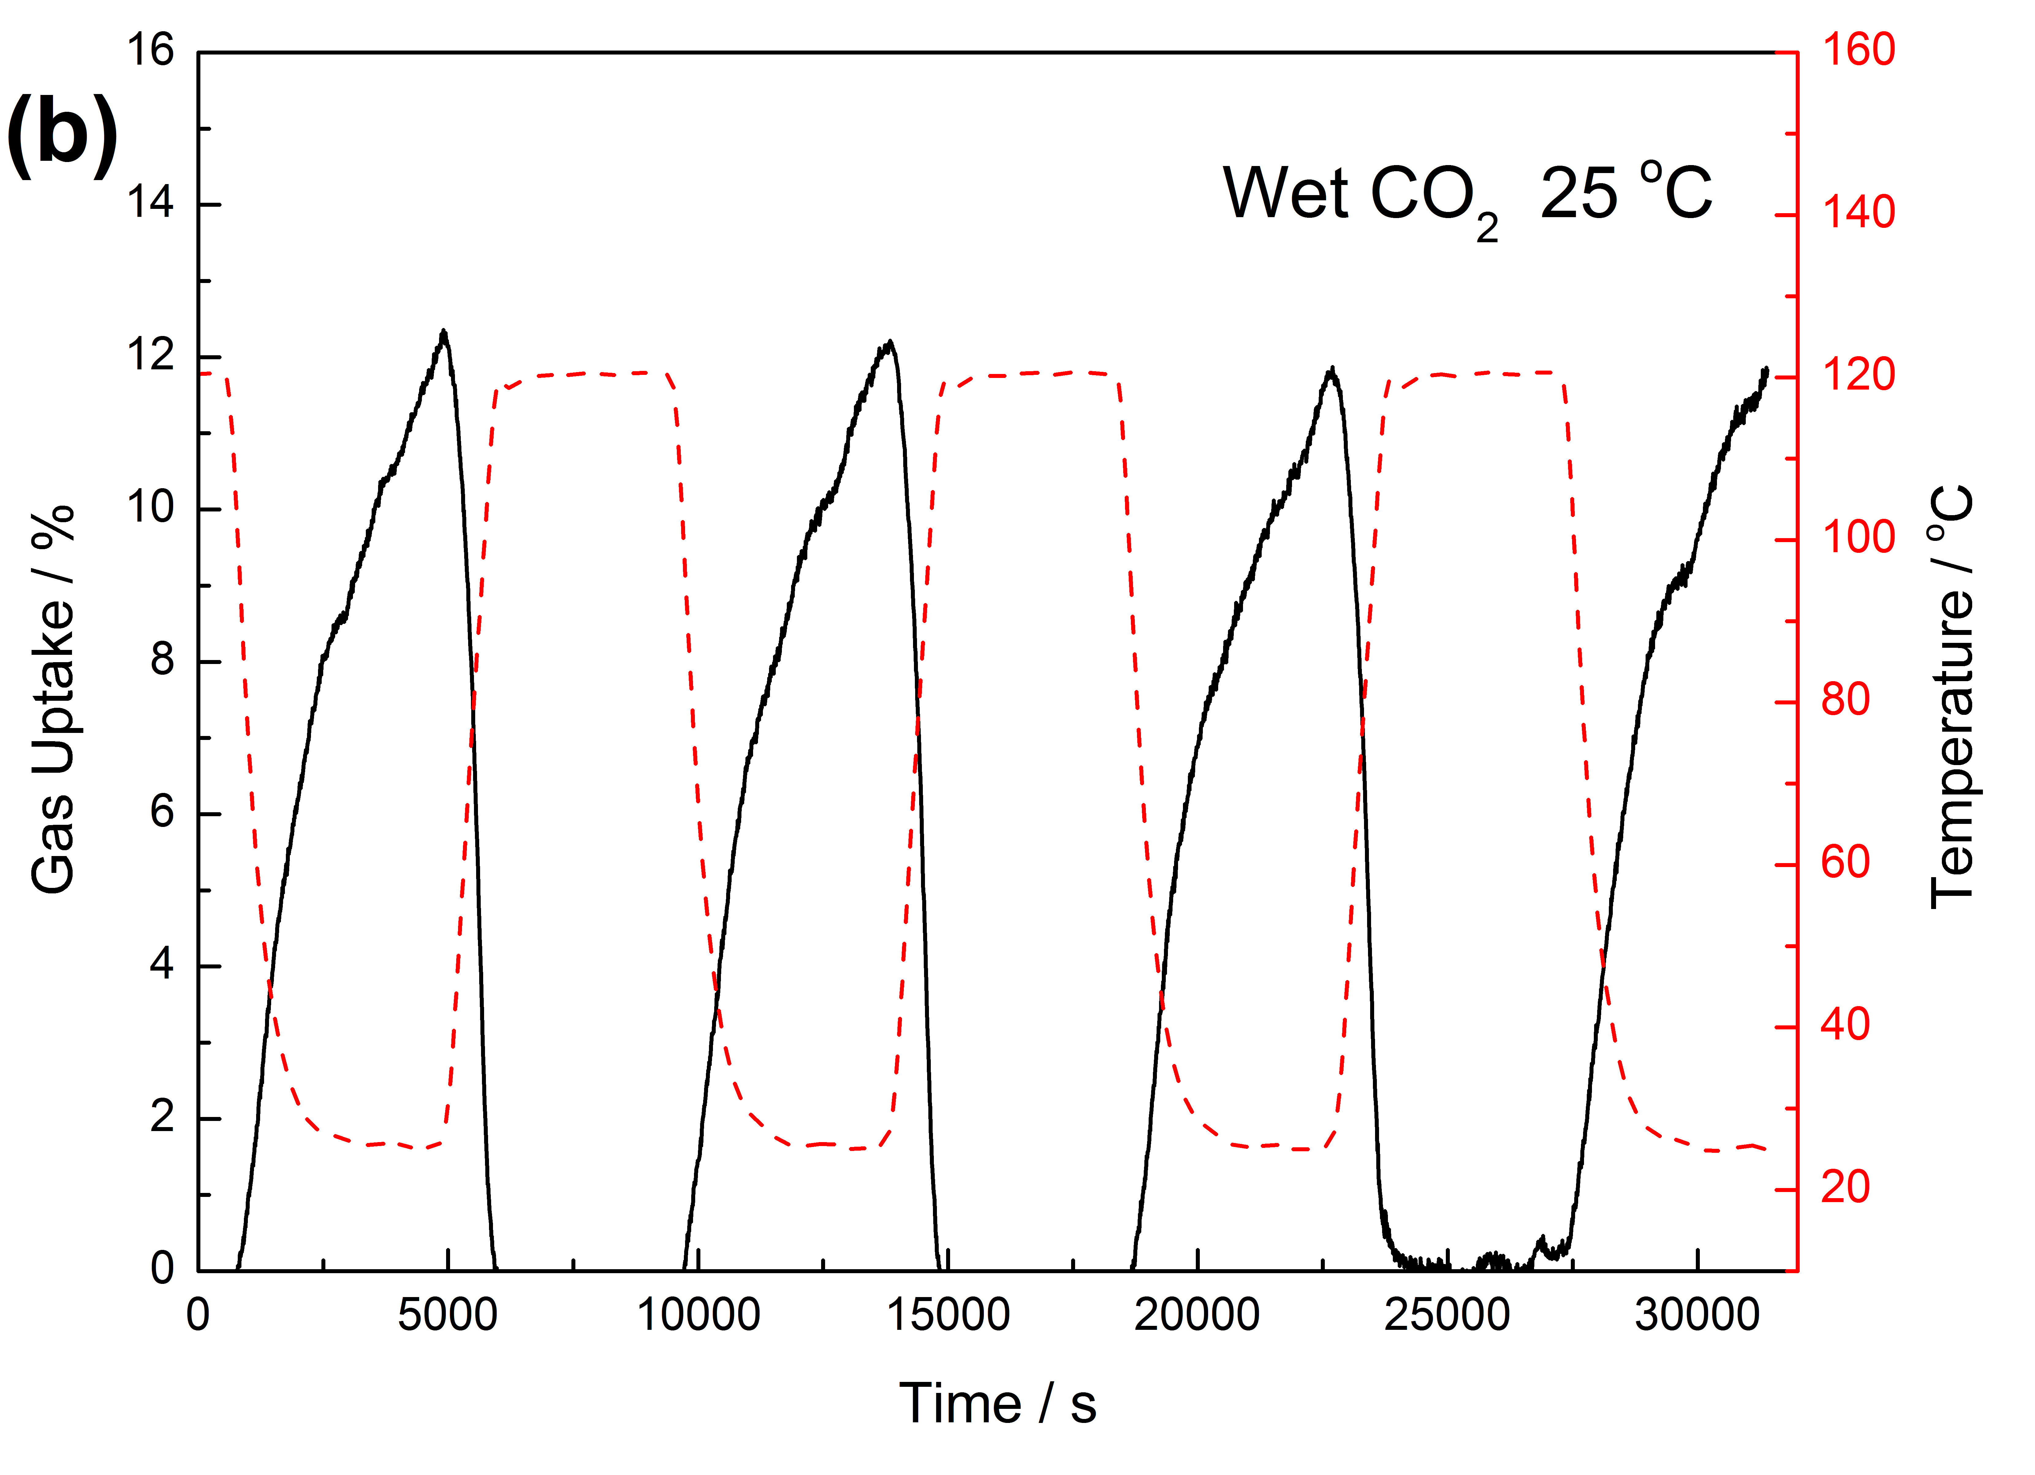
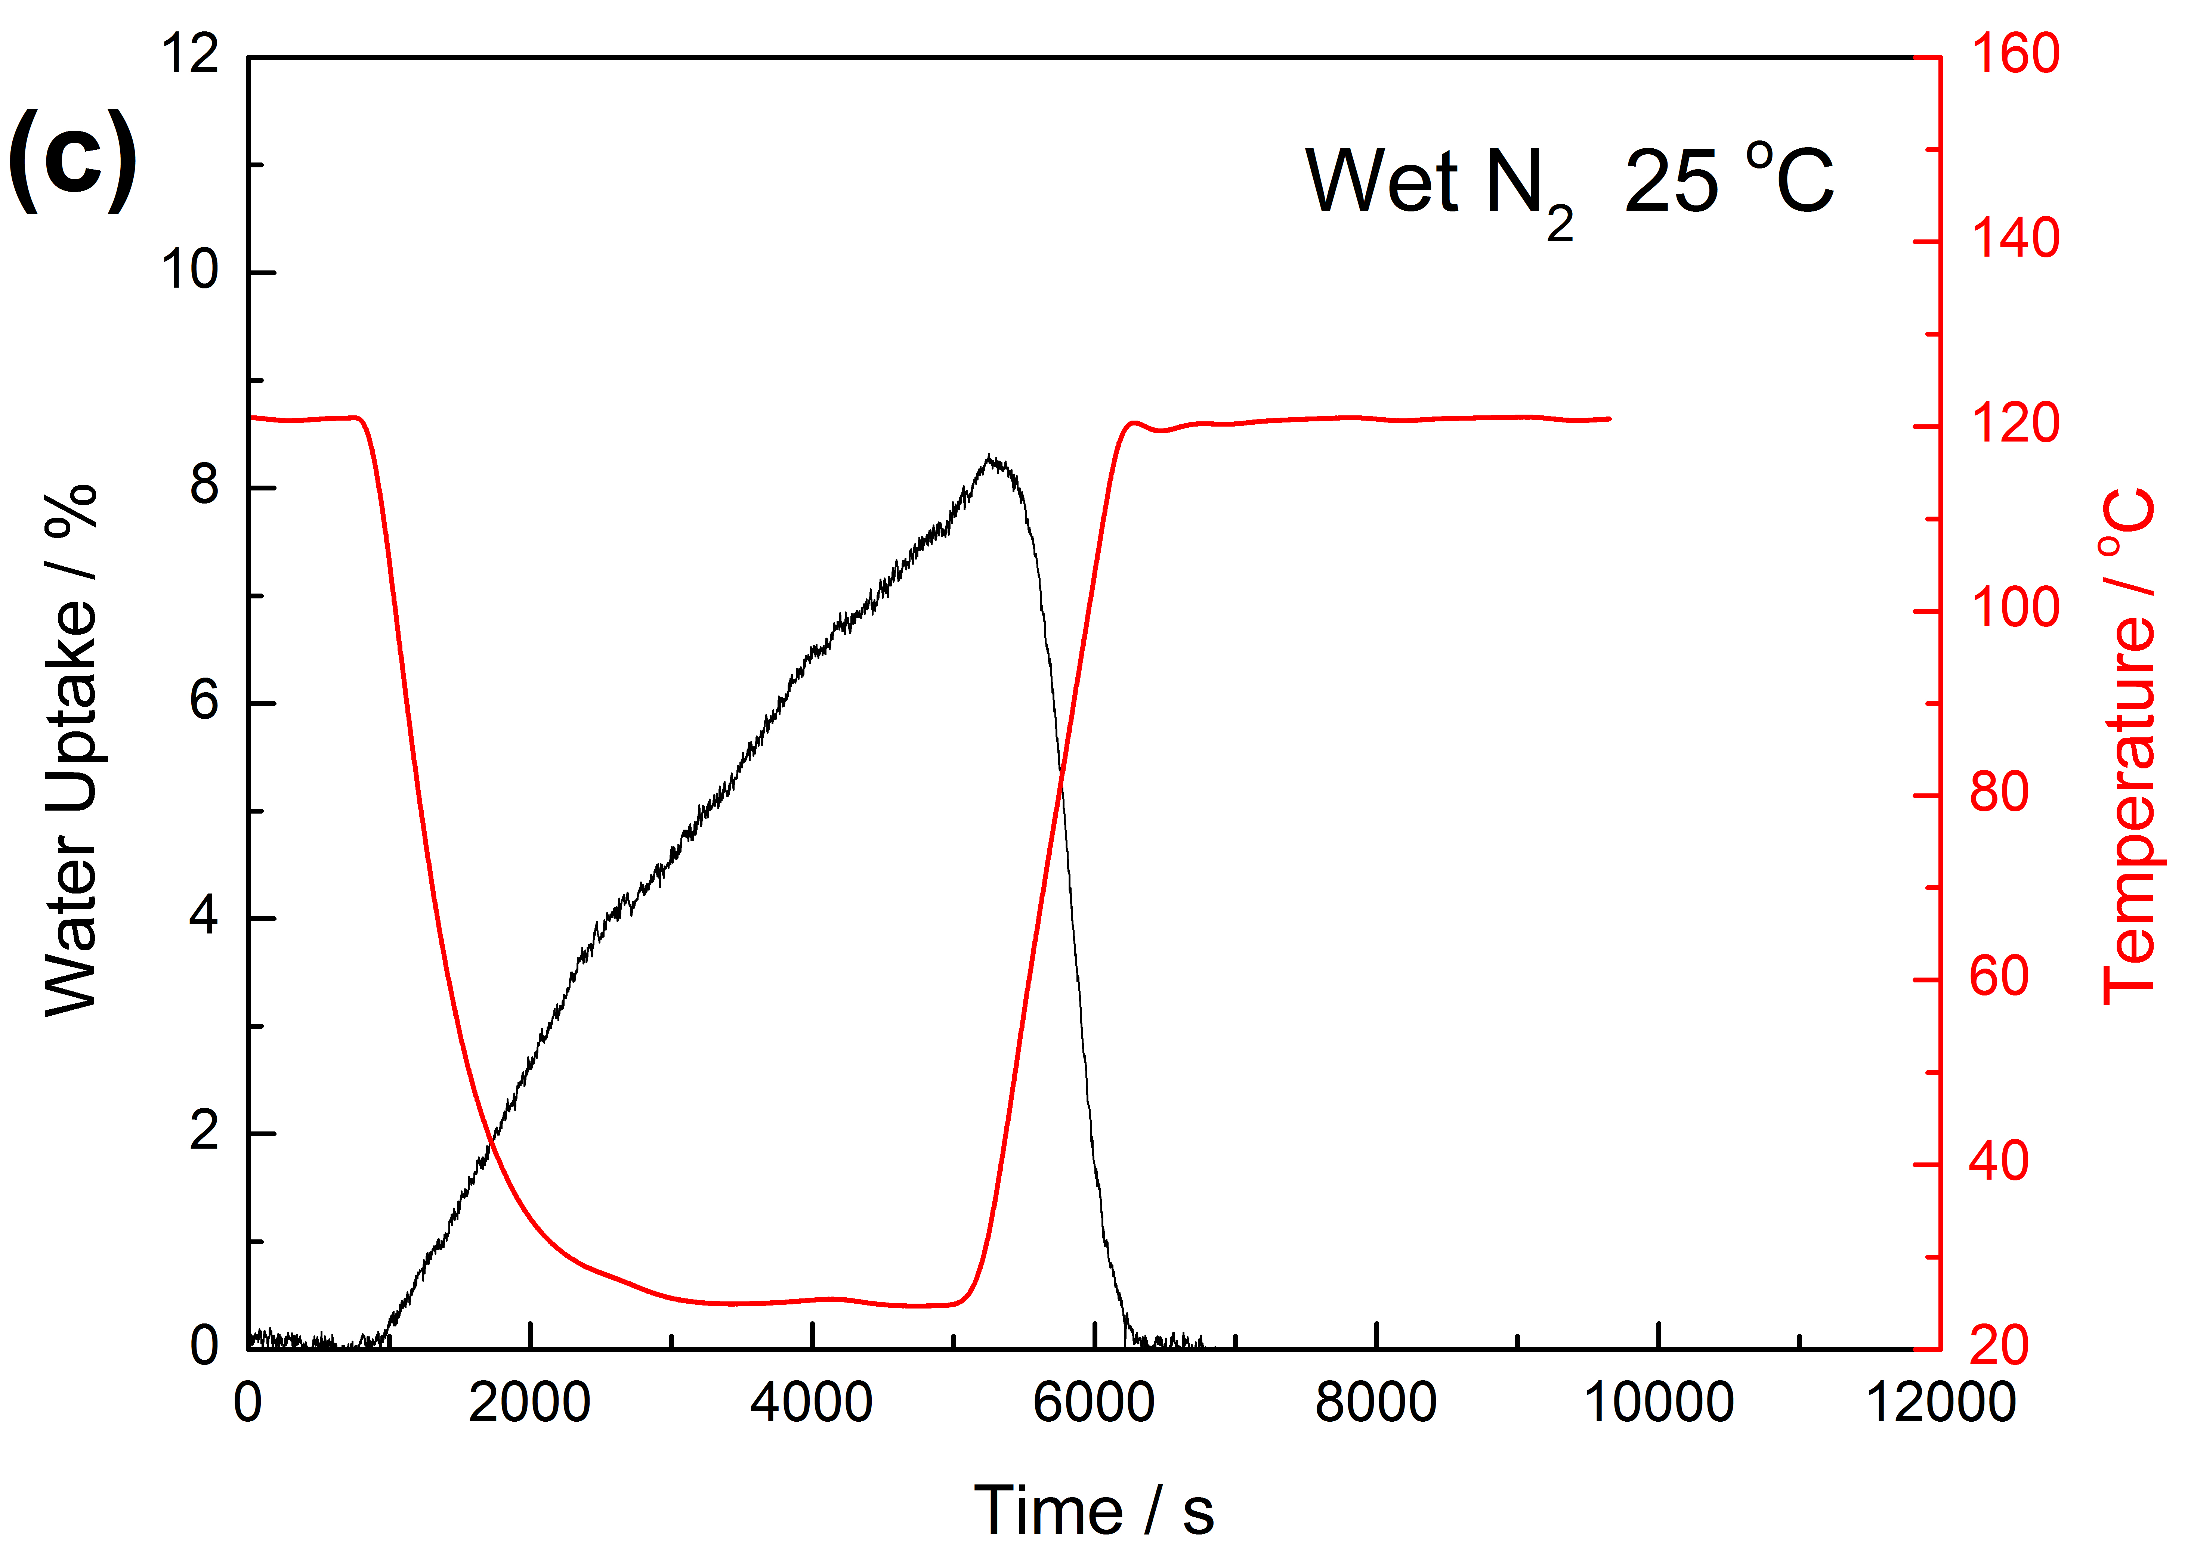
Figure 5: Cyclic performance of gas sorption on PC2-700 at 25 °C in both (a) dry and (b) wet (85% N₂ + 15% CO₂) flows; (c) a single cycle of water adsorption on PC2-700 in a wet N₂ gas flow.
Figure 5a shows four cycles of dry CO₂ adsorption at 25 °C. It demonstrates that PC2-700 can maintain a stable 6-7 wt% CO₂ uptake after multiple cycles of adsorption and desorption. In each cycle, the sorbent reaches its maximum CO₂ uptake in about 30 minutes. However, in the case of wet CO₂ adsorption (Figure 5b), the shape of the adsorption/desorption curve changes from the “square” to the “sawtooth” pattern. Figure 5b shows that, in the wet CO₂ gas flow, the sorbent maintains a gas uptake about 12 wt%, which is higher than that is tested in the dry CO₂ gas flow. In addition, even after an hour of adsorption, the weight of the sample is still increasing, indicating that the sorbent is still adsorbing gas molecules from the gas flow. Furthermore, it is interesting to notice that the initial rate of gas uptake is faster in the case of the wet CO₂ adsorption. However, the adsorption rate decreases with the increasing gas uptake, and it becomes slower than that of the dry CO₂ uptake at the later stage.
In order to analyse the influence of water on CO₂ adsorption, an additional single cycle wet N₂ adsorption test is carried out on PC2-700. Due to the low uptake of N₂ on carbon, the increase in the sorbent weight can be attributed to water adsorption. Figure 5c shows that the adsorption/desorption curve has a “sawtooth” pattern, which is similar to that of the wet CO₂ adsorption (Figure 5b) and is different from that of the dry CO₂ adsorption (Figure 5c). It indicates that the presence of water influences both gas adsorption capacity and rate. Figure 5c also shows that PC2-700 has a water uptake of 8 wt% at 25 °C in an hour, which is comparatively lower than that of the wet CO₂ uptake (12 wt%) and but slightly higher than that of the dry CO₂ uptake (6-7 wt%). It suggests that the presence of water may help to increase CO₂ uptake. This effect may be attributed to the co-adsorption of water and CO₂ on carbon and the dissolution of CO₂ in adsorbed water.
Heat of Adsorption and Influence of Dopants on CO₂ Capture
In addition to the isotherms, CO₂ uptakes are also plotted in Figure S1(a, c and e) against their corresponding porosity parameters, including specific surface area, total pore volume and ultramicropore volume, with both experimental data of pine cones, London Plane leaves and other biomass precursors from literature.¹⁷ It can be observed from Figure S1a and c that specific surface area and pore volume unnecessarily play a dominant role in CO₂ adsorption. Those with higher specific surface area and pore volume unnecessarily have higher CO₂ uptakes. Figure S1e suggests those samples with higher ultramicropore volumes may also have higher CO₂ uptakes. However, there are samples with similar ultramicropore volumes exhibiting large gap in CO₂ uptakes (on the left hand side of the figure). It indicates ultramicropore volume is not the only factor that influences CO₂ uptakes. CO₂ uptakes per unit surface area, total pore volume and ultramicropore volume (specific CO₂ uptakes) are also plotted in Figure S1(b, d and f) against their porosity parameters. In this case, all three figures show a clearly decreasing trend of specific CO₂ uptake with the increasing porosities, which indicates those samples with lower porosities show higher CO₂ uptakes per unit porosities (mostly our pine cones and leaf-derived carbon). It should be noted that the sample PC1-700 occupies the highest position at the top left of Figure S1b, d and f, while all of our pine cones and London Plane leaves derived carbon samples occupy the top-left corner of the figures. This observation indicates that nitrogen and metal dopants play a more important role than porosity for the low pressure CO₂ capture (i.e., ≤ 1 bar).
Figure 4c is the heat of adsorption plot of pine cones derived carbon. PC1-700 shows the highest heats of adsorption than those of the other samples throughout calculated CO₂ uptake range, while PC2-700 and PC2-700H stay at the bottom. This is very different from the CO₂ uptake isotherms in Figure 4a and b, where PC2-700 is at the top. Considering PC1-700 has the least developed porous structure, its high heat of adsorption can be only attributed to the existence of nitrogen and calcium dopants. In addition, PC2-600 possesses the second highest position below that of PC1-700 in Figure 4c but the highest nitrogen content, which indicates the nitrogen dopant has less contribution to the heat of adsorption than that from the calcium dopant.
Figure 4a shows that PC2-700 exhibits an extra 0.9 wt% CO₂ uptake at 25 °C and 1 bar CO₂ when compared with that of PC2-700H. This reduction can be attributed to both reduced ultramicropore volume (by 4%) and the removal of metal dopants. However, PC2-700H doubles the level of nitrogen content of PC2-700, and this can partially “offset” the detrimental effect caused by reduced porosity and metal content. Furthermore, Table 2 shows that PC2-700 possesses a calcium content of 0.5 at%. By simple calculation, even if the “offset effect” by doubled nitrogen dopants is ignored, for every atomic percent of calcium dopant, the CO₂ uptake can be raised by 1.8 wt%. In both studies on the naturally metal-doped carbon sorbents, XPS characterisations show that metal dopants exist in the form of +2 cations, which may enhance CO₂ capture by means of electrostatic interaction. However, metal cations can be either exposed to the gas environment and play the role of an active site for enhanced CO₂ binding, or buried beneath the surface but still within the depth detectable by XPS. Then, the function of metal dopants is weakened in the latter situation.

Conclusions
Porous-carbons derived from pine-cones naturally contain well dispersed calcium and nitrogen elements. The porous structure of the carbon sorbent is mainly controlled by the KOH/carbon mass ratio and the activation temperature. The CO₂ uptake of carbon sorbent is influenced by its nanoporous structure (especially its ultramicropore volume). Detailed elemental analysis shows that both nitrogen and calcium dopants also provide considerable beneficial effects on CO₂ uptake. A sample activated at 700 °C and with a KOH/carbon mass ratio 2:1, washed by distilled water, shows the highest CO₂ uptake of 20.9 wt% under 1 bar CO₂ and 25 °C, which matches the highest CO₂ uptake of biomass-derived carbon sorbent in the literature, thanks to the highly developed nanoporous structure and the naturally-doped nitrogen and calcium in carbon. Further data analysis indicates that calcium and nitrogen doping enhance CO₂ binding with the carbon structure and the resulting carbon exhibit high CO₂ uptake per unit surface area and pore volume. This study shows an effective approach to explore the beneficial effects of atomic metal doping in carbon sorbents and to produce large quantities of porous carbon materials for high capacity CO₂ capture.
Acknowledgements: The authors would like to acknowledge the financial support from the UK EPSRC (EP/G063176/1, EP/G061785/1, EP/I010955/1, and EP/E037267/1) and research support was gratefully received from both Universities.
Supporting Information: Three tables and four figures provide additional information about the porosities, CO₂ uptakes and chemical compositions and yields of pine cone-derived carbon.

References
(1) International Energy Agency, Key World Energy Statistics: From the IEA, International Energy Agency, 2002.
(2) Gadipelli S.; Guo Z. X. Graphene-based materials: Synthesis and gas sorption, storage and separation. Prog. Mat. Sci. 2015, 69, 1-60.
(3) D'Alessandro, D. M.; Smit B.; Long, J. R. Carbon dioxide capture: Prospects for new materials. Angew. Chem. Int. Ed. 2010, 49, 6058-6082.
(4) Hao, G. P.; Li, W. C.; Qian D.; Lu, A. H. Rapid synthesis of nitrogen-doped porous carbon monolith for CO₂ capture. Adv. Mater. 2010, 22, 853-857.
(5) Chen, C.; Kim J.; Ahn, W. S. Efficient carbon dioxide capture over a nitrogen-rich carbon having a hierarchical micro-mesopore structure. Fuel 2012, 95, 360-364.
(6) Sevilla, M.; Valle-Vigon P.; Fuertes, A. B. N-doped polypyrrole-based porous carbons for CO₂ capture. Adv. Funct. Mater. 2011, 21, 2781-2787.
(7) Liu, L.; Deng, Q. F.; Hou X. X.; Yuan, Z. Y. User-friendly synthesis of nitrogen-containing polymer and microporous carbon spheres for efficient CO₂ capture. J. Mater. Chem. 2012, 22, 15540-15548.
(8) Liu, B.; Shioyama, H.; Akita T.; Xu, Q. Metal-organic framework as a template for porous carbon synthesis. J. Am. Chem. Soc. 2008, 130, 5390-5391.
(9) Srinivas, G.; Krungleviciute, V.; Guo, Z. X.; Yildirim, T. Exceptional CO₂ capture in a hierarchically porous carbon with simultaneous high surface area and pore volume. Energ. Environ. Sci. 2014, 7, 335-342.
(10) Srinivas G.; Guo, Z. X. Tuning of ZIF-derived carbon with high activity, nitrogen functionality, and yield – a case for superior CO₂ capture, Chemsuschem 2015, 8, 2123-2132.
(11) Chaikittisilp, W.; Ariga, K.; Yamauchi, Y. A new family of carbon materials: synthesis of MOF-derived nanoporous carbons and their promising applications. J. Mater. Chem. A 2013, 1, 14-19.
(12) Gadipelli, S.; Patel, H. A.; Guo, Z. Carbon Capture: An ultrahigh pore volume drives up the amine stability and cyclic CO₂ capacity of a solid-amine@carbon sorbent. Adv. Mater. 2015, 27, 4902.
(13) Shen, W.; He, Y.; Zhang, S.; Li J.; Fan, W. Yeast-based microporous carbon materials for carbon dioxide capture. Chemsuschem 2012, 5, 1274-1279.
(14) Wang, J.; Heerwig, A.; Lobe, M.; Oschatz, M.; Borchardt L.; Kaskel, S. Fungi-based porous carbons for CO₂ adsorption and separation. J. Mater. Chem. 2012, 22, 13911-13913.
(15) Ello, A. S.; de Souza, L. K. C.; Trokourey, A.; Jaroniec, M. Development of microporous carbons for CO₂ capture by KOH activation of African palm shells. J. CO₂ Utilization 2013, 2, 35-38.
(16) Wang, R.; Wang, P.; Yan, X.; Lang, J.; Peng, C.; Xue, Q. Promising porous carbon derived from celtuce leaves with outstanding supercapacitance and CO₂ capture performance. ACS Appl. Mater. Interfaces 2012, 4, 5800–5806.
(17) Zhu, B.; Qiu, K.; Shang C.; Guo, Z. Naturally derived porous carbon with selective metal-and/or nitrogen-doping for efficient CO₂ capture and oxygen reduction. J. Mater. Chem. A 2015, 3, 5212-5222
(18) Duman, G.; Onal, Y.; Okutucu, C.; Onenc, S.; Yanik, J. Production of activated carbon from pine cone and evaluation of its physical, chemical, and adsorption properties. Energy Fuels 2009, 23, 2197-2204.
(19) Sevilla M.; Fuertes, A. B. Sustainable porous carbons with a superior performance for CO₂ capture. Energ. Environ. Sci. 2011, 4, 1765-1771.
(20) NIST XPS Database, http://srdata.nist.gov/xps/.
(21) Romanos, J. R.; Beckner, M.; Rash, T.; Firlej, L.; Kuchta, B.; Yu, P.; Suppes, G.; Wexler C.; Pfeifer, P. Fungi-based porous carbons for CO₂ adsorption and separation. Nanotechnology 2012, 23, 015401.
(22) Argun, M. E.; Dursun, S.; Karatas M.; Guru, M. Activation of pine cone using Fenton oxidation for Cd(II) and Pb(II) removal. Bioresource technology 2008, 99, 8691-8698.
(23) Dawson, C.; Vincent J. F. V.; Rocca, A. M. How pine cones open. Nature 1997, 390, 668.
(24) Thogersen, A.; Selj, J. H.; Marstein, E. S.; Oxidation effects on graded porous silicon anti-reflection coatings. J. Electrochem. Soc. 2012, 159, D276-D281.
(25) Im, H.; Rasouli, F.; Hajaligol, M.; Formation of nitric oxide during tobacco oxidation. J. Agric. Food Chem. 2003, 51, 7366-7372.
(26) Pels, J. R.; Kapteijn, F.; Moulijn, J. A.; Zhu, Q.; Thomas, K. M. Evolution of nitrogen functionalities in carbonaceous materials during pyrolysis. Carbon 1995, 33, 1641-1653.
(27) Zhu, B.; Li, K.; Liu, J.; Liu, H.; Sun, C.; Snape, C. E.; Guo, Z. Nitrogen-enriched and hierarchically porous carbon macro-spheres – ideal for large-scale CO₂ capture. J. Mater. Chem. A 2014, 2, 5481-5489.
(28) Inanaga, S.; Okasaka, A. Does silicon exist in association with organic compounds in rice plant? Soil science and plant nutrition 1995, 41, 111-117.
(29) Zhao, Y.; Liu, X.; Yao, K. X.; Zhao, L.; Han, Y. Superior capture of CO₂ achieved by introducing extra-framework cations into N-doped microporous Carbon. Chem. Mater. 2012, 24, 4725-4734.
(30) Nandi, M.; Okada, K.; Dutta, A.; Bhaumik, A.; Maruyama, J.; Derks, D.; Uyama, H. Unprecedented CO₂ uptake over highly porous N-doped activated carbon monoliths prepared by physical activation. Chem. Commun. 2012, 48, 10283-10285.
(31) Miyawa J.; Schulman, S. Ultraviolet-visible spectrophotometry. in Handbook of Pharmaceutical Analysis; Ohannesian L., Streeter, A. Taylor & Francis: New York, USA, 2001, pp. 200–201.

* Corresponding author. Tel: +442076797527 Email: z.x.guo@ucl.ac.uk (Zhengxiao Guo)

