Optimisation of immuno-gold nanoparticle complexes for antigen detection
Susan van der Heide^{1,2} and David A. Russell¹ *

(1) School of Chemistry, University of East Anglia, Norwich Research Park, Norwich, Norfolk, NR4 7TJ, UK.

*Corresponding author:
Prof David A. Russell
School of Chemistry
University of East Anglia
Norwich Research Park
Norwich, NR4 7TJ, UK.
E-mail: d.russell@uea.ac.uk

Co-author:
Dr Susan van der Heide¹
School of Chemistry
University of East Anglia
Norwich Research Park
Norwich, NR4 7TJ, UK.

²Co-author present address:
Division of Neurosurgery
Department of Clinical Neurosciences
University of Cambridge
Box 167, Cambridge Biomedical Campus
Cambridge, CB2 0QQ, UK
Email: sv377@cam.ac.uk
Abstract
The aim of this investigation was to define the optimum method of binding antibodies to the surface of gold nanoparticles (AuNPs) and then to apply the optimised antibody-functionalised AuNPs for the detection of a target antigen. A detailed investigation of three different techniques for the functionalisation of AuNPs with anti-cocaine antibody and methods for the subsequent characterisation of the antibody-functionalised AuNP are reported. The addition of anti-cocaine antibody onto the AuNP surface was facilitated by either: a polyethylene glycol (PEG) linker with a –COOH terminal functional group; an aminated PEG ligand; or an N-succinimidyl 3-(2-pyridyldithio)-propionate (SPDP)-Protein A/G intermediate. Characterisation of the functionalised particles was performed using transmission electron microscopy, UV-Visible spectrophotometry and by agarose gel electrophoresis. In addition, the cocaine binding efficacy of the resultant AuNPs and their cocaine-binding capacity was determined using a cocaine-horseradish peroxidase conjugate, and by the application of a microtiter plate-based immunoassay. The results showed that the number of antibody per particle was the highest when the AuNP were functionalised with the Protein A/G intermediate. As compared to free antibody, the cocaine binding efficacy was significantly enhanced using the AuNP-Protein A/G-antibody complex. This optimal antibody-antigen binding efficacy is thought to be the result of the large number of antibody per particle and the oriented binding of the antibody to the Protein A/G on the AuNP surface. These results highlight the ideal immuno-gold nanoparticle characteristics for the detection of target antigens such as cocaine.

Keywords: Gold nanoparticles, antibodies, conjugation, cocaine.

Introduction
Gold nanoparticles (AuNPs) with their ease of synthesis and functionalisation, biocompatible characteristics and optical distinctiveness have proven to be powerful tools within chemistry.¹ The advantageous characteristics of AuNPs are commonly exploited in the form of bio-functionalised particles, which can be fabricated by encapsulating the AuNP in a coating of biological material such as DNA,² protein³ or lectin.⁴ The addition of biomolecules such as antibodies enables AuNPs to be specifically directed to targets of interest via molecular recognition.⁵ The immunological specificity of the antibody in combination with the electron density and unique optical properties of AuNP have made antibody functionalised AuNP attractive for a range of different applications including biological staining, disease diagnosis and cancer therapy.^{3, 6, 7} A useful characteristic for analytical detection which is common to all metal nanoparticles is the high surface to volume ratio.⁸ The binding of an antibody-functionalised AuNP to its target analyte, followed by the addition of a fluorescent marker or enzyme yields a signal that is 10-fold greater than when only a single labelling molecule is bound.⁹ This amplification makes functionalised AuNP particularly applicable for the detection of small compounds in samples containing low concentrations of analyte.¹⁰ A study by Leggett et al., for example, used the amplified signal from fluorescently labelled antibody-functionalised AuNP for the detection of ng quantities of cotinine in latent fingerprints.¹¹ Hazarika et al. demonstrated a similar technique involving antibody-functionalised magnetic particles for the detection of illicit drug metabolites in fingerprints.¹² ^{13, 14}

A number of strategies have been reported for the covalent binding of antibodies onto a gold surface by way of a ligand intermediate.^{5, 15} The most robust form of anchorage onto gold is thought to be provided by thiolated ligands, which form a strong bond between the sulfur and the gold surface.¹⁶ The use of a heterobifunctional ligand, with a thiol group at one terminus and a moiety for binding antibody at the other, is advantageous for the functionalisation of AuNP. In addition to the necessary bond strength, certain ligands can also provide oriented binding of the antibody with the antigen-binding sites facing outward and away from the gold surface. This greatly improves the detection capabilities of the resulting conjugates.¹⁷ In this study, three different approaches involving heterobifunctional ligands were used for the covalent binding of anti-cocaine antibodies onto AuNP.

In the first, a thiolated PEG ligand with terminal carboxyl functionality (PEGCOOH) was used to bind the antibody to the AuNP surface. As described by Mason et al., PEGCOOH can be easily self-assembled onto citrate-stabilised AuNP which results in the functionalised AuNPs with enhanced stability in aqueous solvents.¹⁸ Activation of the -COOH functional group using standard 1-ethyl-3-(3-dimethylaminopropyl) carbodiimide hydrochloride/ hydroxysulfosuccinimide sodium salt (EDC/NHS) chemistry enables covalent binding of antibody via any one of the exposed amine residues on the antibody surface,¹⁹ as illustrated in Fig 1A. AuNP functionalised with antibodies using this ligand are highly stable in aqueous buffers and relatively straightforward to assemble. Synthesis using this method has been reported for a number of applications including as part of an immunoassay for the signal enhancement of HRP,²⁰ and for the detection of amino acids in fingerprints.²¹ Functionalisation of the AuNPs using this approach yields a number of different antibody orientations depending on which of the exposed amine groups on the antibody binds to the ligand. Puertas et al. report that antibodies are preferentially bound to carboxylated ligands via the amine groups situated in the Fab region of the antibody, which results in the antigen-binding surface of the antibody being oriented towards rather than away from the gold surface and potentially hindering antigen binding (as demonstrated in Fig 1A).¹⁷

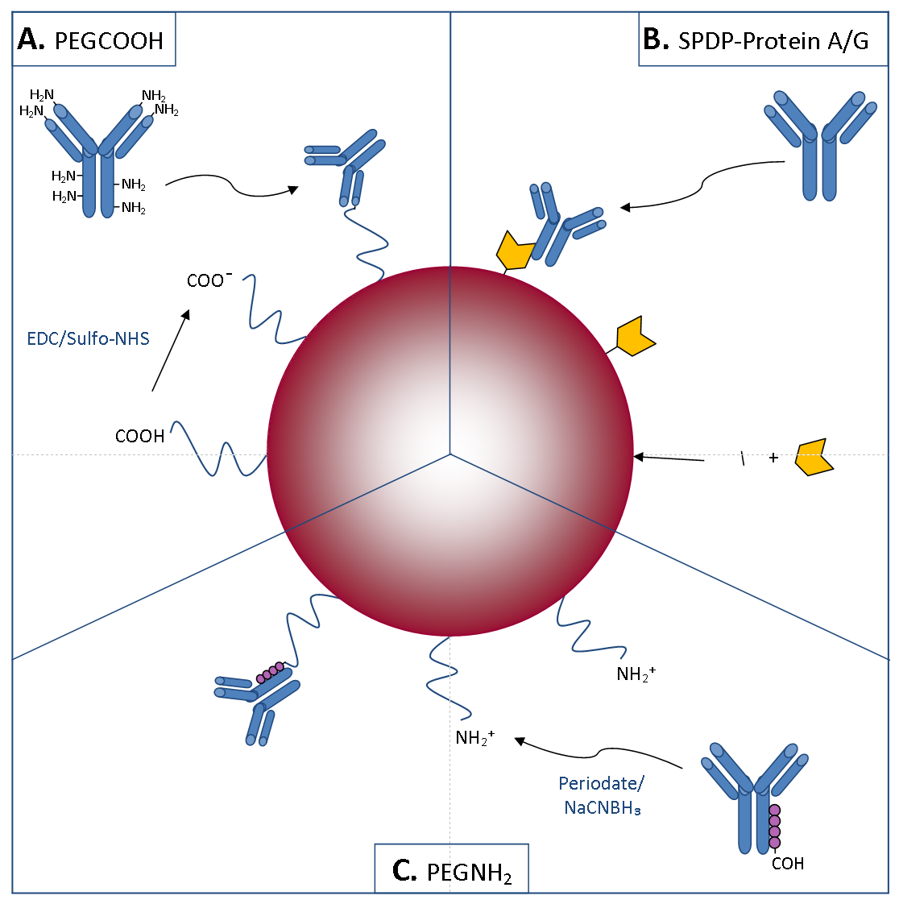

Fig. 1 The three differerent strategies for immobilising antibodies onto AuNP used in this study. (A) The use of a PEGCOOH linker; (B) Protein A/G modified with an SPDP linker; and (C) a PEGNH₂ linker. The antibody is represented in blue and the Protein A/G in yellow.

In the second approach used for the antibody-functionalisation of AuNP, favourable orientation of bound antibodies was achieved via a protein intermediate covalently coupled to the AuNP surface. Bacterial IgG-binding proteins, such as Protein A and Protein G, preferentially bind to the Fc region of antibodies.^{15, 22} Leggett et al. demonstrated the use of AuNPs functionalised with antibodies via a N-succinimidyl 3-(2-pyridyldithio)-propionate (SPDP)-modified Protein A intermediate for the detection of cotinine in latent fingerprints.¹¹ In the present study, the chimeric Protein A/G, a fusion protein which offers four IgG binding sites with the combined binding specificities of both Proteins A and G, was used.²² The Protein A/G was bound to the AuNP surface via the heterobifunctional SPDP ligand. The addition of SPDP to Protein A/G was facilitated by the lysine groups of the protein in combination with the NHS ester on the ligand. Once conjugated to the Protein A/G, the disulfide group of the SPDP was then immobilised onto the gold surface. By exploiting the interaction between Protein A/G and the Fc region of the antibody, this approach to functionalisation orients the antibody so that the antigen-binding region is directed away from the nanoparticle surface, as illustrated in Fig 1B. Although it is more difficult to obtain stable antibody-AuNP conjugates using this method, as compared to the relatively facile PEGCOOH approach, AuNP functionalised using the Protein A/G intermediate should yield a greater proportion of correctly oriented antibodies for antigen binding and therefore produce a more bioactive conjugate.

Directed antibody binding can also be performed using a ligand with an amine functional group, as described by Puertas et al..¹⁷ In this method binding is achieved via the polysaccharide moiety located on the Fc region of the antibody, resulting in presentation of the FAb region for antigen binding in a similar manner as obtained using Protein A/G. In this method the aldehyde on the polysaccharide moiety is first oxidised before being added to the amine-modified particles. The oxidised antibody forms a Schiff base intermediate in the presence of the aminated ligand on the particle which, when reduced, forms a strong bond between the antibody and ligand. AuNP functionalised with antibody using an aminated ligand have previously been synthesised by Kumar et al. for the imaging of intracellular biomarkers.²³ Niidome et al. reported the functionalisation of 40 nm aminated AuNP, synthesised by sodium borohydride reduction using a short cysteamine linker, with DNA using a similar method.²⁴ In the third method for functionalisation used in this present study, 16 nm AuNP with an aminated PEG linker (PEGNH₂) were synthesised and combined with the antibody functionalisation method of Puertas et al. for the functionalisation of AuNP with anti-cocaine antibody.¹⁷ A schematic of this approach is shown in Fig 1C.

This study aimed to define the optimum method of binding anti-cocaine antibody onto the surface of gold nanoparticles (AuNPs) by comparing the three proposed approaches highlighted in Fig 1. Although the resulting optimised antibody-functionalised AuNP were synthesised with the eventual aim of forensic detection of cocaine, the functionalisation techniques compared here are independent of antibody type and can therefore be applied in any antibody-functionalised AuNP-based detection system. UV-Vis spectrophotometry and transmission electron microscopy (TEM) were used to characterise the AuNP core after synthesis. Following the functionalisation of the AuNP, the presence of the anti-cocaine antibody on the particle surface, and the overall cocaine-binding efficiency of each type of functionalised AuNP was extensively characterised by means of gel electrophoresis, enzyme-labelled antigen and application in a plate-based immunoassay. Based on the characterisation of each type of functionalised AuNP in terms of antibody orientation, particle stability and solubility and efficacy of antigen binding, the most effective functionalisation approach was determined to be the Protein A/G intermediate method that facilitated optimal directed binding of the antibody for antigen detection.

Materials and methods
Materials
All reagents were of analytical grade, purchased from Sigma-Aldrich (UK) and used as received unless otherwise stated. Polyclonal anti-cocaine antibody was obtained in 1 mL units of rabbit serum from Europa Bioproducts (UK) and purified as described below. Analytical grade deionised water (dH₂O), methanol (MeOH), hydrochloric acid 32 % (HCl (aq)), sodium dihydrogen orthophosphate dihydrate (NaH₂PO₄·2H₂O), di-sodium hydrogen orthophosphate anhydrous (Na₂HPO₄), sodium hydrogen carbonate (NaHCO₃), sodium chloride (NaCl), glycerol, dimethyl sulfoxide (DMSO) and tri-sodium citrate (Na₃H₅C₆O₇) were all purchased from Fisher Scientific (UK). Dithiothreitol (DTT) and sodium dodecyl sulfate (SDS) were purchased from Pharmacia Biotech (UK). Sheep polyclonal anti-cocaine antibody and horseradish peroxidase (HRP)-labelled mouse monoclonal anti-sheep IgG were purchased from Abcam (UK) and Jackson ImmunoResearch laboratories (USA), respectively. Cocaine-horseradish peroxidase (cocaine-HRP) and cocaine-bovine serum albumin (cocaine-BSA) haptens were purchased from Randox (UK) and Europa Bioproducts (UK), respectively.

Sephadex PD-10 desalting columns were purchased from GE Life Sciences (UK). ‘Slide-A-Lyzer’ mini dialysis units (10,000 MWCO), ‘NAb Protein A plus’ spin columns, Coomassie brilliant blue R250, bromophenol blue sodium salt, ammonium persulfate (APS), 10 MWCO dialysis tubing, sulfo-N-hydroxysuccinimide sodium salt (sulfo-NHS), 1-ethyl-3-(3-dimethylaminopropyl) carbodiimide hydrochloride (EDC), N-succinimidyl 3-(2-pyridyldithio)-propionate (SPDP), 96-well Nunc C8 Maxisorp microtiter plates, 3,3',5,5' tetramethylbenzidine (TMB) substrate solution, and horseradish peroxidase (HRP) were all purchased from Thermo Scientific (UK). α-thio-ω-carboxy polyethylene glycol (PEGCOOH, MW 3317 Da) and α-Mercapto-ω-amino polyethylene glycol hydrochloride (PEGNH₂, MW 3163 Da) were purchased from Iris Biotech GMBH (Germany). Ultrapure agarose and Novex Sharp unstained protein standard (molecular weight marker) were purchased from Invitrogen (UK). N,N,N’-tetramethylethylenediamine (TEMED) was purchased from Bio Rad (UK). Vivaspin20 (30,000 MWCO) and Vivaspin500 (100,000 MWCO) centrifuge tubes were purchased from Sartorius Stedim Biotech (UK). Holey carbon film 300 mesh copper grids were purchased from Agar Scientific (UK).

All centrifugation steps were performed using a Beckman Coulter Allegra X-22R centrifuge. SDS-PAGE gels were cast in a Hoefer S245 dual gel cassette, and performed using a Hoefer Mighty Small II vertical electrophoresis system. Agarose gels were prepared and run using a Scie-Plas HU-15 standard horizontal electrophoresis gel unit. Both SDS-PAGE and agarose gel electrophoresis were performed using an Amersham Pharmacia Biotech EPS 601 power supply. Colorimetric imaging of SDS-PAGE gels was performed using a HP photosmart C4580 scanner. Photographic images of gels were made using a Canon IXUS 115HS handheld digital camera. UV-Vis absorption spectra were recorded on a Hitachi U-3000 spectrophotometer at room temperature. Quartz cuvettes with a 1 cm path length were used. Microtiter plate absorbance intensity readings were recorded using a Perkin Elmer Wallac Envision 2103 multilabel microplate reader. Transmission electron microscope (TEM) images were obtained using a Joel 2000EX TEM operating at 200 kV.

Anti-cocaine antibody purification
Polyclonal anti-cocaine antibody was isolated from the supplied rabbit serum samples by immunoprecipitation followed by Protein A chromatography. Ammonium sulfate precipitation was performed using standard methodology,²⁵ prior to dialysis in mini-dialysis units for 2 h against 2 L of 10 mM phosphate buffer (pH 7.4; PB). Immunochromatography was performed using Protein A spin columns with a sample capacity of ≤ 500 µL in accordance with the manufacturer’s instructions. Three columns were used to accommodate the 900 µL of solution to be purified. Briefly, the columns were equilibrated before use by washing twice with 400 µL of 10 mM phosphate-buffered saline (150 mM NaCl, pH 7.2; PBS). Wash solutions were removed from the columns by centrifugation for 1 min at 4,000 xg. The solution containing the antibody was added at 300 µL per column, and the columns incubated at room temperature on a rotary mixer for 10 min. The columns were then washed three times with 400 µL of 10 mM PBS (pH 7.2). The antibody was eluted from the columns using three 400 µL additions of 0.1 M glycine (pH 2.0). Each of the resulting three fractions was neutralised with 40 µL of 1.0 M tris-HCL buffer (pH 8.5). The presence of antibody in the first and second fractions was determined by UV-VIS spectrophotometry at A₂₈₀ and confirmed by SDS-PAGE.²⁶ The two fractions were combined and dialysed in mini-dialysis units for 2 h against 2 L of 10 mM PB (pH 7.4), and the solutions stored at -20 °C.

AuNP synthesis and characterisation
16 nm citrate-stabilised gold nanoparticles (cAuNP) were synthesised according to the method of Turkevich et al..²⁷ The concentration of AuNP was calculated using the absorption at 520 nm and the extinction coefficient 2.4 x 10⁸ M⁻¹ cm⁻¹.²⁸ Transmission electron microscopy (TEM) was used to characterise the size and morphology of the AuNP. 10 µL of the AuNP in solution was placed onto a holey carbon film 300 mesh copper grid. Excess solvent was removed from the sample by touching the side of the grid with adsorbent tissue paper. The grid was then allowed to dry overnight at room temperature before imaging.

Antibody functionalisation of AuNP using a PEG-carboxyl linker
Antibody-functionalised AuNP were prepared using a modified version of the protocol described by Mason et al., whereby the PEG-carboxyl linker was self-assembled onto AuNP, followed by the addition of the anti-cocaine antibody via the formation of an amide bond.¹⁸ A w/v ratio of 1 PEG:1 AuNP was self-assembled by adding 20 mg of α-thio-ω-carboxy polyethylene glycol (3,317 Da, PEGCOOH) to 20 mL of AuNP prepared as described above. The mixture was then stirred overnight at room temperature. Unbound PEG was removed by centrifugation filtration in a Vivaspin20 tube (2,500 xg, 15 min, 4 °C), after which the AuNP-PEGCOOH were resuspended in 10 mL of 50 mM 2-(N-morpholino)ethanesulfonic acid (MES) buffer (pH 5.5) . Addition of the anti-cocaine antibody to the terminal -COOH functional group on the PEG was performed using sulfo-NHS/EDC chemistry as described by Won and Sim.²⁹ Unbound antibody was removed by three centrifugation steps (14,000 rpm, 15 min, 4 °C), after which the functionalised AuNP were resuspended in 1.0 mL of 10 mM PB (pH 7.4). The antibody-functionalised particles were stored at 4 °C until required for use.

Antibody functionalisation of AuNP using a PEG-amine linker
AuNP with a PEG-amine (PEGNH₂) monolayer were synthesised in a similar manner to the AuNP-PEGCOOH described above. Briefly, a w/v ratio of 1 PEG:1 AuNP was produced by adding 20 mg of α-mercapto-ω-amino poly(ethylene glycol) hydrochloride (MW 3163 Da) to 20 mL of AuNP. The PEG was self-assembled onto the gold surface by stirring overnight at room temperature. Unbound PEGNH₂ was removed by centrifugation, resuspended in 10 mL of 10 mM PB (pH 8.0) and stored at 4 °C until used the same day. Functionalisation of the AuNP-PEGNH₂ was achieved using the method reported by Puertas et al. for the addition of antibody to aminated magnetic particles.¹⁷ Excess reducing agent was removed from the resulting antibody-functionalised AuNP-PEGNH₂ by centrifugation in a Vivaspin20 tube at 2,000 xg for 15 min at 4 °C. Centrifugation was repeated a total of three times. The AuNP-PEGHN₂-antibody were resuspended in 4 mL of 10 mM PB (pH 7.4) after each centrifugation. Once purified, modification of the AuNP surface was measured by UV-Vis spectrophotometry at 520 nm. The functionalised AuNP were stored at 4 °C.

Antibody functionalisation of AuNP using a Protein-A/G intermediate
Antibody immobilisation onto the surface of AuNP via a SPDP-Protein A/G intermediate was performed using the method described by Leggett et al..¹¹ The Protein A/G was first modified by addition of the SPDP linker.¹¹ The presence of SPDP, bound to the Protein A/G, was determined by adding 25 µL of DTT (100 mM in dH₂O) to 1 mL of the SPDP-Protein A/G eluent. The mixture was then stirred for 30 min at room temperature. The presence of 2-thiopyridine in the resulting solution was measured by UV-Vis spectrophotometry at 343 nm, and its concentration subsequently determined based on the recorded absorption spectrum using the extinction coefficient 8.08 x 10³ M⁻¹ cm⁻¹.^{30, 31} The calculated concentration was in turn used as the overall concentration of SPDP-Protein A/G, based on the finding that separated 2-thiopyridine is equivalent to the 2-pyridyl disulfide content of the modified protein as reported by Stuchbury et al..³⁰ The SPDP-Protein A/G was self-assembled onto the surface of the AuNP as described by Leggett et al..¹¹ Purification of the AuNP-Protein A/G was performed by three centrifugation steps (2,500 xg, 12 min, 4 °C) in 10x Vivaspin500 tubes to cater for the 5 mL volume. The aliquots were resuspended in 500 µL of 10 mM PB (pH 7.4) following each centrifugation. The shift in absorption maximum that followed the addition of Protein A/G to the particle surface was measured by UV-Vis spectrophotometry at ca. 520 nm. Anti-cocaine antibody was added to 10 mL of AuNP-Protein A/G to make a final concentration of 10 µg mL⁻¹. The resulting functionalised particles were stored at 4 °C until required for use.

Detection of antibody by SDS PAGE
A modified version of a previously reported SDS-PAGE method was used for the detection of antibody bound to the surface of each of the functionalised AuNP.¹⁷ 500 µL of the functionalised AuNP were first concentrated by centrifugation (2,500 xg, 15 min, 4 °C) in a Vivaspin500 tube. Following centrifugation, 10 µL of AuNP was taken from above the membrane and transferred to a 1.5 mL Eppendorf tube. 10 µL of a 40 % w/v SDS and 20 % v/v mercaptoethanol solution in dH₂O was added and the solution incubated at 100 °C for 10 min. The aggregated AuNP cores were removed by centrifugation at 8,800 xg for 10 min, producing a small black pellet. The supernatant was transferred to a fresh tube and the pellet discarded. In a separate tube, 10 µL of the supernatant was added to 10 µL of SDS-PAGE Laemmli sample buffer and incubated for 5 min at 100 °C. The solution was cooled for approximately 5 min before 10 µL was loaded onto a 15 % SDS-polyacrylamide gel alongside a molecular weight marker. Electrophoresis was performed at a constant voltage of 180 V for 60 min.

Visualisation of AuNP surface modification and size by agarose gel electrophoresis
In this study, the method reported by Hanauer et al. was adapted and applied to the separation of AuNP on the basis of size.³² Antibody-functionalised AuNP were concentrated by centrifugation using a Vivaspin500 tube at 2,500 xg for 15 min at 4 °C. 20 µL of concentrated AuNP solution was then taken from above the membrane and loaded directly onto a 0.2 % w/v agarose gel prepared in 1 x TBE buffer (pH 8.0). The gels were run with a 15 cm electrode spacing at a constant voltage of 150 V for 60 min, using a 0.5 x TBE electrophoresis buffer (pH 8.0). Photographic images of the gels were obtained immediately after electrophoresis.

Estimation of bound antibody concentration using enzyme labelled antigen
Horse Radish Peroxidase labelled cocaine (cocaine-HRP) was used to establish whether the anti-cocaine antibody was present on the surface of the functionalised AuNP. The number of antibodies bound to each AuNP was estimated based on the intensity of the enzyme product generated by the bound labelled antigen. The concentration of the cocaine-HRP hapten was first calculated based on the absorption of HRP at 403 nm using the extinction coefficient 102 mM⁻¹ cm⁻¹.³³ A 1.0 µM cocaine-HRP stock solution was then prepared. Six 500 µL standard solutions of cocaine-HRP, ranging in concentration from 0 to 100 nM, were prepared by diluting the 1.0 µM stock in 10 mM PB (pH 7.4). 200 µL of TMB substrate solution was added to each standard followed by a 20 min incubation in the dark at room temperature. 200 µL of sulfuric acid (0.5 M in dH₂O) was added. A 1:2 dilution of the resulting enzyme product solution was made in 10 mM PB (pH 7.4), before the absorbance intensity was measured at 450 nm.

For the detection of antibody bound to AuNP, a 1:20 dilution of the cocaine-HRP was made in 10 mM PB (pH 7.4). 2.0 µL of this solution was added to 1.0 mL of functionalised AuNP and stirred at room temperature for 30 min. Two 500 µL aliquots of the solution were placed into two Vivaspin500 tubes. Unbound cocaine-HRP was removed by centrifugation at 2,500 xg for 12 min at 4 °C, and the solutions resuspended in 500 µL of 10 mM PB (pH 7.4) per aliquot. Centrifugation was repeated for a total of four wash steps, or until the supernatant below the membrane remained colourless when TMB substrate solution was added. The concentration of AuNP was then determined by measuring the extinction at 520 nm and using the extinction coefficient 2.4 x 10⁸ M⁻¹ cm⁻¹.²¹ Each 500 µL aliquot was then transferred to a 1.5 mL Eppendorf tube, and the presence of HRP determined using the TMB substrate solution in the same way as for the cocaine-HRP standard solutions. The resulting solutions were centrifuged at 10,000 xg for 10 min at 4 °C to remove the aggregated AuNP, producing a small black pellet. 500 µL of the supernatant was taken and the remaining solution and pellet discarded. A 1:1 dilution of the supernatant was made in 10 mM PB (pH 7.4) and the absorbance intensity measured by UV-Vis spectrophotometry at 450 nm.

HRP concentration in the sample was determined by absorbance intensity at 450 nm using a standard calibration curve. Although a 2:1 ratio of cocaine-HRP:antibody is possible based on the two available antigen-binding sites on each antibody, a 1:1 ratio was assumed in order to estimate the maximum possible number of antibodies present on each particle. The average molar ratio of AuNP:antibody was calculated for each type of functionalised particle based on the concentration of AuNP after the final wash step (measured as stated). The molar ratio was expressed as the number of antibody per particle.

Determination of antigen binding efficacy using a microtiter plate-based immunoassay
The efficacy with which the antibody-functionalised AuNP were able to bind cocaine was determined using a cocaine-BSA hapten, which was adsorbed onto microtiter plates to form the basis of a simple immunoassay. Cocaine-BSA (1 mg mL⁻¹ in 10 mM PB, pH 7.4) was first diluted to 100 µg mL⁻¹ in 100 mM carbonate buffer (pH 9.5). 100 µL of this cocaine-BSA solution was then added to each well of the plate. BSA (100 µg mL⁻¹ in 100 mM carbonate buffer, pH 9.5) was added to an equal number of wells on the plate and used as a negative control. The plate was incubated overnight at 4 °C, then washed three times with PBS/T (10 mM PBS with 100 mM NaCl/ 0.05 % v/v Tween-20, pH 7.4). 200 µL of blocking buffer (1.0 % w/v BSA/PBS) was added to each well and incubated for 2 h at room temperature. The plate was then washed a further three times with PBS/T before the addition of either antibody-functionalised AuNP, or unbound antibody (100 µg mL⁻¹ in 10 mM PB, pH 7.4) at 100 µL/well. The plate was then incubated at room temperature for 2 h, after which it was washed three times with PBS/T. 100 µL of the HRP-labelled secondary antibody solution (1:5,000 in 10 mM PB, pH 7.4) was then added to each well, and the plate was incubated for a further 2 h at room temperature. The plate was washed a final four times with PBS/T. TMB substrate solution was added at 100 µL/well followed by a 20 min incubation at room temperature in the absence of light. Sulfuric acid (0.5 M in dH₂O) was added at 100 µL/well to stop the enzymatic reaction, after which the absorption of each well was measured at 450 nm using the multi-label plate reader. Wells without cocaine-BSA hapten bound were used as control blanks. The intensity of the absorbance measured was proportional to the concentration of the antibody, or the functionalised AuNP bound to the adsorbed cocaine-BSA.

Results and discussion

Synthesis of gold nanoparticles
16 nm citrate-AuNP (cAuNP) were synthesised according to the method of Turkevich et al..²⁷ The particles absorb light due to the surface plasmon absorption band with a maximum at ca. 520 nm, yielding an absorption spectrum as shown in Fig 2A. The concentration of the newly synthesised cAuNP shown in Fig 2A was determined to be 3.35 nM using the extinction coefficient 2.4 x 10⁸ M⁻¹ cm⁻¹.²⁸ TEM was used to determine the size of the cAuNP. The average diameter of the citrate-AuNP was measured (n = 101) from the TEM images, as shown in Fig 2B. The calculated average diameter of the cAuNP was 15.6 ± 2.1 nm.

Fig. 2 (A) Typical UV-visible absorption spectrum and (B) TEM image of citrate-stabilised AuNP. The TEM image was taken at 120,000x magnification.

Antibody functionalisation of the AuNPs
Antibody functionalised AuNP with a PEGCOOH linker were prepared using a modified version of the protocol described by Mason et al..¹⁸ The modification of the surface of the cAuNP surface by the addition of PEGCOOH and antibody was indicated by a red-shift in the absorption maximum by approximately 2 nm (from 520 to 522 nm). The increase in wavelength of the extinction maximum following the step-wise addition of PEGCOOH and then antibody to the surface of the AuNP is shown in Fig 3A. AuNP functionalised using PEGCOOH proved to be highly stable in aqueous buffered solutions.

Fig. 3 UV-VIS absorption spectra of the stages of antibody functionalisation of 16 nm cAuNP via the three different approaches used in this study. (A) a PEGCOOH linker; (B) a PEGNH₂ linker; and (C) a SPDP modified Protein A/G intermediate. The three stages of each functionalisation method are indicated by the numbers i-iii in each inset. The different particle types and their absorption maxima at ca. 520 nm are as follows; In (A): (i) Citrate AuNP (520 nm), (ii) AuNP-PEGCOOH (2x concentration; 522 nm) and (iii) AuNP-PEGCOOH-antibody (524 nm); in (B): (i) Citrate AuNP (520 nm), (ii) AuNP-PEGNH₂ (2x concentration; 523 nm) and (iii) AuNP-PEGNH₂-antibody (525 nm); and in (C): (i) Citrate AuNP (520 nm), (ii) AuNP-Protein A/G (1.5x concentration; 523 nm) and (iii) AuNP-Protein A/G-antibody (526 nm). The absorption at 520 nm is indicated by the black line in each of the figures.

For the second approach used in this study, the AuNP were functionalised with antibody through an aminated PEG ligand. The extinction maximum of the AuNP typically increased by 2-3 nm following addition of PEGNH₂ and antibody to the surface, as shown in Fig 3B. The antibody-functionalised AuNP-PEGNH₂ showed relatively good stability in aqueous solutions. The concentration of the antibody-functionalised AuNP obtained was lower than that of the AuNP-PEGCOOH-antibody, as indicated by the lower absorbance intensity of 0.468 of the AuNP-PEGNH₂-antibody (Fig 3B (iii)) as compared to the 0.631 of the AuNP-PEGCOOH-antibody (Fig 3A (iii)). The AuNP-PEGNH₂-antibody often adhered to both glass and plastic sample vials, although this was lessened with the addition of milk buffer in the final stage of functionalisation.

For the third approach of immobilisation of antibody onto the surface of cAuNP, a modified Protein A/G intermediate was employed as a means of facilitating antibody binding (Fig 1B). Functionalisation was performed using the method based on Protein A.¹¹ Protein A/G was first modified to include a disulfide group by conjugation with SPDP. The presence of SPDP bound to the Protein A/G was determined in the column eluent by DTT as described by Carlsson et al..³¹ The release of 2-thiopyridine by unbound SPDP was determined by absorption at 343 nm; its absence in the absorption spectrum of the thiolated protein was used to indicate successful modification (results not shown). The concentration of the SPDP modified Protein A/G in the eluent was determined by the released pyridine-2-thione based on the 1:1 ratio of separated 2-thiopyridine to 2-pyridyl disulfide in the thiolated protein.³⁰ The extinction coefficient 8.08 x 10³ M⁻¹ cm⁻¹ at A₃₄₃ was applied.^{30, 31} A typical SPDP modified Protein A/G concentration of 66.58 µM was obtained.

The modified Protein A/G was self-assembled onto the surface of AuNP in the same manner as for the AuNP-PEGCOOH and AuNP-PEGNH₂. The AuNP-Protein A/G were then incubated in a solution of antibody to facilitate binding between Protein A/G and, preferentially, the Fc region of the antibody. The increase in absorption band maximum of typically 3 nm following the addition of SPDP-Protein A/G and antibody is illustrated in Fig 3C. The AuNP-Protein A/G proved stable in aqueous solutions, and yielded a higher concentration of particles than that produced using either of the other two approaches to functionalisation. The higher concentration was indicated by the extinction intensity of 0.760 obtained for the AuNP-Protein A/G-antibody (Fig 3C (iii)).

Detection of bound antibody by SDS PAGE
Puertas et al. have previously reported the use of SDS-PAGE for detecting antibodies on the surface of functionalised magnetic particles.¹⁷ These authors suggest that the fragmentation pattern of the antibody in the gel depends on the orientation of the antibodies on the nanoparticles.¹⁷ Free antibody treated with SDS and mercaptoethanol will fragment into two parts, a light and a heavy chain, which yield characteristic bands in an SDS-PAGE gel at around 20-30 and 40-60 kDa, respectively. According to Puertas et al., although the fragmentation pattern of an antibody remains, components of the antibody which are covalently bound to a particle will not appear as fragments in a gel.¹⁷ For example, an antibody that is bound to the particle via its heavy chain will result in a gel with only light chain fragments present. This approach was applied to the three types of antibody-functionalised AuNPs used in this present study.

A typical example of a SDS-PAGE gel of fragmented antibody from the surface of antibody-functionalised AuNP-PEGCOOH is shown in Fig 4. As expected, the AuNP-PEGCOOH without antibody produced no protein fragments (lane A, Fig 4). Free antibody produced the characteristic two-band profile, at around 20-30 and 40-60 kDa, which are attributed to the light and heavy chains of the antibody respectively, as indicated by the arrows in Lane B of Fig 4. The fragments from AuNP-PEGCOOH-antibody (Fig 4, lane C) yielded a band at ca. 60 kDa corresponding to the molecular weight of the heavy chain antibody fragment. There is possibly a faint band in the 20-30 kDa region (in Fig 4C) which would be associated with the light chain fragment. The results suggest that while random binding of the antibody, via one of several available amine groups, is possible, the predominant binding to the PEGCOOH functionalised nanoparticle is via the light chain component of the antibody.
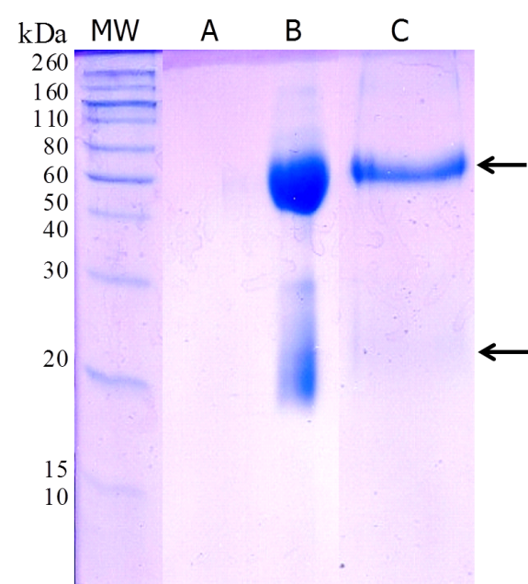
Fig. 4 A typical 15 % acrylamide SDS-PAGE gel showing the protein fragments obtained from antibody-functionalised AuNP-PEGCOOH. Lane A: A control lane of AuNP-PEGCOOH without antibody; Lane B: free anti-cocaine antibody; and Lane C: AuNP-PEGCOOH-antibody, each following treatment with SDS and mercaptoethanol. The lane with the molecular weight marker is labelled MW.

A typical SDS-PAGE gel from AuNP-Protein A/G-antibody yielded fragments which slightly differed from those of the AuNP-PEGCOOH shown in Fig 4. A band at ca. 50 kDa, corresponding to the MW of the heavy chain of the antibody, was present in the lane containing fragments from AuNP-Protein A/G. The band corresponding to the antibody light chain was absent (results not shown). This suggests that the heavy chain fragments had dissociated predominantly from the AuNP-Protein A/G-antibody rather than light chain fragments, indicating that the antibody had immobilised to Protein A/G via the FAb fragment rather than the Fc region as anticipated. Alternative antibody-Protein A/G binding has been previously reported by Clarizia et al., who showed that up to 50 % of Protein A/G interactions result in misalignment of the antibody.³⁴ An alternative possibility is that light chain fragments from antibody bound to Protein A/G via the Fc region were present, but not at concentrations sufficient for staining.

Overall, the SDS-PAGE gel results confirms the presence of antibody on the surface of the AuNP and provides evidence of functionalisation of the AuNP. However, the results for the AuNP-PEGCOOH and AuNP-Protein A/G functionalised nanoparticles were inconclusive regarding the orientation of the antibody on the AuNP surface. The antibody fragments obtained from the AuNP-PEGNH₂-antibody could not be visualised using an SDS-PAGE gel. It was thought that the concentration of bound antibody on the functionalised AuNP-PEGNH₂ was too low to yield any identifiable staining in the gels.

Visualisation of AuNP surface modification and size by agarose gel electrophoresis
AuNP modified by addition of proteins and ligands were separated on the basis of size using 0.2 % w/v agarose gels. This approach is based on that each successive addition to the cAuNP surface incrementally increases the size of the particle and thereby slowing its migration through the gel. Typical agarose gels are shown in Fig 5A, where the position of AuNP after the addition of protein or ligand corresponds to their predictably slowed migration through the gel; this enabled different stages of the functionalisation process to be separated. The characteristic burgundy colour of the AuNP, resulting from their surface plasmon absorption band, enabled visualisation of the bands without additional staining.
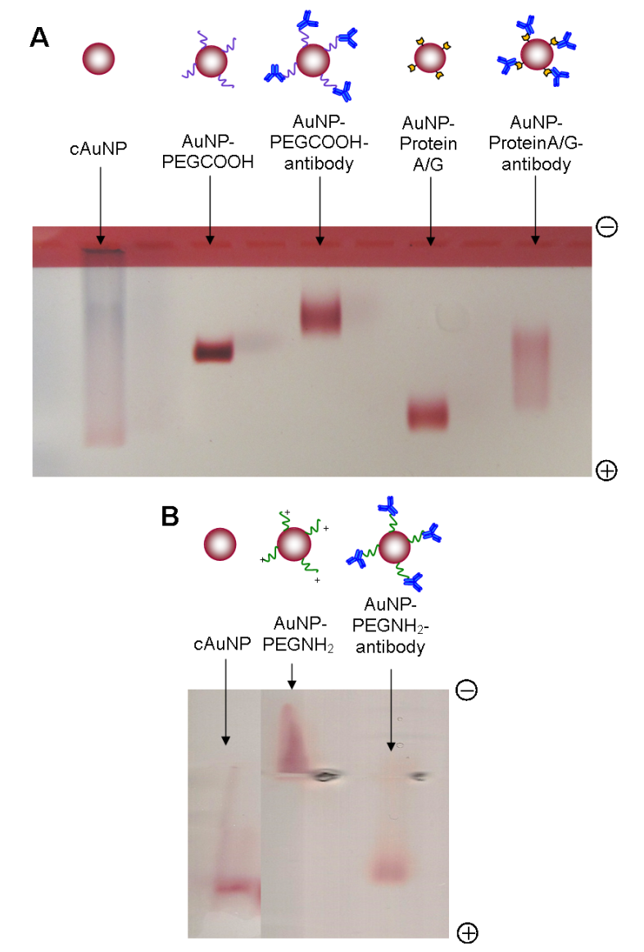
Fig. 5 True colour photographs of 0.2 % w/v agarose gels of cAuNP at each stage of the functionalisation process. (A) Shows the step-wise addition of PEGCOOH, modified Protein A/G and anti-cocaine antibody to the surface of AuNP; while (B) shows the addition of PEGNH₂ to cAuNP followed by anti-cocaine antibody.

AuNP-PEGNH₂ show somewhat different results since the positive charge of the amine functional group under alkaline conditions causes the particles to migrate towards the negative rather than the positive electrode in the gel. Addition of antibody to the AuNP-PEGNH₂ reverses the charge, since the overall net charge of the AuNP would be negative. Separation on the basis of charge of the AuNP-PEGNH₂ is illustrated in Fig 5B, where negatively charged cAuNP can be distinguished from positively charged AuNP-PEGNH₂ by the direction of migration (towards the positive and negative electrode, respectively). The positive charge of the PEGNH₂ on the AuNP was reversed by addition of antibody, causing the AuNP-PEGNH₂-antibody to shift to a migration towards the positive electrode. Separation of AuNP by agarose gel electrophoresis based on the successive addition of protein or ligand to the surface of the particles proved highly successful. It is apparent that the step-wise functionalisation of the AuNPs could be readily visually confirmed using this method.

Estimating the number of bound antibody per AuNP using enzyme-labelled antigen
Enzyme labelled antigen (cocaine-HRP) was used to simultaneously label and quantify the anti-cocaine antibody on the functionalised AuNP. The use of enzyme-labelled antigen over indirect antibody labelling (by way of secondary antibody) enables both detection of the antibody, as well as measuring the specificity and efficacy of antigen binding. In this study, cocaine-HRP was added to the antibody-functionalised AuNP, and the bound HRP detected via an enzyme substrate. Negative controls in the form of AuNP without antibody, in the case of AuNP-Protein A/G, or AuNP functionalised with BSA in place of antibody were used to distinguish any element of non-specific binding. A standard curve of cocaine-HRP at concentrations ranging from 10 - 75 nM was used to determine the amount of the labelled antigen bound to the AuNP. From this, the relative number of antibody per AuNP was estimated based on an assumed 1:1 ratio of bound cocaine-HRP:antibody.

The absorption spectra of the enzyme product obtained from antibody-functionalised AuNP treated with cocaine-HRP showed that the signal produced was significantly higher for the AuNP-PEGCOOH and AuNP-Protein A/G antibody complexes when compared with their respective negative controls. This highlighted the successful identification of antibody on the functionalised AuNP using the enzyme-labelled antigen. It also confirmed that specific binding of cocaine-HRP, as indicated by the absence of signal when no antibody was present on the AuNP. A signal was obtained from antibody-functionalised AuNP-PEGNH₂ which was considerably lower than those from the AuNP-PEGCOOH-antibody and AuNP-Protein A/G-antibody. This suggested that the concentrations of both the AuNP and the bound antibody were insufficient for this method of analysis.

The absorbance intensity, at 450 nm, and the number of antibody per particle for each type of functionalised AuNP are shown in Table 1. The highest number of antibodies per particle was achieved using the AuNP-Protein A/G method of functionalisation. The preferential binding of Protein A/G to the Fc region yields antibody positioned with the FAb region correctly oriented for optimal binding of the antigen. Conversely, binding by way of a -COOH functional group can occur via a number of available amine groups and therefore produces a variety of antibody orientations. The lower number of antibody per AuNP estimated for the AuNP-PEGCOOH-antibody as compared to the AuNP-Protein A/G-antibody could be the result of this random orientation, as antibody positioned without the FAb region exposed would not necessarily be detected. The low number of antibody per AuNP-PEGNH₂ fell outside the range of the cocaine-HRP standard curve for accurate quantification, indicating that insufficient signal was obtained with this type of functionalised AuNP. This latter result indicated that the AuNP-PEGNH₂ method of functionalisation was unsuitable for the production of AuNP for the detection of the cocaine antigen, and further analysis with this type of AuNP was therefore ceased. The AuNP-Protein A/G approach to antibody functionalisation yielded the highest antibody to AuNP ratio.

Table 1. The estimated number of antibody per AuNP, shown together with the concentrations of both the antibody and AuNP for each of the antibody functionalisation approaches used.

 | A₄₅₀ | [Antibody] / (nM) | [AuNP] (nM) | Antibody / AuNP
AuNP-PEGCOOH-antibody | 1.722 | 52.40 | 2.75 | 19.1
AuNP-ProteinA/G-antibody | 1.666 | 50.45 | 1.43 | 35.2
AuNP-PEGNH₂-antibody | 0.06 | 0.7 | 0.48 | 1.2

Determination of antigen binding efficacy using a microtiter plate-based immunoassay
The binding efficacy of the antibody-functionalised AuNP was estimated using a cocaine-BSA hapten immobilised onto a microtiter plate. The presence of functionalised AuNP bound to the immobilised cocaine-BSA was determined using a HRP-labelled secondary antibody targeted to the primary antibody on the surface of the AuNP. Addition of an enzyme substrate in the presence of AuNP-antibody was measured by absorbance intensity at 450 nm. Wells with BSA bound in place of cocaine-BSA were used as negative controls. Free anti-cocaine antibody was used as a positive control enabling signal amplification generated by the functionalised AuNP to be measured.

A typical set of results, expressed as the absorbance intensity of the enzyme product, are shown in Fig 6 for the application of free antibody, AuNP-Protein A/G-antibody and AuNP-PEGCOOH-antibody, respectively. The highest signal was obtained using antibody functionalised AuNP-Protein A/G applied to wells containing cocaine-BSA. This signal was greater than those of the free antibody and the antibody functionalised AuNP-PEGCOOH. The signal from the AuNP-PEGCOOH-antibody was lower than the free antibody, suggesting that AuNP functionalised using this approach does not yield an amplified signal. No non-specific binding was seen in the negative control wells, in which AuNP-Protein A/G-antibody were applied to wells with only BSA bound (Fig 6). Overall, the results indicate that the AuNP-Protein A/G-antibody were the most effective means of labelling cocaine on a solid surface, yielding a signal that was greater than that produced by the antibody alone.

Fig. 6 The absorbance intensity at 450 nm from HRP-labelled primary antibody, or anti-cocaine antibody-functionalised AuNP bound to cocaine-BSA immobilised onto a microtiter plate. The results obtained following the application of antibody, AuNP-Protein A/G-antibody, and AuNP-PEGCOOH-antibody are shown. A representative result obtained from a BSA control well is also shown. Each absorbance intensity value represents the mean ± SD of at least three measurements.

Conclusions
The aim of this study was to determine the optimum method for binding antibodies onto the surface of gold nanoparticles (AuNPs). While numerous approaches of nanoparticle functionalisation exist in the literature,^{11, 17, 18} it is not clear which method provides the maximal number and optimal orientation of the antibodies on the biofunctionalised particle surface. Here, detailed methods for the functionalisation and subsequent thorough characterisation of anti-cocaine antibody-functionalised AuNP have been described. Three methods of the antibody functionalisation of ca. 16 nm gold nanoparticles were based on the use of Protein A/G, PEGCOOH and PEGNH₂ as linkers between the antibody and gold nanoparticle surface. Of the three approaches of functionalisation of the AuNP, the PEGCOOH-based approach was the simplest to perform and yielded the most consistently stable antibody-functionalised AuNP. However, the cocaine-binding efficacy of the antibody-functionalised AuNP-PEGCOOH was significantly reduced due to the random, rather than oriented, binding of the anti-cocaine antibody to the PEGCOOH on the AuNP surface. The results of the investigation showed that the AuNP-PEGNH₂ based approach was the least effective method of functionalisation and yielded the lowest number of bound antibody per nanoparticle. In contrast, the antibody-functionalised AuNP-Protein A/G based method showed the highest level of cocaine-binding, likely due to the orientated nature of the bound antibody on the Protein A/G intermediate. Based on the extensive characterisation of each type of antibody functionalised AuNP, it was shown that the SPDP modified Protein A/G-based approach proved to be the most effective method of generating antibody-functionalised nanoparticles for the enhanced detection of cocaine. While the antibody-functionalised AuNP were synthesised for the detection of cocaine, the optimised Protein-A/G functionalisation technique presented here is independent of antibody type. Therefore, in the future, the use of the Protein-A/G intermediate could be applied to the development of any antibody-functionalised AuNP-based detection system.

Acknowledgements
The authors acknowledge the School of Chemistry, University of East Anglia for the financial studentship support for S.v.d.H. The Home Office Centre for Applied Science and Technology (CAST) are gratefully acknowledged for their financial support. The authors are grateful to Dr Colin McDonald (School of Chemistry, University of East Anglia, Norwich, UK) for assistance with the TEM images.

References
1. K. Omidfar, F. Khorsand and M. Darziani Azizi, Biosens. Bioelectron., 2013, 43, 336-347.
2. C. P. Jia, M. Y. Liu, Y. Y. Huang, X. H. Lou, S. H. Yao, Q. H. Jin, J. L. Zhao and J. Q. Xiang, Analyst, 2010, 135, 327-331.
3. Z. P. Li, Y. C. Wang, C. H. Liu and Y. K. Li, Anal. Chim. Acta, 2005, 551, 85-91.
4. M. H. Zareie, X. Xu and M. B. Cortie, Small, 2007, 3, 139-145.
5. R. Wilson, Chem. Soc. Rev., 2008, 37, 2028-2045.
6. W. J. Parak, R. A. Sperling, P. Rivera gil, F. Zhang and M. Zanella, Chem. Soc. Rev., 2008, 37, 1896-1908.
7. E. Boisselier and D. Astruc, Chem. Soc. Rev., 2009, 38, 1759-1782.
8. E. C. Dreaden, A. M. Alkilany, X. Huang, C. J. Murphy and M. A. El-Sayed, Chem. Soc. Rev., 2012, 41, 2740-2779.
9. S. Nagl, M. Schaeferling and O. S. Wolfbeis, Microchim. Acta, 2005, 151, 1-21.
10. J. Aveyard, P. Nolan and R. Wilson, Anal Chem, 2008, 80, 6001-6005.
11. R. Leggett, E. E. Lee-Smith, S. M. Jickells and D. A. Russell, Angew. Chem. Int. Ed., 2007, 46, 4100-4103.
12. P. Hazarika, S. M. Jickells, K. Wolff and D. A. Russell, Angew. Chem. Int. Ed., 2008, 47, 10167-10170.
13. P. Hazarika, S. M. Jickells, K. Wolff and D. A. Russell, Anal. Chem., 2010, 82, 9150-9154.
14. P. Hazarika and D. A. Russell, Angew. Chem. Int. Ed., 2012, 51, 3524-3531.
15. A. K. Trilling, J. Beekwilder and H. Zuilhof, Analyst, 2013, 138, 1619-1627.
16. M. Giersig and P. Mulvaney, Langmuir, 1993, 9, 3408-3413.
17. S. Puertas, M. Moros, R. Fernandez-Pacheco, M. R. Ibarra, V. Grazu and J. M. de la Fuente, J Phys. D Appl. Phys., 2010, 43.
18. M. D. Mason, W. Eck, G. Craig, A. Sigdel, G. Ritter, L. J. Old, L. Tang, M. F. Brennan and P. J. Allen, ACS Nano, 2008, 2, 2263-2272.
19. Z. Grabarek and J. Gergely, Anal. Biochem., 1990, 185, 131-135.
20. C. Cao and S. J. Sim, Biosens. Bioelectron., 2007, 22, 1874-1880.
21. X. Spindler, O. Hofstetter, A. M. McDonagh, C. Roux and C. Lennard, Chem. Commun., 2011, 47, 5602-5604.
22. M. Eliasson, A. Olsson, E. Palmcrantz, K. Wiberg, M. Inganäs, B. Guss, M. Lindberg and M. Uhlen, J. Biol. Chem., 1988, 263, 4323-4327.
23. S. Kumar, J. Aaron and K. Sokolov, Nat. Prot., 2008, 3, 314-320.
24. T. Niidome, K. Nakashima, H. Takahashi and Y. Niidome, Chem. Commun., 2004, 1978-1979.
25. M. Page and R. Thorpe, in The Protein Protocols Handbook, ed. J. M. Walker, Springer, 2nd ed. edn., 1996, pp. 721-722.
26. J. M. Walker, in The Protein Protocols Handbook, 3rd ed., ed. J. M. Walker, Springer, New York, 2009, pp. 177-185.
27. J. Turkevich, P. C. Stevenson and J. Hillier, Disc. Faraday Soc., 1951, 11, 55-75.
28. J. J. Storhoff, A. A. Lazarides, R. C. Mucic, C. A. Mirkin, R. L. Letsinger and G. C. Schatz, J. Am. Chem. Soc., 2000, 122, 4640-4650.
29. S. H. Won and S. J. Sim, Analyst, 2012, 137, 1241-1246.
30. T. Stuchbury, M. Shipton, R. Norris, J. Malthouse, K. Brocklehurst, J. Herbert and H. Suschitzky, Biochem. J., 1975, 151, 417-432.
31. J. Carlsson, H. Drevin and R. Axen, Biochem. J., 1978, 173, 723.
32. M. Hanauer, S. Pierrat, I. Zins, A. Lotz and C. Sonnichsen, Nano Lett, 2007, 7, 2881-2885.
33. G. R. Schonbaum and S. Lo, J. Biol. Chem., 1972, 247, 3353-3360.
34. L.-J. A. Clarizia, D. Sok, M. Wei, J. Mead, C. Barry and M. J. McDonald, Anal. Bioanal. Chem., 2009, 393, 1531-1538.

