Recent developments in micro- and nanofabrication techniques for the preparation of amorphous pharmaceutical dosage forms

Sheng Qi¹*, Duncan Craig²

- School of Pharmacy, University of East Anglia, Norwich, Norfolk, UK, NR4 7TJ
- UCL School of Pharmacy, 29-39 Brunswick Square, London, UK, WC1N 1AX

Correspondence: Sheng Qi,

Abstract
Nano- and microfabrication techniques have been widely explored in the textile, polymer and biomedical arenas, although more recently these systems have attracted considerable interest as drug delivery vehicles with concomitant considerations of physical characterization, scalability, stability and drug release. In this review, the current thinking with regards to the manufacture of solid amorphous pharmaceutical materials using electrohydrodynamic and gyration-based approaches, melt-spinning approaches, thermal moulding, inkjet printing and 3D printing will be examined in the context of their potential and actual viability as dosage forms. A series of practical examples will be discussed as to how these approaches have been used as means of producing drug delivery systems for a range of delivery systems and treatments.

Keywords: micro- and nano-fabrication, electrospinning, electrospraying, pressure gyration, thermal moudling, inkject printing, 3D extrusion-based printing

List of content
- Introduction
- Electrohydrodynamics for micro- and nano-structure fabrication
  - Basic working principles of electrospraying and electrospinning
  - Electrospraying
    - Application of electrospraying the preparation of amorphous pharmaceuticals
  - Electrospinning and melt electrospinning
    - Application in amorphous pharmaceutical preparation
  - Scale-up towards industrial applications
  - Current limitations and future perspectives
- Pressurized gyration and centrifugal approaches
- Spin coating for micro- and nano-film formation
  - Applications for the generation of amorphous pharmaceuticals
  - Current limitations and future potential of spin coating for pharmaceutical preparation
- Thermal injection molding for direct manufacturing of micro-structured pharmaceutical products
  - Basic processing associated with thermal injection moulding
  - Examples of pharmaceutical applications of the IM process
  - Limitations and industrial potential
- Printing technologies for micro- and nano-fabrication of amorphous pharmaceuticals
  - Inkjet printing
  - Current limitations to pharmaceutical inkjet printing
  - Extrusion-based 3-dimensional printing
  - Current limitations in pharmaceutical 3D printing
7. Conclusions and future outlook

- Introduction
Solid amorphous pharmaceuticals have a particular advantage in being able to provide rapid dissolution in comparison to crystalline materials, however they have the intrinsic disadvantage of physical instability, particularly for low molecular weight drugs [1]. A wide range of industrial processes can be used to produce amorphous solids, such as freeze drying, spray drying, hot melt extrusion, melt granulation and film casting. As with pharmaceutical products containing crystalline drug materials, the amorphous material may be compressed into conventional tablets or filled into capsules as dry powder/granule forms. Although amorphous forms of the active ingredient often address the dissolution difficulties of the crystalline form of the drug, the issue of patient adherence associated with physically taking such bulky solid dosage forms still remains. For example, recent research revealed that more than 55% patients from all age groups have difficulties swallowing such dosage forms [2]. There is therefore interest in exploring alternative approaches to dosage form design which overcome the issues of both the need for improved dissolution and practical dosage form viability, including the methodologies outlines in this review. However, any such approaches must be scalable in an industrial setting and, very preferably, be affordable for a global market, especially with a view to usage in countries where healthcare needs and economic flexibility are mismatched. The movement towards personalized or stratified medicine also requires flexible dosing tailored for individual patients [3], dosage forms that can in themselves be easily administrated to the patient [4], and advanced formulation innovations for maximizing therapeutic effectiveness and minimizing side-effects (particularly for potent and/or cytotoxic drugs) [5].

One family of approaches that is attracting considerable interest is the use of micro- or nanofabrication techniques in order to develop structured systems, either in terms of external shape and size or alternatively containing complex internal micro- or nanostructures, that may either be delivered in themselves or else be incorporated into more conventional dosage forms with enhanced performance characteristics. Such systems have demonstrated the potential to facilitate one or all the required improvements of a drug delivery system described above [6-8]. The recent FDA approved 3D printed levetiracetam tablets by Aprecia Pharmaceuticals for treating seizures is an excellent example. The 3D printed tablets have a highly porous internal environment, with the micron scale pore size providing a large surface area leading to ultra-rapid drug dissolution (within few seconds) and release after administration [9].

A key characteristic of many of these fabrication approaches (henceforth referred to as nanofabrication for simplicity) is that the products tend to be amorphous in nature, hence there is an alignment between the manufacture, the performance and the fundamental physical structure of these systems. It is this alignment that the current review will address. More specifically, the focus will be on outlining the basic approaches to scalable manufacture that are currently being explored with a particular focus on the amorphous characteristics of the associated materials, particularly by using case studies to demonstrate principles of structure-performance relationships. Indeed, every approach described here represents a very large area of study in their own right, hence it is necessary to be selective rather than inclusive in terms of the work cited. Nevertheless, an interesting development across all these field is the exploration of these methods as a means of producing amorphous dosage forms as opposed to scaffolds, inserts and other biomedical platforms. By examining the literature through the prism of the production of viable amorphous dosage forms, the viability of the different approaches and their possible future utilities takes on a new perspective.

The micro- and nanofabrication methods discussed in this review can be loosely divided into two categories based on their basic working principle of forming solid structures, these being either solvent evaporation-based or thermal melt and solidification-based methods. Solvent based electrohydrodynamic methods, electrospraying and electrospinning, spin coating, pressurized gyration and solvent based inkjet printing rely on the removal of solvents which are used to dissolve the carrier materials/excipients and drugs. In contrast to conventional pharmaceutical solvent evaporation based processes, such as film casting and spray drying, the formation of micro- and nano-structures using these methods mainly relies on the micro- and nano-scale dispensing volumes and an ultra-fast solvent evaporation rate. The thermal melt and solidification processes discussed in this review are melt electrospinning, thermal inkjet printing, extrusion based 3D printing, and thermal moulding. These methods are used for processing polymeric based drug delivery systems. As a result of the higher viscosity of a polymer melt in comparison to polymer solutions used in the solvent-based fabrication methods mentioned previously, the dimensions of materials produced by thermal based methods are usually in the micron rather than nano range. Nevertheless, these approaches have the concomitant advantage of the absence of solvent use and removal, while the requirements for nanoscale manufacture may vary according to the application. In all cases, consideration will also be given to the scalability of the approach in question as this is a key consideration for product development.
2. Electrohydrodynamics for micro- and nano-structure fabrication
Electrohydrodynamics refers to the dynamics of a fluid under an electrically charged field. There are two main electrohydrodynamic processing techniques, electrospraying and electrospinning [10]. Following Lord Rayleigh’s theoretical estimation on the limit of charge a liquid droplet could carry before forming a liquid jet in 1882 [11], John Zeleny first published experimental work in 1914 on electrospraying [12]. In the 1920s, Geoffrey Ingram Taylor described the formation of a liquid cone with convex sides and a round tip which had an angle of 98.6° when a threshold electrical voltage was applied to an electrically conductive liquid [13]. This was later named as Taylor’s cone in the field of electrohydrodynamic research. These two manufacturing processes work on same principle, but are distinguished by the physical form of the liquid when leaving the Taylor’s cone, more specifically droplets for electrospraying (leading to particles) and a continuous stream for electrospinning (leading to fibers), as shown in Figure 1.
The best-known and earliest application of electrospraying involves the ionization process that occurs in a mass spectrometer [14]. The adoption of both processes by the biomedical and pharmaceutical field is rather recent and is mainly associated with the ability of the techniques to fabricate micro- and nano-structures including particles, fibers and beaded fibers, which are of interest for both drug delivery and tissue engineering [15-17]. This review will only focus on their applications in amorphous drug delivery systems. The readers are directed to other comprehensive reviews on the applications of these techniques in other biomedical fields such as tissue engineering [15-17].
  - Basic working principles of electrospraying and electrospinning
The basic set-ups of electrospraying and electrospinning are very similar as shown in Figure 1. The sample liquid feeds into the nozzle at a constant rate. The nozzle is connected to a high voltage and the collector, which can be in a range of different physical shapes and forms, is normally connected to counterelectrode. The electric gradient draws the liquid jet to travel towards the collector and deposit on the collector. In the conventional situation, electrostatic charging of the fluid at the tip of the nozzle results in the formation of the well-known Taylor cone, from the apex of which a single fluid jet is ejected. For electrospinning, the liquid jet accelerates and thins in the electric field as it moves towards the collector, resulting in a rapidly whipping fluid jet. For electrospraying, the fluid jet breaks into small droplets and the liquid into disperses into fine droplets. Despite the close origins of both of electrospining and electrospraying, separate research communities have developed, studying how to control the processes independently, thus they are discussed separately in this review.
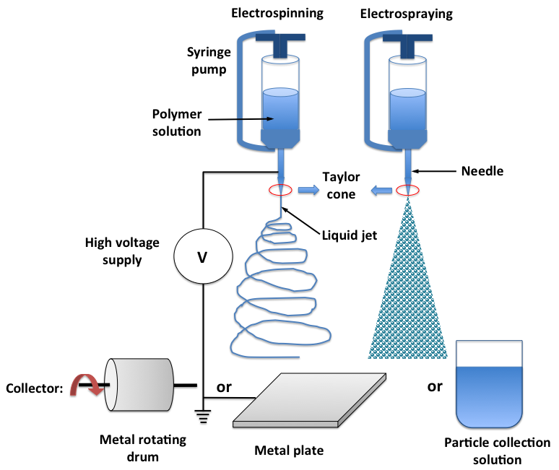
Figure 1. Schematic representations of the basic set-up of electrospinning and electrospraying instrumentation. Other modifications of the orientation of the feeding syringe, needle and the collector used are possible.
  - Electrospraying
For electrospraying, surface stresses overcome the surface tension of the liquid jet, deforming the liquid jet to form droplets. Electrodynamic forces (proportional to the electric fields induced by the charged nozzle and emitted droplets), gravity, liquid dynamic viscosity and inertia, and drag force (proportional to jet velocity and the viscosity of the gas surrounding the jet) are the key parameters governing the process [18]. A commonly used scaling relation has been developed to describe the interplay of these factors and their effect on the formation of droplets emitted from a Taylor cone-jet:
$d=α\frac{Q^{\text{aQ}}ε_{0}^{aε}ρ_{1}^{aρ}}{σ_{1}^{aσ}γ_{1}^{aγ}}$ Eq. 1
where d is droplet diameter, Q is volume flow rate, ε₀ is permittivity of free space, ρ_{l} is liquid density, σ_{l} is liquid surface tension, γ₁ is liquid bulk conductivity, and α is a coefficient depending on liquid permittivity [18].
    - Application of electrospraying the preparation of amorphous pharmaceuticals
The principles of electrospraying and the use of this method to encapsulate pharmaceutically relevant molecules has been reviewed by Bock et al [19]. As a result of the fast solvent evaporation rate associated with the electrospraying process, the fast drying may result in the formation of amorphous materials. Wang and co-worker reported the use of electrospraying to prepare hyper-quenched glassy materials which allowed them to study the fundamentals of micro-heterogeneities in amorphous organic materials [20]. In this study, the authors estimated equivalent quenching (caused by endothermic evaporation effects) rates of approximately 10⁵ K/s which is much faster than conventional quenching using liquid nitrogen (around 120K/s). Significant exothermic relaxation, well below the glass transition (0.75T_{g}), was observed in these hyperquenched amorphous materials. This phenomenon has been observed previously in multicomponent mineral and metallic glasses, but not in organic materials prepared using conventional melt-cool or solvent evaporation methods. Maija Nyström and co-workers prepared amorphous indomethacin, piroxicam and budesonide using electrospraying under atmospheric and reduced pressure, the latter in order to improve the drying process [21]. It was found that each of the drugs formed powders with particle size between 1–5 micrometers. The authors reported that for chloroform solutions, electrospraying under reduced pressure led to formation of notably more stable amorphous drug particles than electrospraying under atmospheric pressure. This improved stability of the amorphous drugs produced via use of reduced pressure was not observed when ethanol was used as the solvent. This solvent dependent effect of the stability of the result amorphous material was attributed to the faster evaporation rate of chloroform in comparison to ethanol. Electrosprayed budesonide showed lower crystallinity (64%) in comparison to indomethacin (79%). However in the literature other solvent evaporation methods such as spray drying have been reported to be unable to produce amorphous indomethacin and forms II and I were rapidly formed shortly after spray drying [22]. This is likely to be attributable to the much faster solvent evaporation that occurs during the electrospraying process. Using indomethacin as an example, a large body of literature is available comparing the stability of amorphous drug prepared by melt-cool and solvent evaporation based methods [23-25]. For example, Karmwar and co-workers reported the increased physical stability of amorphous indomethacin as a function of cooling rate when prepared by the melting-cool method [24]. Furthermore, the physical stability of amorphous indomethacin also can be affected by the preparation method used. It was found that the physical stability and crystallization tendency of the amorphous drug has direct correlation with the relaxation time of the amorphous form obtained. Depending on the method of preparation this relaxation time is in the ranking order of being quench cooled amorphous samples>cryo-milled (α-form)>spray dried>ball milled (α-form) [25].
Amorphous solid dispersions have also been prepared by electrospraying. Ronie and co-workers reported the incorporation of griseofuvin in enteric polymers [26]. The authors presented physicochemical evidence of griseofuvin being amorphous and the delivery system being a disordered solid dispersion. This led to the enhanced uptake of griseofulvin using an in vitro Caco-2/HT29 model. Similarly, Zhang and co-worker also reported the conversion of griseofulvin into the amorphous state via electrosprayed core-shell microparticles to achieve enhanced in vitro and in vivo performance [27]. The fully amorphous state of solid dispersions of indomethacin in inulin acetate microparticles was also achieved by electrospraying which only release drug under colonic conditions [28]. Li and co-worker reported the fully amorphous state of the microparticles with core-shell microstructures loaded with quercetin. The microparticles were fabricated using a coaxial electrospray (using a double layered nozzle to allow the feed of solution for forming core and shell of the particles) and attributed the formation of the stable amorphous state to the interaction of active ingredient and excipients [29]. The effect of miscibility of drug and excipients on the stability and yield of amorphous dispersion particles prepared by electrospraying was discussed by Kawakami [30]. Different phase separation and transformation behavior of the model drugs (carbamazepine, prednisolone) were observed. Carbamazepine showed rapid and complete phase separation and crystallization behavior when the drug loading was above the miscibility limit in PVP (40%); whereas prednisolone showed progressive amorphous-amorphous phase separation which remained relatively stable under ambient conditions. For the case of solid dispersions of carbamazepine and PVP, other studies using conventional solvent evaporation methods also showed the preservation of amorphous state of carbamazepine with good physical stability under the miscibility limit [31], hence in this case no clear advantage of forming stable amorphous has been demonstrated using electrospraying.
In contrast to the above drugs with a relatively stable amorphous state, Kawakami and co-workers challenged the ability of using electrospraying process to prepare amorphous material by using a model drug with high instability in its amorphous state, fenofibrate [32]. The authors found that post coaxial electrospraying, fenofibrate was present in the core of dispersion particles and 58% of the drug was in the crystalline state. However with an additional annealing process after electrospraying at 100°C for 30s, the authors confirmed the transformation of the remaining 58% crystalline fenofibrate into its amorphous state, which subsequently significantly improved the dissolution, and oral bioavailability of the drug. This is an interesting approach to induce the solid phase transformation. Using a similar principle, electrospraying has shown its unique potential for the preparation of nanocrystals as a future continuous pharmaceutical manufacturing process. As reported by Wang and co-workers, electrosprayed carbamazepine nanoparticles were predominantly amorphous immediately after electrospraying [33]. Second stage thermal annealing at 90°C allowed the full transformation of amorphous carbamazepine to its most stable form, form III. As a result of the small particle size, these electrosprayed carbamazepine nanocrystals showed significantly increased apparent solubility and dissolution rate in comparison to unprocessed crystalline carbamazepine powder. Recently, electrospraying was also used for the preparation of combination therapy formulations. Sakuma and co-workers reported that using electrospraying to co-encapsulate amorphous lopinavir and ritonavir into microparticles with an enteric polymer shell led to a synergistic boosting effect of the oral absorption of both drugs [34].
Although the rapid solvent evaporation of the process may seem have physical effects (such as quenching) on certain amorphous systems discussed above, there is no clear evidence from the existing literature to demonstrate that electrohydrodynamic processes can provide superior long-term physical stability over other conventional solvent evaporation based processing methods. However, it is an alternative method for producing micro and nanoparticles with the capacity of producing systems with microstructures such as core-shell and multiple layers via using co-axial or multi-axial electrospraying. This type of microstructure is somewhat difficult to obtain using other, more conventional solvent evaporation methods.
2.3 Electrospinning and melt electrospinning
Electrospinning involves the generation of fibrous materials via the generation of a continuous jet of fluid under the influence of a high voltage electric field. As with electrospraying, the physics behind electrospinning is complex and there are a number of processing challenges that need to be overcome [35], include the spinnability of the polymer in question and the propensity of the system to form beads. Electrostatic repulsion leads to the overcoming of the surface tension of the fluid to be spun and deformation of the droplet at the tip of the nozzle into a Taylor cone. When a strong enough voltage is applied to the nozzle, a liquid jet forms and the electric force drives the jet towards a collector connected to the counterelectrode. After the formation of the jet, there are two stages of the process before the fibers deposit on the collector, the steady stage and the chaotic movement stage. Several models have been reported in the literature to describe the steady-stage which is an interplay of the jet diameter, velocity, surface charge density, current, and electric field [36, 37]. These models indicate that the jet diameter is highly surface charge density and local electric field dependent. The rapid movement of charges to the surface of the jet after it leaves the nozzle reduces the diameter of the liquid jet. A scaling relation has been developed to describe the steady-state diameter of the jet in relation to operating parameters [35]:
$d=(\frac{Q^{3}ρ}{2π^{2}E_{∞}I})^{\frac{1}{4}}z^{−\frac{1}{4}}$ Eq. 2
where d is jet diameter, Q is flow rate, ρ is fluid density, E∞ is applied field strength, and z is axial coordinate. Therefore by adjusting these parameters, the fiber diameter can be controlled. As an example, with low flow rates, low fluid viscosities, and high applied electric field strengths, one should expect the formation of fibers with small diameters.
Solution-free melt electrospinning is also a process which offers easier control of the fiber generation with reduced chaotic movement of the fibers. This leads to higher flexibility in directing the pattern formation of the fibers, but with the compromise of a thicker fiber diameter in comparison to solution electrospinning. Readers are directed to existing comprehensive reviews on melt electrospinning [38,39].
2.3.1 Application in amorphous pharmaceutical preparation
The main application of electrospinning in amorphous formulation preparation has been heavily focused on the advantage it can provide through rapid dissolution due to the amorphous nature and large surface area of the materials which can particularly benefit poorly soluble drugs [40-43]. In late 90s and early 2000s, there was a surge of filed patents of using electrospinning for the preparation of pharmaceuticals [44,45]. In the early 2000s, Verreck and co-worker reported the use of electrospinning for formulating itraconazole in both oral and transdermal formulations [46,47]. In both cases, itraconazole was found to be in incorporated in the amorphous state in the fibers which provided rapid dissolution of the drug. The release rates were found to be drug-polymer ratio and fiber diameter dependent. Recently, the effectiveness of electrospinning as a process for enhancing the delivery of poorly soluble drugs was assessed by Soti and co-workers by comparing the in vitro performance of electrospun formulations with those prepared by other solvent evaporation methods, such as spray drying [48]. The authors highlighted that the storage stability of the formulations produced by fast solvent evaporation methods including electrospinning showed much better preservation of the long-term stability of the amorphous state of the API in comparison to spray drying which had much slower drying speed. This study demonstrated the practical advantage of electrospinning on longer kinetics physical stability for the preparation of amorphous materials over conventional solvent based manufacturing methods used in the industry. However the mechanism associated with this improvement in stability is not yet clearly understood.
In comparison to other melt-cool based processes, melt electrospinning offers the additional advantage of high surface area to volume ratio which can contribute to accelerated drug release rate from a dispersion based formulation. Nagy and co-workers have reported the use of melt electrospinning to prepared fast-releasing carvedilol-Eudragit E amorphous solid dispersions [49]. The study compared the same dispersions prepared by hot melt extrusion, solution electrospinning and melt electrospinning. All dispersions were confirmed being amorphous. However, electrospun formulations showed faster release rate than the melt extrudates which was contributed to the high surface area of the electrospun the samples. No significant difference was reported between melt electrospinning and solution electrospinning. In comparison to amorphous dispersions containing organic compounds, as is the case with most drug formulations, electrospun polymer dispersions containing inorganic materials such as nutraceutical salts have been recently reported to yield nanocrystals of the salts in the polymer fibers, as shown in Figure 2 [50]. This may be associated with poor miscibility between inorganic salts and water-soluble polymers such as PEG and PVP and the changes of conductivity of the electrospinning solution caused by adding the salt.
The rapid elongation process during electrospinning may have a profound effect on the orientation of molecules, in particular polymers, and many amorphous dispersions systems contains polymers as excipients and have a key function of stabilizing amorphous drugs. Long chain molecules have a high level of degrees of freedom to deformation, thus easily extended along the fiber axes (which applies to both crystalline and amorphous polymer materials). These orientation effects during the fiber formation can modify the mechanical, thermal, optical and many other properties of the processed material. As an example, stretching poly (vinylidene fluoride) films can lead to the formation of novel types of crystal modifications [51]. This effect has been seen in electrospun PEG nanofibers. With a high order of alignment of the polymer chains, further mechanical stress applied by stretching can lead to the changes in the changes of polymer orientation which was evident by PXRD results shown in Figure 2 [50].
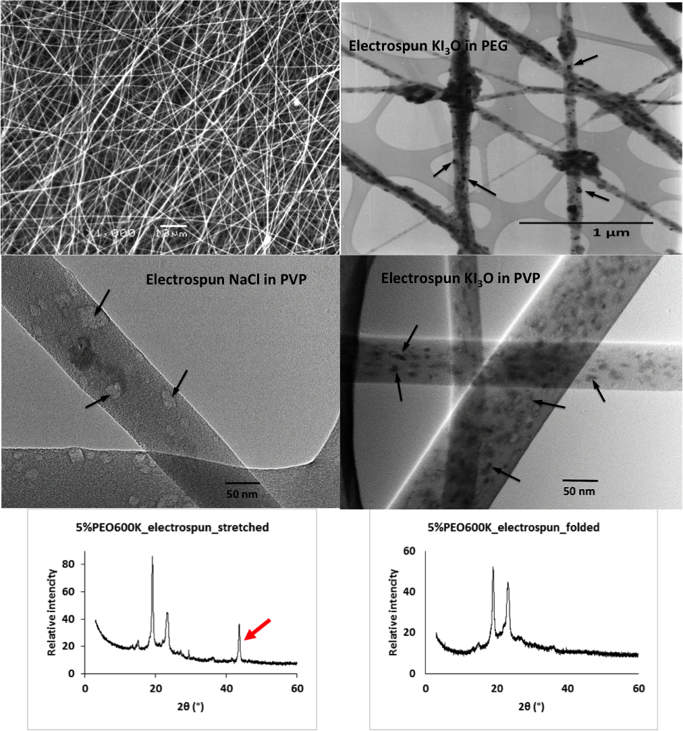
Figure 2. Electrospun polymeric solid dispersions (top right); TEM images of electrospun water-soluble polymer based nanofibers containing inorganic salt nanocrystals (as indicated by arrows in the images); PXRD patterns of electrospun PEG fibers being stretched and without mechanical stretching indicating the changes introduced by the mechanical stress to the molecular orientation of the polymers. Reproduced from reference [50].
  - Scale-up towards industrial applications
One of the main disadvantages of electrospinning and electrospraying is the low yield, which typically is in the region of mg/hour. Indeed, scale up of electrohydrodynamic processes is still a work in progress. In the 1990s, linear arrays of Taylor cones on capillary electrode tubes was reported as an early stage proof-of-concept for scale-up production of electrospraying [52]. This concept was further developed to replace capillaries with orifices for dispensing liquids [53]. Multiplexed electrospray has been researched in the past 10-15 years as a new way to increase the throughput of electrospraying process [53,54]. This involves the assembly of an array of micronozzles, thereby increasing throughout while retaining an efficient size platform from which manufacture takes place. For example, Deng et al [54] microfabricated multiplexed distributors in silicon using deep reactive ion etch (DRIE) of silicon wafers. The authors developed an array of uniform nozzles which could be interspaced at distances in the region of 1mm apart, each nozzle having a protrusion distance in the region of 150 to 450 µm, an outer diameter ranging from 180 to 240 µm and an inner diameter of 120 µm. The authors used this system to produce uniform particles, using a nozzle density of 250 nozzles/cm².
Given the combined interests of the pharmaceutical, biomedical and textile industries, the scale up of electrospinning has been fast moving. Many potential approaches have been proposed in the literature and various needleless electrospinning methods including the uses of different designs of rotating and stationary spinnerets have been shown to have advantages in terms of scale-up production in comparison to traditional needle-like nozzle electrospinning [55,56]. As an example, Figure 3 shows the design of the rotating cylinder spinneret which have already been commercialised and are currently available for high throughput production. For example, the industrial-scale apparatus by Inovenso Ltd. and the free-surface Nanospider system by Elmarco are shown in Figure 3. Academic research on scale-up of electrospun pharmaceutical products is also available [56,57]. Krogstad and co-worker evaluated the scalability of tenofovir loaded PVA fiber mats for vaginal drug delivery using free-surface electrospinning [58]. The scale-up batch processing reported by the authors did not compromise the high loading of drug (up to 60%). Brettmann and co-workers used free-surface electrospinning to produce dispersions of crystalline drugs in water-soluble poly(vinyl pyrrolidone) fibers [59]. Despite remaining as a crystalline form, the dissolution rates of compressed tablets made from electrospun fibers were significantly increased in comparison to those made from the crystalline starting material. This was attributed to the significant drug particle size reduction. The authors identified that free-surface electrospinning has great potential as a continuous process for producing powder-free solid dosage forms containing crystalline as well as amorphous drugs.
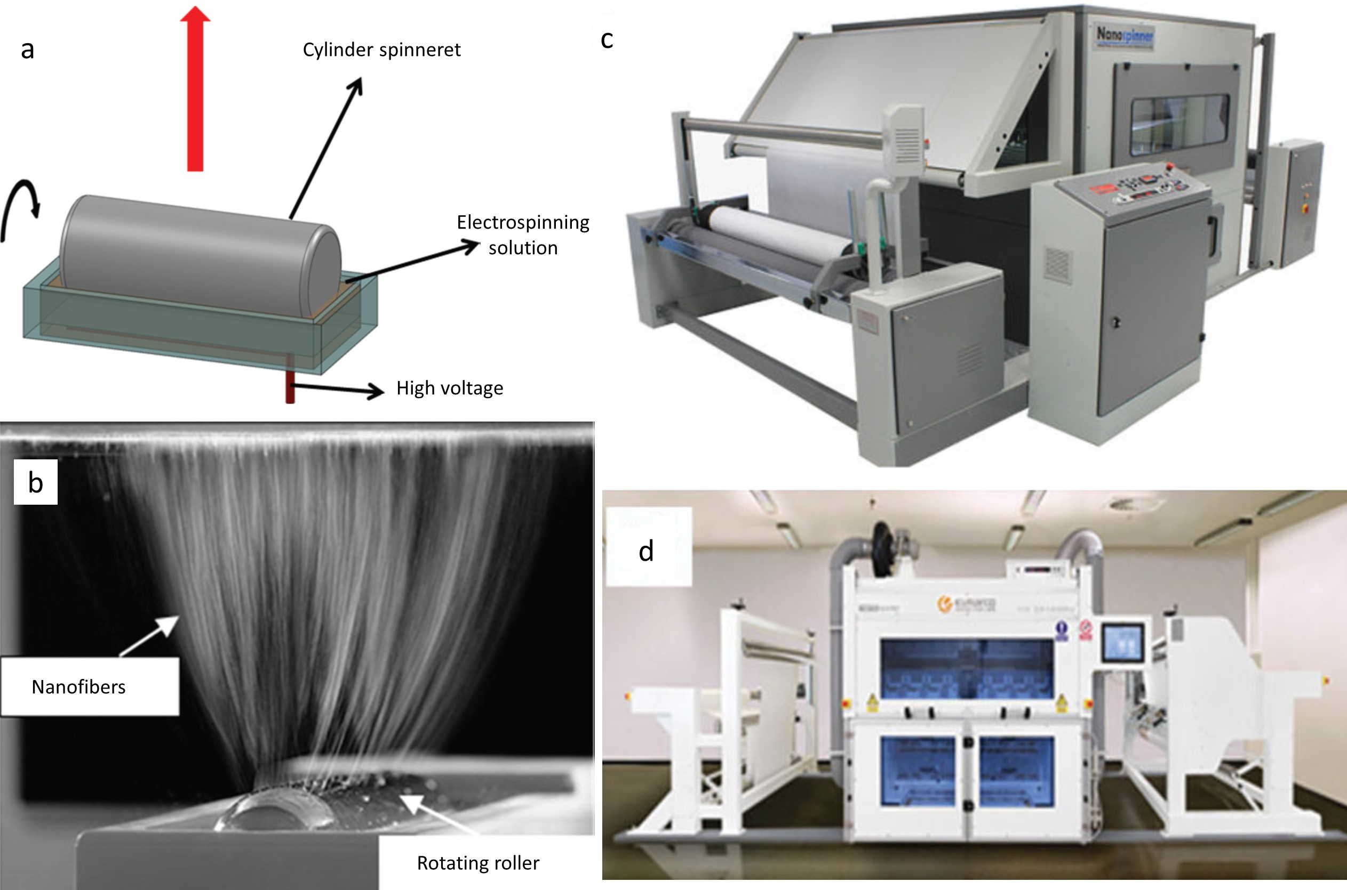
Figure 3. a) Illustration of the working principle of electrospinning using a needleless rotating cylinder spinneret and b) cylinder spinneret in action. Reproduced from reference [56]; c) Industrial-scale electrospinning system, Nanospinner416 produced by Inovenso Ltd. (d) Industrial-scale, free-surface electrospinning system, Nanospider produced by Elmarco. Reproduced from reference [57].
  - Current limitations and future perspectives
Electrospinning and eletrospraying have been increasingly recognized as a new way to produce amorphous pharmaceutical solids with the unique features of rapid dissolution and high flexibility of formulation configuration, which can be used to provide flexible dosing, and the design of combination therapy. Although scaled-up production using these electrohydrodynamic techniques is not fully mature, the progress that has been made is extremely encouraging. As a result of the micron to nano-scale nature of the solid structures produced by these methods, the understanding of the effects of such nano- and microstructures on the physical stability and the production of amorphous material is still not fully resolved. For example Tipduangta and co-workers reported different phase separation behaviour of polymer blends processed using conventional film casting and electrospinning. The significance of such phase and solid transformation behaviour has been recognized and demonstrated by some existing fundamental amorphous studies, such as Wang’s work mentioned previously on the significant relaxation behavior of amorphous organic material produced by electrospraying below the T_{g} in comparison to melt-quenched materials [20].
- Pressurized gyration and centrifugal approaches
A parallel approach to nanofiber (and indeed particle) formation via electrohydrodynamics is the use of the centrifugal force as the driver for conversion from the solution or melt to solid amorphous structures. Recent interest has focused on pressurized gyration, whereby a pressurized solution is spun rapidly and extruded through a series of orifices; the solvent evaporates to leave a solid fiber which is collected around the periphery of the apparatus [60]. The system is described in more detail below, but the interest has been generated on the basis of the possibility of producing amorphous nanofibers at a scale commensurate with commercial production. This has then opened up the possibility of using this approach to manufacture solid dispersions for oral administration as well as a range of other applications such as drug loaded textiles. We also briefly outline very recent developments in using centrifugal approaches for spinning melt systems, again for oral solid dispersion production.
The pressurized gyration apparatus has been described in detail previously [55,60-62] and comprises a cylindrical aluminium vessel into which a series of orifices are drilled around the horizontal circumference (Figure 4a). These orifices are 0.5mm in diameter, although it is perfectly possible to prepare drums with varying orifice diameter and spacing. The rotation speed (typically up to 36,000rpm) may be controlled, as may the pressure under which spinning takes place via the gas inlet at the top of the vessel, with pressure up to 0.3MPa typically used. The mechanism of fiber formation is associated with the Rayleigh-Taylor theory of jet instability, whereby the interface between the liquid and air (which is considered as a second liquid for these purposes) is considered to become unstable as the two fluids of differing densities exert force on each other as the liquid is jettisoned from the drum. As the liquid is extruded, the system may initially be considered to be a droplet. However, Marangoni stress (force at an interface between fluids due to a surface tension gradient) is generated, resulting in flow at the tip of the droplet. The polymer jet further stretches while rapid solvent evaporation allows thinning and drying into the nanofibrous structure. The manufacturing process and product properties are determined by the solution properties such as viscosity, surface tension, polymer molecular weight, concentration, processing parameters and environmental parameters. A detailed study of the relationship between solution properties and fiber formation has been outlined in [62].
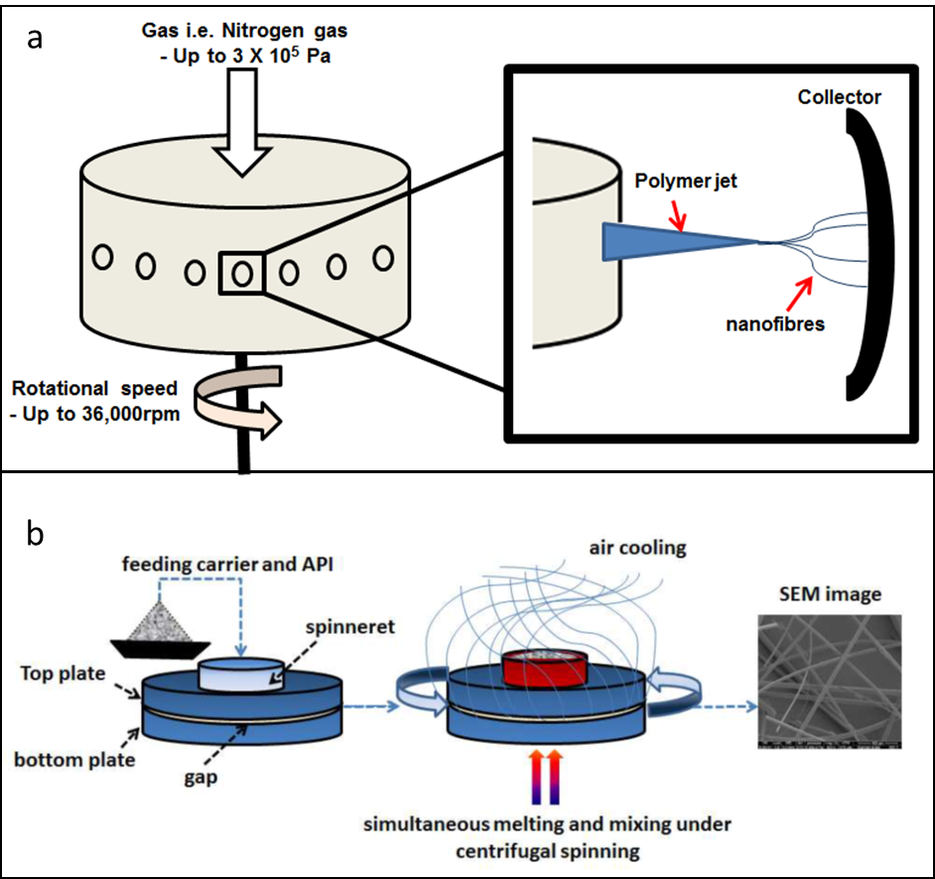
Figure 4. a) Schematic of the pressurised gyration system, showing the perforated chamber and (inset) the ejection of the polymer jet and associated nanofiber formation. Reproduced from Reference [61]; b) Schematic representation of the centrifugal spinning apparatus and individual process steps in the preparation of drug-loaded microfibers. Reproduced from Reference [67].
Early studies on the pharmaceutical applications of this approach include an investigation by Raimi-Abraham et al [60] whereby the spinning properties of (unloaded) polyvinyl pyrrolidone (PVP) were explored. This polymer is widely used within the pharmaceutical arena as a binder and general excipient, but is also widely used as a matrix for solid dispersions. The possibility of using pressurized gyration for solid disperse nanofibers is of obvious interest due to the possibility of scalable production, hence it was essential to establish the basic spinning behavior and fiber characteristics for the polymer. In the study, the authors demonstrated that fibers with a diameter in the region of 470-970nm could indeed be generated using aqueous solvents. Interestingly, the authors also addressed the issue of how the glass transition properties of such materials may be assessed, particularly in the context of most fabrication techniques only producing a small amount of material which in turn may render conventional thermal approaches problematic. The authors used the technique of Transition Temperature Microcopy [63], which allows thermal assessment of softening point to be made across a two dimensional grid via a thermistor interfaced with an AFM. This allowed the glass transition of individual fibers to be assessed, as outlined in Figure 5.
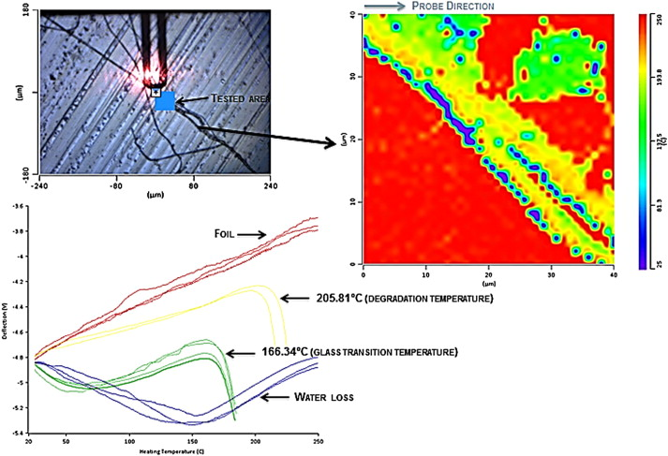
Figure 5. Apparatus and data for Transition Temperature Microscopy conducted on K90F 30% fibers. The top left image is a top-down photograph of the nano-thermal probe showing the tested area. The red halo seen on the probe is from the laser which is used to measure the probe deflection. The image on the right is a thermal map generated from the experiment. The bottom left image shows the nano-TA profiles corresponding to transitions observed in the thermal map. Reproduced from reference [60].
These studies were then extended to examine the incorporation of model drugs on the structure and performance of the fibers [61]. Incorporation of ibuprofen was shown to slightly increase the fiber diameter (which in this case was in the low micron range) but was also shown to produce a molecular dispersion, as evidences using XRD and MTDSC. It was also noted that the dissolution of the drug from the fibers was not only extremely rapid but also showed clear evidence for supersaturation when measured under non-sink conditions. While bioavailability studies have not yet been conducted, the implication from these investigations is that there is a very reasonable possibility of significant improvement in oral bioavailability using the nanofiber approach, both from the point of view of the large surface area leading to rapid dissolution but also the possibility of supersaturation increasing the concentration gradient across the absorptive membrane.
An offshoot from the study of generating protein-loaded fibers has been the generation of microbubbles using a single step process [64], which is in itself of interest within the biomedical bubble technology field due to the need for a simple and rapid generation process for immediate use as, for example, echogenic contrast materials for ultrasound. Mixtures of lysozyme with polyvinyl alcohol were found to form fibers at low protein concentrations but, surprisingly, the gyration process produced bubbles at specific protein loadings. These were subsequently coated with gold nanoparticles to enhance stability and to facilitate UV tuning. While a side issue from the intention of using pressure gyration as a means of presenting pharmaceutical proteins and biologicals in a readily miscible amorphous form, it nevertheless demonstrates that the process may lead to structures and phenomena that may be unexpected and difficult to predict. Subsequent work has demonstrated that this appears to be a general phenomenon (or at least is observed with numerous proteins) and hence work is ongoing to explore pressurized gyration as a means of bubble generation for therapeutic applications.
Studies have also taken place on exploring the use of pressurized gyration for the generation of bioadhesive fibers, particularly for vaginal application. Brako et al [65] examined the spinning properties of polyethylene oxide, sodium carboxymethylcellulose, polaycraylic acid and sodium alginate, finding that pressurized gyration was able to produce fibers with diameters as low as 100nm. In addition, the authors developed an indicative test for bioadhesion of nanofibers using texture analysis and atomic force microscopy.
Finally, there are also methods associated with centrifugal fiber formation which rely on spinning melt systems. Centrifugal spinning involves the use of a rotating spinning head (typically 2000-13000 rpm) into which the material is placed at elevated temperatures. The head contains either orifices or a gap between two plates through which the molten material may escape. The molten liquid experiences stretching due to air friction followed by rapid solidification leading to fiber formation in the micro- or nanometer size range [66]. The method is widely used within the glass fiber and confectionary industries. More recently, interest has increased in using this approach for pharmaceuticals, not least because the time scales in which the material is in the molten state is quite limited, thereby reducing the risk of thermal degradation. A recent study by Marano et al [67] has examined the potential of using a centrifugal spinning device (a schematic is shown in Figure 4b) to incorporate drugs (olanzapine and piroxicam) into sucrose for enhanced oral bioavailability via the formation of an amorphous solid dispersion. The authors demonstrated that the fibers were fully amorphous and showed marked dissolution improvements compared to the equivalent crystalline drug samples.
4. Spin coating for micro- and nano-film formation
Spin coating is a process that prepares a thin film with controllable thickness on a substrate. It has been widely used for microfabrication in the semiconductor industry [68]. Spin coating is similar to film casting, but differs in that film casting involves solvent evaporation under ambient conditions or low vacuum. In spin coating, solvent evaporation occurs at a rapid speed due to the fast spinning of the coated object (Figure 6). The main step in the spin coating procedure is the deposition of the liquid onto a fast rotating substrate which is fixed on top of the chuck in the spin coater via an applied vacuum underneath. Often additional post-coating heating treatment can be applied to ensure complete solvent removal and solidification of the film. The deposited liquid rapidly spreads due to the centrifugal force to form a thin film which the thickness between micron to few nanometers depending on the film-forming material used. The fluid viscous forces dominate the thinning behavior during the spreading of the solution, with solvent evaporation dominating the coating thinning behavior during the drying stage. Solvent molecules have to diffuse to the surface prior to evaporation during drying. The mismatch of the diffusion rate and evaporation rate of the solvent often during spinning and spreading causes slight compositional changes in the film during drying. These compositional changes can lead to the fluctuation of changes in the surface tension and lateral motions of the drying fluid which results roughness of the spin-coated film. [69].
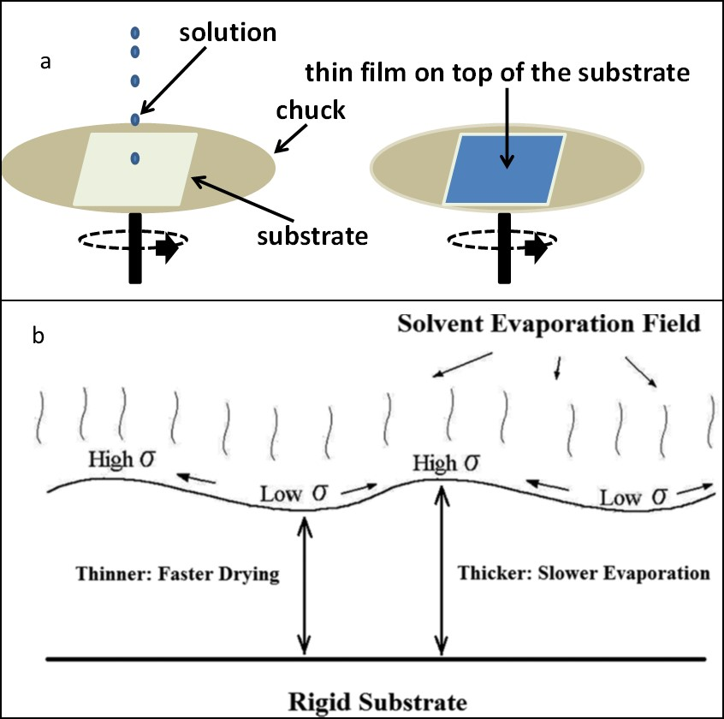
Figure 6. a) Illustration of spin coating process; b) schematic diagram of solvent evaporation during coat formation. Reproduced from reference [69].
4.1 Applications for the generation of amorphous pharmaceuticals
The biomedical applications of spin coating as a micron and nanofabrication method has been increasing, but are still limited in comparison to the electrohydrodynamic processes mentioned above. With the advantages of high reproducibility, quick preparation and precise control during manufacture, spin coating has been used to prepare amorphous drugs and solid dispersions for understanding fundamental behaviour such as physical stability [70-73]. By using spin coating to prepare solid dispersions containing model drugs, Ng et al [70] prepared a series of amorphous solid dispersions containing different model drugs including celecoxib, felodipine, fenofibrate and carbamazepine and polymers with different hygroscopicity. The authors reported that key factors which affect the physical stability of solid dispersions under stressed humidity were the physical stability of drugs and the hygroscopicity of polymers. In another study from the same group, drug migration of felodipine from the bulk towards the surface in the spin coated felodipine-PVP K29/32 thin films was discovered when the spin coated solid dispersion films were aged upon exposure to stressed humidity [71]. The literature highlighted above demonstrated that spin coating is an effective diagnostic tool for the pre-formulation stage of solid dispersion research alongside gaining insight into the fundamental principles associated with their physical stability
The physical stability of amorphous drugs alone has been studied in various aspects including the effect of storage conditions on relaxation time, recrystallisation tendency and rates in bulk and at surfaces of different amorphous drugs [74,75]. For example amorphous nifedipine and indomethacin have showed significantly faster recrystallisation rates at the surface than that of the bulk [76]. Taylor et al used quench cooling and spin coating to prepare a variety of amorphous drugs, and classified them into three groups based on their recrystallisation tendency [72,75]. In Taylor et al’s studies, useful information concerning the “glass forming ability” and “glass stability” of amorphous drugs were provided and it was concluded that drugs with high glass forming ability were normally more physically stable (aged under ambient conditions) than drugs with low glass forming ability. However, the crystallisation tendency of amorphous drugs prepared by melt-cool and spin coating in these studies was not completely the same and only around 68% of cases showed the same trend [72]. This may suggest that the physical stability of amorphous drugs can vary depending on the preparation method. Yang and co-worker used the spin-coating method to prepare drug-polymer solid dispersions and compared the stability of such systems with those prepared by hot melt extrusion [77]. The authors reported better kinetic stability of the amorphous dispersions prepared by spin coating in comparison to the same dispersions prepared by hot melt extrusion. As the films are of sub-micron (tens to hundreds nanometers thick) thickness, the formation of the nuclei should not be restricted, thus the better kinetic stability was attributed to the rapid solvent evaporation rate of the spin coating process that could be translated into an equivalent quenching effect. This again agrees well with other research on the effect of different processing on the physical stability of amorphous materials with faster quenching leading to higher kinetic stability.
Although spin coating is not an ideal production method for large scale manufacturing of solid dispersions used in formulations for oral delivery, the adaptation of spin coating to coat medical devices for drug delivery purposes has been reported with increasing frequency. For example, Ponnusamy and co-workers reported the use of spin coating to produce a porous double-layer controlled release coating of PLGA and antifibrotics (mitomycin C and 5-fluorouracil) onto glaucoma drainage devices to reduce fibrosis during the wound-healing period [78,79]. Although the solid-state physicochemical characterization data of the drug-polymer coatings was not provided, the release data is indicative of the formation of molecular dispersions of both water soluble and poorly soluble drug with the polymer. The favourable in vivo effectiveness of the spin-coated devices used in percutaneous coronary intervention (PCI) was verified recently using a rabbit model [80]. Scott and co-workers reported the potential of spin-coating for providing fast-dissolving drug-polymer film deposition on balloon catheters during PCI for reducing restenosis [81]. The polymer films were composed of active ingredient (a mimic of the proteoglycan decorin, also called DS-SILY), poly(vinyl alcohol) (PVA) and poly(ethylene glycol) (PEG). Although solid state characterization data was not provided, the film rapidly dissolved into nanometer size fragments within 2 minutes indicating the phase separation of water-soluble PEG and PVA in the films. The fast release DS-SILY also implies the possible formation amorphous drug-polymer dispersion. A similar application using PCI was also reported by Karagkiozaki and co-worker. However, instead of coating balloon catheters for the implantation of stents, the authors used the biodegradable polymer, PLGA, to incorporate the antiplatelet drug dipyridamole, which is weakly basic with a low solubility at blood plasma pH, and coat the stents [82]. The drug release from the coating occurred over 70 days and the systems were shown to inhibit platelet aggregation.
4.2 Current limitations and future potential of spin coating for pharmaceutical preparation
As spin coating is a mature thin-film deposition technique within the fields of silicon processing and the semi-conductor industries, scale up of the technique for coating of pharmaceutical and biomedical devices and delivery systems should be reasonably easy in terms of instrumentation, but still not feasible for large scale production of large quantities of solid dispersions formulations such as those used for oral drug delivery. However, one of the most significant issues associated with spin coating is the drug solution waste produced during the spinning stage of the process which reduces the accuracy of the amount of active ingredient deposited in the film formed. This may be overcome by precise preformulation and processing development to design the liquid feed with the appropriate viscosity combined with the suitable number of feeding droplets applied during each film formation to minimize waste and improve the dose uniformity of the formulations. As demonstrated within the existing literature, spin coating certainly has excellent potential as a rapid and well-controlled method for the decomposition of amorphous drug-polymer thin films on to solid substrates such as medical devices. However more research on how to refine the process so that it is suitable for standard pharmaceutical application is still needed.
5. Thermal injection molding for direct manufacturing of micro-structured pharmaceutical products
Thermal injection molding (IM) is one of the most widely used manufacturing techniques in the plastics industry. It has the ability to rapidly manufacture objects with complex shape, geometry and 3D microstructure, but also requires the materials to be thermoplastic so that they easily deform and fill closed-mould cavities under heat and pressure during the process. With the increased use of polymers in the production of pharmaceutical, Speiser introduced IM as a pharmaceutical preparation method in 1964 for producing solid dosage forms [83]. The resolution of the structural features IM can produce is dependent on the machinery (such as a drill) used in fabricating the mould. One of the examples of using IM for fabricating pharmaceutical micro-structures is using modified IM (so called micromolding) to produce low-cost microneedles with 100X100µm micro-channels and needle tip radius of 125µm using amorphous cyclic olefin copolymers [84]. By incorporating foaming agents, IM also has been used to manufacture porous biomedical scaffolds [85, 86]. In these cases, the porosity of the scaffold can be controlled by carefully adjusting processing parameters such as pressure and molding temperature. These porous microstructures are crucial for regulating the growth of the embedded cells. However, most pharmaceutical applications of IM are still at the early feasibility investigation stage. Only limited literature exists reporting on how IM can be used to fabricate complex microstructures in a dosage form. Nevertheless, this technique is included in this review in order to highlight those studies that have outlined the future potential of IM as a continuous manufacturing process for producing drug delivery systems. Indeed, it is arguable that, even for simple immediate release tablets, IM is a more suitable process to deliver true end-to-end continuous manufacturing than traditional multistep tableting [87]. The scale up of pharmaceutical IM can be easily achieved as demonstrated by Egalet® for the manufacture of their patented core-shell oral products for pain management with abuse-deterrent features [88, 89].
  - Basic processing associated with thermal injection moulding
IM is a simple process with two basic unit stages, the injecting unit and clamping unit (as seen in Figure 7). Horizontal, vertical or hybrid IM instrumental designs are available with these two basic units configured in different ways. Heating is provided by the various heating bands located in the barrel area of the injection unit. Under the injection pressure provided by the pressure-generating element located in the barrel region, the heated material is forced into the mould which normally is composed of two halves. The clamping unit holds the two halves of the mould together during injection, hence the clamping force is required to be greater than the injection pressure to prevent the mould opening during the process. The mould temperature can be precisely controlled. After cooling and hardening, the finished product can be ejected by the pins in the mobile half of the mold. For some lab scale IM instruments, automated cooling and ejection are not available and manual operation is needed. With the application of heat and pressure to the thermoplastic materials, many materials exhibit shrinkage after processing [90]. For pharmaceutical products, this change in appearance presents significant quality issues, although this phenomenon has not been widely studied in a pharmaceutical context. For many other conventional non-medical plastics, fine-tuning of the molding parameters, the cavity pressure and mould temperature have been reported to allow the control of shrinkage in materials [91]. A comprehensive understanding of the thermomechanical properties of pharmaceutical materials is extremely important for the rational selection of injection mouldable excipients and optimization of formulations; clearly, there is much to be learned from existing experience within the plastics industry. Secondly, a potentially significant performance issue for IM pharmaceutical systems is that the processed material is highly densified in comparison to other thermal processing such as HME [92,93]. This may lead to slow release of drug from such matrix based formulations. Therefore creating interior porosity and adding soluble additives to the IM matrix have been trialed to compensate for this intrinsic feature of IM materials [93-95]. For example, Melocchi and co-workers demonstrated the dissolution and disintegration rates of HME placebo and drug (furosemide) containing tablets are significantly slower than the IM tablets after the incorporation of soluble additives such as NaHCO₃ and tartaric acid. These soluble excipients were added to facilitate the disintegration of the IM tablets in order to achieve rapid drug dissolution. More than an 8-fold increase in furosemide release within 60 minutes was obtained in comparison to formulations without them [95].
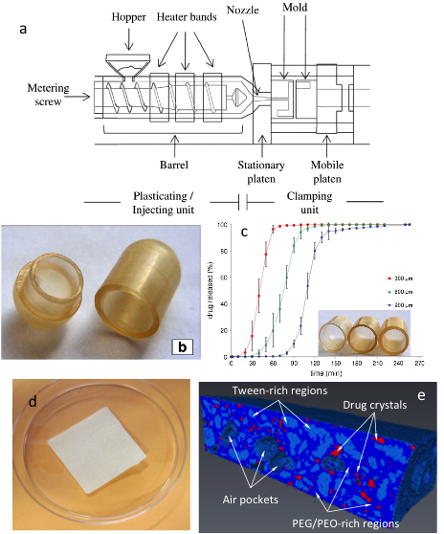
Figure 7. a) Schematic illustration of the IM process containing injecting and clamping units. Reproduced from reference [96]; b) Photographs of a Klucel® LF-based capsule shell with 900 μm nominal thickness manufactured using IM, and c) average in vitro release profiles of acetaminophen from Klucel® LF-based capsular devices with differing shell thicknesses Reproduced from reference [97]; d) IM buccal patch containing felodipine and e) micro-CT image of the IM patches indicating the phase separation of different amorphous and crystalline domains. Reproduced from reference [98].
  - Examples of pharmaceutical applications of the IM process
IM has been used to process a number of amorphous and semi-crystalline polymers to produce carriers/containers (such as capsule shells) or drug delivery matrices [94-98]. Immediate release IM formulations have used semi-crystalline PEGs with MCC as a reinforcement agent [95]. In these immediate release formulations, the active APIs present as crystalline drug particles and the dissolution of PEG will lead to the liberation of drug particles and subsequent dissolution. Recently the production of amorphous solid dispersions for the delivery of poorly soluble drugs by blending soluble polymers with different thermoplastic properties has been explored [93, 98]. Low molecular weight PEG has been shown to be a suitable plasticizer for facilitating the IM process and subsequent drug release. However, blending introduces complexity to the phase behavior of the formulation. Depending on the polymer-polymer and polymer-drug miscibilities, the IM formulations may exhibit amorphous-amorphous or amorphous-crystalline phase separation [98].
For oral controlled release formulations, many natural polymers such as wheat starch, zein and soy protein isolate have been reported to be suitable for IM process [96, 99-103]. With the blending of targeted (e.g. Eudragit L and S) or biodegradable polymers (e.g. EC), targeted release formulations can be produced [104, 105]. For many of these polymers, plastisicers are needed to make the material processable by IM. For starch based polymers, the most effective plastisicers are water and or water/glycerol mixtures which also works well for zein [94, 96, 99,100,106-111]. After IM, most thermoplastic starches exhibit postcrystallisation phenomena, although sodium starch glycolate, an alternative carrier material, can remain fully amorphous for at least 6 month [94, 112].
5.3 Limitations and industrial potential
Despite the lower resolution and lack of sophistication for creating microstructures in comparison to other methods mentioned above, IM remains as the most readily adaptable scalable manufacturing process for the pharmaceutical industry. It can easily be integrated into a fully continuous manufacturing process for pharmaceutical products. The process is well-established and well understood, thus there is considerable knowledge on process control to achieve desirable quality attributes in products are readily available in research field of polymer processing. However, in order to take it further as a pharmaceutical process, significant research effort is required into understanding of the effect of the process on pharmaceutical materials and their long-term stabilities. In most cases, the process is set to operate above the melting or glass transition temperature of the materials. After moulding, the material is cooled at a specified rate (much slower rates than solvent evaporation methods). Therefore the transformation and the physical stabilities of the resulted amorphous states can be in close relation to this relatively slow (but controllable) cooling. Many IM processes also have a post moulding curing process to minimize shrinkage. This again will impact on the stability of the amorphous material produced. In addition, most IM formulations are bulky matrix systems, thus the cooling experienced by the material at the surface is much faster than the material located at the inner core. As with HME, this may also lead to the different phase separation behaviour of drug loaded amorphous systems [77].
6. Printing technologies for micro- and nano-fabrication of amorphous pharmaceuticals
Printing technologies include a wide range of methods with different working principles for fabricating objects often with complex 2D and 3D designs [113]. In contrast to moulding-based methods for 2D and 3D micro- and nano-structure fabrication that has been discussed earlier, printing methods do not require the use of a mould which provides a greater degree of freedom in the structural design of pharmaceutical product. The change of design does not require changes of configuration of the printing machinery leading to the attractive advantage of adapting printing technologies in pharmaceutical manufacturing to provide high flexibility of formulation design and dosing according to patient’s needs. Many researchers foresee such flexibility as being key to the personalized medicine trend espoused for the future of the pharmaceutical industry. In this review two well established printing methods for fabricating amorphous pharmaceutical solids are discussed, inkjet printing and extrusion based 3D printing via fused filament fabrication (which is thermal based process and different to the powder-liquid 3D printing used in the recently FDA approved Aprecia® 3D printed tablet case) [9].
6.1 Inkjet printing
For pharmaceutical applications, inkjet printing is a group of methods that deposit liquid droplets under digital control to form either 2D or 3D microstructures (through layer-by-layer assembly) for largely solid form high throughput selection or preparation of drug delivery systems [114-116]. Similar to electrospraying, the basic working mechanism of inkjet printing is based on Rayleigh’s theory of droplet formation from a fluid jet [115]. Inkjet printing can be classified into two types, continuous printing (CIJ) and drop-on-demand (DoD) printing. The distinguishing difference between them is the timing of the formation of the droplets. During CIJ printing, the droplets form via the breakup of a continuous stream of liquid through an ejection nozzle, whereas DoD only produces a single droplet in response to a signal. For the fabrication of pharmaceutical solids, the most widely used inkjet printing method is DoD, which can be with either a piezoelectric or thermal inkjet printhead for the ejection of droplets [114]. The detailed working principles of these different printheads are described elsewhere in other comprehensive review papers [113,114,117,118]. On average the droplets formed during inkjet printing is larger than the droplets formed during electrospraying described earlier. The typical droplets formed via DoD printing are with diameters of 10-50µm, corresponding to liquid volumes between 1-70pL [113]. This printing resolution is often more limited by the diameter of the nozzle used for printing than the physical properties of the liquid and is independent of the driving forces for droplet formation (in other words either piezoelectric or thermal printing). Manipulating the physical properties of the printing liquid including surface tension, density and viscosity are often used to fine tune the formation of droplets as single droplets and minimize satellite droplet formation, as seen in Figure 8 [113,119]. Satellite droplet formation often causes variation and inconsistency in particle size and morphology. Therefore minimal satellite droplet formation is desirable for most applications of inkjet printing [113,119].
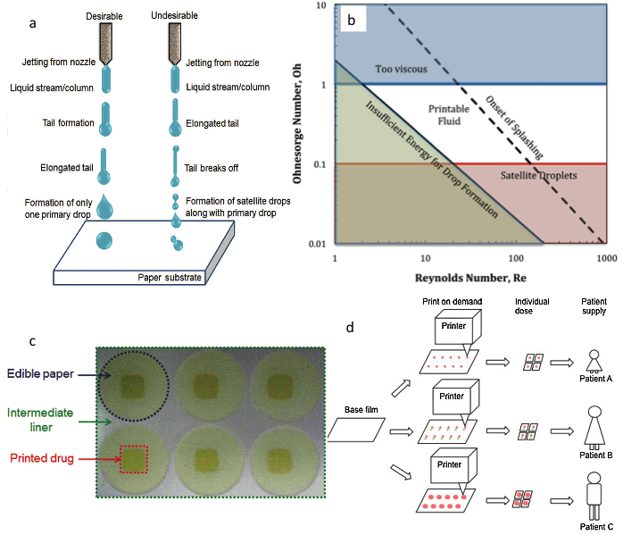
Figure 8. a) schematic illustration of inkjet printing indicating the formation of satellite droplets being undesirable; b) the correlation between solution viscosity and formation of satellite droplets in inkjet printing; c) the appearance and configuration of inkjet printed pharmaceutical films; d) Customized printing on demand at point-of-care (red and green coloring displays different ink solutions, e.g., with different drug-loading). a and c are reproduced from reference [119]. b is reproduced from [120] and d is reproduced from reference [121].
Given the key focus of this review in terms of producing amorphous pharmaceuticals, it is important to pay attention to the interplay between the material’s physicochemical properties and the effect of processing on the material. The key operational elements in inkjet printing include the liquid formulation supply, which feeds to the printhead via the ancillary fluid delivery system. Droplets are then formed through the printing nozzle and dried on the substrates of choice (either 3D structures or flat surfaces). The printing resolution of inkjet printing is limited by the nozzle size to within the tens of microns which means that the drying speeds of the droplets are slower than that of the same liquid processed by electrohydrodynamic methods, but more rapid than those of conventional solvent evaporation methods such as spray drying and film casting. The speed of drying may impact on the physical properties of the resulting amorphous materials including the dissolution rate of inkjet printed poorly soluble drugs and formulations. For example, Meléndez and co-workers reported the use of thermal inkjet printing to produce a solid prednisolone formulation [122]. Although no amorphous prednisolone was obtained after inkjet printing, mixed polymorphic form I and metastable form III of the API was found which was attributed to rapid drying of the printing process. However, due to poor stability of the amorphous state of the model drug, no pure amorphous form of the drug was obtained. It should also be noted that the type of carrier fluid used for dissolving or dispersing the API can also significantly affect the drying stage of the processed material. In the literature, most reported carrier solvents are water, DMSO, acetone and ethanol [122].
Genina and co-workers further reported the effect of print density on the resultant product [123]. By adjusting the distance between jetted droplets, flexible dosing can be achieved. However, the amorphous nature of the resultant formulation is highly API dependent. In this study, fully amorphous caffeine was not obtained, but loperamide hydrocholide was easily converted into fully amorphous after inkjet printing. However it is worth noting that intrinsically loperamide is a good glass-forming compound, but not caffeine. Therefore this cannot be used as indication of the inkjet printing having an advantage for forming amorphous systems over other solvent methods. Recently the interactions between the substrates surface and the deposited material was also studied to evaluate the effect on the resulting material. Genina and co-workers reported non-crystalline rasagiline mesylate was generated when printed on porous copy paper due to the absorption of the drug containing fluid into the substrate, whereas recrystallization of API occurred after printing when orodispersible films and water impermeable transparency films were used as substrates [124]. This interesting finding agrees well with the generation of amorphous materials using confined space such as mesoporous materials [125]. This opens a new arena for amorphous formulations produced by combining the advantages of printing process and the concept of space confinement for stabilization amorphous pharmaceuticals. Sandler and co-workers also reported the combination of the two concepts to produce amorphous pharmaceuticals with the flexibility of individualized dosing [126]. The authors manipulated the feed liquid to allow the penetration of printing liquid into the porous substrates. Better penetration of the printing fluid into the subtract was indicated to have the potential to be used as a trigger to control the crystallization behavior of the printed drug.
It is well known that the spatial distribution of drug in a finished dosage form can sometimes significantly affect therapeutic outcomes due to the different dissolution behavior. Similar to other amorphous dispersion formulations, drug distribution in inkjet printed formulations has also been a concern of the quality of the product with studies reported in the literature. Buanz and co-workers described the surface crystallization of clonidine hydrochloride in thermal inkjet printed films, whereas solvent casted drug containing films retained the drug in the matrix of the film as an amorphous dispersion [127]. However the formation of an amorphous dispersion led to the anti-plasticizing effect of the casted film and thus a higher brittleness. Although the amorphous state of the drug was not maintained in the inkjet printed drug-polymer film, the readily phase separated microcrystalline drug at the surface of the printed film led to superior mechanical properties and better stability under accelerated conditions in comparison to the film obtained by solvent casting. As clonidine is soluble in water (50mg/ml), dissolution is not limited by the presence of drug crystals in the inkjet printed films. The authors reported similar drug release results from the two types of films (phase separated by inkjet printing and dispersion by solvent casting). However, phase separation is anticipated to disadvantage drug dissolution in the cases of poorly water-soluble APIs. By altering the carrier fluid (including the polymer excipient and solvent), it should be possible to reduce this crystallization behavior. As reported by Wickström and co-workers, amorphous dispersions of indomethacin in PVP and co-amorphous of indomethacin and I-arginine were obtained via piezoelectric inkjet printing on porous paper substrate [128].
6.2 Current limitations to pharmaceutical inkjet printing
A common issue with the characterization of inkjet printed formulations is interference from the substrate on the thermal and spectroscopic results of the formulations making the confirmation of the physical state of the drug rather difficult. More localized characterization methods, such AFM, LTA and spectroscopic imaging techniques, are more suitable for studying these inkjet printed formulations, but little of this type of analysis is documented in the literature. Scoutaris and co-workers demonstrated the excellent suitability of such localized analytical techniques for studying the physical state of drugs in the printed microdrop formulations [129]. In this study, nano-TA and AFM in combination with confocal Raman microscopy confirmed the formation of molecular dispersions of felodpine in PVP which led to an increased dissolution rate of the model drug. These characterisation techniques also allowed the detection of crystallization of the model drug with extended spraying time during printing, suggesting the importance of the use of appropriate operational parameter in order to obtain the finished products with desired properties. With clear future potential as a continuous manufacturing process for personalized medicine with high dosing flexibility and possible combination therapy, reliable and robust characterization approaches are urgently needed for quality control and in-process monitoring of pharmaceutical inkjet printing.
6.3 Extrusion-based 3-dimensional printing
As was the case with inkjet printing, 3D printing (as adapted for pharmaceutical formulation fabrication) uses digital models to control the deposition of materials in a layer-by-layer fashion to form a 3D solid object. 3D printing is an umbrella term for a wide range of additive manufacturing processes including stereolithography, sintering, melting, fused deposition modeling (FDM) or fused filament fabrication (FFF) and inkjet printing when multiple layers of droplets are used to construct the solid structure [112,130]. There is a vast body of literature and rapidly growing body of research using 3D printing in biomedical applications including regenerative medicine [121,130]. This review will solely focus on the use of 3D printing for the fabrication of amorphous pharmaceuticals and most reported cases concern the application of fused filament fabrication via extrusion as shown in Figure 9 [131]. The working principle of this method is based on using hot melt extruded polymer-drug melts to directly write over a moving solid substrate and in most reported studies desktop commercially available 3D printers (which are not specially designed for extrusion of pharmaceutical polymers) were used. In the case of extrusion based 3D printing, the significant challenge is the development of suitable feed material with the appropriate thermal mechanical properties that can be processed using 3D printers. Also the speed of printing is still slower than the conventional tableting process, thus it finds main application in the production of highly sophisticated controlled or targeted release formulations. Rattanakit and co-workers reported the use of an extrusion based 3D printer to produce drug loaded PVA micro-reservoirs coated with PLGA layers to achieve highly a controlled, multi-phasic drug release performance [132].
As a result of the single screw extrusion working mechanism of commercially available 3D printers, a limited number of suitable carrier materials has been reported in literature for 3D printing, and in most of the cases PVA is used. The approach reported for drug incorporation is also limited and in many cases filaments were pre-soaked with drug saturated organic solutions for loading the drug onto the filament. This drug loading method limits the intimate mixing and interaction of the drug and polymer and reduced the chances of forming amorphous molecular dispersions. Skowyra and co-worker used this method to produce controlled release prednisolone loaded PVA tablets [133]. In contrast to inkjet printed formulations of prednisolone discussed earlier [122], 3D printed prednisolone-PVA tablets allowed the maintenance of a largely amorphous drug in the formulation. This is largely attributed to the presence of the carrier polymer fused with the drug which preserves the amorphous state of the drug. Similar PVA formulations with different model drugs, 5-aminosalicylic acid (5-ASA, mesalazine) and 4-aminosalicylic acid (4-ASA), were produced via 3D printing [134]. However, due to the thermal sensitivity of the model drugs, the authors reported the thermal degradation of a high proportion of the 4-ASA caused by this thermal based printing process. Crystalline drug was found in both formulations. The soaking method used to load the model drug prior to the 3D printing may be responsible for this result.
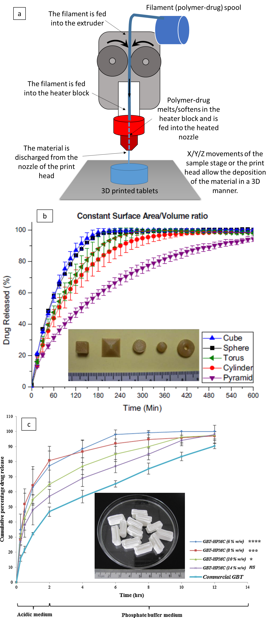
Figure 9. a) Schematic illustration of extrusion based 3D printing; b) Paracetamol dissolution profiles from 3D printed (180°C extrusion temperature was used during 3D printing in this case) solid dosage with surface area/volume ratio of 1 (inserted image shows the appearances of the solid dosage forms with different geometry). Reproduced from reference [135]. c) More controlled release dissolution profiles of 3D printed guaifenesin-HPMC bilayer tablets (room temperature extrusion based 3 D printing) than commercial compressed guaifenesin tablets (with inserted image of 3D printed guaifenesin-HPMC bilayer tablets). Reproduced from reference [136].
In addition to using the carrier materials to control the release rate of the API, Goyanes and co-workers also demonstrated the effect of tablet geometry on the release profiles of the drug from PVA [135]. In order to minimize the surface drug coating effect caused by loading drug through socking 3D printed matrices in drug solution [133, 134], this study was conducted on samples prepared via hot melt extrusion of drug-polymer mixture to produce the filaments for 3D printing. By keeping the surface area, or surface area-to-volume ratio, or weight constant, the release profiles of the model drug (paracetamol) showed different release rates (Figure 9). Although the authors did not perform any model fitting of the drug release data, erosion was assumed to be the dominating mechanism of drug release. The authors also concluded that surface area-to-volume ratio has more effect on drug release rate than surface area. This agrees well with previous work on conventional tablets [137,138].
6.4 Current limitations to pharmaceutical 3D printing
The current adoption of 3D printing for pharmaceutical solid dosage forms is still dominated by multi-layer based tablet-like geometry. Little has been reported on the use of micron structure creation capacity of 3D printing for advanced drug delivery. The more advanced and complex formulation designs which can provide special functionality for controlled or targeted drug delivery still await to be explored. Of course the cost- and time-effectiveness of using 3D printing over other conventional processes should be carefully evaluated and the scale-up of industrial pharmaceutical printers is still an area requires further maturity. Other clear hurdles include the screening and selection of suitable materials for extrusion based 3D printing. As the extruders built within most of the 3D printers are single screw type, the thermomechaical requirements for the material to be processed are different from pharmaceutical hot melt extrusion. Instrument development to integrate the mixing the filament making step into the 3D printing will give the advantage of enabling 3D printing to potentially be a continuous manufacturing process for advanced drug delivery system production.
7. Conclusions and future outlook
This review has described a series of manufacturing methods for producing amorphous pharmaceuticals which micron or nanostructures. Some of them are still in the early stages of development and scale-up is still under development, whereas others are already able to be produced on an industrial scale and can be easily modified to suit the purposes of the pharmaceutical industry. The abilities to of these methods to produce stable amorphous pharmaceuticals is highly dependent on each individual process. However, thus far there is no clear indication of the superiority of any of these methods for producing stable amorphous pharmaceuticals in comparison to the conventional thermal and solvent evaporation based preparation methods such as hot melt extrusion, melt granulation, freeze drying and spray drying. The established view of the thermodynamic stability of amorphous pharmaceutical being highly dominated by the intrinsic properties of the amorphous material such as molecular mobility remains unchallenged by the evidence presented in the existing literature on these emerging preparation methods. However some evidence has surfaced to highlight that the kinetic aspect of the amorphous stability can be affected by the preparation method which agrees well with the existing literature. These new preparation methods can allow the production of unique, micro and nano-structured materials for the delivery of amorphous pharmaceuticals which often can enhance some key in vitro and in vivo behaviours of the formulations, such as disintegration and dissolution. In order to move forwards with these new manufacturing methods, more in depth material science and process engineering research are required. For the amorphous pharmaceutical field, it is extremely important to conduct more fundamental research on the effect of micron and nanostructures on the stability of amorphous materials produced using these sophisticated systems which is currently lacking in the literature.
Reference
- S. Qi, W.J. McAuley, Z. Yang, P. Tipduangta, Physical stabilization of low-molecular-weight amorphous drugs in the solid state: a material science approach, Ther. Deliv. 5 (2014) 817-841.
- J.T. Schiele, R. Quinzler, H.D. Klimm, M.G. Pruszydlo, W.E. Haefeli, Difficulties swallowing solid oral dosage forms in a general practice population: prevalence, causes, and relationship to dosage forms, Eur. J. Clin. Pharmacol. 69 (2013) 937-48.
- C. Matuchansky, The promise of personalised medicine, Lancet. 386 (2015) 742.
- A.T. Florence, V.H. Lee, Personalised medicines more tailored drugs, more tailored delivery, Int. J. Pharm. 415 (2011) 29–33.
- W. Fierz, Challenge of personalized health care: to what extent is medicine already individualized and what are the future trends? Med. Sci. Monit. 10 (2004) 111–123.
- G.A. Hughes, Nanostructure-mediated drug delivery, Nanomedicine. 1 (2005) 22-30.
- O.C. Farokhzad, R. Langer, Impact of nanotechnology on drug delivery, ACS Nano. 3 (2009) 16-20.
- M. Goldberg, R. Langer, X. Jia, Nanostructured materials for applications in drug delivery and tissue engineering. J. Biomater. Sci. Polym. Ed. 18 (2007) 241-68.
- ZipDose® Technology (data on file), Aprecia Pharmaceuticals Company, 2015. https://www.aprecia.com/zipdose-platform/zipdose-technology.php
- L.T. Cherney, Electrohydrodynamics of electrified liquid menisci and emitted jets, J. Aerosol Sci. 30 (1999) 851–862.
- L. Rayleigh,On the equilibrium of liquid conducting masses charged with electricity, Phil. Mag. 14 (1882) 184–186.
- J. Zeleny, Instability of electrified liquid surfaces, Phys. Rev. 10 (1917) 1–6.
- G. Taylor, Disintegration of water drops in an electrical field, Proc. R. Soc. London A. 280 (1964) 383–397.
- J. B. Fenn, M. Mann, C. K. Meng, S. F. Wong, C. M. Whitehouse, Electrospray ionization for mass spectrometry of large biomolecules, Science. 246 (1989) 64–71.
- S. Chakraborty, I.C. Liao, A. Adler, K.W. Leong, Electrohydrodynamics: A facile technique to fabricate drug delivery systems, Adv. Drug Deliv. Rev. 61 (2009) 1043–1054.
- T.J. Sill, H.A. von Recum, Electrospinning: Applications in drug delivery and tissue engineering, Biomaterials. 29 (2008) 1989-2006.
- D.I. Braghirolli, D. Steffens, P. Pranke, Electrospinning for regenerative medicine: a review of the main topics, Drug Discov Today. 19 (2014) 743-53.
- A. Jaworek, A.T. Sobczyk, Electrospraying route to nanotechnology: an overview, J. Electrost. 66 (2008) 197–219.
- N. Bock, T.R. Dargaville, M.A. Woodruff, Electrospraying of polymers with therapeutic molecules:State of the art, Prog. Polym. Sci. 37 (2012) 1510– 1551.
- L.M. Wang, S. Borick, C. A. Angell, An electrospray technique for hyperquenched glass calorimetry studies: Propylene glycol and di-n-butyl phthalate, J. Non-Cryst. Solids. 353 (2007) 3829–3837.
- M. Nyström, M. Murtomaa, J. Salonen, Fabrication of amorphous pharmaceutical materials by electrospraying into reduced pressure. Proc. ESA Annual Meeting on Electrostatics (2010) Paper B2.
- O.I. Corrigana, E.M. Holohana, M.R. Reillya, Physicochemical Properties of Indomethacin and Related Compounds Co-Spray Dried with Polyvinylpyrrolidone, Drug Dev. Ind. Pharm. 11 (1985) 677-695.
- P. Karmwar, K. Graeser, K.C. Gordon, C.J. Strachan, T. Rades, Effect of different preparation methods on the dissolution behaviour of amorphous indomethacin, Eur. J. Pharm. Biopharm. 80 (2012) 459-64.
- P. Karmwar, J.P. Boetker, K.A. Graeser, C.J. Strachan, J. Rantanen, T. Rades, Investigations on the effect of different cooling rates on the stability of amorphous indomethacin, Eur. J. Pharm. Sci. 44 (2011) 341-50.
- P. Karmwar, K. Graeser, K.C. Gordon, C. J. Strachan, T. Rades, Investigation of properties and recrystallisation behaviour of amorphous indomethacin samples prepared by different methods, Int. J. Pharm. 417 (2011) 94-100.
- J. Roine, M. Kaasalainen, M. Peurla, A. Correia, F. Araújo, H.A. Santos, M. Murtomaa, J. Salonen, Controlled Dissolution of Griseofulvin Solid Dispersions from Electrosprayed Enteric Polymer Micromatrix Particles: Physicochemical Characterization and in Vitro Evaluation, Mol. Pharmaceutics. 12 (2015) 2254–226.
- S. Zhang, K. Kawakami, M. Yamamoto, Y. Masaoka, M. Kataoka, S. Yamashita, S. Sakuma, Coaxial Electrospray Formulations for Improving Oral Absorption of a Poorly Water-Soluble Drug. Mol. Pharmaceutics. 8 (2011) 807–813.
- A.K. Jain, V. Sood, M. Bora, R. Vasita, D.S. Katti, Electrosprayed inulin microparticles for microbiota triggered targeting of colon, Carbohyd. Polym. 112 (2014) 225-34.
- C. Li, D.G. Yu, G.R. Williams, Z.H. Wang. Fast-dissolving core-shell composite microparticles of quercetin fabricated using a coaxial electrospray process, PLoS One. 9 (2014) e92106.
- K. Kawakami, Miscibility analysis of particulate solid dispersions prepared by electrospray deposition, Int. J. Pharm. 433(2012) 71-8.
- S. Sethia, E. Squillante, Solid dispersion of carbamazepine in PVP K30 by conventional solvent evaporation and supercritical methods, Int. J. Pharm. 272 (2004) 1-10.
- K. Kawakami, S. Zhang, R.S. Chauhan, N. Ishizuka, M. Yamamoto, Y. Masaoka, M. Kataoka, S. Yamashita, S. Sakuma, Preparation of fenofibrate solid dispersion using electrospray deposition and improvement in oral absorption by instantaneous post-heating of the formulation, Int. J. Pharm. 450 (2013) 123-8.
- M. Wang, G.C. Rutledge, A.S. Myerson, B.L. Trout, Production and characterization of carbamazepine nanocrystals by electrospraying for continuous pharmaceutical manufacturing, J. Pharm. Sci. 101 (2012) 1178-88.
- S. Sakuma, S. Matsumoto, N. Ishizuka, K. Mohri, M. Fukushima, C. Ohba, K. Kawakami, Enhanced Boosting of Oral Absorption of Lopinavir Through Electrospray Coencapsulation with Ritonavir, J. Pharm. Sci. 104 (2015) 2977-2985.
- G.C. Rutledge, S.V. Fridrikh, Formation of fibers by electrospinning, Adv. Drug Deliv. Rev. 59 (2007) 1384–1391.
- D. Li, Y. Xia, Electrospinning of Nanofibers: Reinventing the Wheel? Adv. Mater, 16 (2004)1151–1170.
- J.H. He, H.M. Liu, Variational approach to nonlinear problems and a review on mathematical model of electrospinning, Nonlinear Anal. 63 (2005) e919–e929.
- D.W. Hutmacher, P.D. Dalton, Melt Electrospinning, Chem. Asian J. 6 (2011) 44-56.
- T.D. Brown, P.D. Dalton, D.W. Hutmacher, Direct Writing by Way of Melt Electrospinning, Adv. Mater. 23 (2011) 5651-57.
- U. Paaver, I. Tamm, I. Laidmäe, A. Lust, K. Kirsimäe, P. Veski, K. Kogermann, J. Heinämäki, Soluplus Graft Copolymer: Potential Novel Carrier Polymer in Electrospinning of Nanofibrous Drug Delivery Systems for Wound Therapy, BioMed Res. Int. Article ID 789765 (2014) 7 pages.
- F.L. Lopez, G.C. Shearman, S. Gaisford, G.R. Williams, Amorphous Formulations of Indomethacin and Griseofulvin Prepared by Electrospinning, Mol. Pharmaceutics 11 (2014) 4327−4338.
- U.E. Illangakoon, H. Gill, G.C. Shearman, M. Parhizkar, S. Mahalingam, N.P. Chatterton, G.R. Williams, Fast dissolving paracetamol/caffeine nanofibers prepared by electrospinning, Int. J. Pharm. 477 (2014) 369–379.
- M. Hamori, S. Yoshimatsu, Y. Hukuchi, Y. Shimizu, K. Fukushima, N. Sugioka, A. Nishimura, N. Shibata, Preparation and pharmaceutical evaluation of nano-fiber matrix supported drug delivery system using the solvent-based electrospinning method, Int. J. Pharm. 464 (2014) 243–251.
- F. Ignatious, J. Baldoni, Electrospun pharmaceutical compositions, WO0154667 (2001)
- F. Ignatious, L. Sun, Electrospun amorphous pharmaceutical compositions, WO 2004014304 (2004)
- G. Verreck, I. Chun, J. Peeters, J. Rosenblatt, M.E. Brewster, Preparation and characterization of nanofibers containing amorphous drug dispersions generated by electrostatic spinning, Pharm. Res. 20 (2003) 810–7.
- G. Verreck, I. Chun, J. Peeters, J. Rosenblatt, A.V. Dijck, J. Mensch, M. Noppe, M.E. Brewster, Incorporation of drugs in an amorphous state into electrospun nanofibers composed of a water-insoluble non-biodegradable polymer. J. Control. Release. 92 (2003) 349–60.
- P.L. Sóti, K. Bocz, H. Pataki, Z. Eke, A. Farkas, G. Verreck, É. Kiss, P. Fekete, T. Vigh, I. Wagner, Z.K. Nagy, G. Marosi, Comparison of spray drying, electroblowing and electrospinning for preparation of Eudragit E and itraconazole solid dispersions, Int. J. Pharm. 494 (2015) 23–30.
- Z.K. Nagy, A. Balogh, G. Drávavölgyi, J. Ferguson, H. Pataki, B. Vajna, G. Marosi, Solvent-free melt electrospinning for preparation of fast dissolving drug delivery system and comparison with solvent-based electrospun and melt extruded systems, J. Pharm. Sci. 102 (2013) 508–517.
- C. Rustemkyzy, P. Belton, S. Qi, Preparation and Characterisation of Ultra-Rapidly Dissolving Orodispersible Films for Treating and Preventing Iodine Deficiency in the Paediatric Population, J. Agric. Food Chem. 63 (2015) 9831–9838.
- F. Sadeghi, A. Ajji, Study of crystal structure of (Polyvinylidene fluoride/clay) nanocomposite films: Effect of process conditions and clay type, Polym. Eng. Sci. 49 (2009) 200-207.
- A.J. Rulison, R.C. Flagan, Scaleup of Electrospray Atomization Using Linear Arrays of Taylor Cones, Rev. Sci. Instrum. 64 (1993) 683-686.
- R. Bocanegra, D. Galán, M. Márquezb, I.G. Loscertales, A. Barrero, Multiple electrosprays emitted from an array of holes, J. Aerosol Sci. 36 (2005) 1387–1399.
- Weiwei Deng, James F. Klemic, Xiaohui Li, Mark A. Reed, Alessandro Gomez. Increase of electrospray throughput using multiplexed microfabricated sources for the scalable generation of monodisperse droplets, J. Aerosol Sci. 37 (2006) 696–714.
- S. Mahalingam, M. Edirisinghe, Forming of polymer nanofibres by a pressurised gyration process, Macromol. Rapid Commun. 34 (2013) 1134–1139.
- H. Niu, T. Lin, Fiber Generators in Needleless Electrospinning. J. Nanomaterials. Article ID 725950 (2012) 13 pages.
- L. Persano, A. Camposeo, C. Tekmen, D. Pisignano, Industrial Upscaling of Electrospinning and Applications of Polymer Nanofibers: A Review, Macromol. Mater. Eng. 298 (2013) 504–520.
- E.A. Krogstad, K.A. Woodrow, Manufacturing scale-up of electrospun poly(vinyl alcohol) fibers containing tenofovir for vaginal drug delivery, Int. J. Pharm. 475 (2014) 282-91.
- B.K. Brettmann, K. Cheng, A.S. Myerson, B.L. Trout, Electrospun formulations containing crystalline active pharmaceutical ingredients, Pharm. Res. 30 (2013) 238–246.
- B.T. Raimi-Abraham, S. Mahalingam, M. Edirisinghe, D.Q.M. Craig, Generation of poly(N-vinylpyrrolidone) nanofibres using pressurised gyration, Mat. Sci. Eng. C 39 (2014) 168–176.
- B.T. Raimi-Abraham, S. Mahalingam, P.J. Davies, M. Edirisinghe, D.Q.M. Craig, Development and Characterization of Amorphous Nanofiber Drug Dispersions Prepared Using Pressurized Gyration, Mol. Pharmaceutics. 12 (2015) 3851-3861.
- S. Mahalingam, B.T. Raimi-Abraham, D.Q.M. Craig, M. Edirisinghe, Solubility–spinnability map and model for the preparation of fibres of polyethylene (terephthalate) using gyration and pressure, Chem. Eng. J. 280 (2015) 344-353.
- J.G. Moffat, S. Qi, D.Q.M. Craig, M. Spatial Characterization of Hot Melt Extruded Dispersion Systems Using Thermal Atomic Force Microscopy Methods: The Effects of Processing Parameters on Phase Separation, Pharm. Res. 31 (2014) 1744-1752.
- S. Mahalingam, B.T. Raimi-Abraham, D.Q.M. Craig, M. Edirisinghe, Formation of protein and protein-gold nanoparticle stabilized microbubbles by pressurized gyration, Langmuir. 31 (2015) 659–666.
- F. Brako, B. Raimi-Abraham, S. Mahalingam, D.Q.M. Craig, M. Edirisinghe, Making nanofibres of mucoadhesive polymer blends for vaginal therapies, Eur. Polym. J. 70 (2015) 186-196.
- X. Zhang, Y. Lu, Centrifugal spinning: An alternative approach to fabricate nanofibers at high speed and low cost, Polym. Rev. 54 (2014) 677-701.
- S. Marano, S.A. Barker, B.T. Raimi-Abraham, S. Missaghi, A. Rajabi-Siahboomi, D.Q.M. Craig, Development of Micro-fibrous Solid Dispersions of Poorly Water-Soluble Drugs in Sugars using Temperature-Controlled Centrifugal Spinning, Eur. J. Pharm. Biopharm. submitted (2015)
- K. Norrman, A. Ghanbari-Siahkali, N.B. Larsen, 6 Studies of spin-coated polymer films, RSC Annu. Rep. C (Physical Chemistry). 101 (2015) 174-201.
- D.P. Birnie III, A Model for Drying Control Cosolvent Selection for Spin-Coating Uniformity: The Thin Film Limit, Langmuir. 29 (2013) 9072−9078.
- Y.C. Ng, Z. Yang, W.J. McAuley, S. Qi, Stabilisation of amorphous drugs under high humidity using pharmaceutical thin films, Eur. J. Pharm. Biopharm. 84 (2013) 555-565.
- S. Qi, J.G. Moffat, Z. Yang, Early Stage Phase Separation in Pharmaceutical Solid Dispersion Thin Films under High Humidity: Improved Spatial Understanding Using Probe-Based Thermal and Spectroscopic Nanocharacterization Methods, Mol. Pharmaceutics. 10 (2013) 918-930.
- B. Van Eerdenbrugh, J.A. Baird, L.S. Taylor, Crystallization tendency of active pharmaceutical ingredients following rapid solvent evaporation—classification and comparison with crystallization tendency from undercooled melts, J. Pharm. Sci. 99 (2010) 3826-3838.
- B. Van Eerdenbrugh, L.S. Taylor, Small Scale Screening To Determine the Ability of Different Polymers To Inhibit Drug Crystallization upon Rapid Solvent Evaporation, Mol. Pharmaceutics. 7 (2010) 1328-1337.
- T. Wu, L. Yu, Surface Crystallization of Indomethacin Below Tg, Pharm. Res. 23 (2006) 2350-2355.
- J.A. Baird, B. Van Eerdenbrugh, L.S. Taylor, A classification system to assess the crystallization tendency of organic molecules from undercooled melts, J. Pharm. Sci. 99 (2010) 3787-3806.
- L. Zhu, L. Wong, L. Yu. Surface-Enhanced Crystallization of Amorphous Nifedipine, Mol. Pharmaceutics. 5 (2008) 921-926.
- Z. Yang, K. Nollenberger, J. Albers, J. Moffat, D. Craig, S. Qi, The effect of processing on the surface physical stability of amorphous solid dispersions, Eur. J. Pharm. Biopharm. 88 (2014) 897-908.
- T. Ponnusamy, H. Yu, V.T. John, R.S. Ayyala, D.A. Blake, A novel antiproliferative drug coating for glaucoma drainage devices, J. Glaucoma. 23 (2014) 526-34.
- T. Ponnusamy, L.B. Lawson, L.C. Freytag, D.A. Blake, R.S. Ayyala, V.T. John, In vitro degradation and release characteristics of spin coated thin films of PLGA with a “breath figure” morphology, Biomatter. 2 (2012) 77-86.
- E.D. Schoenberg, D.A. Blake, F.B. Swann, A.W. Parlin, D. Zurakowski, C.E. Margo, T. Ponnusamy, V.T. John, R.S. Ayyala, Effect of Two Novel Sustained-Release Drug Delivery Systems on Bleb Fibrosis: An In Vivo Glaucoma Drainage Device Study in a Rabbit Model, Transl. Vis. Sci. Technol. 4 (2015) 4.
- R.A. Scott, K. Park, A. Panitch, Water soluble polymer films for intravascular drug delivery of antithrombotic biomolecules, Eur. J. Pharm. Biopharm. 84 (2013) 125-31.
- V. Karagkiozaki, E. Vavoulidis, P.G. Karagiannidis, M. Gioti, D.G. Fatouros, I.S. Vizirianakis, S. Logothetidis, Development of a nanoporous and multilayer drug-delivery platform for medical implants, Int. J. Nanomedicine. 7 (2012) 5327-38.
- R. Hüttenrauch, Injection-molding technic for the production of oral delayed action preparations. 1. Injection molding, Die Pharmazie 29 (1974) 297–302.
- F. Sammoura, J.J. Kang, Y.M. Heo, T.S. Jung, L.W. Lin, Polymeric microneedle fabrication using a microinjection molding technique, Microsyst. Technol. 13 (2007) 517-522.
- H. Haugen, J. Will, W. Fuchs, E. Wintermantel, A novel processing method for injection-molded polyether–urethane scaffolds, Part 1: Processing, J. Biomed. Mater. Res. –A. 77B (2006) 65–72.
- M.E. Gomes, A.S. Ribeiro, P.B. Malafaya, R.L. Reis, A.M. Cunha, A new approach based on injection moulding to produce biodegradable starch-based polymeric scaffolds: morphology, mechanical and degradation behavior, Biomaterials. 22 (2001) 883–889.
- S. Mascia, P.L. Heider, H. Zhang, R. Lakerveld, B. Benyahia, P.I. Barton, R.D. Braatz, C.L. Cooney, J.M.B. Evans, T.F. Jamison, K.F. Jensen, A.S. Myerson, B.L. Trout, End-to-end continuous manufacturing of pharmaceuticals: Integrated synthesis, purification, and final dosage formation, Angew. Chem. Int. Ed. Engl. 52 (2013) 12359– 12363.
- P.H. Hemmingsen, A.V. Pedersen, D. Bar-Shalom, Controlled release pharmaceutical compositions for prolonged effect, U.S. patent No. 8,821,928
- C. Andersen, K. Lindhardt, J.M. Oevergaard, L.I. Lyhne-Iversen, M.R. Olsen, A.M. Haahr, P.H. Hemmingsen, Formulations and methods for the controlled release of active drug substances, U.S. patent No. 9,023,394
- J.M. Fischer, Handbook of molded part shrinkage and warpage, William Andrew Inc., New York, 2003.
- M. Kurt, Y. Kaynak, O.S. Kamber, B. Mutlu, B. Bakir, U. Koklu, Influence of molding conditions on the shrinkage and roundness of injection molded parts, Int. J. Adv. Manuf. Tech. 46 (2010) 571-578.
- A. Rothen-Weinhold, K. Besseghir, E. Vuaridel, E. Sublet, N. Oudry, F. Kubel, R. Gurny, Injection-molding versus extrusion as manufacturing technique for the preparation of biodegradable implants, Eur. J. Pharm. Biopharm. 48 (1999) 113–121.
- T. Quinten, Y. Gonnissen, E. Adriaens, T.D. Beer, V. Cnudde, B. Masschaele, L. Van Hoorebeke, J. Siepmann, J.P. Remon, C. Vervaet, Development of injection moulded matrix tablets based on mixtures of ethylcellulose and low-substituted hydroxypropylcellulose, Eur. J. Pharm. Sci. 37 (2009) 207–216.
- L. Zema, G. Loreti, A. Melocchi, A. Maroni, L. Palugan, A. Gazzaniga, Gastroresistant capsular device prepared by injection molding, Int. J. Pharm. 440 (2013) 264–272.
- A. Melocchi, G. Loreti, M. D. Del Curto, A. Maroni, A. Gazzaniga, L. Zema, Evaluation of Hot-Melt Extrusion and Injection Molding for Continuous Manufacturing of Immediate-Release Tablets, J. Pharm. Sci. 104 (2015) 1971–1980.
- L. Zema, G. Loreti, A. Melocchi, A. Maroni, A. Gazzaniga, Injection Molding and its application to drug delivery, J. Control. Release. 159 (2012) 324–331.
- A. Gazzaniga, M. Cerea, A. Cozzi, A. Foppoli, A. Maroni, L. Zema, A Novel Injection-Molded Capsular Device for Oral Pulsatile Delivery Based on Swellable/Erodible Polymers, AAPS PharmSciTech. 12 (2011) 295-303.
- M. Alhijjaj, J. Bouman, N. Wellner, P. Belton, S. Qi, Creating drug solubilisation compartments via phase separation in multi-component buccal patches prepared by direct hot melt extrusion-injection moulding, Mol. Pharmaceutics. (2015) DOI: 10.1021/acs.molpharmaceut.5b00532
- J. Bouman, P. Belton, P. Venema, E. van der Linden, R. de Vries, S. Qi, The Development of Direct Extrusion-Injection Moulded Zein Matrices as Novel Oral Controlled Drug Delivery Systems, Pharm. Res. 32 (2015) 2775-86.
- J. Bouman, P. Belton, P. Venema, E. van der Linden, R. de Vries, S. Qi, Controlled release from zein matrices: interplay of drug hydrophobicity and pH, Pharm. Res. 2015. Accepted
- G. Cuff, F. Raouf, A preliminary evaluation of injection moulding as a tabletting technology, Pharm. Technol. Eur. 11 (1999) 18–26.
- C.M Vaz, P.F.N.M van Doeveren, R.L. Reis, A.M. Cunha, Development and design of double-layer co-injection moulded soy protein based drug delivery devices, Polymer. 44 (2003) 5983–5992.
- T. Quinten, T. De Beer, C. Vervaet, J.P. Remon, Evaluation of injection moulding as a pharmaceutical technology to produce matrix tablets, Eur. J. Pharm. Biopharm. 71 (2009) 145–154.
- S. Keszei, A. Szabó, G. Marosi, P.r Anna, S. Nagy, Use of Thermoplastic Starch in Continuous Pharmaceutical Process, Macromol. Symp. 239 (2006) 101–104.
- A. Gazzaniga, A. Maroni, M.E. Sangalli, L. Zema, Time-controlled oral delivery systems for colon targeting, Expert Opin. Drug Deliv. 3 (2006) 583–597.
- P.H. Hemmingsen, A.M. Haahr, C. Gunnergaard, J.M. Cardot, Development of a New Type of Prolonged Release Hydrocodone Formulation Based on Egalet® ADPREM Technology Using In Vivo–In Vitro Correlation, Pharmaceutics 3 (2011) 73–87.
- R. F. T. Stepto, I. Tomka, Injection moulding of natural hydrophilic polymers in the presence of water, Chimia. 41 (1987) 76–81.
- L. Eith, R. F. T. Stepto, I. Tomka, F. Wittwer, The injection-moulded capsule, Drug Dev. Ind. Pharm. 12 (1986) 2113–2126.
- L. Eith, R. F. T. Stepto, F. Wittwer, I. Tomka, Injection-moulded drug-delivery systems, Manuf. Chem. 58 (1987) 21–25.
- R. F. T. Stepto, Thermoplastic starch and drug delivery capsules, Polym. Int. 43 (1997) 155–158.
- S.J. Burns, D. Corness, G. Hay, S. Higginbottom, I. Whelan, D. Attwood, S.G. Barnwell, An in vitro assessment of liquid-filled capill® potato starch capsules with biphasic release characteristics, Int. J. Pharm. 134 (1–2) (1996) 223–230.
- L.P.B.M. Jannsen, L. Moscicki, Thermoplastic starch—A green material for various industry. Wiley, Germany, 2009.
- R. Kolakovic, T. Viitala, P. Ihalainen, N. Genina, J. Peltonen, N. Sandler, Printing technologies in fabrication of drug delivery systems, Expert Opin. Drug Deliv. 10 (2013) 1711–1723.
- R. Daly, T.S. Harrington, G.D. Martin, I.M. Hutchings, Inkjet printing for pharmaceutics – A review of research and manufacturing, Int. J. Pharm. 494 (2015) 554-67.
- M. Alomari, F.H. Mohamed, A.W. Basit, S. Gaisford, Personalised dosing: Printing a dose of one’s own medicine, Int. J. Pharm. 494 (2015) 568-77.
- A.B.M. Buanz, M.H. Saunders, A.W. Basit, S. Gaisford, Preparation of personalised-dose salbutamol sulphate oral films with thermal ink-jet printing, Pharm. Res. 28 (2011) 2386-2392.
- G.D. Martin, I.M. Hutchings, Fundamentals of inkjet technology, in: I.M. Hutchings, G.D. Martin, (Eds.), Inkjet Technology for Digital Fabrication, Wiley-Blackwell, pp. 21–44.
- P. Ihalainen, A. Määttänen, N. Sandler, Printing technologies for biomolecule and cell-based applications, Int. J. Pharm. 494 (2015) 585-92.
- D. Raijada, N. Genina, D. Fors, E. Wisaeus, J. Peltonen, J. Rantanen, N. Sandler, A Step Toward Development of Printable Dosage Forms for Poorly Soluble Drugs, J. Pharm. Sci. 102 (2013) 3694–3704.
- G.R. McKinley, M. Renardy, Wolfgang von Ohnesorge, Phys. Fluids 23 (2011) 127101.
- M. Preis, J. Breitkreutz, N. Sandler, Perspective: Concepts of printing technologies for oral film formulations, Int. J. Pharm. 494 (2015) 578-84.
- P.A. Meléndez, K.M. Kane, C.S. Ashvar, M. Albrecht, P.A. Smith, Thermal inkjet application in the preparation of oral dosage forms: Dispensing of prednisolone solutions and polymorphic characterization by solid-state spectroscopic techniques, J. Pharm. Sci. 97 (2008) 2619–2636.
- L. Hirshfield, A. Giridhar, L.S. Taylor, M.T. Harris, G.V. Reklaitis, Dropwise additive manufacturing of pharmaceutical products for solvent-based dosage forms, J. Pharm. Sci. 103 (2014) 496-506.
- N. Genina, D. Fors, M. Palo, J. Peltonen, N. Sandler, Behavior of printable formulations of loperamide and caffeine on different substrates—Effect of print density in inkjet printing, Int. J. Pharm. 453 (2013) 488–497.
- K.K. Qian, R.H. Bogner, Application of mesoporous silicon dioxide and silicate in oral amorphous drug delivery systems, J. Pharm. Sci. 101 (2012) 444–463.
- N. Sandler, A. Määttänen, P. Ihalainen, L. Kronberg, A. Meierjohann, T. Viitala, J. Peltonen, Inkjet printing of drug substances and use of porous substrates-towards individualized dosing, J. Pharm. Sci. 100 (2011) 3386-3395.
- A.B.M. Buanz, C.C. Belaunde, N. Soutari, C. Tuleu, M.O. Gul, S. Gaisford. Ink-jet printing versus solvent casting to prepared oral films: Effect on mechanical properties and physical stability, Int. J. Pharm. 494 (2015) 611-8.
- H. Wickström, M. Palo, K. Rijckaert, R. Kolakovic, J.O. Nyman, A. Määttänen, P. Ihalainen, J. Peltonen, N. Genina, T. de Beer, K. Löbmann, T. Rades, N. Sandler, Improvement of dissolution rate of indomethacin by inkjet printing, Eur. J. Pharm. Sci. 75 (2015) 91-100.
- N. Scoutaris, M.R. Alexander, P.R. Gellert, C.J. Roberts, Inkjet printing as a novel medicine formulation technique, J. Control. Release. 156 (2011) 179–185.
- H.N. Chia, B.M. Wu, Recent advances in 3D printing of biomaterials, J Biol Eng. 9 (2015) 4.
- B.N. Turner, R. Strong, S.A. Gold, A review of melt extrusion additive manufacturing processes: I. Process design and modelling, Rapid Prototyping J. 20 (2014) 192-204.
- P. Rattanakit, S.E. Moulton, K.S. Santiago, S. Liawruangrath, G.G. Wallace, Extrusion printed polymer structures: A facile and versatile approach to tailored drug delivery platforms, Int. J. Pharm. 422 (2012) 254–263.
- J. Skowyra, K. Pietrzak, M.A. Alhnan, Fabrication of extended-release patient-tailored prednisolone tablets via fused deposition modelling (FDM) 3D printing, Eur. J. Pharm. Sci. 68 (2015) 11–17.
- A. Goyanes, A.B.M. Buanz, G.B. Hatton, S. Gaisford, A.W. Basit, 3D printing of modified-release aminosalicylate (4-ASA and 5-ASA) tablets, Eur. J. Pharm. Biopharm. 89 (2015) 157–162.
- A. Goyanes, P. Robles Martinez, A. Buanz, A.W. Basit, S. Gaisford, Effect of geometry on drug release from 3D printed tablets, Int. J. Pharm. 494 (2015) 657-63.
- S.A. Khaleda, J.C. Burleya, M.R. Alexandera, C.J. Roberts, Desktop 3D printing of controlled release pharmaceutical bilayer tablets, Int. J. Pharm. 461 (2014) 105–111.
- T.D. Reynolds, S.A. Mitchell, K.M. Balwinski, Investigation of the Effect of Tablet Surface Area/Volume on Drug Release from Hydroxypropylmethylcellulose Controlled-Release Matrix Tablets, Drug Dev. Ind. Pharm. 28 (2002) 457–466.
- J. Siepmann, H. Kranz, N.A. Peppas, R. Bodmeier, Calculation of the required size and shape of hydroxypropyl methylcellulose matrices to achieve desired drug release profiles, Int. J. Pharm. 201 (2000) 151–164.

