ABSTRACT
The study presented in this paper explores to what extent and in what ways the communication between clinicians and patients on Ask-the-Expert healthcare websites is patient-centred. It further demonstrates the value of using a theory and text-driven discourse analytical approach for the analysis of verbal communication in a specific (health professional) domain. The UK website Netdoctor is used as a case study. Thirty exchanges from this site, on the topic of depression, were analysed using a discourse-pragmatic framework, drawing on existing theories and definitions of Patient-Centred Communication (PCC), a classification of empathic communication acts (Author, 2011) and existing research on advice-giving in online communication. The analysis shows that, overall, experts make wide use of PCC, particularly empathic expression, in their online responses. The author concludes that there is a high potential for the expression of PCC on Ask-the-Expert health sites and that this may be more or less exploited, depending on the restrictions imposed on the contributors by the site managers and users’ expectations.
KEY WORDS: patient-centred communication; empathy; advice; Ask-the-Expert healthcare websites; online medical consultation; depression

HIGHLIGHTS (Core findings):
- The experts’ responses on the Netdoctor website are considerably patient-centred.
- Empathic formulations make up about a third of the words in the responses.
- Experts’ expression of acceptance are particularly frequent.
- Open advice make up for a further third of the words in the responses.
- The potential for eliciting patients’ feelings and views is minimally exploited.

INTRODUCTION
It is now widely accepted that medical professionals’ ability to express empathy and place the patient at the centre of the consultation is fundamental to a successful consultation (e.g. Bonvicini et al. 2009: 4). Research shows, for example, that medical practitioners’ expression of empathy may encourage patients to talk more freely about their conditions, leading to clearer diagnoses, higher adherence to treatment regimens and, ultimately, higher patient satisfaction, therapeutic effect and recovery rates (Hojat et al. 2002; Piasecky 2003; Bonvicini et al. 2009). Empathy and patient-centred communication (PCC) are at the core of the Calgary-Cambridge approach (Silverman et al. 2005) to consultation skills training, widely implemented at higher education medical and health institutions in Britain and elsewhere. The result is that newly educated medical professionals are expected to demonstrate empathy to their patients, provide them with appropriate information about their conditions, involve them in decisions about their therapy and, therefore, share responsibility in their recovery. Some research appears to suggest, however, that empathic and patient-centred communication might be harder to achieve in online consultations, particularly in the case of asynchronous communication (e.g. Lovejoy et al. 2009) and that this is due, at least partly, to the limitations of the digital context (particularly, the anonymity of the interaction). Other research, on the other hand, suggests that this medium may and is used to fulfil an interactional as well as an informative function. The aim of this paper is to contribute to this discussion by:
a) Introducing a new theory- and text-driven analytical framework, specifically suited to the analysis of PCC and empathy in asynchronous UK Ask-the-Expert healthcare websites.
b) Exploring whether and to what extent PCC and empathy are demonstrated in the written responses of the medical experts contributing to the leading UK Ask-the-Expert healthcare website Netdoctor and
c) Considering the implications of the findings.
The first section of the paper provides an overview of the current research in the area of online medical consultations. The subsequent section introduces the data and analytical methodology used for the analysis of the Netdoctor online consultations. In the remaining sections the results are presented and discussed with reference to their theoretical, methodological and practical implications.
ONLINE MEDICAL CONSULTATIONS: ASK-THE-EXPERTS WEBSITES
Online forums aimed at providing peer or expert support on a variety of health topics and issues have become an increasingly common type of online communication. Studies of the online support communities (peer support) ‘have mainly been concerned with the emotional impact and the tone of the conversations’ (Smedberg 2007:15), generally highlighting the advantages of such communities in providing a form of much needed social support as well as information to people affected by a health condition (McCormack et al. 2009). ‘Ask the expert’ sites, however, were initially investigated only in terms of the quality and accuracy of the information provided (Bromme et al. 2005) rather than for their interactive and communicative value. Guidelines aimed at the medical experts contributing to these sites similarly prioritise the informative over the rapport-building function of these sites. The Health on the Net Code of Conduct for medical and health websites worldwide (1996), for example, makes provision for the quality of the information made available to patients (i.e. stating that advice and claims must be clearly presented, be authoritative and substantiated and support the information provided by the patients’ physicians) but does not refer to the quality of the interaction itself.
It is only more recently that clinical communication researchers and linguists have turned their attention to this latter aspect, exploring the interactive nature of medical consultations shaped by virtual settings. A recent review of existing studies (in English and Dutch), investigating the effects of e-health on the relationship between patients and medical professionals (Dedding et al. 2011) reveals, for example, that, in spite of some obvious limitations (e.g. the patients cannot be directly observed and examined), a number of interaction-enhancing effects have been observed. One such effect is the possibility for the patients to elaborate on the details of their symptoms and contextual factors in the absence of time and place constraints. Further positive effects include: the increased opportunity for patients’ self-disclosure, arising from the anonymity afforded by the online mode, and the tendency for experts to adopt a more patient-centred and co-operative approach to the consultation, knowing that patients are able to acquire extensive expertise of their conditions through the healthcare sites themselves. Research by Cook and Doyle (2002), Wade et al. (2004) and, particularly, Epstein (2011) indicates that client-rated alliance scores (clients’ rating of the value of their relationship with their therapists) in online psychotherapy in the US and England are equal to those in face-to-face sessions. Roter et al’s used the Roter Interaction Analysis System (RIAS) to investigate patient-centeredness in e-mail messages between patients and their regular physicians on a popular US consumer health information website. They concluded that such messages ‘accomplish informational tasks, but may also be a vehicle for emotional support and partnership’ (2008:80). A similar investigation of e-mail messages between cancer patients and oncology nurses in Norway, using another interaction analysis system, the Verona Coding Definitions of Emotional Sequences (VR-CoDES-CC), showed that a majority of patients appear to exploit this mode of communication to express their emotions and that nurses ‘demonstrated satisfactory sensitivity to patients’ emotions in their responses’ (Grimsbø et al., 2012:36). These findings may similarly be explained in terms of patients having the time and confidence to express their feelings and views online as much (if not more) than in face-to-face consultations. Medical professionals may also exploit the opportunity afforded by the medium to review the patients’ queries and ensure that they respond to expression of emotion and concern, if they think it is important. Most of these studies, have focused on situations in which patients have either already established a relationship with the health providers through previous face-to-face consultations or have developed it over the course of repeated online consultations with the same health professionals. Occasional one-off asynchronous exchanges with unknown experts (as in many Ask-the-Expert health sites), however, may be expected to be less conducive to the establishment of interpersonal rapport. PCC and empathy may actually not be deemed relevant in this context by either interactants.
The majority of the studies reviewed for this paper rely on observational and survey measures. A minority have analysed the nature of the communication itself, including: Roter et al. (2008) and Grimsbø et al. (2012:36), using quantitative coding systems and Locher and Hofmann (2006) and Locher (2010), using discourse analysis. Existing discourse analysis of Ask-the-Expert health sites focuses specifically on how the advice is formulated throughout the interactions. It does, however, indicate that significant interactional work is taking place precisely in the ways the advice is expressed. In her study of “advice columns” in an American health internet site (2010), Locher shows, for example, how, medical experts attempt to mitigate the potential face-threatening character of giving advice by means of indirectness and hedging.
This paper explores more explicitly the overall potential interactive value of Ask-the-Expert health sites by focusing on the most interactionally significant aspects of the exchanges to be found on one such site in a UK context: Netdoctor. The data and methodological approach are detailed in the following section.
METHODOLOGY
Data
The website Netdoctor was chosen as a case study because it is, arguably, the most established independent Ask-the-Expert healthcare websites in the UK. This site offers discussion forums, health service advice and news and the opportunity to contact medical experts for more specific online written advice. In order to receive such advice, users are asked to write their enquiry in the electronic form provided, giving as much detail as possible about their condition. The experts’ responses are confidential but a number of exchanges are, subsequently, archived and made available for viewing to non-members. In the Archive, enquiry and advice sections are referred to as ‘question’ and ‘answer’ respectively. Very often two consecutive and complementary answers per question are given by two different experts. The analysis in this paper focuses on a sample of these archived exchanges, dating from 2004 and 2013. A screen shot of one such exchange is provided for illustration in Appendix 1.
Each consultation costs a fee and the response is provided within 24 hours. The experts are all qualified medical professionals (names, credential and qualifications are fully listed) but are not permitted to give precise diagnoses or prescribe specific medication. The site informs us that their overall aim is to: ‘break down the “medical language barrier”’ between the doctor and the patient and that the experts’ objective is to meet the patients’ needs for understanding their conditions and the choices available to them. To this extent the communication is, therefore, patient-centred. No reference is made, however, to any other patients’ needs such as, for example, the potential need for emotional support or encouragement.
The topic of depression was chosen in that the experts’ interpersonal communication skills are, arguably, particularly relevant in this context. If features of PPC are not detected here, then they would be unlikely to appear in the responses related to other conditions, although this would, of course, need to be tested through further analysis.
Both questions and answers were collected in order to consider each exchange as a whole and evaluate the responses in relation to the enquiries. It is immediately obvious that the site users are very explicit about their feelings of depression and clearly express both their feelings and views alongside the required factual details and request for advice. The focus of the analysis, however, was on observing how (if at all) the medical experts respond to this and only their responses were analysed. The exchanges were selected in order of appearance on the list and saturation point was achieved following the analysis of 30 exchanges, for a total of 14,867 words (averaging about 500 words per exchange). The experts’ responses make up 61.5% (9147 words) of the corpus. In 11 exchanges the same two experts provide consecutive complementary responses (as shown in Appendix 1), which were analysed as one combined response in each case. 15 exchanges include only one reply by the Netdoctor Medical Team. In the remaining 4, three different individual experts provide one response in each case. Responses by individual experts are signed by name and qualification. The distribution of experts is shown in Table 1.

TABLE 1 ABOUT HERE

There are no issues of confidentiality as the contributors’ names are replaced by codes on the original site. The contributors are also reminded that their queries may be made publicly accessible in the Archives and that no personal information may, therefore, be provided.
Analytical approach and framework
There exist a number of validated medical communication coding systems (most noticeably, the Roter Interactive Analysis System, or RIAS, developed by Roter and Larson 2002), which account for accomplished interactional goals on the part of both medical professionals and patients (such as clinicians’ expression of approval, reassurance and counsel in RIAS). This type of coding, however, is suited particularly to the analysis of much larger corpora and is harder to apply in cases where interactional functions overlap and finer qualitative analysis is needed. The approach taken for the analysis of the Netdoctor exchanges is different in that the functional categories are specifically developed to account for PCC and empathy in the context of Ask-the-Expert health websites and the categorization allows for the possibility that the same expression may convey more than one meaning and is, therefore, coded accordingly. A formulation such as: Don’t be discouraged if the medication does not work immediately, for example, provides advice and conveys empathy (demonstrating understanding for the patient’s potential feelings) at the same time. The analytical framework is explained in further detail in the rest of this Section.
Given the specific goal-oriented nature of the exchanges, a discourse analytical approach was used, involving speech acts as core units of analysis and distinguishing speech act types according to their interactive function within the wider speech event (as initially proposed, for example, by Sinclair and Coulthard, 1975 for the description of classroom discourse and further advocated for corpus data in general by others, e.g. O’Keeffee, Clancy and Adolphs 2011:96-98). A goal-oriented and context-specific classification of speech acts was, therefore, initially produced, taking definitions of PCC and clinical empathy as a starting point. According to Epstein et al.’s review (2005:1517) the main concerns of PCC include:
1) ‘Eliciting and understanding the patient’s perspective – concerns, ideas, expectations, needs, feelings and functioning’ and
2) ‘Helping patients to share power and responsibility by involving them in choices to the degree they wish’
The first concern is very closely related to the concept of clinical empathy. There is indeed wide agreement that empathy is at the core of a patient-centred medical consultation (Bonvicini et al. 2009). Based on the review of relevant previous linguistic studies (e.g. Suchman et al. 1997; Wynn and Wynn 2006; Martinovski et al. 2007 and Pickering and Garrod, 2004), medical consultation training material (e.g. Piasecky 2003; Silverman et al. 2013 and Moulton 2007) and the relevant medical literature (e.g. Hojat et al. 2002), the following expressive dimensions of empathy (or empathic speech acts) may be identified (adapted from Author, 2011: 148-149):
- Eliciting patients’ feelings and views e.g.: What brought this on, do you think?
- Responding to patients’ cues:
  - Expressing explicit understanding and acknowledgement of patients’ feelings and views e.g.: I understand that you are upset/ anxious/ confused
  - Expressing acceptance as:
    - Unconditional positive regard (praise and positive judgment) e.g.: You are doing your best for your father at the moment.
    - ‘Neutral’ support (non judging of patients as people and expressing support even when approval cannot be granted) e.g.: It is not surprising that you are not very patient at the moment.
Examples of elicitation are uncommon in the Netdoctor responses because each exchange is self-contained (limited to one query and one or two consecutive responses) and any request for further information on the part of the expert, would not be met.
Implicit expressions of understanding and acknowledgment of the patient’s perspective may generally take the form of accommodation to the patients’ speech style (lexical, syntactic or pragmatic ‘alignment’, as defined by Garrod and Pickering, 2004) or orientation to the patients’ narrative through repetition, back-channelling or checking formulations, signalling or confirming that the health professional is listening and understanding. In the Netdoctor exchanges, the most common form of such implicit expression is the experts’ reference to contextual details mentioned by patients in their initial enquiries. Such references are, therefore, also coded under empathy (see below).
Expressions of sympathy (such as: I am sorry to hear that) do not satisfy the core definition of empathy to the extent that they do not convey explicit understanding and acknowledgement of patients’ feelings and views but they still appear to have a role to play within PCC. Relevant expressions are, therefore, accounted for in the analysis.
See Author 2011 for a fuller overview of empathic communicative acts and how they were derived drawing on definitions of empathy in the medical literature and existing linguistic studies and frameworks.
Expressions that appear un-empathic, i.e. showing lack of concern for the patients’ perspective (e.g. in the form of rejection, question or dismissal of their views and feelings) also needed to be accounted for and were coded as negative empathy (as against empathy).
The second concern of PCC may be seen as an extension of the first: In seeking to show understanding and respect for their patients’ perspectives, medical professionals typically involve them in the choices and decisions concerning their illness and therapy. This process of negotiation requires, among other, the appropriate modulation of directives (e.g. through expressions of obligation and desirability) on the part of medical professionals, aimed at encouraging rather than constraining the patients’ participation. Given that the medical experts are expected to provide informed medical advice in their responses, one needs to consider whether and to what extent this advice-giving function is reconciled with giving patients options. Appropriate modulation of the pragmatic force of the advice is implicated here. Previous work on advice-giving in different contexts (Internet discussion forums, Morrow, 2006), mundane conversation (Shaw, Potter and Hepburn, 2015) and expert advice-giving on health websites (Locher and Hofmann, 2006 and Locher 2010), have all highlighted the interactional dimension of advice-giving, whereby more or less direct or mitigated formulations may be used to fit the context of the specific exchange. Imperatives and modal expressions of obligation, such as you must/ should or it is essential that you are generally classified as explicit advice, while particular interrogatives (e.g. Have you talked about this with your GP?) and assessment-expressing declaratives (e.g. I think the Migraine Clinic is a good source of information) are counted among the most implicit forms (Shaw, Potter and Hepburn’s distinction, 2015. The examples are mine). In order to obtain an overview of the nature of the advice in the Netdoctor exchanges and the degree to which patients appear to be granted decision power, it was useful to distinguish between explicit formulations, which, arguably, place the patients under stronger pressure to comply and implicit formulations, which only point to potential course of action. Within explicit formulations, it was, similarly, possible to distinguished between strong expressions of obligation, leaving the patients with no options other than comply (e.g. You must stop smoking) and weaker expressions of desirability and suggestion (e.g. Giving up smoking would be advisable). The terms closed and open where used to highlight the optionality differential between these two subtypes. Examples and further clarifications of these categories are provided below. Clearly, the granted level of optionality would greatly depend on safety issues and categorical expression of obligation would be fully in the patient’s interest for a good proportion of the advice. It is, nevertheless, worth observing to what extent the need to provide safe advice is reconciled with the need to grant patients options in this particular online context.
A theory- and corpus-driven analytical framework suited to the analysis of PCC and empathy in online Ask-the-Expert exchanges was, therefore, produced. The relevant speech acts are presented and illustrated below using examples from the corpus (the exchange number from which each example is taken, is given in square brackets). The coding abbreviation for each parameter is indicated in the square bracket beside it. This enables the reader to see how the coding was applied in the example of a coded exchange provided in Appendix 2.

EXPERTS’ RESPONSES
EMPATHY (positive)
- Eliciting patient’s FEELINGS, VIEWS [Elic]:
Why is it so difficult for you, do you think? [16]
Reference to/ acknowledgement of patient’s FEELINGS (stated or imagined) [F]
Understandably you felt absolutely used and alone [4]
…you are having such horrid feelings [8]
I understand that you must get fed up with the prospects of these symptoms recurring [6]
- Reference to/ endorsement of patient’s VIEWS or perspective (stated or imagined) [V]
Everything you say makes absolute sense [7]
- Reference to other DETAILS mentioned by patient [Det]
It sounds very much as though your therapy is a bit directionless at the moment [22]
The hardship that you had to face in recent times [28]
- Acceptance
Positive judgement of patient [Apos]:
You clearly have a good deal of insight… [12]
Unconditional support (normality, taking patient’s side) [Asup]:
The symptoms you describe are not unusual [3]
You deserve the best treatment [2]
Rejecting patient’s (voiced or not voiced) negative self-judgement [Arej]
You certainly do not need to feel bad or guilty [2]
I’m sure this isn’t your fault [1]
Encouragement (expert’s reference to positive aspects of the situation): [Enc]
You can be sure a way out can be found for you. [3]
…but just remember it can and it will get better. [28]
SYMPATHY [S]
Expression of expert’s feelings and good wishes:
I am really sorry to hear about your continuing problems [6]
I do hope this information helps you [8]
I’m glad that you are no longer self-harming [11]
Good luck to you [11]
EMPATHY (negative)
- Questioning patient’s feelings, views or behaviour (unsuitable, questionable, unreal…) [Q]:
I don’t understand why you want reassurance that you could ‘trust’ this person [23]
How about seeing things in a more positive light? [18]
- Negative judgement (referring to patient’s shortcomings, inability) [Njud]
Your chaotic life style [19]
This is pretty disastrous if you don't feel you can talk to your psychiatrist. That's what he or she is there for. [16]
ADVICE (explicit) [Ad/ex]
- Closed [Ad/ex/cl] (not leaving room for options)
First of all go and see your doctor and be totally open and honest with them [2]
You need to see a doctor this week [1]
It is essential that you consider restarting treatment [12]
- Open [Ad/ex/op] (leaving options)
Try crushing ice cubes in your hands [10]
I recommend you read the book 'The confidence to be yourself' by Dr Brian Roet [1]
One thing you could do is to ask the receptionist to book you a double appointment with your doctor. [8]
It would be worth talking to your doctor about this. [24]
ADVICE (implicit: always open) [Ad/imp]
Referring to helpful professionals or therapies etc.:
There are some good modern treatments that can be quite free of side effects. [6]
There is an excellent organisation called Cruse, which is a support association for anyone who has been bereaved. [13]
EXPLANATION [E]
Providing medical clarification of/ information on symptoms, illness or therapy (without the advisory implication to be found in the examples of ‘implicit advice’). (The underlined expressions are hyperlinked):
Treatment usually consists of expert psychotherapy together with modern antidepressant drugs [2]
Sometimes exhaustion is the predominating symptom. In such cases it may be referred to as chronic fatigue syndrome [6]
In some cases, two or more functions were carried out one ‘inside’ or ‘beside’ the other and both functions were coded and counted separately. An example from exchange 16 is:
The self-harming is important [EXPLANATION] – so please do what David says and pluck up courage and tell your GP or the psychiatrist [ADVICE + EMPATHY: REFERENCE TO FEELING].
Here the reference to the patient’s likely feeling (anxiety in telling the GP about their self-harming) implied by the word courage is embedded in the advice-giving but is counted separately. The explanation given in this example introduces and supports the advice but it is useful to see explanation and advice as performing two separate functions in relation to PCC.
There are, conversely, relatively long formulations in which the same function seems to be carried out over two syntactically separate clauses as in exchange 2 (see Appendix 2):
Most people will suffer from it [depression] at some stage in their lives, and 10 per cent of the population actually need hospital admission to overcome it [ACCEPTANCE: UNCONDITIONAL SUPPORT].
In this example, the meaning of the first clause (it is very common to suffer from depression) appears to be strengthened and extended in the second clause (not just ordinary depression but also severe depression, requiring hospital admission, is very common). In this cases only one rather than two instances of the function were coded.
The experts’ exchanges were independently coded by the author and a research colleague according to the above parameters. The coding was mostly consistent across the two coders but some discrepancies arose in relation to the distinction between open advice and explanation. These were solved through discussion and the distinguishing criteria clarified as a result (see definitions of these parameters in the list above). The details mentioned by the patients in their initial enquiries are typically referred to by the experts in a summarised form, which is difficult to quantify. An attempt was made to group together references to similar aspects and count this as one occurrence rather than many (see coded example in Appendix 2). Quantifying the explanation given to patients in terms of individual instances was also problematic and overall word percentages are more significant than number of occurrences in this case (see clarification in Section below).
RESULTS
Although not calculated numerically and not included in the table of results (Table 2 below), patients can be seen to use the site not only to ask for information and advice but also to disclose their feelings and views. Three instances of this are included in just two lines in the query from exchange 2 (presented in Appendix 2), as follows:
[I'm sorry to be doing this] [feeling], but [it's a release] [feeling] to just type out the words. To be honest, [it's amazing] [view] seeing what I have written.
Overall, however, users’ queries are noticeably shorter than the experts’ responses and amount to just 38.5% of the corpus, with each query averaging at 190 words as against an average of 500 words per exchange.
An overview of the findings from the analysis of the responses is presented in Table 2 below. 521 relevant occurrences were found that fulfil one of the identified communicative functions. As mentioned above, word percentages are a more significant measure of frequency than number of instances in the case of EXPLANATION, DETAILS and, to some extent, ADVICE (open advice in particular), which are typically conveyed over more than one clause, making itemization problematic. In all other cases, however, the number of occurrences is arguably a more relevant measurement of frequency because instances can be counted with more precision and the same expressive value (e.g. ACKNOWLEDGMENT OF FEELINGS) may be achieved by one word (e.g. courage [16], as seen above) or a whole sentence (e.g. I understand that you must get fed up with the prospects of these symptoms recurring [6]). Both measures (word percentage and occurrences) are, however, reported in Table 2 and taken into account in the presentation and discussion of the findings in this and the following Sections. All types of expression were equally distributed in the responses and no noticeable variation was observed between experts.

TABLE 2 ABOUT HERE

Considering the function of the site, it is not surprising to see that most of the experts’ contributions take the form of advice (43.65%, 217 occurrences). ADVICE is very evenly distributed between the ‘explicit’ and ‘implicit’ type in terms of word percentages (21.81% and 21.18% respectively) but ‘explicit’ formulations are more common in terms of occurrences (120 as against 97 implicit forms). Within the ‘explicit’ formulations, the ‘closed’ type is approximately doubly as frequent as the ‘open’ type. ‘Implicit’ advice is open by definition so that OPEN ADVICE is, approximately, doubly as frequent as CLOSED ADVICE (29.2% and 14.45% respectively) but the difference, although still noticeable, is not as marked in terms of occurrences (135 and 82 respectively).
Expression of positive EMPATHY is also very frequent, amounting to just under a third of all the words in the experts’ responses (29.94%, 171 occurrences). The distribution of positive EMPATHY shows that expressions of ACCEPTANCE are particularly common (18.36%, 94 occurrences), especially UNCONDITIONAL SUPPORT (7.68%, 35 occurrences). EXPRESSION OF ENCOURAGEMENT (4.73%, 32 occurrences) and REJECTION OF NEGATIVE SELF-JUDGEMENT (4.27%, 18 occurrences) are also well represented while POSITIVE SELF-JUDGEMENT is less common (1.67%, 9 occurrences). ACKNOWLEDGING FEELINGS / ENDORSING VIEWS (the core dimension of empathy) is less widely represented than ACCEPTANCE overall but still prominent, particularly in terms of occurrences (7.06%, 50 occurrences). Experts also often refer to DETAILS mentioned by the patients in their queries (3.78%, 21 occurrences). The ELICITING aspect, on the other hand, is minimally represented (0.73%, 6 occurrences).
A fair proportion of words is taken up by EXPLANATION in the responses themselves (16.5%) and, further, through the frequent live links (which is difficult to quantify). Expressions of SYMPATHY are quite low in terms of word percentage (3.19%) but more prominent in occurrences (31). Expressions of NEGATIVE EMPATHY are very uncommon in word percentage (2.58%), but still relatively noticeable in terms of occurrences (15).
DISCUSSION AND CONCLUSIONS
By highlighting the potential and actual presence of PCC in an online asynchronous Ask-the Expert context, this study provides a useful insight into how the communicative affordances of online healthcare provision may be assessed and fully exploited. Considering the limited amount of data, it is not possible to draw definitive conclusions as to the frequency of the expressive choices throughout the whole of the Netdoctor site but a reasonably accurate overview for the responses to the depression queries was gained. The analysis overall reveals that the Netdoctor experts appreciate the value of balancing the interactional and informative elements in their responses and clearly use PCC and empathy. This matches Roter et al. (2008) and Grimsbø et al.’s (2012) findings that e-mails between patients and health professionals may perform significant interactional work. This seems to apply not only in cases where medical professional and patients already have an established relationship, arising from prior face-to-face communication (as in Roter et al.’s study) but also when the two parties have not previously met (as in Grimsbø et al.’s study and the one presented here).
Even though the online format provides users with the space for a relatively detailed descriptions of the symptoms, however, this option does not seem to be fully exploited by the users on Netdoctor, whose queries are overall relatively concise. This reflects the situation in face-to-face interaction where clinicians typically talk more than patients (as firstly shown in Roter, Hall and Katz’s study in 1988). Although the experts elicited further information in 6 cases, the site does not overall encourage multiple exchanges as it requires users to pay a £15 fee for each individual query (whether completely new or related to a previous one). This may stop most users from providing or asking for any additional information and obtaining further clarification/advice in a follow-up message. This places a constraint on the important eliciting dimension of empathy. The potential for the contributors (patients and experts) to engage in more extended ‘eliciting’ and ‘responding’ work and build a stronger relationship would arguably be increased on sites that facilitate multiple enquiries and responses. In the e-mail exchanges between patients and their physicians investigated by Roter et al (2008), for example, repeated contact was the norm and the patients’ contributions were on average doubly as long as their physicians’.
In spite of this missing opportunity, however, the analysis shows that users do express their feelings and views in their initial enquiries. This is indeed not surprising in the case of somebody who may be suffering from depression but may also apply to other conditions since physical pain is invariably accompanied by some feelings of depression and fear. Should the feelings and views, more or less explicitly disclosed by the patients, not be met by any acknowledgement on the part of the experts, the exchange may, arguably, be perceived as ‘anomalous’ (even if not outright hurtful) by some patients, in spite of its overriding informative purpose.
Of the two other core dimensions of clinical empathy (acknowledging feelings and views and acceptance), the latter dominates (particularly, unconditional support and encouragement) but the former is also relatively prominent. It would be worth checking in more detail, however, whether experts are missing opportunities for acknowledging users’ feeling and views (which are, as mentioned, very clearly expressed by the site users in all their queries). The experts’ frequent use of accepting expressions does clearly indicate that they overall place value on the interpersonal quality of the exchange and may be prepared to look out for further options to acknowledge understanding of the users’ feelings (whether explicitly stated or implied). It is, in any case, noteworthy that virtually 30% of the words in the responses have an empathic function. This matches Roter et al’s findings (2008:84) that approximately 27% of the words used by physicians in their study included ‘emotionally responsive’ expressions and ‘compliments’. This is far more than observed in the studies of face-to-face consultations investigated by Roter et al. (1988), reporting that socio-emotional communication on the part of the physicians averages at 14%.
In our study we also identify some further interactive features in the form of sympathy and negative empathy, both relatively infrequent, particularly in terms of word percentages. The low frequency of sympathy may indicate the experts’ awareness of its limited therapeutic value in comparison with empathy (as emphasised in the Cambridge-Calgary medical training model). The fact that examples of negative empathy (rejecting feelings and views and negative judgement of the patients) are very few may, similarly, indicate that experts deliberately avoid them. It would be worth exploring, however, whether they ought to be avoided altogether by, for example, investigating the users’ reactions too such expressions.
On the face of it, it looks like the nature of the advice provided is aptly calibrated in force (open and closed) and the appropriate amount of explanation is delivered for users to be able to make more informed choices about the options available to them. Open advice, (explicit-open and implicit) giving patients suggestions and options, is doubly as common (29.2%) as closed advice (14.45%), possibly indicating that the experts ascribe patients a great deal of responsibility for their care. The frequency of explanation/information appears to be much lower in our study (16.5%) than in Roter et al.’s (2008) (50-60%) but this does not account for the information provided through hyperlinks.
Ultimately, however, PCC and empathy are open entities in that they greatly depend on the patient’s expectations of the exchange. It is possible, for example, that patients may expect online advice to be more informative than empathic or for advice to be more defined than open-ended. Matching users’ expectations with experts’ communicative strategies is ultimately at the core of a patient-centred approach, meaning that the former ought to be also fully investigated. Specific constraints imposed on the contributors to the sites (experts as well as users) by the website managers are also very relevant. Legal constraints on the nature of the advice that may be provided on these sites has a bearing, for example, on the level of choice users are presented with by the experts. In the case of Netdoctor and as set out by the Health on the Net Code of Conduct for medical and health websites worldwide (1996), the medical experts are not to give precise diagnoses or prescribe specific medication. The advice may, therefore, be more ‘open’ here than in face-to-face consultations. This may actually be perceived by some users as unhelpful, particularly if they are not made fully aware of the constraints under which the experts operate. Additionally, the requirement to pay for the advice clearly imposes limitations on the nature of the interaction, as discussed above.
The study presented in this paper has further demonstrated the value of using a theory and text-driven discourse analytical framework for the analysis of interactional features in medical consultations. The use of goal-oriented and context-specific speech acts as units of analysis has turned out to be particularly productive. By using this approach it was possible to move from an initial theorization of empathic and patient-centred speech acts to an overview of the actual forms that such acts take in a specific context. The framework could be adapted to the analysis of PCC and empathy on other similar sites as well as in synchronous and face-to-face clinical consultations. Further aspects of PCC and empathy may be relevant in this and other medical consultation contexts, including, for example, the calibration of (un)certainty, other forms of (mis)-alignment (e.g. metaphorical or technical expression) and intonation (in synchronous consultations) and these could be included in the adapted analytical framework.
The analysis could be extended to sites in different cultural settings, thereby increasing awareness of (register-based) cross-cultural differences in the understanding and use of clinical communication. Particular consideration should be given, in this case, to the role that PCC and empathy have (or do not have) in the specific socio-cultural context under investigation. Cross-cultural comparisons of this type would overall draw attention to the potential for maximising the interactive value of online health consultation (within the limits of cultural acceptability).
The findings from such studies could additionally provide the basis for developing training material, aimed at enhancing the communication skills of the experts contributing to the sites and, thereby, the value of the sites to the users. Testing the effect of particular formulations on real site users would be crucial in distinguishing theoretical from practical effectiveness and designing appropriate interventions.
References
Author. 2011.
Bonvicini, K. A., M. J. Perlin, C. L. Bylund, G. Carroll, R. A. Rouse and M. G. Goldestein. 2009. ‘Impact of communication training on physician expression of empathy in patient encounters’. Patient Education and Counselling 75: 3-10.
Bromme, R., R. Jucks and T. Wagner. 2005. ‘How to refer to “diabetes”? Language in online health advice.’ Applied Cognitive Psychology 19: 569-86.
Cook, J. E., and C. Doyle. 2002. ‘Working alliance in online therapy as compared to face-to-face therapy: Preliminary results.’ Cyberpsychology and Behaviour 5: 95-105
Dedding, C., R. van Doorn, L. Winkler and R. Reis. 2011. ‘How will e-health affect patient participation in the clinic? A review of e-health studies and the current evidence for changes in the relationship between medical professionals and patients.’ Social Science and Medicine 72: 49-53.
Epstein, R. M., P. Franks, K. Fiscella, K. G. Shields, S. C. Meldrum, R. L. Kravitz and
P. R. Duberstein. 2005. ‘Measuring patient-centred communication in patient- physician consultations: Theoretical and practical issues.’ Social Science and Medicine 61/7: 1516-28.
Epstein, R. 2011. ‘Distance therapy comes of age: Recent studies show that psychotherapy delivered through electronic devices can benefit patients.’ Scientific American Mind May. Retrieved from http://www.scientificamerican.com/article.cfm?id=distance- therapy-comes-of-age.
Garrod, S. and M. J. Pickering. 2004. ‘Why is conversation so easy?’ Trends in Cognitive Science 8: 8-11.
Grimsbø, G. H., C. M. Ruland, and A. Finset. 2012. ‘Cancer patients’ expression of emotional cues and concerns and oncology nurses’ responses, in online patient-nurse communication service.’ Patient Education and Counseling 88: 36-43.
Hall, J.A., D.L. Roter and N.R. Katz. 1988. ‘Meta-analysis of correlates of provider behavior in medical encounters.’ Med Care 26/7: 657-75.
Health on the Net Foundation. 1996. Code of Conduct (HONcode). Retrieved from http://www.healthonnet.org/HONcode
Hojat, M., J. S. Gonnella, T. J. Nasca, S. Mangione, J. J. Veloksy and M.Magee. 2002. ‘Physician empathy: definition, components, measurement and relationship to gender and specialty.’ American Journal of Psychiatry 159/9: 1563-69.
Locher, M. A. 2010. ‘Health Internet sites: a linguistic perspective on health advice columns’
Social Semiotics 20/1: 43-59
Locher, M. A. and S. Hoffmann. 2006. ‘The emergence of the identity of a fictional expert
advice-giver in an American Internet advice column’. Text and Talk 26/1: 69-106.
Lovejoy, T. I., P.D. Demireva, L. J. Grayson and J. R. McNamara. 2009. ‘Advancing the practice of online psychotherapy. An application of Rogers’ diffusion of innovations theory.’ Psychotherapy theory, Research, Practice, Training 46: 112-24.
McCormack, A. and N. S. Coulson. 2009. ‘Individuals with eating disorders and the use of online support groups as a form of social support.’ Journal of Psychosocial Research on Cyberspace 3: article 5.
Morrow, P. R. 2006. ‘Telling about problems and giving advice in an Internet discussion
forum: some discourse features.’ Discourse Studies 8/4: 531-548.
Netdoctor. (Last updated 7-12-2011. Accessed 2013). Ask the doctor: Depression Archive. Retrieved from http://www.netdoctor.co.uk/ate/health/depression/600249.shtml
O’Keeffee, A., B. Clancy and S. Adolphs. 2011. Introducing Pragmatics in Use. Abingdon: Routledge.
Roter, D.L., S. Larson, D. Z. Sands, D.E. Ford and T. Houston. 2008. ‘Can e-mail messages between patients and physicians be patient-centred?’ Health Communication 23: 80-6.
Shaw, C., J. Potter and A. Hepburn. 2015. ‘Advice-implicative actions: using interrogatives
and assessments to deliver advice in mundane conversation.’ Discourse Studies 17/3: 317-342.
Silverman, J, S. Kurtz and J. Draper. 2005. Skills for Communicating with Patients 2nd ed. Abingdon: Radcliffe.
Sinclair, J. M. and M. Coulthard. 1975. Towards an Analysis of Discourse. London: Oxford
University Press.
Smedberg, A. 2007. ‘How to combine the online community with Ask the Expert system in a health care site. A comparison of online health systems usage.’ Proceedings of the First International Conference on the Digital Society, 15.
Wade, S. L., C. R. Wolfe and J. P. Pestian. 2004. ‘A web-based family problem-solving intervention for families of children with traumatic brain injuries.’ Behaviour Research Methods, Instruments and Computers 36: 261-69.

Table 1. Expert distribution
EXPERTS | RESPONSES
Individuals A+B (pair)  Individual A  Individual C  Individual D  Netdoctor Medical Team | 11  2  1  1  15

Table 2: Overview of the communicative features in the experts’ responses
Expression Type | Total occurrences:  521 | Total words: 14,867 words | % (words)  100
EMPATHY (CORE) Total | 171 | 2739 | 29.94
ELICITING  RESPONDING | 6 | 67 | 0.73
Acknowledging feelings | 37 | 484 | 5.29
Endorsing views | 13 | 162 | 1.77
Reference to details | 21 | 346 | 3.78
Accepting (Total)  Positive Judgement  Unconditional Support  Rejecting negative self-judgement  Expression of encouragement | 94  9  35  18  32 | 1680  153  703  391  433 | 18.36  1.67  7.68  4.27  4.73
SYMPATHY | 31 | 292 | 3.19
NEGATIVE EMPATHY Total | 15 | 236 | 2.58
Dismissing feelings | 2 | 32 | 0.34
Rejecting views | 9 | 183 | 2
Negative judgement | 4 | 21 | 0.22
ADVICE (Total)  Explicit  Open  Closed  Implicit (always open) Total  Total Open | 217  120  38  82  97  135 | 3993  1996  674  1322  1997  2671 | 43.65  21.81  7.36  14.45  21.18  29.2
EXPLANATION | 87 | 1561 | 16.5
OTHER |  | 326 | 4.14

Appendix 1: Screen shot showing the layout of question and answers in the Netdoctor Archive.
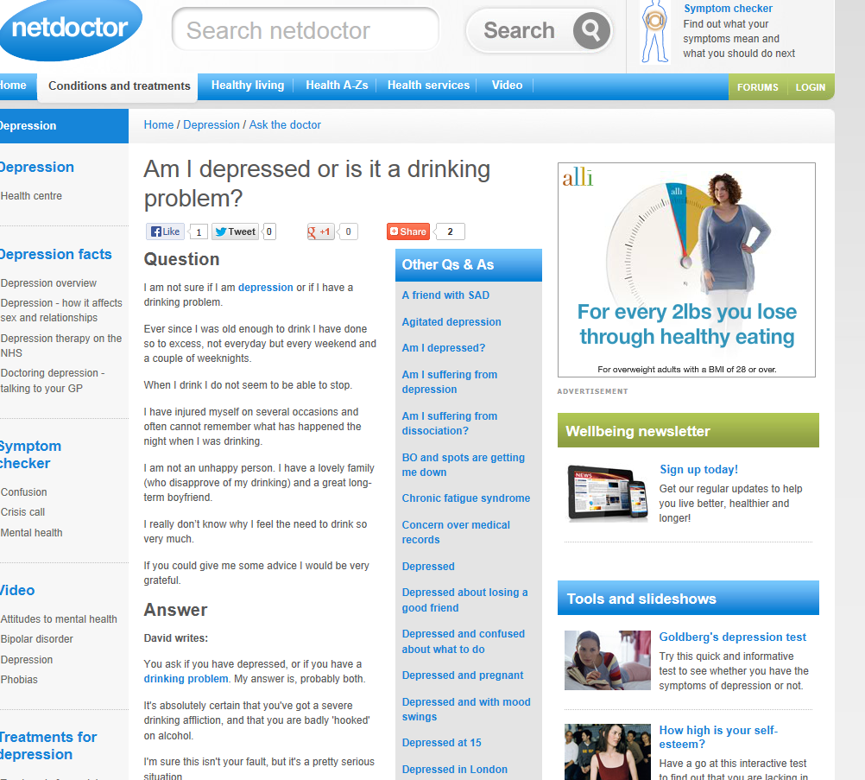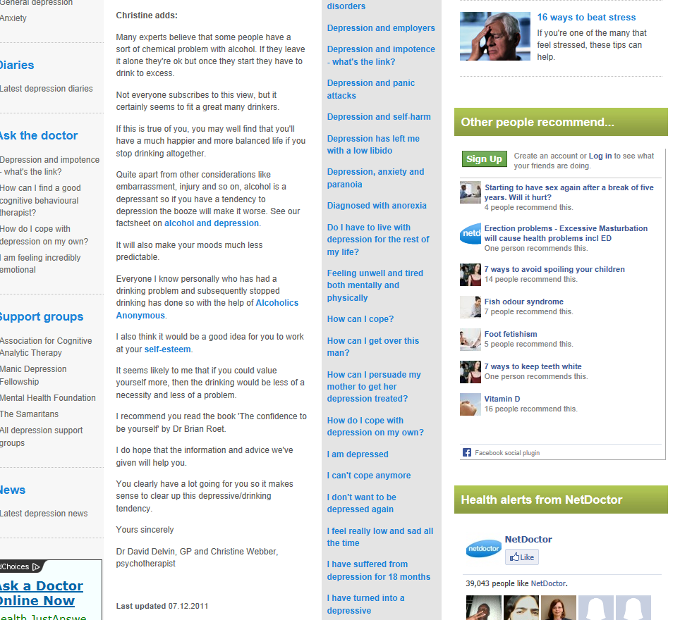
Appendix 2: Example of coded exchange
The coding abbreviations are the ones provided in Section 2 in correspondence with the main parameters listed.
The relevant codes in this exchange are:
V: Reference to patient’s views
Det: Reference to details mentioned by patient
E: Explanation
Enc: Encouragement
Apos: Acceptance: Positive regard
Asup: Acceptance: Unconditional support
Arej: Acceptance: Rejection of patient’s negative self evaluation
Ad/imp: Implicit advice
Ad/exp/cl: Explicit advice/ closed type.

Curly brackets are used in combination with square brackets when multiple functions are carried out within the same sentence unit.
Exchange no 2: Am I depressed?

Question
I think that I am suffering from depression and after reading about this illness I realise that I must see a doctor, but I am afraid to.
I feel down all of the time and have no motivation to do anything, including work, exercise, hobbies, even a bath at night.
I just want to read my book, watch television or go to bed.
I feel tired all of the time and people are now always saying how tired I look.
I left work today because I couldn't go through the day.
I managed to talk to a friend yesterday, he understands and thinks I should see someone. I can’t tell my boyfriend, I don't know how to.
If I go to the doctor, I'm sure they will just send me away. I don't think they'll believe anything is wrong!
I've also got a tendency to say what I think people want to hear.
I had hypnotherapy and counselling and afterwards said I felt okay. But I don't feel okay.
I hate myself, I've put on weight and look fat and ugly, I can't stand that look of hatred in my own eyes when I look in the mirror, and (although I know I be too chicken to do it) I think that maybe the best option is death.
Maybe then people won't have to put up with me anymore, always moaning and never doing anything about it. I’m so self-pitying.
I'm sorry to be doing this, but it's a release to just type out the words. To be honest, it's amazing seeing what I have written.
I haven't covered everything but will end with this. I know that I am successful in my job (I don't know how!), I have a wonderful boyfriend (too good for me, so I'm sure he'll find someone better, a lovely house, a car, thinking of having a baby (but I don't want to be a bad mother).
So why do I feel a failure?
Why do I hate myself?
I know I need help, but don't really know how to go about it.

Answer
[You are absolutely right that you are almost certainly suffering with a degree of depression] [V].
[Your {lack of motivation} {feeling down for no reason}, {no interest in work or hobbies}, {constantly feeling exhausted} and {your physical symptoms} of headaches and {putting on weight} are all typical of this condition] {Det} + [E].
[Your {lack of self-esteem} {Det} and the fact that you have contemplated death as being the best option is suggestive that your depression is relatively severe] [E].
[The good news is that your depression is eminently treatable]. [Enc]
[It's great you have a wonderful boyfriend and are successful in your job] [Enc], [and it is a wonderful credit to you that you have managed to continue functioning efficiently whilst feeling as bad as you do] [Apos].
[You're also very sensible to postpone having a baby at the current time] [Apos]. Pregnancy is a huge undertaking and you need to be really happy and healthy before embarking on this life-changing course [Ad/imp].
[Depression is very common] [Asup] and [almost always temporary] [Enc].
[Most people will suffer from it at some stage in their lives, and 10 per cent of the population actually need hospital admission to overcome it] [Asup].
[You are not alone] [Asup], and [you certainly do not need to feel bad or guilty about feeling in low spirits] [Arej].
[First of all go and see your doctor and be totally open and honest with them so that your treatment may begin] [Adv/expl/cl].
[Take your boyfriend with you if you wish, having spoken to him about how you feel first] [Adv/exp/cl].
[Treatment usually consists of expert psychotherapy together with modern antidepressant drugs] [E], which are [quickly effective and have minimal side effects when used correctly] [E+ Enc].
[The chances are that within two to three weeks you will be feeling a great deal better, and that in two to three months you will feel completely back to normal] [Enc].
[You owe this to yourself] [Asup] and [you deserve the very best treatment] [Asup].
Yours sincerely
The Netdoctor Medical Team

