Environmental and diagenetic records from trace elements in the Mediterranean coral Cladocora caespitosa

S.H. Royle^{1*}, J.E. Andrews¹, J. Turner¹, P. Kružić²
1: School of Environmental Sciences, University of East Anglia, Norwich, England, NR4 7TJ, UK.
2: Laboratory for Marine Biology, Department of Zoology, Faculty of Science, University of Zagreb, Rooseveltov trg 6, 10000 Zagreb, Croatia.
*Corresponding author: E-mail: s.royle@uea.ac.uk; Telephone: 07986636602

Abstract
Trace element contents in coralline aragonite have long been used as proxies to record environmental growth conditions such as sea surface temperature (SST). In this study we explored whether trace element contents in modern and fossil corals (Cladocora caespitosa) from the Mediterranean could help constrain SST temperature and seasonality of climate in late Pleistocene interglacials. In modern Adriatic C. caespitosa, the individual corallite Sr/Ca signal captures seasonal variation with up to 68% of the variance related to SST. A similar but weaker relationship is shown by Mg/Ca. However, published equations to quantify absolute water temperature from Sr and Mg contents in modern C. caespitosa did not yield consistent or credible results, because each corallite exerts a strong, non-predictable ‘vital effect’. With no constant species-specific offset from equilibrium, temperature-trace element relationships become, at best, colony specific and unsuitable for absolute palaeotemperature reconstruction. Despite this, temperature-related cyclicity in Sr and Mg is preserved in corallites up to at least MIS 7 age, allowing identification of seasonality in SST. In addition, unusual trace element anomalies in modern C. caespitosa can inform on events such as sediment discharge into the coastal zone. Partial diagenetic alteration of fossil C. caespitosa skeletons from aragonite to calcite destroys original SST driven cyclic trace element signals and is an effective indicator of corallite preservation quality.
Key Words
Palaeoclimate; Corals; Trace elements; LA-ICP-MS; Pleistocene; Mediterranean.

Introduction
While there is a large body of data available from terrestrial and marine proxies to reconstruct Mediterranean palaeoclimatic conditions in the interglacials of the late Pleistocene (e.g. Affek et al., 2008; Bar-Matthews et al., 2003; Cheddadi et al., 2005, 1996; Couchoud et al., 2009; Drysdale et al., 2005; Fontugne and Calvert, 1992; Frogley, 1999; Kukla et al., 1997; Martrat et al., 2004; Roberts et al., 2008; Thunell and Williams, 1983; Tzedakis et al., 2003) most of these proxy records are of too low resolution to reveal sub-annual or (in most cases) even sub-decadal detail. There are thus few available data sets recording high resolution, sub-seasonal temperature ranges for previous interglacials in the Mediterranean region. While thick shelled bivalves are one potential archive ((Maier and Titschack, 2010; Schöne et al., 2005)) a good option in the Mediterranean is the coral Cladocora caespitosa (Silenzi et al., 2005; Montagna et al., 2007; Royle et al., 2015). These studies showed the feasibility of extracting high resolution (approximately weekly) geochemical records from modern samples of this coral as a proxy for SST. Silenzi et al. demonstrated significant correlation between Sr/Ca content in the autumn-winter growth bands and SST at the inter-annual timescale studied; Montagna et al. found close relationships between trace element ratios (Sr/Ca, B/Ca, Mg/Ca, U/Ca, Ba/Ca) at ~weekly resolution; in particular, B/Ca ratios showed strong correlation with variations in SST; Royle et al. found that coralline δ¹⁸O can preserve high resolution SST records back to at least Marine Isotope Stage (MIS) 7.
Here we build on the work of Montagna et al. (2007), using high resolution trace element analysis of both modern and fossil C. caespitosa to help constrain and understand changes in the seasonality of climate in late Pleistocene interglacials. To do this we set ourselves the following nested questions. (1) Can trace elements in modern C. caespitosa record absolute temperatures, quantitatively? If not, (2) can trace elements in modern C. caespitosa return relative temperature changes? If not, (3) do the trace elements in C. caespitosa record only qualitative information.
Our focus was thus on trace element/Ca ratios that are known to show temperature dependency during uptake into coralline aragonite: e.g., Li (Hathorne et al., 2013; Montagna et al., 2014), B (Montagna et al., 2007; Trotter et al., 2011), Sr (Beck et al., 1992; Marshall and McCulloch, 2002; McCulloch et al., 1994; Montagna et al., 2007; Silenzi et al., 2005; Weber, 1973), Mg (Mitsuguchi et al., 1996; Montagna et al., 2007; Silenzi et al., 2005; Sinclair et al., 1998), Ba (Lea et al., 1989; Montaggioni et al., 2006; Montagna et al., 2007), U (Montagna et al., 2007; Rong Min et al., 1995; Sinclair et al., 1998). We also measured element proxies for changes in nutrient availability and sediment supply: e.g., Ba (Alibert et al., 2003; Montaggioni et al., 2006) and P (LaVigne et al., 2010; Montagna et al., 2006), and lithogenic elements (Fe, Zn, Na, K) to assess changes in sediment input, contamination and diagenetic alteration.
C. caespitosa is a colonial, generally ahermatypic, constructional, zooxanthellate coral (Schuhmacher and Zibrowius, 1985) that lives in the photic zone. Modern C. caespitosa mostly live in water depths of 7-25 m, although they can be found down to 40 m where waters are clear enough for light to penetrate (Rodolfo-Metalpa et al., 2008). Fossil assemblages are thus most likely to have lived in water depths <25 m.
Extensive biostromes of C. caespitosa are very rare in the Mediterranean/Adriatic today, however, large banks dominated by this species were much more widespread in earlier interglacials of the late Pleistocene to mid Holocene (e.g. Bernasconi et al., 1997; Houghton et al., 2003; Leeder et al., 2003; Mastronuzzi et al., 2003; Peirano et al., 2009; Pirazzoli et al., 1997) suggesting that growing condition were more favourable. In southern Italy and in the Gulf of Corinth, Greece, these corals have been used extensively for U/Th dating of uplifted marine terraces (Houghton et al., 2003; Leeder et al., 2003, 2005; Peirano et al., 2009; Pirazzoli et al., 1997; Roberts et al., 2009) such that there is readily accessible study material from deposits that already have secure chronology.
Like all other shallow-water scleractinian corals, modern C. caespitosa secretes an aragonite skeleton with average growth rates between 1.36 to 5.2 mm yr⁻¹ (Peirano et al., 1999; Peirano et al., 1998). Annual pairs of visible growth bands are formed by two growth processes (1) lengthening of the corallite wall and (2) internal fusion of skeletal elements. Corallite wall lengthening is dominant in summer producing low density bands, while internal fusion dominates during winter producing high density bands. This is related to the seasonal change in water temperature and irradiation and appears to be unrelated to the growth depth of the colony (Peirano et al., 1999).
As with tropical reef-building corals (e.g. Allison & Finch, 2004; Armid et al., 2011; Correge, 2006; Lea et al., 1989; Mitsuguchi et al., 1996), both the stable isotopic and trace elemental compositions of C. caespitosa represent a natural archive for the physical and chemical features of the surrounding environment (Silenzi et al., 2005; Montagna et al., 2007; Royle et al., 2015). Although C. caespitosa does not incorporate either trace elements or stable isotopes into skeletal aragonite under equilibrium conditions (Cohen & McConnaughey, 2003; McConnaughey, 1989; McConnaughey, 1989; Rollion-Bard et al., 2011; Weber & Woodhead, 1972), changes in trace element content may still be related to SST variation if the vital effects can be understood or corrected for.

Materials and Methods
Living corallites were collected from the C. caespitosa bank in Lake Veliko Jezero, on the Island of Mljet in Croatia (42°46’08’’N; 17°22’ 26’’E; Figure 1) on the 21st September 2012. This is the largest known living bank of C. caespitosa approximately 650 m in areal extent in water depths of 4-18 m. This locality is well studied with extensive water parameter data (Kružić and Benković, 2008; Kružić and Požar-Domac, 2003; Kružić, 2002; Kružić et al., 2008).
Figure 1 Map showing location of Mljet Island, Croatia: box in (A) delineates Mljet National Park; (B) Island of Mljet and surrounding region; (C) Mljet C. caespitosa bank sampling and monitoring stations. Depths to the lake bed indicate gradient of slope.
Fossil material was collected from various localities around the Gulf of Corinth, Greece, especially on the western Perachora Peninsula (Figure 2) where uplifted shallow marine terrace ages are mapped with confidence back to MIS 7 (Leeder et al., 2005, e.g. 2003; Turner et al., 2010). The MIS 7 samples are attributed to either MIS 7a or 7c (MIS 7a/c) as neither the U/Th ages, nor the terrace elevations, allow confident separation of these highstand deposits (Leeder et al., 2005). Localities were selected (Table 1) where material showed no obvious recrystallization or secondary cement growth visible by hand lens, minimal algal encrustation, endolithic boring or iron staining, and limited sediment infill in corallite cavities. Multiple samples in ‘life position’ were collected from colonies that had already been screened for mineralogical purity by combined X-ray diffraction, scanning electron microscopy (SEM) and trace element geochemistry (Leeder et al.2005; Turner et at., 2010).
Figure 2 Map of the Gulf of Corinth fossil C. caespitosa sampling sites. (A) Greece with study area (box); (B) Gulf of Corinth with major faults: ML = Mavra Litharia; X = Xylocastron; C = Corinth; Is = Isthmus of Corinth, P= Perachora; box marks Perachora Peninsula; (C) Perachora Peninsula; stars mark sample localities, GP = Goat Point; LV = Lake Vouliagmeni; WM = West Makrugoaz Ridge; WF = West Flagnoro Bay.
Table 1 Fossil site descriptions
Location | MIS and radiometric age | Lithology and preservation potential | Sample ID
West Makrugoaz Ridge  38°01’21.8’’N; 22°52’49.8’’E  23 m above modern SL | MIS 5e; deposit U-Th dated to 108-133ka (Leeder et al., 2003) | Bioclastic marls, partially cemented by syndepositional marine aragonite. Preserved as terrace remnant on ridge at 23 m modern elevation. Preservation potential is high, the site is arid, and the coral aragonite returns consistent U/Th dates. | SHR 02/11/11-08 (I)  SHR 02/11/11-08 (II)
West Flagnoro Bay 38°01’11.1’’N; 22°53’33.5’’E  19 m above modern SL | MIS 5e, correlated to dated terraces by mapping (Leeder et al., 2005, 2003) | Bioclastic marls, preserved as terrace remnant on ridge flank. Preservation potential is medium-high as the site is arid. | SHR 04/11/11-10
Goat Point  38°02’45.17’’N; 22°52’49.72’’E  2-3 m above modern SL | MIS 5e, correlated to dated terraces by mapping (Leeder et al., 2005, 2003) | Bioclastic marls, terrace remnant, down faulted before MIS 5a/c and immersed in seawater during MIS 5a/c. Currently in the modern seawater splash zone. Preservation potential is medium-low, the coral aragonite returns inconsistent U/Th dates and SEM images show evidence of patchy diagenetic alteration. | JEA 010626-04
Lake Vouliagmenis, 38°01’55.2’’N; 22°52’14.1’’E  25 m above modern SL | MIS 7a/c; Deposit U-Th dated to 186-195ka (Leeder et al., 2005) | Bioclastic marls, preserved as terrace remnant on ridge flank. Preservation potential is medium-high, the site is arid and the coral aragonite returns mostly consistent U/Th dates. | SHR 02/11/11-02 (I)  SHR 02/11/11/-02 (II)
Corals were bleached in 30% H₂O₂ overnight to oxidise organic tissue (only modern samples), sonicated with deionised water, scraped clean, and then further sonicated to ensure removal of all surface contaminants (Figure 3). Corallites were then cut in half parallel to growth direction with a wire saw to expose longitudinal sections. Half the corallite was studied by SEM (Figure 4) to screen for micro-scale diagenetic alteration, syndepositional marine cement growth and trapped detritus, all of which may compromise the geochemical signature of primary coralline aragonite (Cohen & Hart, 2004; Montaggioni et al., 2006; Montagna et al., 2007; Silenzi et al., 2005). In agreement with Montagna at al., (2007) the solid wall-regions of the corallite appeared most resistant to alteration and so these regions were targeted for analysis. Sample JEA 010626-04 was used as an example of a coral that showed partial wall-region alteration.
Figure 3 Modern (top) and MIS 5e (bottom) C. caespitosa samples after cleaning.
Figure 4 SEM images showing (A) original well-preserved skeletal aragonite crystals in a modern C. caespitosa; and (B) diagenetically altered corallite wall where blocky calcite has replaced original aragonite in a poorly preserved MIS 5e C. caespitosa.
Laser Ablation - Inductively Coupled Plasma - Mass Spectrometry (LA-ICP-MS)
Trace elements were analysed on a Thermo-Electron X Series ICP-MS using a New Wave Research UP-213 Laser Ablation System and argon carrier gas, calibrated before each sample run using NIST glass standards 610 and 612 (using NIST published values from http:nist.gov/srm). However, as the laser coupled better with the carbonate matrix of the samples than the silicate glass of the standards, the derived values were overestimations. The data were corrected using ⁴³Ca = 38% as an internal standard against which to normalise other element concentrations to 100% CaCO₃ (aragonite). These calibrations reduce the effect of fluence variation between runs.
The corallite wall areas for analysis were pre-ablated in a continuous tract to remove surface contamination, especially metals derived from cutting the samples. Pre-ablation settings of 250 μm spot size, 90% laser output, 12 Hz repetition rate, 10 μms⁻¹ scan speed, 5 μm depth per pass were used
Sample analysis was carried out using individual discrete laser spots to achieve an optimum signal to noise ratio rather than a continuous tract (cf. Montagna et al. 2007). The optimum settings were found to be: 75 μm spot size, 55% laser output, 4 Hz repetition rate, and 40 s dwell time. Laser spots were placed every 200 μm along the corallite wall, parallel to the direction of growth to achieve approximately fortnightly data resolution. SEM analysis of the samples showed well-focused evenly spread ablation pits.
The detectors in the mass spectrometer were set up to record the concentrations of the stable isotopes: ⁷Li, ¹¹B, ²³Na, ²⁴Mg, ²⁷Al, ³¹P, ³⁹K, ⁴³Ca, ⁵⁵Mn, ⁵⁶Fe, ⁶⁵Cu, ⁶⁶Zn, ⁸⁶Sr, ¹³⁵Ba, ²³⁸U.
Calibrated concentrations were transformed to trace element/⁴³Ca notation to facilitate inter-comparison with literature data.
Reproducibility (Supplementary Table 1) was conducted on compositionally homogeneous abiotic marine aragonite cement. Two lines, parallel to crystal c–axes, were pre-ablated and 6 spots analysed along each, using identical laser settings to those for coralline aragonite.
Sr, Mg and Ba data were highly reproducible with RSD’s of 3.9% for Sr, 4.4% for Ba and 9.4% for Mg and for this reason were the elements of main focus in this study. U (11.9%), B (12.3%) and to a slightly lesser extent Na (22.8%) and P (25.4%) had acceptable reproducibility. Elements with low reproducibility (RSD>100%) were the metallic elements normally present in low concentrations and not generally resolvable from background.

Results
The mean trace element concentrations and trends in trace element distributions of all analysed C. caespitosa samples are summarised in Table 2. In all samples, Na, Sr, and Mg had concentrations at least an order of magnitude higher than other elements.
Table 2 Summary of the average trace element concentrations (reported as X/Ca where X is the trace element measured) and main trends of trace element distribution in all LA-ICP-MS analysed C. caespitosa samples. Trace element/⁴³Ca (varying units) ratios are normalised to 100% aragonite (CaCO₃) using internal standard ⁴³Ca = 38%. Abbreviations describing trends are as follows: A.S.C. = Annual Scale Cyclicity, the following number shows number of cycles recorded, (N.) denotes a noisy signal; L.F.C. = Low Frequency Cyclicity, the following number shows number of cycles recorded; ‘Spike’ identifies a signal dominated by a high magnitude, low frequency spike; L.T.G. = Long Term Gradient, the following number shows number of cycles overprinted on this if applicable; H.F.N. = High Frequency Noise (no obvious trend).
Element | PK 21/09/12-01(I) | PK 21/09/12-01(II) | PK 21/09/12-02(II) | PK 21/09/12-05 | PK 21/09/12-06 | SHR 02/11/11-08(II) | SHR 04/11/11-10 | JEA 010626-04 | SHR 02/11/11-02(I) | SHR 02/11/11-02(II)
Element | Modern |  |  |  |  | MIS 5e |  |  | MIS 7a/c
⁷Li (µmol/mol) | -  - | 12.23  H.F.N. | 11.86  H.F.N. | 17.90  H.F.N. | 15.26  A.S.C. 6/7 | 73.82  H.F.N. | 104.87  H.F.N. | 29.81  H.F.N. | 7.00  H.F.N. | 3.82  H.F.N.
¹¹B (mmol/mol) | 1.08  Spike | 0.75  A.S.C. 7 | 0.76  A.S.C. 8 | 1.02  H.F.N. | 1.08  A.S.C. 6/7 | 0.81  A.S.C.  8 | 0.93  A.S.C. 8 | 1.08  S.C. 6/7 | 1.02  A.S.C. 7 | 1.00  A.S.C.  8
²³Na (mmol/mol) | 25.16  Spike | 22.48  H.F.N. | 27.87  A.S.C. 8 | 25.12  H.F.N. | 24.92  L.F.C. 4 | 25.61  H.F.N | 31.18  H.F.N. | 24.56  L.T.G. | 16.70  S.S. 6/7 | 13.67  H.F.N.
²⁴Mg (mmol/mol) | 4.89  A.S.C. (N.) 9.5 | 5.04  A.S.C. 7 (N.) | 5.30  A.S.C. 8 (N.) | 6.00  A.S.C. 6/7 | 5.99  A.S.C. 6/7 | 4.37  A.S.C. 8 | 5.14  A.S.C. 8 | 4.98  H.F.N. | 5.82  A.S.C. 7 | 5.97  A.S.C. 8
²⁷Al (mmol/mol) | 0.16  Spike | 0.01  H.F.N. | 0.02  H.F.N. | 0.02  H.F.N. | 0.03  - | -  - | -  - | 0.07  H.F.N. | -  - | -  -
³¹P (mmol/mol) | -  - | -  H.F.N. | 0.1  H.F.N. | 0.02  H.F.N. | 0.02  - | 0.25  H.F.N. | 0.34  H.F.N. | 0.22  H.F.N. | 0.20  H.F.N. | 0.09  H.F.N.
³⁹K (mmol/mol) | 1.41  Spike | 0.05  H.F.N. | 0.58  H.F.N. | 0.61  A.S.C. 6/7 | 0.53  L.F.C. 4 | 0.23  H.F.N. | 0.32  H.F.N. | 0.48  H.F.N. | 0.54  H.F.N. | 0.45  H.F.N.
⁵⁵Mn (mmol/mol) | -  - | -  - | -  - | -  - | 0.01  - | 0.01  H.F.N. | 0.01  H.F.N. | 0.04  H.F.N. | -  - | -  -
⁵⁶Fe (mmol/mol) | 0.04  Spike | -  - | -  -. | 0.01  - | 0.01  H.F.N. | 0.02  H.F.N. | 0.21  H.F.N. | 0.05  H.F.N. | 0.04  H.F.N. | 0.03  H.F.N.
⁶⁵Cu (mmol/mol) | 0.02  Spike | -  - | -  - | -  - | -  - | -  - | 0.01  H.F.N. | -  - | -  - | -  -
⁶⁶Zn (mmol/mol) | 0.02  Spike | -  - | -  - | -  - | -  - | -  - | -  - | -  - | -  - | -  -
⁸⁶Sr (mmol/mol) | 10.13  A.S.C. 9.5 | 11.19  A.S.C. 7 | 10.29  A.S.C. 8 | 11.38  A.S.C. 6/7 | 10.92  A.S.C. 6/7 | 9.06  A.S.C. 8 | 7.97  A.S.C. 8 | 13.30  S.C.  6/7 | 10.35  A.S.C. 7 | 10.65  A.S.C. 8
¹³⁵Ba (mmol/mol) | 0.01  A.S.C. 9.5 | 0.01  A.S.C. 7 | 0.01  A.S.C. 8 | 0.01  A.S.C. 6/7 | 0.01  A.S.C. 6/7 | 0.04  A.S.C. 8 | 0.02  H.F.N. | 0.06  S.C. 6/7 | 0.02  A.S.C. 7 | 0.03  H.F.N.
²³⁸U (µmol/mol) | 1.42  A.S.C. 9.5 | 1.14  A.S.C. 7 (N.) | 0.83  A.S.C. 8 (N.) | 1.03  A.S.C.  6/7 | 0.93  A.S.C. 6/7 | 1.06  A.S.C. 8 | 0.69  A.S.C. 8 | 0.02  A.S.C. 7 |  | 2.04  A.S.C.  8
Discussion of results
By plotting the trace element/⁴³Ca values against distance from the start of the analysed transect changes in trace element composition over the length of a corallite were produced; the data from sample PK 21/09/12-01 (I) are shown as an example (Figures 5 & 6), the trends in other sample data being much the same. These trace element profiles have been smoothed using a 4-point running median, to reduce noise and to highlight trends over seasonal scales. Figure 5 shows that for the majority of trace elements present in measureable concentrations there are clear variations in their distribution along the length of the corallite.
Patterns in the distribution of trace elements (Table 2; Figure 5) group into three categories:
- Elements that show clear cyclicity, typically, Mg, Sr, Ba, B and U. These elements have cycles that approximately match the number of years’ growth of the corallite, based on the location of pairs of seasonal growth bands following Peirano et al. (2005). These cycles are thus interpreted as annual features related to the development of the growth bands and suggesting that there is a temperature, or other annual-scale, signal preserved by trace element content. Within each sample these elements generally show similar patterns suggesting a common control on their uptake. Where cyclic elemental traces are plotted, Mg/Ca is shown with a reversed y-axis for easy comparison, as this element’s cycles have reverse polarity relative to other elements.
- Elements with a low frequency, high magnitude spike, apparently overprinting signals that are otherwise be cyclic (seen in sample PK 21/09/12-01(I) with Al, B, Cu, Fe, Zn).
- Elements present in measureable quantities but with no discernible trends; the signal of these traces is apparently high frequency ‘noise’, typically Al, K, Li, Na, P (not figured).
Figure 5a PK 21/09/12-01, trace element profiles with clear cyclic trends. 9.5 cycles are visible and these are most obvious in Ba and Sr. Vertical lines separate complete cycles.

Figure 5b PK 21/09/12-01, trace element profiles showing high magnitude, low amplitude spike. B/Ca shows a degree of cyclicity until this is partially overprinted by the spike (K/Ca and P/Ca shown separately in Figure 12).
Although a number of trace element records show apparent annual-scale cyclicity, Sr and Mg have the clearest signal and became a focus of our study. The cyclic signal in these corals has similar form to that of δ¹⁸O, attributed mainly to seasonal variation in water temperature (Royle et al. 2015; Figure 6). Water temperature is a primary control on uptake of trace elements and incorporation into biogenic aragonite (e.g. Beck et al., 1992; Montagna et al., 2007; Rong Min et al., 1995; Silenzi et al., 2005) and Sr and Mg are commonly used as palaeothermometers in coralline aragonite (e.g. Beck et al., 1992; Marshall & McCulloch, 2002; McCulloch et al., 1994; Mitsuguchi et al., 1996).
Figure 6 Modern Croatian C. caespitosa sample PK 21/09/12-01 δ¹⁸O and Sr/Ca profiles normalised to the same time series; both profiles show similar annual sinusoidal cycles, interperted as mainly water temperature change (δ¹⁸O data from Royle et al. (2015)
Strontium uptake in coralline aragonite has a negative relationship with seawater temperature (Alibert and McCulloch, 1997; Beck et al., 1992; de Villiers et al., 1994; Marshall and McCulloch, 2002; Montagna et al., 2007; Sayani et al., 2011; Silenzi et al., 2005; Weber, 1973) and Mg uptake a positive relationship (Mitsuguchi et al., 1996; Montagna et al., 2007; Silenzi et al., 2005; Sinclair et al., 1998). Temporal normalisation of the data assumed that each Sr peak maxima/Mg peak minima corresponded to the time of the year with the lowest seawater temperatures at this locality (January/February); similarly each Sr trough minima/Mg peak maxima corresponded to the time of the year with the highest seawater temperatures (August/September).
This approach produced cycles with similar magnitude and shape in separate samples. These are shown in Figure 7, which also shows mean monthly in situ measured SST data for reference (obtained from the Croatian Meteorological and Hydrological Institute). The high amplitude 2008-2009 ‘summer’ peak and the particularly low amplitude 2009-2010 ‘summer’ peak, are clear examples of coherence between samples.
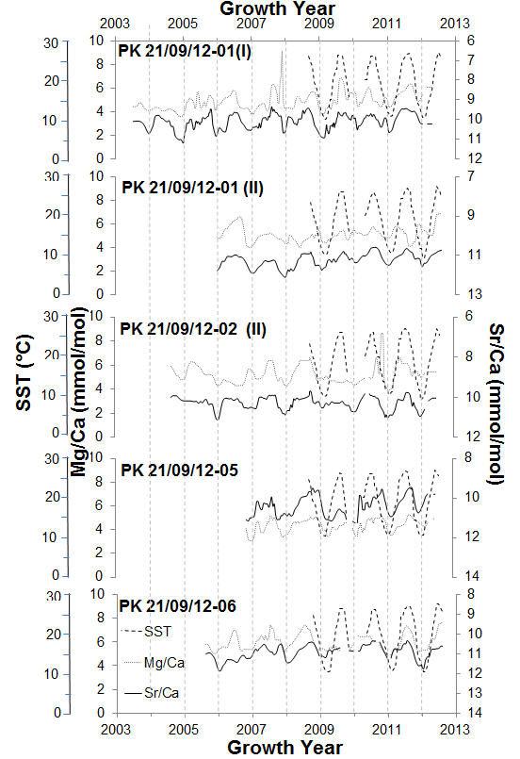
Figure 7 Modern Croatian C. caespitosa samples (PK 21/09/12) Sr/Ca and Mg/Ca profiles normalised to a time series with in situ measured SSTs (from September 2008 when recording started). Intra-year trends can be matched between corallite samples, e.g. the high amplitude 2008-2009 ‘summer’ peak and the particularly low amplitude 2009-2010 ‘summer’ peak are clear in most samples. Mean monthly SST data for Lake Veiko Jezero (obtained by the Croation Meterorological and Hydrological Institute) shown for reference.
Comparison of the strength of relationship (R²) between mean annual Sr/Ca with mean in situ measured SSTs demonstrates the ability of coral skeletal chemistry to capture inter-annual temperature variability (Table 3). The data show that up to 40% of the inter-annual variability in SST can be captured by the Sr/Ca signal. However, we note the R² values are variable and not statistically significant (p = 0.1-0.52) probably due to the small number (maximum 7) of years of SST data available.
Table 3 Mean annual in situ measured SSTs and mean annual Sr/Ca values for each modern C. caespitosa sample. R² values are shown for each annual Sr/Ca vs annual SST relationship, note that P values are all high and show that any relationships are not statistically significant due to the small size of the data sets.
Year | SST (°C) | Sr/Ca (mmol/mol)
Year | SST (°C) | PK 21/09/12  -01(I) | PK 21/09/12  -01(II) | PK 21/09/12  -02(II) | PK 21/09/12  -05 | PK 21/09/12  -06
2004 | 20.1 | 10.33 | - | - | - | -
2005 | 20.3 | 10.19 | - | 10.25 | - | -
2006 | 20.5 | 10.22 | 11.25 | 10.35 | - | 11.37
2007 | 20.2 | 10.04 | 11.55 | 10.23 | 11.48 | 10.78
2008 | 20.3 | 10.01 | 11.41 | 10.25 | 11.24 | 10.85
2009 | 20.5 | 10.18 | 11.22 | 10.36 | 11.57 | 10.88
2010 | 19.8 | 10.04 | 11.00 | 10.25 | 11.26 | 10.63
2011 | 19.1 | 9.91 | 11.03 | 10.39 | 11.32 | 10.88
R² |  | 0.40 | 0.35 | 0.09 | 0.21 | 0.14
P |  | 0.1 | 0.21 | 0.52 | 0.43 | 0.46

The temporally normalised Sr/Ca data was also regressed onto the in situ measured SST (Figure 8). While these regressions of Sr/Ca are implicitly ‘tuned’ to winter/summer temperature extremes (see above) such that R² values are probably overestimated, the relationships between Sr/Ca and SST are strong: R² values (Figure 8) suggest temperature is the main control on strontium uptake (47-68% of the variance in Sr/Ca related to changes in SST). The relationships between Mg/Ca and SST are less convincing with R² ranging between 0.07-0.42 (Figure 8). Overall the relationships suggest that intra-annual changes in SST are captured by the Sr/Ca record of an individual coral. However, the slopes and intercepts of the regression lines for each coral are significantly different from each other, suggesting intra-site variability in the relationship between Sr/Ca and SST. This type of variability has been demonstrated in other studies (de Villiers et al., 1994) and is clearly an issue for absolute SST reconstructions using fossil corals.
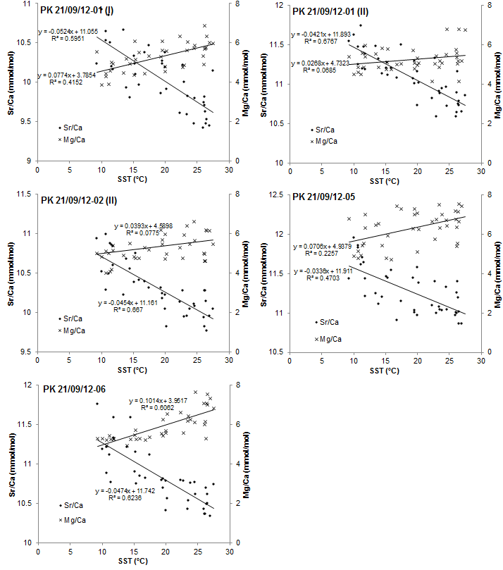
Figure 8 Linear regressions between Sr/Ca, Mg/Ca vs. in situ measured SST for all modern C. caespitosa samples. Note that while all R² values are similar the gradients and intercepts of the regression lines are different.

The mean annual SST at Mljet between 2003-2010 was 20.3°C (Kružić et al., 2012), with a mean summer maximum of 27.5°C and mean winter minimum of 11°C (data obtained from the Croatian Meteorological and Hydrological Institute, analytical error ˂0.2°C). The seasonal range is reduced (26 to 14°C) in the deeper (~15 m) water parts of the coral bank. As the temperatures of growth are known it is thus possible to test the validity of published C. caespitosa trace element/Ca palaeothermometers.
Silenzi et al. (2005) and Montagna et al. (2007) both published equations for the relationships between Sr/Ca and Mg/Ca and SST for C. caespitosa:
Equation 1: Sr/Ca(mmol/mol) = 11.25(±0.38) - 0.079(±0.026) ∙ SST(ºC)
(r² =0.36)
(Silenzi et al., 2005)
Equation 2: Sr/Ca(mmol/mol) = 10.50(±0.13) - 0.073(±0.006) ∙ SST(°C)
(r² = 0.52)
(Montagna et al., 2007)
Equation 3: Mg/Ca (mmol/mol) = -4.41(±3.10) +0.55(±0.21) ∙ SST (ºC)
(r² = 0.29)
(Silenzi et al., 2005)
Equation 4: Mg/Ca (mmol/mol) = 1.66(±0.28) + 0.121(±0.013) ∙ SST (°C)
(r² = 0.36)
(Montagna et al., 2007)
The calculated SSTs for the modern Mljet National Park corals are summarised in Table 4 and Figures 9 and 10.

Table 4 Summary of temperatures calculated from modern Croatian (PK 21/09/12) Sr and Mg compositions using the published equations. Equations 1 and 2 are the Silenzi et al. (2005) Sr/Ca-SST and Mg/Ca SST calibration equations, Equations 3 and 4 are the Montagna et al. (2007) Sr/Ca-SST and Mg/Ca-SST calibration equations. Analytical error (RSD) on the Sr/Ca ratios corresponds to uncertainties of ±4.90°C and ±5.31°C and on the Mg/Ca ratios of ±0.86°C and ±3.90°C for the Silenzi et al. (2005) and Montagna et al. (2005) equations respectively.
 |  | Equation | PK 21/09/12-01(I) | PK 21/09/12-01(II) | PK 21/09/12-02(II) | PK 21/09/12-05 | PK 21/09/12-06
Sr/Ca-calculated average SSTs (°C) | Summer maximum | 1 | 21.5 | 5.1 | 16.7 | 3.48 | 8.4
Sr/Ca-calculated average SSTs (°C) | Summer maximum | 2 | 13.0 | -4.7 | 7.8 | -6.5 | -1.1
Sr/Ca-calculated average SSTs (°C) | Winter minimum | 1 | 6.2 | -5.4 | 5.6 | -9.1 | -1.3
Sr/Ca-calculated average SSTs (°C) | Winter minimum | 2 | -3.6 | -16.1 | -4.2 | -20.1 | -11.8
Sr/Ca-calculated average SSTs (°C) | Annual Range | 1 | 15.3 | 10.5 | 11.0 | 12.5 | 9.8
Sr/Ca-calculated average SSTs (°C) | Annual Range | 2 | 16.6 | 11.4 | 12.0 | 13.6 | 10.7
Sr/Ca-calculated average SSTs (°C) | Annual Average | 1 | 14.2 | 0.7 | 12.2 | -1.7 | 4.2
Sr/Ca-calculated average SSTs (°C) | Annual Average | 2 | 5.1 | -9.5 | 2.9 | -12.1 | -5.7
Mg/Ca-calculated average SSTs (°C) | Summer maximum | 3 | 19.8 | 18.5 | 19.8 | 20.7 | 20.7
Mg/Ca-calculated average SSTs (°C) | Summer maximum | 4 | 40.0 | 33.8 | 39.6 | 41.1 | 44.0
Mg/Ca-calculated average SSTs (°C) | Winter minimum | 3 | 15.4 | 16.2 | 16.1 | 16.9 | 17.5
Mg/Ca-calculated average SSTs (°C) | Winter minimum | 4 | 19.8 | 23.6 | 22.8 | 26.7 | 29.3
Mg/Ca-calculated average SSTs (°C) | Annual Range | 3 | 4.4 | 2.2 | 3.7 | 3.8 | 3.2
Mg/Ca-calculated average SSTs (°C) | Annual Range | 4 | 20.2 | 10.2 | 16.8 | 14.4 | 14.8
Mg/Ca-calculated average SSTs (°C) | Annual Average | 3 | 16.9 | 17.2 | 17.1 | 18.9 | 18.9
Mg/Ca-calculated average SSTs (°C) | Annual Average | 4 | 26.7 | 28.0 | 27.7 | 35.9 | 35.9

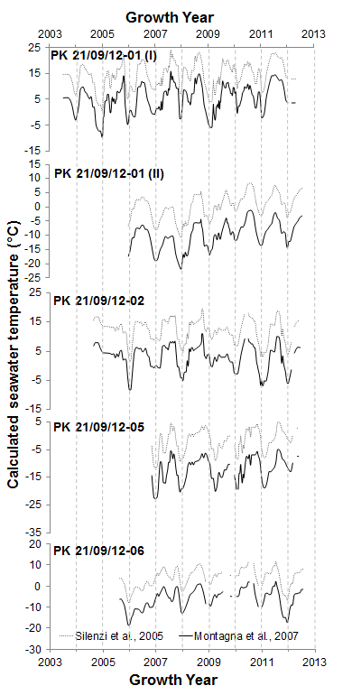
Figure 9 Sr/Ca calculated palaeotemperatures using equations published by Silenzi et al. (2005) and Montagna et al. (2007)

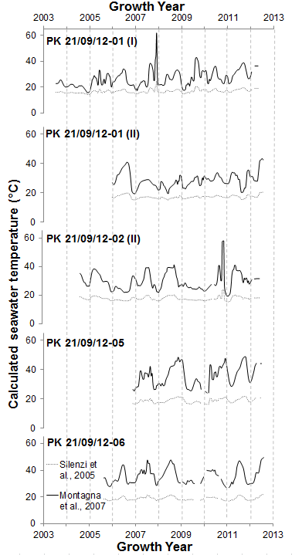
Figure 10 Mg/Ca calculated palaeotemperatures using equations published by Silenzi et al. (2005) and Montagna et al. (2007)
The temperatures derived from these equations are significantly different to each other. The Sr/Ca derived temperatures from Equation 2 are ~10°C cooler than those from Equation 1. Moreover, both equations yield negative temperatures that are too low to be credible. For Mg/Ca derived temperatures, Equation 3 provides a reasonably realistic average temperature for each sample but also a narrow seasonal range with less than 5°C variation. Equation 4 produces a reasonably realistic seasonal variation (15-20°C), but with temperatures that are too high (mostly between 30 to 55°C). It is also clear that there is a large degree of intra-site variation in Sr/Ca and Mg/Ca (and other trace elements) between corallites so that quite different temperatures are calculated from a single equation. As all the corals have grown within metres of each other, they should have experienced very similar growth conditions; clearly an individual corallite is not recording the actual temperature in its skeletal Sr and Mg composition.
The observed variation between samples suggests that each coral exhibits an appreciable metabolic control, a ‘vital effect’ (Urey et al., 1951), over the uptake and incorporation of trace elements from the seawater into its calcifying skeleton. This implies there is no constant, species-specific offset from equilibrium; any temperature-trace element relationship is essentially colony specific, which complicates regional-scale SST reconstruction from fossils. A reliable proxy for regional-scale temperature requires disequilibrium to be constant at least at the genus or species level (Marshall and McCulloch, 2002). These findings of intra-site variability in trace element uptake agree with some studies on tropical corals, such as Porites, where analysis of multiple colonies has highlighted issues with reproducibility of a constant Sr/Ca calibration between sites and even within the same study locality (e.g. de Villiers et al., 1994).
Intra-specific variation may be related to photosynthetic variability of the symbiotic zooxanthellae (Cohen et al., 2002) which introduces a kinetic control linked to growth rate (Cohen et al., 2001). Faster growing corals have been observed to have lower skeletal Sr/Ca than slower growing corals at the same site (de Villiers et al., 1995; Goodkin et al., 2007) and even within a single colony as low density skeleton has a higher mean Sr/Ca than higher density skeleton from the same growth horizon (Alibert and McCulloch, 1997). This occurs due to preferential ion uptake by the CA-ATPase transport pathway through the calcioblastic membrane of the coral during calcification. As Ca-ATPase has a higher affinity for Ca than Sr (Yu and Inesi, 1995), when this pump is highly active, leading to higher calcification rates, the coral’s extracellular calcifying fluid (ECF) has a depleted Sr/Ca ratio compared to seawater (due to active discrimination of the Sr ion). When the pump is switched off, or slow, then the ECF’s Sr content approaches that of seawater due to passive diffusion of seawater into the calcifying space (Cohen et al., 2001; Ip and Krishnaveni, 1991). The Ca-ATPase pump is activated by the exposure of the polyp to light, as ATP from photosynthesis is needed for active ion transport, with light triggering Ca²⁺ uptake (Al-Horani et al., 2003a, 2003b). Corals with higher rates of photosynthesis will therefore have lower Sr/Ca values.
More efficient photosynthesis may be caused by either increased exposure to light – in shallower, less turbid or less shaded patches of the colony - or because they have higher concentrations of/more active symbiotic zooxanthellae. It is conceivable that these variables could be different within one colony, for example if some corallites are shaded by the others: shade parameters will also change with time, an individual growing out of shade or becoming shaded by other corals or plants. Similarly, sediment input and water turbidity can change, C. caespitosa being quite tolerant of water turbidity (Tremblay et al., 2011).
Coral food sources such as zooplankton biomass can also vary in availability on different parts, and depths, of reefs or banks (Alldredge and King, 1977). This impacts skeletal Sr/Ca incorporation because night time calcification rate (when Sr and Ca are delivered passively to the ECF at near equilibrium levels) is primarily controlled by zooplankton availability (Houlbrèque et al., 2003) using energy from this respiration to synthesise organic molecules (Al-Horani et al., 2003b) for non-photosynthetic skeletal calcification.
The combined growth rate and temperature controls on Sr/Ca content of the precipitating aragonite is likely to extend to, and explain the variance in, other trace elements. Moreover, C. caespitosa is particularly well adapted to living in turbid waters due to its combined reliance on autotrophy and heterotrophy (Peirano et al., 2004): this means the relative reliance on autotrophy/heterotrophy in a particular colony could be highly variable.
It is also known that (tropical) corals under stress do not conform to the normal rules for skeletal trace element-SST relationships. At high or low temperatures highly anomalous results have been recorded (Marshall and McCulloch, 2002). Montagna et al. (2007) show that C. caespitosa ceases to calcify at temperatures below 13.8°C, a lower minimum than that of most tropical corals, which typically cease to calcify below about 16-18°C (Burns, 1985; Jacques et al., 1977; Lough and Barnes, 2000), but higher than that for Dipsastraea (Favia) speciosa (Seo et al., 2013), which is capable of accurately recording winter SST’s down to 13°C; minimum calcification temperature is thus probably another species-specific variable.
At Mljet, water temperatures are near or below the C. caespitosa minimum temperature for calcification for much of the winter (Montagna et al., 2007) while, during summer, temperatures often peak around the maximum levels this species can tolerate (Kružić, 2007; Kružić et al., 2014; Rodolfo-Metalpa et al., 2005). The Sr/Ca data from modern individual corals in this study has a similar distribution to that described in Montagna et al. (2007). Figure 11 shows clear asymmetric unimodal distributions toward lower values (corresponding to higher SST values) due to most growth occurring during the warmer summer months. In contrast the in situ mean monthly measured SST data shows a bimodal distribution with maxima at the average summer and winter values. This suggests these corals cease to calcify during much of winter as concluded by Montagna et al. (2007).
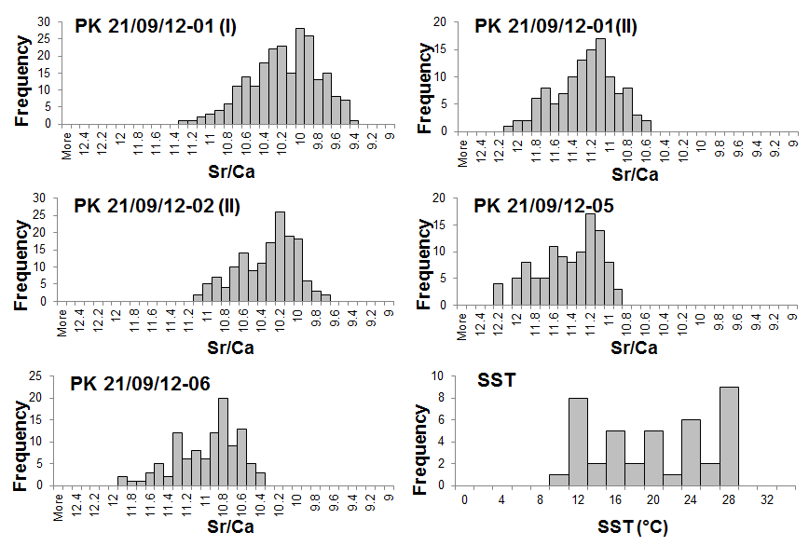
Figure 11 Histograms of Sr/Ca values for each modern C. caespitosa sample and in situ measured SSTs. Note asymmetric unimodal distribution for Sr/Ca toward lowest values and bimodal pattern for SSTs toward the average summer and winter values. Sr/Ca x-scales are inverted due to this element’s inverse relationship with SST.
The obvious variability in trace element uptake in modern C. caespitosa samples shows there is little potential for trace elements to be used for palaeothermometry if quantitative, absolute temperature reconstruction is the aim. However, as individual coral Sr/Ca variability captures seasonal variation (with up to 68% of the variance in Sr/Ca related to changes in SST) then palaeo-seasonality and inter-annual temperature change should be resolvable from individual well-preserved fossil corallites. Reconstruction of statistically significant regional seasonal variation would require analysis of multiple coral colonies to reduce the clear variability implicit in Figure 8.
Other applications for trace elements in C. caespitosa
The preserved trace element cyclicity shows that C. caespitosa records some essence of environmental conditions as it grows. There may, therefore, be potential to procure other, non-quantitative, information.
The non-cyclic profiles of PK 21/09/12-01 are dominated by a large, multi-peaked spike (Figure 5b); lithogenic elements Al, K, Fe, Cu, Zn and Na all record this feature, but the strongest records are K/Ca and P/Ca (Figures 12a, b). The spike clearly starts abruptly in late 2007, a record of an event, injecting high concentrations of these elements into seawater. The peaked pattern could be a composite of at least three smaller spikes, suggesting multiple (linked) injections followed by a quite abrupt dispersal and reduction in elemental concentrations, finishing in late 2009.
Figure 12 PK 21/09/12-01 trace element profiles showing the clearest high magnitude, low amplitude spikes in the signal; believed to be related to a large influx of sediment into the seawater. (A) K/Ca; (B) qualititative P/Ca (P content could not be calibrated accurately with the standards used in this study explaining the negative concentrations).
P/Ca content of corals records seawater concentrations (LaVigne et al., 2010; Montagna et al., 2006) which can reflect changes in biological productivity and cycling in the water column. In the Mediterranean, however, increases in phosphate content are mainly related to river-runoff and sediment supply (Béthoux et al., 1998). The other lithogenic-associated ‘spike’ elements are common in both detrital sediments and organic matter (especially P). This suggests that during 2007 an event introduced larger than normal volumes of both inorganic and organic detritus into the Croatian coastal Adriatic, probably a suspension of soil clay minerals, incorporated into the coralline skeleton as clay coatings on aragonite crystals rather than as impurities trapped in the crystal lattice (Mertz-Kraus et al., 2009). Interestingly, Ba does not record this event clearly, which contrasts with data from Alibert et al. (2003) and Montaggioni et al. (2006) who both found that Ba/Ca ratios in modern near shore corals are related to riverine sediment discharge into the coastal zone.
During the late summer of 2007, following a particularly long heat wave in Southern and Eastern Europe, widespread wildfires burned through coastal regions of Croatia affecting a total area of 1590km² (CRED, 2009; U.S. Agency for International Development, 2007; Viegas et al., 2009). When fires destroy vegetation, terrestrial sediments are destabilised such that enhanced soil erosion occurs during the following rainy season(s). This effect lasts until the hinterland vegetation is re-established, which can take years (e.g. Abram et al., 2003).
Increased sediment supply due to increased soil erosion following the 2007 wild fires fits well with the trace elemental data from this sample. Further evidence for this is the presence of organic, woody matter (possibly charcoal) preserved embedded in the inner edge of the corallite wall of PK 21/09/12-01 (Figure 13). This is only present at one horizon in the corallite at approximately 21.5 mm from the base; within error the correct position to be entrapped debris from the 2007 fires. Living corals are known to incorporate water column particulates into their skeletons within hours (Naqvi, 1994; Erez and Braun, 2007), coinciding with increased riverine run off.
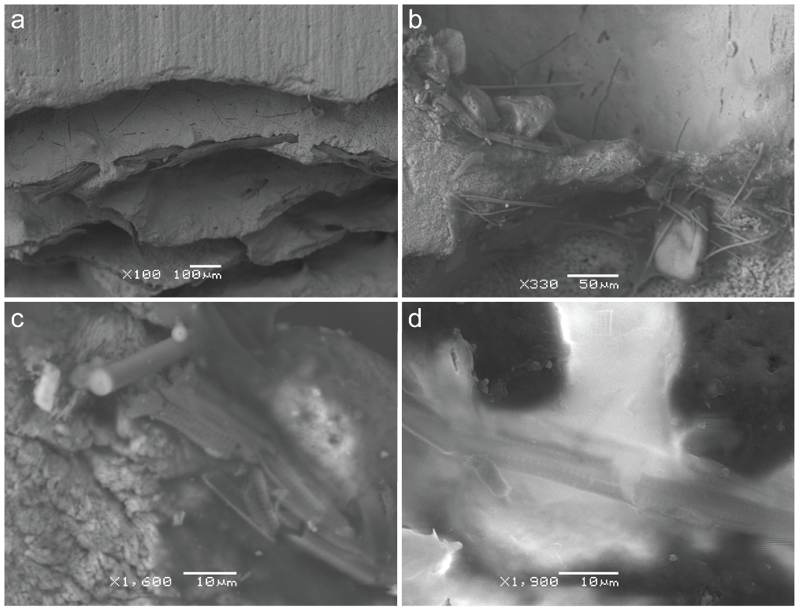
Figure 13 PK 21/09/12-01, secondary electron images of organic detritus at various magnifications. (a) Twig fragments embedded in the corallite wall, (b-d) smaller woody tissues trapped within skeletal cavities. Only d is gold-coated, the rest were imaged under low vacuum due to difficulties with applying an even covering of gold to the complex microstructure of the corallite.
In the summer 2007 records, all samples (except PK 21/09/12-01(II)), show high, broad peaks in Mg/Ca and Sr/Ca with little variation compared to other years. This suggests summer 2007 was relatively long and hot, with water temperatures consistently high for the whole season, supporting reports of the long heat wave that preceded the fires (BBC, 2007).
This demonstrates the potential for coastal corals to be used as palaeo-event indicators. In this case only the presence of charcoal makes the causal link between soil erosion recorded by the elemental data and wildfire. Moreover, this event was not recorded in the other samples from the colony, suggesting that corallite growth position was key; presumably corals that did not record the event grew in less turbid areas, sheltered from the increased sediment flux.
Trace elements as indicators of fossil preservation
Although the modern material has elemental contents reflecting growth environment, this need not be the case in fossil or sub fossil material. Fossil material has typically had many thousands of years potentially exposed to percolating meteoric waters or exposed in the marine supratidal splash zone where open system conditions allow elemental remobilisation, partial dissolution and cementation, collectively termed ‘stabilization’; this can cause the loss or smoothing of growth environment signals such as annual-scale cyclic trends. The elemental data from fossil corals (below) is thus focussed on exploring their preservation and the subsequent robustness of any growth environment indicators.
Fossil Greek samples
Fossil samples were mostly selected on the basis that their preservation was likely to be good, with the hypothesis that cyclic signals seen in modern corals would be preserved (Table 2). The average concentrations measured and types of trends shown are summarised in Table 2; most samples do preserve annual scale cyclicity in Sr, Mg, B, Ba and U as seen in the modern samples.

Discussion of results
Most samples were normalised to a time series in the same way as the modern samples (see above); however, if annual scale cyclicity in Sr or Mg was not present, it was necessary to establish a temporal framework for each trace element profile by attempting to match distances along the ablation transect with the spacings of the growth bands, assuming each growth band was representative of the same period of time (5 months for the winter, recessed, bands and 7 months of the summer, pronounced, bands (Peirano et al., 1999)).
Well preserved samples
The well preserved fossil corals generally have similar trace element contents and ranges to the modern corals (Table 2). The exceptions are P, where the fossil data (P/Ca ratios) are an order of magnitude higher in some samples, and Li where two MIS 5e samples in particular again have Li/Ca ratios an order of magnitude higher than the modern values. The higher Li and P contents are not accompanied by increased lithogenic-associated elements (e.g. Al, K, Fe) so probably reflect localised adsorption of soluble Li and P from the thin soils that overly some of the sample sites, rather than detrital contamination. As there is no evidence of alteration of the coralline aragonite (see below) it is likely this adsorption was diffusion-controlled associated with the decay of intercrystalline organic material.
Figure 14 Mg/Ca and Sr/Ca profiles through fossil C. caespitosa corallites showing clear, annual-scale cyclicity: (A) MIS 5e corallite SHR 02/11/11-08(II); (B) MIS 5e corallite SHR 04/11/11-10; (C) MIS 7a/c corallite SHR 02/11/11-02(I); (D) MIS 7a/c corallite SHR 02/11/11-02(II)
This minor difference noted, samples as old as 225 ka show clear annual-scale signals in, for example, Sr and Mg (Figures 14a-d) which demonstrates they are preserving their original geochemical signature: this is supported by the presence of well-preserved aragonite crystals under SEM (Figure 15).
Figure 15 Well preserved acicular aragonite exposed in broken septa in MIS 5e C. caespitosa sample SHR 02/11/11-08(II) confirms lack of diagenetic alteration; Gold coated secondary electron image.
While there was no expectation to gain absolute, quantitative palaeotemperatures from the fossil Sr/Ca records (see above), the Montagna et al. (2007) equation (Equation 2) was used to investigate whether these fossils record seasonal temperature patterns in the way the modern ones do. This equation was used as Sr/Ca, in the modern corals, has a stronger relationship with SST than Mg/Ca; also the Montagna equation produces a closer-to-actual seasonality range than the Silenzi et al. (2005) equation. The resultant SST profiles are shown in Figure 16:
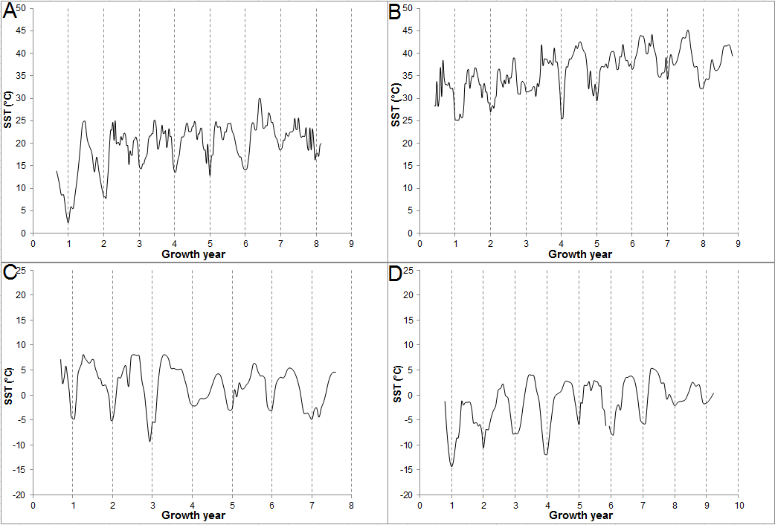
Figure 16 SST profiles for each of the well preserved fossil C. caespitosa samples, produced using the Montagna et al. (2007) Equation (Equation 2): (A) MIS 5e corallite SHR 02/11/11-08(II); (B) MIS 5e corallite SHR 04/11/11-10; (C) MIS 7a/c corallite SHR 02/11/11-02(I); (D) MIS 7a/c corallite SHR 02/11/11-02(II). While offset from each other, the MIS 5e samples give higher temperatures than those from MIS 7a/c, which are, in turn, similar to those from the modern samples (Figure 9).
Table 5 Summarised Sr/Ca-calculated SSTs from the well preserved fossil C. caespitosa samples
Sample | Age | Sr/Ca-calculated average SSTs (°C)
Sample | Age | Summer maximum (°C) | Winter minimum (°C) | Annual average (°C) | Annual range (°C)
SHR 02/11/11-08 (II) | MIS 5e | 25.7 | 11.8 | 19.8 | 13.8
SHR 04/11/11-10 | MIS 5e | 41.2 | 30.1 | 34.6 | 11.2
SHR 02/11/11-02 (I) | MIS 7a/c | 6.3 | -4.5 | 2.1 | 10.9
SHR 02/11/11-02 (II) | MIS 7a/c | 2.8 | -8.3 | -2.1 | 11.1

The data in Table 5 show that the absolute temperatures are mostly not realistic, the data from MIS 7a/c being much too cool, and at least one of the MIS 5e corals (SHR 04/11/11-10) recording anomalously warm values (cf. discussion and comparative data in Royle et al., 2015); this outcome is not unexpected given the results from our modern corals (see above). However, the seasonal temperature ranges for MIS 7a/c fossils are similar to those from the modern samples, albeit larger than the ~6 ˚C range suggested by stable isotopes (Royle et al., 2015). The MIS 5e coral SHR 02/11/11-08 (II) records a higher than modern temperature which is close to those inferred from faunal and isotopic data (Bardaji et al., 2009; Royle et al., 2015); however, the 13.8 ˚C seasonal range is much larger than the 6-7 ˚C range inferred for the Gulf of Corinth by Garilli (2011). The minimum temperature returned by SHR 02/11/11-08 (II) looks anomalously low, given than faunal arguments suggest a minimum around 19 ˚C (Bardaj et al., 2009). Cleary a much bigger data set is required to test the statistical robustness of these interesting data.
Altered sample
Figure 17 JEA 010626-04 Mg/Ca and Sr/Ca profiles through MIS 5e corallite showing hints of annual-scale cyclicity, however this is mostly lost in apparently random, higher frequency ‘noise’. U/Ca is also shown for comparison with Sr/Ca.
The trace element/Ca record for this MIS 5e sample is an example of partial alteration in a coral with an unusually complex post-depositional history. The sample was collected at about 5 m modern elevation in the modern seawater splash zone. Based on regional uplift models (Leeder et al., 2005; 2003; Figure 18) the fossil was probably emergent for 20-30 ka after death (at about ~125 ka), before being re-immersed in seawater during the sea-level highstands of MIS 5c and 5a, due to ~20 m down-throw from local faulting (Figure 18). Following MIS 5a the coral became emergent again during the lowstands of MIS 2 and 3, but situated close to sea-level (and thus in the marine splash zone) during the 7 thousand years as Holocene sea-levels approached modern elevations. The local down-throw associated with faulting is key as this caused this sample to be re-immersed in seawater twice during its history and to be situated close to modern sea level in the Holocene.
Figure 18 Post depositional history for the MIS 5e sample JEA 010626-04 (sea level curve modified from Leeder et al. (2003)). This coral was down-faulted ~20 m between 5e and 5c (based on field relations) before uplift recommenced. Because of this the corals were re-submerged in seawater during the high-stands of MIS 5c and 5a, exposed to the splash zone throughout the Holocene and to meteoric fluids during other times.
Annual scale cyclic trends in Mg/Ca and U/Ca for the first two growth years of this coral decrease in amplitude thereafter, with the overall Mg/Ca content increasing and the trend completely disappearing into ‘background’ for the rest of the record, while the cyclic trend of Sr is noisy in growth years 1 and 2 and then shows increased Sr content thereafter. The Mg data suggests that the younger part of the coral has been partially stabilized from aragonite to calcite with incorporation of Mg in the diagenetic calcite. This is supported by presence of diagenetic calcite fabrics under SEM, from regions of apparently unaltered primary aragonite through to complete replacement by calcite (Figure 4b). The Sr and U data could reflect partial stabilization following episodes of marine diagenesis (see diagenetic history above) when immersion allowed precipitation of marine aragonite cements with higher Sr/Ca and U/Ca than the skeletal aragonite (e.g. Cohen and Hart, 2004; Montaggioni et al., 2006); however, SEM study did not discover any marine aragonite cement. Instead, we suggest that the Sr and U data may simply show that partial alteration was not fully open-system leaving calcite domains, where Sr and U liberated from the dissolving aragonite, were forced to be accommodated.
Conclusions
- It is clear from the cyclicity in Sr/Ca and Mg/Ca that modern C. caespitosa skeletal aragonite records some environmental growth conditions in its trace element record. In the best case, individual corallites of Adriatic C. caespitosa, have a Sr/Ca signal that captures up to 68% of the variance related to SST. However, attempts to quantify absolute water temperatures from modern C. caespitosa Sr/Ca or Mg/Ca failed because each corallite exerts a strong, non-predictable ‘vital effect’. A combination of both inter and intra-site variability shows there is little scope for the trace elemental composition of C. caespitosa to be used as an absolute palaeothermometer.
- Original environmental geochemical signatures, including temperature-related cyclicity in Sr/Ca and Mg/Ca can be preserved in corallites up to at least MIS 7 age, allowing identification of seasonality in water temperatures.
- One modern coral has an element record dominated by the effects of sediment discharge. In this example the peaks in Al, Fe, P, K, B, Na, Cu, Zn, can be linked to wild fire caused by summer aridity, further indicated in the coral by entrapped woody debris. Catchment fires allowed enhanced soil erosion and sediment discharge into the coastal zone. This shows the potential for fossil coastal corals to record unusual catchment events.
- In one fossil C. caespitosa of MIS 5e age, partial alteration of the corallite wall from aragonite to calcite occurred due to prolonged exposure in the marine splash zone. This calcitization destroyed the original cyclic trace element signals. Analysis of samples by LA-ICP-MS to identify the presence/absence of annual scale cyclicity is an effective protocol for testing fossil corallite preservation quality before expensive analyses such as U-Th dating.
Acknowledgements
SHR was funded by NERC studentship NE/J500069/1/R78248E. Graham Chilvers gave expert assistance and advice with LA-ICP-MS and Bertrand Leze helped with SEM analysis. We particularly thanks the PPP reviewers and editor who encouraged us to expand and improve our data analysis and interpretations with their constructive comments.

References
Abram, N.J., Gagan, M.K., McCulloch, M.T., Chappell, J., Hantoro, W.S., 2003. Coral reef death during the 1997 Indian Ocean dipole linked to Indonesian wildfires. Science (80-. ). 301, 952–955. doi:10.1126/science.1083841
Affek, H.P., Bar-Matthews, M., Ayalon, A., Matthews, A., Eiler, J.M., 2008. Glacial/interglacial temperature variations in Soreq cave speleothems as recorded by “clumped isotope” thermometry. Geochim. Cosmochim. Acta 72, 5351–5360. doi:10.1016/j.gca.2008.06.031
Al-Horani, F.A., Al-Moghrabi, S.M., de Beer, D., 2003a. Microsensor study of photosynthesis and calcification in the scleractinian coral, Galaxea fascicularis: active internal carbon cycle. J. Exp. Mar. Bio. Ecol. 288, 1–15. doi:10.1016/S0022-0981(02)00578-6
Al-Horani, F.A., Al-Moghrabi, S.M., de Beer, D., 2003b. The mechanism of calcification and its relation to photosynthesis and respiration in the scleractinian coral Galaxea fascicularis. Mar. Biol. 142, 419–426. doi:10.1007/s00227-002-0981-8
Alibert, C., Kinsley, L., Fallon, S.J., McCulloch, M.T., Berkelmans, R., McAllister, F., 2003. Source of trace element variability in Great Barrier Reef corals affected by the Burdekin flood plumes. Geochim. Cosmochim. Acta 67, 231–246. doi:Pii s0016-7037(00)01055-4 10.1016/s0016-7037(02)01055-4
Alibert, C., McCulloch, M.T., 1997. Strontium/calcium ratios in modern Porites corals from the Great Barrier Reef as a proxy for sea surface temperature: Calibration of the thermometer and monitoring of ENSO. Paleoceanography 12, 345–363. doi:10.1029/97pa00318
Alldredge, A.L., King, J.M., 1977. Distribution, abundance, and substrate preferences of demersal reef zooplankton at Lizard Island Lagoon, Great Barrier Reef. Mar. Biol. 41, 317–333. doi:10.1007/BF00389098
Allison, N., Finch, A.A., 2004. High-resolution Sr/Ca records in modern Porites lobata corals: Effects of skeletal extension rate and architecture. Geochemistry Geophys. Geosystems 5, 1–10. doi:Q05001 10.1029/2004gc000696
Armid, A., Asami, R., Fahmiati, T., Sheikh, M.A., Fujimura, H., Higuchi, T., Taira, E., Shinjo, R., Oomori, T., 2011. Seawater temperature proxies based on D(Sr), D(Mg), and D(U) from culture experiments using the branching coral Porites cylindrica. Geochim. Cosmochim. Acta 75, 4273–4285. doi:10.1016/j.gca.2011.05.010
Bardaji, T., Goy, J.L., Zazo, C., Hillaire-Marcel, C., Dabrio, C.J., Cabero, A., Ghaleb, B., Silva, P.G., Lario, J., 2009. Sea level and climate changes during OIS 5e in the Western Mediterranean. Geomorphology 104, 22–37. doi:10.1016/j.geomorph.2008.05.027
Bar-Matthews, M., Ayalon, A., Gilmour, M., Matthews, A., Hawkesworth, C.J., 2003. Sea-land oxygen isotopic relationships from planktonic foraminifera and speleothems in the Eastern Mediterranean region and their implication for paleorainfall during interglacial intervals. Geochim. Cosmochim. Acta 67, 3181–3199. doi:10.1016/s0016-7037(02)01031-1
BBC, 2007. Dubrovnik fire threat subsiding [WWW Document]. URL http://news.bbc.co.uk/1/hi/world/europe/6932578.stm
Beck, J.W., Edwards, R.L., Ito, E., Taylor, F.W., Recy, J., Rougerie, F., Joannot, P., Henin, C., 1992. Sea-surface temperature from coral skeletal strontium/calcium ratios. Science (80-. ). 257, 644–647. doi:10.1126/science.257.5070.644
Bernasconi, M.P., Corselli, C., Carobene, L., 1997. A bank of the scleractinian coral Cladocora caespitosa in the Pleistocene of the Crati valley (Calabria, Southern Italy) growth verses environmental conditions. Boll. della Soc. Paleontol. Ital. 36, 53–62.
Béthoux, J.P., Morin, P., Chaumery, C., Connan, O., Gentili, B., Ruiz-Pino, D., 1998. Nutrients in the Mediterranean Sea, mass balance and statistical analysis of concentrations with respect to environmental change. Mar. Chem. 63, 155–169. doi:10.1016/s0304-4203(98)00059-0
Burns, T.P., 1985. Hard-coral distribution and cold-water disturbances in South Florida: variation with depth and location. Coral Reefs 4, 117–124. doi:10.1007/BF00300870
Cheddadi, R., de Beaulieu, J.-L., Jouzel, J., Andrieu-Ponel, V., Laurent, J.-M., Reille, M., Raynaud, D., Bar-Hen, A., 2005. Similarity of vegetation dynamics during interglacial periods. Proc. Natl. Acad. Sci. U. S. A. 102, 13939–43. doi:10.1073/pnas.0501752102
Cheddadi, R., Yu, G., Guiot, J., Harrison, S.P., Prentice, I.C., 1996. The climate of Europe 6000 years ago. Clim. Dyn. 13, 1–9. doi:10.1007/s003820050148
Cohen, A.L., Hart, S.R., 2004. Deglacial sea surface temperatures of the western tropical Pacific: A new look at old coral. Paleoceanography 19, 1–6. doi:Pa4031 10.1029/2004pa001084
Cohen, A.L., Layne, G.D., Hart, S.R., Lobel, P.S., 2001. Kinetic control of skeletal Sr/Ca in a symbiotic coral: Implications for the paleotemperature proxy. Paleoceanography 16, 20–26. doi:10.1029/1999PA000478
Cohen, A.L., McConnaughey, T.A., 2003. Geochemical perspectives on coral mineralization, in: Dove, P.M., DeYoreo, J.J., Weiner, S. (Eds.), Biomineralization. Mineralogical Soc Amer, Chantilly, pp. 151–187. doi:10.2113/0540151
Cohen, A.L., Owens, K.E., Layne, G.D., Shimizu, N., 2002. The effect of algal symbionts on the accuracy of Sr/Ca paleotemperatures from coral. Science (80-. ). 296, 331–333. doi:10.1126/science.1069330
Correge, T., 2006. Sea surface temperature and salinity reconstruction from coral geochemical tracers. Palaeogeogr. Palaeoclimatol. Palaeoecol. 232, 408–428. doi:10.1016/j.palaeo.2005.10.014
Couchoud, I., Genty, D., Hoffmann, D., Drysdale, R., Blamart, D., 2009. Millennial-scale climate variability during the Last Interglacial recorded in a speleothem from south-western France. Quat. Sci. Rev. 28, 3263–3274. doi:10.1016/j.quascirev.2009.08.014
CRED, 2009. EM-DAT: The OFDA/CRED International Disaster Database [WWW Document]. URL http://www.emdat.be/search-details-disaster-list (accessed 3.20.14).
De Villiers, S., Nelson, B.K., Chivas, A.R., 1995. Biological-controls on coral Sr/Ca and δ18O reconstructions of sea-surface temperatures. Science (80-. ). 269, 1247–1249. doi:10.1126/science.269.5228.1247
De Villiers, S., Shen, G.T., Nelson, B.K., 1994. The Sr/Ca-temperature relationship in coralline aragonite: Influence of variability in (Sr/Ca)seawater and skeletal growth parameters. Geochim. Cosmochim. Acta 58, 197–208. doi:10.1016/0016-7037(94)90457-x
Drysdale, R.N., Zanchetta, G., Hellstrom, J.C., Fallick, A.E., Zhao, J.X., 2005. Stalagmite evidence for the onset of the Last Interglacial in southern Europe at 129 ± 1 ka. Geophys. Res. Lett. 32, L24708. doi:10.1029/2005gl024658
Erez, J., Braun, A., 2007. Calcification in hermatypic corals is based on direct seawater supply to the biomineralization site. Geochim. Cosmochim. Acta 71, A260.
Fontugne, M.R., Calvert, S.E., 1992. Late Pleistocene variability of the carbon isotopic composition of organic matter in the eastern mediterranean: monitor of changes in carbon sources and atmospheric CO2 concentrations. Paleoceanography 7, 1–20. doi:10.1029/91PA02674
Frogley, M.R., 1999. Climate variability in northwest Greece during the last interglacial. Science (80-. ). 285, 1886–1889. doi:10.1126/science.285.5435.1886
Goodkin, N.F., Hughen, K.A., Cohen, A.L., 2007. A multicoral calibration method to approximate a universal equation relating Sr/Ca and growth rate to sea surface temperature. Paleoceanography 22, PA1214. doi:10.1029/2006PA001312
Hathorne, E.C., Felis, T., Suzuki, A., Kawahata, H., Cabioch, G., 2013. Lithium in the aragonite skeletons of massive Porites corals: A new tool to reconstruct tropical sea surface temperatures. Paleoceanography 28, 143–152. doi:10.1029/2012PA002311
Houghton, S.L., Roberts, G.P., Papanikolaou, I.D., McArthur, J.M., Gilmour, M.A., 2003. New 234U/230Th coral dates from the western Gulf of Corinth: Implications for extensional tectonics. Geophys. Res. Lett. 30. doi:2013 10.1029/2003gl018112
Houlbrèque, F., Tambutté, E., Ferrier-Pagès, C., 2003. Effect of zooplankton availability on the rates of photosynthesis, and tissue and skeletal growth in the scleractinian coral Stylophora pistillata. J. Exp. Mar. Bio. Ecol. 296, 145–166. doi:10.1016/S0022-0981(03)00259-4
Ip, Y.K., Krishnaveni, P., 1991. Incorporation of strontium (90Sr2+) into the skeleton of the hermatypic coral Galaxea fascicularis. J. Exp. Zool. 258, 273–276. doi:10.1002/jez.1402580219
Jacques, T.G., Pilson, M.E.Q., Cummings, C., Marshall, N., 1977. Laboratory observations on respiration, photosynthesis, and factors affecting calcification in the temperate coral Astrangia danae. Proc. 3rd Int. Coral Symp. 2, 455–461.
Kružić, P., 2002. Marine fauna of the Mljet National Park (Adriatic Sea, Croatia). 1. Anthozoa. Nat. Croat. 11, 265–292.
Kružić, P., 2007. Polyp expulsion of the coral Cladocora caespitosa (Anthozoa, Scleractinia) in extreme sea temperature conditions. Nat. Croat. 16, 211–214.
Kružić, P., Benković, L., 2008. Bioconstructional features of the coral Cladocora caespitosa (Anthozoa, Scleractinia) in the Adriatic Sea (Croatia). Mar. Ecol. Evol. Perspect. 29, 125–139. doi:10.1111/j.1439-0485.2008.00220.x
Kružić, P., Lipej, L., Mavrić, B., Rodić, R., 2014. Impact of bleaching on the coral Cladocora caespitosa in the eastern Adriatic Sea. Mar. Ecol. Prog. Ser. 509, 193–202.
Kružić, P., Požar-Domac, A., 2003. Banks of the coral Cladocora caespitosa (Anthozoa, Scleractinia) in the Adriatic Sea. Coral Reefs 22, 536. doi:10.1007/s00338-003-0345-y
Kružić, P., Sršen, P., Benković, L., 2012. The impact of seawater temperature on coral growth parameters of the colonial coral Cladocora caespitosa (Anthozoa, Scleractinia) in the eastern Adriatic Sea. Facies 58, 477–491.
Kružić, P., Žuljević, A., Nikolić, V., 2008. Spawning of the colonial coral Cladocora caespitosa (Anthozoa, Scleractinia) in the Southern Adriatic Sea. Coral Reefs 27, 337–341. doi:10.1007/s00338-007-0334-7
Kukla, G., McManus, J.F., Rousseau, D., Chuine, I., 1997. How long and how stable was the last interglacial? Quat. Sci. Rev. 16, 605–612. doi:10.1016/s0277-3791(96)00114-x
LaVigne, M., Matthews, K.A., Grottoli, A.G., Cobb, K.M., Anagnostou, E., Cabioch, G., Sherrell, R.M., 2010. Coral skeleton P/Ca proxy for seawater phosphate: Multi-colony calibration with a contemporaneous seawater phosphate record. Geochim. Cosmochim. Acta 74, 1282–1293. doi:10.1016/j.gca.2009.11.002
Lea, D.W., Shen, G.T., Boyle, E.A., 1989. Coralline barium records temporal variability in Equatorial Pacific upwelling. Nature 340, 373–376. doi:10.1038/340373a0
Leeder, M.R., McNeill, L.C., Collier, R.E.L., Portman, C., Rowe, P.J., Andrews, J.E., Gawthorpe, R.L., 2003. Corinth rift margin uplift: New evidence from Late Quaternary marine shorelines. Geophys. Res. Lett. 30, 1–4. doi:1611 10.1029/2003gl017382
Leeder, M.R., Portman, C., Andrews, J.E., Collier, R.E.L., Finch, E., Gawthorpe, R.L., McNeill, L.C., Pérez-Arlucea, M., Rowe, P., 2005. Normal faulting and crustal deformation, Alkyonides Gulf and Perachora peninsula, eastern Gulf of Corinth rift, Greece. J. Geol. Soc. London. 162, 549–561. doi:10.1144/0016-764904-075
Lough, J.M., Barnes, D.J., 2000. Environmental controls on growth of the massive coral Porites. J. Exp. Mar. Bio. Ecol. 245, 225–243. doi:10.1016/S0022-0981(99)00168-9
Maier, E., Titschack, J., 2010. Spondylus gaederopus: A new Mediterranean climate archive - Based on high-resolution oxygen and carbon isotope analyses. Palaeogeogr. Palaeoclimatol. Palaeoecol. 291, 228–238. doi:10.1016/j.palaeo.2010.02.032
Marshall, J.F., McCulloch, M.T., 2002. An assessment of the Sr/Ca ratio in shallow water hermatypic corals as a proxy for sea surface temperature. Geochim. Cosmochim. Acta 66, 3263–3280. doi:10.1016/s0016-7037(02)00926-2
Martrat, B., Grimalt, J.O., Lopez-Martinez, C., Cacho, I., Sierro, F.J., Flores, J.A., Zahn, R., Canals, M., Curtis, J.H., Hodell, D.A., 2004. Abrupt temperature changes in the Western Mediterranean over the past 250,000 years. Science (80-. ). 306, 1762–5. doi:10.1126/science.1101706
Mastronuzzi, G., Sanso, P., Tuccimei, P., Vesica, P.L., 2003. Stop 3.3.1 - The Cladocora caespitosa bank of Santa Teresiola locality, in: Mastronuzzi, G., Sanso, P. (Eds.), Project IGCP 437 - Coastal Environmental Change during Sea-Level Highstands: A Global Synthesis with Implication for Management of Future Coastal Change: Puglia 2003 Final Conference, Quaternary Coastal Morphology and Sea Level Changes - Field Guide GI2S. pp. 85–100.
McConnaughey, T., 1989a. 13C and 18O isotopic disequilibrium in biological carbonates: I. Patterns. Geochim. Cosmochim. Acta 53, 151–162. doi:10.1016/0016-7037(89)90282-2
McConnaughey, T., 1989b. 13C and 18O isotopic disequilibrium in biological carbonates: II. In vitro simulation of kinetic isotope effects. Geochim. Cosmochim. Acta 53, 163–171. doi:10.1016/0016-7037(89)90283-4
McCulloch, M.T., Gagan, M.K., Mortimer, G.E., Chivas, A.R., Isdale, P.J., 1994. A high resolution Sr/Ca and δ18O coral record from the Great Barrier Reef, Australia, and the 1982-1983 El-Nino. Geochim. Cosmochim. Acta 58, 2747–2754. doi:10.1016/0016-7037(94)90142-2
Mertz-Kraus, R., Brachert, T.C., Jochum, K.P., Reuter, M., Stoll, B., 2009. LA-ICP-MS analyses on coral growth increments reveal heavy winter rain in the Eastern Mediterranean at 9 Ma. Palaeogeogr. Palaeoclimatol. Palaeoecol. 273, 25–40. doi:10.1016/j.palaeo.2008.11.015
Mitsuguchi, T., Matsumoto, E., Abe, O., Uchida, T., Isdale, P.J., 1996. Mg/Ca thermometry in coral-skeletons. Science (80-. ). 274, 961–963. doi:10.1126/science.274.5289.961
Montaggioni, L.F., Le Cornec, F., Correge, T., Cabioch, G., 2006. Coral barium/calcium record of mid-Holocene upwelling activity in New Caledonia, South-West Pacific. Palaeogeogr. Palaeoclimatol. Palaeoecol. 237, 436–455. doi:10.1016/j.palaeo.2005.12.018
Montagna, P., McCulloch, M.T., Douville, E., López Correa, M., Trotter, J., Rodolfo-Metalpa, R., Dissard, D., Ferrier-Pagès, C., Frank, N., Freiwald, A., Goldstein, S., Mazzoli, C., Reynaud, S., Rüggeberg, A., Russo, S., Taviani, M., 2014. Li/Mg systematics in scleractinian corals: Calibration of the thermometer. Geochim. Cosmochim. Acta 132, 288–310. doi:10.1016/j.gca.2014.02.005
Montagna, P., McCulloch, M.T., Mazzoli, C., Silenzi, S., Odorico, R., 2007. The non-tropical coral Cladocora caespitosa as the new climate archive for the Mediterranean: high-resolution (~ weekly ) trace element systematics. Quat. Sci. Rev. 26, 441–462. doi:10.1016/j.quascirev.2006.09.008
Montagna, P., McCulloch, M.T., Taviani, M., Mazzoli, C., Vendrell, B., 2006. Phosphorus in cold-water corals as a proxy for seawater nutrient chemistry. Science (80-. ). 312, 1788–1791.
Naqvi, S.A.., 1994. Seasonal variation in an annually-banded coral Porites: A scanning electron microscopy investigation. Mar. Geol. 118, 187–194. doi:10.1016/0025-3227(94)90082-5
Peirano, A., Abbate, M., Cerrati, G., Difesca, V., Peroni, C., Rodolfo-Metalpa, R., 2005. Monthly variations in calix growth, polyp tissue, and density banding of the Mediterranean scleractinian Cladocora caespitosa (L.). Coral Reefs 24, 404–409. doi:10.1007/s00338-005-0020-6
Peirano, A., Kružić, P., Mastronuzzi, G., 2009. Growth of Mediterranean reef of Cladocora caespitosa (L.) in the Late Quaternary and climate inferences. Facies 55, 325–333. doi:10.1007/s10347-008-0177-x
Peirano, A., Morri, C., Bianchi, C.N., 1999. Skeleton growth and density pattern of the temperate, zooxanthellate scleractinian Cladocora caespitosa from the Ligurian Sea (NW Mediterranean). Mar. Ecol. Prog. Ser. 185, 195–201.
Peirano, A., Morri, C., Bianchi, C.N., Aguirre, J., Antonioli, F., Calzetta, G., Carobene, L., Mastronuzzi, G., Orru, P., 2004. The Mediterranean coral Cladocora caespitosa: a proxy for past climate fluctuations? Glob. Planet. Change 40, 195–200. doi:10.1016/s0921-8181(03)00110-3
Peirano, A., Morri, C., Mastronuzzi, G., Bianchi, C.N., 1998. The coral Cladocora caspitosa (Anthozoa, Scleractinia) as a bioherm builder in the Mediterranean Sea. Mem. Descr. della Cart. Geol. d’Italia 52, 59–74.
Pirazzoli, P.A., Mastronuzzi, G., Saliege, J.F., Sanso, P., 1997. Late Holocene emergence in Calabria, Italy. Mar. Geol. 141, 61–70. doi:10.1016/s0025-3227(97)00057-1
Roberts, G.P., Houghton, S.L., Underwood, C., Papanikolaou, I., Cowie, P.A., van Calsteren, P., Wigley, T., Cooper, F.J., McArthur, J.M., 2009. Localization of Quaternary slip rates in an active rift in 105 years: An example from central Greece constrained by 234U-230Th coral dates from uplifted paleoshorelines. J. Geophys. Res. 114, B10406. doi:10.1029/2008jb005818
Roberts, N., Jones, M.D., Benkaddour, A., Eastwood, W.J., Filippi, M.L., Frogley, M.R., Lamb, H.F., Leng, M.J., Reed, J.M., Stein, M., Stevens, L., Valero-Garcés, B., Zanchetta, G., 2008. Stable isotope records of Late Quaternary climate and hydrology from Mediterranean lakes: the ISOMED synthesis. Quat. Sci. Rev. 27, 2426–2441. doi:10.1016/j.quascirev.2008.09.005
Rodolfo-Metalpa, R., Bianchi, C., Peirano, A., Morri, C., 2005. Tissue necrosis and mortality of the temperate coral Cladocora Caespitosa. Ital. J. Zool. 72, 271–276. doi:10.1080/11250000509356685
Rodolfo-Metalpa, R., Peirano, A., Houlbreque, F., Abbate, M., Ferrier-Pages, C., 2008. Effects of temperature, light and heterotrophy on the growth rate and budding of the temperate coral Cladocora caespitosa. Coral Reefs 27, 17–25. doi:10.1007/s00338-007-0283-1
Rollion-Bard, C., Chaussidon, M., France-Lanord, C., 2011. Biological control of internal pH in scleractinian corals: Implications on paleo-pH and paleo-temperature reconstructions. Comptes Rendus Geosci. 343, 397–405. doi:10.1016/j.crte.2011.05.003
Rong Min, G., Lawrence Edwards, R., Taylor, F.W., Recy, J., Gallup, C.D., Warren Beck, J., 1995. Annual cycles of U/Ca in coral skeletons and U/Ca thermometry. Geochim. Cosmochim. Acta 59, 2025–2042. doi:10.1016/0016-7037(95)00124-7
Royle, S.H., Andrews, J.E., Marca-Bell, A., Kružić, P., Turner, J.A., 2015. Seasonality in sea surface temperatures from δ18O in Cladocora caespitosa: modern Adriatic to late Pleistocene, Gulf of Corinth. J. Quat. Sci. 30, 298–311. doi:10. 1002/jqs.2768
Sayani, H.R., Cobb, K.M., Cohen, A.L., Elliott, W.C., Nurhati, I.S., Dunbar, R.B., Rose, K.A., Zaunbrecher, L.K., 2011. Effects of diagenesis on paleoclimate reconstructions from modern and young fossil corals. Geochim. Cosmochim. Acta 75, 6361–6373. doi:10.1016/j.gca.2011.08.026
Schöne, B.R., Fiebig, J., Pfeiffer, M., Gleβ, R., Hickson, J., Johnson, A.L.A., Dreyer, W., Oschmann, W., 2005. Climate records from a bivalved Methuselah (Arctica islandica, Mollusca; Iceland). Palaeogeogr. Palaeoclimatol. Palaeoecol. 228, 130–148. doi:10.1016/j.palaeo.2005.03.049
Schuhmacher, H., Zibrowius, H., 1985. What is hermatypic - a redefination of ecological groups in corals and other organisms. Coral Reefs 4, 1–9. doi:10.1007/bf00302198
Seo, I., Lee, Y. Il, Watanabe, T., Yamano, H., Shimamura, M., Yoo, C.M., Hyeong, K., 2013. A skeletal Sr/Ca record preserved in Dipsastraea ( Favia ) speciosa and implications for coral Sr/Ca thermometry in mid-latitude regions. Geochemistry, Geophys. Geosystems 14, 2873–2885. doi:10.1002/ggge.20195
Silenzi, S., Bard, E., Montagna, P., Antonioli, F., 2005. Isotopic and elemental records in a non-tropical coral (Cladocora caespitosa): Discovery of a new high-resolution climate archive for the Mediterranean Sea. Glob. Planet. Change 49, 94–120. doi:10.1016/j.gloplacha.2005.05.005
Sinclair, D.J., Kinsley, L.P.J., McCulloch, M.T., 1998. High resolution analysis of trace elements in corals by laser ablation ICP-MS. Geochim. Cosmochim. Acta 62, 1889–1901. doi:10.1016/s0016-7037(98)00112-4
Thunell, R.C., Williams, D.F., 1983. Paleotemperature and paleosalinity history of the estern Mediterranean during the Late Quaternary. Palaeogeogr. Palaeoclimatol. Palaeoecol. 44, 23–39. doi:10.1016/0031-0182(83)90003-2
Tremblay, P., Peirano, A., Ferrier-Pages, C., 2011. Heterotrophy in the Mediterranean symbiotic coral Cladocora caespitosa: comparison with two other scleractinian species. Mar. Ecol. Prog. Ser. 422, 165–177. doi:10.3354/meps08902
Trotter, J., Montagna, P., McCulloch, M., Silenzi, S., Reynaud, S., Mortimer, G.E., Martin, S., Ferrier-Pagès, C., Gattuso, J.P., Rodolfo-Metalpa, R., 2011. Quantifying the pH “vital effect” in the temperate zooxanthellate coral Cladocora caespitosa: Validation of the boron seawater pH proxy. Earth Planet. Sci. Lett. 303, 163–173. doi:10.1016/j.epsl.2011.01.030
Turner, J.A., Leeder, M.R., Andrews, J.E., Rowe, P.J., Van Calsteren, P., Thomas, L., 2010. Testing rival tectonic uplift models for the Lechaion Gulf in the Gulf of Corinth rift. J. Geol. Soc. London. 167, 1237–1250. doi:10.1144/0016-76492010-035
Tzedakis, P.C., Frogley, M.R., Heaton, T.H.E., 2003. Last Interglacial conditions in southern Europe: evidence from Ioannina, northwest Greece. Glob. Planet. Change 36, 157–170. doi:10.1016/S0921-8181(02)00182-0
U.S. Agency for International Development, 2007. Southeast Europe - Wildfires and Drought [WWW Document]. Fact Sheet #1, Fisc. Year 2007. URL http://reliefweb.int/sites/reliefweb.int/files/resources/11D630DB90C5BC274925735B00019D36-Full_Report.pdf (accessed 2.6.15).
Urey, H.C., Lowenstam, H.A., Epstein, S., McKinney, C.R., 1951. Measurement of paleotemperatures and temperatures of the Upper Cretaceous of England, Denmark and the Southeastern United States. Geol. Soc. Am. Bull. 62, 399. doi:10.1130/0016-7606(1951)62[399:MOPATO]2.0.CO;2
Viegas, D.X., Albert, S., Gavriil, X., Carlos, R., Mario, R.L., Paulo, P.L., Darko, S., Anna, Z., Rodney, W., John, D., David, C., Jesus, S.-M.-A., 2009. Recent Forest Fire Related Accidents in Europe. Publications Office of the European Union.
Weber, J.N., 1973. Incorporation of strontium into reef coral skeletal carbonate. Geochim. Cosmochim. Acta 37, 2173–2190. doi:10.1016/0016-7037(73)90015-x
Weber, J.N., Woodhead, P.M., 1972. Temperature dependance of oxygen-18 concentration in reef coral carbonates. J. Geophys. Res. 77, 463–473. doi:10.1029/JC077i003p00463
Yu, X., Inesi, G., 1995. Variable Stoichiometric Efficiency of Ca2+ and Sr2+ Transport by the Sarcoplasmic Reticulum ATPase. J. Biol. Chem. 270, 4361–4367. doi:10.1074/jbc.270.9.4361

