Title page

An Investigation into the Influence of Drug-Polymer Interactions on the Miscibility, Processability and Structure of Polyvinylpyrrolidone-Based Hot Melt Extrusion Formulations

Siok-Yee Chan^{1,3}, Sheng Qi¹, Duncan Q.M. Craig²

- School of Pharmacy, University of East Anglia, Norwich NR4 7TJ
- UCL School of Pharmacy, 29-39 Brunswick Square, London WC1N 1AX
- Current address: School of Pharmaceutical Sciences, Universiti Sains Malaysia, 11800 USM, Penang, Malaysia

Correspondence author: Duncan Q.M.Craig, duncan.craig@ucl.ac.uk
Abstract

While hot melt extrusion is now established within the pharmaceutical industry, the prediction of miscibility, processability and structural stability remains a pertinent issue, particularly in the context of whether molecular interaction is necessary for suitable performance. Here we integrate the use of theoretical and experimental drug-polymer interaction assessment with determination of processability and structure of dispersions in two polyvinylpyrrolidone-based polymers (PVP and PVP vinyl acetate, PVPVA). Caffeine and paracetamol were chosen as model drugs on the basis of their differing hydrogen bonding potential with PVP. Solubility parameter and interaction parameter calculations predicted a greater miscibility for paracetamol, while ATR-FTIR confirmed the hydrogen bonding propensity of the paracetamol with both polymers, with little interaction detected for caffeine. PVP was found to exhibit greater interaction and miscibility with paracetamol than did PVPVA. It was noted that lower processing temperatures (circa 40ºC below the T_{g} of the polymer alone and T_{m} of the crystalline drug) and higher drug loadings with associated molecular dispersion up to 50% w/w were possible for the paracetamol dispersions, although molecular dispersion with the non-interactive caffeine was noted at loadings up to 20% w./w. A lower processing temperature was also noted for caffeine-loaded systems despite the absence of direct interactions. The study has therefore indicated that theoretical and experimental detection of miscibility and drug-polymer interactions may lead to insights into product processing and extrudate structure, with molecular interaction representing a helpful but not essential aspect of drug-polymer combination prediction.

Keywords: HME; solid dispersion; hot melt extrusion; solubility parameter; melting point depression; polyvinylpyrrolidone
Graphical Abstract

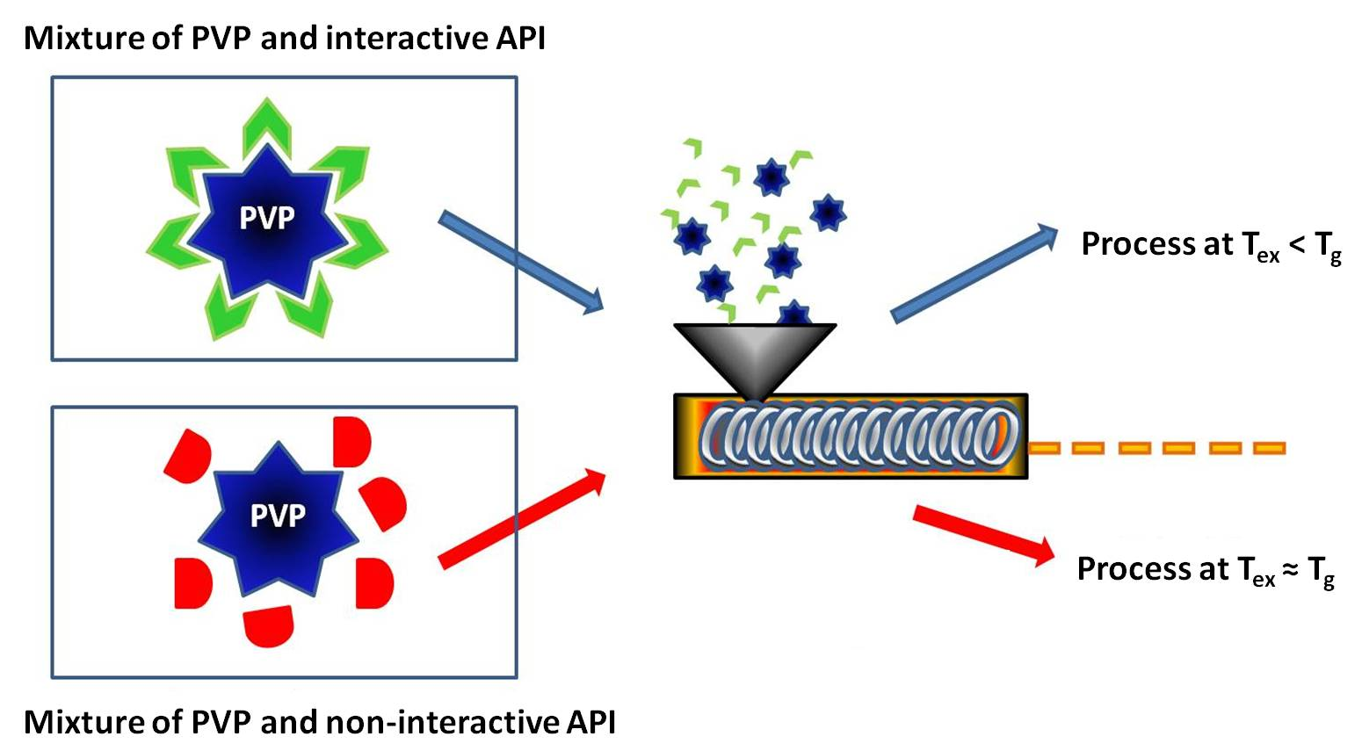

1. Introduction

Solid dispersion formulations, whereby drugs are dispersed in water-miscible polymers using techniques such as hot melt extrusion, have attracted considerable attention due to the potential for enhancing bioavailability of poorly soluble drugs (Huang and Dai, 2014). In theory, an ideal solid dispersion would comprise a homogeneous mixture of the active pharmaceutical ingredient (API) and carrier as a stable one-phase system whereby the drug is present as a molecular dispersion, thereby negating the necessity to break down the lattice structure prior to dissolution. Almost invariably, the polymer is wholly or largely amorphous in nature and hence the products obtained are glassy materials whereby kinetic and thermodynamic stability must be carefully considered. Alternatively, a two phase system may be formed either on manufacture or storage, effectively representing a solid suspension. While the precise relationship between phase separation and product performance has not been fully established, the general belief is that molecular miscibility is desirable and hence most studies have been conducted with this aim in mind.
In this study we focus on the role of direct molecular interactions on the processing and structural properties of HME systems, particularly with a view to investigating the role of such interactions in determining miscibility, processability and subsequent solid structure. As outlined above, within the field miscibility is generally perceived as being a highly desirable characteristic of drug-polymer systems (Thakral and Thakral, 2013), while direct molecular interaction is considered to be a significant contributing factor to miscibility, ergo such interactions are desirable or indeed essential. It is this assumption that we wish to explore here by using two systems of broadly similar polarity and molecular weight but with clear differences in the extent of molecular interaction with the polymers under study.
A number of theoretical approaches have been explored in order to predict miscibility and interaction, including the well-known Flory-Huggins approach, the Hansen solubility parameter approach and, more recently, the perturbed-chain statically associating fluid theory (PC-SAFT) (Prudic et al., 2014). Amongst these methods, the Flory-Huggins theory has been widely used for the miscibility prediction of solid phases (Huang and Dai, 2014; Marsac et al., 2006; Zhao et al., 2011); the approach involves calculation of an interaction parameter (χ) between the components and incorporates consideration of the molecular weight, composition and size of the molecule, hence the inherent physical dissimilarity of the API and polymer are to some extent accounted for. The interaction parameter may be calculated via measurement of the melting point depression (described in more detail below) and may lead to a comprehensive assessment of the thermodynamic drivers and extent of miscibility. In contrast, the Hansen solubility parameter approach predicts miscibility on the basis of the intrinsic chemical similarity of the components. In this method, the solubility parameter δ may be obtained empirically as sum of the different contribution forces i.e. dispersive, polar and hydrogen bond interaction, with components showing similar solubility parameters being predicted to have high mutual solubility. The solubility parameter approach is generally considered to be more suitable for non-polar or slightly polar systems and the Flory-Huggins approach to more polar compounds (Li et al, 2013). As a solid dispersion is typically composed of a polar polymer and a non-polar drug, both approaches may be potentially applicable.
It is noteworthy that the Flory-Huggins approach indicates that adhesive interaction between the drug and polymer is a pre-requisite for the required enthalpic component of the free energy of mixing (Thakral and Thakral, 2013), hence such interactions are predicted to be essential for forming a stable molecular dispersion. However, both approaches are arguably indistinct as the Flory-Huggins interaction parameter may be calculated from the difference in the drug and polymer solubility parameters, with a smaller difference leading to a small positive value of χ which in turn favors miscibility. Nevertheless, there is still some uncertainty as to how a measurable and distinct molecular interaction, as opposed to a similarity in molecular polarity, may contribute to miscibility or indeed whether such interactions are a pre-requisite to the favorable performance characteristics association with processability, structure and dissolution.
In terms of solid dispersion preparation, hot melt extrusion (HME) has become recognized as a robust and scalable method of manufacture. The method involves application of mechanical mixing to a heated sample followed by extrusion and/or shaping in a single continuous process (Netchacovitch et al., 2015). The practical and economic feasibility of the approach, together with the favorable dissolution performance of the incorporated API, has attracted great interest within the pharmaceutical industry (Kanaujia et al., 2011; Li et al., 2014; Tian et al., 2013). In order to successfully extrude polymer-based amorphous dispersions, the extrusion temperature is typically set 30 to 60 ºC higher than the T_{g} (glass transition temperature) or T_{m} (melting temperature) of the polymer to ensure good flowability of the mixture during the extrusion process (Chokshi et al., 2005; Li et al., 2014; McGinity et al., 2006). However, given that the choice of a high T_{g} polymer is often preferred due to the physical stabilisation of the amorphous solid dispersions (Hancock and Zografi, 1997; Sathigari et al., 2012; Shah et al., 2013), the T_{g} of many pharmaceutically acceptable polymers may be too high for the extrusion process for reasons of cost or heat-induced degradation; hence, a more moderate working temperature is required and there is therefore a balance between stabilization of the system and feasibility of manufacture. The issue of minimizing processing temperature via molecular interactions, which is itself related to miscibility, so as to reduce the risk of degradation has been highlighted by Li et al. (2014) who discussed the possibility of extrusion at temperatures below the melting point of the drug via judicious use of interacting systems. Here we examine the role of such interactions in reducing the extrusion temperature below the Tg of the polymer itself with a concomitant view to examining the capacity for forming molecular dispersions for interactive and non-interactive systems.
One candidate for manufacture using HME is the hydrophilic synthetic polymer polyvinylpyrrolidone (PVP), which has a T_{g} value commensurate with drug-loaded HME production but is also reported to directly interact with some drugs so as to enhance stabilization of the molecular dispersion (Chauhan et al., 2013; Huang and Dai, 2014; Li et al., 2013; Wegiel et al., 2015). PVP is also reported to inhibit and retard the recrystallization of the API via formation of a network around the drug molecules or growing crystal surface (Tantishaiyakul et al., 1999); both effects limit the molecular mobility of the API (Ozaki et al., 2013). However, use of this polymer has been limited by concerns regarding thermal degradation and hygroscopicity. Here, we argue that appropriate examination of conditions, based on appreciation of the molecular interactions between the drug and polymer, may lead to effective manufacture at moderate temperatures and hence prevention of deselection of a useful and effective polymer. We examine both PVP and the vinyl acetate derivative, PVPVA, both of which are credible materials for HME processing.
The approach of the current study is threefold, with all aspects being interrelated in terms of developing fundamental understanding of drug-polymer interactions as a means of predicting dispersion behavior. Firstly, we study the miscibility of APIs with PVP using the Hansen solubility parameter approach and the measurement of interaction parameters obtained via melting point depression approaches (Marsac et al., 2009). We compare theoretical to experimental data to ascertain the effectiveness of these theoretical approaches as an early predictor of miscibility in the final product. Secondly, we examine the extent to which the miscibility and interaction may itself be used to reduce the processing temperature of the HME via plasticization effects, thereby reducing the risk of thermal degradation. Finally we explore the role of direct interaction between the drug and polymer via the use of two API systems (caffeine and paracetamol) which, while nominally similar in terms of molecular weight, have very different levels of molecular interaction with PVP (Illangakoon et al., 2014). These APIs therefore provide a useful model for investigating the extent to which such interactions may play a role in miscibility, processing and performance.

2. Materials and methods

2.1 Materials
Povidone® K29-32 (PVP K29-32) and Plasdone® S630 (PVPVA 6:4) were generous gifts from ISP (Switzerland). Paracetamol (PCM) was obtained from Rhodia Organique, whereas caffeine (CAF) was purchased from Acros Organics (New Jersey, USA).

2.2 Theoretical prediction of drug-polymer miscibility
Prior to the preparation of solid dispersions, the miscibility of the drug-polymer systems was investigated using a range of predictive approaches.

2.2.1 Solubility parameter calculation
The solubility parameter approach is a widely used method in estimating the miscibility and compatibility of a mixture system. The original concept of this approach is described by Hildebrand (Van Krevelen and Te Nijenhuis, 2009) who stated that solubility of a given solute in a solvent is determined by the cohesive energy density i.e. the cohesive energy per unit volume of the substance. This concept is developed to specify the solubility parameter that is defined as the square root of the cohesive density energy. Solubility is favoured when structures of solute and solvent possess similar solubility parameters (Van Krevelen and Te Nijenhuis, 2009). The cohesive energy is closely related to the molar heat of evaporation ΔH_{vap}, as presented in Equation (1)

E_{coh} = ΔH_{vap} – pΔV ≈ ΔH_{vap} - RT (1)

where E_{coh} is cohesive energy, p is pressure, ΔV is the volume change, R is the universal gas constant and T is temperature. Since it is not possible to obtain the vaporization energy of a polymer directly, group contribution methods were developed to estimate the solubility parameter of polymeric systems. More specifically, the Hoftyzer/ Van Krevalen and the Hoy methods (Van Krevelen and Te Nijenhuis, 2009) consider the cohesive energy to be dependent on different forces in the molecule which include dispersive (F_{di}), hydrogen bond (E_{hi}) as well as polar forces (F_{pi}). The values of these forces are given in a reference table in Van Krevelen and Te Nijenhuis (2009). With knowledge of these forces, the solubility parameter of a molecule can be estimated. Miscibility of the components may be estimated from the difference in the solubility parameter, as will be discussed in a later section.

2.2.2 Flory-Huggins approach
The Flory-Huggins theory has been used for calculating free energy of mixing and estimating miscibility of drug-polymer components (Marsac et al., 2006; Tian et al., 2013; Zhao et al., 2011). In considering the mixing of a large molecular weight polymer and a low molecular weight API, the Flory Huggins approach suggests a hypothetical “lattice” in space. It assumes that the probability of the solvent (in this case the API) making contact with the segment of polymer (in this case monomer) is equal to the volume fraction of the polymer segments, i.e. the corresponding monomer (Gong et al., 1989). The Flory-Huggins interaction parameter χ is used to account for the enthalpy of mixing; the free energy of mixing of an API-polymer system ΔG_{m} is given by Equation (2)

$\frac{∆G_{M}}{RT}=n_{drug}ln∅_{drug}+n_{polymer}ln∅_{polymer}+n_{drug}∅_{polymer}χ_{drug−polymer}$ (2)

where $n_{drug}$ is number of moles of the drug, $n_{polymer}$ is number of moles of polymer, $∅_{drug}$ is volume fraction of the drug, $∅_{polymer}$ is the volume fraction of the polymer, $χ_{drug−polymer}$is the interaction parameter between the drug and polymer. By knowing the interaction parameter, χ, one can estimate the mixing behaviour of an API to polymer system using the Flory-Huggins theory via estimation of the free energy of mixing which in turn indicates the driving energetics of the process. However the approach requires the interaction parameter χ to be estimated. Earlier reports indicated that the solubility parameter and melting point depression approaches maybe used to estimate the miscibility and interaction parameter of a blend, respectively (Marsac et al., 2009; Marsac et al., 2006; Tian et al., 2013; Zhao et al., 2011). Both of these approaches were adopted in the current study in relation to aid characterization of the raw materials and the extruded products.

2.2.3 Interaction parameter estimation using the melting point approach
To derive the drug-polymer interaction parameter using the melting point depression approach, the melting data was used in Equation (3) (Marsac et al., 2006; Paudel and Van den Mooter, 2011; Zhao et al., 2011).

$\left(\frac{1}{T_{Mmix}}−\frac{1}{T_{Mpure}}\right)=\frac{−R}{∆H_{fus}}\left[ln∅_{drug}+\left(1−\frac{1}{m}\right)∅_{polymer}+χ_{12}∅_{polymer}^{2}\right]$ (3)
where T_{Mpure} is the melting temperature of the pure API, T_{Mmix} is the depressed melting temperature of the mixture, R is the universal gas constant, ΔH_{fus} is heat of fusion of the pure API, m is the volume ratio of polymer to its volume lattice (which is taken as the volume of drug), $χ_{12}$ is interaction parameter, $∅_{drug}$ and $∅_{polymer}$ is the volume fraction of the drug and polymer respectively which were obtained from Equation (4).

$∅_{drug}=\frac{V_{drug}}{V_{drug}+V_{polymer}}$ (4)

where V is volume of the component which is denoted by its subscription. The volume of a component is calculated from the value of weight divided by value of density, i.e. V= m/ρ.
By rearranging Equation (3) and Equation (5), the interaction parameter, $χ_{12}$ between the drug-polymer could be obtained by plotting the function of depressed melting temperature of PCM against the volume fraction of the polymer, i.e.

$\left[\left(T_{Mmix}^{−1}\right)−\left(T_{Mpure}^{−1}\right)×\frac{{∆H}_{fus}}{−R}\right]−\left[1−\left(\frac{1}{m}\right)×∅_{polymer}\right]−\left[ln∅_{drug}\right]=χ_{12}×∅_{polymer}^{2}$ (5)

where volume fraction of the polymer were obtained by dividing the weight of the polymers used by their corresponding density which was obtained from product information from the supplier (ISP Pharmaceuticals, 2007).

2.3 Practical preparation and characterization methods

2.3.1 Preparation of physical mixtures
Physical mixtures of the APIs (i.e. PCM and CAF) and PVP carriers were weighed according to the desired drug-polymer ratio and the mixtures were gently mixed in a mortar and pestle for approximately 2 minutes.

    - Melting point depression measurements
To predict the interaction parameter using the melting point depression method, physical mixes were prepared in drug-rich proportions (from 75 - 95% w/w drug loading) and scanned by modulated DSC (Q2000, TA Instrument, Newcastle USA) with ± 0.212 ºC every 40s at 2 ºC per minute to 200 ºC using aluminum pans. Pin-holed lids were used to allow removal of water, particularly given the hygroscopic nature of the PVP polymers (Callahan et al., 1982). Modulated mode was used to distinguish the T_{g} and relaxation endotherm of the polymer, particularly PVP K29-32, from the melting endotherm of PCM. All experiments were run in triplicate.

Preparation of hot melt extruded solid dispersions
To compare theoretical and practical approaches to assess miscibility, HME samples were prepared using Thermo Scientific HAAKE MiniLab II Micro Compounder with intermeshing twin screw extruder. PCM-loaded samples ranging from 20%-70% PCM were prepared for PVP, while 20%-50% PCM were prepared for PVPVA. For both HME system of CAF, 10% -20% and 10%-30% CAF systems were prepared, respectively. The temperature of extrusion was determined by the minimum temperature at which extrusion was possible over a reasonable drug concentration range. The difference between the API loadings is a reflection of experimental observations whereby the maximum loading was determined by the point at which the appearance of the extrudate became opaque. The conditions chosen (temperature and loading) therefore represent the least aggressive that would produce clear extrudates, with the other manufacturing parameters being kept constant. Table 1 displays the processing parameters used in the production of the HME systems. Note that extrusion of the PVP, PVPVA alone and caffeine-loaded extrudates at 120ºC was not possible due to the high torque involved.

Table 1:Parameters used in the production of HME systems
Formulations (HME % w/w API-carrier) | Extrusion temperature (ºC) | Screw speed (rpm) | Residence time (minutes)
20-70% PCM PVP K29-32 | 120 | 100 | 5
20-50% PCM PVPVA | 120 | 100 | 5
10-20% CAF PVP K29-32 | 155 | 100 | 5
10-30% CAF PVPVA | 180 | 100 | 5

    - Attenuated total reflectance Fourier transform infrared spectroscopy
In order to confirm the existence of interactions between the API and carriers, attenuated total reflectance Fourier transform infrared spectroscopy (ATR-FTIR) measurements were carried on raw material, physical mixes and freshly ground extrudates. The spectra were recorded over a wavenumber range of 500 cm⁻¹ to 4000 cm⁻¹ with a resolution of 2 cm⁻¹ and 64 scans using IFS-60/S Fourier transform infrared (Bruker Optics, Coventry, UK) with an ATR accessory.
    - Powder X-ray diffraction
X-ray powder diffraction (XRPD) scans of raw materials, physical mixes and ground HME extrudates were performed using a Thermo ARL Xtra model (Switzerland) equipped with a copper X-ray Tube (1.540562 Å). The extrudates were crushed into powder form and compacted into the sample holder of the XRPD. Measurements were performed from 10º to 30º (2θ) coupled with scanning speed of 0.01º / step and 1 second for every scan step to cover the characteristic peaks of the crystalline PCM and CAF.
    - Thermal analysis of HME systems
All the HME extrudates were cut into approximately 3-5mm strand and scanned by modulated DSC (Q2000, TA Instrument, Newcastle USA) with ± 0.212 ºC every 40s at 2 ºC per minute to 250 ºC using aluminum pans. Pin-holed lids were used to allow removal of water. Thermal events were further analyzed using hot stage microscopy (HSM) with polarized light to identify crystalline material via birefringence. A FP82HT hot stage equipped with a FP90 central processor (Mettler Toledo, Leicester, UK) was installed on a polarized microscope model (Leica, Milton Keynes, UK) with the JVC camera. Sample was heated at 10 ºC per minutes from room temperature to 250ºC.

3. Results

3.1 Solubility parameter calculations

The solubility parameters obtained from the Hoftzyer/Van Krevelen and Hoy methods have been previously suggested to provide good correlation with experimentally derived values obtained from heat of vaporization data (Van Krevelen and Te Nijenhuis, 2009). Therefore, in this study, solubility parameters used were the average values obtained from the two methods. Table 2 displays the calculated value for each method and their average as well as the difference between the solubility parameters of drug and polymer carriers.

Table 2: Solubility parameters of the APIs and PVP polymers
Compound | Solubility parameter, δ |  |  | Δδ (δ_{d} - δ_{p})
 | Hoftyzer/ Van Krevelen (MPa)^{1/2} | Hoy (MPa)^{1/2} | Average  (MPa)^{1/2} | PVP K29-32  (MPa)^{1/2} | PVPVA  (MPa)^{1/2}
Paracetamol | 27.17 | 26.83 | 27.00 | 3.83 | 4.68
Caffeine | 35.19 | 27.48 | 31.34 | 8.17 | 9.02
PVP K29-32 | 26.29 | 20.05 | 23.17
PVPVA | 24.38 | 20.54 | 22.32

The difference in the solubility parameters between the drug and polymer is an indication of drug-polymer miscibility. When the difference is more than 10 MPa^{1/2}, there is potential for immiscibility between the mixture components. Conversely, when the difference is less than 7 MPa^{1/2}, the mixture is expected to a show good miscibility (Sarode et al., 2013; Thakral and Thakral, 2013; Zhao et al., 2011). The last two columns of Table 2 represent the differences of solubility parameters between the drug and polymer carriers. Binary systems of PCM-PVP and PCM-PVPVA are expected to show good miscibility, as indicated by the low differences between the PCM and its carrier systems (PVP and PVPVA; < 7 MPa^{1/2}). On the other hand, difference of the solubility parameters between the drug and polymer in binary systems of CAF-PVP and CAF-PVPVA are Δδ > 8 MPa^{1/2} suggesting a more limited miscibility of the drug and carriers. These results therefore indicate that a greater miscibility is predicted for PCM in either carrier than is predicted for caffeine. However, it is noteworthy that some miscibility is nevertheless predicted for the caffeine-polymer systems.

3.2 Calculation of the interaction and related parameters via melting point depression
Drug-polymer miscibility was also estimated using the melting point depression approach. Fig. 1 shows an example of DSC traces of the depressed melting point of PCM in the PM of binary PCM-PVP ranging from 75% to 100% of drug loading. An apparent melting point depression was detected for PCM in the presence of PVP in which the onset of T_{m} of PCM was recorded as 156ºC at 75% w/w PCM. The melting point depression for caffeine was considerably less marked (raw data not shown).

Figure 1. DSC traces of physical mixes of PCM-PVP from (a) 75%, (b) 80% , (c) 85%, (d) 90%, (e) 95%, and (f)100 % w/w drug loading) measured at 2 ºC/min. Onset melting points of each the DSC thermogram were taken as the melting temperature of the corresponding systems.
Melting point depression of the drug system is attributed to the change in overall chemical potential of the mixture as a result of interactions between the drug and the polymer (Tian et al., 2013; Zhao et al., 2011). These interactions include Van der Waals, hydrogen bond, charge transfer as well as (potentially) ionic interactions. Structurally, hydrogen bond formation was anticipated between PCM and PVP due to the presence of a proton donor in PCM and proton acceptor in the pyrrolidone moiety of PVP. However, this is not anticipated in the binary CAF and PVP because of the lack of a proton donor in the CAF molecule. Therefore, the difference in ability of hydrogen bond formation between the PCM-PVP and CAF-PVP systems may explain the different degree of melting point depression. In the context of HME, the depressed melting temperature will promote flowability of the mixture in the HME; this may potentially allow a favorable mixing process between the drug and polymer at temperatures lower than anticipated from the melting data of the pure drug, as indeed was found for PCM (see Table 1).
Fig. 2 displays a function of the depressed melting temperature against volume fraction of PVP polymers (based on Equation 5), with the slopes yielding the interaction parameter, $χ_{12}$.

Figure 2. Plot used to determine the interaction parameters of PCM-PVP, PCM-PVPVA, CAF-PVP and CAF-PVPVA systems.

Note that the caffeine systems yielded R² values < 0.9 hence it was considered inappropriate to calculate the interaction factor from this data. According to the relationship between the free energy of mixing and the interaction parameter as presented in Equation (2), a favorable mixing can be realized only if the drug-polymer interaction parameter is negative. In addition, the smaller the magnitude of the interaction parameter would give rise to a more negative free energy mixing, ΔG_{m}, thus a more negative interaction parameter indicates a higher potential for drug-polymer interaction. Table 3 summarizes the interaction parameters of the PCM-polymer systems, whereby in both cases the interaction parameters are negative. The interaction parameter of PCM-PVP is more negative than PCM-PVPVA at a temperature close to the melting of the APIs which implies a better interaction between PCM and PVP than between PCM and PVPVA.

Table 3: Flory-Huggins interaction parameters based on melting point depression of physical mixtures of paracetamol with PVP/PVPVA
Formulation | Interaction parameters, χ₁₂ | Correlation, R²
PCM / PVP | -1.2525 | 0.9498
PCM / PVPVA | -0.7947 | 0.9412

To extend the analysis, the free energy of mixing (ΔG_{m}) of the PCM systems were also calculated based on the interaction parameters from Table 3 by using Equation (1) in section 2.2. Fig. 3 displays the obtained Gibbs free energy values plotted against the volume fraction of PVP carriers.
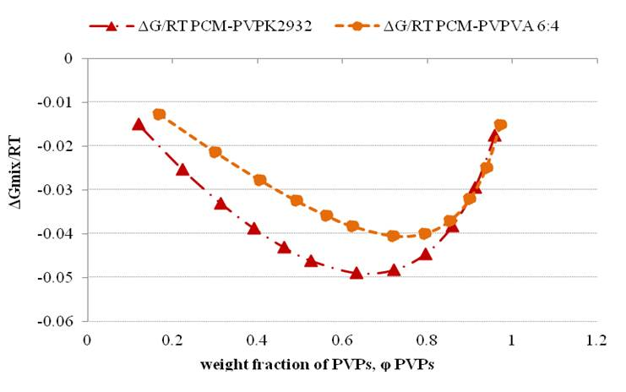

Figure 3. The changes in free energy of mixing of the API and polymer systems as a function of volume fraction of polymer as predicted using interaction parameter of Flory-Huggins lattice theory : ̶ ̶ ▪ ̶ ̶̶ ̶ PCM/PVP, and - - - - PCM/PVPVA.

The Gibbs free energies for the PCM mixtures were negative which indicated miscibility of the PCM and the carriers. This is in good agreement with the conclusions drawn from the (close) values of the solubility parameters (Table 2). According to Fig. 3, the minimum negative value of the PCM-PVPVA system lies at a higher value of polymer fraction (i.e. at 0.7 mole fraction of PVPVA) compared to PCM-PVP which has a minimum at 0.6 mole fraction of polymer. This indicates that a higher PVPVA fraction is needed to achieve a maximum miscibility between PVPVA and PCM in comparison to the homopolymer. These predictions will be correlated to the physical structure of the SD extrudates in a later section.

3.3 HME processability of the API-polymer systems

It has been suggested that HME products need to be processed at an extrusion temperature (T_{ex}) approximately 30-60ºC higher than glass transition temperature (T_{g}) of the polymer to allow the polymer to have a viscosity low enough to allow extrusion (Chokshi et al., 2005; Li et al., 2014; McGinity et al., 2006). However, it is also necessary to consider the liquefaction of the drug within the processing apparatus, as the presence of a suspension would be expected to increase viscosity and hence impede processing. On that basis, it is generally accepted that the T_{ex} must be high enough to both reduce polymer viscosity and facilitate liquefaction of the drug, either via melting or dissolution or both in preparing amorphous solid dispersion. While no issues for extrusion were envisaged for PVPVA due to its low T_{g} (at circa 106ºC), initial attempts at processing PVP alone at any temperature lower than 180ºC (higher than the T_{g} of PVP =164ºC) failed to result in extruded product because the torque was too high to allow extrusion. There is therefore clearly a challenge in identifying conditions that allow polymer processing in order to avoid degradation whilst also allowing the drug to dissolve or melt. Previous studies have suggested that extrusion may take place at T_{ex} < T_{m} of the drug (Li et al., 2014; Shah et al., 2013) due to plasticization and/or interaction effects, while Guo et al. (2013) have suggested that thermosensitive drugs may be successfully extruded at temperatures around the glass transition of the polymer. However, to date there has been limited evidence that the presence of the drug may in fact allow extrusion at a temperature much lower than the T_{g} of the polymer, with concomitant positive implications for thermal stability. Furthermore, the respective roles of direct molecular interaction and simple miscibility in allowing such as decrease in processing temperature is not yet clear.
In this study, the extrusion temperatures were initially explored on the basis of the extrudability of the binary products. For both drugs, temperatures which were approximately 50ºC lowered in comparison to the T_{m} of the drug were found to be effective. A T_{ex} value of 120ºC was chosen for HME PCM systems; this is of interest as it is lower than the T_{g} of the polymer alone, indicating extensive plasticization of the system by the PCM and thereby allowing lower temperature extrusion than would be usually expected. A T_{ex} of 180ºC was initially chosen for HME CAF systems and found to be suitable for extrudability despite being well below the T_{m} of caffeine. However, subsequent testing of PVP using thermogravimetric analysis showed that there was potential degradation of PVP at 180ºC, hence for HME CAF PVP products the lower temperature of 155ºC was selected; it is interesting to note that the caffeine was also effective in reducing the temperature of extrudability of the PVP (which could not be successfully extruded alone at 180ºC) despite there being no evidence for interaction and limited predicted mesicibility. It was therefore not possible to use exactly the same conditions for all four systems; instead, in all four cases the minimum temperatures that could be safely used were selected (Table 1). In terms of maximum loading, this parameter was determined by the visual appearance of the extrudates. More specifically, the maximum concentration was determined by the appearance of opacity in the extrudates. Examination of Table 1 shows that not only was it possible to use lower processing temperature from PCM compared to CAF, but that the former could also be incorporated up to higher concentrations before the extrudates appeared opaque. Clearly, therefore, the two drugs exhibit very different processability profiles in terms of both temperature and loading. This in turn indicates that the differing miscibility between the two, which we ascribe at least partially to direct molecular interactions, may have a profound effect on the choice of processing parameters. However, the use of the interactive and non-interactive drugs allows illustration of the point that while the interactive system allowed a greater lowering of processing temperature, the non-interactive drug-polymer system also showed a considerable reduction in T_{ex} which we tentatively ascribe to simple dissolution of the drug in the polymer.

3.4 Interaction assessment using ATR-FTIR

Fig. 4 shows the ATR-FTIR spectra of pure PCM, PVP, the PM and HME of 20-70% PCM PVP. The carbonyl (C=O) group stretching of the PVP monomer is seen at 1652 cm⁻¹; after HME processing of PVP with PCM, this band was shifted to a lower frequency of 1647 cm⁻¹, indicating interaction with the API at this carbonyl group. The ATR-FTIR spectrum of crystalline PCM indicates a characteristic band at 3324 cm⁻¹ which is attributed to NH stretching; this band was broadened in the HME product. Furthermore, the –OH stretching band of crystalline PCM at 3100 cm ⁻¹ was also broadened in the HME PCM PVP products. Both changes of these characteristic peaks indicated different vibration modes of -NH and –OH in the HME PVP-based SD compared to the pure drug.

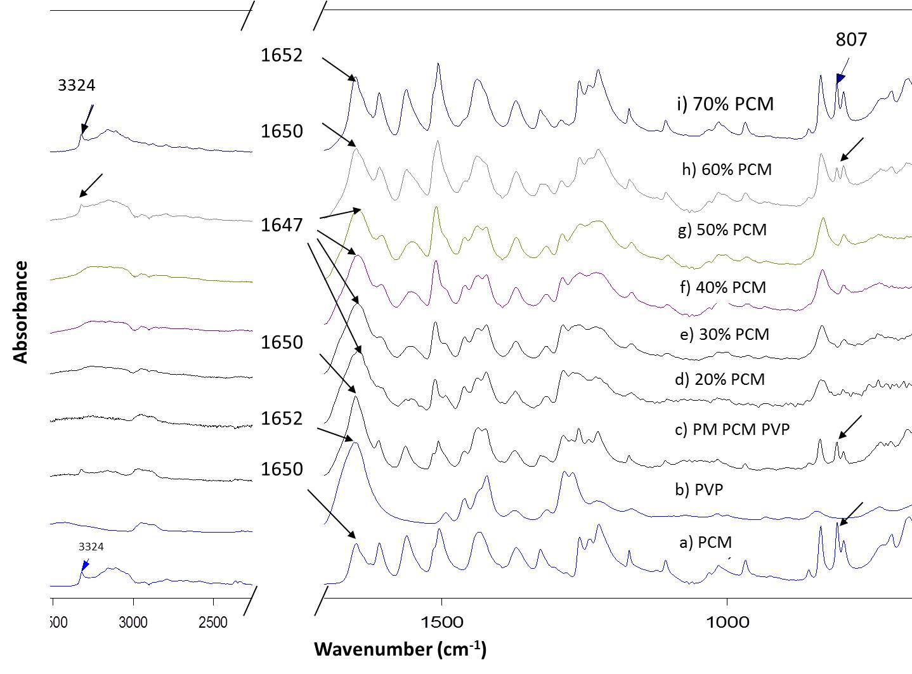

Figure 4. ATR-FTIR spectra of PCM, PVP and HME PCM-PVP systems
Combining the observations of the down-shifted carbonyl stretching band in PVP monomer and the broadening in –NH/-OH stretching band of PCM molecules, it is suggested that hydrogen bond interactions are formed between the C=O group of the PVP monomer and the NH or OH groups of PCM; this is in agreement with previously reported literature (Illangakoon et al., 2014; Nair et al., 2001; Wang et al., 2002). In the fingerprint region of circa 900-700 cm⁻¹, triplet peaks were seen for pure PCM and PM 50% PCM-PVP. However, in HME products, only a doublet was seen. According to Qi et al., the triplet peaks in this region may be attributed to crystalline PCM, whereas a doublet peak infers amorphous PCM (Qi et al., 2008). Therefore, based on the ATR FTIR spectra in Figure 4, HME 10% to 50% PCM PVP extrudates were amorphous in nature as shown by the double band in print region of 900-700 cm⁻¹. At higher PCM loading of HME PVP-based (60% and 70%) SD, the ATR-FTIR spectra show the reappearance of the diagnostic peaks of crystalline PCM (3100, 3324 and 807 cm⁻¹) which suggests the presence of crystalline material in those samples.
Fig. 5 shows the ATR-FTIR spectra of pure PCM, PVPVA and HME PCM-PVPVA systems. The ATR-FTIR spectra of PVPVA indicates two peaks at C=O stretching region, i.e. 1734 cm⁻¹ and 1667 cm⁻¹ which correspond to the C=O stretching of vinyl acetate and pyrrolidone, respectively.

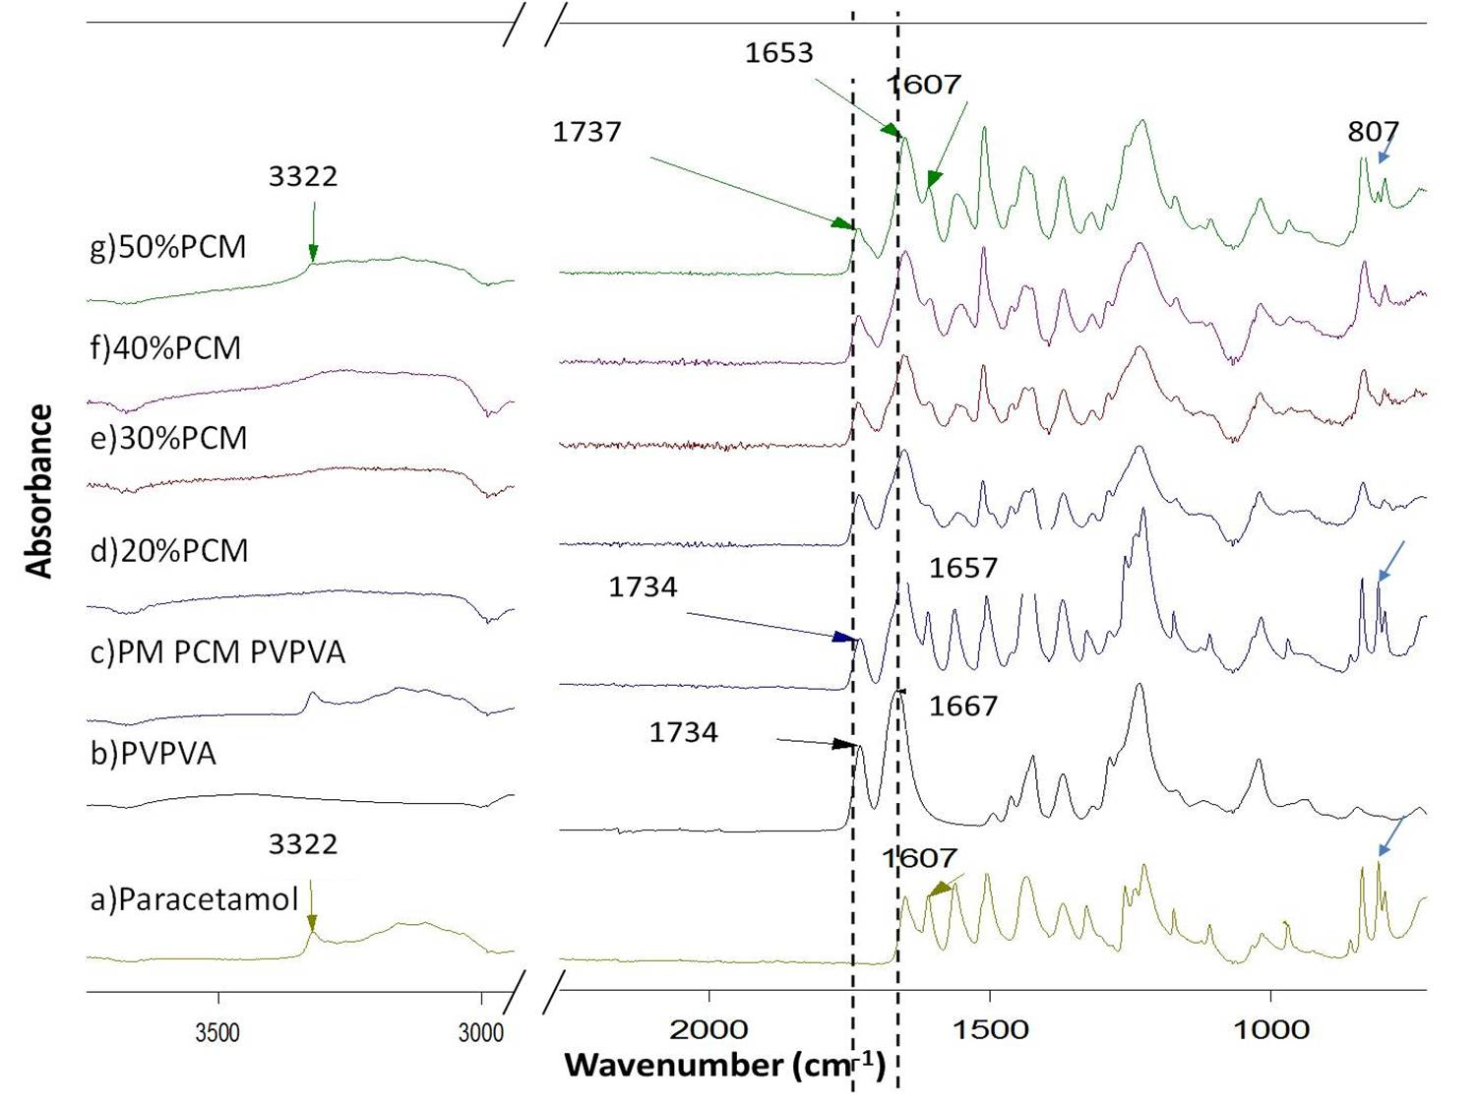

Figure 5. ATR-FTIR spectra of PCM, PVPVA and HME PCM-PVPVA systems
Interestingly, it is found that the C=O stretching (1734 cm⁻¹) of the VA moiety in both PM and HME preparations of binary PCM-PVPVA did not shift in comparison to the spectra of PVPVA alone. This is in contrast to the C=O stretching of pyrrolidone where down-shifting of its peak position (from 1667 cm⁻¹ to 1653 cm⁻¹) was noted in HME PCM-PVPVA in comparison to the PM and raw PVPVA. Therefore it is believed that the main interactions between PCM and PVPVA occurs preferentially at the C=O group of the pyrrole group rather than the C=O in vinyl-acetate group. On that basis, the intensity of PCM-polymer interaction was higher in PVP carrier system than in the HME PVPVA system.
Fig. 6 compares the ATR-FTIR spectra of CAF, PVP and HME CAF in PVP. ATR-FTIR spectra of HME 10-20% CAF in PVP did not show any significant peak position shifts in the carbonyl stretching region of the PVP as compared to its corresponding PM. This was attributed to the absence of molecular interactions between the CAF and PVP molecules. Similar results were found for PVPVA systems (data not shown).

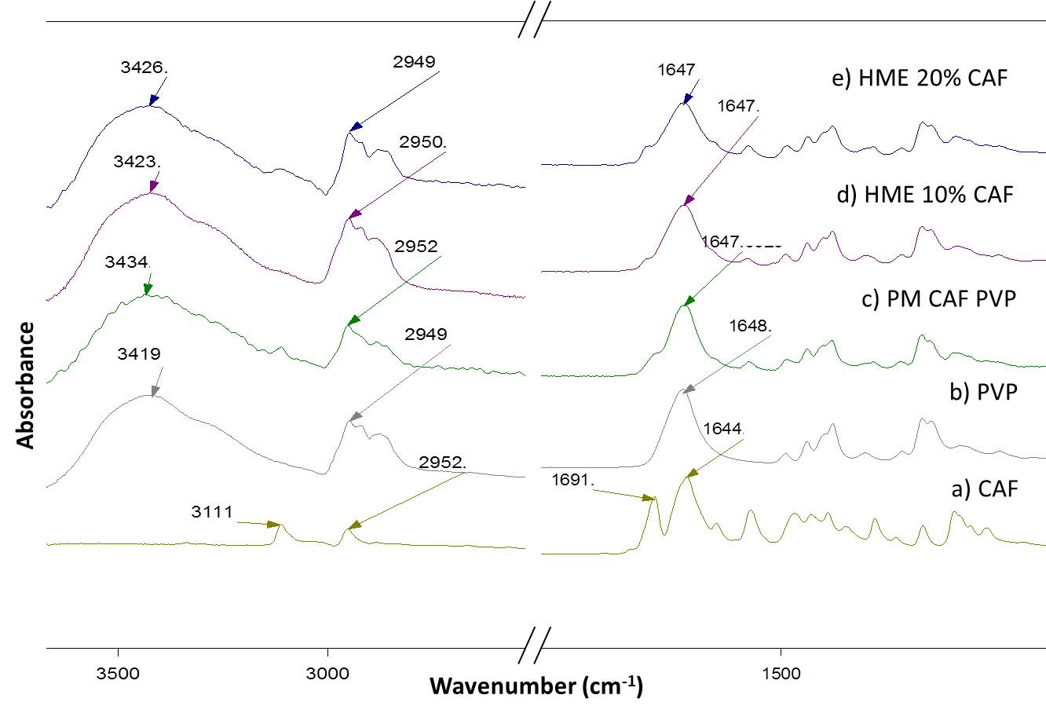

Figure 6. ATR-FTIR spectra of CAF, PVP and HME CAF-PVP systems

To summarise the ATR-FTIR results, PCM has been shown to demonstrate evidence for an interaction between the drug and the carriers PVP and PVPVA, with evidence for involvement of the C=O group of the PVP monomer and the NH and/or OH groups of PCM. The interaction between PCM and PVPVA was weaker and occurred preferentially at the C=O group of the pyrrole group. However, CAF has shown very limited interaction within the extrudated systems. Evidence was also obtained for phase separation into crystalline drug phases for PCM at 50% w/w loading in HME PVPVA system.

3.5 X-ray Powder Diffraction of HME solid dispersions

3.5.1 HME PCM-PVP and PVPVA systems
Fig. 7 shows the XRPD diffractograms of the extruded PCM PVP systems. The diffractograms showed halo patterns up to 50% drug loadings. At higher PCM loading i.e. 60%-70%, diffraction peaks were noted as anticipated from the opaque appearance of the extrudate at these loadings, indicating the presence of crystalline material in 60%-70% PCM loading system.
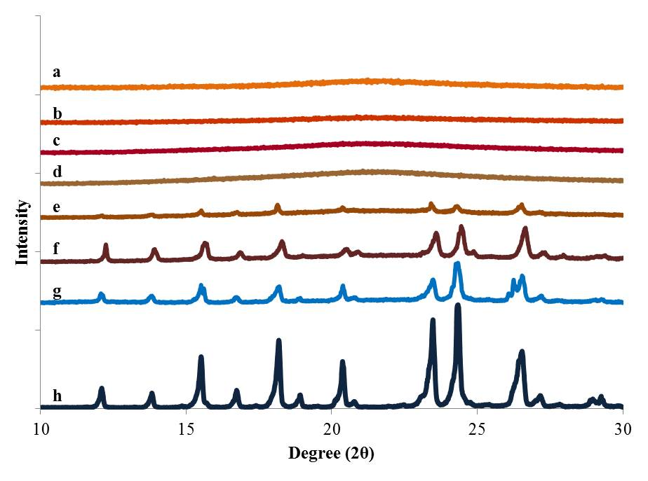
Degree (2Ɵ)
Intensity
Figure 7. X-ray Diffraction patterns of PCM and PVP, a) HME 20% PCM, b) HME 30% PCM , c) HME 40% PCM, d) HME 50% PCM, e) HME 60% PCM, f) HME 70% PCM, g) PM 20% PCM and h) Pure PCM
The peaks in the X-ray diffractograms of HME 60% and 70% PCM PVP corresponded to the initial polymorphic form, i.e. Form I (Łuczak et al., 2013). The detection of crystalline material for HME 60% PCM-PVP and above was a reflection of the relatively low extrusion temperature, i.e. 120ºC, which allowed limited dissolution up to 50% drug loading in PVP. However, a reduction in crystalline content were still seen in extrudates with 60% and 70% drug loading, which were found to have 13.72% and 29.25 % of crystallinity respectively. The percentage of crystalline material within the extrudates was calculated based on calibration according to the intensity of the two sharp peaks at 23.4 and 24.5º 2θ from XRPD diffractograms of physical mixtures of PCM and polymer with known crystalline percentage (de Villiers et al., 1998).
Fig. 8 shows the XRPD data of HME PCM in PVPVA systems. Unlike PVP carriers systems, the HME 50% PCM-PVP gave rise to X-ray diffraction peaks with a calculated crystallinity of 10.52%. This in turn implies that the solubility limit of PCM in PVPVA is lower than that in PVP using the same extrusion temperature of 120ºC.
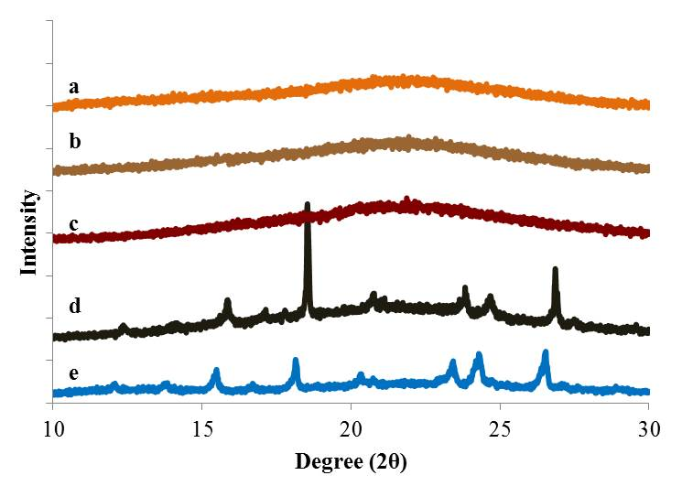

Figure 8. X-ray diffraction patterns of PCM with PVPVA a) HME 20% PCM, b) HME 30% PCM, c) HME 40% PCM, d) HME 50% PCM, e) PM of 20 % PCM-PVPVA

3.5.2 HME CAF-PVP and PVPVA systems
XRPD was also used to analyze extrudates of HME CAF in PVP systems. Fig. 9 displays the XRPD spectra of CAF, PM and HME of CAF PVP. A halo pattern was only detected in HME 10% CAF-PVP. In XRPD diffractograms of HME 20% CAF-PVP, a single characteristic peak at 2θ = 26.86º was noted which is attributed to metastable Form I CAF (Fig.9d, arrowed) (Descamps and Decroix, 2014). The detection of Form I in the hot processed HME PVP-based extrudates may reflect the enantiotropic nature of this material, with Form I being generated at higher temperatures (Descamps et al., 2005; Descamps and Decroix, 2014; Kishi and Matsuoka, 2010), although clearly the form has persisted on cooling. Since the peaks in the X-ray diffractograms of HME PVP-based CAF systems indicated a different polymorphic form of CAF which was different from the PM of raw CAF, the percentage of CAF crystallinity in the HME extrudates was not calculated.
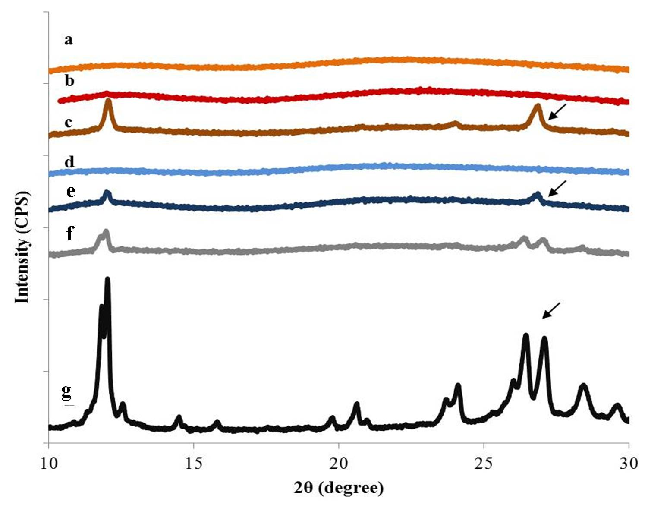

Figure 9. X-ray diffraction patterns of, a) HME 10% CAF PVPVA, b) HME 20% CAF PVPVA, c) HME 30% CAF PVPVA, d) HME 10% CAF PVP e) HME 20% CAF PVP, f) PM of 10% CAF PVPVA g) commercial CAF as received
Compared to HME CAF-PVP, a higher non-crystalline loading was noted for HME CAF PVPVA as shown by its halo patterns in XRPD diffractograms at 20% drug content (Fig. 11b). This might be ascribed to the higher extrusion temperature employed in HME PVPVA system (i.e. 180 ºC) as compared to PVP (i.e. 155 ºC). Similarly to the HME 20% CAF-PVP, XRPD diffractograms of the extruded 30% CAF-PVPVA system indicated single peaks at 2θ = 26.86º which was attributed to the Form I CAF (Fig. 9c); this is due to the transformation of CAF Form II (raw) to Form I during processing at 180 ºC.

3.6 Thermal analysis of the HME polymer systems
The DSC data of PCM-PVP and PCM –PVPVA HME systems showed melting peaks at 60%PCM PVP and 50% PCM PVPVA system (data not shown), hence the data indicated that the drug was molecularly dispersed up to these concentrations, as found using XRPD. The glass transition values were measured as lying between 31.3 to 76.2ºC for HME PCM PVP system and 37.2 to 46.6ºC for PCM PVPVA systems, although the possibility of water plasticization on the cooled materials could not be excluded and hence these values were not considered further as a direct measure of drug-polymer miscibility.
A more complex profile was noted for the CAF-loaded systems (Figure 10). DSC traces showed an endothermic response for both 10% and 20% CAF PVP systems between 207ºC to 233ºC which is close to the melting temperature of crystalline CAF. However there was also evidence for recrystallisation during the heating run, hence the presence of the endotherm could not be taken as definitive evidence of the presence of crystalline material in the original sample. Indeed, for 20% PVPVA systems there was a clear exotherm which we attribute to caffeine recrystallization during heating. This was further supported by HSM data whereby crystals were seen to appear at circa 112ºC (Figure 11).

Figure 10. MTDSC thermograms of (a) HME 10% CAF-PVP, (b) HME 20% CAF, (c) HME 10% CAF-PVPVA and (d) HME 20% CAF-PVPVA

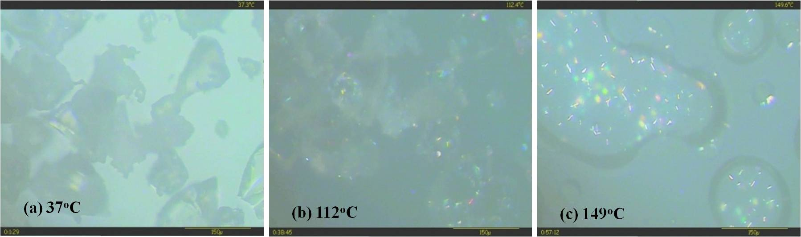
Figure 11. HSM investigation of HME 10% CAF-PVPVA at a heating rate of 10 ºC per inute. The marked temperature at left bottom corner of each screen indicates the temperature of sample. Polarized light was used in screen (b) and (c)

Overall, therefore, the thermal analysis studies have broadly supported the conclusions from the FTIR and XRD in suggesting that a molecular dispersion is generated for PCM at concentrations up to circa 60% w/w, while for caffeine the miscibility is much lower, despite the higher extrusion temperatures used.

4. Discussion

The study has explored the miscibility, processability and final structure of HME systems prepared using two model drugs with very different propensities for interaction with the two polymers used. In considering the findings, it is necessary to delineate the phenomena involved as while interrelated they are nonetheless distinct. The intrinsic miscibility between the drugs and polymers will be dependent on several factors, one being the possibility of direct molecular interaction, another being the similarities in hydrophobicity and hydrophilicity of the two component structures. By using two drugs with different propensities for interaction, it is possible to examine how such interactions may influence both miscibility and processability, the latter being considered in terms of both temperature at which processing is possible and the maximum drug loading that may be used to produce clear (and potentially molecularly dispersed) products.
The extent of miscibility was assessed using theoretical approaches in the first instance. It is reported that when differences in Hansen’s solubility parameters of drug-polymer mixes are < 7.0 MPa^{1/2}, significant miscibility between the two components is expected (Maniruzzaman et al., 2013; Sarode et al., 2013; Thakral and Thakral, 2013; Zhao et al., 2011). In this study, good miscibility was predicted in the binary system of the interacting API (PCM) and the PVP-based polymers, as shown by the small difference in their solubility parameters. In contrast, solubility parameters of the non-interacting API, i.e. CAF with PVPs polymers show differences of > 8 MPa^{1/2} which imply limited miscibility. From the melting point depression approach, similar conclusions may be drawn in that there was a clear indication of greater miscibility for the PCM systems.
In terms of experimental assessment of the HME systems, the ATR-FTIR again supports a greater interaction between the PCM and the two polymers than was the case for CAF, hence it is reasonable to conclude that the two model drugs show clear predicted miscibility differences which may reasonably be associated with the presence or absence of molecular interactions between the drug and polymer.
Examination of both the conditions used to produce HME dispersions indicated that lower temperatures could be used for PCM systems, to the extent that it was possible to process at temperatures below T_{g} of the pure polymers. This would strongly indicate plasticizing effects which in turn indicates miscibility of the PCM with the polymers used. However similar lowering, at least in relation to the melting point of the drug, was seen for caffeine, indicating that the drug was also acting as a plasticizer despite the lack of direct interaction with the polymer. Nevertheless, the drug loading which could be effectively processed into an amorphous dispersion system was much lower than for PCM. The phase separation in the cooled extrudates were also examined using FTIR, XRD and DSC, with good agreement between data sets in that the PCM systems were molecularly dispersed up to circa 50% w/w as opposed to circa 20% for CAF.
Overall, therefore, the study has shown that a high level of molecular interaction does appear to increase the maximum concentration that may be incorporated at a molecular level and may also facilitate lowering of T_{ex}. Consequently, such interactions may be beneficial in terms of maximum loading but appear to be less necessary for facilitating processability. The study has also highlighted the role of such interactions in facilitating the use of PVP in particular as a matrix for extrusion. However the study has also shown that such interactions, at least at a level detectable by spectroscopic techniques, are not in fact essential for successful reduction in processing temperature and molecular dispersion formation, as evidenced by the successful lowering of the T_{ex} and the molecular loading of the CAF systems. One may therefore conclude that direct interaction is therefore extremely helpful, but is not essential in forming suitable HME formulations. Indeed, examination of the predictive tools used would indicate that solubility parameters, which incorporate molecular interactions but are not dominated by them, may be an effective means of predicting not only miscibility but also processing suitability of drug-polymer combinations.

5. Conclusions

This study has examined the miscibility of two model APIs, caffeine (CAF) and paracetamol (PCM), in PVP-based solid dispersions prepared via hot melt extrusion. It has been shown that the solubility parameter and melting point depression methods may be used to assess comparative miscibility at an early stage, with good correlation found between such approaches and subsequent processing behavior and structure. PCM was predicted to be more miscible in both polymers (especially PVP homopolymer), this being supported by practical evidence with regard to phase separation on extrusion. The miscibility of PCM was attributed to hydrogen bonding which was absent for CAF, an assertion supported by ATR-FTIR. In terms of processing, the interactive systems (PCM-based) could be processed at temperature below the T_{g} of the polymer alone which can be reasonably ascribed to plasticization effects. Similarly, the maximum loading which produced clear extrudates was also higher for the PCM systems. However, the non-interacting CAF systems also showed extrusion temperature lowering and molecular miscibility, albeit to a lesser extent.
Overall, the study has shown that miscibility and molecular interactions may be intrinsically linked and indeed predicted from theoretical approaches, with implications for both extrudability and phase separation. However direct interactions do not appear to be essential for either improvements in processability and molecular dispersion, hence examination of solubility parameter difference may in itself be an effective means of determining suitability of drug-polymer combinations for enhanced performance, irrespective of interaction potential.

Acknowledgement

The financial support from Universiti Sains Malaysia is greatly appreciated.

References

Callahan, J.C., Cleary, G.W., Elefant, M., Kaplan, G., Kensler, T., Nash, R.A., 1982. Equilibrium Moisture Content of Pharmaceutical Excipients. Drug Dev. Ind. Pharm. 8, 355-369.
Chauhan, H., Hui-Gu, C., Atef, E., 2013. Correlating the behavior of polymers in solution as precipitation inhibitor to its amorphous stabilization ability in solid dispersions. J. Pharm. Sci. 102, 1924-1935.
Chokshi, R.J., Sandhu, H.K., Iyer, R.M., Shah, N.H., Malick, A.W., Zia, H., 2005. Characterization of physico-mechanical properties of indomethacin and polymers to assess their suitability for hot-melt extrusion processs as a means to manufacture solid dispersion/solution. J. Pharm. Sci. 94, 2463-2474.
de Villiers, M.M., Wurster, D.E., Van der Watt, J.G., Ketkar, A., 1998. X-Ray powder diffraction determination of the relative amount of crystalline acetaminophen in solid dispersions with polyvinylpyrrolidone. Int. J. Pharm. 163, 219-224.
Descamps, M., Correia, N.l.T., Derollez, P., Danede, F., Capet, F.d.r., 2005. Plastic and Glassy Crystal States of Caffeine. The J. Phys. Chem. 109, 16092-16098.
Descamps, M., Decroix, A.A., 2014. Polymorphism and disorder in caffeine: Dielectric investigation of molecular mobilities. J. Mol. Struct. 1078, 165-173.
Gong, X.F., Shing, K.S., Chang, W.V., 1989. Effect of composition dependent Flory interaction parameter χ on polymer adsorption theory. Polym. Bull. 22, 71-78.
Guo, Z., Lu, M., Li, Y., Pang, H., Lin, L., Liu, X., Wu, C., 2014. The utilization of drug–polymer interactions for improving the chemical stability of hot-melt extruded solid dispersions. J. Pharm. Pharmacol. 66, 285-296.
Hancock, B.C., Zografi, G., 1997. Characteristics and significance of the amorphous state in pharmaceutical systems. J. Pharm. Sci. 86, 1-12.
Huang, Y., Dai, W.-G., 2014. Fundamental aspects of solid dispersion technology for poorly soluble drugs. Acta Pharm. Sin. B. 4, 18-25.
Illangakoon, U.E., Gill, H., Shearman, G.C., Parhizkar, M., Mahalingam, S., Chatterton, N.P., Williams, G.R., 2014. Fast dissolving paracetamol/caffeine nanofibers prepared by electrospinning. Int. J. Pharm. 477, 369-379.
ISP Pharmaceuticals, 2007. Plasdone ® Povidone Product Guide, USA, p. 12.
Kanaujia, P., Lau, G., Ng, W.K., Widjaja, E., Hanefeld, A., Fischbach, M., Maio, M., Tan, R.B.H., 2011. Nanoparticle formation and growth during in vitro dissolution of ketoconazole solid dispersion. J. Pharm. Sci. 100, 2876-2885.
Kishi, Y., Matsuoka, M., 2010. Phenomena and Kinetics of Solid-State Polymorphic Transition of Caffeine. Cryst. Growth Des. 10, 2916-2920.
Li, B., Liu, H., Amin, M., Wegiel, L., Taylor, L., Edgar, K., 2013. Enhancement of naringenin solution concentration by solid dispersion in cellulose derivative matrices. Cellulose 20, 2137-2149.
Li, Y., Pang, H., Guo, Z., Lin, L., Dong, Y., Li, G., Lu, M., Wu, C., 2014. Interactions between drugs and polymers influencing hot melt extrusion. J. Pharm. Pharmacol. 66, 148-166.
Łuczak, A., Jallo, L.J., Dave, R.N., Iqbal, Z., 2013. Polymorph stabilization in processed acetaminophen powders. Powder Technol. 236, 52-62.
Maniruzzaman, M., Morgan, D.J., Mendham, A.P., Pang, J., Snowden, M.J., Douroumis, D., 2013. Drug–polymer intermolecular interactions in hot-melt extruded solid dispersions. Int. J. Pharm. 443, 199-208.
Marsac, P., Li, T., Taylor, L., 2009. Estimation of Drug–Polymer Miscibility and Solubility in Amorphous Solid Dispersions Using Experimentally Determined Interaction Parameters. Pharmaceut. Res. 26, 139-151.
Marsac, P., Shamblin, S., Taylor, L., 2006. Theoretical and Practical Approaches for Prediction of Drug–Polymer Miscibility and Solubility. Pharmaceut. Res. 23, 2417-2426.
McGinity, J.W., Repka, M.A., Koleng, J.J., Zhang, F., 2006. Hot-Melt Extrusion Technology. Encyclopedia of Pharmaceutical Technology: Third Edition, 2004 - 2020.
Nair, R., Nyamweya, N., Gönen, S., Martínez-Miranda, L.J., Hoag, S.W., 2001. Influence of various drugs on the glass transition temperature of poly(vinylpyrrolidone): a thermodynamic and spectroscopic investigation. Int. J. Pharm. 225, 83-96.
Netchacovitch, L., Thiry, J., De Bleye, C., Chavez, P.F., Krier, F., Sacré, P.Y., Evrard, B., Hubert, P., Ziemons, E., 2015. Vibrational spectroscopy and microspectroscopy analyzing qualitatively and quantitatively pharmaceutical hot melt extrudates. J. Pharm. Biomed. Anal.
Ozaki, S., Kushida, I., Yamashita, T., Hasebe, T., Shirai, O., Kano, K., 2013. Inhibition of crystal nucleation and growth by water-soluble polymers and its impact on the supersaturation profiles of amorphous drugs. J. Pharm. Sci. 102, 2273-2281.
Paudel, A., Van den Mooter, G., 2011. Influence of Solvent Composition on the Miscibility and Physical Stability of Naproxen/PVP K 25 Solid Dispersions Prepared by Cosolvent Spray-Drying. Pharmaceut. Res. 29, 251-270.
Prudic, A., Ji, Y., Sadowski, G., 2014. Thermodynamic Phase Behavior of API/Polymer Solid Dispersions. Mol. Pharm. 11, 2294-2304.
Qi, S., Gryczke, A., Belton, P., Craig, D.Q.M., 2008. Characterisation of solid dispersions of paracetamol and EUDRAGIT® E prepared by hot-melt extrusion using thermal, microthermal and spectroscopic analysis. Int. J. Pharm. 354, 158-167.
Sarode, A.L., Sandhu, H., Shah, N., Malick, W., Zia, H., 2013. Hot melt extrusion (HME) for amorphous solid dispersions: Predictive tools for processing and impact of drug–polymer interactions on supersaturation. Eur. J. Pharm. Sci. 48, 371-384.
Sathigari, S.K., Radhakrishnan, V.K., Davis, V.A., Parsons, D.L., Babu, R.J., 2012. Amorphous-state characterization of efavirenz—polymer hot-melt extrusion systems for dissolution enhancement. J. Pharm. Sci. 101, 3456-3464.
Shah, S., Maddineni, S., Lu, J., Repka, M.A., 2013. Melt extrusion with poorly soluble drugs. International Journal of Pharmaceutics 453, 233-252.
Tantishaiyakul, V., Kaewnopparat, N., Ingkatawornwong, S., 1999. Properties of solid dispersions of piroxicam in polyvinylpyrrolidone. Int. J. Pharm. 181, 143-151.
Thakral, S., Thakral, N.K., 2013. Prediction of drug–polymer miscibility through the use of solubility parameter based Flory–Huggins interaction parameter and the experimental validation: PEG as model polymer. J. Pharm. Sci. 102, 2254-2263.
Tian, Y., Booth, J., Meehan, E., Jones, D.S., Li, S., Andrews, G.P., 2013. Construction of Drug–Polymer Thermodynamic Phase Diagrams Using Flory–Huggins Interaction Theory: Identifying the Relevance of Temperature and Drug Weight Fraction to Phase Separation within Solid Dispersions. Mol. Pharm. 10, 236-248.
Van Krevelen, D.W., Te Nijenhuis, K., 2009. Properties of polymers, Cohesive Properties and Solubility, Fourth Edition ed. Elsevier Scientific Publication, Oxford, UK, pp. 189-227.
Wang, S.-L., Lin, S.-Y., Wei, Y.-S., 2002. Transformation of Metastable Forms of Acetaminophen Studied by Thermal Fourier Transform Infrared (FT-IR) Microspectroscopy. Chem. Pharm. Bull. 50, 153-156.
Wegiel, L., Mosquera-Giraldo, L., Mauer, L., Edgar, K., Taylor, L., 2015. Phase Behavior of Resveratrol Solid Dispersions Upon Addition to Aqueous media. Pharm Res, 1-14.
Zhao, Y., Inbar, P., Chokshi, H.P., Malick, A.W., Choi, D.S., 2011. Prediction of the thermal phase diagram of amorphous solid dispersions by flory–huggins theory. J. Pharm. Sci. 100, 3196-3207.
List of Figure

Figure 1. DSC traces of physical mixes of PCM-PVP from (a) 75%, (b) 80% , (c) 85%, (d) 90%, (e) 95%, and (f)100 % w/w drug loading) measured at 2 ºC/min. Onset melting points of each the DSC thermogram were taken as the melting temperature of the corresponding systems.
Figure 2. Plot used to determine the interaction parameters of PCM/PVP,PCM/PVPVA, CAF-PVP and CAF-PVPVA systems.
Figure 3. The changes in free energy of mixing of the API and polymer systems as a function of volume fraction of polymer as predicted using interaction parameter of Flory-Huggins lattice theory : ̶ ̶ ▪ ̶ ̶̶ ̶ PCM/PVP, and - - - - PCM/PVPVA.
Figure 4. ATR-FTIR spectra of PCM, PVP and HME PCM-PVPVA systems
Figure 5. ATR-FTIR spectra of PCM, PVPVA and HME PCM-PVPVA systems
Figure 6. ATR-FTIR spectra of CAF, PVP and HME CAF-PVP systems
Figure 7. X-ray Diffraction patterns of PCM and PVP, a) HME 20% PCM, b) HME 30% PCM , c) HME 40% PCM, d) HME 50% PCM, e) HME 60% PCM, f) HME 70% PCM, g) PM 20% PCM and h) Pure PCM
Figure 8. X-ray diffraction patterns of PCM with PVPVA a) HME 20% PCM, b) HME 30% PCM, c) HME 40% PCM, d) HME 50% PCM, e) PM of 20 % PCM-PVPVA
Figure 9. X-ray diffraction patterns of, a) HME 10% CAF PVPVA, b) HME 20% CAF PVPVA, c) HME 30% CAF PVPVA, d) HME 10% CAF PVP e) HME 20% CAF PVP, f) PM of 10% CAF PVPVA g) commercial CAF as received
Figure 10. MTDSC thermograms of (a) HME 10% CAF-PVP, (b) HME 20% CAF, (c) HME 10% CAF-PVPVA and (d) HME 20% CAF-PVPVA
Figure 11. HSM investigation of HME 10% CAF-PVPVA 6:4 at a heating rate of 10 ºC per inute. The marked temperature at left bottom corner of each screen indicates the temperature of sample. Polarized light was used in screen (b) and (c)
Supplementary information 1
Water content (% w/w) of freshly prepared HME extrudates as a function of drug-polymer composition
Drug loading  % w/w | Water content (%w/w)
Drug loading  % w/w | HME PCM- PVP K29-32 | HME PCM-PVPVA | HME CAF-PVP K29-32 | HME CAF-PVPVA
10 | - | - | 2.68 ± 0.52 | 2.33 ± 0.42
20 | 1.86 ± 0.29 | 2.49 ± 0.37 | 2.56 ± 0.10 | 2.11 ± 0.36
30 | 1.59 ± 0.39 | 1.66 ± 0.12 | - | -
40 | 1.84 ± 0.57 | 1.64 ± 0.17 | - | -
50 | 2.02 ± 0.75 | 1.28 ± 0.17 | -
60 | 1.92 ± 0.47 | - | - | -
70 | 1.59 ± 0.16 | - | - | -

Supplementary information 2
T_{g} of the HME extrudates as a function of drug-polymer composition

Drug loading  % w/w | Glass Transition temperature (ºC)
Drug loading  % w/w | HME PCM- PVP K29-32 | HME PCM-PVPVA | HME CAF-PVP K29-32 | HME CAF-PVPVA
10 | - | - | 106.3 ± 9.2 | 59.0 ± 1.0
20 | 76.2 ± 0.5 | 46.6 ± 2.9 | 82.1 ±1.8 | 51.6 ± 3.2
30 | 60.6 ± 1.6 | 44.1 ± 2.0 | - | -
40 | 54.8 ± 1.0 | 41.3 ± 0.5 | - | -
50 | 42.5 ± 1.9 | 37.2 ± 0.7 | -
60 | 33.6 ± 2.4 | - | - | -
70 | 31.3 ± 0.7 | - | - | -

Supplementary information 3
Raw data of depressed melting temperatures of PM system
Solid dispersion systems | Drug loading  (% w/w) | Onset melting point (ºC) | Melting enthalpy (KJ/mol)
PCM-PVP K29-32 | 70 | 149.92 ± 471 | 13.72 ± 0.36
 | 75 | 159.28 ± 2.51 | 15.36 ± 0.13
 | 80 | 162.82 ± 2.37 | 17.45 ± 0.57
 | 85 | 163.53 ± 0.44 | 18.83 ± 0.23
 | 90 | 165.36 ± 0.36 | 20.66 ± 0.13
 | 95 | 166.47 ± 0.21 | 23.23 ± 0.41
 | 100 | 167.45 ± 0.26 | 27.83 ± 0.49
PCM-PVPVA | 70 | 145.40 ± 4.98 | 12.47 ± 0.15
 | 75 | 156.29 ± 5.67 | 14.40 ± 0.73
 | 80 | 159.68 ± 1.21 | 15.90 ± 0.32
 | 85 | 161.62 ± 1.59 | 17.52 ± 0.64
 | 90 | 165.09 ± 0.43 | 20.60 ± 0.57
 | 95 | 166.30 ± 0.21 | 23.36 ± 0.91
 | 100 | 167.45 ± 0.26 | 27.83 ±0.49
CAF-PVP K29-32 | 70 | 223.07 ± 0.88 | 9.94 ± 0.16
 | 75 | 226.72 ± 0.27 | 12.40 ± 064
 | 80 | 227.18 ± 2.83 | 13.09 ± 1.19
 | 85 | 230.27 ± 1.23 | 14.49 ± 1.38
 | 90 | 232.30 ± 0.95 | 18.08 ± 0.55
 | 95 | 233.05 ± 106 | 18.06 ± 1.03
 | 100 | 233.78 ± 0.14 | 24.27 ± 0.36
CAF-PVPVA | 70 | 220.21 ± 1.19 | 10.17 ± 0.98
 | 75 | 224.87 ± 1.37 | 11.87 ± 0.83
 | 80 | 228.54 ± 0.60 | 14.11 ± 0.38
 | 85 | 229.47 ± 1.62 | 15.73 ± 0.32
 | 90 | 230.36 ± 1.86 | 16.53 ± 0.65
 | 95 | 231.52 ± 1.57 | 18.01 ± 0.56
 | 100 | 233.78 ± 0.14 | 24.27 ± 0.36

