Clinical skills for postgraduates: Assessing the sense of smell
Author 1 & Corresponding Author:
Mr Irfan Syed
Rhinology & Facial Plastics Fellow
St George’s Hospital
Blackshaw Road
Tooting
SW17 0QT
Tel: 07773360479
irfan.syed@doctors.org.uk

Author 2:
Mr Carl Philpott
Anthony Long Senior Lecturer
Honorary Consultant ENT Surgeon & Rhinologist
James Paget University Hospital
Lowestoft Road
Gorleston,
Great Yarmouth,
Norfolk, NR31 6LA
Tel: 01603 591105
C.Philpott@uea.ac.uk

The assessment of the sense of smell is a frequently overlooked part of the clinical examination. The assessment is sometimes more complex than the examination of a “single” cranial nerve and is therefore not infrequently restricted to the simple question. Do you have any problems with your sense of smell?
Amongst examination candidates there is almost always a degree of uncertainty about how to proceed when the patient replies ‘Yes’ both in terms of immediate examination and further investigations.
In this short article we outline a basic schema for the examination of the sense of smell and answering questions about further investigations.
Due to the subjective nature of smell perception the assessment involves a combination of targeted history & clinical examination

Initial targeted questions
‘Do you have any problems with your sense of smell?’
If the answer to this question is ‘Yes’ the next step is to ask a series of questions to establish the nature of smell loss e.g. diminished or absent sense of smell (hyposmia/anosmia) or distortion e.g. perception of an offensive smell that isn’t present as an external stimulus (phantosmia) or distorted perception of an external stimulus (parosmia) See Fig 1.

Disorders of smell
Anosmia Total loss of smell
Hyposmia Diminished sense of smell
Parosmia Perception of smell different to that previously remembered
Troposmia form of parosmia where the distortion is unpleasant
Euosmia form of parosmia where the distortion is pleasant
Phantosmia Perception of a smell in absence of a stimulus
Cacosmia form of phantosmia with a bad smell

Fig 1 Terminology for disturbance of smell

Timing of the smell disturbance
Was this a gradual or rapid loss of smell? Is the smell disturbance intermittent or persistent?
Is there any associated loss of taste?
Many patients complain of a concomitant loss of taste and do not recognise that it is due to diminished olfaction until this is explored in more detail.
Any associated events/medical conditions
In particular ask specifically about head injury, history of a viral upper respiratory tract infection or chronic sinonasal conditions. Any prior history of surgical procedures to the nose/sinuses is also relevant.
Are there any endocrine disturbances e.g. diabetes mellitus, hypothyroidism, hypogonadism?
Medication history
There are numerous medications that are associated with disturbance of smell/taste. Importantly the effect on smell may occur over a period of time and there may also be a delay in recovery of smell after cessation of medication.
Exposure to chemicals?
Does the patient smoke? Is there any exposure to industrial chemicals, environmental toxins etc?
Associated neurological/psychiatric symptoms
There is an association between smell disturbance and neurodegenerative diseases e.g. Alzheimer’s Disease & Parkinson’s Disease. Particularly in older patients it is worth asking specifically about memory problems and motor symptoms. Temporal lobe epilepsy may be associated with olfactory hallucinations. Olfactory disturbance is also recognised in schizophrenia.

Examination
Nasal examination should include anterior rhinoscopy and rigid fibreoptic nasendoscopic examination to visualise the nasal cavity and nasopharynx. This should identify any obvious inflammation, muco-purulent discharge, polyps or masses. In particular the olfactory cleft should be examined for any signs of oedema or purulent discharge. Significant rhinitis may give the mucosa a pale appearance.
A dental examination may be appropriate if there is a history of persistent foul odour and especially if any symptoms of dysgeusia are present.
A full examination of the cranial nerves and examination of signs of raised intracranial pressure e.g. papilloedema may be appropriate.
In particular, remember that the trigeminal system (cranial nerve V) is involved in the detection of noxious stimuli through sensory innervation of the nose & sinuses. This is distinct from detection of olfactory stimuli via the olfactory nerve (cranial nerve I).

Do you know any particular tests for assessing the sense of smell?
Ideally an olfactory test should be a validated one of which there are number of commercially available kits in existence. The modalities of smell assessed may vary; most will assess identification and others will also address threshold and discrimination. Common odorants for threshold testing include n-butyl alcohol and pehethyl alcohol; the former has a neutral odour, availability, low toxicity and solubility. For example, the ‘Sniffin Sticks’ system can be supplied with either n-butanol or phenethyl alcohol felt tip pens that contain different sequential dilutions of the test odour (2). ‘Sniffin sticks’ have the advantage of being able to assess odour threshold, discrimination & identification. Other test kits include the University of Pennsylvania Smell Identification Test (UPSIT)(1). This involves 40 microencapsulated odours in 4 envelope sized booklets with 10 scratch and sniff odourants in each booklet. Above each odorant strip there are four possible choices for the correct odour. The anosmic patient will score around 10/40 and patients with hyposmia may be categorised as mild/moderate/severe depending on the score. The test may also identify patients that are feigning symptoms if they score less than 5. The limitation of identification tests in isolation is that they require verbalisation of the odours as well as cultural exposure.

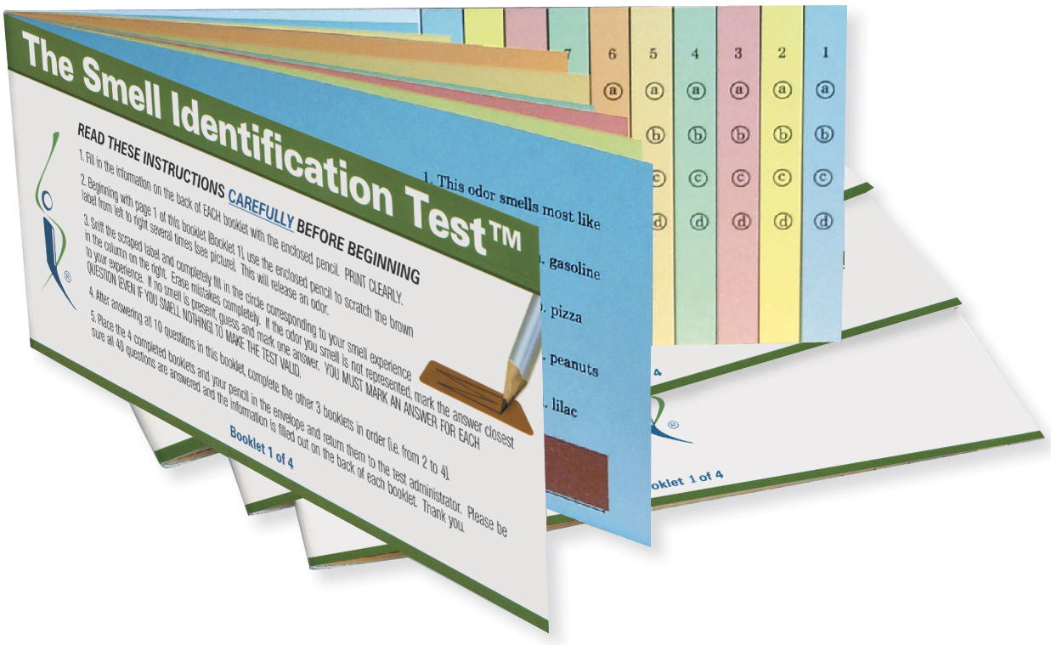
Fig 2 The booklets for the University of Pennsylvania Smell Identification Test. Photo courtesy of Sensonics, Inc.,Haddon Hts., NJ 08035 USA.

References

1. Doty RL, McKeown DA, Lee WW, Shaman P. A study of the test-retest reliability of ten olfactory tests. Chemical senses. 1995;20(6):645-56.

2. Hummel T, Sekinger B, Wolf SR, Pauli E, Kobal G. 'Sniffin' sticks': olfactory performance assessed by the combined testing of odor identification, odor discrimination and olfactory threshold. Chemical senses. 1997;22(1):39-52.

