Cochrane Corner: what are the effects of reducing saturated fat intake on cardiovascular disease and mortality?

Lee Hooper, Nicole Martin, Asmaa Abdelhamid

Acknowledgements: George Davey Smith is an author of the systematic review discussed here, and we thank him for his support for this article.

The Corresponding Author has the right to grant on behalf of all authors and does grant on behalf of all authors, an exclusive licence (or non exclusive for government employees) on a worldwide basis to the BMJ Publishing Group Ltd and its Licensees to permit this article (if accepted) to be published in HEART editions and any other BMJPGL products to exploit all subsidiary rights.

Background
What should we be telling our patients about saturated fat and cardiovascular risk? There have been highly publicised systematic reviews of observational data suggesting no relationship between saturated fat and all-cause mortality or coronary heart disease (CHD).[1,2] This is sensational, but is it correct? Randomised controlled trials (RCTs) are better than observational studies at clarifying effectiveness of interventions, and large numbers of people have been involved in randomised trials of saturated fat reduction over periods of at least 24 months. What do trials tell us about the effects of saturated fat reduction on health? And if we cut down on saturated fat, does it matter what we eat in its place? To find out, we carried out a Cochrane systematic review of randomised controlled trials.[3]

Review methods
We worked with the World Health Organization Nutrition Guidance Expert Advisory Group (WHO NUGAG) to ensure the review accurately assessed effects of reducing saturated fats on all-cause mortality, cardiovascular morbidity and other health outcomes, and to consider the differential effects on health outcomes of replacement of the energy from saturated fat by polyunsaturated fats, monounsaturated fats, carbohydrates or protein. Review methods followed the Cochrane Handbook for Systematic Reviews of Interventions (http://community.cochrane.org/handbook). The inclusion criteria for the Cochrane review are summarised in the Table, along with key review results.[3]

Review findings
Meta-analysis of the 15 included RCTs did not suggest that reducing saturated fat altered risks of all-cause mortality, cardiovascular mortality, CHD mortality, CHD events, non-fatal MI or stroke, but there was a 17% reduction in people experiencing cardiovascular disease (CVD) events and a marginal effect (suggesting a 10% reduction) on those experiencing myocardial infarction (fatal or non-fatal). In this context we defined CVD events as including myocardial infarction, angina, stroke, heart failure, peripheral vascular events, atrial fibrillation and unplanned coronary artery bypass surgery or angioplasty. Participants were counted as having at least one of these events, or not having any of these events.

The 17% reduction in people having CVD events caused by saturated fat reduction was robust to multiple sensitivity analyses including removal of the largest trial (Women’s Health Initiative), meta-analysis methods, removing studies where saturated fat was not significantly reduced in the intervention arm, and removing studies where serum total cholesterol was not significantly reduced in the intervention arm. The effect size was also robust to removal of studies at high or unclear risk of selection and performance bias.

As reduction in saturated fat is almost always compensated for by some other form of energy, we wanted to understand effects of replacing saturated fats with other macronutrients. Subgrouping of studies that replaced saturated fat with polyunsaturated fats showed 27% reductions in people experiencing CVD events (RR 0.73, 95% CI 0.58 to 0.92, see Figure), while studies replacing saturated fats with protein or carbohydrates did not protect against CVD. There were insufficient studies to assess replacement with mono-unsaturated fats. In an earlier Cochrane review we tried to clarify the different effects of replacement by poly- and monounsaturated fats.[4] We searched for trials that randomised participants to reducing saturated fat and replacing it with polyunsaturated fats compared to reducing saturated fat and replacing it with monounsaturated fats – but unfortunately there were insufficient included studies to compare effects of the two strategies on health outcomes.

Subgrouping and meta-regression were used to understand the characteristics of trials where the reduction in people experiencing CVD events was greatest. We found that most cardiovascular event reduction occurred in trials that primarily replaced saturated fat calories with polyunsaturated fat, showed greater serum total cholesterol reductions, greater saturated fat reduction and greater increase in polyunsaturated and monounsaturated fats. The reduction in CVD events was consistent in people with and without existing CVD, and at increased risk of CVD (people with high blood pressure, high serum cholesterol or diabetes, for example).

There was no evidence of harmful effects of reducing saturated fat intakes on cancer mortality, cancer diagnoses or blood pressure, but we did see small improvements in body weight (mean difference -2.0 kg, 95% CI -3.7 to -0.3), and body mass index (mean difference -0.5kg/m², 95% CI -0.8 to -0.2).

Study limitations
The included RCTs were not perfect – some had unclear allocation concealment, few were appropriately blinded (as this is difficult to do in dietary trials) and most had systematic differences in care between participants in the low saturated fat and usual saturated fat arms. However, when we assessed effects in subgroups of trials with good allocation concealment, that were appropriately blinded and that did not have systematic differences in care between arms the effect sizes in these subgroups were very similar to those in the overall meta-analyses. We could see no reason to suggest that poor validity was inflating the effect size. After careful consideration of study validity, set out in a GRADE table, we felt that the evidence from the trials in this review constituted moderate evidence that reducing saturated fat reduces CVD events in people with and without cardiovascular disease.

Comparison with systematic reviews of observational studies
We are unable to compare our finding of a 17% reduction in people experiencing CVD events, or the suggestion of a 10% reduction in myocardial infarction, with findings from the systematic reviews of observational studies. This is because the methodologically strongest systematic review of observational studies did not assess relationships between saturated fat intake and cardiovascular events or myocardial infarction.[1] However, our results were fairly comparable for relationships between saturated fat intake and all of de Souza’s outcomes:
- all-cause mortality (our review of RCTs found RR 0.97, 95% CI 0.90 to 1.05, while de Souza’s review of observational studies found RR 0.99, 95% CI 0.91 to 1.09).
- CVD mortality (our review of RCTs found RR 0.95, 95% CI 0.80 to 1.12, while de Souza’s review of observational studies found RR 0.97, 95% CI 0.84 to 1.12)
- CHD mortality (our review of RCTs found RR 0.98, 95% CI 0.84 to 1.15, while de Souza’s review of observational studies found RR 1.15, 95% CI 0.97 to 1.36)
- Stroke (our review of RCTs found RR 1.00, 95% CI 0.89 to 1.12 for total stroke, while de Souza’s review of observational studies found RR 1.02, 95% CI 0.90 to 1.15 for ischemic stroke)
- Type II diabetes (our review of RCTs found RR 0.96, 95% CI 0.90 to 1.02, while de Souza’s review of observational studies found RR 0.95, 95% CI 0.88 to 1.03)

Saturated fat in context
If replacing saturated fats with unsaturated fats (which would modify, not reduce, total fat intake) protects us from CVD events, what should we advise our patients and the public about total fat intake? Other Cochrane reviews have focussed on this question, finding that reducing total fat intake does not affect all-cause mortality, CVD mortality or CVD events,[4] but that total fat reductions do cause small but statistically significant reductions in body weight sustained over time.[5] This body weight effect was a mean weight reduction of 1.5 kg (95% CI -2.0 to -1.1 kg) compared to the usual fat intake groups, but greater weight loss resulted from greater fat reductions. The size of the effect on weight was mirrored by reductions in body mass index (-0.5 kg/m², 95% CI -0.7 to -0.3) and waist circumference (-0.3 cm, 95% CI -0.6 to -0.02). This is similar to the effect on weight of reducing saturated fat.

Clinical impact
The review findings are suggestive of a small yet potentially important reduction in cardiovascular risk stemming from reduction of saturated fat intake, though without any clear effects on all-cause mortality or CVD mortality (at least over the duration of the included trials, a mean duration of over 4 years). Replacing the energy from saturated fat with polyunsaturated fat appears to be a useful strategy in reducing the risk of CVD events, and replacement with carbohydrate or protein appears less useful, but effects of replacement with monounsaturated fat were unclear. The level of reduction in CVD events did not appear to alter by study duration, sex or baseline level of cardiovascular risk, so the advice to reduce saturated fats and replace them with polyunsaturated fats is appropriate for men and women, CVD patients and the public.

While the review found no effect of dietary saturated fat reduction on all-cause or cardiovascular mortality (the best estimate from this review would be a 3% reduction in risk of all-cause mortality and a 5% reduction in risk of cardiovascular mortality, but these effects were not statistically significant), this perhaps was not surprising with mean trial durations of 4 to 5 years.

Nutritional recommendations are based on the totality of evidence (including mechanistic studies, epidemiological research and RCTs) but focus most strongly on RCTs which minimise the biases inherent in the clustering of lifestyle advantage. The trials reviewed in this systematic review justify the following recommendation: Lifestyle advice to all those with, or at risk of cardiovascular disease and to lower risk population groups should continue to include permanent reduction of dietary saturated fat and partial replacement by polyunsaturated fats.

References
- De Souza RJ, Mente A, Maroleanu A, Cozma AI, Ha V, Kishibe T et al. Intake of saturated and trans unsaturated fatty acids and risk of all cause mortality, cardiovascular disease, and type 2 diabetes: systematic review and meta-analysis of observational studies. BMJ 2015;351:h3978. DOI: 101136/bmj.h3978

- Siri-Tarino PW, Sun Q, Hu FB, Krauss RM. Meta-analysis of prospective cohort studies evaluating the association of saturated fat with cardiovascular disease. Am J Clin Nutr 2010;91:535-46.

- Hooper L, Martin L, Abdelhamid A, Davey Smith G. Effects of reduction in saturated fat on cardiovascular disease. Cochrane Database of Systematic Reviews 2015, Issue 6. Art. No.: CD011737. DOI: 10.1002/14651858.CD011737.

- Hooper L, Summerbell CD, Thompson R, Sills D, Roberts FG, Moore HJ, Davey Smith G. Reduced or modified dietary fat for preventing cardiovascular disease. Cochrane Database of Systematic Reviews 2012, Issue 5. Art. No.: CD002137. DOI: 10.1002/14651858.CD002137.pub3.

- Hooper L, Abdelhamid A, Bunn D, Brown T, Summerbell CD, Skeaff CM. Effects of total fat intake on body weight. Cochrane Database of Systematic Reviews 2015, Issue 8. Art. No.: CD011834. DOI: 10.1002/14651858.CD011834.

Table. PICOT summary for included randomised controlled trials (RCTs) assessing the effects of reducing saturated fat on mortality and cardiovascular disease (CVD).
Population | Adult humans, with and without CVD
Intervention | Reduced saturated fat intake
Comparison | Usual saturated fat intake
Outcome | Mortality or cardiovascular morbidity data available
Timing | Intervention ≥24 months duration
Included studies | 15 RCTs, 17 comparisons, ~59,000 participants
Effects of reducing saturated fat on: |  | GRADE level of evidence
- all-cause mortality | RR 0.97 (95% CI 0.90 to 1.05), 12 trials, 55,858 participants | Mod
- CVD mortality | RR 0.95 (95% CI 0.80 to 1.12), 12 trials, 53,421 participants | Mod
- CVD events | RR 0.83 (95% CI 0.72 to 0.96), 13 trials, 53,300 participants | Mod
- CHD mortality | RR 0.98 (95% CI 0.84 to 1.15), 10 trials, 53,159 participants | Mod
- CHD events | RR 0.87 (95% CI 0.74 to 1.03), 12 trials, 53,199 participants | Low
- MI, fatal & non-fatal | RR 0.90 (95% CI 0.80 to 1.01), 11 trials, 53,167 participants | Mod
- non-fatal MI | RR 0.95 (95% CI 0.80 to 1.13), 9 trials, 52,834 participants | Mod
- Stroke, any | RR 1.00 (95% CI 0.89 to 1.12), 8 trials, 50,952 participants | Mod
CI: confidence interval, CVD: cardiovascular disease, GRADE: Grading of Recommendations Assessment, Development and Evaluation, http://www.gradeworkinggroup.org/, MI: myocardial infarction, Mod: moderate, RR: relative risk

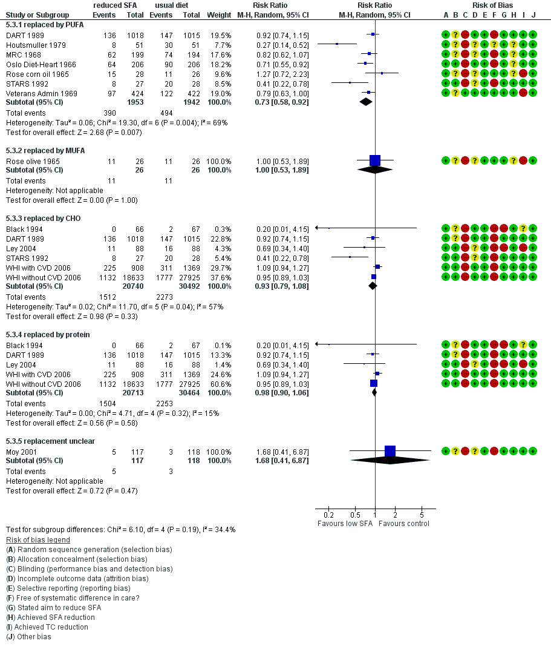
Figure. Meta-analysis of the effects of reduced saturated fat intake on people experiencing CVD events, subgrouped by macronutrients substituted for the missing saturated fat (some studies replaced with several macronutrients so appear more than once). Forest plot reproduced with permission from “Hooper L, Martin N, Abdelhamid A, Davey Smith G. Reduction in saturated fat intake for cardiovascular disease. Cochrane Database of Systematic Reviews 2015, Issue 6. Art. No.: CD011737. DOI: 10.1002/14651858.CD011737.”

Please note that de Souza’s results compare high saturated fat with low saturated fat intakes, while our systematic review of RCTs we assesses effects of reducing saturated fat (effectively compares low saturated fat intake with high intake), so the RRs will be inverted. It is difficult to compare these directly but confidence intervals appear to overlap for all outcomes.

