One is not enough: Group size modulates social gaze-induced object desirability effects

Francesca Capozzi¹, Andrew P. Bayliss², Marco R. Elena¹, Cristina Becchio^{3,1}

1 Center for Cognitive Science, Department of Psychology, University of Turin, Via Po 14, 1023 Torino, Italy
2 School of Psychology, University of East Anglia, Norwich Research Park, NR4 7TJ Norwich, UK
3 Department of Robotics, Brain, and Cognitive Sciences, Fondazione Istituto Italiano di Tecnologia, Via Morego 30, 16163 Genova, Italy

Corresponding author: Cristina Becchio
Department of Robotics, Brain, and Cognitive Sciences
Fondazione Istituto Italiano di Tecnologia
Via Morego 30, 16163 Genova, Italy
e-mail: cristina.becchio@unito.it
phone: +39 3498913671

Abstract
Affective evaluations of objects are influenced by the preferences expressed by other people via their gaze direction, so that objects looked at are liked more than objects looked away. But when can others’ preferences be trusted? Here we show that group size influences the extent to which individuals tend to conform to others’ gaze preferences. We adopted the conventional gaze cuing paradigm and modified the design in such a way that some objects were consistently cued by only one face (single face condition), whereas other objects were consistently cued by several different faces (multiple faces condition). While response-time measures revealed equal gaze-cueing effects for both conditions, a boost in affective evaluation was only observed for objects looked at by several different faces. Objects looked at by a single face were not rated differently than objects looked away. These findings suggest that observers make use of group size to evaluate the generalizability of the epistemic information conveyed by others’ gaze: objects looked at are liked more than objects looked away, but only when they are looked by multiple faces.

Key words: gaze-cueing; liking; object evaluation; group size; conformity.

Introduction
Our preferences for objects are influenced not only by direct experience, but also by the preferences expressed by other people (e.g., Campbell-Meiklejohn, Bach, Roepstorff, Dolan, & Frith, 2010). A subtle way in which others’ preferences can influence object evaluation is through eye gaze direction. Objects looked at by other people do not only receive more attention: when looked at by faces with a neutral or positive facial expression, they are also perceived as more likeable than objects looked away (Bayliss, Paul, Cannon, & Tipper 2006; Bayliss, Frischen, Fenske, & Tipper, 2007; King, Rowe, & Leonards, 2011; Manera, Elena, Bayliss, & Becchio, in press; Treinen, Corneille, & Luypaert, 2012; van der Weiden, Veling, & Aarts, 2010).
This liking effect has been taken to suggest that we trust others’ preferences as a reliable source of information about the valence qualities of objects (Bayliss et al. 2006; 2007; but see also Kruglanski, Pierro, Mannetti, & De Grada, 2006). If someone looks toward an object, it is because they like it (Baron-Cohen, Campbell, Karmiloff-Smith, Grant, & Walker, 1995, Shimojo, Simion, Shimojo, & Scheier, 2003), but if they look away from it, they do not. So, it would benefit us to take on board this information and use it to guide and influence our own evaluative processes.
However, as noted by Frith and Frith (2007), there is an inherent ambiguity about a person’s attitude towards an object. When we observe a person gazing at an object with a positive expression, this may correctly indicate that the object is highly desirable, but the response could also indicate a subjective dispositional attitude, i.e., something about that person’s idiosyncratic likes and dislikes, rather than something about the relevant properties of the object. This raises a problem about the generalizability of the epistemic information conveyed by others’ gaze: does gaze direction signal a subjective preference or a relevant property of the referent of the object?
An important index of the generalizability of others’ attitudes is consensus, i.e., the extent to which other persons perform the behaviour toward the object in the same situation (see Kelley, 1967). A pleasant object may be disliked by one person; however, if several people look away from the same object, this will most likely indicate that the object has an inherent negative valence. If others’ gaze is used to evaluate the value of objects in the environment, consensus may thus be expected to be a critical variable in producing the effect.
Gaze-mediated liking has been reported for objects looked at by multiple faces (e.g., Bayliss et al, 2006; Manera et al., 2014; Treinen et al., 2012) as well for objects looked at by a single face (Bayliss et al., 2007; King et al., 2011; van der Weiden et al., 2010). So far, however, no study has investigated whether the number of faces plays a role determining how much an object is liked.
To address this issue, in the present study we adopted the conventional gaze cuing paradigm (see Frischen, Bayliss & Tipper, 2007, for review) and modified the design in such a way that some objects were consistently cued by the only one face (single face condition), whereas other objects were consistently cued by several different faces (multiple faces condition). Critically, each object would appear equally often, the only difference between conditions being the number of individuals associated with it. Frischen and Tipper (2004) showed that the strength of the shift of attention following a gaze-cue is not modulated by whether the same face is presented for hundreds of trials or a different face appears on every trial. Based on this evidence, we predict that the faster processing of gazed-at targets (i.e., gaze cuing of attention) would not differ across the different types of stimulus faces. However, in the same experiment, participants were asked to rate levels of liking of objects that were either gazed at (cued) or gazed away from (uncued). With this measure, a number of outcomes might be predicted. Firstly, despite an equal number of stimulus-stimulus pairings in each condition, the liking effect might be increased for objects looked at by multiple faces in comparison to objects looked by a single face. This would suggest that liking reflects social consensus, increasing as the number of people signalling their preference towards the object increases. Alternatively, if liking reflect a form of evaluative conditioning (see Bry, Treinen, Corneille, & Yzerbyt, 2011), then it should not matter whether the object (i.e., conditioned stimulus) is paired consistently with the same face identity (i.e., unconditioned stimulus) or with varying unconditioned stimuli of the same value during acquisition (Hofmann, De Houwer, Perugini, Baeyens, & Crombez, 2010). Similar liking ratings should thus be expected for the single face and the multiple faces conditions.

Materials and methods
Participants
Twenty-five subjects (6 male and 19 female, mean age: 20.68 years, age range: 19-26 years) volunteered for this study. All participants reported normal or corrected-to-normal vision and were naïve with respect to the purpose of the study.

Apparatus and stimuli
Stimulus presentation and data collection were controlled by E-Prime2 (Psychology Software Tools, Inc.). Stimuli were presented 60 cm away from the participant on a 17.3 inch computer screen (16:9 aspect ratio, 1600x900 pixels resolution). Eight unfamiliar faces (4 males, 4 females) with moderately positive facial expression were used as cue stimuli. The faces varied between 6.5 and 8.5 cm in width, and between 9.7 and 10.3 cm in height. They had three possible gaze directions: pupils straight ahead, pupils averted leftward, pupils averted rightward. The eye regions were approximately 0.5 cm high and 3.5 cm in width. The faces were presented in the centre of the screen. The fixation cross, which preceded each trial, measured 0.4 X 0.4 cm.

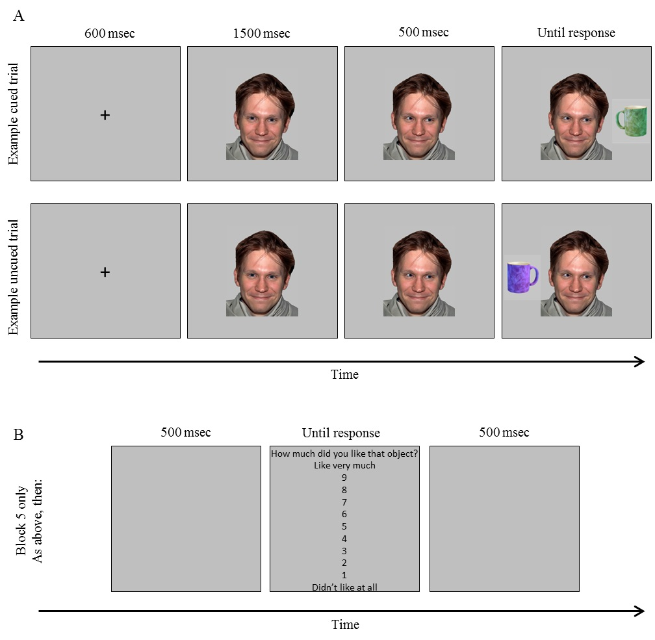

Fig. 1. A) Illustration of the time course of two sample trials. At the top, an example of cued trial. The green cup is cued. At the bottom, in an example of uncued trial, the blue version of this item is uncued. 14 items were paired with 7 different faces, 14 items were paired with a single face. Throughout the experiment, this cueing relationship was maintained. Thus, in this example, the green cup was always gazed at in each of the ten exposures by a single face. (B) Illustration of the time course of the subsequent ratings screen appearing after response in the final (fifth) block only. In the original display the chart and the question were in Italian.

The target stimuli consisted of 28 images of household objects (Bayliss et al., 2006; 2007): 14 “garage” items (e.g., a saw, a screwdriver, a drill), and 14 “kitchen” items (e.g., a saucepan, a spoon, a mug). Objects varied between 1.5 cm and 5.5 cm in width, and between 1 cm and 3.9 cm in height. Images were digitally manipulated in Adobe Photoshop to create four different colour versions of each object (blue, red, yellow and green). Thus, there were a total of 112 possible target stimuli. They were presented on the left or on the right of the cueing face, so that the centre of the target was in line with gaze direction and approximately 12.5 cm from the centre of the screen (Figure 1.A).
For the recording of preference ratings of the stimuli, a chart (in Italian) was presented, with the question “How much did you like that object?” at the top of the screen and with a column of numbers from 9 to 1, headed by the words “Like very much” at the top and the words “Don’t like at all” at the bottom of the screen (Figure 1.B).

Design
We employed a within-subject design with cueing and number of faces as within-subject factors. The cueing factor was whether the target object was looked at (cued) or looked away from (uncued). The number of faces factor was whether the target object was cued/uncued by a single face or by multiple faces. In the single face condition, a single face consistently looked at (and looked away from) 14 items (7 kitchen items, 7 garage items). In the multiple faces condition, seven faces consistently looked at (and looked away from) the remaining 14 items (7 kitchen items, 7 garage items). The eight faces were randomly assigned to single face or multiple faces conditions across subjects. The manner in which the targets (kitchen/garage items) were presented to each participant was controlled as in previous reports (Bayliss et al., 2007). For each item, its colour, cueing status, and paired number of faces were determined randomly for each participant.

Procedure
Participants completed 5 blocks, 4 standard cuing blocks followed by a final rating block. In the standard cueing trials of blocks 1 to 4, the participants were asked to fixate the fixation cross, to refrain from eye movements, to ignore the uninformative gaze cue, and to respond to the target as quickly as possible. Each trial started with a 600 ms fixation cross. The face would then appear, with eyes gazing straight ahead for 1500 ms. Then, 500 ms before target onset, the eyes would move to the left or the right. The target remained visible until response or until 2500 ms elapsed. Participants used the “h” and “spacebar” keys to respond to the category of the target object. Whether ‘‘h” corresponded to “garage” or “kitchen” items was counterbalanced between participants. At response, a tone was sounded to give feedback on performance (a ‘‘bell’’ for correct and a ‘‘buzzer’’ for incorrect/timeout). Finally, a 500 ms blank interval preceded the next trial (Figure 1.A). After 28 practice trials (using all target objects), participants completed 4 blocks of 112 trials, where each target was viewed twice in each block. In the final (fifth) rating block, the procedure changed slightly. The participants were now informed that following their target categorization response, a blank screen would be presented (500 ms), followed by a ratings screen. They were required to rate the item they had just responded to, so that higher scores were given to objects that they preferred. They were told to select a number from 1 to 9, and to press the corresponding key on the keyboard. After their liking rating, a blank screen (500 ms) preceded the next trial (Figure 1.B). In total, therefore, the participants completed 560 trials of the gaze cueing procedure, being exposed ten times to 28 cued targets and ten times to 28 uncued targets. 14 targets were paired with 7 different faces (each face appearing in 40 trials), 14 targets were paired with a single face (appearing in 280 trials). Each of the 56 targets was rated twice in the final (fifth) block. After the experiments, participants were thanked and asked a) what they thought the purpose of the experiment was; b) whether they had noticed any regularity in the pairing of objects and faces. No participant indicated suspicion about the purpose of the experiment or indicated that some objects were consistently looked by a single face.

Results
Gaze cueing of attention. Accuracy and reaction times (RTs) were analysed for the standard cueing trials (Blocks 1 to 4). Accuracy in categorizing the targets was 96.65%. A repeated measures ANOVA (an alpha of .05 was used for tests of statistical significance) A repeated measures ANOVA on percent errors with cueing (cued vs. uncued) and number of faces (single vs. multiple) as within-subject factors revealed no significant effect of cueing (F(1,24) = .377; p = .545). The main effect of number of faces was not significant (F(1,24) = 3.550; p = .072), but there was a trend for percent errors being lower in the single face condition (M = 2.62; SD = 2.15) than in the multiple faces condition (M = 3.28; SD = 2.08). The interaction cueing by number of faces did not approach significance (F(1,24) = .114; p = .738). Correct responses contributed to the mean RTs for each subject in each condition. Repeated measures ANOVA with cueing (cued vs. uncued) and number of faces (single vs. multiple) as within-subject factors on RTs revealed a main effect of cueing (F_{(1,24)} = 56.155; p < .001; η² = .701), with quicker responses when the target was cued (M = 606.38 SD = 74.75) than when it was uncued (M = 645.84 SD = 83.69). Neither the effect of number of faces (F_{(1,24)} = 1.214; p = .282; η² = .048) nor the interaction cueing by number of faces (F_{(1,24)} = 2.655; p = .116; η² = .100) approached significance, suggesting that the single and the multiple faces produced similar amounts of attentional cueing (see Figure 2).
Object ratings. A repeated measures ANOVA on object ratings with cueing (cued vs. uncued) and number of faces (single vs. multiple) as within-subject factors revealed a significant interaction (F_{(1,24)} = 6.381; p = .019; η² = .210), indicating that the effect of cueing of object ratings was different for the single and the multiple-faces conditions. Post-hoc analyses confirmed that cued items (M = 5.42, SD = 1.02) were rated more favorably than uncued items (M = 5.29, SD = 1.00) in the multiple faces condition (t_{(1,24)} = 2.266; p = .033; d_{z} = .453), whereas cued (M = 5.39, SD = 1.06) and uncued items (M = 5.44, SD = .95) were not rated differently to each other in the single face condition (t_{(1,24)} = -.895; p = .380; d_{z} = -0.179) (see Figure 2 and 3). No other significant differences were observed. Neither the main effect of cueing (F<1; p = .448; η² = .024) nor the main effect of number of faces reached significance (F<1; p = .632; η² = .010).

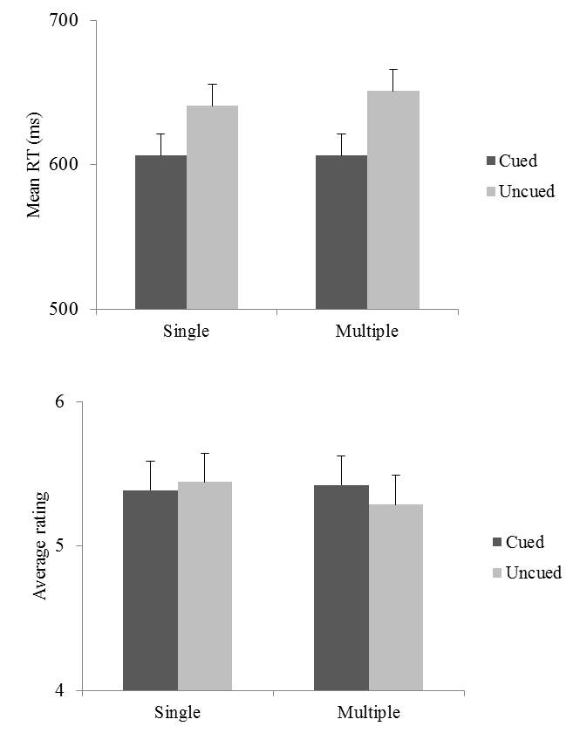

Fig. 2. Mean reaction times (upper panel) and mean ratings (lower panel) for targets appearing in the single face and in the multiple faces conditions.

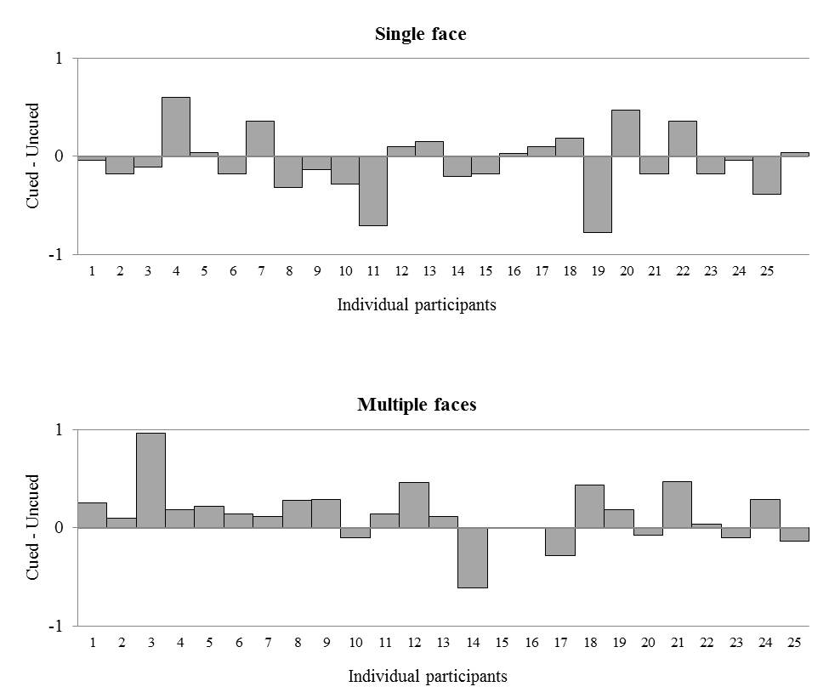

Fig. 3. Individual liking scores (cued ratings minus uncued ratings) for the single face and the multiple faces conditions. Bars above the x-axis illustrate that a participant rated cued items higher than uncued items. Bars are ordered by order of recruitment.

Discussion
We follow others’ gaze and, by doing so, we can discover what it is that they are attending to (Frischen, Bayliss, & Tipper, 2007). The effects of eye gaze, however, are not simply about altering the direction of attention. Stimuli perceived to be looked at by faces displaying a neutral or positive expression also acquire a positive valence (Bayliss, et al., 2006). This increased liking for objects looked at by others has been proposed to reflect an advantageous social adaptation: observers accommodate others’ gaze preferences in their own behavior as it aids in assessing information about the environment and objects within it (Bayliss, et al., 2006). But when can others’ preferences be trusted?
Face trustworthiness has been shown to play a moderating role in establishing object preferences (King, et al., 2011; Treinen, et al., 2012). For example, it has been demonstrated that liking is increased for objects looked at by a face previously described as trustworthy, but not for objects looked at by a face described as untrustworthy (King, et al., 2011). Even when the target face is trustworthy, however, exposure to a single face may not be sufficient to establish whether gaze direction reflects a subjective preference or a relevant property of the referent of the object. Our findings provide the first demonstration that while the number of faces looking at an object has little impact on attention, it can strongly influence the object affective evaluation. In line with the ‘social consensus’ hypothesis, we found that objects looked at were liked more than objects looked away, but only when they were looked by multiple faces. In the present data set, objects looked at by a single face were not rated differently than objects looked away. This is in spite of the fact that objects cued by a single face appeared equally often as objects cued by multiple faces.
These findings indicate that liking is not merely determined by the co-occurrence of object and face, but is sensitive to the number of faces implicitly signalling their preference towards the object. As a result, although a single face may produce liking effects in specific experimental contexts (e.g., King et al., 2011), a single face’s looking behaviour is not enough to influence object affective evaluation when others faces do not signal the same like/dislike.
From infancy onward, human beings are dependent on the ‘epistemic authority’ of others for the evaluation of objects and events (Ellis & Kruglanski, 1992; Kruglanski, Raviv, Bar-Tal, Raviv, Sharvit, Bar, et al., 2005). Social psychological analyses of group processes have accordingly emphasized the tendency of groups to exert pressures toward conformity (cf. Asch, 1955; Deutsch & Gerard, 1955 – but see Hodges & Geyer, 2006 for a different view), with group size influencing the extent to which individuals tend to conform. The finding that liking is influenced by the number of faces looking at the target object suggests that group size may similarly influence gaze-mediated liking.

Acknowledgements
This work received funding from the European Research Council under the European Union’s Seventh Framework Programme (FP7/2007-2013) / ERC grant agreement n. 312919.

References
Asch, S. E. (1955). Opinions and social pressure. Scientific American, 193(5), 31–35.
Baron-Cohen, S., Campbell, R., Karmiloff-Smith, A., Grant, J., & Walker, J. (1995). Are children with autism blind to the mentalistic significance of the eyes? British Journal of Developmental Psychology, 13(4), 379–398.
Bayliss, A. P., Frischen, A., Fenske, M. J., & Tipper, S. P. (2007). Affective evaluations of objects are influenced by observed gaze direction and emotional expression. Cognition, 104, 644–653.
Bayliss, A. P., Paul, M. A., Cannon, P. R., & Tipper, S. P. (2006). Gaze cueing and affective judgments of objects: I like what you look at. Psychonomic Bulletin & Review, 13(6), 1061–1066.
Bry, C., Treinen, E., Corneille, O., & Yzerbyt, V. (2011). Eye'm lovin' it! The role of gazing awareness in mimetic desires. Journal of Experimental Social Psychology, 47, 987–993.
Campbell-Meiklejohn, D. K., Bach, D. R., Roepstorff, A., Dolan, R.J., & Frith, C.D. (2010). How the opinion of others affects our valuation of objects. Current Biology, 20, 1165–1170.
Deutsch, M., & Gerard, H.B. (1955). A study of normative and informative social influences upon individual judgment. Journal of Abnormal Social Psychology, 51(3), 629–36.
Ellis, S., & Kruglanski, A. W. (1992). Self as an epistemic authority: Effects on experiential and instructional learning. Social Cognition, 10(4), 357–375.
Frischen, A., & Tipper, S.P. (2004). Orienting attention via observed gaze shift evokes longer term inhibitory effects: Implications for social interactions, attention, and memory. Journal of Experimental Psychology: General, 133, 516–533.
Frischen, A., Bayliss A. P., & Tipper, S. P. (2007). Gaze cueing of attention: Visual attention, social cognition, and individual differences. Psychological Bulletin, 133(4), 694–724.
Frith, C. D., & Frith, U. (2007). Social cognition in humans. Current Biology, 17, R724–R732.
Hodges, B. H., & Geyer, A. L. (2006). A nonconformist account of the Asch experiments: Values, pragmatics, and moral dilemmas. Personality and Social Psychology Review, 10(2), 2–19.
Hofmann, W., De Houwer, J., Perugini, M., Baeyens, F., & Crombez, G. (2010). Evaluative conditioning in humans: A meta-analysis. Psychological Bulletin, 136(3), 390–421.
Kelley, H. H. (1967). Attribution theory in social psychology. In Levine D. (ed.), Nebraska symposium on motivation (pp.192-238). Lincoln: University of Nebraska Press.
King, D., Rowe, A., & Leonards, U. (2011). I trust you; hence I like the things you look at: gaze cueing and sender trustworthiness influence object evaluation. Social Cognition, 29(4), 476–485.
Kruglanski, A. W., Pierro, A., Mannetti, L., & De Grada, E. (2006). Groups as epistemic providers: Need for Closure and the unfolding of group-centrism. Psychological Review, 113(1), 84–100.
Kruglanski, A. W., Raviv, A., Bar-Tal, D., Raviv, A., Sharvit, K., Bar, R., Pierro., A., Mannetti, L. (2005). Says who? Epistemic authority effects in social judgment. In Zanna, M. P (ed.) Advances in Experimental Social Psychology, Vol. 37 (pp. 345–390). San Diego, CA: Elsevier Academic Press.
Manera V., Elena M. R., Bayliss A. P., & Becchio C. (in press). When seeing is more than looking: Intentional gaze modulates object desirability. Emotion. doi: 10.1037/a0036258.
Shimojo, S., Simion, C., Shimojo, E., & Schieir, C. (2003). Gaze bias reflects and influences preference. Nature Neuroscience, 9, 1–6.
Treinen, E., Corneille, O., & Luypaert, G. (2012). L-eye to me: The combined role of Need for Cognition and facial trustworthiness in mimetic desires. Cognition, 122, 247–251.
van der Weiden, A., Veling, H., & Aarts, H. (2010). When observing gaze shifts of others enhances object desirability. Emotion, 10(6), 939–943.

