Object ownership and action:
The influence of social context and choice on the physical manipulation of personal property

Merryn D. Constable^{1,2}, Ada Kritikos³, Ottmar V. Lipp⁴ & Andrew P. Bayliss⁵
¹Faculty of Kinesiology and Physical Education, University of Toronto
²Department of Psychology, University of Toronto
³School of Psychology, University of Queensland
⁴School of Psychology and Speech Pathology, Curtin University
⁵School of Psychology, University of East Anglia

Short title: ACTION AND PERSONAL PROPERTY
Word Count: 7,429

Author note
Merryn D. Constable, Faculty of Kinesiology and Physical Education, University of Toronto, and Department of Psychology, University of Toronto, Ada Kritikos, School of Psychology, University of Queensland, Ottmar Lipp, School of Psychology and Speech Pathology, Curtin University, and Andrew P. Bayliss, School of Psychology, University of East Anglia.
Correspondence regarding this article should be addressed to Merryn D. Constable, School of Kinesiology and Physical Education, University of Toronto, 55 Harbord Street, Toronto, Ontario, Canada, M5S 2W6. E-mail: merryndconstable@gmail.com. Telephone: +1 416 220 0782

Abstract
Understanding who owns what is important for guiding appropriate action in a social context. Previously, we demonstrated that ownership influences our kinematic patterns associated with hand-object interactions (Constable et al. 2011). Here, we present a series of experiments aimed at determining the underlying mechanisms associated with this effect. We asked participants to lift mugs that differed in terms of ownership status (Experiments 1 & 2) and personal preference (Experiment 3) while recording spatial and acceleration measures. In Experiment 1 participants lifted their own mug with greater acceleration and drew it closer to themselves than they did the experimenter’s mug. They also lifted the experimenter’s mug further to the right compared with other mugs. In Experiment 2, spatial trajectory effects were preserved, but the acceleration effect abolished, when the owner of the ‘Other-Owned’ mug was a known – but absent – confederate. Experiment 3 demonstrated that merely choosing to use a mug was not sufficient to elicit rightward drift or acceleration effects. We suggest that these findings reflect separate and distinct mechanisms associated with socially related visuomotor processing.

Keywords: ownership, possessions, kinematics, embodied cognition, preference, social cognition

Object ownership and action: The influence of social context and choice on the physical manipulation of personal property
Ownership is fundamental in conceptual, practical, and legal terms to human society. In modern society, the concept of ownership contributes to social functioning between individuals. When we interact with our own and other people’s property on a daily basis, it is important to abide by our society’s social and legal contracts to avoid conflict. Is it possible that such socially relevant constructs become embodied within our motor system? The purpose of the present research is to examine how the attribution of social meaning manifests in human kinematic patterns. The following experiments are specifically designed to be sensitive to differences in the kinematics associated with differing ownership status. We manipulate the social context the participant experiences to reveal the cognitive mechanisms that underpin social cognitive processes associated with personal property.What’s mine is mine and what’s yours is yours: Cognitive processing of self- and other-owned objects
Generally speaking, we like what we own more than that which we do not (e.g. mere-ownership effect, Beggan 1992). Humans also show enhanced awareness and more robust processing of what is theirs (Cunningham et al. 2008; Cunningham et al. 2011; Kim and Johnson 2012; Turk et al. 2013; Turk et al. 2011a; van den Bos et al. 2010) and attention biases towards self-related stimuli (Alexopoulos et al. 2012; Turk et al. 2011b). For example, Cunningham et al. (2008) show that temporary ownership elicits a memory advantage. They gave participants a set of cards to separate into two baskets. One basket was designated their own, and one was designated as another participant’s. The cards placed in the participant’s ‘own’ basket were recognised more frequently than those placed in the other participant’s basket. Using a similar task, Turk and colleagues (2011b) also demonstrated a narrowing of attention towards self- owned items. Overall, these processing and attentional biases suggest that the cognitive system prioritises the representation of self-owned items.
There is a wealth of research focusing on ‘what I own’ but there is still relatively little research that investigates how other people’s property is represented. There are clear heuristics that adults use when determining ownership status (Beggan and Brown, 1994; Kanngiesser and Hood, 2014; Merrill, 1998; Palamar et al. 2012), so can we use cognitive measures to observe the nuanced aspects of how individuals identify, process, reason about and interact with other people’s property? Indeed, the finding that other-owned objects are not cognitively represented the same way as self-owned objects in terms of motor affordances (Constable et al. 2011; Turk et al. 2011a) is a first step towards answering these questions.
An embodied social cognitive approach to studying object ownership
According to theories of embodied cognition cognitive processes such as thought cannot be clearly separated from perception and action (e.g. Anderson et al. 2012; Borghi 2005; Niedenthal et al. 2005). For example, if participants are required to say the word ‘climbing’ as compared to ‘sinking’ while performing a reach, greater perturbation along the vertical plane is observed (Kritikos et al. 2011). We propose that the principles of embodied cognition can also apply to less tangible and predictable concepts such as ownership. Indeed, according to Borghi and Cimatti (2010) representing objects in terms of their contextual properties when dealing with complex action situations may be useful rather than simply attending to their lower level perceptual qualities, such as shape and weight.
Kinematic research reveals the automaticity with which we incorporate concepts associated with social context into our own action planning and representations. For example, cooperative and competitive intentions are reflected in different motor patterns (Georgiou et al. 2007) and a participant’s kinematics are sensitive to another person’s attitude within these contexts (Becchio et al. 2008). A request for an object can alter kinematic patterns: when participants are in the process of transferring an object to a container and a confederate holds out their hand, the movement tends to deviate towards the hand. In some cases, participants ignore their goal altogether and place the object in the confederate’s hand (Sartori et al. 2009).
Further, the attribution of meaning can change the way we respond and interact with stimuli. The intrinsic affective valence associated with an object alters our perception of reachable space (Valdés-Conroy et al. 2012) and valenced stimuli such as ‘kiss’ or ‘funeral’ elicit an approach or avoidance effects in reaction time (Chen and Bargh 1999; Markman and Bendl 2005; van Dantzig et al. 2008). This notion has been extended recently using positively or negatively construed inanimate objects and socially relevant contextual indicators (Lugli et al. 2012). Similarly, individual spontaneous interactions with stimuli influence their subsequent evaluation (Constable et al. 2013).
We have previously shown that the attribution of ownership status to an object influences adult’s hand-object interactions (Constable et al. 2011). We asked participants to lift mugs that differed on the basis of ownership: a mug they owned, a mug owned by the experimenter, or a mug without a designated owner. Participants’ kinematic patterns were consistent with an inhibition of action towards other-owned objects: participants bring their own objects closer to the body, push objects owned by a known, present other away from the body while treating them more carefully (less acceleration).
Broadly, we propose that participants’ attribution of socially relevant semantic information to each mug directly influences visuomotor processing. In fact, the effects on different kinematic measures may be associated with specific aspects of the social cognitive construct of ownership and reflect separate and distinct processes. Further investigation is needed, however, to determine the distinct social cognitive mechanisms underlying these kinematic differences.
The present study
We aimed to replicate the kinematic results obtained by Constable and colleagues (2011) in order to confirm that the influence of ownership status on action execution is indeed robust as well as establish the boundary conditions of these effects. Experiment 1 was a direct replication of our previous study, with one additional manipulation. In Constable et al. (2011), we found that people drew their own mug closer to their own body, and with greater acceleration, while lifting it from the table. We also found – in accordance with our proposition that the ownership status of other people’s property is coded in our motoric interactions – that the Experimenter’s mug drifted further to the right, than the participant’s mug. First, we aim to arbitrate between two possible explanations of this effect. One explanation is that the ownership status of the object (‘Owned by someone else’) led the participants to exaggerate the natural trajectory of a right-handed lifting action which moves away from one’s own body. The second explanation relates to the fact that the Experimenter was seated to the right of the workspace. Combined with the observation that participants drew their mugs towards themselves, and the Experimenter’s mug drifted towards the Experimenter, we might conclude that the kinematics of the lifting action are biased spatially toward the mug’s owner. Therefore, we manipulated between-subjects where the experimenter stood (‘Experimenter Location’: to the left or the right). If the participant acts so as to take the Experimenter’s mug away from the self, the Experimenter’s mug will drift further to the right irrespective of Experimenter location. The alternative explanation would be supported if Experimenter location influences deviation as a function of ownership status.
After broadly replicating the findings of Constable et al. (2011) in Experiment 1, we explored the influence of owner presence in Experiment 2 by removing the owner from the environment entirely. There are a wide variety of effects demonstrating that the mere presence of another person can alter behavior (e.g. the bystander effect, Fischer et al. 2011; social facilitation, Snyder et al. 2012; social inhibition, Bell and Yee 1989 In the present research, is the presence of the owner critical for the emergence of the differential motor effects on our critical spatial and acceleration measures found in Experiment 1? It may be that these subtle effects are a behavioral manifestation of a desire to smooth and maintain personal relationships. Perhaps the standard motor codes associated with other people’s property are not triggered when the social context of ownership is no longer salient or important. If this is the case, the differences in the dynamic manipulation between the mugs will not be as robust.
Finally, Experiment 3 was conducted to determine if the ownership effects obtained in Experiments 1 and 2 could be explained simply in terms of mere preference and choice, which are frequently confounded with ownership (see the mere ownership effect, Beggan 1992). Rather than inducing ownership over mugs, participants were asked to choose a mug to use during the experiment. The experimenter also chose a mug. Importantly, neither the participant nor the experimenter owned the mugs used in this experiment. As such, we predicted that the participant’s and experimenter’s chosen mugs would be manipulated in the same way. If, however, the effects reported in Experiments 1 and 2 can be elicited even in this minimal personally-relevant experimental context, then it would be difficult to credit them as ownership effects. To pre-empt the findings, aside from drawing one’s chosen mug towards oneself, Experiment 3 did not reveal any influence of mug choice on kinematics.
Across the three experiments we show that (a) the pattern of lift trajectories is stable when comparing mugs with differing ownership status, regardless of the location of the owner, (b) the acceleration effects associated with ownership seem to rely on the presence of the owner, and (c) the drift towards the participant’s body may be associated with preference rather than ownership directly. Broadly speaking, these three experiments provide further evidence that ownership influences visuomotor processing and performance. Only two of the previously found ownership effects (rightward drift and acceleration), however, are dissociable effects specifically associated with ownership. The results are largely consistent with the notion that the link between perception and action is socially mediated: socially related variables can be embodied within the motor system and influence object-oriented actions as a function of the social information regarding that object.
Experiment 1
Experiment 1 was a replication of Constable et al. (2011, Experiment 1), except that the Experimenter’s location relative to the workspace was manipulated between-subjects in order to explore the influence of spatial-social context in this paradigm. We used motion capture to record participants’ natural lifts with three different mugs (their own, the experimenter’s, and one without a designated owner). We predicted that the pattern of data shown by Constable et al. (2011) would be reproduced. Specifically, that the Experimenter’s mug would drift to the right further than the other two mugs; the Participant’s mug would deviate further towards the participant’s body and achieve greater acceleration and greater deceleration than the other two mugs.
Method
Participants.
Forty-nine naive right-handed individuals took part in the experiment (mean age = 20.67 years, SD = 4.29 years; 10 were male) in exchange for partial course credit or AU$30.
Materials and Apparatus.
Fifty-one white ceramic mugs (height =10cm, diameter of base = 6 cm) were used in the experiment. Each participant was given a mug and instructed to paint a design of their choosing with any of eighteen colours provided. During the experiment, two other mugs were used; the experimenter’s, which was also painted, and a blank mug without an explicitly defined owner (see Fig 1a for examples). Lifts were recorded in Cartesian coordinate space (x = left-right; y = forward- back; z = up-down) using three spherical reflective markers (12mm diameter) attached to each mug and a three camera infrared motion capture system (ProReflex, Qualisys; 100-Hz sample rate, measurement error < 0.3mm). Four markers were also attached to the participant’s hand (index finger and thumb) and wrist (styloid process of the radius and ulna).
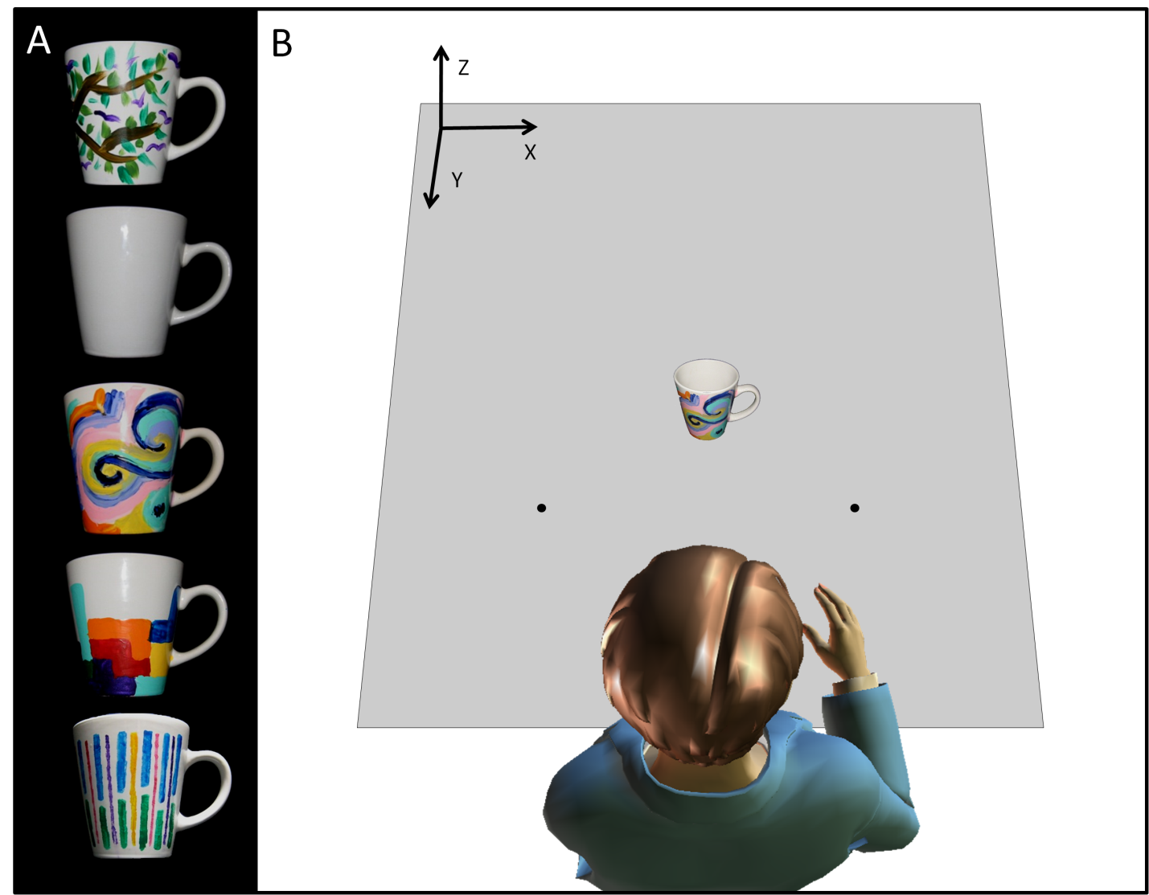
Fig 1 Panel a: Examples of the mugs used in Experiments 1 & 2. From top, Experimenter’s/Confederate’s mug, Unowned mug, three Participants’ mugs. Panel b: Illustration of the experimental set-up (not to scale) for Experiments 1, 2 & 3
Design & Procedure.
After the participant’s painted mug dried they used the mug for an average of 12.83 days (SD= 3.77) prior to the experimental session. Self reported usage rates averaged 1.57 times per day (SD = 1.18, min = 0.36, max = 6.11). The participant was seated in front of a table and told that their movements (reach, grasp, lift, replace) with each of the three mugs would be recorded. The experimenter introduced the three mugs by stating that the participant should make the action towards whichever mug was on the table at the time and that this might be their own mug, ‘my mug’ (the experimenter’s), or ‘this unpainted mug’. Participants were then asked to make a practice reach, grasp, lift, and replace action using only the handle to ensure they understood their task and were doing it in a natural manner. Each trial began with the participant closing their eyes, and their hand resting comfortably in front of them at a marked location with their thumb and index finger gently opposing. The experimenter would then place a mug in front of the participant at one of three marked locations 30cm away from the starting position (directly in front, or 40° to the right or left, see Fig 1b). A tone would sound to indicate that the participant should open their eyes and initiate their movement. There were a total of 108 trials, 36 per mug (Participant’s, Experimenter’s, Unowned) divided equally between the three marked locations, presented randomly. The experimenter stood within participants’ peripersonal space (i.e. 30-80cm from left/right shoulder) either to the right (n = 24) or the left (n = 25) of the table.
Data Analysis.
Two participants’ data from the ‘experimenter on the left’ condition were discarded prior to analysis as their means lay 3SDs above/below the group mean on multiple critical measures. Individual trials with recording errors (0.47%) were also removed before analysis. Four measures, as previously examined by Constable and colleagues (2011), were calculated using the coordinate and timing data recorded. At the maximum height reached by the mug we took both the x- and y- coordinates to look at the displacement along these axes from the mugs’ starting position (resulting in the measures ‘x at z-max’ and ‘y at z-max’). We also examined ‘Peak acceleration during lift’ and ‘Peak deceleration during placement’ which refer to the maximum acceleration a mug reached from the beginning of lift until the maximum height was reached and the maximum deceleration the participant achieved from the time at which maximum height was reached until the mug was rested on the table once more. A 3 X 2 mixed-factors measures ANOVA, with ‘Mug Type’ (participant’s, experimenter’s or unowned) as the within-subjects factor and ‘Experimenter Position’ (right or left) as the between-subjects factor, was conducted on all four measures.
Results
As directed, participants interacted with the mugs in a natural manner. On average participants took 707ms (SD = 195ms) to initiate movement towards the mug after hearing the tone. The entire action took 2054ms (SD= 508), with the mug in flight for 1046ms (SD = 297ms). These measures are consistent with previously observed data (Constable et al., 2011). Where appropriate we used a Huynh-Feldt correction.
Spatial Manipulation.
During the lift phase of the movement, ‘x at z-max’ indicated that the mugs tended to drift to the right (6.8 mm; see Fig 2a). This rightward drift varied as a function of ‘Mug Type’, F(1.86, 83.56) = 6.04, MSE = 7.25, p =.004, η_{p}² = .118. The experimenter’s mug drifted significantly further to the right (7.9 mm) compared with the participant’s mug (6.4 mm, t(46) = 2.45, p =.018, d_{z} =.36) and the unowned mug (6.2 mm, t(46) = 3.46, p =.001, d_{z} =.50). The participant’s mug and the unowned mug did not differ, t(46) = .36, p =.72, d_{z} =.05. Interestingly, there was a trend for smaller rightward drift when the experimenter stood on the left (4.1 mm) than the right (9.5 mm), F(1, 45) = 3.61, MSE = 285, p =.064, η_{p}² = .074. However, the critical ‘Experimenter Position’ by ‘Mug Type’ interaction did not approach significance, F(1.86, 83.56) = .009, MSE = 7.25, p =.99, η_{p}² < .001. The mugs also tended to drift towards the participant’s body during lift (17.5 mm; see Fig 2a). Again, this varied as a function of ‘Mug Type’, F(1.60, 72.12) = 13.67, MSE = 10.22, p < .001, η_{p}² = .233. The participant’s mug drifted significantly further towards the participant (19.2 mm) compared with the experimenter’s mug (16.1 mm, t(46) = 4.38, p <.001, d_{z} =.64) and the unowned mug (17.3 mm, t(46) = 2.99, p =.004, d_{z} =.44). The unowned mug also drifted further towards the participant’s body compared to the other owned mug, t(46) = 2.91, p =.006, d_{z} =.42. A main effect of experimenter position was also observed, F(1, 45) = 12.38, MSE = 614, p =.001, η_{p}² = .216. When the experimenter stood to the left all mugs drifted further towards the participant (25.0 mm) compared with when the experimenter stood to the right (10.3 mm). Again, critically, the interaction between ‘Mug Type’ and ‘Experimenter Position’ was non-significant, F(1.60, 72.12) = 1.81, MSE = 10.22, p =.18, η_{p}² = .039.

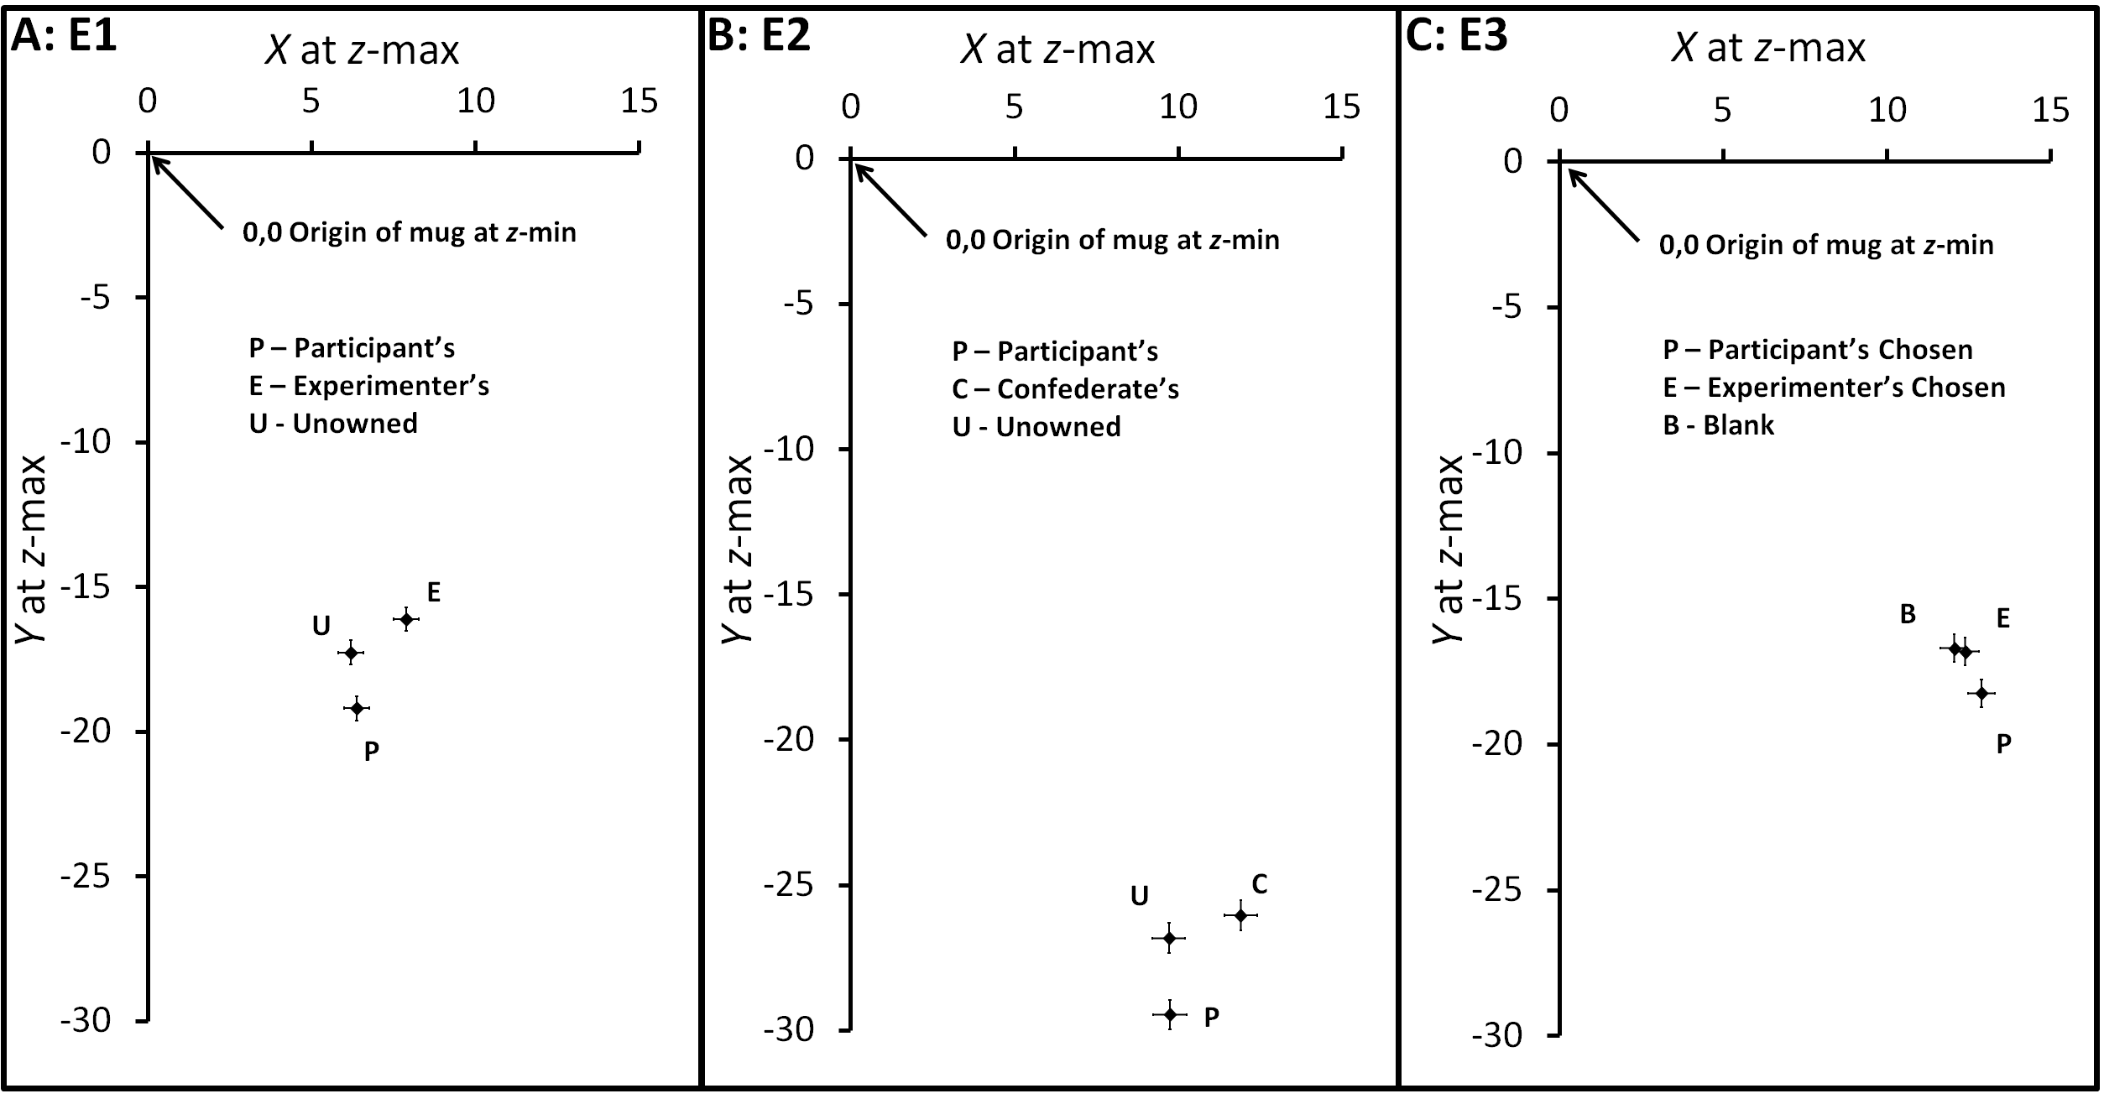
Fig 2 Graph illustrating the x (left–right) and y (toward-away) positions of the mug at the maximum mug height for each of the mugs used in Experiments 1, 2, & 3 attained during lift phase of the action relative to the starting position on the table (i.e. x = 0, y = 0, z = 0). Panel a: Experiment 1. Panel b: Experiment 2. Panel c: Experiment 3. Error bars represent standard error of the mean for within-subjects effects (Loftus and Masson 1994)

Dynamic Manipulation.
This measure varied as a function of ‘Mug Type’, F(1.56, 70.25) = 4.54, MSE = 1531496, p = .02, η_{p}² = .092. Participants reached a higher acceleration with their own mug (8477mm/s²) compared with the experimenter’s mug, (7825mm/s², t(46) = 2.65, p =.01, d_{z} =.39) and a trend for a difference with the unowned mug was observed (7954mm/s², t(46) = 1.84, p =.07, d_{z} =.27), see Fig 3a. The difference between the experimenter’s and unowned mugs was not significant, t(46) = .84, p =.41, d_{z} =.12. Again, there was no main effect of ‘Experimenter Position’, F(2, 90) = 1.42, MSE = 4.67 x 10⁷, p = .24, η_{p}² = .03. Therefore, the pattern of data is consistent with Constable et al.’s (2011) data, with greatest acceleration applied to the participants’ own mug, and least acceleration applied to the Experimenter’s mug.
This pattern was, however, qualified by a significant interaction between ‘Mug Type’ and ‘Experimenter Position’, F(1.56, 70.25) = 4.71, MSE = 1531496, p = .01, η_{p}² = .095. When the experimenter stood to the right, participants reached a higher acceleration with their own mug (9494mm/s²) compared to the experimenter’s, (8481mm/s², t(23) = 2.64, p =.02, d_{z} =.54) and the unowned mug (8294mm/s², t(23) = 3.11, p =.005, d_{z} =.64). There was no difference between the other owned and unowned mugs, t(23) = 1.18, p =.25, d_{z} =.24. When the Experimenter was situated to the left no comparisons were revealed to be significant, (all ps < .08). So, although when the experimenter stood to the right of the participant, greater acceleration was applied to the Participant’s mug than to the Experimenter’s mug, this pattern was disrupted in the ‘Experimenter-on-left’ condition.
Inconsistent with, Constable et al. (2011) there was no effect of ‘Mug Type’ on ‘Peak deceleration during placement’, F(2, 90) < 1, MSE = 4975866. Moreover, experimenter position did not significantly interact with ownership, F(2, 45) = 1.53, MSE = 5.3 x 10⁷, p = .22, η_{p}²=.03.
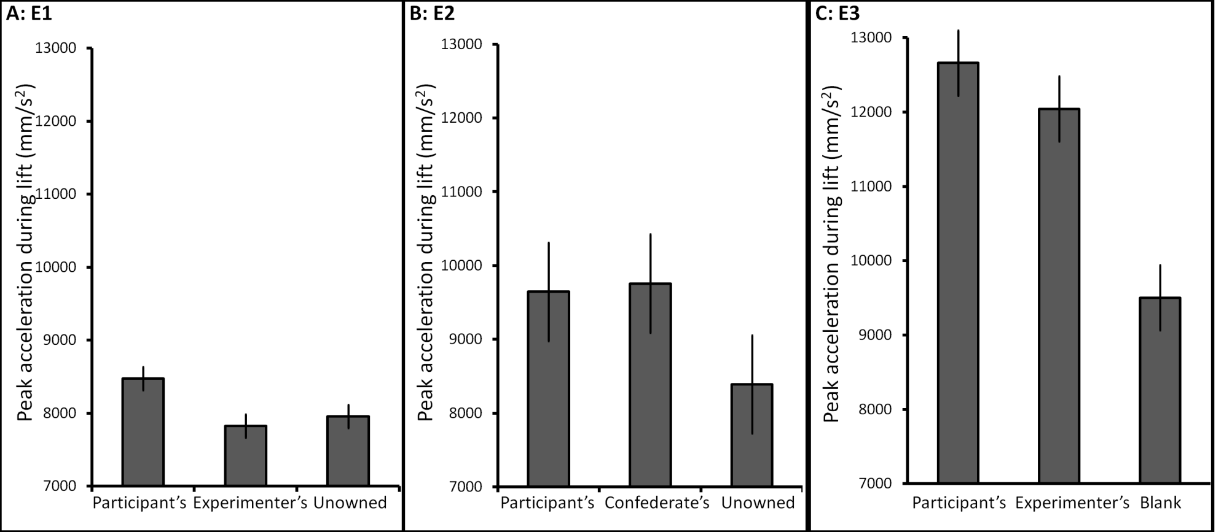
Fig 3 Graph illustrating the mean peak acceleration reached during the lift phase of the action for each mug in Experiments 1, 2, & 3. Panel a: Experiment 1. Panel b: Experiment 2. Panel C: Experiment 3. Error bars represent standard error of the mean for within-subjects effects (Loftus and Masson 1994)

Discussion
Participants drew their own mug closer towards themselves and displayed greater acceleration during lift compared to the experimenter’s mug and the unowned mug. Moreover, when participants lifted the experimenter’s mug, it drifted further to the right than when they lifted their own mug or the unowned mug. We also varied ‘Experimenter Position’ in this experiment, but this factor did not interact with ‘Mug Type’ on either spatial measure. Hence, it is unlikely that these effects are due to the location of the experimenter or in some way idiosyncratic to our design and experimental set-up. More likely, we are observing an exaggerated rightward drift due to biomechanical factors involved in a right-handed abductive movement. When interacting with the Experimenter’s mug, this exaggerated repulsion from the body may be due to a reticence to interact with the experimenter’s mug.
However, there were some main effects of experimenter location on the spatial measures of lift trajectory. Overall, it seemed that participants in the ‘Experimenter on the left’ condition showed less deviated lifts in general than the participants who completed the experiment when the experimenter stood to the right. This is an unexpected finding that is orthogonal to the ownership effect, but may be consistent with a bias towards one side of space that contains a distractor stimulus, such as seen in a cued line bisection task (e.g. Milner et al. 1992; Riddoch and Humphreys 1983). In the present study, the ‘distractor’ may be the experimenter. Indeed, experimenter location has previously been shown to bias line bisection (Garza et al. 2008).
With the acceleration data, the replication of our previous work was only partial. Although deceleration was significantly affected by ownership in our previous report (Constable et al. 2011) this effect was non-significant in the present study. Acceleration during lift, however, mirrored our previous data well. We consistently observed greater acceleration being applied to the participant’s own mug compared with the experimenter’s or the unowned mug.
In sum, we have demonstrated the reliability of Constable et al’s (2011, Experiment 1) methodological approach, replicated the findings and demonstrated that although the location of the experimenter may have some influence on how people lift objects, it does not alter the effects of the main manipulation of interest: ownership status. Next, we further investigate these phenomena by modulating the social context in which the objects are presented.
Experiment 2
Experiment 1 suggests that knowledge of ownership status alters visuomotor processing during hand-object interactions. Further, it seems that interactions with other people’s property are somewhat restrained. Therefore, reducing the salience of a socially relevant relationship between an object and its owner may moderate the need to treat other’s property any differently to one’s own. Consequently, Experiment 2 was designed to assess if the presence of an owner is necessary for ownership status to produce kinematic effects. As such, a confederate brought the ‘other owned’ mug to the room, then left before the experiment began. If the effects rely entirely on the fact that the experimenter is the owner of the ‘Other-owned mug’ and is present at the time, then the effects of ownership should be abolished. However, the effects will remain if they are based solely on knowledge about ownership status.
Method
Participants.
Twenty-seven naive right handed individuals took part in the experiment (mean age = 21.63 years, SD = 4.50 years; 6 were male) in exchange for either course credit or AU$30. Three participants’ data were removed from the analysis because they indicated they were aware of the staged nature of the confederate scenario. One participant mug’s design degraded due to aggressive washing, but we retained their data because they were able to identify the mug as their own.
Materials, Apparatus, Design & Procedure.
These were identical to Experiment 1 except for the introduction of a confederate scenario at the beginning of the experimental session. Participants used their mug for an average of 13.63 days (SD = 3.43 days), and self-reported usage rates from 0.57 to 6.5 times per day (M = 1.56, SD = 1.30).
Each participant was seated in front of a table while the experimenter began to attach markers to the mugs. She then pretended to look for her own mug and indicated to the participant that she could not find it but would call another lab member and ask to borrow theirs in order to complete the experiment. The confederate then came and gave the experimenter the same mug that was used as the ‘Experimenter’s mug’ in Experiment 1 and left. The experimenter finished attaching markers to the mugs and commenced the experiment. Although each participant was exposed to only one confederate, two were used during the study. A confederate was assigned on the basis of convenience. Both confederates were, like the experimenter, young female graduate researchers with dark hair, blue/green eyes, of average height and similar names (Hayley and Harriet). The experiment then proceeded as usual with the experimenter positioned to the right of the participant.
Results
Trials with recording errors (1.23%) were removed before analysis. We looked at the same measures reported in Experiment 1. On average participants took 679ms (SD = 136ms) to initiate movement towards the mug after hearing the tone. The entire action took 2085ms (SD = 337ms), with the mug in flight for 1035ms (SD = 221ms). A Huynh-Feldt correction was applied to degrees of freedom where appropriate.
Spatial Manipulation.
As before, ‘Mug Type’ had a significant effect on ‘x at z-max’, F(2,46) = 6.22, MSE = 6.09, p =.004, η_{p}² = .213. The other owned mug drifted significantly further to the right (11.9 mm) during lift compared to the participant’s mug (9.7 mm, t(23) = 2.69, p = .01, d_{z} = .55) and the unowned mug (9.7 mm, t(23) = 3.17, p = .004, d_{z} =.65, see Fig 2b). The participant’s mug and the unowned mug did not differ significantly, t(23) = .039, p = .97, d_{z} = .01. ‘Mug Type’ had a significant effect on ‘y at z-max’, F(2,46) = 12.00, MSE = 6.40, p <.001, η_{p}² = .343. As Fig 2b indicates, the participant’s mug drifted significantly further toward the participant during lift (29.5 mm) than the other owned mug (26.0 mm, t(23) = 3.17, p <.001, d_{z} = .89) and the unowned mug (26.8 mm, t(23) = 3.37, p = .003, d_{z} = .67). The unowned mug and other owned mug did not differ significantly, t(23) = 1.28, p = .21, d_{z} =.26.
Dynamic Manipulation.
There was no effect of ‘Mug Type’ on ‘Peak acceleration during lift’, F(1.61, 36.91) = 1.3, MSE = 13275297, p =.28, η_{p}² = .053 (see Fig 3b) or on deceleration, F(1.51,34.68) = 1.05, MSE = 10379363, p =.34, η_{p}² = .043.
Discussion
When we removed the owner of the ‘other’ object from the room during testing the trajectory effects remained. We observed a greater rightward drift with the confederate’s mug compared to the other mugs and participants drew their own mug closer towards themselves compared with the confederate’s and the unowned mug. Consistent with Experiment 1, no effect on deceleration during placement was obtained. Contrary to Experiment 1, however, mug type did not have an effect on acceleration during lift. Given that an a priori power analysis on the basis of the effect size obtained by Constable et al. (2011), d_{z} = .86, revealed that a sample of 10 participants would be required to reach sufficient power at the recommended .80 level (Cohen 1988), failure to obtain an acceleration effect here is unlikely to be the result of a small sample size. This suggests that the ownership effects previously associated with acceleration during lift are context dependent and may be dissociable from the trajectory measures being investigated.
As we still obtain a trajectory effects, it is not likely that a reduction in salience of the owner-object relationship is responsible for the lack of an effect on our acceleration measure. Perhaps, as previously suggested (Constable et al. 2011) differences in acceleration reflect different degrees of care taken. Therefore, this established boundary condition is more consistent with the idea that the observed differences are associated with a conflict prevention strategy aimed at developing, smoothing, and maintaining interpersonal relationships. A desire to take care of other people’s property leads to less acceleration when interacting with the mug. If the owner is not present, however, this socially related goal is no longer salient and we observe no difference between the confederate’s and the participant’s mug in terms of acceleration. In the final experiment we investigate whether the effects obtained in Experiment 1 are truly representative of ownership by focusing on the commonly confounded variable of preference.
Experiment 3
One fundamental difficulty whilst studying ownership is that ownership is often confounded with preference or choice. When we own an object we also tend to evaluate it more favorably compared to other objects (Beggan 1992). In order to determine if a participant’s knowledge of ownership status is associated with the embodiment of ownership rather than preference differences, we repeated the experiment but without an ownership component. Instead, participants chose a mug to use during the experiment and were not permitted to keep it. No mention of ownership was made to participants nor did they use the mug outside of the experimental task. Hence, preference and choice are still imbued in the mug, but ownership is absent. Upon completing the lifting task, participants indicated their degree of liking for the three mugs used during testing.
Method
Participants.
Thirty-seven new right handed individuals took part in the experiment (mean age = 19.46 years, SD = 2.04 years; 11 were male) in exchange for course credit.
Materials & Apparatus.
White ceramic mugs that were physically identical to those used in Experiments 1 and 2 were used. Eleven mugs painted by laboratory assistants were rated by 22 independent raters who were given a 7-point Likert scale, and asked to rate how much they liked the mug, how masculine/feminine the design appeared and also how much effort they felt had been given to the design. On the basis of these ratings, six mugs were selected as being the most neutral in terms of liking and effort. Of these six mugs, three fell on the masculine end of the scale and three fell on the feminine end of the scale (Appendix 1 provides the ratings for each mug used). These six mugs plus a blank mug were used in the experiment (see Fig 4).
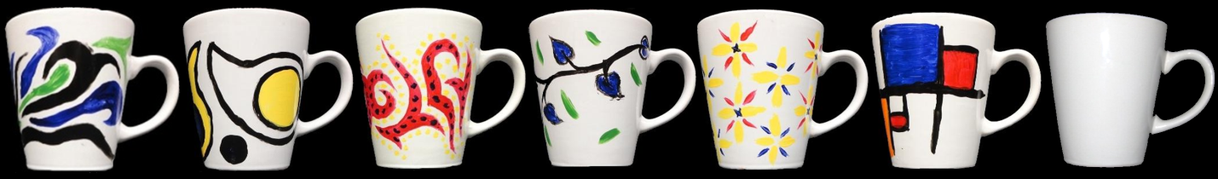
Fig 4. The 6 painted mugs and the blank mug used in Experiment 3. From left, Mug 1, Mug 2, Mug 3, Mug 4, Mug 5, Mug 6 and the blank mug.
Design & Procedure.
The design and procedure of the experimental session was identical to Experiments 1 and 2, except for how the mugs were selected. The six painted mugs were arranged pseudo-randomly between participants in a row on the table. Participants were asked to “choose a mug to use in the experiment today”. The experimenter then also chose a mug from the array, which was always one of two mugs (Mug 4 or 5). The experimenter then said “we will also use this blank mug for the experiment today” while presenting the blank mug to the participant. The experiment then proceeded as usual (see Experiment 1) with the experimenter standing to the right of the participant and concluded with participants indicating which mug they and the experimenter had chosen and providing liking ratings on a 10-point scale.
Results
One participant’s data was removed before analysis due to a high number of recording errors (10%). Other individual trials with recording errors (0.54%) were removed before analysis. On average participants took 662ms (SD = 227ms) to initiate movement towards the mug after hearing the tone. The entire action took 1947ms (SD = 458ms), with the mug in flight for 951ms (SD = 242ms). All participants identified the mug they and the experimenter chose correctly. Huynh-Feldt corrections were applied where appropriate.
Mug Ratings.
There was a significant effect of mug on participant’s ratings, F(1.78, 62.22) = 32.69, MSE = 3.13, p <.001, η_{p}² = .48. The participant’s chosen mug was rated higher (M=7.03, SD=1.34) than the experimenter’s chosen mug (M=6.39, SD=1.50, t(35) = 2.14, p = .04, d_{z} =.36) which was rated higher than the blank mug (M=4.01, SD=2.02, t(35) = 5.46, p < .001, d_{z} =.91). This suggests that participant’s did, indeed, have a preference for the mug they chose over the others they were lifting during the testing phase.
Spatial Manipulation.
Contrary to Experiments 1 and 2, no main effect of ‘Mug Type’ on ‘x at z-max’ was observed, F(2,70) = 1.553, MSE = 4.08, p =.219, η_{p}² = .042. A trending effect of ‘Mug Type’ on ‘y at z-max’ was obtained, F(1.49,52.14) = 3.26, MSE = 11.45, p =.06, η_{p}² = .085 (see Fig 2c). Planned comparisons revealed that the participant’s chosen mug drifted toward the participant during lift (18.2 mm) significantly further than the experimenter’s chosen mug (16.8 mm, t(35) = 2.73, p =.01, d_{z} = .45) and a trended towards significance with the blank mug (16.7 mm, t(35) = 1.81, p =.08, d_{z} = .30). The blank and experimenter’s chosen mug did not differ significantly, t(35) = .21, p = .84, d_{z} = .03.
Dynamic Manipulation.
A significant effect of ‘Mug Type’ on ‘Peak acceleration during lift’ was obtained, F(1.74,60.74) = 14.49, MSE = 8020400, p <.001, η_{p}² = .293. The experimenter’s chosen mug and the participant’s chosen mug did not differ significantly, t(35) = .826, p =.415, d_{z} = .14 (see Fig 3c). The blank mug reached a lower acceleration (9502mm/s²) compared with the experimenter’s chosen mug (12043mm/s², t(35) = 4.53, p < .001, d_{z} = .75) and the participant’s chosen mug (12660 mm/s², t(35) = 5.92, p < .001, d_{z} = .99). There was a significant effect of ‘Mug Type’ on deceleration, F(1.68,58.82) = 12.57, MSE = 15789464, p <.001, η_{p}² = .264. Mirroring the acceleration data, the blank mug reached a lower peak deceleration (8716mm/s²) compared with the Experimenter’s chosen mug (12232mm/s², t(35) = 4.93, p < .001, d_{z} =.82) and the participant’s chosen mug (12623mm/s2, t(35) = 5.01, p < .001, d_{z} =.83). The Experimenter’s chosen mug and the Participant’s chosen mug did not differ significantly, t(35) = .374, p =.711, d_{z} =.06.
Discussion
The findings from Experiments 1 and 2 may not have been purely due to the ownership status of the mugs, but contaminated by differential preferences we hold for objects that we own. To establish the extent to which mere choice (and thereby preference) influences the kinematics of mug lifts, we removed the ownership manipulation. A manipulation check confirmed that participants did like their chosen mug more than the other mugs they lifted during the experiment. Contrary to previous experiments, no differences in rightward drift were observed between the mugs. There was a significant difference associated with both acceleration during lift and deceleration during the placement of the mug, however, this difference was due to the blank mug. The only effect obtained in previous experiments that remained was ‘y at z-max’, with participants drawing the mug they had chosen closer towards their body compared to the other mugs. Further, for measures on which we failed to replicate previously found effects (x at z-max, acceleration and deceleration), we collected a sufficient sample size to detect effects of the same magnitude as those obtained by Constable et al. (2011), d_{z}s = .86 – 1.11 at the recommended .80 level (Cohen 1988).
In Constable et al. (2011) we suggested that the ‘y at z-max’ effect could be due to an over learned ‘drinking’ motor response. This explanation, however, is not consistent with finding the same effect in response to a preference manipulation. Therefore, we suspect that this may be an approach response to objects we like, whether owned, or not. On the other hand, the effects obtained in Experiments 1 and 2 associated with ‘x at z-max’, ‘Lift height’, and ‘Peak acceleration during lift’ seem to be independent from preference.
Given that the mere-ownership effect (Beggan, 1992) produces greater liking associated with one’s own things it is possible that participants liked their own mug in Experiments 1 and 2 to a much greater extent than the preferred mug in Experiment 3 creating a smaller difference in preference between the mugs here. This may account for the lack of effects obtained in this experiment but because we still obtain an effect in ‘y at z-max’ the absence of the other effects obtained in previous experiments is unlikely attributable to a lack of difference in preference.General Discussion
Over three experiments, we have replicated and extended the findings associated with ownership related effects. These studies show that the previously described (Constable et al. 2011) kinematic effects pertaining to differences in ownership status are context dependent and dissociable from each other (see Fig 5). Importantly, this is the first evidence directly implicating ownership as a variable that alters cognitive processing, distinct from preference.
Fig 5 Indication of whether the critical comparison between the Participant's own/chosen mug and the Other owned/chosen mug was replicated (tick) or failed to replicate (cross) across experiments and the possible underlying process involved in the effects
In general, measures of interest (‘x at z-max’, ‘y at z-max’ and ‘peak acceleration during lift’) reflected the operation of distinct cognitive mechanisms. Given that ‘x at z-max’ was the only measure of interest exclusively linked with ownership in the experiments presented here, and previous research (see Constable et al. 2011), we suggest that it is a valid and robust representation of embodiment of the social construct of ownership. ‘Y at z-max’ was the only measure that consistently produced the same pattern of results throughout the three experiments, one of which did not involve ownership. As such, it is difficult to make an argument that the inducement of ownership is required to elicit effects associated with a drift towards the participant. Regarding acceleration, however, differences between the mugs were absent when the owner of the object was absent. As we failed to replicate the previously reported (Constable et al. 2011) pattern of results associated with deceleration we interpret the acceleration data with caution. It may suggest that when participants were in the presence of the owner in Experiment 1 they were taking extra care with the experimenter’s mug, perhaps as a conflict prevention strategy.
Rightward drift during lift
Looking at ‘x at z-max’ more closely, in Experiment 1 we addressed the alternative hypothesis that mugs drift towards their owner during lift. The experimenter’s mug drifted further towards the right as compared to both the participant’s mug and the unowned mug. The location of the experimenter, however, did not interact with mug type. The most parsimonious explanation of the data, therefore, is that the effect represents a general reticence to interact with other people’s property rather than the participant moving the owned object towards its owner.
The same pattern of results for ‘x at z-max’ was observed when the owner of the ‘other owned’ object was absent (Experiment 2). Therefore, this measure is robust to socially related environmental changes. This indicates that the social construct of ownership is embodied within the motor system and prompts automatic motor processing even in the absence of a visible need to account for other people’s property. The pattern of results in Experiment 2 provides further evidence disqualifying the idea that the mugs travel towards their owner during lift as the owner was not present. We propose instead that this pattern of movement is a result of a general avoidance process. Overall, the pattern of results associated with this measure provides a strong case for the notion that ownership alters visuomotor processing beyond a conscious goal of developing, smoothing, and maintaining interpersonal relationships, reflecting automatic approach and avoidance processes.
Proximity to the body during lift
Across all three experiments the participant’s own (Experiments 1 & 2), or chosen (Experiment 3) mug, drifted further towards the participant’s body during lift compared with the other (Experimenter’s, Confederate’s, or Experimenters chosen) mug or the blank mug. Constable and colleagues (2011) previously suggested that this may be associated with an over-learned motor process. The fact that the same pattern of results emerged when participants have had no prior exposure to the mugs and there is no difference in familiarity between the three mugs they lift (Experiment 3), suggests that this is not the case. Rather, it is consistent with a preference for, or a positive connotation associated with, the participant’s own or chosen mug as compared with the others. This explanation concurs with previous research on the approach/avoidance effect (Chen and Bargh 1999; Lugli et al. 2012; Markman and Brendl 2005; van Dantzig et al. 2008) showing that positive words or positively connoted objects elicit faster response times when the action involves pulling a lever or mouse towards the body while negative words or negatively connoted objects elicit a faster response time when the action involves pushing the lever or mouse away. The attribution of ownership (Experiments 1 & 2) and the act of choosing an object (Experiment 3) may construe otherwise neutral objects as being positive and favorable (as in the mere-ownership effect, Beggan 1992) via a common mechanism that is special neither to ownership or choice.
Acceleration associated with lifting actions
In Experiment 1, participants reached higher peak acceleration during the lift phase of the movement with their own mug compared with the experimenter’s mug and the unowned mug. No difference was observed, however, when the owner of the other object was absent from the room during testing. Therefore, the differences observed in Experiment 1 may reflect a desire to be seen to take care of other people’s things or a means to maintain social connections by avoiding conflicts only when those individuals are present. There was a significant difference observed in Experiment 3 but this difference was associated with the blank mug reaching a lower peak acceleration rather than any difference between chosen mugs.
The larger overall acceleration observed in Experiment 3 is surprising. However, it is possible that this is due to the fact that ownership as a construct is absent in this Experiment. We have previously indicated that acceleration may be indicative of a level of care associated with the mugs. It is likely that participants want to care for their own mug, and perhaps the other person’s mug to an even greater extent (as indicated in Experiment 1). When the construct of ownership is removed, the social and personal cost of damaging the mugs is a lot less salient in the overall experimental context for these participants, which could lead to greater acceleration overall.
Familiarity vs. Ownership
There are many variables that are typically present and contribute to the cognitive representation of ownership. For example, familiarity is often an aspect of ownership. Is it possible that the ‘ownership’ effects we observe in the presented experiments are merely attributable to differences in familiarity? Although we do not directly test this, our pattern of results suggest that the cognitive representation of ownership elicits effects that cannot be attributable solely to familiarity. First, our ‘ownership’ related measures seem to be associated with interacting with other people’s things rather than one’s own things. In these experiments participants had identical levels of familiarity with the ‘other-owned’ mug and the ‘unowned’ mug and despite this differences were still observed. Second, it is possible that the higher peak acceleration associated with the owned mug in Experiment 1 could be attributed to a greater familiarity with one’s own mug, that is, we are more confident in interacting with our own things. However, this would predict that the acceleration effect would remain in Experiment 2 as the participants had the same level of familiarity with each mug across both experiments. Therefore, it seems unlikely that the differences in ownership are merely a reflection of differing levels of familiarity.
How familiarity interacts with ownership still poses interesting questions for future research. For example, is temporary ownership or instant ownership represented in the same way or in a cognitively distinct manner as long-term ownership? Do ownership related effects change over time as one becomes more familiar with the object? Does your understanding of another person’s level of familiarity with their own object have subsequent effects on your behavior with regards to that object?
Beyond the question on familiarity, there are ample opportunities for future research involving ownership and action. For example, factors such as the fragility of an object alter the way in which we interact with it (Savelsbergh, Steenbergen and van der Kamp, 1996) but can ownership alter the way in which we perceive fragility and subsequently is this change observed in our actions? Perhaps context plays a role in how these ownership effects are modulated. Our intention to cooperate with the other individual, how much we like them, and how comfortable we would be to actually touch or drink from a mug owned by a particular individual are all factors that may interact with ownership at the level of hand-object interactions.
As acknowledged by James (1890) distinguishing between ‘me’ and ‘mine’ is not trivial. Given the importance of possessions to our sense of self, it is not surprising that we are acutely aware of our own property (Belk 1988). But the data presented here also demonstrate that we implicitly account for other people’s property and this process is reflected in the way we act upon objects in our immediate surroundings. The attribution of meaning to owned objects alters our behaviors in a subtle and contextually driven way. Indeed, future research may find that these ownership related effects are further modulated by other factors such as the fragility of the object or the context of the interaction (for example, are we cooperating with the other individual, do we like the other individual, are we comfortable drinking from a mug owned by the other individual?) More specifically, the data provide a strong case for the inhibition of action towards other people’s property. We also demonstrate that preference cannot account for these ownership related effects. Moreover, ownership independently contributes to differences in individual’s motoric interactions with objects. The methodological approach presented here may also provide a new means of investigating the developmental trajectory of ownership cognition and how this alters an individual’s perception of and interactions with important socially relevant objects.

Acknowledgements
This research was supported by a University of Queensland Research Scholarship (Constable) and Australian Research Council Discovery Grants (to Kritikos, Slaughter, Sofronoff & Bayliss - DP130100253; Lipp - DP110100460). The authors would like to thank Hayley Colman and Harriet Dempsey-Jones for volunteering as confederates in Experiment 2. The authors would also like to thank Hayley Colman, Harriet Dempsey-Jones and Samuel Sparks for lending their artistic skills to painting the mugs used in Experiment 3.

References
Alexopoulos T, Muller D, Ric F, Marendaz C (2012) I, me, mine: Automatic attentional capture by self-related stimuli. Eur J Soc Psychol 42 (6):770-779
Anderson ML, Richardson MJ, Chemero A (2012) Eroding the boundaries of cognition: Implications of embodiment. Top Cogn Sci 4 (4):717-730
Becchio C, Sartori L, Bulgheroni M, Castiello U (2008) Both your intention and mine are reflected in the kinematics of my reach-to-grasp movement. Cognition 106 (2):894-912
Beggan JK (1992) On the Social Nature of Nonsocial Perception: The Mere Ownership Effect. J Pers Soc Psychol 62 (2):229-237
Beggan JK, Brown EM (1994). Association as a Psychological Justification for Ownership. The Journal of Psychology 128(4): 365–380.
Belk RW (1988) Possessions and the extended self. J Consum Res 15 (2):139-168
Bell PA, Yee LA (1989) Skill level and audience effects on performance of a karate drill. J Soc Psychol 129 (2):191-200
Borghi AM (2005) Object concepts and action. In: Pecher D, Zwaan RA (eds) Grounding cognition: The role of perception and action in memory, language, and thinking. Cambridge University Press, Cambridge
Borghi AM, Cimatti F (2010) Embodied cognition and beyond: Acting and sensing the body. Neuropsychologia 48 (3):763-773
Chen M, Bargh JA (1999) Consequences of automatic evaluation: Immediate behavioral predispositions to approach or avoid the stimulus. Pers Soc Psychol B 25 (2):215-224
Cohen J (1988) Statistical power analysis for the behavioral sciences. Lawrence Erlbaum Associates, Hillsdale, NJ
Constable MD, Bayliss AP, Tipper SP, Kritikos A (2013) Self-generated cognitive fluency as an alternative route to preference formation. Conscious Cogn 22 (1):47-52
Constable MD, Kritikos A, Bayliss AP (2011) Grasping the concept of personal property. Cognition 119 (3):430-437
Cunningham SJ, Turk DJ, Macdonald LM, Neil Macrae C (2008) Yours or mine? Ownership and memory. Conscious Cognition 17 (1):312-318
Cunningham SJ, Van den Bos MB, Turk DJ (2011) Exploring the effects of ownership and choice on self-memory biases. Memory 19 (5):449-461
Fischer P, Krueger JI, Greitemeyer T, Vogrincic C, Kastenmüller A, Frey D, Heene M, Wicher M, Kainbacher M (2011) The bystander-effect: A meta-analytic review on bystander intervention in dangerous and non-dangerous emergencies. Psychol Bull 137 (4):517-537
Garza JP, Eslinger PJ, Barrett AM (2008) Perceptual-attentional and motor-intentional bias in near and far space. Brain Cognition 68 (1):9-14
Georgiou I, Becchio C, Glover S, Castiello U (2007) Different action patterns for cooperative and competitive behaviour. Cognition 102 (3):415-433
James W (1890) The principles of psychology, vol 1. Henry Holt and Co., New York
Kanngiesser P, Hood B (2014). Not by labor alone: considerations for value influence use of the labor rule in ownership transfers. Cogn Sci 38 (2): 353-366.
Kim K, Johnson MK (2012) Extended self: Medial prefrontal activity during transient association of self and objects. Soc Cogn Affect Neurosci 7 (2):199-207
Kritikos A, Dozo N, Painter D, Bayliss A (2012) Mountain high, valley low: Direction-specific effects of articulation on reaching. Q J Exp Psychol 65 (1):39-54
Loftus GR, Masson MEJ (1994) Using confidence intervals in within-subject designs. Psychon Bull Rev 1 (4):476-490
Lugli L, Baroni G, Gianelli C, Borghi AM, Nicoletti R (2012) Self, others, objects: How this triadic interaction modulates our behavior. Mem Cognition 40 (8):1373-1386
Markman AB, Brendl CM (2005) Constraining theories of embodied cognition. Psychol Sci 16 (1):6-10
Merrill TW (1998) Property and the right to exclude. Nebraska Law Review 77:730-755
Milner AD, Brechmann M, Pagliarini L (1992) To halve and to halve not: An analysis of line bisection judgements in normal subjects. Neuropsychologia 30 (6):515-526
Niedenthal PM, Barsalou LW, Winkielman P, Krauth-Gruber S, Ric F (2005) Embodiment in attitudes, social perception, and emotion. Pers Soc Psychol Rev 9 (3):184-211
Palamar M, Le DT, Friedman O (2012). Acquiring ownership and the attribution of responsibility. Cognition 124(2): 201–208
Riddoch MJ, Humphreys GW (1983) The effect of cueing on unilateral neglect. Neuropsychologia 21 (6):589-599
Sartori L, Becchio C, Bulgheroni M, Castiello U (2009) Modulation of the action control system by social intention: Unexpected social requests override preplanned action. J Exp Psychol Human 35 (5):1490-1500
Savelsbergh, G. J. P., Steenbergen, B., & van Der Kamp, J. (1996). The role of fragility information in the guidance of the precision grip. Hum Movement Sci, 15(1): 115-127.
Snyder AL, Anderson-Hanley C, Arciero PJ (2012) Virtual and live social facilitation while exergaming: Competitiveness moderates exercise intensity. J Sport Exerc Psychol 34 (2):252-259
Turk DJ, Brady-van den Bos M, Collard P, Gillespie-Smith K, Conway MA, Cunningham SJ (2013) Divided attention selectively impairs memory for self-relevant information. Mem Cognition 41 (4):503-510
Turk DJ, van Bussel K, Brebner JL, Toma AS, Krigolson O, Handy TC (2011a) When "it" becomes "mine": Attentional biases triggered by object ownership. J Cognitive Neurosci 23 (12):3725-3733
Turk DJ, van Bussel K, Waiter GD, Macrae CN (2011b) Mine and me: Exploring the neural basis of object ownership. J Cognitive Neurosci 23 (11):3657-3668
Valdés-Conroy B, Román FJ, Hinojosa JA, Shorkey SP (2012) So Far So Good: Emotion in the Peripersonal/Extrapersonal Space. PLoS ONE 7 (11)
van Dantzig S, Pecher D, Zwaan RA (2008) Approach and avoidance as action effects. Q J Exp Psychol 61 (9):1298-1306
van den Bos M, Cunningham SJ, Conway MA, Turk DJ (2010) Mine to remember: The impact of ownership on recollective experience. Q J Exp Psychol 63 (6):1065-1071
Appendix 1A
Table 1
Mean ratings (liking, masculinity/femininity, effort) of the six painted mugs used in Experiment 3 provided by 22 independent raters.
 | Liking  M (SD) | Masculinity/Femininity  M (SD) | Effort  M (SD)
Mug 1 | 5.27(1.32) | 4.32(1.09) | 2.41(0.59)
Mug 2 | 5.73(2.00) | 4.41(0.80) | 2.50(0.67)
Mug 3 | 5.14(1.61) | 5.05(1.70) | 3.09(0.43)
Mug 4 | 5.73(1.58) | 5.86(0.83) | 2.50(0.51)
Mug 5 | 5.09(1.77) | 6.91(1.31) | 2.59(0.59)
Mug 6 | 5.86(1.78) | 3.86(1.13) | 2.73(0.55)

Notes. Liking and Masculinity/Femininity were both rated on a 9 point Likert Scale. 1 = Strongly dislike or Highly Masculine, 9 = Strongly like or Highly Feminine. Effort was rated in terms of 1 = No effort invested, 2 = Not much effort was invested, 3 = A moderate amount of effort was invested, 4 = A large amount of effort was invested.

