Homogeneity of antimicrobial policy, yet heterogeneity of antimicrobial resistance: antimicrobial non-susceptibility among 108,717 clinical isolates from primary, secondary and tertiary care patients in London

Authors:
Moore, Luke SP ^{1,2}
Freeman, Rachel ²
Gilchrist, Mark J ²
Gharbi, Myriam ¹
Brannigan, Eimear T ²
Donaldson, Hugo ²
Livermore, David M ^{3,4}
Holmes, Alison H ^{1,2}*

¹ National Centre for Infection Prevention and Management, Imperial College London, Hammersmith Campus, Du Cane Road, London. W12 0HS. United Kingdom.

² Imperial College Healthcare NHS Trust, Fulham Palace Road, London.W6 8RF. United Kingdom.

³ Norwich Medical School, University of East Anglia, Norwich. NR4 7TJ. United Kingdom.
⁴ Antimicrobial Resistance & Healthcare Associated Infection Reference Unit, Public Health England, 61 Colindale Avenue, London NW9 5EQ

Corresponding author: *Professor Alison H Holmes, National Centre for Infection Prevention and Management, Imperial College London, Hammersmith Campus, London. W12 0HS. United Kingdom.
Email: alison.holmes@imperial.ac.uk, telephone: 02033131283, fax: 02083833394.

Running title:
Heterogeneity of antimicrobial resistance in London.

Keywords:
Antibiogram
Healthcare-associated infection
Multi-drug resistant organism
Antimicrobial stewardship
Antimicrobial policy

Synopsis:
Objectives: We examined the four-year trend in antimicrobial susceptibilities and prescribing across levels-of-care at two London teaching hospitals and their multisite renal unit, and for the surrounding community.
Methods: Laboratory and pharmacy information management systems were interrogated, with antimicrobial use and susceptibilities analysed between hospitals, within hospitals, and over time.
Results: 108,717 isolates from 71,687 patients were identified, with significant differences (at p<0.05) in antimicrobial susceptibility between and within hospitals. Across the four years, rates of extended-spectrum β-lactamase (ESBL)-/AmpC-producing Enterobacteriaceae ranged from 6.4 to 10.7% among community isolates, 17.8 to 26.9% at ward level and 25.2 to 52.5% in critical-care. Significant variations were also demonstrated in glycopeptide-resistant enterococci (ward level 6.2 to 17.4%; critical-care 21.9 to 56.3%), methicillin-resistant Staphylococcus aureus (ward level 18.5 to 38.2%; critical-care 12.5 to 47.9%) and carbapenem-resistant Pseudomonas spp. (ward level 8.3 to 16.9%; critical-care 19.9 to 53.7%). Few instances of persistently higher resistance were seen between the hospitals in equivalent cohorts, despite persistently higher antimicrobial use in hospital 1 than hospital 2. We found significant fluctuations in non-susceptibility year-on-year across the cohorts, but with few persistent trends.
Conclusions: The marked heterogeneity of antimicrobial susceptibilities between hospitals, within hospitals, and over time demands detailed, standardised surveillance and appropriate benchmarking to identify possible drivers and effective interventions. Homogenous antimicrobial policies are unlikely to continue to be suitable as individual hospitals join hospital networks, and policies should be tailored to local resistance rates, at least at the hospital level, and possibly with finer resolution, particularly for critical-care.

Introduction
Antimicrobial resistance rates vary between countries,¹ and between the community and hospitals.² Variation within hospitals is also described; internationally, resistance rates are often highest in critical care,^{3,4} but in Europe this varies by organism¹ and, in the UK, critical care reservoirs seem less apparent.⁵ Robust benchmarking is lacking however, despite advocacy towards standardised collection of cumulative antimicrobial susceptibility test data⁶ (the “antibiogram”).⁷

Identification of local variations in bacterial resistance between cohorts^{2,8} and over time⁹ enables informed decisions on empiric antimicrobial regimens, and is becoming increasingly practicable as economic and political pressures create hospital networks, wherein previously-separate units, patient cohorts and their associated flora are now served by single large centralised laboratories. Single antimicrobial policies are frequently adopted within these networks, often not adequately allowing for variations in bacterial resistance between and within the sites served. In this context, antimicrobial policies rarely account for the variations in carriage rates of resistant bacteria in relation to population structure and travel or migration patterns.¹⁰ Defining patient cohorts according to locale, level of care, and other acknowledged risk factors for antimicrobial resistance, with subsequent detailing of resistance trends may facilitate more appropriate antimicrobial prescribing. A further concern is that highly standardised antimicrobial policies may concentrate selection pressure on particular agents, sequentially eroding their utility, exactly as occurred with anti-gonococcal treatments.¹¹

This study analyses four years of bacterial susceptibility data and prescribing trends from two west London tertiary referral hospitals, their multisite renal unit, and the surrounding community practices, all served by a single laboratory. The objectives were to describe fine-resolution variations in resistance rates and trends between the hospitals, within the hospitals at ward (NHS Level 0 and Level 1 beds) and critical care (NHS Level 2 and Level 3 beds)¹² levels and, furthermore, to seek relationships between resistance patterns and antimicrobial use.

Methods
The laboratory information management system (LIMS; Sunquest ®; Misys) was interrogated for the seven cohorts of interest: teaching hospital 1 (27 critical care beds; 388 ward beds), teaching hospital 2 (26 critical care beds; 453 ward beds), the multisite renal unit (84 inpatient beds; approximately 3100 dialysis and transplant outpatients), and community specimens (from over 50 local primary care practices and from outpatients attending clinics in hospitals 1 and 2). Hospital 1 includes general medicine, cardiology, and tertiary referral haematology, cardiothoracic surgery and hepatobiliary surgery. Hospital 2 includes general medicine, general surgery, trauma and orthopaedics and tertiary referral oncology and neurosurgery. All patients at hospital 1, hospital 2 and the renal unit were over 16 years of age. A third hospital within the hospital network utilised a different LIMS at the time of this study and was excluded. Infection advice for all sites is provided by an integrated team of infection specialists, with an established overarching antimicrobial policy and an active antimicrobial stewardship programme for all hospitals in the network. Off-policy prescription does occur under the direction of infection specialists.

All samples submitted for culture for clinical indications (as indicated by the clinician requesting submission of the sample) were identified covering the four fiscal years from 2009 to 2013 (in the UK the fiscal year runs from April to March). They included blood and cerebrospinal fluid, respiratory and ear/nose/throat, tissue and wound, genital and urine samples. Samples submitted for the purposes of cross-infection screening and methicillin-resistant Staphylococcus aureus (MRSA) screening were excluded, as variations in screening practice existed between and within the hospitals. The clinical criteria and sampling protocols to obtain diagnostic specimens for culture were uniform across the two hospitals in the corresponding ward and critical care cohorts. Results were de-duplicated for organisms repeatedly isolated within a seven-day period from the same patient. Laboratory operating procedures followed national standards for microbiological investigation;¹³ identification of isolates was by using API® (bioMérieux) from 2009-2011 and by matrix-assisted laser desorption/ionisation time-of-flight spectroscopy (Biotyper®; Bruker) from 2011-2013. Susceptibilities were determined by disc diffusion using British Society for Antimicrobial Chemotherapy criteria.¹⁴ AmpC- and extended-spectrum β-lactamase (ESBL)-producing Enterobacteriaceae were identified by standard methods.¹³ Comparisons between sites and cohorts were carried out for: glycopeptide-resistant enterococci (GRE), MRSA, Pseudomonas spp. and AmpC- and ESBL- producing Enterobacteriaceae (defined as including Citrobacter spp., Escherichia coli, Enterobacter spp., Hafnia spp., Klebsiella spp., Morganella spp., Pantoea spp., Proteus spp., Providencia spp., Raoultella spp., Serratia spp., and other lactose-fermenting coliforms but excluding Salmonella spp. and Shigella spp.). Enterobacteriaceae were considered at family level rather than for each species separately, as standard operating procedures stipulate identification to genus or species level only for those isolates from invasive sites or with particular resistance patterns. Non-susceptibility (i.e. resistant and intermediate) proportions were calculated against the total number of isolates tested in each isolate group.

Antimicrobial usage data were sourced from the hospital network pharmacy system, and defined daily doses per 1000 occupied bed days (DDD/1000 OBD) were calculated.¹⁵ Antimicrobial usage data is based upon antimicrobials distributed to wards and was available to the hospital level for Hospitals 1 and 2 (inpatients only); and for the renal inpatient practice. All antibacterials were included; antivirals, antileprotics, antimycobacterial and antihelminthic medications were excluded. Antimicrobial guidelines were reviewed for the relevant time periods to identify any policy shifts.

Variable referral practice from local primary care centres precluded estimation of population attributable rates of infection and resistance, but isolate frequency was calculated for inpatients based upon occupied bed days. Confidence intervals (CI) for non-susceptibility were calculated using the Wilson method with continuity correction.¹⁶ Analysis was undertaken in Stata/SE Version 11®, with chi-squared tests for inter-cohort comparison and for temporal trends, with binomial regression analysis when these identified significant differences (p<0.05, with the Bonferroni correction to account for multiple comparisons between years in each cohort).

Results
The LIMS extract yielded antimicrobial susceptibility results for 145,703 isolates. After excluding organisms not of interest to this study, 108,717 isolates from 105,319 samples and 71,687 patients remained.

Isolate frequency in relation to occupancy denominators
At ward level, little variation was observed between the two hospitals in terms of the frequency of isolation of the species groups reviewed (Table 1, expressed as isolates/1000 occupied bed days), with the exception of an upswing in Enterobacteriaceae isolates in the most recent year, observed in both hospitals. The frequency of isolates from the renal inpatient cohort was comparable to the general ward areas. Marked year-by-year fluctuations were observed in isolate frequency in critical care, but with a modest overall down-trend. Three features were notable: first, the high frequency of isolates of all species groups in hospital 1 in critical care in 2009-2010, not attributable to any discernible policy changes, case-mix or known outbreaks; secondly, a marked down-trend in the frequency of enterococci in both critical care units over the study period; and last, a year-on-year decrease in Enterobacteriaceae isolates from critical care patients at hospital 2.

Resistance in Enterobacteriaceae
Fifty-five thousand six-hundred Enterobacteriaceae were identified (Table 2). Significantly higher prevalence rates for Enterobacteriaceae with ESBL-/AmpC- phenotypes were seen in critical care versus general wards in hospital 1 in 3 of the 4 years and in hospital 2 in all 4 years (Table 3; Figure 1a). Proportions of ESBL-/AmpC- phenotypes were c. 1 in 5 Enterobacteriaceae from general wards and up to 1 in 2 in critical care. Fluctuating rates of Enterobacteriaceae with ESBL-/AmpC- phenotypes were seen at the two hospitals, with significant differences in these rates between the critical care areas in 3 of the 4 years, but only in the two most recent years in general ward cohorts. ESBL-/AmpC- rates among Enterobacteriaceae from the renal outpatient cohort were as high as at hospital ward level and, among renal inpatients, were as high as in critical care, peaking at 51.5% in 2012-13. The difference in prevalence of ESBL-/AmpC- producing Enterobacteriaceae between renal inpatients and renal outpatients was significant in all 4 years.

Binomial regression demonstrated a significant increase in the relative proportion of ESBL-/AmpC-producing Enterobacteriaceae from general inpatients from 2009-10 to 2010-11 of 18.8% (95% CI 1.4-39.1%, p=0.03). Hospital 1 critical care also showed a significant, 1.8-fold, increase in the prevalence of these organisms from 2010-11 to 2011-12 (95% CI 1.4-2.3, p<0.001). In hospital 2, critical care saw a significant relative increase in the prevalence of ESBL-/AmpC- producers from 2009-10 to 2010-11 of 43.6% (95% CI 20.7-70.9%, p<0.001), followed by a relative decrease from 2010-11 to 2011-12 of 23.3% (95% CI 6.3-37.1%, p=0.009). Proportions of ESBL-/AmpC-producing Enterobacteriaceae in community samples showed significant increases between 2009-10 and 2010-11 (p<0.001) and 2010-11 to 2011-12 (p<0.001) followed by a dip from 10.7% to 9.5% in 2012-13 (p=0.03); year-to-year variation was however small compared with the hospital cohorts.

Non-susceptibility to ciprofloxacin among the Enterobacteriaceae varied surprisingly little between or within the hospitals (Table 3), with non-susceptibility rates clustered from 18.1% to 25.7% (Figure 1b). However the renal unit showed significant variation in ciprofloxacin non-susceptibility between in- and out-patient cohorts in all 4 years. For renal outpatients, the prevalence of ciprofloxacin non-susceptibility was almost double that among ward patients in hospital 1 and 2; that for renal inpatients neared triple those in hospitals 1 and 2. There was no significant temporal variation in ciprofloxacin non-susceptibility in either hospital or in the renal unit. Non-susceptibility to ciprofloxacin in community isolates was approximately half that among inpatients.

We saw little carbapenem non-susceptibility in Enterobacteriaceae, precluding robust temporal or inter-cohort analysis. Meropenem non-susceptibility was noted in fewer than 0.5% in all hospital Enterobacteriaceae, except for renal inpatient isolates during 2009-10, when an outbreak due to OXA-48-carbapenemase producing Klebsiella pneumoniae was detected.¹⁷ Ertapenem non-susceptibility also was noted in 1-2% of Enterobacteriaceae, predominantly Enterobacter species, and was attributed to the breakpoint determining a “tail” of AmpC-de-repressed isolates to be non-susceptible.

Resistance in Pseudomonas
Twelve-thousand six-hundred and sixteen Pseudomonas spp. were identified, 10,226 of them confirmed as P. aeruginosa (Table 2). Across both hospitals and the renal cohorts, Pseudomonas spp. comprised 75.3-88.9% of all non-fermenters, with 63.0-77.1% identified as P. aeruginosa. Non-susceptibility to ciprofloxacin (Figure 2a), piperacillin/tazobactam (Figure 2b) and meropenem (Figure 2c) was analysed.

There was significant variation in ciprofloxacin non-susceptibility rates between the two hospitals in critical care in only 1 year, and at ward level in 2 years. Within-hospital comparisons demonstrated significant differences in all 4 years in hospital 2, with the non-susceptibility rate in critical care almost double that in general wards (Table 3). Temporal analysis found no significant variation in ciprofloxacin non-susceptibility in critical care, but showed significant falls at ward level in hospital 2 between 2009-10 and 2010-11 (p=0.002) and in hospital 1 between 2010-11 and 2012-13 (p=0.001). The renal inpatient cohort showed a significant fall (almost 50%) in ciprofloxacin non-susceptibility between 2010-11 and 2011-12 (p<0.001). In the community, ciprofloxacin non-susceptibility among Pseudomonas spp. remained between 11.1% and 14.3% across the 4 years.

Meropenem non-susceptibility was more prevalent than piperacillin/tazobactam non-susceptibility in all years and cohorts (Table 2; Figures 2b, 2c). Non-susceptibility to meropenem were significantly more prevalent (typically 2-3-fold) in critical care than in general wards in all years at both hospitals (Table 3). Instances of significant between-hospital variation in meropenem non-susceptibility were more between corresponding levels of care, with less variation for piperacillin/tazobactam non-susceptibility.

There was no statistically significant temporal variation in non-susceptibility to meropenem or piperacillin/tazobactam in the ward or critical care cohorts, in renal outpatients, or in the community. In the renal inpatient cohort, by contrast, there were significant falls in the prevalence of non-susceptibility to both meropenem (33.3 to 8.9%; p<0.001) and piperacillin/tazobactam (23.2 to 3.7%; p<0.001) between 2010-11 and 2011-12.

Resistance in enterococci
Thirteen-thousand six-hundred and forty-three enterococci were identified (Table 2). Significant difference in GRE rates between ward and critical care areas applied for all years in both hospitals (Table 3; Figure 3a). Comparison between the hospitals demonstrated significant differences in GRE prevalence at ward level in all years, but little significant variation between the critical care areas (exception 2009-10). GRE were consistently 2 to 4 times more frequent among enterococci from renal inpatients than renal outpatients, and this was significant in all years. There was no significant year-on-year variation in the proportion of GRE in any cohort.

Analysis of amoxicillin non-susceptible enterococci (i.e. presumptive E. faecium) demonstrated significant variation between critical care and general ward areas in both hospitals in all years (Table 3; Figure 3b); specifically, the proportions of amoxicillin non-susceptible enterococci in critical care were typically twice those in general wards in hospital 1, and 3 to 6 times higher in hospital 2. Significant variation was also demonstrated between renal inpatients and outpatients, with the former having amoxicillin non-susceptible rates c. 4 times those for the latter. Comparison between the two hospitals demonstrated little significant variation in the proportion of amoxicillin non-susceptible enterococci between the critical care cohorts (exception 2012-13), but, for general ward isolates, hospital 1 consistently had 1.5 to 4 times higher rates, than hospital 2. Amoxicillin non-susceptibility among community isolates was consistent, and 10-fold below the other cohorts, at 1.0-2.6%.

Resistance in S. aureus
Twenty-six thousand eight-hundred and fifty-eight S. aureus isolates were identified, of which 4292 (16.0%) were MRSA (Table 2; Figure 4). MRSA rates were significantly higher in critical care than in general wards at hospital 1 only in 2009-10 (Table 3). In hospital 2, MRSA was more prevalent in critical care areas in two years, with its proportion peaking at almost twice that at ward level in 2011-12. Comparison between the hospitals at ward level demonstrated an alternating trend as to which had the higher MRSA rate; these differences were significant until 2012-13. In critical care, hospital 2 had persistently higher MRSA rates than hospital 1 across all years, and this was significant in two years. Among renal patients, the proportion of MRSA from the inpatient cohort was significantly higher than from the outpatient cohort in 3 of the 4 years, peaking at almost double in 2009-10.

Analysis over time showed a significant decrease in the proportion of MRSA at ward level in hospital 1 between 2010-11 and 2011-12, from 38.2% to 19.9% (p<0.001), with no significant subsequent rebound . A similar decrease at ward level was observed in hospital 2 over a longer period, from 38.2% in 2009-10 to 27.4% in 2010-11 (p<0.001). This was then followed by a further decrease, from 25.4% in 2011-12 to 18.5%, in 2012-13 (p<0.001). In critical care, no significant temporal variations were observed in hospital 1, but hospital 2 saw a significant recent reduction in the proportion of MRSA, from 47.9% in 2011-12 to 22.7% in 2012-13 (p<0.001). In the community, MRSA showed a downward trend, with significant falls between 2009-10 and 2010-11 (p=0.02), and between 2011-12 and 2012-13 (p<0.001).

Antimicrobial usage
Biannual point prevalence studies consistently indicated that 33.3-41.9% of patients were on antimicrobials, with this proportion rising to 62.9-71.4% in critical care and, among renal inpatients, to 71.8-80.4%. Analysis as DDD/1000 OBD, for the four most commonly prescribed antimicrobials (ciprofloxacin, amoxicillin/clavulanate, piperacillin/tazobactam and meropenem) among all in-patient groups is shown in Table 4, demonstrating persistently higher use in hospital 1 than hospital 2. This differential was 23-56% for ciprofloxacin, 26-53% for amoxicillin/clavulanate, 53-82% for piperacillin/tazobactam, 74-117% for meropenem and, for total antimicrobial use, 27-40%. Although the renal unit had lower use of amoxicillin/clavulanate than either hospital, use of ciprofloxacin was 159-213% higher than hospital 2, piperacillin/tazobactam use was 104-147% higher and meropenem use 39-264% higher. There was little variation over time in the proportion of prescribing accounted for by these top four antimicrobials, except for a spike in meropenem use in hospital 1 in 2011-12, a reduction by half for meropenem consumption among renal inpatients between 2010-11 and 2011-12, and for ciprofloxacin, a fall of c. 33% during the study period in hospital 1 and of 20% in the renal inpatient cohort.

Review of antimicrobial policies revealed only two major changes in the study period, both promoting use of narrower-spectrum antimicrobials. The first, in 2010, was the introduction, across the hospital network, of an antimicrobial policy for infection in over-65-year-olds. This stipulated use of narrow-spectrum antimicrobials, avoiding amoxicillin/clavulanate for urinary tract infections, peritonitis and pneumonia (advocating aminoglycosides, amoxicillin/metronidazole/gentamicin and amoxicillin respectively). It aimed to reduce Clostridium difficile infections. The second major change related to antimicrobial stewardship in the renal cohort from 2009 onwards (below).

Discussion:
We found significant differences in antimicrobial non-susceptibility within and between the two hospitals for Enterobacteriaceae, enterococci, S. aureus and Pseudomonas spp. Furthermore, we found substantial year-on-year fluctuation in non-susceptibility among most ‘drug-bug’ combinations, but with few persistent trends. There was much less fluctuation in results for the community cohort, refuting the hypothesis that the variation in the hospital isolates represented a testing quality issue.

The data suggest a few instances where the cohort at one hospital had persistently higher non-susceptibility rates than the corresponding cohort at the other hospital. Notable examples include MRSA in hospital 2 critical care, meropenem non-susceptible Pseudomonas spp. in hospital 1 critical care, and amoxicillin non-susceptible enterococci (i.e. E. faecium) in hospital 1 ward areas. Nevertheless, the wider lack of consistency in relative rates, or trends, between the two hospitals suggests that short-term factors were a greater factor in influencing year-on-year variation. These short-term factors could potentially represent transmission, with many ‘mini-outbreaks’ among patients who are hospitalised or who have frequent healthcare contact. A concept of ‘mini-outbreaks’, particularly in the critical care areas, is additionally supported by the fluctuations in the frequency with which species are encountered within each cohort (Table1). Further investigation, with prospective large-scale typing is indicated, and may be facilitated by the increasing availability of whole genome sequencing.

One factor that may contribute to variation seen between the two critical care units is the impact of the use of selective digestive decontamination (SDD)¹⁸ in hospital 2 critical care, but not in hospital 1. This may help to explain why isolation rates of Enterobacteriaceae were generally lower in hospital 2 critical care than hospital 1. However, Enterobacteriaceae displaying an ESBL-/AmpC- phenotype peaked at 52.2% in 2010-2011 at hospital 2 (twice that in hospital 1 in the corresponding year). Over the succeeding two years, the rates of isolates with ESBL-/AmpC- phenotype converged, despite no change in SDD practice. Elsewhere, data on the impact of SDD on multi-drug resistant organisms is conflicting, and long-term cluster-randomised controlled trials are needed.^{19,20}

In contrast to the general lack of consistency in differences in rates of resistance between the two hospitals, the results do suggest reasonably consistent ‘within hospital’ variation, with higher resistance rates, and a greater frequency of isolates, in critical care versus ward areas. A consistent excess of resistance was also seen in the renal cohorts, where resistance rates in renal inpatients resembled those in critical care, rather than at ward level; whereas resistance rates in renal outpatients resembled those of ward inpatients rather than community patients. This differential between the proportions of resistant isolates in general versus specialist cohorts was demonstrated for most ‘drug-bug’ combinations, with the exception of methicillin-resistance for S. aureus and ciprofloxacin non-susceptibility in Enterobacteriaceae, where fairly uniform rates were noted across all cohorts. One of the most likely causes for these ‘within hospital’ variations may be the greater frequency of antimicrobial use in critical care areas/renal inpatients than in general wards. In our six-monthly point prevalence studies, critical care antimicrobial usage was higher than the benchmarked national point prevalence finding of 60.8% for critical care patients,²¹ and usage in the renal inpatient cohort was higher even than in critical care. Increased use of devices and central intravenous cannulae in critical care and among renal inpatients may be driving frequent empiric co-prescription of glycopeptides, selecting for GRE.²² Nevertheless, markedly higher antimicrobial prescribing in hospital 1 than hospital 2 was not reflected in higher overall resistance rates.

Beyond the levels of antimicrobial usage, one of the biggest drivers of variation both between and within hospitals may be the spectra of activity of the particular antimicrobials prescribed, and it is widely suggested that resistance itself is encouraging increasingly broad-spectrum empiric antimicrobial use, thereby driving selection of further resistance. A possible example was seen with the spike in meropenem usage in hospital 1 between 2009-10 and 2010-11, which was temporally associated with spikes in piperacillin/tazobactam resistance among Pseudomonas spp. at both ward and critical care levels. This rise in meropenem use was associated with a non-significant, but possibly consequent, rise in meropenem-non-susceptible Pseudomonas spp. in both hospital 1 cohorts, persisting in critical care for the subsequent year. Addressing this feedback loop through antimicrobial stewardship is key, and advances in rapid microbiological diagnostics to facilitate de-escalation may help.^{23,24}

One example of successful interruption of such a feedback loop is demonstrated in the renal cohort data. Until and including 2010-11, meropenem use in this cohort was high. Following an outbreak of K. pneumoniae with an OXA-48-carbapenemase in 2008-2010, carbapenem use was almost halved on the advice of infection specialists between 2010-11 and 2011-12. Whilst causality cannot be directly attributed, a beneficial, yet unintended, impact, over a relatively short time frame, was a significant fall in the proportion of Pseudomonas spp. non-susceptible to meropenem. A marked and concordant fall in piperacillin/tazobactam resistance in Pseudomonas spp. - despite plateaued consumption in this cohort over this period - may reflect the fact that both meropenem and piperacillin/tazobactam are affected by, and putatively select for, the same efflux-based resistance mechanisms in P. aeruginosa.

A further facet of antimicrobial use may contribute to the high burden of antimicrobial non-susceptibility; specifically homogenous use, concentrating selection pressure on a fraction of the antimicrobial armamentarium.^{25,26} In our study, just four agents consistently represented 34-50% of all antimicrobials prescribed in the hospitals and the renal inpatients, and two of these – amoxicillin/clavulanate and piperacillin/tazobactam – are closely related. Whilst the damaging consequences of homogenous antimicrobial policies are not proven for all antimicrobials,²⁷ an argument for heterogeneity exists and might be achieved through antimicrobial cycling,^{28,29} or mixing.^{30,31} The latter option is likely preferable, through offering broader choices of antimicrobials within policies, and prospective monitoring to preserve the diversity of prescribing within those choices offered.

Critics of antibiogram-based surveillance data often cite inaccuracies in the sampling of selected patient populations and restricted geographical sampling.³² We largely evaded these problems by extracting all data from a laboratory serving multiple cohorts across two hospitals, and an associated community, that shared an overarching antimicrobial policy and infection specialists. Antibiograms also can suffer in accuracy, and therefore utility, when there are marked changes in patient mix. There was some change in patient population through this study period, with solid organ oncology being consolidated from both hospitals to hospital 2 in 2010-11, and with the formation of a new heart attack centre at hospital 1 in 2009-10. Changes in primary care in one part of west London between 2010-11 and 2011-12 led to in a decrease in the number of community samples. Changing hospital configurations highlight the need for regular antibiogram review and relation to the patient cohorts. A further limitation of this study reflects the susceptibility rates not being stratified by infection site; rates may potentially vary between sample types, not least because of sampling bias. However using an all-sample approach to resistance surveillance, rather than restricting data to blood culture results, may better reflect the drivers towards antimicrobial prescribing in clinical practice. A further limitation is the inability to delineate whether clinical isolates from patients in one cohort were acquired in that cohort, or elsewhere (e.g. community-acquired isolates detected during inpatient stays or hospital-acquired infections becoming manifest in the community). The impact of community antimicrobial use, over and above hospital use, on the variation in susceptibility rates seen between cohorts could not be assessed, and would require longitudinal, linked, primary and secondary care patient-level data, not presently available.

Conclusion:
The Annual Report of the Chief Medical Officer,³³ the UK Five-Year Antimicrobial Resistance Strategy,³⁴ the Chennai Declaration³⁵ and the G8 Science Ministers Statement³⁶ all highlight surveillance as key to addressing antimicrobial resistance. Aggregated regional or hospital level data are no longer adequate, and analysis to a finer resolution is needed (whilst retaining statistical power to detect variation), as here. Standardisation of reporting parameters urgently need to be agreed.

Despite (i) overarching antimicrobial and infection control policies, (ii) standardised laboratory practice, and (iii) integrated infection specialists with an active stewardship programme, this study found significant variation in antimicrobial susceptibility in common organisms between different patient cohorts in the multisite hospital network. Variations in antimicrobial use and clinical practice may be responsible, but relationships are far from clear, and random fluctuations, potentially due to numerous ‘mini-outbreaks’ may be short-term modulators. Marked heterogeneity in antimicrobial susceptibility moreover suggests that whole-hospital antimicrobial policies may not be appropriate in hospitals with multiple sites, or where units have markedly different patient populations. Local policies, rapidly responsive to short-term fluctuations of both antimicrobial resistance and prescribing patterns, may be necessary and desirable. Policies should also be mindful of the potential unintended consequences of reactionary prescribing.

Acknowledgements: We would like to thank the contribution of Imperial College Healthcare NHS Trust Antimicrobial Review Group and Pharmacy Department, Mr Paul Jones Biomedical Scientist, and the Antimicrobial Resistance Monitoring and Reference Laboratory at Public Health England.

Funding: This work was supported by the National Institute of Health Research Imperial Biomedical Research Centre, and the UK Clinical Research Collaboration who fund the Centre for Infection Prevention and Management (UKCRC G0800777).

Transparency: D.M.L. is partly self-employed and consults for numerous pharmaceutical and diagnostic companies, including Achaogen, Adenium, Allecra, Astellas, AstraZeneca, Bayer, Basilea, bioMérieux, Cubist, Curetis, Discuva, Fedora, GSK, Merck, Meiji Seika, Pfizer, Roche, Shionogi, Tetraphase, VenatoRx and Wockhardt; he holds grants or contracts from AstraZeneca, Cubist, Meiji Seika, Merck and Wockhardt; has received lecture honoraria or travel reimbursement from AstraZeneca, Bruker, Curetis, GSK, J&J, Merck, Novartis, Pfizer and Tetraphase and holds shares in Dechra, Leo, GSK, Merck and Pfizer, collectively amounting to <10% of portfolio value.
A.H.H. has consulted for bioMérieux.
M.J.G. has attended advisory boards for AstraZeneca and The Medicines Company.
All other authors: No conflict of interest declared.

References
1. European Centre for Disease Prevention and Control. Antimicrobial resistance surveillance in Europe 2011. http://www.ecdc.europa.eu/en/publications/publications/antimicrobial-resistance-surveillance-europe-2011.pdf (17 June 2014, date last accessed).
2. Lamoth F, Wenger A, Prod’hom G, et al. Comparison of hospital-wide and unit-specific cumulative antibiograms in hospital- and community-acquired infection. Infection 2010; 38: 249–53.
3. Azim A, Dwivedi M, Rao PB, et al. Epidemiology of bacterial colonization at intensive care unit admission with emphasis on extended-spectrum beta-lactamase- and metallo-beta-lactamase-producing Gram-negative bacteria--an Indian experience. J Med Microbiol 2010; 59: 955–60.
4. Verhamme KMC, De Coster W, De Roo L, et al. Pathogens in early-onset and late-onset intensive care unit-acquired pneumonia. Infect Control Hosp Epidemiol 2007; 28: 389–97.
5. Reynolds R, Maher K, Hope R, The BSAC Extended Working Party on Respiratory Resistance Surveillance. ICU - always the hotbed of resistance ? Clin Microbiol Infect 2011; 17: P1231.
6. Zapantis A, Lacy MK, Horvat RT, et al. Nationwide Antibiogram Analysis Using NCCLS M39-A Guidelines. J Clin Microbiol 2005; 43: 2629–34.
7. Clinical and Laboratory Standards Institute. Analysis and Presentation of Cumulative Antimicrobial Susceptibility Test Data; Approved Guideline. Third Edition. CLSI, Wayne, PA, USA, 2009.
8. Binkley S, Fishman NO, LaRosa LA, et al. Comparison of unit-specific and hospital-wide antibiograms: potential implications for selection of empirical antimicrobial therapy. Infect Control Hosp Epidemiol 2006; 27: 682–7.
9. Aldeyab MA, Harbarth S, Vernaz N, et al. The impact of antibiotic use on the incidence and resistance pattern of extended-spectrum beta-lactamase-producing bacteria in primary and secondary healthcare settings. Br J cCinical Pharmacol 2012; 74: 171–9.
10. Wickramasinghe NH, Xu L, Eustace A, et al. High community faecal carriage rates of CTX-M ESBL-producing Escherichia coli in a specific population group in Birmingham, UK. J Antimicrob Chemother 2012; 67: 1108–13.
11. Livermore DM. Minimising antibiotic resistance. Lancet Infect Dis 2005; 5: 450–9.
12. Department of Health. The Critical Care Minimum Dataset (CCMDS) 2006. http://www.isb.nhs.uk/documents/dscn/dscn2005/022005v3.pdf (13 Jan 2014, date last accessed).
13. Public Health England. Standards for Microbiology Investigations. http://www.hpa.org.uk/ProductsServices/MicrobiologyPathology/UKStandardsForMicrobiologyInvestigations/TermsOfUseForSMIs/AccessToUKSMIs/ (13 Jan 2014, date last accessed).
14. British Society of Antimicrobial Chemotherapy. BSAC Methods for Antimicrobial Susceptibility Testing Version 12. http://bsac.org.uk/wp-content/uploads/2012/02/Version-12-Apr-2013_final1.pdf (13 Jan 2014, date last accessed).
15. WHO Collaborating Centre for Drug Statistic Methodology. Guidelines for ATC classification and DDD assignment 2013 http://www.whocc.no/filearchive/publications/1_2013guidelines.pdf (17 June 2014, date last accessed).
16. Newcombe RG. Two-sided confidence intervals for the single proportion: comparison of seven methods. Stat Med 1998; 17: 857–72.
17. Thomas CP, Moore LSP, Elamin N, et al. Early (2008–2010) hospital outbreak of Klebsiella pneumoniae producing OXA-48 carbapenemase in the UK. Int J Antimicrob Agents 2013; 42: 531–6.
18. De Smet AMGA, Kluytmans JAJW, Cooper BS, et al. Decontamination of the digestive tract and oropharynx in ICU patients. N Engl J Med 2009; 360: 20–31.
19. Oostdijk E a N, de Smet AMG a, Blok HEM, et al. Ecological effects of selective decontamination on resistant gram-negative bacterial colonization. Am J Respir Crit Care Med 2010; 181: 452–7.
20. Daneman N, Sarwar S, Fowler RA, Cuthbertson BH. Effect of selective decontamination on antimicrobial resistance in intensive care units: a systematic review and meta-analysis. Lancet Infect Dis 2013; 13: 328–41.
21. Health Protection Agency. English National Point Prevalence Survey on Healthcare-associated Infections and Antimicrobial Use, 2011. http://www.hpa.org.uk/webc/HPAwebFile/HPAweb_C/1317134304594 (17 June 2014, date last accessed).
22. Shime N, Kosaka T, Fujita N. The importance of a judicious and early empiric choice of antimicrobial for methicillin-resistant Staphylococcus aureus bacteraemia. Eur J Clin Microbiol Infect Dis 2010; 29: 1475–9.
23. Advisory Committee on Antimicrobial Resistance and Healthcare Associated Infection. Antimicrobial Stewardship: Start Smart - Then Focus. https://www.gov.uk/government/uploads/system/uploads/attachment_data/file/215308/dh_131181.pdf (13 Jan 2014, data last accessed).
24. Ashiru-Oredope D, Sharland M, Charani E, McNulty C, Cooke J. Improving the quality of antibiotic prescribing in the NHS by developing a new Antimicrobial Stewardship Programme: Start Smart--Then Focus. J Antimicrob Chemother 2012; 67: 51–63.
25. Livermore DM. Fourteen years in resistance. Int J Antimicrob Agents 2012; 39: 283–94.
26. Sandiumenge A, Diaz E, Rodriguez A, et al. Impact of diversity of antibiotic use on the development of antimicrobial resistance. J Antimicrob Chemother 2006; 57: 1197–204.
27. Ginn AN, Wiklendt AM, Gidding HF, et al. The ecology of antibiotic use in the ICU: homogeneous prescribing of cefepime but not tazocin selects for antibiotic resistant infection. PLoS One 2012; 7: e38719.
28. Bergstrom CT, Lo M, Lipsitch M. Ecological theory suggests that antimicrobial cycling will not reduce antimicrobial resistance in hospitals. Proc Natl Acad Sci U S A 2004; 101: 13285–90.
29. Chow K, Wang X, Curtiss R, Castillo-Chavez C. Evaluating the efficacy of antimicrobial cycling programmes and patient isolation on dual resistance in hospitals. J Biol Dyn 2011; 5: 27–43.
30. Sandiumenge A, Lisboa T, Gomez F, Hernandez P, Canadell L, Rello J. Effect of antibiotic diversity on ventilator-associated pneumonia caused by ESKAPE Organisms. Chest 2011; 140: 643–51.
31. Piper GL, Kaplan LJ. Antibiotic heterogeneity optimizes antimicrobial prescription and enables resistant pathogen control in the intensive care unit. Surg Infect (Larchmt) 2012; 13: 194–202.
32. Dalhoff A. Resistance surveillance studies: a multifaceted problem--the fluoroquinolone example. Infection 2012; 40: 239–62.
33. Davies SC. Annual Report of the Chief Medical Officer, Volume 2, 2011. Infections and the rise of antimicrobial resistance. http://media.dh.gov.uk/network/357/files/2013/03/CMO-Annual-Report-Volume-2-20111.pdf (19 Feb 2014, date last accessed).
34. Davies SC, Gibbens N. UK Five Year Antimicrobial Resistance Strategy 2013 to 2018. https://www.gov.uk/government/uploads/system/uploads/attachment_data/file/244058/20130902_UK_5_year_AMR_strategy.pdf (19 Feb 2014, date last accessed).
35. Ghafur A, Mathai D, Muruganathan A, et al. The Chennai Declaration: a roadmap to tackle the challenge of antimicrobial resistance. Indian J Cancer 2013; 50: 71–3.
36. Willetts D, Livanov, Schütte G, et al. G8 Science Ministers Statement.; 2013. https://www.gov.uk/government/news/g8-science-ministers-statement (23 Sept 2013, date last accessed)

Table 1. Isolates per 1000 occupied bed days (isolates/1000 OBD) from secondary and tertiary care inpatients in West London, 2009-2013. Sample types for isolates from the renal inpatient cohort comprised 11% blood cultures, 7% respiratory tract, 8% invasive tissue or fluid, 48% non-invasive wound swab, 26% urine. Sample types for isolates from hospital 1 were 9% blood cultures, 13% respiratory tract, 10% invasive tissue or fluid, 37% non-invasive wound swab, 31% urine; those for isolates from hospital 2: 5% blood cultures, 14% respiratory tract, 8% invasive tissue or fluid, 38% non-invasive wound swab, 35% urine.

 | Renal |  |  |  | Hospital 1 |  |  |  |  |  |  |  | Hospital 2
 | Inpatient |  |  |  | Wards |  |  |  | Critical care |  |  |  | Wards |  |  |  | Critical care
 | 2009-2010 | 2010-2011 | 2011-2012 | 2012-2013 | 2009-2010 | 2010-2011 | 2011-2012 | 2012-2013 | 2009-2010 | 2010-2011 | 2011-2012 | 2012-2013 | 2009-2010 | 2010-2011 | 2011-2012 | 2012-2013 | 2009-2010 | 2010-2011 | 2011-2012 | 2012-2013
Enterobacteriaceae  (55,600 isolates) | 13 | 9 | 10 | 14 | 17 | 11 | 13 | 23 | 51 | 26 | 27 | 33 | 13 | 13 | 11 | 17 | 40 | 37 | 27 | 20
Pseudomonas spp.  (12,616 isolates) | 5 | 5 | 5 | 4 | 6 | 3 | 3 | 4 | 26 | 12 | 12 | 19 | 5 | 5 | 5 | 5 | 23 | 28 | 27 | 19
Enterococci  (13,643 isolates) | 7 | 4 | 3 | 4 | 5 | 4 | 3 | 4 | 20 | 13 | 9 | 10 | 4 | 3 | 3 | 4 | 12 | 13 | 6 | 5
S. aureus  (26,858 isolates) | 3 | 3 | 3 | 4 | 5 | 4 | 4 | 7 | 15 | 4 | 6 | 8 | 8 | 8 | 7 | 7 | 13 | 14 | 13 | 11
Table 2. Bacterial non-susceptibility to selected antimicrobials among 108,717 clinical isolates from primary, secondary and tertiary care patients in West London, 2009-2013.
 | Community |  |  |  | Renal |  |  |  |  |  |  |  | Hospital 1 |  |  |  |  |  |  |  | Hospital 2
 |  |  |  |  | Outpatient |  |  |  | Inpatient |  |  |  | Wards |  |  |  | Critical care |  |  |  | Wards |  |  |  | Critical care
 | 2009-2010 | 2010-2011 | 2011-2012 | 2012-2013 | 2009-2010 | 2010-2011 | 2011-2012 | 2012-2013 | 2009-2010 | 2010-2011 | 2011-2012 | 2012-2013 | 2009-2010 | 2010-2011 | 2011-2012 | 2012-2013 | 2009-2010 | 2010-2011 | 2011-2012 | 2012-2013 | 2009-2010 | 2010-2011 | 2011-2012 | 2012-2013 | 2009-2010 | 2010-2011 | 2011-2012 | 2012-2013
Enterobacteriaceae isolates  (55,600 total) | 13225 | 12880 | 5055 | 6641 | 314 | 389 | 575 | 703 | 396 | 283 | 293 | 365 | 1229 | 831 | 965 | 1661 | 494 | 254 | 248 | 304 | 1995 | 1799 | 1508 | 2186 | 371 | 289 | 207 | 140
Ciprofloxacin  non-susceptibility | 9.6% | 11.3% | 12.0% | 11.5% | 36.0% | 29.6% | 36.7% | 42.2% | 59.1% | 54.1% | 54.9% | 60.8% | 23.7% | 26.2% | 25.7% | 23.4% | 24.3% | 18.1% | 18.5% | 23.7% | 20.1% | 22.5% | 20.8% | 20.7% | 19.9% | 25.3% | 19.8% | 24.3%
AmpC or ESBL phenotype | 6.4% | 8.2% | 10.7% | 9.5% | 24.5% | 22.4% | 27.0% | 29.9% | 35.6% | 38.9% | 43.3% | 51.5% | 21.5% | 25.5% | 26.9% | 21.1% | 29.1% | 25.2% | 44.4% | 47.0% | 21.5% | 23.1% | 20.8% | 17.8% | 36.4% | 52.2% | 40.1% | 36.4%
Pseudomonas spp. isolates  (12,616 total) | 1869 | 1954 | 745 | 1505 | 146 | 133 | 130 | 103 | 155 | 138 | 135 | 102 | 454 | 266 | 213 | 282 | 252 | 111 | 107 | 169 | 820 | 748 | 658 | 652 | 211 | 218 | 207 | 133
Ciprofloxacin  non-susceptibility | 12.3% | 14.3% | 12.8% | 11.1% | 26.7% | 23.3% | 15.4% | 19.4% | 40.6% | 45.7% | 25.9% | 27.5% | 25.6% | 33.8% | 20.7% | 22.7% | 32.5% | 29.7% | 34.6% | 28.4% | 26.6% | 20.1% | 18.4% | 15.8% | 35.1% | 26.6% | 30.0% | 39.8%
Piperacillin/tazobactam non-susceptibility | 1.0% | 2.4% | 2.3% | 1.9% | 2.7% | 3.8% | 5.4% | 2.9% | 19.4% | 23.2% | 3.7% | 6.9% | 6.8% | 12.4% | 8.0% | 7.8% | 8.3% | 27.0% | 15.0% | 13.0% | 7.7% | 8.2% | 5.6% | 4.4% | 17.1% | 17.0% | 17.4% | 14.3%
Meropenem  non-susceptibility | 3.6% | 3.5% | 5.0% | 3.2% | 10.3% | 6.8% | 4.6% | 5.8% | 32.9% | 33.3% | 8.9% | 18.6% | 16.7% | 18.4% | 10.3% | 13.1% | 32.9% | 39.6% | 42.1% | 33.1% | 15.6% | 11.6% | 8.2% | 8.0% | 31.8% | 21.1% | 27.5% | 22.6%
Enterococci isolates (13,643 total) | 2689 | 3284 | 1555 | 1321 | 77 | 79 | 91 | 102 | 226 | 132 | 93 | 105 | 341 | 281 | 238 | 324 | 188 | 128 | 80 | 89 | 607 | 467 | 370 | 481 | 115 | 100 | 48 | 32
Amoxicillin  non-susceptibility | 1.5% | 1.0% | 2.1% | 2.6% | 15.6% | 15.2% | 8.8% | 13.7% | 58.8% | 56.8% | 55.9% | 59.0% | 43.7% | 35.6% | 31.5% | 34.0% | 57.4% | 71.9% | 61.3% | 71.9% | 11.0% | 21.6% | 16.5% | 20.6% | 67.8% | 67.0% | 56.3% | 43.8%
Vancomycin  non-susceptibility | 0.3% | 0.4% | 1.4% | 1.1% | 22.1% | 17.7% | 14.3% | 12.8% | 56.2% | 59.8% | 64.5% | 55.2% | 17.3% | 17.4% | 11.3% | 15.4% | 41.5% | 56.3% | 25.0% | 34.8% | 9.2% | 9.6% | 6.2% | 10.0% | 55.7% | 49.0% | 37.5% | 21.9%
S. aureus isolates (26,858 total) | 5076 | 5495 | 4382 | 4658 | 67 | 86 | 111 | 95 | 100 | 79 | 96 | 104 | 402 | 319 | 336 | 517 | 142 | 42 | 52 | 72 | 1211 | 1144 | 941 | 932 | 116 | 112 | 96 | 75
Methicillin  non-susceptibility | 13.7% | 12.3% | 11.3% | 9.3% | 16.4% | 18.6% | 18.9% | 14.7% | 33.0% | 31.6% | 24.0% | 26.9% | 29.1% | 38.2% | 19.9% | 21.1% | 19.0% | 35.7% | 23.1% | 12.5% | 38.3% | 27.4% | 25.4% | 18.5% | 44.0% | 39.3% | 47.9% | 22.7%

 | Between hospital  critical-care:  hospital 1 vs. hospital 2 | Between hospital wards:  hospital 1 vs. hospital 2 | Within hospital 1:  critical-care vs. wards | Within hospital 2:  critical-care vs. wards | Renal:  inpatients vs. outpatients
Enterobacteriaceae  ESBL-/AmpC-  phenotype | 2009-10 *  2010-11 ***  2011-12 NS  2012-13 * | 2009-10 NS  2010-11 NS  2011-12 ***  2012-13 ** | 2009-10 ***  2010-11 NS  2011-12 ***  2012-13 *** | 2009-10 ***  2010-11 ***  2011-12 ***  2012-13 *** | 2009-10 **  2010-11 ***  2011-12 ***  2012-13 ***
Enterobacteriaceae  Ciprofloxacin  non-susceptible | 2009-10 NS  2010-11 *  2011-12 NS  2012-13 NS | 2009-10 *  2010-11 *  2011-12 **  2012-13 * | 2009-10 NS  2010-11 **  2011-12 *  2012-13 NS | 2009-10 NS  2010-11 NS  2011-12 NS  2012-13 NS | 2009-10 ***  2010-11 ***  2011-12 ***  2012-13 ***
Pseudomonas spp.  Ciprofloxacin  non-susceptible | 2009-10 NS  2010-11 NS  2011-12 NS  2012-13 * | 2009-10 NS  2010-11 ***  2011-12 NS  2012-13 * | 2009-10 *  2010-11 NS  2011-12 **  2012-13 NS | 2009-10 *  2010-11 *  2011-12 ***  2012-13 *** | 2009-10 *  2010-11 ***  2011-12 *  2012-13 NS
Pseudomonas spp.  Piperacillin/tazobactam  non-susceptible | 2009-10 ***  2010-11 NS  2011-12 NS  2012-13 NS | 2009-10 NS  2010-11 *  2011-12 NS  2012-13 * | 2009-10 NS  2010-11 ***  2011-12 NS  2012-13 NS | 2009-10 ***  2010-11 ***  2011-12 ***  2012-13 *** | 2009-10 ***  2010-11 ***  2011-12 NS  2012-13 NS
Pseudomonas spp.  Meropenem  non-susceptible | 2009-10 NS  2010-11 ***  2011-12 *  2012-13 * | 2009-10 NS  2010-11 **  2011-12 NS  2012-13 * | 2009-10 ***  2010-11 ***  2011-12 ***  2012-13 *** | 2009-10 ***  2010-11 ***  2011-12 ***  2012-13 *** | 2009-10 ***  2010-11 ***  2011-12 NS  2012-13 **
Enterococcus spp.  Glycopeptide  non-susceptible | 2009-10 *  2010-11 NS  2011-12 NS  2012-13 NS | 2009-10 ***  2010-11 **  2011-12 **  2012-13 ** | 2009-10 ***  2010-11 ***  2011-12 **  2012-13 *** | 2009-10 ***  2010-11 ***  2011-12 ***  2012-13 * | 2009-10 ***  2010-11 ***  2011-12 ***  2012-13 ***
Enterococcus spp.  Amoxicillin  non-susceptible | 2009-10 NS  2010-11 NS  2011-12 NS  2012-13 ** | 2009-10 ***  2010-11 ***  2011-12 ***  2012-13 *** | 2009-10 **  2010-11 **  2011-12 ***  2012-13 *** | 2009-10 ***  2010-11 ***  2011-12 ***  2012-13 ** | 2009-10 ***  2010-11 ***  2011-12 ***  2012-13 ***
S. aureus  Methicillin  non-susceptible | 2009-10 ***  2010-11 NS  2011-12 **  2012-13 NS | 2009-10 ***  2010-11 ***  2011-12 *  2012-13 NS | 2009-10 *  2010-11 NS  2011-12 NS  2012-13 NS | 2009-10 NS  2010-11 **  2011-12 ***  2012-13 NS | 2009-10 *  2010-11 *  2011-12 NS  2012-13 *
Table 3. Statistical analysis of variation in non-susceptibility between cohorts and over time among 108,717 clinical isolates from primary, secondary and tertiary care patients in West London, 2009-2013. *significant at p<0.05; ** significant at p<0.01; ***significant at p<0.001; NS no significant difference.

Table 4. Defined daily doses per 1000 occupied bed days (DDD/1000 OBD) of selected antimicrobials used in secondary and tertiary care patients in West London, 2009-2013. Percentages in parentheses indicate the consumption of that agent as a proportion of all antimicrobials used.

 | Renal inpatients |  |  |  |  |  |  | Hospital 1 |  |  |  |  |  |  |  | Hospital 2
 | 2009-2010 | 2010-2011 |  | 2011-2012 |  | 2012-2013 |  | 2009-2010 |  | 2010-2011 |  | 2011-2012 |  | 2012-2013 |  | 2009-2010 |  | 2010-2011 |  | 2011-2012 |  | 2012-2013
Ciprofloxacin | 218 | 211 |  | 197 |  | 184 |  | 106 |  | 120 |  | 109 |  | 87 |  | 70 |  | 77 |  | 73 |  | 71
Ciprofloxacin | (18.1%) | (15.7%) |  | (14.5%) |  | (12.9%) |  | (7.1%) |  | (7.3%) |  | (6.4%) |  | (4.9%) |  | (6.2%) |  | (5.9%) |  | (6.0%) |  | (5.2%)
Amoxicillin-clavulanate | 127 | 138 |  | 177 |  | 158 |  | 305 |  | 354 |  | 394 |  | 384 |  | 243 |  | 248 |  | 257 |  | 286
Amoxicillin-clavulanate | (10.5%) | (10.2%) |  | (13.0%) |  | (11.1%) |  | (20.4%) |  | (21.5%) |  | (23.2%) |  | (21.6%) |  | (21.5%) |  | (19.1%) |  | (21.1%) |  | (21.0%)
Piperacillin-tazobactam | 114 | 135 |  | 158 |  | 147 |  | 87 |  | 110 |  | 104 |  | 110 |  | 48 |  | 65 |  | 64 |  | 72
Piperacillin-tazobactam | (9.5%) | (10.0%) |  | (11.6%) |  | (10.3%) |  | (5.8%) |  | (6.7%) |  | (6.1%) |  | (6.2%) |  | (4.2%) |  | (5.0%) |  | (5.2%) |  | (5.3%)
Meropenem | 142 | 143 |  | 76 |  | 85 |  | 77 |  | 112 |  | 100 |  | 106 |  | 39 |  | 53 |  | 46 |  | 61
Meropenem | (11.8%) | (10.7%) |  | (5.6%) |  | (6.0%) |  | (5.2%) |  | (6.8%) |  | (5.9%) |  | (6.0%) |  | (3.5%) |  | (4.1%) |  | (3.8%) |  | (4.5%)
Cumulative proportion as a percentage of all antimicrobials prescribed [95%CI] | 49.8% | 46.5% |  | 44.6% |  | 40.3% |  | 38.5% |  | 42.3% |  | 41.6% |  | 38.7% |  | 35.3% |  | 34.2% |  | 36.2% |  | 36.1%
 | [49.3-50.3] |  | [46.1-47.0] |  | [44.1-45.1] |  | [39.8-40.8] |  | [38.3-38.8] |  | [42.0-42.6] |  | [41.3-41.8] |  | [38.5-39.0] |  | [35.1-35.5] |  | [34.0-34.4] |  | [35.9-36.4] |  | [35.8-36.3]

Figures:
Figure 1a. Proportion of Enterobacteriaceae from clinical samples displaying ESBL/AmpC resistance phenotypes among 55,600 isolates from primary, secondary and tertiary care patients in West London, 2009-2013. Error bars indicate 95% confidence intervals calculated by Wilson's method with continuity correction.

Figure 1b. Proportion of Enterobacteriaceae from clinical samples resistant to ciprofloxacin among 55,600 isolates from primary, secondary and tertiary care patients in West London, 2009-2013. Error bars indicate 95% confidence intervals calculated by Wilson's method with continuity correction.

Figure 2a. Proportion of Pseudomonas spp. from clinical samples displaying ciprofloxacin non-susceptibility among 12,616 isolates from primary, secondary and tertiary care patients in West London, 2009-2013. Error bars indicate 95% confidence intervals calculated by Wilson's method with continuity correction.

Figure 2b. Proportion of Pseudomonas spp. from clinical samples displaying piperacillin/tazobactam non-susceptibility among 12,616 isolates from primary, secondary and tertiary care patients in West London, 2009-2013. Error bars indicate 95% confidence intervals calculated by Wilson's method with continuity correction.

Figure 2c. Proportion of Pseudomonas spp. from clinical samples displaying meropenem non-susceptibility among 12,616 isolates from primary, secondary and tertiary care patients in West London, 2009-2013. Error bars indicate 95% confidence intervals calculated by Wilson's method with continuity correction.

Figure 3a. Proportion of enterococci from clinical samples displaying glycopeptide non-susceptibility among 13,643 isolates from primary, secondary and tertiary care patients in West London, 2009-2013. Error bars indicate 95% confidence intervals calculated by Wilson's method with continuity correction.

Figure 3b. Proportion of enterococci from clinical samples displaying amoxicillin non-susceptibility among 13,643 isolates from primary, secondary and tertiary care patients in West London, 2009-2013. Error bars indicate 95% confidence intervals calculated by Wilson's method with continuity correction.

Figure 4. Proportion of Staphylococcus aureus from clinical samples displaying methicillin non-susceptibility among 26,858 isolates from primary, secondary and tertiary care patients in West London, 2009-2013. Error bars indicate 95% confidence intervals calculated by Wilson's method with continuity correction.

Figure 1a
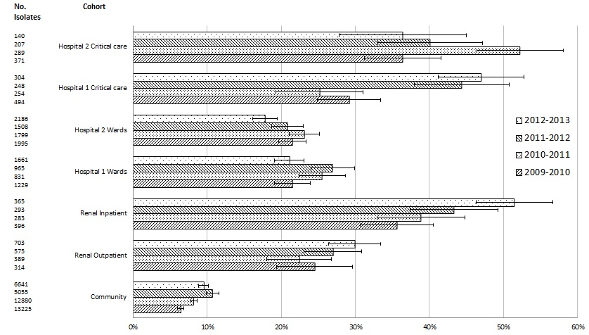
Figure 1b
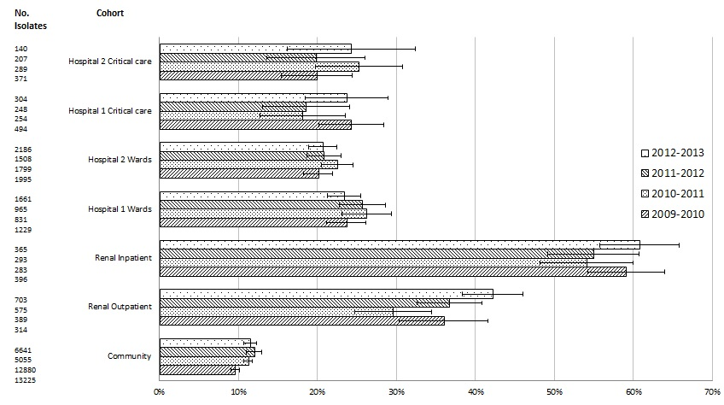
Figure 2a
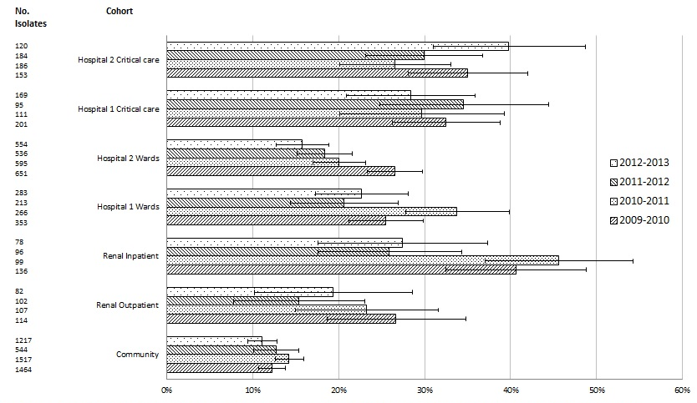
Figure 2b
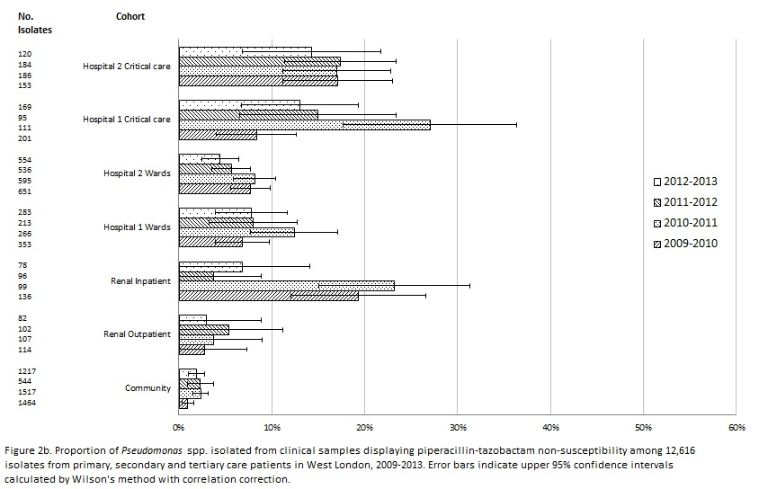
Figure 2c
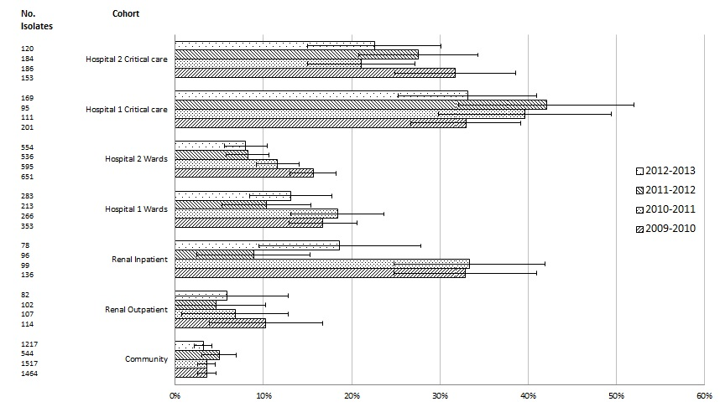
Figure 3a
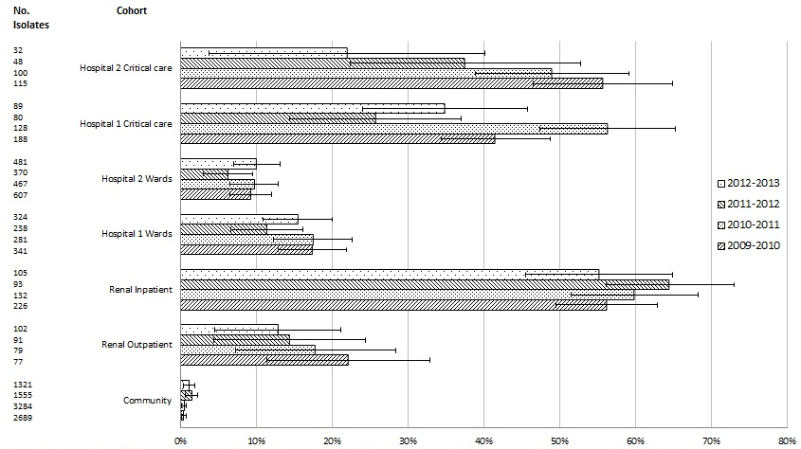
Figure 3b
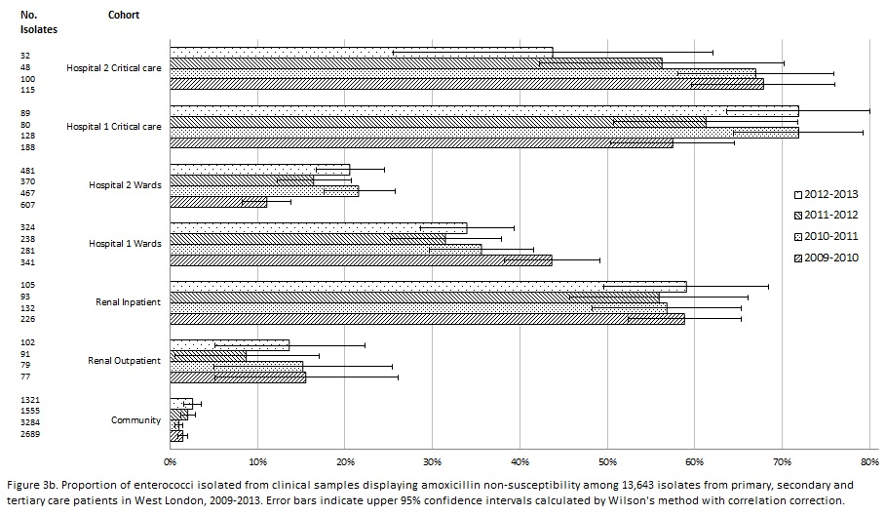
Figure 4
