“Beat Back the Hun!” How an act of ‘self’-construction was turned into an exemplary case of ‘othering’.

Andreas Musolff, University of East Anglia

To call Germans “Huns”, or collectively, “the Hun”, in Britain today counts as an offensive utterance, and the specific lexical item Hun in this meaning a “dysphemism” (as opposed to the better-known “euphemism”). In current usage, it only occasionally resurfaces in tongue-in-cheek statements, often related to football. In the run-up to the 2014 Football World Championship, for instance, John Grace in the Guardian weekend magazine gave a review of past performances of the England team, in which the 1990 semi-final match against West Germany was characterized as an event “in which the beastly Hun went ahead from a deflected free kick” (The Guardian magazine, 31 May 2014). During the 2010 World Championship, which took place in Germany, the Daily Star had run a title, "Ze Hun are big on fun!" (The Guardian: Greenslade Blog, 25 June 2010). The term Hun also features as a citation (and often as a good punning opportunity for headlines) in articles that discuss anti-German incidents and statements and relate them to lingering resentments from World Wars I and II. The last time that a British press organ used the name in (quasi-)earnest seems to have been in 1994 when the Sun trumpeted its own praise for supposedly having prevented the participation of a German Bundeswehr contingent in the British 50 year anniversary commemorations of the end of World War 2 that were planned for the following year: “The Sun bans the Hun. The Sun’s proud army of old soldiers and heroes last night forced John Major to ban German troops from marching through London” (The Sun, 24 March 1994).
What gives the Hun nickname such an enduring appeal as an anti-German invective, even if it is used mainly mockingly these days? Should it be regarded as a metaphor, given that its non-figurative reference to an ancient Asian people is transparent to most users?

1. Historical references
British dictionaries agree on the basic definition of Hun/Huns as referring to an ancient Asian people “who invaded Europe c. AD 357, and in the middle of the 5th c., under their famous king Attila (…) overran and ravaged a great part of this continent”. Since the early 19th century, its pejorative use for designating (and stigmatizing) any kind of “reckless or wilful destroyer of the beauties of nature or art: an uncultured devastator” is recorded; its specific (and extensionally exclusive) focus on Germans is exemplified in the first stanza of Rudyard Kipling’s poem “For All We have and Are”, published in The Times on 2 September 1914, i.e. barely one month ‘into’ the First World War:
For all we have and are,
For all our children’s fate,
Stand up and meet the war.
The Hun is at the gate!
Our world has passed away
In wantonness o’erthrown.
There is nothing left to-day
But steel and fire and stone.
Though all we knew depart,
The old commandments stand:
“In courage keep your heart,
In strength lift up your hand.”
Once more we hear the word
That sickened earth of old:
“No law except the sword
Unsheathed and uncontrolled,”
Once more it knits mankind,
Once more the nations go
To meet and break and bind
A crazed and driven foe.
Comfort, content, delight—
The ages’ slow-bought gain—
They shrivelled in a night,
Only ourselves remain
To face the naked days
In silent fortitude,
Through perils and dismays
Renewed and re-renewed.
Though all we made depart,
The old commandments stand:
“In patience keep your heart,
In strength lift up your hand.”
No easy hopes or lies
Shall bring us to our goal,
But iron sacrifice
Of body, will, and soul
There is but one task for all—
For each one life to give.
Who stands if freedom fall?
Who dies if England live?

The second main stanza with its reference to Once more highlights the historical parallel that Kipling lays between the Huns of ancient notoriety and the Germans of 1914 as a “crazed and driven foe” that started the war by invading and brutalizing a helpless neutral country, i.e. Belgium. This was not Kipling’s first usage of the Hun-German association; in 1902, he had warned against the British Empire leaguing “With the Goth and the Shameless Hun” in the poem The Rowers, occasioned by a German proposal that Britain should help in a threatening show of naval power against Venezuela.
The most famous (or, rather, infamous) connection between Germans and the ancient Huns, however, was made by none else than the Emperor of Germany, Wilhelm II, in 1900, when in Bremerhaven on 27 July 1900 he gave one of several farewell speeches to German troops that sailed to join the international (Western) expedition against the so-called “Boxer rebellion” in China. To the dismay of his own government, he extemporised and exhorted the soldiers to behave ‘like the Huns’ against the Chinese in order to win historic glory:
Kommt Ihr vor den Feind, so wird er geschlagen, Pardon wird nicht gegeben; Gefangene nicht gemacht. Wer Euch in die Hände fällt, sei in Eurer Hand. Wie vor tausend Jahren die Hunnen unter ihrem König Etzel sich einen Namen gemacht, der sie noch jetzt in der Überlieferung gewaltig erscheinen lässt, so möge der Name Deutschland in China in einer solchen Weise bekannt werden, dass niemals wieder ein Chinese es wagt, etwa einen Deutschen auch nur scheel anzusehen.

This passage, which John C.G. Röhl considers the most horrific of the Kaiser’s long list of diplomatic and other rhetorical gaffes, was excised from the “official” version of the speech authorised by the imperial government under the then Reichskanzler, Prince Chlodwig von Hohenlohe-Schillingsfürst, but saw publication in the Weser-Zeitung on 29 July 1900 and, translated, by The Times on the next day. The English translation read:
No quarter will be given, no prisoners will be taken; Let all who fall into your hands be at your mercy. Just as the Huns a thousand years ago under the leadership of Etzel gained a reputation in virtue of which they still live in historical tradition, so may the name of Germany become known in such a manner in China that no Chinaman will ever dare to look askance at a German.

Both the OED and Brewer’s Dictionary trace the origins of the ‘Hun-German’ association to this speech. Given the British attention to the Kaiser’s belligerent speeches, this connection is by no means implausible. Nor was such critical interest restricted to Britain; in the German parliament, the Social Democratic opposition attacked the government by citing letters of German soldiers serving in China who reported atrocities against the Chinese population. These letters were dubbed Hunnenbriefe (‘Hun letters’) in an obvious allusion to the ‘Hun speech’. The SPD leader, August Bebel, and other opposition members of the Reichstag referred to atrocities reported in the ‘Hun letters’ in parliament to denounce the German Empire’s part in the invasion, to which the War Minister, Heinrich von Goßler, responded in November 1900 by stating that “consequences such as those voiced by Mr. Bebel were completely impossible”; however, he conceded the possibility that “His Majesty’s speech might have been open to misunderstandings“, not least through establishing the reference to the “Huns”. This somewhat half-hearted defence of Wilhelm II’s speech is an indication of the government’s embarrassment and, when seen together with the criticism from the parliamentary opposition, provides evidence of a less-than-enthusiastic reception of the Hun-comparison even in parts of imperial Germany’s public.
Nonetheless, there can be little doubt that Wilhelm II himself intended the comparison to be a commendation and praise of his soldiers, not an order to commit atrocities. For him, the Hun-reference was based on a simplistic analogy: the Huns of late Antiquity were a warlike, brave and militarily successful people who were therefore famously remembered in history. The German expedition corps should show themselves equally warlike, brave and successful; this would likewise guarantee them a honourable mention in the history books (and scare off remaining potential enemies). Wilhelm’s vague knowledge of the historical record shows up in the use of the name Etzel for Attila, which is a literary name based on the “Etzel” figure of the medieval Nibelungenlied, not a historically documented designation of Attila. (Wilhelm II’s literary knowledge seems not to have been too precise either, as the Etzel of the Nibelungenlied is not shown as a heroic figure; rather, he is Kriemhild’s second husband – after Siegfried – at whose court all the remaining Nibelungs die in battle but Etzel takes no part in the fighting).

2. The World War 1 “Hun” stereotype
Compared with Wilhelm II’s one-dimensional Hun-German analogy based on an (assumed) terium comparationis of military prowess, its anti-German version in Kipling’s 1902 and 1914 poems, and a fortiori those of the Allied war propaganda 1914-1918, painted a much more colourful picture of barbaric brutality and depravity, as illustrated also by British and US American war posters. In these posters – for a small selection, see appendix –, the Hun featured as the absolute ‘Other’ of Western/Christian Civilisation, i.e. as a destroyer of homes and families, a rapist and murderer with blood-stained hands, with further accessories such as the “Pickelhaube” helmet, blood-dripping sword or bayonet, a plump, burly figure and a grimacing face and even as a “King Kong”-like ape monster, wielding “Kultur” as a club, ready to commit more atrocities. These depictions appeal implicitly, and in conjunction with the respective short texts explicitly, to the onlooker to do everything in his or her power to stop “the Hun” in his tracks, i.e. to join the Allied armies or to support them by buying war bonds. Most of these posters are from the last two years of the war, by which time Allied propaganda had amassed a bulk of more or less factual evidence of German war crimes, especially in occupied Belgium, including the British government-commissioned “Report on Alleged German Outrages” of 1915, which documented reports of civilian executions, rapes and the destruction of cultural monuments. Media reporting across the British Empire and the USA went much further, to the point of inventing stories of mass rapes (figuratively summarized in the form of the Rape of Belgium personification), of German soldiers impaling Belgian babies, and of the German high command ordering the erection of corpse factories. However, on the basis of Kipling’s 1902 and 1914 poems, we can assume that even without the evidence of German war crimes and its propagandistic exploitation, the main features of barbaric ferociousness and belligerence (see Kipling’s “A crazed and driven foe”) must have been in the British public domain before World War I: the factual and alleged war crimes served as corroborating evidence, not as the basis for the (German as )Hun dysphemism.
To say that this version of the German as Hun link was different from or even opposed to that intended by the Kaiser in 1900 would be an understatement. His boast about German troops’ military prowess equalling that of the ancient Huns was a hyperbolic comparison (see the “Wie…. so …”/“Just as….” construction) based on a vague historical/literary allusion. As the embarrassed and sarcastic reactions in Germany demonstrated, it was seen as grotesquely inappropriate in its political context (of a military response by supposedly ‘civilised’ powers against terrorist violence in a country that was considered by them as backward), so that it quickly fell victim to ironical deconstruction and critical reinterpretation. By contrast, the WW1 German as Hun stereotype was part of a figurative conceptual scenario that amalgamated alleged characteristics of the historical Huns and applied them collectively to the contemporary German Empire that had gone to war against most other European states. In order to understand its impact fully, we need to consider briefly structural and functional features of such scenarios.
In categorisation theory, the category of “scenario” forms a sub-type of conceptual “frames” or “schemas”. It consists of a set of assumptions (made by competent members of a given discourse community) about the prototypical elements of a particular domain of knowledge and experience – i.e. its participants, ‘dramatic’ story lines and default outcomes – as well as ethical evaluations of these elements, which may also be connected to specific attitudes and emotional stances. The war-as-rape narrative, which figured in the “Rape of Belgium” story in World War I, is a frequently employed metaphorical scenario that has been used for conceptualising other wars, e.g., the “Rape of Kuwait” (by Iraq under Saddam Hussein) in 1991, which led to the US-led “Gulf-War”. Within the war as rape scenario, the Hun-figure is the epitome of the merciless aggressor-enemy whom the hero-rescuer figure has to vanquish to save the victim. The moral evaluation and action appeal implied by the scenario are not at all hard to infer; on the contrary, they appear as self-evident and ‘natural’ to the receiving public.

3. The Hun stereotype and collective “Face”
The personification of the German nation as the Hun in the war as rape scenario makes this dysphemistic categorisation accessible for inferences regarding its ‘personal’ qualities. We have mentioned above his standard pictorial attributes, which feature Pickelhaube, a brutal facial grimace, blood-dripping or –besmirched hands and weapons etc. They amount to a figure that can only be viewed as repelling, disgusting and vicious. It is the epitome of a “negative face” in the sense of socio-psychological “Face theory”, pioneered in the USA by Erving Goffman and adapted in linguistic and intercultural (im-)politeness theories over the past six decades. In this analysis, we rely on Scollon and Scollon’s notion of Face as a discursively constructed communicative identity that is constitutive for social relationships such as deference, hierarchy and solidarity in culture-specific ways. Communicative Face is not static but (re-)established and negotiated in every communicative encounter, and it creates expectations and obligations concerning future behaviour that are, crucially, shared (or assumed to be shared) by the community of (discursive) practice. Losing, maintaining, saving, or ‘giving’ face are thus not just inter-individual actions, but refer to social systems of norms and values, which vary across cultures and motivate different “Face systems”. These differences can lead to misunderstandings in intercultural encounters where the participants are insufficiently aware of their respective culture-specific expectations. The two versions of the Germans as Huns scenario evidently invoke diametrically opposed collective Faces of the German nation, which are based on equally opposed values attached to the Hun-reference. While it would be perhaps exaggerated to speak of an “intercultural misunderstanding” – insofar as Wilhelm II’s speech was not misunderstood but rather reinterpreted – the face-theoretical approach may help to analyse in more detail ‘what went wrong’ with the initially intended moral-boosting speech.
Communicative Face theory was developed initially for the purpose of studying intercultural face-to-face encounters and their potential for miscommunications. To speak of the Face of a collective “Self”, such as a nation state, is a metaphorical application of the concept of Face and social identity, which treats collectives as if they were individual characters or subjective agents and therefore can also have their own social Selves. Such personalisation is endemic in colloquial parlance when we speak of nations as ‘thinking’, ‘speaking’, ‘deciding’, and ‘acting’, e.g. in statements of the type ‘Germany declared war against/went to war with nation X in 1914’. Although this shorthand type of referring to a nation as a quasi-person is by no means ideologically neutral (as it presupposes the existence of something like ‘national identities’ or ‘characters’), it is universally applicable and is hardly noticed as a figurative conceptualisation in everyday discourse and in the media. However, when a personalised perspective on a specific nation is reinforced to form a stereotype that is loaded with strong emotional and evaluative aspects and roles in specific scenarios, as in the case of the Germans as Huns metaphor in the Rape of Belgium-story, we are dealing with a collective “Self”, whose role may be viewed in terms of its public Face vis-à-vis the community of all other nation-“Selves” (for whom it is a more or less friendly “Other”). Within the (world-) “Family of Nations” as assumed by Allied propaganda, Germany’s public Face was turned into that of the Hun as the aggressor and perpetrator of crimes, a “crazed and driven foe” who had to be brought to heel, i.e. its social identity as a responsible, civilized and internationally acceptable nation-“Self” had been completely destroyed.
What is particularly remarkable about the Germany as Hun metaphor is the extreme, close to ‘180 degrees’ reversal of its pragmatic implications when compared with its ‘original’ use by Wilhelm II. Even if we take into account its near-instantaneous criticism and dismissal even within Germany, there can be no doubt that it was meant and understood as an attempt at Face-enhancing “Self”-praise: the Kaiser exhorting ‘his’ soldiers to establish a praiseworthy reputation of Germany as a proud warrior-nation that is afraid of nobody else (and that others should be afraid of, viz. the Chinese who would not dare to look askance at any German). By contrast, the WW1 Hun stereotype retained from Wilhelm II’s analogy only the aspect of the warrior-nation but reactivates another feature associated with the historic Huns, i.e. barbaric ferocity, and re-contextualized it within the war as rape scenario, which determined its maximally negative ethical and political evaluation. The vaguely positive Hun-“Self” of Wilhelm II’s speech was reshaped into an abhorrent “Other”-stereotype that elicited revulsion and calls to action, such as Kipling’s, to join in vanquishing an adversary whose atrocities could not be tolerated under any circumstance.

4. Conclusions
Compared with its use during WW1, the Hun-stereotype as occasionally employed in British media today may appear harmless and thoroughly historicized. In present-day remembrance events for World War 1 that commemorate German war atrocities such as hostage executions and the destruction of Louvain/Leuven, the German as Hun metaphor, as part of the Rape of Belgium scenario, is commonly put into the context of allied atrocity propaganda and thus relativized. Besides its use in war commemorations, the Hun reference occurs in tongue-in-cheek references to non-military British-German ‘confrontations’ (see introductory examples) as an historical allusion, i.e. not as a topically relevant designation of the German nation. Needless to say, there are also no state officials of today’s Federal Republic of Germany who exhort their troops to behave with ‘Hunnish’ ferocity when joining topical international military missions, such as in Afghanistan, or Iraq. Thus, the Hun epithet has developed from a ‘live’ metaphor into a historical allusion, which, even if were employed in earnest, would primarily mark out its user as harking back to WW1 (and II) propaganda jargon.
What seems to be less well remembered than the metaphor itself is the fact that the negative British Hun-stereotype was the product of a radical reinterpretation of a preceding usage by a national leader who used it to praise his soldiers. The resulting characterisation of Germans as being typically militaristic, merciless and (neo-)barbarian was, however, more than a mere reversal of the initially intended historical analogy. The reference to the Huns of Antiquity played only a marginal, if any, role in the British post-1914 uses; instead, the Germans as Hun stereotype acquired its own iconography and narrative-evaluative logic in the context of the war as rape scenario, as part of which it undermined any post-1914 recognition of imperial Germany as an ‘honourable’ enemy and destroyed its collective Face. It developed sufficient plausibility to legitimize the British and Allied war effort and the subsequent punishment of Germany. As such, it went beyond ‘othering’ Germany in the sense of depicting it as an “outgroup” that is different from and opposed to the own side (i.e. here, the Allied “Self”). Not only were Germans-as-Huns viewed collectively as another nation that, politically and militarily, had become an enemy but they were conceived of an existential opponent whose further activities had to be stopped at all cost. The dysphemism was more than an “insult” in the sense of (im-)politeness theory, i.e. as an act of threatening Germany’s public Face. Rather, it achieved a moral stigmatization effect, due to its implicit embedding in the rape of Belgium scenario, which invoked a strong and lasting ethical condemnation. The Face of the German Other was not only threatened or damaged but destroyed to an extent which would only be surpassed by the effect of revelations about the Holocaust in and after World War 2. The monster-depiction of the Hun as King Kong-like fiend in one of the War propaganda posters (see appendix item 3) is an apt rendition of this massive Face-destruction. The Pickelhaube-helmeted German Hun-ape is the unpalatable, extreme Other of any human civilised Self – be it individual or collective. Historians of propaganda have linked the persistence of the Hun-stereotype and the Rape of Belgium scenario to the harsh treatment of defeated Germany in the Versailles Peace treaty, which had to be ‘sold’ to the public in the Allied public as a “just” punishment, and to the mistrust and cynicism in British and US public about atrocity propaganda following post-war revelations about its exaggerations and misrepresentations, which later led to disbelieving attitudes concerning atrocity reports from Nazi Germany. These medium-/long-term consequences of national ‘Othering’ were, of course, historically graver than the almost grotesque circumstances of its emergence from a reinterpreted sabre-rattling boast by a monarch who tried to compensate verbally for the perceived second-rank status of his country in the “Age of empire”. The strange origins of the Hun stereotype in an act of nationalist “Self”-praise that backfired and was turned into the basis for a devastating hostile stereotyping, however, can serve as model case of collective inter-national/cultural Face work that illustrates the dangers of using metaphorical analogies and scenarios without taking their inherent dialectic potential – the possibility of reversing their ideological bias – into consideration.

Appendix
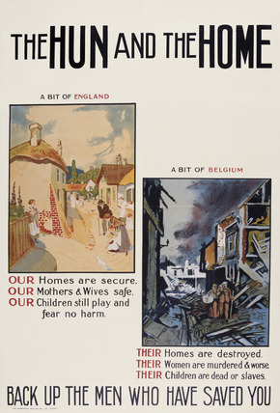
1. The Hun and the Home (Britain, 1918)

2. God bless dear Daddy who is fighting the Hun (Australia 1918).
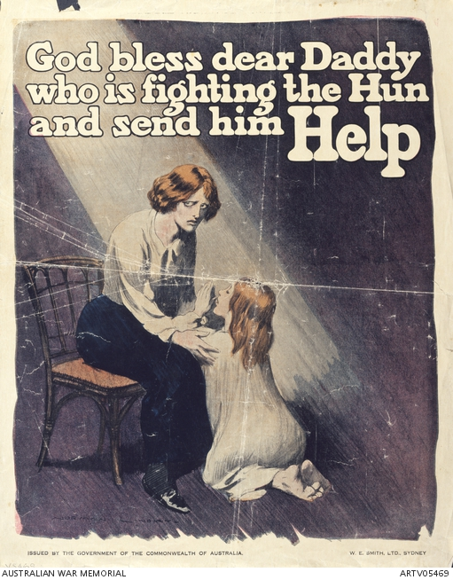

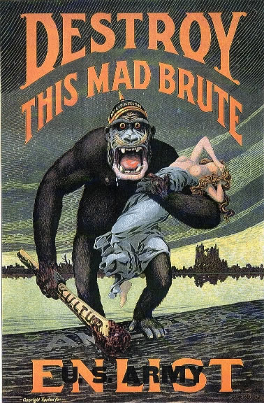
3. Destroy this mad brute (US 1917/18)

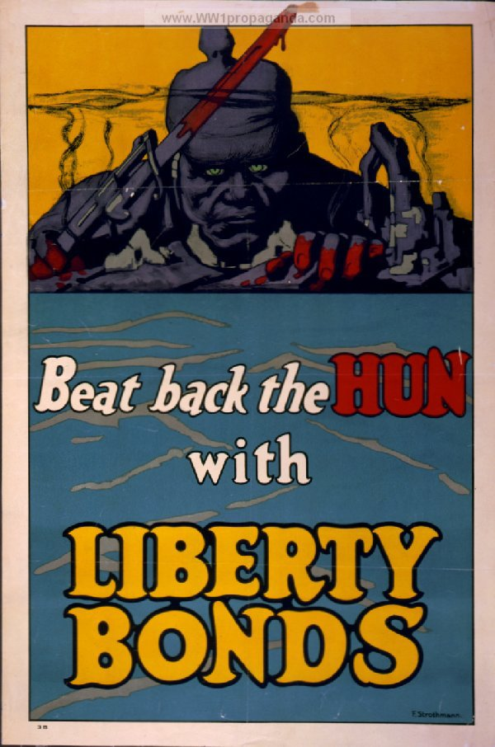
4. Beat back the Hun (US, 1918)

See Penelope Brown and Stephen C. Levinson, Politeness: Some Universals in Language Usage. Cambridge: Cambridge University Press, 1987; Jonathan Culpeper, Impoliteness: Using Language to Cause Offence. Cambridge: Cambridge University Press, 2011, 24-31.
See Keith Allan and Kate Burridge, Euphemism and Dysphemism. Language Used as Shield and Weapon. Oxford: Oxford University Press, 1991, 31-32.
E.g. Daily Mail 22 July 2011: “As it is revealed half of Britons have German blood... Time to embrace your inner Jerry!”; The Observer 28 November 2004: “Stop making fun of the Hun”; New Statesman, 21 June 1996: “We’re far too horrid to the Hun”.
Oxford English Dictionary on historical Principles, 2n ed., eds. J. A. Simpson and E. S. C. Weiner. Oxford: Clarendon Press, 1989, vol. VII, 489; similarly Brewer’s Dictionary of Phrase and Fable. Ed. Adrian Room. (13th, “Millennium” edition) London: Cassell 1999, 596. Encarta World English Dictionary, Ed.-in-Chief Kathy Rooney. London: Bloomsbury, 1999, 918.
Oxford English Dictionary on historical Principles, 1989, vol. VII, 489.
Rudyard Kipling, The Works of Rudyard Kipling. Ware: Wordsworth 1994, 341-342; italicisation by AM. For its historical and biographical context see A. Michael Matin, “’The Hun is at the Gate!’: Historicizing Kipling’s Militaristic Rhetoric, From the Imperial Periphery to the National Center – Part 2, The French, Russian and German Threats to Great Britain”, in Studies in the Novel 31/4 (1999), 432-470.
Rudyard Kipling, The Works of Rudyard Kipling 1994, 341-342.
See Bernhard Fürst v. Bülow [the Reich’s Foreign Secretary at the time of the speech, later in 1900 to become Chancellor], Denkwürdigkeiten, ed. F. v. Stockhammer, vol. 1, Berlin: Ullstein 1930, 359-360; Giles MacDonogh, The last Kaiser. William the Impetuous. London: Weidenfeld & Nicolson, 2000, 244-245.
For the versions of text of the speech and their editorial history comp. Axel Matthes (ed.), Reden Kaiser Wilhelms II. München: Rogner & Bernhard, 1976, 85-88, Michael Behnen (ed.) (1977). Quellen zur deutschen Außenpolitik im Zeitalter des Imperialismus 1890-1911. Darmstadt: Wissenschaftliche Buchgesellschaft, 244-247, and Bernd Sösemann, “Die sog. Hunnenrede Kaiser Wilhelms II. Textkritische und interpretatorische Bemerkungen zur Ansprache des Kaisers in Bremerhaven vom 27. Juli 1900”, in Historische Zeitschrift, 222 (1976), 342-358.
John C.G. Röhl, Kaiser, Hof und Staat: Wilhelm II. und die deutsche Politik. Munich: Beck 1988, 21.
Oxford English Dictionary on historical Principles, 1989, vol. VII, 489.
Oxford English Dictionary on historical Principles, 1989, vol. VII, 489; Brewer’s Dictionary of Phrase and Fable 1999, 596; similarly, Geoffrey I. Hughes, (2006). An encyclopedia of swearing: the social history of oaths, profanity, foul language, and ethnic slurs in the English-speaking world. New York: M.E. Sharpe, 243-244; John Ayto, Movers and Shakers: A Chronology of Words that Shaped Our Age. Oxford: Oxford University Press 2006, 43.
See Michael Stürmer, Das ruhelose Reich. Deutschland 1866-1918. Berlin: Siedler, 1994, 291, 338-340; Dominik Geppert, Pressekriege. Öffentlichkeit und Diplomatie in den deutsch-britischen Beziehungen (1896-1912). Munich: Oldenbourg, 2007, 159-167; Christopher Clark. The Sleepwalkers: How Europe went to War in 1914. London: Allen Lane, 2012, 235; Michael Balfour, The Kaiser and his Times. London: The Cresset Press, 1964, 226-227.
For the German original see Otto Ladendorf, Historisches Schlagwörterbuch. Straßburg: Trübner 1906 (http://www.textlog.de/schlagworte-hunnenbriefe.html, accessed 29 August 2014); translation into English: AM.
For those parts of the German public who favoured expansionist colonialism as part of imperial “Weltpolitik”, on the other hand, the Kaiser’ speech would have chimed perfectly with their “Self”-stereotypes of a nation that needed not only to catch up with other European Powers in the “race” for colonies but had a mission to surpass and even take over the role of chief-coloniser and -civiliser on other continents (see Felicity Rash, German Images of the Self and the Other. Nationalist, Colonialist and Anti-Semitic Discourse, 1871-1918. Basingstoke: Palgrave-Macmillan, 2012).
See Martin Wengeler, „Von den kaiserlichen ‚Hunnen’ bis zu Schröders ‚uneingeschränkter Solidarität’. Argumentative und lexikalische Kontinuitäten in deutschen “Kriegsbotschaften” seit 1900“, in Brisante Semantik, Neuere Konzepte und Forschungsergebnisse einer kulturwissenschaftlichen Linguistik. eds. Dietrich Busse, Thomas Niehr and Martin Wengeler, Tübingen: Niemeyer, 2005, 209-232, here 226.
Besides texts and pictorial depictions, the Hun-stereotype also ‘featured’ in the then still young medium of film, viz. Hollywood productions such as The Hun Within, The Kaiser, the Beast of Berlin and The Claws of the Hun, all from 1918 (see Taylor, Munitions of the Mind, 186).
James Bryce, Viscount (1915). Report of the Committee on Alleged German Outrages. London: HMSO. For its commissioning and its impact see Trevor Wilson, “Lord Bryce’s Investigation into Alleged German Atrocities in Belgium, 1914-15”, in Journal of Contemporary History, 14/3 (1979), 369-383, and Gary S. Messinger, British Propaganda and the State in the First World War. Manchester: Manchester University Press, 70-84.
See Larry Zuckerman, The Rape of Belgium. The Untold Story of World War I. New York: New York University Press 2004; Messinger, British Propaganda and the State in the First World War; Schneider, Thomas F. and Hans Wagener (eds.), "Huns" vs. "Corned beef": representations of the other in American and German literature and film on World War I. Göttingen: V&R unipress 2007; Joachim Neander and Randal Marlin, “Media and Propaganda: The Northcliffe Press and the Corpse Factory Story of World War I”, in Global Media Journal (Canadian Edition) 3/2 (2010), 67-82; Nicholas John Cull, David Holbrook Culbert and David Welch, Propaganda and Mass Persuasion. A Historical Encyclopedia 1500 to the Present. Santa Barbara, CA: ABC-Clio, 2001, 25. Philip M. Taylor, Munitions of the Mind. A history of propaganda from the ancient world to the present day. Manchester: Manchester University Press 2003, 178-180.
See Peter Fleming, Die Belagerung zu Peking. Zur Geschichte des Boxer-Aufstandes. Frankfurt: Eichborn, 1997; Holger Hufer, Deutsche Kolonialpolitik in der Ära des Wilhelminismus: Asien und der Boxeraufstand. München: GRIN-Verlag, 2003; Mechthild Leutner and Klaus Mühlhahn (eds.), Kolonialkrieg in China. Die Niederschlagung der Boxerbewegung 1900-1901. Berlin: Ch. Links Verlag, 2007.
For cognitive categorization theory see Charles J. Fillmore, “An alternative to checklist theories of Meaning”, in: Proceedings of the Berkeley Linguistics Society, 1 (1975), 123-131; George Lakoff, Women, Fire, and Dangerous Things: What Categories Reveal about the Mind. Chicago: University of Chicago Press, 1987; John R. Taylor, Linguistic Categorization, Oxford: Oxford University Press, 1995; Gilles Fauconnier and Mark Turner, The Way We Think: Conceptual Blending and the Mind's Hidden Complexities. New York: Basic Books, 2002.
Andreas Musolff, “Metaphor Scenarios in Public Discourse”, in Metaphor and Symbol, 21/1 (2006): 23-38.
For use of the rape metaphor in the Gulf war of 1991 see George Lakoff, “Metaphor and War: The metaphor system used to justify war in the Gulf”, in ed. Martin Pütz, Thirty Years of Linguistic Evolution: Studies in Honour of René Dirven. Amsterdam: Benjamins, 1992, 463-481.
See Erving Goffman, “On Face Work: An analysis of ritual elements in social interaction”, in Psychiatry 18 (1955): 213-231, Brown and Stephen C. Levinson, Politeness: Some Universals in Language Usage; Richard J. Watts, Sachiko Ide and Konrad Ehlich (eds.), Politeness in Language. Studies in its History, Theory and Practice. Berlin/New York: de Gruyter, 2005.
Ronald Scollon, Suzanne Wong Scollon, and Rodney H. Jones, Intercultural Communication: A Discourse Approach. Third revised ed. Oxford: Wiley-Blackwell, 2012, 46-55.
Scollon, Scollon and Jones, Intercultural Communication: A Discourse Approach, 56-67.
The use of a nation state’s name for the whole of its population and its treatment as a collective person can be seen as a metonymy and/or a metaphor: in the first sense as a whole-for-part reference (e.g. nation-for-government) or as a metaphor (nation-as-person). For a critical discussion of the figurative interpretation see Piotr Twardzisz, The Language of Interstate Relations. In Search of Personification, Basingstoke: Palgrave-Macmillan, 152-172.
See for instance the British Library’s “Theme area” for World War I (http://www.bl.uk/world-war-one/themes, accessed 7 September 2014), and commemorative articles such as “The city that turned Germans into 'Huns' marks 100 years since it was set ablaze” (The Daily Telegraph 25 August 2014).
Only 1 out of over 100 British commemoration articles assembled in a research corpus (see Musolff forthcoming, “The afterlife of an infamous gaffe: Wilhelm II’s 1900 Hun comparison and the Hun metaphor for Germans during World War 1 in British and German popular memory”. Pragmatics and Society 2015) draws attention to the connection between Wilhelm II’s speech and the British use in WW1 (The Daily Telegraph, 25 August 2014: “Here comes the Hun: how First World War cemented a popular term for Germans”).
Scollon, Scollon and Jones, Intercultural Communication: A Discourse Approach, 276.
In Carl Schmitt’s terminology of sovereignty theory, this would make them a Feind, rather than a mere Gegner, a foe rather than an enemy; see Carl Schmitt, Der Begriff des Politischen. Berlin: Duncker & Humblot [1927/1932] 2002, 18-19, 104-107, 124.
Culpeper, Impoliteness, 135, 143.
The “stigma” category refers to Goffman’s notion of “stigma” as part of his relational and dialectic concept of Face theory, see Erving Goffman, Stigma. Notes on the Management of Spoiled Identity. London: Penguin 1990, especially 13-15, 161.
Taylor, Munitions of the Mind, 195-197.
Eric Hobsbawm, The Age of Empire 1870-1914. London: Abacus 1995.
'The Hun and the Home', 1918 (c), © National Army Museum Copyright (http://prints.national-army-museum.ac.uk/image/443663/david-wilson-the-hun-and-the-home-1918-c_, accessed 29 August 2014.
http://www.awm.gov.au/collection/ARTV05469/, accessed 29 August 2014.
http://www.dhm.de/lemo/objekte/pict/pl003967/index.html, accessed 29 August 2014.
www.WW1propaganda.com, accessed 29 August 2014.

