ASSOCIATED CONTENT
A Decaheme Cytochrome as a Molecular Electron Conduit in Dye-Sensitized Photoanodes
Ee Taek Hwang,†,‡ Khizar Sheikh,†,‡ Katherine L. Orchard,^{§, ǁ} Daisuke Hojo,^{*,ǁ} Valentin Radu,†,‡ Chong-Yong Lee,§ Emma Ainsworth,± Colin Lockwood, ± Manuela A. Gross,§ Tadafumi Adschiri,^{ǁ} Erwin Reisner,*,§ Julea N. Butt,*,± and Lars J. C. Jeuken*,†,‡
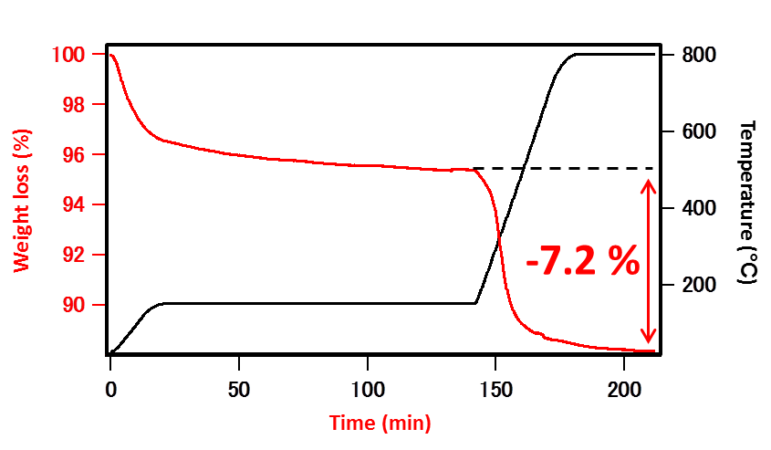
Figure S1. Thermogravimetric analysis (TGA) of DHBA-TiO₂ nanoparticles.

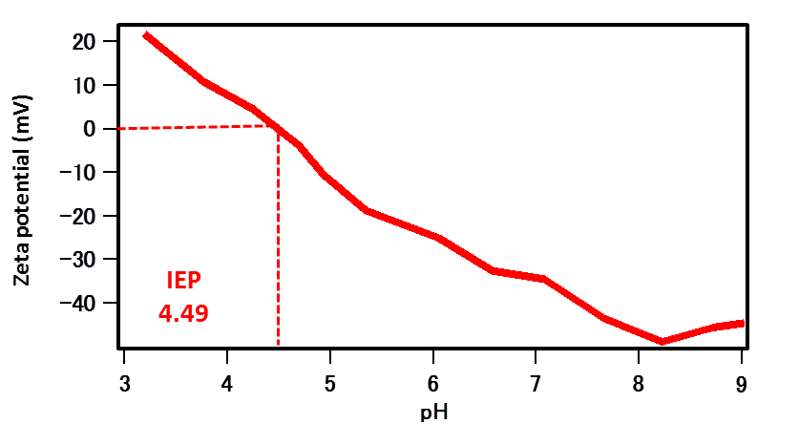
Figure S2. Zeta potential of DHBA-TiO₂ as a function of pH. The isoelectric point (IEP) is highlighted.

(A)
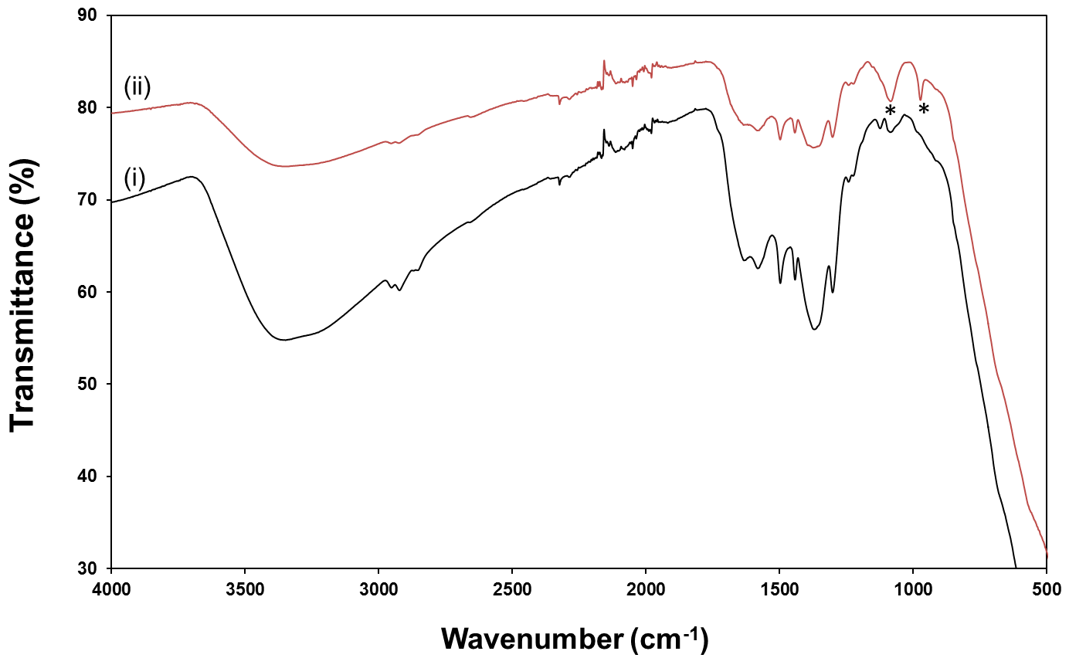
(B)
Figure S3. Fourier-transform infrared (FT-IR) spectra of (A) (i) DHBA-TiO₂ nanocrystal and (ii) RuP-DHBA-TiO₂ and (B) RuP; Peaks marked with “*” correspond to the phosphonate groups of RuP.

(A)
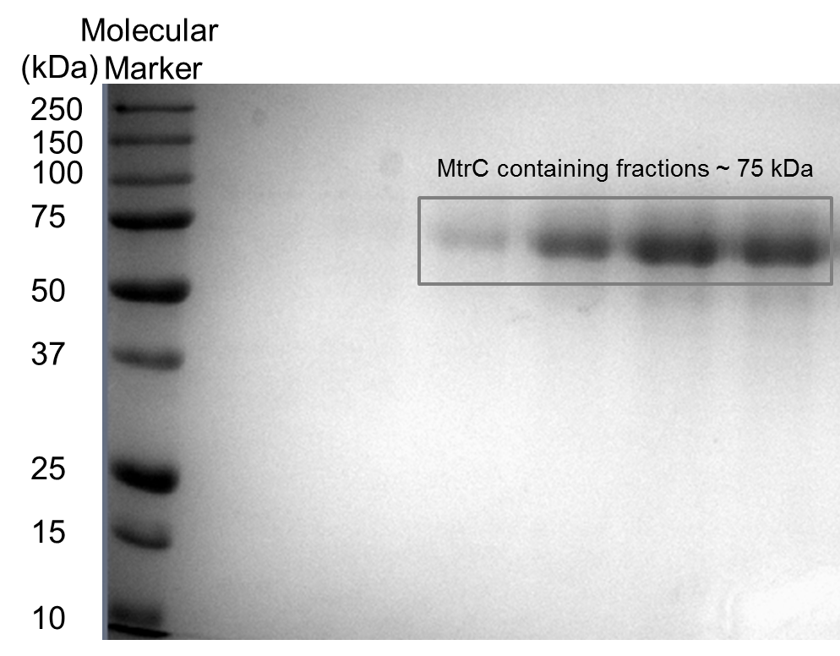
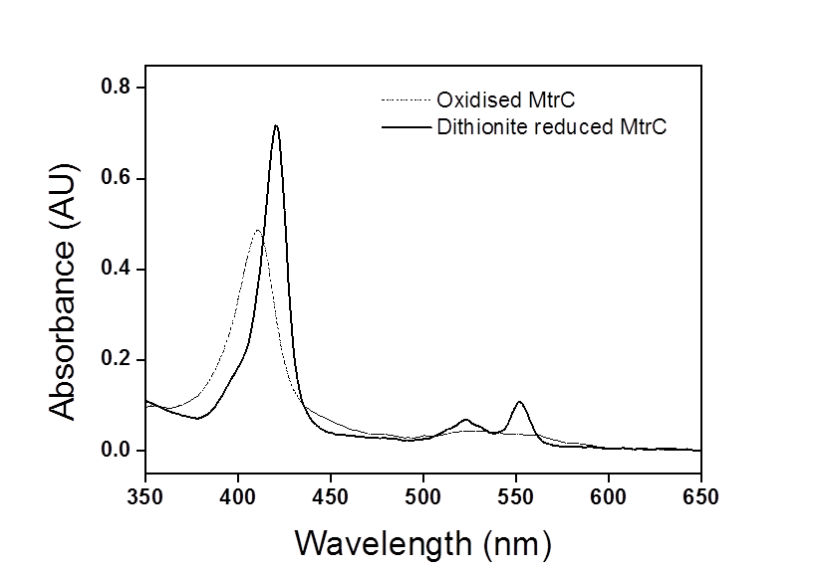
(B)

Figure S4. Characterization of MtrC protein (A) SDS/PAGE analysis. The proteins were resolved by 12% (wt/vol) SDS/PAGE and stained with Coomassie blue (B) Electronic absorbance spectra of MtrC, Oxidized (dash line) and sodium dithionite reduced (solid line).
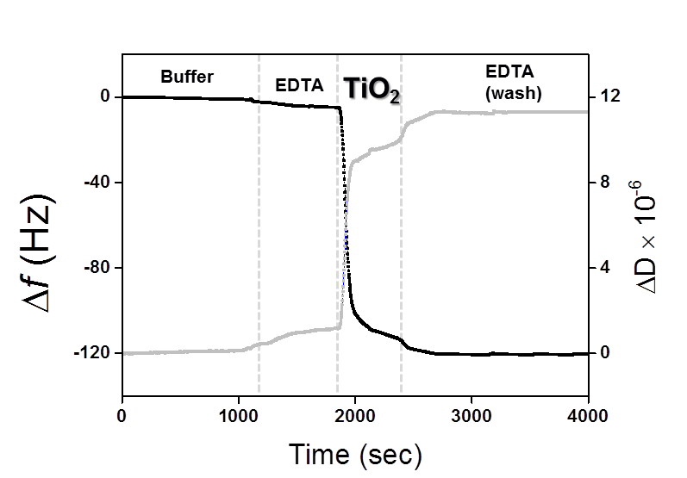
(A)

(B)
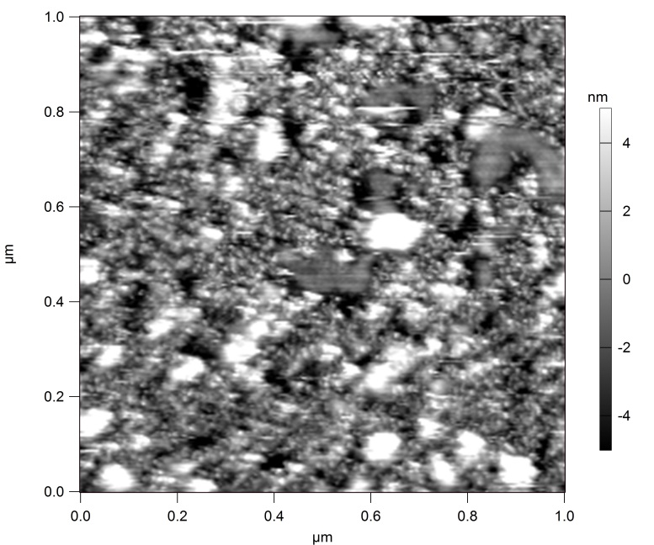
0.2 µm

Figure S5. Characterizations of RuP-TiO₂ nanocrystals on SAM-modified gold surfaces (A) QCM-D results in buffer (20 mM MOPS, 30 mM Na₂SO₄ at pH 7.4) with frequency (black line, left axis) and dissipation (grey line, right axis) against time. To measure absorbed nanocrystals on electrode, RuP-TiO₂ nanocrystals (0.2 mg/mL) was applied to QCM-D crystals. RuP-TiO₂ nanocrystal binding was performed in buffer (25 mM EDTA at pH 7.4). The plots shown are representative of triplicate experiments. (B) AFM height images of RuP-TiO₂ nanocrystals on the SAM-modified gold electrode, and the image is 1 μm × 1 μm and is displayed on a 10 nm z-scale. All gold surfaces used in this study are modified with 8-OH/8-NH₃⁺ (80/20).
Figure S6: Measured photocurrent of TiO₂/MtrC conduit system onto SAM-modified gold electrode at 0.4 V vs SHE as a function of the light intensity. Black and red data points are from independent experiments. The line is a linear fit to all data.
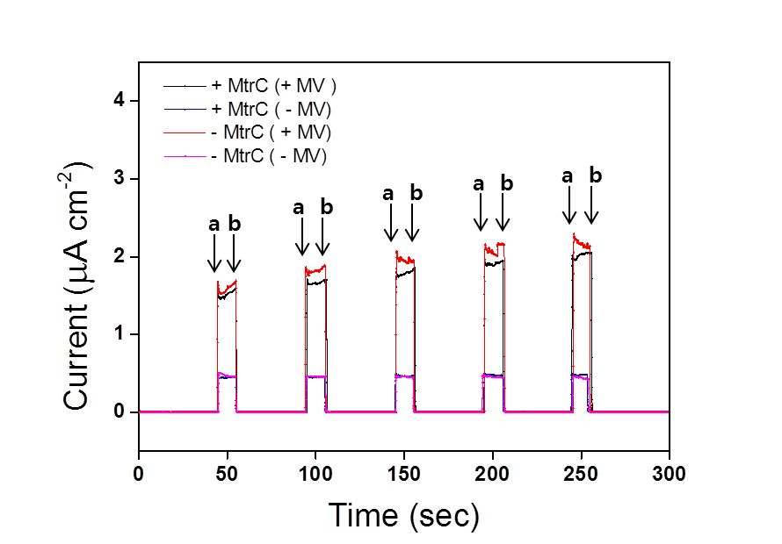
Figure S7. Measured photocurrent of TiO₂/MtrC conduit system and TiO₂ only system onto SAM-modified gold electrode at 0.4 V vs SHE. The photocurrent was measured at 20 °C in 20 mM EDTA, pH 7.4, either in the absence and presence of 1 mM methyl viologen (MV²⁺). The switch “ON” (illumination on)-marked (a); switch “OFF”-marked (b)

