Online Appendix for:

The impact of climate change on agriculture:
nonlinear effects and aggregation bias in Ricardian models of farmland values

Carlo Fezzi
Ian Bateman

The Additive Mixed Model (AMM) estimation

This Appendix provides details regarding the estimation of the semi-parametric model.

We represent the smooth functions in equation (6) as splines, i.e. linear combination of basis functions of the regressors (e.g. Ruppert, Wand and Carroll, 2003; Wood, 2006a,b; Keele, 2009). For example, considering one of the non-climatic factors g_{x} and indicating the basis functions with b_{x,j}(g_{x}) (j=1,..,l_{x}), the corresponding smooth function can be written as:

(A1) $s_{x}(g_{x})=\sum_{j=1}^{J_{x}}{δ_{x,j}b_{x,j}(s_{x})}=δ_{x}^{'}b_{x}$

where δ_{x,j} (j = 1,...,J_{x}) are the parameters to be estimated and J_{x} is the number of basis functions which determines the maximum possible flexibility of the relation between g_{x} and V (the higher the value, the more non-linear or ‘wiggly’ is the estimated effect). Among the simplest basis functions are those corresponding to linear regression splines, which fit a piecewise linear function between a set of knots located between the range of values of the regressor. The number of knots determines the flexibility of the splines and the number of parameters to be estimated. In the linear case with r knots (κ_{1x},..., κ_{rx}) and suppressing the subscript x for simplicity, equation (A1) becomes:

(A2) $s(g)=δ_{0}+δ_{1}g+\sum_{j=1}^{r}{δ_{j+1}(g−κ_{j})_{+}}$ ,

where (g – κ_{j})₊ = max(0, g – κ_{j}) (note that, if there are multiple smooth functions, the constant is only identifiable by imposing a sum-to-zero constraint). While this type of spline is conceptually very intuitive, it can present sharp corners at the knots and therefore is too restrictive for many applications. In this paper we use natural cubic splines, which offer computational advantages when applied to large datasets (see Wood, 2006b). These type of splines fit third degree polynomial functions between each set of knot, with first and second derivatives constrained to be continuous in the entire range of g(.). Furthermore, in order to avoid erratic behavior at the extremes, the fit before the first knot and after the last one is constrained to be linear (i.e. first and second derivatives are set to zero). This results in the number of basis functions J_{x} being equal to the number of knots r.

The number of knots effectively determines the flexibility of the smooth function. Given a fixed number of knots, the model can be estimated as a standard regression, i.e. by Ordinary Least Squares (OLS) or Maximum Likelihood (ML). However, there is a trade-off between sufficient knots to accurately represent any unknown, non-linear relation and, at the same time, avoid the risk of overfitting. This is a common problem in semi-parametric approaches. A practical solution to this long-standing issue is penalized estimation (Ruppert, Wand and Carroll, 2003; Wood, 2006b). The idea here is to augment the likelihood by including a penalty for the excessive roughness (typically indicated with the term ‘wiggliness’) of the smooth functions, which can be expressed as a function of the integral of the square of its second derivative. The penalized likelihood corresponding to the smooth function in equation (A1) can then be written as:

(A3) $l_{p}(δ)=l(δ)+λ\int{s^{''}}(g)^{2}\text{dg}$,

where l(.) is the model likelihood, l_{p}(.) is the model penalized likelihood, δ is the vector of parameters to be estimated and λ is the smoothing parameter, which controls the weight given to the ‘wiggliness’ penalty. As λ increases so the function becomes smoother, with λ → ∞ corresponding to a straight line fit. In this framework, therefore, the flexibility of the smooth function is regulated by the value of the smoothing parameter λ rather than by the number and placement of the knots, which actually make little difference (see Keele, 2009, for some examples). Ruppert, Wand and Carroll (2003), for example, show that the degrees of freedom of a smoothing spline are just a mathematical transformation of λ.

Various techniques have been proposed to estimate the optimal amount of smoothing (i.e. the parameter λ) directly from the data (see Wood, 2006b, and Keele, 2009). In this paper we use ML estimation techniques representing the smoothing splines as random effects (Ruppert, Wand and Carroll, 2003). The random effect representation of the natural cubic spline corresponding to equation (A1) can be written as:

(A4) $s(g)=δ_{0}+δ_{1}g+\sum{φ_{j}}b_{j}(g)$ ,

where the b_{j}(g) are non-linear basis functions (whose definition is somewhat lengthy and given, for example, in Welham et al., 2007), δ₀ and δ₁ are the fixed effect (un-penalized) parameters and the φ_{j} are elements of a vector of random effects drawn from a N(0, σ_{φ}²H), where H depends on the penalties (A3). This approach models non-linearity as a form of heterogeneity across groups. The data within each set of knots form each group. The intuition behind this representation is that a linear fit (φ₁ = φ₂ = ... = φ_{r-2} = 0) would ignore these differences and capture the relationship with only two parameters, whereas an un-penalized likelihood (φ₁, φ₂, ..., φ_{r-2} estimated as fixed effect) would provide highly variable and "wiggly" estimates (in the extreme case, with a knot at each data point, it would perfectly interpolate the data). Between these two extremes, the random effect representation provides the optimal (i.e. best linear un-biased predictor; Speed, 1991) trade-off between excessive smoothing and overfitting of the non-linear function.

This specification can be estimated as a standard random effect model, i.e. by ML or Restricted Maximum Likelihood, (REML). By estimating each smoothing parameter λ as σ_{u}²/σ_{φ}², these techniques resolve the subtle task of determining the model flexibility a priori, by incorporating this choice into the actual estimation process. Another important feature of this method is that, if a non-linear relationship is not supported by the data, the corresponding smoothing parameter will automatically be estimated to have a high value, the resulting random effect will be close to zero and the smooth function will reduce to a standard linear form. Moreover, this approach can also be extended to bivariate functions, in order to flexibly capture any joint non-linear effects of two explanatory variables. In this paper we model the impact of rainfall and temperature on land value by using tensor products (Wood, 2006a), which have the important properties of being invariant to changes in the scale of the regressors and can, therefore, be used to smooth variables expressed in different units. Finally, since this estimation technique expresses smoothing splines as random effect terms, inference can be implemented within the standard framework for this class of models (Pinheiro and Bates, 2000; Ruppert, Wand and Carroll, 2003). For instance, model reduction can be implemented with likelihood ratio tests for hypotheses on the random effects and with F-tests for hypotheses on the fixed effects. However, as in standard random effect models, testing for the random effects will be only approximate since it involves setting the variance of certain components of the random effects to zero, which is on the boundary of the parameter region (Stram and Lee, 1994).

Flexible functional forms can be also estimated using alternative methods, such as piecewise linear functions or step functions. While these approaches typically suffer from high multicollinearity and require ad-hoc assumptions on the locations and the amount of steps or of linear function to be employed, they also provide very simple and intuitive estimates. For this reason they have been commonly used as benchmarks against which more refined models can be compared. Following Schlenker and Roberts (2009), in Figure A1 and Figure A2 we provide visual comparison of our AMM model against these two alternative specifications.

We specify the piecewise linear function of the joint impact of degree days and precipitation on land value using eleven coefficients, allowing the levels of both variables to jointly change their estimated marginal effects. Regarding the step function we employ an extremely flexible approach by allowing the steps to vary for each 100mm of rainfall and 100dayºC, yielding a total of 53 different coefficients. Figure A1 compares the estimated effect of precipitation according to these two alternative models against the AMM estimates. The piecewise linear functions approach yields estimates which are very close and statistically insignificant from those obtained using the AMM. The step function approach, while obviously being more flexible and, therefore, providing more erratic predictions, confirms the interaction effects between temperature and precipitation, with rainfall affecting negatively land values when temperatures are low and becoming a positive factor for higher temperatures. Figure A2 performs the same illustration for temperature for different levels of rainfall. Again, all three models provide very close estimates.

Figure A1: The effect of precipitation on the logarithm of farmland value for different levels of temperature
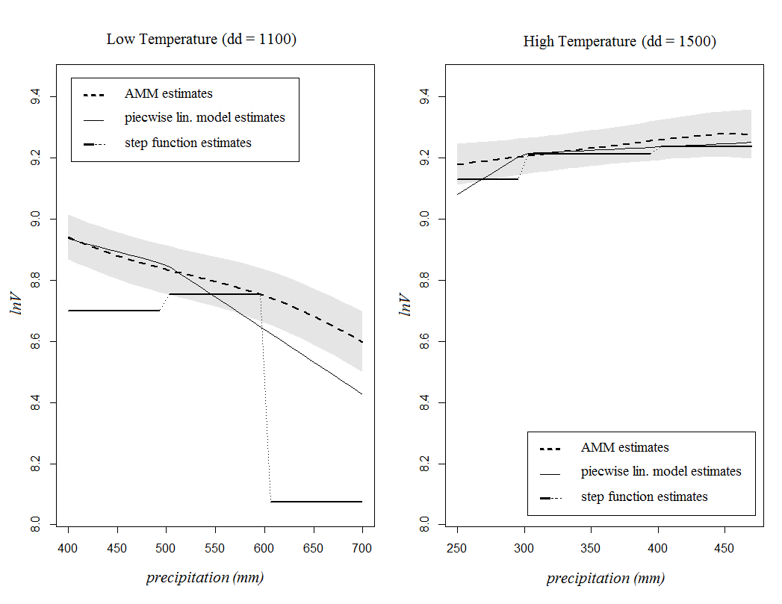
Left panel shows the estimated effect of precipitation when temperature is low (300mm in the growing season). Right panel shows the estimated effect of precipitation when temperature is high (500mm in the growing season). Gray shadowed area represents ± 1 standard error intervals according to the AMM.

Figure A2: The effect of temperature on the logarithm of farmland value for different levels of precipitation
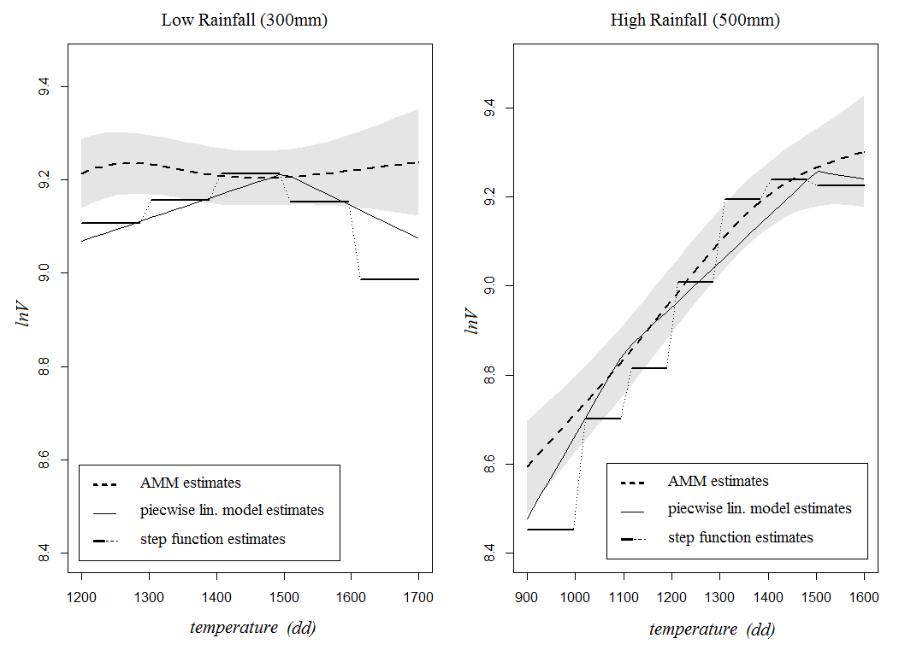
Left panel shows the estimated effect of precipitation when temperature is low (300mm in the growing season). Right panel shows the estimated effect of precipitation when temperature is high (500mm in the growing season). Gray shadowed area represents ± 1 standard error intervals according to the AMM.

References

Keele L. (2009) Semiparametric regression for the social sciences, Wiley and Sons, Chichester.

Pinheiro J.C., Bates D.M. (2000) Mixed effects models in S and S-plus, Springer, New York.

Ruppert D., Wand M.P., Carroll R.J. (2003) Semiparametric regression, Cambridge University Press, New York.

Schlenker W., Roberts M. (2009) Nonlinear Temperature Effects indicate Severe Damages to U.S. Crop Yields under Climate Change, Proceedings of the National Academy of Sciences, vol. 106, 2009, pp. 15594-15598.

Stram D. O., Lee, J. W. (1994) Variance components testing in the longitudinal mixed-effects models, Biometrics, vol. 50, pp. 1171–1177.

Speed T.P. (1991) Comment on: that BLUP is a good thing: the estimation of random effects (by G.K. Robinson), Statistical Science, vol. 6, pp. 42-44.

Welham S.J., Cullis B.R., Kenward M.G., Thompson R. (2007) A comparison of mixed model splines for curve fitting, Australian and New Zealand Journal of Statistics, vol. 49, pp. 1-23.

Wood, S.N. (2006a) Low rank scale invariant tensor product smooths for generalized additive mixed models, Biometrics, vol. 62, pp. 1025-1036.

Wood S.N. (2006b) Generalized additive models: an introduction with R, Chapman and Hall, New York.

Several other types of bases have been proposed in the literature. Rupper, Wand and Carroll (2003) and Wood (2006b) provide a comprehensive illustration. Welham et al. (2007) demonstrate the links existing among the most commonly used bases and undertake a simulation study from which no clear winner emerges.

