Excited State Structural Dynamics in Higher Lying Electronic States: S₂ State of Malachite Green
Sergei Laptenok, Kiri Addison, Ismael A. Heisler and Stephen R. Meech*
School of Chemistry, University of East Anglia, Norwich Research Park, Norwich NR4 7TJ, UK

Abstract
The S₂ fluorescence of malachite green is measured with sub 100 fs time resolution. Ultrafast spectral dynamics in the S₂ state preceding S₂ decay are resolved. Measurements in different solvents show that these sub 100 fs dynamics are insensitive to medium polarity and viscosity. They are thus assigned to ultrafast structural evolution between the S₂ Franck-Condon and equilibrium configurations.

*Author to whom correspondence should be addressed (s.meech@uea.ac.uk)

Introduction
Kasha’s rule concerns the propensity of molecules to emit from the lowest excited state of a given multiplicity.[1] Although there are a number of exceptions to this rule (azulene being the best known[2]) it holds well for the vast majority of organic molecules. However, as the sensitivity of instruments increased so observations of fluorescence from higher excited states, which must occur, even though in competition with fast internal conversion to the lower lying states, began to accumulate. There are now a number of quite well characterised examples of emission from the second excited singlet state, S₂, of organic molecules.[3-6] In a number of such cases the short lived S₂ emission has been time resolved by means of ultrafast fluorescence spectroscopy.[7-12] In the majority of cases simple population decay was observed, which is mainly determined by the rate of internal conversion. However, in one case excited state electron transfer quenching of S₂ was inferred,[13] while in another, weak bimolecular quenching of S₂ was reported.[14] In this work we report sub 100 fs time resolved emission from the S₂ state of malachite green (MG), and observe ultrafast evolution of the S₂ emission spectrum which precedes fast internal conversion. We assign this to structural dynamics in S₂, which can therefore precede internal conversion or excited state chemistry, even in higher lying states.
MG (with other tri-phenyl methane dyes) is one of the best characterised molecules in terms of ultrafast spectroscopy.[15-23] Excitation to the S₁ electronic state at ca. 630 nm is followed by an excited state structure change, a propeller like synchronous rotation of the three phenyl rings, which promotes fast internal conversion to the ground state, due to the close approach or intersection of S₁ and S₀ states. The reaction has been used as a model for barrierless reactions in solutions.[24] Numerous observations show that the radiationless decay is sensitive to the medium viscosity.[19,21] This result is consistent with radiationless decay being promoted by large scale structural reorganisation, such as phenyl ring rotation, which is opposed by medium friction. Indeed the excited state lifetime of MG is widely used as a viscosity probe.[25-30]
The S₂ fluorescence of MG is easily observed (Figure 1) and, being well separated from the S₁ emission, is readily analysed. This feature of MG photophysics was already realized by two groups who provided a detailed analysis of the time resolved S₂ fluorescence 200 fs resolution up-conversion.[7,12] On this longer timescale our data follow closely those reported earlier by Yoshizawa et al.[7] However, with improved time resolution we also uncover new sub 100 fs emission wavelength dependent dynamics in the S₂ state.
Experimental
MG (oxalate salt, structure in Figure 1) was obtained from Sigma-Aldrich and used as received. Samples for fluorescence up-conversion experiments were made with an optical density of about 0.3 in a 1 mm cell at the excitation wavelength of 400 nm. For the steady state fluorescence (Figure 1) much lower concentrations and 1 cm cells were used. Fluorescence was time resolved using a fluorescence up-conversion spectrometer described in detail elsewhere.[31] Essentially a 780 mW Titanium sapphire laser output pulses of 80 nm spectral width at a repetition rate of 80 MHz. These were compressed to sub 20 fs pulses in a prism pulse compressor. The compressed output was routed through a 50 μm thick second harmonic generation crystal. The 400 nm pulses thus generated were further recompressed by a pair of chirped mirrors and used to excite the MG sample. Fluorescence was collected by all reflective optics and focussed onto a 100 μm sum frequency generation crystal, where it was overlapped with the residual 800 nm pulses, independently recompressed with another pair of chirped mirrors. The pathlength difference between the 400 nm and 800 nm pulses was controlled by a delay stage with 0.2 micron reproducibility to provide optical delays with femtosecond accuracy. The UV light generated at the sum-frequency was detected via a monochromator and low noise photon counting photomultiplier. Time resolution was measured by up-conversion of Raman scatter from heptane and, under the conditions used in the experiment, was determined as 55 fs. The centre emission wavelength detected was selected by varying the SFG crystal angle and the monochromator wavelength. Because of the 30-40 nm width of the excitation pulse, the tunability is limited, but clear differences were resolved between measurements at the peak and red edge of the MG S₂ emission (see below).
Results and Discussion
Figure 2A shows the time resolved S₂ fluorescence of MG in aqueous solution measured at 510 nm on the red edge of the emission (marked in Figure 1). The emission rises with an 80 fs time constant and then decays in a biexponential fashion with a dominant decay constant of 190 fs and a minor longer component of 520 fs (Table I). The dominant decay constant is in good agreement with the measurement of Yoshizawa et al.[7], but the ultrafast risetime has not previously been observed. That the fast rise is real and not a consequence of curve fitting is shown in Figure 2A, where the data and fit are compared with the convoluted curve that would result if only decaying components were included. Figure 2B shows the time resolved fluorescence of S₁, which rises with a 200 fs time constant and decays with a dominant 520 fs lifetime. Evidently the decay of S₂ feeds the S₁ emission.
The comparison of figures 1 and 2 leads to a significant conclusion. The steady state S₂ emission is more intense than that of S₁ (Figure 1) but also has the shorter decay time (Table I). However, the S₀ → S₂ absorption clearly also has a smaller transition moment than S₀ → S₁. This combination rules out the possibility that the sole decay pathway of S₂ is internal conversion to S₁ – if that were the case then the latter must have the higher fluorescence yield, contrary to what is observed. Thus, a substantial fraction of the initially excited S₂ population must decay by a route which does not lead to S₁ fluorescence (we calculate up to 90% assuming simple first order kinetics and that the optical density is indicative of the transition moment; Yoshizawa et al. calculated 80% from slightly different assumptions[7]). Thus the dominant decay pathway from S₂ is to a non-fluorescent state, and the rate constant for this process is the main factor determining the ca 200 fs S₂ lifetime. This shows that there are multiple pathways for the decay of S₂, of which S₂ → S₁ internal conversion is only one (and not the most efficient). This further suggests a different relaxation pathway to that recently calculated for the MG S₂ state.[12,32] There have been a number of suggestions of the existence of a manifold of non-fluorescent charge transfer states in MG.[22] Thus, one can speculate that the most efficient decay of S₂ is into these dark charge transfer states, such as has been observed for the S₁ decay of similar molecules, including Auramine O[31,33] and Thioflavin T.[34] In those cases the charge transfer state is populated on the picosecond timescale, suggesting that the 200 fs timescale in MG must correspond to strong coupling of S₂ to the dark state. Alternatively there may be a direct S₂ → S₀ pathway. High time resolution transient absorption studies of MG excited at 400 nm may help to resolve this pathway.
The ultrafast rise in the S₂ emission of MG in aqueous solution was studied as a function of emission wavelength between 457 nm and 520 nm (Figure 3A, Table I). At 457 nm, the peak of the S₂ emission spectrum (Figure 1), no risetime was detected, while on the red edge (repeated measurements centred between 500 nm and 520 nm) a wavelength independent risetime of 70±20 fs was found. In all cases only a single decay was resolved of 210±30 fs. The wavelength resolved data in Figure 3 are of lower signal-to-noise than the data in Figure 2, so the low amplitude long component was not resolved. The observation of single exponential decay kinetics near the maximum of the emission and a risetime on the red edge is characteristic of a time dependent Stokes shift of the spectrum (in principle a corresponding fast decay should be observed on the blue edge, but those wavelengths are inaccessible due to scattered excitation light). Thus the fast risetime observed does not reflect S₂ population dynamics, but rather the shift of the S₂ emission to the red on the timescale of <100 fs, which then sets the timescale for the excited state evolution in S₂.
One plausible explanation for the spectral shift is excited state solvation dynamics, in which solvent dipoles in an equilibrium orientation about the ground state solute relax to accommodate the changed electronic structure of the instantaneously formed Franck-Condon (FC) excited state.[35] Such a relaxation leads to a time dependent shift of the emission to longer wavelengths, as has been extensively studied for S₁ emission. Water is known to exhibit exceptionally fast and highly non-single-exponential solvation dynamics, with the two dominant fast components measured at <50 fs and 120 fs, associated with ultrafast hydrogen bond dynamics.[36] This timescale correlates with the present observations for MG in aqueous solution. To further test the role of solvation dynamics we studied MG S₂ emission in ethylene glycol (EG), also as a function of wavelength (Figure 3B, Table I). EG was shown to have a significantly slower solvation time than water, with the fastest component reported to be 187 fs with a number of slower components; only the fastest components are likely to influence the short lived S₂ state.[35] However, no significant change in the risetime was detected between water and EG solvents (Figure 3C, Table I), suggesting that solvation dynamics is not the mechanism leading to the observed S₂ spectral dynamics.
Instead of solvation dynamics we assign the fast spectral red shift in S₂ to structural relaxation in the FC excited S₂ state. Such structural dynamics can arise when the equilibrium structure of S₂ has a different structure to the ground state. The fast and solvent independent nature of the relaxation suggests that the reorganisation is barrierless, does not involve large scale charge redistribution and does not require large scale changes in geometry. A plausible candidate for such fast reorganisation is a lengthening of the bond connecting the central carbon to phenyl rings or a reorganisation within the dimethylamino substituent on two of the rings. The 70 fs rise suggests that the mode associated with the excited state structural change is of a few hundred wavenumbers. This is indeed too high for phenyl torsion, but also low for a CC stretch. Thus the sub 100 fs timescale is more consistent with reorganisation in the –N(CH₃)₂ groups giving rise to a shift in the S₂ emission spectrum. More definitive conclusions require calculations of the excited state potential energy surface.
Summary
A fluorescence up-conversion study of S₂ emission from MG reveals a previously unobserved ultrafast structural relaxation. This structural evolution precedes the decay of S₂, and is independent of solvent. This behaviour distinguishes it from the structure change promoting decay of S₂ and S₁, both of which are sensitive to solvent friction. We speculate that such fast solvent independent dynamics are associated with a small scale structural reorganization. Further it is shown that S₂ → S₁ internal conversion is not the dominant S₂ relaxation pathway.

Acknowledgement
We are grateful to EPSRC for financial support (EP/H025715/1 and EP/K000764/1). KA thanks UEA for a studentship.
Table I Wavelength resolved rise (τ_{r}) and decay constants for the emission of MG in water and EG
solvent | H₂O |  |  |  |  |  | Ethylene Glycol^{b}
λ_{obs} | 467 nm | 500 nm | 510 nmª |  | 520 nm | 652 nm | 480 nm | 515 nm | 535 nm
τ₁/ fs | 190 | 240 | 190 | 230 | 230 | 520 | 400 | 300 | 500
a₁ |  |  | 0.88 |  |  | 2.4 | 0.80 | 0.74 | 0.96
τ₂/ fs |  |  | 520 |  |  | 520 | 1200 | 1000 | 3100
a₂ |  |  | 0.12 |  |  | 0.3 | 0.2 | 0.26 | 0.04
τ_{r}/ fs | NO^{c} | 60 | 80 | 70 | 80 | 200 | NO | 70 | 70
a_{r} | NO | -1.5 | -2.5 | -1.5 | -1.9 | -2.5 | NO | -1.3 | -1.1

ªData at 510 nm were obtained in repeated experiments. The first data set (Figure 2) were obtained at a single wavelength with high signal-to-noise and thus the second component in the S₂ decay is resolved. ^{b} The S₂ decay in EG required a bi-exponential fit. ^{c}Not Observed

Figure Legends
Figure 1 Absorption and emission spectra for MG in water and EG. The emission spectra were collected for excitation at 400 nm, and are normalized to the S₂ emission intensity. The enhanced yield for the S₁ emission in EG is due to the greater sensitivity of S₁ decay to solvent viscosity, noted elsewhere. The excitation and emission wavelengths used for fluorescence up-conversion are marked. Those for EG are shifted relative to water to account for the solvent induced spectral shift. The structure of the MG is shown as an inset.
Figure 2 High signal-to-noise fluorescence up-conversion data for MG in water. (A) S₂ emission at 510 nm. The red fitted line is for the data shown in Table 1. The green line is the fit where only decaying components were allowed; the risetime is clearly essential for a proper description of the data. (B) S₁ emission at 652 nm, showing the risetime matching the S₂ decay (Table I).
Figure 3 (A) Wavelength resolved S₂ emission in aqueous solution. The risetime was not recovered for the peak emission wavelength (Table I). (B) Wavelength resolved S₂ emission from MG in EG. (C) S₂ emission from MG in water and EG on the same scale. Note that the risetime is the same as for aqueous solution but the S₂ decay time is slower in the more viscous solvent.

Figure 1
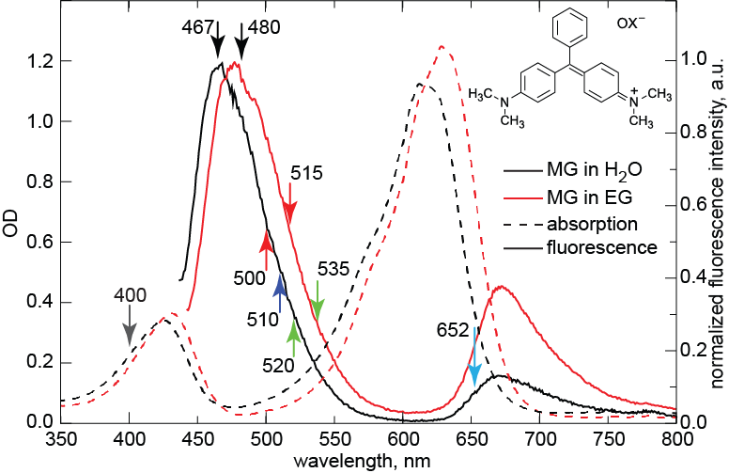
Figure 2
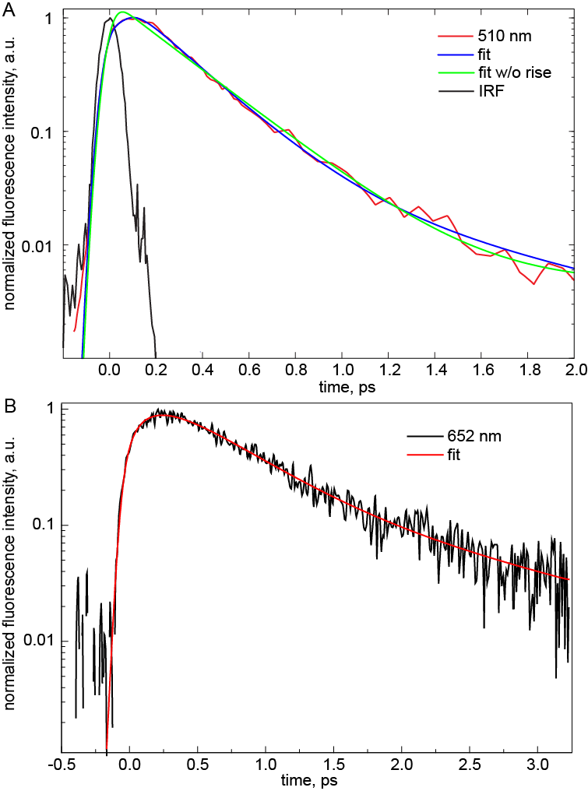

Figure 3
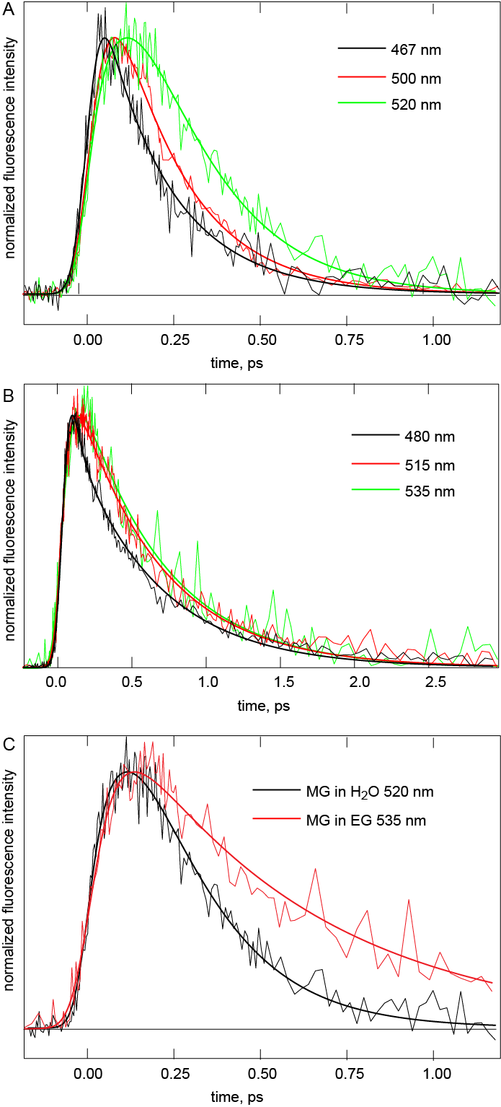
References
[1] L. JR, Principles of Fluorescence, Springer, 2006.
[2] G. Viswanath, M. Kasha, Journal of Chemical Physics 24 (1956) 574.
[3] A. Janowski, J. Rzeszotarska, Journal of Luminescence 21 (1980) 409.
[4] D. Chahraoui, P. Valat, J. Kossanyi, Research on Chemical Intermediates 17 (1992) 219.
[5] M. Ravikanth, D. Reddy, T.K. Chandrashekar, Journal of Photochemistry and Photobiology a-Chemistry 72 (1993) 61.
[6] S. Muralidharan, A.J. Lough, K. Yates, Journal of Photochemistry and Photobiology a-Chemistry 71 (1993) 245.
[7] M. Yoshizawa, K. Suzuki, A. Kubo, S. Saikan, Chemical Physics Letters 290 (1998) 43.
[8] J.A. Mondal, H.N. Ghosh, T. Mukherjee, D.K. Palit, Journal of Physical Chemistry A 109 (2005) 6836.
[9] K.P. Ghiggino, N.K. Giri, J. Hanrieder, J.D. Martell, J. Muller, M.F. Paige, B. Robotham, J. Szmytkowski, R.P. Steer, Journal of Physical Chemistry A 117 (2013) 7833.
[10] X. Liu, E.K.L. Yeow, S. Velate, R.P. Steer, Physical Chemistry Chemical Physics 8 (2006) 1298.
[11] D.W. Cho, M. Fujitsuka, J.H. Ryu, M.H. Lee, H.K. Kim, T. Majima, C. Im, Chemical Communications 48 (2012) 3424.
[12] A.C. Bhasikuttan, A.V. Sapre, T. Okada, Journal of Physical Chemistry A 107 (2003) 3030.
[13] M. Fujitsuka, D.W. Cho, S. Tojo, A. Inoue, T. Shiragami, M. Yasuda, T. Majima, Journal of Physical Chemistry A 111 (2007) 10574.
[14] M. Maiti, R.P. Steer, Chemical Physics Letters 482 (2009) 254.
[15] N.H. Gottfried, B. Roither, P.O.J. Scherer, Optics Communications 143 (1997) 261.
[16] Y. Nagasawa, Y. Ando, T. Okada, Chemical Physics Letters 312 (1999) 161.
[17] E.P. Ippen, C.V. Shank, A. Bergman, Chemical Physics Letters 38 (1976) 611.
[18] D. Magde, M.W. Windsor, Chemical Physics Letters 24 (1974) 144.
[19] D. Benamotz, C.B. Harris, Chemical Physics Letters 119 (1985) 305.
[20] D. Benamotz, C.B. Harris, Journal of Chemical Physics 86 (1987) 5433.
[21] D. Benamotz, C.B. Harris, Journal of Chemical Physics 86 (1987) 4856.
[22] E. Riedle, M. Bradler, M. Wenninger, C.F. Sailer, I. Pugliesi, Faraday Discussions 163 (2013) 139.
[23] Y. Nagasawa, Y. Ando, D. Kataoka, H. Matsuda, H. Miyasaka, Y. Nagasawa, Journal of Physical Chemistry A 106 (2002) 2024.
[24] B. Bagchi, G.R. Fleming, D.W. Oxtoby, Journal of Chemical Physics 78 (1983) 7375.
[25] Y. Nagasawa, Y. Nakagawa, A. Nagafuji, T. Okada, H. Miyasaka, Journal of Molecular Structure 735 (2005) 217.
[26] T. Fujino, K. Hirota, K. Ohta, T. Tahara, Chemistry Letters 37 (2008) 1240.
[27] P. Sen, S. Yamaguchi, T. Tahara, Faraday Discussions 145 (2010) 411.
[28] S.R. Meech, K. Yoshihara, Journal of Physical Chemistry 94 (1990) 4913.
[29] X. Shi, E. Borguet, A.N. Tarnovsky, K.B. Eisenthal, Chemical Physics 205 (1996) 167.
[30] S. Rafiq, R. Yadav, P. Sen, Journal of Physical Chemistry B 114 (2010) 13988.
[31] I.A. Heisler, M. Kondo, S.R. Meech, Journal of Physical Chemistry B 113 (2009) 1623.
[32] A. Nakayama, T. Taketsugu, Journal of Physical Chemistry A 115 (2011) 8808.
[33] M. Glasbeek, H. Zhang, M.J. van der Meer, Journal of Molecular Liquids 86 (2000) 123.
[34] N. Amdursky, Y. Erez, D. Huppert, Accounts of Chemical Research 45 (2012) 1548.
[35] M.L. Horng, J.A. Gardecki, A. Papazyan, M. Maroncelli, Journal of Physical Chemistry 99 (1995) 17311.
[36] R. Jimenez, G.R. Fleming, P.V. Kumar, M. Maroncelli, Nature 369 (1994) 471.

