Advanced Endoscopy:

Confocal laser endomicroscopy in gastrointestinal diseases
Short title: Goetz, Kiesslich: CLE in GI diseases

Martin Goetz¹, Alastair Watson², Ralf Kiesslich¹
¹I. Medizinische Klinik und Poliklinik, Universitätsmedizin Mainz, Mainz, Germany, ²The Norwich Medical School, University of East Anglia, England

Address correspondence
Professor Alastair Watson
Eliz Fry Bldg. 2.14
Norwich Medical School
University of East Anglia
Norwich, NR4 7TJ
England
Tel: +(0)1603 592693 (secretary)
+(0)1603-597266 (office)
Email: Alastair.watson@uea.ac.uk

ABSTRACT
Confocal laser endomicroscopy (CLE) is a novel endoscopic technique permitting in vivo microscopy (optical biopsies) of the gastrointestinal mucosa. CLE has been studied in a multitude of diseases of the upper and lower gastrointestinal tract, including Barrett’s esophagus, gastric inflammation and cancer, celiac disease, colorectal adenoma and carcinoma, and inflammatory bowel diseases. CLE has recently evolved and been studied for bile duct and liver imaging.
CLE has shown overall high accuracy and enabled smart, targeted biopsies rather than untargeted sampling. Furthermore, the availability of real time microscopic information during endoscopy has immediate impact on therapeutic decisions and guides endoscopic interventions. CLE is also a unique tool for observation of (patho-)physiologic events in their natural environment (functional imaging) and has been linked to molecular imaging of gastrointestinal neoplasia in vivo, thereby broadening our understanding of mucosal pathology in clinical and basic science.

Keywords: Endomicroscopy; Molecular imaging; Barrett’s esophagus; Squamous cell cancer; Gastric cancer, Celiac disease, Ulcerative colitis, Colorectal cancer; Epidermal growth factor receptor, Vascular Endothelial Growth Factor.
Abbreviations: BE, Barrett’s esophagus; CLE, confocal laser endomicroscopy; EGFR, Epidermal growth factor receptor; EUS; endoscopic ultrasound; GvHD, graft versus host disease; IBD, inflammatory bowel disease; IM, intestinal metaplasia; IN, intraepithelial neoplasia; IPCL, intrapapillary capillary loop; NOTES, natural orifice transluminal endoscopic surgery; UC, ulcerative colitis; VEGF, Vascular Endothelial Growth Factor.

INTRODUCTION
Confocal laser endomicroscopy (CLE) was introduced 2004 into the endoscopist’s armamentarium of novel imaging techniques¹. Unlike conventional magnification endoscopy, CLE enables intravital microscopy of focal planes within the human gastrointestinal mucosa during ongoing endoscopy, enabling real time optical biopsy. A multitude of diseases from the upper, middle and lower gastrointestinal (GI) tract have already been investigated with CLE. Most trials have focused on inflammation and neoplasia. While histopathology still remains the gold standard in tissue diagnosis, CLE can be used to target biopsies or endoscopic interventions to regions of specific interest (smart biopsies) rather than having to rely on untargeted random biopsies. This reduces the number of biopsies and at the same time increases their diagnostic yield{Kiesslich, 2007 #566}. It has also stimulated exploration with CLE of organs not accessible by conventional endoscopy such as bile duct or liver. On the other hand, CLE has opened a completely new view onto the GI mucosa. In vivo observation of subcellular mucosal details becomes possible in vivo without the need to process tissue, and even subtle details of (patho-)physiological processes can be visualized without major artifacts known from the processing of conventional histopathological specimens. Together with the option to perform similar confocal imaging in animal research this has opened new fields for translational endoscopy and even molecular imaging.

TECHNIQUE OF ENDOMICROSCOPY AND STAINING PROTOCOLS

Technique of confocal endomicroscopy
The first human trials of endomicroscopy used a miniaturized scanning device integrated into the distal tip of a custom built endoscope (Pentax EC-3870CIFK, Tokyo, Japan). A wavelength of 488 nm is delivered via a single optical fiber that serves as a pinhole for confocal endomicroscopy and raster-scans the tissue at a resolution of 1024x1024 pixels. The collection bandwidth is 505 to 585 nm. The imaging plane depth can be user-adjusted from surface to 250 µm in 4 µm increments. Serial optical sections with a lateral resolution of 0.7 µm are obtained parallel to the tissue surface within a FOV of 475x475 µm (Fig. 1). The same scanner is integrated into a handheld probe for animal research (FIVE1, Optiscan, Notting Hill, Australia). The images provided in this review have been captured with endoscope-based CLE.
Flexible confocal mini-probes can be passed through the working channel of most conventional endoscopes even into the bile duct (probe-based CLE, pCLE; Cellvizio, Mauna Kea Technology, Paris, France). For probe based endomicroscopy the imaging plane as well as the laser power is fixed, and resolution is limited by the number of the fibers (30000 single fibers = pixels). However, faster image acquisition is obtained, and image streams can be merged into a real time video by a technology called mosaicing. Probes are available at different FOV and diameters ranging from 0.3 to 4.2 mm. For animal research, a 660 nm excitation wavelength is available in addition to excitation at 488 nm (Fig. 1).

Confocal imaging in vivo
For CLE in patients, a fluorescent agent has to be applied. In most studies, fluorescein has been used that shows excitation and emission spectra compatible with the blue laser light range. Fluorescein is the preferred contrast agents and provides a favorable safety profile². After intravenous injection, fluorescein distributes throughout the organism, and confocal imaging is possible within seconds after application. Fluorescein yields good contrast of vessels and tissue architecture. However, it does not stain nuclei. In animal studies with lower regulatory requirements a multitude of staining protocols has been evaluated in vivo³, and even antibodies have been fluorescently labeled.
Alternative local contrast agents are acriflavine and cresyl violet which allows visualization of nuclei. However the safety profile of these agents in humans is less clearly established than fluorescein though these agents have been used as skin disinfectants for over 80 years.

Just as every advanced endoscopy technique, CLE requires thorough training, knowledge of mucosal pathology, and repeated feedback from an expert GI pathologist. It has been estimated that approximately 100 cases are required after a supervised introduction to reliably perform CLE in Barrett’s esophagus⁴. We currently follow a two-step approach for teaching endomicroscopy: The first, basic step includes differentiating normal from abnormal mucosa; the second (and more advanced) step is to make a microscopic diagnosis based on the images generated in vivo. For the basic step, a number of 30 examinations has been estimated necessary, with online and printed support.

UPPER GASTROINTESTINAL TRACT

Endomicroscopy of the esophagus
Patients with suspected squamous cell cancer of the esophagus often show field cancerisation with multiple suspicious areas. CLE has been tested augmented by chromoendoscopy with Lugol’s solution⁷. 43 lesions were detected in 21 patients, of which 27 were proven to be cancer in histology. CLE correctly classified all malignant lesions based on the cellular architecture and altered intrapapillary capillary loops (IPCL, Fig. 2). 2 lesions were falsely classified as cancerous. Thus, CLE was able to facilitate rapid diagnosis in patients with multiple lesions. A follow-up trial confirmed a significantly higher proportion of irregular cellular arrangement, increased diameter and irregular shape of IPCLs in squamous cell cancer⁸.
Most trials of the upper GI tract have been performed in Barrett’s esophagus (BE). In BE, the Seattle Protocol recommends random quadrant biopsies and targeted biopsies from lesions for surveillance. However, the detection of neoplasia in BE can be challenging, and low and high grade IN can be present side by side with non-dysplastic Barrett’s epithelium. Endomicroscopy is the only endoscopic imaging techniques which can diagnose specialized intestinal epithelium pathognomonic for BE and its key structure goblet cell in the distal esophagus in vivo during ongoing endoscopy (Fig. 2). In a first study, CLE was able to predict the presence of BE and associated IN with an accuracy of over 90% and to differentiate specialized intestinal epithelium from gastric epithelium during endoscopy based on a simple classification⁹. This was followed by a trial investigating in a cross over design whether CLE with targeted biopsies improved the diagnostic yield of BE-associated neoplasia compared to the Seattle protocol¹⁰. Targeted biopsy guided by CLE almost doubled the diagnostic yield for IN, and two thirds of patients under surveillance did not need any mucosal biopsies.
In BE, normal appearing mucosa by high resolution endoscopy was examined with pCLE and matched to biopsies¹¹. In a per site analysis on 201 sites, pCLE prediction had negative predictive value of 99% and a positive predictive value of 44%. Similar results came from a recent trial from three academic centers assessing 68 patients with BE. With quadrant biopsies as a gold standard, pCLE had a high on-site negative predictive value of 95% to exclude IN however at a low positive predictive value of only 18%¹². In a preliminary evaluation of pCLE diagnosis of offline video sequences in BE, accuracy and interobserver agreement was substantial especially among endomicroscopy experts¹³. A direct comparison of endoscope vs. probe based CLE to explain for differences in PPV and specificity in the above mentioned trials has not been conducted. It may be speculated that the higher resolution of endoscope integrated CLE facilitates the diagnosis of IN by visualisation of single cells whereas the somewhat lower resolution of pCLE is sufficient to identify the tubular structure of non-neoplastic Barrett’s glands. Given this growing database it remains to be demonstrated that with CLE endoscopists will be able to abandon quadrant biopsies for endomicroscopically targeted biopsies altogether.

Endomicroscopy of the stomach
In the stomach, many of the neoplastic lesions arise within non-circumscript pathologies. CLE is able to visualize the morphology of gastritis, intestinal metaplasia (IM) and atrophy, IN and cancer (Fig. 3). It can aid in this setting to rapidly screen larger areas in vivo by multiple optical biopsies and subsequently target tissue sampling to areas with highly suspicious microscopic patterns.
The normal gastric mucosa shows a regular cobble-stone pattern with round pits in the corpus and branched pits in the antrum and cardia. CLE is not only able to visualize the morphologic changes associated with gastritis, but also the causative agent such as Helicobacter pylori in vivo. For this, the topical application of acriflavine is necessary in addition to intravenous fluorescein. H. pylori incorporates acriflavine and is identified as white spots adjacent to the epithelial lining¹⁴. In a prospective study, this staining protocol identified H. pylori-associated gastritis with an accuracy of 93%¹⁵. CLE features significantly associated with H. pylori gastritis were neutrophil accumulation, microabscesses and white spots (H. pylori). It is important to remember that fluorescein alone cannot differentiate white blood cell since no staining of nuclei is achieved. This is only possible in conjunction with acriflavine. These studies also exemplify that with the high resolution of endoscope based CLE even bacteria can be visualized in vivo.
Intestinal metaplasia (IM) and gastric atrophy often co-exist side by side with gastritis in a patchy pattern. IM is characterized by three features in CLE: goblet cells, columnar absorptive cells with brush border, and villiform foveolar epithelium. In a study on 53 patients, 267 optical biopsy sites were evaluated. IM was predicted with a sensitivity of 98%, a specificity of 95%, and an interobserver agreement of 0.94 with histology as the gold standard¹⁶. Similarly, gastric atrophy could be predicted with high accuracy ¹⁷. The main advantage of CLE in such diffuse changes with premalignant potential is that a larger area can be rapidly screened by multiple optical (virtual) biopsies, and real biopsies can be focused and targeted to the most suspicious spots.
To differentiate gastric hyperplastic polyps from gastric adenomas, 66 patients were investigated¹⁸. The in vivo accuracy to differentiate these two entities during ongoing endoscopy was 90%, thus facilitating immediate therapeutic decision. Earlier studies have focused on the diagnosis of gastric cancer¹⁹. Criteria to classify a lesion as malignant were visualization of crowded glands showing irregular size and epithelial heights with intraluminal folding, glandular budding and branching as well as increased density of capillaries with dilated and distorted appearance²⁰. With such criteria, sensitivity and specificity to predict the presence of gastric IN was 78% and 82%, resp. Importantly, in this single center trial interobserver agreement was similar between two endoscopists and between endoscopist and pathologist (kappa 0.70 and 0.71, resp.). In a recent large trial, a first set of 182 patients were examined to establish criteria for superficial gastric cancer. This was followed by an evaluation phase in 1786 patients. In this second phase, CLE was compared with white light endoscopy for real time diagnosis of gastric cancer with histopathology as the gold standard. CLE showed excellent sensitivity (89%), specificity (99%) and accuracy (99%) for the in vivo diagnosis of gastric superficial cancer and high grade IN lesions²¹.
Such early lesions are good candidates for endoscopic resection. Whereas residual tumor at the deep margin is usually an indication for surgery, positive lateral margins can be treated by repeated endoscopic resection if the tumor residues can be identified. 24 patients underwent CLE two weeks after endoscopic resection²². 19 patients were considered tumor free according to histopathology, but 5 had indefinite lateral margins that were treated endoscopically under CLE guidance. Accuracy of CLE to predict incomplete resection was 92% with histopathology as the gold standard. No recurrence was observed at mean endoscopic follow-up of 8.3 months. This trial again exemplifies the use of CLE not to replace histology, but to target histopathologic diagnosis to the most suspicious sites while at the same time integrating immediate microscopic diagnosis into guiding intervention during endoscopy.

Endomicroscopy of the small intestine
Histopathology of duodenal specimens for diagnosis of celiac disease may yield false negative results due to sampling error and poor quality specimens. In a first study on celiac disease, 31 patients (6 untreated, 11 treated, 14 controls) were examined by CLE²³. Whereas villous atrophy and crypt hypertrophy can often nicely be resolved, the visualization and quantification of intraepithelial lymphocytes (Marsh I) is difficult in vivo with fluorescein (Fig. 4). CLE was able to differentiate celiac disease from controls with high accuracy, and even a trend to a higher diagnostic yield with CLE vs. histopathology specimens was observed in those patients with established celiac disease (sampling error for real biopsies). Resolution under gluten-free diet of mucosal alterations associated with celiac disease could be visualized by CLE. Such diagnostic protocols have even been applied to pediatric endoscopy in 19 children from 2-12.66 yearsand have shown good sensitivity and specificity of 100% and 80%, resp. ²⁴

LOWER GASTROINTESTINAL TRACT

Endomicroscopy for colonic neoplasia
The first trial on CLE in humans was performed in patients scheduled for screening or surveillance colonoscopy¹. Here, a simple classification was established to differentiate normal from regenerative (inflammatory or hyperplastic) and neoplastic mucosa based on the crypt and vessel architecture. With this classification, a prediction of neoplasia in vivo was achieved with an accuracy of 99% using intravenous fluorescein (Fig. 5). These results were confirmed in follow-up studies²⁵, supporting the notion that specifically trained endoscopists are able to evaluate microscopic mucosal architecture.
Since fluorescein does not stain nuclei, the differentiation of low grade vs. high grade IN was not investigated. This was achieved in a follow-up study combining fluorescein with topical acriflavine. Such a protocol allowed the differentiation of low-grade from high-grade adenomas²⁶. Since direct nuclear visualization may carry a risk of mutagenesis (although this has not been reported with acriflavine), indirect nuclear visualization by cytoplasmic contrast was studied using cresyl violet for both chromoendoscopy for identification of colorectal lesions and endomicroscopy for their immediate characterization²⁷.

Endomicroscopy in inflammatory colitis
In ulcerative colitis (UC), patients harbor an increased risk for developing IN in the course of disease. CLE cannot provide pan-microscopic examination of the entire colon, but should be targeted to regions of interest, for example guided by chromoendoscopy²⁸. If used in such a targeted fashion, CLE was able to predict the presence of IN in vivo with an accuracy of 98% (Fig. 5). If endomicroscopy suggested normal mucosa, histopathology confirmed normal mucosa in 99% of optical biopsy sites. These results further support the notion of taking fewer targeted (“smart”) biopsies rather than untargeted random biopsies: The combined use of CLE with chromoendoscopy reduced the number of biopsies in comparison to white light endoscopy surveillance to 3.9 biopsies/patient instead of 40 to 50, but still demonstrated a more than 4-fold increased diagnostic yield for IN on a per lesion-basis. Besides, inflammation was readily detectable microscopically during endoscopy. It has not yet been investigated if screening for inflammation by CLE can be used to monitor mucosal healing for sustained deep remission of UC and to guide the intensity of medical therapy.
Microscopic colitis is a chronic inflammation with patchy distribution that up to now was only diagnosed histologically whereas white light endoscopy typically does not show pathologic findings. Therefore, this condition is frequently underdiagnosed in untargeted random biopsies. CLE provides multiple virtual biopsies on-site. It has been shown that both the lymphocytic infiltration and the subepithelial band can be visualized by CLE, and real biopsies can be restricted to these sites²⁹⁻³¹.
Patients with intestinal graft-versus-host disease (GvHD) after bone marrow transplantation have an essential need for rapid endoscopic and histologic diagnosis. However, biopsies are associated with an increased bleeding risk and significant time delay to final diagnosis. In a recent study, CLE provided immediate diagnosis and grading of GvHD and was even able to show epithelial details such as apoptosis³².

BEYOND THE INTESTINAL LUMEN
In gastrointestinal diseases, confocal microscopy is not confined to the intestinal epithelium. Probe-based CLE has opened a door for endomicroscopic visualization of biliary epithelium by advancing a confocal miniprobe into the bile duct via a duodenoscope. Biliary strictures often pose a diagnostic dilemma. Confocal imaging in this setting has been evaluated in 14 patients³³. The presence of irregular vessels within the stenosis predicted biliary neoplasia with an accuracy of 86% and showed better sensitivity (83%) than histology (50%). Although a follow-up study found a lower accuracy rate in 14 indeterminate strictures³⁴, CLE may represent a valuable additional tool to assist in the difficult differential diagnosis of biliary strictures. Even visualization of pancreatic intraductal neoplasm has been described³⁵.
Confocal microscopy has also been used during mini-laparoscopy for in vivo visualization for liver tissue. To enable sterile instrumentation within the abdominal cavity, a rigid confocal prototype probe (with identical optical properties as endoscope-based CLE) was covered with a sterile stainless steel sheath and bagged with a camera sleeve³⁶. A first study using fluorescein yielded only superficial visualization of liver tissue. Due to the prominent human liver capsule, deeper imaging could not be achieved with blue laser light. In a follow-up trial, liver parenchyma could be visualized by using a near-infrared laser light source in conjunction with indocyanine green, providing microscopic intravital imaging with imaging planed depths up to 350 µm below the tissue surface³⁷. Such deeper tissue imaging could also be used to define infiltration depth of mucosal lesions in the GI tract prior to endoscopic resection which is usually not possible with blue laser light. Such approaches could also point to a use of CLE during surgery, for example to screen for R0 resection in cancer surgery.
In a porcine model, a CLE probe has been introduced through a 22-gauge puncture needle during endoscopic ultrasound (EUS) for visualization of parenchymal intraabdominal organs³⁸. This proof-of-principle approach may assist in future targeting of parenchymal biopsies during EUS–guided puncture. In a similar feasibility study, CLE probes were passed through endoscope working channels during natural orifice transluminal endoscopic surgery (NOTES) for in vivo microscopy of intraabdominal tissue³⁹. Outside the field of gastroenterology, CLE has been applied (but is not restricted) to cancer diagnosis in the oral cavity⁴⁰, the urinary bladder and gynecology⁴³.

TRANSLATIONAL ENDOMICRISCOPY

Functional imaging
CLE does not only imitate histology. It is also unique in its ability to provide microscopic visualization of the mucosa virtually free of artifacts (such as fixation, cutting, staining artifacts). Therefore CLE constitutes a completely novel tool to investigate microarchitectural mucosal alterations in their natural surroundings. It has recently been described that the intestinal epithelium is punctured by numerous gaps that result from single cell shedding⁴⁴ (Fig. 6). A translational study demonstrated that such gaps can be visualized in healthy patients by CLE and that gaps are more frequent in a mouse model of colitis⁴⁵. The disposition of the mucosa to show more gaps in the setting of inflammation could constitute a microscopic morphologic correlate of a loss of mucosal barrier function. It has recently been described that gaps are more frequent in patients with IBD, regardless of type, pattern or therapy of IBD⁴⁶, although the therapeutic implication of this finding is not yet defined. In agreement with this point, bacteria could be visualized more frequently in patients with IBD in clinical remission than in healthy controls⁴⁷. These bacteria are resolved as white spots within the epithelium and the lamina propria due to the high resolution of endoscope-based CLE (Fig. 6).
Another tissue aspect that is frequently seen with CLE but is difficult to resolve with conventional histopathology is perfusion and its alterations in inflammation and neoplasia⁴⁸. It has not only been shown that extravasation of fluorescein identifies increased vessel leakiness in ulcerative colitis⁴⁹ and IN¹. Changes in the microvessel density have also been used to identify IN in Barrett’s esophagus⁵⁰. Such analysis tools could be used assist in semi-automated, computer-aided diagnosis algorithms and could also be used to monitor vessel density under anti-angiogenetic therapy of cancer.

Molecular imaging
CLE not only allows high resolution in vivo functional imaging, but also fluorescent labeling of molecules with exogenous agents such as peptides, antibodies or probes with tumor-specific activation are fluorescently labeled. Such molecular imaging aims to specifically detect and characterize neoplasia or inflammation. In animal models, labeling of colorectal cancer xenografts with antibodies targeting Epidermal Growth Factor Receptor (EGFR)⁵¹ and Vascular Endothelial Growth Factor (VEGF)⁵³ enabled molecular imaging. It resulted in on-site differentiation of receptor expression in xenografts in vivo and on resected human tissue. Using a labeled peptide, even molecular imaging of colorectal adenomas in humans during ongoing colonoscopy was achieved⁵⁴. In perspective, such enhanced detection and definition of lesions based on their molecular signature may result in on-site immunohistochemistry, enabling screening with higher diagnostic yield and prediction of response and surveillance of molecular targeted therapies in inflammation and cancer.

CONCLUSIONS
In summary, confocal laser endomicroscopy has enabled for the first time microscopy at subcellular resolution during ongoing endoscopy in diseases of the upper and lower gastrointestinal tract. Multiple trials have confirmed high diagnostic accuracy of CLE using even simplified confocal pattern classifications. Endomicroscopy is not intended to replace histopathology, but rather to target biopsies to regions of interest based on microarchitectural alterations (smart biopsies). In addition, CLE allows virtually artifact-free microscopic imaging of the intact mucosa and thereby permits interrogation of cellular events in the natural surroundings. In conjunction with molecular imaging, this points to new applications of CLE in clinical and basic science in gastroenterology.

FIGURE LEGENDS

Figure 1: Systems for confocal endomicroscopy:
The two types of CLE systems are currently available: In the endomicroscope (upper panel), the laser scanner is integrated into the distal part of an endoscope. Adaptable imaging plane depth yields serial en face optical sections through the mucosa at high resolution. Probe based-CLE (lower panel) can be passed through the working channel of most conventional endoscopes. It offers lower resolution and a fixed imaging plane depth, but faster image acquisition. Both systems yield sections parallel to the mucosal surface.
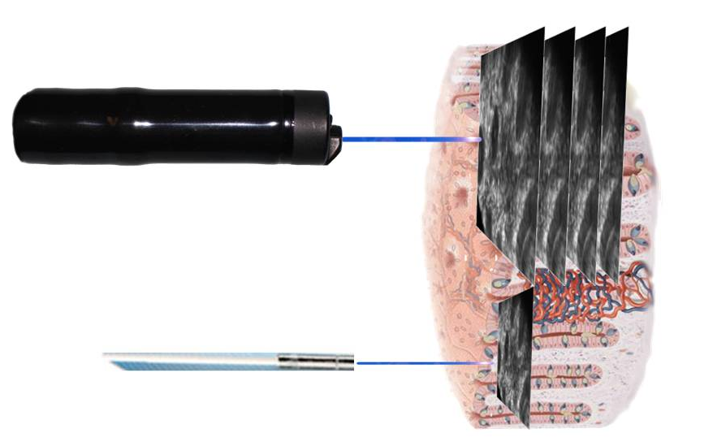

Figure 2: Esophagus
A. In normal squamous epithelium of the esophagus, IPCL are filled with fluorescein and can be easily identified (arrows). B. In squamous cancer, the tissue structure is severely disturbed, and pools of extravasated fluorescein are intercalated into dark malignant cells. C. Multiple goblet cells (large cells with dark mucin inclusions, arrows) and a villous pattern in the distal esophagus are key structures for identification of Barrett’s esophagus. The double lining on the tip of the villi constitute the brush border in specialized metaplasia (arrowheads). D. In Barrett’s associated cancer, pathological vessels (arrows) can be seen close to the tissue surface, and significant leakage of fluorescein is seen. Dark cells identify malignancy (arrowheads) probably due to the lower pH in cancer cells and pH-dependent fluorescent intensity of fluorescein.
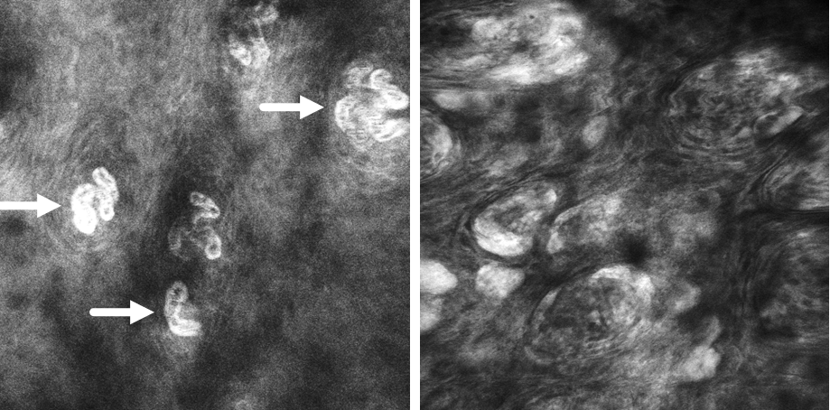
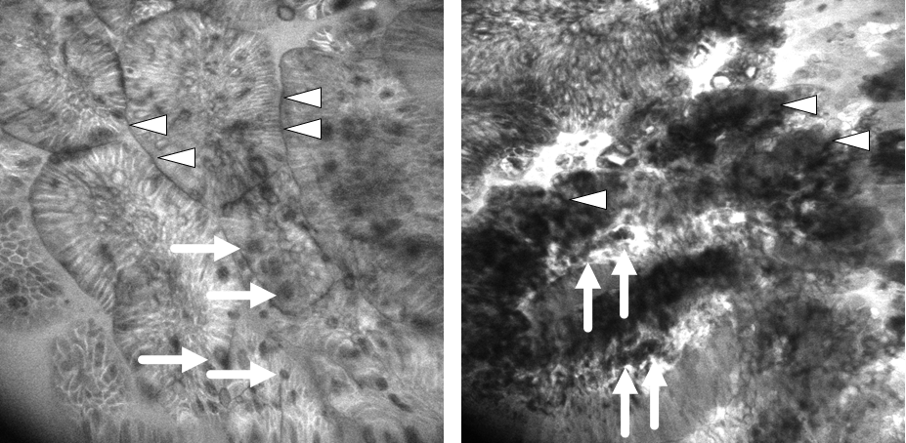

Figure 3: Stomach
A. Healthy stomach (here: Corpus) typically shows cobblestone appearance at surface level and regular pits. Laser power usually has to be increased since intragastric pH is low and acidity is accompanied by low fluorescence intensity. B. In intestinal metaplasia, villi and goblet cells (arrows) can be seen alongside gastric epithelium. High flurescence intensity within the lumen (asterisk) indicates enhanced vessel leakiness, e.g. in gastritis. C. In gastric cancer, the epithelium is irregular and shows sudden breaks in structure (arrow). Malignant (epithelial) cells of different size are seen in the lamina propria and in the lumen. The lumen is bright white due to massive leakage of fluorescein (asterisk).
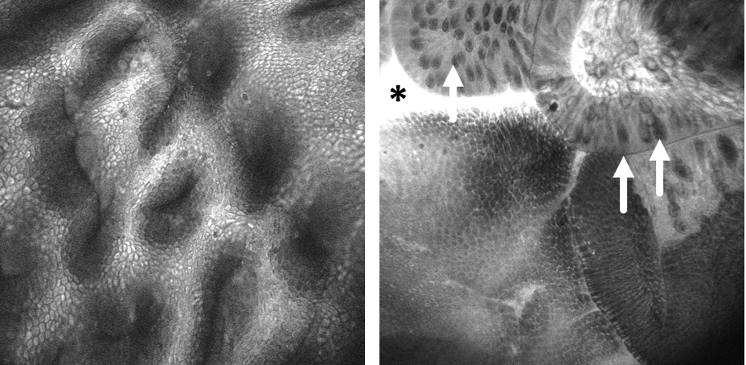
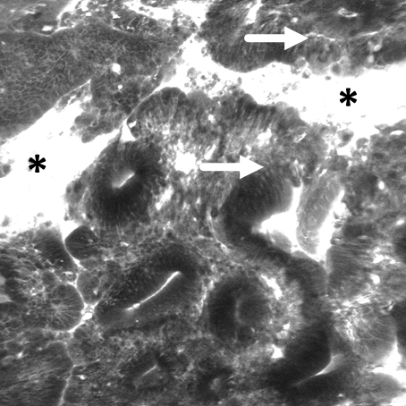

Figure 4: Small intestine
A. Normal small intestine shows regular villi with regular epithelium and hair-pin like capillary loops (arrows) underneath the basal membrane. B. In contrast in celiac disease villi are flattened and broadened, showing signs of inflammation.
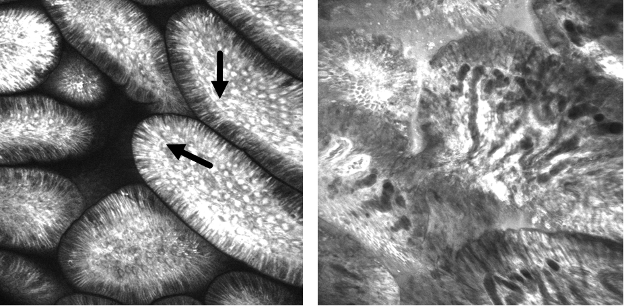

Figure 5: Colon
A. In healthy colonic mucosa, regular round crypt openings (arrows) are surrounded by goblet cells, resembling a slice of orange. In subepithelial sections, regular capillaries can be found surrounding the crypts in a honeycomb pattern. B. In colitis-associated neoplasia, crypts are elongated and fingerlike (arrows), and extravasation of fluorescein indicates inflammatory activity.
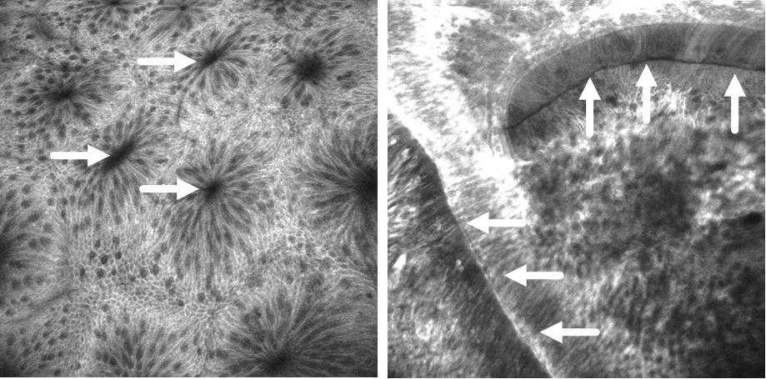

Figure 6: Gaps and bacterial translocation

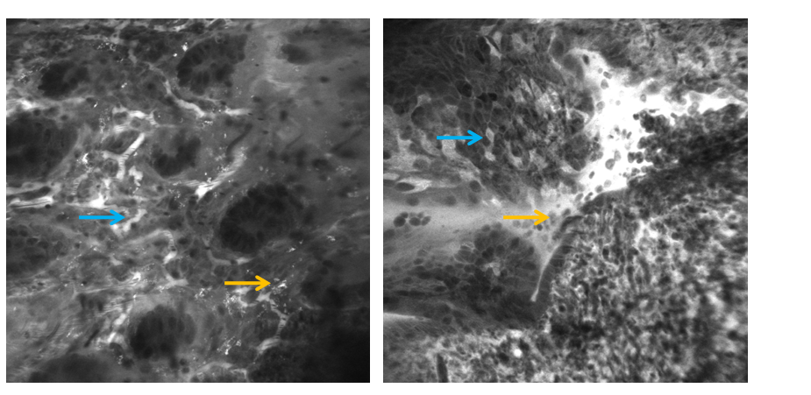

A B

A: Endomicroscopy in a patient with Ulcerative colitis. The lamina propria shows inflammatory cellular infiltrate and increased capillary network (see blue arrow). Intramucosal bacteria can be identified based on their specific shape and size as well as their fluorescein uptake.

B

Cell shedding can be readily identified (orange arrow). Cells are shed in the lumen leaving a small gap (blue arrow). Cell shedding and gap formation is increased in patients with inflammatory bowel diseases.

REFERENCES

