Protein Photochromism Observed by Ultrafast Vibrational Spectroscopy

Andras Lukacs,^{1†} Allison Haigney,^{2‡} Richard Brust,² Kiri Addison,¹ Michael Towrie,³ Gregory M. Greetham,³ Garth A. Jones,¹ Atsushi Miyawaki,⁴ Peter J. Tonge²* and Stephen R. Meech¹*

1. School of Chemistry, Norwich Research Park, University of East Anglia, Norwich NR4 7TJ, UK. 2. Department of Chemistry, Stony Brook University, Stony Brook, New York, 11794, USA. 3. Central Laser Facility, Research Complex at Harwell, Harwell Science and Innovation Campus, Didcot, Oxon OX11 0QX, UK 4. Laboratory for Cell Function Dynamics, Brain Science Institute, RIKEN, 2-1 Hirosawa, Wako, Saitama, 351-0198 Japan
*Authors for correspondence (peter.tonge@stonybrook.edu; s.meech@uea.ac.uk)
† Present address: Department of Biophysics, Medical School, University of Pecs, Hungary
‡ Present address: The Wistar Institute, Philadelphia, PA 19104 USA
Abstract
Photochromic proteins, such as Dronpa, are of particular importance in bioimaging, and form the basis of ultraresolution fluorescence microscopy. The photochromic reaction involves switching between a weakly emissive neutral trans form of the chromophore (A) and its emissive cis anion (B). Controlling the rates of switching has the potential to significantly enhance the spatial and temporal resolution in microscopy. However, the mechanism of the switching reaction has yet to be established. Here we report a high signal-to-noise ultrafast transient infra-red investigation of the photochromic reaction in the mutant Dronpa2, which exhibits facile switching behavior. In these measurements we excite both the A and B forms and observe the evolution in the IR difference spectra over hundreds of picoseconds. Electronic excitation leads to bleaching of the ground electronic state and instantaneous (sub picosecond) changes in the vibrational spectrum of the protein. The chromophore and protein modes evolve with different kinetics. The chromophore ground state recovers in a fast non-single-exponential relaxation, while in a competing reaction the protein undergoes a structural change. This results in formation of a metastable form of the protein in its ground electronic state (A’), which subsequently evolves on the time scale of hundreds of picoseconds. The changes in the vibrational spectrum that occur on the sub-nanosecond time scale do not show unambiguous evidence for either proton transfer or isomerization, suggesting that these low yield processes occur from the metastable state on a longer time scale and are thus not the primary photoreaction. Formation of A’, and further relaxation of this state to the cis anion B, are relatively rare events, thus accounting for the overall low yield of the photochemical reaction.

Keywords: Dronpa, Dronpa2, photoswitching, cis-trans, time resolved infrared spectroscopy, ultrafast
Introduction
Photochromic proteins, of which Dronpa is the prototypical example,¹⁻² form an important subset of the green fluorescent protein (GFP) family. Dronpa is repeatedly photoswitchable between a green emitting bright state (B) generated through 380 nm irradiation of the UV/blue absorbing dark state (A) which may in turn be formed on 490 nm irradiation of B.²⁻⁴ Typically the dark (A) to bright (B) switching has a larger cross section than the reverse process. This photochromic behavior forms the basis of a number of revolutionary advances in ultraresolution fluorescence microscopy which combines tens of nanometer 3D spatial resolution with the benefits of a genetically expressible chromophore.⁵⁻¹¹
Despite the significance of Dronpa, the mechanism of photoswitching is far from fully characterized. This is an obvious hindrance to the design of new photochromic proteins with enhanced properties for imaging. For example, resolution and imaging speed depend on A/B and B/A switching rates, which might be manipulated by mutagenesis if the mechanism is known. In addition other photoswitchable functions (for example probing site specific photo-activated drug release and photodynamic therapy¹²⁻¹³ in genetically modified organisms) may be devised. It is established that the A state is the neutral form of the chromophore (Figure 1) while the B state is its deprotonated anionic form, suggesting that a proton transfer reaction occurs during photoswitching. This may be an excited state proton transfer (ESPT) reaction, such as occurs in wild type (wt) GFP,¹⁶⁻¹⁸ or may occur in the ground electronic state. Dronpa has the same chromophore as wt GFP and essentially the same β-barrel structure, although the proteins differ both in the arrangement of the amino acid residues near the chromophore and in the isomeric form of the chromophore itself. Structural studies of the A and B states of Dronpa showed that the A state adopts a trans form with respect to the bridging double bond and shows some disorder, while the B state has the cis form typical of fluorescent proteins (Figure 1). This suggests that the photochromic reaction also involves a photoinduced trans-cis isomerization.¹⁹⁻²¹
In this article, we report real time observations of the primary steps of the photochromic reaction in the Dronpa mutant Dronpa2 using ultrafast ultrasensitive time-resolved infrared (TRIR) spectroscopy.²² This complements two earlier ultrafast optical studies of Dronpa, by Hofkens and co-workers ⁴ and van Thor and co-workers.²³ The first study of ultrafast electronic spectroscopy following A state excitation revealed dynamics on the picosecond time scale consistent with the weak fluorescence of A. In addition, the measured rates depended on whether D₂O or H₂O was the solvent, leading to the suggestion that the primary process was ESPT, as in wtGFP.⁴ Very recently van Thor and co-workers reported the first TRIR study of Dronpa.²³ They presented decay associated spectra showing a 9 ps excited state decay of the A* excited state leading to a new state, assigned as the protonated cis ground state, which was stable on a 100 ps time scale. Thus, they proposed that the primary event is the trans - cis isomerization reaction, and not ESPT. The present results extend these TRIR measurements to a wider frequency range and to longer times. This permits the observation of modes associated with changes in protein structure around the chromophore, which are found to evolve on the hundreds of picoseconds time scale. These data lead us to propose a more complex picture of the primary events in the Dronpa photocycle, involving changes in both the chromophore and the surrounding protein matrix. In addition we contrast our Dronpa data with measurements on wt GFP, for which the transient IR modes have been assigned. The marked differences between the spectra and dynamics of these identical chromphores in their distinct protein environments are discussed in terms of a mechanism for the photochromic reaction.
Results and Discussion
The photochromic nature of Dronpa presents challenges to ultrafast spectroscopy which we resolved by studying the mutant Dronpa2 rather than Dronpa itself; Dronpa2 has a mutation (Met159Thr) that enhances both the A to B switching rate and the thermal B to A relaxation.²⁵ This allows the study of both B and A states separately, provided the sample is flowed and continuously illuminated at the appropriate wavelength (see experimental details). The TRIR spectra of Dronpa2 excited at 400 nm (i.e. in the neutral protonated dark A state of the chromophore) are shown in Figure 2a. In these transient difference spectra the negative peaks (bleaches) correspond to the removal of IR absorbing states while positive signals (transients) indicate the creation of transient or product states. Features in the difference spectra which appear during the time resolution (200 fs) are assigned to IR active vibrations of the bleached A ground state or vibrations of the A* excited state, or to protein modes perturbed by the change in electronic state. The latter includes changes in chromophore - environment H-bonding structure without a corresponding change in nuclear structure.
A number of significant new features are revealed in these TRIR spectra. First, the spectrum is complex. There are ten obvious bleach modes and seven transient absorptions in the range surveyed. In contrast, the isolated chromophore of Dronpa in methanol solution has only five bleach modes over the same range, which have been fully assigned¹⁸ (supporting information Figure S1, Table S1). This complexity can be ascribed to two sources. First, multiple isomers in the A state; DFT calculations show that the C=O mode near 1688 cm⁻¹ is sensitive to the isomeric form (supporting information, Table S1). This disorder may explain the appearance of a pair of bleach bands at high frequency (1671 cm⁻¹ and 1690 cm⁻¹) in Dronpa2 where only one is present in the non-irradiated chromophore in solution²⁶ (Figure S1). This is consistent with the proposal of disorder in the x-ray structure of the Dronpa A state.¹⁵ Second, modes associated with the protein also contribute to instantaneous bleaches and corresponding transients in the TRIR spectra, as has been shown for other photoactive proteins. The appearance of such protein modes in Figure 2a is indicative of strong H-bond interactions between the chromophore and surrounding residues, which are modified upon electronic excitation. Modes in the spectrum which have no counterpart in the isolated chromophore are found at 1623 cm⁻¹ (bleach) and 1425 - 1500 cm⁻¹ (a complex differential lineshape) and must therefore arise from the protein.
The second key feature in Figure 2 is that the spectral complexity is reflected in complex kinetics. First we will consider kinetics associated with individual bands (Figure 2b-e, Figure S2) and then discuss a global analysis of the spectra (Figure 3). The transient (1663 cm⁻¹) and bleach (1688, 1650 and 1608 cm⁻¹) modes associated with the chromophore reveal a major relaxation component of 7±2 ps (Figure 2b, S2). Such a fast recovery of the ground state indicates rapid radiationless decay, consistent with the weak emission from the A* state. This result is consistent with previous ultrafast studies of Dronpa⁴ which also found picosecond time scale ground state recovery and excited state decay times. This contrasts strongly with the behavior of the (non-photochromic) wt GFP, where the A* state forms the anionic (I*) state through ESPT with high efficiency, so that the ground state is repopulated on the nanosecond time scale.²⁸ The fast decay observed in Dronpa2 is more similar to the sub-picosecond decay of the chromophore in solution, which is associated with conformational freedom about the bridging methylene bond;²⁸ the NMR studies of Mizuno et al. suggested a degree of flexibility in the Dronpa A state compared to wt GFP, which is consistent with the observed ultrafast decay.¹⁵ However, both transient decay and ground state recovery of these chromophore modes are non-single exponential with additional components of 30 to 100 picoseconds being resolved (Figure S2). Such a broad range of relaxation times is consistent with a distribution of decay rates rather than true two-state relaxation. Since both spectroscopy (see above) and structure data⁷ suggest multiple conformations for the A state chromophore in Dronpa such a distribution of decay rates is expected, given the known sensitivity of HBDI decay to structural distortion.²⁹
Significantly, a number of other modes are measured to have either appreciably faster (Figure 2c) or slower (Figure 2d,e) kinetics than the 7 ps associated with chromophore ground state recovery. Examples of such kinetics are shown in Figure 2c-e, where the representation of the chromophore kinetics (1688 cm⁻¹, Figure 2b) are included for reference; the numerical results for fitting all modes to a bi-exponential function are collected in supporting information (Figure S2). In particular, modes assigned to the protein exhibit kinetics which are quite distinct from those associated with the chromophore. For example modes at 1470 cm⁻¹ (Figure 2d) and 1580 cm⁻¹ show a rise on the 7 ps time scale while modes at 1470 and 1500 cm⁻¹ (Figure 2e) have a component which relaxes in about 1 ns. The 1623 cm⁻¹ protein bleach mode lacks the 7 ps component associated with the chromophore and instead has tens of picosecond and > 300 ps relaxation components. These observations prove both that the formation of new states from the initially excited state occurs in competition with the 7 ps chromophore ground state recovery, and that there is a slow (hundreds of picoseconds) subsequent evolution in protein structure.
An alternative to analyzing the kinetics associated with specific modes with a multi-exponential fitting function is to conduct a global kinetic analysis. The study of individual bands revealed a fast decay in chromophore modes plus some slower components, a fast rise in some proteins modes and a much longer decay time. These data suggest the application of a sequential model A* → A’ → X→ F, where A’ and X are intermediate states and F is a final state; attempts to describe the data with a single intermediate were unsuccessful, consistent with the multiple timescales recovered from the bi-exponential fitting (Figure S2). The results of the global analysis are shown in Figure 3, with ultrafast (2.3 ps), fast (22 ps) and slow (458 ps) decay constants associated with each state being recovered. Further details of this analysis are presented in supporting information.
The bands which are unambiguously associated with the recovery of the chromophore ground state (e.g. 1690, 1650, 1608 cm⁻¹) are dominated by, but not exclusively due to, the faster two components. This does not necessarily indicate a contribution from two distinct states with different spectra but results from the way in which this sequential global analysis model (which is the simplest model to fit the data but is not unique, see supporting information) fits the non-exponential ground state recovery. Significantly, bands which were assigned to the protein behave quite differently in the global spectrum, in line with the single frequency analysis above. The 1623 cm⁻¹ bleach has a major component of the intermediate state, but no slow component. In contrast the 1580 cm⁻¹ bleach forms on the faster time scale and mainly decays in hundreds of picoseconds. The complex lineshape between 1450 and 1500 cm⁻¹ has major components associated with the slow relaxation. In the final state (F) these protein modes have also relaxed, but a number of long lived modes in the 1550 to 1670 cm⁻¹ region remain, which may be associated with the final cis anion (Figure 3). These protein modes require further study by isotopic substitution and site directed mutagenesis for a conclusive assignment.¹⁸ Importantly, the single frequency and global analysis results point to the same conclusion; the picosecond time scale ground state recovery is accompanied by population of a metastable state of the protein around the chromophore (called here A’) which undergoes further structural relaxation on the hundreds of picoseconds time scale to states which ultimately lead to the B state.
Further insight into the nature of the metastable state, A’, can be obtained by contrasting the TRIR following excitation of the A state of Dronpa2 (Figure 2) with those from excitation of the B state and of the A state of wt GFP; this is done in Figure 4. There are striking difference between the TRIR spectra of the Dronpa2 A and B states. In the B state the C=O bleach (calculated to be the highest wavenumber mode, see supporting information) has shifted down to 1663 cm⁻¹ and the amplitude of the bleach associated with the phenyl ring mode (1498 cm⁻¹) has increased significantly. In addition the chromophore ground state recovery kinetics are much slower in the B state (ca 1 ns), consistent with a long lived fluorescent state. These spectral differences can be understood in terms of photoinduced changes in the structure of both the protein environment and the chromophore between the A and B states. The B state is an anion in the cis form. Formation of the anion is calculated to lead to a shift to lower frequency in the C=O mode (Table S1) for either isomer, consistent with observation. Further, NMR studies of Dronpa suggested that in the B state a strong H-bond is formed between the phenolate O– and an adjacent amino acid residue (S142).¹⁵ DFT calculations show that H-bonding at O– leads to an enhanced (weak to strong) intensity of the phenyl stretch mode (Table S1), consistent with Figure 4. Such a strong H-bond can restrict internal motion in the chromophore, suppressing radiationless decay, which is consistent with a slower excited state decay.²⁸ Thus, TRIR spectra and dynamics of the B state support its assignment to anionic cis form in a strongly H-bonding environment.
The comparison between the neutral A states of Dronpa2 and wt GFP (Figure 4c) is also instructive. The first feature to note is that the intense phenyl bleach mode, observed near 1500 cm⁻¹ in both wt GFP and the Dronpa B state (Figure 4b), is significantly weaker in Dronpa A. This suggests (see above) a stronger H-bond between the phenolic OH of the chromophore in wt GFP than in Dronpa A, lending the chromophore to have a more quinoidal character in the former; this result is also consistent with facile ESPT in wt GFP.
For both Dronpa and GFP the emissive B state is ascribed to the cis anion. In wt GFP this is formed in a fast ESPT reaction, and the question arises whether this also occurs in Dronpa. ESPT has a clear signature in TRIR, the appearance of a carbonyl mode at 1710 cm⁻¹ due to protonation of the carboxylate of an adjacent amino acid residue, accompanied by the disappearance of a carboxylate mode at 1560 cm⁻¹ (Figure 4c).¹⁷⁻¹⁸ These changes arise from protonation of the glutamic acid residue E222 in wt GFP.¹⁸ It was proposed on the basis of ultrafast electronic spectroscopy that the Dronpa B state is also formed via such an ESPT reaction.⁴ The highly conserved glutamate residue (E144 in Dronpa) linked to the phenolic OH by a water molecule³⁰ could act as an acceptor, and this structure recalls the proton wire found in wt GFP. However, there is no evidence for such an ESPT in the TRIR data (Figures 2 and 4a), specifically no new carbonyl features are formed in the TRIR spectra as the A* excited state decays; thus we conclude, in agreement with van Thor and co-workers,²³ that ESPT is not the primary step in Dronpa. Instead Warren et al. proposed that trans to cis isomerization occurs on the picosecond time scale.²³ DFT calculations suggest that this would lead to an increase in the frequency of the C=O mode, which would thus appear as the formation of a transient to higher wavenumber than the 1690 cm⁻¹ bleach; this is not observed in our data (Figures 2,4a). Thus there is also no direct evidence for a picosecond isomerization reaction in the TRIR data. Rather we propose that the primary step is decay of the excited state driven by reorganization of H-bonds between the chromophore and the protein. This picosecond reorganization leads mainly to radiationless decay to the original ground state but also, with a lower yield, to a metastable form of the protein in which one or more amino acid residues have reorganized. This state is associated with the final spectrum in Figure 3. Unfortunately neither the number nor the nature of the residues involved is known, precluding the estimation of a yield. This metastable form then either decays back to the original ground state or undergoes a proton transfer/isomerization reaction leading ultimately to the B state. The present data do not reveal the order of these reactions, which will require sensitive measurements on a longer time scale.
These ideas are summarized in Figure 5 where a mechanism is proposed. The TRIR data show that the main fate of the excited A state chromophore in Dronpa2 is a non-single exponential ground state recovery on a few and tens of picoseconds time scale. This state also populates a metastable protein structure around the ground state chromophore, with a distinct TRIR spectrum which persists on the hundreds of picoseconds time scale, here called here A′ (Figure 5). The fast appearance of bleach modes associated with the protein and the fast decay kinetics associated with some transient modes point to the formation of A′ from A* (or potentially from a hot A ground state after the ultrafast internal conversion, our data cannot distinguish these possibilities). The further relaxation of the A′ state occurs in a non-single exponential fashion on a time scale of hundreds of picoseconds. We speculate that A′ is a conformation of the protein which can undergo a proton transfer in the ground electronic state, and thus probably involves the conserved E144 residue (Figure 5b). The A′ state can thus relax to the anionic form of the chromophore, which further relaxes to the cis conformer and forms the H-bond which ultimately stabilizes the B state (Figure 5b). This mechanism is consistent with the observed TRIR data and the low cross section for photochemical generation of the B state, although the details and order of the slowest steps are not unambiguously resolved in the present data.
Conclusion
High quality TRIR data revealed complex spectra and kinetics in the photochromic protein Dronpa2. Detailed analysis and a comparison with wt GFP suggested a mechanism for photochromic which involves formation of a new metastable ground state, A′, in which the protein structure has reorganized about the initial chromophore. This state relaxes ultimately to the B state. To further probe the nature of A′ will require: QM/MM calculations of the possible reaction pathway (which have begun to appear³⁰); TRIR studies of a wider range of isotopically edited mutants of Dronpa; TRIR measurements on an extended time scale from picoseconds to milliseconds to observe the full photoconversion.³¹ Such measurements are in progress.
Experimental
TRIR measurements were performed using an ultrafast laser system described in detail elsewhere,²² with a 10 kHz repetition rate and ~ 100 fs time resolution. For these measurements the excitation wavelength was 400 nm for the A state and 450 nm for B. The spot size was 100 µm and the pulse energy was below 400 nJ. Photoactive proteins were studied in a flow cell (0.5 ml total volume, 50 µm path length) with CaF₂ windows. The flow cell was rastered in the beam to avoid photobleaching and degradation during the measurement. To ensure that only one state of the protein was studied the solution was irradiated by 380 nm or 505 nm LED arrays to generate B and A states respectively. The protein reservoir was irradiated and flowed for several hours prior to experiments to ensure full conversion, and then continuously irradiated during the measurements. The IR probe transmission was measured as a function of pump-probe delay time after the pump pulse, and TRIR spectra are reported as normalized difference spectra at time delays between 1 ps and 1 ns. The pump probe polarization angle was set to magic angle to eliminate effects of molecular reorientation. The infrared spectra were measured by two matched 128 pixel MCT detectors, yielding a resolution of 3 cm⁻¹ per pixel.
Dronpa2 was expressed and purified as described elsewhere²⁵ and resuspended in D₂O buffer for TRIR measurements using a series of dilution/concentration cycles.
Figure Legends
Figure 1. Structure of the Dronpa chromophore in its neutral (protonated) cis and trans states.
Figure 2. (a) TRIR spectra of Dronpa2 excited in the A state at 400 nm. (b) kinetics at 1688 cm⁻¹ of the ground state recovery. The 1688 cm⁻¹ mode can be associated with the chromphore ground state bleach. (c)-(e) ultrafast kinetics for three different peaks in the spectrum, in each case the kinetics are compared to the chromophore kinetics measured at 1688 cm⁻¹, inverted for the comparison where necessary. For full kinetic data see supporting information.
Figure 3.Global analysis of Dronpa TRIR kinetics. The spectra associated with the A*, A’ and subsequent states are shown along with the associated time constants and normalized kinetics (inset).
Figure 4. The TRIR spectra of Dronpa2 A state (a) are compared with those of Dronpa2 B state (b) and wt GFP A state (c).
Figure 5. Proposed mechanism for Dronpa2 photochromic. (a) Schematic energy level diagram for the important charge and isomer (cis and trans) states of the chromophore. Thick black lines are electronic states, thinner lines are postulated transition states, with barriers indicating the relative rates. Arrows connect states investigated in the present work. Blue lines represent radiative (solid) and radiationless (dashed) electronic transitions while red arrows represent transitions within electronic states. Cis A and trans B are not observed in the present work but are assumed to be populated at some stage and are included to complete the cycle. Relative energies are assumed on the basis of relative stabilities and measured transition energies, the actual energies remain to be determined by calculation. (b) Possible molecular origins of the various charge and isomer states of Dronpa2 involving the conserved E144 residue.

Figure 1
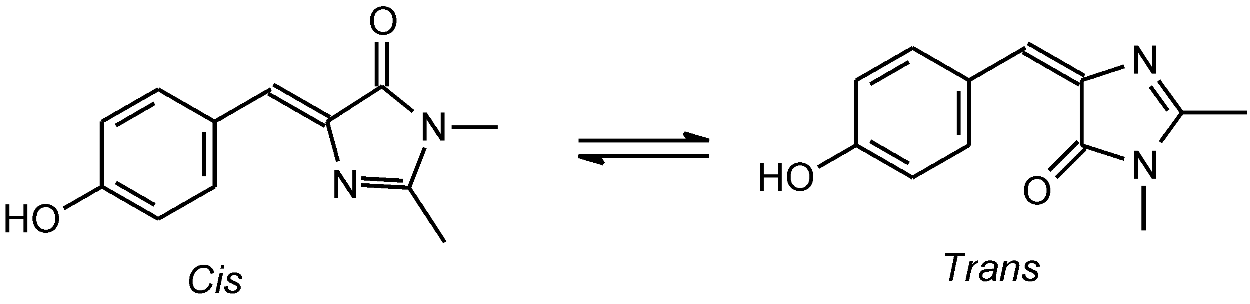

Figure 2
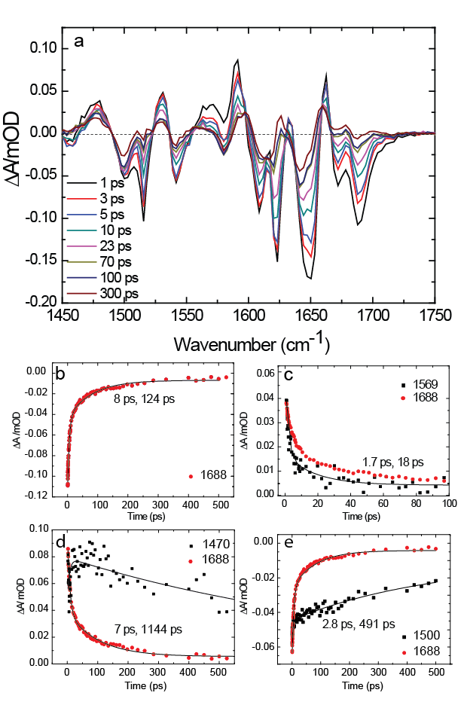
Figure 3
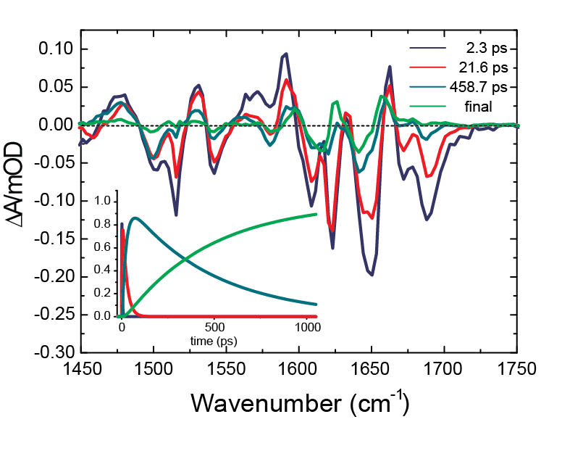
Figure 4
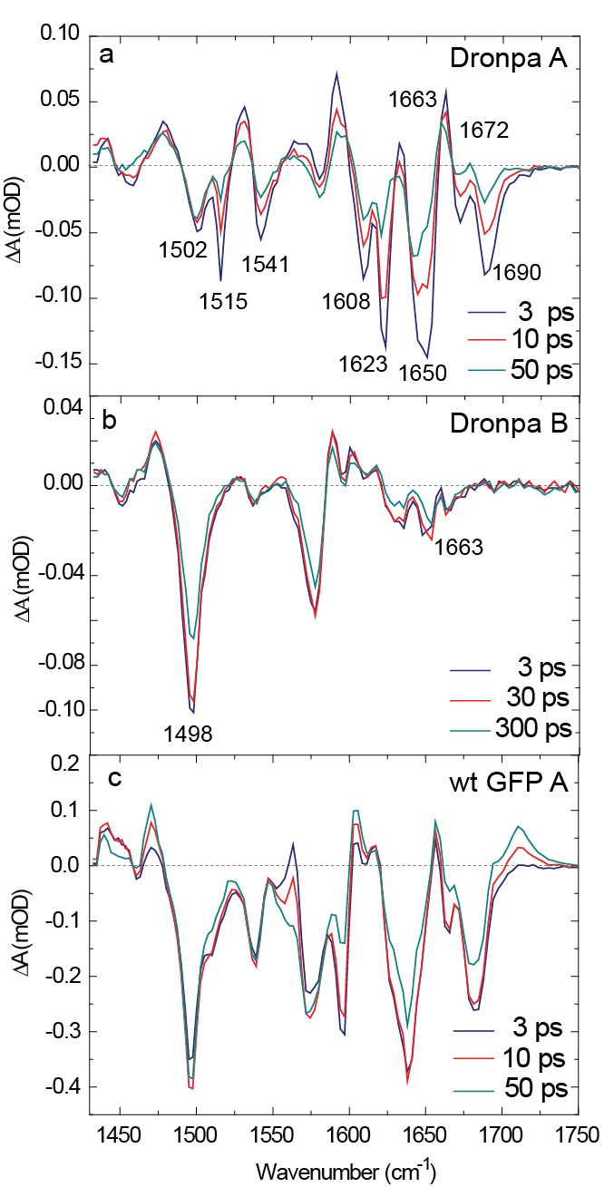
Figure 5
Ackowledgement
This work was supported by grants from EPSRC (EP/G002916 to SRM), STFC (programme 101005 to SRM and PJT) and NSF (CHE-1223819 to PJT).
Supporting Information Available
Supporting information contains TRIR spectra of HBDI in solution, DFT calculations and a table summarizing experimental and calculated vibrational frequencies, and data analysis methods. This information is available free of charge via the Internet at http://pubs.acs.org
References

(1) Ando, R.; Mizuno, H.; Miyawaki, A. Regulated Fast Nucleocytoplasmic Shuttling Observed by Reversible Protein Highlighting. Science 2004, 306, 1370-3.
(2) Habuchi, S.; Ando, R.; Dedecker, P.; Verheijen, W.; Mizuno, H.; Miyawaki, A.; Hofkens, J. Reversible Single-Molecule Photoswitching in the Gfp-Like Fluorescent Protein Dronpa. Proc Natl Acad Sci U S A 2005, 102, 9511-6.
(3) Dedecker, P.; Hotta, J.; Ando, R.; Miyawaki, A.; Engelborghs, Y.; Hofkens, J. Fast and Reversible Photoswitching of the Fluorescent Protein Dronpa as Evidenced by Fluorescence Correlation Spectroscopy. Biophys J 2006, 91, L45-7.
(4) Fron, E.; Flors, C.; Schweitzer, G.; Habuchi, S.; Mizuno, H.; Ando, R.; Schryver, F. C.; Miyawaki, A.; Hofkens, J. Ultrafast Excited-State Dynamics of the Photoswitchable Protein Dronpa. J Am Chem Soc 2007, 129, 4870-1.
(5) Dedecker, P.; Mo, G. C.; Dertinger, T.; Zhang, J. Widely Accessible Method for Superresolution Fluorescence Imaging of Living Systems. Proc Natl Acad Sci U S A 2012, 109, 10909-14.
(6) Flors, C.; Hotta, J.; Uji-i, H.; Dedecker, P.; Ando, R.; Mizuno, H.; Miyawaki, A.; Hofkens, J. A Stroboscopic Approach for Fast Photoactivation-Localization Microscopy with Dronpa Mutants. J Am Chem Soc 2007, 129, 13970-7.
(7) Grotjohann, T.; Testa, I.; Leutenegger, M.; Bock, H.; Urban, N. T.; Lavoie-Cardinal, F.; Willig, K. I.; Eggeling, C.; Jakobs, S.; Hell, S. W. Diffraction-Unlimited All-Optical Imaging and Writing with a Photochromic Gfp. Nature 2011, 478, 204-8.
(8) Heilemann, M.; Dedecker, P.; Hofkens, J.; Sauer, M. Photoswitches: Key Molecules for Subdiffraction-Resolution Fluorescence Imaging and Molecular Quantification. Laser & Photonics Reviews 2009, 3, 180-202.
(9) Hofmann, M.; Eggeling, C.; Jakobs, S.; Hell, S. W. Breaking the Diffraction Barrier in Fluorescence Microscopy at Low Light Intensities by Using Reversibly Photoswitchable Proteins. Proc Natl Acad Sci U S A 2005, 102, 17565-9.
(10) Rego, E. H.; Shao, L.; Macklin, J. J.; Winoto, L.; Johansson, G. A.; Kamps-Hughes, N.; Davidson, M. W.; Gustafsson, M. G. Nonlinear Structured-Illumination Microscopy with a Photoswitchable Protein Reveals Cellular Structures at 50-Nm Resolution. Proc Natl Acad Sci U S A 2012, 109, E135-43.
(11) Shroff, H.; Galbraith, C. G.; Galbraith, J. A.; White, H.; Gillette, J.; Olenych, S.; Davidson, M. W.; Betzig, E. Dual-Color Superresolution Imaging of Genetically Expressed Probes within Individual Adhesion Complexes. Proc Natl Acad Sci U S A 2007, 104, 20308-13.
(12) Bulina, M. E.; Chudakov, D. M.; Britanova, O. V.; Yanushevich, Y. G.; Staroverov, D. B.; Chepurnykh, T. V.; Merzlyak, E. M.; Shkrob, M. A.; Lukyanov, S.; Lukyanov, K. A. A Genetically Encoded Photosensitizer. Nat Biotechnol 2006, 24, 95-9.
(13) Serebrovskaya, E. O.; Edelweiss, E. F.; Stremovskiy, O. A.; Lukyanov, K. A.; Chudakov, D. M.; Deyev, S. M. Targeting Cancer Cells by Using an Antireceptor Antibody-Photosensitizer Fusion Protein. Proc Natl Acad Sci U S A 2009, 106, 9221-5.
(14) Habuchi, S.; Dedecker, P.; Hotta, J.; Flors, C.; Ando, R.; Mizuno, H.; Miyawaki, A.; Hofkens, J. Photo-Induced Protonation/Deprotonation in the Gfp-Like Fluorescent Protein Dronpa: Mechanism Responsible for the Reversible Photoswitching. Photochem Photobiol Sci 2006, 5, 567-76.
(15) Mizuno, H.; Mal, T. K.; Walchli, M.; Kikuchi, A.; Fukano, T.; Ando, R.; Jeyakanthan, J.; Taka, J.; Shiro, Y.; Ikura, M., et al. Light-Dependent Regulation of Structural Flexibility in a Photochromic Fluorescent Protein. Proc Natl Acad Sci U S A 2008, 105, 9227-32.
(16) Chattoraj, M.; King, B. A.; Bublitz, G. U.; Boxer, S. G. Ultra-Fast Excited State Dynamics in Green Fluorescent Protein: Multiple States and Proton Transfer. Proc Natl Acad Sci U S A 1996, 93, 8362-7.
(17) Stoner-Ma, D.; Jaye, A. A.; Matousek, P.; Towrie, M.; Meech, S. R.; Tonge, P. J. Observation of Excited-State Proton Transfer in Green Fluorescent Protein Using Ultrafast Vibrational Spectroscopy. J Am Chem Soc 2005, 127, 2864-5.
(18) Stoner-Ma, D.; Melief, E. H.; Nappa, J.; Ronayne, K. L.; Tonge, P. J.; Meech, S. R. Proton Relay Reaction in Green Fluorescent Protein (Gfp): Polarization-Resolved Ultrafast Vibrational Spectroscopy of Isotopically Edited Gfp. J Phys Chem B 2006, 110, 22009-18.
(19) Andresen, M.; Stiel, A. C.; Trowitzsch, S.; Weber, G.; Eggeling, C.; Wahl, M. C.; Hell, S. W.; Jakobs, S. Structural Basis for Reversible Photoswitching in Dronpa. Proc Natl Acad Sci U S A 2007, 104, 13005-9.
(20) Andresen, M.; Wahl, M. C.; Stiel, A. C.; Grater, F.; Schafer, L. V.; Trowitzsch, S.; Weber, G.; Eggeling, C.; Grubmuller, H.; Hell, S. W., et al. Structure and Mechanism of the Reversible Photoswitch of a Fluorescent Protein. Proc Natl Acad Sci U S A 2005, 102, 13070-4.
(21) Stiel, A. C.; Trowitzsch, S.; Weber, G.; Andresen, M.; Eggeling, C.; Hell, S. W.; Jakobs, S.; Wahl, M. C. 1.8 a Bright-State Structure of the Reversibly Switchable Fluorescent Protein Dronpa Guides the Generation of Fast Switching Variants. Biochem J 2007, 402, 35-42.
(22) Greetham, G. M.; Burgos, P.; Cao, Q. A.; Clark, I. P.; Codd, P. S.; Farrow, R. C.; George, M. W.; Kogimtzis, M.; Matousek, P.; Parker, A. W., et al. Ultra: A Unique Instrument for Time-Resolved Spectroscopy. Appl Spectrosc 2011, 64, 1311-1319.
(23) Warren, M. M.; Kaucikas, M.; Fitzpatrick, A.; Champion, P.; Sage, J. T.; van Thor, J. J. Ground-State Proton Transfer in the Photoswitching Reactions of the Fluorescent Protein Dronpa. Nat Commun 2013, 4, 1461.
(24) van Thor, J. J.; Ronayne, K. L.; Towrie, M.; Sage, J. T. Balance between Ultrafast Parallel Reactions in the Green Fluorescent Protein Has a Structural Origin. Biophys J 2008, 95, 1902-12.
(25) Ando, R.; Flors, C.; Mizuno, H.; Hofkens, J.; Miyawaki, A. Highlighted Generation of Fluorescence Signals Using Simultaneous Two-Color Irradiation on Dronpa Mutants. Biophys J 2007, 92, L97-9.
(26) Addison, K.; Conyard, J.; Dixon, T.; Bulman Page, P. C.; Solntsev, K. M.; Meech, S. R. Ultrafast Studies of the Photophysics of Cis and Trans States of the Green Fluorescent Protein Chromophore. J Phys Chem Lett 2012, 3, 2298-2302.
(27) Lukacs, A.; Haigney, A.; Brust, R.; Zhao, R. K.; Stelling, A. L.; Clark, I. P.; Towrie, M.; Greetham, G. M.; Meech, S. R.; Tonge, P. J. Photoexcitation of the Blue Light Using Fad Photoreceptor Appa Results in Ultrafast Changes to the Protein Matrix. J Am Chem Soc 2011, 133, 16893-900.
(28) Meech, S. R. Excited State Reactions in Fluorescent Proteins. Chem Soc Rev 2009, 38, 2922-34.
(29) Conyard, J.; Kondo, M.; Heisler, I. A.; Jones, G.; Baldridge, A.; Tolbert, L. M.; Solntsev, K. M.; Meech, S. R. Chemically Modulating the Photophysics of the Gfp Chromophore. J Phys Chem B 2011, 115, 1571-7.
(30) Li, X.; Chung, L. W.; Mizuno, H.; Miyawaki, A.; Morokuma, K. A Theoretical Study on the Nature of on- and Off-States of Reversibly Photoswitching Fluorescent Protein Dronpa: Absorption, Emission, Protonation, and Raman. J Phys Chem B 2010, 114, 1114-26.
(31) Greetham, G. M.; Sole, D.; Clark, I. P.; Parker, A. W.; Pollard, M. R.; Towrie, M. Time-Resolved Multiple Probe Spectroscopy. Rev Sci Instrum 2012, 83, 103107.

TOC FIGURE
